Comparative Study on Oxidative Stability of Mustard, Groundnut, and Coconut Oils during Repeated Frying: Implications for Indian Household Cooking Practices
Abstract
Repeated heating of edible oils during frying accelerates lipid oxidation, resulting in the formation of degradation products that adversely affect nutritional quality and may pose health risks. This study compared the oxidative stability of three edible oils commonly consumed in India - mustard oil, groundnut oil, and coconut oil - under repeated heating conditions designed to simulate typical household frying practices. Changes in physicochemical properties, including pH, refractive index, free fatty acid content, acid value, peroxide value, iodine value, UV-visible spectroscopic oxidation indices, smoke point, and Fourier transform infrared (FTIR) spectral characteristics, were systematically analysed over successive heating cycles. The results revealed progressive oxidative deterioration in all three oils, with differences in thermal stability among them. Coconut oil exhibited the greatest oxidative stability, showing comparatively smaller changes in peroxide value, acid value, iodine value, and secondary oxidation products throughout the heating period. In contrast, mustard oil and groundnut oil, which contain higher proportions of unsaturated fatty acids, demonstrated greater susceptibility to thermal oxidation, as evidenced by marked increases in free fatty acid content, peroxide value, acid value, and spectroscopic oxidation markers. These findings highlight the influence of fatty acid composition on the thermal stability of edible oils. The study provides experimental evidence relevant to the selection of oils with greater resistance to oxidative degradation during repeated household frying. The findings contribute to food-quality assessment, consumer awareness, and safer cooking practices.
Keywords: Oxidative stability; mustard oil; groundnut oil; coconut oil; repeated frying; lipid oxidation; peroxide value; iodine value; smoke point; FTIR spectroscopy

- Introduction
Edible plant oils are important nutritional sources obtained from seeds, fruits, and pulps, serving as major sources of energy and enhancing food flavour and texture (Zhou et al., 2020). They contain essential fatty acids, fat-soluble vitamins (A, D, E, and K), and natural antioxidants such as α-tocopherol, which contribute to health maintenance (Mazzocchi et al., 2021). In addition, they supply trace minerals such as phosphorus, magnesium, potassium, and calcium, contributing to their overall nutritional value (Zhou et al., 2020). Edible oils constitute an essential component of culinary practices worldwide, serving as both nutrient sources and cooking media (Vekataralu Bhavadharani et al., 2023). Vegetable oils are important dietary lipids that supply essential fatty acids and energy while enhancing food quality (Orsavova et al., 2015). In India, mustard oil, groundnut oil, and coconut oil are widely preferred, and their distinctive fatty acid profiles influence their thermal and oxidative behaviour (Dorni et al., 2018). Frying exposes oils to high temperatures (typically 150-220 °C), accelerating oxidation through free-radical mechanisms that degrade nutritional quality and produce compounds such as aldehydes, ketones, and trans fatty acids (Mohammadian Fazli et al., 2022; Omer et al., 2023). Oxidation is a major limitation in the food industry and a primary cause of spoilage in edible oils and oil-containing foods (Lu et al., 2025). Consumption of vegetable oil that has been repeatedly heated during frying has been associated with atherosclerosis risk, low-density lipoprotein (LDL) levels, and total blood lipid levels (Mishra et al., 2023). The oxidation rate is strongly correlated with the degree of unsaturation; oils rich in polyunsaturated fatty acids (PUFAs), such as mustard and groundnut oils, degrade faster than saturated-fat-rich coconut oil (Madhujith & Sivakanthan, 2019). The susceptibility of an oil to oxidation is significantly influenced by its fatty acid composition. Oils with a higher degree of unsaturation are more vulnerable to lipid oxidation because they contain more double bonds (Moorthy et al., 2023). Linolenic acid oxidises fastest, followed by linoleic acid and then oleic acid (Maszewska et al., 2018). Beyond fatty acid composition, several other factors can accelerate or inhibit oil oxidation. Temperature and heat are important because higher temperatures increase the rate of oxidation reactions, making oils more susceptible to degradation during processing, storage, and cooking, especially frying. Frying exposes oils to prolonged high temperatures, promoting rapid oxidation and the formation of polar compounds, dimers, and oligomers. Repeated heating further accelerates oil deterioration (Bhuiyan et al., 2016; Omer et al., 2023). Recent evidence indicates that repeated heating produces measurable changes in physicochemical quality indices, including peroxide and acid values, supporting cycle-based assessment of frying-oil deterioration (Khaled et al., 2023).
The oxidative stability of edible oils is influenced by multiple factors. Temperature plays a major role because higher heat accelerates oxidation, making oils more susceptible to degradation during processing, storage, and especially frying. Prolonged exposure to frying temperatures promotes the formation of polar compounds, dimers, and oligomers, while repeated heating further exacerbates deterioration (Bhuiyan et al., 2016; Omer et al., 2023). Exposure to light, particularly through transparent packaging, can induce photooxidation and increase free-radical formation, while a higher oxygen concentration promotes reactions with unsaturated fatty acids and thereby enhances oxidation (Fadda et al., 2022). Prooxidants, such as metal ions (copper and iron) and chlorophylls, catalyse hydroperoxide decomposition and further accelerate deterioration (Fadda et al., 2022). Processing methods also influence stability; refining may reduce natural antioxidants and lower resistance to oxidation, whereas appropriate processing techniques can remove prooxidants and improve stability (Madhujith & Sivakanthan, 2019). In addition, free fatty acids, mono- and diacylglycerols, and thermally oxidised compounds can promote autoxidation and increase the rate of oil degradation (Freis & Vemulapalli, 2025). Current literature indicates that fatty acid composition, frying temperature, heating duration, and reuse frequency collectively influence the oxidative stability of edible oils (Saha et al., 2025). During deep-fat frying, oxidation, hydrolysis, and polymerisation occur concurrently and progressively compromise oil integrity (Bazina et al., 2025). Experimental evidence further shows that successive frying cycles alter fatty acid profiles and increase lipid-peroxidation indices, with the extent varying according to oil type and frying temperature (Aduol et al., 2025). Monitoring iodine value, oxidative stability, fatty acid composition, and specific oxidation products across frying cycles can provide complementary evidence of oil deterioration (Choi et al., 2024).
Repeated use of cooking oils in Indian households, driven by economic and cultural reasons, exacerbates oil degradation, increasing potential health risks including cardiovascular diseases and oxidative stress-related conditions (Ganesan et al., 2019). Despite this, comparative data on the oxidative stability of these oils under realistic repeated frying conditions remain limited, particularly for Indian household scenarios where cooking styles and oil reuse frequency vary widely.
This study aims to systematically evaluate and compare the oxidative stability of mustard oil, groundnut oil, and coconut oil subjected to repeated frying heat cycles. The study investigates changes in key physicochemical parameters, including free fatty acid content, peroxide value, acid value, iodine value, and the formation of primary and secondary oxidation products, using standardised analytical and instrumental techniques. In addition, functional properties related to cooking performance and safety, such as smoke point, are assessed. By correlating laboratory-based indicators of lipid oxidation with common household cooking practices, the study seeks to provide scientific evidence for selecting edible oils that maintain greater oxidative stability during repeated heating, thereby supporting healthier and safer dietary oil consumption.

- Materials and Methods

  - Sample Collection
Three edible oils, namely mustard oil, groundnut oil, and coconut oil, were procured from reputable commercial brands in Lucknow, India. Only refined, unblended oils were selected to minimise variability. The samples were stored in glass containers at ambient temperature and protected from light until testing commenced.
2.2 Frying Procedure
Approximately 400 mL of each oil was heated manually in a clean, dry stainless-steel pan on a standard domestic stovetop burner and subjected to repeated frying cycles. Each cycle consisted of heating until continuous visible smoke appeared, to mimic typical household practices, followed by cooling to room temperature. The heating-cooling process was repeated at equal intervals over 20 days. Aliquots were collected on days 0, 5, 10, 15, and 20 for analysis.
  - Physicochemical Parameters
2.3.1 pH
pH was measured using a calibrated digital pH meter in aqueous emulsions of the oil samples. The instrument was calibrated using standard buffer solutions of pH 7.0 and 4.0 to ensure accuracy. For analysis, 10 g of each oil sample was homogenised with 100 mL of distilled water and stirred to extract water-soluble acidic or basic compounds. The mixture was then filtered through Whatman No. 1 filter paper, and the electrode of the calibrated pH meter was immersed in the filtrate. The stabilised reading displayed by the instrument was recorded as the pH value of the respective oil sample (Kumar et al., 2019).
    - Refractive index (RI)
The refractive index (RI) is a key physicochemical parameter that reflects oil purity, unsaturation, and structural integrity and can indicate thermal degradation or adulteration. The oils were analysed using a Milwaukee MA871 Digital Refractometer calibrated with distilled water (RI = 1.3330 at 20 °C). Oil samples (2-3 drops) were placed on the prism, and the device measured the critical angle of total internal reflection to provide precise digital RI values, thereby enabling assessment of oil quality and oxidative changes (Babu, 2020).

2.3.3 Free fatty acid (FFA)
Free fatty acid (FFA) content is a key indicator of hydrolytic degradation and oil quality, particularly under thermal stress such as frying. Oil samples were analysed for free fatty acids using AOCS Method Ca 5a-40 (American Oil Chemists' Society, 1993). Elevated FFA levels reflect triglyceride breakdown, contributing to rancidity and reduced oxidative stability. A 10 g portion of oil was dissolved in 60 mL of neutralised ethanol and titrated with 0.025 M NaOH using phenolphthalein as the endpoint indicator. FFA content was expressed as a percentage of oleic acid, providing a quantitative measure of oil hydrolysis and quality deterioration (Sebastian et al., 2014).
FFA % as oleic acid = $\frac{alkali volume \left(ml\right)×alkali normality×28.2}{sample weight (g)}$

2.3.4 Acid value (AV)
Acid value (AV) quantifies the free fatty acids in oils and is expressed as milligrams of KOH. The acid value of the oil samples was determined according to ISO 660:2009. For the determination, an accurately weighed oil sample of approximately 2 g was placed in a conical flask and mixed with 10 mL of neutralised hot ethanol and 1 mL of phenolphthalein. The mixture was boiled for 5 min and titrated with standard alkali while hot until a pale-pink colour appeared (International Organization for Standardization, 2009; Banchode et al., 2021).
Acid Value = $\frac{56.1 V×N}{W}$
Where;
V = Volume in mL of standard potassium hydroxide or sodium hydroxide used
N = Normality of the potassium hydroxide solution or Sodium hydroxide solution; and
W = Weight in gm of the sample

2.3.5 Peroxide value (PV)
Peroxide value (PV) indicates the extent of oil oxidation through hydroperoxide formation and contributes to the assessment of rancidity in unsaturated fats. In this experiment, PV was determined using AOCS Method Cd 8b-90 (American Oil Chemists' Society, 1993). Five grams of oil were dissolved in 30 mL of glacial acetic acid-chloroform (3:2), followed by the addition of 0.5 mL of potassium iodide. After 30 mL of distilled water had been added, the mixture was titrated with 0.1 M sodium thiosulphate using starch as the endpoint indicator (Sebastian et al., 2014).
Peroxide Value = $\frac{Titre value×N×1000}{W}$
where;
Titre Value = V_{sample} - V_{blank}
N = Normality of potassium thiosulphate
W = Weight of the sample (g)

    - Iodine value (IV)
The iodine value (IV) measures the degree of unsaturation in oils and fats and is expressed as grams of iodine absorbed per 100 g of sample. For determination, an accurately weighed oil sample was dissolved in carbon tetrachloride and reacted with an excess of Wijs solution. After standing in the dark (30 min for non-drying or semi-drying oils and 1 h for drying oils), potassium iodide and water were added, and the liberated iodine was titrated with standardised sodium thiosulphate using starch as an indicator. Blank determinations were performed simultaneously to ensure accuracy (American Oil Chemists' Society, 1993).
Iodine value = $\frac{12.69 \left(B-S\right) N}{W}$
Where;
B = volume in mL of standard sodium thiosulphate solution required for the blank.
S = volume in mL of standard sodium thiosulphate solution required for the sample
N = normality of the standard sodium thiosulphate solution
W = weight in gm of the sample

    - UV-Visible Spectroscopy
The formation of conjugated oxidation products in oils was monitored using UV-visible spectroscopy at two key wavelengths: 232 nm (K232) for conjugated dienes formed during early fatty acid oxidation and 270 nm (K270) for conjugated trienes, aldehydes, and ketones representing secondary oxidation products. Approximately 0.05 g of oil was diluted in 25 mL of spectroscopic-grade isooctane or cyclohexane, mixed until homogeneous, and filtered if necessary. A blank was used for instrument calibration. Absorbance was measured in quartz cuvettes with a 1 cm path length, with K232 indicating primary oxidation (hydroperoxides) and K270 reflecting secondary degradation (aldehydes and ketones). Samples were analysed while protected from light to prevent further photooxidation. This method quantified progressive oxidative changes during repeated frying (International Olive Council, 2019).
  - Functional Parameters
    - Smoke Point
The smoke point, an indicator of thermal stability and functional degradation, was determined using AOCS Method Cc 9a-48 (American Oil Chemists' Society, 2017). Approximately 25 mL of oil was heated in a stainless-steel pan at a specified rate while a stream of air was passed continuously through it. The temperature at which continuous visible smoke appeared was recorded using a calibrated digital thermometer as the smoke point. Fresh oils exhibited higher smoke points because of their low free fatty acid content and minimal oxidation, whereas repeated frying led to a progressive decline, reflecting the accumulation of degradation products such as FFAs, hydroperoxides, aldehydes, and polymers. Monitoring the decline in smoke point provided insights into oil usability, safety, and responsible frying practices (Perera et al., 2020).
2.4.2 Fourier Transform Infrared (FTIR) Spectroscopy
FTIR spectroscopy was used to assess molecular-level changes in edible oils induced by thermal and oxidative degradation during repeated frying. Fresh (Day 0) and degraded (Day 20) samples were analysed using an FTIR spectrometer with an ATR accessory over the range of 4000-400 cm⁻¹. A small oil aliquot (1-2 drops) was applied directly to the clean ATR crystal without dilution. Between analyses, the crystal was cleaned with hexane and ethanol to prevent contamination, and background spectra were recorded for baseline correction. Key absorption bands examined included C=C-H stretching (~3010 cm⁻¹) for unsaturation, carbonyl stretching (~1743 cm⁻¹) for ester and oxidation products, and the O-H (~3500 cm⁻¹) and C-O (1150-1050 cm⁻¹) regions indicative of hydrolysis and polar-compound formation. Comparative analysis of the Day 0 and Day 20 spectra revealed structural alterations consistent with oxidative and hydrolytic degradation during prolonged frying (Soni et al., 2022).
  - Statistical Analysis
All measurements were conducted in triplicate for each cycle. Data were expressed as the mean ± standard deviation.
3. Results
3.1 Physicochemical Changes
3.1.1 Changes in RI
The highest RI was observed in mustard oil (1.47 ± 0.03), followed by groundnut oil (1.46 ± 0.05), whereas coconut oil exhibited the lowest RI (1.45 ± 0.05). Mustard oil, which is rich in MUFAs (oleic and erucic acids), showed the highest RI because oils with greater unsaturation exhibit higher RI values owing to the influence of double bonds on light refraction (Wazed et al., 2023). Groundnut oil also had a high RI, consistent with its oleic and linoleic acid content and antioxidant stability (Sunil et al., 2015). In contrast, coconut oil, which is high in saturated fats such as lauric and palmitic acids, showed the lowest RI, in agreement with reports that saturated oils have lower RI values (Ghani et al., 2018).
Table 1 Mean Refractive index of oils
Oil | Refractive Index Value
Mustard oil | 1.47 ± 0.03
Groundnut oil | 1.46 ± 0.05
Coconut oil | 1.45 ± 0.05

3.1.2 Changes in pH
The pH values indicate the presence of free fatty acids and minor hydrolytic changes before heating. Coconut and mustard oils showed lower pH values of 3.47 ± 0.05 and 3.51 ± 0.03, respectively, suggesting greater natural acidity or slight degradation. In contrast, groundnut oil had a higher pH of 4.40 ± 0.07, indicating lower free acidity and better initial stability, likely owing to its higher MUFA content and reduced moisture absorption, which limit early hydrolysis (Kumar et al., 2019).
Table 2 Mean pH of oils
Oil | pH
Mustard oil | 3.51 ± 0.03
Groundnut oil | 4.40 ± 0.07
Coconut oil | 3.47 ± 0.05

3.1.3 Changes in FFAs
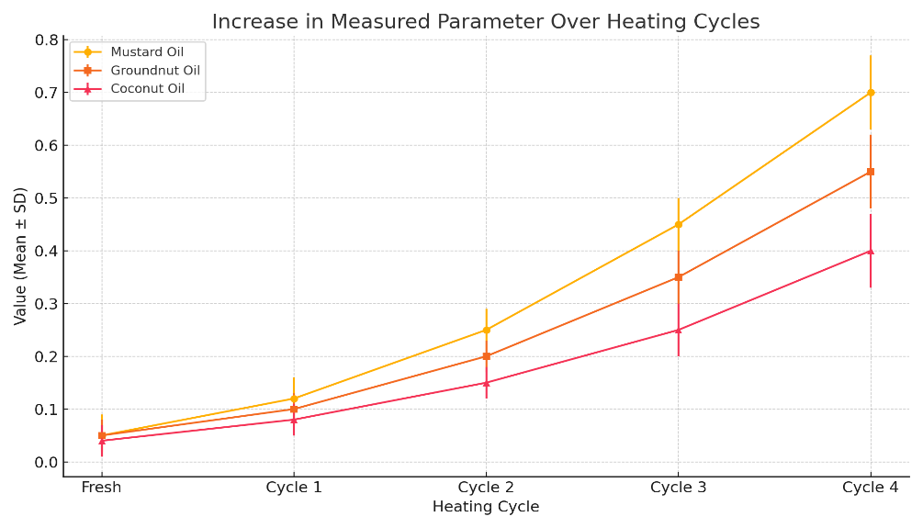
Mustard oil showed the greatest increase in FFA, from 0.05% (fresh) to 0.70% (after the fourth cycle), indicating extensive hydrolytic degradation owing to its higher degree of unsaturation and oxidative susceptibility. Groundnut oil increased from 0.05% to 0.55%, reflecting moderate degradation and better stability than mustard oil, likely owing to its higher MUFA content. Coconut oil, which is rich in saturated fats, showed the smallest increase, from 0.04% to 0.40%, demonstrating strong resistance to hydrolytic degradation. Overall, FFA levels increased progressively with frying cycles in the following order: mustard > groundnut > coconut. These results indicate that unsaturated oils degraded faster under heat, whereas saturated oils such as coconut oil remained more stable.
Figure 1 FFA levels across frying cycles of oils
3.1.4 Changes in Acid values
The acid value (AV) of mustard oil increased with each frying cycle, rising from 0.10 ± 0.04 to 0.80 ± 0.07 mg KOH/g, indicating substantial hydrolytic and oxidative degradation. Groundnut oil showed a moderate increase from 0.10 ± 0.06 to 0.60 ± 0.03 mg KOH/g, reflecting better stability. Coconut oil exhibited the smallest increase, from 0.08 ± 0.05 to 0.45 ± 0.04 mg KOH/g, demonstrating strong resistance to thermal degradation owing to its high saturated-fat content. Overall, the progressive increase in AV across all oils highlights the effect of repeated frying on oil quality through hydrolysis and oxidation. Mustard oil degraded most rapidly, followed by groundnut oil and coconut oil. The results emphasise the need to select thermally stable oils for repeated frying to reduce exposure to oxidised products and maintain nutritional quality. Under the experimental conditions, coconut oil showed greater resistance to degradation than mustard oil.
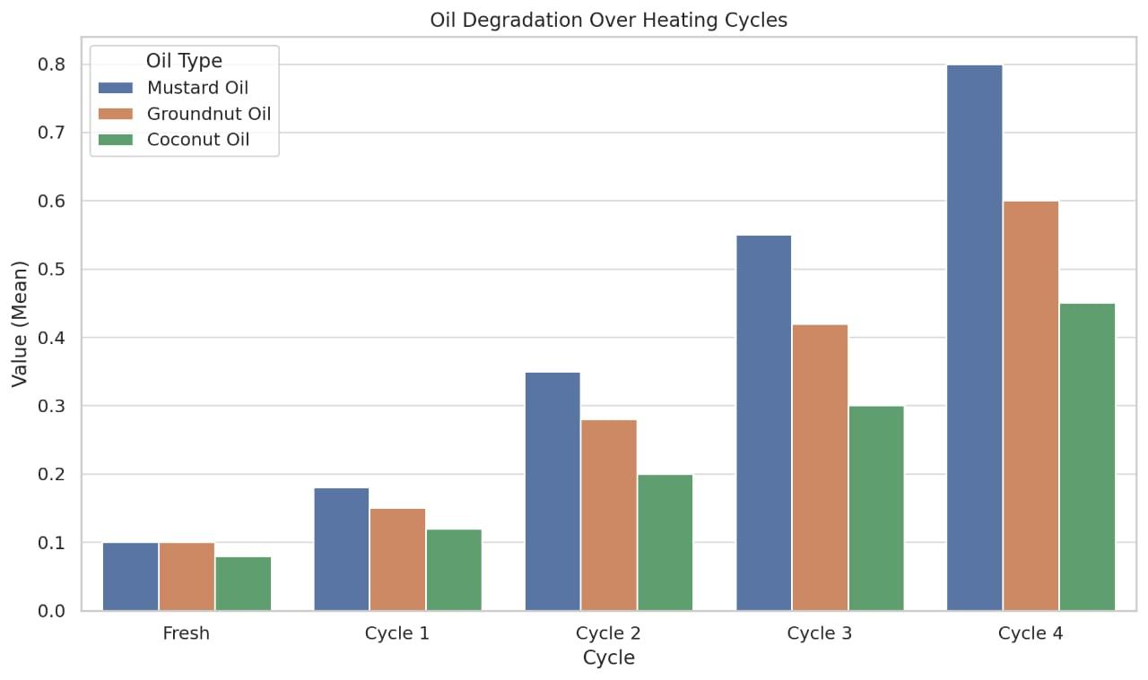
Figure.2 Acid Value across frying cycle of oils
3.1.5 Changes in Iodine values
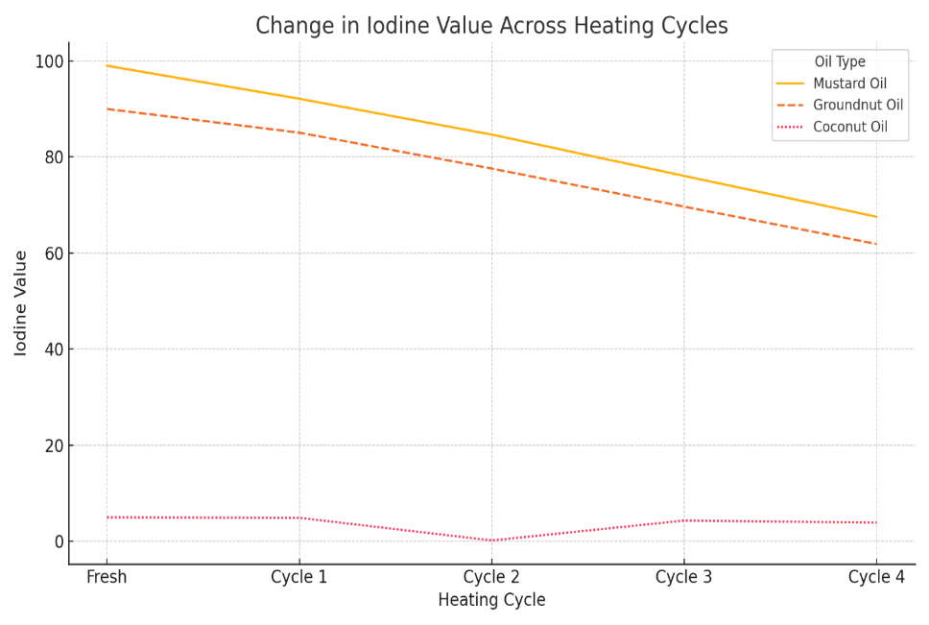
Mustard oil showed a sharp decline in iodine value (IV) from 99.00 g I₂/100 g (fresh) to 68.00 g I₂/100 g (after the fourth cycle), reflecting its high susceptibility to oxidative deterioration due to its rich polyunsaturated fatty acid content, particularly erucic acid. Groundnut oil exhibited a moderate decrease from 90.00 g I₂/100 g to 62.00 g I₂/100 g, indicating better oxidative stability owing to its higher monounsaturated-fat content. Coconut oil showed minimal change, with IV decreasing slightly from 5.00 g I₂/100 g to 3.90 g I₂/100 g, confirming its strong resistance to oxidation because of its high saturation level. Overall, the progressive decline in IV for mustard and groundnut oils highlights the oxidative breakdown of unsaturated fatty acids during repeated frying. In contrast, the stability of coconut oil underscores the protective role of saturated fats against oxidation. These results reaffirm that oils with greater unsaturation are more prone to oxidative degradation, emphasising the need to consider fatty acid composition when selecting oils for repeated frying to maintain quality and safety.

Figure 3 Iodine Value across frying cycle of oils

3.1.6 Changes in Peroxide values
Mustard oil showed the greatest increase in peroxide value (PV), from 5.97 ± 0.15 to 21.08 ± 0.24 meq O₂/kg after four frying cycles, indicating substantial oxidative deterioration associated with its high PUFA content. Groundnut oil also showed a notable increase (3.91 ± 0.23 to 17.31 ± 0.21 meq O₂/kg), reflecting moderate susceptibility to oxidation. In contrast, coconut oil exhibited the smallest increase in PV (1.22 ± 0.13 to 9.80 ± 0.15 meq O₂/kg), confirming greater oxidative stability associated with its saturated fatty acid composition. Overall, PV increased in all oils with successive frying cycles in the following order: mustard > groundnut > coconut, consistent with their degrees of unsaturation. These results indicate that unsaturated oils oxidised faster under heat, emphasising the need to limit reuse to maintain quality and safety.
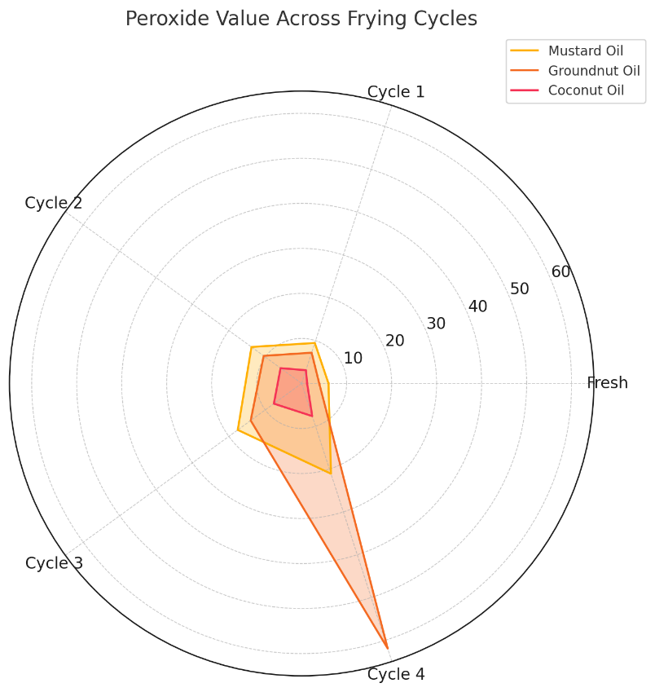
Figure 4 Peroxide Value across frying cycle of oils
3.1.7 UV-Vis Determination of Oxidation Products
Mustard oil exhibited the greatest increase (K232: 1.10 to 2.40; K270: 0.10 to 0.30), reflecting its high PUFA content and strong susceptibility to oxidation. Groundnut oil showed a moderate increase (K232: 0.95 to 2.05; K270: 0.08 to 0.28), whereas coconut oil showed the smallest increase (K232: 0.60 to 1.25; K270: 0.05 to 0.18), consistent with its saturated nature and greater thermal stability. These results align with previous studies showing that higher UV absorbance at 232 and 270 nm indicates lipid oxidation and declining oil quality during repeated frying.
Table 3 UV-Vis Absorbance (K232 and K270) of edible oils across frying cycles
Frying Cycle | Mustard Oil |  | Groundnut Oil |  | Coconut Oil
 | K₂₃₂ | K₂₇₀ | K₂₃₂ | K₂₇₀ | K₂₃₂ | K₂₇₀
Fresh | 1.1 | 0.1 | 0.95 | 0.08 | 0.6 | 0.05
Cycle 1 | 1.45 | 0.14 | 1.2 | 0.12 | 0.75 | 0.08
Cycle 2 | 1.7 | 0.18 | 1.45 | 0.17 | 0.9 | 0.12
Cycle 3 | 2.1 | 0.24 | 1.8 | 0.22 | 1.1 | 0.15
Cycle 4 | 2.4 | 0.3 | 2.05 | 0.28 | 1.25 | 0.18
3.1.8 Fourier Transform Infrared Spectroscopy
Mustard oil showed notable reductions in the C-H (2924 and 2854 cm⁻¹), C=O (1746 cm⁻¹), and C=C (1654 cm⁻¹) peaks, together with an increase in the O-H band (3470 cm⁻¹), indicating oxidation, hydrolysis, and loss of unsaturation. Groundnut oil displayed moderate decreases in similar peaks, reflecting partial triglyceride breakdown and oxidation, with a stronger O-H band suggesting hydroperoxide formation. Coconut oil exhibited only slight reductions in C-H and C=O intensities and minimal spectral shifts, confirming its high oxidative stability and resistance to thermal degradation. Thus, degradation followed the order mustard > groundnut > coconut, consistent with their degrees of unsaturation.

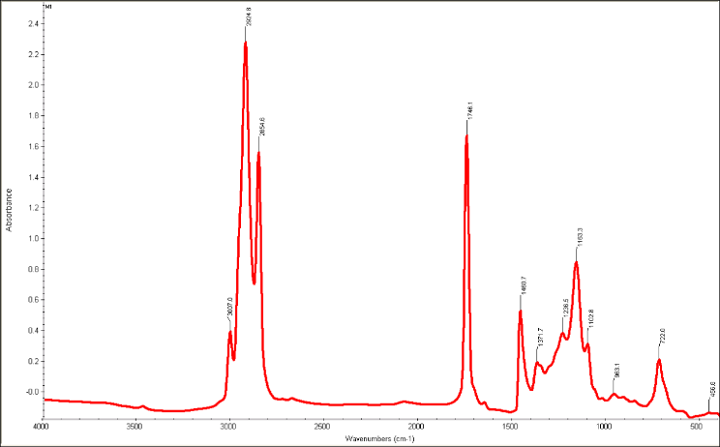  (a) FTIR spectra of fresh mustard oil sample | 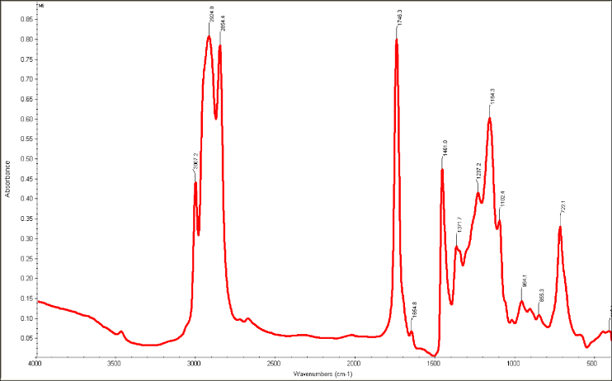  (b) FTIR spectra of mustard oil sample after cycle 4
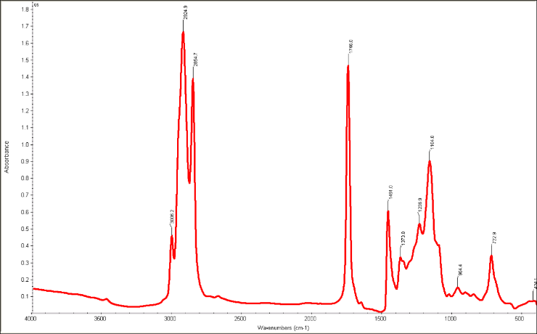  (c) FTIR spectra of fresh groundnut oil sample | 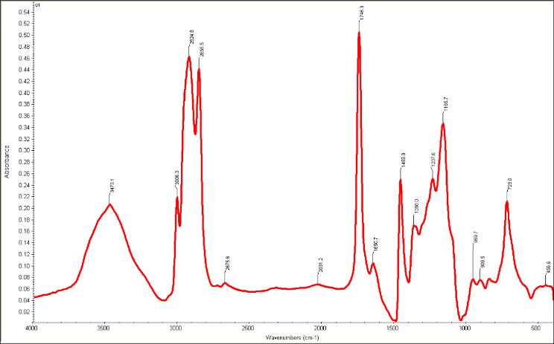  (d) FTIR spectra of groundnut oil sample after cycle 4
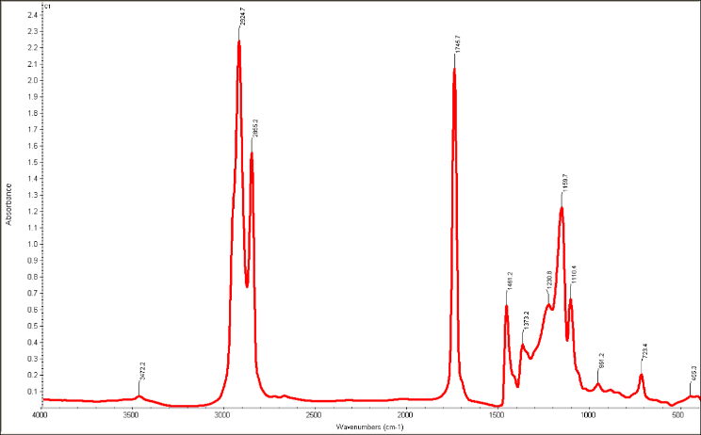  (e) FTIR spectra of fresh coconut oil sample | 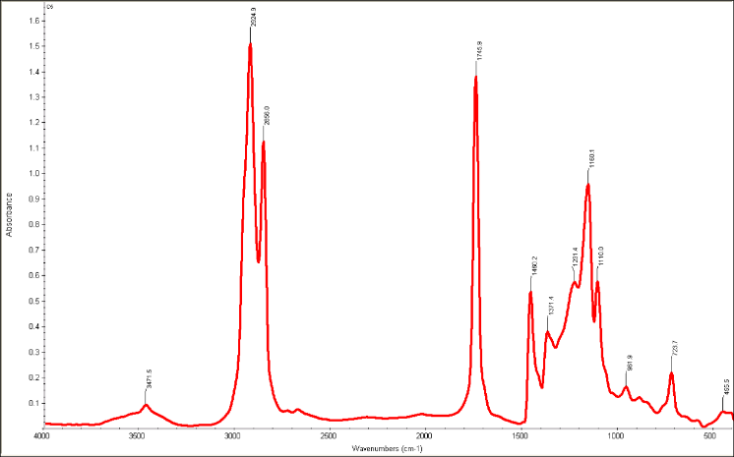  (f) FTIR spectra of coconut oil sample after cycle 4
Figure 5 FTIR spectra of different oils
3.2 Functional Changes
3.2.1 Smoke Point
Mustard oil showed a sharp decline in smoke point from 230 °C (fresh) to 200 °C (after the fourth cycle), representing a 30 °C reduction and indicating substantial thermal decomposition associated with its high PUFA content. This finding suggests that mustard oil degraded rapidly under repeated frying, thereby compromising its quality and safety. The smoke point of groundnut oil decreased from 225 °C to 198 °C, representing a 27 °C reduction and reflecting moderate stability associated with its higher MUFA content, although prolonged use still promoted degradation and the potential formation of harmful compounds. Coconut oil exhibited the smallest change, decreasing from 220 °C to 210 °C, highlighting its greater thermal stability and resistance to oxidation associated with its saturated-fat composition. Under the tested conditions, coconut oil showed the greatest stability during repeated frying, followed by groundnut oil and mustard oil.
Figure 3.6 Smoke point across frying cycle of oils

Fig 6: Graf Showing the Smoke point over frying cycle

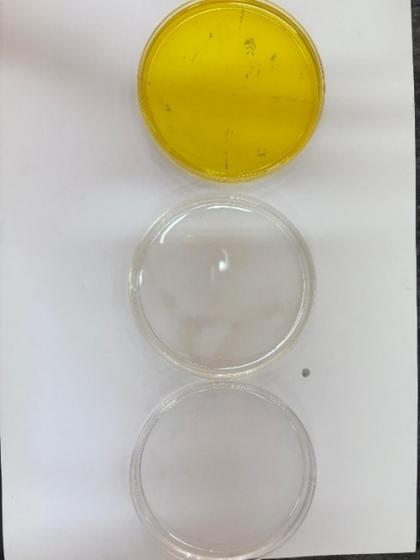  (a) (b) (c)  Fresh oil | 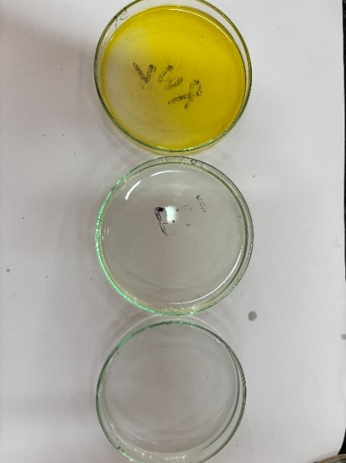  (a) (b) (c)  After 1st frying cycle | 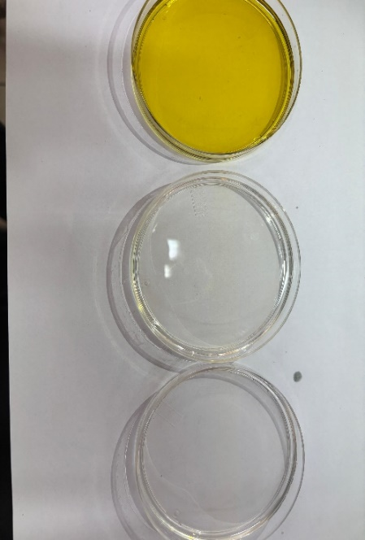  (a) (b) (c)  After 2nd Frying cycle
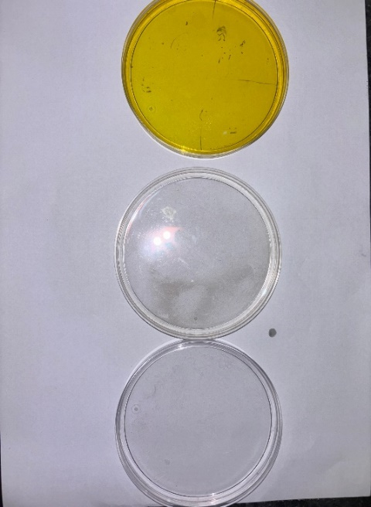  (a) (b) (c)  After 3rd frying cycle | 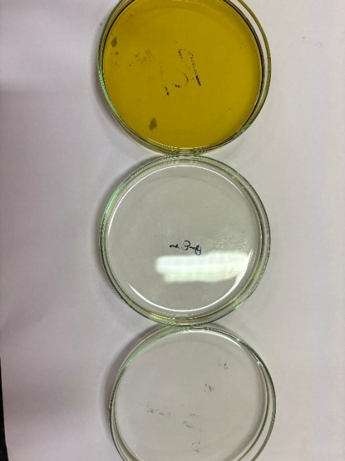  (a) (b) (c)  After 4th frying cycle
Figure 7 Oil samples of (a) Mustard Oil, (b) Groundnut oil and (c) Coconut Oil at different frying cycle
Discussion
The comparative study highlights the critical role of fatty acid composition in determining the oxidative stability of oils during household frying. The high saturated-fat content of coconut oil imparts notable resistance to hydrolysis and peroxidation, corroborating earlier findings regarding its thermal stability and limited alteration during frying (De Paiva Azevedo et al., 2021; Sharanke & Sivakanthan, 2022). The comparatively stable AV and PV values indicate lower free fatty acid cleavage and peroxide formation. Conversely, mustard oil's high MUFA and PUFA concentrations result in greater susceptibility to oxidation, as demonstrated by marked increases in FFA, AV, and peroxide levels during repeated heating (Rashid et al., 2023). Groundnut oil, which is rich in monounsaturated oleic acid, showed intermediate oxidative degradation, reflecting its composition. The decrease in iodine value across frying cycles in unsaturated oils indicates the progressive loss of double bonds through oxidative cleavage. This reduction is consistent with the observed increases in conjugated dienes and trienes, which are characteristic intermediates of lipid peroxidation (Moorthy et al., 2023). Secondary oxidation products, such as aldehydes and ketones detected by UV-visible spectroscopy and FTIR, contribute to flavour deterioration and potential health hazards. Changes in functional parameters, including a reduced smoke point and increased foaming, suggest that degradation affects cooking safety and oil usability. An increased tendency to foam may increase fire risk and impair heat transfer during household frying. These findings underscore the health implications of repeated oil use and reinforce recommendations against multiple reuses of oils rich in unsaturated fatty acids. The greater stability of coconut oil suggests that it was more resistant to repeated frying under the tested conditions, although its saturated-fat content warrants nutritional consideration. The study addresses a knowledge gap by simulating household cooking conditions and integrating multiple analytical techniques, thereby providing data relevant to consumer choices and public-health guidance in India and similar settings.
Limitation
This study was conducted under controlled laboratory conditions designed to simulate Indian household frying practices, which may not fully represent the variability of real-life cooking conditions. Only three commonly consumed edible oils were evaluated, and the findings may not be directly applicable to other edible oils with different fatty acid compositions. Furthermore, the study focused primarily on physicochemical and spectroscopic indicators of oxidation and did not quantify specific toxic oxidation products or assess their biological effects. Future studies should include a wider range of edible oils, diverse frying conditions, identification of oxidation products, and toxicological assessments to provide a more comprehensive evaluation of frying-oil safety.
Conclusion
This research elucidates the oxidative stability patterns of mustard, groundnut, and coconut oils during repeated frying under Indian household conditions. Oil reuse should be limited to preserve quality and safety. The use of mustard oil should be restricted to two frying cycles, groundnut oil to three cycles, and coconut oil to four cycles under controlled conditions. Oils showing signs of oxidation, such as off-odours, darkening, thickening, or a low smoke point, should be discarded because continued use may cause nutrient loss and possible adverse effects on human health. Coconut oil exhibited the highest oxidative resilience owing to the predominance of saturated fatty acids, maintaining its physicochemical and functional quality during repeated heating. Mustard and groundnut oils, which have higher degrees of unsaturation, underwent greater oxidative degradation, as evidenced by increases in free fatty acids, peroxide value, and acid value and decreases in iodine value. These findings highlight the importance of selecting oils with appropriate fatty acid profiles for frying and limiting repeated use to mitigate risks associated with oxidised lipids. Consumer education and regulatory policies should emphasise oxidative-stability parameters alongside nutritional profiles to promote safer cooking practices. The results contribute to knowledge of oil stability and may inform future studies on frying-oil quality, oxidation-resistant edible oils, and food-safety interventions. Furthermore, this research supports the development of science-based dietary recommendations and public-health strategies aimed at promoting safer cooking practices and improving the nutritional quality of fried foods.
Conflict of Interest
The authors declared no potential conflict of interest with respect to the authorship and publication.

Funding source
No funding organization in the public, private, or non-profit sectors, including universities, gave a designated grant in support of this research.

Acknowledgment
The authors would like to express their sincere gratitude to the Department of Food and Nutrition, Babasaheb Bhimrao Ambedkar University, Lucknow, for providing the laboratory facilities required to conduct the experiments and complete this study.

Availability of data and material
The datasets generated and analysed during the current study are available from the corresponding author upon reasonable request.

Declaration of Generative AI in Scientific Writing
This is to certify that the research presented in this manuscript has been conducted solely by the authors without the assistance of generative AI tools in any stage of scientific writing, including the conception, drafting, revising, and editing of the manuscript. All analyses, interpretations, and conclusions are the original work of the authors, derived from the referenced studies and methodologies employed. No AI tools were used to generate text, images, or data interpretations for this submission.

Code availability
Not applicable. No software applications or custom codes were used in this research.

Credit authorship contribution statement

Manisha Saha: Methodology, software, and writing - original draft; Alka Nanda: Software and writing - review and editing; Priyanka Shankar: Supervision and validation.

References
• Zhou, Y., Zhao, W., Lai, Y., Zhang, B., & Zhang, D. (2020). Edible plant oil: Global status, health issues, and perspectives. Frontiers in Plant Science, 11, 1315. https://doi.org/10.3389/fpls.2020.01315
• Mazzocchi, A., De Cosmi, V., Risé, P., Milani, G. P., Turolo, S., Syrén, M.-L., Sala, A., & Agostoni, C. (2021). Bioactive compounds in edible oils and their role in oxidative stress and inflammation. Frontiers in Physiology, 12, 659551. https://doi.org/10.3389/fphys.2021.659551
• Vekataralu Bhavadharani, P., Parameswaran, G., & Sakkaravarthy, A. (2023). Studies on the quality indices of processing of edible vegetable oils. International Journal of Nutrition and Food Sciences, 12(4), 109–115. https://doi.org/10.11648/j.ijnfs.20231204.14
• Orsavova, J., Misurcova, L., Ambrozova, J. V., Vicha, R., & Mlcek, J. (2015). Fatty acids composition of vegetable oils and its contribution to dietary energy intake and dependence of cardiovascular mortality on dietary intake of fatty acids. International Journal of Molecular Sciences, 16(6), 12871–12890. https://doi.org/10.3390/ijms160612871
• Dorni, C., Sharma, P., Saikia, G., & Longvah, T. (2018). Fatty acid profile of edible oils and fats consumed in India. Food Chemistry, 238, 9–15. https://doi.org/10.1016/j.foodchem.2017.05.072
• Mohammadian Fazli, M., Zanganeh, H., & Hassanzadazar, H. (2022). Effect of heating on disposal point of main edible oils available in Iran market. Food Science & Nutrition, 10(12), 4394–4402. https://doi.org/10.1002/fsn3.3033
• Omer, N., Atta, S. A., Jame, R., Alotaibi, F. A., Al-Tweher, J. N., Al-Aoh, H. A., Suliman, Z. E., & Mustafa, S. K. (2023). Effect of frying and reheating processes on the fatty acids and antioxidants of commonly used cooking oils in the Arabian region: A comparative study. Oriental Journal of Chemistry, 39(5), 1205–1213. https://doi.org/10.13005/ojc/390513
• Lu, Y., Xiong, R., Tang, Y., Yu, N., Nie, X., Zhang, L., & Meng, X. (2025). An overview of the detection methods to the edible oil oxidation degree: Recent progress, challenges, and perspectives. Food Chemistry, 463, 141443. https://doi.org/10.1016/j.foodchem.2024.141443
• Mishra, S., Firdaus, M. A., Patel, M., & Pandey, G. (2023). A study on the effect of repeated heating on the physicochemical and antioxidant properties of cooking oils used by fried food vendors of Lucknow city. Discover Food, 3, Article 7. https://doi.org/10.1007/s44187-023-00046-8
• Madhujith, T., & Sivakanthan, S. (2019). Oxidative stability of edible plant oils. In J.-M. Mérillon and K. G. Ramawat (Eds.), Bioactive molecules in food (pp. 529–551). Springer. https://doi.org/10.1007/978-3-319-78030-6_94
• Moorthy, K. S., Nagalapura, A. N., & Vijayaraj, P. (2023). Comparative assessment of edible oil oxidative stability through accelerated stability study. Biomedicine, 43(6), 1662–1666. https://doi.org/10.51248/.v43i6.3524
• Maszewska, M., Florowska, A., Dłużewska, E., Wroniak, M., Marciniak-Lukasiak, K., & Żbikowska, A. (2018). Oxidative stability of selected edible oils. Molecules, 23(7), 1746. https://doi.org/10.3390/molecules23071746
• Bhuiyan, M. T. H., Khan, M., Rahman, A., & Chowdhury, U. K. (2016). Effect of reheating on thermophysical properties of edible oil at high temperature. International Journal of Advanced Research in Physical Science, 3(2), 30–34. https://www.arcjournals.org/article/1560
• Fadda, A., Sanna, D., Sakar, E. H., Gharby, S., Mulas, M., Medda, S., Yeşilçubuk, N. Ş., Karaca, A. C., Gozukirmizi, C. K., Lucarini, M., Lombardi-Boccia, G., Diaconeasa, Z., & Durazzo, A. (2022). Innovative and sustainable technologies to enhance the oxidative stability of vegetable oils. Sustainability, 14(2), 849. https://doi.org/10.3390/su14020849
• Freis, A. M., & Vemulapalli, S. P. B. (2025). Analysis of the generation of harmful aldehydes in edible oils during sunlight exposure and deep-frying using high-field proton nuclear magnetic resonance spectroscopy. Foods, 14(3), 513. https://doi.org/10.3390/foods14030513
• Ganesan, K., Sukalingam, K., & Xu, B. (2019). Impact of consumption of repeatedly heated cooking oils on the incidence of various cancers: A critical review. Critical Reviews in Food Science and Nutrition, 59(3), 488–505. https://doi.org/10.1080/10408398.2017.1379470
• Kumar, R., Chandra, S., Samsher, Kumar, V., Sunil, & Chaudhary, V. (2019). Physico-chemical study of edible and composite edible oil. International Journal of Agricultural Engineering, 12(1), 129–135. https://doi.org/10.15740/HAS/IJAE/12.1/129-135
• Babu, G. A. (2020). A comparison on the frying stability of some edible oils commonly used in India. International Journal of Progressive Research in Science and Engineering, 1(4), 122–131. https://journal.ijprse.com/index.php/ijprse/article/view/115
• Sebastian, A., Ghazani, S. M., & Marangoni, A. G. (2014). Quality and safety of frying oils used in restaurants. Food Research International, 64, 420–423. https://doi.org/10.1016/j.foodres.2014.07.033
• International Organization for Standardization. (2009). Animal and vegetable fats and oils—Determination of acid value and acidity (ISO Standard No. 660:2009). https://www.iso.org/standard/44879.html
• Banchode, R., Bhallamudi, S. P., & Kanchana, S. P. (2021). Evaluation of the quality of commonly used edible oils and the effects of frying. The Scientific Temper, 12(1–2). https://doi.org/10.58414/SCIENTIFICTEMPER.2021.12.1.34
• American Oil Chemists’ Society. (1993). Official methods and recommended practices of the American Oil Chemists’ Society (4th ed.). AOCS Press.
• International Olive Council. (2019). Spectrophotometric investigation in the ultraviolet (COI/T.20/Doc. No. 19/Rev. 5). https://www.internationaloliveoil.org/wp-content/uploads/2019/11/Method-COI-T.20-Doc.-No-19-Rev.-5-2019-2.pdf
• American Oil Chemists’ Society. (2017). Determination of the smoke point of animal and vegetable fats and oils (AOCS Official Method Cc 9a-48). In Official methods and recommended practices of the American Oil Chemists’ Society (7th ed., 2nd printing). AOCS Press.
• Perera, D. N., Hewavitharana, G. G., & Navaratne, S. B. (2020). Determination of physicochemical and functional properties of coconut oil by incorporating bioactive compounds in selected spices. Journal of Lipids, 2020, 8853940. https://doi.org/10.1155/2020/8853940
• Soni, A., Yusuf, M., Mishra, V. K., & Beg, M. (2022). An assessment of thermal impact on chemical characteristics of edible oils by using FTIR spectroscopy. Materials Today: Proceedings, 68, 710–716. https://doi.org/10.1016/j.matpr.2022.05.568
• Wazed, M. A., Yasmin, S., Basak, P., Hossain, A., Rahman, M. M., Hasan, M. R., Khair, M. M., & Khatun, M. N. (2023). Evaluation of physicochemical parameters of edible oils at room temperature and after heating at high temperature. Food Research, 7(4), 91–100. https://doi.org/10.26656/fr.2017.7(4).900
• Sunil, L., Reddy, P. V., Krishna, A. G. G., & Urooj, A. (2015). Retention of natural antioxidants of blends of groundnut and sunflower oils with minor oils during storage and frying. Journal of Food Science and Technology, 52(2), 849–857. https://doi.org/10.1007/s13197-013-1069-9
• Ghani, N. A. A., Channip, A., Hwa, P. C. H., Ja’afar, F., Yasin, H. M., & Usman, A. (2018). Physicochemical properties, antioxidant capacities, and metal contents of virgin coconut oil produced by wet and dry processes. Food Science & Nutrition, 6(5), 1298–1306. https://doi.org/10.1002/fsn3.671
• de Paiva Azevedo, E. P., Alves, E. M. D. S., de Souza, J. R. B., de Araújo, K. S., de Santana Khan, S., de Mendonça, C. E. A., & Maciel, M. I. S. (2021). Fatty acid in raw and heated coconut oil in eleven coconut oil food preparations analysed by gas chromatography. International Journal of Gastronomy and Food Science, 24, 100329. https://doi.org/10.1016/j.ijgfs.2021.100329
• Sharanke, K., & Sivakanthan, S. (2022). Comparative study on stability of coconut oil, sunflower oil and palm oil during continuous deep frying. Ceylon Journal of Science, 51(4), 359–368. https://doi.org/10.4038/cjs.v51i4.8053
• Rashid, F., Akter, F., Khan, M. M., Rana, M. S., Bari, T., Das, M., Islam, M. A., & Aziz, M. G. (2023). Quality changes of common edible frying oils during frying of traditional foods. Asian Food Science Journal, 22(8), 41–49. https://doi.org/10.9734/afsj/2023/v22i8652
• Khaled, B. M., Sina, A. A., Alam, A., Alim, M. A., & Biswas, M. (2023). Study on the purification and reusability of burnt cooking oil and assessment of its physicochemical and safety parameters. Asian Food Science Journal, 22(5), 19–27. https://doi.org/10.9734/afsj/2023/v22i5633
• Saha, M., Shankar, P., Mishra, A. R. K., & Nanda, A. (2025). A review on oxidative stability of edible oils during frying: Insight into lipid degradation and quality preservation. Journal of Advances in Food Science & Technology, 12(3), 44–58. https://doi.org/10.56557/jafsat/2025/v12i39324
• Bazina, N., Ahmed, T., Almdaaf, M., Abu Hallalah, H. M. O., & Jibia, S. (2025). Chemical changes in deep-fat frying: Reaction mechanisms, oil degradation, and health implications. Food Science & Nutrition, 13(10), e70969. https://doi.org/10.1002/fsn3.70969
• Aduol, K. O., Onyango, A. N., Mokua, B. N. K., Okoth, J. K., & Ayua, E. O. (2025). Reheating oils during deep frying alters fatty acid profiles, lipid peroxidation level, and nutritional indices of French fries. Journal of Food Science, 90(9), e70555. https://doi.org/10.1111/1750-3841.70555
• Choi, Y., Lee, D., Yim, J., & Lee, K.-G. (2024). Analysis of 8-oxooctanoate, 9-oxononanoate, fatty acids, oxidative stability, and iodine value during deep-frying of French fries in edible oils blended with palm oil. Food Science and Biotechnology, 33(12), 2761–2775. https://doi.org/10.1007/s10068-024-01615-y

