Formulation and Evaluation of in situ Hydrogel of Esomeprazole for Peptic Ulcer Treatment

Abstract
Peptic ulcer therapy with esomeprazole may be limited by acid sensitivity, a short plasma half-life, and inadequate gastric residence of conventional dosage forms. This study aimed to formulate and evaluate a gastroretentive in situ hydrogel of esomeprazole using sodium alginate and chitosan. Four formulations (F1–F4) were prepared through ion-mediated gelation according to a 2² factorial design, with HPMC, sodium citrate, calcium carbonate, sodium bicarbonate, and methyl paraben as formulation components. Pre-formulation testing included organoleptic evaluation, melting point, absorption maximum, FT-IR analysis, solubility, and partition coefficient. The formulations were assessed for appearance, pH, viscosity, floating lag time, floating duration, gelling capacity, swelling, spreadability, drug content, and in vitro drug release in acidic medium. Esomeprazole showed a melting range of 185–187 °C, an absorption maximum of 301 nm, and a log P of 0.93 ± 0.05. Among the formulations, F2 provided the most balanced performance, with a pH of 6.36, solution viscosity of 320 cP, gel viscosity of 6,800 cP, gelling time of 14 seconds, floating lag time of 65 seconds, floating duration exceeding 24 hours, spreadability of 30.61 g·cm/s, and drug content of 99%. F2 released 77.5% of the drug over 6 hours. The findings indicate that F2 formed a buoyant and structurally stable matrix capable of sustaining esomeprazole release in vitro. Further stability and in vivo studies are required before therapeutic performance can be established.

Keywords: Esomeprazole; in situ hydrogel; gastro-retentive drug delivery system; peptic ulcer; floating system; sodium alginate

- INTRODUCTION
  - Peptic Ulcer Disease
Peptic ulcer disease (PUD) is a well-established gastrointestinal disorder characterised by lesions in the gastric mucosa or upper duodenum caused by the damaging effects of gastric acid and pepsin. It develops from an imbalance between aggressive factors, including hydrochloric acid, pepsin, Helicobacter pylori infection, bile salts, and non-steroidal anti-inflammatory drugs (NSAIDs), and protective gastric-mucosal mechanisms, including mucus production, bicarbonate secretion, adequate blood flow, and epithelial regeneration. Peptic ulcers are mainly classified as gastric ulcers, which affect the stomach, or duodenal ulcers, which occur in the upper part of the small intestine (Vakil, 2024). The condition affects millions of people worldwide and remains an important cause of morbidity. Common symptoms include epigastric discomfort, abdominal bloating, nausea, regurgitation, early satiety, and gastrointestinal haemorrhage. Untreated peptic ulcers may cause perforation, obstruction, or bleeding (Almadi et al., 2024).

  - Brief Mechanism of Peptic Ulcer Formation
A mucus-bicarbonate barrier normally protects the gastric mucosa from digestive injury. When defensive mechanisms are overwhelmed by aggressive factors, a peptic ulcer may develop. H. pylori stimulates regeneration of the mucosal layer and induces inflammation, whereas NSAIDs inhibit prostaglandin synthesis, resulting in reduced mucus and bicarbonate production. Excess gastric acid causes additional mucosal damage and may ultimately lead to ulcer formation (Almadi et al., 2024).
  - Esomeprazole
Esomeprazole magnesium is the S-enantiomer of omeprazole and belongs to the class of drugs known as proton pump inhibitors. It has favourable pharmacokinetic properties and a prolonged acid-suppressive effect; therefore, it is widely used to treat acid-related disorders (Pacifici, 2023).
  - Mechanism of Action
Esomeprazole acts as a prodrug and is activated in the acidic environment of the secretory canaliculi of gastric parietal cells. The activated sulfenamide derivative covalently modifies the H⁺/K⁺-ATPase enzyme system (proton pump), thereby suppressing the final stage of gastric acid secretion. This action inhibits both stimulated and basal acid secretion, facilitating ulcer healing and symptom relief (Andersson et al., 2001; Franciosi et al., 2022).
Pharmacokinetic Characteristics
Esomeprazole has an oral bioavailability of approximately 50-90%, which may increase with repeated dosing because of reduced first-pass metabolism. It is highly protein-bound (approximately 97%), primarily to plasma proteins, which contributes to its distribution in the body. The drug undergoes extensive hepatic metabolism, predominantly through the cytochrome P450 enzymes CYP2C19 and CYP3A4, producing pharmacologically inactive metabolites. Esomeprazole has a short elimination half-life of approximately 1-1.5 hours; however, its pharmacological effect persists for longer because it irreversibly inhibits the gastric proton pump (H⁺/K⁺-ATPase). The inactive metabolites are eliminated mainly in the urine, with a smaller proportion excreted in the faeces.
Pharmacodynamic Characteristics
Esomeprazole is a proton pump inhibitor (PPI) that acts as a prodrug and is activated in the acidic environment of gastric parietal cells. Once activated, it irreversibly inhibits the H⁺/K⁺-ATPase (proton pump), which mediates the final step in gastric acid secretion. This mechanism suppresses both basal and stimulated gastric acid production in a dose-dependent manner, leading to an increase in intragastric pH. Esomeprazole is highly selective for gastric proton pumps, with minimal effects on proton pumps in other tissues, thereby supporting targeted therapeutic action. Clinically, it is used to treat peptic ulcer disease, gastro-oesophageal reflux disease (GERD), and Zollinger-Ellison syndrome. It is also indicated for the prevention of NSAID-induced gastric ulcers and is commonly included in combination regimens for the eradication of Helicobacter pylori infection (Alfahad et al., 2021).
Despite its well-established efficacy, esomeprazole has Joshiations that can affect its therapeutic performance. The drug is acid-sensitive and has a relatively short plasma half-life, which may limit its duration of action. Conventional dosage forms may not provide prolonged gastric residence or sustained drug release, potentially resulting in suboptimal therapeutic outcomes. Consequently, advanced drug-delivery systems, including gastroretentive and in situ gelling formulations, have received attention as approaches to prolong gastric retention, improve bioavailability, provide sustained drug release, and optimise the therapeutic performance of esomeprazole.

  - In Situ Gelling Drug Delivery Systems
In situ gelling systems are liquid formulations that transform into gels upon exposure to physiological conditions, such as changes in pH or temperature or interactions with ions. The gel formed in the stomach remains buoyant and provides sustained drug release (Konatham et al., 2021; Padmasri et al., 2020; Vigani et al., 2020).
Recent evidence indicates that oral in situ gel performance depends on the coordinated selection of gel-forming polymers, physiological triggers, and stability conditions to achieve reproducible gelation and sustained drug release (Dhanya et al., 2022; Shreya et al., 2025).
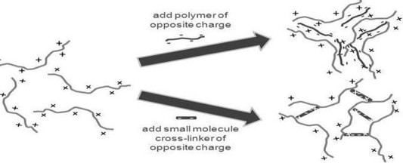
Figure 1:Ion exchange mechanism of hydrogel
  - In situ gelling systems offer several benefits, such as the following
In situ gelling systems offer several advantages that may improve drug delivery and patient outcomes. These systems require only a small volume of medication and are convenient to administer, which may enhance patient compliance. They enable controlled and sustained release of active pharmaceutical ingredients, thereby prolonging drug action and reducing dosing frequency. In addition, the uptake of both fat-soluble and water-soluble drugs in the stomach is generally greater than that in the intestine, making these systems suitable for gastric drug delivery. In situ gels may also improve bioavailability by increasing residence time at the absorption site and may provide localised drug action, thereby reducing systemic adverse effects. Furthermore, they may protect acid-sensitive drugs by providing a suitable delivery environment and may contribute to improved therapeutic performance.
Reliable evaluation of gel-based delivery systems requires consistent assessment of pH, rheology, gel structure, mechanical properties, and phase-transition behaviour (Wang et al., 2025).
  - Floating Hydrogels
Floating hydrogels are three-dimensional, interconnected polymeric networks that can absorb substantial amounts of water while maintaining their structure. These systems have a low density and remain buoyant in gastric fluid, thereby prolonging gastric residence. The combination of sodium alginate, HPMC, and chitosan provides favourable properties, including mucoadhesion through ionic interactions, prolonged drug release, and controlled swelling. Calcium carbonate acts as a gas-generating agent that releases carbon dioxide to provide buoyancy (Sudhi et al., 2020).
Calcium-mediated alginate cross-linking can influence matrix formation and dissolution behaviour, while gastrointestinal in situ gel strategies require adequate viscosity and resistance to luminal washout to support local retention and controlled delivery (Kim, 2024; Shen et al., 2024).
However, formulation-specific evidence for an esomeprazole gastroretentive in situ hydrogel combining sodium alginate and chitosan with gas-generating and ion-mediated components remains limited. Therefore, systematic evaluation of gelation, buoyancy, physicochemical characteristics, and sustained in vitro drug release is required for this formulation approach.
  - Objective of the Study
The objective of this study was to formulate and evaluate a gastroretentive in situ hydrogel of esomeprazole using sodium alginate and chitosan and to assess its pH, viscosity, gelling behaviour, floating properties, swelling, spreadability, drug content, and in vitro drug-release profile.
- MATERIAL AND METHOD
2.1 Material:
Esomeprazole was supplied as a complimentary sample by Dhamtec Pharma and Consultants (Maharashtra, India), and sodium alginate was obtained from HiMedia Laboratories. Chitosan and sodium bicarbonate were sourced from Sigma-Aldrich/HiMedia; calcium carbonate was obtained from HiMedia Laboratories; HPMC was purchased from Colorcon Laboratories; methyl paraben was sourced from Sigma-Aldrich/HiMedia; and sodium citrate was obtained from HiMedia Laboratories.
2.2 Method:
2.2.1 Pre-formulation studies
Pre-formulation studies constitute the first stage of formulation development. These studies examine the physical and chemical properties of a drug substance, both independently and in combination with suitable excipients. They primarily include assessments of solubility, melting point, partition coefficient, and physical characteristics.
Identification of drug
Organoleptic properties of drug
A small quantity of the esomeprazole sample was taken and physically examined for colour, odour, and taste.
Melting point
The melting point of esomeprazole magnesium trihydrate was determined using Thiele's tube method in three independent trials. A small quantity of esomeprazole powder was placed in a capillary tube and positioned in the Thiele's melting-point apparatus, and the temperature at which the powder melted was recorded.
Determination of absorption maxima (𝜆𝑚𝑎𝑥)
Determination of the absorption maximum is generally performed to assess drug purity and identify the wavelength of maximum absorption (𝜆𝑚𝑎𝑥) of esomeprazole. Standard stock solutions of esomeprazole magnesium at concentrations of 6 µg/mL and 8 µg/mL were prepared in distilled water and acidic buffer (pH 1.2). The solutions were then analysed using a UV-visible spectrophotometer over the wavelength range of 400-200 nm.
Fourier transform infrared spectroscopy (FT-IR)
FT-IR is an efficient, rapid, and cost-effective analytical method used to predict drug-excipient interactions. The analysis was conducted using the potassium bromide pellet method. Esomeprazole and its combinations with different polymers were uniformly mixed with 200 mg of potassium bromide, and the mixture was compressed using a mechanical die press. The spectra were recorded using a Shimadzu Fourier-transform infrared spectrometer over a frequency range of 4,000-450 cm⁻¹ (Israr et al., 2022).
Solubility study
The solubility of the sample was assessed in several media, including distilled water, 0.1 N acid buffer, and ethanol. A quantity of the drug was added to 10 mL of each medium and agitated for 30-40 minutes. The supernatant was filtered and diluted and then analysed using a UV-visible spectrophotometer at 301 nm.
Partition coefficient
A weighed quantity of drug powder was dissolved in aqueous and organic solvents in a separating funnel. The organic phase containing the dissolved drug was separated and analysed using UV spectrophotometry. Water and n-octanol were used for the study.
P= Co/Cw
Where,
Co= drug concentration in the organic phase
Cw=drug concentration in the aqueous phase

2.2.2 Experimental design
A 2² factorial design was applied in this experiment, with two factors at two levels each, and all four combinations were evaluated. The two independent variables, sodium alginate (x1) and chitosan (x2), were coded at low and high levels (-1 and +1, respectively). The dependent variables were gelling capacity (y1) and viscosity in the solution state (y2).
2.2.3 Preparation of in situ gelling solution
- The weighed quantity of sodium alginate was dissolved in distilled water at 60 °C.
- Accurately weighed HPMC and chitosan were dissolved separately in distilled water.
- The weighed sodium citrate and calcium carbonate were mixed in distilled water in a separate beaker.
- Accurately weighed sodium bicarbonate and methyl paraben were added to the sodium citrate and calcium carbonate mixture.
- All chemicals were mixed with sodium alginate and the other polymers using a mechanical stirrer at room temperature.
- The weighed esomeprazole was dispersed in 1 mL of ethyl alcohol.
- The drug mixture was slowly added to the polymer mixture with continuous stirring.
2.3 Formula of formulation
Table1:FormulationsofEsomeprazoleHydrogel (for 100 ml gel)
Chemicals | F1 | F2 | F3 | F4
Esomeprazole | 2 gm | 2 gm | 2 gm | 2 gm
Sodium alginate | 1 gm | 3 gm | 1 gm | 3 gm
Chitosan | 0.25 gm | 0.25 gm | 1 gm | 1 gm
HPMC | 0.75 gm | 0.75 gm | 0.75 gm | 0.75 gm
Sodium citrate | 0.25 gm | 0.25 gm | 0.25 gm | 0.25 gm
Calcium carbonate | 0.75 gm | 0.75 gm | 0.75 gm | 0.75 gm
Sodium bicarbonate | 0.50 gm | 0.50 gm | 0.50 gm | 0.50 gm
Methyl paraben | 0.1 gm | 0.1 gm | 0.1 gm | 0.1 gm
Distilled Water | q.s. | q.s. | q.s. | q.s.

2.4 Evaluation of formulation
- Physical appearance and pH determination: The colour, clarity, and homogeneity of the prepared formulations were observed. The pH of each floating in situ hydrogel solution was measured at room temperature using a calibrated digital pH meter, and the value for each formulation was recorded.
- Viscosity: Oral in situ floating hydrogels should have low viscosity during administration and subsequently transform into a high-viscosity gel in the stomach. A Brookfield viscometer (spindle no. 2 at 40 rpm) was used to measure viscosity at ambient temperature (25 °C) in the solution state and at physiological temperature (37 °C) after gelation.
- Floating lag time: This was defined as the time required for the formulation to rise from the bottom of the vessel to the surface of the medium (0.1 N HCl, pH 1.2). A floating lag time of less than a few minutes was considered optimal for prompt protection against peptic ulcers (Yadiki et al., 2024).
- Floating duration: This was the period for which the hydrogel remained buoyant on the surface of the medium. A floating duration of at least 12-24 hours was considered necessary to support once-daily dosing (Yadiki et al., 2024).
- Gelling capacity and gelling time: Gelling time was defined as the time required for the oral liquid formulation to transform into a gel upon exposure to gastric acid and was measured in seconds. Gelling capacity reflected the ability of the solution to form a buoyant gel upon contact with gastric acid. A grading system (+++) based on gelation time and structural durability was used (Patel et al., 2021).
- Swelling index: This parameter represents the increase in hydrogel size and weight over time.
Swelling index (SI)% =(Wt– Wo/Wo)
Wt = weight of the swollen hydrogel
W₂ =initial dry weight of the hydrogel
- Spreadability: This property measures the ability of the in situ gel to spread over the gastric mucosal lining and form a barrier. It was determined using the parallel-plate method. A specified amount of gel was placed between glass slides, and the time required for the upper slide to separate under a specified weight was measured.
S = (m × L) / t
where:
S = Spreadability (g·cm/s)
m = Weight tied to the upper slide (g)
L = Length of the glass slide (cm)
t = Time taken for the upper slide to separate or move (s)
- Drug content: A volume of 10 mL of the formulation, equivalent to 40 mg of esomeprazole, was accurately transferred to a 100 mL volumetric flask containing 0.1 N HCl. The mixture was shaken vigorously for 30 minutes, sonicated for 20 minutes, and filtered. Dilutions of the filtrate were prepared with 0.1 N HCl. The absorbance was measured at 301 nm (λmax of esomeprazole), and the values were substituted into the calibration-curve equation to determine the concentration.
- In vitro drug release study of esomeprazole-loaded in situ hydrogel:
An in vitro release test was conducted using 50 mL of acidic buffer (pH 1.2) in a Franz diffusion cell with a semipermeable membrane. A 0.5 g hydrogel sample was placed in the cell. Samples were collected at regular intervals from 0.5 to 6 hours and analysed spectrophotometrically at 301 nm. Kinetic analysis was performed using BIT software to determine the reaction order, and the release data were fitted to kinetic models to identify the drug-release mechanism (Joshi et al., 2025).

- Results and Discussion
3.1 Pre-formulation Studies
3.1.1 Organoleptic Properties of the Drug
Table2:Organolepticpropertiesofthe drug
Properties | Organolepticproperties
Description | Crystallinepowder
Color | Pale yellow
Odour | Odourless
Taste | Tasteless
The observed pale-yellow, odourless crystalline appearance provided a preliminary identity check but should be interpreted alongside instrumental analyses because organoleptic assessment alone is not specific for chemical identity or purity. Published physicochemical characterisations of esomeprazole magnesium similarly combine visual examination with UV and FT-IR measurements, while showing that the reported appearance may vary with salt form, hydration state, and solid-state characteristics (Kanwar & Gautam, 2021; Nguyen et al., 2017).

3.1.2 Melting point
The melting-point range of the sample was 185-187 °C, which was close to the standard range of 185-189 °C reported in the Indian Pharmacopoeia. The absence of melting-point depression suggested that the sample did not contain detectable organic impurities and was suitable for formulation.
The narrow melting range indicates relatively uniform thermal behaviour; however, agreement with a compendial range should be regarded as supportive rather than definitive evidence of purity because hydration state, polymorphism, and thermal degradation can influence the observed transition. Accordingly, the melting-point result is most appropriately interpreted alongside the spectroscopic and formulation-compatibility findings (Kanwar & Gautam, 2021; Nguyen et al., 2017).
Table3:Meltingpoint
Trialno. | Observedmelting point (oC) | Standardmelting point (oC) IP | Inference
1 | 185 | 184-189 | The sampleispure.
2 | 187 | 184-189 | The sampleispure.
3 | 185 | 184-189 | The sampleispure.

3.1.3 Determination of absorption maxima (𝜆𝑚𝑎𝑥):
The absorption maximum (𝜆𝑚𝑎𝑥) of esomeprazole was 301 nm.
The measured absorption maximum at 301 nm is consistent with published UV spectrophotometric methods and independent physicochemical characterisation of esomeprazole magnesium. This agreement supports the use of 301 nm for subsequent assay and release measurements, provided that calibration linearity, blank interference, and solution stability are controlled in the selected analytical medium (Kanwar & Gautam, 2021; Nguyen et al., 2017; Prabu et al., 2008).
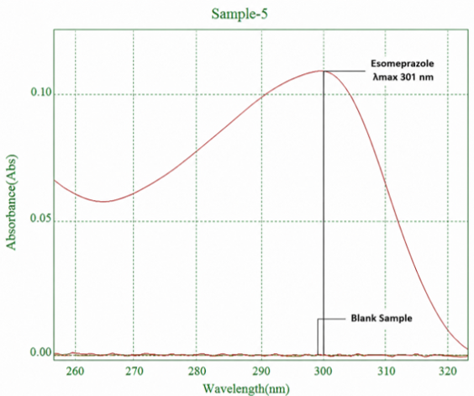
Figure 2: (𝜆𝑚𝑎𝑥) of Esomeprazole
3.1.4 Fourier transform infrared spectroscopy (FT-IR)
FT-IR spectroscopy was performed to evaluate the compatibility of esomeprazole magnesium with the excipients used in the formulation. The spectra of pure esomeprazole and the developed formulation were recorded over the range of 4,000-400 cm⁻¹. The pure drug spectrum exhibited characteristic absorption bands corresponding to O-H/N-H stretching (3,200-3,400 cm⁻¹), C-H stretching (2,950-2,850 cm⁻¹), C=N/aromatic C=C stretching (1,600-1,625 cm⁻¹), C-N stretching (1,250-1,300 cm⁻¹), and S=O stretching (1,030-1,070 cm⁻¹). The formulation spectrum showed the same characteristic peaks, with only slight variations in intensity and minor shifts in position. No new absorption bands appeared, and the characteristic peaks of esomeprazole did not disappear, indicating no significant drug-excipient interaction. Retention of the characteristic functional-group vibrations suggested that the formulation process did not alter the chemical structure of esomeprazole magnesium and supported compatibility and stability within the developed formulation.
Retention of the principal esomeprazole bands without the appearance of new bands supports the absence of readily detectable covalent incompatibility. Nevertheless, small shifts or changes in intensity may also arise from hydrogen bonding, ionic association, or differences in sample hydration. Because alginate and chitosan can form polyelectrolyte complexes, interpretation should emphasise preservation of drug-specific bands rather than assume that every spectral shift is analytically negligible (Berger et al., 2004; Kanwar & Gautam, 2021; Lawrie et al., 2007).
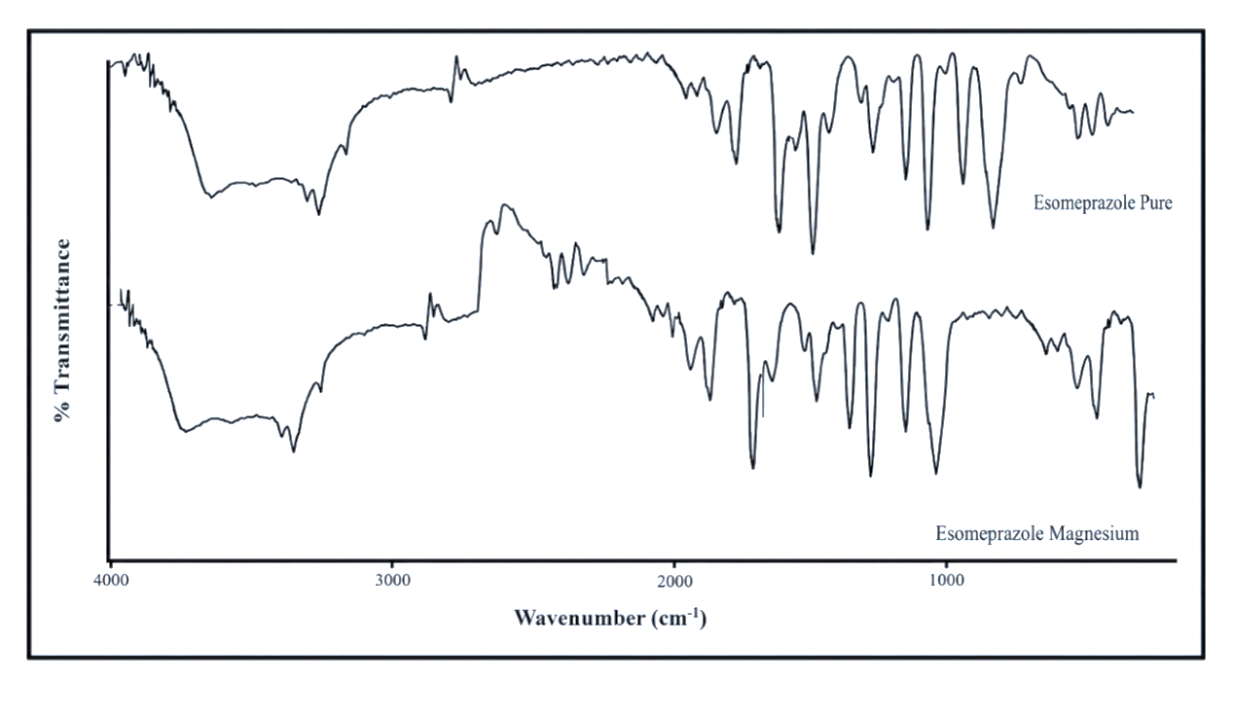
Figure 3: FT-IR Spectrum of Esomeprazole
3.1.5 Solubility studies
Esomeprazole showed the highest solubility in ethanol and poor solubility in acidic medium. These data indicate the instability of the drug in the gastric environment and support hydrogel formation as an approach to protect the drug from acidic conditions in the stomach.
The low apparent solubility in acidic medium is consistent with the recognised acid sensitivity and pH-dependent behaviour of esomeprazole, whereas the markedly greater value in ethanol demonstrates the strong influence of solvent composition on dissolution. These findings support the use of a polymeric matrix and microenvironmental pH control, although solubility measurements alone cannot distinguish reversible dissolution limitations from chemical degradation in acid (Kanwar & Gautam, 2021; Nguyen et al., 2017; Sharma et al., 2019).
Table4: Solubility in distilled water, 0.1 acid buffer, and ethanol
S. no. | Distilled water  (mg/ml) | 0.1 Acid Buffer | Ethanol
1. | 0.87 | 0.24 | 22.79
2. | 0.89 | 0.25 | 22.83
3. | 0.91 | 0.26 | 22.87
Mean | 0.89 | 0.25 | 22.83
Solubility category | Slightlysoluble | Poorlysoluble | Highlysoluble

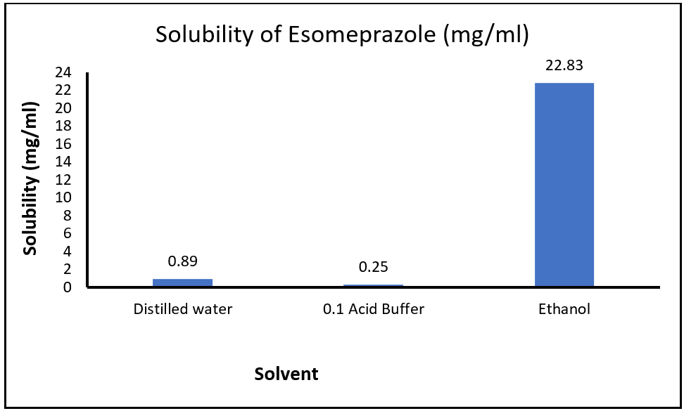
Figure 4: Solubility of esomeprazole
3.1.6 Partition coefficient
The log P of esomeprazole was 0.93 ± 0.05, which was within the stated acceptance range of 0.6-1.1. This value indicates a balance between hydrophilic and lipophilic behaviour, which may facilitate dissolution in the hydrated polymer core and passive diffusion across lipid membranes.
The measured log P indicates appreciable partitioning into the organic phase; however, it is lower than some reported or predicted values for esomeprazole. Such differences may reflect the salt form, pH-dependent ionisation, solvent saturation, equilibration conditions, and analytical procedure. The present value should therefore be treated as method-specific and interpreted alongside the drug's pH-dependent solubility rather than as a fixed intrinsic constant (Kanwar & Gautam, 2021; Nguyen et al., 2017; Prabu et al., 2008).

Table5: Partition Coefficient of Esomeprazole
Trialno. | Co(mg/ml) | Cw(mg/ml) | Partition coefficient | Logp
1. | 0.083 | 0.010 | 8.3000 | 0.9191
2. | 0.087 | 0.009 | 9.6667 | 0.9853
3. | 0.084 | 0.011 | 7.6364 | 0.8829
Average = 0.93 ± 0.05

3.2 Evaluation studies
3.2.1 Physical Appearance and pH Determination
The four formulations were evaluated for colour, clarity, homogeneity, and pH. The pH values were within the stated safe oral range of 6.17 ± 0.04 to 6.82 ± 0.02. The pH decreased in the order F1 > F3 > F2 > F4 because chitosan is a cationic polymer that shifts the solution towards an acidic profile. A pH above 6.0 was maintained to support drug stability during storage before administration.
The near-neutral initial pH is compatible with oral administration and may reduce pre-administration degradation of an acid-labile drug. The downward pH trend with increasing chitosan is mechanistically plausible because protonation of chitosan amino groups and electrostatic association with alginate can alter the formulation microenvironment; nevertheless, storage stability should be confirmed directly rather than inferred from pH alone (Berger et al., 2004; Lawrie et al., 2007; Nguyen et al., 2017).
Table6:PhysicalappearanceandPH determination
Formulation | Color | Clarity | Homogeneity | PH
F1 | Off-white | Translucent | Excellent | 6.82
F2 | Milky white | Opaque | Good | 6.36
F3 | Yellowish | Opaque | Good | 6.52
F4 | Pale yellow | Opaque | Fair | 6.17

3.2.2 Viscosity
Viscosity increased in the order F1 < F2 < F3 < F4 because of greater polymer-chain entanglement. All batches remained liquid and pourable, supporting oral administration. F2 had a solution viscosity of 320 cP and a gel viscosity of 6,800 cP, providing a balance between pourability at room temperature and rapid conversion into a sustained-release hydrogel.
The concentration-dependent increase in viscosity is consistent with greater polymer-chain overlap and entanglement. An oral in situ gel must balance sufficiently low pre-gel viscosity for pourability with rapid development of a stronger gastric matrix; studies of alginate-based systems similarly show that polymer composition and viscosity modifiers jointly influence gel rheology and sustained-release performance (Himawan et al., 2022; Kubo et al., 2003; Sharma et al., 2019).
Table7:Viscosityofformulationinsolutionandgelstate
Formulation | Solution viscosity  (Cps) at 250C | Gel viscosity  (Cps) at 370C
F1 | 210 | 4650
F2 | 320 | 6800
F3 | 340 | 7300
F4 | 470 | 8860

3.2.3 Floating lag time and floating duration
F4 exhibited the shortest floating lag time because its higher polymer concentration rapidly formed a dense gel that trapped CO₂ bubbles. In contrast, F3 had the longest lag time because less polymer was available for cross-linking. F1 and F2 remained buoyant for longer because their strong polymer matrices limited gas escape.
All formulations initiated floating within the stated physiological limit of 3 minutes, which may help prevent early gastric emptying.
Rapid buoyancy is attributable to carbon dioxide generation and retention within the developing polymer network, whereas prolonged floating requires sufficient matrix cohesiveness to limit gas escape and erosion. The differences among formulations therefore likely reflect the combined effects of cross-link density, viscosity, and matrix porosity rather than polymer concentration alone (Himawan et al., 2022; Kubo et al., 2003; Sharma et al., 2019).
Table8:Floatinglagtimeandfloating duration
Formulation | Floatinglagtime(FLT) | Floatingduration(h)
F1 | 60 s | >24hours
F2 | 65s | >24hours
F3 | 75s | 12 hours
F4 | 38 s | <24hours

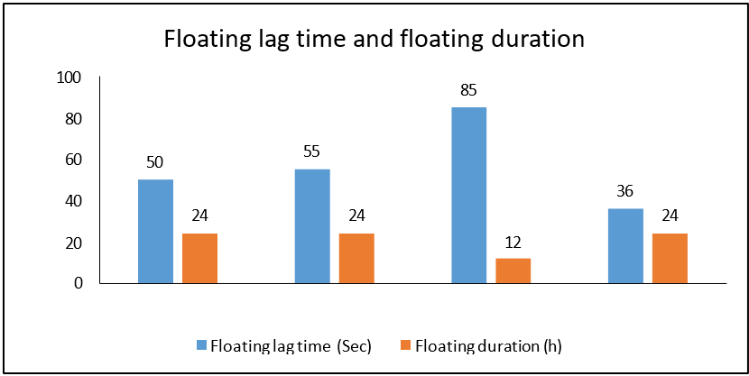
Figure 5: Floating lag time and floating duration of F1, F2, F3, F4

3.2.4 Gelling capacity and gelling time
F4 had the shortest gelling time and an excellent grade (+++) because the high polymer content promoted immediate chain entanglement upon contact with acid. F1 and F2 had suitable gelling times and stable grades. F3 exhibited delayed gelation and a poor grade because of its lower polymer content.
Acid-triggered liberation of calcium ions promotes alginate cross-linking and formation of a gel depot, while chitosan-alginate interactions can further modify network cohesion. The short gelling times are consistent with oral in situ systems designed to gel promptly after contact with gastric fluid, although a very rigid matrix may also restrict diffusion or undergo heterogeneous erosion (Berger et al., 2004; Kubo et al., 2003; Sharma et al., 2019).
Table9:Gellingcapacityandgellingtime
Formulation | Gelling time(sec) | Gelling grade | Matrixintegrity
F1 | 12 | (++) | Forms an immediategelthatremainsintact.
F2 | 14 | (+++) | Formsan immediate gel, highlyrigid.
F3 | 22 | (+) | Forms a slowergelanddisintegrates early.
F4 | 5 | (+++) | Formsanimmediategel;erodesafter24 hours.

3.2.5 Spreadability
Formulations with higher polymer concentrations offered greater mechanical resistance; consequently, the slide-separation time increased and spreadability decreased.
Moderate spreadability was considered optimal, and F2 showed a balanced value that supported adequate spreading over the gastric lining.
The inverse relationship between polymer content and spreadability is consistent with increased viscous and elastic resistance at higher network density. Moderate spreadability is desirable because it may promote distribution within gastric contents without compromising the cohesive structure required for flotation and sustained release; however, the parallel-plate result should be regarded as a comparative formulation parameter rather than direct evidence of in vivo mucosal coverage (Himawan et al., 2022; Kubo et al., 2003; Sharma et al., 2019).

Table 10: Spreadability of F1, F2, F3, F4
Formulation | Massapplied(g) | Separationtime(sec) | Spreadability (g·cm/s)
F1 | 20 | 3.2 | 46.88
F2 | 20 | 4.9 | 30.61
F3 | 20 | 3.8 | 39.47
F4 | 20 | 7.5 | 20.00

3.2.6 Swelling index
Gel expansion resulting from water absorption by the polymer was measured at 2, 4, 6, and 8 hours. F1 reached its maximum swelling at 4 hours, whereas F3 reached its maximum at 6 hours before the matrices eroded. Their lower alginate content may have limited formation of a dense framework capable of resisting continued water penetration. F2 and F4 maintained structural integrity throughout the 8-hour period because their higher polymer content formed a dense calcium-ion-mediated network that retained a large volume of water without collapsing.
F2 showed favourable swelling kinetics, avoiding both the premature erosion observed in F1 and the excessive water uptake observed in F4, thereby maintaining a stable diffusion barrier for sustained release.
The progressive swelling of F2 and F4 indicates continued hydration and expansion of a cross-linked network, whereas erosion of F1 and F3 suggests insufficient structural resistance during prolonged exposure. Swelling can lengthen the diffusional path and retard release, but excessive swelling or pore formation may also accelerate transport; therefore, the observed profile reflects the balance among water uptake, cross-link density, porosity, and matrix erosion (Berger et al., 2004; Sharma et al., 2019; Siboro et al., 2021).
Table 11: Swelling index of formulation
Formulation | SI at 2 h (%) | SI at 4 h (%) | SI at 6 h (%) | SI at 8 h (%)
F1 | 32.3 | 47.4 | Eroded | Eroded
F2 | 64.6 | 92.3 | 123.7 | 147.5
F3 | 45.2 | 66.7 | 85.4 | Eroded
F4 | 76.2 | 117.4 | 155.3 | 184.9

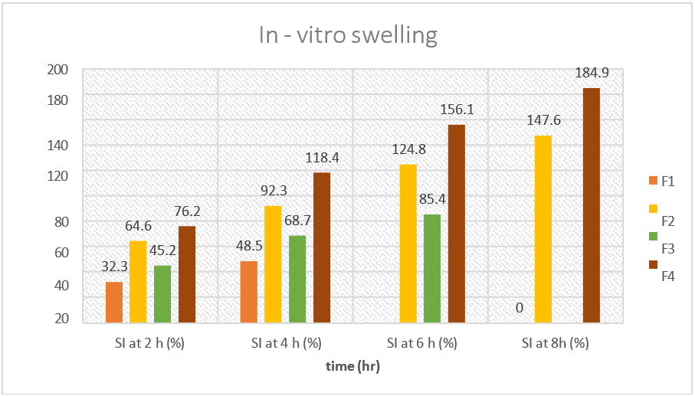
Figure 6: Indicating Swelling Index of F1, F2, F3, F4

3.2.7 Drug content analysis
The Indian Pharmacopoeia specifies an acceptance range of 95-105%. F2 had the highest drug content, indicating minimal drug loss during formulation. All formulations showed satisfactory dose uniformity, suggesting that the observed differences in dissolution were related to polymer-matrix kinetics rather than unequal drug loading.
The drug-content values show limited variation among formulations and are within the stated compendial range, supporting acceptable incorporation of esomeprazole in the tested batches. This reduces, but does not eliminate, the possibility that release differences arose from loading variability; replicate assay precision, extraction recovery, and content-uniformity criteria remain important when attributing those differences primarily to matrix behaviour (Kanwar & Gautam, 2021; Nguyen et al., 2017; Prabu et al., 2008).
Table 12: Drug content of formulation (F1, F2, F3, F4)
Formulation | Drugweight(g) | Measureddrug amount (g) | Drugcontent(%)  ± SD
F1 | 2.0 | 1.94 | 97.00
F2 | 2.0 | 1.98 | 99.00
F3 | 2.0 | 1.92 | 96.00
F4 | 2.0 | 1.96 | 98.00

Figure 7: Drug content of F1, F2, F3, F4

3.2.8 In vitro Drug-Release Study
The study included measurements at 30-minute intervals for up to 6 hours using a standard USP dissolution apparatus and reported standard deviations. F1 showed a pronounced burst release and released 100% of its drug content by 3.5 hours because of hydrogel erosion. F3 also lost structural integrity in the acidic medium and eroded at 6 hours. F2 and F4 showed controlled, uniform release profiles. F2 provided a balance of steady and sustained drug release, avoiding both the premature drug dumping observed with F1 and F3 and the restrictive core entrapment observed with F4. When drug release was plotted against time, the best-fitting model for F2 was the Hixson-Crowell model, with a high degree of linearity. The r² value was 0.9943, which was interpreted as indicating an anomalous transport mechanism.
The slower release from F2 and F4 is consistent with the combined effects of gel hydration, increased diffusion-path length, and resistance to erosion. Hixson-Crowell fitting indicates that changes in surface area or dimensions may contribute to release, but it does not by itself establish anomalous transport; assignment of anomalous transport generally requires a complementary model, such as Korsmeyer-Peppas, and reporting of the release exponent. Model selection should therefore consider comparative goodness-of-fit, parameter plausibility, and the assumptions of each model (Korsmeyer et al., 1983; Siboro et al., 2021; Siepmann & Peppas, 2011).
Table 13: Drug release of formulation (F1, F2, F3, F4)
Time (h) | F1 release (%) | F2 release (%) | F3 release (%) | F4 release (%)
0.5 | 2.3 | 12.3 | 16.5 | 10.1
1.0 | 5.4 | 17.6 | 27.3 | 12.3
1.5 | 13.6 | 25.4 | 38.9 | 16.6
2.0 | 17.46 | 36.4 | 42.22 | 25.3
2.5 | 21.22 | 38.9 | 47.77 | 27.8
3.0 | 24.26 | 46.6 | 51.76 | 33.4
3.5 | 27.54 | 51.3 | 58.33 | 37.8
4.0 | 29.33 | 57.4 | 63.33 | 40.7
4.5 | 31.32 | 60.7 | 64.22 | 47.2
5.0 | 33.56 | 67.1 | 64.88 | 49.8
5.5 | 36.65 | 73.5 | 65.23 | 54.1
6.0 | 39.44 | 77.5 | 68.23 | 57.4

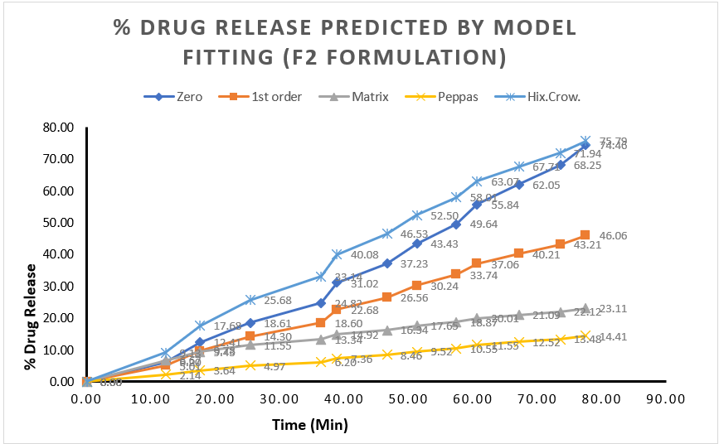
Figure 8: % Drug Release Predicted by Model Fitting (F2 Formulation)

- Conclusion
The present study developed and optimised an in situ gel-based floating matrix for gastroretentive delivery of esomeprazole using a 2² factorial design. Four formulations (F1-F4) containing sodium alginate and chitosan as gelling agents, sodium citrate as the cross-linking agent, and calcium carbonate as the floating agent were prepared. Pre-formulation studies showed a melting point of 185-187 °C and a log P of 0.93 ± 0.05. F2 was identified as the optimised formulation, with a solution viscosity of 320 cP and a gel viscosity of 6,800 cP at body temperature. It had a floating lag time of 65 seconds, remained buoyant for more than 24 hours, achieved an excellent gelling grade (+++), and showed a spreadability of 30.61 g·cm/s. F2 released 77.5% of the drug over 6 hours, indicating sustained release in vitro. The combined use of sodium alginate, chitosan, and HPMC formed a stable floating matrix that may protect esomeprazole under acidic conditions and prolong drug release. These findings support further investigation of the formulation for gastroretentive delivery in peptic ulcer management, including conditions associated with H. pylori.

5. Limitation

The study evaluated only four formulations and relied primarily on in vitro physicochemical, buoyancy, swelling, and drug-release tests. Drug release was assessed for 6 hours, despite floating-duration claims extending beyond 24 hours. In addition, the release-mechanism interpretation requires confirmation using complementary kinetic models and complete model parameters. Future research should expand the evaluation of the developed gastroretentive in situ hydrogel by investigating a wider range of formulation variables and optimisation strategies to further improve its performance. Long-term and accelerated stability studies should be conducted to establish the physicochemical stability and shelf life of the formulation under different storage conditions.

Declaration of AI Use

This manuscript was prepared through the combined contributions of all author(s), including contributions to the study design, data, content development, results, interpretation, and related scholarly work. The author(s) acknowledge the use of Grammarly and ChatGPT to assist with grammar checking, language refinement, reference formatting. These AI-assisted tools were not used as authors and did not replace the intellectual contributions or scholarly judgment of the author(s). All AI-assisted outputs, including content, references, and interpretations, were carefully reviewed, revised, verified, and approved by the author(s). The author(s) accept full responsibility for the accuracy, integrity, and final content of the manuscript.

References

Alfahad, M., Jasim, M. H. M., Qazzaz, M. E., Alassaf, F. A., & Abed, M. N. (2021). Proton pump inhibitors and peptic ulcer management: Antioxidant mechanisms. Journal of Drug Delivery and Therapeutics, 11(4-S), 242–246. https://doi.org/10.22270/jddt.v11i4-S.4955
Almadi, M. A., Lu, Y., Alali, A. A., & Barkun, A. N. (2024). Peptic ulcer disease. The Lancet, 404(10447), 68–81. https://doi.org/10.1016/S0140-6736(24)00155-7
Andersson, T., Röhss, K., Bredberg, E., & Hassan-Alin, M. (2001). Pharmacokinetics and pharmacodynamics of esomeprazole, the S-isomer of omeprazole. Alimentary Pharmacology & Therapeutics, 15(10), 1563–1569. https://doi.org/10.1046/j.1365-2036.2001.01087.x
Berger, J., Reist, M., Mayer, J. M., Felt, O., Peppas, N. A., & Gurny, R. (2004). Structure and interactions in covalently and ionically crosslinked chitosan hydrogels for biomedical applications. European Journal of Pharmaceutics and Biopharmaceutics, 57(1), 19–34. https://doi.org/10.1016/S0939-6411(03)00161-9
Dhanya, K. P., Siji, C., Jamshiya, E., Nihal, P., & Deepthi, O. (2022). In situ gel drug delivery system: A review. Journal of Pharmaceutical Research International, 34(29B), 38–45. https://doi.org/10.9734/jpri/2022/v34i29B36056
Franciosi, J. P., Mougey, E. B., Dellon, E. S., Gutiérrez-Junquera, C., Fernández-Fernández, S., Venkatesh, R. D., & Gupta, S. K. (2022). Proton pump inhibitor therapy for eosinophilic esophagitis: History, mechanisms, efficacy, and future directions. Journal of Asthma and Allergy, 15, 281–302. https://doi.org/10.2147/JAA.S274524
Himawan, A., Djide, N. J. N., Mardikasari, S. A., Utami, R. N., Arjuna, A., Donnelly, R. F., & Permana, A. D. (2022). A novel in vitro approach to investigate the effect of food intake on the release profile of valsartan in a solid dispersion-floating gel in situ delivery system. European Journal of Pharmaceutical Sciences, 168, 106057. https://doi.org/10.1016/j.ejps.2021.106057
Israr, M., Pugliese, N., Farid, A., Ghazanfar, S., Di Cerbo, A., Muzammal, M., Alamri, A. S., Asdaq, S. M. B., Ahmad, A., & Khan, K. A. (2022). Preparation and characterization of controlled-release floating bilayer tablets of esomeprazole and clarithromycin. Molecules, 27(10), 3242. https://doi.org/10.3390/molecules27103242
Joshi, V., Raja, M. H., & Dobhal, K. (2025). Formulation and characterization of the esomeprazole microsponge loaded in-situ gel. Journal of Clinical and Biomedical Sciences, 15(3), 204–210. https://doi.org/10.58739/jcbs/v15i3.25.77
Kanwar, K., & Gautam, S. P. (2021). Qualitative portrayal of esomeprazole magnesium by exploring diverse analytical and investigative approaches. Journal of Pharmaceutical Research International, 33(34B), 52–68. https://doi.org/10.9734/jpri/2021/v33i34B31848
Kim, R. (2024). Investigating a calcium alginate-xylitol coating methodology for controlled release profiles of multivitamin tablet as a model drug. Journal of International Research in Medical and Pharmaceutical Sciences, 19(2), 24–33. https://doi.org/10.56557/jirmeps/2024/v19i28701
Konatham, M., Gorle, M. T., Pathakala, N., Bakshi, V., Mamidisetti, Y. D., Chinthakindi, P., & Jadi, R. K. (2021). In situ gel polymers: A review. International Journal of Applied Pharmaceutics, 13(1), 86–90. https://doi.org/10.22159/ijap.2021v13i1.39504
Korsmeyer, R. W., Gurny, R., Doelker, E., Buri, P., & Peppas, N. A. (1983). Mechanisms of solute release from porous hydrophilic polymers. International Journal of Pharmaceutics, 15(1), 25–35. https://doi.org/10.1016/0378-5173(83)90064-9
Kubo, W., Miyazaki, S., & Attwood, D. (2003). Oral sustained delivery of paracetamol from in situ-gelling gellan and sodium alginate formulations. International Journal of Pharmaceutics, 258(1–2), 55–64. https://doi.org/10.1016/S0378-5173(03)00163-7
Lawrie, G., Keen, I., Drew, B., Chandler-Temple, A., Rintoul, L., Fredericks, P., & Grøndahl, L. (2007). Interactions between alginate and chitosan biopolymers characterized using FTIR and XPS. Biomacromolecules, 8(8), 2533–2541. https://doi.org/10.1021/bm070014y
Nguyen, H. V., Baek, N., & Lee, B.-J. (2017). Enhanced gastric stability of esomeprazole by molecular interaction and modulation of microenvironmental pH with alkalizers in solid dispersion. International Journal of Pharmaceutics, 523(1), 189–202. https://doi.org/10.1016/j.ijpharm.2017.03.047
Pacifici, G. M. (2023). Clinical pharmacology of esomeprazole in infants and children. International Journal of Clinical Reports and Studies, 2(4). https://doi.org/10.31579/2835-8295/029
Padmasri, B., Nagaraju, R., & Prasanth, D. (2020). A comprehensive review on in situ gels. International Journal of Applied Pharmaceutics, 12(6), 24–33. https://doi.org/10.22159/ijap.2020v12i6.38918
Patel, M. S., Patel, A. D., Doshi, N. R., & Vyas, G. (2021). Design and development of novel floating in situ gel of amoxicillin for the treatment of peptic ulcer disease caused by Helicobacter pylori. Acta Scientific Pharmaceutical Sciences, 5(9), 81–93. https://actascientific.com/ASPS/ASPS-05-0786.php
Prabu, S. L., Shirwaikar, A., Shirwaikar, A., Kumar, C. D., Joseph, A., & Kumar, R. (2008). Simultaneous estimation of esomeprazole and domperidone by UV spectrophotometric method. Indian Journal of Pharmaceutical Sciences, 70(1), 128–131. https://doi.org/10.4103/0250-474X.40351
Sharma, S., Sarkar, G., Srestha, B., Chattopadhyay, D., & Bhowmik, M. (2019). In-situ fast gelling formulation for oral sustained drug delivery of paracetamol to dysphagic patients. International Journal of Biological Macromolecules, 134, 864–868. https://doi.org/10.1016/j.ijbiomac.2019.05.092
Shen, Y., Feng, Y., Liang, S., Liang, C., Li, B., Wang, D., & Sun, J. (2024). In situ gelation strategy for efficient drug delivery in a gastrointestinal system. ACS Biomaterials Science & Engineering, 10(8), 5252–5264. https://doi.org/10.1021/acsbiomaterials.4c00751
Shreya, L., Suma, U. S., & Zohmingliani, R. (2025). Recent advances in oral in situ gel drug delivery system: A polymeric approach. Drug Development and Industrial Pharmacy, 51(12), 1639–1649. https://doi.org/10.1080/03639045.2025.2559033
Siboro, S. A. P., Anugrah, D. S. B., Ramesh, K., Park, S.-H., Kim, H.-R., & Lim, K. T. (2021). Tunable porosity of covalently crosslinked alginate-based hydrogels and its significance in drug release behavior. Carbohydrate Polymers, 260, 117779. https://doi.org/10.1016/j.carbpol.2021.117779
Siepmann, J., & Peppas, N. A. (2011). Higuchi equation: Derivation, applications, use and misuse. International Journal of Pharmaceutics, 418(1), 6–12. https://doi.org/10.1016/j.ijpharm.2011.03.051
Sudhi, U. S., Kumar, S. S., Nowfiya, F. N., Mathan, S., & Dharan, S. S. (2020). Floating oral in-situ gelling system: A review. Journal of Pharmaceutical Sciences and Research, 12(10), 1315–1319. https://www.jpsr.pharmainfo.in/Documents/Volumes/vol12issue10/jpsr12102012.pdf
Vakil, N. (2024). Peptic ulcer disease: A review. JAMA, 332(21), 1832–1842. https://doi.org/10.1001/jama.2024.19094
Vigani, B., Rossi, S., Sandri, G., Bonferoni, M. C., Caramella, C. M., & Ferrari, F. (2020). Recent advances in the development of in situ gelling drug delivery systems for non-parenteral administration routes. Pharmaceutics, 12(9), 859. https://doi.org/10.3390/pharmaceutics12090859
Wang, E., Qi, Z., Cao, Y., Li, R., Wu, J., Tang, R., Gao, Y., Du, R., & Liu, M. (2025). Gels as promising delivery systems: Physicochemical property characterization and recent applications. Pharmaceutics, 17(2), 249. https://doi.org/10.3390/pharmaceutics17020249
Yadiki, K. K., Kokatanur, U., Dandagi, P. M., & Hulyalkar, S. (2024). Formulation and evaluation of floating oral in situ gel of liquorice extract. Indian Journal of Pharmaceutical Education and Research, 58(1s), s167–s175. https://doi.org/10.5530/ijper.58.1s.16

