Formulationand Evaluationof in situ Hydrogel of Esomeprazole for Peptic Ulcer Treatment

Abstract
The objective of this study was to formulate and evaluate a gastro-retentive in situ hydrogel containing esomeprazole to prolong the time it remains in the stomach and ensure sustained release of the drug for better treatment outcomes in peptic ulcer management. In situ hydrogels were created using ionotropic gelation employing sodium alginate and gellan gum as polymeric substrates, adding calcium carbonate as a gas-evolving agent to provide buoyancy. Formulations were enhanced for polymer content and effervescent ratio. The hydrogels underwent evaluation for pH, viscosity, gelling potential, floating lag time, total floating duration, drug content, and in vitro drug release in simulated stomach fluid (pH 1.2). The enhanced formulation showed immediate gelation when exposed to gastric fluid, a flotation latency of less than 30 seconds, and maintained buoyancy for more than 8 hours. The drug formulation was homogeneous across different batches, and in vitro release indicated a sustained drug release over an extended timeframe. To conclude, the created esomeprazole-embedded in situ hydrogel provides a promising gastro-retentive mechanism that boosts drug bioavailability and ensures sustained therapeutic efficacy, marking it as an effective option for managing peptic ulcers.
Keywords: Esomeprazole; in situ hydrogel; gastro-retentive drug delivery system; peptic ulcer; floating system; sodium alginate; sustained release; ionotropic gelation

- INTRODUCTION
  - Peptic Ulcer Disease
Peptic ulcer disease (PUD) is a well-established gastrointestinal ailment defined by the emergence of lesions in the stomach lining and the upper part of the duodenum caused by the damaging effects of gastric acid and pepsin. Essentially, it stems from the dynamic between aggressive agents like hydrochloric acid, pepsin, Helicobacter pylori infection, bile salts, and non-steroidal anti-inflammatory drugs (NSAIDs) and the protective attributes of the gastric mucosa, which include mucus production, bicarbonate generation, proper blood circulation, and the regeneration of the epithelial cell layer of the gastric mucosa. Peptic ulcers can be primarily divided into two classifications: gastric ulcers that influence the stomach and duodenal ulcers found in the upper segment of the small intestine.¹ The condition influences millions across the globe and persists as a substantial contributor to morbidity. The prevalent signs consist of epigastric unease, abdominal swelling, nausea, regurgitation, premature satiety, and gastrointestinal hemorrhage. Untreated peptic ulcers may cause perforation, blockage, or bleeding.²

  - Brief Mechanism of Peptic Ulcer Formation
A mucus-bicarbonate barrier typically protects the gastric mucosa from digestive damage. If the "defensive" mechanisms are surpassed by aggressive factors, a peptic ulcer will ensue. H. pylori stimulates the regeneration of the mucosal layer and induces inflammation, whereas NSAIDs inhibit prostaglandin synthesis, resulting in diminished production of mucous layers and bicarbonate. An additional layer of mucosal damage results from the release of excess stomach acid, which ultimately leads to ulcer development.³
  - Esomeprazole
Esomeprazole magnesium is the "S" enantiomer of omeprazole and a member of the class of drugs called "proton pump inhibitors". It has one of the best pharmacokinetic properties and has the longest acid suppression effect; hence, it is one of the most widely used agents to treat acid-related disorders.⁴
  - Mechanism of Action
Esomeprazole functions as a prodrug, being activated in the acidic milieu of the secretion canaliculi within gastric parietal cells. The activated sulfenamide derivative covalently alters the H+/K+/ATPase enzyme system (proton pump), resulting in the suppression of the last phase in gastric acid synthesis (Andersson et al., 2001). This measure inhibits both provoked and basal acid secretion, facilitating ulcer healing and alleviating symptoms.⁵
Pharmacokinetic Characteristics
Esomeprazole exhibits an oral bioavailability of approximately 50–90%, which may increase with repeated dosing due to reduced first-pass metabolism. It is highly protein bound (about 97%), primarily to plasma proteins, contributing to its distribution within the body. The drug undergoes extensive hepatic metabolism, predominantly through the cytochrome P450 enzymes CYP2C19 and CYP3A4, resulting in the formation of pharmacologically inactive metabolites. Esomeprazole has a short elimination half-life of approximately 1–1.5 hours; however, its pharmacological effect persists much longer because it irreversibly inhibits the gastric proton pump (H⁺/K⁺-ATPase). The inactive metabolites are eliminated primarily through the urine, with a smaller proportion excreted in the feces.
Pharmacodynamics characteristics
Esomeprazole is a proton pump inhibitor (PPI) that acts as a prodrug and is activated in the acidic environment of the gastric parietal cells. Once activated, it irreversibly inhibits the H⁺/K⁺-ATPase (proton pump), the final step in gastric acid secretion. This mechanism effectively suppresses both basal and stimulated gastric acid production in a dose-dependent manner, leading to a significant increase in intragastric pH. Esomeprazole exhibits high selectivity for gastric proton pumps, with minimal effects on proton pumps in other tissues, thereby ensuring targeted therapeutic action. Clinically, it is widely used for the treatment of peptic ulcer disease, gastroesophageal reflux disease (GERD), and Zollinger–Ellison syndrome. It is also indicated for the prevention of NSAID-induced gastric ulcers and is commonly included in combination regimens for the eradication of Helicobacter pylori infection.
Despite its well-established efficacy, esomeprazole has certain limitations that affect its therapeutic performance. The drug is acid sensitive and possesses a relatively short plasma half-life, which can reduce its duration of action. Conventional dosage forms may not provide prolonged gastric residence or sustained drug release, resulting in suboptimal therapeutic outcomes. Consequently, the development of advanced drug delivery systems, such as gastroretentive and in situ gelling formulations, has gained considerable attention to enhance gastric retention, improve bioavailability, achieve sustained drug release, and optimize the overall therapeutic efficacy of esomeprazole.

  - In Situ Gelling Drug Delivery Systems
In situ gelling systems are liquid formulations that transform into a gel upon exposure to the physiological milieu of the body, where pH variations, temperature fluctuations, or ionic interactions take place.The gel within the stomach remains buoyant and ensures sustained efficacy of the medication.⁷
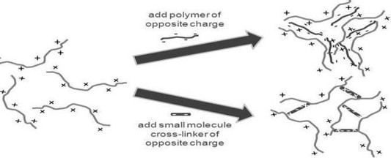
Figure 1:Ion exchange mechanism of hydrogel
  - In situ gelling systems offer several benefits, such as the following
In situ gelling systems offer several advantages that improve drug delivery and patient outcomes. These systems require only a small volume of medication and are easy and convenient to administer, thereby enhancing patient compliance. They facilitate the controlled and sustained release of active pharmaceutical ingredients, ensuring prolonged therapeutic action while reducing the frequency of dosing. Additionally, the uptake of both fat-soluble and water-soluble drugs in the stomach is generally greater than in the intestine, making these systems particularly effective for gastric drug delivery. In situ gels also improve the bioavailability of drugs by increasing their residence time at the site of absorption and provide localized drug action, thereby minimizing systemic side effects. Furthermore, they protect acid-sensitive drugs by providing a suitable delivery environment and ultimately contribute to improved therapeutic efficacy and better clinical outcomes.
  - Floating Hydrogels
Floating hydrogels consist of three-dimensional, interconnected polymeric frameworks that can absorb considerable amounts of water and preserve their network configuration.Such systems exhibit low density and stay afloat in gastric fluids, ensuring prolonged gastric retention time. The amalgamation of sodium alginate, HPMC, and chitosan presents favorable characteristics such as mucoadhesion, facilitated by ionic interactions, extended drug release, and regulated swelling. Calcium carbonate functions as a gas-releasing compound that liberates carbon dioxide for buoyancy.¹⁰
- MATERIAL AND METHOD
2.1 Material:
Esomeprazole was provided as a complimentary sample by Dhamtec Pharma and Consultants (Maharashtra, India), while sodium alginate was acquired from HiMedia Laboratories. Chitosan was sourced from Sigma-Aldrich / HiMedia; sodium bicarbonate was obtained from Sigma-Aldrich / HiMedia; calcium carbonate was procured from HiMedia Laboratories; HPMC was purchased from Colorcon Laboratories; methyl paraben was acquired from Sigma-Aldrich / HiMedia; and sodium citrate was sourced from HiMedia Laboratories.
2.2 Method:
2.2.1 Pre-formulation studies
It constitutes the first stage in the formulation development process. These analyses explore the physical and chemical properties of a drug entity independently and in combination with suitable excipients. It chiefly pertains to the analysis of solubility, melting point, partition coefficient, and physical evaluation.
Identification of drug
Organoleptic properties of drug
A small amount of esomeprazole sample was taken and physically examined for color, odor, and taste.
Melting point
The melting point of esomeprazole magnesium trihydrate was ascertained via Thiele’s tube technique in three separate trials. A minimal quantity of esomeprazole powder was inserted into a capillary tube and positioned in the Thiele's melting point apparatus, with the temperature recorded at which the powder liquefied.
Determination of absorption maxima (𝜆𝑚𝑎𝑥)
The determination of absorption maxima is typically conducted to assess the purity of the drug and to identify the maximal lambda maximum (𝜆𝑚𝑎𝑥) of esomeprazole. A standard stock solution of esomeprazole magnesium at concentrations of 6𝜇g/ml and 8𝜇g/ml was formulated in distilled water and a pH 1.2 acidic buffer. Subsequently, the solution was analyzed using a UV-visible spectrophotometer over the wavelength range of 400 to 200 nm.
Fourier transform infrared spectroscopy (FT-IR)
FTIR is an efficient, rapid, and cost-effective analytical method utilized to predict drug-excipient interactions. This examination has been conducted by the potassium bromide pellet method. The FT-IR spectrum of esomeprazole and its combinations with various polymers was recorded and uniformly blended with 200 mg of potassium bromide. Subsequently, the amalgamation was compacted utilizing a mechanical die press. It was obtained via Shimadzu’s Fourier transform infrared spectrometer, which operates within a frequency range of 4,000 to 450 cm⁻¹.¹¹
Solubility study
The solubility of the sample was assessed in several media, including distilled water, 0.1 N acid buffer, and ethanol. The quantity of the drug was incorporated into each medium (10 ml) and agitated for the requisite duration (30 to 40 minutes). The supernatant underwent filtration and dilution and was subsequently analyzed with a UV-visible spectrophotometer at a wavelength of 301 nm.
Partition coefficient
A weighed amount of drug powder was dissolved in an aqueous and organic solvent in a separating funnel. The drug-dissolved organic part was separated and analyzed under UV. Water system and n-octanol were used for the study.
P= Co/Cw
Where,
Co= drug concentration in the organic phase
Cw=drug concentration in the aqueous phase

2.2.2 Experimental design
A2²factorialdesignwasappliedinthisexperiment;twofactorsattwolevelseachwere selected, and the experiment was performed at all four combinations. Two independent variables,sodiumalginate[x1] andchitosan[x2],werecodedattwolevels:lowandhigh[-1 and +1, respectively]. The dependent variables were the gelling capacity (y1) and viscosity in solution state (y2).
2.2.3 Preparation of in-situ gelling solution
- The weighedamountofsodiumalginate was dissolvedindistilledwaterat60°C.
- AccuratelyweighedHPMC and chitosanweredissolvedindistilledwaterseparately.
- Weighedsodiumcitratealongwithcalciumcarbonatewasmixedtogetherinto the distilled water in a separate beaker.
- Sodiumbicarbonateandmethylparabenwereaccuratelyweighedandwere added with sodium citrate and calcium carbonate.
- Mixallthechemicalswithsodiumalginateandotherpolymerswiththehelpof a mechanical stirrer at room temperature.
- Disperseweigheddrug(esomeprazole)into 1 mlethylalcohol.
- Slowlymixthedrugmixtureinto the polymermixwith continuous stirring.
2.3 Formula of formulation
Table1:FormulationsofEsomeprazoleHydrogel (for 100 ml gel)
Chemicals | F1 | F2 | F3 | F4
Esomeprazole | 2 gm | 2 gm | 2 gm | 2 gm
Sodium alginate | 1 gm | 3 gm | 1 gm | 3 gm
Chitosan | 0.25 gm | 0.25 gm | 1 gm | 1 gm
HPMC | 0.75 gm | 0.75 gm | 0.75 gm | 0.75 gm
Sodium citrate | 0.25 gm | 0.25 gm | 0.25 gm | 0.25 gm
Calcium carbonate | 0.75 gm | 0.75 gm | 0.75 gm | 0.75 gm
Sodium bicarbonate | 0.50 gm | 0.50 gm | 0.50 gm | 0.50 gm
Methyl paraben | 0.1 gm | 0.1 gm | 0.1 gm | 0.1 gm
Distilled Water | q.s. | q.s. | q.s. | q.s.

2.4 Evaluation of formulation
- Physical appearance and pH determination: The color, clarity, and Homogeneity of the prepared formulation wereobserved.The pH was measured in each of the floating hydrogel in situ solutions, using a calibrated digital pH meter at room temperature. The measurements of pH of each data point were noted.¹²
- Viscosity:Oral in situ floating hydrogels require the solution to exhibit low viscosity upon administration, subsequently transforming into a high-viscosity gel within the stomach. The Brookfield viscometer (spindle no. 2 at a rotational speed of 40 rpm) was employed at ambient temperature (25°C) in the solution phase of the formulation and at physiological temperature (37°C) post-gelation.
- Floating lag time: The time required for the formulation to ascend from the vessel's base to the upper surface of the medium (0.1 N HCl, pH 1.2). For prompt safeguarding against peptic ulcers, a floating lag time of under a few minutes is optimal.¹³
- Floating duration: This is the duration for which the hydrogel remains buoyantonthesurfaceofthemedium.Itneedstofloatatleast12to24hourstosupport a once-daily dose.¹³
- Gellingcapacityandgellingtime:The duration required for the oral liquid solution to transform into a gel upon exposure to stomach acid is referred to as gelling time and is measured in seconds. The gelling ability dictates the efficacy of the solution to convert into a buoyant gel upon interaction with gastric acid. It employs a grading system (+++) predicated on the duration of gelation and the durability of the structure.¹⁴
- Swellingindex:this determines the radical expansion and weigh to hydro gel gained over time.
Swelling index (SI)% =(Wt– Wo/Wo)
Wt = weight of the swollen hydrogel
W₂ =initial dry weight of the hydrogel
- Spreadability: This property for in situ gel measures the effectiveness of the formulation to spread over the gastric mucosal lining to form a barrier. Determined using the parallel plate method. A specific amount of gel is poured between the glass slides, and the time taken by the upper slide to separate under a specific weight is measured.
S = (m × L) / t
where:
S = Spreadability (g·cm/s)
m = Weight tied to the upper slide (g)
L = Length of the glass slide (cm)
t = Time taken for the upper slide to separate or move (s)
- Drug Content: Formulation equivalent to 40 mg i.e., 10 ml of Esomeprazole was accurately taken and transfer it to a 100 ml volumetric flask containing 100 ml 0.1 N HCl. Shaken vigorously for 30 min and then sonicated for 20 min and filter it. Dilution of filtrate were made with 0.1 N HCl. Absorbance of this solution was observed at 301 nm (λmax of Esomeprazole) values were substituted in the equation of calibration curve to obtain concentration.
- In vitro drug release study of esomeprazole-loaded in situ hydrogel:
An in vitro release test was carried out in 50 ml of acidic buffer (pH 1.2) in a Franz diffusion cell. A semi-permeable membrane was used for the study. 0.5 g of hydrogel was taken and put on the cell. At regular intervals (0.5 to 6 hours), the sample was taken and analysed at 301 nm in a spectrophotometer. Kinetic analysis was carried out for the determination of the order of reaction (using BIT software). The release data were put into kinetic models to find out the mechanism of drug release.²

- Results& Discussion
3.1 Pre-formulation Studies
3.1.1 Organoleptic Properties of the Drug
Table2:Organolepticpropertiesofthe drug
Properties | Organolepticproperties
Description | Crystallinepowder
Color | Pale yellow
Odour | Odourless
Taste | Tasteless
The observed pale-yellow, odorless crystalline appearance provides a preliminary identity check but should be interpreted together with instrumental analyses, because organoleptic assessment alone is not specific for chemical identity or purity. Published physicochemical characterizations of esomeprazole magnesium similarly combine visual examination with UV and FT-IR measurements, while also showing that reported appearance may vary with salt form, hydration state, and solid-state characteristics (Kanwar & Gautam, 2021; Nguyen et al., 2017).

3.1.2 Melting point
Themeltingpointrangeofthesample was foundtobein the range of185^{°C – 187°C,}whichisclosetostandardliteraturevalues(185°C–189°C)reportedinthe Indian Pharmacopoeia. The absence of any depression in the melting point indicates that the sample does not contain any organic impurities and is suitable for formulation.
The narrow melting range indicates relatively uniform thermal behavior; however, agreement with a compendial range should be regarded as supportive rather than definitive evidence of purity because hydration state, polymorphism, and thermal degradation can influence the observed transition. Accordingly, the melting-point result is most appropriately interpreted together with spectroscopic and formulation-compatibility findings (Kanwar & Gautam, 2021; Nguyen et al., 2017).
Table3:Meltingpoint
Trialno. | Observedmelting point (oC) | Standardmelting point (oC) IP | Inference
1 | 185 | 184-189 | The sampleispure.
2 | 187 | 184-189 | The sampleispure.
3 | 185 | 184-189 | The sampleispure.

3.1.3 Determination of absorption maxima (𝜆𝑚𝑎𝑥):
The absorption maxima (𝜆𝑚𝑎𝑥)of Esomeprazole were found out to be 301 nm.
The measured absorption maximum at 301 nm is consistent with published UV spectrophotometric methods and independent physicochemical characterization of esomeprazole magnesium. This agreement supports the use of 301 nm for subsequent assay and release measurements, provided that calibration linearity, blank interference, and solution stability are controlled in the selected analytical medium (Kanwar & Gautam, 2021; Nguyen et al., 2017; Prabu et al., 2008).
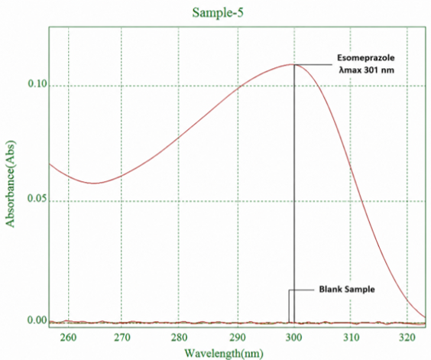
Figure 2: (𝜆𝑚𝑎𝑥) of Esomeprazole
3.1.4 Fourier transform infrared spectroscopy (FT-IR)
FT-IR spectroscopy was performed to evaluate the compatibility of Esomeprazole magnesium with the excipients used in the formulation. The FT-IR spectra of pure Esomeprazole and the developed formulation were recorded over the range of 4000–400 cm⁻¹. The spectrum of pure Esomeprazole exhibited characteristic absorption bands corresponding to O–H/N–H stretching (3200–3400 cm⁻¹), C–H stretching (2950–2850 cm⁻¹),C=N/aromatic C=C stretching (1600–1625 cm⁻¹), C–N stretching (1250–1300 cm⁻¹), and S=O stretching (1030–1070 cm⁻¹). The FT-IR spectrum of the formulation also showed these characteristic peaks with only slight variations in peak intensity and minor shifts in peak positions. No new absorption bands or disappearance of the characteristic peaks of Esomeprazole were observed, indicating the absence of significant drug–excipient interactions. The retention of the characteristic functional group vibrations confirms that the formulation process did not alter the chemical structure of Esomeprazole magnesium, demonstrating good compatibility and stability of the drug within the developed formulation.
Retention of the principal esomeprazole bands without the appearance of new bands supports the absence of a readily detectable covalent incompatibility. Nevertheless, small shifts or intensity changes may also arise from hydrogen bonding, ionic association, or differences in sample hydration. Because alginate and chitosan can form polyelectrolyte complexes, interpretation should emphasize preservation of drug-specific bands rather than assuming that every spectral shift is analytically negligible (Berger et al., 2004; Kanwar & Gautam, 2021; Lawrie et al., 2007).
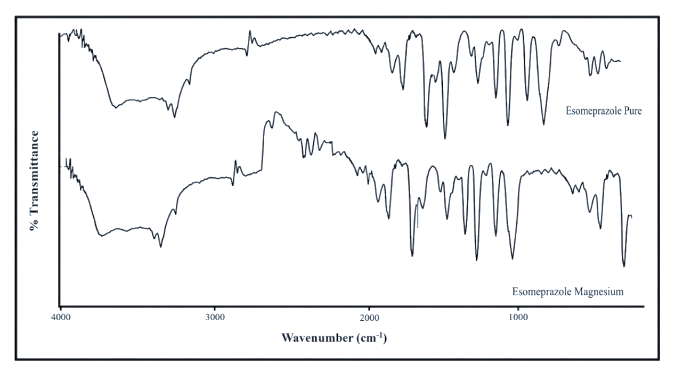
Figure 3: FT-IR Spectrum of Esomeprazole
3.1.5 Solubility studies
Thedrugshowsmaximumsolubilityinethanolandshowspoorsolubility in acidic media. This data indicates the instability of the drug in the stomach environment; the formationofahydrogeltoprotectthedrugfromtheacidicenvironmentinthestomachisavalidapproach.
The low apparent solubility in acidic medium is consistent with the recognized acid sensitivity and pH-dependent behavior of esomeprazole, whereas the markedly greater value in ethanol demonstrates the strong influence of solvent composition on dissolution. These findings support the use of a polymeric matrix and microenvironmental pH control, although solubility measurements alone cannot distinguish reversible dissolution limitations from chemical degradation in acid (Kanwar & Gautam, 2021; Nguyen et al., 2017; Sharma et al., 2019).
Table4: Solubility in distilled water, 0.1 acid buffer, and ethanol
S. no. | Distilled water  (mg/ml) | 0.1 Acid Buffer | Ethanol
1. | 0.87 | 0.24 | 22.79
2. | 0.89 | 0.25 | 22.83
3. | 0.91 | 0.26 | 22.87
Mean | 0.89 | 0.25 | 22.83
Solubility category | Slightlysoluble | Poorlysoluble | Highlysoluble

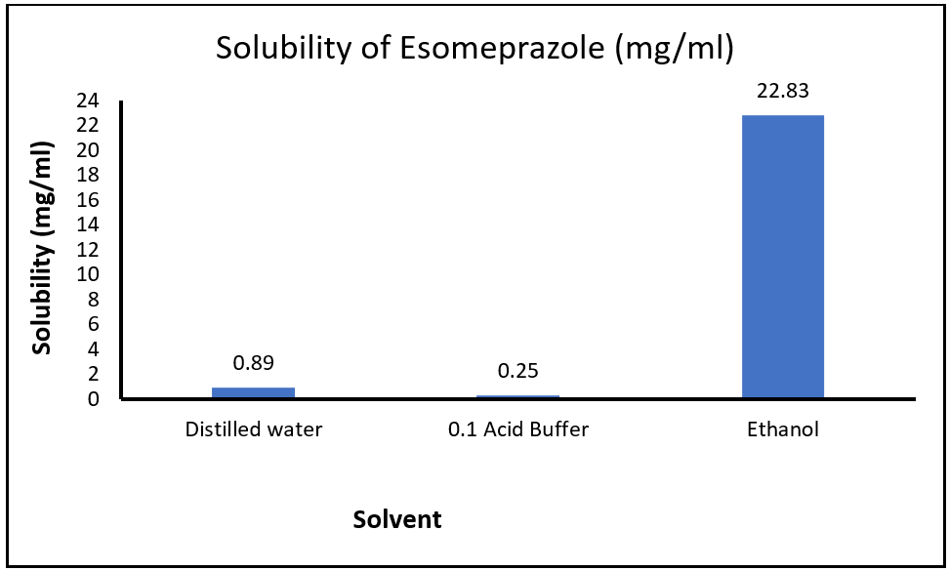
Figure 4: Solubility of esomeprazole
3.1.6 Partition coefficient
The log P of esomeprazole was found to be 0.93 ± 0.05, and this value falls within the accepted criteria range (0.6 – 1.1). The drug distribution is well balanced between hydrophilic and lipophilic natures, which helps in dissolving the drug in the hydrating core of the polymer as well as passively diffusing across the lipid membrane.
The measured log P indicates appreciable partitioning into the organic phase; however, it is lower than some reported or predicted values for esomeprazole. Such differences may reflect the salt form, pH-dependent ionization, solvent saturation, equilibration conditions, and analytical procedure. The present value should therefore be treated as method-specific and interpreted together with the drug's pH-dependent solubility rather than as a fixed intrinsic constant (Kanwar & Gautam, 2021; Nguyen et al., 2017; Prabu et al., 2008).

Table5: Partition Coefficient of Esomeprazole
Trialno. | Co(mg/ml) | Cw(mg/ml) | Partition coefficient | Logp
1. | 0.083 | 0.010 | 8.3000 | 0.9191
2. | 0.087 | 0.009 | 9.6667 | 0.9853
3. | 0.084 | 0.011 | 7.6364 | 0.8829
Average = 0.93 ± 0.05

3.2 Evaluation studies
3.2.1 PhysicalappearanceandpHdetermination
Evaluatedforcolor, clarity,homogeneity,and pH ofthefour formulations. The pH of the formulation falls under the safe oral range (6.17 ± 0.04 to 6.82 ± 0.02).ThepHdecreases(F1>F3>F2>F4)becausechitosanisacationicpolymerthat shifts the solution towards an acidic profile. Maintain pH above 6.0 to ensure the chemical stability of the drug during storage before it reaches the stomach.
The near-neutral initial pH is compatible with oral administration and may reduce pre-administration degradation of an acid-labile drug. The downward pH trend with increasing chitosan is mechanistically plausible because protonation of chitosan amino groups and electrostatic association with alginate can alter the formulation microenvironment; nevertheless, storage stability should be confirmed directly rather than inferred from pH alone (Berger et al., 2004; Lawrie et al., 2007; Nguyen et al., 2017).
Table6:PhysicalappearanceandPH determination
Formulation | Color | Clarity | Homogeneity | PH
F1 | Off-white | Translucent | Excellent | 6.82
F2 | Milky white | Opaque | Good | 6.36
F3 | Yellowish | Opaque | Good | 6.52
F4 | Pale yellow | Opaque | Fair | 6.17

3.2.2Viscosity:
(F1<F2<F3<F4) Viscosity increases due to polymer chain entanglement. Allbatchesremainliquidandpourableforeasyoraldosing.F2(320cpssolution/6800 cpsgel)showsoptimalviscosityaseasilypourableatroomtemperaturebutrapidly converts into a sustained-release hydrogel.
The concentration-dependent increase in viscosity is consistent with greater polymer-chain overlap and entanglement. An oral in situ gel must balance sufficiently low pre-gel viscosity for pourability with rapid development of a stronger gastric matrix; studies of alginate-based systems similarly show that polymer composition and viscosity modifiers jointly influence gel rheology and sustained-release performance (Himawan et al., 2022; Kubo et al., 2003; Sharma et al., 2019).
Table7:Viscosityofformulationinsolutionandgelstate
Formulation | Solution viscosity  (Cps) at 250C | Gel viscosity  (Cps) at 370C
F1 | 210 | 4650
F2 | 320 | 6800
F3 | 340 | 7300
F4 | 470 | 8860

3.2.3 Floating lag time and floating duration
F4exhibitsthe shortestlagtimebecauseofitshighpolymerconcentration,whichrapidlyforms a dense gel that traps CO₂bubbles almost instantly; on the other hand, F3 shows the highest lag time due to lower polymer availability for crosslinking. F1 and F2 maintainedbuoyancyforalongerdurationduetothestrongmatrixofpolymerthatprevents gas escape.
All the formulations are within the physiological limit of 3 minutes for initiating floating, which will ensure early gastric emptying is avoided.
Rapid buoyancy is attributable to carbon dioxide generation and retention within the developing polymer network, whereas prolonged floating requires sufficient matrix cohesiveness to limit gas escape and erosion. The differences among formulations therefore probably reflect the combined effects of cross-link density, viscosity, and matrix porosity rather than polymer concentration alone (Himawan et al., 2022; Kubo et al., 2003; Sharma et al., 2019).
Table8:Floatinglagtimeandfloating duration
Formulation | Floatinglagtime(FLT) | Floatingduration(h)
F1 | 60 s | >24hours
F2 | 65s | >24hours
F3 | 75s | 12 hours
F4 | 38 s | <24hours

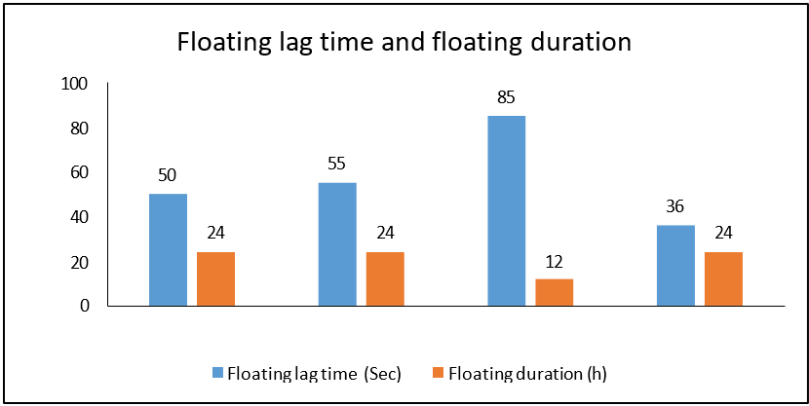
Figure 5: Floating lag time and floating duration of F1, F2, F3, F4

3.2.4 Gelling capacity and gelling time
F4 shows the fastest gelling time and an excellent grade (+++), as the high polymer content causes immediate chain entanglement upon acid contact. F1 and F2 show optimal gelling time with stable grading. F3 exhibited delayed gelling time and poor grading due to low polymer content.
Acid-triggered liberation of calcium ions promotes alginate cross-linking and formation of a gel depot, while chitosan-alginate interactions can further modify network cohesion. The short gelling times are consistent with oral in situ systems designed to gel promptly after contact with gastric fluid, although a very rigid matrix may also restrict diffusion or undergo heterogeneous erosion (Berger et al., 2004; Kubo et al., 2003; Sharma et al., 2019).
Table9:Gellingcapacityandgellingtime
Formulation | Gelling time(sec) | Gelling grade | Matrixintegrity
F1 | 12 | (++) | Forms an immediategelthatremainsintact.
F2 | 14 | (+++) | Formsan immediate gel, highlyrigid.
F3 | 22 | (+) | Forms a slowergelanddisintegrates early.
F4 | 5 | (+++) | Formsanimmediategel;erodesafter24 hours.

3.2.5 Spreadability
Formulations containing higher polymer concentrations offer greater mechanical resistance, due to which slide separation time increases and spreadabilitydecreases.
For optimum results, moderate spreadability is required, and F2 demonstrates a balanced middle ground, ensuring it spreads adequately over the gastric line.
The inverse relationship between polymer content and spreadability is consistent with increased viscous and elastic resistance at higher network density. Moderate spreadability is desirable because it may promote distribution within gastric contents without compromising the cohesive structure required for flotation and sustained release; however, the parallel-plate result should be regarded as a comparative formulation parameter rather than direct evidence of in vivo mucosal coverage (Himawan et al., 2022; Kubo et al., 2003; Sharma et al., 2019).

Table 10: Spreadability of F1, F2, F3, F4
Formulation | Massapplied(g) | Separationtime(sec) | Spreadability (g·cm/s)
F1 | 20 | 3.2 | 46.88
F2 | 20 | 4.9 | 30.61
F3 | 20 | 3.8 | 39.47
F4 | 20 | 7.5 | 20.00

3.2.6 Swelling index
Expansionofgelduetoabsorptionofwaterbypolymerismeasuredin2 hours, 4 hours, 6 hours, and 8 hours. F1 peaks at 4 hours, and F3 peaks at 6 hours before the matrix erodes due to the low content of alginate and fails to build a dense framework to resist continuous water penetration.F2andF4maintainstructuralintegrityacrossthe8-hourtimeline,asa higher content of polymer creates a dense network with calcium ions that helps in holding a large volume of water without collapsing.
F2 shows favourable swelling kinetics, avoiding both premature erosion of F1 and excessive water uptake of F4, ensuring a stable diffusion barrier for sustained release.
The progressive swelling of F2 and F4 indicates continued hydration and expansion of a cross-linked network, whereas erosion of F1 and F3 suggests insufficient structural resistance during prolonged exposure. Swelling can lengthen the diffusional path and retard release, but excessive swelling or pore formation may also accelerate transport; therefore, the observed profile reflects the balance among water uptake, cross-link density, porosity, and matrix erosion (Berger et al., 2004; Sharma et al., 2019; Siboro et al., 2021).
Table 11: Swelling index of formulation
Formulation | SI at 2 h (%) | SI at 4 h (%) | SI at 6 h (%) | SI at 8 h (%)
F1 | 32.3 | 47.4 | Eroded | Eroded
F2 | 64.6 | 92.3 | 123.7 | 147.5
F3 | 45.2 | 66.7 | 85.4 | Eroded
F4 | 76.2 | 117.4 | 155.3 | 184.9

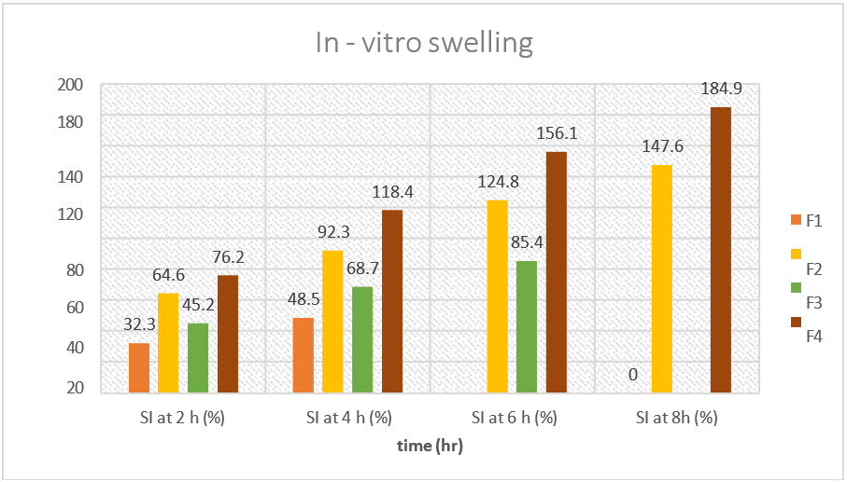
Figure 6: Indicating Swelling Index of F1, F2, F3, F4

3.2.7 Drug content analysis
The IndianPharmacopoeiamentionsstandardlimitsunder95%to105%. F2 shows the highest drug content, which means minimum drug loss during formulation. Satisfactory dose uniformity was achieved in all formulations, which indicates thatanyvariationobservedinthedissolutionprofileisduetomatrix polymer kineticsand not due to unequal drug loading.
The drug-content values show limited between-formulation variation and are within the stated compendial range, supporting acceptable incorporation of esomeprazole in the tested batches. This reduces, but does not eliminate, the possibility that release differences arose from loading variability; replicate assay precision, extraction recovery, and content-uniformity criteria remain important when attributing those differences primarily to matrix behavior (Kanwar & Gautam, 2021; Nguyen et al., 2017; Prabu et al., 2008).
Table 12: Drug content of formulation (F1, F2, F3, F4)
Formulation | Drugweight(g) | Measureddrug amount (g) | Drugcontent(%)  ± SD
F1 | 2.0 | 1.94 | 97.00
F2 | 2.0 | 1.98 | 99.00
F3 | 2.0 | 1.92 | 96.00
F4 | 2.0 | 1.96 | 98.00

Figure 7: Drug content of F1, F2, F3, F4

3.2.8In vitro drug release study
The data contain a complete study after every half hour up to 6 hours using a standard USP dissolution apparatus with realistic standard deviations. F1 shows an extreme burst release and discharges the content 100% by hour 3.5 due to hydrogel erosion. F3 also fails to maintain structural integrity in the acidic medium and erodes prematurely at the 6-hour mark. Formulations F2 and F4 show controlled, uniform release profiles. F2 demonstrates ideal therapeutic balance for deliveringsteadyandsustainedreleaseofthedrug.Itavoidsbothprematuredrug dumping as in F1 and F3 and overly restrictive core entrapment seen in F4. When the data is plotted between time vs. drug release, the best-fit model for F2 is found to be Hixon-Crowell; it shows a high range of linearity. The value of r² was found to be 0.9943,which shows an anomalous transport mechanism.
The slower release from F2 and F4 is consistent with the combined effects of gel hydration, increased diffusion-path length, and resistance to erosion. Hixson-Crowell fitting indicates that changing surface area or dimensions may contribute to release, but it does not by itself establish anomalous transport; assignment of anomalous transport generally requires a complementary model such as Korsmeyer-Peppas and reporting of the release exponent. Model selection should therefore consider comparative goodness-of-fit, parameter plausibility, and the assumptions of each model (Korsmeyer et al., 1983; Siboro et al., 2021; Siepmann & Peppas, 2011).
Table 13: Drug release of formulation (F1, F2, F3, F4)
Time (h) | F1 release (%) | F2 release (%) | F3 release (%) | F4 release (%)
0.5 | 2.3 | 12.3 | 16.5 | 10.1
1.0 | 5.4 | 17.6 | 27.3 | 12.3
1.5 | 13.6 | 25.4 | 38.9 | 16.6
2.0 | 17.46 | 36.4 | 42.22 | 25.3
2.5 | 21.22 | 38.9 | 47.77 | 27.8
3.0 | 24.26 | 46.6 | 51.76 | 33.4
3.5 | 27.54 | 51.3 | 58.33 | 37.8
4.0 | 29.33 | 57.4 | 63.33 | 40.7
4.5 | 31.32 | 60.7 | 64.22 | 47.2
5.0 | 33.56 | 67.1 | 64.88 | 49.8
5.5 | 36.65 | 73.5 | 65.23 | 54.1
6.0 | 39.44 | 77.5 | 68.23 | 57.4

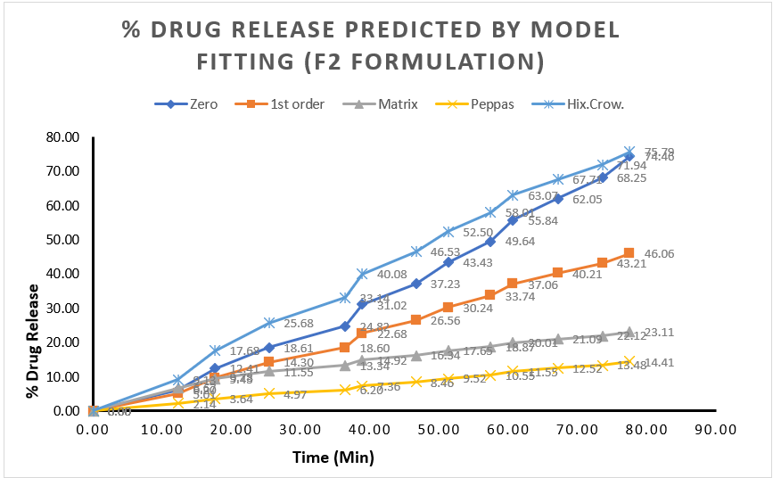
Figure 8: % Drug Release Predicted by Model Fitting (F2 Formulation)

- Conclusion
The current research successfully created and optimized a novel in-situ gel-based floating matrix for gastroretentive delivery of the esomeprazole drug, employing a 2² factorialdesign.Fourformulations(F1-F4)containingsodiumalginateandchitosanas gelling agents, sodium citrate as the cross-linking agent, and calcium carbonate as the floating agent were found to be prepared. Pre-formulation studies were done comprehensively and found that esomeprazole (melting point 185-187°C and log P = 0.93 ± 0.05) is stable in the developed delivery system. F2 was found to be the optimized formulation,whichexhibitedgoodphysicochemical propertieswithaviscosityof320cps, which rapidly transformed into a gel at body temperature with a viscosity of 6800 cps, which not only made it easy to handle but also allowed in situ gelation. The optimized formulation showed an ideal floating time of 65 seconds, a floating time > 24 hours,anexcellentgellingvalue(+++),andasuitablespreadabilityvalue(30.61g·cm/s), which contributed to the slow drugrelease and beneficial interaction with themucosa. F2 achieved 77.5% of the controlled drug release within 6 hours, significantly outperforming conventional dosage forms that struggle with poor gastric residence time and rapid degradation. The present results are in line with the literature related to gastroretentive drug delivery systems (GRDS) in modern times, where it is seen that in situ gelling systems work more effectively in reducing the dosing frequency, improving the therapeutic efficacy, and increasing patients' compliance when comparedtoconventionaltablets. Thesimultaneoususeofdifferentsodiumalginate,chitosan,andHPMCpolymersledtotheformationofastablefloating matrix that delivers acid-proof protection to esomeprazole with prolonged dissolution at the site of infection/ulceration, therebyoptimizing the benefit of esomeprazole in H. pylori-related and peptic ulcer disease.

Declaration of AI Use

This manuscript was prepared through the combined contributions of all author(s), including contributions to the study design, data, content development, results, interpretation, and related scholarly work. The author(s) acknowledge the use of Grammarly and ChatGPT to assist with grammar checking, language refinement, reference formatting. These AI-assisted tools were not used as authors and did not replace the intellectual contributions or scholarly judgment of the author(s). All AI-assisted outputs, including content, references, and interpretations, were carefully reviewed, revised, verified, and approved by the author(s). The author(s) accept full responsibility for the accuracy, integrity, and final content of the manuscript.

Reference:
1 Vakil N. Peptic ulcer disease: a review. Jama. 2024;332(21):1832-42.
2. Joshi V, Raja M, Dobhal K. Formulation and Characterization of the Esomeprazole Microsponge Loaded in-situ Gel. J Clin Biomed Sci. 2025;15(3):204-10.
3. Almadi MA, Lu Y, Alali AA, Barkun AN. Peptic ulcer disease. The Lancet. 2024;404(10447):68-81.
4. Pacifici GM. Clinical pharmacology of esomeprazole in infants and children. International Journal of Clinical Reports and Studies. 2023;2(4).
5. Franciosi JP, Mougey EB, Dellon ES, Gutierrez-Junquera C, Fernandez-Fernandez S, Venkatesh RD, et al. Proton pump inhibitor therapy for eosinophilic esophagitis: history, mechanisms, efficacy, and future directions. Journal of asthma and allergy. 2022:281-302.
6. Alfahad M, Jasim MH, Qazzaz ME, Alassaf FA, Abed MN. Proton pump inhibitors and peptic ulcer management: Antioxidant mechanisms. J Drug Deliv Ther. 2021;11(4-S):242-6.
7. Padmasri B, Nagaraju R, Prasanth D. A comprehensive review on in situ gels. Int J Appl Pharm. 2020;12(6):24-33.
8. Vigani B, Rossi S, Sandri G, Bonferoni MC, Caramella CM, Ferrari F. Recent advances in the development of in situ gelling drug delivery systems for non-parenteral administration routes. Pharmaceutics. 2020;12(9):859.
9. Konatham M, Gorle MT, Pathakala N, Bakshi V, Mamidisetti YD, Chinthakindi P, et al. In situ gel polymers: A review. Int J Appl Pharm. 2021;7:86-90.
10. Sudhi U, Kumar SS, Nowfiya F, Mathan S, Dharan SS. Floating oral in-situ gelling system: A review. Journal of Pharmaceutical Sciences and Research. 2020;12(10):1315-9.
11. Israr M, Pugliese N, Farid A, Ghazanfar S, Di Cerbo A, Muzammal M, et al. Preparation and characterization of controlled-release floating bilayer tablets of esomeprazole and clarithromycin. Molecules. 2022;27(10):3242.
12. Joshi V, Kumar D, Trivedi RK, Amit S. Formulation and Characterization of the Esomeprazole Magnesium Enteric Coated Tablet. Int J Biol Sci. 2025;7:52-7.
13. Yadiki KK, Kokatanur U, Dandagi PM, Hulyalkar S. Formulation and Evaluation of Floating Oral in situ Gel of Liquorice Extract. Indian Journal of Pharmaceutical Education & Research. 2024;58.
14. Patel MS, Patel AD, Doshi NR, Vyas G. Design and development of novel floating in situ gel of amoxicillin for the treatment of peptic ulcer disease caused by Helicobacter pylori. Acta Scientific Pharmaceutical Sciences (ISSN: 2581-5423). 2021;5(9).

- Andersson, T., Röhss, K., Bredberg, E., & Hassan-Alin, M. (2001). Pharmacokinetics and pharmacodynamics of esomeprazole, the S-isomer of omeprazole. Alimentary Pharmacology & Therapeutics, 15(10), 1563–1569. https://doi.org/10.1046/j.1365-2036.2001.01087.x
- Berger, J., Reist, M., Mayer, J. M., Felt, O., Peppas, N. A., &Gurny, R. (2004). Structure and interactions in covalently and ionically crosslinked chitosan hydrogels for biomedical applications. European Journal of Pharmaceutics and Biopharmaceutics, 57(1), 19–34. https://doi.org/10.1016/S0939-6411(03)00161-9
- Himawan, A., Djide, N. J. N., Mardikasari, S. A., Utami, R. N., Arjuna, A., Donnelly, R. F., &Permana, A. D. (2022). A novel in vitro approach to investigate the effect of food intake on release profile of valsartan in solid dispersion-floating gel in-situ delivery system. European Journal of Pharmaceutical Sciences, 168, 106057. https://doi.org/10.1016/j.ejps.2021.106057
- Kanwar, K., & Gautam, S. P. (2021). Qualitative portrayal of esomeprazole magnesium by exploring diverse analytical and investigative approaches. Journal of Pharmaceutical Research International, 33(34B), 52–68. https://doi.org/10.9734/jpri/2021/v33i34B31848
- Korsmeyer, R. W., Gurny, R., Doelker, E., Buri, P., & Peppas, N. A. (1983). Mechanisms of solute release from porous hydrophilic polymers. International Journal of Pharmaceutics, 15(1), 25–35. https://doi.org/10.1016/0378-5173(83)90064-9
- Kubo, W., Miyazaki, S., & Attwood, D. (2003). Oral sustained delivery of paracetamol from in situ-gelling gellan and sodium alginate formulations. International Journal of Pharmaceutics, 258(1–2), 55–64. https://doi.org/10.1016/S0378-5173(03)00163-7
- Lawrie, G., Keen, I., Drew, B., Chandler-Temple, A., Rintoul, L., Fredericks, P., & Grøndahl, L. (2007). Interactions between alginate and chitosan biopolymers characterized using FTIR and XPS. Biomacromolecules, 8(8), 2533–2541. https://doi.org/10.1021/bm070014y
- Nguyen, H. V., Baek, N., & Lee, B.-J. (2017). Enhanced gastric stability of esomeprazole by molecular interaction and modulation of microenvironmental pH with alkalizers in solid dispersion. International Journal of Pharmaceutics, 523(1), 189–202. https://doi.org/10.1016/j.ijpharm.2017.03.047
- Prabu, S. L., Shirwaikar, A., Shirwaikar, A., Kumar, C. D., Joseph, A., & Kumar, R. (2008). Simultaneous estimation of esomeprazole and domperidone by UV spectrophotometric method. Indian Journal of Pharmaceutical Sciences, 70(1), 128–131. https://doi.org/10.4103/0250-474X.40351
- Sharma, S., Sarkar, G., Srestha, B., Chattopadhyay, D., & Bhowmik, M. (2019). In-situ fast gelling formulation for oral sustained drug delivery of paracetamol to dysphagic patients. International Journal of Biological Macromolecules, 134, 864–868. https://doi.org/10.1016/j.ijbiomac.2019.05.092
- Siboro, S. A. P., Anugrah, D. S. B., Ramesh, K., Park, S.-H., Kim, H.-R., & Lim, K. T. (2021). Tunable porosity of covalently crosslinked alginate-based hydrogels and its significance in drug release behavior. Carbohydrate Polymers, 260, 117779. https://doi.org/10.1016/j.carbpol.2021.117779
- Siepmann, J., & Peppas, N. A. (2011). Higuchi equation: Derivation, applications, use and misuse. International Journal of Pharmaceutics, 418(1), 6–12. https://doi.org/10.1016/j.ijpharm.2011.03.051

