Original Research Article
Isolation and Evaluation of Extracellular Enzyme-Producing Endophytic Bacteria from Curcuma caesia Roxb.

Abstract
Aims: The present study aimed to isolate, identify, and evaluate extracellular enzyme-producing bacterial endophytes from the rhizomes of Curcuma caesia Roxb. and to assess their potential for biotechnological applications. Study Design: An experimental, laboratory-based study. Place and Duration of Study: Department of Biotechnology, Dr B. R. Ambedkar University, Etcherla, Andhra Pradesh, India, from June to May 2025. Methodology: Endophytic bacteria were isolated from surface-sterilised rhizomes of Curcuma caesia and identified through morphological, biochemical, and 16S rRNA gene sequence analyses. The isolates were screened for extracellular amylase, protease, cellulase, and lipase production using standard qualitative plate assays. Enzyme activities were quantified using the dinitrosalicylic acid (DNS) assay for amylase and cellulase, the Folin-Ciocalteu method for protease, and the olive oil emulsion titration assay for lipase. Results: Three bacterial endophytes were identified as Enterobacter hormaechei, Bacillus flexus, and Bacillus amyloliquefaciens. Enterobacter hormaechei exhibited the highest amylase (85 µg/mL; 0.000047 U/mL) and protease (70 µg/mL; 0.000039 U/mL) activities. In contrast, Bacillus amyloliquefaciens showed the highest cellulase (65 µg/mL; 0.000036 U/mL) and lipase (9.67 U/mL) activities, whereas Bacillus flexus displayed moderate enzyme production. The variation in enzyme activity among the isolates indicated their diverse hydrolytic capabilities and functional roles in the degradation of starch, proteins, cellulose, and lipids. Conclusion: The bacterial endophytes associated with Curcuma caesia possess substantial extracellular enzyme-producing potential. The superior amylase and protease activities of Enterobacter hormaechei and the enhanced cellulase and lipase production by Bacillus amyloliquefaciens indicate their potential for agricultural, industrial, and biotechnological applications. Further studies on enzyme purification, optimisation of production conditions, and large-scale production are recommended to evaluate their commercial potential.
Keywords: Curcuma caesia Roxb.; endophytic bacteria; extracellular enzymes; amylase; protease; cellulase; lipase; 16S rRNA sequencing; Enterobacter hormaechei; Bacillus amyloliquefaciens

1. Introduction
Endophytic bacteria are microorganisms that colonise the internal tissues of healthy plants without causing disease and establish mutually beneficial relationships with their hosts. These microorganisms enhance plant growth through several mechanisms, including biological nitrogen fixation, phytohormone production, nutrient solubilisation, the synthesis of antimicrobial metabolites, and the secretion of extracellular hydrolytic enzymes. Owing to these beneficial characteristics, endophytic bacteria have attracted considerable attention as valuable resources for sustainable agriculture, environmental management, and industrial biotechnology. Their ability to produce diverse bioactive metabolites and enzymes has generated increasing interest in medicinal plants as reservoirs of novel endophytic microorganisms (Kandasamy & Kathirvel, 2023; Mili et al., 2024; Rana et al., 2020). Extracellular enzymes produced by endophytic bacteria, including amylases, cellulases, proteases, and lipases, play essential roles in plant-microbe interactions by facilitating nutrient acquisition, host-tissue colonisation, and the degradation of complex organic substrates. These enzymes are also industrially important and are extensively used in the food, pharmaceutical, detergent, textile, leather, paper, biofuel, and waste-management industries because of their high catalytic efficiency and environmentally favourable nature. Consequently, the isolation of novel enzyme-producing endophytes from medicinal plants has become an important area of microbiological and biotechnological research (Kumar et al., 2017; Raghav et al., 2022; Rana et al., 2020).
Recent studies have further shown that endophytic bacteria from medicinal plants can combine plant growth-promoting traits with extracellular hydrolytic activities, while broader plant-microbe research has emphasised their contributions to nutrient acquisition, host defence, and stress adaptation (Ram et al., 2024; Ramanuj & Shelat, 2018; Sahoo et al., 2024).
Curcuma caesia Roxb. (black turmeric), a member of the family Zingiberaceae, is a medicinal herb widely distributed in South and Southeast Asia. The rhizomes of C. caesia have long been used in traditional medicine to treat inflammation, respiratory disorders, wounds, skin diseases, and various other ailments. Phytochemical investigations have demonstrated that the plant is rich in sesquiterpenoids, flavonoids, phenolic compounds, essential oils, and other secondary metabolites associated with antioxidant, antimicrobial, anti-inflammatory, antidiabetic, and anticancer activities. The distinctive phytochemical composition of C. caesia also provides a favourable ecological niche for diverse endophytic microorganisms capable of producing valuable enzymes and bioactive metabolites (Anjum & Chandra, 2026; Ibrahim et al., 2023). Recent studies have highlighted the diversity of endophytic microorganisms associated with species of the genus Curcuma and their ability to produce biologically active compounds of pharmaceutical and agricultural significance. Nevertheless, investigations specifically focused on extracellular enzyme-producing bacterial endophytes from Curcuma caesia remain limited. Most published studies have primarily emphasised the phytochemical constituents and pharmacological activities of the host plant, whereas comparatively little attention has been given to the functional characterisation of its bacterial endophytes and their enzyme-producing potential. This knowledge gap warrants further investigation to identify bacterial strains with potential biotechnological applications (Anjum & Chandra, 2026; Dilkush et al., 2025; Mili et al., 2024).
Evidence from Curcuma and related Zingiberaceae hosts has identified functionally diverse bacterial endophytes, including Bacillus amyloliquefaciens, and demonstrated metabolite-mediated antagonistic activity against plant pathogens (Dilkush et al., 2026; Thankam & Manuel, 2023).
Despite these advances, a focused comparative assessment of amylase, protease, cellulase, and lipase production by culturable bacterial endophytes isolated specifically from C. caesia rhizomes remains insufficiently documented.
Therefore, the present study was undertaken to isolate endophytic bacteria from the rhizomes of Curcuma caesia Roxb., characterise the isolates using morphological, biochemical, and molecular (16S rRNA gene) analyses, and evaluate their ability to produce extracellular hydrolytic enzymes, including amylase, protease, cellulase, and lipase. The findings provide insights into the diversity and functional potential of Curcuma caesia-associated bacterial endophytes and their prospective applications in agriculture, industrial biotechnology, and enzyme-based bioprocesses.
2. Materials and Methods

2.1 Isolation of Endophytic Bacteria
Fresh, healthy rhizomes of Curcuma caesia Roxb. were thoroughly washed under running tap water to remove adhering soil particles and were then treated with 0.1% Tween 20 for 10 min. The rhizomes were rinsed several times with sterile distilled water and surface-sterilised sequentially with 70% ethanol for 60 s, 1% sodium hypochlorite for 30 s, and 0.1% mercuric chloride for 30 s. The sterilised tissues were subsequently rinsed five to six times with sterile distilled water to eliminate residual sterilising agents (Bacon & White, 2000; Hallmann et al., 1997; Schulz & Boyle, 2005). The surface-sterilised rhizomes were aseptically cut into segments of approximately 0.5 cm and placed on nutrient agar (NA) plates. The plates were incubated at 28 ± 2 °C for 24-48 h, and the emerging bacterial colonies were repeatedly subcultured to obtain pure isolates. The effectiveness of the surface-sterilisation procedure was verified by plating the final rinse water on nutrient agar plates. The absence of microbial growth confirmed successful surface sterilisation (Bacon & White, 2000; Schulz & Boyle, 2005).

2.2 Molecular Characterisation of Bacterial Endophytes by 16S rRNA Gene Sequencing
Genomic DNA was extracted from the bacterial endophytic isolates (I1, I2, and I3), and its quality was assessed by electrophoresis on a 1.0% agarose gel. The 16S rRNA gene was amplified using universal bacterial primers according to the method described by Lane (1991). PCR products of approximately 1,500 bp were verified by agarose gel electrophoresis, purified, and subjected to bidirectional sequencing using the BigDye Terminator v3.1 Cycle Sequencing Kit on an ABI 3730xl DNA Analyzer. The resulting sequences were assembled into consensus sequences and compared with the NCBI GenBank database using the BLAST program to identify closely related bacterial species. Phylogenetic relationships among the isolates were determined using the maximum-likelihood method based on the Tamura-Nei model implemented in MEGA version 11.

2.3 Screening and Quantification of Extracellular Enzyme Production
The bacterial endophytic isolates were screened for extracellular enzyme production, including amylase, protease, cellulase, and lipase, using standard qualitative plate-assay methods. Amylase production was evaluated on starch agar plates. After incubation, the plates were flooded with 1% iodine solution, and the formation of a clear halo around the bacterial colonies indicated starch hydrolysis and amylase production (Bernfeld, 1955; Miller, 1959). Protease production was determined on skim-milk agar plates, where the appearance of a clear zone around the colonies confirmed proteolytic activity (Cupp-Enyard, 2008). Cellulase activity was assessed on carboxymethyl cellulose (CMC) agar plates. Following incubation, the plates were stained with 1% Congo red and destained with 1 M NaCl. Clear halos around the colonies indicated cellulose degradation (Gupta et al., 2012). Lipase production was evaluated on olive oil agar medium, and clear hydrolysis zones around the bacterial colonies confirmed lipolytic activity (Hasan et al., 2006; Sharma et al., 2001).
For the quantitative enzyme assays, the bacterial isolates were cultured in their respective production media and incubated at 37 °C under optimised conditions. The cultures were centrifuged at 5,000 rpm for 10 min, and the resulting cell-free supernatants were collected as crude enzyme extracts.
Amylase and cellulase activities were quantified using the 3,5-dinitrosalicylic acid (DNS) method, with starch and carboxymethyl cellulose as the respective substrates. The concentration of reducing sugars released during substrate hydrolysis was determined by measuring absorbance at 540 nm, and enzyme activities were calculated using a glucose standard curve (Miller, 1959).
Protease activity was determined using the casein hydrolysis method with Folin-Ciocalteu reagent, and absorbance was measured at 660 nm. Enzyme activity was calculated using a tyrosine standard curve (Cupp-Enyard, 2008).
Lipase activity was determined using an olive oil emulsion substrate. The crude enzyme extract, immobilised in calcium alginate beads, was incubated with the substrate at 37 °C for 30 min. The liberated free fatty acids were titrated against 0.05 N NaOH using phenolphthalein as the indicator. Lipase activity was calculated using the following equation:
Enzyme activity (U) = (V × N × 1000) / T
where V is the volume of NaOH consumed (mL), N is the normality of NaOH, and T is the incubation time (min) (Hasan et al., 2006).
3. Results

3.1 Isolation and Molecular Identification of Bacterial Endophytes
Three bacterial endophytes were successfully isolated from the rhizomes of Curcuma caesia. Based on morphological characteristics, biochemical analyses, and 16S rRNA gene sequencing, the isolates were identified as Enterobacter hormaechei, Bacillus flexus, and Bacillus amyloliquefaciens. These bacterial endophytes were subsequently selected for the qualitative and quantitative evaluation of extracellular amylase, protease, cellulase, and lipase production.

3.2 Screening of Bacterial Endophytes for Extracellular Enzyme Production

Amylase Activity
The amylase activity of the bacterial endophytic isolates was quantitatively determined using the 3,5-dinitrosalicylic acid (DNS) assay with glucose as the standard. The production of reducing sugars following starch hydrolysis was measured colourimetrically at 540 nm. All three isolates exhibited extracellular amylase activity, indicating their ability to hydrolyse starch. Differences in absorbance values among the isolates reflected variation in amylase production and starch-degrading potential (Table 1).
Table 1: Estimation of Amylase Activity of Bacterial Endophytes Using the DNS Assay
S.NO | Std Glucose  ml | Vol of water  ml | Conc. of glucose  (µg mL⁻¹) | DNS reagent  ml | O.D | Net O.D  540 nm
1 | Blank | 1 | - | 1 | 0.15
2 | 0.2 | 0.8 | 20 | 1 | 0.30 | 0.15
3 | 0.4 | 0.6 | 40 | 1 | 0.33 | 0.18
4 | 0.6 | 0.4 | 60 | 1 | 0.37 | 0.22
5 | 0.8 | 0.2 | 80 | 1 | 0.40 | 0.25
6 | 1 | - | 100 | 1 | 0.45 | 0.30
Enterobacter hormaechei | 1 | - |  | 1 | 0.31 | 0.16
B. flexus | 1 | - |  | 1 | 0.34 | 0.19
B. amyloliquefaciens | 1 | - |  | 1 | 0.37 | 0.22
Quantitative estimation of extracellular amylase activity in bacterial endophytic isolates using the dinitrosalicylic acid (DNS) assay. Variations in absorbance values among the isolates indicate differences in amylase production and starch-hydrolyzing ability.
Standard glucose calibration curve and quantitative estimation of extracellular amylase activity in Enterobacter hormaechei, Bacillus flexus, and Bacillus amyloliquefaciens determined by the DNS assay. The variation in absorbance values indicates differences in amylase production among the bacterial endophytic isolates( Figure 1).
Figure 1: Glucose Standard Curve and Comparative Analysis of Extracellular Amylase Production by Enterobacter hormaechei, Bacillus flexus, and Bacillus amyloliquefaciens using the DNS Assay
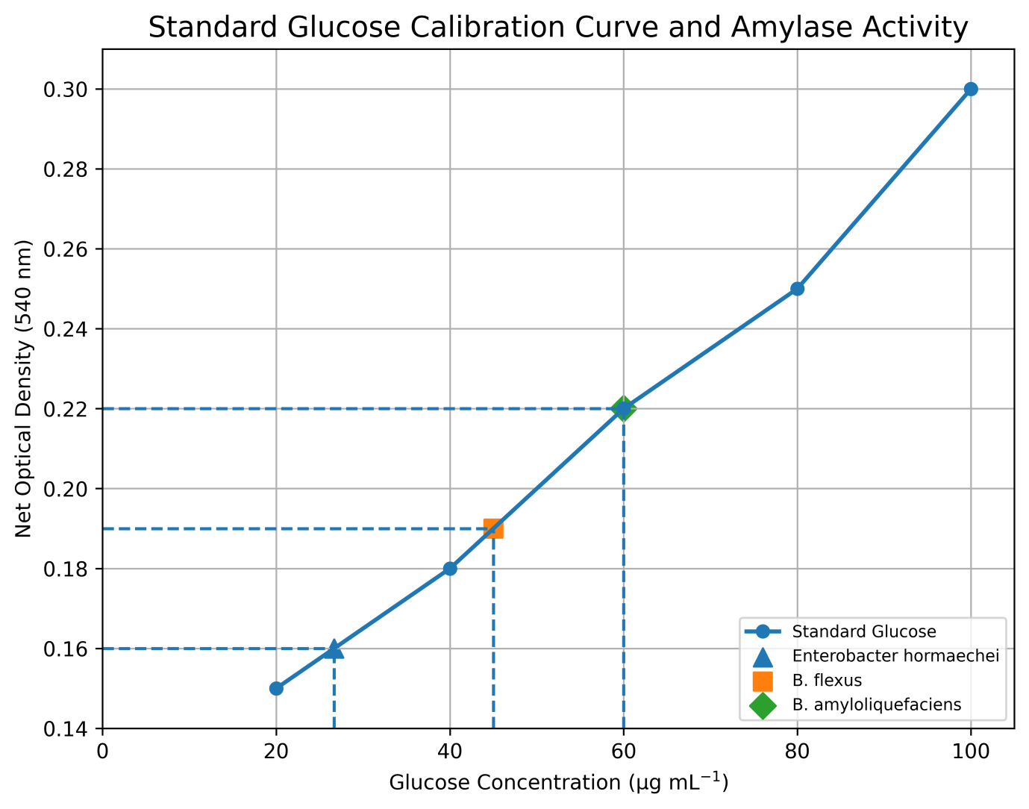
Extracellular amylase activity of Enterobacter hormaechei, Bacillus flexus, and Bacillus amyloliquefaciens determined by the DNS assay based on reducing sugar production following starch hydrolysis.
The extracellular protease activity of the bacterial endophytic isolates was quantitatively determined using the Folin-Ciocalteu (FC) assay with tyrosine as the standard. All three isolates, Enterobacter hormaechei, Bacillus flexus, and Bacillus amyloliquefaciens, exhibited protease activity, demonstrating their ability to hydrolyse casein. Differences in absorbance values among the isolates indicated variation in protease production and proteolytic potential, suggesting a possible role in nutrient cycling and beneficial plant-microbe interactions (Table 2).
Table 2: Extracellular protease activity of bacterial endophytic isolates determined by the Folin–Ciocalteu assay using tyrosine as the standard.
S.NO | Std Tyrosine ml | Distilled water ml | Cons of Tyrosine (µg mL⁻¹) | Alkaline Copper Sulphate (A+B) (mL) | Vol of F.C reagent ml | O.D  660 nm | Net O.D  660nm
Blank | - | 1 | - | 5 | 1.5 | 0.06
1 | 0.2 | 0.8 | 20 | 5 | 1.5 | 0.15 | 0.09
2 | 0.4 | 0.6 | 40 | 5 | 1.5 | 0.18 | 0.12
3 | 0.6 | 0.4 | 60 | 5 | 1.5 | 0.24 | 0.18
4 | 0.8 | 0.2 | 80 | 5 | 1.5 | 0.28 | 0.22
5 | 1 | - | 100 | 5 | 1.5 | 0.32 | 0.26
Enterobacter hormaechei |  | - |  | 5 | 1.5 | 0.27 | 0.21
Bacillus flexus |  | - |  | 5 | 1.5 | 0.30 | 0.24
Bacillus amyloliquefaciens |  | - |  | 5 | 1.5 | 0.32 | 0.26
Quantitative estimation of extracellular protease activity of bacterial endophytic isolates using the Folin–Ciocalteu assay with tyrosine as the standard.
The extracellular protease activity of the bacterial endophytic isolates was quantified using the Folin-Ciocalteu assay with tyrosine as the standard. All three isolates—Enterobacter hormaechei, Bacillus flexus, and Bacillus amyloliquefaciens—exhibited protease activity, although differences in net optical density indicated variation in their proteolytic potential (Figure 2).
Figure 2. Standard tyrosine calibration curve and extracellular protease activity of bacterial endophytic isolates.

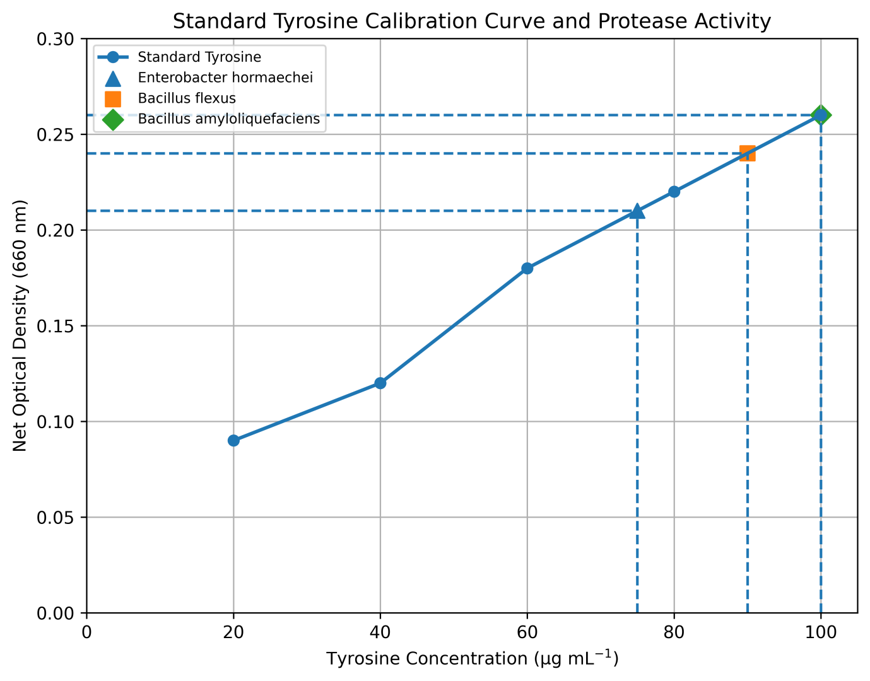
Comparative extracellular protease activity of Enterobacter hormaechei, Bacillus flexus, and Bacillus amyloliquefaciens determined by the Folin–Ciocalteu assay using tyrosine as the standard.
The cellulase activity of the bacterial endophytic isolates was determined using the dinitrosalicylic acid (DNS) assay with glucose as the standard. All three isolates—Enterobacter hormaechei, Bacillus flexus, and Bacillus amyloliquefaciens—exhibited extracellular cellulase activity. Variation in net optical density values indicated differences in cellulase production among the isolates (Table 3).
Table3. Cellulase activity of bacterial endophytes determined using the DNS assay with glucose as the standard.
S.NO | Std Glucose ml | Volume of  water ml | Conc.  of glucose  (µg mL⁻¹) | DNS reagent ml | O.D | Net O.D  540 nm
Blank | Blank | 1 | - | 1 | 0.06
0.2 | 0.2 | 0.8 | 20 | 1 | 0.18 | 0.12
0.4 | 0.4 | 0.6 | 40 | 1 | 0.28 | 0.22
0.6 | 0.6 | 0.4 | 60 | 1 | 0.38 | 0.32
0.8 | 0.8 | 0.2 | 80 | 1 | 0.40 | 0.34
1 | 1 | - | 100 | 1 | 0.48 | 0.42
Enterobacter hormaechei | 1 | - |  | 1 | 0.14 | 0.08
B. flexus | 1 | - |  | 1 | 0.19 | 0.13
B.amyloliquefaciens | 1 | - |  |  | 0.18 | 0.12
Quantitative estimation of extracellular cellulase activity of Enterobacter hormaechei, Bacillus flexus, and Bacillus amyloliquefaciens determined by the dinitrosalicylic acid (DNS) assay using glucose as the standard.
The extracellular cellulase activity of the bacterial endophytic isolates was evaluated using the dinitrosalicylic acid (DNS) assay with glucose as the standard. Enterobacter hormaechei, Bacillus flexus, and Bacillus amyloliquefaciens exhibited cellulase activity, with variation in net optical density indicating differences in cellulolytic activity among the isolates (Figure 3).
Figure 3.Standard glucose calibration curve and extracellular cellulase activity of bacterial endophytes determined using the DNS assay.
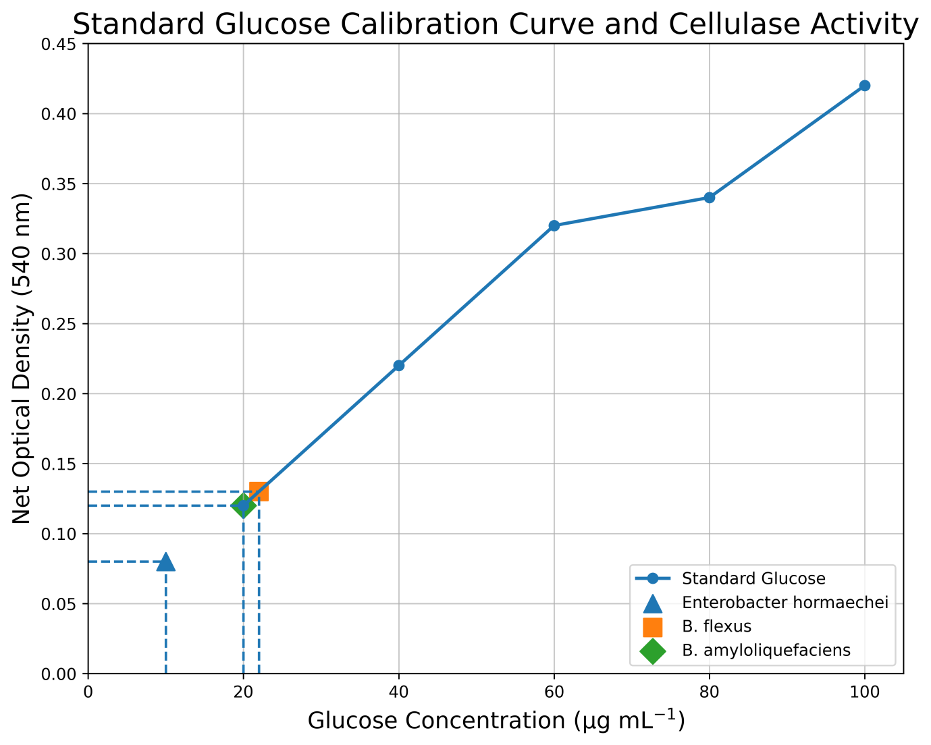
Comparative extracellular cellulase activity of Enterobacter hormaechei, Bacillus flexus, and Bacillus amyloliquefaciens determined by the dinitrosalicylic acid (DNS) assay using glucose as the standard.
The extracellular lipase activity of the bacterial endophytic isolates was evaluated using the olive oil emulsion titration method. Enterobacter hormaechei, Bacillus flexus, and Bacillus amyloliquefaciens exhibited lipase activity, with variation in lipolytic activity observed among the isolates (Figure 4).
Figure 4. Extracellular lipase activity of bacterial endophytes determined by the olive oil emulsion titration method.
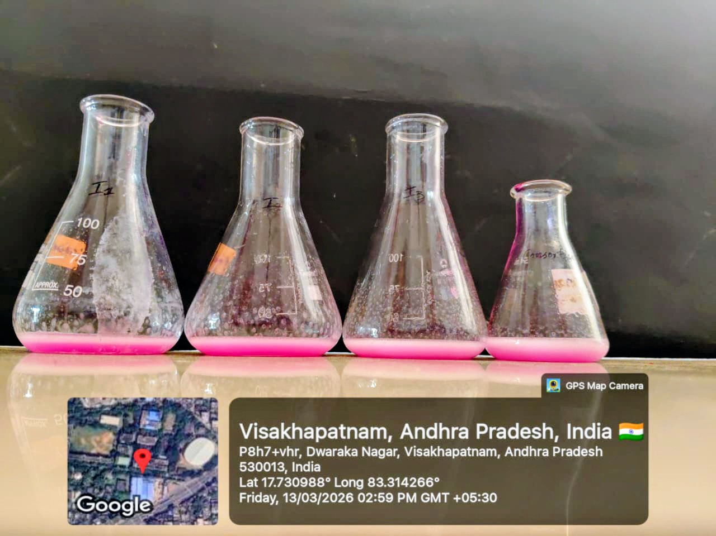
Comparative extracellular lipase activity of Enterobacter hormaechei, Bacillus flexus, and Bacillus amyloliquefaciens determined by the olive oil emulsion titration method.
The extracellular lipase activity of the bacterial endophytic isolates was quantified using the olive oil emulsion titration method. Bacillus amyloliquefaciens exhibited the highest lipase activity, followed by Bacillus flexus and Enterobacter hormaechei, indicating differences in lipase production among the isolates (Figure 5).
Figure 5. Lipase activity of bacterial endophytic isolates determined by the olive oil emulsion titration method.
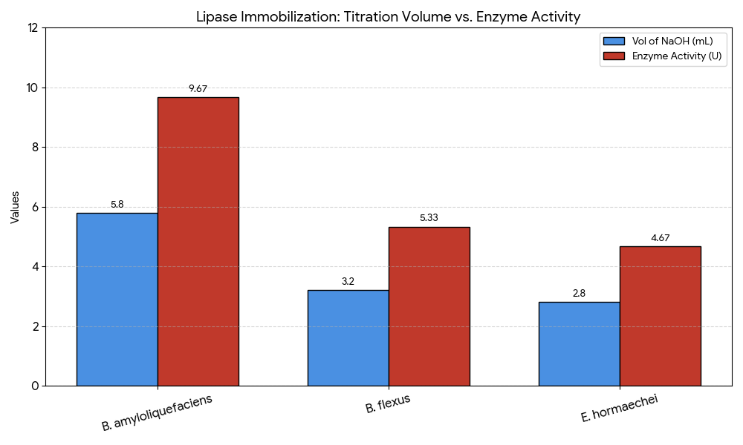
Comparative extracellular lipase activity of Enterobacter hormaechei, Bacillus flexus, and Bacillus amyloliquefaciens determined using the olive oil emulsion titration method.
5. Discussion
Endophytic bacteria are recognised as an important component of the plant microbiome because of their ability to promote plant growth and produce a wide range of extracellular enzymes with agricultural, pharmaceutical, and industrial applications. In the present study, three bacterial endophytes isolated from the rhizomes of Curcuma caesia were identified as Enterobacter hormaechei, Bacillus flexus, and Bacillus amyloliquefaciens based on morphological, biochemical, and 16S rRNA gene sequencing analyses. These findings are consistent with previous reports indicating that Bacillus and Enterobacter species are among the predominant bacterial endophytes associated with medicinal plants and contribute to plant growth promotion through nutrient mobilisation, the production of bioactive metabolites, and the secretion of extracellular enzymes (Dilkush et al., 2025; Ibrahim et al., 2023; Kandasamy & Kathirvel, 2023; Kumar et al., 2017; Rana et al., 2020). All three bacterial isolates exhibited extracellular amylase activity, confirming their ability to hydrolyse starch into reducing sugars. Among the isolates, Bacillus amyloliquefaciens showed comparatively higher amylase activity than Bacillus flexus and Enterobacter hormaechei. Members of the genus Bacillus are widely recognised for their ability to produce extracellular amylases with applications in the food-processing, textile, pharmaceutical, and fermentation industries. Similar observations have been reported in studies of plant-associated endophytes, in which Bacillus species were identified as efficient producers of hydrolytic enzymes involved in nutrient acquisition and plant colonisation (Kandasamy & Kathirvel, 2023; Raghav et al., 2022). The DNS assay used in the present study is a well-established method for estimating the reducing sugars released during starch hydrolysis (Bernfeld, 1955; Miller, 1959).
Protease activity was detected in all three bacterial isolates using the Folin-Ciocalteu assay, demonstrating their ability to hydrolyse casein. Bacillus amyloliquefaciens exhibited the highest protease activity, followed by Bacillus flexus and Enterobacter hormaechei. Extracellular proteases enable microorganisms to degrade complex proteins into smaller peptides and amino acids, thereby improving nutrient availability and facilitating successful colonisation within plant tissues. Similar findings have been reported for endophytic microorganisms isolated from medicinal plants, in which Bacillus species exhibited high proteolytic activity and were considered potential sources of industrially important enzymes (Cupp-Enyard, 2008; Raghav et al., 2022).
The cellulase assay demonstrated that all three bacterial endophytes were capable of producing extracellular cellulase, although differences in enzyme activity were observed among the isolates. Cellulolytic enzymes play an important role in cellulose degradation, allowing endophytic bacteria to establish themselves within plant tissues while maintaining a beneficial association with the host. Comparable results were reported by Gupta et al. (2012), who demonstrated the cellulolytic potential of bacterial isolates, and by Raghav et al. (2022), who highlighted extracellular enzyme production as a characteristic feature of plant-associated endophytes.
Lipase activity was observed in all three bacterial isolates using the olive oil emulsion titration method. Among the isolates, Bacillus amyloliquefaciens exhibited the highest lipase activity, followed by Bacillus flexus and Enterobacter hormaechei. Microbial lipases are versatile biocatalysts with important applications in the food, detergent, pharmaceutical, cosmetic, and biodiesel industries. The superior lipase activity observed in Bacillus amyloliquefaciens agrees with previous reports describing Bacillus species as efficient producers of extracellular lipases with high catalytic activity and broad industrial relevance (Hasan et al., 2006; Sharma et al., 2001). Furthermore, recent studies on endophytes associated with medicinal plants have emphasised the potential of endophytic bacteria as sources of industrial enzymes and other bioactive metabolites (Dilkush et al., 2025; Mili et al., 2024; Raghav et al., 2022).
Overall, the present study demonstrates that the bacterial endophytes isolated from Curcuma caesia possess diverse extracellular enzyme-producing capabilities. Among the three isolates, Bacillus amyloliquefaciens consistently exhibited superior amylase, protease, and lipase activities, whereas all isolates produced measurable cellulase activity. These findings are consistent with previous reports highlighting the metabolic versatility of Bacillus species and their importance as producers of extracellular enzymes (Dilkush et al., 2025; Kandasamy & Kathirvel, 2023; Raghav et al., 2022). The results further support the evidence that endophytic bacteria associated with medicinal plants represent potential biological resources for agricultural, biotechnological, and industrial applications. Future studies should focus on enzyme purification, molecular characterisation, optimisation of culture conditions, and large-scale production to evaluate their commercial potential.

6. Conclusion

The study recovered three culturable bacterial endophytes—Enterobacter hormaechei, Bacillus flexus, and Bacillus amyloliquefaciens—from the rhizomes of Curcuma caesia Roxb. Each isolate produced detectable amylase, protease, cellulase, and lipase activity under the laboratory conditions used, confirming functional variation in extracellular hydrolytic enzyme production. The comparative assays showed that enzyme activity differed among the isolates, while B. amyloliquefaciens exhibited the highest lipase activity in the olive oil emulsion titration assay. Collectively, the results indicate that C. caesia-associated bacterial endophytes constitute a potential source of extracellular enzymes for further investigation. The present evidence is preliminary and does not establish industrial performance or commercial suitability. Further work should purify and characterise the enzymes, determine their kinetic properties, optimise culture and fermentation conditions, investigate the corresponding enzyme-encoding genes, and assess reproducibility at a larger scale. Such validation is necessary to determine whether these isolates can be developed for agricultural, environmental, or enzyme-based biotechnological applications.

7. Limitations and Future Prospects
The present study was limited to the isolation, identification, and preliminary evaluation of extracellular enzyme production by bacterial endophytes associated with Curcuma caesia. Enzymatic activities were assessed using laboratory-scale qualitative and quantitative assays; however, enzyme purification, molecular characterisation, kinetic analysis, and optimisation of production conditions were not performed. In addition, the industrial applicability, in vivo efficacy, and large-scale production potential of the enzymes were not investigated. Future studies should focus on the purification and detailed biochemical characterisation of these enzymes, together with the optimisation of culture conditions and fermentation parameters to improve enzyme yield. Whole-genome sequencing and molecular analysis of enzyme-encoding genes would provide deeper insights into the genetic mechanisms underlying enzyme production. Furthermore, exploring the applications of these enzymes in agriculture, food processing, pharmaceuticals, biofuel production, and environmental bioremediation may enhance their biotechnological value. The development of enzyme-producing endophytic bacterial formulations could also contribute to sustainable agricultural practices and advances in industrial biotechnology.
Declaration of AI Use
This manuscript was prepared through the combined contributions of all author(s), including contributions to the study design, data, content development, results, interpretation, and related scholarly work. The author(s) acknowledge the use of Grammarly and ChatGPT to assist with grammar checking, language refinement, reference formatting. These AI-assisted tools were not used as authors and did not replace the intellectual contributions or scholarly judgment of the author(s). All AI-assisted outputs, including content, references, and interpretations, were carefully reviewed, revised, verified, and approved by the author(s). The author(s) accept full responsibility for the accuracy, integrity, and final content of the manuscript.

Conflict of interest
No conflict of interest declared by the authors in this manuscript.

References
Anjum, A., & Chandra, V. (2026). A comprehensive review on the broad-spectrum utility and phytochemistry of Curcuma caesia Roxb. Phytomedicine Plus, 6(1), 100961. https://doi.org/10.1016/j.phyplu.2026.100961
Bacon, C. W., & White, J. F. (Eds.). (2000). Microbial endophytes. CRC Press. https://doi.org/10.1201/9781482277302
Bernfeld, P. (1955). Amylases, α and β. In S. P. Colowick and N. O. Kaplan (Eds.), Methods in enzymology (Vol. 1, pp. 149–158). Academic Press. https://doi.org/10.1016/0076-6879(55)01021-5
Cupp-Enyard, C. (2008). Sigma’s non-specific protease activity assay—Casein as a substrate. Journal of Visualized Experiments, (19), e899. https://doi.org/10.3791/899
Dilkush, F., Sarathambal, C., Alfiya, P. V., Praveena, R., & Prasath, D. (2025). Metabolic optimization of endophytic bacteria from aromatic ginger (Kaempferia galanga), and black turmeric (Curcuma caesia), for enhanced biocontrol of Pythium myriotylum. Physiological and Molecular Plant Pathology, 140, 102898. https://doi.org/10.1016/j.pmpp.2025.102898
Dilkush, F., Sarathambal, C., Charles, S., Peter, B., Praveena, R., & Prasath, D. (2026). Antagonistic bacterial endophytes from gingers and their metabolite-mediated interactions against Pythium soft rot. Current Microbiology, 83, 34. https://doi.org/10.1007/s00284-025-04608-0
Gupta, P., Samant, K., & Sahu, A. (2012). Isolation of cellulose-degrading bacteria and determination of their cellulolytic potential. International Journal of Microbiology, 2012, 578925. https://doi.org/10.1155/2012/578925
Hallmann, J., Quadt-Hallmann, A., Mahaffee, W. F., & Kloepper, J. W. (1997). Bacterial endophytes in agricultural crops. Canadian Journal of Microbiology, 43(10), 895–914. https://doi.org/10.1139/m97-131
Hasan, F., Shah, A. A., & Hameed, A. (2006). Industrial applications of microbial lipases. Enzyme and Microbial Technology, 39(2), 235–251. https://doi.org/10.1016/j.enzmictec.2005.10.016
Ibrahim, N. N. A., Wan Mustapha, W. A., Sofian-Seng, N.-S., Lim, S. J., Mohd Razali, N. S., Teh, A. H., Abdul Rahman, H., & Mediani, A. (2023). A comprehensive review with future prospects on the medicinal properties and biological activities of Curcuma caesia Roxb. Evidence-Based Complementary and Alternative Medicine, 2023, 7006565. https://doi.org/10.1155/2023/7006565
Kandasamy, G. D., & Kathirvel, P. (2023). Insights into bacterial endophytic diversity and isolation with a focus on their potential applications—A review. Microbiological Research, 266, 127256. https://doi.org/10.1016/j.micres.2022.127256
Kumar, A., Singh, A. K., Kaushik, M. S., Mishra, S. K., Raj, P., Singh, P. K., & Pandey, K. D. (2017). Interaction of turmeric (Curcuma longa L.) with beneficial microbes: A review. 3 Biotech, 7(6), 357. https://doi.org/10.1007/s13205-017-0971-7
Lane, D. J. (1991). 16S/23S rRNA sequencing. In E. Stackebrandt and M. Goodfellow (Eds.), Nucleic acid techniques in bacterial systematics (pp. 115–175). John Wiley & Sons. https://catalog.nlm.nih.gov/discovery/fulldisplay/alma996854943406676/01NLM_INST%3A01NLM_INST
Mili, C., Saha, S., Mishra, P. K., & Tayung, K. (2024). Exploring bioactive metabolites produced by endophytes associated with the genus Curcuma L.: A pharmaceutical prospect. Pharmacological Research – Natural Products, 3, 100054. https://doi.org/10.1016/j.prenap.2024.100054
Miller, G. L. (1959). Use of dinitrosalicylic acid reagent for determination of reducing sugar. Analytical Chemistry, 31(3), 426–428. https://doi.org/10.1021/ac60147a030
Raghav, D., Jyoti, A., Siddiqui, A. J., & Saxena, J. (2022). Plant-associated endophytic fungi as potential bio-factories for extracellular enzymes: Progress, challenges and strain improvement with precision approaches. Journal of Applied Microbiology, 133(2), 287–310. https://doi.org/10.1111/jam.15574
Ram, J. P. S., Ramakrishnan, R., K, P. K., Singh, S., R., A. K., Govindan, S., Selvaraj, R., & Manikandan, R. (2024). Phyto-safe in vitro regeneration and harnessing antimicrobial-resistant endophytes as bioinoculants for enhanced growth and secondary metabolites yield in Nilgirianthus ciliatus. BMC Plant Biology, 24, 872. https://doi.org/10.1186/s12870-024-05582-8
Ramanuj, K. B., & Shelat, H. N. (2018). Plant growth promoting potential of bacterial endophytes from medicinal plants. Advances in Research, 13(6), 1–15. https://doi.org/10.9734/AIR/2018/40014
Rana, K. L., Kour, D., Kaur, T., Devi, R., Yadav, A. N., Yadav, N., Dhaliwal, H. S., & Saxena, A. K. (2020). Endophytic microbes: Biodiversity, plant growth-promoting mechanisms and potential applications for agricultural sustainability. Antonie van Leeuwenhoek, 113(8), 1075–1107. https://doi.org/10.1007/s10482-020-01429-y
Sahoo, S., Panda, S. S., Kumar, S., Nigam, R., Sarangi, S., Choudhary, M., Yuvarani, R., & Shivam. (2024). A review on plant-microbe interactions and its defence mechanism. Plant Cell Biotechnology and Molecular Biology, 25(11–12), 159–175. https://doi.org/10.56557/pcbmb/2024/v25i11-128920
Schulz, B., & Boyle, C. (2005). The endophytic continuum. Mycological Research, 109(6), 661–686. https://doi.org/10.1017/S095375620500273X
Sharma, R., Chisti, Y., & Banerjee, U. C. (2001). Production, purification, characterization, and applications of lipases. Biotechnology Advances, 19(8), 627–662. https://doi.org/10.1016/S0734-9750(01)00086-6
Thankam, S. R., & Manuel, S. G. A. (2023). Identification and characterization of endophytic bacteria isolated from Curcuma longa. Proceedings of the National Academy of Sciences, India Section B: Biological Sciences, 93, 763–774. https://doi.org/10.1007/s40011-023-01466-3

