Original Research Article
Incidence of Alternaria blight disease in Indian mustard (Brassica juncea L.) in Eastern region of Bihar, India

Abstract
Indian mustard (Brassica juncea L.) is an important oilseed crop in India, but its productivity is constrained by foliar diseases, including Alternaria blight. This study assessed the incidence of Alternaria blight and the recovery of associated fungi from mustard fields in eastern Bihar during the 2023–2024 and 2024–2025 rabi seasons. Thirty sites were surveyed across Banka, Bhagalpur, Katihar, Khagaria, Madhepura and Munger, with five sites examined in each district. Symptomatic tissues were surface-treated, cultured on potato dextrose agar at 25 ± 1°C for 7–9 days and examined using cultural and microscopic characteristics. Percentage disease incidence was calculated from infected and total plants at each site. Symptoms were recorded at all surveyed sites. Mean district incidence was 41.11% in Banka, 42.21% in Bhagalpur, 20.30% in Katihar, 56.90% in Khagaria, 61.39% in Madhepura and 63.81% in Munger, with an overall mean of 47.62%. Alternaria brassicicola was recovered from every site in both seasons, whereas Curvularia lunata was co-isolated from five sites in the first season and six sites in the second. The ratios of samples yielding A. brassicicola alone to those yielding both fungi were 5:1 and 4:1, respectively. The findings indicate widespread recovery of A. brassicicola and marked spatial variation in disease incidence. Because identification was morphology-based and pathogenicity was not tested, recovery frequency should not be interpreted as evidence of aggressiveness or exclusive causation.
Keywords: Alternaria brassicae; Alternaria brassicicola; Brassica juncea; Curvularia lunata; disease survey; eastern Bihar; fungal isolation; Indian mustard; leaf blight; percentage disease incidence

Introduction
Indian mustard (Brassica juncea), a rabi crop commonly known as sarson or rai, is a well-known oilseed crop cultivated in India. Indian mustard accounts for approximately 27.8% of India's total cooking-oil production (Prasad & Lallu, 2006). India ranks third in mustard production after Canada and China, contributing approximately 13% of global output during 2020-2021 to 2024-2025. In 2024-2025, India's average mustard productivity was 1,461 kg/ha, approximately 70.6% of the global average of 2,070 kg/ha. Mustard is cultivated across 24 Indian states, of which Rajasthan accounts for the largest share (45.03%), followed by Madhya Pradesh (13.47%) and Uttar Pradesh (12.54%). Bihar ranked ninth, accounting for 1.01% of production in 2020-2021 and 0.82% in 2024-2025. During 2022-2023 to 2024-2025, yield was reported to be approximately 1,197 kg/ha. It is the most important oilseed crop in the state in terms of both cultivated area (0.88 lakh ha) and production (1.05 lakh tonnes) (Kumar et al., 2025). Rapeseed-mustard is affected by several foliar diseases, including powdery mildew (Erysiphe cruciferarum), downy mildew (Peronospora parasitica), white rust (Albugo candida), Sclerotinia stem rot (Sclerotinia sclerotiorum), bacterial black rot (Xanthomonas campestris), and Alternaria blight (Alternaria spp.). Alternaria blight is caused mainly by Alternaria brassicae (Berk.) Sacc., Alternaria raphani, and Alternaria brassicicola (Schw.). Among these diseases, Alternaria blight caused by Alternaria brassicicola is one of the most destructive black spot diseases of Indian mustard (Babli et al., 2025). Alternaria infection causes dark brown lesions on leaves, stems, and siliquae, thereby reducing photosynthetic capacity, accelerating senescence, and ultimately causing crop loss (Nowicki et al., 2012). Yield losses result from early defoliation, flower-bud abortion, premature ripening, silique dehiscence, and seed shrivelling (Macioszek et al., 2020). In addition to reducing yield, infection affects seed quality by decreasing seed size and causing discolouration (Sharma & Kumar, 2023). Recent investigations have documented variation in disease response among Indian mustard genotypes and examined distinct management approaches against Alternaria pathogens, reinforcing the need for standardised disease assessment (Dhakar et al., 2026; Kiran et al., 2024; Meur et al., 2015; Mishra et al., 2025). Moreover, cultural and morphological characteristics may vary among Alternaria isolates; therefore, morphology-based identification is best regarded as a preliminary assessment that can be strengthened through molecular confirmation (Dodmani et al., 2025; Yang et al., 2025). Despite the importance of mustard cultivation in Bihar, district-level evidence on the field incidence of Alternaria blight in the eastern region remains limited, particularly across consecutive growing seasons. Comparative information combining field incidence measurements with the cultural and microscopic recovery of associated fungi from multiple districts of eastern Bihar is also insufficient.
Considering the importance of this problem, the present study aimed to assess the incidence of Alternaria blight in Indian mustard (Brassica juncea L.) in the eastern region of Bihar.

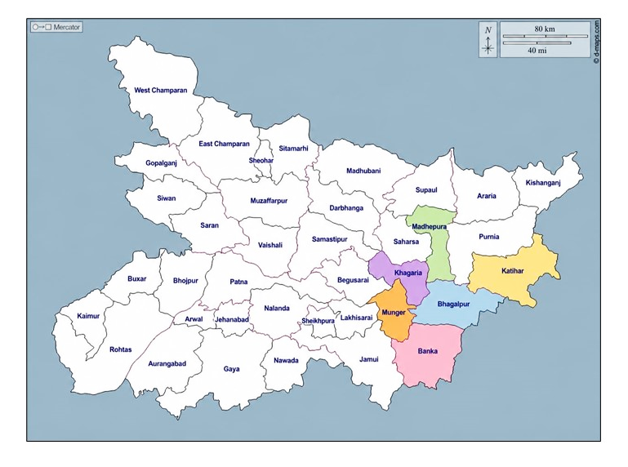
Figure 1: Map highlights the district of Eastern Bihar
taken for survey (Adapted from d-maps)

Materials and Methods
A survey of Alternaria blight in Indian mustard, associated with Alternaria brassicicola, was conducted in six districts of eastern Bihar: Banka, Bhagalpur, Katihar, Khagaria, Madhepura, and Munger (Figure 1). The survey was conducted during the rabi seasons of 2023-2024 and 2024-2025. Data were collected from the last week of February to early March, when the crops were at maturity. Five sites in each district were selected to determine percentage disease incidence. None of the surveyed sites was free from the pathogen. Based on symptomatology, 30 sites were assessed, and diseased samples were collected. The surveyed locations and recovered pathogens are listed in Table 1.
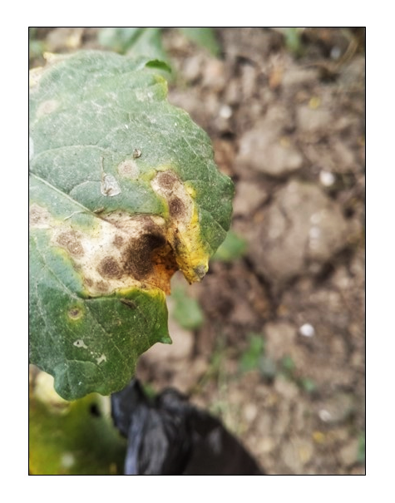
Figure 2: Leaf showing concentric blight
The diseased portions were cut, treated with 70% ethyl alcohol for 30 seconds, and then washed three times with sterile water. The treated portions were immersed in 1-2% sodium hypochlorite solution for 2-10 minutes and subsequently rinsed with sterile water (Sahu et al., 2022). After drying, the blighted tissues were inoculated onto potato dextrose agar medium, and the inoculated Petri plates were incubated at room temperature (25 ± 1°C) for 7-9 days. Fungal growth was examined under a compound microscope to determine the occurrence of Alternaria brassicicola in the samples. The characteristic concentric blight symptom is shown in Figure 2. Percentage disease incidence of Alternaria blight in Indian mustard was assessed across the six surveyed districts of eastern Bihar: Banka, Bhagalpur, Katihar, Khagaria, Madhepura, and Munger (Pandey et al., 2024). The intensity of Alternaria leaf blight was assessed by estimating the proportion of infected plants across each field. Disease intensity was scored on a 0-5 scale (Conn et al., 1990) using randomly selected plants from each field, as follows:

0 | No symptoms
1 | 1-10% leaf or pod area infected
2 | 11-25% leaf or pod area infected
3 | 26-50% leaf or pod area infected
4 | 51-75%leaf or pod area infected
5 | 75% or above leaf or pod area infected

Percentage disease incidence was calculated from the numbers of infected and total plants in each field (Pandey et al., 2024; Shrivastava et al., 2023). Five sites were selected randomly in each district. Field incidence of Alternaria spp. was evaluated using a systematic W-shaped sampling pattern across the plot to minimise edge effects (Koima et al., 2022). The total number of plants in each selected area was counted, and diseased plants were recorded for subsequent calculations (Manjhi et al., 2018).
The formula used to calculate percentage disease incidence (PDI) is given below:

$$PDI=\frac{No.of infected plants}{Total no.of plants}×100$$

Results and Discussion
The survey was conducted during two consecutive mustard-growing seasons, 2023-2024 and 2024-2025, and Alternaria brassicicola was recovered most frequently.

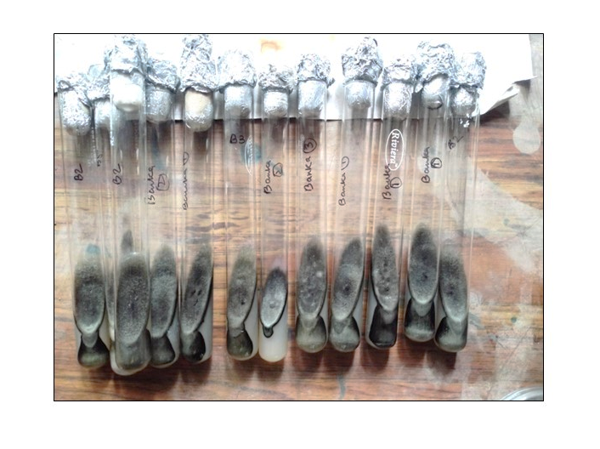
Fig 3: Pure culture of Alternaria brassicicola on
PDA medium in culture tubes

Cultural and microscopic characterization
Under laboratory conditions, cultures obtained from diseased samples formed dark olive-brown to black colonies on potato dextrose agar in Petri plates. The cultures were subsequently subcultured, and pure cultures were maintained in culture tubes (Figure 3).
Dark olive-brown to black, velvety colonies were observed on potato dextrose agar. Microscopic examination revealed pigmented, septate mycelia and chained, muriform conidia consistent with the diagnostic morphology of Alternaria brassicicola. The mycelium was septate, branched, and dark brown, indicating that the pathogen was dematiaceous. Conidiophores arose singly or in small groups of approximately 2-12 or more through leaf stomata. Conidia were dark brown, smooth-walled, cylindrical to oblong, and muriform; they were produced in chains of up to 20 or more and arose through small pores in the conidiophore wall. The conidia tapered slightly towards the apex and were pseudorostrate (beakless) (Nowakowska et al., 2019). Accordingly, the present identification was based on morphology rather than molecular methods.

Relative recovery of fungal isolates
Across the 30 survey sites, Alternaria brassicicola was recovered during both seasons, whereas Curvularia lunata was detected in a smaller subset of samples. During the first season, Alternaria brassicicola alone was recovered from 25 sites, whereas Alternaria brassicicola together with Curvularia lunata was recovered from five sites. During the second season, Alternaria brassicicola alone was recovered from 24 sites, whereas co-isolation with Curvularia lunata occurred at six sites (Table 3). The ratios of samples yielding Alternaria brassicicola alone to those yielding both fungi were therefore 5:1 and 4:1 in the first and second seasons, respectively. Results from the two consecutive seasons showed that Alternaria brassicicola alone accounted for 83.34% of samples and co-isolation with Curvularia lunata for 16.66% in the first season; the corresponding values were 80.00% and 20.00% in the second season (Table 3). This consistent recovery supports the widespread occurrence of Alternaria brassicicola in the surveyed mustard fields; however, isolation frequency represents relative cultural recovery and should not be equated directly with aggressiveness or exclusive causation. Multi-location studies of rapeseed-mustard diseases and controlled bioassays show that disease expression varies with pathogen isolate, host genotype, inoculum level, and environmental conditions (Meena et al., 2024; Mishra et al., 2024; Nowakowska et al., 2019). The occasional co-isolation of Curvularia lunata therefore requires separate molecular identification and pathogenicity testing before its epidemiological importance can be inferred.

District-wise disease incidence
Based on Table 2, mean PDI across the five surveyed sites was 63.81% in Munger, 61.39% in Madhepura, 56.90% in Khagaria, 42.21% in Bhagalpur, 41.11% in Banka, and 20.30% in Katihar, with an overall mean of 47.62%. These data indicate a pronounced spatial gradient, with Munger, Madhepura, and Khagaria experiencing substantially greater disease incidence than Katihar. Comparable studies have shown that Alternaria blight development varies among locations and crop stages and is influenced by host age, sowing date, temperature, humidity, and inoculum availability (Dhaliwal & Singh, 2020; Humpherson-Jones & Phelps, 1989; Meena et al., 2011). Long-term surveillance in India likewise demonstrates that geographical and prevailing weather conditions contribute to variation in disease initiation and severity (Meena et al., 2024).

Table 01- List of different regions of Eastern Bihar’s District taken under survey for two consecutive seasons:

S. No. | District | Region | Location Coordinate | Pathogen Isolated
01. | Banka | Amarpur Road, Banka | 24.896 °N, 86.913 °E | Alternaria brassicicol
01. | Banka | Kakwara Tola, Chiutia | 24.851 °N, 86.899 °E | Alternaria brassicicol
01. | Banka | Kakwara Tola, Chiutia | 24.851 °N, 86.902 °E | Alternaria brassicicola , Curvularia lunata
01. | Banka | Kanka | 24.917 °N, 86.898 °E | Alternaria brassicicola , Curvularia lunata
01. | Banka | Samukhiya | 24.934 °N, 86.898 °E | Alternaria brassicicola
02. | Bhagalpur | Bhagalpur | 25.184 °N, 86.801 °E | Alternaria brassicicola
02. | Bhagalpur | Champanala | 25.239 °N, 86.926 °E | Alternaria brassicicola
02. | Bhagalpur | Hardeo Chak, Pirpainti Road | 25.230 °N, 87.389 °E | Alternaria brassicicola
02. | Bhagalpur | Itahari Pirpainti | 25.228 °N, 87.394 °E | Alternaria brassicicola
02. | Bhagalpur | Purani Sarai | 25.231 °N, 86.914 °E | Alternaria brassicicola
03. | Katihar | Bhangaha | 25.579 °N, 87.278 °E | Alternaria brassicicola
03. | Katihar | Katihar | 25.506 °N, 87.245 °E | Alternaria brassicicola
03. | Katihar | Kursela, Forbesganj Road, Chandpur Milik | 25.507 °N, 87.246 °E | Alternaria brassicicola & Curvularia lunata
03. | Katihar | Pothia, Malhoria | 25.535 °N, 87.261 °E | Alternaria brassicicola
03. | Katihar | Shabda | 25.542 °N, 87.261 °E | Alternaria brassicicola
04. | Khagaria | Alauli, Khagaria Road, Bachhouta | 25.538 °N, 86.455 °E | Alternaria brassicicola
04. | Khagaria | Alauli, Khagaria Road, Bachhouta | 25.532 °N, 86.455 °E | Alternaria brassicicola
04. | Khagaria | Bachhouta | 25.546 °N, 86.448 °E | Alternaria brassicicola
04. | Khagaria | Bhadas Uttar | 25.528 °N, 86.458 °E | Alternaria brassicicola & Curvularia lunata
04. | Khagaria | Mathurapur | 25.516 °N, 86.458 °E | Alternaria brassicicola
05. | Madhepura | Dighi | 25.712 °N, 86.986 °E | Alternaria brassicicola
05. | Madhepura | Durgapur | 25.611 °N, 86.982 °E | Alternaria brassicicola
05. | Madhepura | Gamail Mohanpur, Bihariganj Road | 25.712 °N, 86.966 °E | Alternaria brassicicola
05. | Madhepura | Kathautia | 25.812 °N, 86.993 °E | Alternaria brassicicola
05. | Madhepura | Madhepura Durga Mandir Road | 25.601 °N, 86.989B °E | Alternaria brassicicola
06. | Munger | Herudiyara | 25.340 °N, 86.463 °E | Alternaria brassicicola
06. | Munger | Janki Nagar | 25.349 °N, 86.520 °E | Alternaria brassicicola
06. | Munger | Keshopur | 25.345 °N, 86.521 °E | Alternaria brassicicola
06. | Munger | Munger | 25.349 °N, 86.510 °E | Alternaria brassicicola & Curvularia lunata
06. | Munger | Nauagarhi | 25.348 °N, 86.521 °E | Alternaria brassicicola

Table 02- Average Percentage Disease Incidence of areas selected for survey:

S.no. | District | Spot | Total No. of Plants | Infected Plants | PDI
1. | Banka | 1 | 78 | 40 | 51.29%
1. | Banka | 2 | 80 | 34 | 42.5%
1. | Banka | 3 | 75 | 32 | 42.67%
1. | Banka | 4 | 82 | 25 | 30.49%
1. | Banka | 5 | 70 | 27 | 38.58%
2. | Bhagalpur | 1 | 82 | 31 | 37.80%
2. | Bhagalpur | 2 | 80 | 28 | 35.00%
2. | Bhagalpur | 3 | 70 | 41 | 58.57%
2. | Bhagalpur | 4 | 75 | 28 | 37.34%
2. | Bhagalpur | 5 | 85 | 36 | 42.35%
3. | Katihar | 1 | 80 | 11 | 13.75%
3. | Katihar | 2 | 70 | 18 | 25.71%
3. | Katihar | 3 | 80 | 21 | 26.25%
3. | Katihar | 4 | 88 | 8 | 09.10%
3. | Katihar | 5 | 75 | 20 | 26.67%
4. | Khagaria | 1 | 100 | 55 | 55.00%
4. | Khagaria | 2 | 88 | 40 | 45.46%
4. | Khagaria | 3 | 74 | 39 | 52.70%
4. | Khagaria | 4 | 84 | 55 | 65.48%
4. | Khagaria | 5 | 120 | 79 | 65.84%
5. | Madhepura | 1 | 87 | 62 | 71.26%
5. | Madhepura | 2 | 92 | 50 | 54.35%
5. | Madhepura | 3 | 96 | 59 | 61.46%
5. | Madhepura | 4 | 98 | 54 | 55.10%
5. | Madhepura | 5 | 88 | 57 | 64.78%
6. | Munger | 1 | 84 | 51 | 60.72%
6. | Munger | 2 | 104 | 78 | 75.00%
6. | Munger | 3 | 89 | 44 | 49.44%
6. | Munger | 4 | 90 | 57 | 63.34%
6. | Munger | 5 | 95 | 67 | 70.53%
*PDI – Per cent Disease Incidence

Table 03- List of pathogens isolated from different spots:

S.no. | District | Spot | Occurrence of Pathogen
S.no. | District | Spot | 2023-2024 |  | 2024-2025
S.no. | District | Spot | Alternaria brassicicola | Curvularia lunata | Alternaria brassicicola | Curvularia lunata
01. | Banka | Spot 1 | + | - | + | -
01. | Banka | Spot 2 | + | - | + | -
01. | Banka | Spot 3 | + | + | + | +
01. | Banka | Spot 4 | + | + | + | -
01. | Banka | Spot 5 | + | - | + | -
02. | Bhagalpur | Spot 1 | + | - | + | -
02. | Bhagalpur | Spot 2 | + | - | + | -
02. | Bhagalpur | Spot 3 | + | - | + | -
02. | Bhagalpur | Spot 4 | + | - | + | +
02. | Bhagalpur | Spot 5 | + | - | + | -
03. | Katihar | Spot 1 | + | - | + | +
03. | Katihar | Spot 2 | + | - | + | -
03. | Katihar | Spot 3 | + | + | + | +
03. | Katihar | Spot 4 | + | - | + | -
03. | Katihar | Spot 5 | + | - | + | -
04. | Khagaria | Spot 1 | + | - | + | -
04. | Khagaria | Spot 2 | + | - | + | -
04. | Khagaria | Spot 3 | + | + | + | -
04. | Khagaria | Spot 4 | + | - | + | -
04. | Khagaria | Spot 5 | + | - | + | -
05. | Madhepura | Spot 1 | + | - | + | -
05. | Madhepura | Spot 2 | + | - | + | -
05. | Madhepura | Spot 3 | + | - | + | -
05. | Madhepura | Spot 4 | + | - | + | +
05. | Madhepura | Spot 5 | + | - | + | -
06. | Munger | Spot 1 | + | - | + | -
06. | Munger | Spot 2 | + | - | + | -
06. | Munger | Spot 3 | + | - | + | +
06. | Munger | Spot 4 | + | + | + | -
06. | Munger | Spot 5 | + | - | + | -
(+) indicates the availability of Alternaria brassicicola, (+) shows the presence of Curvularia lunata and (–) shows absence of Curvularia lunata

Conclusion
The survey documented Alternaria blight symptoms at all 30 mustard-field sites examined across six districts of eastern Bihar during two consecutive rabi seasons. Disease incidence varied considerably among districts, ranging from 20.30% in Katihar to 63.81% in Munger, with an overall mean of 47.62%. Munger, Madhepura and Khagaria recorded the highest district means, whereas Katihar recorded the lowest. Cultural and microscopic examination consistently recovered Alternaria brassicicola from every surveyed site in both seasons. Curvularia lunata occurred less frequently and only as a co-isolate, being detected at five sites in 2023–2024 and six sites in 2024–2025. These observations demonstrate spatial variation in field incidence and the widespread cultural recovery of A. brassicicola during crop maturity. However, isolation frequency alone cannot establish pathogen aggressiveness, exclusive causation or yield effects. Molecular confirmation, pathogenicity testing, repeated assessments across crop development and integration of cultivar, management and meteorological information are required to clarify pathogen identity, epidemiological significance and district-level disease patterns.

Limitations
The survey assessed five sites per district near crop maturity and may not represent disease development throughout the growing season. Mustard cultivars, sowing dates, management practices, and meteorological conditions were not analysed. Fungal identification was based on cultural and microscopic characteristics without DNA sequencing or species-specific PCR because this was a preliminary incidence-based study. Pathogenicity tests were not performed, and the causal role of the co-isolated Curvularia lunata remains uncertain. These limitations restrict the interpretation of pathogen prevalence and the causes of geographical variation. Because the survey used terminal-season observations and morphology-based isolation, repeated assessments throughout crop development, paired meteorological data, molecular confirmation, and pathogenicity assays would provide a stronger basis for explaining district-level differences and the significance of mixed fungal recovery, which will be explored further.
Conflict of Interest (s)
The authors declare no conflict of interest between them.

Declaration of AI Use

This manuscript was prepared through the combined contributions of all author(s), including contributions to the study design, data, content development, results, interpretation, and related scholarly work. The author(s) acknowledge the use of Grammarly and ChatGPT to assist with grammar checking, language refinement, and reference formatting. These AI-assisted tools were not used as authors and did not replace the intellectual contributions or scholarly judgment of the author(s). All AI-assisted outputs, including content, references, and interpretations, were carefully reviewed, revised, verified, and approved by the author(s). The author(s) accept full responsibility for the accuracy, integrity, and final content of the manuscript.

Reference
Babli, Pandya, R. K., & Ahirwar, M. K. (2025). Survey and surveillance on Alternaria blight of mustard in Grid region M.P., India. Plant Archives, 25(1), 799–802. https://doi.org/10.51470/PLANTARCHIVES.2025.v25.no.1.120
Conn, K. L., Tewari, J. P., & Awasthi, R. P. (1990). A disease assessment key for Alternaria blackspot in rapeseed and mustard. Canadian Plant Disease Survey, 70(1), 19–22. https://phytopath.ca/wp-content/uploads/cpds-archive/vol70/CPDS_Vol_70_No_1_%2819-22%291990.pdf
Dhakar, M., Sasode, R. S., Yadav, R., Tripathi, M. K., Tomar, S. S., Tomar, S. S., Singh, J., & Jatav, R. (2026). Evaluation of mustard (Brassica juncea L.) hybrids against Alternaria blight incited by Alternaria brassicae under artificial inoculation conditions. Plant Cell Biotechnology and Molecular Biology, 27(7–8), 360–370. https://doi.org/10.56557/pcbmb/2026/v27i7-810865
Dhaliwal, R. S., & Singh, B. (2020). Effect of weather parameters and date of sowing on intensity of Alternaria blight of rapeseed mustard. Indian Phytopathology, 73, 89–95. https://doi.org/10.1007/s42360-020-00193-3
Dodmani, B. A., Prasad, L., Singh, N., Katoch, S., & Saharan, M. S. (2025). Unraveling diversity in Alternaria brassicae affecting Indian mustard: Morphological, pathogenic and molecular approaches. Current Microbiology, 82, Article 542. https://doi.org/10.1007/s00284-025-04521-6
Humpherson-Jones, F. M., & Phelps, K. (1989). Climatic factors influencing spore production in Alternaria brassicae and Alternaria brassicicola. Annals of Applied Biology, 114(3), 449–458. https://doi.org/10.1111/j.1744-7348.1989.tb03360.x
Kiran, A., Mandal, D., & Kumar, S. (2024). In vitro study on fungicide sensitivity of Alternaria brassicicola for managing leaf blight in mustard (Brassica juncea). International Journal of Plant & Soil Science, 36(12), 33–37. https://doi.org/10.9734/ijpss/2024/v36i125180
Koima, I. N., Kilalo, D. C., Orek, C. O., Wagacha, J. M., & Nyaboga, E. N. (2022). Survey of fungal foliar and panicle diseases in smallholder sorghum cropping systems in different agro-ecologies of lower eastern Kenya. Microbiology Research, 13(4), 765–787. https://doi.org/10.3390/microbiolres13040055
Kumar, V., Sharma, A. K., Yogi, R. K., & Singh, V. V. (2025). Rapeseed-mustard cultivation in India: National overview and regional insights with reference to Madhya Pradesh. Journal of Oilseed Brassica, 16(2), 149–157. https://doi.org/10.56093/job.v16i2.172304
Macioszek, V. K., Wielanek, M., Morkunas, I., Ciereszko, I., & Kononowicz, A. K. (2020). Leaf position-dependent effect of Alternaria brassicicola development on host cell death, photosynthesis and secondary metabolites in Brassica juncea. Physiologia Plantarum, 168(3), 601–616. https://doi.org/10.1111/ppl.12998
Manjhi, P., Tomar, D. S., Srivastav, A. K., & Nayak, M. K. (2018). Alternaria blight of mustard and its association with weather parameters. Annals of Plant and Soil Research, 20(3), 250–253. https://gkvsociety.com/control/uploads/3073817.pdf
Meena, P. D., Chattopadhyay, C., Meena, S. S., & Kumar, A. (2011). Area under disease progress curve and apparent infection rate of Alternaria blight disease of Indian mustard (Brassica juncea) at different plant age. Archives of Phytopathology and Plant Protection, 44(7), 684–693. https://doi.org/10.1080/03235400903345281
Meena, P. D., Rai, P. K., & Saharan, G. S. (2024). Distribution maps depicting geographical prevalence of rapeseed-mustard diseases in India. Indian Phytopathology, 77, 627–644. https://doi.org/10.1007/s42360-024-00765-7
Meur, G., Shukla, P., Dutta-Gupta, A., & Kirti, P. B. (2015). Characterization of Brassica juncea–Alternaria brassicicola interaction and jasmonic acid carboxyl methyl transferase expression. Plant Gene, 3, 1–10. https://doi.org/10.1016/j.plgene.2015.06.001
Mishra, A., Khan, N. A., Jha, R. K., Murugesh, T., & Singh, A. (2024). Study of resistance mechanism of Alternaria blight (Alternaria brassicicola) by biochemical markers in Indian mustard (Brassica juncea L. Czern. & Coss.). Frontiers in Plant Science, 15, Article 1420197. https://doi.org/10.3389/fpls.2024.1420197
Mishra, D. N., Prasad, L., & Suyal, U. (2025). Synthesis of zinc oxide nanoparticles using Trichoderma harzianum and its bio-efficacy on Alternaria brassicae. Frontiers in Microbiology, 16, Article 1506695. https://doi.org/10.3389/fmicb.2025.1506695
Nowakowska, M., Wrzesińska, M., Kamiński, P., Szczechura, W., Lichocka, M., Tartanus, M., Kozik, E. U., & Nowicki, M. (2019). Alternaria brassicicola–Brassicaceae pathosystem: Insights into the infection process and resistance mechanisms under optimized artificial bio-assay. European Journal of Plant Pathology, 153(1), 131–151. https://doi.org/10.1007/s10658-018-1548-y
Nowicki, M., Nowakowska, M., Niezgoda, A., & Kozik, E. U. (2012). Alternaria black spot of crucifers: Symptoms, importance of disease, and perspectives of resistance breeding. Journal of Fruit and Ornamental Plant Research, 76(1), 5–19. https://doi.org/10.2478/v10032-012-0001-6
Pandey, M. K., Ahmad, M. M., Siddiqui, S., Kumar, A., Singh, S. K., & Rai, D. (2024). Survey on the disease incidence of Alternaria blight of mustard in eastern and central parts of Uttar Pradesh. International Journal of Plant and Environment, 10(1), 69–75. https://doi.org/10.18811/ijpen.v10i01.09
Prasad, R., & Lallu. (2006). Management of Alternaria blight of mustard with combination of chemicals and botanicals. Annals of Plant Protection Sciences, 14(2), 400–403.
Sahu, P. K., Tilgam, J., Mishra, S., Hamid, S., Gupta, A., Jayalakshmi, K., Verma, S. K., & Kharwar, R. N. (2022). Surface sterilization for isolation of endophytes: Ensuring what (not) to grow. Journal of Basic Microbiology, 62(6), 647–668. https://doi.org/10.1002/jobm.202100462
Sharma, S. K., & Kumar, A. (2023). Effect of date of sowing on growth, seed yield and economics of Indian mustard (Brassica juncea) varieties under rainfed conditions. Indian Journal of Agricultural Research, 57(1), 56–59. https://doi.org/10.18805/IJARe.A-5947
Shrivastava, A., Tripathi, M. K., Singh, P., Tiwari, S., Tripathi, N., Tiwari, P. N., Parihar, P., Singh, J., & Chauhan, S. (2023). Disease indexing of Indian mustard genotypes against Alternaria blight disease. The Pharma Innovation Journal, 12(4), 8–13. https://www.thepharmajournal.com/archives/?year=2023&vol=12&issue=4&ArticleId=19794
Yang, Y., Gan, Y., Xu, W., Huang, Y., Xin, T., Tan, R., & Song, J. (2025). Analysis of whole-genome for Alternaria species identification. Journal of Fungi, 11(3), Article 185. https://doi.org/10.3390/jof11030185

