Original Research Article

Phenotypic Diversity and Correlation Analysis of Morphological Traits in rice (Oryza sativa L.)

Abstract
Sixty rice genotypes were evaluated in kharif season of 2023 at Norman E. Borlaug Crop Research Centre (NEBCRC) of G.B. Pant University of Agriculture and Technology, Pantnagar (Uttarakhand) in an alpha-lattice design with two replications to quantify phenotypic diversity and examine associations among 15 morphological and yield-related traits. The traits comprised plant height, flag-leaf length, flag-leaf breadth, leaf area, days to 50% flowering, number of panicles per plant, panicle length, number of grains per panicle, grain yield, biological yield, harvest index, grain length, grain breadth, grain length/breadth ratio and test weight. Pearson correlation analysis revealed that grain yield was strongly and positively associated with harvest index (r = 0.81, P < 0.01) but negatively associated with biological yield (r = -0.35, P < 0.01). Biological yield was positively associated with days to 50% flowering (r = 0.79, P < 0.01), flag-leaf length (r = 0.69, P < 0.01), leaf area (r = 0.68, P < 0.01), grains per panicle (r = 0.36, P < 0.01), plant height (r = 0.27, P < 0.05) and panicle length (r = 0.27, P < 0.05). Standardized Euclidean-distance-based hierarchical analysis partitioned the genotypes into five clusters containing 19, 8, 14, 10 and 9 entries, respectively. The greatest inter-cluster distance occurred between Clusters II and IV (6.885), while the smallest occurred between Clusters I and II (4.826). Cluster V showed the largest within-cluster distance (4.713), indicating comparatively high heterogeneity. Genotypes belonging to the widely separated Clusters II and IV constitute useful parental pools, provided their trait means and agronomic performance are also complementary. The results demonstrate appreciable morphological differentiation and identify trait relationships relevant to selection for rice improvement.
Keywords: agromorphological traits; cluster analysis; Euclidean distance; genetic resources; grain yield; Pearson correlation; rice germplasm

1. Introduction
Rice (Oryza sativa L.) is a principal staple food crop, and sustained genetic improvement is required to meet rising demand under increasingly variable production environments. The effectiveness of a breeding programme depends on the availability, characterization and purposeful use of diverse germplasm. Morphological evaluation remains a practical first step because it is inexpensive, directly connected with field performance and can identify contrasting parents for subsequent breeding and molecular characterization. Morphological characterization and the assessment of phenotypic variability are therefore valuable for identifying useful breeding material across both rice and other crop germplasm (Hien et al., 2007; Kumar et al., 2024; Kumari et al., 2023).
Yield is a complex quantitative trait determined by the joint action of component characters and the environment. Correlation analysis helps identify traits that vary together with grain yield, although correlation alone does not establish causation or a direct genetic effect. In rice, panicle attributes, seed number and seed weight have frequently shown useful associations with yield, and phenotypic and genotypic correlations have been used to identify potential selection criteria (Ashfaq et al., 2012; Vanlalrinngamaet al., 2023a). Multivariate procedures complement pairwise correlation by summarizing simultaneous differences among genotypes. Morphology-based clustering and divergence analysis have successfully differentiated rice landraces and cultivars and identified contrasting parental groups (Kumari et al., 2025; Sinha & Mishra, 2013; Vanlalrinngamaet al., 2023b).
The present study was therefore undertaken to (i) assess phenotypic relationships among 15 morphological and yield-related traits in 60 rice genotypes, (ii) classify the genotypes according to multivariate phenotypic similarity, and (iii) identify divergent groups that may be useful in parental selection for rice improvement.

2. Materials and methods

2.1 Experimental material and field design
The experimental material consisted of 60 rice genotypes, including UPR and CGIL breeding lines and released or locally adapted cultivars (Table 1). The trial was conducted at Pantnagar, Uttarakhand, India, during the 2023 crop season. The genotypes were evaluated in an alpha-lattice design with two replications. Recommended agronomic practices were followed to raise a uniform crop.
Table 1. Rice genotypes evaluated at Pantnagar during the 2023 crop season.
Code | Genotype | Code | Genotype
1 | UPR-4466-13-1-1-1 | 31 | CGIL-865-3
2 | UPR-4572-3-1-1-1 | 32 | CGIL-1072-3
3 | UPR-4574-3-1-1-1 | 33 | CGIL-718-2
4 | UPR-4571-2-1-1-1 | 34 | CGIL-1419-1
5 | UPR-4079-10-1-1-1 | 35 | CGIL-853-3
6 | UPR-4084-14-1-1-1 | 36 | CGIL-644-2
7 | UPR-4088-1-1-1 | 37 | CGIL-754-3
8 | UPR-4218-17-1-1-2 | 38 | CGIL-908-3
9 | UPR-4246-9-1-1-3 | 39 | CGIL-648-2
10 | UPR-4257-8-1-1-1 | 40 | CGIL-936-1
11 | UPR-4259-2-1-1-3 | 41 | CGIL-801-3
12 | UPR-4259-9-1-1-2 | 42 | CGIL-919-3
13 | UPR-4451-2-1-1-1 | 43 | CGIL-861-1
14 | UPR-4451-7-1-1-1 | 44 | CGIL-918-3
15 | UPR-4458-4-1-1-1 | 45 | PD 23
16 | UPR-4707-7-1-1-1 | 46 | HANSRAJ
17 | UPR-4707-9-1-1-1 | 47 | PRASAD
18 | UPR-4706-1-1-1-1 | 48 | GOVIND BHOG
19 | UPR-4715-9-1-1-1 | 49 | BINDATI
20 | UPR-4712-6-2-1-1 | 50 | IR 64
21 | UPR-4714-4-1-1-1 | 51 | GOVIND
22 | UPR-4713-1-1-1-1 | 52 | IR 24
23 | UPR-4724-10-2-1-1 | 53 | PSD 17
24 | UPR-4707-1-1-1-1 | 54 | TRAORI
25 | UPR-4466-2-1-1-1 | 55 | PD 28
26 | UPR-4707-6-2-1-1 | 56 | PANT BAS 1
27 | CGIL-1303-3 | 57 | PSD 27
28 | CGIL-803-1 | 58 | PD 24
29 | CGIL-1065-3 | 59 | PUSA 44
30 | CGIL-96-2 | 60 | IET-4687-9-1-1-1

2.2 Traits recorded
Observations were recorded for 15 traits: plant height (PH), flag-leaf length (FLL), flag-leaf breadth (FLB), leaf area (LA), days to 50% flowering (DFF), number of panicles per plant (NPP), panicle length (PL), number of grains per panicle (NG/P), grain yield per plant(GY), biological yield per plant(BY), harvest index (HI), grain length (GL), grain breadth (GB), grain length/breadth ratio (L/B) and test weight (TW).

2.3 Statistical analysis
Pearson product-moment correlation coefficients (r) were calculated among genotype means in R version 4.3.0, and the correlation matrix was visualized using the ggcorrplot and ggplot2 packages. The coefficient was calculated following Pearson (1895), and its recent application to phenotypic trait associations in rice is described by Islam et al. (2025). Standardized morphological data were subjected to agglomerative hierarchical cluster analysis. Pairwise dissimilarities were calculated using Euclidean distance, and clusters were formed using Ward's linkage algorithm as implemented by the ward.D method in R (Murtagh & Legendre, 2014).

3. Results

3.1 Correlation among traits
The correlation matrix showed coordinated variation among plant architecture, phenology, yield components and grain dimensions (Figure 1). Grain yield had a strong positive correlation with harvest index (r = 0.81, P < 0.01), indicating that genotypes allocating a larger proportion of biomass to grain tended to yield more. In contrast, grain yield was negatively correlated with biological yield (r = -0.35, P < 0.01). Grain yield showed no statistically significant correlation with the remaining measured traits in this dataset.
Biological yield was positively correlated with DFF (r = 0.79, P < 0.01), FLL (r = 0.69, P < 0.01), LA (r = 0.68, P < 0.01), NG/P (r = 0.36, P < 0.01), PH (r = 0.27, P < 0.05) and PL (r = 0.27, P < 0.05), but was negatively associated with HI (r = -0.81, P < 0.01). Strong structural relationships included PH with PL (r = 0.95, P < 0.01), FLL with DFF (r = 0.92, P < 0.01), DFF with LA (r = 0.73, P < 0.01), FLL with LA (r = 0.73, P < 0.01), and FLB with LA (r = 0.69, P < 0.01). PL was positively correlated with NG/P (r = 0.40, P < 0.01). Grain dimensions were interdependent: GL correlated positively with L/B (r = 0.74, P < 0.01) and TW (r = 0.31, P < 0.05); GB correlated negatively with L/B (r = -0.80, P < 0.01) but positively with TW (r = 0.74, P < 0.01); and L/B correlated negatively with TW (r = -0.33, P < 0.01).
Figure 1. Pearson correlation matrix among 15 traits evaluated in 60 rice genotypes at Pantnagar during 2023.
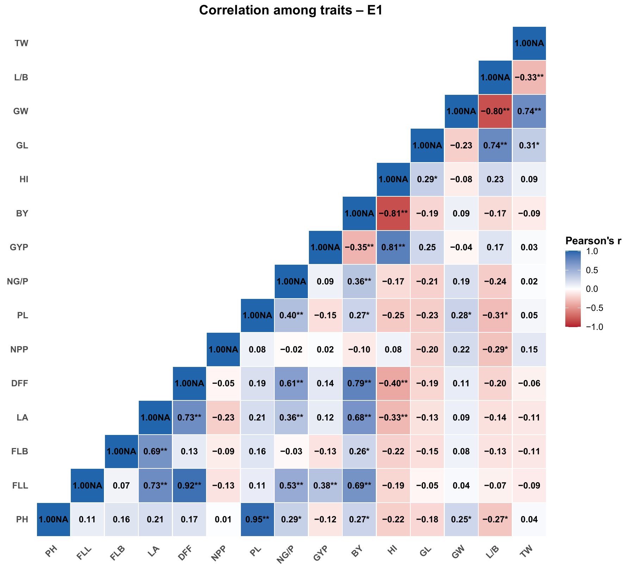
PH, plant height; FLL, flag-leaf length; FLB, flag-leaf breadth; LA, leaf area; DFF, days to 50% flowering; NPP, number of panicles per plant; PL, panicle length; NG/P, grains per panicle; GYP/GY, grain yield per plant; BY, biological yield per plant; HI, harvest index; GL, grain length; GW/GB, grain breadth; L/B, length/breadth ratio; TW, test weight. *P < 0.05; **P < 0.01. “NA” attached to diagonal values is a plotting-label artefact and does not represent missing data.

3.2 Phenotypic clustering and divergence
Hierarchical clustering resolved the 60 genotypes into five groups (Figure 2; Table 2). Cluster I was the largest (19 genotypes), followed by Cluster III (14), Cluster IV (10), Cluster V (9) and Cluster II (8). The clusters contained mixtures of advanced breeding lines and named cultivars, showing that the observed phenotypic grouping was not determined solely by the genotype naming series.
Table 2. Cluster composition and within-cluster distance of 60 rice genotypes.
Cluster | n | Intra-cluster distance | Genotypes
1 | 19 | 4.012 | UPR-4466-13-1-1-1, UPR-4571-2-1-1-1, UPR-4079-10-1-1-1, UPR-4084-14-1-1-1, UPR-4246-9-1-1-3, UPR-4458-4-1-1-1, UPR-4706-1-1-1-1, UPR-4714-4-1-1-1, UPR-4466-2-1-1-1, CGIL-96-2, CGIL-1419-1, CGIL-754-3, CGIL-908-3, CGIL-918-3, BINDATI, PSD 17, TRAORI, PD 28, PSD 27
2 | 8 | 3.667 | UPR-4572-3-1-1-1, UPR-4574-3-1-1-1, UPR-4451-7-1-1-1, UPR-4715-9-1-1-1, CGIL-853-3, CGIL-861-1, HANSRAJ, IR 24
3 | 14 | 4.063 | UPR-4088-1-1-1, UPR-4259-2-1-1-3, UPR-4707-7-1-1-1, UPR-4707-6-2-1-1, CGIL-1303-3, CGIL-1065-3, CGIL-644-2, CGIL-648-2, CGIL-936-1, CGIL-801-3, PRASAD, IR 64, GOVIND, PD 24
4 | 10 | 4.455 | UPR-4218-17-1-1-2, UPR-4257-8-1-1-1, UPR-4259-9-1-1-2, UPR-4451-2-1-1-1, UPR-4707-9-1-1-1, UPR-4713-1-1-1-1, UPR-4707-1-1-1-1, CGIL-803-1, PD 23, GOVIND BHOG
5 | 9 | 4.713 | UPR-4712-6-2-1-1, UPR-4724-10-2-1-1, CGIL-865-3, CGIL-1072-3, CGIL-718-2, CGIL-919-3, PANT BAS 1, PUSA 44, IET-4687-9-1-1-1
Within-cluster distance ranged from 3.667 in Cluster II to 4.713 in Cluster V. Thus, Cluster II was the most internally homogeneous group, whereas Cluster V showed the greatest dispersion among its members. Inter-cluster distances ranged from 4.826 to 6.885 (Table 3). The greatest separation was observed between Clusters II and IV (6.885), closely followed by Clusters II and III (6.851). The smallest distance occurred between Clusters I and II (4.826), suggesting comparatively greater phenotypic resemblance between these groups.
Table 3. Intra- (diagonal) and inter-cluster Euclidean distances among five clusters.
Cluster | I | II | III | IV | V
I | 4.012 | 4.826 | 5.682 | 5.365 | 5.337
II | 4.826 | 3.667 | 6.851 | 6.885 | 5.941
III | 5.682 | 6.851 | 4.063 | 5.085 | 5.303
IV | 5.365 | 6.885 | 5.085 | 4.455 | 5.519
V | 5.337 | 5.941 | 5.303 | 5.519 | 4.713
Figure 2. Hierarchical clustering of 60 rice genotypes based on standardized morphological traits and Euclidean distance.
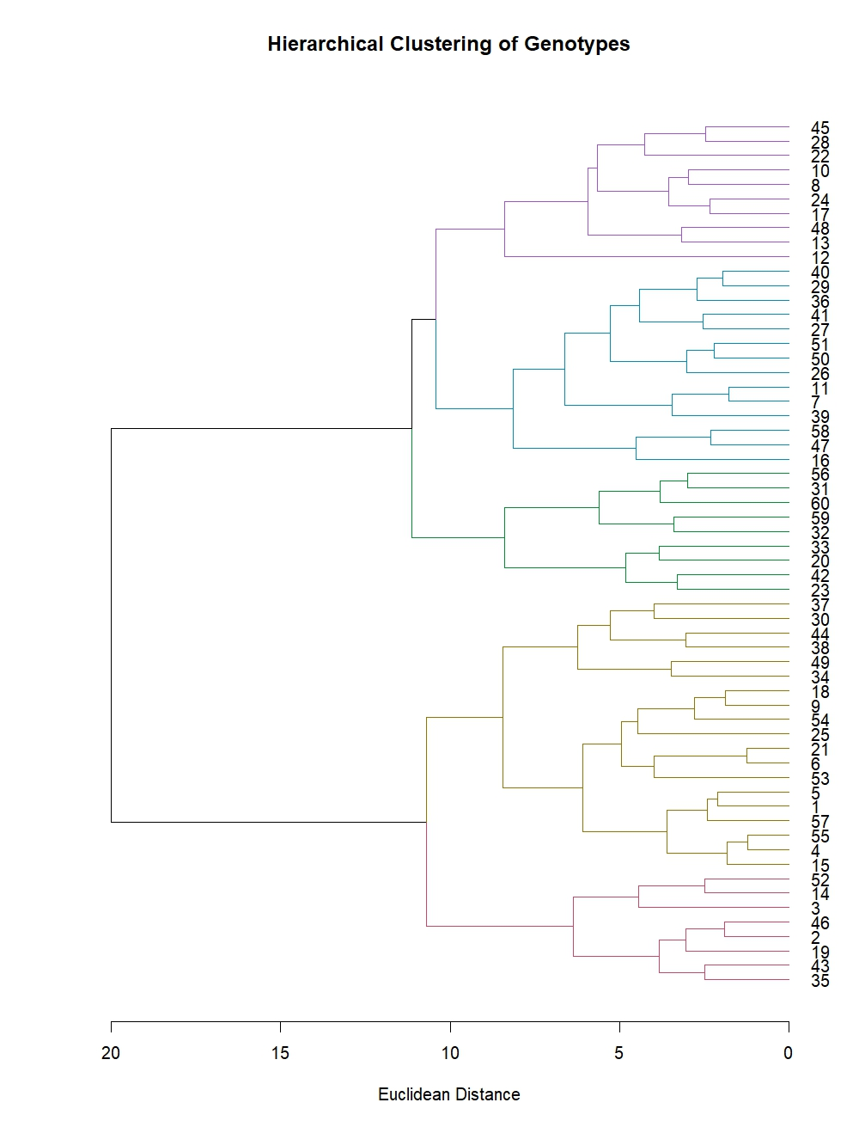
Dendrogram labels 1-60 correspond to the genotype codes reported in Table 1. Branch colours indicate the five-cluster solution.

4. Discussion
The sizeable correlations among leaf dimensions, flowering time, plant height, panicle length and biomass indicate that major components of rice phenotype did not vary independently. The strong PH-PL correlation suggests coordinated expression of plant stature and panicle architecture in this material. Likewise, the positive relationships of FLL and LA with DFF and BY indicate that later-flowering genotypes tended to develop a larger photosynthetic canopy and greater total biomass. Recent rice studies have similarly shown that yield improvement benefits from joint consideration of correlation, path effects and agro-morphological variability, although the magnitude and direction of associations depend on the germplasm and target environment (Ali et al., 2021; Singh et al., 2022; Yadav et al., 2024).
Harvest index was the trait most closely associated with grain yield. Its positive relationship with yield, coupled with the negative BY-HI relationship, suggests that efficient partitioning rather than greater biomass alone distinguished higher-yielding entries in this experiment. The negative GY-BY correlation should not be interpreted as evidence that biomass is intrinsically undesirable; it may reflect differences in maturity, partitioning or the scale used for plot measurements. Path analysis and multi-environment evaluation would be needed to distinguish direct from indirect effects. The direction and magnitude of individual associations can differ among germplasm sets, reinforcing the need to validate selection criteria in the target population and environment.
The grain-dimension correlations were biologically coherent. Longer grains produced higher L/B ratios, while broader grains lowered the ratio. Test weight was positively related to grain breadth and grain length, but negatively related to L/B, indicating that heavier samples were associated more strongly with grain width than with slenderness. Recent phenotypic-diversity assessments have likewise identified grain dimensions, grain weight and other quantitative descriptors as important sources of differentiation among rice genotypes (Hamidah et al., 2024; Quan et al., 2024). These relationships are relevant when simultaneously breeding for grain type and yield-related attributes.
Five-cluster differentiation demonstrates broad phenotypic variation within the 60-genotype panel. Recent studies using agro-morphological descriptors, Euclidean or D2 distances, principal components and molecular markers have similarly resolved rice panels into distinct groups and emphasized the use of widely separated, agronomically complementary parents (Chakravorty, 2024; Farheen et al., 2022; Fatamatuzzohoraet al., 2024; Howlader et al., 2025; Remme et al., 2024). The large distance between Clusters II and IV identifies them as contrasting parental pools. However, distance alone is not sufficient for choosing parents: breeders should select specific members of these clusters only after comparing cluster means, individual adjusted means, adaptation, grain quality and the direction of target traits. This qualification is important because the supplied dataset contains cluster memberships and distances but not cluster means for the 15 traits.
The study was conducted in one environment with two replications, so the results characterize phenotypic divergence under Pantnagar conditions in 2023. Multi-location and multi-year evaluation would clarify the stability of the observed trait relationships, while integration with molecular-marker information would improve inference about the genetic basis of the phenotypic groups. Morphological characterization nevertheless provides an efficient preliminary screen and can guide the construction of smaller, contrasting sets for subsequent breeding and genomic analysis.

5. Conclusion
The study identified measurable phenotypic diversity among 60 rice genotypes evaluated for 15 morphological and yield-related traits under Pantnagar conditions in 2023. Grain yield was most strongly associated with harvest index, suggesting the importance of biomass partitioning in this set of materials. Biological yield was associated with flowering time, leaf traits, plant height, panicle length and grains per panicle. Hierarchical clustering separated the genotypes into five groups, with the widest divergence observed between Clusters II and IV. These clusters may provide useful contrasting material for parental selection, provided that individual genotype performance, trait means, adaptation and grain quality are further evaluated. The findings provide a preliminary phenotypic basis for germplasm classification and future breeding work.

Declaration of AI Use

This manuscript was prepared through the combined contributions of all author(s), including contributions to the study design, data, content development, results, interpretation, and related scholarly work. The author(s) acknowledge the use of Grammarly and ChatGPT to assist with grammar checking, language refinement, reference formatting. These AI-assisted tools were not used as authors and did not replace the intellectual contributions or scholarly judgment of the author(s). All AI-assisted outputs, including content, references, and interpretations, were carefully reviewed, revised, verified, and approved by the author(s). The author(s) accept full responsibility for the accuracy, integrity, and final content of the manuscript.

Conflict of interest
The authors declare no conflict of interest.

Data availability
The phenotypic data supporting this study are available from the corresponding author on reasonable request.

References
Ali, S. S., Suresh, B. G., & Lavanya, G. R. (2021). Genetic diversity and correlation studies in rice (Oryza sativa L.). International Journal of Chemical Studies, 9(1), 2768-2772. https://doi.org/10.22271/chemi.2021.v9.i1am.11643
Ashfaq, M., Khan, A. S., Khan, S. H. U., & Ahmad, R. (2012). Association of various morphological traits with yield and genetic divergence in rice (Oryza sativa L.). International Journal of Agriculture & Biology, 14, 55-62.
Chakravorty, A. (2024). Genetic diversity analysis in some lowland rice landraces using agro-morphological traits. Applied Biological Research, 26(2), 246-252. https://doi.org/10.48165/abr.2024.26.01.28
Farheen, M., Murthy, K. G. K., Mohan, Y. C., & Kumar, J. H. (2022). Genetic diversity analysis for yield and morpho-physiological traits in elite rice (Oryza sativa L.) genotypes under semi-dry system through D2 statistics. International Journal of Environment and Climate Change, 12(11), 827-835. https://doi.org/10.9734/ijecc/2022/v12i1131045
Fatamatuzzohora, M., Islam, M. S., Rabbee, M. F., Hossain, M. S., Kang, S. G., & Matin, M. N. (2024). Genetic variation, population structure, and cluster analysis of rice (Oryza sativa L.) genotypes using morphological characteristics and molecular markers. Cereal Research Communications, 52(4), 1751-1768. https://doi.org/10.1007/s42976-024-00569-5
Hamidah, Sunaryo, W., Rusdiansyah, &Nurhasanah. (2024). Genetic diversity and cluster analysis of local pigmented rice from East and North Kalimantan, Indonesia based on quantitative and qualitative characters. Biodiversitas, 25(5), 1938-1945. https://doi.org/10.13057/biodiv/d250510
Hien, N. L., Sarhadi, W. A., Oikawa, Y., & Hirata, Y. (2007). Genetic diversity of morphological responses and the relationships among Asian aromatic rice (Oryza sativa L.) cultivars. Tropics, 16(4), 343-355. https://doi.org/10.3759/tropics.16.343
Howlader, N. C., Bulbul, M. T. A., Islam, M. Z., Arafat, E., Hasan, M. Z., & Rana, M. S. (2025). Assessing rice genotypes based on agro-morphological characterization and diversity analysis in southern Bangladesh. Discover Plants, 2, Article 189. https://doi.org/10.1007/s44372-025-00253-w
Islam, M. Z., Chakrabarty, T., Akter, N., Khalequzzaman, M., Prince, M. F. R. K., Pittendrigh, B. R., Tomita, M., & Ali, M. P. (2025). Genetic variability, correlation and path coefficient analysis of phenotypic traits and genetic diversity of Aman rice landraces (Oryza sativa L.). Scientific Reports, 15, Article 18606. https://doi.org/10.1038/s41598-025-03547-x
Kumar, B., Singh, M. K., Kumari, N., Kumari, S., Banshidhar, & Singh, D. (2024). Variability assessment and screening of superior rice (Oryza sativa L.) genotypes for grain micronutrients and yield components. Electronic Journal of Plant Breeding, 15(3), 794-800. https://doi.org/10.37992/2024.1503.088
Kumari, N., Singh, M. K., Kumar, B., Kumari, S., Banshidhar, & Singh, D. (2025). Genetic divergence in rice genotypes for grain micronutrients and yield. International Journal of Plant and Environment, 11(3), 630-635. https://doi.org/10.18811/ijpen.v11i03.22
Kumari, S., Kumari, N., Singh, M. K., & Kumar, B. (2023). Variability assessment for yield component and protein content in chickpea (Cicer arietinum L.) genotype. The Pharma Innovation Journal, 12(2), 578-582.
Murtagh, F., & Legendre, P. (2014). Ward's hierarchical agglomerative clustering method: Which algorithms implement Ward's criterion? Journal of Classification, 31(3), 274-295. https://doi.org/10.1007/s00357-014-9161-z
Pearson, K. (1895). Note on regression and inheritance in the case of two parents. Proceedings of the Royal Society of London, 58, 240-242. https://doi.org/10.1098/rspl.1895.0041
Quan, C., Li, S., Li, H., Yu, W., & Jin, J. (2024). Genetic diversity study of phenotypic traits of 73 rice varieties approved in Jilin Province. Crops, 40(3), 64-75. https://doi.org/10.16035/j.issn.1001-7283.2024.03.009
Remme, R. N., Joti, S., & Islam, M. Z. (2024). Agro-morphological characterization and genetic diversity assessment of nineteen BRRI-released rice varieties. Khulna University Studies, 21(1), 84-97. https://doi.org/10.53808/KUS.2024.21.01.978-ls
Singh, S., Dixit, S., Tarkeshwar, Yadav, K., & Dutt, A. (2022). Direct and indirect effect computed between different phenotypic and genotypic level of yield relatable traits in rice (Oryza sativa L.) under sodic soil. The Pharma Innovation Journal, 11(7), 692-697. https://doi.org/10.22271/tpi.2022.v11.i7i.13732
Sinha, A. K., & Mishra, P. K. (2013). Morphology-based multivariate analysis of phenotypic diversity of landraces of rice (Oryza sativa L.) of Bankura district of West Bengal. Journal of Crop and Weed, 9(2), 115-121.
Vanlalrinngama, C., Jha, B., Singh, S. K., Tigga, A., Kumar, B., Kumari, N., & Singh, M. K. (2023a). Trait association studies in diverse genotypes of rice for their utilization in biofortification. Environment Conservation Journal, 24(3), 152-156. https://doi.org/10.36953/ECJ.14472440
Vanlalrinngama, C., Jha, B., Singh, S. K., Tigga, A., Kumar, B., Kumari, N., & Singh, M. K. (2023b). Variability and divergence studies on rice genotypes for micronutrient potential and its utility in biofortification. Environment Conservation Journal, 24(1), 151-156. https://doi.org/10.36953/ECJ.10662286
Yadav, S. P. S., Bhandari, S., Ghimire, N. P., Mehata, D. K., Majhi, S. K., Bhattarai, S., Shrestha, S., Yadav, B., Chaudhary, P., & Bhujel, S. (2024). Genetic variability, character association, path coefficient, and diversity analysis of rice (Oryza sativa L.) genotypes based on agro-morphological traits. International Journal of Agronomy, 2024, Article 9946332. https://doi.org/10.1155/2024/9946332

