Case report
Bleomycin-induced flagellate erythema in a patient with classic Kaposi’s sarcoma: report of a rare adverse effect
ABSTRACT
Aims: To report a rare, bleomycin-specific cutaneous adverse effect — flagellate erythema — occurring early in a patient treated for classic Kaposi’s sarcoma, and to review its clinical features, pathogenesis and management.
Presentation of Case: A 61-year-old HIV-negative man with no relevant history presented with one year of slowly enlarging angiomatous nodules and infiltrated erythemato-violaceous plaques on the lower limbs and right wrist, without mucosal or nodal involvement. Skin biopsy showed irregular vascular slits dissecting collagen with a perivascular mononuclear infiltrate, and immunohistochemistry was positive for HHV-8, confirming Kaposi’s sarcoma. An extension work-up (HIV serology, thoraco-abdomino-pelvic computed tomography and lymph-node ultrasonography) excluded visceral involvement. Intramuscular bleomycin monochemotherapy was started. Four days after the first 5-mg injection, the patient developed a pruritic maculopapular eruption on the trunk, back and proximal limbs, with linear “whip-like” streaks on the back and buttocks, typical of flagellate erythema. Pharmacovigilance causality assessment strongly implicated bleomycin (I4B4). The rash resolved completely within one week of antihistamine therapy, without residual hyperpigmentation.
Discussion: Flagellate erythema, first described in 1970, is an uncommon but characteristic reaction attributed to the low cutaneous activity of bleomycin hydrolase, with microtrauma and a heat-recall phenomenon proposed as triggers. It arises independently of dose and route, with a latency from a few hours to six months, and is diagnosed clinically. Management relies on antihistamines and corticosteroids, usually without discontinuing bleomycin.
Conclusion: Flagellate erythema is a specific and potentially early complication of bleomycin that warrants close cutaneous monitoring of treated patients.
Keywords: Bleomycin; flagellate erythema; flagellate dermatitis; Kaposi’s sarcoma; cutaneous drug reaction; pharmacovigilance; case report.
1. INTRODUCTION
Bleomycin, originally isolated from the fungus Streptomyces verticillus, is a chemotherapeutic agent with both antibiotic and cytotoxic properties; its oxidative activity induces DNA strand breaks that lead to cell death (Pasquet et al., 2009). It is used to treat several malignancies, including cutaneous squamous cell carcinomas, malignant lymphomas, germ cell tumours and Kaposi’s sarcoma, and is also employed topically for keloid scars and plantar warts (Lahlou et al., 2018).
Cutaneous adverse effects of bleomycin are frequent and diverse, but some are rare and highly specific to the drug. Flagellate erythema — also termed flagellate dermatitis — is one such reaction, characterised by linear, “whip-like” erythematous streaks (Moulin et al., 1970). We report a case of bleomycin-induced flagellate erythema occurring early after the first injection in a patient treated for classic Kaposi’s sarcoma, and we review the clinical features, pathogenesis and management of this uncommon complication.
2. PRESENTATION OF CASE
A 61-year-old man with no notable medical history and no personal or family history of atopy presented with angiomatous nodules of the lower limbs that had been slowly enlarging for one year.
Dermatological examination revealed infiltrated erythemato-violaceous plaques together with painless, non-pruritic angiomatous nodules on both lower limbs, as well as similar lesions over the right wrist. There was no mucosal involvement and no palpable lymphadenopathy, and the remainder of the physical examination was unremarkable. The disease was classified as stage II according to the Brambilla classification of classic Kaposi’s sarcoma (Fig. 1).
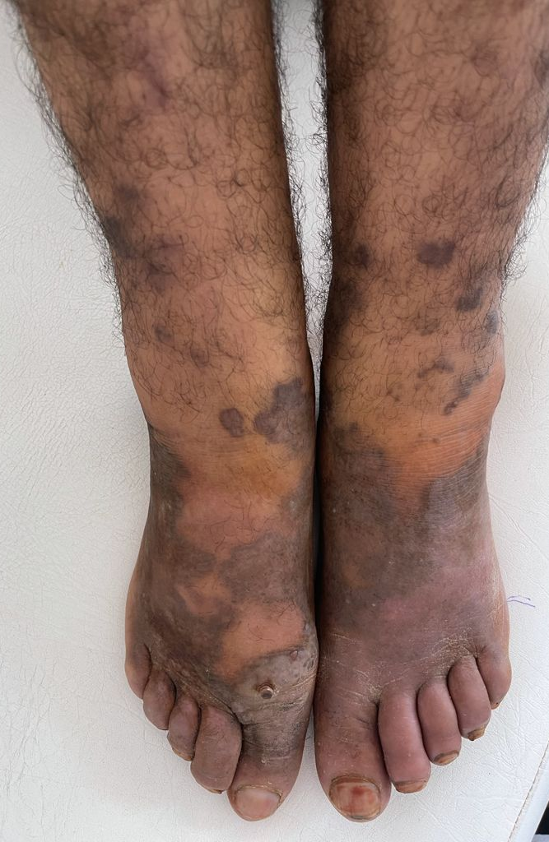
Fig. 1. Infiltrated erythemato-violaceous plaques and angiomatous nodules on the lower limb (classic Kaposi’s sarcoma, Brambilla stage II).

Histopathological examination of a skin biopsy showed a dermis containing numerous irregular vascular slits dissecting collagen bundles, lined by mildly atypical endothelial cells and associated with a perivascular infiltrate of mononuclear inflammatory cells, consistent with Kaposi’s sarcoma. The diagnosis was confirmed by immunohistochemistry, with positive nuclear staining for anti-HHV-8 antibodies (Fig. 2).

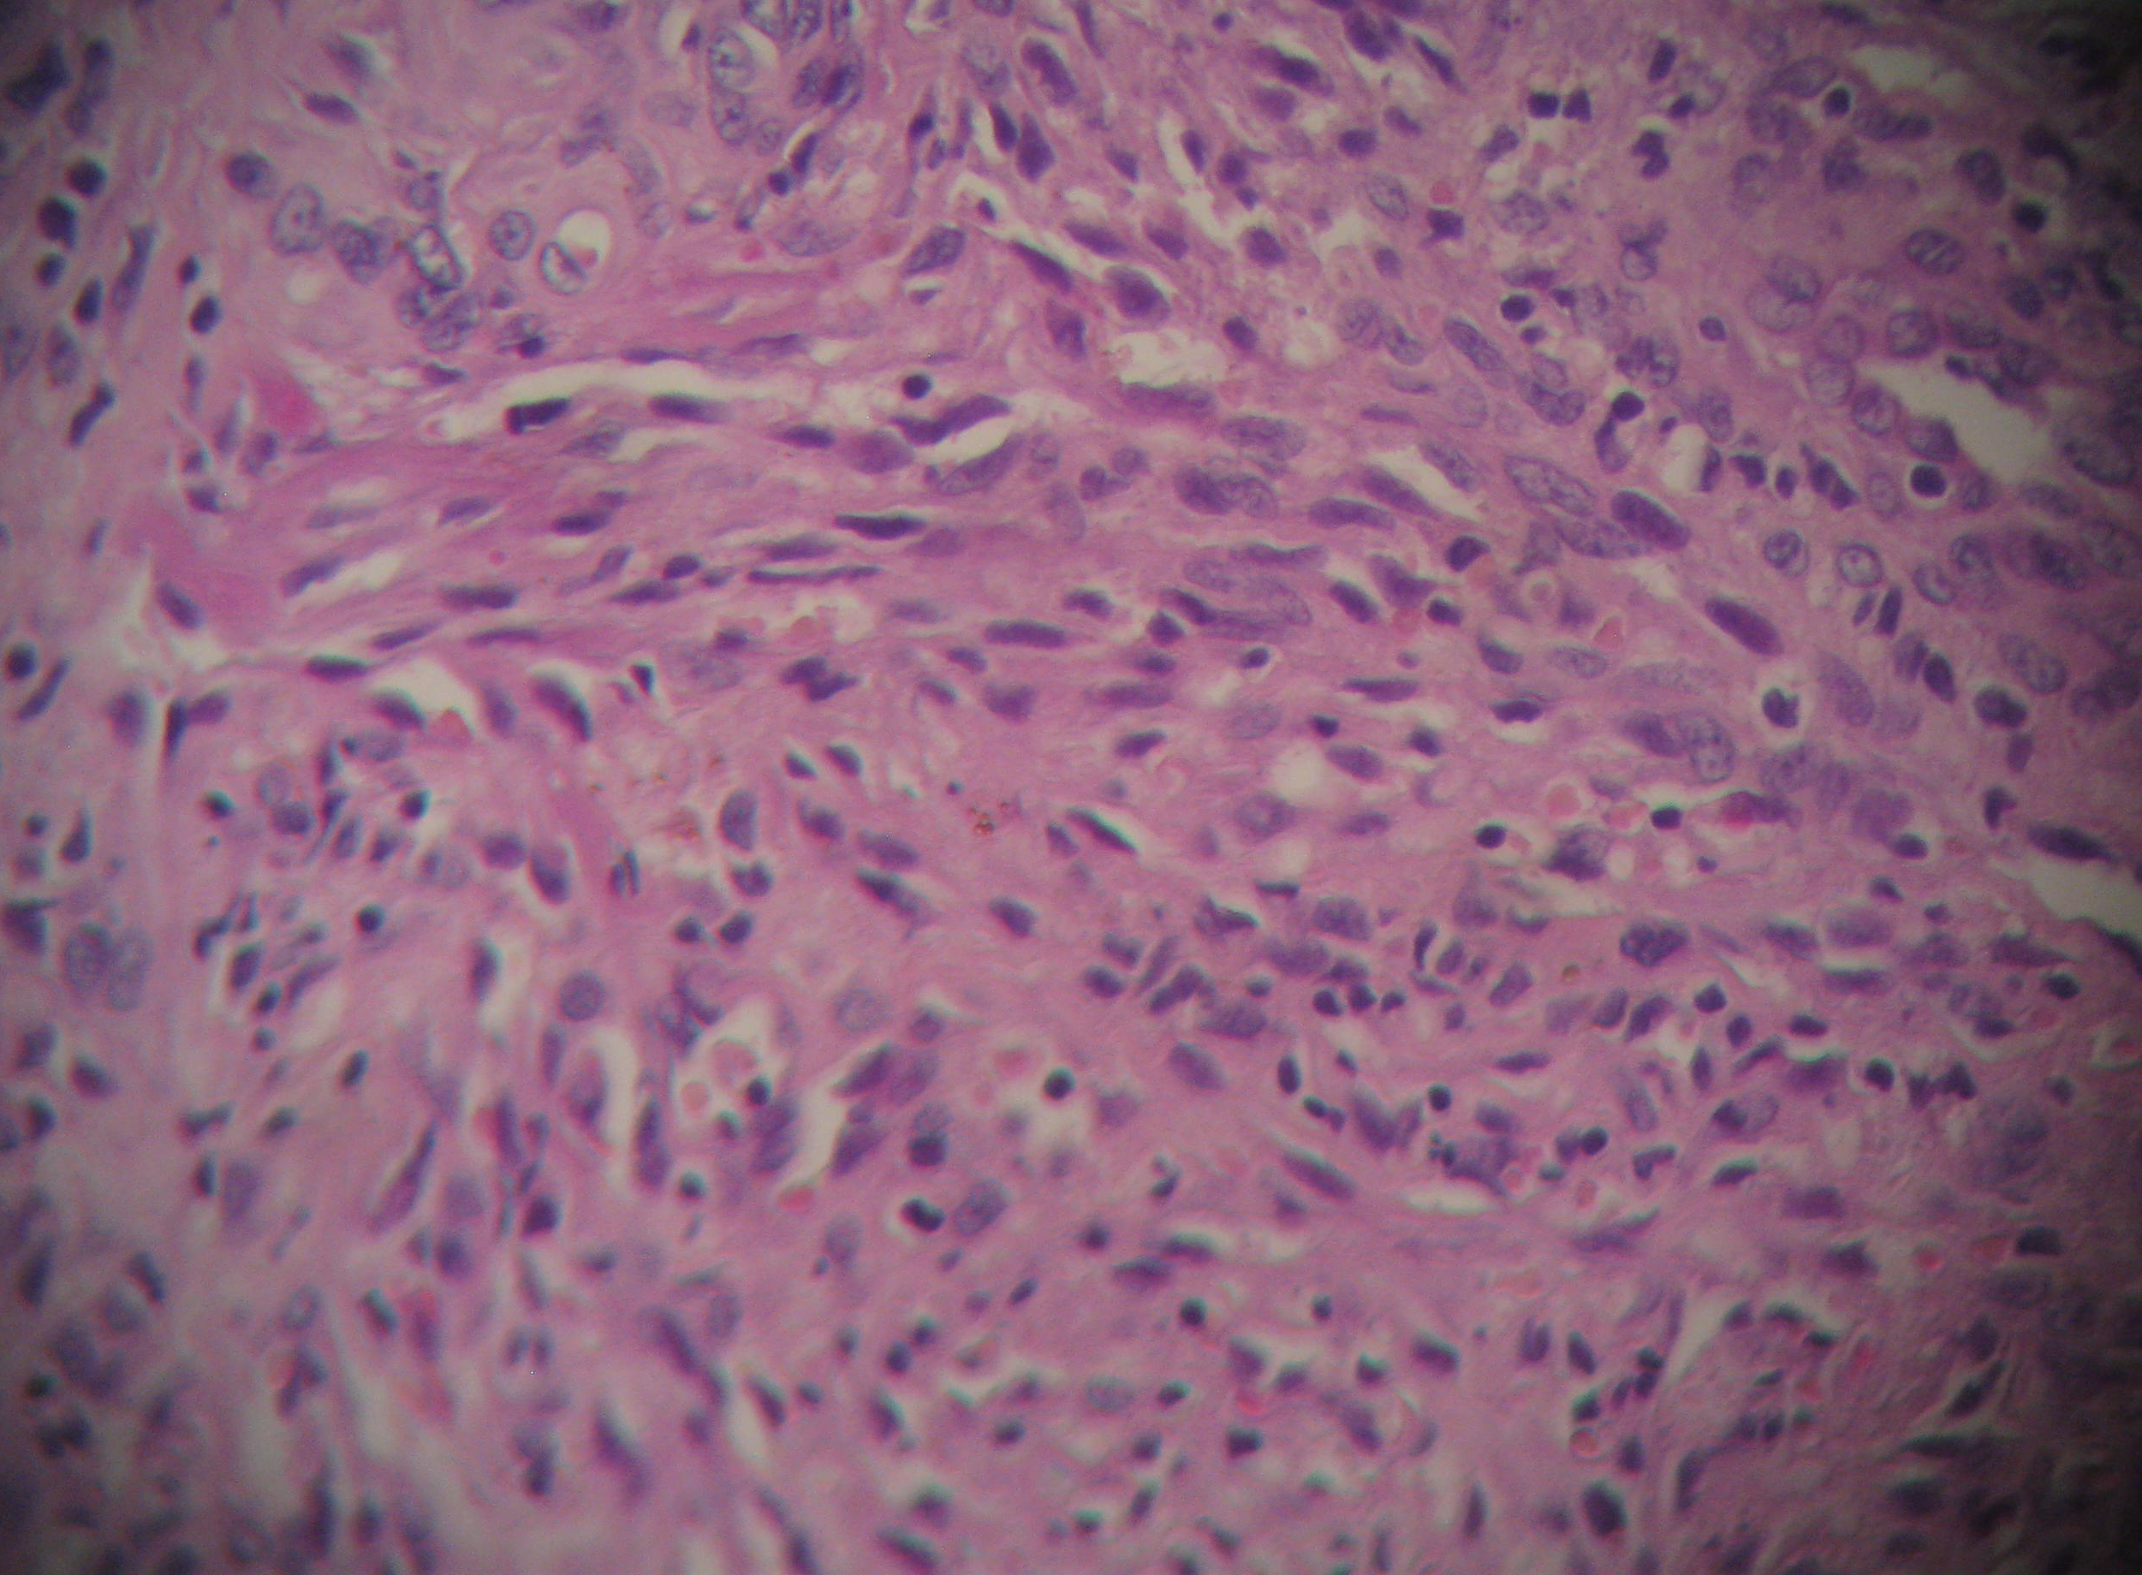
Fig. 2. Skin biopsy showing irregular vascular slits dissecting the dermal collagen, lined by endothelial cells, with a perivascular mononuclear infiltrate (haematoxylin–eosin). Inset: positive nuclear immunostaining for anti-HHV-8.

The extension work-up was negative: HIV serology was negative, and thoraco-abdomino-pelvic computed tomography and lymph-node ultrasonography showed no evidence of secondary visceral involvement.
After a normal pre-therapeutic assessment, bleomycin monochemotherapy was initiated by intramuscular injection at a dose of 15 mg every 15 days (three 5-mg injections on three consecutive days), without exceeding a total cumulative dose of 300 mg; the intramuscular route allowed ambulatory management.
Four days after the first intramuscular injection, the patient developed a pruritic maculopapular rash predominating on the trunk, the back and the proximal limbs. On the back and gluteal region, the lesions took on a linear, “whip-like” configuration consistent with flagellate erythema (Fig. 3).

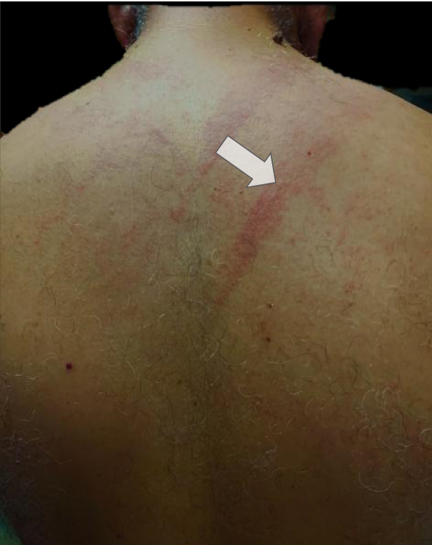

Fig. 3. Linear, “whip-like” erythematous streaks on the back four days after the first intramuscular bleomycin injection (flagellate erythema; white arrow).

The event was reported to the national poison control and pharmacovigilance centre; intrinsic and extrinsic causality assessment attributed a high probability to bleomycin (imputability score I4B4). The eruption resolved completely within one week of antihistamine therapy, with no residual post-inflammatory hyperpigmentation (Fig. 4).

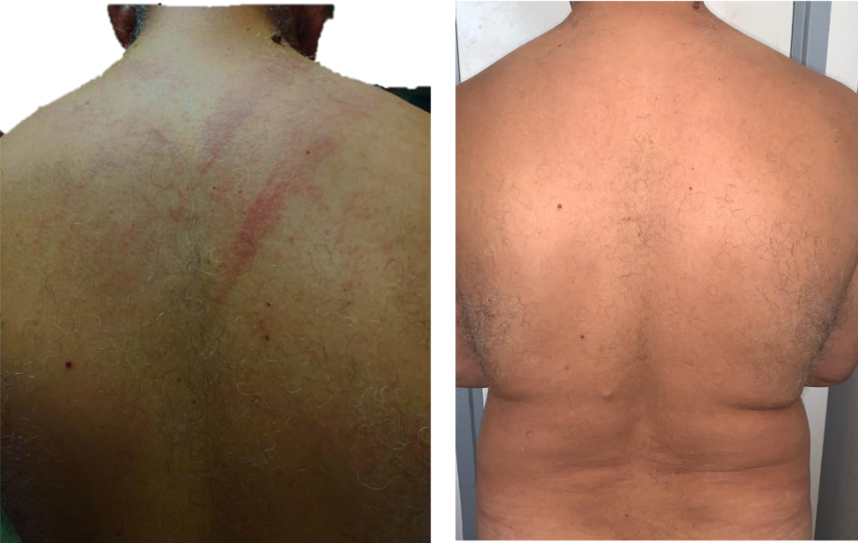
Fig. 4. Complete resolution of the eruption after one week of antihistamine therapy, without residual post-inflammatory hyperpigmentation.
3. DISCUSSION
Kaposi’s sarcoma is an angioproliferative disorder first described by the dermatologist Moritz Kaposi in 1872. It is a multifocal, hyperplastic proliferation with a dual vascular and fibroblastic component and cutaneous, mucosal and visceral expression, causally associated with human herpesvirus 8 (HHV-8) (Cesarman et al., 2019). Four epidemiological forms are recognised — classic (Mediterranean), endemic (African), iatrogenic and epidemic (HIV-associated) — with a spectrum ranging from indolent locoregional disease to disseminated, aggressive forms (Lebbé et al., 2019). Our patient, an older HIV-negative man with indolent lower-limb lesions and no visceral involvement, corresponds to the classic form. Because HIV-associated disease must be excluded, systematic HIV screening is warranted in any patient presenting with Kaposi’s sarcoma.
Therapeutic options range from watchful waiting for indolent disease to local therapies (surgical excision, cryotherapy, radiotherapy, intralesional chemotherapy) and systemic treatments; among the agents used as monochemotherapy, bleomycin is one of the most frequently employed (Lebbé et al., 2019). After administration, bleomycin is rapidly inactivated in most tissues by the enzyme bleomycin hydrolase. The skin and lungs are relatively deficient in this enzyme, which explains why they are the elective sites of expression of its toxicity (Pasquet et al., 2009).
Flagellate erythema was first described in 1970 (Moulin et al., 1970). It is an uncommon but characteristic adverse effect that, according to some authors, may complicate up to 20% of bleomycin treatments (Cullingham & Kost, 2021; Lahlou et al., 2018). It is considered specific to bleomycin, although it has also been reported with peplomycin, a bleomycin derivative, and described in association with dermatomyositis and adult-onset Still’s disease. Its occurrence is independent of the route of administration, the nature or histological type of the treated lesion, and the cumulative dose received (Pasquet et al., 2009); reactions have been reported after cumulative doses as low as 15 mg, and typically between 90 and 285 mg (Lahlou et al., 2018). In our patient the eruption appeared strikingly early — only four days after a single 5-mg injection — underscoring that even minimal exposure can trigger the reaction.
The interval between administration and onset ranges from a few hours to six months. Diagnosis remains clinical: flagellate erythema presents as intermingled, linear erythematous streaks resembling whip marks, which may be widespread and oedematous or localised, and which predominate on the trunk and proximal limbs (Salmi & Errihani, 2016). In our observation, the clinical presentation and distribution were consistent with previously reported data. The reaction has been described across diverse indications, including chemotherapy for lymphoma, intrapleural instillation for malignant effusion, intralesional treatment of plantar warts, and — as in our case — Kaposi’s sarcoma.
The pathogenesis remains debated. The leading hypothesis is the local deficiency of bleomycin hydrolase in the skin, leading to cutaneous accumulation of the drug. In addition, any dermographic stimulus such as intense pruritus or minor trauma (scratching) may act as a trigger by inducing vasodilation, extravasation and increased local accumulation of the drug (Mota et al., 2014). A particular “heat-recall” phenomenon — reappearance of flagellate erythema in a previously affected area after heat exposure — has also been proposed; accordingly, cooling of previously affected areas before chemotherapy may be useful (Mota et al., 2014).
Management of bleomycin-induced flagellate erythema relies on antihistamines and/or topical corticosteroids, and bleomycin does not necessarily need to be discontinued. A short course of oral corticosteroids (for example, prednisolone 40–60 mg/day) may be used for extensive, intensely pruritic and poorly tolerated eruptions that are nonetheless not life-threatening. Permanent post-inflammatory hyperpigmentation of the affected area is a frequent sequela (Mota et al., 2014); notably, our patient’s lesions resolved completely without residual pigmentation, a favourable outcome probably related to the localised nature of the eruption and prompt symptomatic treatment.
Beyond flagellate erythema, bleomycin can induce a range of cutaneous adverse effects. Some, such as alopecia, are common to many chemotherapies, whereas others are more characteristic of bleomycin, including hyperpigmentation over pressure areas and the nails (melanonychia), sclerodermoid plaques, digital necrosis complicating Raynaud’s phenomenon, and neutrophilic eccrine hidradenitis. Awareness of this spectrum helps clinicians recognise and manage these reactions appropriately.
4. CONCLUSION
Bleomycin-induced flagellate erythema is a distinctive cutaneous adverse reaction that may occur early and does not necessarily depend on cumulative dose or route of administration. In this patient with classic Kaposi’s sarcoma, the eruption appeared four days after the first intramuscular bleomycin injection and resolved within one week with antihistamine therapy. Recognition is mainly clinical, supported by the characteristic linear whip-like erythematous streaks and compatible drug exposure. The case highlights the importance of close dermatological monitoring during bleomycin therapy and timely symptomatic management to avoid unnecessary diagnostic delay or inappropriate treatment interruption.

Limitations
This report describes a single patient, so general conclusions about incidence, recurrence risk or optimal management cannot be drawn. Long-term follow-up after resolution of the eruption is not detailed, and the outcome after continued or repeated bleomycin exposure is not reported. The diagnosis was clinical and supported by pharmacovigilance assessment, without skin biopsy of the erythematous eruption

COMPETING INTERESTS
Authors have declared that no competing interests exist.
CONSENT
All authors declare that written informed consent was obtained from the patient for publication of this case report and the accompanying images. A copy of the written consent is available for review by the Editorial Office/Chief Editor/Editorial Board members of this journal.
ETHICAL APPROVAL
All authors hereby declare that all procedures were performed in accordance with the ethical standards of the responsible institutional committee and with the 1964 Declaration of Helsinki. The reporting of this single case complies with the STROBE recommendations for observational studies.
Declaration of AI Use

This manuscript was prepared through the combined contributions of all author(s), including contributions to the study design, data, content development, results, interpretation, and related scholarly work. The author(s) acknowledge the use of Grammarly and ChatGPT to assist with grammar checking, language refinement, reference formatting. These AI-assisted tools were not used as authors and did not replace the intellectual contributions or scholarly judgment of the author(s). All AI-assisted outputs, including content, references, and interpretations, were carefully reviewed, revised, verified, and approved by the author(s). The author(s) accept full responsibility for the accuracy, integrity, and final content of the manuscript.

REFERENCES
1. Pasquet, F., Pavic, M., Estival, J.-L., Karkowski, L., & Debourdeau, P. (2009). Flagellar erythema: a rare complication of bleomycin. The Review of Internal Medicine, 30(7), 637–639. https://doi.org/10.1016/j.revmed.2008.08.005
2. Lahlou, A., Galouj, S., & Mernissi, F. Z. (2018). Flagellated erythema secondary to bleomycin: about two observations. Pan African Medical Journal, 30, 263. https://doi.org/10.11604/pamj.2018.30.263.10158
3. Moulin, M. M. J., Fière, B., & Beyvin, A. (1970). Bleomycin-induced skin pigmentation. Bulletin de la Société Française de Dermatologie et de Syphiligraphie, 77, 293–296.
4. Jesarman, E., Damania, B., Crown, S. E., Martin, J., Bower, M., & Whitby, D. (2019). Kaposi sarcoma. Nature Reviews Disease Primers, 5(1), 9. https://doi.org/10.1038/s41572-019-0060-9
5. Lebbé, C., Garbe, C., Stratigos, A. J., Harwood, C., Peris, K., Del Marmol, V., … Grob, J.-J. (2019). Diagnosis and treatment of Kaposi’s sarcoma: European consensus-based interdisciplinary guideline (EDF/EADO/EORTC). European Journal of Cancer, 114, 117–127. https://doi.org/10.1016/j.ejca.2018.12.036
6. Cullingham, K., & Kost, G. (2021). A case of bleomycin-induced flagellate dermatitis: A case report. SAGE Open Medical Case Reports, 9, 2050313X211039476. https://doi.org/10.1177/2050313X211039476
7. Salmi, N., & Errihani, H. (2016). Bleomycin-induced flagellated dermatosis: a new clinical case. Pan African Medical Journal, 25, 86. https://doi.org/10.11604/pamj.2016.25.86.9784
8. Mota, G. D., Penna, A. M. D., Soares, R. C., & Baiocchi, O. C. G. (2014). Bleomycin-induced flagellate dermatitis. Brazilian Journal of Hematology and Hemotherapy, 36(4), 297–299. https://doi.org/10.1016/j.bjhh.2014.03.011

