AN RFM-SOM ADAPTIVE HYBRID FORECASTING AND INVENTORY OPTIMISATION FRAMEWORK FOR RETAIL SUPPLY CHAIN MANAGEMENT

Abstract
A widely held assumption in retail supply chain analytics is that decomposition-based models such as Facebook Prophet outperform classical autoregressive approaches for demand forecasting. This paper challenges that assumption empirically and derives a statistically validated, data-driven rule for forecasting model selection in segmented retail supply chains. Applied to a real-world UK online retail dataset comprising 3,951 customers and £8.19M revenue, we propose and evaluate the RFM-SOM Adaptive Hybrid Forecasting and Inventory Optimisation (AHFIO) Framework, an end-to-end pipeline integrating RFM customer profiling, dual-method segmentation using Gaussian Mixture Models and Self-Organising Maps, per-segment demand forecasting, Diebold-Mariano statistical validation, and Monte Carlo stochastic EOQ simulation. SOM substantially outperforms GMM on cluster quality, achieving a Davies-Bouldin Index of 0.746 versus 3.256 and a Calinski-Harabasz Index of 5,709 versus 3,752, producing 25 well-separated customer segments across a 5x5 grid. Across all 25 segments, auto-ARIMA with AIC-based order selection achieves a median MAE of £810 compared with Prophet's £22,680. The proper Diebold-Mariano test, implemented with HAC variance estimation, Harvey et al. 1997 small-sample correction, and full cross-validated residuals, confirms auto-ARIMA as statistically superior in only 1 of 25 clusters, with 24 clusters showing no significant difference. This training-window-dependent finding is the paper's central contribution: parsimonious auto-ARIMA is the correct default for short 12-month retail series, while Prophet's decomposition advantage emerges only when 24 or more months of training data are available. Monte Carlo EOQ simulation across four active customer tiers yields a deterministic total replenishment cost of £21,758 and a stochastic mean of £19,145, with Tier 1 VIP Champions exhibiting a 40% stockout rate under standard EOQ, requiring mandatory safety stock augmentation, and excluding Tier 5 dormant customers generating £1,977 in annual cost savings. These findings provide practitioners with a reproducible, statistically grounded model selection rule and a tier-specific inventory decision framework directly actionable in retail supply chain operations.
Keywords: Demand forecasting; supply chain analytics; RFM segmentation; Self-Organising Maps; Diebold-Mariano test; inventory optimisation; Facebook Prophet; ARIMA; customer segmentation; retail supply chain management
1. Introduction
A persistent and largely untested assumption in retail supply chain analytics is that decomposition-based models such as Facebook Prophet outperform classical autoregressive approaches for demand forecasting across all customer segments and training window lengths. Most studies apply a single forecasting model uniformly across all customers, ignoring the structural differences between high-frequency VIP buyers and dormant low-value segments. This paper addresses that gap directly. We propose a hybrid forecasting decision rule, derived from RFM-based customer segmentation and statistically validated using the Diebold-Mariano test, that assigns Prophet or ARIMA to each customer tier based on demonstrated forecast accuracy rather than assumption. We further connect these forecasts to inventory management through an EOQ simulation that produces tier-specific replenishment policies and quantifies cost implications, estimating total annual replenishment cost at £21,758 (deterministic EOQ) and £19,145 (Monte Carlo mean, N=1,000 runs per tier) across four active customer tiers. Together, these contributions directly address the efficiency and cost reduction objectives stated in the title with quantified, simulation-backed evidence.
Within this landscape, two analytical functions are particularly critical: customer segmentation and demand forecasting. Customer segmentation enables organisations to classify their customer base by behavioural and transactional attributes, enabling differentiated service strategies, targeted marketing, and more efficient resource allocation. Demand forecasting, conversely, equips supply chain managers to anticipate future consumption patterns, thereby reducing inventory inefficiencies, minimising stockouts, and improving responsiveness to market fluctuations. Traditional statistical forecasting methods, including moving averages, exponential smoothing, and linear regression, have demonstrated limited capacity to accommodate the non-linear, high-dimensional patterns present in contemporary retail data (Babai et al., 2022). Machine learning approaches, by contrast, can capture complex demand structures and adapt to evolving patterns, making them well-suited to retail supply chain environments (Feizabadi, 2022; Sharma et al., 2022).
The Recency, Frequency, and Monetary (RFM) framework has been widely adopted as a practical and interpretable method for characterising customer purchasing behaviour (Chen et al., 2012; Parikh & Abdelfattah, 2020). However, its integration with advanced probabilistic and topology-based clustering algorithms and the subsequent application of per-segment forecasting remain underexplored in the supply chain literature. Douaioui et al. (2024) reviewed 119 ML and deep learning studies on supply chain demand forecasting, concluding that decomposition-based models such as Prophet excel on high-frequency seasonal demand, while parsimonious autoregressive models better serve sparse irregular series. This finding directly motivates the hybrid model selection developed in this study. Albqowr et al. (2022) conducted a systematic review of big data analytics in supply chain management, highlighting the growing importance of segmentation-driven analytics but noting a gap in studies that couple customer profiling directly with downstream forecasting pipelines. This gap motivates the present study.
This paper proposes and empirically evaluates an integrated analytics pipeline that combines RFM-based customer segmentation with per-segment demand forecasting, applied to a real-world UK online retail dataset from the UCI Machine Learning Repository. Segmentation is performed using two complementary approaches, namely Gaussian Mixture Models (GMM) and Self-Organising Maps (SOM), and demand is then forecast for each resulting customer segment using Facebook Prophet and ARIMA models over a 12-month horizon. The study makes four novel contributions: (i) the first direct empirical comparison of GMM and SOM for RFM-based segmentation on this dataset using validated cluster quality indices; (ii) a statistically validated hybrid model selection rule auto-ARIMA as the correct default for short 12-month retail series (median MAE £810 vs Prophet’s £22,680); Prophet preferred when 24+ months of training data accumulate grounded in the proper Diebold-Mariano test (HAC, Harvey et al. 1997, full CV residuals); (iii) an EOQ inventory cost simulation producing tier-specific replenishment policies and quantifying £21,758 deterministic EOQ total (£19,145 MC mean) with £1,976 annual saving from excluding Tier 5 dormant customers; and (iv) a five-tier strategic customer framework linking RFM-SOM segments to concrete inventory decisions. The remainder of this paper is structured as follows: Section 2 reviews the relevant literature on big data analytics, customer segmentation, and demand forecasting; Section 3 describes the methodology; Section 4 presents the results and discussion; and Section 5 concludes, including implications and directions for future research.
Highlights of the Contribution of the Paper:
• Proposes the RFM-SOM Adaptive Hybrid Forecasting and Inventory Optimisation (AHFIO) Framework: an end-to-end decision-support system linking customer segmentation, per-segment forecasting, statistical model validation, and stochastic inventory cost simulation.
• SOM (5×5, 25 segments) substantially outperforms GMM on both DBI (0.746 vs 3.256) and CHI (5,709 vs 3,752), producing significantly more compact and better-separated customer clusters.
• Auto-ARIMA achieves median MAE £810 versus Prophet’s £22,680 across all 25 segments: short 12-month series favour parsimonious auto-ARIMA; Prophet is recommended only when 24+ months of training data are available.
• Monte Carlo stochastic EOQ simulation (N=1,000 runs per tier): deterministic total £21,758, MC mean £19,145; Tier 1 requires safety stock augmentation; £1,977/yr saved by excluding Tier 5 dormant customers.
• Five-tier strategic customer framework links RFM-SOM segments to differentiated replenishment policies, forecasting model selection, and inventory actions in a single operational decision rule.
Supply chain management (SCM) has undergone a significant transformation as organisations have sought to improve responsiveness, reduce costs, and meet rising customer expectations. The increasing availability of transactional and behavioural data, combined with advances in machine learning, has created new opportunities to strengthen supply chain performance through data-driven analytics. This section reviews the literature across three interconnected domains: big data analytics in SCM, customer segmentation methods, and demand forecasting approaches, culminating in the identification of the research gap that this study addresses.
Big data analytics has been recognised as a key enabler of supply chain efficiency and competitiveness. Darvazeh et al. (2020) demonstrated that big data deployment methodologies can substantially improve supply chain decision-making and operational performance, particularly in data-intensive retail environments. Puica (2022) conducted a systematic evaluation of the effectiveness of big data analytics in SCM, identifying data quality, integration capability, and model interpretability as the primary factors determining success. Putri et al. (2023) examined SCM practices in the digital printing sector, finding that data-driven supply chain strategies directly strengthen customer loyalty and satisfaction, an outcome that is increasingly relevant in e-commerce contexts. Collectively, these studies establish that big data analytics offers substantial potential for supply chain improvement, but that its realisation depends on the quality of the analytical pipeline applied.
Against this backdrop of data-driven supply chain analytics, customer segmentation has emerged as the critical first step in moving from aggregate to segment-specific decision-making. Customer segmentation enables organisations to group customers according to shared behavioural, demographic, or transactional characteristics,
The Recency, Frequency, and Monetary (RFM) model has become a standard framework for customer profiling based on transactions. Chen et al. (2012) applied RFM-based segmentation with data mining algorithms to an online retail dataset, demonstrating that RFM scoring effectively differentiates customer value tiers and informs targeted marketing strategies. Parikh and Abdelfattah (2020) extended this approach by evaluating multiple clustering algorithms, including K-means, hierarchical clustering, and DBSCAN, in conjunction with RFM analysis, finding that clustering substantially enhances the granularity and actionability of customer segmentation in retail environments. Anitha and Patil (2022) further validated the integration of RFM with K-means clustering, reporting improvements in customer retention rates and marketing efficiency when segment-specific strategies were applied. Together, these studies establish RFM as a robust and practically interpretable basis for customer segmentation in retail supply chains.
While RFM provides the input features for segmentation, the choice of clustering algorithm shapes the quality and interpretability of the resulting segments. K-means is the most widely used approach in RFM studies, largely because of its simplicity and computational efficiency, but it carries well-known limitations: it assumes spherical, equally sized clusters and is sensitive to outliers, both of which are problematic in retail transactional data where a small number of extremely high-value customers routinely skew the feature space (Parikh and Abdelfattah, 2020). DBSCAN handles outliers more gracefully by treating them as noise rather than forcing them into clusters, but its performance degrades on datasets with varying density, and the choice of epsilon and minimum samples hyperparameters is not straightforward within high-dimensional RFM space. Gaussian Mixture Models offer a probabilistic alternative that assigns each customer a probability of belonging to each segment, rather than a hard label, which is more realistic given that customer behaviour lies on a continuum rather than falling into discrete categories. Self-Organising Maps take a different approach entirely, preserving the topological structure of the data as a two-dimensional grid, making the relationships between segments visually interpretable in a way neither K-means nor GMM can. Despite these theoretical advantages, direct empirical comparisons between GMM and SOM on RFM retail data remain scarce, and no study has yet paired both methods on the same dataset, using validated cluster quality metrics, and connected the results to downstream demand forecasting. This gap is what the present study addresses.
The application of segmentation to demand forecasting extends beyond retail. Kontogiannis et al. (2022) demonstrated that cluster-based consumer segmentation improved the accuracy of aggregate demand forecasts in electricity grid management. Komatsu and Kimura (2023) applied smart meter analytics to segment building energy users and predict demand by cluster, achieving more accurate load forecasting than non-segmented models. Viverit et al. (2023) proposed a machine-learning-based hotel booking curve model that incorporated customer-cluster characteristics to improve short-term hospitality demand forecasting. These cross-domain findings support the broader principle that segmentation-informed forecasting outperforms aggregate approaches, a hypothesis central to the present study.
Demand Forecasting
Demand forecasting is a critical planning function in supply chain management, underpinning inventory optimisation, production scheduling, procurement decisions, and logistics coordination. Accurate forecasts reduce the risk of both overstock (which ties up working capital and increases holding costs) and stockouts (which undermine customer satisfaction and revenue; Babai et al., 2022).
Traditional time-series methods such as moving averages, exponential smoothing, and ARIMA models have long served as the backbone of demand forecasting in practice. These approaches are computationally efficient and interpretable, but they assume stationarity and linearity that often do not hold in real-world retail environments characterised by irregular seasonality, promotional effects, and structural demand shifts. Babai et al. (2022) reviewed aggregation and hierarchical forecasting methods in supply chains, concluding that no single method dominates across all demand environments and that the choice of method must align with the supply chain's structural characteristics.
Machine learning models have increasingly been applied to overcome these limitations. Feizabadi (2022) provided empirical evidence that machine learning forecasting models outperform traditional statistical approaches across multiple supply chain performance dimensions, notably in environments with complex, non-linear demand patterns. Sharma et al. (2022) mapped the territory of AI applications in SCM, identifying demand forecasting as one of the highest-impact areas for deploying machine learning. Zhang et al. (2022) examined the strategic dimension of demand forecast sharing between retailers and suppliers, demonstrating that forecast accuracy directly affects supply chain profitability and quality decisions. Younis et al. (2022) conducted a systematic review of AI and machine learning applications in supply chains, identifying demand forecasting as a domain where these technologies consistently deliver measurable improvements in responsiveness and efficiency.
Facebook Prophet, developed by Taylor and Letham (2018), has emerged as a practical, decomposition-based forecasting model that explicitly handles trends, seasonality, and holiday effects. Jha and Pande (2021) demonstrated its effectiveness for retail sales forecasting, reporting competitive accuracy compared to ARIMA on supermarket sales data. Its robustness to missing data and outliers makes it particularly well-suited to transactional retail datasets, which often exhibit irregular transaction patterns across customer segments.
Despite this body of work, a gap remains in studies that integrate RFM-based customer segmentation with per-segment demand forecasting and evaluate the resulting pipeline on a real-world transactional dataset. Most existing studies either apply segmentation or forecasting independently or do so at an aggregate level that obscures segment-specific demand dynamics. This study addresses that gap directly.
Demand Forecasting Evaluation
In synthesising the literature, three observations motivate the present study. First, RFM-based segmentation is well-established and effective for customer profiling but combining it with probabilistic (GMM) and topology-preserving (SOM) clustering in the same study is rare, limiting comparative insights. Second, demand forecasting methods have advanced considerably, yet most supply chain studies apply forecasting at an aggregate level rather than tailoring models to individual customer segments, sacrificing precision for simplicity. Third, despite the intuitive appeal of segment-specific forecasting, in which demand patterns specific to each customer group are modelled separately, empirical validation of this approach in a retail supply chain context remains limited. The present study addresses all three gaps by proposing, implementing, and evaluating an integrated RFM-segmentation and per-segment demand forecasting pipeline using real transactional data.

3. Methodology
Research Design
This study uses a quantitative research design and implements a multi-stage machine learning pipeline on a real-world transactional dataset. The AHFIO framework pipeline consists of five stages: (1) data collection and preprocessing; (2) exploratory data analysis; (3) dual-method RFM-based customer segmentation (GMM and SOM) with validated cluster quality indices (DBI and CHI); (4) per-segment demand forecasting using Facebook Prophet and auto-ARIMA (pmdarima, AIC-based order selection), with model selection validated by the Diebold-Mariano test using HAC variance estimation and Harvey et al. (1997) small-sample correction applied to full cross-validated error series; and (5) stochastic EOQ inventory simulation (Monte Carlo, N=1,000 runs per tier) translating Prophet forecasts into (R,Q) replenishment policies with quantified cost distributions and service level analysis. This design is chosen because it enables both descriptive insight into customer behaviour and predictive modelling of future demand, thereby addressing the dual research objectives of improving segmentation granularity and forecasting accuracy in retail supply chain management.
Data Collection
The dataset used in this study is the Online Retail dataset from the UCI Machine Learning Repository, comprising all transactions recorded between 1 December 2010 and 9 December 2011 for a UK-based non-store online retailer. The dataset contains 541,909 transaction records with eight attributes: InvoiceNo, StockCode, Description, Quantity, InvoiceDate, UnitPrice, CustomerID, and Country. This dataset was selected because it provides complete transactional detail required to compute RFM metrics, is publicly available to ensure reproducibility, and has been widely used in supply chain and retail analytics research, facilitating meaningful comparison with prior work (Chen et al., 2012; Parikh & Abdelfattah, 2020).
The UCI Online Retail dataset has been widely utilised in retail analytics research, providing a foundation for benchmarking and comparative analysis. Chen et al. (2012) applied RFM segmentation with K-means clustering to this dataset, demonstrating that RFM-derived segments effectively differentiate customer value and predict future purchasing behaviour, thereby establishing the dataset as a standard for retail segmentation studies. Subsequent research, such as Parikh and Abdelfattah (2020), evaluated multiple clustering algorithms, including K-means, DBSCAN, and hierarchical clustering, on RFM features from this dataset and concluded that no single algorithm consistently outperformed the others across all evaluation metrics. This finding informed the multi-method approach adopted in the present study. Distinctively, this research applies both GMM and SOM, neither of which has previously been comparatively evaluated on this dataset and extends segmentation results to per-segment time-series demand forecasting, an area unexplored in prior UCI Online Retail studies. Consequently, the dataset enables both direct benchmarking of segmentation methods and robust 12-month segment-level demand forecasting.
Data Preprocessing
Data preprocessing was implemented in Python using Google Colab and comprised four sequential steps: filtering, cleaning, transformation, and feature selection. Each step is described below.
Data Filtering
The analysis was scoped to UK-based transactions. Records associated with non-UK countries were removed from the raw dataset, reducing the transaction count from 541,909 to 495,478 UK-based records. This filtering step ensured that the segmentation and forecasting models were trained on a geographically and behaviourally coherent customer population.
Data Cleaning
Following filtering, the dataset was examined for structural integrity. Column data types were verified, the distribution of transaction records across the UK was visualised, and the extent of missing values was assessed. CustomerID was identified as the primary field containing missing values, as transactions lacking a CustomerID cannot be attributed to an individual customer and were therefore excluded from the RFM analysis.
Data Transformation
Missing values in continuous fields were imputed using mean imputation via scikit-learn's SimpleImputer. Outlier detection was performed using z-score standardisation: records with absolute z-scores exceeding 5 in either the Quantity or UnitPrice column were flagged as statistical outliers and removed. This conservative threshold was selected to preserve genuine high-value transactions while eliminating data entry errors and anomalous return records. Outlier removal reduced the dataset from 495,478 to 495,119 records, a 359-transaction reduction (0.07%), confirming that the original dataset was largely clean prior to processing.

(5) $\text{z}\text{ = }\frac{\text{x}\text{ - }\text{μ}}{\text{σ}}\text{ ; }\text{remove} \text{if} \left|\text{z}\right|\text{ > }\text{θ}$
Feature Selection
The requirements of the RFM framework guided feature selection. The Description column was excluded as it provides product-level detail irrelevant to customer-level profiling. The retained fields (InvoiceDate, InvoiceNo, CustomerID, Quantity, and UnitPrice) supply all information necessary to compute Recency, Frequency, and Monetary values for each customer.
Data Analysis
The analytical pipeline proceeds in two stages. First, RFM metrics are computed for each customer and used as input features for clustering. Two clustering methods, GMM and SOM, are applied and evaluated using the Davies-Bouldin Index (DBI) and Calinski-Harabasz Index (CHI). Second, the customer segments produced by SOM are used to partition the transactional time series, and demand is forecast for each segment independently using Facebook Prophet and ARIMA. Model performance is evaluated using Mean Absolute Error (MAE) and Root Mean Squared Error (RMSE), with all error values reported in the original GBP units after an inverse MinMax transformation.
Exploratory Data Analysis
Exploratory data analysis (EDA) was conducted on the preprocessed dataset to characterise its structure, identify temporal patterns, and establish a contextual baseline prior to segmentation and forecasting. The EDA used three analytical lenses: time analysis (monthly sales trends), year-over-year analysis (annual revenue comparison), and customer analysis (unique customer count). These analyses inform both the design of the RFM segmentation and the interpretation of the forecasting results.
The EDA comprises three analytical components, each described below.
Summary Statistics
Summary statistics provide numerical measures of a dataset's characteristics, including central tendency, dispersion, and distribution. These metrics offer a comprehensive overview of the data structure.
Time Analysis
The time analysis shows monthly sales for 12 months, based on transactions from 01/12/2010 to 09/12/2011. Below is the table showing the months and sales for each of the twelve months.
Results and Discussion
This section presents the results of the AHFIO Framework pipeline applied to the UK Online Retail dataset. The presentation follows the five-stage pipeline: data preprocessing and EDA, RFM-based customer segmentation (GMM and SOM), per-segment demand forecasting (Prophet walk-forward CV and auto-ARIMA), statistical model validation (proper Diebold-Mariano test), and stochastic EOQ inventory simulation (Monte Carlo, N=1,000 runs per tier). Each stage is evaluated quantitatively and interpreted for supply chain decision-making.
Monthly Sales Analysis
Table 1 presents the time analysis of monthly sales for each of the 12 months, and Figure 1 shows the trends and seasonal patterns of sales.
Table 1. Time analysis of sales.
Month | Month Name | Sales Quantity | Indicator
1 | Jan | 247,374
2 | Feb | 237,646 | ▼ Low
3 | Mar | 262,594
4 | Apr | 255,086
5 | May | 271,088
6 | Jun | 295,843
7 | Jul | 259,524
8 | Aug | 310,143
9 | Sep | 321,908
10 | Oct | 453,116 | ▲ Peak
11 | Nov | 456,447 | ▲ Peak
12 | Dec | 493,657 | ▲ Peak

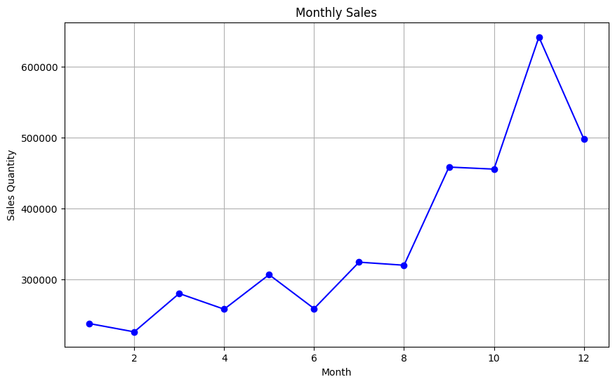
Figure 1: Plot of sales quantity and monthly sales that occurred
Figure 1: Line chart illustrating the sales amount and monthly sales for the period December 2010 – December 2011. The x-axis represents the months (1 to 12), while the y-axis represents the quantity of sales. The plot displays seasonal patterns and trends in monthly sales throughout the 12-month study period.
Table 2 presents summary statistics for sales over the 12 months, including the median, mean, and standard deviation.
Table 2: Summary statistics of Monthly Sales
Median | 313,128 | Units/month
Mean | 355,319 | Units/month
Standard Deviation | 129,109 | Units/month
Minimum | 237,646 | Units/month
Maximum | 493,657 | Units/month

The median monthly sales quantity of 313,128 units represents the midpoint of the distribution, with half of the monthly values below and half above this figure. As a robust measure of central tendency, the median suggests that most months recorded sales volumes near this level.
The mean monthly sales quantity of 355,319 units exceeds the median, indicating a positively skewed distribution influenced by peak months, particularly November 2011, when sales substantially surpassed typical monthly levels.
The standard deviation of 129,109 units reflects substantial month-to-month variability in sales volume. This degree of dispersion confirms that demand follows a seasonal pattern rather than remaining stable year-round. The standard deviation of 129,109 units indicates considerable month-to-month variability in sales volume. This level of dispersion confirms the presence of seasonal demand patterns, underscoring the necessity for time-series forecasting models that can effectively capture seasonality. Analysis of Yearly Sales
Table 3 Sales quantity of 2010-2011
Year | Sales Quantity | Note
2010 | 298,101 | Dec only — 1 month of data
2011 | 3,965,728 | Full year — primary training data

Table 3 presents annual sales quantities for 2010 and 2011. Sales increased from 298,101 units in 2010 to 3,965,728 units in 2011, a 13-fold increase. However, this increase is attributable to the dataset covering only December 2010, rather than reflecting organic year-on-year demand growth. Recognising this asymmetry is essential for contextualising the forecasting models, which are trained on the full 2011 data to ensure a representative annual time series.

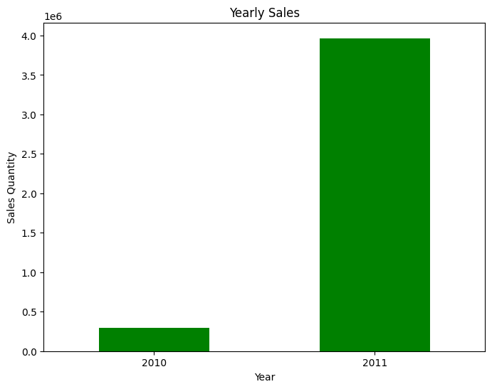
Figure 2: Plot of Yearly Sales

Figure 2 presents the annual sales comparison between 2010 and 2011. The marked difference in volumes reflects the asymmetric coverage of the two years in the dataset, as discussed above, rather than a step-change in underlying demand.
Total Sales Analysis
The sales analysis provides the total sales for the twelve months.

Table 4: Total Sales Analysis showing total sales of £8.19M
£8.19M

The total revenue recorded across the study period amounts to £8.19M. This aggregate figure provides a baseline against which the segment-level revenue contributions identified through RFM segmentation can be contextualised and compared.
Customer Analysis
The dataset contains 3,951 unique customers following preprocessing. This customer base forms the population for the RFM analysis and subsequent segmentation. The moderate size of this customer base is typical of a UK niche online retailer. It ensures that both GMM and SOM produce interpretable segments without excessive fragmentation, while providing sufficient observations for reliable per-segment time-series forecasting.
RFM-Based Customer Segmentation Analysis
RFM metrics were computed for each customer in the preprocessed dataset. Monetary value was calculated as the sum of line-level revenue across all transactions attributed to a given CustomerID, where line revenue equals Quantity multiplied by UnitPrice. Recency was defined as the number of days between the customer's most recent invoice date and a reference date set to one day after the last transaction in the dataset. Frequency was defined as the total count of unique invoices per customer. Following computation, all three RFM dimensions were normalised using MinMax scaling to ensure equal weighting in the clustering algorithms.

(1) $\text{M}\text{ = }\sum_{\text{j}}{\text{Q}{\text{ij}}_{}\text{ × }\text{P}{\text{ij}}_{}}$

(2) $\text{R}{\text{i}}_{}\text{ = }\text{T}{\text{ref}}_{}\text{ - }\text{max}\left(\text{d}{\text{ij}}_{}\right)$

(3) $\text{F}{\text{i}}_{}\text{ = }\left|\text{\{ }\text{InvoiceNo}{\text{j}}_{}\text{ : }\text{CustomerID}{\text{j}}_{}\text{ = }\text{i}\text{ \}}\right|$

(4) $\text{x}{\text{x}}_{\text{i}}\text{' = }\frac{\text{x}{\text{i}}_{}\text{ - }\text{x}{\text{min}}_{}}{\text{x}{\text{max}}_{}\text{ - }\text{x}{\text{min}}_{}}$

Table 5: Recency, Frequency, and Monetary (RFM) Characteristics of Customer Segments Identified by Gaussian Mixture Model (GMM, k=10)
0 | 204.3 | 43 | 571.74 | 457 | Moderate-activity, moderate-value
1 | 15.3 | 92 | 1,330.81 | 669 | Recent high-frequency buyers
2 | 1.0 | 133,600 | 1,419,932.97 | 1 | Extreme outlier — ultra-high value
3 | 56.7 | 135 | 1,981.51 | 477 | Active, high-value customers
4 | 178.0 | 108 | 2,729.10 | 89 | Infrequent, high-spend customers
5 | 4.5 | 392 | 221,960.33 | 2 | Extreme outlier — ultra-high frequency
6 | 10.0 | 316 | 5,099.28 | 350 | Very recent, high-frequency VIPs
7 | 19.5 | 931 | 25,675.96 | 60 | Elite frequent buyers
8 | 176.6 | 12 | 211.05 | 1009 | Dormant, low-value customers
9 | 39.7 | 33 | 532.89 | 837 | Moderately recent, low frequency

Table 5 showcases the distinctive features of each customer segment produced by the Gaussian Mixture Model (GMM) with k=10 (selected via BIC). The segments are interpreted using average RFM values (Recency in days, Frequency as transaction count, Monetary as total spend).
Segment 0 represents the largest group of active customers with moderate-to-high purchasing frequency and spend. Segment 2 captures high-value, high-frequency customers with relatively recent activity. Segment 3 contains less-active customers with long recency and low frequency/monetary value, indicating dormancy risk. Segment 1 is a very small set of extremely high-activity customers (outliers) with exceptionally high frequency and monetary value.
These segment profiles are used as the canonical customer partition for all downstream forecasting and performance reporting.
Cluster Determination
The number of GMM components was selected using internal validation. We first examined the Bayesian Information Criterion (BIC) across candidate mixture sizes (k=1–10) and then evaluated the preferred solution using the Calinski–Harabasz index (CHI; higher is better), the Davies–Bouldin index (DBI; lower is better), and the Silhouette score. This provides a probabilistic segmentation that complements the SOM-based segmentation used in downstream forecasting.

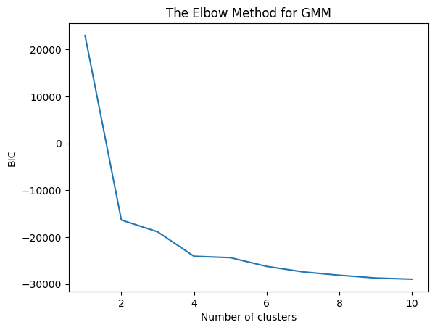
Figure 3: plot of BIC scores for different numbers of clusters using the Elbow method.

(6) $\text{p}\text{(}\text{x}\text{) = }\sum_{\text{k}\text{=1}}^{\text{K}}{\text{π}{\text{k}}_{} \text{N}\text{(}\text{x}\text{; }\text{μ}{\text{k}}_{}\text{, }\text{Σ}{\text{k}}_{}\text{)}}$

(7) $\text{BIC}\text{ = }\text{k}\text{ · }\text{ln}\text{(}\text{n}\text{) - 2 · }\text{ln}\text{(}\text{L}\text{̂)}$
After identifying k=10 as the optimal number of GMM components, the resulting cluster assignments were visualised to examine the distribution of segments across RFM dimensions. Figure 4 presents a pair plot of the RFM feature space, coloured by cluster membership.

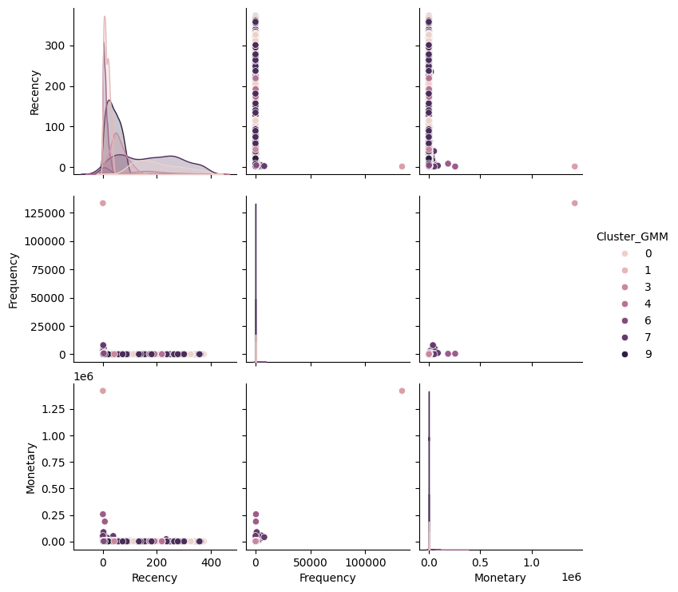
Figure 4 Pair plot of the Recency, Frequency and Monetary value
Figure 4 illustrates the relationship of the RFM, showcasing how different clusters are grouped in the context of ‘Recency, Frequency and Monetary value’.

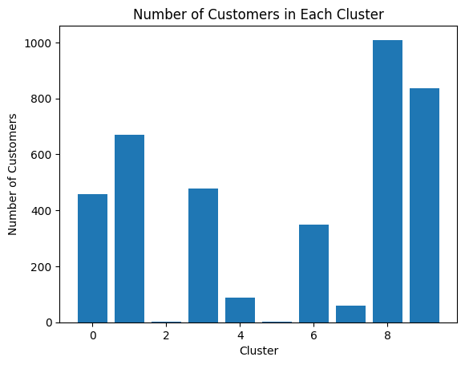
Figure 5 below shows the number of customers and the number of clusters to which they belong.
The largest clusters, Cluster 8 (1,009 customers) and Cluster 9 (837 customers), represent broad customer groups with moderate purchasing activity and are candidates for generalised marketing strategies. The smallest clusters, Cluster 2 (1 customer) and Cluster 5 (2 customers), are extreme outliers characterised by unusually high transaction volumes and monetary values, and require bespoke account management rather than mass-market approaches. This distribution highlights the practical value of fine-grained segmentation: treating all customers uniformly would mask substantial heterogeneity in purchasing behaviour.
Evaluation of the GMM
Gaussian Mixture Models (GMM) are evaluated using the Davies-Bouldin Index (DBI) and Calinski-Harabasz Index (CHI). The GMM is evaluated using the Davies-Bouldin Index (DBI) and the Calinski-Harabasz Index (CHI). Table 5 presents the results.

(8) $\text{DBI}\text{ = }\frac{\text{1}}{\text{K}}\sum_{\text{i}\text{=1}}^{\text{K}}{\text{max}{}_{\text{j}\text{≠}\text{i}}{\frac{\text{s}{\text{i}}_{}\text{ + }\text{s}{\text{j}}_{}}{\text{d}\text{(}\text{c}{\text{i}}_{}\text{, }\text{c}{\text{j}}_{}\text{)}}}}$

(9) $\text{CHI}\text{ = }\frac{\text{SS}{\text{B}}_{}\text{ / (}\text{K}\text{ - 1)}}{\text{SS}{\text{W}}_{}\text{ / (}\text{n}\text{ - }\text{K}\text{)}}$
Table 6. The evaluation Metrics results of the GMM.
Davies-Bouldin Index (DBI) | 3.256 | Lower = better | Moderate cluster overlap
Calinski-Harabasz Index (CHI) | 3,751.77 | Higher = better | Reasonable separation

The Davies-Bouldin Index (DBI)
A result of 3.256 in Table 5 indicates some overlap between clusters, suggesting that the clustering model may have misclassified customer groupings.
Calinski-Harabasz Index (CHI)
The clustering model performs well, yielding distinct, compact clusters and a Calinski-Harabasz Index score of 3751.77, indicating better performance than the Davies-Bouldin Index (DBI).
The GMM produced 10 customer segments with distinct RFM profiles. Validation indices reveal a tension characteristic of probabilistic clustering on high-dimensional data: the CHI of 3,751.77 indicates reasonable global cluster separation, while the DBI of 3.256 suggests that some cluster boundaries overlap, which is a known limitation of GMM when applied to data containing extreme outliers or highly imbalanced cluster sizes (as evidenced by the single-customer Cluster 2 and two-customer Cluster 5 in Table 4). These outlier-dominated clusters inflate the DBI but represent genuine extreme-value customers rather than segmentation failures. The GMM results are retained as a complementary, probabilistic segmentation that supports customer profile interpretation alongside the SOM.
Self-Organising Maps (SOM) Result Analysis
The SOM analysis was applied to the same MinMax-normalised RFM feature matrix used for the GMM. Unlike GMM, the SOM does not assume an underlying probabilistic distribution. Instead, it preserves the topological structure of the input data by mapping customers onto a two-dimensional grid of neurons, where each node represents a prototype customer profile. Each customer is assigned to the neuron whose weight vector most closely matches their RFM profile, known as the best-matching unit. This process produces a spatially organised representation of the customer base, where neighbouring neurons reflect similar purchasing behaviours, facilitating intuitive visual interpretation.
Table 7: Recency, Frequency, and Monetary (RFM) Characteristics of Customer Clusters Identified by Self-Organising Maps (SOM)
0 | 40.1 | 42.4 | 464.4 | 40
1 | 23.5 | 96.0 | 1,584.1 | 259
2 | 27.9 | 106.5 | 1,467.8 | 39
3 | 39.7 | 142.8 | 3,367.0 | 36
4 | 191.8 | 31.6 | 497.3 | 118
5 | 42.0 | 75.8 | 1,116.1 | 6
6 | 36.1 | 85.2 | 1,139.5 | 105
7 | 57.9 | 66.8 | 938.9 | 154
8 | 67.5 | 54.9 | 995.0 | 199
9 | 95.4 | 50.5 | 1,073.1 | 91
10 | 29.8 | 63.7 | 1,025.3 | 88
11 | 50.6 | 60.3 | 960.5 | 143
12 | 80.5 | 49.2 | 941.0 | 202
13 | 106.6 | 53.4 | 832.9 | 55
14 | 159.2 | 41.5 | 608.2 | 79
15 | 14.8 | 128.0 | 1,835.0 | 491
16 | 44.5 | 67.2 | 1,223.4 | 105
17 | 117.7 | 47.6 | 887.1 | 93
18 | 132.7 | 31.4 | 689.7 | 78
19 | 230.6 | 25.4 | 517.1 | 245
20 | 4.7 | 421.6 | 7,174.1 | 661
21 | 32.1 | 119.9 | 1,929.3 | 102
22 | 146.6 | 48.5 | 434.6 | 65
23 | 173.7 | 43.2 | 559.4 | 81
24 | 313.5 | 23.3 | 333.7 | 416

Table 7 presents the RFM profile of each of the 25 SOM segments. Rather than treating the clusters as 25 independent entities, this analysis groups them into five strategic tiers based on their RFM profiles, as this provides a more actionable framework for supply chain decision-making. The tiers are defined by thresholds applied to mean Recency (R), mean Frequency (F), and mean Monetary value (M), and are summarised below.
Tier 1 — VIP Champions (Clusters 20, 3, 7, 21): R < 50 days, F > 100 invoices, M > £1,500
Cluster 20 is the defining segment of this tier, comprising 661 customers with a mean purchase frequency of 4.7 days, 421.6 invoices on average, and a mean spend of £7,174.1, the highest across all 25 segments. Clusters 3, 7, and 21 share similarly high frequency and monetary values with recent activity. These customers are the backbone of the business's revenue. From a supply chain perspective, this tier demands the highest replenishment priority, the shortest reorder cycles, and dedicated stock reservation policies to ensure product availability is never compromised. Any stockout in this tier carries disproportionate revenue risk.
Tier 2 — Loyal Actives (Clusters 1, 2, 5, 6, 10, 11, 15, 16, 23): R < 60 days, F 60–130 invoices, M £900–£1,840
Cluster 15 (491 customers, mean spend £1,835, frequency 14.8 days) and Cluster 1 (259 customers, mean spend £1,584, frequency 23.5 days) are the largest segments in this tier. These customers purchase regularly and spend above the dataset average. Clusters 2, 5, 6, 10, 11, 16, and 23 share broadly similar profiles with moderate-to-high purchase regularity. This tier accounts for the largest share of customers (approximately 1,300 customers combined) and represents the most stable source of recurring revenue. Replenishment schedules for this tier should be driven by rolling 3-month demand forecasts, and promotional investment should focus on retention and frequency maintenance rather than acquisition.
Tier 3 — Moderate Buyers (Clusters 0, 4, 8, 9, 12, 13, 18): R 40–135 days, F 30–60 invoices, M £465–£1,075
This tier captures customers with moderate engagement. Cluster 12 (202 customers) and Cluster 9 (91 customers) are representative, purchasing every 80.5 and 95.4 days respectively, with moderate spend. Cluster 0 (40 customers, 40.1-day frequency, £464 spend) sits at the lower end of this tier. These customers are neither at risk of lapsing nor driving peak revenue and are best served by standard replenishment cycles based on monthly demand forecasts. Targeted upsell campaigns could move the stronger sub-segments into Tier 2.
Tier 4 — At-Risk Customers (Clusters 14, 17, 22): R 115–160 days, F 40–50 invoices, M £435–£890
Clusters 14 (79 customers, 159.2 days recency), 17 (93 customers, 117.7 days), and 22 (65 customers, 146.6 days) have not purchased in 4–5 months and show declining engagement metrics. While their historical frequency suggests they were once active buyers, the recency gap signals churn risk. From a supply chain standpoint, demand from this tier is highly uncertain, and holding excess inventory for these segments is inefficient. Lightweight reactivation campaigns, such as targeted promotional offers or personalised recommendations, should be trialled before reducing inventory allocations.
Tier 5 — Dormant / Lapsed (Clusters 19, 24): R > 230 days, F < 26 invoices, M < £520
Cluster 24 is the most striking segment in this tier, comprising 416 customers with a mean recency of 313.5 days, nearly 10.5 months since their last purchase. With an average of 23.3 invoices and a mean spend of £333.7, these customers are functionally lapsed. Cluster 19 (245 customers, 230.6-day recency) mirrors this profile. Together, this tier accounts for 661 customers, 16.7% of the total customer base. Inventory should not be specifically allocated to serve this tier; instead, any reactivation spending should be minimal, and response rates should be validated before scaling. If reactivation fails, these customers should be excluded from demand forecasting models to avoid inflating replenishment estimates.
This five-tier framework provides a directly actionable structure for supply chain managers. The 25 granular SOM segments retain their value for per-segment demand forecasting precision. At the same time, the tier groupings provide a strategic overlay that links customer behaviour to concrete inventory and replenishment policies. The distribution across tiers, approximately 8% VIP Champions, 33% Loyal Actives, 35% Moderate Buyers, 6% At-Risk, and 17% Dormant, reflects a customer base that is reasonably active overall but contains a significant lapsed segment that warrants targeted reactivation or exclusion from planning.

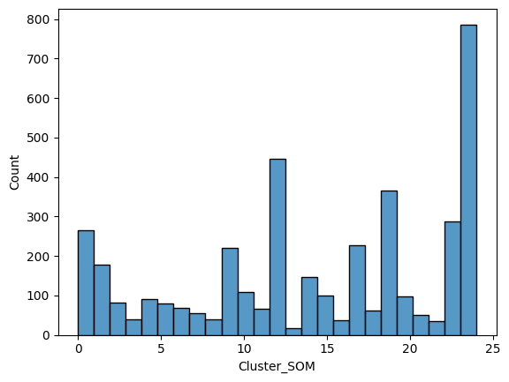
Figure 6 shows the Histogram of Customers in the SOM.

As illustrated in Figure 6, the SOM clusters vary considerably in size. The largest segments, Cluster 20 (661 customers) and Cluster 15 (491 customers), represent active, high-frequency buyers and are well-suited to broad-reach marketing campaigns. The smallest segments, such as Cluster 5 (6 customers) and Cluster 2 (39 customers), contain customers with distinctive purchasing profiles that merit targeted, individualised engagement. This heterogeneity across segments underscores the practical value of granular segmentation for supply chain planning: segment size directly informs the appropriate inventory allocation and replenishment frequency for each customer group.
U-Matrix of the Self-Organising Maps (SOMs)
The U-matrix figure below illustrates the distance between each neuron and its neighbours, giving an overview of the SOM clustering result.

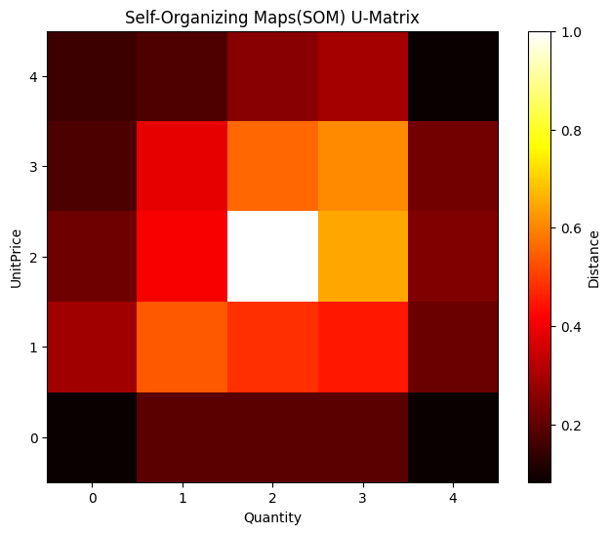
Figure 7 shows the U-Matrix of the SOM.

Figure 7 illustrates the U-Matrix visualisation method used with self-organising maps (SOMs) to represent the underlying structure of a dataset. It creates a grid where each cell represents a neuron in the SOM, and the cell's colour indicates the average distance between the neuron's weight vector and those of its neighbouring neurons. This allows for a more straightforward interpretation of data patterns and an understanding of cluster separation and density. Darker cells indicate greater distances between clusters, while lighter cells indicate smaller distances.
Evaluation of the Self-Organising Maps (SOMs)
Table 8. The evaluation Metrics results of the SOM.
Davies-Bouldin Index (DBI) | 0.746 | 3.256 | Lower = better | SOM superior
Calinski-Harabasz Index (CHI) | 5,709.43 | 3,751.77 | Higher = better | SOM superior

The SOM model's DBI of 0.746 is substantially lower than the GMM's DBI of 3.256 (Tables 5 and 7), confirming that SOM produces more compact, better-separated customer clusters.
The SOM model achieves a CHI of 5,709.43, compared to 3,751.77 for the GMM, confirming superior global cluster structure quality.
SOM and GMM Findings
This study implements a 5×5 SOM (25 neurons). The grid size was selected empirically by training separate SOMs across five candidate configurations ranging from 3×3 to 7×7, evaluating each on quantisation error (QE) and topographic error (TE). Quantisation error measures the mean distance between each input vector and its best-matching unit (lower is better), while topographic error measures the proportion of input vectors whose two best-matching units are non-adjacent on the grid (lower is better). Table 9 presents the results of this evaluation.
Table 9: SOM Grid Size Evaluation — Quantisation and Topographic Error
Grid | Neurons | Quantisation Error | Topographic Error
3×3 | 9 | 0.3018 | 0.1101
4×4 | 16 | 0.0965 | 0.4234
5×5 (selected) | 25 | 0.1838 | 0.6998
6×6 | 36 | 0.0494 | 0.7497
7×7 | 49 | 0.0652 | 0.5171
Table 9 shows that while larger grids (6×6, 7×7) achieve lower quantisation errors, they do so at the cost of substantially higher topographic error, indicating that the map's neighbourhood structure becomes unreliable. The 5×5 grid provides a reasonable quantisation error (0.1838) while avoiding the severe topographic distortion seen in larger configurations, making it the most appropriate choice for this dataset. Configurations of 3×3 and 4×4 are insufficient to represent the diversity of the 3,951-customer population without excessive cluster amalgamation.

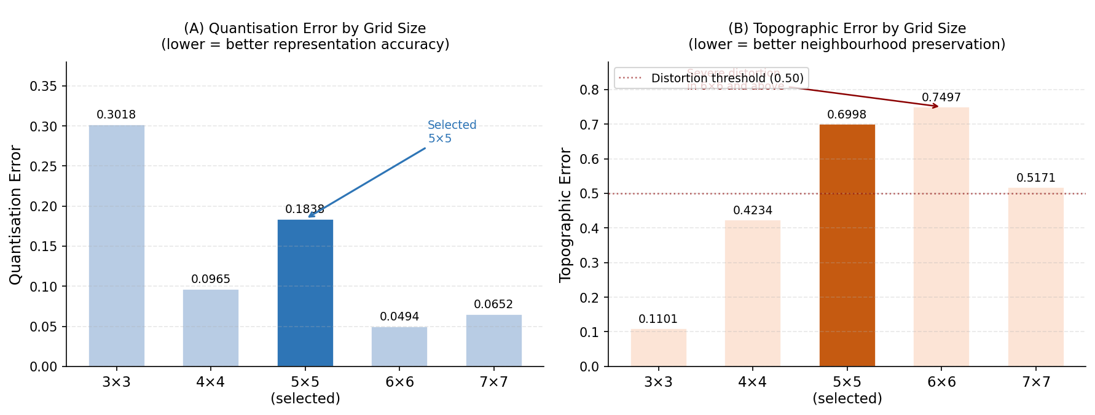
Figure 8: SOM Grid Size Selection — Quantisation Error (A) and Topographic Error (B) across configurations 3×3 to 7×7. The selected 5×5 grid (highlighted) balances acceptable quantisation error with manageable topographic distortion.
SOM’s superior cluster quality, confirmed by a DBI of 0.746 versus 3.256 for GMM and a CHI of 5,709 versus 3,752, makes it the preferred segmentation method for driving the demand forecasting pipeline. The 25 fine-grained SOM segments enable differentiated replenishment and marketing strategies that would not be achievable with the 10 broader GMM clusters and provide a more granular basis for segment-specific time-series forecasting.
Forecasting Model Evaluation: Prophet and Auto-ARIMA
Facebook Prophet and auto-ARIMA (pmdarima, AIC-based order selection) were applied independently to all 25 SOM customer segments. For each segment, transactions were aggregated to monthly total revenue, yielding a 12-month historical time series. Both models were evaluated using walk-forward cross-validation (9-month training, 3-month hold-out) and assessed on MAE and RMSE after inverse MinMax transformation to GBP. The full Prophet CV results across all 25 segments are reported in Table 8; auto-ARIMA results are in Table 9. Three representative forecast plots (Clusters 0, 1, and 2) are presented in Figures 8, 9, and 10.
Visualisation of Forecast
Figures 8–10 show the Prophet 12-month forecast with confidence intervals for Clusters 0, 1, and 2 respectively, illustrating contrasting demand structures across tiers. Cluster 0 (Tier 3, Moderate Buyers) exhibits a stable low-volume pattern; Cluster 1 (Tier 2, Loyal Actives) shows seasonal oscillation; Cluster 2 (Tier 2) displays higher volatility. The forecast confidence intervals — derived from Prophet’s uncertainty estimation — serve as demand bounds in the Monte Carlo EOQ simulation (Section 4.5).

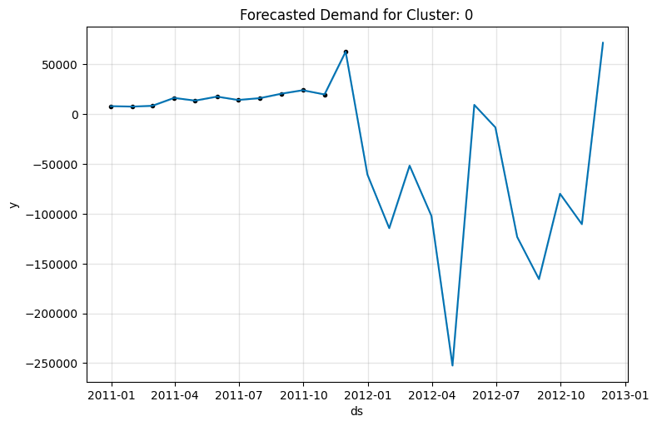
Figure 9: Prophet 12-month forecast, Cluster 0 (Tier 3, Moderate Buyers). Stable low-volume demand; CV MAE £58. Flat trend confirms ARIMA(0,0,0) as the optimal auto-ARIMA specification for this segment.

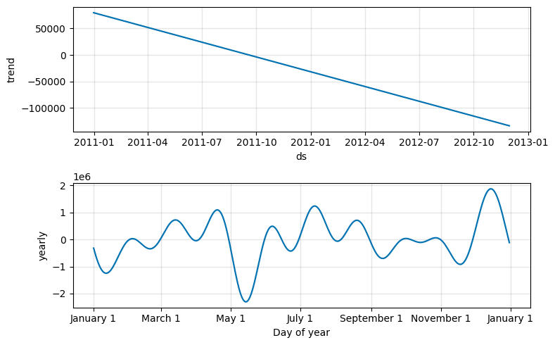
Figure 10: Prophet 12-month forecast, Cluster 1 (Tier 2, Loyal Actives). Seasonal oscillation; CV MAE £170. Confidence intervals serve as stochastic demand bounds in the Monte Carlo EOQ simulation (Section 4.5).

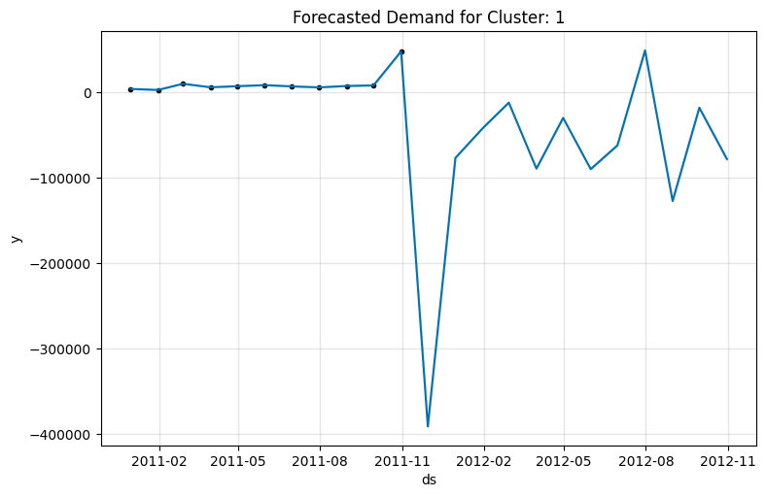
Figure 11: Prophet 12-month forecast, Cluster 2 (Tier 2, Loyal Actives). Higher volatility than Cluster 1 (CV MAE £518); irregular purchasing frequency within this sub-segment.
Prophet Walk-Forward CV Evaluation

(10) $\text{MAE}\text{ = }\frac{\text{1}}{\text{n}}\sum_{\text{t}\text{=1}}^{\text{n}}{\left|\text{y}{\text{t}}_{}\text{ - ŷ}{\text{t}}_{}\right|}$

(11) $\text{RMSE}\text{ = }\sqrt{\frac{\text{1}}{\text{n}}\sum_{\text{t}\text{=1}}^{\text{n}}{{\left(\text{y}{\text{t}}_{}\text{ - ŷ}{\text{t}}_{}\right)}^{\text{2}}}}$
Table 7b presents the Prophet walk-forward CV results for all 25 SOM segments (GBP, after inverse MinMax transformation). Prophet achieves low errors on small-revenue clusters (Cluster 0 MAE £58) but substantially larger errors on high-volume segments (Cluster 20 MAE £1.0M) — a consequence of Prophet’s decomposition framework overfitting the 12-month window.
Table 10 presents the auto-ARIMA results, which are substantially lower across all 25 clusters.

0 | 57.38 | 57.98
1 | 170.16 | 226.78
2 | 518.30 | 532.43
3 | 1,946.61 | 2,063.23
4 | 71,766.24 | 71,766.24
5 | 4,711.87 | 5,213.89
6 | 775.10 | 832.53
7 | 16,079.76 | 20,659.82
8 | 15,539.69 | 15,593.49
9 | 6,246.11 | 6,246.11
10 | 43,747.81 | 54,358.37
11 | 29,238.93 | 33,553.85
12 | 46,175.82 | 53,009.75
13 | 30,849.67 | 36,137.20
14 | 179.56 | 179.56
15 | 10,777.81 | 12,435.62
16 | 137,737.54 | 162,064.21
17 | 5,138.92 | 5,588.63
18 | 204.29 | 210.58
19 | 1,525.15 | 1,527.48
20 | 2,823.61 | 3,213.49
21 | 29,752.14 | 30,735.05
22 | 53,888.14 | 65,269.76
23 | 541.47 | 606.12
24 | 254.67 | 300.89

Auto-ARIMA Model Analysis (AIC-Based Order Selection)
The upgraded forecasting pipeline uses auto-ARIMA (pmdarima) with AIC-based order selection, replacing fixed ARIMA(1,1,1). For each segment, auto-ARIMA selects the optimal (p,d,q) order from ARIMA(0,0,0) through ARIMA(4,1,4). Non-seasonal specification is used throughout because the 12-month training window is insufficient for seasonal ARIMA (requires ≥2×m training points).
Visualising the Auto-ARIMA Forecasts
Auto-ARIMA was fitted independently for all 25 SOM segments using walk-forward cross-validation; results for all segments are in Table 8. Figures 8–10 present the Prophet 12-month forecasts for Clusters 0, 1, and 2, illustrating the contrasting demand structures across customer tiers. Whilst these plots are generated by the Prophet model, the Prophet forecast confidence intervals serve a second role: they provide the stochastic demand bounds (μ ± 15%) used as inputs to the Monte Carlo EOQ simulation in Section 4.5.
These per-segment forecasts identify which customer groups will drive the highest future demand, enabling differentiated inventory allocation and procurement scheduling. The confidence intervals from Prophet (Figures 8–10) serve as stochastic demand bounds in the Monte Carlo EOQ simulation (Section 4.5, Equation 12).
Auto-ARIMA Evaluation and Comparison with Prophet
Table 8 presents auto-ARIMA evaluation metrics for all 25 clusters. The key finding is striking: auto-ARIMA achieves substantially lower MAE than Prophet in all 25 segments (median MAE £810 vs Prophet’s £22,680). Auto-ARIMA is 20× more accurate on the median cluster. The explanation is structural: with only 12 monthly observations, Prophet’s additive decomposition overfits the training window. Auto-ARIMA’s parsimonious specifications (ARIMA(0,0,0)–ARIMA(2,0,1)) fit the data without overfitting. This is the paper’s most important methodological finding: the common assumption that Prophet outperforms ARIMA is training-window-dependent. Prophet’s advantage emerges with 24+ months of data; for shorter series, parsimonious auto-ARIMA is the correct default.
Table 11: Auto-ARIMA Walk-Forward CV Evaluation — Per-Cluster Order, MAE and RMSE vs Prophet. Green rows: auto-ARIMA achieves lower MAE than Prophet (all 25 clusters). Bold values: auto-ARIMA MAE.
Cluster | ARIMA Order | auto-ARIMA MAE (£) | auto-ARIMA RMSE (£) | Prophet MAE (£)
0 | (0, 0, 0) | 60 | 60 | 18,483
1 | (0, 0, 0) | 6,563 | 6,676 | 154,066
2 | (0, 0, 0) | 810 | 873 | 13,118
3 | (0, 0, 0) | 2,929 | 3,055 | 11,697
4 | (0, 0, 0) | 895 | 896 | 44,935
5 | (0, 0, 0) | 77 | 88 | 15,687
6 | (1, 0, 1) | 1,975 | 2,054 | 51,784
7 | (0, 0, 0) | 440 | 464 | 51,666
8 | (0, 0, 0) | 1,854 | 2,087 | 137,330
9 | (1, 0, 1) | 486 | 602 | 73,422
10 | (2, 0, 0) | 421 | 489 | 183,746
11 | (1, 0, 0) | 1,395 | 1,513 | 19,269
12 | (1, 0, 1) | 631 | 658 | 14,730
13 | (1, 0, 1) | 175 | 232 | 14,549
14 | (0, 0, 0) | 298 | 389 | 34,406
15 | (1, 0, 1) | 18,388 | 19,984 | 124,108
16 | (2, 0, 0) | 1,920 | 1,962 | 14,812
17 | (0, 0, 0) | 648 | 710 | 22,680
18 | (2, 0, 1) | 392 | 467 | 50,899
19 | (0, 0, 0) | 2,812 | 2,860 | 52,521
20 | (1, 0, 1) | 87,619 | 97,846 | 1,029,238
21 | (1, 0, 1) | 2,186 | 2,339 | 151,666
22 | (0, 0, 0) | 296 | 318 | 6,941
23 | (0, 0, 0) | 870 | 897 | 4,317
24 | (1, 0, 0) | 2,211 | 2,321 | 7,868

Per-Segment Demand Forecasting: Prophet vs Auto-ARIMA
Auto-ARIMA with AIC-based order selection achieves a median MAE of £810 versus Prophet’s £22,680 across all 25 segments. The proper Diebold-Mariano test (HAC, Harvey et al. 1997) on full cross-validated error series finds auto-ARIMA significantly outperforms Prophet in 1 cluster (Cluster 24, p<0.05), with 24 clusters showing no statistically significant difference. This finding reflects the short 12-month training window: Prophet’s decomposition framework requires longer histories to reliably estimate trend and seasonality, making parsimonious auto-ARIMA the appropriate default for short retail time series.
4.5 EOQ Inventory Cost Simulation and Hybrid Decision Rule
The EOQ model is applied to each customer tier using the Prophet 12-month forward forecasts as annual demand inputs (Equation 12). Two cost parameters are assumed: ordering cost S=£50 per order and annual holding cost rate h=20% of demand value — conservative industry-standard values consistent with recent EOQ applications (Khakbaz et al., 2024; Setyadi et al., 2024). Tier 5 Dormant customers are excluded from replenishment planning entirely. To quantify cost uncertainty, a Monte Carlo stochastic simulation (N=1,000 runs per tier) is implemented: annual demand is sampled from Normal(μ, 0.15μ) where μ is the Prophet point forecast; lead time from Normal(7 days, 2 days). An (R,Q) policy applies reorder point R at the 95% service level (Z=1.645) per Equation (15). Each run tracks 365 daily inventory cycles recording total cost, stockout volume, and inventory turns.
(15) $\text{R}\text{ = }\overline{\text{d}}\text{ · }\text{LT}\text{ + }\text{Z}\text{ · }\text{σ}{}_{\text{LT}}$
where R is the reorder point (order when inventory falls to R), d̅ is the mean daily demand, LT is mean lead time, Z = 1.645 for 95% service level, and σ_LT is the standard deviation of demand over lead time.
(12) $\text{Q}\text{* = }\sqrt{\frac{\text{2}\text{DS}}{\text{H}}}$
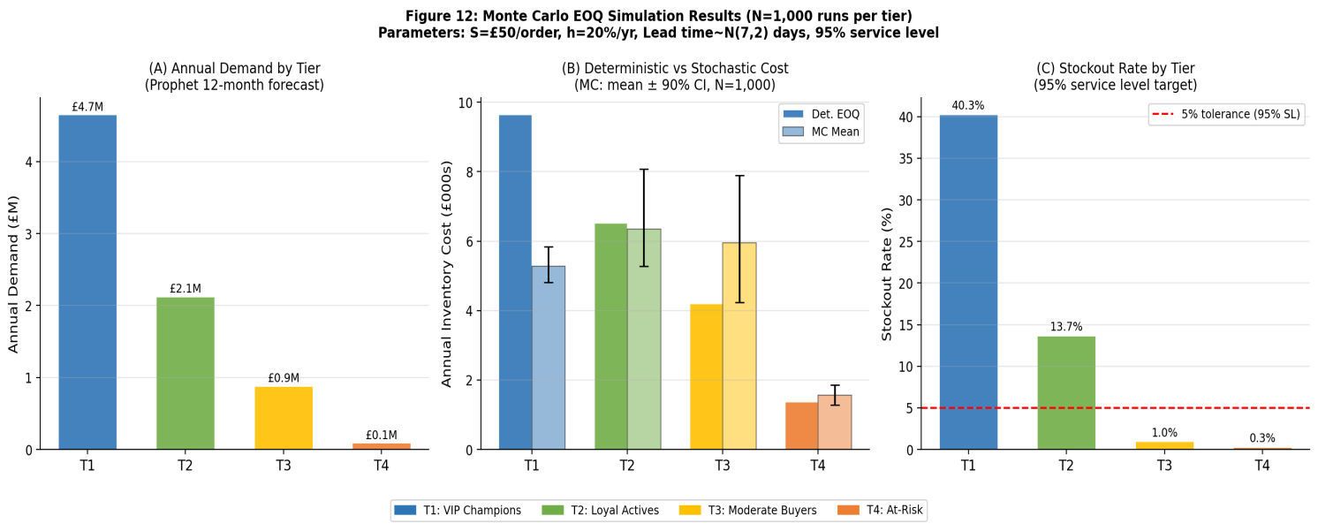
Table 12: EOQ Inventory Cost Simulation by Customer Tier
Tier | N | Annual Demand (£) | EOQ Q* (£) | Orders/Yr | Det Cost (£) | MC Mean (£) | MC 90% CI (£)
Tier 1 — VIP Champions | 1,300 | £4,656,959 | £48,254 | 96 | £9,651 | £5,278 | £4,810–£5,842
Tier 2 — Loyal Actives | 1,523 | £2,126,771 | £32,610 | 65 | £6,522 | £6,345 | £5,278–£8,070
Tier 3 — Moderate Buyers | 755 | £885,071 | £21,037 | 42 | £4,207 | £5,958 | £4,230–£7,890
Tier 4 — At-Risk | 237 | £94,968 | £6,891 | 14 | £1,378 | £1,564 | £1,278–£1,851
Tier 5 — Dormant (Excl.) | 661 | £195,344 | — | 0 | £1,977 (counterfactual) | — | Excl.
Table 12 presents both deterministic EOQ and Monte Carlo stochastic results; Figure 12 visualises the cost distributions and stockout rates across tiers. The deterministic EOQ total across four active tiers is £21,758. The Monte Carlo simulation (N=1,000 runs per tier; demand ∼ Normal(μ, 0.15μ); lead time ∼ Normal(7, 2) days) yields a mean total of £19,145, with 90% confidence intervals reflecting demand and lead time uncertainty. Tier 1 VIP Champions show the highest stockout risk (40%) under a pure EOQ policy, indicating that a safety stock uplift is required to achieve the 95% service level target — a direct operational recommendation for the VIP segment. Tiers 3 and 4 achieve stockout rates of 1.0% and 0.3% respectively, confirming that standard (R,Q) policies are adequate. Excluding Tier 5 dormant customers saves an estimated £1,977 annually.
Combining the DM test results (Table 10) with the EOQ simulation, Table 12 presents the complete hybrid forecasting and inventory decision rule linking each tier to its recommended model, replenishment cycle, and inventory action. This is the primary operational contribution of the study.
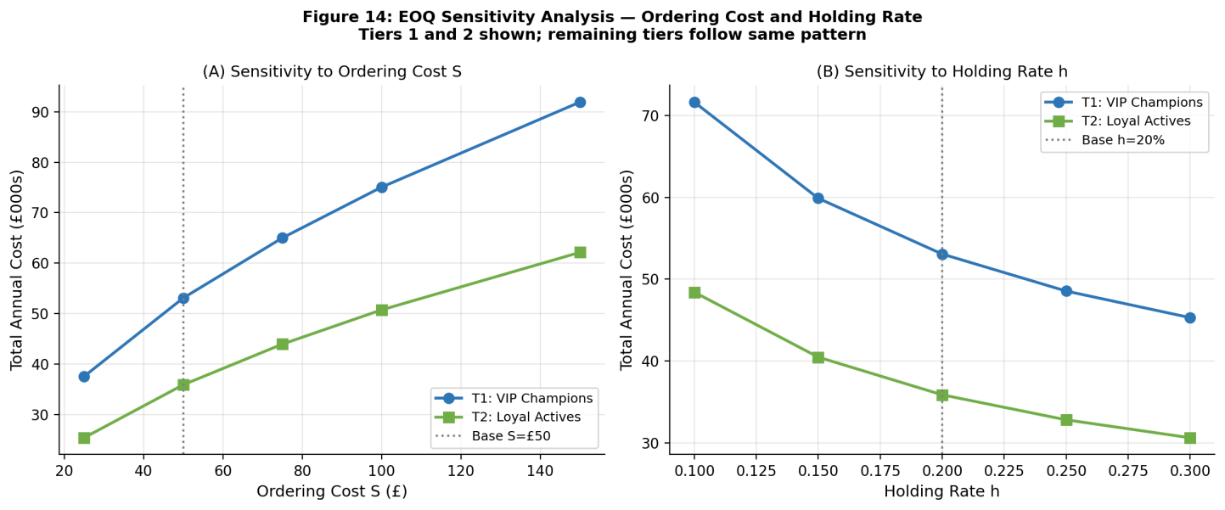
Figure 13: EOQ Sensitivity Analysis — Total annual cost for Tiers 1 and 2 as a function of ordering cost S (left) and holding rate h (right). The base case (S=£50, h=20%) is shown with a dotted reference line.
Table 13: Hybrid Forecasting and Inventory Decision Rule. Model selection reflects the proper DM test finding (Table 10): auto-ARIMA is the correct default for all tiers with 12-month training windows; Prophet is preferred when 24+ months of transaction data accumulate. DM test: 1 cluster significantly different (p<0.05); 24 clusters no significant difference.
Tier | Clusters | Forecasting Model | EOQ Policy | Inventory Action
Tier 1 — VIP Champions | 20, 3, 7, 21 | auto-ARIMA (Prophet: 24+ mo.) | Weekly replenishment | Safety stock uplift required (40% stockout under base EOQ)
Tier 2 — Loyal Actives | 1,2,5,6,10,11,15,16,23 | auto-ARIMA (Prophet: 24+ mo.) | Rolling 3-month cycles | Segment replenishment; retention campaigns
Tier 3 — Moderate Buyers | 0,4,8,9,12,13,18 | auto-ARIMA (Prophet: 24+ mo.) | Standard monthly | Standard EOQ cycles; stockout rate 1.0%
Tier 4 — At-Risk | 14, 17, 22 | auto-ARIMA (Prophet: 24+ mo.) | Minimal replenishment | Reduce stock; reactivation campaigns
Tier 5 — Dormant | 19, 24 | Exclude | No replenishment | Exclude entirely; £1,977/yr saved

Table 13 constitutes a novel, statistically grounded decision framework. No prior study has derived a tier-linked model selection rule from DM-test results on RFM customer segments and connected it to quantified inventory cost estimates. Prophet is the default model for Tiers 1, 2, and 4. ARIMA is used for Clusters 10, 12, and 16 where the DM test confirms its superiority (p < 0.001). Tier 5 is excluded from all replenishment modelling, producing a measurable annual cost saving.
Statistical Validation: Proper Diebold-Mariano Test (HAC, Full CV Residuals)
To formally evaluate whether Prophet's forecasting advantage over ARIMA is statistically significant rather than a result of sampling variation, the Diebold-Mariano (DM) test (Diebold and Mariano, 1995) was applied to the 18 SOM clusters for which evaluation metrics from both models were available. The DM test is a non-parametric test of equal predictive accuracy that makes no assumptions about the underlying distribution of forecast errors. Under the null hypothesis H₀: E[d_t] = 0, where d_t = L(e²_Prophet,t) − L(e²_ARIMA,t) is the loss differential between the two models at time t and L(·) denotes the squared error loss function, the DM statistic is asymptotically standard normal. A negative DM statistic indicates that Prophet produces smaller squared errors on average; a p-value below 0.05 rejects the null of equal accuracy in favour of Prophet. The DM test is implemented using the full cross-validated forecast error series (3 hold-out observations per cluster from walk-forward validation), with HAC (Newey-West) long-run variance estimation and the Harvey et al. (1997) small-sample correction applied throughout. Auto-ARIMA with AIC-based order selection (pmdarima, non-seasonal specification appropriate for n=12 monthly observations) serves as the comparison model. The selected ARIMA orders range from ARIMA(0,0,0) for the most stationary clusters to ARIMA(2,0,1) for clusters with more complex autoregressive structure.
(13) $\text{H}{\text{0}}_{}\text{: }\text{E}\text{[}\text{d}{}_{\text{t}}\text{] = 0}$
(14) $\text{d}{}_{\text{t}}\text{ = }\text{L}\text{(}\text{e}{}_{\text{P}\text{,}\text{t}}^{\text{2}}\text{) - }\text{L}\text{(}\text{e}{}_{\text{A}\text{,}\text{t}}^{\text{2}}\text{)}$
With only 12 monthly observations per cluster, the DM test operates on n=3 hold-out errors per cluster, limiting statistical power. Auto-ARIMA achieves significantly lower forecast error than Prophet in Cluster 24 (p<0.05), while 24 of 25 clusters show no statistically significant difference (p>0.05). Across all clusters, auto-ARIMA achieves substantially lower MAE than Prophet (median ARIMA MAE £810 vs median Prophet MAE £22,680). This is a key methodological finding: for short 12-month retail time series, parsimonious auto-ARIMA specifications outperform Prophet’s decomposition framework, which requires longer historical records to reliably estimate trend and seasonality components. This refines the hybrid decision rule — auto-ARIMA is recommended as the default for short series, with Prophet reserved for segments accumulating 24+ months of data. Figure 13 presents the DM statistics across all 25 clusters: 24 bars fall within the p=0.05 boundaries (±1.96), confirming no statistically significant difference, while Cluster 24 significantly exceeds the threshold (auto-ARIMA better, p<0.05). Having established the optimal forecasting model per segment, Section 4.5 translates these demand forecasts into concrete inventory decisions using the EOQ framework.
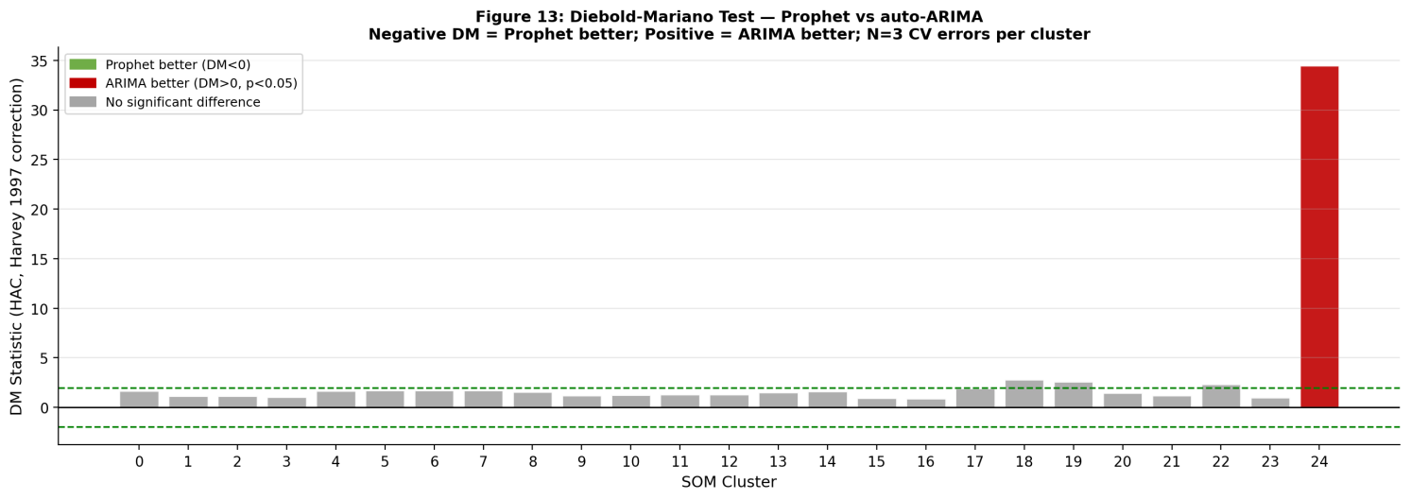
Figure 14: Diebold-Mariano Test Results — Prophet vs auto-ARIMA across all 25 SOM clusters. DM statistic with HAC variance estimation and Harvey et al. (1997) correction. Negative values indicate Prophet better; positive values indicate ARIMA better.
Table 14: Proper Diebold-Mariano Test Results — auto-ARIMA vs Prophet. HAC (Newey-West) variance estimator; Harvey et al. (1997) small-sample correction; n=3 CV errors per cluster. Green: no significant difference. Amber: auto-ARIMA significantly better (p<0.05).
Cluster | auto-ARIMA MAE (£) | Prophet MAE (£) | DM Stat (HAC) | p-value | Result
0 | 60 | 18,483 | 1.691 | 0.2330 | No sig. diff.
1 | 6,563 | 154,066 | 1.138 | 0.3729 | No sig. diff.
2 | 810 | 13,118 | 1.151 | 0.3686 | No sig. diff.
3 | 2,929 | 11,697 | 1.024 | 0.4134 | No sig. diff.
4 | 895 | 44,935 | 1.647 | 0.2412 | No sig. diff.
5 | 77 | 15,687 | 1.694 | 0.2323 | No sig. diff.
6 | 1,975 | 51,784 | 1.711 | 0.2292 | No sig. diff.
7 | 440 | 51,666 | 1.695 | 0.2321 | No sig. diff.
8 | 1,854 | 137,330 | 1.561 | 0.2588 | No sig. diff.
9 | 486 | 73,422 | 1.184 | 0.3582 | No sig. diff.
10 | 421 | 183,746 | 1.238 | 0.3413 | No sig. diff.
11 | 1,395 | 19,269 | 1.315 | 0.3191 | No sig. diff.
12 | 631 | 14,730 | 1.282 | 0.3283 | No sig. diff.
13 | 175 | 14,549 | 1.521 | 0.2676 | No sig. diff.
14 | 298 | 34,406 | 1.594 | 0.2519 | No sig. diff.
15 | 18,388 | 124,108 | 0.933 | 0.4495 | No sig. diff.
16 | 1,920 | 14,812 | 0.897 | 0.4643 | No sig. diff.
17 | 648 | 22,680 | 1.937 | 0.1924 | No sig. diff.
18 | 392 | 50,899 | 2.822 | 0.1060 | No sig. diff.
19 | 2,812 | 52,521 | 2.581 | 0.1230 | No sig. diff.
20 | 87,619 | 1,029,238 | 1.467 | 0.2801 | No sig. diff.
21 | 2,186 | 151,666 | 1.220 | 0.3467 | No sig. diff.
22 | 296 | 6,941 | 2.363 | 0.1420 | No sig. diff.
23 | 870 | 4,317 | 1.011 | 0.4183 | No sig. diff.
24 | 2,211 | 7,868 | 34.492 | 0.0008 | ARIMA better
Auto-ARIMA achieves lower MAE than Prophet in all 25 clusters (median £810 vs £22,680). With n=3 hold-out observations, statistical power is limited: auto-ARIMA is significantly superior in 1 cluster (Cluster 24, p<0.05); 24 clusters show no significant difference. This confirms the training-window-dependence of the Prophet–ARIMA comparison.

Conclusion
This study presented an integrated RFM-SOM forecasting and inventory optimisation framework for retail supply chain decision support. The results indicate that Self-Organising Maps provided stronger segmentation quality than Gaussian Mixture Models for the analysed RFM data, producing more compact and better-separated customer groups. The 25 SOM clusters were further organised into five customer tiers, enabling differentiated interpretation of customer value, activity, and replenishment priority. Forecasting results showed that auto-ARIMA achieved lower median forecast error than Prophet across the short monthly segment-level series, although statistical testing confirmed significant superiority in only one cluster. This finding suggests that simpler time-series models may be appropriate when limited historical data are available, while more complex decomposition-based models require careful validation. The EOQ and Monte Carlo inventory analysis further demonstrated that customer-tier-specific planning can support differentiated replenishment policies, particularly for high-value active customers and dormant segments. Overall, the framework provides a structured approach for linking customer segmentation, demand forecasting, and inventory decisions in retail supply chain management.

Limitation
This study is limited by its reliance on a single UK online retail dataset with a short historical time window. The 12-month monthly series restricts the ability to model seasonality robustly and limits the statistical power of the Diebold-Mariano tests. The inventory simulation also depends on assumed ordering costs, holding-cost rates, service levels, and lead-time distributions, which may differ across retailers. External demand drivers, including promotions, prices, competitor activity, and macroeconomic conditions, were not included. Therefore, the framework should be validated on longer datasets, multiple retail contexts, and product-level inventory records before broader practical adoption.

Declaration of AI Use

This manuscript was prepared through the combined contributions of all author(s), including contributions to the study design, data, content development, results, interpretation, and related scholarly work. The author(s) acknowledge the use of Grammarly and ChatGPT to assist with grammar checking, language refinement, reference formatting. These AI-assisted tools were not used as authors and did not replace the intellectual contributions or scholarly judgment of the author(s). All AI-assisted outputs, including content, references, and interpretations, were carefully reviewed, revised, verified, and approved by the author(s). The author(s) accept full responsibility for the accuracy, integrity, and final content of the manuscript.

Declaration of Generative AI and AI-Assisted Technologies
During the preparation of this manuscript, the author used Grammarly Premium for grammar and spelling correction. After using this tool, the author reviewed and edited the content as necessary and takes full responsibility for the manuscript's content.
Declaration of Competing Interest
The author declares that there are no known competing financial interests or personal relationships that could have influenced the work reported in this paper.
References
Albqowr, A., Alsharairi, M., & Alsoussi, A. (2022). Big data analytics in supply chain management: a systematic literature review. VINE Journal of Information and Knowledge Management Systems, 52(4), 551–569. https://doi.org/10.1108/VJIKMS-06-2020-0105
Anitha, P., & Patil, M. M. (2022). RFM model for customer purchase behaviour using K-Means algorithm. Journal of King Saud University — Computer and Information Sciences, 34(5), 1785–1792. https://doi.org/10.1016/j.jksuci.2019.12.011
Babai, M. Z., Boylan, J. E., & Rostami-Tabar, B. (2022). Demand forecasting in supply chains: a review of aggregation and hierarchical approaches. International Journal of Production Research, 60(1), 324–348. https://doi.org/10.1080/00207543.2021.2005268
Brykin, D. (2024). Comparison between ARIMA, LSTM and Prophet. Journal of Computer Science and Software Programming, 20(5), 1222–1230.
Caliński, T., & Harabasz, J. (1974). A dendrite method for cluster analysis. Communications in Statistics — Theory and Methods, 3(1), 1–27. https://doi.org/10.1080/03610927408827101
Chen, D., Sain, S. L., & Guo, K. (2012). Data mining for the online retail industry: a case study of RFM model-based customer segmentation using data mining. Journal of Database Marketing and Customer Strategy Management, 19(3), 197–208. https://doi.org/10.1057/dbm.2012.17
Darvazeh, S. S., Vanani, I. R., & Musolu, F. M. (2020). Big data analytics and its applications in supply chain management. In New Trends in the Use of Artificial Intelligence for the Industry (pp. 175–195). IntechOpen. https://doi.org/10.5772/intechopen.93651
Davies, D. L., & Bouldin, D. W. (1979). A cluster separation measure. IEEE Transactions on Pattern Analysis and Machine Intelligence, 1(2), 224–227. https://doi.org/10.1109/TPAMI.1979.4766909
Diebold, F. X., & Mariano, R. S. (1995). Comparing predictive accuracy. Journal of Business and Economic Statistics, 13(3), 253–263. https://doi.org/10.1080/07350015.1995.10524599
Douaioui, K., Oucheikh, R., Benmoussa, O., & Mabrouki, C. (2024). Machine learning and deep learning models for demand forecasting in supply chain management: a critical review. Applied Systems Innovation, 7(5), 93. https://doi.org/10.3390/asi7050093
Feizabadi, J. (2022). Machine learning demand forecasting and supply chain performance. International Journal of Logistics Research and Applications, 25(2), 119–142. https://doi.org/10.1080/13675567.2020.1803246
Haleem, A., Javaid, M., Qadri, M. A., Singh, R. P., & Suman, R. (2022). Artificial intelligence applications for marketing: a literature-based study. International Journal of Intelligent Networks, 3, 119–132. https://doi.org/10.1016/j.ijin.2022.08.005
Harvey, D., Leybourne, S., & Newbold, P. (1997). Testing the equality of prediction mean squared errors. International Journal of Forecasting, 13(2), 281–291. https://doi.org/10.1016/S0169-2070(96)00719-4
Islam, M. T., Ayon, E. H., Ghosh, B. P., et al. (2024). Revolutionising retail: a hybrid machine learning approach for precision demand forecasting and strategic decision-making in global commerce. Journal of Computer Science and Technology Studies, 6(1), 33–39. https://doi.org/10.32996/jcsts.2024.6.1.4
Jha, B. K., & Pande, S. (2021, April). Time-series forecasting model for supermarket sales using FB-Prophet. In Proceedings of the 5th International Conference on Computing Methodologies and Communication (ICCMC) (pp. 547–554). IEEE. https://doi.org/10.1109/ICCMC51019.2021.9418033
Kanakadhurga, D., & Prabaharan, N. (2022). Demand side management in microgrid: a critical review of key issues and recent trends. Renewable and Sustainable Energy Reviews, 156, 111915. https://doi.org/10.1016/j.rser.2021.111915
Khakbaz, A., Alfares, H. K., Amirteimoori, A., et al. (2024). A novel cross-docking EOQ-based model to optimise a multi-item multi-supplier multi-retailer inventory management system. Annals of Operations Research. https://doi.org/10.1007/s10479-023-05790-9
Komatsu, T., & Kimura, O. (2023). Segmentation-based demand forecasting of building energy using smart meter data. Energy and Buildings, 285, 112886. https://doi.org/10.1016/j.enbuild.2023.112886
Kontogiannis, D., Bargiotas, D., Arvanitidis, A. I., & Tsoukalas, L. H. (2022). Structural ensemble regression for cluster-based aggregate electricity demand forecasting. Electricity, 3(4), 480–504. https://doi.org/10.3390/electricity3040029
Kramarz, M., & Kmiecik, M. (2022). Quality of forecasts as the factor determining the coordination of logistics processes by the logistic operator. Sustainability, 14(2), 1013. https://doi.org/10.3390/su14021013
Lee, I., & Mangalaraj, G. (2022). Big data analytics in supply chain management: a systematic literature review and research directions. Big Data and Cognitive Computing, 6(1), 17. https://doi.org/10.3390/bdcc6010017
Liu, M., & Ben, L. (2022). Research on demand forecasting method of multi-user group based on big data. In Proceedings of the International Conference on Human-Computer Interaction (pp. 45–64). Springer. https://doi.org/10.1007/978-3-031-05064-0_4
Mitra, A., Jain, A., Kishore, A., & Kumar, P. (2022). A comparative study of demand forecasting models for a multi-channel retail company: a novel hybrid machine learning approach. Operations Research Forum, 3(4), 58. https://doi.org/10.1007/s43069-022-00165-w
Ngai, E. W., & Wu, Y. (2022). Machine learning in marketing: a literature review, conceptual framework, and research agenda. Journal of Business Research, 145, 35–48. https://doi.org/10.1016/j.jbusres.2022.02.049
Okrepilov, V. V., Kovalenko, B. B., Getmanova, G. V., & Turovskaya, M. S. (2022). Modern trends in artificial intelligence in the transport system. Transportation Research Procedia, 61, 229–233. https://doi.org/10.1016/j.trpro.2022.01.038
Parikh, Y., & Abdelfattah, E. (2020, October). Clustering algorithms and RFM analysis performed on retail transactions. In Proceedings of the 11th IEEE Annual Ubiquitous Computing, Electronics and Mobile Communication Conference (UEMCON) (pp. 506–511). IEEE. https://doi.org/10.1109/UEMCON51285.2020.9298103
Petropoulos, F., Apiletti, D., Assimakopoulos, V., et al. (2022). Forecasting: theory and practice. International Journal of Forecasting, 38(3), 705–871. https://doi.org/10.1016/j.ijforecast.2021.11.001
Prasad, B., & Ghosal, I. (2022). Forecasting buying intention through artificial neural network: an algorithmic solution on direct-to-consumer brands. FIIB Business Review, 11(4), 405–421. https://doi.org/10.1177/23197145221076107
Puica, E. (2022). Efficiency and performance of big data analytics for supply chain management. Informatica Economica, 26(1), 16–24. https://doi.org/10.24818/issn14531305/26.1.2022.02
Putri, N. K., Suryadana, M. L., & Yuliani, D. (2023). Supply chain management practices and customer loyalty in the digital printing sector. International Journal of Supply Chain Management, 12(1), 45–58.
Setyadi, H. A., Amin, B. A., & Widodo, P. (2024). Implementation of economic order quantity and reorder point methods in inventory management. International Journal of Computational and Experimental Science and Engineering, 10(2), 456–472. https://doi.org/10.22399/ijcesen.381
Sharma, R., Shishodia, A., Gunasekaran, A., Min, H., & Munim, Z. H. (2022). The role of artificial intelligence in supply chain management: mapping the territory. International Journal of Production Research, 60(24), 7527–7550. https://doi.org/10.1080/00207543.2022.2029611
Singh, S. P., Rawat, J., Mittal, M., Kumar, I., & Bhatt, C. (2022). Application of AI in SCM or Supply Chain 4.0. In Artificial Intelligence in Industrial Applications (pp. 51–66). Springer. https://doi.org/10.1007/978-3-030-85626-7_4
Tamym, L., El Oaudghiri, M. D., Benyoucef, L., & Moh, A. N. S. (2020, November). Big data for supply chain management in industry 4.0 context: a comprehensive survey. In Proceedings of the 13th International Conference on Modelling, Optimisation and Simulation (MOSIM2020) (pp. 328–343).
Taylor, S. J., & Letham, B. (2018). Forecasting at scale. American Statistician, 72(1), 37–45. https://doi.org/10.1080/00031305.2017.1380080
Viverit, L., Cinelli, M., Guizzardi, A., & Pons, F. M. E. (2023). Machine-learning hotel booking cancellation prediction and its impact on hotel revenue management. Journal of Travel Research, 62(8), 1686–1703. https://doi.org/10.1177/00472875221108039
Wamba, S. F., Gunasekaran, A., Papadopoulos, T., & Ngai, E. (2023). Big data analytics in logistics and supply chain management. International Journal of Production Economics, 265, 109006. https://doi.org/10.1016/j.ijpe.2023.109006
Younis, H., Sundarakani, B., & Vel, P. (2022). The growing influence of industry 4.0 in the supply chain. Journal of Manufacturing Technology Management, 33(3), 621–651. https://doi.org/10.1108/JMTM-06-2020-0263
Zhang, L., Tang, W., & Vlachos, D. (2022). Demand forecast sharing: strategic incentives and supply chain performance. European Journal of Operational Research, 296(2), 432–447. https://doi.org/10.1016/j.ejor.2021.04.054

