Evaluation of antioxidant status and libido enhancing activities of ethanolic extract of Aframomum melegueta seed using wistar rat models.

Abstract
Aframomum menegueta seeds are reported to have libido enhancing properties but the involvement of antioxidant in the improvement of mating behavior has not been established. This study determined the effect of 70% ethanol extract of Aframomum menegueta seeds on mating behavior (MF, ML, IF, IL, EF, EL and PEI), serum hormones (Testosterone (TET), follicle stimulating hormone (FSH), luteinizing hormone (LH) and prolactin (PRL) as well as oxidative stress biomarkers (SOD, CAT, GPx, GSH and MDA) in male Wistar rats. Twenty-five male Wistar rats were randomly shared into five groups containing five rats each. Groups I, 2, and 3 were treated with 120, 240 and 360mg/Kg of the ethanolic extract of Aframomum menegueta seeds while group 4 and 5 were treated with 1mg/Kg of testosterone and 10ml/Kg of distilled water to serve as positive and negative controls respectively. The extract was found to significantly (P≤0.05) increased ML, IF, EF while ML, IL and PEI were significantly decreased (P≤0.05) when compared with the negative control. However the group that was treated with testosterone had mating behavior parameters significantly higher (P≤0.05) than the treated group that received the highest dose (group3). Similarly, the serum levels of testosterone, FSH, and LH were dose-dependently higher (P≤0.05) in the treated groups when compared to the negative control group while the PRL level was significantly (P≤0.05) decreased in the treated and positive control groups. The levels of CAT, SOD, GPx and GSH were significantly (P≤0.05) increased while MDA was significantly (P≤0.05) decreased in the treated groups compared to the negative control group. These results suggest that the extract produce the libido enhancing effect as indicated by the mating behavior through increased testosterone via the activation of the hypothalamic-pituitary-gonadal axis which may be facilitated by the improved oxidation status.

Introduction
One of the fundamental parameters for the assessment of the quality of life is sexual function with diverse impact on the social and psychological well-being of an individual (Brody, 2006). The global incidence of male reproductive dysfunction, particularly erectile dysfunction and declining libido, has emerged as a significant public health challenge affecting quality of life and psychological well-being. Libido is a person’s overall sexual drive or desire for sexual activity. It is a natural biological and psychological energy that fluctuates based on a complex mix of hormones, physical health, emotional wellbeing, and lifestyle factors. Male reproductive dysfunction is reported to account for about 50% of all cases and affect more than 17% of the male of reproductive age worldwide (WHO, 2023). A review reported by Kessler et al., (2019), indicates that erectile dysfunction is associated with increased risks of cardiovascular diseases, dementia, and early death which affected up to 5million in UK as at 2019 while estimating that by 2025, about 322 million men may have been affected worldwide. This has led to many social and marital problems which has prompted the search and development of a number of treatment options. Among the various contributors to male infertility, modern lifestyle factors, some pharmaceutical products, environmental toxins, genetic factors and predisposing disease conditions including metabolic disorders frequently induce chronic oxidative stress, which impairs testicular function and disrupts the hypothalamic-pituitary-gonadal axis (Babalola et al, 2023).
According to Kingsberg and Woodard (2015), aphrodisiacs are substances that amplify mating drive and are usually used to manage intimacy issues. These substances include food and food products, pharmaceutical, aromas and herbal substances, which may adjust key reproductive signals like pregnancy hormone, other female hormones, and male hormone as well as brain signals. (Gauthaman et al., 2017). Although synthetic aphrodisiacs like phosphodiesterase-5 inhibitors are widely available, their high cost, systemic side effects, and lack of antioxidant properties limit their long-term therapeutic utility. Consequently, there is a critical need to evaluate natural, bioactive alternatives that can concurrently mitigate oxidative damage and enhance reproductive vitality (treatment and management of declining libido). One of such plant being explored for its libido enhancing activities is Aframomum melegueta.
Alligator pepper (Aframomum melegueta [Roscoe] K. Schum) also known as grains of Paradise or Guinea pepper is an herbaceous perennial tropical plant in the family of Zingiberaceae native to West Africa. It can grow to a height of about 1.0 to 1.5 meters and produces purple flowers that gives rise to 5 to 7cm long pods containing small reddish-brown seeds. It is commonly used as spices in food and for the treatment of various ailments including management of convulsion, leprosy, inflammation and rheumatoid pains (Okwu and Eunice, 2009).
Aframomum melegueta (Alligator pepper), is reported to possess aphrodisiac and rejuvenative properties. However, its specific impact on systemic antioxidant status in relation to libido-enhancing activities remains inadequately quantified. This study utilizes Wistar rat model to systematically investigate how Aframomum melegueta modulates antioxidant defense mechanisms to improve copulatory behavior and reproductive performance.

Methods
Plant materials and extraction. The fruits of Aframomum melegueta were purchased from Urua Ikpe, Essien Udim Local Government area of Akwa Ibom State in January 2026. The plant sample was identified and authenticated by a taxonomist in the Department of Biological Science, Akwa Ibom State Polytechnic, Ikot Osurua. The seeds were separated from the rest of the fruit and then washed and dried at room temperature 25ºC for 24 hours. 250 g of the plant seeds was weighed, blended into fine power using laboratory mortar and pestle and thereafter soaked at room temperature (25°C) in 1.0 L of 70% aqueous-ethanol for 72 days, with occasional agitation. The extract was filtered using Whatman paper No4 and this process was repeated twice. The filtrates were combined and concentrated in vacuo to give an extract with 12.26% yield. It was then stored at 4°C until needed.
Phytochemical Analysis: Preliminary analysis of the secondary metabolites in A. menegueta was conducted to detect level of alkaloids, tannins, flavonoids, and saponins using established protocols reported by Khedr et al., (2024) while cardiac glycosides levels were determined using the method of . Thereafter the LD₅₀ of the extract was estimated using Swiss albino mice administered through intraperitoneal (ip) route by method according to Lorke (1983).
Animals Study: Mature male and female Wistar rats (190 g to 240 g) were obtained from the animal house of the University of Uyo, Uyo, Nigeria for the study. The male and female animals were separately, acclimatized and maintained for two week under standard conditions (12 h light/12 h dark cycle) at the animal house of the Department of Science Technology Akwa Ibom State Polytechnic, Ikot Osurua. The animals were fed with growers’ pellet (New Hope Agricultural and Technology Nigeria Limited, Logbara, Ogun State, Nigeria) and water was given ad libitum. All animal experiments conformed to the guide for the care and use of Laboratory Animals published by the National Academies Press (2011).
Effect of Extract on Sexual Behaviour in Male Rats. Twenty-five sexually matured male rats were randomly divided into five groups of five rats per group. Groups I, II and III received three different doses (120, 240, and 360mg/kg (p.o) of the extract respectively. Group IV received 1mg/kg of testosterone (sc). Group V received 10ml/kg distilled water (p.o) as a control. The administration was repeated daily for 14 days before commencement of the sexual behavior experiment. Estrous were induced in the female rats used for the experiment by administration of 17-β estradiol (10 µg/kg body weight) and progesterone (500 µg/kg body weight), 48 hours and 8 hours respectively before the commencement of the experiment. The sexual behavior experiment was conducted from the hours of 7pm to 11pm. The males were placed in a Plexiglass box, using a red bulb for 10 minutes to acclimatize themselves before introduction of the estrous - induced female. Their mating activities were monitored by measuring the following indices; Mount Latency (ML), Intromission Latency (IL), Ejaculatory Latency (EL), Mount Frequency (MF), Intromission Frequency (IF), Penile Erection (PE) and Ejaculatory Frequency (EF).

Collection of blood samples.
Twenty-four hours after the last treatment, the animals were anesthetized using diethyl ether and blood sample collected through cardiac puncture preserved in ice for 30minutes. The whole blood for each sample were centrifuged at 3000 rpm for 10 min and the serum were separated, properly labelled and preserved for biochemical analysis.

Biochemical Assays

The oxidative stress and antioxidant status of each sample were evaluated by measuring the serum SOD, CAT, GPx, GSH and MDA.
Serum superoxide dismutase (SOD) activity was determined by using the spectrophotometric method of Popov et al. (2003). According to this protocol, xanthine oxidase was used as standard. Blank and sample tubes were read against bidistilled water at 560 nm. Results were expressed as U/L.
CAT Activity in serum was assessed using the methodology outlined by Aebi et al (1984). The concentration calculated. GPx activity was determined according to an established procedure using H₂O₂ as a substrate (Puglia and Valentine 1967). Glutathione level was determined according to the method of Beutler et al., (1963). Here 800 µl of phosphate buffer was added to 200 µl of serum. The first absorbance (AB1) at 412 nm was recorded. 100 µl of Ellman's reagent was added to the same tube, and the 2nd absorbance (AB2) was recorded.
Determination of MDA level MDA level was determined according to the method reported by Gutteridge (1995). The absorbances were read in a spectrophotometer at 532 nm
Hormonal assays
Serum concentrations of luteinizing hormone (LH), follicle stimulating hormone (FSH), prolactin (PRL) and testosterone were quantified using enzyme linked immunosorbent assay (ELISA) techniques, following the manufacturer’s instructions for each specific kit. FSH was quantified using the Rat FSH ELISA Kit (Sigma-Aldrich, Catalog #RAB0326), as validated for rat sera (Hui et al., 2020, Sigma-Aldrich, 2024). Luteinizing hormone (LH) was determined according to the method of Leiva and de la Lastra, `992). Testosterone was measured using the Testosterone ELISA Kit (Enzo Life Sciences, Catalog #ADI-900-065), as validated for rat sera (Smith et al., 2017, Enzo Life Sciences, 2024) while serum prolactin concentration was measured using the prolactin ELISA kit according to the method of Frantz, (1978). The ELISA analyzer was calibrated with standard curves and validated for rat sera (Andreasson et al., 2015). All ELISA procedures followed established protocols for hormone quantification (Crowther, 2022).

Statistical analysis. Results obtained from the study were expressed as the mean ± standard error of mean (n=5). Group differences and comparisons were assessed using one-way analysis of variance (ANOVA), followed by Tukey’s post-hoc test using SPSS version 23 IBM®, SPSS® (NY, USA), and a significant difference was considered at P < 0.05.

Results
Effect of A menegueta seed extracts on mating behavior of male Albino rats.
The result of the mating behavior of male Albino rats following the administration of graded doses of A menegueta seed extracts for 14 days are as represented in Table1. The extract significantly (P≤0.05) decreased mount latency (ML), intromission latency (IL) and ejaculation latency (EL) when compared to the negative control. The observed decrease were dose dependent. However the values for the group that received the highest dose (group3) were not significantly different from the group treated with testosterone suggesting that the extract may act through the increase in testosterone production. The mount frequency (MF), intromission frequency (IF) and ejaculation frequency (EF) were significantly (P≤0.05) increased in the treated groups compared to the negative control. The increase was also dose dependent. The frequencies in the three treated groups were significantly (P≤0.05) different from each other. Finally the post ejaculation interval (PEI) was significantly (P≤0.05) higher in the test group compared to the negative control. The PEI of the positive control was significantly higher (P≤0.05) than the values from the treated groups.
Table.1 Effect of A menegueta ethanolic extract on mating parameters of male Albino Wistar rats after daily treatment for 14 days.
Treatment Mating Behavour parameter
ML(s) MF IL (s) IF EL(min) PEI(s) EF
Group1 | 23.22±3.15^{x} | 18.00±2.17^{x} | 43.34±1.33^{x} | 7.13±1.33^{x} | 12.13±0.63^{x} | 157.22±4.21^{x} | 14.12±2.13^{x}
Group2 | 27.13±2.11^{x} | 22.14±2.01^{x} | 36.38±2.34^{x} | 8.52±0.72^{x} | 8.68±0.71^{x} | 145.34±5.74^{x} | 15.32±1.08^{x}
Group3 | 32.62±3.52^{x} | 24.71±1.78^{x} | 33.42±0.63^{x} | 10.23±0.83^{x} | 8.13±0.85^{x} | 133.87±3.21^{x} | 18.34±0.93^{x}
Group4 | 35.24±4.23 | 25.35±2.52 | 32.32±1.75 | 12.28±1.41 | 7.02±1.14 | 140.27±5.42 | 19.37±1.21
Group5 | 47.33±3.61 | 13.23±2.52 | 51.25±3.61 | 5.23±0.17 | 16.29±1.04 | 229.72±5.76 | 10.07±2.06
ML= mounting latency, IF = mounting frequency, MF = mounting frequency, IL = Intromission latency, IF = Intromission frequency, EL = ejaculation latency, PEI = post ejaculation interval and EF = erection frequency. (x = P≤ 0.05; N = 5)
Effect of A menegueta seed extracts on hormonal levels of male Albino rats.
The results of effect of A menegueta seed extracts on hormonal levels of male Albino rats are presented in Fig3 and Fig 4 below. The serum follicle stimulating hormone (FSH), luteinizing hormone (LH) and testosterone (TET) were significantly (P≤0.05) increased dose-dependently in the treated groups when compared to the negative control. The concentration of FSH and LH were significantly (P≤0.05) decreased in the positive control group as compared to the treated and negative control groups. The concentration of prolactin (PRL) were significantly (P≤0.05) decreased in the treated groups when compared to the negative control while it was significantly increased in the positive control when compared to the negative control and the treated groups.
Effect of A menegueta seed extracts on antioxidants levels of male Albino rats.
The concentration of the antioxidant enzymes superoxide dismutase (SOD), catalase (CAT) and glutathione peroxidase (GPx) as well as glutathione (GSH) and malondialdehyde (MDA) levels were analyzed and the results presented in Fig1 and Fig2. The concentration of the antioxidant enzymes SOD, CAT and GPx were significantly (P≤0.05) increased in the treated groups dose-dependently compared to the negative control. However the levels of these enzymes in the positive control was significantly (P≤0.05) increased compared to those of the treated groups. Similarly, the concentration of GSH were increased significantly (P≤0.05) compared to the control while the concentration of MDA were significantly decreased (P≤0.05) in the treated and positive control groups compared to the negative control group.

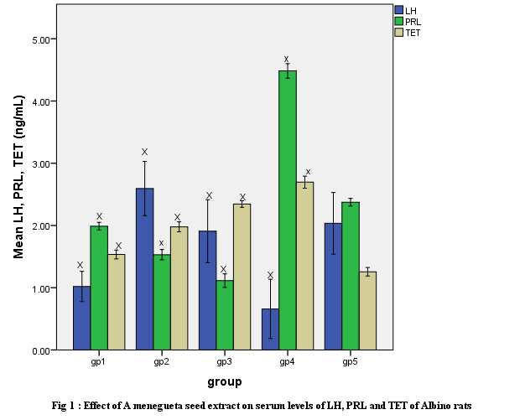

Discussion:
This research examined the antioxidant involvement in libido enhancement properties of Aframomum menegueta seed extract using male Wistar rat. To evaluate this, the libido enhancing properties was assessed through the mating behavior parameters namely; mount, intromission and ejaculation frequencies as well as post-ejaculation interval, mount, intromission and ejaculation latencies.
Mount frequency (MF) measures the total number of times a male animal mount a female from the rear without achieving vaginal penetration within a specified time frame and is widely used to evaluate an animal’s sexual motivation, libido and social dominance while intromission frequency (IF) measures the total number of successful vaginal penetrations a male animal achieves before ejaculation. It is a primary biomarker for erectile function and copulatory performance. Ejaculation frequency (EF) is defined as the total number of times a male successfully ejaculate during a designated observation period. It reflects overall reproductive capability and stamina of the animal (Gao et al 2022). On the other hand, mount latency is a primary biomarker for sexual motivation, desire and libido. A shorter mount latency signifies higher level of sexual arousal or motivation, conversely a prolonged mount latency can indicate sexual dysfunction. It is a measure of the time between introducing a receptive female animal into a testing environment and the male animal’s first mount attempt. Intromission latency is the time interval between the introduction of a
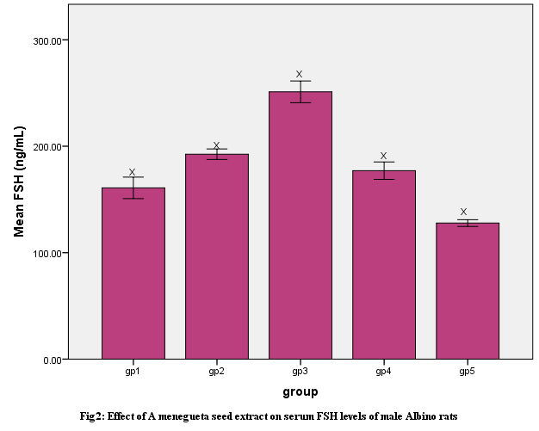

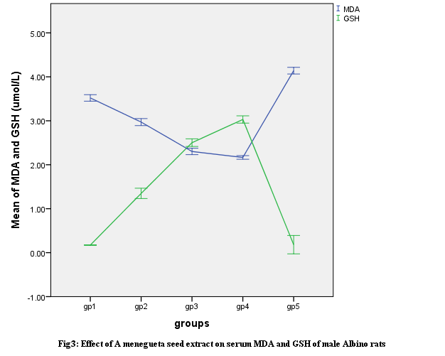

receptive female into the mating environment and the male’s first successful vaginal penetration while ejaculation latency is the total time that elapse between the male animal’s first successful vaginal penetration (intromission) and the exact moment of ejaculation. It is a mean of evaluating copulatory performance, ejaculatory threshold and sexual stamina.

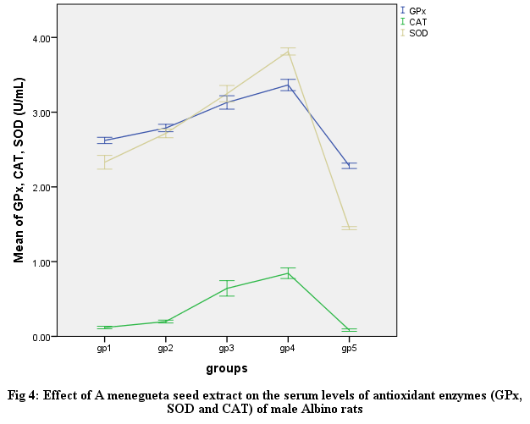

The result of the study showed that the administration of seed extract of A menegueta produced a dose-dependent increased (P≤0.05) in MF, IF and EF compared to the negative control group while Mount latency (ML), intromission latency (IL) and ejaculation latency (EL) were decreased by the extract and the positive control group that received testosterone.
Specifically, mount frequency, intromission frequency and ejaculation frequency are important biomarkers of sexual vigor, libido and potency while MF reflects sexual motivation and IF indicated the efficiency of erection, penile orientation and the ease of activating ejaculatory reflexes which is used to assess copulatory efficiency, pelvic thrusting capability and sensory feedback loop required to trigger ejaculation (Yakubu et al., 2010; Ratnasooriya et al., 2000 and Afoigwe-Ogeyemhe et al., 2019).
The observed decrease in intromission latency along with increased intromission frequency of the male rats in the treated groups supports the probable erectile function enhancing activity of A. menegueta. Furthermore, sexual stimulation usually manifests in higher frequency of ejaculation within a specified time period (Chan, 2010; Gotep et al., 2021)
The post ejaculatory interval (PEI) is considered a measure of potency, libido and the degree of recovery from exhaustion after the first set of mating and a critical parameter for evaluating the effect of administered extract on erectile function Sharma et al., 2010. Reduced PEI also indicated an improvement in erection and the ability to copulate excellently (Fouche et al., 2015).

In animal studies, the levels follicle stimulating hormone (FSH), testosterone (T), luteinizing hormone (LH) could be used as the main index for evaluating sexual function. The hypothalamus – pituitary – gonad axis is very vital in the regulation of these functions. Hypothalamus response to and regulate blood sex hormone levels. It sends signal to anterior pituitary that regulate the release of LH, FSH and PRL. In the male, the release of LH, FSH increase the synthesis of testosterone while the release of PRL leads to decrease synthesis of testosterone or feedback inhibition of the pathway (Barbieri, 2014). While LH in male binds to leydig cells in the testes and activate the synthesis and secretion of testosterone and indirectly promote spermatogenesis, FSH acts directly on sertoli cells located within the seminiferous tubules of the testes stimulating spermatogenesis. Thus the increase in the blood concentration of LH and FSH produce a corresponding increase in the concentration of testosterone. Testosterone is the main hormone that enhances (libido) sexual desire, motivation and sexual performance and this requires a critical threshold concentration in the blood for these physiological functions to be expressed. Also it has been reported that the combination of normal levels of FSH and testosterone is responsible for a satisfactory quality and quantity of spermatogenesis. Put together, the enhancement of libido by the extract of A menegueta seed as shown by the results of mating behavior parameter may be through its capacity to produce the observed increase in the concentration of LH, FSH, and testosterone as well as decreased concentration of PRL in the treated groups compared to the negative control group. Other researchers have reported that mating is associated with increasing the circulating concentration of testosterone during the acquisition of sexual experience ( ) and that the enhanced copulatory performance of male rats by the extract of M. angustifolia could be attributed to the increase in serum testosterone concentration (Fouche et al., 2015). The extract of A menegueta seed produced similar effect suggesting that the extract enhances libido through this pathway.
Oxidative stress arises when excessive ROS overwhelm intrinsic antioxidant defenses, causing cellular and molecular injury (Afzal et al., 2023). The testes and spermatozoa are particularly vulnerable due to high polyunsaturated lipid content and limited antioxidant capacity, making oxidative stress a major contributor to male infertility (Agarwal et al., 2014; Bisht et al., 2017). In the male, it a vital contributor to infertility, acting working together with inflammation to impair spermatogenesis and sperm function (Agunloye et al., 2026). Oxidative stress (OS) significantly contributes to male reproductive dysfunction, a factor implicated in a substantial fraction of infertility cases. Yu et al in his review elucidated the intricate interplay between oxidative stress and male reproductive health, emphasizing the molecular and cellular mechanisms through which reactive oxygen species (ROS) impair sperm function with special focus on lipid peroxidation of sperm membranes, DNA damage, and apoptotic cell death, which collectively undermine sperm viability and fertility potential (Yu et al., 2025). Also some disease conditions such as diabetes mellitus, cardiovascular disease, etc. are known to increase oxidative stress that ultimately contributes to low libido and erectile dysfunction. Previous studies have suggested that A menegueta seed extract have antioxidant properties and the result of this study shows that the ethanolic extract of A menegueta seed increased the concentration of SOD, CAT GPx and GSH while decreasing the concentration of MDA when compared to the untreated group. This result suggest that some phytochemicals in the extract has the potential to improve the oxidative status of the testes and prevent oxidative stress that could have affected spermatogenesis (particularly through peroxidation) and other sexual functions as indicated by the level of MDA.

Conclusions
The ethanolic seed extract of Aframomum melegueta improved selected mating behaviour parameters in male Wistar rats after 14 days of administration. The extract-treated groups showed increased mating frequencies and reduced mating latencies compared with the negative control. The treatment was also associated with changes in reproductive hormones, including increased testosterone and follicle stimulating hormone and reduced prolactin in extract-treated animals. In addition, the extract improved antioxidant status by increasing superoxide dismutase, catalase, glutathione peroxidase, and reduced glutathione, while reducing malondialdehyde. These findings suggest that A. melegueta seed extract may have libido-related activity in this rat model, with possible involvement of hormonal and antioxidant pathways.
COMPETING INTERESTS: Authors declared that there is no conflict interests.
Declaration of AI Use

This manuscript was prepared through the combined contributions of all author(s), including contributions to the study design, data, content development, results, interpretation, and related scholarly work. The author(s) acknowledge the use of Grammarly and ChatGPT to assist with grammar checking, language refinement, reference formatting. These AI-assisted tools were not used as authors and did not replace the intellectual contributions or scholarly judgment of the author(s). All AI-assisted outputs, including content, references, and interpretations, were carefully reviewed, revised, verified, and approved by the author(s). The author(s) accept full responsibility for the accuracy, integrity, and final content of the manuscript.

Reference
- Aebi H. Catalase In: Bergmeyer, H.U., Ed., Methods of Enzymatic Analysis, Verlag Chemie/Academic Press Inc., Weinheim/NewYork, 1974; 673-680.
- Aebi H. (1984) Catalase in vitro. Methods Enzymol. 105(C):121-26
- Afzal S, Abdul Manap AS, Attiq A, Albokhadaim I, Kandeel M, Alhojaily SM. (2023). From imbalance to impairment: the central role of reactive oxygen species in oxidative stress-induced disorders and therapeutic exploration. Front Pharmacol. 14:1269581.
- Agunloye, O. M Olawuyi, E. A. Oguntade, I A. Aleruwa, S O. Oboh, G. (2026) Restorative effects of Aframomum melegueta and Aframomum danielli-supplemented diets on sperm quality and testicular health following scopolamine-induced neurotoxicity in rats. Explor Neurosci. 5:1006123. https://doi.org/10.37349/en.2026.1006123
- Agarwal A, Durairajanayagam D, Halabi J, Peng J, Vazquez-Levin M. (2014). Proteomics, oxidative stress and male infertility. Reprod Biomed Online. 29:32–58.
- Amadi,A B., Agomuo, E N., Ibegbulem, C O (2004). Research Method in Biochemistry, Supreme Publishers, Owerri, Nigeria. 8(2): 458-463
- Andreasson, U., Perret-Liaudet, A., van Waalwijk van Doorn, L. J., Blennow, K., Chiasserini, D., Engelborghs, S., … Teunissen, C. E. (2015). A practical guide to immunoassay method validation. Frontiers in Neurology, 6, 179.
- Beutler E, Duron O, Kelly BM (1963). Improved method for the determination of blood glutathione. J. Lab. Clin. Med. 61:882–888.
- Bisht S, Faiq M, Tolahunase M, Dada R. (2017). Oxidative stress and male infertility. Nat Rev Urol. 14: 470–85.
- Brody S (2006). Blood pressure reactivity to stress is better for people who recently had penile-vaginal intercourse than for people who had other or no sexual activity. Biological Psychology 71(2):214-222. https://doi.org/10.1016/j.biopsycho.2005.03.005
- Chan J (2010). In search of animal models for male sexual dysfunction. PhD. Dissertation, Division of Pharmacology, Utrecht Institute for Pharmaceutical Sciences. http://igitur archive.library.uu.nl/dissertations/2010-1105-200234/UUindex.html
- Chena, L., Shib, G. Huangc, D. Lid, Y. Mae, C. Shia, M. Suf, B. Shi G (2019) Male sexual dysfunction: A review of literature on its pathological mechanisms, potential risk factors, and herbal drug intervention. Biomedicine and Pharmacotherapy 112: 108585. https://doi.org/10.1016/j.biopha.2019.01.046
- Committee for the update of the guide for the care and use of laboratory animals, Institute for laboratory animal research, division on earth and life studies, national research council of the national academies. Guide for the care and use of laboratory animals. 8th ed. The National Academies Press, Washington, DC., USA. 2011.
- Crowther, J. R. (2022). The ELISA guidebook (3rd ed.). Humana Press. https://doi.org/10.1007/978-1-0716-2136-3
- Enzo Life Sciences. (2024). Testosterone ELISA Kit (Catalog #ADI-900-065) Technical datasheet. Farmingdale, NY: Enzo Life Sciences. https://www.enzolifesciences.com
- Frantz AG. (1978)Enzyme immunosorbent assay for prolactin. New England Journal of Medicine. 298:201–205. doi: 10.1056/NEJM197801262980408.
- Gauthaman, K., Grace, V. M., & Nair, R. (2017). Plant-based natural aphrodisiacs and their mechanisms: A review. Journal of Ethnopharmacology, 202, 166–183. https://doi.org/10.1016/j.jep.2017.03.047
- Gotep, JG, Sabo, SY Makama, S, Uguru, MO and Okwuasaba, FK (2021) Aphrodisiac activity of ethanol extract and fractions of Fadogia cienkowskii Shweinf. Rubiaceae roots in albino rats. Journal of Medicinal Plants Research Vol. 15(2), pp. 86-95, February, 2021 DOI: 10.5897/JMPR2020.7070
- Gutteridge JM (1995). Lipit peroxidation and antioxidants as biomarkers of tissue damage, Clin. Chem 41(12):1819– 1828.
- Gutteridge JMC. (1994). Biological origin of free radicals, and mechanisms of antioxidant protection. Chem Biol Interact. 91(2-3):133-40.
- Harborne, J B (1984). Phytochemical methods: a guide to modern Techniques of plant analysis. 2nd ed. Chapman and Hall, London, United Kingdom Pp4-16
- Hui, Q., Yang, R., Lu, C., Bi, J., Li, L., Gong, J., Zhang, L., Jin, Z., & Wang, X. (2020). Validation of a double-sandwich enzyme linked immunoassay for pharmacokinetic study of an rh-aFGF hydrogel in rat skin and serum. Frontiers in Pharmacology, 11, 700. http://doi.org.10.3389/fphar.2020.00700
- Kessler A, Sollie S, Challacombe B, Briggs K and Hemelrijck (2019). The global prevalence of erectile dysfunction: a review. BJU International 124(4) 587-599).
- Khedr, N M, A.A. Ibrahim, M. El-Metwally, S. Eldakroory , And M.I. Soliman (2024). Phytochemical Analysis, Antioxidant Activity, Antimicrobial Evaluation, And Cytotoxicity Effects Of Wild Medicinal Plants SABRAO Journal of Breeding and Genetics 56 (4): 1552-1562, http://doi.org/10.54910/sabrao2024.56.4.21
- Kingsberg, S. A., & Woodard, T. (2015). Female sexual dysfunction: Focus on low desire. Journal of Sexual Medicine, 12(7), 1640– 1651. https://doi.org/10.1111/jsm.12949
- Leiva LA, and de la Lastra M. (1992). Enzyme-linked immunosorbent assay for rat and human luteinizing hormone. Neuroendocrinology. 56(5):660-5. doi: 10.1159/000126290.
- Lorke D. (1983). A new approach to practical acute toxicity testing. Archives of Toxicology 54(4):275-287.
- Ojo, E.T.; Aluko, O.M.; Umukoro, S. (2018). Psychopharmacological Evaluation of Antidepressant-like Activity of Ethanol Seed Extract of Grains of Paradise (Aframomum melegueta K. Schum.) in Mice. J. Food Biochem. 42, 12.
- Ogwu, M.C.; Dunkwu-Okafor, A.; Omakor, I.A.; Izah, S.C. (2024). Medicinal Spice, Aframomum melegueta: An Overview of the Phytochemical Constituents, Nutritional Characteristics, and Ethnomedicinal Values for Sustainability. In Herbal Medicine Phytochemstry; Izah, S.C., Ogwu, M.C., Akram, M., Eds.; Springer Nature: Cham, Switzerland, pp. 1–23. ISBN 978-3-031-21973-3.
- Paglia PE, Valentine WN. (1967). Studies on the quantitation and qualitative characterization of erythrocyte glutathione peroxidase. J Lab Clin Med 70:158–169. [PubMed: 6066618]
- Popov B, Gadjeva V, Valkanov P, Popova S, Tolekova A. (2003) Lipid peroxidation, superoxide dismutase and catalase activities in brain tumor tissues. Archives of physiology and biochemistry111 (5): 455-459.
- Sharma V, Thakur M, Chauhan NS, Dixit VK. (2010). Effects of petroleum ether extract of Anacyclus pyrethrum DC on sexual behaviour in male rats. J Chinese Integrate Med. 8:767–73.
- Sigma-Aldrich. (2024). Rat FSH ELISA Kit (Catalog #RAB0326) Technical datasheet. Sigma-Aldrich. Retrieved from https://www.sigmaaldrich.com/RAB0326
- Sun Y, Oberley LW, Li Y. (1988). A simple method for clinical assay of superoxide dismutase. Clin Chem. 34(3):497-500.
- Ratnasooriya WD, Dharmasiri MG. (2000). Effects of Terminalia catappa seeds on sexual behaviour and fertility of male rats. Asian J Androl. 2:213–9.
- Umukoro, S.; Ashorobi, R. (2006). Anti-Stress Potential of Aqueous Seed Extract of Aframomum melegueta. Afr. J. Biomed. Res. 8, 119–122.
- Yakubu MT, Afolayan AJ. (2009). Effect of aqueous extract of Bulbine natalensis (Baker) stem on the sexual behaviour of male rats. Int J Androl. 32:629–36.
- Yakubu MT, Akanji MA. (2010). Effect of Aqueous Extract of Massularia acuminata Stem on Sexual Behaviour of Male Wistar Rats. Evidence-Based Complement Alternate Med Article ID 738103, 10 pages doi:10.1155/2011/ 738103Article ID 738103, 10 pages doi:10.1155/201.
- Yu X, Jin M, Zhang Y, Lu Y, Zhu R, Liu YF, Jie Ma Y, Song J, Sun J. (2025). Oxidative Stress and its Implications for Male Reproductive Dysfunction: Mechanistic Insights, Clinical Impacts, and Advances in Therapeutic Interventions. Andrology. 9. doi: 10.1111/andr.70143. Epub ahead of print. PMID: 41208294.
- World Health Organization. (2023) Incidence of infertility: 1 in 6 people globally affected by infertility. Available online at: https://academic.oup.com/hropen/article/2023/2/hoad007/7066921

