Case report
Clinical Utility of Electrocardiography and Point-of-Care Ionized Calcium Monitoring in the Diagnosis and Management of Recurrent Transition Hypocalcaemia in a Murrah Buffalo
ABSTRACT
This case describes the clinical application of electrocardiography (ECG) and point-of-care ionized calcium (PoC-iCa) estimation in the diagnosis and therapeutic monitoring of recurrent transition hypocalcaemia in a Murrah buffalo.A pluriparous Murrah buffalo in its second lactation was presented to the Veterinary Clinical Complex, Veterinary College and Research Institute, Orathanadu, ten days after calving with a history of partial anorexia, reduced milk yield and previous calcium therapy administered by a local veterinarian. Clinical examination revealed depression, cold extremities, sluggish pupillary light reflex, ruminal atony and reduced intensity of heart sounds. Haematological parameters were within normal physiological limits, while serum biochemical analysis indicated markedly reduced ionized calcium concentration (0.90 mmol/L). Electrocardiographic evaluation demonstrated prolongation of the corrected QT (QTc; 0.45 s) and corrected ST (STc; 0.47 s) intervals, consistent with delayed ventricular repolarization associated with hypocalcaemia. The animal was treated with intravenous calcium borogluconate, Ringer's lactate, dextrose normal saline, vitamin B-complex and oral mineral supplementation. Serial PoC electrolyte monitoring demonstrated progressive improvement in ionized calcium concentration from 0.90 mmol/L at the time of presentation to 1.25 mmol/L after the first treatment, 1.40 mmol/L on the second day and 1.80 mmol/L after one week. Clinical recovery was evidenced by restoration of appetite, normalization of ruminal motility and improved general condition.The present case demonstrates that ECG-derived QTc and STc intervals, together with rapid PoC ionized calcium estimation, provide valuable adjunctive diagnostic and monitoring tools for recurrent transition hypocalcaemia in buffaloes. Their combined application facilitates early diagnosis, assessment of treatment response and informed clinical decision-making under both hospital and field conditions.
Keywords: Murrah buffalo, recurrent hypocalcaemia, electrocardiography, point-of-care diagnostics, ionized calcium.

INTRODUCTION
The transition period, extending from approximately three weeks before to three weeks after parturition, represents a critical physiological phase in dairy buffaloes characterized by profound metabolic adaptations to support fetal growth, calostrum synthesis, and initiation of lactation (Manjunath et al., 2019). During this period, disturbances in calcium homeostasis, particularly hypocalcaemia, remain a major metabolic challenge affecting animal health, productivity, and reproductive performance (Horst et al., 1994; Goff, 2008). Although total serum calcium estimation is routinely used for diagnosis, ionized calcium (iCa), representing the biologically active fraction of circulating calcium, provides a more accurate reflection of calcium availability and neuromuscular function (DeGaris and Lean, 2008).
Calcium imbalance can influence cardiac electrophysiology by altering myocardial repolarization, leading to electrocardiographic abnormalities, particularly prolongation of the QT interval and corrected QT (QTc) interval. Electrocardiography (ECG) therefore provides a non-invasive approach for detecting cardiac electrical alterations associated with metabolic disturbances. However, limited information is available regarding the relationship between real-time ionized calcium status and ECG changes during transition period hypocalcaemia in buffaloes.
Thus, Point-of-care estimation of ionized calcium enables rapid bedside assessment (Shu et al., 2017) and may facilitate early identification of subclinical calcium disorders. Integration of PoC-iCa measurement with ECG monitoring may provide a practical diagnostic approach for evaluating metabolic and cardiac consequences of hypocalcaemia (Yogeshpriyaet al., 2019). Therefore, the present study aimed to assess the clinical utility of combined ECG monitoring and PoC-iCa estimation for diagnosis and monitoring of transition period hypocalcaemia in a Murrah buffaloe.
CASE HISTORY AND DIAGNOSIS
A pluriparous Murrah buffalo in its second lactation was presented to the Veterinary Clinical Complex, Veterinary College and Research Institute Orathanadu, with a history of calving 10 days prior to presentation. The animal exhibited inappetence and reduced milk yield for the preceding four days (Fig. 1A). It had reportedly received calcium therapy earlier for a similar condition, suggesting recurrence. On clinical examination, the rectal temperature was within normal limits (38.5 °C). The heart rate was 58 beats per minute, with reduced intensity of heart sounds. Additional findings included sluggish pupillary light reflex, cold extremities and absence of ruminal motility. Hematological parameters were within normal limits; however, serum ionized calcium was markedly reduced (0.9 mmol/L). Electrocardiographic evaluation revealed prolongation of the corrected QT (QTc) interval (0.45 s) and ST (STc) interval (0.47 s) (Fig. 2) indicative of hypocalcemia-associated cardiac changes. Based on the history, clinical findings, reduced ionized calcium levels and characteristic electrocardiographic alterations, the condition was diagnosed as recurrent hypocalcemia in a transition buffalo.
METHODS
A two-calving Murrah buffalo was presented during the transition period (10 days postpartum) with a history of partial anorexia and reduced milk yield for four consecutive days. The animal had received calcium therapy from a local veterinarian for two days; however, recurrence of clinical signs indicated persistent calcium imbalance. The transition period is a critical phase in buffaloes due to increased calcium demand for colostrum synthesis and lactation initiation (Goff, 2008). Failure of rapid adaptation of calcium homeostatic mechanisms predisposes animals to clinical or subclinical hypocalcaemia (Constable et al., 2017). Clinical examination revealed a dull and depressed demeanour with a woebegone expression. The rectal temperature (38.5°C), respiratory rate (25/min), and heart rate (58 bpm) were within normal physiological limits. However, sluggish pupillary light reflex, cold external extremities, partial anorexia, ruminal atony, and uterine inertia were observed. These clinical manifestations were consistent with impaired neuromuscular function associated with reduced calcium availability. Rumen fluid analysis showed normal pH and protozoal motility, excluding ruminal acidosis and simple indigestion as major differential diagnoses.
Electrocardiographic recording was performed as method described by Yogeshpriya et al. (2019). The buffalo was restrained in a standing position, and ECG was recorded using a bipolar base-apex lead system with limb Lead I configuration. The positive electrode was positioned at the fifth intercostal space just caudal to the olecranon, while the negative electrode was placed in the jugular furrow at the lower one-third of the neck. The ECG was recorded at a paper speed of 50 mm/sec with a calibration of 10 mm/mV. The QTc and STc intervals were calculated using Bazett’s correction formula.
In the present study, the ionized calcium concentration was estimated using an i-STAT® point-of-care blood analyser (Abbott Point of Care, USA). Whole blood samples were collected aseptically and analysed immediately to avoid alterations in ionized calcium concentration due to sample storage, pH changes, and delayed processing. The i-STAT system was used for rapid estimation of electrolyte parameters including ionized calcium (iCa), sodium, potassium, and chloride concentrations. Serial ionized calcium monitoring was performed before treatment, during calcium supplementation (Day 1 and Day 2), and after one week to assess the therapeutic response.
DISCUSSION
Haematological evaluation revealed no significant abnormalities. The total erythrocyte count, haemoglobin concentration, and total leukocyte count were 5.98 ×10⁶/µL, 11.1 g/dL, and 6.86 ×10³/µL, respectively. Differential leukocyte counts were within physiological limits, indicating the absence of systemic inflammatory or infectious involvement. The normal haematological profile supported the metabolic origin of the clinical condition.
Serum biochemical analysis revealed a reduced ionized calcium concentration (0.90 mmol/L), confirming recurrent hypocalcaemia. This was in agreement with Sweety and Pradeep (2021) and Yogeshpriya et al. (2020) who were also revealed the biologically active ionized fraction of calcium plays a vital role in neuromuscular transmission, muscle contraction, and cardiac excitation-contraction coupling in their study. Additional biochemical alterations included increased AST activity (199 U/L), reduced phosphorus concentration (3.3 mg/dL), and mild elevation of magnesium concentration (2.47 mg/dL), which may reflect metabolic stress during the postpartum period.
Electrocardiographic assessment demonstrated alterations associated with hypocalcaemia-induced delayed ventricular repolarization. The recorded ECG parameters included heart rate (62 bpm), P wave amplitude (0.2 mV), P wave duration (0.06 sec), R wave amplitude (1 mV), PR interval (0.24 sec), and QRS duration (0.1 sec). The QT interval was prolonged (0.44 sec), with increased corrected QT interval (QTc; 0.45 sec) and corrected ST interval (STc; 0.47 sec). Hypocalcaemia delays the plateau phase (Phase II) of ventricular action potential by reducing calcium-mediated repolarization currents, resulting in prolonged ventricular repolarization (Kalita and Mazumder, 2023). Therefore, QTc and STc prolongation may serve as useful ECG indicators for early detection of calcium imbalance.
The STc value observed in the present case (0.47 sec) exceeded the reported threshold (>0.385 sec) associated with hypocalcaemia in dairy cattle, supporting the diagnostic significance of ECG monitoring. The presence of ECG alterations despite a normal heart rate emphasizes that cardiac electrical abnormalities may precede severe cardiovascular signs in hypocalcaemic animals (Fig.2). This was in accordance with the study of Yogeshpriya et al. (2019) who also observed prolonged ST and QT interval in ECG of cattle with hypocalcemia.
The buffalo was treated with intravenous calcium borogluconate along with supportive therapy consisting of Ringer’s lactate (10 mL/kg), dextrose normal saline (5 mL/kg), vitamin B complex (10 mL/day), and oral Tonakind bolus (6000 mg/day). Serial point-of-care ionized calcium monitoring demonstrated progressive restoration of calcium status. The ionized calcium concentration increased from 0.90 mmol/L before therapy to 1.25 mmol/L on day 1, 1.40 mmol/L on day 2, and 1.80 mmol/L after one week of treatment. This was in agreement with Syed et al. (2020) who observed recurrence of hypocalcemia in buffalo. In the present study clinical improvement was observed parallel to restoration of ionized calcium concentration(Fig.1B) according to study demonstrated by Horst et al. (1994). Feed intake improved on the first day, returned to normal by the second day, and remained normal after one week. Ruminal motility improved from 1 movement/min on day 1 to 2 movements/min on subsequent examinations, indicating recovery of calcium-dependent smooth muscle activity.
Follow-up haematological evaluation showed stable blood parameters during treatment. Total leukocyte count remained within normal limits (6.86, 6.91, and 6.70 ×10³/µL on day 1, day 2, and after one week, respectively). Erythrocytic parameters showed gradual improvement, with RBC count increasing from 5.98 ×10⁶/µL to 7.16 ×10⁶/µL and haemoglobin increasing from 11.1 to 12.3 g/dL after one week. Serum biochemical monitoring showed improvement, with calcium concentration increasing from 1.25 mmol/L on day 1 to 1.40 mmol/L on day 2 and AST activity decreasing from 199 to 152 U/L.
The present case highlights the diagnostic and therapeutic importance of integrating point-of-care ionized calcium estimation with ECG monitoring in recurrent hypocalcaemia of transition buffaloes. PoC-iCa provides rapid assessment of biologically available calcium and enables evaluation of treatment response, whereas ECG parameters such as QTc and STc intervals provide supportive evidence of cardiac involvement. This combined approach may serve as a practical decision-making tool for early diagnosis, monitoring, and successful management of metabolic calcium disorders in buffaloes during the transition period.

Conclusions
This case highlights the supportive role of electrocardiography and point-of-care ionized calcium estimation in the diagnosis and monitoring of recurrent transition hypocalcaemia in a Murrah buffalo. Reduced ionized calcium concentration was accompanied by prolongation of QTc and STc intervals, suggesting an association between calcium imbalance and altered ventricular repolarization. Clinical improvement occurred following calcium therapy and supportive treatment, with progressive restoration of ionized calcium concentration. The combined use of point-of-care ionized calcium testing and ECG evaluation may assist clinical decision-making in similar cases, provided the findings are interpreted along with clinical signs, biochemical values and treatment response.

Declaration of AI Use

This manuscript was prepared through the combined contributions of all author(s), including contributions to the study design, data, content development, results, interpretation, and related scholarly work. The author(s) acknowledge the use of Grammarly and ChatGPT to assist with grammar checking, language refinement, reference formatting. These AI-assisted tools were not used as authors and did not replace the intellectual contributions or scholarly judgment of the author(s). All AI-assisted outputs, including content, references, and interpretations, were carefully reviewed, revised, verified, and approved by the author(s). The author(s) accept full responsibility for the accuracy, integrity, and final content of the manuscript.

REFERENCES
DeGaris, P. J., & Lean, I. J. (2008). Milk fever in dairy cows: A review of pathophysiology and control principles. The Veterinary Journal, 176(1), 58–69.
Goff, J. P. (2008). The monitoring, prevention, and treatment of milk fever and subclinical hypocalcemia in dairy cows. The Veterinary Journal, 176(1), 50–57.
Horst, R.L., Goff, J.P., & Reinhardt, T.A. (1994). Calcium and vitamin D metabolism in the dairy cow. Journal of dairy science, 77 7, 1936-51 .
Shu, S., Bai, Y., Wang, G., Xiao, X., Fan, Z., Zhang, J., Zhao, C., Zhao, Y., Xia, C., & Zhang, H. (2017). Differentially expressed serum proteins associated with calcium regulation and hypocalcemia in dairy cows. Asian-Australasian journal of animal sciences, 30(6), 893–901. https://doi.org/10.5713/ajas.16.0615
Manjunath, S. P., Chaitra, Y., & Rashmi, R. (2019). Post estrus hypocalcemia in cows. Journal of Entomology and Zoology Studies, 7(6), 1214–1216.
Sweety and Pradeep Kumar. (2021). Hypocalcemia (milk fever) in buffalo: A case report. The Pharma Innovation Journal, 10(SP-11), 2474–2475.
Radostits, O. M., Gay, C. C., Hincheliff, K. W. and Constable, P.D. 2007.Veterinary Medicine.10th edn. Sounders Elsevier Edinburgh, London.
Syed, A. M. Shafi, T. A. Siddiqui, M. F. M. F ., Sakhare, M. P. and Mane, P. M. (2020). Parturient Paresis in a Buffalo. Indian Journal of Veterinary Medicine. 40: 2, 51-52.
Yogeshpriya, S., Selvaraj, P., Krishnakumar, S. Saravanan, M. and Ramkumar, P.K.(2019). ECG Markers in Subclinical Hypocalcaemia Exacerbated Clinical Ketosis in Transition Cows. Indian Vet. J., May 2019, 96 (05) : 47 - 49
Yogeshpriya, S., Selvaraj, P., Ramkumar, P. K., Venkatesan, M., Saravanan, M., & Jayalakshmi, K. (2020). Accuracy of direct vs calculated ionized calcium in treatment planning for transition cow medical care: A review of 104 dairy cows. International Journal of Chemical Studies, 8(1), 2009–2011. https://doi.org/10.22271/chemi.2020.v8.i1ad.8560

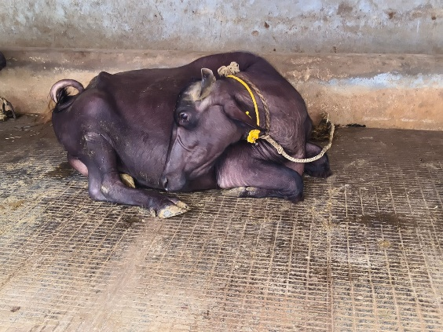
B
A
Fig. 1.Murrah buffalo presented with recurrent hypocalcemia before (A)and after treatment (B)
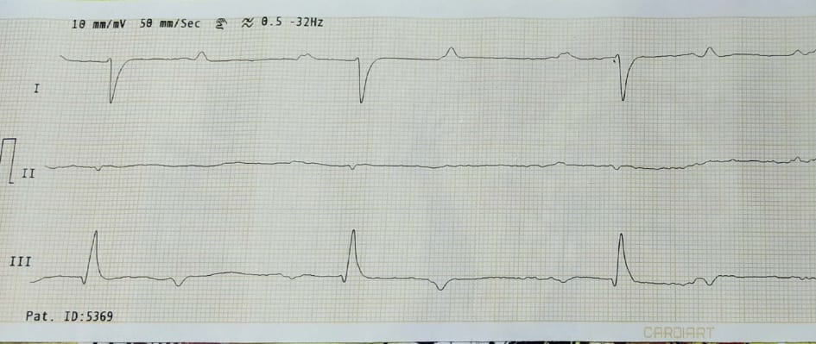
Fig. 2. Electrocardiogram (Lead I) of a Murrah buffalo showing prolongation of corrected QT (QTc) and ST (STc) intervals

