Methodology of Nutritional and Yield Evaluation of Advanced Potato Clones for Eastern Indo-Gangetic Plains

Abstract

Potato (Solanum tuberosum L.) is the most important vegetable crop of the world. The varietal development includes evaluation of advanced clones for yield and quality parameters viz., nutritional parameters like Fe, Zn, carotenoids, Anthocyanin and ascorbic acid content present in the tubers. The important yield parameters like germination, total and marketable tuber yield, high dry matter, resistance to diseases, shallow eyed and consumer preferred skin colour (red, purple, white and pink etc.). The field and laboratory experiment were conducted at ICAR Central Potato Research Institute, Regional Centre, Patna, Bihar and ICAR CPRI, Shimla respectively during the years 2023-2024 and 2024-2025. The ten advanced potato clone’s PS/19-02, PS/19-04, PS/19-12, PS/19-24, PS/19-26, PS/19-31, PS/19-41, PS/19-43, PS/19-44 and PS/19-50, along with five control varieties of potato viz; Kufri Lohit, Kufri Manik, Kufri Lalit, Kufri Lalima and Kufri Neelkanth were evaluated. The performance of advanced clones was evaluated with respect to the important characters like germination, total tuber yield, marketable tuber yield, dry matter content and nutritional status of the tubers. The experiment was planted in experimental field of crop improvement section in the pattern of Randomized Block Design with 03 replications. The planting distance of potato tubers were 20 cm (Plant x Plant) and 60 cm (Row x Row) and depth of planting 4-5 cm deep in the soil on ridges. The experiment was planted in two sets i.e. 75 days & 90 days duration crop. The Advanced clone were evaluated and selected on the basis of superior marketable tuber yield (32.51 t/ha (PS/19-50) at 75 days duration crop, 36.88 t/ha (PS/19-41) in 90 days crop) and low storage losses as total weight loss (7.37 % in PS/19-50 and 17.4% in PS/19-41) during ambient storage conditions. The nutritional status of the tubers was high (34.65 ppm Fe in PS/19-24, 25.31ppm Zn in PS/19-50) tuber shape ovoid to round, red color, light red flesh colour, shallow eyes and good organoleptic qualities. The aim of the experiment was to evaluate the performance of advanced clone for the important yield and quality traits for breeding red skinned potato varieties for Eastern Indo-Gangetic Plains.

KEYWORDS: Advanced clones, Potato varieties, Total tuber yield, Marketable tuber yield.

Introduction

Potato (Solanum tuberosum L.) is very important and ranks after wheat, rice and maize at world level in food crops. The total world potato production is estimated at 390 million metric tons in 2025. India ranks second with the production of 60 million tonnes after China (95 million tons) in terms of production with a share of nearly 15% in 2025 and third in terms of potato area after China and Russia. India produced 60 million tons of potatoes (FAO STAT, 2025). Potato is starchy vegetable crop with multifarious uses and utility. In future, potato is expected to play important role in food and nutritional security of the world and Asian countries especially for India. The major growing states in India are Uttar Pradesh, West Bengal, Bihar, Gujrat, Madhya Pradesh, Punjab, Assam and Haryana. In our country per capita consumption of potato is comparatively less (28 kg/ annum) than the world (33 kg/annum). In India it is favorite vegetable of every age group of people and is integral part of food and traditional dishes for example chips, papad made during Indian festival like Holi and makar Sankranti etc. now a days it is likely to find more preferable place in the dietary habit of Indian people across the various states. Central Potato Research Institute, Shimla has released more than 65 potato varieties for cultivation in different agro climatic region since 1958 (Luthra et al. 2020). Besides these, several other potato clones or local varieties (named
locally to unreleased hybrids or exotic varieties) are under cultivation since long. Some of these exotic varieties introduced by the Britishers before independence and a few of them especially processing varieties were brought for commercial interest by industry people. Although, local varieties do not have organized seed potato production programme but they do have their presence in a limited area and scale for one or the other reasons. These varieties are, however, preferred for their special traits like skin and flesh colour, taste, and preparation of other local dishes. The quality of potato, and its storage life, is reduced by the loss of moisture, decay and physiological breakdown. Suitable and efficient post-harvest technology and marketing of potatoes are vital to the entire production-consumption system because of
its bulkiness and semi-perishability. In the present study the advanced clones were evaluated for various parameters like plant emergence, yield, dry matter, storability and nutritional quality parameters. The outstanding advanced clones were introduced in All India Coordinated Multi-location testing a preliminary step towards the release of a clone as promising variety.

2. MATERIALS AND METHODS

Potato is recognized as a cool-season crop that thrives best under moderate temperatures, adequate moisture, and fertile soils. For successful experimentation and cultivation, a well-prepared and well-drained field is essential. The crop performs optimally when soil temperatures remain between 17–19 °C, as this range supports both vegetative growth and tuber initiation (Luthra et al., 2001). Potatoes can adapt to a wide variety of soils, including sandy loam, silt loam, and clayey soils, provided drainage is sufficient. Soil acidity also plays a crucial role, with a pH range of 5.0–6.5 being most suitable for healthy crop development (Chhidda Singh, 2001). Overall, the combination of cool climate, proper soil preparation, and balanced soil conditions ensures favourable growth and productivity of the potato crop (Khurana et al., 2003)

2.1 Planting Materials

The material in this study were ten advanced potato clones PS/19-02, PS/19-04, PS/19-12, PS/19-24, PS/19-26, PS/19-31, PS/19-41, PS/19-43, PS/19-44 and PS/19-50, along with five control varieties of potato viz; Kufri Lohit, Kufri Manik, Kufri Lalit, Kufri Lalima and Kufri Neelkanth.

2.2 Location of Experiment

The experiment was carried out at the experimental field of ICAR-CRPI RS Patna during the agricultural years 2023–24 and 2024–25, with the objective of evaluating advanced potato clones under the Institute Research Programme “Breeding for Table Potatoes”. Specifically, the work was undertaken as part of the project “Breeding medium maturing red-skinned potato varieties for the eastern plains.” The clones were planted according to the standard, approved technical programme between November 10–15, 2023–24 and November 8–12, 2024–25, coinciding with the Rabi season. The cropping cycle in this region begins in November and concludes in the last week of February, culminating in the harvesting and storage of seed tubers. This systematic approach not only ensures adherence to institutional protocols but also strengthens the prospects of developing region-specific, medium-maturing red-skinned potato varieties that can enhance productivity and adaptability in the eastern plains.

2.3 Experimental Design

The experiment was laid out in a Completely Randomized Block Design (CRBD) with three replications, ensuring statistical reliability and minimizing experimental error. Two sets of trials were conducted, varying in the number of days to dehauming & harvest. The one harvested at 75 days after planting and the other at 90 days after planting to assess the performance of advanced clones under different maturity durations. Each clone, along with control varieties, was planted in five rows of 12 tubers with a plot size of 3.0 m × 2.4 m (7.8 m²). This meticulous design provided a robust framework for evaluating yield, maturity, and adaptability traits, thereby strengthening the breeding programme aimed at developing medium-maturing, red-skinned potato varieties suitable for the eastern plains.
Plate 1 : Breeding programme of Potato
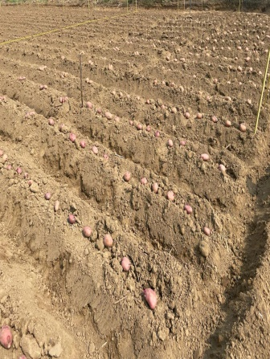 | 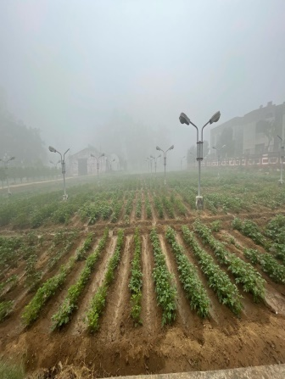 | 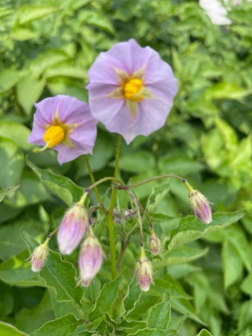 | 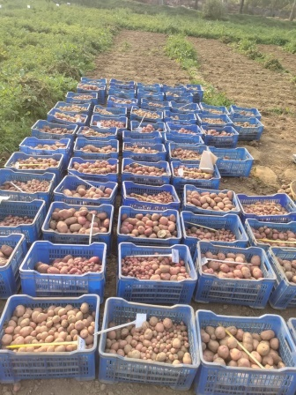
Potato: ridge planting | Potato hybridization block | Potato flower | Harvesting

2.4 Field Preparation

A well-prepared field is mandatory for good crop growth and development. Potato crop is planted as early, medium (Timely) and late (Rukundo et.al., 2020). This experiment was done to evaluate medium maturing red and purple skinned potato advance clones. For successful experiment field was prepared by deep ploughing (20-25 cm deep) with the help of soil turning plough, followed by 2-3 cross harrowing and 2-3 shallow ploughing with leveling of the field. Good tuberization of the potato crop needs a well-prepared field during cultivation of the crop. Planking is very important cultural practices to retain the available moisture in the field, which plays important role at the time of sowing and helps better and even germination of the crop (Singh et.al., 2014).

2.5 Seed Size, Seed Rate and Spacing

Tubers with 30 to 50 g weight are ideal for planting of the crop (Hirdesh et.al., 2003). In this experiment, whole tubers of standard size were planted on the ridges. The plant-to-plant distance was 20 cm and row to row distance was 60 cm. After planting of the crop, light irrigation was given in the field in order to promote good and even germination of the tubers ( Luthra et.al., 2001)

2.6 Manure and Fertilizers

Potato crop is a heavy feeder crop, it requires high doses of fertilizers i.e. 180:80:100 (N: P: K). Along with these fertilizers farm yard manure plays important role to maintain this soil structure and population of beneficial microflora and fauna (Luthra et.al., 2001). In the potato crop 25-30 tones/ha well decomposed farmyard manure was applied for getting better crop growth and tuber yield. This FYM was applied during land preparation and given enough time to mix well in the soil. Whereas chemical fertilizers like Nitrogen in the form of Urea, Phosphorous in the form of DAP and Potassium in the form of MOP were applied as basal dose (1/2 N: P: K). the remaining dose of nitrogen was applied after earthing up operation that is 25-30 days after planting (Subarta, 1997).

2.7 Method of Planting

The tubers were planted on the ridges. These ridges were made after land preparation with the help of tractor driven ridge-maker or with the help of Spade manually. For conducting the experiment Bed cutting (3mx60cmx 5 lines) was done as per layout of the experiment. The planting of potato tubers were done with the help of khurpi at the depth of 7-8 cm followed by covering of the tubers with surrounding soil. Light irrigation was given just after planting of the experiment for better germination of the experimental material.

Inter Culture Operations

Inter culture operation plays important role in the expression of yield and yield attributing traits. Weeds are major problems in the potato crop. The important weeds are Moth grass, Gajar ghaas, Palak grass, Trifolium spp.etc. After planting of the crop, weedicide Oxflurofen 23.5% SC (500 ml/ha) was sprayed at pre- emergence stage. In order to control prolific growth of weeds in the field during germination of the crop. All inter culture operations like weeding, earthing up etc. were done manually as per requirement of the crop. After hoeing remaining half dose of Nitrogen in the form of Urea was applied in side of the furrows and then earthing up was done in order to get better nutrition to support tuberization in the crop. In potato crop 4-5 irrigations at an interval of 10-15 days were given to meet the moisture requirement of the crop. Irrigation interval may vary as per requirement and level of moisture present in the field. Late blight of potato is very harmful disease in this crop as it affects leaves, stems, tubers etc (Singh et.al., 2014). This disease spreads very fast under congenial environment and if not controlled timely then it may destroy whole crop. This disease was controlled by one prophylactic spray of Mancozeb 75WP followed by 2 sprays of Cymoxanil 8% + Mancozeb 64% WP at an interval of 15 days. For control of as aphids and pest such as potato leaf cutters, cutworms etc. Imidacloprid 17.8% SL was sprayed in 45 days crop.

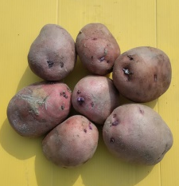 | 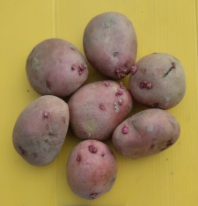 | 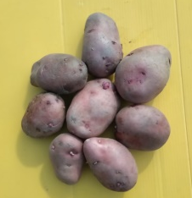 | 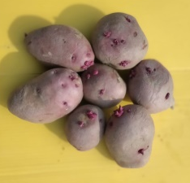 | 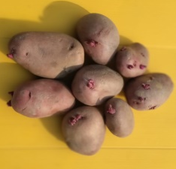
PS/19-02 | PS/19-04 | PS/19-12 | PS/19-24 | PS/19-26
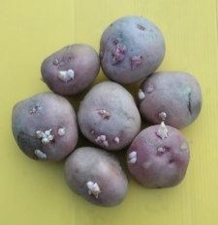 | 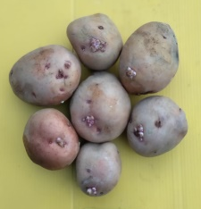 | 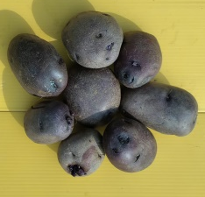 | 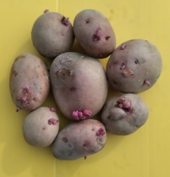 | 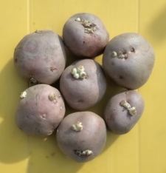
PS/19-31 | PS/19-41 | PS/19-43 | PS/19-44 | PS/19-50
Plate 2: Tuber colour variation in sprouted tubers of advanced clones

2.9 Data collection and recording
The important observations were recorded for range of plant emergence (%), Total Tuber Yield (t/ha), Marketable tuber yield (t/ha), bio-chemical components and dry matter (%). The other important observations like Plant Emergence (%), total tuber yield (t/ha), marketable tuber yield (t/ha), dry matter (%) and Dry matter (%) were recorded at different physiological stages of the crop. Plant emergence was recorded at 30 days after planting by counting and calculation of percentage with germinated tubers over total planted tubers per plot, Total Marketable yield was calculated by weighing of the whole produce harvested from a plot (total tuber yield) & designated as total tuber yield per plot. The marketable tuber yield (kg/plot) was recorded by eliminating very small grade tubers from the total tuber yield of the plot and designated as marketable yield per plot. Dry matter (%) was calculated by keeping 200g fresh tubers during the harvesting from each replication. These tubers were cut into small pieces followed by 72 hours drying in hot air oven. After drying of the cut potatoes these were weights on the electronic balance. The measured cut tuber weight of the dry matter (%) of the respective advanced clones and varieties. The bio-chemical parameters like Zn, Fe were calculated as per standard procedure at CPB&PHT laboratory of ICAR-CPRI, Shimla. The bio-chemical parameters like Carotenoid, Anthocyanin, Ascorbic acid were calculated as per standard procedure at PHT laboratory of ICAR-CPRI, Shimla.
Formula
Plant Emergence (%) | = | No. of plants germinated (30 DAP) | x | 100
Plant Emergence (%) | = | No. of total tubers planted per plot | x | 100

Total Tuber yield (t/ha) | = | Weight of the harvested total tubers per plot (kg) | x | 10000
Total Tuber yield (t/ha) | = | Area of the plot (m²) | x | 10000

 |  | Total wt. of harvested tubers (kg) –
Marketable Tuber yield (t/ha) | = | wt. of very small tubers per plot (kg) | x | 10000
Marketable Tuber yield (t/ha) | = | Area of the plot (m²) | x | 10000

Dry matter (%) | = | Weight of the cut, oven, dried potato | x | 100
Dry matter (%) | = | fresh weight of the potato | x | 100

Result and discussion

Data interpretation and analysis
- Plant Emergence: Data were recorded for plant emergence, 30 days after planting (Table-1). The plant emergence ranged from 72.22% (PS/19-43) to 85.56% (PS/19-12) in 75 days crop. In the experiment planted for evaluation in 90 days crop the range was 65.0% (PS/19-26) to 85.0% (PS/19-50).

Advanced clones /Varieties | Emergence (%)
Advanced clones /Varieties | At 75 days | At 90 days
PS/19-02 | 81.11 | 70.00
PS/19-04 | 77.78 | 71.11
PS/19-12 | 85.56 | 84.45
PS/19-24 | 80.00 | 77.78
PS/19-26 | 73.33 | 65.00
PS/19-31 | 78.89 | 77.78
PS/19-41 | 81.11 | 78.33
PS/19-43 | 72.22 | 70.56
PS/19-44 | 76.67 | 70.00
PS/19-50 | 73.33 | 85.00
K.Lalima | 84.44 | 82.22
K.Lalit | 81.11 | 79.44
K.Lohit | 74.44 | 72.22
K.Manik | 73.34 | 68.89
K.Neelkanth | 82.22 | 78.89
CD (0.05) : | 12.88 | 12.99
CV (%) : | 10.54 | 11.01
Table & Fig. 1: Plant Emergence of advanced clones (2023-24)

- Total tuber yield: The total tuber yield was recorded maximum in PS/19-12 (24.67 t/ha) followed by PS/19-41 (24.66 t/ha) in 75 days crop experiment. In the 90 days crop experiment the total tuber yield was highest in PS/19-12 (37.47 t/ha) followed PS/19-24 (36.56 t/ha) performed better or at par than the controls. (Table-2).

Advanced clones /Varieties | Total tuber Yield (t/ha)
Advanced clones /Varieties | At 75 days | At 90 days
PS/19-02 | 23.55 | 33.00
PS/19-04 | 22.16 | 32.25
PS/19-12 | 24.67 | 37.47
PS/19-24 | 22.69 | 36.56
PS/19-26 | 14.72 | 23.87
PS/19-31 | 18.26 | 26.80
PS/19-41 | 24.66 | 33.17
PS/19-43 | 22.67 | 28.59
PS/19-44 | 22.33 | 30.45
PS/19-50 | 24.54 | 25.71
K.Lalima | 15.68 | 21.18
K.Lalit | 22.73 | 29.48
K.Lohit | 21.13 | 29.92
K.Manik | 13.33 | 19.12
K.Neelkanth | 14.74 | 37.57
CD (0.05) : | 10.25 | 11.29
CV (%) : | 34.12 | 24.77
Table & Fig. 2: Total tuber Yield (t/ha) of advanced clones (2023-24)

- Marketable tuber yield: The marketable tuber yield was recorded after subtraction of weight of very small tubers from the total tuber yield. In 75 days crop marketable tuber yield was maximum in PS/19-50 (24.31 t/ha) significantly superior over planted control varieties. In the 90 days crop highest marketable tuber yield was recorded in PS/19-12 (34.99 t/ha) followed by PS/19-24 (34.91 t/ha) significantly at par with the most of the control varieties (Table-3).

Advanced clones /Varieties | Mkt. tuber Yield (t/ha)
Advanced clones /Varieties | At 75 days | At 90 days
PS/19-02 | 22.30 | 31.07
PS/19-04 | 22.00 | 31.12
PS/19-12 | 23.85 | 34.99
PS/19-24 | 22.19 | 34.91
PS/19-26 | 14.64 | 23.03
PS/19-31 | 17.86 | 25.30
PS/19-41 | 23.87 | 31.50
PS/19-43 | 22.20 | 26.99
PS/19-44 | 21.58 | 29.13
PS/19-50 | 24.31 | 24.20
K.Lalima | 15.15 | 20.21
K.Lalit | 22.25 | 28.20
K.Lohit | 20.85 | 28.11
K.Manik | 12.79 | 18.11
K.Neelkanth | 14.20 | 34.36
CD (0.05) : | 10.03 | 11.01
CV (%) : | 34.23 | 25.55
Table & Fig. 3: Marketable tuber Yield (t/ha) of advanced clones (2024-25)

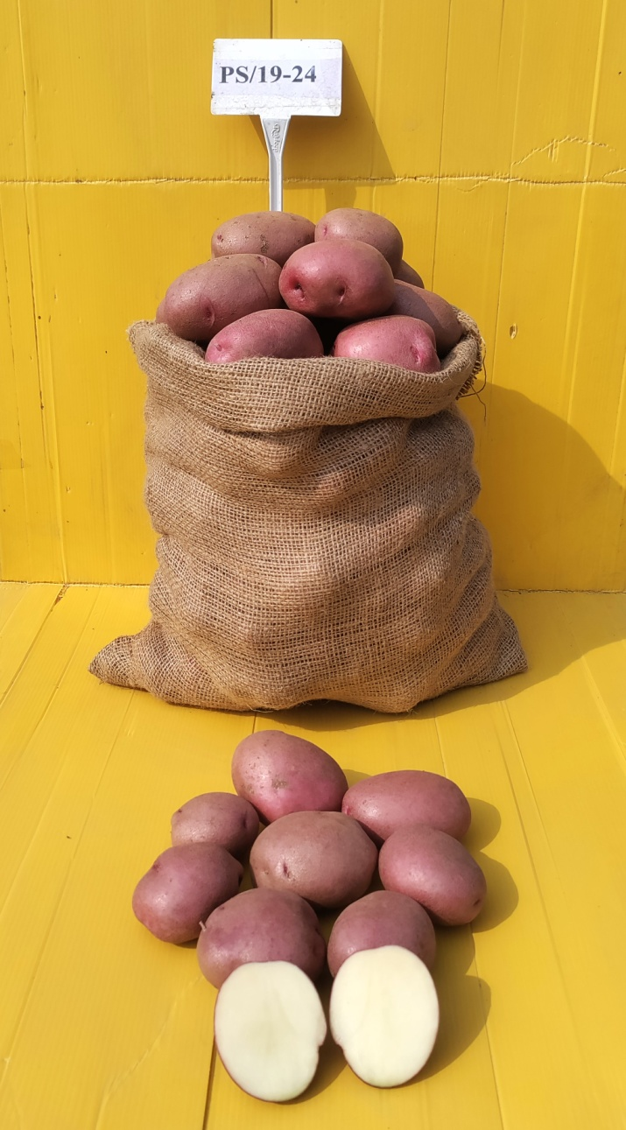 | 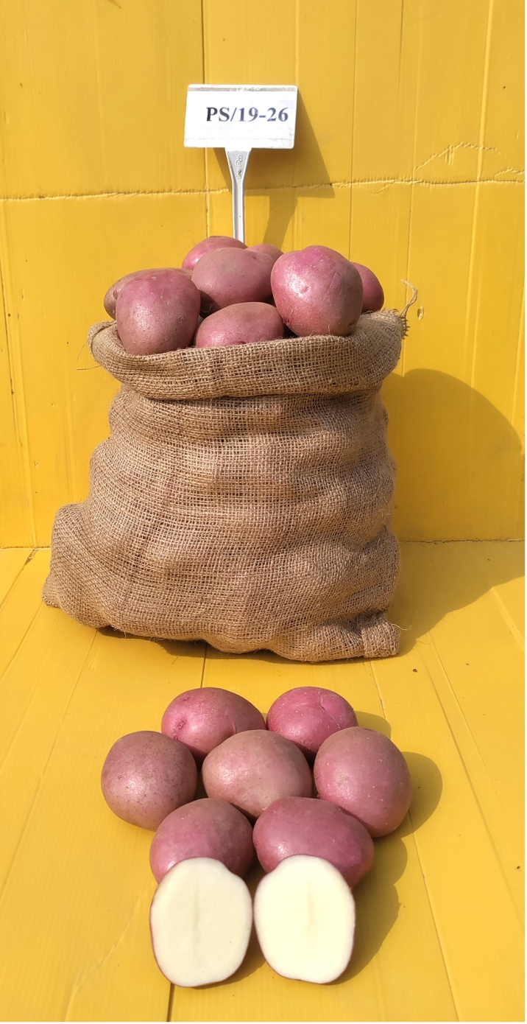 | 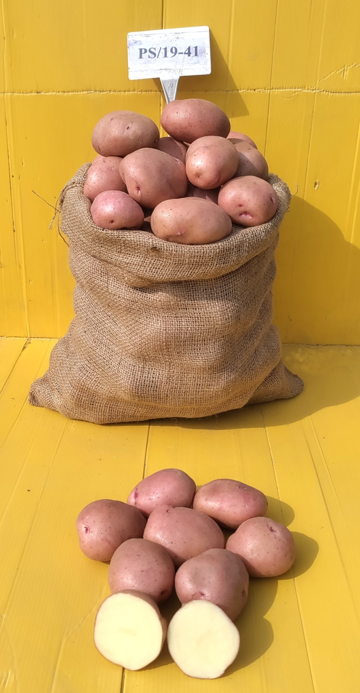 | 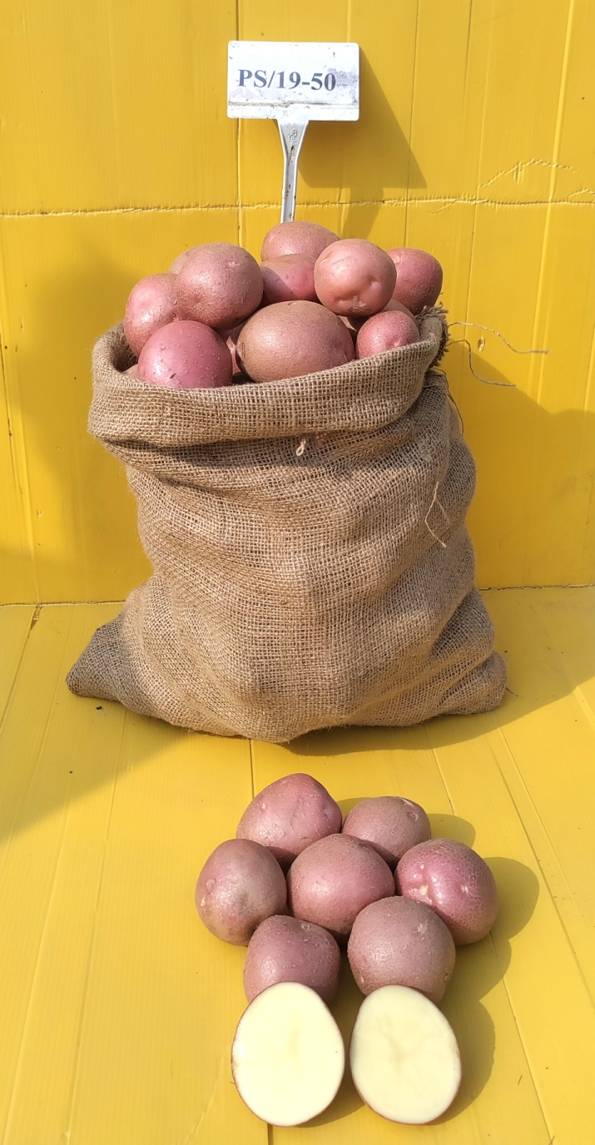
PS/19-24 | PS/19-26 | PS/19-41 | PS/19-50
Plate 3: Tubers of promising advanced clones

- Dry Matter: The dry matter content plays very important role in selection of clones. The range varies from 24.83% (PS/19-02) to 14.17% (PS/19-04) during the year 2023-24, while it ranged from 19.67% (PS/19-50) to 12.17% (K.Lohit) during the year 2024-25.
Dry Matter (%) of advanced clones (2023-24)
Advanced clones /Varieties | Dry Matter % at 90 days
PS/19-02 | 24.83
PS/19-04 | 14.17
PS/19-12 | 17.83
PS/19-24 | 17.83
PS/19-26 | 14.83
PS/19-31 | 17.50
PS/19-41 | 17.33
PS/19-43 | 17.17
PS/19-44 | 14.83
PS/19-50 | 18.50
K.Lalima | 15.67
K.Lalit | 15.17
K.Lohit | 14.83
K.Manik | 17.67
K.Neelkanth | 17.33
CD (0.05) : | 1.27
CV (%) : | 4.60

Advanced clones /Varieties | Dry Matter %
Advanced clones /Varieties | At 75 days | At 90 days
PS/19-02 | 15.67 | 18.67
PS/19-04 | 15.00 | 16.17
PS/19-12 | 15.83 | 17.50
PS/19-24 | 18.67 | 20.50
PS/19-26 | 16.17 | 20.00
PS/19-31 | 15.50 | 20.00
PS/19-41 | 17.17 | 21.33
PS/19-44 | 17.83 | 18.83
PS/19-50 | 19.67 | 21.17
K.Lalit | 18.33 | 23.17
K.Lohit | 12.17 | 17.67
K.Manik | 15.00 | 16.67
CD (0.05) | 2.02 | 2.76
CV (%) | 7.25 | 8.52
Table & Fig. 4: Dry Matter (%) of advanced clones (2024-25)

Nutritional values and clone performance
Potatoes are rich source of carbohydrate, a nutrient-rich staple food. A medium baked potato (150 g, with skin) provides about 110–133 calories, is naturally fat-free, and delivers high amounts of potassium, vitamin C, and vitamin B6, along with fibre and protein. Nowadays different coloured potatoes like white, purple, pink, red, dark red are bred and varieties are developed which are rich in Anthocyanins and carotenoids. These coloured potatoes are used for bhujia, chips and boiled purposes. Zn and Fe are main minerals responsible to maintain the health of women and children are also present in potatoes in significantly good amount (Yadav et.al., 2023). The Zn was highest in the control variety Kufri Lohit (26.85 ppm), Fe and carotenoids were highest in PS/19-24 (34.65 ppm and 82,2 µg/100 g fresh weight), the Anthocyanin were highest in PS/19-50 (24.6 mg/100-gram fresh weight). The important vitamin i.e, Vitamin C was highest in Potato variety Kufri Manik (32.2 mg/100-gram fresh weight) table and graph 1.

Table 5: nutritional components of potato varieties and advanced clones

S. No. | Sample | Zn  (ppm) | Fe  (ppm) | Carotenoid  (µg/100-gram fresh weight) | Anthocyanin  (mg/100-gram fresh weight) | Vitamin C  (mg/100-gram fresh weight)
1. | PS/19-24 | 22.54 | 34.65 | 82.2 | 13.5 | 27.4
2. | PS/19-26 | 21.37 | 31.20 | 34.8 | 12.8 | 23.3
3. | PS/19-41 | 23.48 | 34.24 | 64.8 | 2.4 | 18.5
4. | PS/19-50 | 25.31 | 32.07 | 66.0 | 24.6 | 25.1
5. | K. Manik | 26.31 | 33.24 | 77.0 | 11.76 | 32.2
6. | K. Lohit | 26.85 | 34.37 | 73.5 | 0.84 | 29.8

The medium maturing red skinned advanced clones viz., PS/19–41, PS/19-50 were suitable for table potatoes. The total tuber yield was maximum in PS/19-12 (37.47 t/ha) followed by PS/19-24 (36.56 t/ha), PS/19-41 (33.17 t/ha), PS/19-02 (33.00 t/ha) and PS/19-50 (25.71 t/ha). The PS/19-24, PS/19-41 and PS/19-50 bears attractive red coloured potato with yellow creamy flesh and good in taste after boiling and frying. The tubers are round, shallow eyed and yellow creamy flesh colour are preferred by consumers. The dry matter content plays important role in processing of varieties as it is positively correlated with the quality of products like chips, French fries etc. As per organoleptic test these advanced clones bear Mealy texture with pleasant flavour. The tubers of these advanced clones cook easily (15-18 minutes) and also cooked and boiled tubes were free from any discoloration after cooking. These clones do not have any internal or external defect during harvesting and after storage of the tubers.

Conclusion
The evaluated potato clones showed variability for emergence, tuber yield, marketable yield, dry matter and nutritional quality traits under the eastern Indo-Gangetic Plains. PS/19-12 and PS/19-24 performed well for marketable yield at 90 days, while PS/19-50 showed better marketable yield at 75 days and higher anthocyanin content among the tested clones. PS/19-24 showed comparatively high iron and carotenoid contents. The findings suggest that selected advanced clones, particularly PS/19-24, PS/19-41 and PS/19-50, may be useful for further evaluation as red-skinned table potato material. However, multilocation and multi-season testing with consistent quality assessment is necessary before recommending any clone for wider cultivation or varietal release.
Limitations
The study was limited to specific experimental locations and seasons, and some quality traits were reported for selected samples only. Storage-loss data and detailed biochemical estimation procedures were not fully presented. Further multilocation testing, complete statistical analysis, standardized nutritional profiling and validation across additional seasons are required to confirm the stability and suitability of the promising clones.

Competing Interests
Authors have declared that they have no known competing financial interests or non-financial interests or personal relationships that could have appeared to influence the work reported in this paper.
Declaration of AI Use

This manuscript was prepared through the combined contributions of all author(s), including contributions to the study design, data, content development, results, interpretation, and related scholarly work. The author(s) acknowledge the use of Grammarly and ChatGPT to assist with grammar checking, language refinement, reference formatting. These AI-assisted tools were not used as authors and did not replace the intellectual contributions or scholarly judgment of the author(s). All AI-assisted outputs, including content, references, and interpretations, were carefully reviewed, revised, verified, and approved by the author(s). The author(s) accept full responsibility for the accuracy, integrity, and final content of the manuscript.

References
Amador, V., Bou J, Martine-Garcia J. Monte E. Rodriguez Falcon M. Russo E. and Prat S. (2001). Regulation of potato tuberization by daylength and gibberellins. The Inter. J. of Development Biology. 45(SI) S37-S38.
Bartova V, Barta J, Barbacoa A, Zdrahal Z, Horakova V. (2015). Amino acid composition and nutritional value of four cultivated South American potato species. J Food Compos Anal.; 40:78-85.
Beals KA. (2019). Potatoes, nutrition and health. Am J Potato Res.; 96:102-10.
Bhagwati R.R. Saikia M. and Sut D. (2002) Variability heritability, genetic advance and character association in True Potato Seed (TPS) population.
Bonier bale M. (2020). Procedures for standard evaluation trials of advanced potato clones. An international cooperator's guide. International Potato Center, Lima, Peru.
Burgos G, Zum Felde T, Andre C, Kubow S. (2007) The potato and its contribution to the human diet and health. In: Campos H, Ortiz O, editors. The potato crop. Cham, Switzerland: Springer. 2020;37-74.
Chidda Singh (2010). Modern Techniques of Raising Field Crops.;449-463.
CIP, 2009. Catalog of potato varieties. International Potato Center, Lima, Peru.
CIP, 2007. Procedures for standard evaluation trials of advanced potato clones. International Potato Center Apart ado 1558, Lima 12, Peru.
Cutter EG. (2018) Structure and development of the potato plant. In: Haris, P. M. The potato crop. Springer, Science + Business media, B.V, UK.;70-152.
Dalamu, S.K. Luthra, J.K. Tiwari, J. Sharma (2019). Mineral content of red skinned potatoes of eastern India. J. Horti. Sci.;14(1):79-82
Das S, Mitra B, Saha A, Mandal S, Paul PK, El-Sharnouby M, Hassan MM, Maitra S, Hossain A. (2021). Evaluation of quality parameters of seven processing type potato (Solanum tuberosum L.) cultivars in the Eastern Sub-Himalayan Plains. Foods.; 10:1138.
FAOSTAT, Food and Agriculture Organization of the United Nations, Rome, Italy; 2019, 2020, 2021, 2022.
Firman D, Daniels S. (2011). Factors affecting tuber numbers per stem leading to improved seed rate recommendations. Potato council report ;22-28
Gopal J. (2015). Challenges and Way-forward in Selection of Superior Parents, Crosses and Clones in Potato Breeding. Potato Research.;58:165-88.
Hardigan, M.A. Laimbeer F.P.E. Newton L. Crisovan E. Hamilton J. P. Vaillancourt B. and Buell C.R. (2017). Genome diversity of tuber-bearing Solanum uncovers complex evolutionary history and targets of domestication in the cultivated potato. Proceedings of the national academy sciences. 114(46). E9999-E10008.
Hassanpanah D, Hassanabadi H. (2014). Evaluating quantitative and qualitative traits of promising potato clones and commercial cultivars using the GGE BI- plot and AMMI models. (article in Persian with an abstract in English). Iranian Journal of Agricultural Science.;30:149-164.
Haverkort A, Struik P, Visser RGF, Jacobsen E. (2009). Applied biotechnology to combat late blight in potato caused by Phytophthora infestans. Potato Research.52:249-64.
Hawkes JG, Francisco-Ortega J. (1993). The early history of the potato in Europe. Euphytica.;70:1-7.
Hirdesh Kumar, B Rashmi, Murlidhar J, Sushma Tiwari, Singh SP, Samad Diya RK. (2003) Evaluation of potato (so tube, L Selenium tuberosum capital L.) hybrid and varieties for medium maturity and quality component for North Central India. Biological forum – An international journal.;15(2); 1244–1250.
Horton DE. (1987). Potatoes: Production, marketing and programs for developing countries. International Potato Center.
Jansky S. (2009). Breeding, genetics and cultivar development. Advances in potato chemistry and technology. Academic Press, Burlington, VT.;27-62.
Jozani S, Abd-Mishani GHRS, Hosenzadeh AH, Seyed Tabatabaei BE(2003). Genetic diversity analysis of commercial potato cultivars (Solanum tuberosum) in Iran using RAPD-PCR technique. (article in Persian with an abstract in English) Iranian Journal of Agricultural Science.;34:1021-1029.
Kabira JN, Lembaga B. (2003). Quality Evaluation procedures for research and food industries applicable in East and Central Africa Kenya Agricultural Research Institute Publication;.
Kibar H. (2012). Design and management of postharvest potato (Solanum tuberosum L) storage structures. Ordu Univ. J Sci Tech.;2-23-48.
Kowalczewski PŁ, Olejnik A, Białas W, Rybicka I, Zielinska-Dawidziak M, Siger A, Kubiak P, Lewandowicz G. (2019). The nutritional value and biological activity of concentrated protein fraction of potato juice. Nutrients.; 11:1523.
Lutaladio N, Castaldi L. (2009). Potato: The hidden treasure. Journal of Food Composition and Analysis.;22(6):491-493.
Luthra, S.K. (2001). Heritability, genetic advance and character association in potato. Journal of the Indian Potato Association. 28(1)1-3.
Meltzer HV. (1992). The effect of growth regulators on the relationship between numbers of stems and tubers in potato. Potato Research.;35:297-303.
Muhinyuza JB, Shimelis H, Melis R, Sibiya J, Nzaramba MN. (2012). Participatory assessment of potato production constraints and trait preferences in potato cultivar development in Rwanda. Int J Dev Sci.; 1:358-80.
Mulatu E, Ibrahim O, Bekele E. (2005). Improving Potato Seed Tuber Quality and Producers Livelihoods in Hararghe, Eastern Ethiopia. Journal of New Seeds.;7(3):31–56.
Mulema J, Adipala E, Olanya O, Wagoire W. (2008) Yield stability and resistant potato selections. Exp Agric; 44:145-55
Muthoni J, Shimelis H, Melis R. (2014). Genetics and reproductive biology of cultivated potato (Solanum tuberosum L.), implications in breeding. Reproductive Biology of Plants. CRC press, Taylor & Francis group.;164-194
Khurana SMP, Minhas JS, Pandey SK. (2003). The Potato: Production and Utilization in Sub-Tropics Mehta, New Delhi. 2003;15-24.
Patel R. Patel N, Pandey S, Patel J, Kanbi V (2008). Adaptability of Potato in north Gujarat, Potato J.; 2008 ;35:19-22.
Roy, A.K. and Singh, P.K. (2006) Genetic Variability, heritability and genetic advance for yield in potato (Solanum Tuberosum L.) International Journal of Plant Sciences 1(2) 282-285.
Rukundo P, Ndacyayisenga T, Ntizo S, Kirimi S, Nshimiyima. (2020). Components of CIP advanced potato clones J Appl Biosci.;136:13909-20.
Rukundo P. (2019). Overview of potato sector in Rwanda.
Saxena Rani and Mathur Prasoon. (2013). Analysis of Potato Production Performance and Yield Variability in India. Potato J.;40(1):38-44
Singh, B.P. and Rana, P.K. (2014). History of Potato and its emerging problems in India. In Souvenir-National seminar on emerging problems in potato. Shimla India: India Potato Association. (7-21)
Subarta M, Upadhya M. (1997). Potato production in west Bengal 1997; 15:646-9
USAID. (2016). Early generation seed systems study. Country report study. USAID Bureau of Food Security.
www.hau.gov.in (OPSTAT, 2023)
Yadav Sarla, S.K. Luthra, R. K. Singh, and S.P. Singh. 2024. “Evaluation of Red & Purple Skinned Advance Clones Suitable for Eastern Indo-Gangetic Plains of India”. Journal of Advances in Biology & Biotechnology. 27 (11):23–32. https://doi.org/10.9734/jabb/2024/v27i111588.
Yadav Sarla and S.K. Luthra 2023. Performance evaluation and selection of initial clonal generations of Potato for tuber and yield attributing. Frontiers in Crop Improvement 11(III):2016-2021
Yadav Sarala, R.K. Singh, S.K. Luthra and V. Kapoor 2022. Performance evaluation of advanced clones of potato (Solanum tuberosum L.) suitable for eastern plains. Frontiers in Crop Improvement 10(III):1804- 1811
Yadav Sarala, M. Kumar and S.K. Yadav 2021. Optimization of Phosphoric fertilizers for cultivation of potato under high phosphorus soils of Eastern Indo- Gangetic plains of Bihar. Journal of Agri-search. 8(2): 79-82
Yadav Sarala, S.K. Luthra, V. Kapoor, S.P. Singh, R.K. Singh, J. Sharma, S. Dutta and B. Singh. 2023. Assessment of Tuber Yield and Nutritional Parameters of Red Skinned Advance Clone of Potato Suitable for Cultivation in Eastern Indo Gangetic Plains of India. Frontiers in Crop Improvement 11(VII):3358-3363
Yadav, Sarla, S.K. Luthra, V. Kapoor, V.K. Gupta, and B. Singh 2024. "Evaluation of Red Skinned Advanced Potato (Solanum tuberosum L.) Clones for Tuber Yield and Yield Parameter in Eastern Indo-Gangetic Plains of India. Journal of Advances in Biology & Biotechnology, 27(10): 1222–1231.https://doi.org/10.9734/jabb/2024/v27i101544.
Yadav Sarala, M. Kumar and R.K. Singh 2020. Screening and Evaluation of Initial Clonal Generations of Potato Hybrids for Yield and Yield Attributing Characters. Journal of Agri-search, 7(4):198-201

