Methodological Approaches to Hybridization and Selection in initial generations of potato (Solanum tuberosum L.) clones.

Abstract
The cultivated potato (Solanum tuberosum L.) has different ploidy levels. In nature it is highly heterozygous tetraploid species with 2n=4x=48 Chromosomes. The breeding and selection of initial clones of potato played important role in the development of farmer and consumer preferred varieties. An experiment was conducted during 2020-21 and 2021-22 consist of F₁, F₁C₁, F₁C₂ and F₁C₃ generations of table potatoes. The parents were selected as per objective of the breeding program i.e. Breeding red skinned potato varieties with medium maturity suitable for eastern plains . Female parents were identified on the basis of desirable characters like early maturity, early bulking, red tuber colour, tuber flesh colour, shape and depth of the eyes etc. Whereas male parents were selected for the characters like plant type, tuber colour and pollen viability etc. the hybridization work was done at ICAR CPRI Regional Station, Patna and ICAR CPRI Kufri-Fagu Unit, Shimla. The initial generations were planted and evaluated at Patna, Bihar. In F₁ the selection was done as per the shape, skin colour, flesh colour and depth of eyes on the potato tubers and it was 1619 and 1660 clones during 2020-21 and 2021-22 respectively. The selection percentage of F₁C₁ was 30% (2020-21) and 15 % (2021-22) whereas, in F₁C₂ it was 22 % and 25 percent respectively during the year 2020-21 and 2021-22. The clones in F₁C₃ generation were selected and forwarded for further evaluation in preliminary yield trials, the selection percentage was 18 and 40 % during 2020-21 and 2021-22 respectively.
Key words: Potato, Initial generation, Hybridization, Clones, Selection percentage.

Introduction
Potato (Solanum tuberosum L.) is one of the important vegetable crop cultivated all over India. It is mainly contributed and cultivated by states of Uttar Pradesh, West Bengal and Bihar during Rabi season and available as main source of vegetable throughout the year. It is decorated with source of carbohydrate, protein and minerals like Zn and Fe. The crop is also considered as poor man’s friend, introduced to India from Europe in the beginning of seventeenth century ^{18,20}. It is most economic vegetable in India, provide a source of low-cost energy to the human diet and food security to increasing population. It ranks fourth most important crop after rice, wheat and maize (Singh et.al, 2015). It was identified as ‘Hidden treasure’ as per ‘International year of potato’ 2008 and considered that it is able to resolve global food security and poverty alleviation with increasing world population. It is short duration cool season crop nearly 3 months crop¹⁸ with good amount of production. It's easy cultivation and worldwide adoption has made it a valuable cash crop for millions of farmers in India and all over the world. India is the second largest producer of potato in the world after China⁵. Potato crop area, production and productivity increased over last six decades by 8.5, 29.4 and 3.5 times, respectively (Kaur, 2017). India the most populous country with the rapidly increasing population it may face multiple challenges in near future with regard to potato production and yield. It is expected that demand of potato will be approximately 125 m tones by 2050. The production in recent years are approximately 51 m tones (ARDB, 2019). Potatoes are rich source of starch, vitamins especially C and B₁ and minerals (Fe, Zn, Ca, K etc.). The objective of the experiment was to develop cultivars with consumer preferred tuber colour, shape, high yield, improved quality of red and coloured skinned potato varieties. The breeding and selection of initial clones of potato were done during 2020-21 and 2021-22. As the first step, parents were selected as per objective of the breeding program. Female parents were identified on the basis of desirable characters like early maturing, early bulking, tuber colour, tuber flesh colour, shape and depth of the eyes etc. Whereas male parents were selected for the characters like plant type, tuber colour and pollen viability. The initial generations were planted evaluated and selection was done as per the objective of the breeding programme.

Materials and methods

Location and selection of field
The field experiments were carried out during two consecutive years i.e. 2020-21 and 2021-22 ICAR- Central Potato Research Station Patna, Bihar. Potato crop requires fertile, well drained soils sandy loam to loamy soils for growth and development. This crop grows well in sandy loam soils. It is Rabi season crop in plains and Kharif season crop in hills and southern part of India, (Yadav et al. 2020, 2021, 2023).

Research material
The experimental material consists of initial clonal generations of potato clones viz. F₁, F₁C₁, F₁C₂ and F₁C₃. These clones were obtained as harvest of berries as result of hybridization and planted clonal generations in the experimental field of crop improvement section of ICAR CPRI RS, Patna, Bihar.
Plate 1. Pollen viability categories observed in selected male parents.
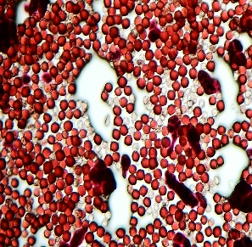 | 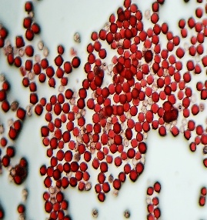 | 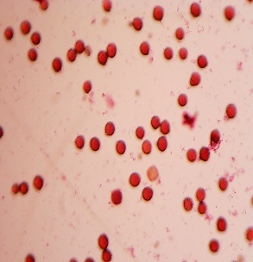 | 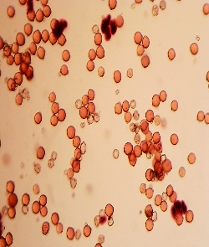
Pollens of selected male parent | Dark stained live pollen grains | _{Low pollen load} | _{Non-viable pollen grains}

Nursery preparation and planting
The male and female parents with desirable traits like plant type, tuber colour, tuber shape, tuber flesh colour were selected and planted in hybridization block of ICAR-CPRI RS Patna, Bihar and Kufri-Fagu unit, Shimla, H.P. Hybridization was done in all possible combinations between desirable parents. In successful crosses the development of berries initiates within a week after hybridization. The potato berries mature 40-50 days after setting. The matured berries were harvested and kept for another 15 days for ripening and softening. The true potato seeds were extracted from the ripened berries by the process of meshing and staining. The extracted seeds were shade dried for 4-5 days and then kept in air-tight containers. The seed treatment with 1500 ppm gibberellic acid solution for 24 hours, enhance germination of TPS (Chakraborty, 1991). The treated seeds were then strained and mixed with coco pit. The treated seeds of different crosses were kept separately in the cotton cloth Potali (small bags). These small bags were kept in seed incubator at 24-25 ⁰C for one week. The TPS requires optimum temperature and sufficient moisture for its germination, it may vary cross to cross. These germinated seeds were sown on the raised nursery beds (15m x 1m x 60cm). The nursery were sown during the last week of September and the potato clones were planted during the last week of October to first week of November. These seedlings were transplanted at a distance of 10 cm on the ridge of the furrow followed by light irrigation (Yadav et. al. 2025). Gap filling was done by identifying damaged, un-established seedlings after one week of transplanting followed by earthing up operation.

Design of Experiment
The potato seedlings of 25-30 days old were planted in the well-prepared main field at a distance of plant-to-plant 10cm and row to row, 45cm. The potato clones were planted in unreplicated plots with just a single plant in the seedling (F₁), five in F₁C₁, 30 in F₁C₂ and 120 plants in F₁C₃ (Yadav et. al. 2020). Depending upon the number of tubers of harvested and selected F₁C₂, F₁C₃ were planted in Randomized Block Design in 2 replications. The clonal screening and selection of these generations were done for the characters like early bulking, tuber size, tuber shape, depth of eye, tuber colour and field resistance to late blight of potato etc. (Federer et al, 2012).
Interculture Operations and fertilizer requirement
Potato is heavy feeder crop. At the time of land preparation 25-30 tons of farmyard manure, 1/2 N+P+K was applied in the soil. Chemical fertilizers were applied in the form of urea, DAP and MOP at the rate of 150: 80: 100: N:P: K. The tubers were planted in the rows, of 3m length at a distance of 15cm plant to plant and 60 cm row to row. The earthing up operation was done at 25-30 days after planting. Hand weeding was also done followed by application of rest amount of N for better tuber development.

Data Recording & Analysis
These experiments were carried out with a total of 83,440 true potato seeds of 84 successful crosses during 2020-21 and 1,09,603 true potato seeds of 26 successful crosses 2021-22. These TPS were produced at ICAR- Central Potato Research Institute, Patna, Bihar & Kufri, Shimla by hand emasculation, bulk pollination during Rabi and Kharif season respectively. In F₁C_{1,} 764 and 747 cultures were planted in single row of five tubers each in the 3m row length with 15 cm plant to plant distance. Whereas, 175 and 164 F₁C₂ cultures were planted in two rows of 3m length during 2020-21 and 2021-22 respectively. fourty-three and fourty five cultures of F₁C₃ along with five controls (K.Mohan, K.Pukhraj, K.Lalima, K.Lalit, K.Ganga, K. Neelkanth and K. Jyoti) were evaluated at 75 days in 3.6m² area in RBD in two replications during 2020-21 and 2021-22 respectively. These cultures were evaluated considering total tuber yield, tuber shape, colour and disease reactions for further evaluation in preliminary yield trial (PYT). Data on germination count was recorded 30 days after planting. Rouging is very important agronomic practice, done to remove diseased, off-type plants before irrigation. The other clonal generations were harvested manually at 90 days after planting (Faithi et. al, 2009). The initial clones with more tuber yield and desirable tuber characteristics were selected for further evaluation. The selected clones after harvesting were kept as planting material for next generation evaluation. In F_{1,} 1619 & 1660 clones during 2020-21 and 2021-22 were kept for further evaluation respectively. In F_{1:} F₁C_{1:} F₁C₂: F₁C_{3:} 10:100:200:200 tubers were kept for next generation evaluation. All the observations were recorded and statistical analysis were done as per Panse and Sukhatame, 1978 statistical methodology. The difference between significant means were tested against C.D. at 5 percent of probability.

RESULTS AND DISCUSSION

1. Hybridization, TPS Production and Seedling Transplanting
A total of 83,440 and 1,09,603 True Potato Seeds of 84 and 26 successful crosses were sown in the nursery beds and out of them 57,758 and 52,333 seedlings were transplanted in the main field. The seedlings were harvested 90 days after planting, selection was done for tuber colour, shape, flesh colour, eyes depth. The selected clones were 1619 & 1660 during 2020-21 & 2021-22 for further evaluation in F₁C₁ generation (Table 1).

Plate 2. Stages of hybridization, true potato seed production, nursery preparation, seedling transplanting, and field establishment.
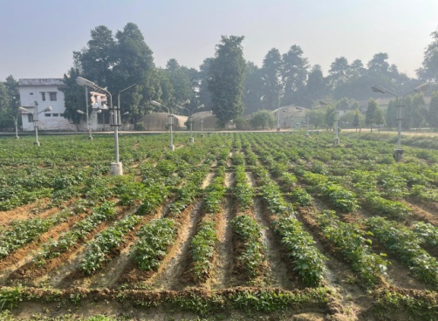
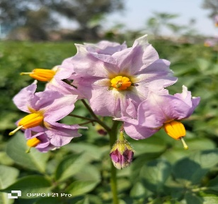
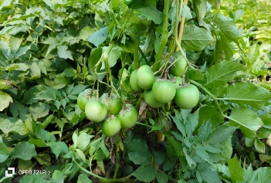
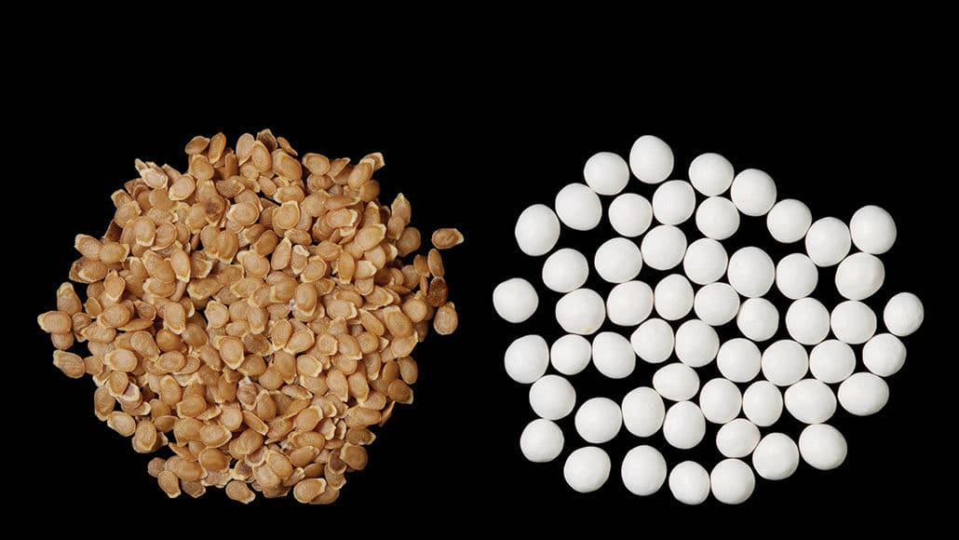
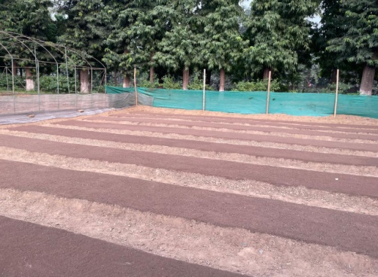
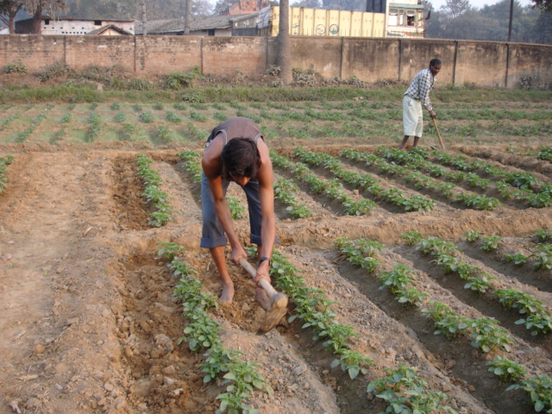
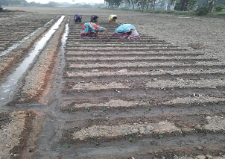
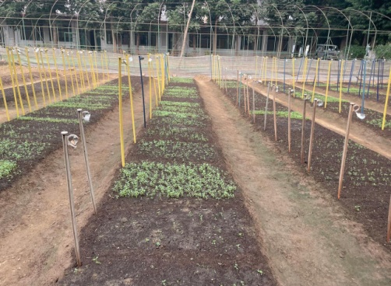
Hybridization Block
Potato Flowers
Berry Development
True Potato Seeds
Nursery Preparation
Seedling Transplanting
Transplanted Field

TPS Nursery

Table 1. Hybridization methodology, seeds sown, seedlings transplanted, and clones selected in the F1 generation of potato hybrids during 2020-21 and 2021-22

Hybridization methodology | Seeds sown in nursery |  | Seedling transplanted in main field |  | Number of Clones selected
Hybridization methodology | 2020-21 | 2021-22 | 2020-21 | 2021-22 | 2020-21 | 2021-22
Emasculation and pollination method | 22550 | 30653 | 19605 | 19173 | 739 | 745
Bulk pollination | 60890 | 78950 | 38153 | 33160 | 880 | 915
Total | 83440 | 109603 | 57758 | 52333 | 1619 | 1660

Figure 1. Seedling transplanting percentage under different hybridization methodologies.

Figure 2. Clonal selection percentage under different hybridization methodologies.
Plate 2 summarizes the operational sequence from parental hybridization to field establishment, while Figures 1 and 2 present the corresponding transplanting and clonal-selection percentages. The numerical differences between emasculation-and-pollination and bulk-pollination treatments should be interpreted cautiously because progeny size reflects the number of seeds generated, parental fertility and cross compatibility, and subsequent establishment of genetically heterogeneous seedlings rather than breeding value alone. Potato hybridization studies show that parental combining ability and cross-specific effects can influence progeny performance, whereas true-potato-seed systems require consistent germination, seedling emergence, and plantlet establishment before field performance can be evaluated reliably (Lindhout et al., 2011; Ortiz et al., 1988; van Dijk et al., 2025). Accordingly, the transplanting and selection percentages reported here are useful operational indicators, although comparisons among hybridization methods would be more informative when accompanied by the numbers of crosses attempted, berry set, seeds per berry, germination percentage, and family-specific survival.

2. Evaluation in F₁C₁ and F₁C₂ generations
In F₁C₁, 764 and 747 cultures were planted in single row of five tubers and out of them 169 and 113 cultures of 44 and 18 crosses were selected in F₁C₁ for further evaluation in F₁C₂ during 2020-21 and 2021-22 respectively. In F₁C₂, 175 and 164 cultures were planted and out of them 79 & 52 were selected for further evaluation in F₁C₃. during 2020-21 and 2021-22 (Table 2).

Table 2. Selection of clones during 2020-21 and 2021-22 in the initial clonal generations (ICG)
Clonal generation | No. of clones planted |  | No. of clones selected
Clonal generation | 2020-21 | 2021-22 | 2020-21 | 2021-22
F₁C₁ | 764 | 747 | 169 | 113
F₁C₂ | 175 | 164 | 79 | 52
F₁C₃ | 45 | 45 | 28 | 17
* ICG- Initial Clonal Generations

Figure 3. Clonal selection percentage across the initial clonal generations.
The generation-wise reduction in the number of retained cultures is consistent with deliberate selection pressure across the F1C1, F1C2, and F1C3 stages (Figure 3); however, selection percentages alone do not quantify the accuracy with which genetically superior clones were identified. Earlier research indicates that visual selection for tuber colour, shape, and eye depth can be informative in initial generations, whereas yield and other environmentally sensitive traits generally require cautious negative selection followed by replicated evaluation (Brown et al., 1987; Gopal et al., 1992). Recent evidence further indicates that pedigree, genomic, and multispectral information can improve breeding-value accuracy when early-stage potato clones cannot yet be tested across multiple environments (Maggiorelli et al., 2025). Therefore, the contrasting retention rates between years may reflect differences in population composition, selection intensity, and seasonal conditions and should not, by themselves, be interpreted as evidence that one year produced inherently superior breeding material.

3. Evaluation in F₁C₃ generation
Forty-three cultures along with five controls (K. Ganga, K. Ashoka, K. Pukhraj, K. Neelkanth & K. Lalit) were evaluated at 75 days in 7.2 m² area in RBD with three replications. Out of them 28 cultures were selected during 2020-21 whereas, 45 cultures along with seven controls (K. Ganga, K. Pukhraj, K. Neelkanth, K. Lalit, K. Lalima, K. Jyoti & K. Mohan) were evaluated at 75 days in 7.2 m² area in RBD with three replications during 2021-20. Out of them 17 cultures were selected considering total tuber yield, shape, colour and disease reactions (Gopal et. al, 1994 and Luthra et al., 2001, 2005).

Table 3. Yield performance of selected initial clones in the initial evaluation trial (F1C3) at 75 days after planting

2020-21 |  |  |  | 2021-22
Adv. Clone code | Germination | Yield (t/ha) |  | Adv. Clone code | Germination | Yield (t/ha)
PS/17-09 | 98.33 | 29.58 |  | PS/18-1 | 96.66 | 31.47
PS/17-10 | 94.44 | 23.43 |  | PS/18-2 | 93.33 | 26.75
PS/17-11 | 93.33 | 26.11 |  | PS/18-3 | 90.83 | 29.16
PS/17-12 | 94.67 | 32.78 |  | PS/18-4 | 92.50 | 25.24
PS/17-13 | 95.56 | 26.57 |  | PS/18-8 | 98.66 | 32.60
PS/17-14 | 96.67 | 24.91 |  | PS/18-11 | 91.66 | 22.77
PS/17-15 | 95.56 | 26.46 |  | PS/18-21 | 91.66 | 31.90
PS/17-16 | 95.56 | 29.63 |  | PS/18-28 | 91.66 | 25.74
PS/17-17 | 96.67 | 29.17 |  | PS/18-31 | 96.66 | 37.21
PS/17-18 | 95.56 | 29.96 |  | PS/18-33 | 92.50 | 24.20
PS/17-19 | 97.78 | 31.63 |  | PS/18-43 | 96.66 | 39.82
PS/17-20 | 96.67 | 28.63 |  | PS/18-44 | 91.66 | 26.66
PS/17-21 | 97.78 | 29.94 |  | PS/18-46 | 92.50 | 26.53
PS/17-22 | 94.44 | 32.66 |  | PS/18-48 | 93.33 | 23.26
PS/17-23 | 96.67 | 37.49 |  | PS/18-53 | 93.33 | 22.71
PS/17-26 | 94.44 | 27.93 |  | PS/18-60 | 98.33 | 32.15
PS/17-27 | 95.56 | 27.87 |  | PS/18-65 | 93.33 | 28.34
PS/17-32 | 93.33 | 27.78
PS/17-33 | 96.00 | 21.23 |  | K.Lalit | 95.00 | 28.48
PS/17-34 | 90.00 | 30.13 |  | K.Mohan | 98.33 | 45.72
PS/17-35 | 91.11 | 29.35 |  | K.Ganga | 96.66 | 38.16
PS/17-45 | 95.00 | 24.72 |  | K.Jyoti | 93.33 | 33.02
PS/17-55 | 92.22 | 23.36 |  | K.Pukhraj | 95.00 | 39.09
PS/17-56 | 90.00 | 26.20 |  | K.Lalima | 93.33 | 35.38
PS/17-58 | 90.00 | 23.33 |  | K.Neelkanth | 93.33 | 29.26
PS/17-64 | 92.67 | 28.47
PS/17-67 | 91.11 | 28.49
PS/17-68 | 90.00 | 19.72
K. Lalit | 93.33 | 22.74
K. Mohan | 95.00 | 20.00
K. Ganga | 96.67 | 36.51
K. Jyoti | 96.67 | 24.96
K. Pukhraj | 96.67 | 34.32
K. Neelkanth | 96.67 | 24.72

The range of germination was 90% (PS/17-68) to 98.33% (PS/17-09) and the range of tuber yield was 19.72 t/ha (PS/17-68) to 37.49 (PS/17-23) during the year 2020-21. Whereas, it was 90.83% (PS/18-3) to 98.66% (PS/18-8) for germination percentage and yield ranges from 22.71 t/ha (PS/18-53) to 45.72 t/ha (K.Mohan) during 2021-22. The cultures were significantly superior over the checks planted during the year and selected for further evaluation in Preliminary Yield Trial (Table 3)
The broad ranges in germination and tuber yield indicate substantial phenotypic variability among the F1C3 clones and controls. Nevertheless, yield at 75 days is influenced not only by genotype but also by maturity class, physiological seed quality, crop duration, and field environment; consequently, single-location or limited-season comparisons should be regarded as preliminary (Haverkort & Struik, 2015; Keutgen et al., 2020). Multi-environment and multiyear analyses are generally required to distinguish mean performance from genotype-by-environment interaction and to identify clones that combine high yield with stability (Ahmed et al., 2024). Within the present dataset, PS/17-23 and PS/18-43 were the highest-yielding advanced clones in their respective years, but Table 3 does not report the analysis of variance, standard errors, or critical-difference values needed to independently assess statistical superiority. Their advancement should therefore be based on replicated confirmation of yield, tuber quality, disease reaction, and stability relative to appropriate checks.

Conclusion
In potato breeding, the primary objective is to enhance yield and improve tuber quality compared to existing released varieties. Key tuber traits considered during the breeding program include skin colour, flesh colour, eye depth, shape, size, early bulking, and resistance to insect pests and diseases. Initial clonal generations were developed from true potato seed (TPS) and screened based on agro-morphological traits and yield performance under irrigated conditions. The use of a randomized block design (RBD) provided a systematic framework for evaluating yield-attributing characters and ensuring reliable selection. Morphological traits such as tuber colour, flesh colour, eye depth, shape, and field resistance to major diseases are critical in assessing potato clones. These characteristics play a vital role in selecting superior genotypes that meet both market demand and consumer preferences, thereby guiding the development of high-performing potato varieties.
Competing Interests
Authors have declared that they have no known competing financial interests or non-financial interests or personal relationships that could have appeared to influence the work reported in this paper.

Limitations
The study was conducted over two seasons at a limited number of locations, and early-generation populations were evaluated with restricted replication or as individual plants. Cross-wise information, parental combinations, family-specific establishment and standardized disease scores were not presented. The reported dataset also lacks complete analysis-of-variance results, standard errors and critical-difference values. Consequently, environmental effects cannot be separated adequately from genetic effects, and claims of statistical superiority cannot be independently verified. The selected clones therefore require replicated multi-location and multiyear evaluation before advancement or release decisions.
Declaration of AI Use

This manuscript was prepared through the combined contributions of all author(s), including contributions to the study design, data, content development, results, interpretation, and related scholarly work. The author(s) acknowledge the use of Grammarly and ChatGPT to assist with grammar checking, language refinement, reference formatting. These AI-assisted tools were not used as authors and did not replace the intellectual contributions or scholarly judgment of the author(s). All AI-assisted outputs, including content, references, and interpretations, were carefully reviewed, revised, verified, and approved by the author(s). The author(s) accept full responsibility for the accuracy, integrity, and final content of the manuscript.

References
Agricultural Research Data book (2019). Potato. Indian Council of Agricultural Research-IASRI, New Delhi. 176

Chakraborty A., C.J.M. (1991). Flowering and true seed production in potato (Solanum tuberosum L.). Potato Res., 34: 379– 388.

CPRI (2015). Vision 2050: ICAR- Central Potato Research Institute, Shimla, H.P., India.
DAC (2019). Potato: http://agricoop.nic.in/

FAOSTAT, Food and Agriculture Organization of the United Nations, Rome, Italy. (2019, 2020, 2021)

Fathi, M., Asghari, Z.R., Valizadeh, M., Ahari, Z.S. and Hasan, P.D. (2009). Evaluation of High-Performance Potato Clones obtained from True Seeds. J. of Agri. Sci., 19: 207-214.
Federer, W.T. and Crossa, J. (2012). Screening Experimental Designs for Quantitative Trait Loci, Association Mapping, Genotype-by Environment Interaction, and other Investigations. Frontiers in Physiol., 3: 1-8

Gopal J. (2015). Challenges and Way-forward in Selection of Superior Parents, Crosses and Clones in Potato Breeding. Potato Research 58: 165-88.

Gopal, J., Gaur, P.C. and Rana, M.S., (1994). Heritability, and Intra- and Inter-Generation Associations Between Tuber Yield and its Components in Potato (Solanum tuberosum L.). Plant Breeding, 112: 80–83.

Hassanpanah D. and Hassanabadi H. (2014). Evaluating quantitative and qualitative traits of promising potato clones and commercial cultivars using the GGE BI- plot and AMMI models. (article in Persian with an abstract in English). Iranian Journal of Agricultural Science. 30: 149-164.

Haverkort A., Struik P., Visser R.G.F. and Jacobsen E. (2009). Applied biotechnology to combat late blight in potato caused by Phytophthora infestans. Potato Research 52: 249-64.
Hawkes J.G. and Francisco-Ortega J. (1993). The early history of the potato in Europe. Euphytica 70:1-7.

Kaur, R.P. (2027). Evaluation and selection of potato hybrid clones (Solanum tuberosum) for yield and associated characters. Electronic Journal of Plant Breeding, 8(1): 294-30

Luthra S K, Gopal J, Pandey S K and Singh B P. (2005). Genetic parameters and characters associated in tuberosum potatoes. Potato Journal 32: 234.

Luthra S K. (2001). Heritability, genetic advance and character association in potato. Journal of Indian Potato Association 28: 1–3.

Muthoni J., Shimelis H. and Melis R. (2014). Genetics and Reproductive Biology of Cultivated Potato (Solanum tuberosum L.), Implications in Breeding. Reproductive Biology of Plants. CRC press, Taylor & Francis group. PP. 164-194

Neele A.E.F. (1991). Parental choice and selection in the early generations of a potato breeding programme. PhD. Wageningen University, Netherlands.

Pandey S. and Kaushik S. (2003). Origin, evolution, history and spread of potato. In: Khurana S.M.P., Minhas J.S., Pandey S.K. The Potato: Production and Utilization in Sub-Tropics Mehta, New Delhi. pp. 15-24.

Singh C. (2001). Potato, Modern techniques of crop production. Oxford & IBH Publishing Co. PVT. Ltd. New Delhi. p 449-463

Yadav Sarla, S.K. Luthra, Vinod Kapoor, S.P. Singh, R.K. Singh, Jagdev Sharma, Som Dutta and Brajesh Singh (2026) Performance of advanced potato clone for tuber yield and yield attributes with nutritional parameters suitable for cultivation in Eastern plains of India. Plant archives. 26(1):1697-1702.
Yadav Sarla, S.K. Luthra, Vinod Kapoor, S.P. Singh, R.K. Singh, Jagdev Sharma, Som Dutta and Brajesh Singh (2025) Evaluation of advance clones of potato (Solanum tuberosum L.) for tuber yield and dry matter content. Plant archives. 25(2):2787-2794
Yadav Sarla, S.K. Luthra, Vinod Kapoor, S.P. Singh, R.K. Singh, Jagdev Sharma, Som Dutta and Brajesh Singh (2025) Evaluation of advanced potato clone for tuber yield and dry matter content suitable for cultivation in eastern plains of India. Plant archives. (Accepted ref PA/October, 2025/449)
Yadav, Sarla, S.K. Luthra, V. Kapoor, V.K. Gupta, and B. Singh 2024. "Evaluation of Red Skinned Advanced Potato (Solanum tuberosum L.) Clones for Tuber Yield and Yield Parameter in Eastern Indo-Gangetic Plains of India. Journal of Advances in Biology & Biotechnology, 27(10): 1222–1231.https://doi.org/10.9734/jabb/2024/v27i101544.

Yadav Sarla, S.K. Luthra, R. K. Singh, and S.P. Singh. 2024. “Evaluation of Red & Purple Skinned Advance Clones Suitable for Eastern Indo-Gangetic Plains of India”. Journal of Advances in Biology & Biotechnology. 27(11):23–32. https://doi.org/10.9734/jabb/2024/v27i111588.
Yadav Sarala, R.K. Singh, S.K. Luthra and V. Kapoor 2022. Performance evaluation of advanced clones of potato (Solanum tuberosum L.) suitable for eastern plains. Frontiers in Crop Improvement 10(III):1804- 1811
Yadav Sarala, M. Kumar and R.K. Singh 2020. Screening and Evaluation of Initial Clonal Generations of Potato Hybrids for Yield and Yield Attributing Characters. Journal of Agri-search, 7(4):198-201
Ahmed, I., Biswas, J. C., Jahan, M. A. H. S., Ishtiaque, S., Zahan, T., Islam, M. A., Al-Shuraym, L. A., Sayed, S., Gaber, A., & Hossain, A. (2024). Yield stability among potato varieties suitable for different agroecological regions of Bangladesh. Heliyon, 10(11), e31633. https://doi.org/10.1016/j.heliyon.2024.e31633
Brown, J., Caligari, P. D. S., Mackay, G. R., & Swan, G. E. L. (1987). The efficiency of visual selection in early generations of a potato breeding programme. Annals of Applied Biology, 110(2), 357-363. https://doi.org/10.1111/j.1744-7348.1987.tb03266.x
Gopal, J., Gaur, P. C., & Rana, M. S. (1992). Early generation selection for agronomic characters in a potato breeding programme. Theoretical and Applied Genetics, 84(5-6), 709-713. https://doi.org/10.1007/BF00224173
Haverkort, A. J., & Struik, P. C. (2015). Yield levels of potato crops: Recent achievements and future prospects. Field Crops Research, 182, 76-85. https://doi.org/10.1016/j.fcr.2015.06.002
Keutgen, A. J., Keutgen, N., Wszelaczyńska, E., Pobereżny, J., Milczarek, D., Tatarowska, B., & Flis, B. (2020). Evaluation of photosynthetic and yield traits in ten potato clones and cultivars under farming conditions in Poland. Potato Research, 63(1), 75-95. https://doi.org/10.1007/s11540-019-09429-w
Lindhout, P., Meijer, D. A., Schotte, T., Hutten, R. C. B., Visser, R. G. F., & van Eck, H. J. (2011). Towards F1 hybrid seed potato breeding. Potato Research, 54(4), 301-312. https://doi.org/10.1007/s11540-011-9196-z
Maggiorelli, A., Thelen, K., Prigge, V., Bruckmüller, J., Muders, K., Hartje, S., & Stich, B. (2025). Enhancing the accuracy of genetic values of tested early-stage potato clones utilizing genotypic, pedigree, and drone-retrieved spectral information. The Plant Phenome Journal, 8(1), e70053. https://doi.org/10.1002/ppj2.70053
Ortiz, R., Iwanaga, M., & Mendoza, H. A. (1988). Combining ability and parental effects in 4x-2x crosses for potato breeding. Potato Research, 31, 643-650. https://doi.org/10.1007/BF02361857
van Dijk, L. C. M., Kacheyo, O. C., Lieftink, W. C., Lommen, W. J. M., & Struik, P. C. (2025). Is field-sowing of hybrid true potato seeds feasible for seed or ware potato production under Dutch conditions? An analysis based on a review and twenty experiments. Potato Research, 68(4), 3705-3732. https://doi.org/10.1007/s11540-025-09889-3

