Sedimentological Characterization and Reconstruction of the Depositional Environments of Detrital Formations in the Mohoua Region (Eastern Onshore Basin of Côte d’Ivoire) Based on Lithostratigraphic, Grain-Size, and Morphoscopic Data

ABSTRACT
This study focuses on the sedimentological characterization of clastic deposits encountered in the boreholes located in the Mohoua area, eastern onshore sedimentary basin of Côte d’Ivoire. The main objective is to reconstruct sediment transport conditions and depositional environments through lithological, granulometric, and morphoscopic analyses. Lithological investigations reveal a predominance of sandy deposits locally interbedded with clayey horizons, reflecting variations in hydrodynamic conditions during sedimentation. Grain-size analyses indicate that the sediments are generally moderately to well sorted, suggesting relatively stable transport energy conditions. The statistical parameters of Folk and Ward highlight the dominant role of hydrodynamic sorting processes controlled by currents and wave action. Transport mode analysis based on Visher diagrams shows that rolling is the dominant transport mechanism, followed by saltation and, to a lesser extent, suspension. This distribution reflects bottom-current dynamics energetic enough to mobilize sandy particles. Depositional environment diagrams (Md–So and Sk–Md) indicate a dual fluvial and coastal influence, with nearly equal contributions from river and beach domains. The sediments also display affinities with both coastal and continental dune environments. Morphoscopic analysis of quartz grains reveals a predominance of sub-rounded to rounded particles, indicating transport over moderate to long distances. The occurrence of polished and shiny grains suggests significant transport by water, whereas the presence of matte grains points to a local aeolian influence. Overall, the results highlight a complex sedimentary system resulting from the interaction of fluvial, marine, and aeolian processes. The studied deposits record the evolution of dynamic coastal environments subjected to climatic and hydrodynamic fluctuations during the recent Quaternary history of the eastern Côte d’Ivoire sedimentary basin.
Key words: Sedimentology, grain-size analysis, morphoscopy, depositional environment, sediment transport, Mohoua, Côte d’Ivoire sedimentary basin

1. Introduction
The sedimentary basin of Côte d’Ivoire is part of the group of marginal basins that line the Atlantic coast of West Africa, from Morocco to the Gulf of Guinea. It formed during the breakup of the supercontinent Gondwana and the opening of the South Atlantic in the Lower Cretaceous, following the separation of Africa and South America (Blarez, 1986; Digbehi, 1987; Chierici, 1996). This geodynamic evolution led to the formation of a passive margin characterized by successive episodes of rifting, subsidence, and marine transgressions and regressions that controlled the accumulation of the basin’s sedimentary sequences.
According to the stratigraphic summaries proposed by Digbehi (1987) and Chierici (1996) and cited by Bie et al. (2012), the geological history of the Ivorian basin can be subdivided into four major phases. An initial rifting phase (Barremian–Albian) is marked by continental and margin-fluvial deposits. This is followed by a phase of early oceanic expansion (Cenomanian–Lower Senonian) characterized by significant marine transgressions. A third phase, spanning the Campanian to the Maastrichtian, corresponds to a period of active subsidence that favored the accumulation of marine clays. Finally, the Tertiary is marked by maximum expansion of the basin, accompanied by significant eustatic fluctuations responsible for the alternation of

continental, lagoonal, and marine environments. The economic importance of the Ivorian basin stems from its significant oil potential. The first indications of hydrocarbons were reported in the Eboïnda region in the late 19th century, while the first commercial discoveries were made offshore at the Bélier field in 1974. Since then, several major fields such as Espoir, Foxtrot, Baobab, Lion, and Panthère have been identified, confirming the importance of the Ivorian Basin within the Gulf of Guinea oil province (Sombo et al., 2003; Kouamé et al., 2018). From a scientific perspective, numerous studies have improved our understanding of the basin’s stratigraphy and depositional environments. Studies by Mobio (2006) and Djeya (2010) have shown that Upper Cretaceous deposits are dominated by black clays associated with sandstone and limestone interbeds. Gbangbot (2012) identified fluvial, coastal, and marine depositional environments in the Bingerville and Assinie areas. More recently, Assalé (2013) demonstrated that the eastern part of the Ivorian basin has undergone a complex succession of fluvial, lagune, marine, and mangrove environments from the Late Cretaceous through the Tertiary. Palynological studies have also provided important information on the evolution of the basin. The pioneering studies by Jardiné and Magloire (1965) laid the foundation for the palynostratigraphy of the Ivorian Cretaceous. Subsequently, Loukou (1999), Béhé (2008), Digbehi et al. (2011), and Bie et al. (2012) helped refine the biostratigraphic and paleoenvironmental frameworks of the formations in the Ivorian offshore basin.
Despite these numerous studies, certain areas of the onshore basin remain insufficiently documented, particularly in its eastern part. The Mohoua region is of particular interest due to the diversity of its detrital formations (which can serve as reservoirs) and its location within the coastal and lagoon systems of eastern Côte d’Ivoire. Analyzing the lithological, grain-size, and morphoscopic characteristics of the sediments in this region is therefore a relevant approach for reconstructing the transport processes, hydrodynamic conditions, and depositional environments that governed their formation.
This study aims to characterize the sedimentary formations encountered in the GOTTA 1, GOTTA 2, and GOTTA 3 wells through an integrated approach combining lithostratigraphy, grain size analysis, and morphoscopy of quartz grains. The expected results will contribute to a better understanding of the sedimentary and paleoenvironmental evolution of the eastern part of the onshore basin of Côte d’Ivoire and will provide useful data for regional geological studies. These wells are located in the Ivorian sedimentary basin.

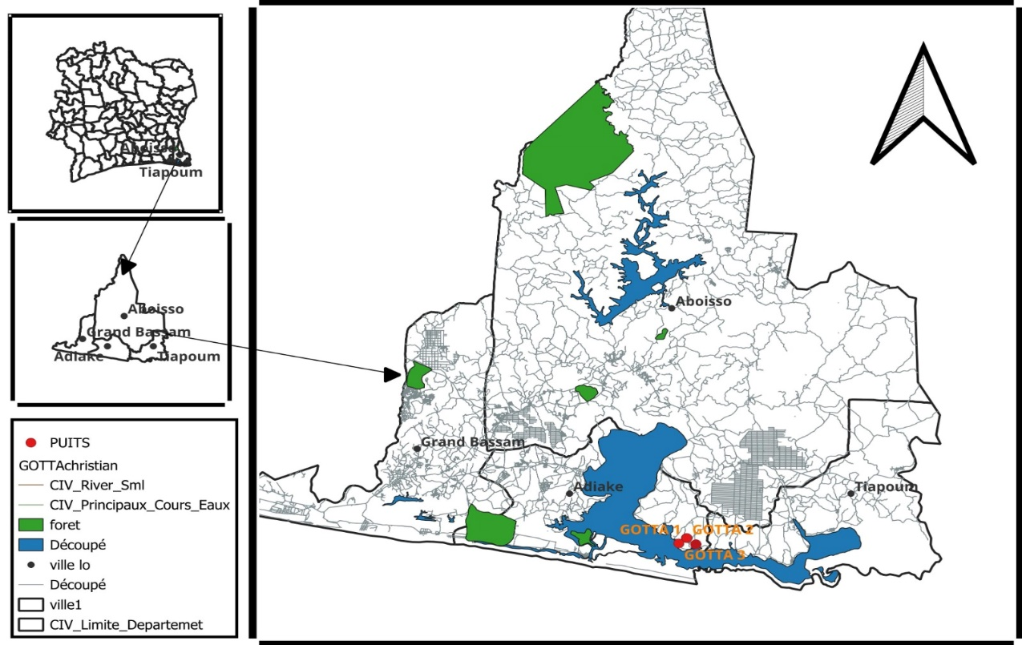
Fig. 1. Study area

2. Materials and methods
The methodology employed is based on a grain-size analysis of the sandy fractions (63 µm to 2 mm) to characterize transport conditions and depositional environments. The samples underwent pretreatment, including washing (to remove impurities and organic matter), drying, and sieving. The sandy fraction was used for the grain-size analysis. The grain-size data were processed using Gradistat software to obtain quantiles and distributions.
Statistical parameters (mean, standard deviation, skewness, median, and mode), calculated using the formulas of Folk and Ward (1957), were used to evaluate the energy of paleoflows and the degree of sediment sorting. Analysis of the grain-size curves (histograms, frequency distributions, and cumulative distributions) allowed for the identification of different facies (sigmoidal, logarithmic, and parabolic) associated with the depositional processes.
Cumulative curves were also used to determine transport modes (suspension, saltation, bedload transport) according to Visher (1969). Depositional environments were identified using the discriminant diagrams of Friedman (1967) and Moiola and Weiser (1968), which allowed for the distinction between fluvial and coastal settings. Finally, a morphoscopic analysis of quartz grains complemented the study by providing information on transport distance and sedimentary agents.
3. Results and discussion
3.1 Sedimentology
This macroscopic observation presents the results of the lithological description of the GOTTA 1, GOTTA 2, and GOTTA 3 wells. Analysis of the drill cuttings led to the following lithological divisions from the base to the top, along with the resulting interpretations.

3.1.1 Lithostratigraphy of the Formations in Wells GOTTA 1, GOTTA 2, and GOTTA 3
3.1.1.1 Lithostratigraphic Description of the Formations in Well GOTTA 1
Well GOTTA 1 extends to a depth of approximately 61 meters. The lithostratigraphy of this well comprises five lithological units: sand, clayey sand, sandy clay, clay, and lateritic crust. In the direction of sedimentation (from the base to the top), the sequence is as follows: Sand with a considerable thickness of 36.8 m. This sand layer is interbedded with a 2-meter-thick layer of sandy clay. This sand is overlain by layers of sandy clay 2.35 m thick and layers of clay 17.65 m thick. Above the clay, a lateritic crust 3.1 m thick has been deposited.
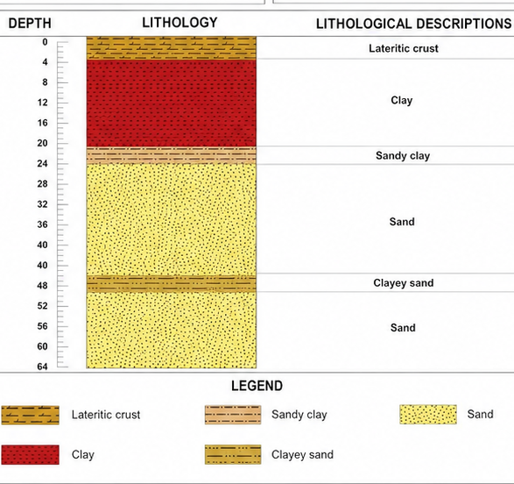

Fig. 2. Lithological log of the GOTTA 1 well

3.1.1.2 Lithostratigraphic Description of the Formations in the GOTTA 2 Well.
The GOTTA 2 well extends to a depth of approximately 60 meters. This well comprises six lithological units, which are: sand, clayey sand, clay, sandstone, bedrock, and gravel. In the direction of sedimentation (from the base to the top), the sequence is as follows: Sand with a thickness of 14.35 m, interbedded with a thin layer of clayey sand 1.5 m thick. On top of this sand, a 1.90-m-thick layer of clay was deposited, followed by a 1.75-m-thick layer of sandstone. Above the sandstone, there is a 15-meter-thick layer of sand and a 20.95-meter-thick layer of clay. Above the clay, a 4.6-meter-thick layer of gravel and a 0.53-meter-thick layer of fine gravel were deposited.
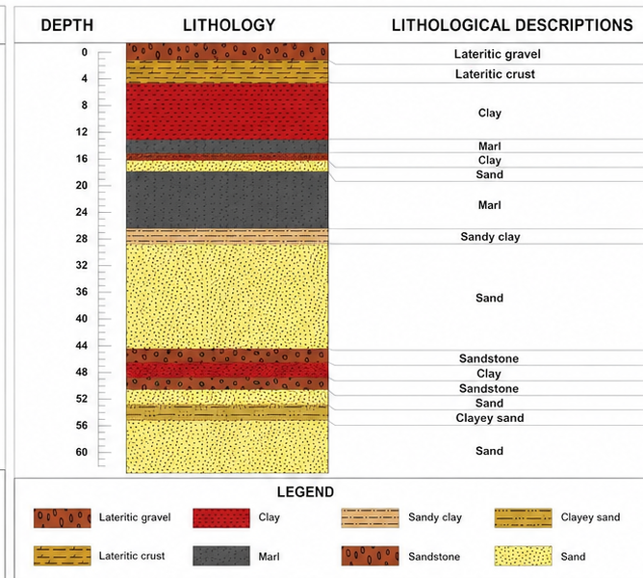

Fig. 3. Lithological log of the GOTTA 2 well.

3.1.1.3 Lithostratigraphic Description of the Formations in the GOTTA Well 3.
The GOTTA 3 well extends to a depth of approximately 46 meters. This well comprises three lithological units, which are: sand, clayey sand, and clay. In the direction of sedimentation (from the bottom to the top), the sequence is as follows: Sand with a considerable thickness of 28 m, interbedded with a thin layer of clayey sand 2 m thick. On top of this sand, a 16-meter-thick layer of clay was deposited.

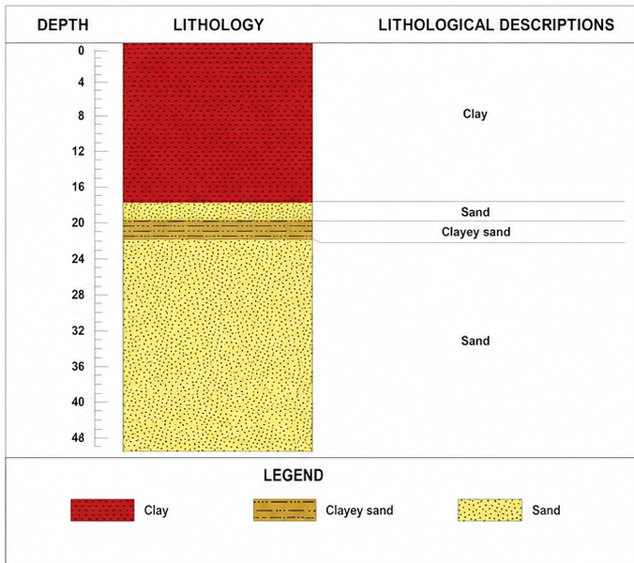

Fig. 4. Lithological log of the GOTTA 3 well

3.1.1.4 Lithological Interpretation
The red color, associated with the presence of Fe₂O₃, indicates intense oxidation during diagenesis, often in a poorly confined, well-ventilated marine environment with moderate to high depositional energy. This type of coloration is evidence of active fluid circulation and prolonged exposure to oxygen. The yellow color, caused by iron hydroxides such as goethite or Limonite results from the recent weathering of iron-bearing minerals. It is typical of a continental or transitional setting with low to moderate energy, often subject to intermittent phases of hydration and oxygenation, in a semi-confined environment. Black indicates a large amount of organic matter or bitumen deposited in an anoxic or suboxic environment, generally confined, such as lagoons, marshes, or deep basins. The depositional energy is very low and current dynamics are virtually nonexistent, which promotes the accumulation of organic matter. The grayish color results from the complete leaching of iron oxides, often in a well-drained continental environment with moderate energy, reflecting prolonged freshwater circulation. This type of deposit is common in fluvial transition zones. The variegated colors observed in sands and clays (kaolins) indicate partial leaching caused by irregular water flow in an unstable, poorly confined environment with variable environmental dynamics. This reflects water level fluctuations and a random distribution of iron oxides and hydroxides. Finally, the brown color, resulting from iron oxidation, indicates a prolonged period of sandy deposition in a well-oxygenated environment—often continental or coastal—with moderate depositional energy, reflecting relative current stability and good sediment aeration.
3.2 Lithological and Environmental Correlation of the GOTTA 1, GOTTA 2, and GOTTA 3 Wells
3.2.1 Lithological Correlation of the GOTTA Wells
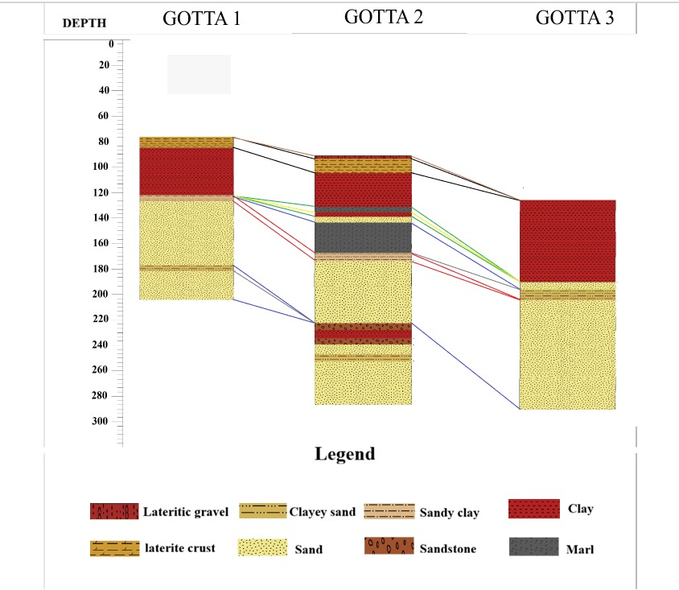
The three (3) wells examined do not have many layers: the GOTTA 2 well exhibits the greatest lithological diversity, meaning it has the largest number of layers. Compared to the other wells (GOTTA 1 and GOTTA 3), certain layers are absent. However, although the GOTTA 2 well exhibits the greatest lithological diversity, some layers are missing; the lithological layers observed in the GOTTA 1 and GOTTA 3 wells are absent from the GOTTA 2 well. These missing layers include: the lateritic crust with a yellow clay base, hardened crusted clay, blackish clay (marl), yellowish sandy clay, yellowish sand, purplish sand, brownish sand, yellowish clayey sand, coarse purplish sand, brownish sand, green sulfur-bearing clay, blackish (marl) sulfur-bearing clay containing liquid bitumen and limestone, bituminous sand, hardened sandy-clayey sandstone at the beginning of the section, yellowish clayey sand, fine- to medium-grained purplish sand with angular quartz, fine yellowish sand, coarse yellowish sand with quartz fragments, fine- to medium-grained purplish sand with angular quartz, coarse yellowish sand with subangular quartz fragments, fine- to medium-grained brownish sand with quartz fragments. These various lithological layers are present in the GOTTA 1 and GOTTA 3 wells, but not in GOTTA 2.

Fig. 5. Lithological correlation of the GOTTA wells
Interpretation
There are two possible explanations for the absence of certain layers in the wells. The first explanation is that the layers were deposited and then eroded by erosive agents (water and wind). According to the second explanation, when the layers were being deposited, they did not form as a result of geological events such as erosion, tectonic movements, and sea-level changes, which interrupted or altered sediment deposition at the time of their formation.
3.2.2 Environmental Correlation of the GOTTA Wells
The sediments from the three wells examined show two (2) types of deposits: continental deposits and marine deposits near the continent. This is due to variations in sea level and environmental conditions at the time of sedimentation.
- At the GOTTA 1 well:
24.1 m to 60.9 m : Yellowish sand to brownish sand, continental deposits.
4.1 m to 24.1 m : Lateritic clay to yellowish sandy clay, nearshore marine deposits.
1 m to 4.1 m : Lateritic crust with a yellow clay base, continental deposit.
- At the GOTTA 2 well:
43.65 m to 59.45 m : Iron-rich sandstone to coarse brownish sand, continental deposits.
41.7 m to 43.65 m : Variegated clay interbedded with a hardened zone, continental deposit.
24.95 m to 41.7 m: Fine-grained grayish sand to iron-bearing sandstone, continental deposits.
15.95 m to 24.95 m: Sulfur-bearing marl (black clay) to hardened yellowish sandy clay, near-shore marine deposits.
14.52 m to 15.95 m: Hardened, armored fine sand, continental deposit.
4 m to 14.52 m: Lateritic clay to clay with bituminous intrusions, near-shore marine deposits.
0.27 m to 4 m: Lateritic gravel to clayey sand to iron-rich lateritic crust with a yellowish base, continental deposits.
- At the GOTTA 3 well:
0.9 m to 17.9 m: Lateritic clay to blackish clay (marl) containing sulfur, liquid bitumen, and limestone; near-shore marine deposits
17.9 m to 45.9 m: Bituminous sand to brownish sand with fine to medium grain size and quartz
fragments; near-shore marine deposits.

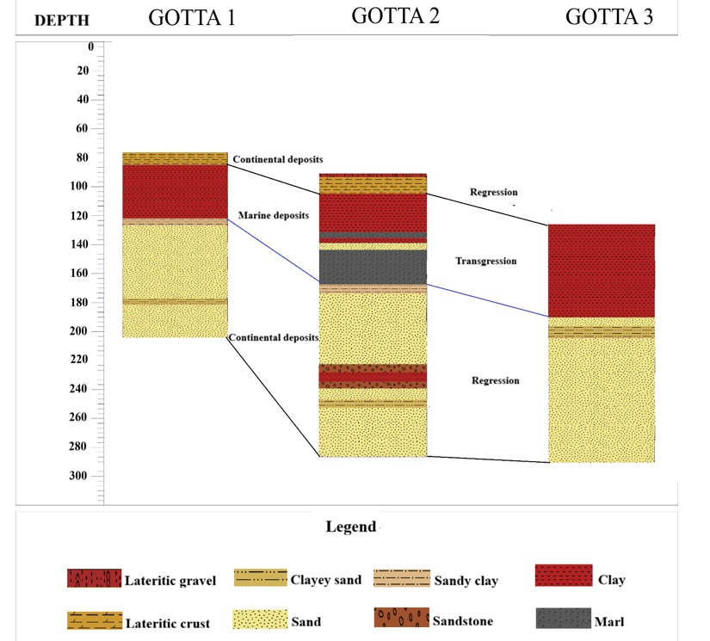

Fig. 6. Environmental Correlation of the GOTTA Wells
Interpretation
The sediments in the studied wells were deposited according to grain size and depositional energy. Coarse and medium-sized grains were deposited under high and medium energy conditions, respectively, in a context of (turbidity: characteristic of a turbulent environment); whereas fine grains, for their part, were deposited under conditions of low depositional energy in a context of (settling, characteristic of a: calm environment). The marine deposit near the continent is due to the presence of both clay (marine environment) and sand (continental environment). These sediments were deposited through two (2) sequences:
- the transgressive sequence, during which sediments are deposited as water levels rise, and the regressive sequence, characterized by a drop in water level, during which they are exposed.
- The presence of iron-rich sandstone is attributed to the sediments’ exposure to sunlight following a drop in water level.

3.3 Grain Size Distribution of Sands from Different Wells
The grain size analysis identified various parameters of grain size distribution, grain size facies, mode of transport, and depositional environment of the sandy fractions for each well.
3.3.1 Grain-size parameters
Grain-size distribution parameters are used to determine the mean grain size (Mz), grain size sorting (So), and asymmetry (Sk). The values of the various grain-size parameters are expressed in phi (Փ).
Table 1. Particle size parameters for the GOTTA 1 well
Ech | Mz | So | Sk | Analysis
E28 | 1,404 | 0,823 | -0,384 | Medium-grained sand, moderately graded, highly asymmetrical toward the coarser grains
E35 | 1,348 | 0,823 | -0,309 | Medium-grained sand, moderately graded, highly asymmetrical toward the coarser grains
E25 | 1,614 | 1,023 | -0,150 | Medium-grained sand, poorly graded, with a tendency toward coarser grains
E34 | 0,831 | 1,006 | 0,089 | Coarse sand, poorly graded, symmetrical
E33 | 0,739 | 1,078 | 0,007 | Coarse sand, poorly graded, symmetrical
E32 | 0,775 | 1,120 | -0,007 | Coarse sand, poorly graded, symmetrical
E30 | 1,359 | 0,850 | -0,314 | Medium-grained sand, moderately graded, highly asymmetrical toward the coarser grains
E24 | 1,712 | 0,980 | -0,141 | Medium-grained sand, moderately graded, asymmetrical toward the coarser grains
E36 | 1,315 | 1,169 | -0,261 | Medium-grained sand, poorly graded, with a tendency toward coarser grains
E26 | 1,755 | 0,952 | -0,146 | Medium-grained sand, medium-sized, asymmetrical toward the coarser grains

Table 2. Particle size parameters for the GOTTA 2 well
Ech | Mz | So | Sk | Analysis
E24 | 1,880 | 0,825 | -0,061 | Medium sand, moderately graded, symmetrical
E26 | 2,161 | 1,022 | -0,585 | Fine sand, of poor quality, highly asymmetrical toward the coarser grains
E23 | 1,143 | 0,842 | 0,290 | Medium-grained sand, medium-sized, asymmetrical toward the finer grains
E28 | 1,638 | 0,882 | -0,151 | Medium-grained sand, medium-sized, asymmetrical toward the coarser grains
E36 | 1,819 | 0,993 | -0,208 | Medium-grained sand, medium-sized, asymmetrical toward the coarser grains
E27 | 1,656 | 0,909 | -0,156 | Medium-grained sand, medium-sized, asymmetrical toward the coarser grains
E38 | 1,309 | 0,770 | -0,380 | Medium-grained sand, moderately graded, highly asymmetrical toward the coarser grains
E29 | 1,418 | 0,733 | -0,361 | Medium-grained sand, moderately graded, highly asymmetrical toward the coarser grains
E33 | 1,131 | 0,988 | -0,390 | Medium-grained sand, moderately graded, highly asymmetrical toward the coarser grains
E37 | 1,150 | 0,826 | 0,254 | Medium-grain sand, medium-grade, asymmetrical toward the ends
Table 3. Particle size parameters for the GOTTA 3 well
Ech | Mz | So | Sk | Analysis
E31 | 1,625 | 0,806 | -0,030 | Medium sand, moderately graded, symmetrical
E25 | 1,638 | 0,911 | -0,109 | Medium-grained sand, medium-sized, with a tendency toward coarser grains
E24 | 2,301 | 0,698 | -0,548 | Fine sand, medium-grained, with a strong asymmetry toward coarser grains
E16 | 1,713 | 0,814 | -0,020 | Medium sand, moderately graded, symmetrical
E17 | 1,762 | 0,817 | -0,009 | Medium sand, moderately graded, symmetrical
E18 | 1,357 | 0,752 | -0,298 | Medium-grained sand, medium-sized, with a tendency toward coarser grains
E20 | 1,616 | 0,805 | -0,004 | Medium sand, moderately graded, symmetrical
E22 | 1,742 | 0,846 | -0,026 | Medium sand, moderately graded, symmetrical
E27 | 1,410 | 0,920 | -0,455 | Medium-grained sand, moderately graded, with a strong asymmetry toward the coarser grains
E28 | 1,666 | 0,864 | 0,033 | Medium sand, moderately graded, symmetrical
E29 | 1,298 | 1,334 | -0,323 | Medium-grained sand, poorly graded, with a strong tendency toward coarser grains

3.3.1.1 Medium
The sandy fractions of the sediments consist of three grain types: coarse sand, medium sand, and fine sand.
Coarse sand : This type of coarse sand is found only in the GOTTA 1 well in samples E34, E33, and E32, with grain sizes ranging from 0.73 Փ < Mz < 0.83 Փ.
Medium sand : Medium sand is found in all wells. The medium sand in the GOTTA 1 well is found in the intervals of E28, E35, E25, E30, E24, E36, and E26, with grain sizes ranging from 1.34 Փ < Mz < 1.75 Փ. For well GOTTA 2, the fine sands in question are those from samples such as E24, E23, E28, E36, E27, E38, E29, E33, and E37. The average grain size of the medium sands ranges from 1.13 Փ < Mz < 1.88 Փ. And those from the GOTTA 3 well are present in samples E3, E25, E16, E17, E18, E20, E22, E27, E28, and E29, with sizes ranging from 1.29 Փ < Mz < 1.74 Փ.
Fine sands : These sands are present in the GOTTA 2 and GOTTA 3 wells. The fine sands from the GOTTA 2 well are found in sample E26, with a grain size of 2.16 Փ. In the GOTTA 3 well, fine sands are found in sample E24, with an average grain size of 2.30 Փ.

Interpretation of Grain Size
The variations observed in grain size depend on the distance the sediments have traveled in the aquatic environment, as well as on the strength of the transport energy. The greater the distance from their source, the smaller the sediment size becomes. Furthermore, the larger the sediment size (coarser), the greater the transport energy.
3.3.1.2 Sorting
Sorting distinguishes between two (2) types of grading: moderately graded and poorly graded.
Moderately graded sands : This sand is found in all three (3) wells. For the GOTTA 1 well, the sorting value ranges from 0.82 < σ < 0.98 in samples E28, E35, E30, E24, and E26. For the GOTTA 2 well, the sorting value ranges from 0.77 < σ < 0.98 in samples : E24, E23, E28, E36, E27, E38, E29, E33, and E37; the sorting value ranges from 0.77 < σ < 0.99. The sorting value ranges from 0.69 < σ < 0.92 for well GOTTA 3. The samples include: E31, E25, E24, E16, E17, E18, E20, E22, E27, and E28.
Poorly graded sands : This type of grading is found in all three (3) wells. In the GOTTA 1 well, samples E25, E34, E33, E32, and E36, with a value ranging from 1.00 < σ < 1.16. The poorly sorted sands in well GOTTA 2 are found in sample E26, with a value of 1.02; and those in well GOTTA 3 are found in sample E29, with a sorting value of 1.33.
Interpretation of the Sorting
The sorting reflects a mixture of grain sizes. This mixture may result from a sudden decrease in transport energy or from the confluence of watercourses.
3.3.1.3 Skewness
Sediments in the eastern part of the Ivorian onshore basin are characterized by four (4) types of skewness: curves skewed toward coarse grains, curves highly skewed toward coarse grains, nearly symmetrical curves, and curves skewed toward fine grains.
Skew toward the coarser grains : This skewness is observed in all three (3) wells. The skewness value ranges from -0.14 < Sk < -0.26 for the GOTTA 1 well; between -0.15 < Sk < -0.20 for well GOTTA 2; and between -0.10 < Sk < -0.29 for well GOTTA 3.
Highly skewed toward coarse grains : This skewness is observed in all three (3) wells. The skewness value ranges from -0.30 < Sk < -0.38 for well GOTTA 1; from -0.39 < Sk < -0.58 for well GOTTA 2; and from -0.32 < Sk < -0.54 for well GOTTA 3.
Nearly symmetrical : The sands in well GOTTA 1, which are skewed toward coarser grains, have a skewness ranging from -0.007 < Sk < -0.08. The skewness of GOTTA 2 (E24), with a skewness value of -0.06, and that of GOTTA 3 range from -0.004 < Sk < -0.03.
Asymmetric toward the fine-grained : These are found only in the GOTTA 2 well (E23 and E37). The skewness value ranges from 0.25 < Sk < 0.29.
3.3.2 Grain-size facies of the sands
The semi-logarithmic cumulative curves for the sands studied in the three wells show a sigmoidal grain-size facies.
3.3.2.1 Grain-size facies of the sands in the GOTTA 1 well
The sands in the GOTTA 1 well are of the sigmoid type.

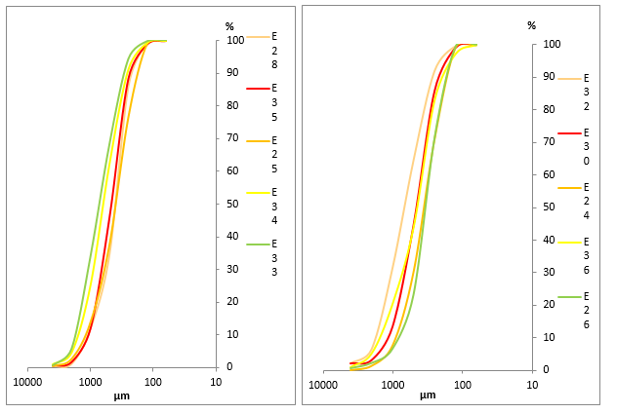

Fig. 7. Sigmoid facies of the sands in the GOTTA 1 well
3.3.2.2 Grain-size facies of the sands in the GOTTA 2 well
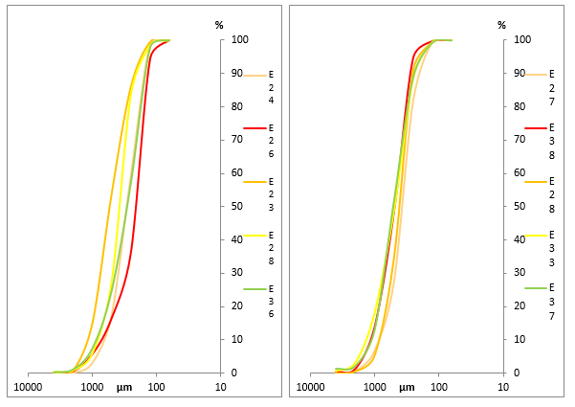
The sands exhibit a sigmoidal trend.

Fig. 8. Sigmoid facies of the sands in the GOTTA 2 well

3.3.2.3 Grain-size facies of the sands in the GOTTA 3 well
The sands in the GOTTA 3 well exhibit a sigmoidal grain-size facies.

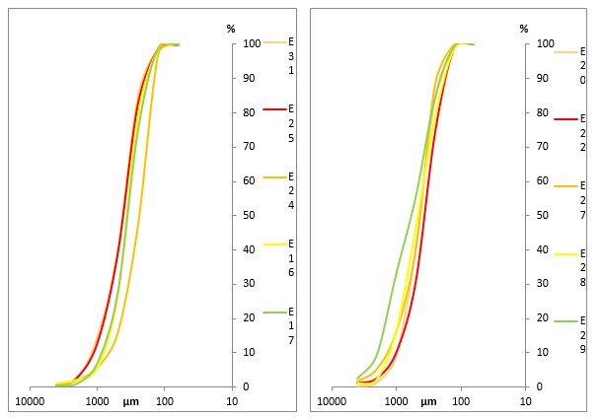

Fig. 9. Sigmoid facies of the sands in the GOTTA 3 well
Interpretation of the grain-size facies
The sigmoid facies shows a gradual reduction in the transport agent (Pinot, 1994) and suggests sedimentation by free accumulation.
3.3.3 Transport modes of sands
According to Visher’s diagram (1969), the loose sediments from the wells show three (3) populations (A-B-C), with population C being the most dominant. This can be explained by the fact that the sediments are generally transported by bedload.
3.3.3.1 Mode of transport of sands from the GOTTA 1 well
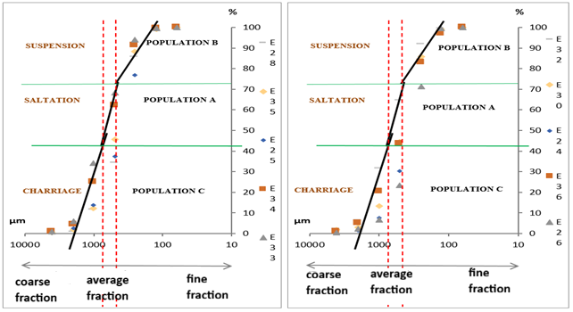
Analysis of these samples shows that rolling (60%) is the dominant mode of transport, followed by saltation (30%) and suspension (10%).

Fig. 10. Diagram of the transport mechanism for sand from the GOTTA 1 well
3.3.3.2 Mode of transport of sediments from the GOTTA 2 well
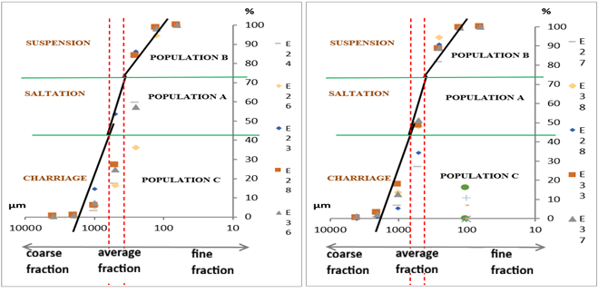
Samples from GOTTA 2 show that rolling (85%) is slightly more prevalent than suspension (10%), followed by saltation (5%).

Fig. 11. Diagram of the sand transport mechanism in the GOTTA 2 well

3.3.3.3 Mode of transport of sediments from the GOTTA 3 well
Samples from GOTTA 3 show that rolling (85%) is slightly more prevalent than rolling (10%), followed by suspension (5%).
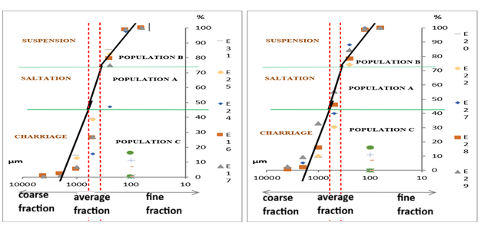

Fig. 12. Diagram of the transport mechanism for sand from the GOTTA 3 well
Interpretation of the mode of sand transport
Rolling : With an average of 65%, this is the dominant mode of transport and indicates that heavy or large grains move along the bottom. This implies that the area has sufficient bottom dynamics to move the grains by rolling.
Saltation : With an average of 25%, this indicates that medium-sized grains move by saltation. This means that currents are sometimes capable of lifting the grains, but are not always strong enough to keep them in suspension.
Suspension : Also averaging 10%, this indicates that the hydrodynamic conditions in the area are strong enough to keep some of the grains in suspension. This phenomenon may be associated with significant turbulence or strong currents that prevent the grains from settling quickly.
3.3.4 Sand Deposition Environment
The distribution of points in the Md-So diagram reveals that 50% of the sediments originate from the river domain and 50% from the beach domain. Furthermore, the Sk-Md diagram shows a scatter plot in which 60% of the data points are concentrated in the coastal dune domain and 40% in the continental dune domain. Based on this grain size distribution, it can be concluded that the sediments in the Mohoua area consist primarily of river and coastal dune sands (Figs. 13, 14, and 15).
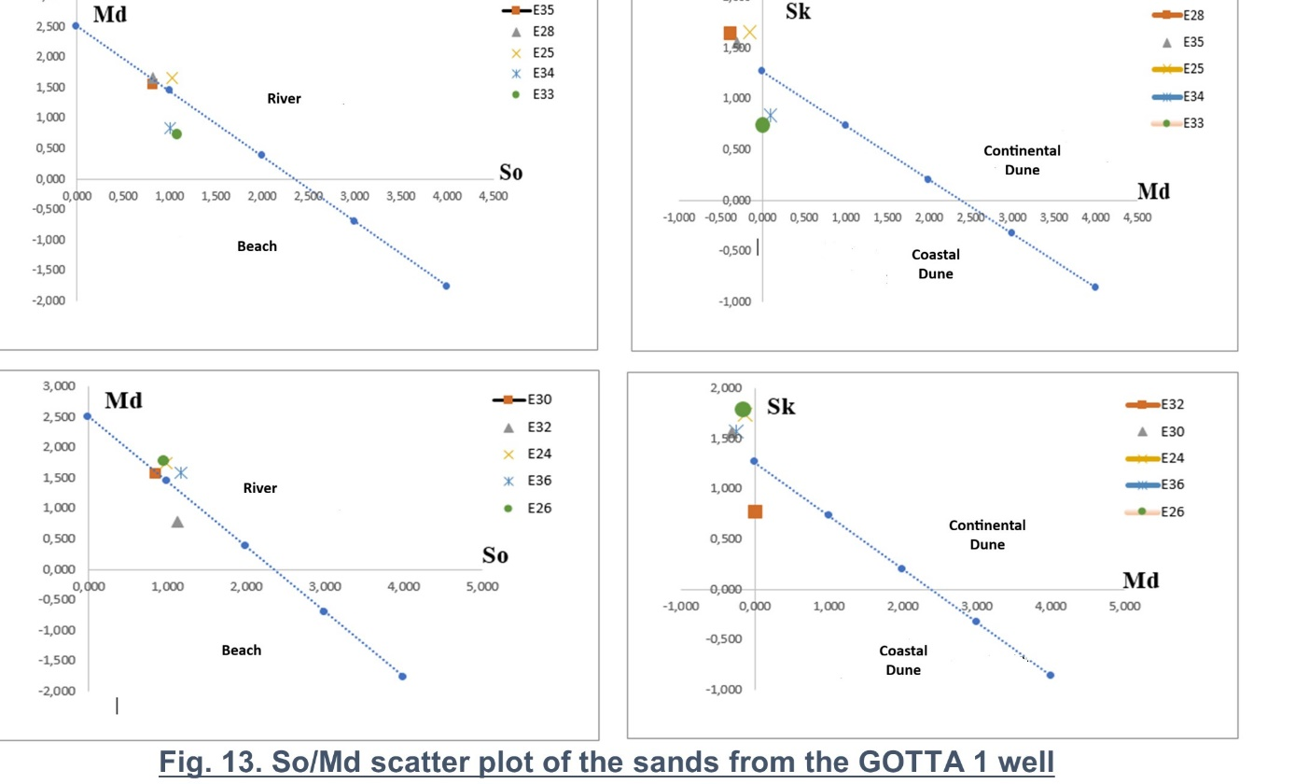
Fig. 13. So / Md Scatter plot of the sands from the Gotta 1 Well

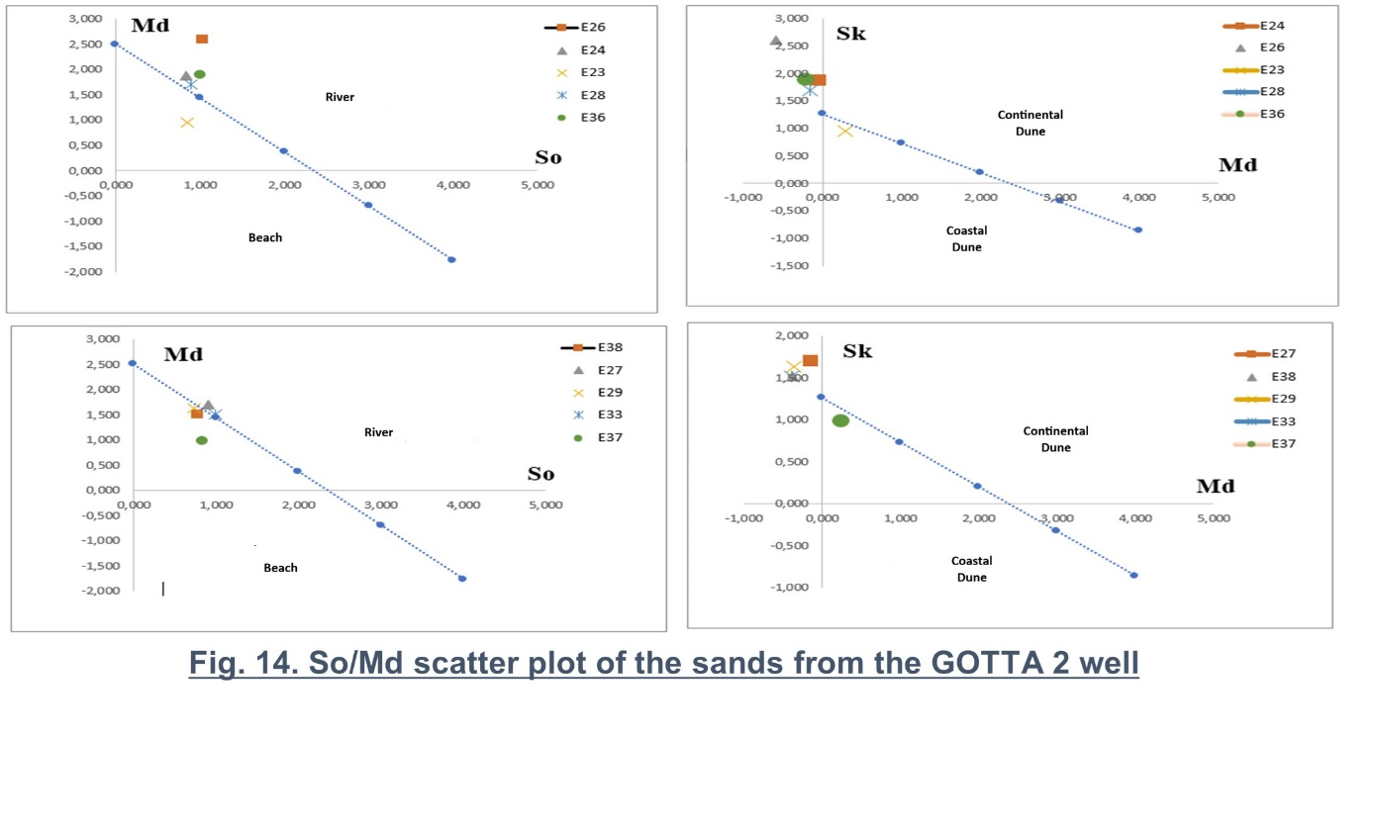
Fig. 14. So / Md Scatter plot of the sands from the Gotta 2 Well

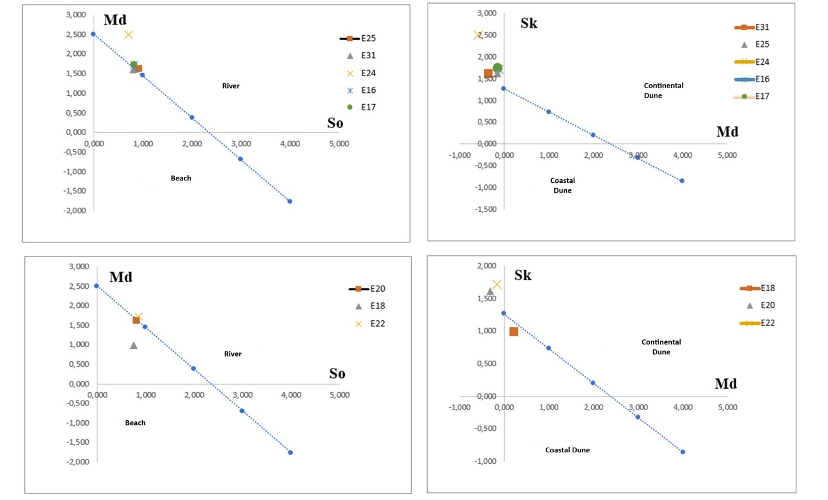
Fig. 15. So / Md Scatter plot of the sands from the Gotta 3 Well

Interpretation of the depositional environment
50% of the sediments originate from the river system : This indicates a significant contribution from fluvial sources, likely related to upstream soil erosion and the transport of fine particles by watercourses. 50% of the sediments originate from the beach system : This suggests a marine influence, with sediments transported by waves and tides from surrounding beaches. The presence of sediments originating from both the river and the beach indicates a complex interaction between fluvial and marine environments. 60% of the sediments are coastal dune sands: Coastal dunes are formed by the action of the wind, which transports and deposits sand grains. Their presence indicates active aeolian processes in the coastal region. 40% of the sediments are continental dune sands: These sediments originate from inland dunes, which are also formed by wind action but in a more continental setting. The distribution of sediments between coastal and continental dunes indicates variations in depositional conditions, such as wind speed and direction, as well as fluctuations in sea level.
3.3.5 Morphology of Quartz Grains
The grains in the sediments from the three (3) boreholes are subrounded (60%), rounded (10%), subangular (8%), and angular (2%). The rounded grains were transported over a long distance, while the subangular and subrounded grains were transported over a medium distance. The angular grains, on the other hand, were transported over a short distance. The whitish quartz grains observed are blunt and glossy, indicating that they were transported by water, and they show cracks likely caused by collisions between grains during transport. Overall, subrounded grains (60%) predominate. The orange and orange-yellow grains have a matte surface, suggesting they were transported by wind. These grains are primarily subrounded to rounded.
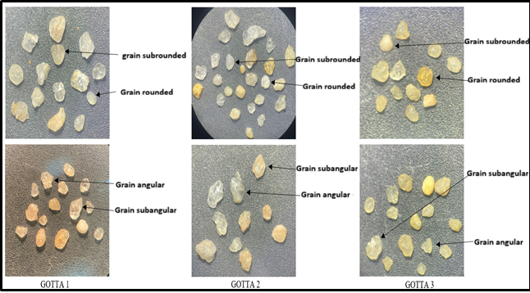

Fig. 16. Morphological examination of several quartz grains from the GOTTA wells

4. Conclusion
From a sedimentological perspective, the deposits analyzed in these wells consist primarily of sand. This lithological study has revealed accumulation cycles associated with warm and humid climatic conditions, typical of transitions between different geological epochs. The paleoenvironment, meanwhile, is characterized by climatic dynamics featuring alternating dry and wet phases, accompanied by intense biological activity in warm coastal waters. Thus, the various analyses conducted on the well cuttings confirm the existence of a dynamic marine environment, influenced by tropical conditions conducive to high biodiversity.
Declaration of AI Use

This manuscript was prepared through the intellectual contributions of the author(s) to the study design, data analysis, interpretation of results, and scholarly content. Grammarly and ChatGPT were used solely to assist with grammatical refinement and reference formatting during manuscript revision. The author(s) accept full responsibility for the accuracy, integrity, and final content of the manuscript.

References
Aka, K. (1991). La sédimentation quaternaire sur la marge de la Côte d’Ivoire : Essai de modélisation. Thèse de Doctorat d’Etat, (Quaternary sedimentation on the Côte d’Ivoire margin: An attempt at modeling. State Doctoral Thesis.)Univ. Nat. Côte d’Ivoire, 146, 233 p.
Assalé, F. Y. P. (2013). Caractérisation sédimentologique, palynologique, géochimique et paléoenvironnementale des formations sédimentaires connexes à la faille des lagunes (Est du bassin onshore de côte d’ivoire), (Sedimentological, palynological, geochemical, and paleoenvironmental characterization of sedimentary formations associated with the Lagunes Fault (eastern onshore Côte d’Ivoire basin))pp 31-361.
Assalé F. Y. P., MONDÉ, S. & AKA K. (2012). Caractérisation litho-stratigraphique et pétro-sédimentologique des formations tertiaire-quaternaires de la région de Bingerville (Côte d’Ivoire). Afrique SCIENCE 08(2) (2012),( Lithostratigraphic and petro-sedimentological characterization of the Tertiary-Quaternary formations in the Bingerville region (Côte d’Ivoire). Afrique SCIENCE 08(2) (2012),) pp. 93-112.
Bessoles, B. (1977). Géologie de l’Afrique, le craton Ouest-africain. Mémoire du Bureau de Recherches Géologiques et Minières,( Geology of Africa: The West African Craton. Memoir of the Bureau de Recherches Géologiques et Minières (BRGM))88 : 403.
Bié, G.R. (2012). Evolution des microflores du bassin sédimentaire de Côte d'Ivoire (marge d'Abidjan) au cours du Cénozoïque : Palynostratigraphie, Paléobotanique, Evolution des environnements de dépôt et Maturation de la matière organique. Thèse de Doctorat., UFR STRM, Université de Cocody, Abidjan, Côte d’Ivoire,( Evolution of microfloras in the Côte d'Ivoire sedimentary basin (Abidjan margin) during the Cenozoic: Palynostratigraphy, paleobotany, evolution of depositional environments, and organic matter maturation. Doctoral thesis, UFR STRM, University of Cocody, Abidjan, Côte d’Ivoire.) 236p.
Blarez, E. (1986). La marge continentale de Côte d’Ivoire-Ghana ; structure et évolution d’une marge continentale transformante. Thèse Doctorat, Univ. Paris VI (The Côte d’Ivoire-Ghana continental margin: structure and evolution of a transform continental margin. Doctoral thesis, University of Paris VI.)(France), 188p.
Buja, J. Géologie des formations sédimentaires du plateau continental ivoirien. Abidjan : Direction de la Géologie, Ministère des Mines et de l’Énergie, (Geology of the sedimentary formations of the Ivorian continental shelf. Abidjan: Directorate of Geology, Ministry of Mines and Energy.)2007. Rapport technique, 62 p.
Cailleux, A. (1947). Distinction des sables marins et fluviatiles. Bull. Soc Géol. Fr., 5e série, XV, pp. 375-404.( Distinction between marine and fluvial sands. Bull. Soc. Géol. Fr., 5th series, XV, pp. 375–404.)
Chamley, H. (1990). Sedimentology. With 177 figures and 17 tables. Translation Thomas Reimer. Springer-Verlag Berlin (edit.), 285p.
Chateauneuf, J. & Reyre Y. (1974). Eléments de palynologie. Applications géologiques. Cours de 3ème cycle en Science de la Terre, Université de Génève,( Elements of Palynology: Geological Applications. Postgraduate Course in Earth Sciences, University of Geneva.) Suisse. 345 p.
Chierici, M.A. (1996). Stratigraphy, paléoenvironnements and geological evolution of the Ivory Coast-Ghana basin. Bulletin des centres de recherches exploration-production ELF-Aquitaine Memoire,( Stratigraphy, paleoenvironments and geological evolution of the Ivory Coast-Ghana basin. Bulletin of the ELF-Aquitaine Exploration-Production Research Centers. Memoir,) 16 : 293-303.
Camil, J. (1984). Pétrographie, chronologie des ensembles granulitiques archéens et formations associées de la région de Man (Côte d’Ivoire). Implication pour l’histoire géologique du craton ouest africain. Thèse Doc. Etat ès Sc. Nat. Univ. Abidjan, (Petrography and chronology of the Archean granulite assemblages and associated formations in the Man region (Côte d’Ivoire). Implications for the geological history of the West African Craton. State Doctoral Thesis (Natural Sciences), University of Abidjan.)n°79, 306 p.
Camus, H. (1970). Annuaire hydrologique de la Côte d’Ivoire. Année 1969. ORSTOM., Abidjan. Adiopodoumé, (Hydrological Yearbook of Côte d’Ivoire. Year 1969. ORSTOM, Abidjan. Adiopodoumé.)122 p.
Camus, H. (1971). Annuaire hydrologique de la Côte d’Ivoire, ORSTOM., Abidjan. Adiopodoumé,( Hydrological Yearbook of Côte d’Ivoire, ORSTOM, Abidjan-Adiopodoumé.) 133 p.
Coulibaly, L. (2005). Développement d’un système tectonique dans le bassin sédimentaire de Côte d’Ivoire : cas du bloc A. Mem. (Development of a tectonic system in the Côte d’Ivoire sedimentary basin: the case of Block A.)D.E.A., Univ. Cocody – Abidjan, 64 p.
Cross, T. A. (1992). Applications of high-resolution sequence stratigraphy to reservoir analysis. In: Surface reservoir characterization - VIIth IFP Research Conference on Exploration Production. R. Eschard & B. Doligez (Eds), Technip, Paris, 179 p.
Coninck, J. (1968). Dinophyceae et Acritarcha de l'Yprésien du sondage de Kallo. Mem. Inst. Roy. Sci. Nat. Belg., Brussels, (Dinophyceae and Acritarcha from the Ypresian of the Kallo borehole. Mem. Inst. Roy. Sci. Nat. Belg., Brussels)161: 1-67, pl 1-17.
Cross, T. A. (1988). Controls on coal distribution in transgressive-regressive cycles, upper Cretaceous, Western interior, U.S.A. In: Sea-level changes: an integrated approach, C. K. Wilgus, B. S. Hastings, C.G. Kendall, H.W. Posamentier, C. A. Ross & J. C. Van Wagoner ((Eds). SEPM Special Publication, 42, 371-380.
Davey, R.J. & Williams, G. L. (1966). The genus Hystrichosphaeridium and its allies. Bull. Brit. Mus. (Nat. Hist.) Geol., Suppl. vol.3 pp.53-106
Deflandre, G. & Cookson, I.C. (1955). Fossil microplankton from Australian Late Mesozoic and Tertiary sediments. Austal. Journal of Marine and Freshwater Research vol.6 pp.242-313 pl.9
Downie, C., Husain, M. & Williams, G.L. (1971). Dinoflagellate cysts and Acritarch associations in the Paleogene of South-Eastern England. Geoscience and Man, 3: 29-35.
Downie, C. & Sarjeant. W, A, S. (1965). Bibliography and index of fossil dinoflagellates and acritarchs. Geological Society of America, Memoir 94, p.1-180 (Cover date December, 1964, issue date January, 1965.).
Evitt, W.R. (1985). Sporopollen in dinoffagellate cysts. Their morphology and interpretation. American Association of Stratigraphie Palynologists Foundation, Austin, Texas, 333 p.
Evitt, W. R., Clarke, R, F, A. & Verdier. J-P. (1967). Dinoflagellate studies III. Dinogymnium acuminatum n. gen., n.sp. (Maastrichtian) and other fossils formerly referable to Gymnodinium Stein. Stanford University Publications, Geological Sciences 10 (4): 1-27.
Friedman, G. M. (1967). Dynamic processes and statistical parameters compared for size frequency distribution of beach and river sands. J. Sed. Ped., 37, pp. 327-354.
Guede, K. E. (2009). Caractérisation Palynostratigraphique et paléoenvironnementale des formations du passage Crétacé-Tertiaire et Eocène dans l’étude du puits offshore DINO-1X ». DEA des Sciences de la Terre option Géologie Marine et Sédimentologie, UFR STRM, Université de Cocody, Abidjan, Côte d’Ivoire, ("Palynostratigraphic and paleoenvironmental characterization of the Cretaceous-Tertiary transition and Eocene formations in the study of the DINO-1X offshore well." DEA (Master of Advanced Studies) in Earth Sciences (specializing in Marine Geology and Sedimentology), UFR STRM, University of Cocody, Abidjan, Côte d’Ivoire.)88 p.
Girard, G., Sircoulon, J., & Toucheboeuf, P. (1971). Aperçu sur les régimes hydrauliques. Le milieu naturel de la Côte d’Ivoire. Mém. ORSTOM, Paris, (Overview of hydrological regimes. The natural environment of Côte d’Ivoire. ORSTOM Memoir, Paris,)nº50. pp.109-155.
Jardine, S. & Magloire, L. (1965). Palynologie et stratigraphie du crétacé des bassins du Sénégal et de Côte d’Ivoire. Mém. Bur. Rech. (Cretaceous palynology and stratigraphy of the Senegal and Côte d’Ivoire basins. Mém. Bur. Rech.)Geol. Et Min., Vol 32, 187-245.
Kouamelan, A. (1996). Géochronologie et géochimie des formations archéennes et protérozoïques de la dorsale de Man en Côte d’Ivoire. Implication pour la transition Archéen Protérozoïque. Thèse de Doctorat, Université de Rennes : (Geochronology and geochemistry of Archean and Proterozoic formations of the Man Shield in Côte d’Ivoire. Implications for the Archean-Proterozoic transition. Doctoral thesis, University of Rennes.)289 p.
Kouamé, L. N., Djroh, S. P., Kouadio, F. J-L. H., Coulibaly, L. & Sombo, B. C. (2018). Mise en évidence d’un autre style structural de la marge continentale de la Côte d’Ivoire à partir de la sismique réflexion : Compression et Magmatisme. (Identification of another structural style of the Côte d’Ivoire continental margin based on reflection seismic data: Compression and Magmatism. Vol.)Vol. 7, 19 p.
Kouamé, L. N. (2012). Marge continentale de Côte d’Ivoire : étude tectono-stratigraphique et des vitesses de propagation des ondes sismiques, Thèse de Doctorat, Univ. F.H.B. (Côte d’Ivoire), (Ivory Coast continental margin: tectono-stratigraphic and seismic wave velocity study, Doctoral Thesis, Univ. F.H.B. (Ivory Coast),)217p.
Laurent, E., Marc, D. R., Ariane, P. (2018). Les bassins sédimentaires. Dans Géologie, pp. 223-226(Sedimentary basins. In Geology, pp.)
Muir, M. D. (1967). Reworking in Jurassic and Cretaceous spore assemblages. In: Paleopalynology second edition. TRAVERSE A. (2007). Department of Geosciences, The Pennsylvania State University, University Park (State College), Pennsylvania (USA Springer edit), 816 p.
Moiola, R. J. & Weiser, D. (1968). Textureal parameters: an evaluation. Journ. Sedim. Petrol. n°38, pp 45-53.
Morgenroth, P. (1966). Mikrofossilien und Konkretionen des nordwest- europäischen Untereozäns. Palaeontographica Abt. (Microfossils and concretions of the Northwest European Lower Eocene. Palaeontographica Section...)B vol.119 pp.1-53 pl.11
Matsuoka, K., Mcminn, A. & Wrenn, J.H. (1997) Restudy of the holotype of Operculodinium centrocarpum (Deflandre & Cookson) Wall (Dinophyceae) from the Miocene of Australia, and the taxonomy of related species. Palynology, v.21, p.19-33, pl.1-4.
Martin, L. (1973). Morphologie, Sédimentologie et Paléogéographie au quaternaire récent du plateau continental ivoirien. Thèse de Doctorat Etat, Univ.( Morphology, Sedimentology, and Paleogeography of the Ivorian Continental Shelf during the Late Quaternary. State Doctoral Thesis, University.) Paris VI, ORSTOM, 340 p.
Martin, L. & Tastet, J-P. (1972). Le Quaternaire du littoral et du plateau continental de Côte d'Ivoire : rôle des mouvements tectoniques et eustatiques. Bull. Ass. Sénég. Etude. Quatern. de l’Ouest Afr., (The Quaternary of the Ivory Coast coastline and continental shelf: role of tectonic and eustatic movements. Bull. Ass. Sénég. Etude. Quatern. de l’Ouest Afr)33-34, pp. 17-32.
Ouffoué, K. B. (2005). Utilisation des foraminifères planctoniques pour la caractérisation du Turonien dans le puits pétrolier « Onshore » Tiémé -1 à l’Ouest du bassin sédimentaire ivoirien. DEA des Sciences de la Terre option Géologie marine,( Use of planktonic foraminifera to characterize the Turonian in the onshore oil well Tiémé-1, western Ivorian sedimentary basin. DEA in Earth Sciences (Marine Geology specialization).) UFR STRM. Université d’Abidjan, 60 p.
Petroci, (1983). Projet sables asphaltiques. Assemblage de carte : secteurs Éboïnda, Est-Adiaké, & Éboïnda lagune (Tar sands project. Map assembly: Éboïnda, East Adiaké, and Éboïnda Lagoon sectors.)(Echelle : 1/50000).
Pettijohn, F. (1949). Sedimentary Rocks – Happer Frères. In : Sedimentology. With 177 figures and 17 tables. Translation Thomas Reimer. CHAMLEY H. Springer-Verlag Berlin Heidelberg, 285 p.
Stover, L. E. & Evitt, W. R. (1978). Analyses of pre-Pleistocene organic-walled dinoflagellates. Stanford Univ. Publ., Geol. Sc. vol.15 pp.1-300
Sombo, B. C. (2002). Etude de l’évolution structurale et sismo-stratigraphique du bassin sédimentaire off-shore de Côte d’Ivoire, marge passive entaillée d’un canyon. Thèse de doct. D’État ès sc., Univ. Abidjan (Côte d’Ivoire), (Study of the structural and seismic-stratigraphic evolution of the offshore sedimentary basin of Côte d’Ivoire, a passive margin incised by a canyon. State Doctoral Thesis in Science, University of Abidjan (Côte d’Ivoire).)pp. 304-305.
Sombo, B. C., Djro, S. C., Yacé, P. & Bodier, C. (2003). Marge ivoirienne et ouverture de l’atlantique sud : analyse synthétique. Edit. Univ. Côte d’Ivoire, Bioterre, Rev. Sci. De la vie et de la terre, Vol. 3, n°1, pp. 69-91
Sarjeant, W. A. S. (1985). « The German Aptian dinoflagellate cysts of Eisenack (1958): à restudy ». Revue de paléobotanique et de palynologie ("The German Aptian dinoflagellate cysts of Eisenack (1958): a restudy." Review of Palaeobotany and Palynology)45, pp. 47-106.
Tagini, B. (1971). Esquisse structurale de la Côte d’Ivoire. Essai de géotectonique régionale. Thèse de l’Université de Lausanne, (Structural Sketch of Côte d’Ivoire. An Essay on Regional Geotectonics. Thesis, University of Lausanne,)302 p.
Tastet, J. P. (1979) : Environnements sédimentaires et structuraux quaternaires du littoral du golfe de Guinée (Côte d’Ivoire, Togo et Bénin). Thèse de Doctorat d’Etat ès.Sci .Nat., Université de Bordeaux I, (Quaternary sedimentary and structural environments of the Gulf of Guinea coastline (Côte d’Ivoire, Togo, and Benin). State Doctorate thesis in Natural Sciences, University of Bordeaux.)n°621, 175p.
Tricart, J. (1965). Principes et méthodes de la géomorphologie, Masson et Cie, Paris,( Principles and Methods of Geomorphology, Masson & Cie, Paris) 496 p
Visher, G. S. (1969). Grain size distribution and depositional processes. Jour. Sedim. Petrol., Tulsa, 39, pp1074-1106.
Versteegh, G. J. M. (1994). Recognition of cyclic and non-cyclic environmental changes in the Mediterranean Pliocene: a palynological approach. Marine Micropaleontology, 23, 147- 183.
Yacé, I. (2002). Initiation à la géologie. L’exemple de la Côte d’Ivoire et de l’Afrique de l’Ouest. Edition CEDA, Abidjan, Côte d’Ivoire, 183 p.( Introduction to geology. The example of Ivory Coast and West Africa. Edition CEDA, Abidjan, Ivory Coast, 183 p.)
Yao, N. J. P. (2012). Caractérisation sédimentologique, minéralogique, géochimique et biostratigraphique des falaises vives de Fresco : région de Grand-Lahou (Cote d’Ivoire). Thèse Doctorat Université F.H.B (Cocody/Abidjan) : 222 p.( Sedimentological, mineralogical, geochemical, and biostratigraphic characterization of the active cliffs of Fresco: Grand-Lahou region (Côte d’Ivoire). Doctoral thesis, F.H.B. University (Cocody/Abidjan): 222 p.)

