Floral Resources and Foraging Preferences of Apis mellifera (Hymenoptera: Apoidea) in an Apiary Area of Northern Côte d’Ivoire

Abstract
The honeybee (Apis mellifera) plays an essential role in pollination and contributes to the maintenance of biodiversity and the productivity of agricultural systems. However, the availability and diversity of floral resources are key factors determining colony nutrition and development. This study aimed to identify the main melliferous plants exploited by A. mellifera and to analyze its foraging preferences in an apiary area of Loufa, in the Korhogo Department, northern Côte d’Ivoire. Observations were conducted over four months around an apiary containing 40 hives, within a 50 m radius, from 6:00 a.m. to 6:00 p.m. A total of 26 plant species belonging to 14 botanical families were recorded. Fabaceae was the most represented family, with seven species, while herbaceous plants constituted the most diverse morphological group. A total of 5,710 visits by A. mellifera were recorded. Trees accounted for the highest foraging activity, representing 56.22% of all visits. Parkia biglobosa, Mangifera indica, and Vitellaria paradoxa were among the most frequently visited species. Foraging activity showed two main peaks, between 9:00 and 11:00 a.m. and between 4:00 and 6:00 p.m., with variations associated with temperature and humidity conditions. Among the recorded plants, 16 species (61.53%) were exploited for both nectar and pollen, six exclusively for nectar, and four exclusively for pollen. These results highlight the importance of local floral resource diversity for the nutrition of A. mellifera and emphasize the need to conserve melliferous plants in apiary areas of northern Côte d’Ivoire.

Keywords: Apis mellifera; melliferous plants, foraging, nectar, pollen, Korhogo, Côte d’Ivoire.

1. Introduction
Bees play a major role in the functioning of ecosystems and agricultural systems through their pollination activities. By promoting the sexual reproduction of plants, they contribute to the maintenance of plant biodiversity, agricultural production, and the balance of natural ecosystems (Klein et al., 2007; FAO, 2018). Among bees, Apis mellifera holds a particularly important position because of its role in pollinating both cultivated and wild plants, as well as its economic value associated with the production of honey and other hive products. Bee-mediated pollination therefore constitutes an essential ecosystem service for maintaining biodiversity and agricultural productivity (Gallai et al., 2009; Potts et al., 2010). However, the maintenance and development of bee colonies depend closely on the availability of floral resources in their environment. Melliferous plants provide mainly the nectar and pollen required for colony nutrition and functioning (Somerville, 2005). Nectar constitutes an important source of energy, whereas pollen provides, among other nutrients, the proteins required for brood development (Yédomonhan et al., 2017). Melliferous plants therefore comprise plant species whose flowers provide bees with food resources, particularly nectar and pollen, and differ from plants that are exclusively nectariferous or polliniferous. The availability of floral resources alone, however, does not explain their exploitation by A. mellifera. Different plant species do not have the same attractiveness as bees. The quantity and quality of nectar and pollen, their accessibility, flower morphology, and flowering periods may influence plant visitation by foragers (Proctor et al., 1996; Yédomonhan et al., 2017). Nectar sugar concentration, pollen nutritional quality, floral density, plant availability, and climatic conditions are also factors that may affect foraging choices (Proctor et al., 1996; Nicolson & Human, 2013). Thus, although a flora may contain a high diversity of melliferous plants, A. mellifera may concentrate its foraging activity on a limited number of species that provide more favorable resource availability or quality. Studying the relationships between A. mellifera and melliferous plants therefore makes it possible to identify the main floral resources exploited by this bee and to better understand interactions between pollinators and their environment. It is also of practical importance for beekeeping, since the availability of floral resources partly determines colony development and apicultural production. Melliferous plants also play an important economic and social role by contributing to the production of honey, wax, propolis, and royal jelly, as well as income generation and food security among rural populations (FAO, 2013; FAO, 2018). In Côte d’Ivoire, the richness of melliferous plants is an important factor determining beekeeping potential and the development of modern apiculture. In West Africa, savanna ecosystems and agricultural areas harbor considerable floristic diversity that can provide important resources for bees. However, the availability of these resources varies according to seasons and the ecological characteristics of the environments (Roubik, 1989). In northern Côte d’Ivoire, particularly in the Korhogo Department, wooded savannas and other Sudanian vegetation formations contain numerous potentially melliferous species that may serve as sources of nectar and pollen for bees (Guinko, 1984). Species such as Vitellaria paradoxa and Parkia biglobosa constitute particularly important food and melliferous resources in these vegetation formations (Konaté et al., 2019). These environments thus contribute to maintaining interactions between plants and pollinators, particularly A. mellifera (Potts et al., 2010). Despite this floristic and beekeeping potential, knowledge of the melliferous resources exploited by A. mellifera remains limited in beekeeping areas of the Korhogo Department. Few studies have precisely characterized the plant species visited by this bee, their relative importance in its foraging activity, and the types of resources collected. A better understanding of these relationships is nevertheless necessary to identify plant species that are particularly important for colony nutrition and to guide the conservation of floral resources in beekeeping areas. In this context, the present study aims to characterize the floral resources exploited by Apis mellifera and to analyze its foraging preferences in a beekeeping area of Loufa, in the Korhogo Department, northern Côte d’Ivoire. More specifically, the study seeks to determine the diversity of melliferous plants, identify the plant species most frequently visited by A. mellifera, characterize the resources collected (nectar and pollen), and examine variations in foraging activity throughout the day and according to environmental conditions.

2. Material and Methods

2.1. Study Area
The study was conducted in the locality of Loufa, located in the department of Korhogo in northern Côte d’Ivoire (Fig. 1). The study area is characterized by fallow vegetation comprising a diversity of potentially melliferous plant species. It is also crossed by a temporary watercourse whose drying up during the dry season may affect the availability of floral resources. The main agricultural activities in the locality are cotton, rice, and maize cultivation, along with mango (Mangifera indica) and cashew (Anacardium occidentale) plantations. The site was selected because of the presence of active apiaries, the apparent diversity of the vegetation, and its accessibility for observations. The Korhogo Department belongs to the district of savannas and the region of Poro. It is located between 8°26′ and 10°27′ N latitude and 5°17′ and 6°19′ W longitude, covering an area of approximately 12,500 km² (Kouakou et al., 2012; INS, 2014). The climate is tropical Sudanian-Sahelian, characterized by a rainy season from May to October and a dry season from November to April (Jourda et al., 2005; Kouakou et al., 2012; Nicholson, 2013). Mean annual rainfall ranges from 1,100 to 1,600 mm, while temperatures range from 25 to 35 °C (Kouakou et al., 2012; World Meteorological Organization, 2021). The vegetation is mainly composed of wooded and shrub savannas, with forest formations and gallery forests occurring along watercourses (White, 1983; FAO, 2018; M’Bra, 2013). Species such as Vitellaria paradoxa and Parkia biglobosa are important food and melliferous resources (Konaté et al., 2019).
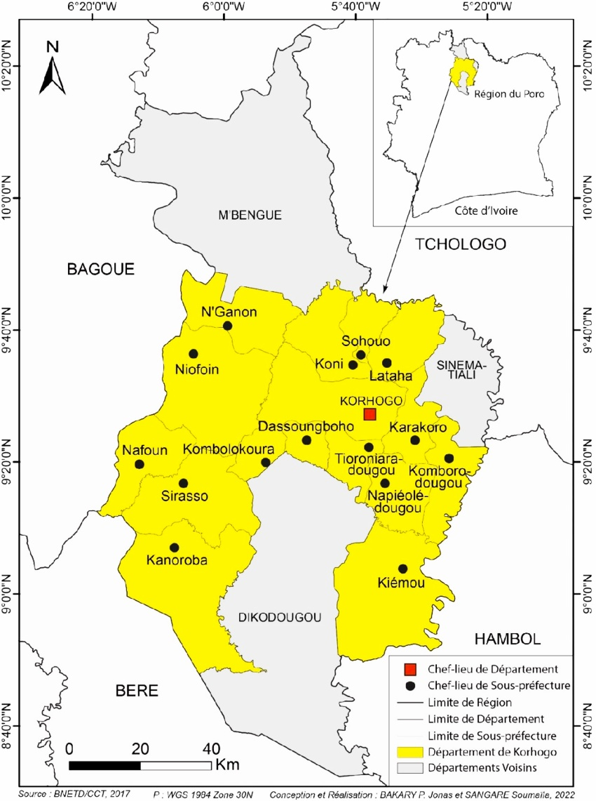

Fig. 1. Location of the study area (BNETD, 2017)

2.2. Sampling design
The study was conducted in an apiary consisting of 40 modern beehives, established in a mosaic landscape comprising agricultural fields, fallows, and natural vegetation formations. This apiary constituted the only sampling unit considered in the study. To characterize the floral resources, present in the immediate surroundings of the colonies, a circular area with a radius of 50 m was delineated around the center of the apiary. This area was used to inventory plant species potentially exploited by bees. Although A. mellifera can travel much greater distances in search of floral resources, the study was deliberately restricted to this area to characterize the flora located in the immediate vicinity of the apiary (Seeley, 1995).

2.3. Inventory and identification of melliferous plants
A preliminary floristic survey was conducted to inventory the plant species present in the study area. Melliferous plants were identified based on their actual visitation by A. mellifera. This approach, based on observations of foraging activity, is commonly used to identify plants exploited by bees (Nombré et al., 2009; Yédomonhan, 2009; Kouassi et al., 2019). Any plant species, whether herbaceous, shrubby, arboreal, or lianas, on which bees were observed collecting nectar or pollen was considered a melliferous plant. Species were identified directly in the field whenever possible. For species that were difficult to identify, leaf samples were collected and preserved as herbarium specimens before being identified with the assistance of a botanist.

2.4. Observation of foraging activity
The observations were conducted daily over a four-month period, from 6:00 a.m. to 6:00 p.m. Each identified melliferous plant species was observed for 15 minutes per hourly interval, following a standardized protocol. During each observation session, the number of bees observed on the flowers, the number of visits, the type of resource collected, as well as temperature and relative humidity were recorded. The floral resources sought were classified as nectar or pollen. A plant species was considered nectariferous when bees visited its flowers without apparent contact with the anthers, which was interpreted as nectar collection. It was considered polliniferous when pollen was visible on the pollen baskets of the observed bees.

2.5. Parameters studied
The main parameters considered were:
- the species richness of melliferous plants;
- the composition of botanical families;
- the morphological type of plants (herbaceous plants, shrubs, trees, and vines);
- the number of visits by A. mellifera per plant species;
- the proportion of visits per species;
- foraging rate, expressed as the number of bees observed per minute;
- the type of resource collected (nectar and/or pollen);
- daily variations in foraging activity;
- temperature and relative humidity during the observation periods.
The visitation frequency of the different plant species was used to characterize their relative importance in the foraging activity of A. mellifera.

2.6. Statistical analysis
The data were entered and analyzed using STATISTICA software version 7.1. Differences between means were assessed using analysis of variance (ANOVA), followed by Duncan’s multiple range test at the 5% significance level.

2.7. Ethical and Practical Considerations
The observations were conducted in collaboration with local beekeepers. The observation protocol was designed to minimize disturbance to the colonies, and no colony was disturbed during the observations.

3. Results

3.1. Diversity of melliferous plants
The floristic inventory conducted around the apiary recorded 26 melliferous plant species, belonging to 23 genera, 14 botanical families, and four morphological types. Fabaceae was the most represented family, with seven species, followed by Asteraceae and Malvaceae, with three species each. Lamiaceae and Anacardiaceae each comprised two species, whereas the other families were represented by only one species each (Fig. 2).
Fig. 2. Diagram indicating the richness of melliferous plant families

According to growth form, herbaceous plants were the most diverse, with 16 species, accounting for 61.54% of all recorded melliferous plants. Trees and shrubs each comprised four species (15.38%), while lianas were represented by two species (7.69%) (Fig. 3).
Fig. 3. Diagram indicating the richness of the morphological types of melliferous plants

3.2. Foraging frequency and speed
A total of 5,710 visits by Apis mellifera were recorded on the different plant species during the study period. Tree species attracted the highest foraging activity, with 3,210 visits, corresponding to 56.22% of the total visits, at an average visitation rate of 18 visits/minute. Herbaceous plants recorded 1,688 visits (29.56%), with an average visitation rate of 9 visits/minute. Shrubs and vines were less frequently visited, with 576 visits (10.09%) and 236 visits (4.13%), respectively (Fig. 4).

Fig. 4. Number of bee visits by plant morphological type

At the level of botanical families, Fabaceae recorded the highest number of visits, with 2,140 visits (37.48%), at an average visitation rate of 12 visits/minute. They were followed by Anacardiaceae, with 1,130 visits (19.79%) and an average visitation rate of 6 visits/minute. The other families each accounted for less than 15% of the total number of visits (Fig. 5).

Fig. 5. Number of bee visits per melliferous plant family

At the species-specific level, Parkia biglobosa was the most visited species, with 1,403 visits, representing approximately 24.6% of the total visits. It was followed by Mangifera indica with 737 visits (12.91%), Vitellaria paradoxa with 677 visits (11.86%), Aeschynomene americana with 419 visits (7.34%), and Anacardium occidentale with 393 visits (6.88%). Each of the other species accounted for less than 5% of the total visits (Table 1).

Table 1. Number of visits per plant species, their proportion, and foraging rate
Plant species | Number of bee visits | Percentage of visits (%) | Foraging speed (n bees / min)
Aeschynomene americana L. | 419 | 7,34 | 3
Ipomoea eriocarpa Roxb | 89 | 1,56 | 0,5
Ocinum basilicum L. | 152 | 2,66 | 0,8
Acmella radicans (L.) Cass | 50 | 0,88 | 0,3
Mimosa pudica L. | 133 | 2,33 | 0,7
Vernonia pauciflora Sch. Bip. | 179 | 3,13 | 1
Crotalaria retusa L. | 22 | 0,39 | 0,1
Senna tora (L.) Roxb. | 20 | 0,35 | 0,1
Cleome viscosa L. | 119 | 2,08 | 0,7
Pennisetum alopecuroides (L.) Spreng. | 81 | 1,42 | 0,5
Calopogonium mucunoides Desv | 101 | 1,77 | 0,6
Passiflora foetida L. | 147 | 2,57 | 0,8
Hyptis suaveolens (L.) Poit. | 240 | 4,20 | 1,3
Ageratum conyzoides L. | 186 | 3,26 | 1
Ludwigia octovalvis Jacq | 96 | 1,68 | 0,5
Mitracarpus hirtus (L.) DC. | 62 | 1,09 | 0,3
Sida rhombifolia L. | 50 | 0,88 | 0,3
Senna occidentalis (L.) Link | 42 | 0,74 | 0,2
Sida acuta Burm.f. | 33 | 0,58 | 0,2
Sida urens L. | 142 | 2,49 | 0,8
Nelsonia canescens (Lam) Spreng | 138 | 2,42 | 0,8
Vitellaria paradoxa C.F. Gaertn. | 677 | 11,86 | 4
Anacardium occidentale L. [cult.] | 393 | 6,88 | 2
Agelanthus dodoneifolius (DC.) Polhill & Wiens | 14 | 0,25 | 0,1
Mangifera indica L. | 737 | 12,91 | 4
Parkia biglobosa (Jacq.) R. Br. ex G. Don | 1403 | 24,57 | 8

3.3. Daily variation in foraging activity
The foraging activity of A. mellifera extended from 6:00 a.m. to 6:00 p.m. Two main activity peaks were observed, the first between 9:00 and 11:00 a.m. and the second between 4:00 and 6:00 p.m. Activity was lower in the early morning, gradually increased from 8:00 a.m., and reached a maximum between 9:00 and 11:00 a.m. A subsequent decline was observed between 12:00 and 3:00 p.m., corresponding to the hottest hours of the day, followed by a resumption of activity toward the end of the day (Fig. 6).

Number of visits

Fig. 6. Curves indicating the influence of temperature and humidity on the foraging activity of the honeybee.

Peak visitation periods nevertheless varied among plant species. Twelve species showed their main visitation peak between 9:00 a.m. and 11:00 a.m., including Aeschynomene americana, Ocimum basilicum, Mimosa pudica, and Vitellaria paradoxa. Five species, including Parkia biglobosa and Senna occidentalis, were more frequently visited between 4:00 p.m. and 6:00 p.m. The remaining nine species exhibited bimodal activity, with two visitation peaks, one in the morning and the other in the late afternoon. The observations also indicated an increase in foraging activity as temperature decreased and relative humidity increased (Fig. 7).

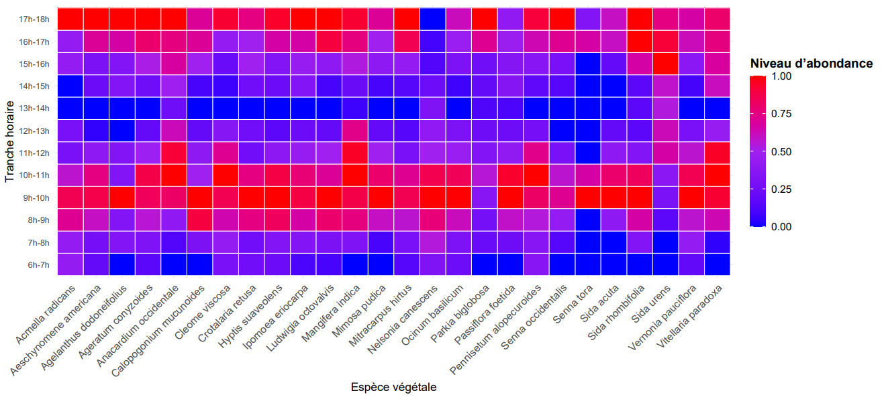
Abundance level

Fig. 7. Map showing the variation in the abundance of Apis mellifera visits to the flowers of each plant species according to time intervals.

(High abundance (0.75 à 1.00), Mean abundance (0.25 à 0.75) et Low abundance (0.00 à 0.25))

3.4. Floral resources exploited
The analysis of the harvested resources showed that 16 plant species, representing 61.53% of the recorded melliferous plants, were exploited for both nectar and pollen. This group comprised eight herbaceous species, four trees, three shrubs, and one liana. In addition, six species (23%) were exclusively exploited for nectar. They consisted mainly of herbaceous species, with five species, and one liana. Finally, four species (15.38%) were exclusively exploited for pollen collection; these included three herbaceous species and one shrub. The 16 species exploited for both resources belonged to nine botanical families, with Fabaceae being the most represented, comprising four species. Asteraceae, Lamiaceae, Malvaceae, and Anacardiaceae each included two species. The nectar-only species belonged to five families, whereas the pollen-only species each belonged to a different family, namely Poaceae, Fabaceae, Asteraceae, and Loranthaceae.

Table 2. Preferences for nutrients collected by bees according to floral species (P: Pollen; N: Nectar; and MT: Morphological type).

Plant species | Plant families | MT | P | N
Aeschynomene americana L. | Fabaceae | Herb | X | X
Ipomoea eriocarpa Roxb | Convolvulaceae | Liana |  | X
Ocinum basilicum L. | Lamiaceae | Shrub | X | X
Acmella radicans (L.) Cass | Asteraceae | Herb | X | X
Mimosa pudica L. | Fabaceae | Herb | X
Vernonia pauciflora Sch.Bip. | Asteraceae | Shrub | X | X
Crotalaria retusa L. | Fabaceae | Herb |  | X
Senna occidentalis (L.) Link | Fabaceae | Herb | X | X
Senna tora (L.) Roxb. | Fabaceae | Herb |  | X
Cleome viscosa L. | Cleomaceae | Herb |  | X
Pennisetum alopecuroides (L.) Spreng. | Poaceae | Herb | X
Calopogonium mucunoides Desv | Fabaceae | Liana | X | X
Passiflora foetida L. | Passifloraceae | Shrub | X | X
Hyptis suaveolens (L.) Poit. | Lamiaceae | Herb | X | X
Ageratum conyzoides L. | Asteraceae | Herb | X
Ludwigia octovalvis Jacq. | Onagraceae | Herb | X | X
Mitracarpus hirtus (L.) DC. | Rubiaceae | Herb | X | X
Sida rhombifolia L. | Malvaceae | Herb | X | X
Sida acuta Burm.f. | Malvaceae | Herb |  | X
Sida urens L. | Malvaceae | Herb | X | X
Nelsonia canescens (Lam) Spreng | Acanthaceae | Herb |  | X
Vitellaria paradoxa C.F. Gaertn. | Sapotaceae | Tree | X | X
Anacardium occidentale L. [cult.] | Anacardiaceae | Tree | X | X
Agelanthus dodoneifolius (DC.) Polhill & Wiens | Loranthaceae | Shrub | X
Mangifera indica L. | Anacardiaceae | Tree | X | X
Parkia biglobosa (Jacq.) R.Br. ex G.Don | Fabaceae | Tree | X | X

4. DISCUSSION
The present study aimed to identify the main melliferous plants exploited by Apis mellifera and to analyze the characteristics of its foraging activity in an apiary area of the Korhogo Department, northern Côte d’Ivoire. The results revealed a diversity of 26 melliferous plant species belonging to 14 botanical families, as well as differential exploitation of floral resources according to plant species, morphological types, and periods of the day. The diversity of melliferous plants observed in the study area may be related to the ecological characteristics of the Sudanian savannas of northern Côte d’Ivoire. These vegetation formations are characterized by high floristic diversity, as demonstrated by Cissé et al. (2020) in a Sudanian savanna area of Ferkessédougou. The simultaneous presence of natural vegetation, fallows, and agricultural areas around the apiary may also contribute to maintaining a high diversity of floral resources available to bees. Fabaceae was the most represented family in our inventory. This predominance may be related to its high representation in savanna ecosystems and its ability to provide nectar and pollen resources to bees. Similar observations were reported by Nombré et al. (2009) in the Sudanian zones of Burkina Faso and by Yédomonhan (2009) in West African beekeeping areas, where Fabaceae also occupies an important position among melliferous plants. The dominance of Fabaceae is also of particular importance for beekeeping, since several species of this family recorded in the study area, notably Parkia biglobosa, Aeschynomene americana, Senna occidentalis, Senna tora, and Crotalaria retusa, are exploited by A. mellifera. This diversity indicates that colony food resources can be provided by several species belonging to the same botanical family while remaining available during different periods. Herbaceous plants accounted for most of the recorded species, with 16 out of 26 species, representing 61.54%. This high representation may be associated with the characteristics of agricultural environments and fallows, which generally favor the development of herbaceous species with relatively short life cycles. This interpretation is consistent with the observations of Konaté and Kampmann (2019), who emphasized the importance of herbaceous species in environments subjected to anthropogenic disturbances. However, the dominance of herbaceous plants in terms of species richness did not translate into a dominance of foraging activity. Although fewer in number, trees accounted for the highest proportion of A. mellifera visits. This difference between species richness and visitation frequency indicates that the number of available plant species alone is not sufficient to assess their importance to bees. Woody species can provide large quantities of floral resources when in bloom, which may explain their high visitation rates. This observation is consistent with Potts et al. (2010), who emphasized the important role of woody plants in maintaining pollinators and pollination services. However, our results differ from those reported by Kouassi et al. (2019) in some agricultural areas of Côte d’Ivoire, where a higher proportion of woody species was observed in the melliferous flora. This difference may reflect the floristic and ecological characteristics of the study sites. Foraging activity was particularly high on Parkia biglobosa, Mangifera indica, and Vitellaria paradoxa, which were among the most frequently visited species. The importance of these species may be related to the abundance of flowers and the availability of nectar and pollen resources they provide for bees. The high visitation rates recorded on these tree species are particularly relevant in the context of northern Côte d’Ivoire, where V. paradoxa and P. biglobosa are characteristic species of agroforestry systems and Sudanian savannas. Their importance therefore extends beyond their ecological and socioeconomic value, as they may also play an important role in providing food resources for bee colonies. These findings are consistent with the observations of Bradbear (2009) and Somerville (2005), who highlighted the importance of numerous tropical tree species as food sources for A. mellifera. They also demonstrate the importance of maintaining melliferous trees in agricultural landscapes, particularly in areas where the availability of floral resources may vary considerably throughout the year. Nevertheless, caution should be exercised when using the term “preference.” In the present study, preference was essentially assessed based on the frequency of observed visits. However, a high visitation frequency may result not only from the intrinsic attractiveness of a plant but also from its abundance, floral density, or availability at the time of observation. Therefore, the results primarily allow us to identify the species most frequently visited by A. mellifera under the conditions of the study. The activity of A. mellifera exhibited two main peaks, between 9:00 and 11:00 a.m. and between 4:00 and 6:00 p.m. This bimodal pattern of daily activity may be related to variations in microclimatic conditions throughout the day. Relatively moderate temperatures and higher humidity observed in the morning, and late afternoon may favor foraging activity and the exploitation of floral resources. Conversely, the decrease in activity observed during the hottest hours may be associated with increasing temperatures and the resulting water stress. Bees may then reduce their flight activity to limit energy expenditure and water loss. Similar observations were reported by Chaker (2023), who demonstrated the importance of temperature and humidity in regulating the foraging activity of A. mellifera. Variation in activity among plant species also indicates that not all plants are exploited at the same time of day. Some species showed maximum visitation in the morning, others in the late afternoon, whereas some were exploited according to a bimodal pattern. This variability may be related to differences in the rates of nectar and pollen production and availability throughout the day. Most of the recorded plants (61.53%) were exploited for both nectar and pollen. This finding highlights the importance of nectar- and pollen-producing plants in the diet of A. mellifera. Nectar primarily provides the energy required for bee activities, whereas pollen constitutes an important source of nutrients necessary for colony development and functioning. The predominance of plants exploited for both types of resources therefore indicates that some species can simultaneously meet several nutritional requirements of the colony. This observation is consistent with the work of Somerville (2005), who emphasized the importance of plants providing both nectar and pollen in the diet of the honeybee. However, the presence of plants used exclusively for nectar or pollen demonstrates that A. mellifera also uses complementary resources from different plant species. This diversity of resource use may help reduce the risks associated with the variable availability of a single floral resource. Overall, the results show that the studied apiary area harbors an appreciable diversity of plants capable of supporting the activity of A. mellifera. Some species, particularly Parkia biglobosa, Mangifera indica, and Vitellaria paradoxa, appear to be particularly important based on their visitation rates. The conservation of these floral resources should therefore be an important component of strategies for developing beekeeping in the Korhogo Department. Maintaining melliferous trees in agricultural landscapes, conserving fallows, and limiting the destruction of spontaneous vegetation could help preserve the resources required by bee colonies. These findings are broadly consistent with concerns regarding the conservation of pollinators and the ecosystem services they provide. Klein et al. (2007) and Potts et al. (2010) have emphasized the importance of pollinators for agricultural systems and the potential consequences of declining floral resources. In this context, knowledge of the plant species exploited by A. mellifera provides a useful basis for guiding measures aimed at conserving floral resources. Finally, the results should be interpreted since the study was conducted around a single apiary and over a limited period. A study covering a complete annual cycle, multiple sites, and different flowering periods would provide a better characterization of the seasonal dynamics of melliferous resources. The study also recommends incorporating pollen analyses of honey and assessing the influence of agricultural practices on the availability and quality of floral resources.

5. Conclusion
This study characterized the floral resources exploited by the honeybee (Apis mellifera) in an apiary area of Loufa, in the Korhogo Department, northern Côte d’Ivoire. A total of 26 melliferous plant species belonging to 14 botanical families and four morphological types were recorded. Fabaceae was the most represented family, while herbaceous plants constituted the most diverse morphological group. However, foraging activity was more concentrated on tree species, which accounted for the highest proportion of visits. Parkia biglobosa, Mangifera indica, and Vitellaria paradoxa were among the most frequently visited species, highlighting their potential importance as floral resources for A. mellifera in this area. A total of 5,710 visits were recorded during the study. Foraging activity also varied throughout the day, with two main peaks observed between 9:00 and 11:00 a.m. and between 4:00 and 6:00 p.m. This variation was associated with environmental conditions, particularly temperature and relative humidity. Furthermore, most of the recorded plants were exploited for both nectar and pollen, highlighting their potential contribution to meeting the nutritional requirements of honeybee colonies. These findings demonstrate the importance of local floral resources for the diet of A. mellifera and for maintaining beekeeping activity in northern Côte d’Ivoire. The conservation of plant species that are particularly frequently visited by bees, especially tree species, should be incorporated into beekeeping landscape management strategies. Studies covering the entire annual cycle and incorporating pollen analysis of hive products would provide a better understanding of seasonal variations in exploited floral resources and clarify their importance for honeybee colonies.

Declaration of AI Use

This manuscript was prepared through the combined contributions of all author(s), including contributions to the study design, data, content development, results, interpretation, and related scholarly work. The author(s) acknowledge the use of Grammarly and ChatGPT to assist with grammar checking, language refinement, reference formatting. These AI-assisted tools were not used as authors and did not replace the intellectual contributions or scholarly judgment of the author(s). All AI-assisted outputs, including content, references, and interpretations, were carefully reviewed, revised, verified, and approved by the author(s). The author(s) accept full responsibility for the accuracy, integrity, and final content of the manuscript.

Competing Interests

Authors have declared that no competing interests exist.

References

Bradbear, N. (2009). Bees and Their Role in Forest Livelihoods. A Guide to the Services Provided by Bees and the Sustainable Harvesting, Processing and Marketing of Their Products. Non-Wood Forest Products (FAO), 19, 194.
Chaker, A. B. M. A. (2023). Biodiversité des abeilles (Hymenoptera : Apoidea) dans deux stations différentes de la région de Constantine. Mémoire de Master. Université frère Mentouri Constantine, (Bee biodiversity (Hymenoptera: Apoidea) at two different sites in the Constantine region. Master's thesis. Frères Mentouri University, Constantine.)I.,73 p.
Cissé, A., Ouattara, M., N’Guessan, A., & N’Gouan A. E. J. (2020). Diversité végétale et usages des plantes dans une zone de savane soudanienne: Cas de la localité de Ferkessédougou (Nord, Côte d’Ivoire). (Plant diversity and plant uses in a Sudanian savanna zone: The case of Ferkessédougou (Northern Côte d’Ivoire))International Journal of Biological and Chemical Sciences, 14(8), 2807 – 2825.
FAO. (2013). Resilient Livelihoods: Disaster Risk Reduction for Food and Nutrition Security Framework Programme. Rome: FAO. ISBN: 978-92-5-107624-8, 93 p.
FAO. (2018). The pollination services of bees for sustainable agriculture. Food and Agriculture Organization of the United Nations, 16 p.
Gallai, N., Salles, J. M., Settele, J., & Vaissière, B. E. (2009). Economic valuation of the vulnerability of world agriculture confronted with pollinator decline. Ecological Economics, 68(3), 810 – 821.
Guinko, S. (1984). Végétation de Haute Volta. Thèse de Doctorat d’état. Université de Bordeaux III (France), Bordeaux,( Vegetation of Upper Volta. State Doctoral Thesis. University of Bordeaux III (France), Bordeaux.) 145 p.
INS. (2014). Recensement Général de la Population et de l’Habitat (General Census of Population and Housing)(RGPH 2014), 153 p.
Jourda, J. P., Saley, M. B., Djagoua, E. V., Kouamé, K. J., & Biémi, J. (2005). Caractérisation hydrogéologique des aquifères de socle en zone tropicale humide: cas de la région de Korhogo (Nord Côte d’Ivoire), (Hydrogeological characterization of basement aquifers in a humid tropical zone: the case of the Korhogo region (Northern Côte d’Ivoire))73 p.
Klein, A. M., Vaissière, B. E., Cane, J. H., Steffan-Dewenter, I., Cunningham, S. A., Kremen, C., & Tscharntke, T. (2007). Importance of pollinators in changing landscapes for world crops. Proceedings of the Royal Society B, 274, 303 – 313.
Konaté, S., & Kampmann, D. (2019). Atlas de la biodiversité de l’Afrique de l’Ouest, tomes IV: Côte d’Ivoire. Abidjan / Frankfurt: Biota / Université Goethe,( Atlas of West African Biodiversity, Volume IV: Côte d’Ivoire. Abidjan / Frankfurt: Biota / Goethe University) 560 p.
Kouakou, E., Koné, B., N’Go A., Gueladio, C. et Savane, I. (2012). Impact of Rainfall Variability on the Groundwater Resources of the White Bandama Bassin (Northern Côte d’Ivoire). Jounal of Water and Climate Change, 85 p.
Kouassi, K. K., Kouamé, N. F., Koné, M., & Trabi, F. F. (2019). Diversité floristique et plantes mellifères en zones agricoles de Côte d’Ivoire. Journal Ivoirien de Botanique Appliquée, (Floristic diversity and melliferous plants in agricultural zones of Côte d’Ivoire. Ivorian Journal of Applied Botany,)3(1), 45 – 60.
M’Bra, K. R. (2013). Approvisionnement en eau potable, déficits d’assainissement et risque sanitaire associé dans un contexte de variabilité climatique à Korhogo (Côte d’Ivoire), mémoire de DEA, (Drinking water supply, sanitation deficits, and associated health risks in the context of climate variability in Korhogo (Côte d’Ivoire) – DEA thesis)Université Felix Houphouët Boigny, 122 p.
Nicholson, S. E. (2013). The west African climate system: a review of recent research and progress. progress in physical geography, 37(5), 553 – 576.
Nicolson, S. W., & Human, H. (2013). Chemical composition of the “low quality” pollen of sunflower (Helianthus annuus) and its effects on bee health. Journal of Apicultural Research, 52(2), 1 – 9.
Nombré, I., Schweitzer, P., & Boussim, I. J. (2009). Plantes mellifères et potentialités apicoles en zone soudanienne du Burkina Faso. International Journal of Biological and Chemical Sciences, 3(5), 1027 – 1042.
Potts, S. G., Biesmeijer, J. C., Kremen, C., Neumann, P., Schweiger, O., & Kunin, W. E. (2010). Global pollinator declines: trends, impacts and drivers. trends in ecology & evolution, 25(6), 345 – 353.
Proctor, M., Yeo, P., & Lack, A. (1996). The Natural History of Pollination. London: Harper Collins, 479 p.
Roubik, D. W. (1989). Ecology and Natural History of Tropical Bees. Cambridge University Press, 514 p.
Seeley, T. D. (1995). The Wisdom of the Hive: The Social Physiology of Honeybee Colonies. Harvard University Press, 295 p.
Somerville, D. (2005). Fat Bees, Skinny Bees: A Manual on Honeybee Nutrition for Beekeepers. Rural Industries Research and Development Corporation, Australia, 142 p.
White, F. (1983). The vegetation of Africa: a descriptive memoir to accompany the unesco/aetfat/unso vegetation map of Africa. Paris: UNESCO, 356 p.
World Meteorological Organization (2021). Guide to Climatological Practices (WMO-No.100). Genève, 177 p.
Yédomonhan, H. (2009). Plantes mellifères et potentialités apicoles au Bénin. Annales des Sciences Agronomiques, (Honey plants and beekeeping potential in Benin. Annals of Agricultural Sciences)13(2), 123 – 138.
Yédomonhan, H., Adomou, A. C., Tossou, M. G., & Akoègninou, A. (2017). Importance des plantes mellifères en zone soudanienne. European Scientific Journal, (Importance of honey plants in the Sudanian zone. European Scientific Journal)13(6), 38 – 56.

