Case report

A Case of Truncal Lichen Striatus in a 30-Year-Old Man

ABSTRACT
Aims: Lichen striatus (LS) is an uncommon, benign, acquired inflammatory dermatosis that develops along the lines of Blaschko and predominantly affects children; its occurrence in adults is exceptional. We report a case of truncal LS in a 30-year-old man and discuss its distinction from other adult acquired blaschkolinear dermatoses.
Presentation of Case: A 30-year-old man with a family history of atopy presented with a non-pruritic papular eruption on the right side of the trunk, without any antecedent trauma, infection, drug intake or vaccination. Examination revealed numerous erythematous-violaceous papules distributed unilaterally along the lines of Blaschko in an inverted-U configuration, not crossing the anterior midline. Dermoscopy showed an erythematous background with pigmentary incontinence. The remaining skin, mucous membranes and appendages were normal. Laboratory work-up was unremarkable, and histopathology demonstrated a lichenoid infiltrate consistent with LS.
Discussion: In adults, LS must be distinguished chiefly from adult blaschkitis, linear lichen planus and linear psoriasis. Adult blaschkitis typically presents with pruritic papulovesicles and a spongiotic pattern on histology, whereas LS shows flat lichenoid papules without spongiosis, as in our patient. The considerable clinicopathological overlap has led some authors to regard these conditions as a single continuum, proposed under the term blaschkolinear acquired inflammatory skin eruption (BLAISE).
Conclusion: Although rare in adults, LS should be considered in any acute, acquired, blaschkolinear eruption in this age group. It resolves spontaneously, and treatment is usually unnecessary except for symptomatic pruritus.
Keywords: Lichen striatus; Blaschko's lines; blaschkolinear dermatosis; adult blaschkitis; dermoscopy; lichenoid infiltrate; case report.
Abbreviations: LS (lichen striatus); AB (adult blaschkitis); BLAISE (blaschkolinear acquired inflammatory skin eruption).
1. INTRODUCTION
Lichen striatus (LS) is an uncommon acquired inflammatory dermatosis that develops along the lines of Blaschko, producing a clinical picture of isolated or coalescent papules arranged in a linear, unilateral band (Herzum et al., 2025; Leung et al., 2024). It was delineated as a Blaschko-linear acquired inflammatory skin eruption by Taieb et al. (1991) and is predominantly a disease of childhood, with most cases occurring between 3 and 10 years of age and a slight female predominance (Patrizi et al., 2004; Herzum et al., 2025). The distribution following the lines of Blaschko is thought to reflect cutaneous mosaicism, with a T-cell-mediated reaction directed against a mosaic keratinocyte clone after loss of immune tolerance (Herzum et al., 2025).
The occurrence of LS in adults is exceptional, with only a limited number of cases reported, and it raises the specific problem of its distinction from other acquired blaschkolinear dermatoses of the adult (Hofer, 2003; Müller et al., 2011). We report a case of truncal LS in a 30-year-old man, and discuss its clinical, dermoscopic and histopathological features together with the relevant differential diagnoses.
2. PRESENTATION OF CASE
A 30-year-old man with a familial background of atopy presented with a papular eruption of the right side of the trunk. The eruption was strictly non-pruritic. On directed questioning, no history of local trauma, preceding infection, drug intake or recent vaccination was identified.
Clinical examination revealed numerous erythematous-violaceous papules, a few millimetres in diameter, distributed unilaterally along the lines of Blaschko over the right flank, forming an inverted-U configuration and not crossing the anterior midline (Fig. 1). Dermoscopy demonstrated an erythematous background together with features of pigmentary incontinence (Fig. 2). Examination of the remaining integument, the mucous membranes and the skin appendages (hair and nails) was unremarkable.
Routine laboratory investigations were within normal limits. A skin biopsy showed a lichenoid inflammatory infiltrate, in keeping with the diagnosis of LS. On the basis of the characteristic Blaschko-linear distribution and the histopathological findings, a diagnosis of adult truncal LS was made. Given the benign, self-limiting nature of the condition and the absence of pruritus, a wait-and-see approach without active treatment was adopted, with clinical monitoring for spontaneous resolution and for possible residual post-inflammatory dyschromia.
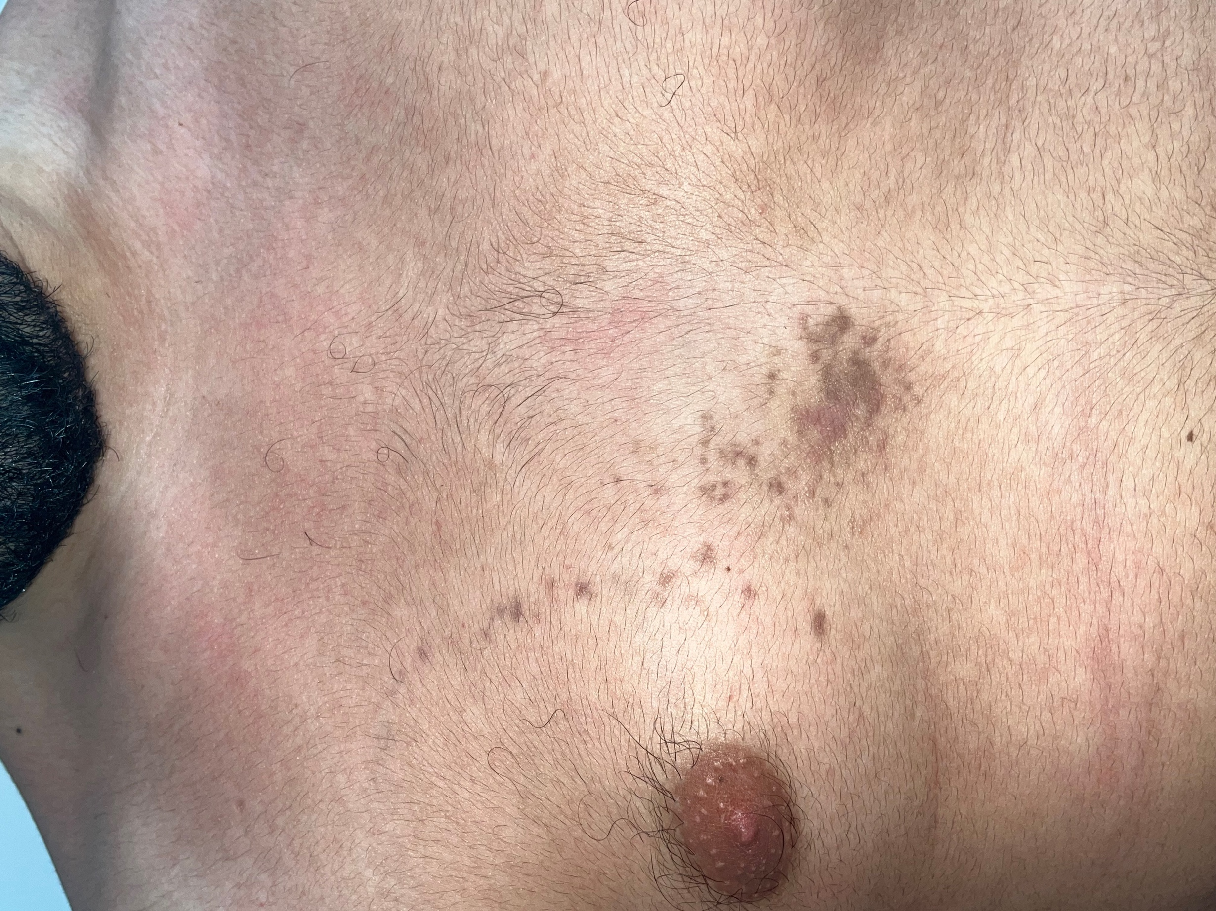
Fig. 1. Numerous erythematous-violaceous papules distributed unilaterally along the lines of Blaschko in an inverted-U configuration over the right side of the trunk, without crossing the anterior midline.
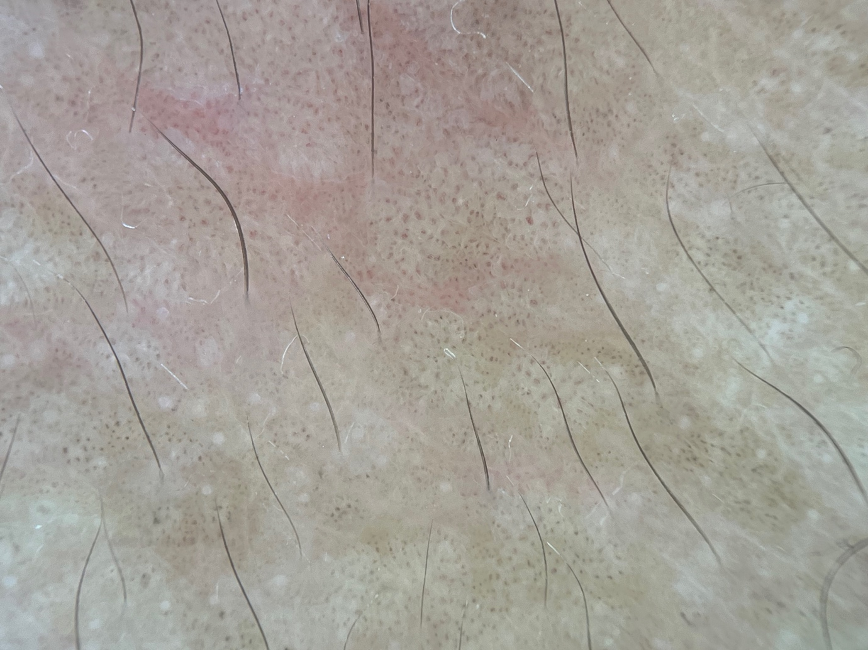
Fig. 2. Dermoscopy showing an erythematous background together with features of pigmentary incontinence.
3. DISCUSSION
LS is a benign acquired inflammatory dermatosis, mainly described in children between 3 and 10 years of age, with a slight female predominance (Patrizi et al., 2004; Herzum et al., 2025). Onset is typically acute, with numerous papules a few millimetres in diameter, isolated or confluent, erythematous in the early phase — or paler and hypopigmented in darker phototypes — and usually non- or only mildly pruritic; the eruption may also present as hypopigmented macules (Leung et al., 2024; Herzum et al., 2025). Although the limbs are the most frequently involved site, the trunk and the face may also be affected (Leung et al., 2024). The unilateral linear topography following the lines of Blaschko is highly suggestive and usually allows a straightforward clinical diagnosis, while histopathology characteristically reveals a lichenoid infiltrate, as observed in our patient (Zhou et al., 2016; Darsha & Cohen, 2020).
In the adult, LS must be differentiated from the other acquired blaschkolinear dermatoses, chiefly adult blaschkitis (AB), linear lichen planus and linear psoriasis (Müller et al., 2011; Herd et al., 1993). AB typically manifests as intensely pruritic, eczematiform papulovesicles, with histology showing spongiosis and without an interface dermatitis; conversely, LS presents as flat papules with a lichenoid, non-spongiotic epidermal pattern, as in our observation (Al-Balbeesi, 2021; Müller et al., 2011). The clinical and histological overlap between these entities has led some authors to consider that the distinction lacks robust supporting evidence, and to propose unifying concepts such as blaschkolinear acquired inflammatory skin eruption (BLAISE), encompassing a spectrum that includes both LS and AB (Darsha & Cohen, 2020; Hofer, 2003).
Dermoscopy, although not specific, can support the diagnosis: an erythematous background, dotted vessels and features of pigmentary incontinence (brownish or grey-blue granules corresponding to dermal melanophages) have been reported, and were partly present in our patient (Chersi et al., 2023; Sar-Pomian et al., 2024). When the eruption reaches a digit, nail involvement is a well-recognised, although under-reported, feature (Bilgic, 2024). A range of triggers has been described in adults, including viral infection, vaccination and immunomodulatory drugs, supporting an immune-mediated pathogenesis; none of these was identified in our patient (Belina et al., 2021; Kenyon et al., 2024). A personal or familial background of atopy, present in our patient, has likewise been reported in association with LS (Patrizi et al., 2004).
The course of LS is spontaneously resolutive, generally over several months, so that no treatment is required (Herzum et al., 2025; Leung et al., 2024). When the eruption is symptomatic, topical corticosteroids or topical calcineurin inhibitors may be used to relieve pruritus (Leung et al., 2024). Post-inflammatory hyperpigmentation or hypopigmentation may persist for several months after resolution, and recurrences are uncommon (Herzum et al., 2025).
4. CONCLUSION
Although rarely observed in adults, LS should be included among the diagnostic hypotheses for any acute, acquired, blaschkolinear eruption in this age group. Recognition of its characteristic distribution and its lichenoid histopathology allows it to be distinguished from adult blaschkitis and from the other linear dermatoses, and avoids unnecessary investigations and treatment. In most cases no treatment is required, apart from symptomatic measures directed at pruritus.
COMPETING INTERESTS
Authors have declared that no competing interests exist.
CONSENT
All authors declare that written informed consent was obtained from the patient for publication of this case report and the accompanying images. A copy of the written consent is available for review by the Editorial office of this journal.
ETHICAL APPROVAL
All authors hereby declare that all procedures performed were in accordance with the ethical standards of the responsible institutional committee and with the 1964 Declaration of Helsinki and its later amendments.
Declaration of AI Use

This manuscript was prepared through the combined contributions of all author(s), including contributions to the study design, data, content development, results, interpretation, and related scholarly work. The author(s) acknowledge the use of Grammarly and ChatGPT to assist with grammar checking, language refinement, reference formatting. These AI-assisted tools were not used as authors and did not replace the intellectual contributions or scholarly judgment of the author(s). All AI-assisted outputs, including content, references, and interpretations, were carefully reviewed, revised, verified, and approved by the author(s). The author(s) accept full responsibility for the accuracy, integrity, and final content of the manuscript.

REFERENCES
- Al-Balbeesi, A. (2021). Adult blaschkitis with lichenoid features and blood eosinophilia. Cureus, 13(8), e16846. https://doi.org/10.7759/cureus.16846
- Belina, M. E., Sarver, M. M., Al-Rohil, R., & Fresco, A. (2021). Lichen striatus post-COVID-19 vaccination. JAAD Case Reports, 16, 16–18. https://doi.org/10.1016/j.jdcr.2021.07.031
- Bilgic, A. (2024). Nail lichen striatus and its differential diagnoses. Skin Appendage Disorders, 10(6), 470–478. https://doi.org/10.1159/000539798
- Chersi, F., Conforti, C., Zalaudek, I., & Di Meo, N. (2023). Lichen striatus post-COVID-19 infection: Clinical and dermoscopic presentations. Dermatology Practical & Conceptual, 13(1), e2023006. https://doi.org/10.5826/dpc.1301a6
- Darsha, A. K., & Cohen, P. R. (2020). Blaschkolinear acquired inflammatory skin eruption (BLAISE): Case report of a young man whose dermatosis had features of lichen striatus and blaschkitis. Cureus, 12(10), e10785. https://doi.org/10.7759/cureus.10785
- Herd, R. M., McLaren, K. M., & Aldridge, R. D. (1993). Linear lichen planus and lichen striatus — opposite ends of a spectrum. Clinical and Experimental Dermatology, 18(4), 335–337. https://doi.org/10.1111/j.1365-2230.1993.tb02211.x
- Herzum, A., Viglizzo, G., Occella, C., Gariazzo, L., Vellone, V. G., Orsi, S. M., & Ciccarese, G. (2025). Lichen striatus: A review. Italian Journal of Dermatology and Venereology, 160(3), 242–247. https://doi.org/10.23736/S2784-8671.24.07998-2
- Hofer, T. (2003). Lichen striatus in adults or 'adult blaschkitis'? There is no need for a new naming. Dermatology, 207(1), 89–92. https://doi.org/10.1159/000070955
- Kenyon, C. M., Kelly, B. G., Bowen, A. R., Gumbleton, M., & Deacon, D. C. (2024). Lichen striatus as an immune-related adverse event following ipilimumab/nivolumab and COVID-19 infection in an adult. JAAD Case Reports, 50, 44–47. https://doi.org/10.1016/j.jdcr.2024.05.038
- Lenormand, C., Cribier, B., & Lipsker, D. (2013). Blaschko-linear manifestations of polygenic inflammatory diseases: Analysis of 17 cases. European Journal of Dermatology, 23(5), 671–676. https://doi.org/10.1684/ejd.2013.2150
- Leung, A. K. C., Lam, J. M., Barankin, B., & Leong, K. F. (2024). Lichen striatus: An updated review. Current Pediatric Reviews. Advance online publication. https://doi.org/10.2174/0115733963273945240101042423
- Müller, C. S., Schmaltz, R., Vogt, T., & Pföhler, C. (2011). Lichen striatus and blaschkitis: Reappraisal of the concept of blaschkolinear dermatoses. British Journal of Dermatology, 164(2), 257–262. https://doi.org/10.1111/j.1365-2133.2010.10053.x
- Patrizi, A., Neri, I., Fiorentini, C., Bonci, A., & Ricci, G. (2004). Lichen striatus: Clinical and laboratory features of 115 children. Pediatric Dermatology, 21(3), 197–204. https://doi.org/10.1111/j.0736-8046.2004.21302.x
- Sar-Pomian, M., Starace, M. V. R., Lencastre, A., Piraccini, B. M., Richert, B., Rudnicka, L., et al. (2024). Dermoscopic nail changes in psoriasis, lichen planus, and lichen striatus. Skin Appendage Disorders, 10(4), 273–292. https://pubmed.ncbi.nlm.nih.gov/39021761/
- Taieb, A., el Youbi, A., Grosshans, E., & Maleville, J. (1991). Lichen striatus: A Blaschko linear acquired inflammatory skin eruption. Journal of the American Academy of Dermatology, 25(4), 637–642. https://doi.org/10.1016/0190-9622(91)70245-W
- Zhou, Y., Yu, Z. Z., Peng, J., Yang, P. P., Li, S. J., & Fan, Y. M. (2016). Lichen striatus versus linear lichen planus: A comparison of clinicopathological features, immunoprofile of infiltrated cells, and epidermal proliferation and differentiation. International Journal of Dermatology, 55(4), e204–e210. https://doi.org/10.1111/ijd.13143

