Protective Effects of Syzygium aromaticum on Oxidative Stress Biomarkers Following Aluminium and Benzo[a]pyrene Toxicity

ABSTRACT
Oxidative stress is a principal mechanism underlying the toxicity of environmental pollutants such as aluminium (Al) and benzo[a]pyrene (BaP), with co-exposure promoting excessive reactive oxygen species generation, lipid peroxidation, and depletion of antioxidant defenses. Syzygium aromaticum (clove), a phenolic-rich medicinal plant with documented antioxidant properties, has not been adequately evaluated against oxidative damage from combined Al and BaP exposure. This study investigated the protective effects of S. aromaticum extract on oxidative stress biomarkers in male Wistar rats exposed to combined Al and BaP toxicity. 54 rats were allocated into nine groups (n = 6): normal control, Al-treated, BaP-treated, Al+BaP-treated, Al+BaP with S. aromaticum (1000, 1500, or 2000 mg/kg), S. aromaticum alone, and Al+BaP with ascorbic acid. Malondialdehyde (MDA), superoxide dismutase (SOD), catalase (CAT), glutathione peroxidase (GPx), and reduced glutathione (GSH) were determined using standard methods, with data analysed by one-way ANOVA and appropriate post hoc test (p < 0.05). Al and BaP, individually and combined, significantly increased MDA while reducing SOD, CAT, GPx, and GSH, with combined exposure producing more pronounced damage. S. aromaticum dose-dependently attenuated lipid peroxidation and restored antioxidant enzyme activities, with the highest dose matching ascorbic acid's efficacy. These findings support S. aromaticum's therapeutic potential as a natural antioxidant against combined toxicant-induced oxidative injury.

Keywords: Syzygium aromaticum; aluminium; benzo[a]pyrene; oxidative stress; malondialdehyde; antioxidant enzymes; reactive oxygen species; Wistar rats.

INTRODUCTION
Environmental pollution has become a major global public health concern owing to the increasing release of toxic chemicals into the ecosystem through industrialization, urbanization, agricultural activities, and fossil fuel combustion. Chronic exposure to environmental contaminants has been implicated in the pathogenesis of numerous diseases affecting the nervous, cardiovascular, hepatic, renal, and reproductive systems. Among the various mechanisms responsible for toxicant-induced tissue injury, oxidative stress has emerged as one of the most extensively studied and universally accepted pathways (Adeniji et al., 2019; Amirdivani et al., 2019). Oxidative stress results from an imbalance between the production of reactive oxygen species (ROS) and the antioxidant defense system, leading to oxidative damage of lipids, proteins, nucleic acids, and cellular organelles. Persistent oxidative stress disrupts normal cellular homeostasis and contributes significantly to the initiation and progression of several pathological conditions.
Aluminium (Al) is one of the most abundant metallic elements in the Earth's crust and is extensively utilized in food packaging, pharmaceuticals, water treatment, cosmetics, construction materials, and numerous industrial applications. Consequently, human exposure to aluminium has become virtually unavoidable through dietary intake, drinking water, occupational exposure, and environmental contamination. Although aluminium possesses no known physiological function in humans, excessive accumulation within biological tissues has been associated with neurotoxicity, hepatotoxicity, nephrotoxicity, immunotoxicity, and reproductive dysfunction (Rajeswari & Sailaja, 2014; Mitra et al, 2022. Experimental evidence suggests that aluminium toxicity is mediated primarily through excessive generation of reactive oxygen species, mitochondrial dysfunction, lipid peroxidation, impairment of antioxidant enzymes, and activation of inflammatory pathways. These oxidative events ultimately result in structural and functional damage to susceptible tissues.
Benzo[a]pyrene (BaP) is a high-molecular-weight polycyclic aromatic hydrocarbon (PAH) generated during the incomplete combustion of organic materials. Major sources of exposure include cigarette smoke, automobile exhaust, industrial emissions, grilled and smoked foods, crude oil combustion, and biomass burning (Jorge et al, 2021). Following absorption, BaP undergoes metabolic activation by cytochrome P450 enzymes to produce highly reactive intermediates capable of generating excessive reactive oxygen species and forming DNA adducts (Traini et al, 2023). These metabolites induce oxidative stress, inflammation, apoptosis, and cellular dysfunction in multiple organs (Traini et al, 2023). Numerous toxicological studies have demonstrated that BaP exposure is associated with significant alterations in antioxidant defense mechanisms, increased lipid peroxidation, and progressive tissue injury (Traini et al., 2023; Jorge et al., 2021).
In real-world environmental settings, humans are seldom exposed to a single toxicant. Rather, simultaneous exposure to multiple pollutants occurs through contaminated air, food, water, and occupational environments. Such combined exposure may produce additive or synergistic toxic effects that exceed those produced by individual toxicants because several contaminants converge on common molecular pathways, particularly oxidative stress and inflammation (Zeng et al, 2022). Despite the widespread occurrence of both aluminium and benzo[a]pyrene, relatively few studies have investigated the biochemical consequences of their combined exposure. Understanding the interaction between these toxicants is essential for accurately assessing environmental health risks and identifying effective therapeutic interventions capable of mitigating their cumulative toxicity.
Oxidative stress represents a critical mechanism underlying the toxicity of both aluminium and benzo[a]pyrene. Reactive oxygen species generated following toxicant exposure readily attack membrane phospholipids, resulting in lipid peroxidation and formation of malondialdehyde (MDA), a widely recognized biomarker of oxidative damage (Dahiru et al., 2022). Concurrently, endogenous antioxidant defense systems become overwhelmed, leading to reduced activities of enzymatic antioxidants such as superoxide dismutase (SOD), catalase (CAT), and glutathione peroxidase (GPx), together with depletion of reduced glutathione (GSH), one of the principal non-enzymatic antioxidants responsible for maintaining intracellular redox homeostasis. The depletion of these antioxidant defenses further amplifies oxidative injury, perpetuating cellular dysfunction and tissue degeneration (Mannucci et al, 2022).
Because oxidative stress is central to the pathogenesis of toxicant-induced diseases, considerable attention has been directed toward identifying naturally occurring antioxidants capable of restoring redox balance and protecting biological systems from oxidative injury. Plant-derived phytochemicals have emerged as promising therapeutic agents because of their ability to scavenge free radicals, enhance endogenous antioxidant enzyme activities, inhibit lipid peroxidation, and modulate inflammatory signalling pathways (Taghipour et al., 2023). Their relative safety, accessibility, and broad pharmacological activities have stimulated increasing interest in their application as complementary strategies for the prevention and management of environmentally induced toxicity.
Syzygium aromaticum (L.) Merr. & L.M. Perry, commonly known as clove, is an aromatic medicinal plant belonging to the family Myrtaceae. Its dried flower buds are rich in bioactive phytochemicals, including eugenol, eugenyl acetate, β-caryophyllene, flavonoids, tannins, and phenolic acids (Taghipour et al., 2023). Among these constituents, eugenol is regarded as the principal bioactive compound responsible for many of the biological activities of clove (Khalil & Ashour, 2021). Numerous experimental studies have demonstrated that S. aromaticum exhibits potent antioxidant, anti-inflammatory, antimicrobial, anti-apoptotic, and cytoprotective properties. These pharmacological effects have largely been attributed to its capacity to neutralize reactive oxygen species, inhibit lipid peroxidation, preserve membrane integrity, and enhance endogenous antioxidant defense systems. Consequently, S. aromaticum has been investigated as a potential therapeutic agent against oxidative stress-mediated disorders affecting various organs.
Although previous investigations have reported the antioxidant activities of S. aromaticum in several experimental models, evidence regarding its protective efficacy against oxidative stress induced by the combined exposure to aluminium and benzo[a]pyrene remains limited (Taghipour et al., 2023; Akinwande et al., 2019). Most available studies have focused on single-toxicant exposure, which does not adequately reflect the complex environmental conditions encountered by human populations. Furthermore, limited information exists regarding the ability of S. aromaticum to restore both enzymatic and non-enzymatic antioxidant defense mechanisms following concurrent exposure to these environmentally relevant toxicants. Addressing this knowledge gap is important for advancing the understanding of natural antioxidant interventions against mixed toxicant exposure.
Therefore, the present study investigated the protective effects of Syzygium aromaticum extract on oxidative stress biomarkers in male Wistar rats exposed to aluminium and benzo[a]pyrene, administered individually and in combination. Specifically, the study evaluated alterations in malondialdehyde (MDA), superoxide dismutase (SOD), catalase (CAT), glutathione peroxidase (GPx), and reduced glutathione (GSH) following toxicant exposure and assessed the capacity of S. aromaticum to ameliorate oxidative damage through restoration of endogenous antioxidant defense systems. The findings of this study are expected to provide further insight into the therapeutic potential of S. aromaticum as a natural antioxidant against oxidative stress associated with environmental toxicant exposure.

Materials and Methods
Chemicals and Reagents
Analytical-grade aluminium chloride (AlCl₃) and benzo[a]pyrene (BaP) were used as the experimental toxicants. Ascorbic acid served as the reference antioxidant. All chemicals and reagents used for the biochemical analyses were of analytical grade and procured from certified commercial suppliers. Diagnostic assay reagents used for the estimation of oxidative stress biomarkers were prepared according to the manufacturers' instructions.
Collection and Authentication of Plant Material
Dried flower buds of Syzygium aromaticum (L.) Merr. & L.M. Perry were obtained from a certified herbal market in Nigeria. Botanical authentication was carried out by a qualified taxonomist in the Department of Plant Science and Biotechnology, University of Port Harcourt (UNIPORT), Nigeria.
Preparation of Syzygium aromaticum Extract
The dried flower buds were thoroughly cleaned, air-dried where necessary, and pulverized into a fine powder using an electric grinder. The powdered material was extracted using distilled water by maceration for 7 days with intermittent agitation. The extract was filtered through Whatman No. 1 filter paper and concentrated under reduced pressure using a rotary evaporator at controlled temperature. The concentrated extract was further dried to obtain a stable crude extract, which was stored at 4°C until use. Fresh suspensions were prepared daily in distilled water immediately before administration.
Experimental Animals
Fifty-four healthy adult male Wistar rats weighing approximately 160g were obtained from the Animal House of University of Port Harcourt (UNIPORT). Animals were housed in clean polypropylene cages under standard laboratory conditions (22 ± 2°C; relative humidity 50–60%; 12-hour light/12-hour dark cycle) with unrestricted access to standard laboratory feed and clean drinking water. The animals were acclimatized for two weeks before the commencement of the experiment.
Experimental Design
Following acclimatization, the animals were randomly assigned into nine experimental groups (n = 6 per group):
- Group I (Normal Control): Received distilled water only.
- Group II (Aluminium): Received aluminium chloride (100 mg/kg body weight).
- Group III (Benzo[a]pyrene): Received benzo[a]pyrene (100 mg/kg body weight).
- Group IV (Aluminium + Benzo[a]pyrene): Received aluminium chloride (100 mg/kg) and benzo[a]pyrene (100 mg/kg).
- Group V (Al + BaP + S. aromaticum 1000 mg/kg): Received aluminium chloride, benzo[a]pyrene, and Syzygium aromaticum extract (1000 mg/kg body weight).
- Group VI (Al + BaP + S. aromaticum 1500 mg/kg): Received aluminium chloride, benzo[a]pyrene, and Syzygium aromaticum extract (1500 mg/kg body weight).
- Group VII (Al + BaP + S. aromaticum 2000 mg/kg): Received aluminium chloride, benzo[a]pyrene, and Syzygium aromaticum extract (2000 mg/kg body weight).
- Group VIII (S. aromaticum only): Received Syzygium aromaticum extract (1000 mg/kg body weight).
- Group IX (Al + BaP + Ascorbic Acid Received aluminium chloride, benzo[a]pyrene, and ascorbic acid (100 mg/kg body weight).
All treatments were administered orally once daily for 28 days.
Sample Collection
Twenty-four hours after the final treatment, the animals were fasted overnight and anaesthetized using diethyl ether. Blood samples were collected by cardiac puncture, and serum was separated by centrifugation at 3000 rpm for 10 minutes. The testes were excised immediately, rinsed in ice-cold normal saline, blotted dry, weighed, and homogenized in phosphate-buffered saline (pH 7.4). The homogenates were centrifuged at 10,000 × g for 15 minutes at 4°C, and the resulting supernatants were collected and stored at −20°C until biochemical analyses.
Determination of Oxidative Stress Biomarkers
Lipid Peroxidation Assay
Lipid peroxidation was evaluated by determining malondialdehyde (MDA) concentration using the thiobarbituric acid reactive substances (TBARS) method (Aguilar & Borges, 2020). The assay is based on the reaction between malondialdehyde and thiobarbituric acid under acidic conditions and elevated temperature to produce a pink chromogen, the absorbance of which was measured spectrophotometrically at 532 nm. Results were expressed as nmol MDA/mg protein.
Superoxide Dismutase (SOD) Activity
Superoxide dismutase activity was determined using the method based on the enzyme's ability to inhibit the autoxidation of epinephrine under alkaline conditions (Sun et al, 1988). Absorbance changes were monitored spectrophotometrically, and enzyme activity was expressed as units per milligram of protein (U/mg protein).
Catalase (CAT) Activity
Catalase activity was estimated by measuring the rate of decomposition of hydrogen peroxide. The decrease in absorbance resulting from hydrogen peroxide degradation was monitored spectrophotometrically at 240 nm, and enzyme activity was expressed as U/mg protein (Hamza & Hadwan, 2020)
Glutathione Peroxidase (GPx) Activity
Glutathione peroxidase activity was determined by measuring the rate at which reduced glutathione was oxidized in the presence of hydrogen peroxide (Sattar et al, 2024). Enzyme activity was quantified spectrophotometrically according to the standard assay protocol and expressed as U/mg protein.
Reduced Glutathione (GSH)
Reduced glutathione concentration was determined using Ellman's reagent (5,5'-dithiobis-(2-nitrobenzoic acid), DTNB), which reacts with sulfhydryl groups to produce a yellow-colored chromophore measurable at 412 nm. GSH concentration was expressed as μmol/mg protein (Ellman, 1959).
Statistical Analysis
All data were collected and expressed as Mean ± Standard Error of Mean (SEM). Statistical analysis was performed using IBM SPSS Statistics (Version 27) and GraphPad Prism (Version 10.4.2). To determine significant differences between group means, a One-way Analysis of Variance (ANOVA) was conducted. Where significant differences were observed, Tukey’s Multiple Comparisons Test (Tukey’s HSD) was used as the post-hoc test to separate the means. A probability value of less than 0.05 (p < 0.05) was considered statistically significant. The results were presented in graphical forms. A single asterisk (*) indicates an adjusted p-value ≤ 0.05; two asterisks (**) indicate p ≤ 0.01; three asterisks (***) indicate p ≤ 0.001; and four asterisks (****) indicate a highly significant difference at p ≤ 0.0001.

RESULTS
Effect on Superoxide Dismutase (SOD)
Significant reduction in antioxidant enzymes (SOD, CAT, GPx) in toxicant groups indicate oxidative stress. Clove extract restored enzyme levels, demonstrating strong antioxidant activity.
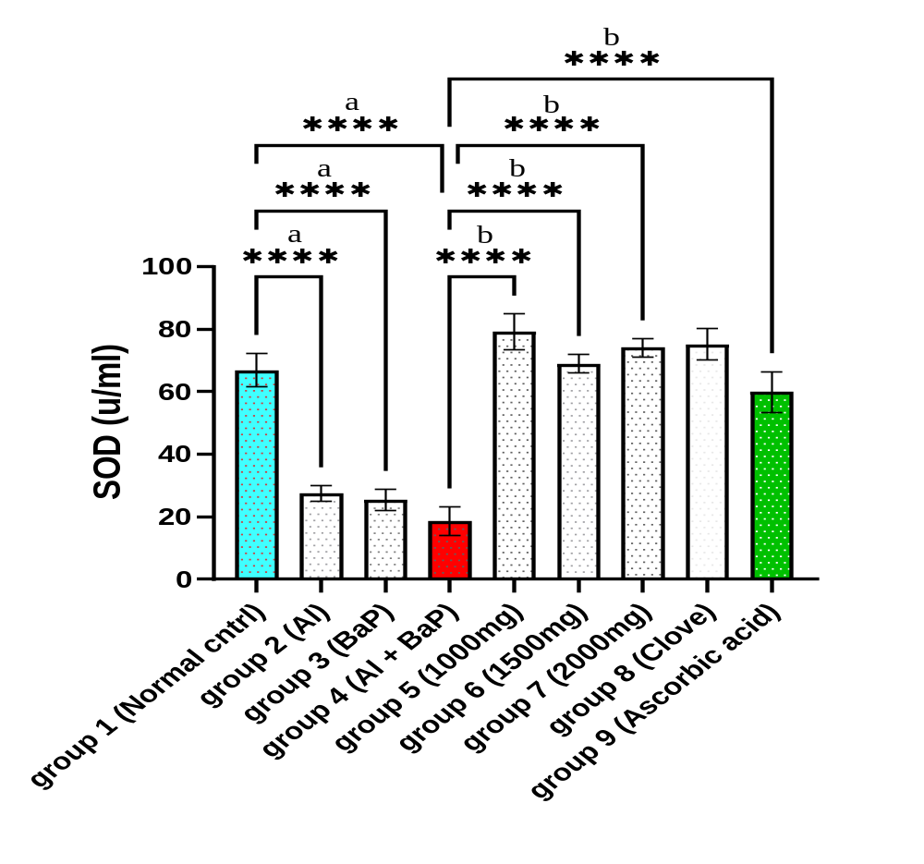
Figure 1: Effect of Extract on Superoxide Dismutase Level.
Data are presented as Mean ± SEM (n=6). “a” indicates significant difference (p < 0.05) compared to Normal Control (Group 1). “b” indicates significant difference (p < 0.05) compared to Negative Control (Group 4). A single asterisk (*) indicates an adjusted p-value ≤ 0.05; two asterisks (**) indicate p ≤ 0.01; three asterisks (***) indicate p ≤ 0.001; and four asterisks (****) indicate a highly significant difference at p ≤ 0.0001.

Effect on MDA
Elevated MDA levels indicate lipid peroxidation. Clove extracts significantly reduced MDA, confirming inhibition of oxidative damage.
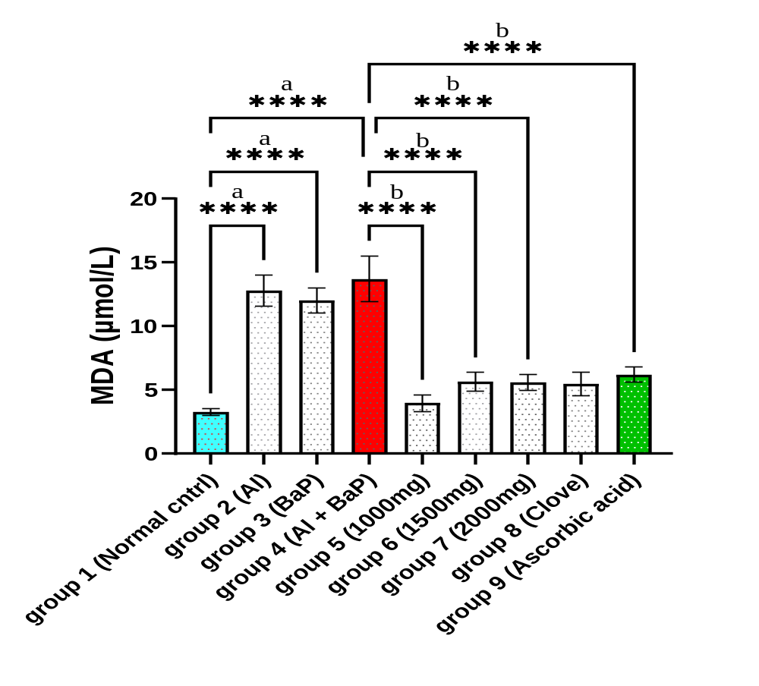
Figure 2: Effect of Syzygium aromaticum Extract on MDA level.
Data are presented as Mean ± SEM (n=6). “a” indicates significant difference (p < 0.05) compared to Normal Control (Group 1). “b” indicates significant difference (p < 0.05) compared to Negative Control (Group 4). A single asterisk (*) indicates an adjusted p-value ≤ 0.05; two asterisks (**) indicate p ≤ 0.01; three asterisks (***) indicate p ≤ 0.001; and four asterisks (****) indicate a highly significant difference at p ≤ 0.0001.

Effect on Catalase
Significant reduction in antioxidant enzymes (SOD, CAT, GPx) in toxicant groups indicate oxidative stress. Clove extract restored enzyme levels, demonstrating strong antioxidant activity.
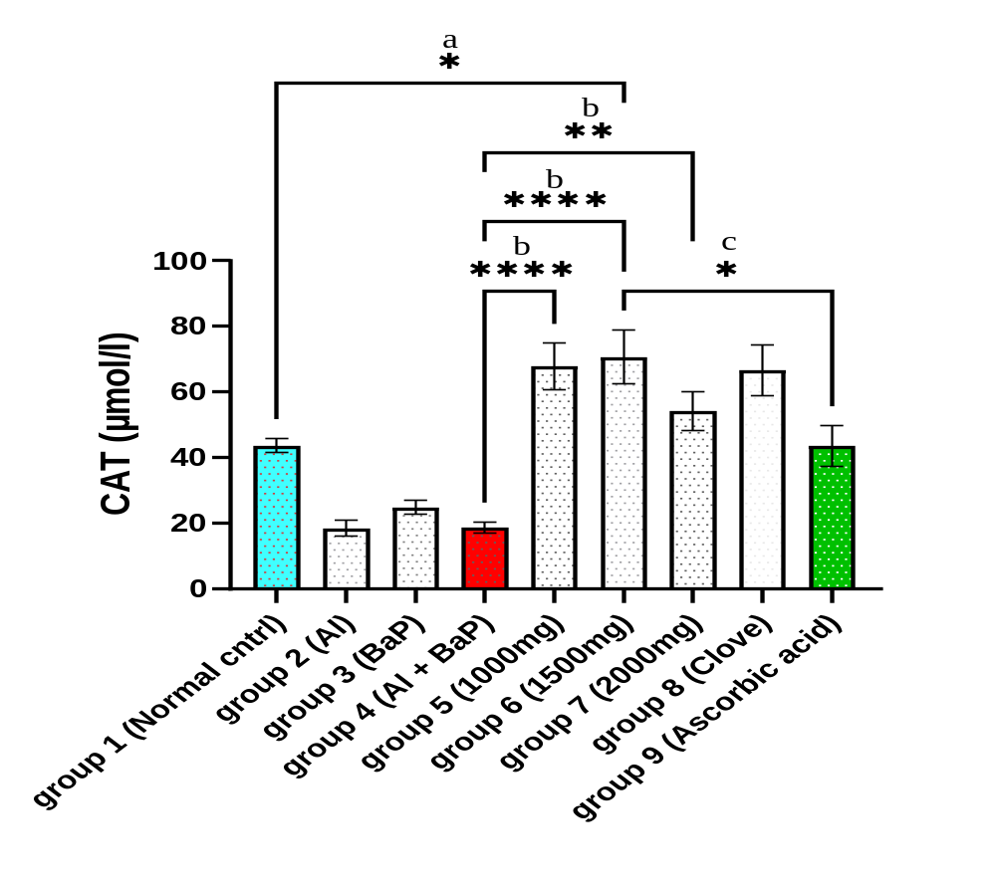
Figure 3: Effect of Syzygium aromaticum Extract on Catalase level.
Data are presented as Mean ± SEM (n=6). “a” indicates significant difference (p < 0.05) compared to Normal Control (Group 1). “b” indicates significant difference (p < 0.05) compared to Negative Control (Group 4). “c” indicates significant difference (p<0.05) compared to the Standard Drug (Group 9). A single asterisk (*) indicates an adjusted p-value ≤ 0.05; two asterisks (**) indicate p ≤ 0.01; three asterisks (***) indicate p ≤ 0.001; and four asterisks (****) indicate a highly significant difference at p ≤ 0.0001.

Effect on GPX
Significant reduction in antioxidant enzymes (SOD, CAT, GPx) in toxicant groups indicate oxidative stress. Clove extract restored enzyme levels, demonstrating strong antioxidant activity.
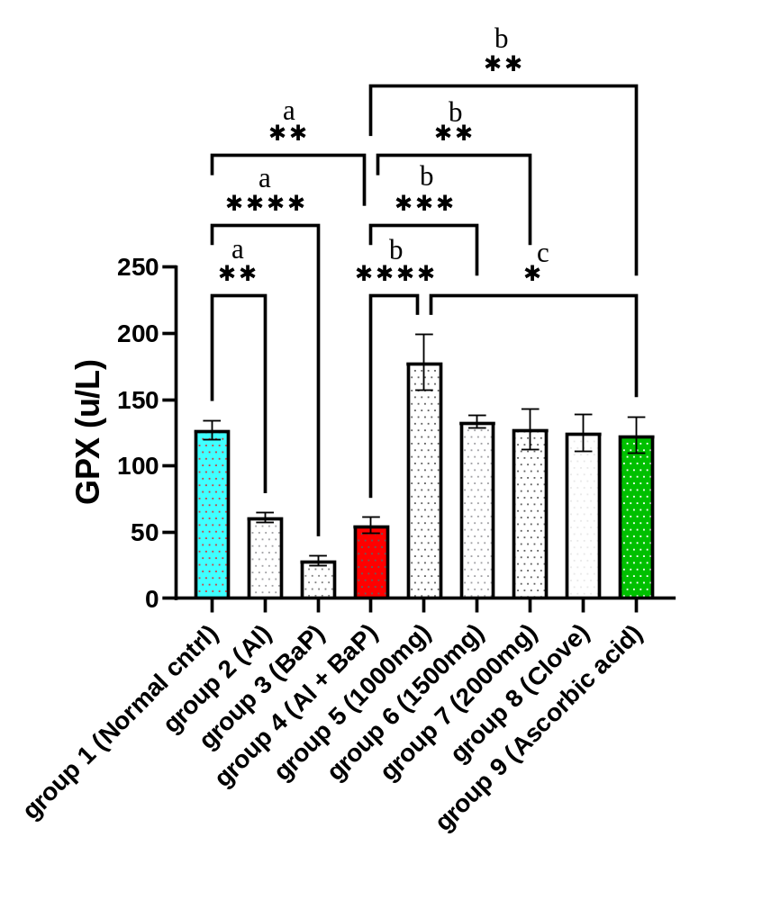
Figure 4: Effect of Syzygium aromaticum Extract on GPX level.
Data are presented as Mean ± SEM (n=6). “a” indicates significant difference (p < 0.05) compared to Normal Control (Group 1). “b” indicates significant difference (p < 0.05) compared to Negative Control (Group 4). “c” indicates significant difference (p < 0.05) compared to the Standard Drug (Group 9). A single asterisk (*) indicates an adjusted p-value ≤ 0.05; two asterisks (**) indicate p ≤ 0.01; three asterisks (***) indicate p ≤ 0.001; and four asterisks (****) indicate a highly significant difference at p ≤ 0.0001.

Effect on GSH
Reduced glutathione levels confirm oxidative depletion. Treatment increased GSH, indicating restoration of intracellular antioxidant defence.
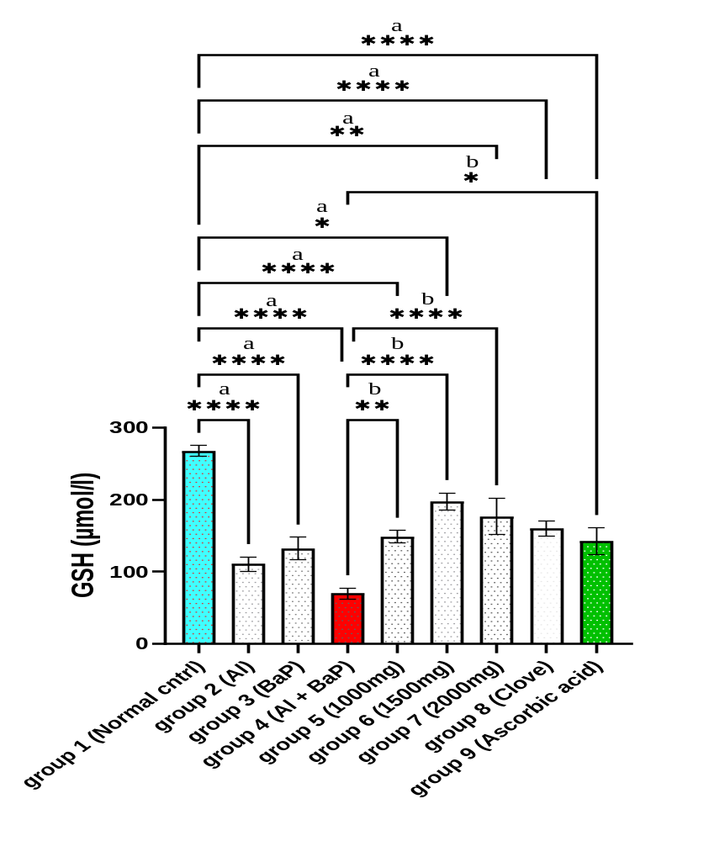
Figure 5: Effect of Extract on GSH level. Data are presented as Mean ± SEM (n=6). “a” indicates significant difference (p < 0.05) compared to Normal Control (Group 1). “b” indicates significant difference (p < 0.05) compared to Negative Control (Group 4). A single asterisk (*) indicates an adjusted p-value ≤ 0.05; two asterisks (**) indicate p ≤ 0.01; three asterisks (***) indicate p ≤ 0.001; and four asterisks (****) indicate a highly significant difference at p ≤ 0.0001.

DISCUSSION
The present study investigated the protective effects of Syzygium aromaticum extract against oxidative stress induced by aluminium and benzo[a]pyrene exposure in male Wistar rats. The findings demonstrated that exposure to either toxicant individually significantly disrupted the antioxidant defense system, while combined exposure produced a more pronounced oxidative imbalance. This was evidenced by elevated malondialdehyde (MDA) levels and concomitant reductions in the activities of superoxide dismutase (SOD), catalase (CAT), glutathione peroxidase (GPx), and reduced glutathione (GSH). Administration of S. aromaticum extract effectively attenuated these alterations in a dose-dependent manner, indicating a substantial antioxidant and cytoprotective effect.
Lipid peroxidation is one of the earliest biochemical consequences of excessive reactive oxygen species (ROS) generation (Mannucci et al., 2022; Dahiru et al., 2022). In the present study, exposure to aluminium and benzo[a]pyrene significantly increased MDA concentrations, indicating enhanced oxidative degradation of membrane lipids. Malondialdehyde is a widely recognized biomarker of oxidative stress because it reflects the extent of free radical-mediated peroxidation of polyunsaturated fatty acids within cellular membranes. Elevated MDA levels suggest severe disruption of membrane integrity, increased cellular permeability, and impairment of normal cellular functions. The more pronounced increase observed following combined exposure indicates that aluminium and benzo[a]pyrene may exert additive or synergistic effects through convergent oxidative pathways (Zeng et al, 2022). Aluminium has been shown to promote ROS generation through interference with mitochondrial electron transport and disruption of intracellular iron homeostasis, whereas benzo[a]pyrene undergoes cytochrome P450-mediated bioactivation to reactive metabolites capable of generating free radicals and initiating lipid peroxidation (Jorge et al., 2021; Traini et al., 2023). The interaction of these mechanisms likely accounts for the greater oxidative injury observed in animals exposed to both toxicants simultaneously. This aligns with previous findings by Wild et al. (2004), Oboh et al. (2017), and Emejuru et al. (2023), suggesting that flavonoids in the extract may regulate liver enzyme activities, thereby protecting hepatic health.
The significant reduction in superoxide dismutase activity observed following toxicant exposure further confirms impairment of endogenous antioxidant defense mechanisms. Superoxide dismutase constitutes the first enzymatic line of defense against oxidative stress by catalysing the conversion of superoxide anions into hydrogen peroxide (Yu & Xiao, 2021). Reduced SOD activity therefore permits the accumulation of superoxide radicals, thereby amplifying oxidative damage and promoting secondary free radical reactions. Similar reductions in SOD activity have been reported in experimental models of aluminium and polycyclic aromatic hydrocarbon toxicity, where excessive ROS generation overwhelms endogenous antioxidant capacity (Olanrewaju et al., 2021; Zeng et al., 2022). Restoration of SOD activity following treatment with S. aromaticum indicates preservation of antioxidant enzyme function and enhanced scavenging of superoxide radicals, thereby limiting oxidative injury.
Catalase activity was also significantly suppressed in toxicant-treated animals. Catalase plays an essential role in cellular antioxidant defense by rapidly converting hydrogen peroxide into water and molecular oxygen, thereby preventing the formation of highly reactive hydroxyl radicals through Fenton-type reactions (Yu & Xiao, 2021). Decreased catalase activity therefore predisposes tissues to hydrogen peroxide accumulation and subsequent oxidative damage. The observed restoration of catalase activity following administration of S. aromaticum suggests that the extract effectively preserved antioxidant enzyme integrity and improved the detoxification of hydrogen peroxide. This finding agrees with previous reports demonstrating the ability of clove-derived phytochemicals to enhance endogenous antioxidant enzyme activities under conditions of oxidative stress (Taghipour et al., 2023; Akinwande et al., 2019).
Glutathione peroxidase and reduced glutathione constitute another critical component of intracellular antioxidant defense. Glutathione peroxidase utilizes reduced glutathione as a cofactor to detoxify hydrogen peroxide and lipid hydroperoxides, thereby protecting cellular membranes from oxidative injury (Mannucci et al., 2022). In the present study, significant reductions in GPx activity and GSH concentration following aluminium and benzo[a]pyrene exposure indicate depletion of intracellular antioxidant reserves as a consequence of sustained oxidative stress. Depletion of GSH compromises cellular redox homeostasis, enhances susceptibility to oxidative injury, and promotes mitochondrial dysfunction and apoptosis (Yu & Xiao, 2021). The ability of S. aromaticum extract to restore both GPx activity and GSH concentration suggests improved maintenance of intracellular redox balance and enhanced capacity to neutralize reactive oxygen species generated during toxicant exposure.
The antioxidant effects observed in the present study are likely attributable to the diverse phytochemical constituents of S. aromaticum, particularly eugenol, which has been extensively reported as one of the most potent naturally occurring phenolic antioxidants (Khalil & Ashour, 2021). Eugenol possesses a phenolic hydroxyl group capable of donating hydrogen atoms to neutralize free radicals, thereby terminating lipid peroxidation chain reactions. In addition to direct free radical scavenging, eugenol and other phenolic constituents of clove have been reported to enhance endogenous antioxidant enzyme activities, preserve glutathione homeostasis, inhibit inflammatory mediators, stabilize biological membranes, and reduce mitochondrial oxidative damage (Taghipour et al., 2023). Other bioactive compounds identified in S. aromaticum, including flavonoids, tannins, and β-caryophyllene, may also contribute synergistically to the observed antioxidant effects through complementary mechanisms involving radical scavenging, metal ion chelation, and modulation of oxidative stress signaling pathways (Taghipour et al., 2023).
The dose-dependent improvement observed following administration of S. aromaticum further supports its pharmacological potential. Progressive restoration of antioxidant biomarkers with increasing extract doses suggests enhanced bioavailability of antioxidant phytochemicals capable of counteracting toxicant-induced oxidative damage. Notably, the highest dose produced antioxidant effects comparable to those observed with ascorbic acid, a well-established antioxidant reference compound. This finding indicates that S. aromaticum possesses considerable antioxidant efficacy and may represent a promising natural alternative for mitigating oxidative stress associated with environmental toxicant exposure.
The present findings are consistent with previous reports demonstrating that natural antioxidant-rich plant extracts protect against chemically induced oxidative injury through enhancement of endogenous antioxidant defenses and suppression of lipid peroxidation (Akinwande et al., 2019; Falade et al., 2022). However, unlike many earlier investigations that evaluated single-toxicant exposure, the present study employed a combined aluminium and benzo[a]pyrene exposure model that more closely reflects real-life environmental conditions (Zeng et al., 2022; Mitra et al., 2022). This experimental design strengthens the translational relevance of the findings and provides additional evidence supporting the therapeutic potential of S. aromaticum under complex environmental exposure scenarios.
Although the present study demonstrates significant antioxidant effects of S. aromaticum, certain limitations should be acknowledged. The study primarily evaluated biochemical indices of oxidative stress without investigating molecular pathways regulating antioxidant responses, such as nuclear factor erythroid 2-related factor 2 (Nrf2), heme oxygenase-1 (HO-1), nuclear factor-kappa B (NF-κB), or apoptotic signaling proteins (Yu & Xiao, 2021). Furthermore, characterization of individual phytochemicals responsible for the observed biological effects was beyond the scope of this investigation. Future studies incorporating molecular analyses, gene and protein expression profiling, molecular dynamics simulations, and pharmacokinetic evaluation would provide a more comprehensive understanding of the mechanisms through which S. aromaticum confers protection against mixed environmental toxicant exposure.

CONCLUSION
The findings of the present study demonstrate that exposure to aluminium and benzo[a]pyrene, both individually and in combination, induces significant oxidative stress by disrupting the endogenous antioxidant defense system and promoting lipid peroxidation. The observed elevation in malondialdehyde levels, together with the depletion of superoxide dismutase, catalase, glutathione peroxidase, and reduced glutathione, confirms that oxidative stress is a major mechanism underlying the toxicity of these environmental contaminants. Notably, combined exposure produced more severe oxidative damage than exposure to either toxicant alone, suggesting additive or synergistic interactions between aluminium and benzo[a]pyrene.
Administration of Syzygium aromaticum extract effectively ameliorated these alterations in a dose-dependent manner by suppressing lipid peroxidation and restoring both enzymatic and non-enzymatic antioxidant defenses. The marked improvement in oxidative stress biomarkers demonstrates the ability of S. aromaticum to preserve cellular redox homeostasis and protect biological tissues against free radical-mediated injury. These protective effects are likely attributable to the synergistic actions of its bioactive phytochemicals, particularly eugenol and other phenolic constituents, which possess potent free radical scavenging and antioxidant properties.
Overall, the present study provides experimental evidence supporting the antioxidant potential of Syzygium aromaticum as a natural therapeutic agent against oxidative damage induced by mixed environmental toxicants. Given the increasing human exposure to multiple environmental pollutants, the use of antioxidant-rich medicinal plants such as S. aromaticum may represent a promising complementary strategy for reducing oxidative injury and its associated pathological consequences. Future studies should focus on elucidating the molecular mechanisms underlying these protective effects through gene and protein expression analyses, advanced computational modelling, and well-designed clinical investigations to facilitate the translation of these findings into preventive and therapeutic applications.

DATA AVAILABILITY STATEMENT
The data supporting the findings of this study are available from the corresponding author upon reasonable request.
CONFLICT OF INTEREST
The authors declare that they have no known competing financial interests or personal relationships that could have appeared to influence the work reported in this paper.

Declaration of AI Use

This manuscript was prepared through the combined contributions of all author(s), including contributions to the study design, data, content development, results, interpretation, and related scholarly work. The author(s) acknowledge the use of Grammarly and ChatGPT to assist with grammar checking, language refinement, reference formatting. These AI-assisted tools were not used as authors and did not replace the intellectual contributions or scholarly judgment of the author(s). All AI-assisted outputs, including content, references, and interpretations, were carefully reviewed, revised, verified, and approved by the author(s). The author(s) accept full responsibility for the accuracy, integrity, and final content of the manuscript.

REFERENCES
Adeniji, A., Okoh, O. & Okoh, A. (2019). Levels of polycyclic aromatic hydrocarbons in the water and sediment of Buffalo River estuary, South Africa and their health risk assessment. Arch. Environ. Con. Tox., 76, 657-669.
Aguilar Diaz De Leon, J., & Borges, C. R. (2020). Evaluation of oxidative stress in biological samples using the thiobarbituric acid reactive substances assay. Journal of Visualized Experiments, (159), e61122. https://doi.org/10.3791/61122
Akinwande, D. V., Adeyemi, J. A., Olawuyi, S. T., Akinola, B. K., & Adedire, C. O. (2019). Protective effects of Camellia sinensis on Syzygium aromaticum- or chlorpyrifos-induced reproductive toxicity in male Wistar rats. Journal of Basic and Applied Zoology, 80, 9. https://doi.org/10.1186/s41936-019-0122-2
Amirdivani, S., Khorshidian, N., Ghobadi Dana, M., Mohammadi, R., Mortazavian, A.M., Quiterio de Souza, S.L., Barbosa Rocha, H. & Raices, R. (2019). Polycyclic aromatic hydrocarbons in milk and dairy products. Int. J. Diary Technol., 72. Doi:10.1111/1471-0307.12567.
Ellman, G. L. (1959). Tissue sulfhydryl groups. Archives of Biochemistry and Biophysics, 82(1), 70–77. https://doi.org/10.1016/0003-9861(59)90090-6
Emejuru SW, Onyegeme-Okerenta BM, Amadi BA. The ameliorative potential of aqueous extract of Hunteria unbellata on alloxan-induced diabetes and hyperlipidemia in Wistar rats. Scientia Africana. 2023;22(3):299-318.
Falade, A. O., Adewole, K. E., Adekola, A. R., Ikokoh, H. A., Okaiyeto, K., & Oguntibeju, O. O. (2022). Aqueous extract of bay leaf (Laurus nobilis) ameliorates testicular toxicity induced by aluminum chloride in rats. Veterinary World, 15(11), 2525–2534. https://doi.org/10.14202/vetworld.2022.2525-2534
Hamza, T. A., & Hadwan, M. H. (2020). New spectrophotometric method for the assessment of catalase enzyme activity in biological tissues. Current Analytical Chemistry, 16(8), 1054–1062. https://doi.org/10.2174/1573411016666200116091238
Jorge, B. C., et al. (2021). Exposure to benzo(a)pyrene from juvenile period to peripubertal impairs male reproductive parameters in adult rats. Chemosphere, 263, 128016. Traini, G., et al. (2023). Effects of benzo[a]pyrene on human sperm functions: An in vitro study. International Journal of Molecular Sciences, 24(19), 14411.
Khalil, N., & Ashour, M. (2021). Eugenol: A comprehensive review of its pharmacological activities.
Mannucci, A., Argento, F. R., Fini, E., Coccia, M. E., Taddei, N., Becatti, M., & Fiorillo, C. (2022). The impact of oxidative stress in male infertility. Frontiers in Molecular Biosciences, 8, 799294. https://doi.org/10.3389/fmolb.2021.799294
Mitra, S., Chakraborty, A. J., Tareq, A. M., Emran, T. B., Nainu, F., Khusro, A., Idris, A. M., Khandaker, M. U., Osman, H., Alhumaydhi, F. A., & Simal-Gandara, J. (2022). Impact of heavy metals on the environment and human health: Novel therapeutic insights to counter the toxicity. Journal of King Saud University – Science, 34(3), 101865. https://doi.org/10.1016/j.jksus.2022.101865
Oboh G, Olasehinde TA, Ademosun AO. Inhibition of enzymes linked to type-2 diabetes and hypertension by essential oils from peels of orange and lemon. J Food Prop. 2017;20(1):S586-S594.
Olanrewaju, J. A., Akinpade, T. G., Olatunji, S. Y., Owolabi, J. O., Enya, J. I., Adelodun, S. T., Fabiyi, S. O., & Desalu, A. B. (2021). Observable protective activities of quercetin on aluminum chloride-induced testicular toxicity in adult male Wistar rat. Journal of Human Reproductive Sciences, 14(2), 113–120. https://doi.org/10.4103/jhrs.jhrs_190_20
Sattar, A. A., Matin, A. A., Hadwan, M. H., Hadwan, A. M., & Mohammed, R. M. (2024). Rapid and effective protocol to measure glutathione peroxidase activity. Bulletin of the National Research Centre, 48(1), 1–17. https://doi.org/10.1186/s42269-024-01250-x
Sun, Y., Oberley, L. W., & Li, Y. (1988). A simple method for clinical assay of superoxide dismutase. Clinical Chemistry, 34(3), 497–500. https://doi.org/10.1093/clinchem/34.3.497
Taghipour, Z., Bahmanzadeh, M., & Rahimi, R. (2023). The effects of clove and its constituents on reproductive system: A comprehensive review. Reproductive Sciences, 30(9), 2591–2614. https://doi.org/10.1007/s43032-023-01223-x
Wild S, Roglic G, Green A, Sicree R, King H. Global prevalence of diabetes: estimates for the year 2000 and projections for 2030. Diabetes Care. 2004;127(5):1047 1053.
Yu, C., & Xiao, J. H. (2021). The Keap1-Nrf2 system: A mediator between oxidative stress and aging. Oxidative Medicine and Cellular Longevity, 2021, 6635460. https://doi.org/10.1155/2021/6635460
Zeng, H., Fang, B., Hao, K., Wang, H., Zhang, L., Wang, M., Hao, Y., Wang, X., Wang, Q., Yang, W., & Rong, S. (2022). Combined effects of exposure to polycyclic aromatic hydrocarbons and metals on oxidative stress among healthy adults in Caofeidian, China. Ecotoxicology and Environmental Safety, 230, 113168. https://doi.org/10.1016/j.ecoenv.2022.113168

