Biochemical profiles of Spirulina microalgal powder: potential applications in functional foods and pharmaceuticals

Abstract
Background: Spirulina microalgae are filamentous, multicellular, blue–green cyanobacteria which serve as popular nutritional sources in medicine, the food industry and aquaculture. Spirulina contains a high content of the macro- and micronutrients, anioxidants and pigments such as carotene, chlorophyll and phycocyanin.
Aims: This study aimed to determine the valuable chemical compounds of Japanese Spirulina microalgal powder for potential application in the functional foods and pharmaceuticals.
Materials and Methods: The characteristics of the powder were initially validated via visual inspection and microscopy. The contents of pigments (carotenoid and chlorophyll) were subsequently determined using UV-Vis spectrophotometric method. The HPLC method which employs a gradient elution program with a mobile phase consisting of dicloromethan:acetonitril:methanol (40:45:15) was used to quantify the content of $β-carotene$. The total phenolic compound content and antioxidant activity were assessed using the Folin-Ciocalteu and DPPH (2,2-Diphenyl-1-picrylhydrazyl) reagents, respectively.
Results: The results indicated that the microalgal powder was a uniform and homogenous substance with a fishy odor appropriate for the analysis. The total carotenoid and chlorophyll contents reached the values of 3.306 mg/g and 6.471 mg/g, respectively. The retention time of $β-carotene$ exhibited approximately 11.75 minutes and the linear regression equation showed statistical significance (R² = 0.9995), and the $β-carotene$ content of the microalgal powder recorded at 2.677 mg/g. The total phenolic content was 0.444 mg/g, and the antioxidant capacity was 25%, which is equivalent to 2.487 $μg/mL$ of vitamin C.
Conclusions: In conclusion, the Japanese Spirulina sp. microalgal powder possessed stable chemical components, including carotenoids, chlorophylls, $β-carotene$ and phenolics, while also exhibiting considerable antioxidant activity. These findings suggest the strong potential of Spirulina powder for effective application in the production of functional foods and pharmaceuticals.

Keywords: Spirulina, chlorophyll, carotenoid, $β-carotene$, phenolic and antioxidant capacity.
INTRODUCTION
Spirulina, a filamentous cyanobacterium, a prominent microalga, recognized for both its rich nutritional composition and the presence of diverse bioactive compounds, is considered a valuable candidate for use as a functional food, animal feed supplement, and therapeutic agent (Khan et al., 2025; Spínola et al., 2024). Arthrospira (Spirulina) platensis has a wide range of pigments, including chlorophyll a, total carotenoids and phycobiliproteins (protein-rich phycocyanin and phycoerythrin). The primary potential of these pigments seems to be their use as natural dyes, the functional properties of health benefits and wide pharmaceutical applications (İsar et al., 2022). The chemical compositions of Spirulina posess high levels of protein, essential fatty acids, vitamins, minerals, and bioactive compounds, such as the phycocyanin pigment, polysaccharides, and carotenoids, in food, feed, and medicine. These compounds exhibit various biological activities, including antioxidant, anti-inflammatory, immunomodulatory, antiviral, anticancer, antidiabetic and lipid-lowering effects (Spínola et al., 2024).
Spirulina preparations enhance the immune system by increasing the phagocytic activity of macrophages, stimulating the production of antibodies and cytokines, and promoting the activation and mobilization of T and B cells. It plays a regulatory role in lipid and carbohydrate metabolism, helping to correct glucose and lipid profiles in diabetic patients and experimental animals. Spirulina is active against several enveloped viruses, including HIV, herpes virus, cytomegalovirus, and influenza virus. Owing to its antioxidant properties, it can inhibit carcinogenesis (cancer development) and reduce toxicity in vital organs such as the liver, kidney, and testes (Khan et al., 2025). Free bilirubin is physiologically recognized as a potent inhibitor of NADPH oxidase activity; this effect is replicated by the phycocyanobilin (PCB) chromophore, a compound abundant in blue-green algae such as Spirulina, likely because PCB is rapidly reduced to phycocyanorubin, a close structural homolog of bilirubin, within mammalian cellular systems (McCarty, 2007).
Given the significant roles of Spirulina microalgae, they have recently been used as the functional foods, and are widely applied in aquaculture, cosmetics and pharmaceuticals worldwide. This study aims to evaluate the contents of pigments (chlorophylls and carotenoids), $β$- carotene, phenolic compounds and the antioxidant activity of Japanese Spirulina power cultivated under the laboratory conditions. The results will serve as a basic for confirming the potential of Spirulina power for applications in the production of functional foods and pharmaceuticals.
MATERIAL AND METHODS
  - Chemicals and instruments

The $β$- carotene and vitamin C standards ﻿were purchased from Sigma-Aldrich and VWR & BDH, respectively. The absolute dicloromethane, acetonitrile, and methanol solvents used for HPLC, along with n-hexane and ethanol, were obtained from Merck, Germany. The gallic acid standard was originated from India. The instruments were used for this research included a UV-Vis spectrophotometer (Shimadzu, Japan), an HPLC (Shimadzu serial L214555, Japan) and a PDA detector (Germany).
  - Research object
The Japanese Spirulina sp. microalgal powder was harvested from the microalgal biomass cultivated in Zarrouk medium at the Laboratory of Biochemistry of Nguyen Tat Thanh University in Vietnam.
  - Research methods
2.2.1. Description of Spirulina sp. powder
The microalgal powder was ground carefully into a fine and homogenous structure using a porcelain mortar and pestle. The characteristics of the microalgal powder were subsequently characterized under an optical microscope at a magnification of 400X.
    - Microalgal powder extraction
Microalgal powder (0.05 g) was extracted with 5 mL of n-hexane in a capped test tubes, at 50 ºC for 15 minutes. The resulting extract was centrifuged at 6000 rpm for 10 minutes and the supernatants was collected and evaporated to dryness. The pellet was subjected to futher extraction until the solution became colorless. All extracts were pooled, and evaporated to dryness for subsequent analysis.
    - Determination of the chlorophyll and carotenoid contents
The extract was redissolved in 5 mL of n-hexane and then absorbaned to spectrophotometic measurement at wavelenghs 450 nm, 662 nm, and 645 nm. The contents of chlorophyll and carotenoids were calculated via the following equations (Prieto et al., 2011; LICHTENTHALER & WELLBURN, 1983):
Carotenoid (mg/g) = $\frac{A450*25.5*a}{m*1000}$
Chlorophyll a (mg/g) = $\frac{(11.75*A662-2.35*A645) x a}{m*1000}$
Chlorophyll b (mg/g) = $\frac{(18.61*A645-3.96*A662) x a}{m*1000}$
Total chlorophyll (mg/g) = Chlorophyll a + Chlorophyll b
Where:
A450, A645 and A662 absorbances were measured at the wavelengths of 450 nm, 645 nm and 662 nm, respectively.
a: dilution factor
m: mass of the weighed microalgal powder (g)
    - Determination of $β$-carotene content using HPLC method
The chromatographic conditions: chromatographic column Luna ® C18 – 4.6 x 250 mm, temperature at 30 ºC, PDA detector, wavelength at 476 nm, injection volume of 30 µL, mobile phase dicloromethan:acetonitril:methanol (40:45:15, v/v/v), flow rate: 1 mL/min (Nguyen et al., 2025).
Preparation of the $β$- carotene standard solution: Approximately 10 mg of $β$- carotene standard was accurately weighed and transferred into a 50 mL volumetric flask. n-Hexane was added to dissolve the compound and fill to the mark. Exactly 1mL of this solution was then pipetted into a 20 mL volumetric flask, and the mobile phase was added to make up the volume. The final solution was filtered through a 0.45 µm membrane filter.
The $β$- carotene calibration curve: A series of $β$- carotene standard solutions with concentrations ranging from 4 to 14 µg/mL were prepared by diluting the initial stock solution (200 µg/mL). Each standard solution was injected into the system under the selected chromatographic conditions and the chromatogram was recorded. A linear regression equation (y = ax + b) was subsequently established, and a plot illustrating the correlation between peak area and $β$- carotene concentration was generated.
The extract of Spirulina microalgal powder: The extract from 1.5 g of the microalgal powder was redissolved with 5 mL of n-Hexane. One milliliter of this extracted mixture was transferred into a 5 mL volumetric flask and the mobile phase was added to the mark. The final solution was filtered through a 0.45 µm membrane filter. The solution was injected into the chromatographic system and the chromatogram was recorded, in six replicates.
$β$- carotene (mg/g) = $\frac{St*Cc*C\%*a}{Sc*1000*m}$
where:
St: the peak area of the Spirulina sample (mAU)
Sc: the peak area of the $β$- carotene standard (mAU)
Cc: Concentration of the $β$- carotene standard ($μg/mL$)
C%: $β$- carotene standard content
a: dilution factor
m: mass of the weighed microalgal powder (g)

Determination of total phenolic content
The gallic acid calibration curve: A series of gallic acid standard solutions with concentrations ranging from 10 to 50 µg/mL were prepared by diluting the stock solution (200 µg/mL). 0.5 mL of each standard concentration was subsequently pipetted into a 2 mL eppendorf tube, followed by the addition of 0.5 mL of Folin ciocalteu’s phenol reagent. Next, 0.5 mL of 10% Na₂CO₃ solution was slowly added. The mixture was incubated in the dark for 90 minutes. The absorbane was then measured at a wavelength of 750 nm. A linear regression equation (y = ax + b) was subsequently established.
Microalgal powder (0.05 g) was extracted with 5 mL of methanol and centrifuged at 5000 rpm for 15 minutes. The supernatant was epovarated to a dry residue, which was then dissolved in 5 mL of absolute methanol to obtain the extract solution for analysis. A 0.5 mL aliquot of the extract was pipetted into a 2 mL eppendorf tube and the subsequent steps of the procedure were carried out as described above. The total phenolic content (µg GAE/g) was calculated base on the following equation:
$$\text{Total phenolic content (}μgGAE/g)\text{ = }\frac{\text{C*a}}{\text{m}}$$
where: C: total phenolic content was determined from the calibration curve (µg GAE/mL)
a: dilution factor
m: mass of the weighed microalgal powder (g)

Determination of antioxidant capacity
Preparation of the DPPH reagent: A 0.004 g of DPPH (1,1-diphenyl-2-picrylhydrazyl) was dissolved with methanol in a 100 mL volumtric flask, and then methanol was added to the mark.
A vitamin C (ascorbic acid) standard solution was used as a positive control to evaluate the antioxidant capacity of the microalgal powder. A series of the vitamin C standard solutions with concentrations ranging from 0.5 to 4.5 $μg$/mL was prepared by diluting the stock solution (10 $μg$/mL). 0.5 mL of each vitamin C concentration was pipetted into a 2 mL Eppendorf tube, followed by the addition of 1 mL of DPPH reagent. The mixture was gently vortexed and then incubated in the dark for 30 minutes. The absorbance was measured at the wavelength of 517 nm. A linear regression equation (y = ax + b) was established, where y represents the optimal density (OD) value and x represents the vitamine C concentration ($μg$/mL).
A 0.05 g of the microlagal powder was extracted with 5 mL of ethanol, and then centrifuged at 5000 rpm for 10 minutes. The supernatant was evaporated to dryness, and then redissolved with 5 mL of ethanol to collect the extract solution for the analysis. This extract solution was prepared according to the procedure described above. The antioxidant capacity (I%) was calculated using the following equation:
I% = ($\frac{{\text{Α}}_{\text{Blank}}\text{ - }{\text{Α}}_{\text{sample}} }{{\text{Α}}_{\text{Blank}}}$) x 100
where: I%: inhibition percentage
A_{Blank}: Absorbance of the blank sample
A_{sample}: Absorbance of the microalgal extract sample
The vitamin C equivalent content was calculated basis of the linear regression equation derived from the vitamin C standard curve, where x represents the concentration of vitamin C, and y represents the DPPH radical scavenging activity.
2.3. Data analysis
The research data was analyzed using Microsoft office Excel 2025 and Paired – samples T-test which was used by SPSS sofware (version 20.0) and the significant error (p – value) was less than 0.05 (p < 0.05).
RESULTS AND DISCUSSION

3.1. Description of Spirulina sp. powder

Visually, the Spirulina microalgal powder presented as a fine, homogenous and smooth substance, that was green in color and had a slightly fishy odor (figure 1a). The cells appeared intact, green and filamentous structure when described under the optical microscope at 400X magnification (figure 1b). Consequently, the Spirulina microalgal powder statisfied the appropriate characteristics for the analysis of the chlorophyll, carotenoid, β-carotene, and phenolic contents and antioxidant activity.

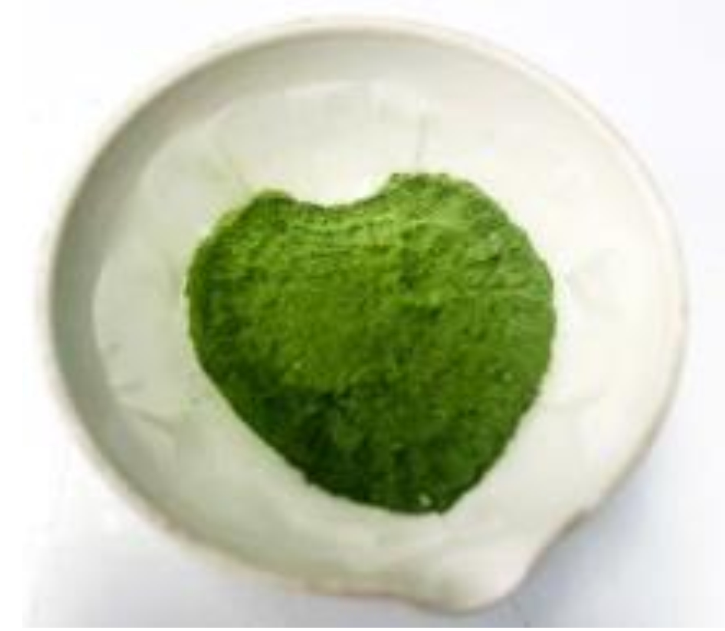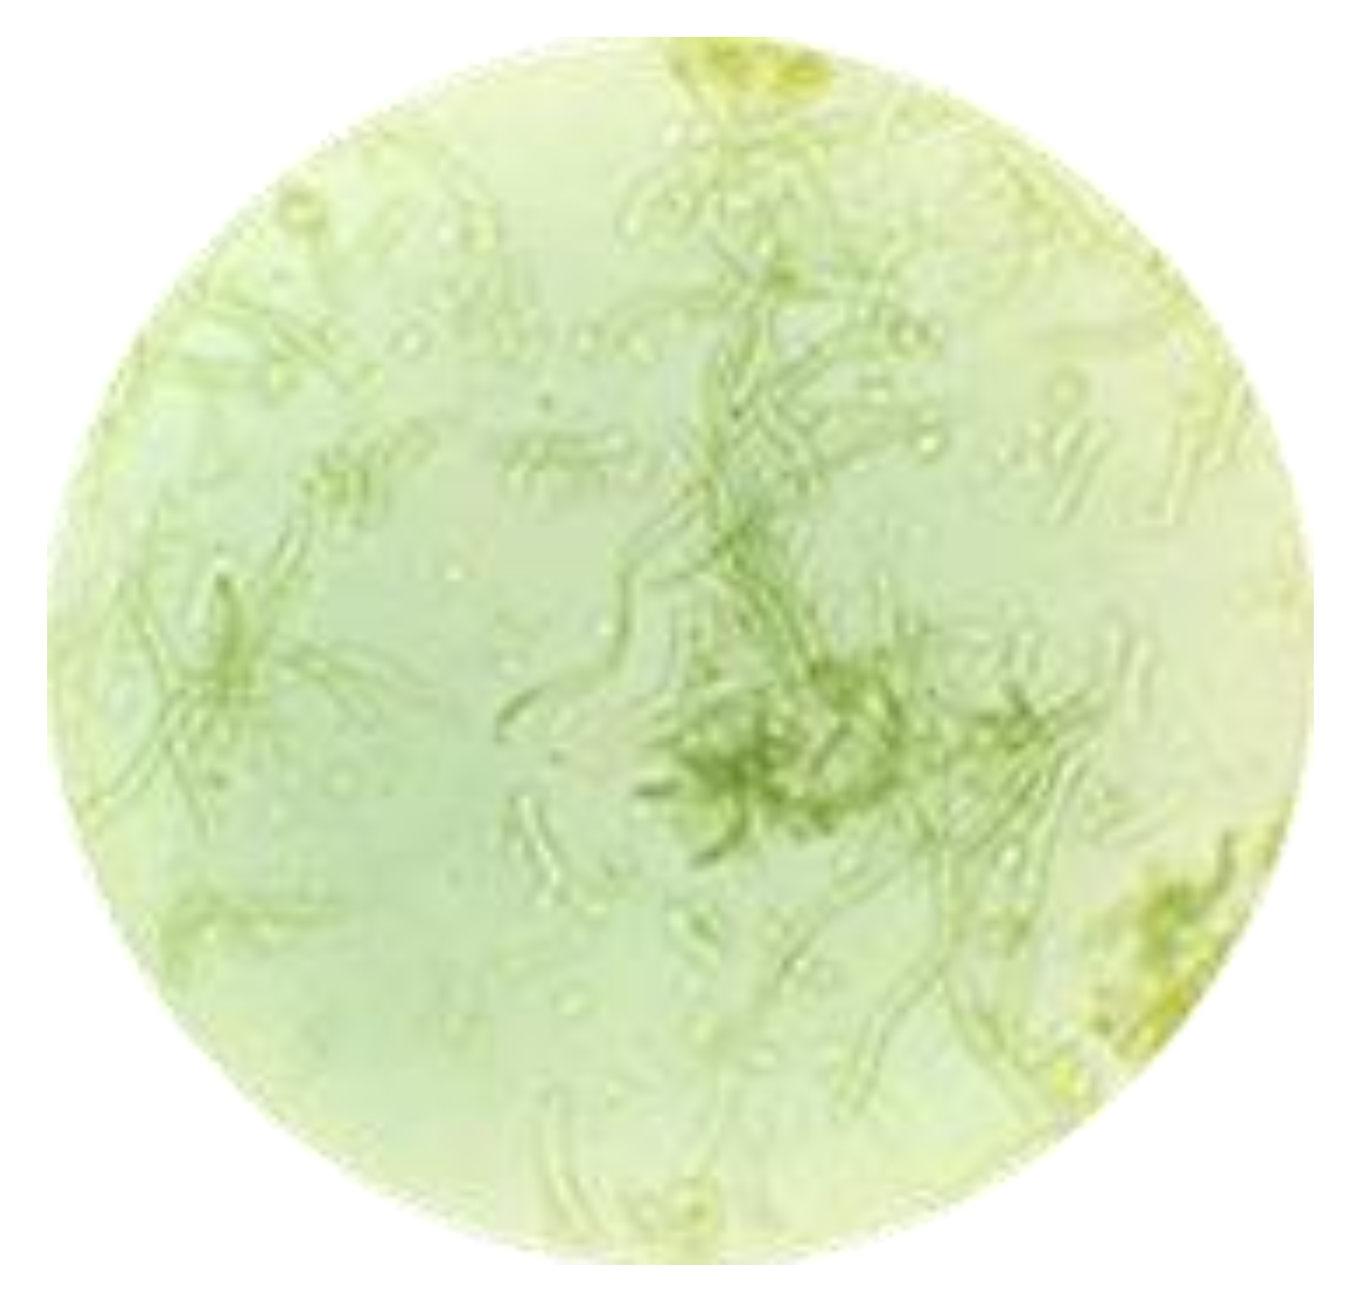
(a)
(b)

Figure.1. The Spirulina powder (a) and the cell under the optical microscope at 400X magnification (b)
  - Pigment contents of Spirulina sp. powder
Figure 2 illustrate the pigment (chlorophyll and carotenoid) contents of Japanese Spirulina sp. powder. The chlorophyll a and b contents in the microalgal powder reached values of 2.446 mg/g and 4.025 mg/g, respectively and the total chlorophyll content was 6.471 mg/g. Conversely, the carotenoid content was recorded at 3,306 mg/g (table.1).

Table.1. Pigment (chlorophyll and carotenoid) contents of Spirulina sp. microalgal powder
Pigments | Chlorophyll a | Chlorophyll b | Total Chlorophyll | Carotenoid
Content (mg/g) | 2.446 $±$ 0.032 | 4.025 $±$ 0.066 | 6.471 $±$ 0.120 | 3.306 $±$0.061
RSD% | 1.292 | 1.644 | 1.861 | 1.847

  - The $β-carotene$content of Spirulina sp. microalgal powder
The retention time of the 10 $μg/mL$ $β-carotene$standard in the chromatogram was approximately 11.827 minutes (figure.2a). The linear range of $β-carotene$ was demonstrated across a concentration span of 4 to 14 $μg/mL$. The $β-carotene$ concentration achieved linearity with the following linear regression equation: y = 309758x – 444270, R² value of 0.995. The p- value (p < 0.05) confirmed the significant linear correlation between the peak and $β-carotene$ concentrations (figure 3, 4, table.2). The analysis of the $β-carotene$ content in the Japannese Spirulina sp. microalgal powder utilizing the established chromatographic conditions, produced a retention time analogous to that of the standard sample and resulted in a recorded value of 2.677 mg/g (figure 2b, table.3).

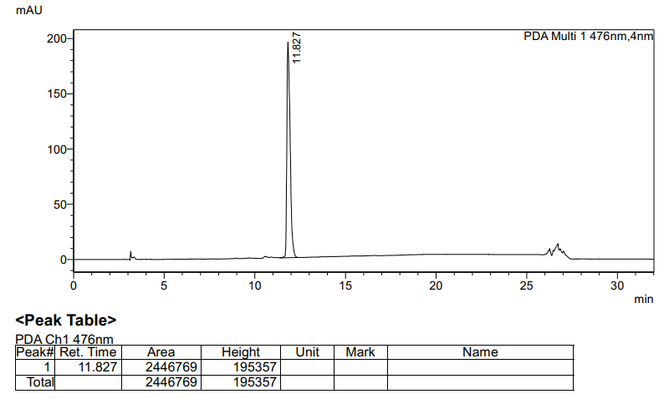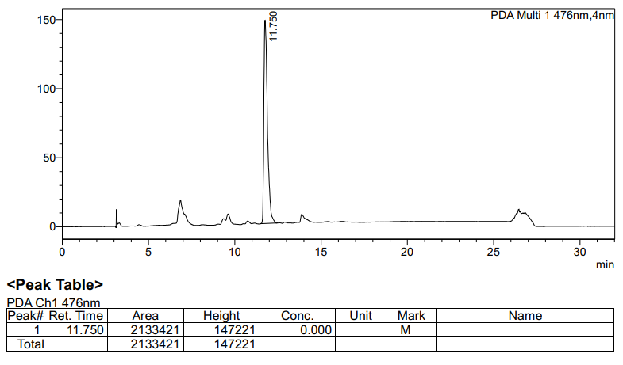
(a)
(b)

Figure.2a and 2b. $β- carotene$ standard chromatograms at concentration of 10 $μg/mL$ (a) and Spirulina microalgal powder (b)

Figure.3. $β- carotene$ standard chromatograms at concentration series ranging from 4 to 14 $μg/mL$

Figure 4. The linear regression equation of the $β- carotene$ standard at concentration series ranging from 4 to 14 $μg/mL$

Table.2. Analytical parameters for the linearity of $β- carotene$ and the gallic acid standard
Parameters | $$β- carotene$$ | Gallic acid
The linear regression equation | y = 309758x - 444270 | y = 0.0301x + 0.0352
Slope (a) | 309758 | 0.0301
Intercept (b) | - 444270 | 0.0352
R Square | 0.9995 | 0.9903
Adjusted R Square | 0.9993 | 0.9871
Significance F | < 0.05 | < 0.05
P-value | < 0.05 | < 0.05

Table.3. $β-carotene$, phenolic content and antioxidant capacity of Spirulina microalgal powder
Characteristics | Aver $±$ SD | RSD %
$β-carotene$ content (mg/g) | 2.677 $±$ 0.089 | 0.033
Phenolic content (mg/g) | 0.444 $±$ 0.088 | 0.199
Antioxidant capacity (I%) | 25.000 $±$ 0.499 | 1.734
  - Phenolic content of Spirulina microalgal powder

The linear range of gallic acid spanned the concentration interval of 10 to 50 $μg/mL$, resulting in the linear regression equation: y = 0.0301x + 0.0352, R² value of 0.9903 and p-value (p < 0.05) confirming linearity (figure 5, table 2). The analysis of total phenolic content of the Spirulina microalgal powder obtained a value of 0.444 mg/g (table.3).

Figure 5. The linear regression equation of gallic acid standard at concentration series ranging from 10 to 50 $μg/mL$
  - The antioxidant capacity of the Spirulina microalgal powder
The vitamin C positive control demonstrated linearity within the concentration range of 0.5 to 4.5 µg/mL, yielding the linear regression equation y = 3.1262x + 17.226, R² value of 0.9919 and p-value (p < 0.05) (figure 6). The antioxidant activity of Spirulina microalgal powder revealed the free radical scavenging activity of 25% (table.3), which was equivalent to 2.487 µg/mL of vitamin C (figure 6).

Figure.6. The linear regression equation of vitamin C standard at concentration series ranging from 0.5 to 4.5 $μg/mL$
DISCUSSION
Spirulina is a highly nutritious microalga with extensive global applications in the contemporary cosmetic and pharmaceutical industries. Its intrinsic value is derived from a diverse component of pigments—including chlorophyll, carotenoids, and phycocyanin—alongside a rich nutritional profile, most notably its high protein content. The results demonstrated that the color of the Spirulina microalgal powder is significantly dictated by its chlorophyll pigmentation. The cyanobacterium Spirulina has garnered significant commercial traction as a functional food mainly because of its high protein content as well as high amounts of pigments, including carotenoids, chlorophylls and phycocyanins. The total carotenoid, chlorophyll a and chlorophyll b contents in the extracts were equal to 3.5 ± 0.2 mg/g, 5.7 ± 0.2 mg/g and 3.4 ± 0.3 mg/g, respectively (by dry Spirulina weight) (Marzorati et al., 2020). The extraction performance of phycocyanin and chlorophyll under diverse thermal, ultrasonic, and solvent conditions was evaluated, with maximum efficiencies reaching 14.88 mg/g and 1.400 mg/g, respectively (Nikolova et al., 2024).
Japanese Spirulina powder exhibits a high total carotenoid concentration of 3.306 mg/g, with beta-carotene accounting for 2.677 mg/g—representing a substantial 80.974% of the total content. According to Park et al., 2018, All-trans-β-carotene, all-trans-zeaxanthin, 9-cis-β-carotene and diatoxanthin were found to be the major carotenoids present in spirulina. 13-cis-β-Carotene was also detected. The content of all-trans-β-carotene was highest among the four major carotenoids in AP-1, C1, C2 and C5 while that of all-trans-zeaxanthin was highest in the remaining samples. AP-1, C1 and C2 contained more than 1.6 mg/g dry weight of total carotenoids while the other samples contained less than 0.8 mg/g total carotenoid content. AP-1 showed the highest total carotenoid content of 4.43 ± 0.03 mg/g (Park et al., 2018). Utilizing Jordan’s methodology, Spirulina powder has been successfully cultivated in Iran. Analysis revealed that beta-carotene constituted a staggering 80% of the total carotenoid profile, followed closely by zeaxanthin; consequently, Spirulina serves as a potent precursor for vitamin A synthesis in various organisms (Valdez-Ortiz et al., 2025).
Carotenoids and phenolics constitute vital antioxidant compounds in plants. Japanese Spirulina microalgae powder records a phenolic content of 0.444 mg GAE/g and an antioxidant capacity of 25%, a value equivalent to 2.487 µg/mL of vitamin C. All phenolic extracts of Spirulina demotrated the presence of large numbers of phenolic acids and flavonoids using the HPLC-DAD profile. Gallic, chlorogenic, cinnamic, pinostrobin and p-OH-benzoic were found as the most abundant constituents among different extracts. Polyphenolic of Spirulina exhibited antioxidant effects on CCI4-induced lipid peroxidation (inhibition %) in liver homogenate and on DPPH radical scavenging activity (with IC50 values ranged from 23.22 to 35.62 µg/ml), in dose-depended manner. Their protective potential was comparable to that of standard phenolic antioxidants (BHT, BHA and -tocopherol, with IC50 values ranged from 13.22 to 23.62 µg/ml). Thus, S. maxima can be considered a potent natural sources of nutraceutical and functional ingredients [10]. Spirulina species were evaluated the antioxidant potentials. Many in vitro and in vivo studies show that treatment with Spirulina significantly reduces oxidative stress. These antioxidant and protective effects are mediated by phycocyanins, β-carotene, and other vitamins and minerals contained within Spirulina (Wu et al., 2016).
CONCLUSIONS
The Japanese Spirulina sp. microalgal powder, harvested from the microalgal biomass cultured under laboratory conditions, exhibited physical and cellular characteristics that were confirmed for analysis of the biochemical components. This microalgal powder contains the contents of the pigments (chlorophyll and carotenoid), $β- carotene$, phenolic compounds and antioxidant activity at high and stable values appropriate for the production of functional foods and pharmaceticals.
Declaration of AI Use

This manuscript was prepared through the combined contributions of all author(s), including contributions to the study design, data, content development, results, interpretation, and related scholarly work. The author(s) acknowledge the use of Grammarly and ChatGPT to assist with grammar checking, language refinement, reference formatting. These AI-assisted tools were not used as authors and did not replace the intellectual contributions or scholarly judgment of the author(s). All AI-assisted outputs, including content, references, and interpretations, were carefully reviewed, revised, verified, and approved by the author(s). The author(s) accept full responsibility for the accuracy, integrity, and final content of the manuscript.

REFERENCES
İSAR, M., CİRİK, S., & TURAN, G. (2022). Production of natural and functional pigments in Arthrospira (Spirulina) platensis cultivated in laboratory conditions. Bulletin of Biotechnology, 3(1), 11-15. https://doi.org/10.51539/biotech.1033326
El-Baky, H. H. A., El Baz, F. K., & El-Baroty, G. S. (2009). Production of phenolic compounds from Spirulina maxima microalgae and its protective effects. African Journal of Biotechnology,8(24), 7059-7067. 10.4314/AJB.V8I24.68794
Khan, Z., Bhadouria, P., & Bisen,P. (2005). Nutritional and therapeutic potential of spirulina. Current Pharmaceutical Biotechnology, 6(5), 373-379. https://doi.org/10.2174/138920105774370607
LICHTENTHALER, H. K., & WELLBURN, A. R. (1983). Determinations of total carotenoids and chlorophylls a and b of leaf extracts in different solvents. Biochemical Society Transactions, 11(5), 591-592. https://doi.org/10.1042/bst0110591
Marzorati, S., Schievano, A., Idà, A., & Verotta, L. (2020). Carotenoids, chlorophylls and phycocyanin from spirulina: Supercritical CO₂ and water extraction methods for added value products Cascade. Green Chemistry, 22(1), 187-196. https://doi.org/10.1039/c9gc03292d
McCarty, M. F. (2007). Clinical potential of Spirulina as a source of Phycocyanobilin. Journal of Medicinal Food, 10(4), 566-570. https://doi.org/10.1089/jmf.2007.621
Nguyen, P. T., Nguyen, D. T., & Vo, T. (2025). Determination of carotenoid and beta-carotene content in Dunaliella Microalgae powder. European Journal of Medical and Health Research, 3(1), 21-26. https://doi.org/10.59324/ejmhr.2025.3(1).05
Nikolova, K., Petkova, N., Mihaylova, D., Gentscheva, G., Gavrailov, G., Pehlivanov, I., & Andonova, V. (2024). Extraction of phycocyanin and chlorophyll from spirulina by “Green methods”. Separations, 11(2), 57. https://doi.org/10.3390/separations11020057
Park, W. S., Kim, H., Li, M., Lim, D. H., Kim, J., Kwak, S., Kang, C., Ferruzzi, M. G., & Ahn, M. (2018). Two classes of pigments, carotenoids and C-phycocyanin, in spirulina powder and their antioxidant activities. Molecules, 23(8), 2065. https://doi.org/10.3390/molecules23082065
Prieto, A., Pedro Cañavate, J., & García-González, M. (2011). Assessment of carotenoid production by Dunaliella Salina in different culture systems and operation regimes. Journal of Biotechnology, 151(2), 180-185. https://doi.org/10.1016/j.jbiotec.2010.11.011
Spínola, M. P., Mendes, A. R., & Prates, J. A. (2024). Chemical composition, Bioactivities, and applications of spirulina (Limnospira platensis) in food, feed, and medicine. Foods, 13(22), 3656. https://doi.org/10.3390/foods13223656
Valdez-Ortiz, A., Meza-Ayala, K. A., García-Padilla, J. M., Valdez-Ortiz, R., & Germán-Báez, L. J. (2025). Pigments from Microalgae: Chlorophyll, carotenoids, and Phycobiliproteins as source of natural colorants for food. Developments in Applied Phycology, 153-175. https://doi.org/10.1007/978-3-031-86433-9_11
Wu, Q., Liu, L., Miron, A., Klímová, B., Wan, D., & Kuča, K. (2016). The antioxidant, immunomodulatory, and anti-inflammatory activities of spirulina: An overview. Archives of Toxicology, 90(8), 1817-1840. https://doi.org/10.1007/s00204-016-1744-5

