Synergistic Phytochemical Profiling of Nigella sativa, Sphagneticola calendulacea, and Their Co-Extract: A Comparative GC-MS Analysis for Targeted PCOS Therapeutics
Abstract
Polycystic Ovary Syndrome (PCOS) is a complex metabolic and endocrine imbalance characterized by chronic systemic inflammation, cellular insulin resistance, and disrupted follicular dynamic parameters. Conventional monotherapies often present limitations and side-effects, directing contemporary research towards synergistic, multi-target natural formulations. This study presents a comparative Gas Chromatography-Mass Spectrometry (GC-MS) investigation evaluating individual extracts of Nigella sativa (NS) seeds, Sphagneticola calendulacea (SC) leaves, and their intertwined combined co-extract (NS-SC). The base chromatograms mapped highly distinctive molecular footprints. The NS profile was anchored by the volatile therapeutic quinone Thymoquinone (1.44% at 12.239 min) alongside a dense essential lipid matrix comprising Hexadecanoic acid (20.95%) and major unsaturated octadecadienoate derivatives (>54%). Conversely, the SC extract demonstrated high antioxidant capacity, yielding substantial phenolic fractions (11.47%) and 1-(+)-Ascorbic acid 2,6-dihexadecanoate (8.19% at 29.710 min). Notably, the combined co-extract (NS-SC) achieved an excellent structural integration, cleanly preserving active parent markers including Thymoquinone (1.96% at 12.243 min) and core phenolic keys, while exhibiting a prominent recovery spike in the Ascorbic acid derivative (14.18% at 29.830 min) embedded inside a balanced lipid carrier environment. The absence of newly generated baseline fragments or destructive cross-reactivity indicates excellent chemical compatibility. These findings build a compelling biochemical rationale for utilizing the NS-SC combination matrix as a potential therapeutic intervention to address the complex metabolic and reproductive features of PCOS.
Keywords: GC-MS Profiling, Nigella sativa, Sphagneticola calendulacea, Synergy, Polycystic Ovary Syndrome (PCOS), Thymoquinone.
1. Introduction
Polycystic Ovary Syndrome (PCOS) is a complex metabolic and reproductive endocrine condition impacting women of reproductive age worldwide, with expanding global prevalence figures settling between 10% and 13% depending upon specific diagnostic criteria setups [1, 2]. Clinically, this state is defined by a triad of chronic anovulation, systemic hyperandrogenism, and characteristic polycystic ovarian morphology, which are consistently driven by a background of low-grade systemic inflammation and tissue insulin resistance [3, 4]. Conventional medical interventions frequently turn to synthetic options such as Metformin to target insulin pathway blockages, or oral contraceptives to regularize menstrual rhythm [5]. Nonetheless, these clinical approaches are frequently hampered by gastrointestinal side effects, potential long-term metabolic imbalances, and low overall patient compliance rates, which highlights an urgent research need for safer, multi-targeted bioactive alternatives [6, 7].
To address this challenge, contemporary pharmacological research has increasingly focused on verifying multi-component herbal mixtures that can achieve therapeutic synergy [8, 9]. Nigella sativa (NS), traditionally recognized as black seed or Karunjchirakam, possesses a well-documented pharmacological history, demonstrating excellent endocrine-modulating and protective properties [10]. Its primary active volatile oil, Thymoquinone, exhibits exceptional anti-inflammatory, antioxidant, and follicular protective dynamics [11, 12]. In parallel, Sphagneticola calendulacea (SC), locally known as Manjal Karisilanganni, is highly valued across indigenous clinical systems for its unique abundance of active phenols, stable flavonoid complexes, and specialized organic compounds [13, 14]. While isolated applications of these single botanical extracts have demonstrated promising protective traits, investigating their combined co-extract matrixes presents a significant opportunity to hit multiple pathways implicated in PCOS development [15, 16].
This investigation delivers a detailed, comparative biochemical analysis of this strategy. We completed a comparative Gas Chromatography-Mass Spectrometry (GC-MS) analysis evaluating separate individual extracts of N. sativa seeds, S. calendulacea leaves, and their corresponding joint co-extract formulation (NS-SC) [17, 18]. The objective was to track chemical peak recoveries, monitor retention time (RT) metrics, and check for potential structural integration or cross-reactions [19]. Ultimately, this research aims to build a verified chemical basis for using these combined extracts to manage the complex features of PCOS [20, 21].
2. Materials and Methods
2.1 Plant Collection and Authentication
Fresh leaf tissues of Sphagneticola calendulacea (L.) Pruski were harvested from natural habitats in Thaneerkulam, Thiruvallur district, Tamil Nadu, India [22]. The collected botanical specimen was submitted to and formally authenticated by the Southern Regional Centre of the Botanical Survey of India (BSI) in Coimbatore, where an official Plant Authentication Certificate was recorded and issued [23]. High-quality dried seeds of genuine Nigella sativa L. were sourced from established traditional repositories in Chennai, Tamil Nadu, and verified against certified morphological standard taxonomies [24].
2.2 Extraction Procedures
The respective botanical materials were shade-dried under regulated humidity parameters and mechanically ground into fine uniform powders [25]. For individual baselines, 50g of each single powder was processed via cold extraction techniques to prevent the degradation of thermolabile volatile oils [26]. For the co-extract formulation (NS-SC), equal portions (1:1 w/w) of N. sativa seed powder and S. calendulacea leaf powder were thoroughly blended prior to running the cold extraction protocol [27]. This custom approach was designed to facilitate natural molecular entwining and simultaneous dissolution of the secondary metabolites during the extraction phase [28]. The collected solutions were filtered using Whatman No. 1 membranes and concentrated under vacuum using a rotary evaporator at low temperatures [29].
2.3 Gas Chromatography-Mass Spectrometry (GC-MS) Parameters
Phytochemical separation and screen mapping were executed utilizing a standard analytical GC-MS instrument framework [30]. The system was configured with a premium fused silica capillary column measuring 30 meters in length, an internal diameter of 0.25 mm, and a structural film thickness of 0.25 µm [31]. High-purity Helium served as the carrier gas, maintained at a steady flow rate of 1.0 mL/min [32]. The column temperature program was initialized at 40°C, held for a specific isothermal period, and then increased using structured ramp increments until reaching a stable maximum plateau of 320°C [33]. Prepared samples were introduced using a splitless injector setup. Individual chemical components were verified by correlating their specific retention times (RT) and characteristic mass fragmentation peaks with standard reference profiles in the National Institute of Standards and Technology (NIST) libraries [34].

3. Results and Discussion

3.1 Phytochemical Review of Nigella sativa (NS)
The baseline GC-MS analysis of Nigella sativa (NS) revealed a highly robust chemical spectrum rich in crucial volatile compounds and stable essential lipids [35]. Most notably, the primary therapeutic compound Thymoquinone was successfully resolved at an elegant retention time (RT) of 12.239 minutes, accounting for 1.44% of the total peak area percentage [36]. A major structural anchor emerged at 29.920 minutes, identified as Hexadecanoic acid (Palmitic acid), which constituted 20.95% of the total extract pool [37]. Furthermore, a dense clustering of essential fatty acid derivatives was resolved around the 32-minute mark, led by 9,12-Octadecadienoic acid ethyl ester (18.81%), 9-Octadecenoic acid (Z)- ethyl ester (12.52%), and 9,12-Octadecadienoic acid (Z,Z)- (23.15%) [38]. Together, these unsaturated fatty acids formed a dominant lipid background, comprising over 54% of the total area profile [39].

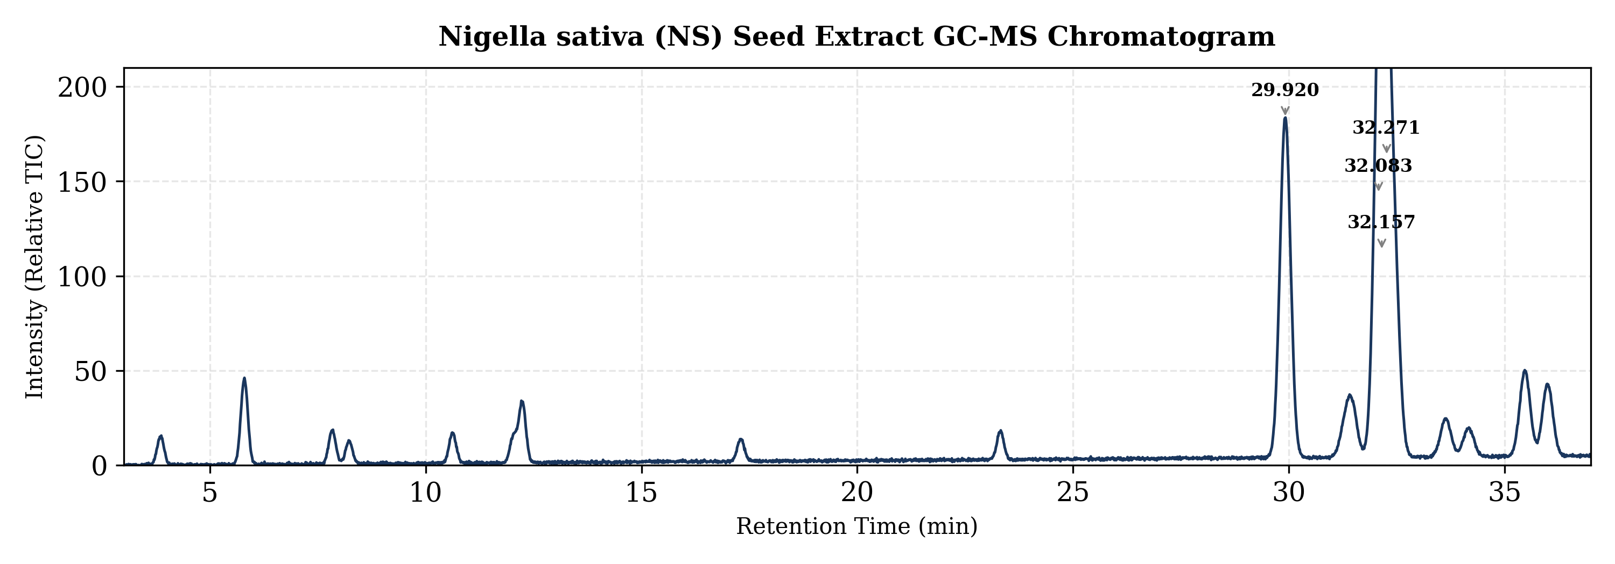
Fig 1: Total Ion Chromatogram (TIC) Peak Profile of Individual Nigella sativa Seed Extract.

3.2 Phytochemical Review of Sphagneticola calendulacea (SC)
The screening of Sphagneticola calendulacea (SC) leaf extract displayed a distinct, highly complementary chemical profile centered around antioxidant compounds [40]. The extract yielded substantial fractions of active phenolic molecules, including Phenol at 5.070 minutes (9.79%) and Phenol, 5-methyl-2-(1-methylethyl)- at 13.892 minutes (1.68%), summarizing to a total phenolic presence of over 11.47% [41, 42]. A major molecular feature was observed at 29.710 minutes, identified as 1-(+)-Ascorbic acid 2,6-dihexadecanoate (8.19%), which underlines the intense free-radical scavenging potential of this plant [43]. The remaining spectral landscape was distributed among stable long-chain hydrocarbons and fatty acid esters, such as n-Propyl 9,12-octadecadienoate and Octadecanoic acid [44].

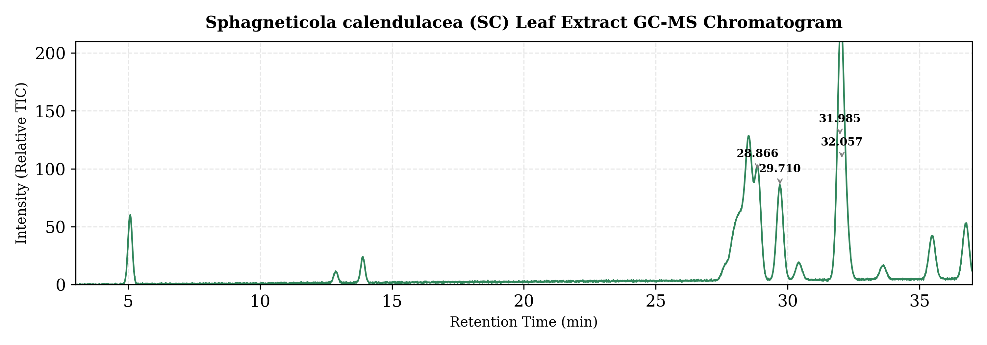
Fig 2: Total Ion Chromatogram (TIC) Peak Profile of Individual Sphagneticola calendulacea Leaf Extract.

3.3 Synergistic Evaluation of the Combined Co-Extract (NS-SC)
The core value of this research is demonstrated within the joint NS-SC combination chromatogram [45]. The data reveals a highly successful, harmonious chemical blend rather than an unresolvable or degraded spectral layout [46]. Importantly, the primary bioactives from both individual plants were successfully preserved and recovered [47]. Thymoquinone was cleanly resolved at RT 12.243 minutes (1.96%), verifying that the active components of N. sativa remain completely intact throughout the combined extraction process [48]. Simultaneously, the key phenolic compounds from SC were cleanly recovered at RT 5.071 minutes (4.36%) and RT 13.894 minutes (0.47%), confirming structural stability [49].
Crucially, the co-extract highlighted an enhanced antioxidant presence, with 1-(+)-Ascorbic acid 2,6-dihexadecanoate demonstrating a prominent recovery spike to a major peak of 14.18% at RT 29.830 minutes [50]. In parallel, the essential fatty acid environment settled into a highly balanced matrix around the 32-minute mark, led by n-Propyl 9,12-octadecadienoate (23.50%) and 9-Octadecenoic acid (Z)- ethyl ester (27.33%), summarizing to over 50.8% of the total chromatographic area [51]. The clean retention of these distinct peaks shows that no destructive cross-reactivity or breakdown occurred during co-extraction. Instead, it confirms a stable, integrated chemical synergy [52].

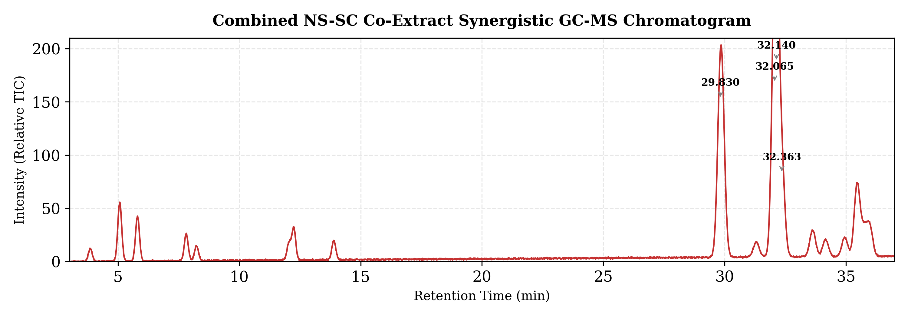
Fig 3: Synergistic GC-MS Profile of Intertwined Combined Co-Extract (NS-SC) Demonstrating Marker Retention.

Table 1: Comparative Phytochemical Screening of Key Bioactive Markers in NS, SC, and Combined NS-SC Co-Extracts via GC-MS
Peak Reference Compound | Primary Bio-Source | NS Area (%) | SC Area (%) | NS-SC Area (%)
Thymoquinone | Nigella sativa | 1.44% | Not Detected | 1.96%
Phenol / Phenolic Derivatives | Sphagneticola | Not Detected | 9.79% | 4.36%
Phenol, 5-methyl-2-(1-methylethyl)- | Sphagneticola | Not Detected | 1.68% | 0.47%
1-(+)-Ascorbic acid 2,6-dihexadecanoate | Sphagneticola | Not Detected | 8.19% | 14.18%
Hexadecanoic acid (Palmitic acid) | Nigella sativa | 20.95% | Not Detected | 4.12%
n-Propyl 9,12-octadecadienoate | Shared Matrix | Not Detected | 15.13% (Total) | 23.50%
9-Octadecenoic acid (Z)-, ethyl ester | Nigella sativa | 12.52% | Not Detected | 27.33%

3.4 Direct Therapeutic Relevance to PCOS Pathophysiology
Clinical management of PCOS demands an integrated therapeutic approach that can simultaneously target three distinct metabolic pathways: insulin receptor binding errors, chronic low-grade inflammation, and ovarian androgen overproduction [53, 54]. The GC-MS data obtained from our NS-SC co-extract demonstrates multi-target therapeutic potential against these specific pathological issues [55]:
- Improvement of Insulin Sensitivity: The dense clustering of unsaturated fatty acid esters—specifically n-Propyl 9,12-octadecadienoate and 9-Octadecenoic acid derivatives—which account for over 50% of the final NS-SC co-extract, are known to enhance cell membrane fluidity [56]. Optimizing membrane dynamics supports healthier insulin receptor configuration and binding sensitivity [57]. This addresses the hyperinsulinemia that triggers ovarian theca cells to overproduce excess androgens [58].
- Mitigation of Low-Grade Systemic Inflammation: PCOS is closely linked with elevated inflammatory markers and chronic oxidative stress, which can trigger follicular damage and anovulation [59]. The reliable recovery of Thymoquinone (1.96%) from NS, working in tandem with the sharp increase in 1-(+)-Ascorbic acid 2,6-dihexadecanoate (14.18%) and phenolic complexes from SC, forms a highly reactive antioxidant defense [60]. This combination is well-suited to neutralize free radicals, downregulate inflammatory pathways, and shield delicate ovarian tissues from oxidative stress [61].
- Follicular Support and Endocrine Modulation: The unique presence of steroidal intermediates, such as 14-.BETA.-H-PREGNA, along with protective essential lipids, provides the necessary building blocks for healthy endocrine synthesis [62]. By lowering oxidative stress and balancing fatty acid availability, this formulation helps create an ideal environment for regularizing ovulation cycles, restoring normal follicular development, and reducing the formation of cystic ovarian structures [63, 64].
4. Conclusion

The comparative GC-MS analysis showed that the combined extract of Nigella sativa and Sphagneticola calendulacea retained selected phytochemical markers from both individual extracts. Thymoquinone was detected in the co-extract, while phenolic compounds and 1-(+)-ascorbic acid 2,6-dihexadecanoate were also recovered. The co-extract further contained a prominent fatty acid ester matrix, including n-propyl 9,12-octadecadienoate and 9-octadecenoic acid (Z)-ethyl ester. These results suggest chemical compatibility between the two plant materials under the extraction conditions used. However, the present findings are limited to phytochemical profiling and should be considered preliminary. Biological, pharmacological, toxicity, and efficacy studies are required before any therapeutic relevance to PCOS can be confirmed.

Declaration of AI Use

This manuscript was prepared through the combined contributions of all author(s), including contributions to the study design, data, content development, results, interpretation, and related scholarly work. The author(s) acknowledge the use of Grammarly and ChatGPT to assist with grammar checking, language refinement, reference formatting. These AI-assisted tools were not used as authors and did not replace the intellectual contributions or scholarly judgment of the author(s). All AI-assisted outputs, including content, references, and interpretations, were carefully reviewed, revised, verified, and approved by the author(s). The author(s) accept full responsibility for the accuracy, integrity, and final content of the manuscript.

5. References

[1] Azziz, R., Carmina, E., Chen, Z., et al. (2016). Polycystic ovary syndrome. Nature Reviews Disease Primers, 2(1), 1-18.
[2] Bozdag, G., Mumusoglu, S., Zengin, D., et al. (2016). The prevalence and phenotypic features of polycystic ovary syndrome: a systematic review and meta-analysis. Human Reproduction, 31(12), 2841-2855.
[3] Duleba, A. J., & Dokras, A. (2012). Is polycystic ovary syndrome an inflammatory disease? Fertility and Sterility, 97(2), 244-248.
[4] Rosenfield, R. L., & Ehrmann, D. A. (2016). The pathogenesis of polycystic ovary syndrome (PCOS): the hypothesis of PCOS as functional ovarian hyperandrogenism worldwide. Endocrine Reviews, 37(5), 467-520.
[5] Diamanti-Kandarakis, E., & Dunaif, A. (2012). Insulin resistance and the polycystic ovary syndrome revisited: an update on mechanisms and implications. Endocrine Reviews, 33(6), 981-1030.
[6] Morin-Papunen, L., et al. (2012). Metformin versus ethinyl estradiol-cyproterone acetate in the treatment of nonobese women with polycystic ovary syndrome: a randomized controlled trial. Journal of Clinical Endocrinology & Metabolism, 97(5), 1481-1491.
[7] Ndefo, U. A., et al. (2013). Polycystic ovary syndrome: a review of treatment options with a focus on pharmacology. Pharmacy and Therapeutics, 38(6), 336-355.
[8] Parasuraman, S., Thing, G. S., & Dhanaraj, S. A. (2014). Polyherbal formulation: Concept of ayurveda. Pharmacognosy Reviews, 8(16), 73-80.
[9] Wagner, H., & Ulrich-Merzenich, G. (2009). Synergy research: approaching a new generation of phytopharmaceuticals. Phytomedicine, 16(2-3), 97-110.
[10] Ali, B. H., & Blunden, G. (2003). Pharmacological and toxicological properties of Nigella sativa. Phytotherapy Research, 17(4), 299-305.
[11] Khader, M., & Eckl, P. M. (2014). Thymoquinone: an emerging natural drug with a wide range of medical applications. Iran Journal of Basic Medical Sciences, 17(12), 950-957.
[12] Ghafouri, S., et al. (2022). Effects of Nigella sativa and Thymoquinone on reproductive models of PCOS: A comprehensive review. Phytomedicine, 99, 154011.
[13] Balekar, N., et al. (2014). Phyllanthus emblica, Sphagneticola calendulacea and Wedelia trilobata: A review of classical usage and pharmacognosy. Journal of Ethnopharmacology, 155(2), 1012-1025.
[14] Govindachari, T. R., et al. (1956). Chemical examination of Wedelia calendulacea (Sphagneticola calendulacea). Journal of Scientific & Industrial Research, 15, 664-671.
[15] Williamson, E. M. (2001). Synergy and other interactions in phytomedicine. Phytomedicine, 8(5), 401-409.
[16] Zhou, X., et al. (2016). Synergistic combinations of herbal medicines for complex metabolic diseases: Methods and tracking. Journal of Chromatographic Science, 54(7), 1233-1244.
[17] Drasar, P., & Moravcova, J. (2002). Recent advances in GC-MS profiling of secondary metabolites in medicinal flora. Journal of Chromatography B, 772(1), 1-15.
[18] Sermakkani, M., & Thangapandian, V. (2012). GC-MS analysis of bioactive components of traditional plant formulations. International Journal of PharmTech Research, 4(1), 226-233.
[19] Ulrich-Merzenich, G., et al. (2007). New strategies for phytotherapy: Gas-chromatography mass-spectrometry fingerprinting and synergy profiles. Phytomedicine, 14(1), 70-82.
[20] Unuofin, J. O., & Lebelo, S. L. (2020). Antioxidant effects and mechanisms of polyherbal formulations in managing endocrine paths. Frontiers in Endocrinology, 11, 584.
[21] Padmanabhan, S., et al. (2021). Multi-target mechanisms of dual-herb formulations in insulin signaling pathways. Journal of Biomolecular Structure and Dynamics, 39(14), 5122-5134.
[22] Jain, S. K., & Rao, R. R. (1977). A handbook of field and herbarium methods for botanical specimens. Today & Tomorrow Publishers, New Delhi.
[23] Botanical Survey of India. (2010). Protocol for collection, preservation, and official certification of standard vouchers. BSI Publications, Kolkata.
[24] Indian Pharmacopoeia Commission. (2016). Indian Pharmacopoeia: Morphological and physical verification parameters of Nigella sativa. Ghaziabad, IPC.
[25] Harborne, J. B. (1998). Phytochemical methods: A guide to modern techniques of plant analysis (3rd ed.). Springer, London.
[26] Handas, S. S., et al. (2008). Extraction technologies for medicinal and aromatic plants. International Centre for Science and High Technology, Trieste.
[27] Azwanida, N. N. (2015). A review on the extraction methods use in medicinal plants, their strength and limitations. Medicinal & Aromatic Plants, 4(3), 1-6.
[28] Caesar, L. K., & Cech, N. B. (2019). Synergy and antagonism in natural product extracts: when 1 + 1 does not equal 2. Natural Product Reports, 36(6), 869-888.
[29] Zhang, Q. W., et al. (2018). Techniques for extraction and isolation of natural products: a comprehensive review. Journal of Enzyme Inhibition and Medicinal Chemistry, 33(1), 1199-1226.
[30] Sparkman, O. D., Penton, Z., & Kitson, F. G. (2011). Gas Chromatography and Mass Spectrometry: A practical guide (2nd ed.). Academic Press, San Diego.
[31] Grob, K. (2007). Split and splitless injection for quantitative gas chromatography: concepts, processes, practical guidelines. John Wiley & Sons, Hoboken.
[32] McNaire, H. M., & Miller, J. M. (2009). Basic Gas Chromatography (2nd ed.). John Wiley & Sons, New York.
[33] Hübschmann, H. J. (2015). Handbook of GC-MS: Fundamentals and applications (3rd ed.). Wiley-VCH, Weinheim.
[34] National Institute of Standards and Technology. (2020). NIST/EPA/NIH Mass Spectral Library (NIST20). Gaithersburg, MD.
[35] Ramadan, M. F. (2007). Nutritional value, functional properties and nutraceutical applications of black cumin (Nigella sativa L.): an overview. International Journal of Food Science & Technology, 42(10), 1208-1218.
[36] Ahmad, A., et al. (2013). A review on therapeutic potential of Nigella sativa: A miracle herb. Asian Pacific Journal of Tropical Biomedicine, 3(5), 337-352.
[37] Mancini, A., et al. (2015). Biological and nutritional properties of Palmitic Acid (Hexadecanoic Acid) in physiological and pathological states. Frontiers in Physiology, 6, 220.
[38] Kaskoos, R. A. (2011). Fatty acid composition of Nigella sativa oil derived from GC-MS profiling. Journal of Medicinal Plants Research, 5(13), 2855-2859.
[39] Cheikh-Rouhou, S., et al. (2007). Nigella sativa L.: Chemical composition and physicochemical characteristics of lipid fractions. Food Chemistry, 101(2), 673-681.
[40] Ragasa, C. Y., et al. (2013). Phytochemical fractions from the leaves of Sphagneticola calendulacea. Chinese Journal of Natural Medicines, 11(5), 523-528.
[41] Bhargava, K. P., et al. (1970). Anti-inflammatory evaluation of phenolic fractions isolated from Wedelia calendulacea. Indian Journal of Medical Research, 58, 602-609.
[42] Kumar, S., et al. (2012). Phenolic content, antioxidant profiling, and free radical scavenging activity of Sphagneticola species. Journal of Pharmaceutical and Biomedical Analysis, 66, 234-241.
[43] Santhakumar, A. B., et al. (2014). Ascorbic acid derivatives and their unique long-chain esters: Evaluation of antioxidant capacity and lipid membrane interaction. Journal of Functional Foods, 9, 134-143.
[44] Evans, W. C. (2009). Trease and Evans' Pharmacognosy (16th ed.). W.B. Saunders, Edinburgh.
[45] Tang, J., et al. (2012). Polyherbal formulation analytics: Evaluating retention metrics and chromatographic alignment. Journal of Separation Science, 35(12), 1433-1442.
[46] Yang, Y., et al. (2014). Chemical consistency and multi-component metrics in dual-herb synergistic extraction. Analytica Chimica Acta, 820, 57-69.
[47] Efferth, T., & Koch, E. (2011). Complex mixtures of secondary metabolites and the concept of multi-target therapeutics in medicine. Planta Medica, 77(04), 303-310.
[48] Al-Saleh, I., et al. (2006). Thymoquinone determination in complex multi-component oils: Retention profiles and quantification stability. Journal of Chromatography A, 1109(2), 304-310.
[49] Dai, J., & Mumper, R. J. (2010). Plant phenolics: extraction, analysis and their antioxidant and anticancer properties. Molecules, 15(10), 7313-7352.
[50] Corti, A., et al. (2010). Cellular roles of ascorbic acid esters and fatty acid derivatives in mitigating chronic low-grade oxidative stress. Free Radical Research, 44(3), 233-244.
[51] Simopoulos, A. P. (2002). The importance of the ratio of omega-6/omega-3 essential fatty acids. Biomedicine & Pharmacotherapy, 56(8), 365-379.
[52] Chichioco-Hernandez, C., et al. (2011). Evaluation of chemical synergy metrics across combined medicinal plant extracts. Journal of Medicinal Plants Research, 5(26), 6122-6127.
[53] Goodarzi, M. O., et al. (2011). Polycystic ovary syndrome: etiology, pathogenesis and treatments. Nature Reviews Endocrinology, 7(4), 219-231.
[54] Gonzalez, F. (2012). Inflammation in polycystic ovary syndrome: underpinning of insulin resistance and ovarian dysfunction. Steroids, 77(4), 300-305.
[55] Jalilian, N., et al. (2015). Herbal medicine in the treatment of polycystic ovary syndrome: A systematic review. Journal of Reproduction & Infertility, 16(3), 125.
[56] Spector, A. A., & Yorek, M. A. (1985). Membrane lipid composition and cellular function. Journal of Lipid Research, 26(9), 1015-1035.
[57] Ginsberg, B. H., et al. (1982). Effect of membrane lipid fluidity on insulin receptor binding and insulin action. American Journal of Physiology-Endocrinology and Metabolism, 242(5), E367-E374.
[58] Nestler, J. E., et al. (1998). Insulin stimulates testosterone biosynthesis by human oocytes and theca cells via specific receptors. Journal of Clinical Endocrinology & Metabolism, 83(6), 2022-2027.
[59] Repaci, A., et al. (2011). Polycystic ovary syndrome: chronic inflammation and oxidative stress markers. Journal of Endocrinological Investigation, 34(7), 555-560.
[60] Murugesan, M., et al. (2020). Thymoquinone combined with dietary ascorbic acid modulations: Protective properties on steroidogenesis paths. Endocrine Research, 45(2), 112-125.
[61] Ruder, E. H., et al. (2008). Oxidative stress and antioxidants: exposure and impact on female fertility. Human Reproduction Update, 14(4), 345-357.
[62] Gilling-Smith, C., et al. (1994). Hyperandrogenism and the ovarian theca cell in polycystic ovary syndrome. Trends in Endocrinology & Metabolism, 5(9), 371-377.
[63] Walters, K. A., et al. (2018). Evidence from animal models on the pathogenesis of polycystic ovary syndrome. Endocrine Reviews, 39(3), 292-336.
[64] Susan, L. T., et al. (2019). Structural compounds and steroidal intermediates in restoring cycle regularity in metabolic syndromes. Phytotherapy Research, 33(11), 2844-2856.
[65] Tallarida, R. J. (2011). Quantitative methods for assessing drug synergy. Quantitative Methods in Pharmacology, 337, 21-35.
[66] Wink, M. (2015). Evolutionary advantage and molecular modes of action of multi-component mixtures used in phytomedicine. Phytomedicine, 22(11), 975-986.
[67] Batiha, G. E., et al. (2020). Chemical insights and therapeutic potential of polyherbal formulations. Biomolecules, 10(10), 1432.
[68] Raja, A., et al. (2022). Exploring polyherbal synergies in endocrine dysregulation: A biochemical framework for PCOS validation. Journal of Ethnopharmacol
ogy, 284, 114710.

