Morphological, Taxonomic and Soil Suitability Evaluation for Sustainable Crop Production Using GIS and Remote Sensing in Gudvella Block, Balangir District, Odisha State, India

Abstract

A comprehensive soil-landscape assessment was undertaken to characterize the morphological, physicochemical and taxonomic properties of soils and to evaluate their suitability for major crops using a GIS-based approach. The study area exhibited considerable physiographic heterogeneity, comprising upper and lower pedi-plains, depressions, hill-side slopes, foot-hill slopes, hillocks and stream-bank positions. Twenty-five representative pedons were examined for morphological and physicochemical characteristics and classified according to Soil Taxonomy. Soil depth varied from 14 to 125 cm, while textures ranged from loamy-skeletal to fine. Soil reaction ranged from strongly acidic to slightly alkaline (pH 4.97-7.85), whereas electrical conductivity (0.01-0.08 dS m⁻¹) and exchangeable sodium percentage (0.56-8.35%) indicated negligible salinity and sodicity constraints. Organic carbon was generally low (0.05-0.50%), while CEC (3.85-37.69 cmol(p⁺) kg⁻¹) and base saturation (21.04-72.90%) varied substantially among pedons. The soils were classified mainly as Entisols, Inceptisols and Alfisols, with Aquic, Lithic, Vertic and related intergrades reflecting contrasting soil-forming environments. Crop suitability assessment revealed marked differences among land-use types. Paddy had 68.3% of the area within S1-S3 classes, whereas maize, potato and sugarcane each occupied approximately 86% within S2-S3. Cotton, mustard and sunflower were predominantly marginally suitable, with substantial areas classified as N1. Approximately 4% of the area was permanently unsuitable (N2). The results demonstrate that soil suitability is controlled by the interaction of soil properties and landscape processes. Integration of soil survey, taxonomy and GIS-based suitability evaluation provides a robust basis for crop-specific land-use planning, soil and water conservation and sustainable agricultural intensification.
Keywords: Soil-landscape relationship, Soil morphology, Soil Taxonomy, Land suitability, GIS.
- Introduction
India is predominantly an agrarian country, where agriculture and allied activities play a vital role in ensuring food and nutritional security, supporting rural livelihoods, and contributing to the national economy. In order to grow food-crops and agricultural products in large quantities to feed the growing millions, intensive farming and rotation of crops are essential. The suitability of a specific land category with a given type of use is known as land appropriateness (Jamil et al., 2018). Land suitability analysis (LSA) is a method to encounter inherent and potential capabilities (Bandyopadhyay et al., 2009), and suitability for different objectives (FAO 1976). It works well to support decision-making during land use planning (Roy and Saha 2018). Additionally, there is a need for larger areas to accommodate the provision of essentials due to the rapid population growth and migration, especially in metropolises. Natural resources including forests, meadows, wetlands, and agricultural fields are converted into settlements or industrial zones as a result, and these places are exploited in ways that are out of proportion to their potential. Designing land use plans that allow for the transmission of natural resources to future generations as well as the managed and sustainable exploitation of these resources in ways that are appropriate to their capability is crucial (Akinci et al., 2013). The agriculture industry needs to pay urgent attention because the nation’s overall population is growing at an alarming rate while its resources are becoming increasingly scarce.
The nation has a significant capacity to develop a range of crops because of agro-ecological heterogeneity. Expanding the farming area is not possible in the current situation since land is a constraining factor. So it is important to identify land suitability classes in order to maximize cereal output on the land that is available. The optimum locations for the crops must be used for cultivation. Consequently, a land-suitability analysis is needed for agricultural production that is sustainable (Sharma et al., 2018). Soil information is a vital component of agricultural planning, as it directly influences land-use suitability and sustainable resource management. Land suitability evaluation is the systematic process of assessing the suitability or capability of a given area of land for a specific use. It involves the evaluation and classification of defined areas of land according to their suitability for particular agricultural uses based on soil, climate, topography, and other relevant land characteristics (Swamy et al.,2017). Crop suitability analysis plays an important role in identifying and utilizing the areas suitable for better crop growth and higher yield without deteriorating the natural resources. Thus, land suitability evaluation is considered as most authentic tool because of its usefulness to predict the land potential for land use planning (Sys et al., 1991). The crop choices required to be made based on the soil suitability evaluation to yield maximum profit and ecological sustainability (Khan and Khan, 2014). Geospatial techniques can be utilised for the identification of the suitable sites for the agricultural lands on different criteria like geology, topography, soil characteristics, drainage, and transport pattern of the study area (Pramanik, M.K., 2016). Land resources are limited and must be utilized in sustain able manner for the survival and prosperity of humanity. The developing countries are facing the major challenge of producing food, fuel, and fodder to fulfill the demand of ever-increasing population. It is also mandatory to ensure that the fertility of land resources is utilized in cultivating crops. Land potentiality must be evaluated so that it can be utilized for the specific purpose. Land potentiality assessment has been defined by FAO (1976) as ‘the analysis of land performance when used for a specified purpose, involving the execution and interpretation of surveys and studies of land forms, soils, vegetation, climate and other characteristics of land in order to identify and make a comparison of promising kinds of land use in terms of suitability to the objectives of the evaluation.
Characterization and classification of soils are important to understand the nature of soil resources (Sahoo et al., 2019; Indumon et al., 2026; Kumawat et al., 2026). Soil classification, on the other hand, helps to organize our knowledge, facilitates the transfer of experience and technology from one place to another and helps to compare soil properties (Bhattacharyya et al., 2024). The integration of Remote Sensing and Geographic Information System (RS & GIS) techniques has improved the accuracy and efficiency of soil resource mapping and spatial analysis in heterogeneous landscapes (Reddy et al., 2015). Considering this, soil-site requirement of sustainable crop production for the region was developed talking into account the available literature and field and local experience as suggested by Naidu et al., (2006). Thus, in view of the above facts, the study was carried out in the Gudvella Block, Balangir District, Odisha State, India to evaluate the soil-site suitability for sustainable crop production in order to achieve optimum production.
- Materials and methods
2.1 Location and climate
The study was carried out in Gudvella Block, Balangir District, Odisha State, situated between 20°21′0″ and 20°32′21″ N latitudes and 83°24′46″ and 83°39′58″ E longitudes (Fig.1). The study area falls within SOI topographical sheets Nos. 64P/6, 64P/7, 64P/10 and 64P/11 at a scale of 1:50,000. The survey area receives an average annual rainfall of 1446.7 mm, predominantly during the South-West monsoon (June–October), with ~90% concentrated in June–August and peaking in July (Fig. 2). Rainfall is erratic, often followed by dry spells that limit Kharif crop growth. The climate is sub-humid, sub-tropical with three seasons: summer, rainy, and winter. Temperatures rise from late March, reaching maxima in May, with hot waves prevailing April-June, while winters are fairly cold. The mean maximum and minimum temperatures are 33.1°C and 20.5°C, respectively; seasonal means are 32.9°C (summer) and 13.7°C (winter), with a mean annual air temperature of 26.8°C. The summer–winter difference of 19.2°C (>6°C) indicates a ‘Hyperthermic’ soil temperature regime, while the soil moisture regime is ‘Ustic’ (‘Aquic’ in depressional landscape areas), reflecting the prevailing sub-humid, sub-tropical climate (USDA Soil Taxonomy).
The area is characterized by twenty-five pedons, which are P1 (Baghala), P2 (Balangir), P3 (Bandopala), P4 (Bangomunda), P5 (Barkani), P6 (Chandanbhati), P7 (Dhanmadher), P8 (Dhumamara), P9 (Dumermunda), P10 (Dungibahal), P11 (Gudvella), P12 (Jogisarda), P13 (Karlakani), P14 (Kodgaon), P15 (Koksila), P16 (Kurli), P17 (Patnagarh), P18 (Purvabhari), P19 (Rajkhel), P20 (Sarasbahal), P21 (Sindurbahal), P22 (Sinkhaman), P23 (Sokarbandhi), P24 (Suktel) and P25 (Tusura). These pedons were morphologically characterized in the field and subsequently classified according to the Keys to Soil Taxonomy (Soil Survey Staff, 2014).
2.2 Geology and vegetations
The study area is underlain predominantly by granite–gneiss formations, with localized alluvial deposits in depressional landscapes. Physiographically, the terrain is diverse, comprising hillside slopes, foothill slopes, hillocks, upper and lower Pedi-plains, and depressions. Slope gradients vary markedly, ranging from very gentle (1–3%) to very steep (33–50%), reflecting a complex geomorphic setting. The spatial variability in parent material and physiographic setting has exerted a strong influence on soil genesis, drainage conditions, and the distribution of soil properties across the landscape. The natural vegetation of the study area is dominated by Terminalia orjuna, Acacia arabica, Terminalia bellirica, Phoenix acaulis, Aegle marmelos, Zizyphus jujube, Acacia catechu and Azadirachta indica. Agriculture is the predominant land use, with rice (Oryza sativa) and maize (Zea mays) cultivated extensively under irrigated conditions, whereas cotton (Gossypium spp.), pulses, and oilseed crops are mainly grown in the rainfed uplands. The interaction of climatic conditions, parent material, physiography, and irrigation availability has strongly influenced pedogenic processes, resulting in distinct soil–landscape relationships and diverse agricultural production systems across the study area.
2.3 Field survey and mapping
The detailed soil survey was carried out using high-resolution Resourcesat-2 LISS-IV False Colour Composite (FCC) satellite imagery and enlarged Survey of India (SOI) toposheets (quadrants) at a working scale of 1:10,000, generated from the original 1:50,000 scale maps. The satellite imagery was interpreted to identify physiographic features and delineate preliminary soil-landscape units. These preliminary boundaries were subsequently verified and refined through intensive field investigations. Land use/land cover (LULC) mapping was carried out through visual interpretation of the satellite imagery based on image elements such as tone, texture, pattern, shape, association, and site characteristics. Slope, hillshade, and 10m contour maps were generated from the Cartosat-1 Digital Elevation Model (DEM; 30m spatial resolution). These terrain derivatives were integrated to prepare the landform map, which served as the base for soil survey and soil mapping.
A detailed soil survey was conducted through systematic field traverses across the major physiographic units of the study area. Representative soil profile pits (pedons) and auger observations were selected to capture the spatial variability in soils associated with differences in landform, slope, drainage, parent material, and landscape position. Based on the Physiography-soil relationship, ten geo-referenced representative pedons were excavated, each representing a distinct physiographic unit. The pedons were morphologically described in the field following the standard procedures of the Soil Survey Manual and Keys to Soil Taxonomy (AIS&LUS, 1970; Soil Survey Staff, 2014). Morphological characteristics recorded for each genetic horizon included horizon designation and boundary, soil depth, matrix colour using the Munsell Soil Color Charts, texture, structure, dry/moist/wet consistence, root abundance and distribution, pore size and abundance, coarse fragments, mottles, concretions, cutans, and other diagnostic pedogenic features relevant to soil genesis and classification. These observations formed the basis for subsequent laboratory analyses, soil classification, and delineation of soil mapping units.
2.4 Soil sampling and analysis
Horizon-wise soil samples were collected from the typifying pedon, air-dried under laboratory conditions, gently crushed, and passed through a 2 mm sieve prior to analysis. The processed samples were analyzed for their routine physical and chemical properties following standard laboratory procedures. Soil pH was measured in 1:2.5 soil water suspension using glass electrode pH meter. Electrical conductivity was measured in 1:2.5 soil water supernatant solutions with the help of conductivity bridge (Jackson, 1973). Soil densities (Bulk density) were determined by pycnometer process (Black and Blake, 1965). Water holding capacity (WHC) was measured by the gravimetric method with Keen’s box (Piper, 1966) and theparticle size analysis (texture) was determined by the Bouyoucos hydrometer method (Bouyoucos, 1972). The organic carbon was determined by rapid titration method (Walkley and Black 1934) and Calcium carbonate (CaCO₃) by rapid titration method (Puri, 1930). Cation exchange capacity (CEC) was determined by the neutral 1 N ammonium acetate extraction method (pH 7.0) using the centrifuge extraction procedure described by Thomas (1982). Exchangeable sodium percentage (ESP) was calculated as the ratio of exchangeable sodium to the cation exchange capacity and expressed as a percentage.
2.5 Soil-site suitability evaluation
Suitability had been assessed following matching crop requirement criteria scheme proposed by Sys (1993) and modified by Naidu et al. (2006). Soil suitability groupings at various levels viz., order i.e., S (suitable) and N (not suitable), reflecting the kind of suitability followed Food and Agriculture Organization framework for land evaluation (FAO, 1976). Order ‘S’ was divided into three classes viz., S1 (Highly suitable), S2 (Moderately suitable) and S3 (Marginally suitable) while order ‘N’ into two classes viz., N1 (Presently not suitable) and N2 (Permanently not suitable), reflecting the degree of suitability within the order. The degree of limitations suggested the suitability class of each soil for a particular crop. The potential land suitability subclasses were determined after considering the improvement measures to correct the limitations.
- Results and discussion
3.1 Soils of the study area

The study area was stratified into seven major physiographic units, namely upper pedi-plains, lower pedi-plains, depression, hills side slopes, foot hill slopes, hillock and stream banks, exhibiting shallow to moderately weathered landscapes. These units were further subdivided according to slope gradient and erosion intensity to represent landscape heterogeneity. Based on the physiographic–soil relationship, twenty-five representative pedons were selected for detailed morphological characterization: P1-Baghala, P2-Balangir, P3-Bandopala, P4-Bangomunda, P5-Barkani, P6-Chandanbhati, P7-Dhanmadher, P8-Dhumamara, P9-Dumermunda, P10-Dungibahal, P11-Gudvella, P12-Jogisarda, P13-Karlakani, P14-Kodgaon, P15-Koksila, P16-Kurli, P17-Patnagarh, P18-Purvabhari, P19-Rajkhel, P20-Sarasbahal, P21-Sindurbahal, P22-Sinkhaman, P23-Sokarbandhi, P24-Suktel and P25-Tusura. Their soil-site characteristics are summarized in Table 1.

The surveyed area exhibited considerable variation in physiography, slope gradient, surface gravelliness, erosion intensity, and drainage conditions, indicating a heterogeneous soil-landscape environment. The physiographic units were dominated by upper pedi-plains (UPP), which occupied approximately 32.2% of the total reported area, followed by lower pedi-plains (LPP; 20.1%), depressional positions (19.4%), and hill-side slopes (15.6%). Smaller physiographic components included stream-bank positions (1.4%), hillocks (0.7%), and foot-hill slopes (0.6%). Such physiographic variability is expected to influence soil-profile development through differences in runoff, sediment redistribution, drainage, and landscape stability. In particular, depressional positions generally function as zones of water and fine-sediment accumulation, whereas upper and lower Pedi-plains positions are more strongly influenced by surface runoff and lateral redistribution of soil material. The importance of landscape position in controlling soil morphology and hydrological behaviour is well established in soil survey and land evaluation studies (FAO, 1976; Basavaraju et al., 2005).

The slope gradient ranged from 1-5% to 10–50%, with the largest proportion of the mapped area occurring under the 1-5% slope class (56.9%). The 5-10% slope class accounted for about 12.3%, whereas the extensive 10–50% slope class occurred mainly on hill-side slopes and covered approximately 15.6% of the total reported area. The remaining area occurred under 3-10 and 10-25% slopes. The predominance of gently sloping terrain indicates generally favourable conditions for agricultural land use in a substantial part of the landscape; however, increasing slope gradient enhances runoff velocity and consequently the potential for soil detachment and transport. The occurrence of steep to very steep slopes on hill-side positions therefore represents an important limitation for intensive cultivation and warrants appropriate soil and water conservation measures.

Surface gravelliness showed marked spatial variability. Most of the pedons/units mapped were recorded as having no appreciable surface gravel, whereas appreciable gravelliness was associated mainly with the hill-side, hillock and some pedi-plains. Based on the values presented, approximately 38.2% of the reported area was represented by units having measurable gravelliness (>15%), including particularly P-1, P-8, P-9, P-12, P-15, P-16 and P-17. High gravel content may adversely affect effective soil volume, available water storage, root proliferation, and ease of tillage, depending on the size, abundance and distribution of coarse fragments. Consequently, gravelliness should be considered together with soil depth and texture when assessing the agricultural suitability of these soils.

The erosion status revealed a distinct relationship with physiography and slope. The none to slight water erosion (e1) was the most extensive individual class, covering approximately 35.4% of the total reported area, followed by e1–e2 (20.2%), e1–e3 (17.4%), and e3–e4 (16.3%). The e2–e3 class accounted for only about 0.6%. The occurrence of e3–e4 erosion was concentrated in the hill-side slope and hillock environments, particularly P-8 and P-15, where slopes of 10–50% and 10–25%, respectively, were recorded. This spatial association indicates that increasing slope gradient and topographic position have contributed substantially to erosion severity.

The drainage characteristics also demonstrated strong landscape control. Well-drained (WD) soils constituted approximately 26.6% of the total reported area, followed by imperfectly drained (ID; 19.3%), moderately well-drained (MWD; 18.0%), excessively drained (ED; 16.3%), and poorly drained (PD; 9.8%) conditions. Well-drained conditions were predominantly associated with upper Pedi-plains and relatively elevated positions, whereas imperfect and poorly drained conditions occurred mainly in depressions and lower landscape positions. For example, P-7, P-20 and P-23, located in depressional settings, were characterized by poorly or imperfectly drained conditions. Conversely, P-8 and P-15, occurring on hill-side slopes and hillocks, respectively, were excessively drained. This distribution reflects the influence of slope, landscape position, surface runoff, infiltration and relative elevation on soil-water regime. Soil survey standards recognize drainage as an important property for evaluating soil-water relationships and agricultural land-use potential.

3.2 Physical and chemical characteristics

The physical and chemical properties of the soils exhibited considerable variability among the twenty-five pedons, reflecting differences in soil texture, profile depth, parent material, landscape position, and degree of pedogenic development. Soil depth ranged from 14 to 125 cm, indicating shallow to very deep soil profiles are presented in Table 2. The shallowest profiles were recorded in P-1, P-8, and P-15, whereas moderately deep soils occurred in P-9, P-13, P-16, P-17, and P-21. Relatively deep profiles, with depths approaching 100 cm, were observed in P-6, P-12, P-18, P-20, and P-22, while very deep profiles were recorded in P-2 to P-5, P-7, P-10, P-11, P-14, P-19, and P-23 to P-25. Such variation in effective soil depth represents an important land-quality attribute, as it directly influences rooting volume, soil-water storage capacity, nutrient availability, and crop productivity.

The soils showed a wide range of textural classes, indicating substantial variation in particle-size distribution. The predominance of finer-textured soils in several pedons suggests appreciable clay accumulation and associated differences in water-holding capacity, nutrient retention and permeability. Conversely, the relatively coarse-textured and gravelly soils occurring in some shallow landscape positions may have restricted effective soil depth and lower available water storage. Soil texture is a fundamental soil property controlling water movement, nutrient retention and root-zone conditions and is therefore an important criterion in land evaluation. The bulk density (BD) of the soils exhibited considerable variability among the 25 pedons, ranging from 1.40 to 1.88 g cm⁻³, with a mean value of 1.58 g cm⁻³. The lowest bulk density was recorded in P-5 (1.40 g cm⁻³), followed by P-16 (1.44 g cm⁻³), P-10 (1.48 g cm⁻³), P-18 (1.49 g cm⁻³), and P-7, P-14 and P-20 (1.50 g cm⁻³). In contrast, the highest bulk density was observed in P-17 (1.88 g cm⁻³), followed by P-1 (1.75 g cm⁻³), P-24 (1.69 g cm⁻³), P-2 (1.66 g cm⁻³), and P-8 (1.65 g cm⁻³). The remaining pedons showed intermediate values ranging from 1.52 to 1.64 g cm⁻³. The observed variation in bulk density may be attributed to differences in soil texture, organic matter content, structural development, compaction, and pedogenic processes among the landscape positions. The relatively higher bulk density in P-17 and P-1 suggests comparatively greater soil compaction and/or a lower proportion of organic matter and structural porosity, whereas the lower values recorded in P-5 and P-16 indicate relatively greater total pore space and better aggregation.

Soil reaction varied from strongly acidic to slightly alkaline, with pH values ranging from 4.97 to 7.85. Most pedons were within the acidic to near-neutral range, whereas P-4 exhibited the highest pH (7.85). The acidic reaction in several pedons may influence the availability of essential plant nutrients and the solubility of potentially toxic elements, whereas the relatively higher-pH soils may have different nutrient-availability constraints. Soil pH is therefore an important indicator of soil chemical environment and crop suitability.

The soils were characterized by very low electrical conductivity (EC), ranging from 0.01 to 0.08 dSm⁻¹, indicating that soluble-salt accumulation was not a significant limitation in the studied pedons. Similarly, exchangeable sodium percentage (ESP) ranged from 0.56 to 8.35%, with all pedons having ESP values below the commonly used threshold for sodic soils. The highest ESP was recorded in P-23 (8.35%), followed by P-14 (5.40%) and P-1 (5.11%), but these values still indicate an absence of pronounced sodicity. Thus, salinity and sodicity do not appear to constitute major chemical limitations to crop production in the study area.

Organic carbon (OC) content ranged from 0.05 to 0.50%, indicating generally low organic-carbon status, with relatively higher values occurring in P-9 (0.50%), P-5 and P-15 (0.45%), P-6 (0.44%) and P-1 (0.43%). Low organic carbon status may be ascribed to poor soil fertility management and depositional activities of alluvium (Srinivasarao, 2011). The low OC status observed in most pedons may be attributed to rapid decomposition under the prevailing warm climatic conditions, continuous cultivation and limited accumulation of organic residues. Organic carbon is an important indicator of soil quality because it contributes to aggregate stability, nutrient cycling, cation exchange capacity and water retention.

The cation exchange capacity (CEC) exhibited the greatest variability, ranging from 3.85 to 37.69 cmol(p⁺) kg⁻¹. The lowest CEC was recorded in P-24 (3.85 cmol(p⁺) kg⁻¹), whereas the highest value occurred in P-10 (37.69 cmol(p⁺) kg⁻¹), followed by P-6 (27.00), P-3 (25.76) and P-4 (26.06 cmol(p⁺) kg⁻¹). The relatively high CEC values in finer-textured soils can be attributed primarily to greater clay content and the nature of the clay minerals, whereas low CEC values are generally associated with coarser-textured soils and low organic-carbon contents. Thus, the observed variation in CEC reflects differences in clay content, mineralogy and organic matter among the pedons.

Base saturation (BS) varied from 21.04 to 72.90%, indicating considerable differences in the proportion of the exchange complex occupied by basic cations. The highest BS was observed in P-18 (72.90%), followed by P-8 (67.71%), P-1 (67.65%) and P-16 (67.04%), whereas P-17 showed the lowest value (21.04%). The relatively low BS in several pedons is consistent with their acidic soil reaction and suggests varying degrees of base-cation depletion and leaching. Conversely, higher BS in some pedons indicates greater retention of exchangeable Ca²⁺, Mg²⁺, K⁺ and Na⁺ on the exchange complex. Base saturation, together with soil reaction and CEC, provides useful information for understanding soil fertility status and taxonomic interpretation.

Overall, the soils were characterized by shallow to very deep profiles, variable textural composition, predominantly acidic to near-neutral reaction, very low salinity, non-sodic conditions, generally low organic-carbon content, highly variable CEC and moderate to high variability in base saturation. The absence of significant salinity and sodicity indicates that these parameters are unlikely to impose major limitations on agricultural use. In contrast, soil depth, texture, acidity, low organic-carbon status and variation in nutrient-retention capacity constitute more important soil-quality attributes for crop productivity. The observed physicochemical variability, together with differences in physiography, slope, erosion and drainage, provides an important basis for subsequent soil-site characterization and crop-specific land-suitability evaluation.

3.3 Morphological characteristics and taxonomic classification

The morphological characteristics and taxonomic classification of the studied soils revealed considerable variation in soil depth, colour, texture, drainage, slope, landscape position and degree of profile development. The soils ranged from shallow to very deep, with textures varying from loamy skeletal to fine textured. Most of the pedons were non-calcareous, indicating an absence of visible carbonate accumulation within the described profiles. Soil colour varied from brown and yellowish brown to dark gray, reddish brown and dusky red, reflecting differences in drainage conditions, parent material, organic matter and pedogenic processes.

The soils of the upper pedi-plains (P-1, P-2, P-3, P-10, P-12, P-13 and P-14) were predominantly very gently to gently sloping and generally exhibited relatively deep to very deep profiles. P-1 was characterized by a shallow, loamy-skeletal profile with well-drained conditions, whereas P-2, P-3, P-10, P-12, P-13 and P-14 were generally deeper and finer textured. The occurrence of moderately well to well-drained conditions in several upper-pedi-plains soils suggests relatively favourable internal drainage and greater landscape stability. In contrast, P-10 and P-14 showed imperfect to moderate drainage, indicating localized differences in soil-water movement within the pedi-plains landscape. The lower pedi-plains (P-4, P-5, P-6, P-11 and P-16) were mainly characterized by very gently to gently sloping terrain and fine-loamy to loamy textures. These soils were generally deep to very deep, although P-16 was moderately deep. Drainage varied from imperfect to moderately well drained, suggesting greater influence of lateral and subsurface water movement in lower landscape positions. The occurrence of fine-textured soils in these positions may favour greater water retention and clay accumulation, while relatively poor drainage in some profiles indicates periodic saturation.

The depressional landscape represented by P-7 was characterized by a very deep, fine-textured profile with grayish brown to dark-gray colours and poor to imperfect drainage. These morphological attributes indicate prolonged or periodic soil-water saturation and reduced drainage conditions. The dark gray colouration and poor drainage are consistent with a comparatively lower landscape position where surface runoff and lateral water movement contribute to temporary water accumulation. Such soils may have important limitations for crops sensitive to waterlogging. The soils occurring on hill-side slopes and hillocks (P-8 and P-15) were distinctly different from those of the pedi-plains. Both profiles were shallow, loamy-skeletal, excessively drained and strongly to very steeply sloping, indicating substantial landscape instability and restricted soil development. The shallow effective depth, coarse fragments and excessive drainage in these soils may limit available water storage and root-zone development. Their steep slopes also increase susceptibility to erosion, necessitating appropriate soil and water conservation measures. The foot-hill position represented by P-9 supported a moderately deep, fine-loamy, well-drained soil under gently to moderately sloping terrain. The reddish-brown colour and relatively favourable drainage suggest a well-aerated pedogenic environment. Overall, the morphological characteristics demonstrate a clear relationship between landscape position, slope gradient, drainage and soil-profile development. Soils on stable, gently sloping positions tended to be deeper and more developed, whereas soils on steep hill-side and hillock positions were shallow, coarse-textured and excessively drained.

Taxonomically, the soils were classified into Entisols, Inceptisols and Alfisols, with most soils belonging to the Inceptisols and Alfisols (Table 3). At the subgroup level, Typic, Aquic, Lithic, Vertic, Oxyaquic, Aeric, and Endoaquic intergrades were identified, indicating variations in soil moisture regime, drainage, shallow lithic contact, and vertic properties. The Entisols were represented mainly by Typic and Lithic Ustorthents (P-1, P-8, P-9, P-15 and P-17), reflecting weak profile development and, in some cases, shallow or skeletal soil conditions and pedon (P-24), classified as Typic Ustipsamments, represents a coarse-textured. The Inceptisols included Dystrudepts, Epi-/Endoaquepts and Haplustepts, with Aquic, Oxyaquic, Vertic and other subgroups indicating wetness and morphological differentiation. The Alfisols comprised Haplustalfs, Epiaqualfs and Rhodustalfs, characterized by relatively advanced profile development and argillic horizon formation. The presence of Aquic and Endoaquept-related subgroups in P-3, P-6 and P-7 reflects the influence of periodic saturation and aquic soil conditions. Similarly, P-4 and P-10 were classified as Vertic and Vertic-related subgroups, indicating the influence of shrink-swell processes associated with finer-textured soils. Overall, the taxonomic classification closely reflected the observed soil-landscape relationships. At the family level, the soils were predominantly fine-loamy, fine, loamy-skeletal, loamy, and coarse-loamy, with mixed mineralogy and hyperthermic soil temperature regime. These morphological and taxonomic variations provide an important basis for interpreting the soil-forming processes, land-use limitations and crop-suitability potential of the study area.

3.4 Soil-site suitability evaluation of major crops

The crop-wise land suitability assessment revealed considerable variation in the extent of suitable land among the evaluated crops (Table 4). The suitability was classified into five classes, namely S1 (Highly suitable), S2 (Moderately suitable), S3 (Marginally suitable), N1 (Currently not suitable) and N2 (Permanently not suitable), following the FAO framework for land evaluation. In this framework, S1 represents land with no significant limitations, whereas S2 and S3 indicate progressively more severe limitations affecting crop productivity and/or management requirements. N1 denotes land that is currently unsuitable but may be improved through appropriate interventions, while N2 represents land with severe and essentially permanent limitations.

3.4.1 Soil-site suitability for paddy

The land suitability assessment indicated that paddy exhibited the broadest distribution across the suitability classes in the study area (Fig.3). Approximately 1,492 ha (6.0%) was classified as S1 (highly suitable), while 8,849 ha (35.6%) and 6,653 ha (26.7%) were categorized as S2 and S3, respectively. In addition, 4,401 ha (17.7%) was classified as N1 (currently not suitable), whereas 995 ha (4.0%) was categorized as N2 (permanently not suitable). Collectively, the S1–S3 classes accounted for approximately 68.3% of the total study area, indicating that a substantial proportion of the land is suitable for paddy cultivation. The occurrence of S1 and S2 classes further suggests the presence of relatively favourable soil and site conditions for paddy production, whereas the S3 and N1 classes reflect varying degrees of land limitations that may require appropriate soil, water, and crop management interventions. These findings are broadly comparable with those reported by Dake and Pragya (2026).

3.4.2 Soil-site suitability for potato

The land suitability assessment for potato cultivation indicated that the S3 (marginally suitable) class was predominant in the study area (Fig.4). No area was classified as S1, whereas 6,262 ha (25.2%) was categorized as S2 and 15,133 ha (60.8%) as S3. Thus, approximately 21,395 ha (86.0%) of the study area was assessed as suitable to varying degrees for potato cultivation (S2 + S3). However, the predominance of the S3 class suggests the presence of considerable land limitations that may adversely affect potato productivity and require appropriate soil, water, and crop management practices for sustainable production. Approximately 995 ha (4.0%) was classified as N2 (permanently not suitable), while the remaining area comprised water bodies and other miscellaneous land uses. The observed pattern of land suitability is broadly consistent with the findings reported by Singha and Swain (2019).

3.4.3 Soil-site suitability for maize

Maize showed comparatively favourable suitability, with 14,049 ha (56.5%) classified as S2 and 7,346 ha (29.5%) as S3. No area was recorded under S1 or N1. Therefore, approximately 86.0% of the area was suitable (S2+S3) for maize cultivation, with the majority falling within the moderately suitable class. This distribution suggests that maize has a relatively broad adaptation to the prevailing land conditions, although the S3 areas may require improved management to overcome existing limitations (Fig.5). The land suitability criteria indicated maize was less suitable due to gravelliness and shallow depth reported by Gowda et al., 2018. Related studies were conducted by Patil et al., 2023.

3.4.4 Soil-site suitability for sugarcane

The land suitability assessment for sugarcane revealed the predominance of the S3 (marginally suitable) class across the study area (Fig. 6). Approximately 4,503 ha (18.1%) was classified as S2 (moderately suitable), whereas 16,892 ha (67.9%) fell under the S3 category. No area was classified as S1 (highly suitable) or N1 (currently not suitable). Overall, about 21,395 ha (86.0%) of the study area was considered suitable for sugarcane cultivation (S2+S3). However, the dominance of the S3 class indicates that sugarcane production is constrained by relatively severe land limitations, necessitating improved agronomic and soil management practices to achieve sustainable productivity. Similar findings have been reported by Nagdev et al. (2026).

3.4.5 Soil-site suitability for cotton

The suitability of cotton was comparatively restricted, with no area falling under S1 or S2 (Fig. 7). Approximately 17,151 ha (69.0%) was classified as S3 and 4,244 ha (17.1%) as N1. Thus, nearly 69% of the area was marginally suitable, while another 17.1% was currently not suitable. It tolerates fairly wide range of soil pH conditions i.e acidity and alkalinity. The field studies show that cotton is successfully grown in deep soils with good drainage (Sehgal et al., 1990). This pattern indicates that cotton cultivation is constrained over a substantial proportion of the area and may require appropriate soil, moisture and agronomic management to improve productivity.

3.4.6 Soil-site suitability for mustard

For mustard, the area was predominantly classified as S3, accounting for approximately 16,690 ha (67.1%), followed by 4,705 ha (18.9%) under N1. No area was categorized as S1 or S2 (Fig.8). Therefore, although a substantial proportion of the area was marginally suitable for mustard, the absence of highly and moderately suitable land suggests relatively greater limitations for its cultivation compared with paddy, maize and potato.

3.4.7 Soil-site suitability for sunflower

Sunflower exhibited a similar pattern to cotton and mustard, with 17,093 ha (68.7%) classified as S3 and 3,875 ha (15.6%) as N1. Only 428 ha (1.7%) was categorized as S2, and no area was identified under S1 (Fig. 9). The predominance of S3 indicates that sunflower cultivation is feasible over a large proportion of the area but is associated with substantial limitations that may reduce yield potential or increase management inputs.

Across all crops, 995 ha (approximately 4.0%) was classified as permanently not suitable (N2), while 1,443 ha (5.8%) constituted water bodies and approximately 1,041 ha (4.2%) represented miscellaneous land uses. The presence of N2 areas indicates locations where the prevailing land characteristics impose severe and essentially irreversible constraints on crop production. According to the FAO framework, such areas should not be considered for sustained cultivation of the evaluated land-use type. Overall, maize, potato and sugarcane showed relatively higher proportions of suitable land (approximately 86%), although potato and sugarcane suitability was predominantly S3. Paddy exhibited a comparatively balanced distribution among S1, S2 and S3 classes, with approximately 68% of the area falling within the suitable order. In contrast, cotton, mustard and sunflower were characterized mainly by S3 and N1 classes, indicating greater limitations to their production. These differences in crop suitability can be attributed to the differential requirements of individual crops and the spatial variability of soil and land characteristics, including soil depth, texture, drainage, available water, fertility status, reaction, salinity/sodicity and topographic conditions. FAO recommends matching these land characteristics with the specific requirements of each land utilization type rather than assigning a uniform suitability rating across crops.

The results therefore indicate that crop-specific land-use planning is essential for optimizing agricultural production and minimizing resource degradation. Areas classified as S2 and S3 may be brought under suitable crops through appropriate management practices, whereas N1 areas require economically feasible land improvement measures before cultivation. In contrast, N2 areas should preferably be retained for alternative land uses compatible with their inherent limitations. Such suitability-based planning provides a scientific basis for crop diversification, resource conservation and sustainable agricultural land management.

4. Conclusion

The integrated soil-landscape assessment revealed pronounced spatial variability in soil properties and land-use potential, driven primarily by physiography, slope, drainage, erosion, soil depth and textural variation. Soils ranged from shallow, gravelly and excessively drained pedons on hill-side slopes and hillocks to deeper, finer-textured and more developed pedons on relatively stable pedi-plains and lower landscape positions. Soil reaction varied from strongly acidic to slightly alkaline (pH 4.97–7.85), whereas very low EC (0.01–0.08 dS m⁻¹) and ESP (0.56-8.35%) indicated negligible salinity and sodicity constraints. Conversely, low organic carbon (0.05-0.50%), variable CEC (3.85-37.69 cmol(p⁺) kg⁻¹) and base saturation (21.04-72.90%) identified soil fertility and nutrient-retention capacity as more relevant management concerns. Taxonomically, the soils were dominated by Entisols, Inceptisols and Alfisols, with Aquic, Lithic, Vertic and related intergrades reflecting contrasting pedogenic and hydrological environments.

The crop-specific suitability assessment demonstrated marked differences in agricultural potential. Paddy had 68.3% of the area within S1-S3, while maize, potato and sugarcane each occupied approximately 86% of the area within S2-S3, although potato and sugarcane were predominantly marginally suitable. Cotton, mustard and sunflower showed greater limitations, being dominated by S3 and N1 classes, while approximately 4% of the area was permanently unsuitable (N2). Overall, the findings confirm that land suitability is controlled by the interaction of soil properties and landscape processes rather than by individual soil attributes. The integration of soil morphology, physicochemical properties, taxonomy and GIS-based suitability assessment therefore provides a robust basis for crop-specific land-use planning, soil and water conservation, fertility management and sustainable agricultural intensification.
Competing Interests
On behalf of corresponding author, there is no completing financial interest or other kind off interest were found in the work reported in this manuscript.
Declaration of AI Use

This manuscript was prepared through the intellectual contributions of the author(s) to the study design, data analysis, interpretation of results, and scholarly content. Grammarly and ChatGPT were used solely to assist with grammatical refinement and reference formatting during manuscript revision. The author(s) accept full responsibility for the accuracy, integrity, and final content of the manuscript.

References
- Jamil, M., Sahana, M. and Sajjad, H. (2018). Crop suitability analysis in the Bijnor District, UP, using geospatial tools and fuzzy analytical hierarchy process. Agric Res 7(4):506–522.
- Bandyopadhyay, S., Jaiswal, R.K., Hegde, V.S. and Jayaraman, V. (2009). Assessment of land suitability potentials for agriculture using a remote sensing and GIS based approach. Int. J. Remote Sensing 30(4):879–895.
- Roy, J. and Saha, S. (2018). Assessment of land suitability for the paddy cultivation using analytical hierarchical process (AHP): a study on Hinglo river basin, Eastern India. Model Earth Syst Environ 4(2):601–618.
- Akinci, H., Özalp, A.Y. and Turgut, B. (2013). Agricultural land use suitability analysis using GIS and AHP technique. Comput Electron Agric 97:71–82.
- Sharma, R., Kamble, S.S. and Gunasekaran, A. (2018). Big GIS analytics framework for agriculture supply chains: a literature review identifying the current trends and future perspectives. Comput Electron Agric 155:103–120.
- Swamy, Y.A.N., Inayathulla, M., Thabrez, M. and Shashishankar, A. (2017). Land Suitability Evaluation of Soils for Crop Production. International Journal of Innovative Research in Science, Engineering and Technology 6(9):18187-18196.
- Sys, C., Van Ranst, E. and Debaveye, J. (1991). Land evaluation, Part-II: Methods in Land Evaluation. General Administration for Development Cooperation, Agricultural publications No.7, Brussels-Belgium, 247.
- Pramanik, M.K. (2016). Site suitability analysis for agricultural land use of Darjeeling district using AHP and GIS techniques.Modeling Earth Systems and Environment. 2(2):1-22.
- Khan, M.S.N. and Khan, M.M.A. (2014). Land suitability analysis for sustainable agricultural land use planning in Bulandshahr District of Uttar Pradesh. International Journal of Scientific and Research Publications, 4(3): 1-11.
- Sahoo, J., Dinesh, D., Bhat, M.A., Anil, A.S. and Anurag, A. (2019). Characterization and classification of soils of selected watershed area of Haryana, North-west India. Indian Journal of Agricultural Sciences 89 (11): 1942–1947.
- Indumon, S.S., Mohitpasha, S., Joseph, A.W.M., Kumar, P.S., Singh, M.K., Roy, D.N., Raizada, S., Gautam, R., Wadodkar, M., Meena, R.L., Gahlod, N.S., Kumar, Y.S., Kumar R. and Tripathi, S.K. (2026). Geomorphic Classification and Evaluation of Selected Soils of West Coast Plains and Hills Zone of Kerala, India. Bionature 46(2): 204-215.
- Kumawat, S.K., Karamvir., Singh, M.K., Roy, D.N., Raizada, S., Monika, Gautam, R., Kumar, Y.S., Joseph, A.W.M., Dhale, S.A., Wadodkar, M., Meena, R.L., Gahlod, N.S., Kumar R. and Tripathi, S.K. (2026). Characterization and Classification of Soils in the Southern Plateau and Hills Region of Utkoor Mandal of Narayanpet District, Telangana State, India.International Journal of Plant & Soil Science 38(8): 742-755.
- Bhattacharyya, K., Sheoran, H. S., Roohi, Seema, Yadav, R. and Ritambhara. (2024). Soil physical properties under different land use systems in eastern districts of Haryana. Agricultural Research Journal, 61(1), 31–38.
- Reddy, G.P.O., Maji, A.K. and Rao, K.V. (2015). GIS and remote sensing applications in soil resource mapping and land use planning. Agropedology, 25(1): 1–12.
- Naidu, L.G.K., Ramamurthy, V., Challa, O., Rajendra, H. and Krishnan, P. (2006). Manual soil-site suitability criteria for major crops. NBSS&LUP Pubbl. 129.
- FAO (1976). A framework for land evaluation. Soils Bulletin 32, Food and Agriculture Organization of the United Nations, Rome, Italy.
- AIS & LUS (1970). Soil Survey Manual (Rev. ed.), All India Soil & Land Use Survey Organisation.
- Soil Survey Staff. (2014). Keys to soil taxonomy (12th ed.). U.S. Department of Agriculture, Natural Resources Conservation Service.
- Jackson, M.L. (1973). Soil chemical analysis (1st ed.). Prentice-Hall of India.
- Black, C.A. and Blake, G.R. (1965) Bulk density. AgronMonogr.
- Piper, C.S. (1966) Soil and plant analysis. Hans Publishers, Bombay
- Bouyoucos, G.J., 1972. The hydrometer as a new method for the mechanical analysis of soils. Soil Sci. 23, 343–354.
- Walkley, A. and Black, I. A. (1934). An examination of the Degtjareff method for determining soil organic matter, and a proposed modification of the chromic acid titration method. Soil Science, 37(1), 29–38.
- Puri, A.N. (1930). A new method of estimating total carbonates in soils. Journal of Imperial Agricultural Research, Pusa bulletin 206, 7.
- Thomas, G.W. (1982). Exchangeable cations. In A. L. Page, R. H. Miller, & D. R. Keeney (Eds.), Methods of soil analysis: Part 2. Chemical and microbiological properties (2nd ed., pp. 159–165). American Society of Agronomy and Soil Science Society of America.
- Sys, C., Van Ranst, E., Debaveye, I. J. and Beernaert, F. (1993). Land evaluation part III: Crop requirements. General administration for development cooperation, Agricultural publication No.7, Brussels-Belgium, 199.
- Basavaraju, D., Naidu, M.V.S., Ramavatharam, N., Venkaiah, K., Rama Rao, G. and Reddy, K. S. (2005). Characterization, classification and evaluation of soils in Chandragiri mandal of Chittoor district, Andhra Pradesh. Agropedology, 15: 55-62.
- Srinivasarao, Ch., Venkateswarlu, B., Dixit, S., Kundu, S., and Gayathri Devi, K. (2011). Soil health improvement: Livelihood impacts in backward and Tribal districts of Andhra Pradesh, CRIDA, Hyderabad, pp 119.
- Sehgal J.L. (1990). Soil resource mapping of India and its application for land use planning. NBSS Publ. 25, NBSS & LUP (ICAR), Nagpur, Maharashtra.
- Gowda, J.V., Anilkumar, S.N., Sathish, A. and Parama, V.R. (2018). Soil fertility mapping, land suitability assessment for suggesting maize and pomegranate crops in Hosakere micro-watershed of Davanagere district, Karnataka. J Soil Water Conservation, 17(1):75-82.
- Patil, P.L., Kalappanavar, D., Geetha, G.P., Patil, R., Adarsh, G.S. and Dasog, G.S. (2023). Characterization and classification of soil resources of Hittinahalli sub-watershed derived from basalt in Northern dry zone of Karnataka. J Agric Sci Technology, 22(4):16-40.
- Dake, S.L. and Pragya, S. (2026). Land Suitability Mapping for Paddy Production Using Remote Sensing and GIS Techniques. International Journal of Engineering, Science, Technology and Innovation, 6(2): 20-25.
- Singha, S. and Swain, K.C. (2019). Land Suitability Assessment for Potato Crop using Analytic Hierarchy Process Technique and Geographic Information System. Journal of Agricultural Engineering, 5(3):77-87.
- Nagdev, R., Meena, R.K., Kumar, A., Joon, V. and Jaya N. S. (2026). Evaluation of soil suitability for sugarcane in the State of Punjab - a case study. Ann. Agric. Res. New Series, 47 (1): 1-6.

Table 1. Site characteristics
Pedon | Series | Physiography | Slope | Gravelliness | Erosion | Drainage | Rainfall (mm) | Temp. (°C) | Area (ha)
P-1 | Baghala | UPP | 5-10% | 40 | e1-e3 | WD | 1446.7 | 26.8 | 3052
P-2 | Balangir | UPP | 1-5% | 0 | e1-e2 | MWD | 1446.7 | 26.8 | 736
P-3 | Bandopala | UPP | 1-5% | 0 | e1-e2 | ID | 1446.7 | 26.8 | 368
P-4 | Bangomunda | LPP | 1-5% | 0 | e1 | MWD | 1446.7 | 26.8 | 677
P-5 | Barkani | LPP | 1-5% | 0 | e1 | ID | 1446.7 | 26.8 | 338
P-6 | Chandanbhati | LPP | 1-5% | 0 | e1-e2 | ID | 1446.7 | 26.8 | 1183
P-7 | Dhanmadher | Depression | 1-5% | 0 | e1 | PD | 1446.7 | 26.8 | 1437
P-8 | Dhumamara | Hills side slopes | 10-50% | 36 | e3-e4 | ED | 1446.7 | 26.8 | 3876
P-9 | Dumermunda | Foot hill slopes | 3-10% | 16 | e2-e3 | WD | 1446.7 | 26.8 | 157
P-10 | Dungibahal | UPP | 1-5% | 0 | e1-e2 | PD | 1446.7 | 26.8 | 149
P-11 | Gudvella | LPP | 1-5% | 0 | e1 | ID | 1446.7 | 26.8 | 397
P-12 | Jogisarda | UPP | 1-5% | 15.83 | e1-e2 | WD | 1446.7 | 26.8 | 1075
P-13 | Karlakani | UPP | 1-5% | 0 | e1-e2 | WD | 1446.7 | 26.8 | 219
P-14 | Kodgaon | UPP | 1-5% | 0 | e1 | MWD | 1446.7 | 26.8 | 367
P-15 | Koksila | Hillock | 10-25% | 39.86 | e3-e4 | ED | 1446.7 | 26.8 | 177
P-16 | Kurli | LPP | 1-5% | 21.24 | e1-e2 | MWD | 1446.7 | 26.8 | 200
P-17 | Patnagarh | UPP | 3-10% | 37.05 | e1-e3 | WD | 1446.7 | 26.8 | 975
P-18 | Purvabhari | LPP | 1-5% | 0 | e1 | WD | 1446.7 | 26.8 | 28
P-19 | Rajkhel | UPP | 1-5% | 0 | e1-e2 | WD | 1446.7 | 26.8 | 131
P-20 | Sarasbahal | Depression | 1-5% | 0 | e1 | ID | 1446.7 | 26.8 | 2524
P-21 | Sindurbahal | UPP | 1-5% | 0 | e1-e3 | MWD | 1446.7 | 26.8 | 304
P-22 | Sinkhaman | UPP | 1-5% | 0 | e1-e2 | WD | 1446.7 | 26.8 | 627
P-23 | Sokarbandhi | Depression | 1-5% | 0 | e1 | PD | 1446.7 | 26.8 | 862
P-24 | Suktel | Stream Banks | 1-5% | 0 | e1-e2 | WD | 1446.7 | 26.8 | 342
P-25 | Tusura | LPP | 1-5% | 0 | e1 | MWD | 1446.7 | 26.8 | 2187
 |  | Waterbodies |  |  |  |  |  |  | 1443
 |  | Miscellaneous |  |  |  |  |  |  | 1041
 |  | Total |  |  |  |  |  |  | 24875

Erosion: e1-None to slight water erosion; e2-Moderate water erosion; e3-Severe water erosion; e4-Very severe water erosion.

Drainage: PD-Poorly drainage; WD-Well drainage; MWD-Moderately well drainage; ID-Imperfectly drainage; ED-Excessively drainage

Physiography: UPP- Upper Pedi-plains; LPP-Lower Pedi-plains

Table 2. Soil characteristics selected for suitability evaluation for major crops
Pedon | Depth (cm) | Texture | BD  (g cm-³) | pH  (1:2.5) | Salinity EC  (dSm-¹) | Sodicity  (ESP) | OC  (%) | CEC  cmol (p+) kg-¹ | BS  (%)
P-1 | 14 | gd | 1.75 | 6.62 | 0.05 | 5.11 | 0.43 | 6.40 | 67.65
P-2 | 117 | h | 1.66 | 6.58 | 0.04 | 2.46 | 0.25 | 10.43 | 58.96
P-3 | 117 | k | 1.52 | 6.07 | 0.04 | 1.31 | 0.19 | 25.76 | 29.55
P-4 | 125 | h | 1.64 | 7.85 | 0.08 | 1.13 | 0.15 | 26.06 | 43.05
P-5 | 103 | k | 1.40 | 4.97 | 0.02 | 2.89 | 0.45 | 11.05 | 54.93
P-6 | 72 | k | 1.58 | 6.51 | 0.02 | 1.53 | 0.44 | 27.00 | 46.30
P-7 | 115 | h | 1.50 | 7.01 | 0.06 | 2.91 | 0.32 | 14.73 | 41.39
P-8 | 16 | gd | 1.65 | 6.45 | 0.02 | 2.57 | 0.25 | 6.54 | 67.71
P-9 | 32 | k | 1.61 | 5.12 | 0.02 | 1.06 | 0.50 | 10.27 | 55.21
P-10 | 120 | r | 1.48 | 7.03 | 0.03 | 1.34 | 0.23 | 37.69 | 32.03
P-11 | 120 | h | 1.58 | 6.43 | 0.04 | 1.75 | 0.17 | 14.23 | 59.88
P-12 | 74 | k | 1.55 | 5.12 | 0.01 | 3.17 | 0.35 | 9.29 | 45.93
P-13 | 34 | k | 1.59 | 6.98 | 0.02 | 1.26 | 0.25 | 12.69 | 59.45
P-14 | 120 | h | 1.50 | 5.69 | 0.01 | 5.40 | 0.22 | 13.47 | 57.87
P-15 | 24 | gd | 1.63 | 5.11 | 0.03 | 0.56 | 0.45 | 15.08 | 24.16
P-16 | 42 | e | 1.44 | 5.04 | 0.07 | 2.44 | 0.26 | 12.92 | 67.04
P-17 | 32 | gd | 1.88 | 5.72 | 0.02 | 2.40 | 0.19 | 6.79 | 21.04
P-18 | 62 | k | 1.49 | 5.77 | 0.02 | 2.23 | 0.25 | 10.08 | 72.90
P-19 | 124 | k | 1.53 | 5.64 | 0.02 | 2.40 | 0.22 | 15.71 | 36.12
P-20 | 89 | k | 1.50 | 6.69 | 0.02 | 4.59 | 0.27 | 8.91 | 66.03
P-21 | 32 | k | 1.61 | 5.44 | 0.08 | 1.83 | 0.41 | 9.36 | 66.50
P-22 | 68 | k | 1.60 | 6.50 | 0.02 | 1.66 | 0.24 | 12.68 | 52.59
P-23 | 116 | h | 1.55 | 6.76 | 0.04 | 8.35 | 0.33 | 15.59 | 66.59
P-24 | 110 | c | 1.69 | 6.69 | 0.02 | 2.18 | 0.05 | 3.85 | 52.98
P-25 | 120 | k | 1.52 | 6.23 | 0.03 | 4.21 | 0.17 | 11.30 | 54.64

Texture: c-loamy sand, gd-gravelly sandy loam, e-loam, h-clay loam, k- sandy clay loam, r-clay

Table 3. Description and classification of soils
Pedon | Series description | Taxonomic classification
P-1 | Shallow, brown to yellowish brown, loamy skeletal, non-calcareous, well drained, gently to moderately sloping, upper pedi-plains. | Loamy Skeletal Shallow, Mixed, Hyperthermic, Typic Ustorthents
P-2 | Very deep, strong brown to yellowish brown, fine loamy, non-calcareous, moderately well to well drained, very gently to gently terraced sloping, upper pedi-plains | Fine, Mixed, Hyperthermic, Typic Haplustalfs
P-3 | Very deep, yellowish brown to dark yellowish brown, fine loamy textured, non-calcareous, moderately well drained, very gently terraced to gently terraced sloping, upper pedi-plains. | Fine Loamy, Mixed, Hyperthermic, Oxyaquic Dystrustepts
P-4 | Very deep, brown, fine textured, non-calcareous, imperfectly to moderately well drained, very gently terraced to gently terraced sloping, lower pedi-plains. | Fine, Mixed, Hyperthermic, Vertic Dystrustepts
P-5 | Very deep, light brownish gray to grayish brown, fine loamy textured, non-calcareous, imperfectly drained, very gently terraced to gently terraced sloping, lower pedi-plains. | Fine Loamy, Mixed, Hyperthermic, Aeric Epiaquepts
P-6 | Deep, yellowish brown to brown, fine loamy textured, non-calcareous, imperfectly to moderately well drained, very gently terraced to gently terraced sloping, lower pedi-plains. | Fine Loamy, Mixed, Hyperthermic, Aquic Dystrustepts
P-7 | Very deep, grayish brown to dark gray, fine textured, non-calcareous, poorly to imperfectly drained, very gently terraced to gently terraced sloping, depression. | Fine, Mixed, Hyperthermic, Typic Endoaquepts
P-8 | Shallow, brown to yellowish brown, loamy skeletal textured, non-calcareous, excessively drained, strongly to very steep sloping, hills side slopes. | Loamy Skeletal, Mixed, Hyperthermic, Lithic Ustorthents
P-9 | Moderately deep, weak red to reddish brown, fine loamy textured, non-calcareous, well drained, gently to moderately sloping, foot hill slopes. | Loamy Shallow, Mixed, Hyperthermic, Typic Ustorthents
P-10 | Very deep, dark gray to brown, fine textured, non-calcareous, poorly to imperfectly drained, very gently terraced to gently terraced sloping, upper pedi-plains. | Fine, Mixed, Hyperthermic, Vertic Epiaquepts
P-11 | Very deep, yellowish brown to brown, fine textured, non-calcareous, imperfectly drained, very gently terraced to gently terraced sloping, lower pedi-plains. | Fine, Mixed, Hyperthermic, Typic Epiaqualfs
P-12 | Deep, dark yellowish brown, fine loamy textured, non-calcareous, moderately well to well drained, very gently terraced to gently terraced sloping, upper pedi-plains. | Fine Loamy, Mixed, Hyperthermic, Typic Dystrustepts
P-13 | Moderately deep, weak red to dusky red, fine loamy textured, non-calcareous, well drained, very gently to gently sloping, upper pedi-plains. | Loamy Shallow, Mixed, Hyperthermic, Typic Dystrustepts
P-14 | Very deep, yellowish brown to brown, fine textured, non-calcareous, imperfectly to moderately well drained, very gently terraced to gently terraced sloping, upper pedi-plains. | Fine, Mixed, Hyperthermic, Aquic Haplustalfs
P-15 | Shallow, brown to yellowish brown, loamy skeletal textured, non-calcareous, excessively drained, strongly to moderately steep sloping, hillock. | Loamy Shallow, Mixed, Hyperthermic, Lithic Ustorthents
P-16 | Moderately deep, brown to yellowish brown, loamy textured, non-calcareous, moderately well drained, very gently to gently terraced sloping, lower pedi-plains. | Loamy Skeletal Shallow, Mixed, Hyperthermic, Aquic Haplustepts
P-17 | Moderately deep, brown to dark yellowish brown, loamy skeletal textured, non-calcareous, well drained, gently to moderately sloping, upper pedi-plains. | Loamy Skeletal, Mixed, Hyperthermic, Typic Ustorthents
P-18 | Comprises deep, yellowish brown to brown, fine loamy textured, non-calcareous, well drained, very gently terraced to gently terraced sloping, lower pedi-plains. | Fine Loamy, Mixed, Hyperthermic, Typic Haplustepts
P-19 | Very deep, weak red to dark red , fine loamy textured, non-calcareous, well drained, very gently to gently terraced sloping, upper pedi-plains. | Fine Loamy, Mixed, Hyperthermic, Typic Rhodustalfs
P-20 | Very deep, grayish brown to dark grayish brown, fine loamy textured, non-calcareous, poorly to imperfectly drained, very gently terraced to gently terraced sloping, depression. | Fine Loamy, Mixed, Hyperthermic, Aeric Epiaquepts
P-21 | Moderately deep, strong brown to yellowish brown, fine loamy textured, non-calcareous, well drained, very gently to gently terraced sloping, upper pedi-plains. | Loamy Shallow, Mixed, Hyperthermic, Typic Haplustepts
P-22 | Deep, weak red to dusky red, fine loamy textured, non-calcareous, well drained, very gently to gently sloping, upper pedi-plains. | Fine Loamy, Mixed, Hyperthermic, Typic Rhodustalfs
P-23 | Very deep, dark grayish brown, fine textured, non-calcareous, poorly to imperfectly drained, very gently terraced to gently terraced sloping, depression. | Fine, Mixed, Hyperthermic, Typic Endoaqualfs
P-24 | Very deep, brown to strong brown, coarse loamy textured, non-calcareous, well drained, very gently to gently sloping, stream banks. | Coarse Loamy, Mixed, Hyperthermic, Typic Ustipsamments
P-25 | Very deep, pale brown to brown, fine loamy textured, non-calcareous, imperfectly to moderately well drained, very gently terraced to gently terraced sloping, lower pedi-plains. | Fine Loamy, Mixed, Hyperthermic, Aquic Haplustalfs

Table 4. Soil-site suitability for different crops
Suitability class | Different Crop
Suitability class | Paddy | Potato | Maize | Sugarcane | Cotton | Mustard | Sunflower
Highly suitable (S1) | 1492 | - | - | - | - | - | -
Moderately suitable (S2) | 8849 | 6262 | 14049 | 4503 | - | - | 428
Marginally suitable (S3) | 6653 | 15133 | 7346 | 16892 | 17151 | 16690 (67) | 17093
Presently not suitable (N1) | 4401 | - | - | - | 4244 | 4705 (19) | 3875
Permanently not suitable (N2) | 995 | 995 | 995 | 995 | 995 | 995 | 995
Waterbodies | 1443 | 1443 | 1443 | 1443 | 1443 | 1443 | 1443
Miscellaneous | 1041 | 1041 | 1041 | 1041 | 1041 | 1041 | 1041

-The observed soil-site characteristics impose limitations that prevent the crop from qualifying for this suitability class.

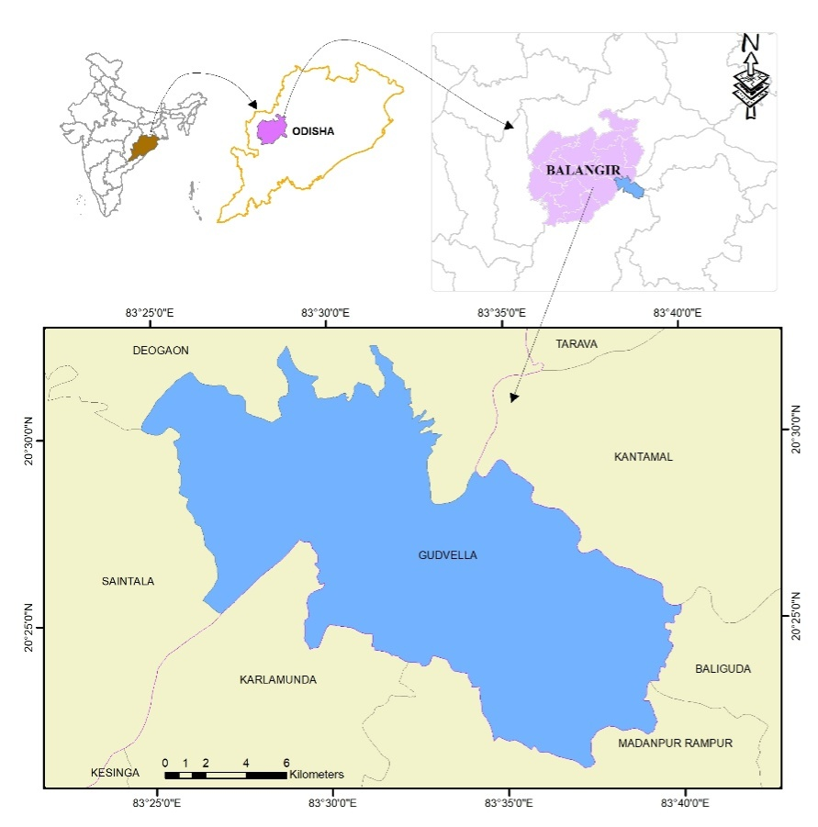
Fig.1. Location map of study area

Fig.2. Average meteorological data of study area (2014-2018)

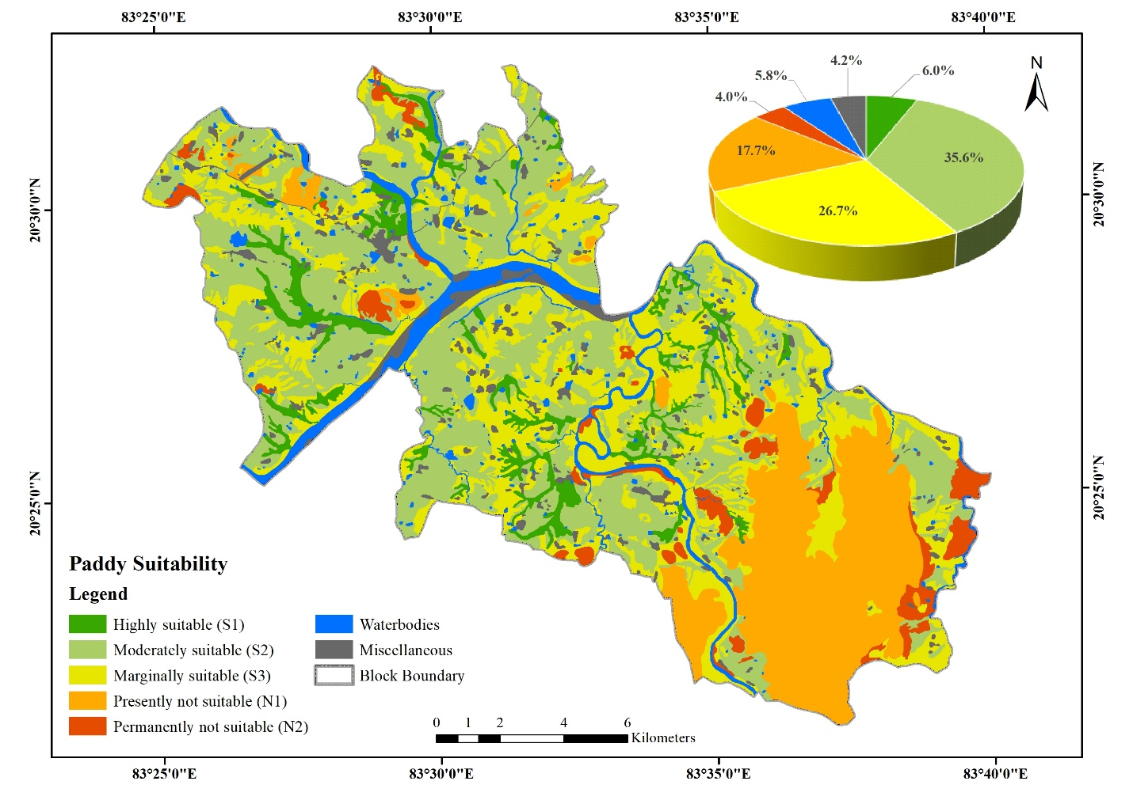Fig. 3. Spatial distribution of Paddy suitability
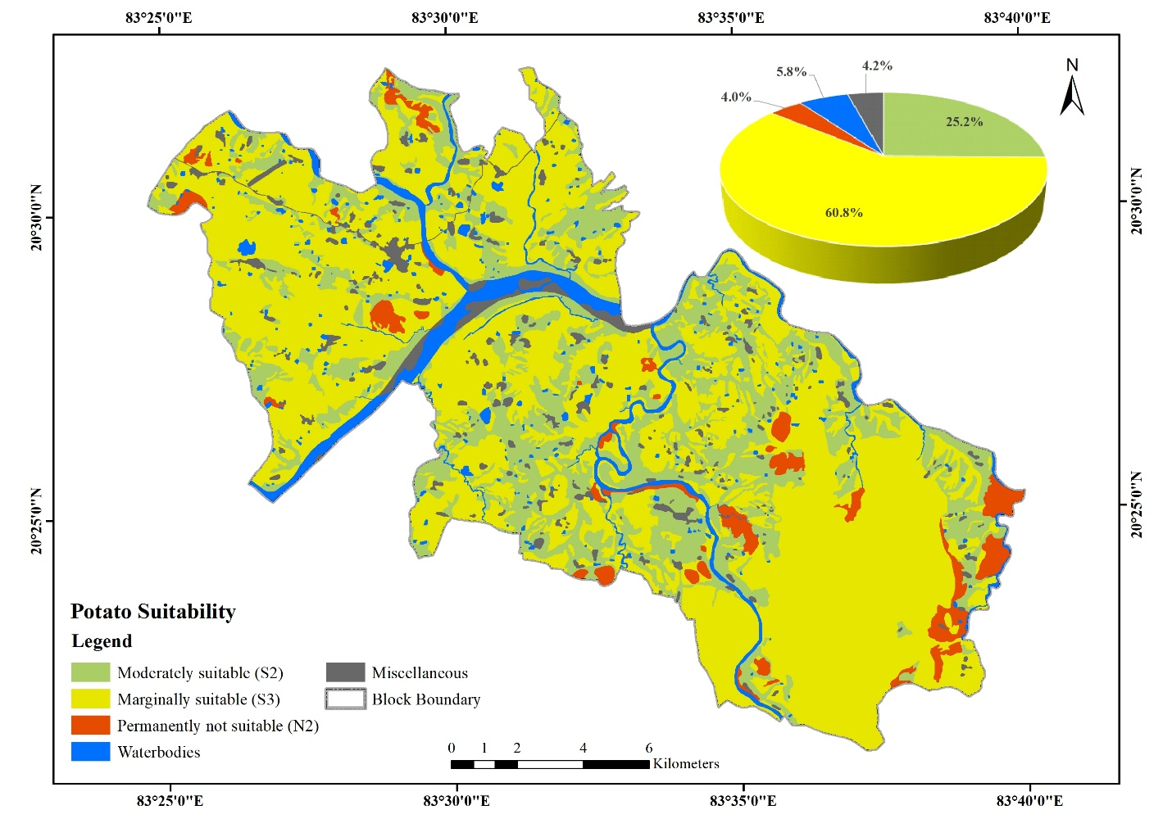
Fig. 4. Spatial distribution of potato suitability
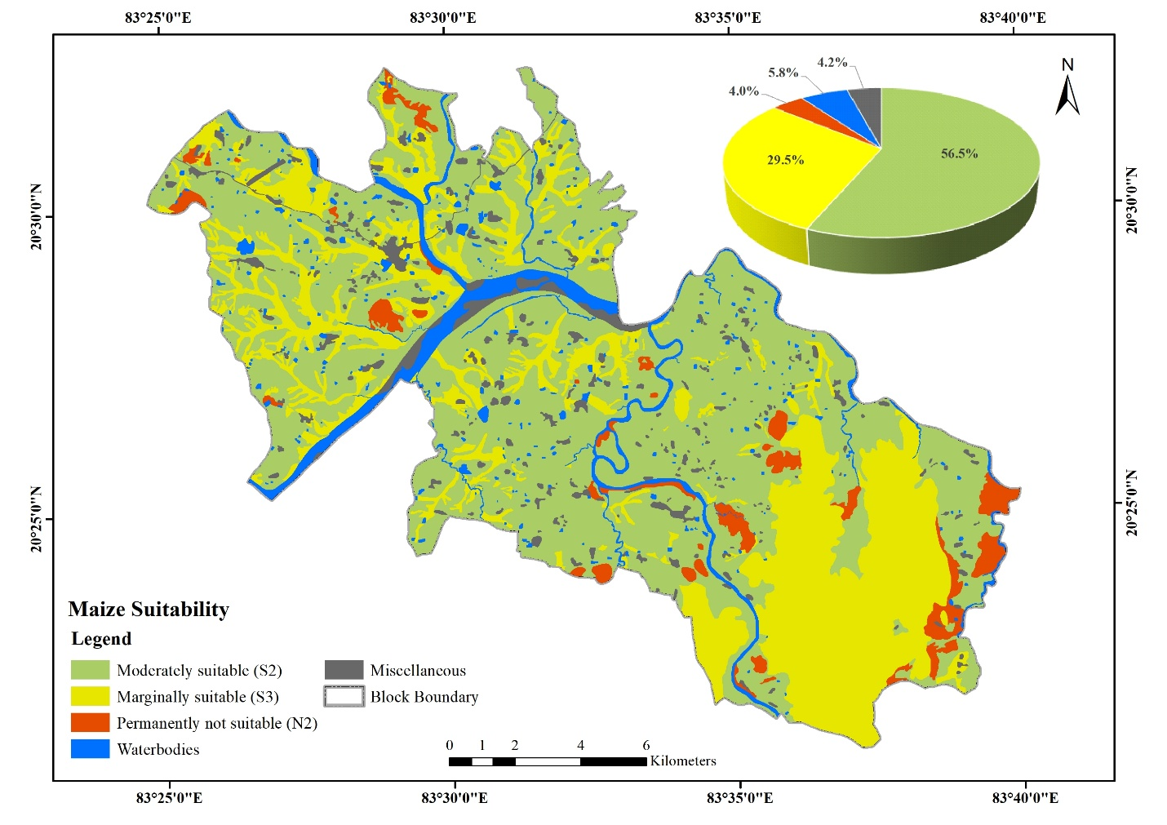
Fig. 5. Spatial distribution of maize suitability
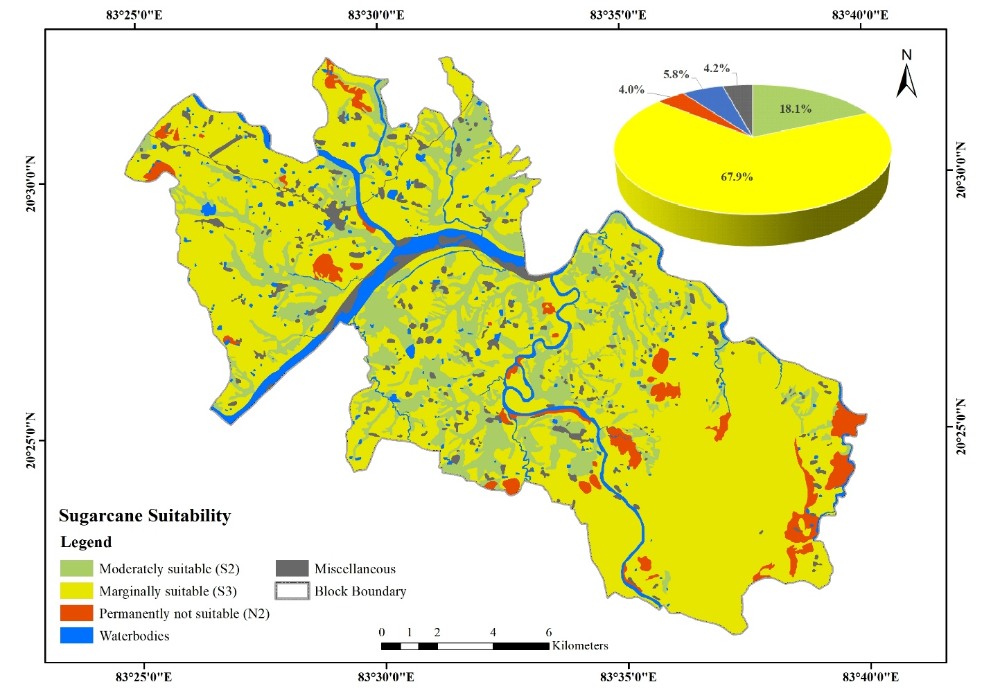
Fig. 6. Spatial distribution of sugarcane suitability
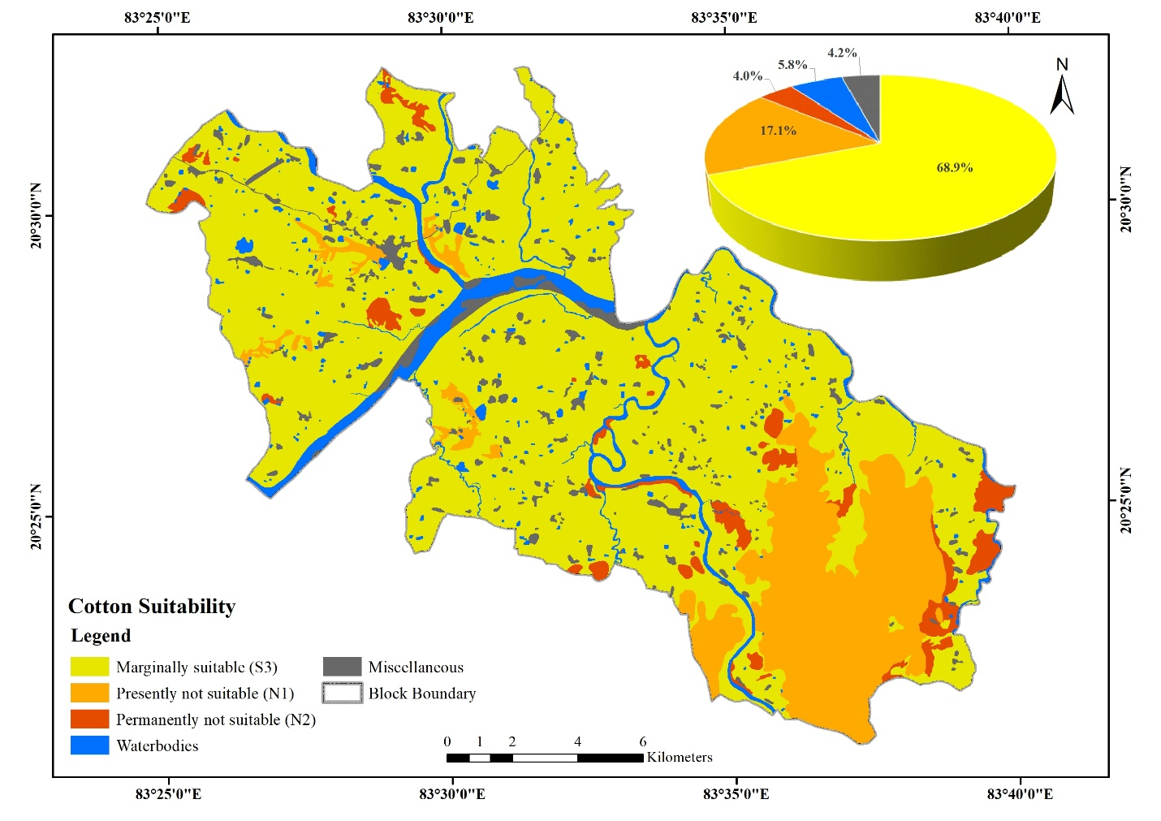
Fig. 7. Spatial distribution of cotton suitability
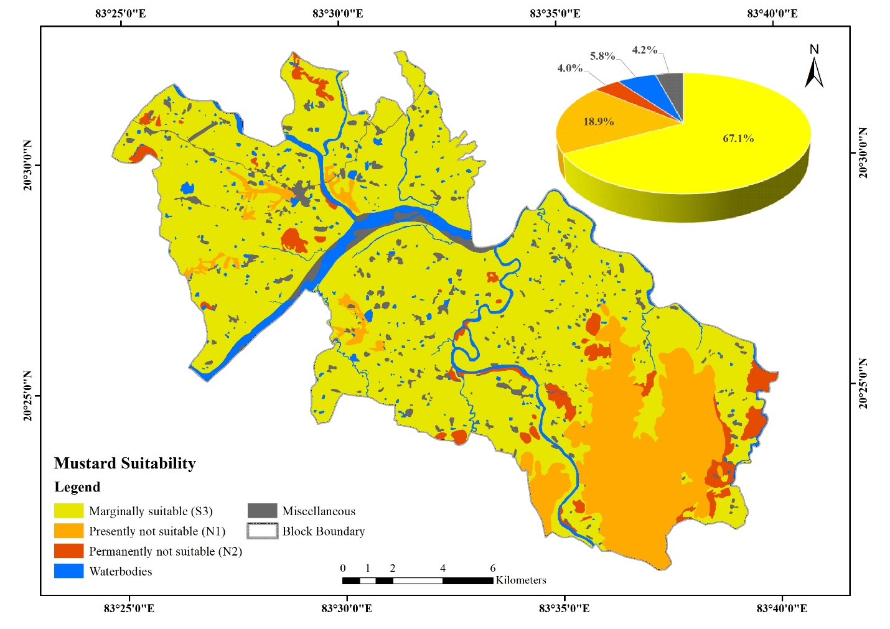
Fig. 8. Spatial distribution of mustard suitability
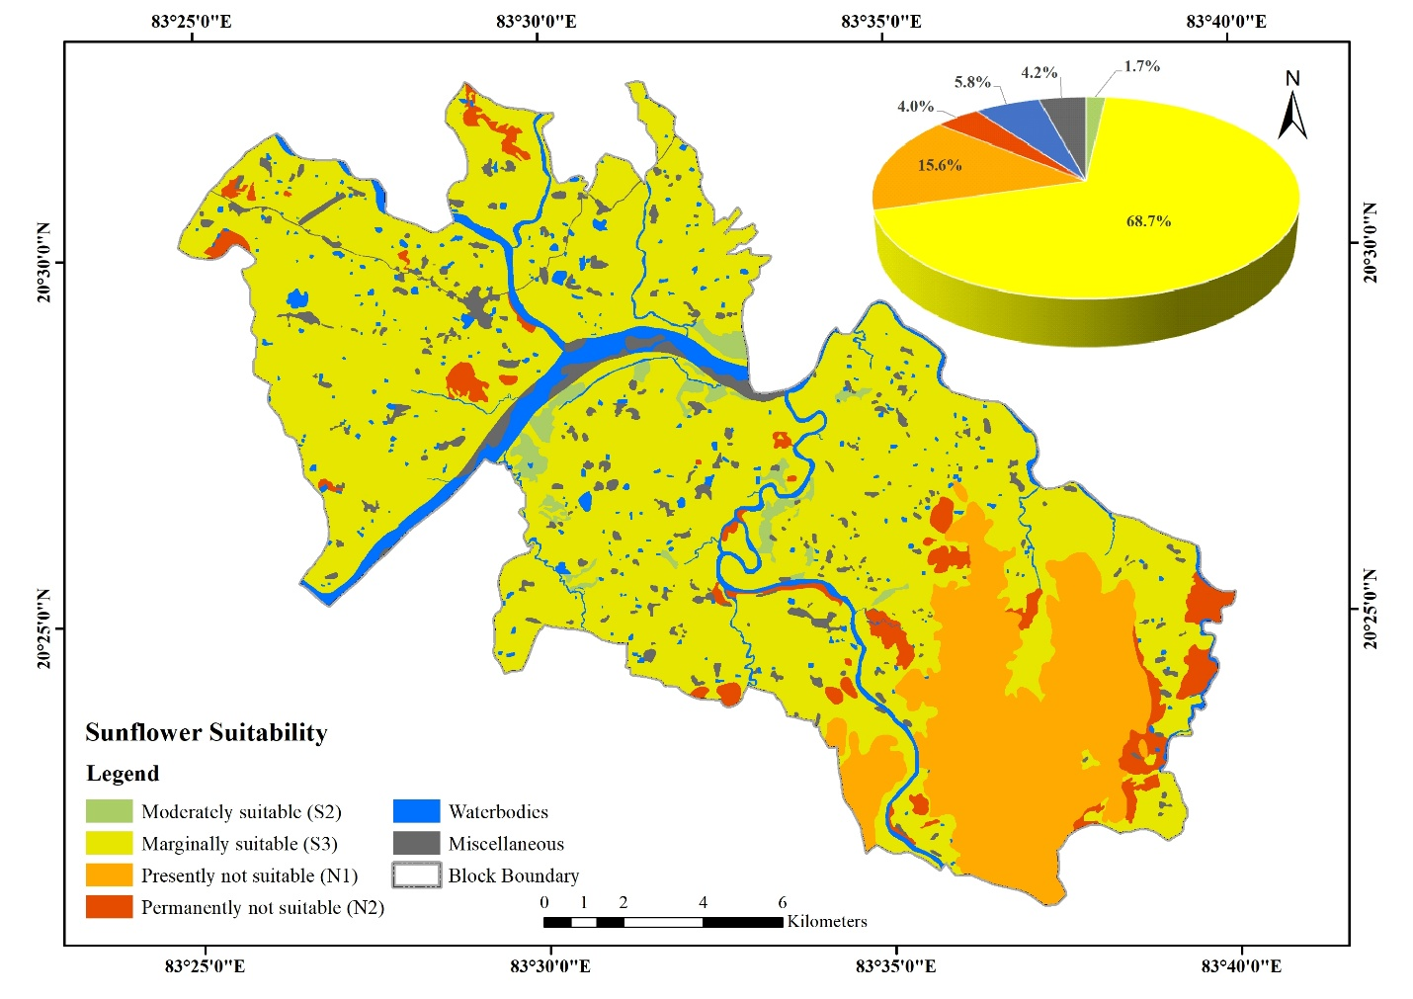
Fig. 9. Spatial distribution of sunflower suitability

