Comparative effects of four liquid fertilizers on the growth and yield of pepper (Capsicum annuum L.) under soilless cultivation in southern Côte d’Ivoire

Abstract
Faced with growing demand for vegetable crops, particularly solanaceous species, the excessive use of synthetic fertilizers and the degradation of arable soils are major constraints on agricultural production in West African urban and peri-urban areas. Soilless cultivation is therefore gaining importance as an alternative production system less dependent on soil quality. This study compared the effects of four liquid fertilizers - two organic (a poultry manure extract and a manure-based fertilizer) and two minerals (Nutrigofol 8-8-8, and NPK 12-22-22 as control) on the growth and yield of pepper grown under soilless conditions, with the broader aim of identifying nutrient solutions that could reduce growers’ dependence on chemical fertilizers. The trial followed a randomized complete block design with four replicates. Treatment had a significant effect on most growth and yield parameters (p < 0.001). The organic fertilizers, and particularly the poultry manure extract, produced significantly higher values than the mineral fertilizers for floral bud number, fruit number, fruit mass, and estimated yield. Estimated yield reached 5.11 t ha⁻¹ with the poultry manure extract, followed by the manure-based fertilizer (3.69 t ha⁻¹), Nutrigofol 8-8-8 (2.81 t ha⁻¹), and NPK 12-22-22 (2.64 t ha⁻¹). Because no unfertilized control was included, these results describe the relative performance of the four fertilizers rather than their absolute agronomic efficiency. Within this comparative scope, the findings indicate that organic nutrient solutions derived from locally available livestock waste can support pepper productivity in soilless systems at least as well as - and for several parameters better than - the mineral fertilizers tested. Valorizing such organic waste as low-cost biofertilizers could contribute to more affordable and resilient vegetable production for expanding West African cities, provided these trends are confirmed against an unfertilized control and under real production conditions.
Keywords: Fertilizers, pepper, yield, soilless cultivation, vegetable

Introduction
Rapid demographic growth is intensifying food-security challenges worldwide. Nearly 98% of undernourished people live in developing countries, mainly in sub-Saharan Africa (Wudil et al., 2022), where food insecurity is closely linked to climate change and its adverse effects on established agricultural production models. In Côte d’Ivoire, climate variability is already affecting the country’s various agricultural production systems (Timité et al., 2022). Current production models therefore need to be reconsidered to meet the food needs of the population - particularly urban populations - in both quantity and quality.
Côte d’Ivoire has committed to a more dynamic agricultural sector built on renewed production systems (UNIDO, 2020). Production systems historically centred on export crops such as cocoa, coffee, oil palm, rubber, and timber are being transformed through the introduction of technological farm-monitoring tools and diversified through agroecological, permanent market-gardening systems. These systems contribute to urban greening and to the health of urban and peri-urban populations, while also helping to mitigate and adapt to climate change, reduce carbon footprints, strengthen urban-rural links, and support sustainable urban development.
This diversification also gives urban populations access to fresh, nutritious food. It does so at a lower cost than food transported over long distances. Among the vegetables whose production needs to expand in urban areas, sweet pepper (Capsicum annuum L.), commonly known as capsicum, still occupies a marginal position (Diarra et al., 2018). Pepper production in Côte d’Ivoire is limited by several abiotic and biotic constraints that reduce yields (Yarou et al., 2017; Gnimassoun et al., 2020), including: (i) the degradation and loss of arable land through soil artificialization; (ii) pest pressure; (iii) the seasonal nature of production; and (iv) long distribution chains for perishable produce. The over-exploitation of arable land linked to population growth and shortened fallow cycles is also driving yield decline (Kassin, 2013). Fallowing remains the main natural mechanism for restoring soil fertility (Mosier et al., 2021), but high pressure on land tenure makes it increasingly difficult to leave land fallow.
Restoring the fertility of agricultural land - for instance through fast-growing trees, ground-cover legumes, or other soil-improvement practices - is one way to offset falling yields. Another common response is to intensify production, generally through heavy use of chemical fertilizers and pesticides to boost short-term yields (Kopittke et al., 2019). However, the overuse of mineral fertilizers tends to acidify and salinize the soil, accelerating rather than reversing the loss of fertility (Wang et al., 2022). Efficient techniques that overcome these constraints are therefore needed. Intensive urban soilless cultivation is one such alternative and could be extended to several vegetable crops, provided accessible, low-cost solutions are developed for growers - notably efficient nutrient solutions adapted to local conditions, and the use of organic matter to manage substrate fertility. In urban and peri-urban areas, manure and other organic residues from animal husbandry are regularly discarded near production sites instead of being recycled, even though their nutrient content makes them potentially valuable fertilizers for quality vegetable production.
Organic matter is recognized to play a key role in the soil fertility of urban vegetable systems (Gnimassoun et al., 2024b; Kuma, 2023). However, urban farmers in Côte d’Ivoire remain reluctant to use these organic residues because of the long duration of the composting process. This study therefore aimed to assess the agronomic effectiveness of a liquid organic fertilizer derived from poultry-farming waste, with a view to improving pepper production in urban areas of Côte d’Ivoire, by comparing it against other organic and mineral nutrient solutions already available to growers.
Materials and methods
Study area
The study area is located in the district of Abidjan, in southern Côte d’Ivoire, West Africa. The trial was carried out in an experimental growing shelter at the Université Nangui Abrogoua (UNA), located between 5°17’ and 5°3’ N and 3°45’ and 4°22’ W. The UNA campus is bounded to the north by the commune of Abobo, near the Banco Forest (Figure 1).
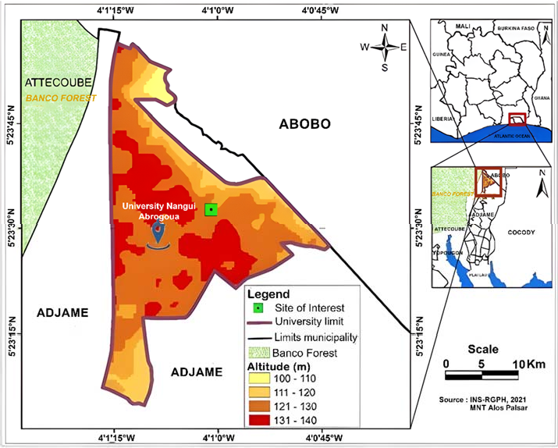
Figure 1. Location of the study site.

Nutrient solution preparation
The poultry-manure-based broth was prepared in a 100 L container. Five kilograms of poultry droppings, 1 kg of fresh neem leaves, 500 g of green papaya leaves, 1 kg of chopped lemongrass leaves, 4 garlic cloves, and 200 g of chili powder were successively added to the container and topped up with 100 L of water. The mixture was homogenized, and the container was sealed hermetically to allow fermentation for 7 days. After fermentation, the solution was filtered through a 0.5 mm mesh and diluted to 20% before use as a plant nutrient solution. Because it combines neem, garlic, and chili - ingredients also recognized for their pest-repellent properties - this broth is likely to provide biopesticidal as well as fertilizing benefits, although the present study did not evaluate its effect on pest incidence.
The other nutrient solutions were obtained by diluting the respective fertilizers in water, and all solutions were applied to irrigate plants in the growing pots following the manufacturers’ recommendations. The doses used were: (i) nutrient solution based on liquid organic fertilizer selected from purins, applied at 5% (50 mL of stock solution diluted in 1 L of water); (ii) nutrient solution based on Nutrigofol 8-8-8 liquid mineral fertilizer, applied at 1% (10 mL of stock solution diluted in 1 L of water); and (iii) nutrient solution based on NPK 12-22-22 mineral fertilizer as control, applied at 1.4 g dissolved in 1 L of water.
Experimental set-up
The study evaluated the effect of nutrient solutions derived from different organic and mineral fertilizers on the growth and yield of pepper. Four treatments were applied: TM (NPK 12-22-22 mineral fertilizer, as control), TC (poultry manure-based broth), TN (Nutrigofol 8-8-8 mineral fertilizer), and TP (organic fertilizer selected from liquid manure). The trial followed a randomized complete block design with 4 replicates of 16 individual plants per treatment (Figure 2), grown in pots filled with inert sand.

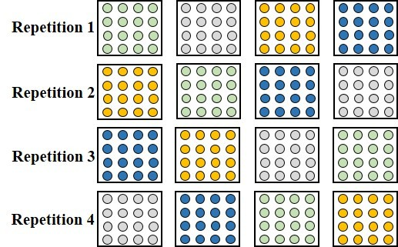

Figure 2. Experimental set-up with the four replicates (green: TM; grey: TC; blue: TN; orange: TP). Circles represent individual pepper plants within each growing pot.

Measurements of agromorphological parameters began two weeks after transplanting, using the four pepper plants located at the centre of each replicate. The parameters recorded were plant height, collar diameter, number of green leaves, number of branches, number of floral buds and flowers, fruit circumference, fruit mass, number of fruits harvested per treatment, and yield. Yield was estimated as:
Yield (kg ha⁻¹) = [yield (g plant⁻¹) × total plants per ha] / 1000
Data analysis
Data normality was checked with the Shapiro-Wilk test and variance homogeneity with Levene’s test. One-way analysis of variance (ANOVA) was then performed on normally distributed data, and the Kruskal-Wallis test on non-parametric data, at a significance threshold of 0.05. Statistical analyses were performed in R (version 4.1.3, 64-bit). Where a significant treatment effect was detected (p < α, α = 0.05), means were compared pairwise using Tukey’s test to identify the treatment(s) responsible for the difference.

Results
Chemical composition of the poultry-manure-based broth
Table I shows the chemical composition of the poultry-manure-based broth obtained after fermentation of the organic matter. The broth was close to neutral pH and contained good levels of K, Ca, and Mg. Nitrogen and organic carbon contents were high, with a C/N ratio of 7.84 ± 1.84.

Table I. Chemical composition of the poultry-manure-based broth.

pH | C (%) | N (%) | P (mg L⁻¹) | K (mg L⁻¹) | Ca (mg L⁻¹) | Mg (mg L⁻¹)
7.57 ± 0.28 | 2.43 ± 0.53 | 0.32 ± 0.08 | 2.13 ± 0.29 | 207.89 ± 21.55 | 74.00 ± 6.51 | 29.66 ± 2.67

Effect of fertilizers on vegetative parameters
Figure 3 shows changes in plant height after transplanting. Plants receiving the manure-based broth (TC) reached the greatest average heights, followed by those receiving liquid manure (TP), in contrast to plants fertilized with Nutrigofol (TN) and NPK (TM). However, analysis of variance showed no statistically significant difference in plant height among treatments (p = 0.17).
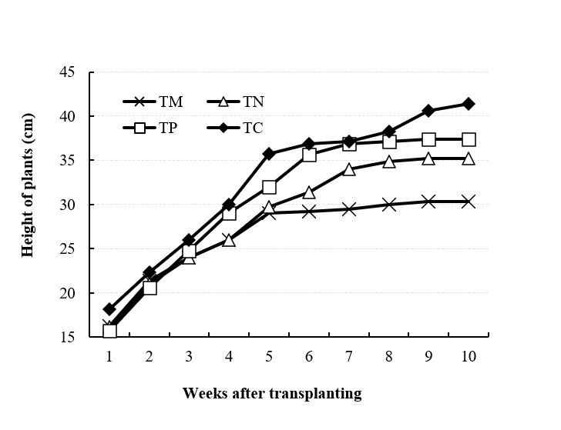
Figure 3. Evolution of average pepper plant height as a function of treatment over time. TM: NPK mineral fertilizer (1.4 g L⁻¹); TN: Nutrigofol 8-8-8 (1%); TP: purin liquid organic fertilizer (5%); TC: liquid compost (20%).

Changes in stem diameter are shown in Figure 4. Plants receiving the manure-based broth had the greatest average stem diameter, followed by those receiving liquid manure, in contrast to plants fertilized with Nutrigofol and NPK. Unlike plant height, statistical analysis showed a significant treatment effect on collar diameter from the first to the sixth week of cultivation (p < 0.05).
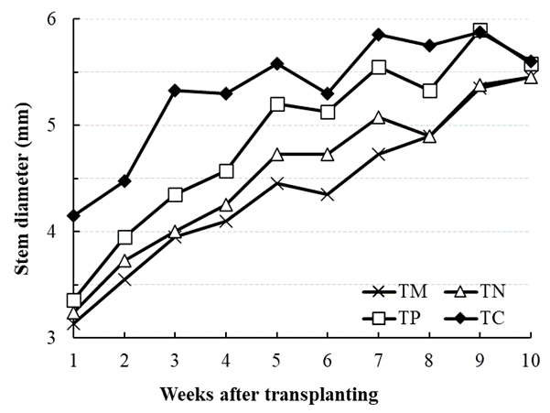
Figure 4. Changes in stem diameter of pepper plants as a function of treatment over time. TM: NPK mineral fertilizer (1.4 g L⁻¹); TN: Nutrigofol 8-8-8 (1%); TP: purin liquid organic fertilizer (5%); TC: liquid compost (20%).

Figure 5 shows the average number of branches per plant at 77 days after transplanting. Fertilizer had a significant effect on branch number (p < 0.05): TC gave the highest mean number of branches and TM the lowest, while TP was statistically intermediate and not significantly different from TN.
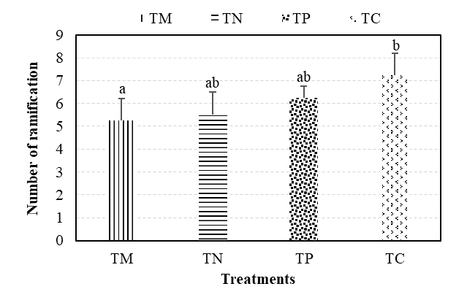
Figure 5. Change in number of branches as a function of treatment at 77 days after transplanting. Means sharing the same letter are not significantly different at the 5% level.

Leaf production per plant over the growing period is shown in Figure 6. Leaf number increased from about 6 to 25 between week 1 and week 10 across all treatments, with the highest mean values recorded for plants receiving the manure-based broth and the lowest for those receiving NPK. However, this difference was not statistically significant (p > 0.05).
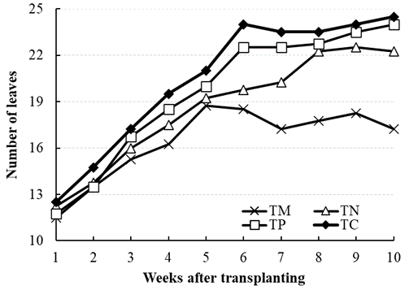
Figure 6. Evolution of the average number of leaves as a function of treatment over time.

Effect of fertilizers on yield parameters
Table II summarizes pepper production parameters at 77 days after transplanting. Treatment had a highly significant effect on floral bud number and flower number (p < 0.001 for both). For both parameters, TC differed significantly from all other treatments (increases of 76-155% for buds and 72-192% for flowers relative to the other treatments), TP differed significantly from TM, and TN did not differ significantly from either TM or TP.
The number of fruits harvested per plant also differed significantly among treatments (p < 0.001). TC (26.50 ± 1.91) produced significantly more fruit than TM and TN (33-139% more) but was not significantly different from TP. TP itself did not differ significantly from either TM or TN, despite numerically higher mean values (66-81% higher).
Fruit diameter differed significantly among treatments overall (p = 0.029), but the pairwise comparisons showed a more nuanced pattern than for the other parameters: only TC differed significantly from TM, with TC producing larger fruit. TN and TP were statistically intermediate, differing significantly from neither TM nor TC.
Fruit mass differed significantly among treatments (p < 0.001). TC produced significantly heavier fruit than all other treatments. TP produced significantly heavier fruit than TM but was not significantly different from TN. TN and TM did not differ significantly from each other.
Estimated yield differed significantly among treatments (p < 0.001). TC gave the highest yield, significantly greater than all other treatments - 38%, 82%, and 94% higher than TP, TN, and TM, respectively. TP gave a significantly higher yield than TM (40% higher) but was not significantly different from TN, despite a 31% numerical advantage. TN and TM did not differ significantly from each other.

Table II. Descriptive statistics of pepper production parameters at 77 days after transplanting under the four experimental treatments.

Variable | Treatment* | Mean ± SD** | CV (%) | n | Min | Max
Number of floral buds | TM | 17.75 ± 1.00ª | 5.56 | 4 | 17.00 | 19.00
Number of floral buds | TN | 18.00 ± 5.00^{ab} | 27.78 | 4 | 13.00 | 23.00
Number of floral buds | TP | 26.25 ± 3.00^{b} | 11.54 | 4 | 23.00 | 29.00
Number of floral buds | TC | 45.50 ± 2.00^{c} | 4.35 | 4 | 44.00 | 48.00
Number of flowers | TM | 13.25 ± 5.05ª | 38.46 | 4 | 8.00 | 18.00
Number of flowers | TN | 15.00 ± 2.92^{ab} | 13.33 | 4 | 13.00 | 17.00
Number of flowers | TP | 22.25 ± 4.57^{b} | 22.73 | 4 | 17.00 | 27.00
Number of flowers | TC | 38.25 ± 0.50^{c} | 2.63 | 4 | 37.00 | 39.00
Number of fruits harvested | TM | 11.00 ± 7.00ª | 63.64 | 4 | 4.00 | 18.00
Number of fruits harvested | TN | 12.00 ± 2.44ª | 16.67 | 4 | 10.00 | 14.00
Number of fruits harvested | TP | 20.00 ± 5.41^{ab} | 25.00 | 4 | 15.00 | 25.00
Number of fruits harvested | TC | 26.50 ± 1.91^{b} | 5.80 | 4 | 25.00 | 28.00
Fruit diameter  (cm) | TM | 14.56 ± 0.89a | 5.52 | 4 | 13.70 | 15.30
Fruit diameter  (cm) | TN | 14.70 ± 0.70^{ab} | 4.76 | 4 | 14.00 | 15.40
Fruit diameter  (cm) | TP | 14.90 ± 1.62^{ab} | 10.00 | 4 | 13.50 | 16.50
Fruit diameter  (cm) | TC | 16.93 ± 0.68^{b} | 3.53 | 4 | 16.40 | 17.60
Fruit mass  (g) | TM | 75.37 ± 18.72ª | 24.00 | 4 | 57.00 | 93.00
Fruit mass  (g) | TN | 80.34 ± 8.88^{ab} | 10.00 | 4 | 72.00 | 88.00
Fruit mass  (g) | TP | 105.57 ± 12.28^{b} | 11.43 | 4 | 93.00 | 117.00
Fruit mass  (g) | TC | 145.90 ± 4.66^{c} | 3.45 | 4 | 140.00 | 150.00
Estimated yield  (kg ha⁻¹) | TM | 2605.70 ± 700ª | 26.92 | 4 | 1900 | 3300
Estimated yield  (kg ha⁻¹) | TN | 2811.90 ± 400^{ab} | 10.71 | 4 | 2500 | 3100
Estimated yield  (kg ha⁻¹) | TP | 3694.95 ± 400^{b} | 10.81 | 4 | 3300 | 4100
Estimated yield  (kg ha⁻¹) | TC | 5106.76 ± 200^{c} | 4.00 | 4 | 4800 | 5200
*TM: NPK mineral fertilizer (1.4 g L⁻¹); TN: Nutrigofol 8-8-8 liquid mineral fertilizer (1%); TP: purin liquid organic fertilizer (5%); TC: liquid compost (20%). **Means followed by the same letter, within a parameter, are not significantly different at the 5% probability level (Tukey’s test).

Discussion
Plant height and leaf number did not differ significantly among treatments. This could reflect either a genuinely similar effect of the different nutrient solutions on these two parameters, or insufficient statistical power given the number of replicates. Zadi et al. (2018) similarly found that coconut seedlings fertilized organically at an average dose of 839 g grew at rates comparable to those receiving chemical fertilizer. Stem diameter and branch number, by contrast, differed significantly among treatments, with organic fertilizers (manure-based broth and liquid manure) outperforming the mineral fertilizers. This is consistent with the more readily available nutrients that organic amendments typically supply at early growth stages (Zhou et al., 2022). Wang et al. (2020) likewise found that organic fertilizer improved vegetative growth in maize, and Gnimassoun et al. (2024a) and Berhe et al. (2022) reported comparable results for pepper. Within the category of organic amendments, poultry droppings in particular have been shown to promote branching in pistachio (Meimand et al., 2018), an effect attributed to the gradual release of minerals from poultry manure, which keeps nutrients available throughout much of the crop cycle (Thepsilvisut et al., 2022).
Fertilizer type also had a significant effect on yield parameters and fruit quality, with organic fertilization generally favoring bud, flower, and fruit production over mineral fertilization. In the present study, the highest values were obtained with the poultry-manure-based broth (TC, applied at 20%), followed by the liquid-manure fertilizer (TP, applied at 5%). Organic fertilizers are generally more soluble and therefore more readily assimilated by the plant (Hitha et al., 2021), which is consistent with several previous reports: Eze et al. (2024) found that compost enriched with poultry droppings significantly increased carrot yields; Gnimassoun (2021) and Sini et al. (2024) reported that organic fertilization of pepper increased fresh and dry fruit weight, fruit number, and yield per plant; and Okoli et al. (2021) showed that organic fertilization with pig dung and poultry droppings significantly increased the growth and yield of fluted pumpkin (Telfairia occidentalis) compared with NPK. Babu et al. (2021) attributed the high agronomic value of poultry manure to the fact that 60-90% of its nitrogen content is already in mineral form and therefore directly available to the plant. Because Gnimassoun (2021), Okoli et al. (2021), and Sini et al. (2024) each derived dosage guidelines for organic livestock residues applied to other vegetable species - guidelines that the present study also followed - it is plausible that other vegetable crops grown in similar soils or substrates could benefit from comparable organic amendments; these warrants dedicated testing rather than extrapolation from the present dataset.
These findings should, however, be interpreted within the limits of the experimental design. The trial did not include an unfertilized absolute control, so the four treatments can only be ranked relative to one another (TC > TP > TN ≈ TM for most reproductive and yield parameters); the data do not indicate whether, or to what extent, any of the fertilizers improved growth or yield compared with unfertilized plants, nor do they establish the fertilizers’ absolute agronomic efficiency. No economic analysis was performed either, so claims about the cost-effectiveness or profitability of the organic fertilizers relative to the mineral fertilizers cannot yet be supported. Confirming the agronomic and economic value of the poultry-manure-based broth will require follow-up trials that include an absolute control and a cost-benefit assessment, ideally conducted under real production conditions rather than in an experimental shelter.
Conclusion
This study compared four liquid fertilizers - two organic and two mineral - as nutrient solutions for pepper grown under soilless conditions in urban Côte d’Ivoire. The poultry-manure-based broth (TC) had a favourable chemical composition (near-neutral pH, adequate C/N ratio, and good K, Ca, and Mg content) and, among the four treatments tested, was consistently associated with the highest values for most reproductive and yield parameters - floral bud number, flower number, fruit number, fruit mass, and estimated yield - followed by the liquid-manure fertilizer (TP), while the two mineral fertilizers (TN and TM) generally gave the lowest values. This pattern is consistent with the more readily available nutrients typically supplied by organic fertilizers at early growth stages, as reported in other pepper and vegetable studies.
Because the trial did not include an unfertilized control, these conclusions describe the relative ranking of the four fertilizers and should not be read as evidence that any of them improves pepper growth or yield in absolute terms, nor as a demonstration of soil-fertility restoration, which was not directly assessed here. Within this comparative scope, the results nonetheless suggest that liquid organic fertilizers derived from locally available poultry waste are a promising, low-cost alternative to the mineral fertilizers currently used by soilless growers in and around Ivorian cities. Confirming this potential - together with its implications for organic-waste valorization, production costs, and eco-friendly urban agriculture in Côte d’Ivoire and other tropical contexts - will require further trials that include an absolute control, an economic evaluation, and testing under real production conditions.
Competing interests
The authors declare no conflicts of interest.
Data availability statement
The data presented in the tables and figures are available on request.
Compliance with ethical standards
Not applicable.
Declaration of AI Use

This manuscript was prepared through the intellectual contributions of the author(s) to the study design, data analysis, interpretation of results, and scholarly content. Grammarly and ChatGPT were used solely to assist with grammatical refinement and reference formatting during manuscript revision. The author(s) accept full responsibility for the accuracy, integrity, and final content of the manuscript.

References
Babu, A., Singh, U., Meena, R., Dadarwal, B. & Jakhar, R. (2021) Use of poultry manure as organic fertilizer in different crops. The Agriculture Magazine, 1(1), pp. 14-15. Available at: https://theagricultureonline.com/wp-content/uploads/2021/12/8.pdf (accessed: 01/08/2026).
Berhe, D.T., Zergaw, Y. & Kebede, T. (2022) Organic amendments direct application and residual effects on vegetative and reproductive growth of hot pepper. The Scientific World Journal, 2805004. https://doi.org/10.1155/2022/2805004.
Diarra, M., Kouadio, D.L., Aboua, K.N., Soro, D.B., Kouadio, A., Traoré, K.S., Koné, M. & Dembelé, A. (2018) Level of pesticide contamination in peppers (Capsicum L., 1753). European Scientific Journal, 14(6), pp. 432-442. https://doi.org/10.19044/esj.2018.v14n6p432.
Eze, F.O., Mukosha, C.E., Anozie, C., Moudry, J., Ali, S., Ghorbani, M., Amirahmadi, E., Baloch, S.B. & Baiyeri, K.P. (2024) Response of carrots (Daucus carota) on the growth, yield, and nutritional composition to varying poultry manure rates. Agricultural Research, 13, pp. 841-850. https://doi.org/10.1007/s40003-024-00723-9.
Gnimassoun, K.E.-G. (2021) Effets combinés du compost de rafles de palmier et de la fiente de volaille sur la fertilité des sols sableux sous culture de piment (Capsicum frutescens) et d’aubergine (Solanum aethiopicum anguivi) dans la localité de Grand-Lahou, sud-ouest de la Côte d’Ivoire. Thèse de doctorat, Université Félix Houphouët-Boigny, Abidjan, Côte d’Ivoire.
Gnimassoun, K.E.-G., Ettien, D.J.B., Bouadou, O.B. & Masse, D. (2020) Effect of empty fruit bunch compost on improving the productivity of two vegetables produced under sandy poor soil in organic matter in the South-West of Côte d’Ivoire. European Journal of Scientific Research, 2, pp. 142-157.
Gnimassoun, K.E.-G., Bolou-Bi, E.B. & Ouattara, M.D. (2024a) Effects of organic amendments on soil chemistry, fauna diversity, and pepper growth in Côte d’Ivoire, West Africa. International Journal of Plant & Soil Science, 36, pp. 955-968. https://doi.org/10.9734/ijpss/2024/v36i74808.
Gnimassoun, K.E.-G., Bolou-Bi, E.B. & Konan, K.R. (2024b) Effectiveness of organic fertilizers in improving soil fertility, productivity, and quality of carrots (Daucus carota) in Southern Côte d’Ivoire. Annual Research & Review in Biology, 39, pp. 39-49. https://doi.org/10.9734/arrb/2024/v39i92116.
Hitha, S., Vinaya, C. & Linu, M. (2021) Organic fertilizers as a route to controlled release of nutrients. In: Controlled Release Fertilizers for Sustainable Agriculture. Academic Press, pp. 231-245. https://doi.org/10.1016/B978-0-12-819555-0.00013-3.
Kassin, K. (2013) Statut, besoins et priorités en matière de gestion durable des sols en Côte d’Ivoire. Regional Conference on the West and Central Africa Soil Partnership, Ghana, 4-6 April 2013. Available at: https://www.fao.org/fileadmin/user_upload/GSP/docs/West_africa_partner/CoteD_Ivoire_Assin.pdf (accessed: 03/08/2026).
Kopittke, P.M., Menzies, N.W., Wang, P., McKenna, B.A. & Lombi, E. (2019) Soil and the intensification of agriculture for global food security. Environment International, 132, 105078. https://doi.org/10.1016/j.envint.2019.105078.
Kuma, A. (2023) Effect of different types of organic manures and mulching materials on growth, yield, and quality of carrot (Daucus carota L.) in Diguna Fango District, South Ethiopia. https://doi.org/10.2139/ssrn.4851877.
Meimand, M.J.M., Shamshiri, M.H., Roosta, H.R. & Khan, E.U. (2018) Poultry manure application time on pistachio (Pistacia vera L.) trees. Advances in Horticultural Science, 32, pp. 177-183. https://doi.org/10.13128/ahs-21898.
Mosier, S., Cordova, S.C. & Robertson, G.P. (2021) Restoring soil fertility on degraded lands to meet food, fuel, and climate security needs via perennialization. Frontiers in Sustainable Food Systems, 5, 706142. https://doi.org/10.3389/fsufs.2021.706142.
Okoli, E.E., Ekesiobi, I.A. & Nworji, M.J. (2021) Effect of organic manure (poultry droppings, cow manure, and pig manure) and inorganic fertilizer (NPK 15:15:15) on the growth and yield of fluted pumpkin (Telfairia occidentalis). The International Journal of Science & Technology, 9, pp. 32-36. https://doi.org/10.24940/theijst/2021/v9/i1/ST2101-013.
Sini, H.N., Barzegar, R., Mashaee, S.S., Ghahsare, M., Mousavi-Fard, S. & Mozafarian, M. (2024) Effects of biofertilizer on the production of bell pepper (Capsicum annuum L.) in a greenhouse. Journal of Agriculture and Food Research, 16, 101060. https://doi.org/10.1016/j.jafr.2024.101060.
Thepsilvisut, O., Chutimanukul, P., Sae-Tan, S. & Ehara, H. (2022) Effect of chicken manure and chemical fertilizer on the yield and qualities of white mugwort at dissimilar harvesting times. PLoS ONE, 17, pp. 1-14. https://doi.org/10.1371/journal.pone.0266190.
Timité, N., Kouakou, A.T.M., Bamba, I., Yao, S.S.B. & Bogaert, J. (2022) Climate variability in the Sudanian zone of Côte d’Ivoire: weather observations, perceptions, and adaptation strategies of farmers. Sustainability, 14, 10410. https://doi.org/10.3390/su141610410.
UNIDO (2020) Programme for Country Partnership Côte d’Ivoire: PCP Industrial Diagnostic Study. Available at: https://www.unido.org/sites/default/files/files/2022-02/PCP_diagnostics_Ivory_Coast_English.pdf (accessed: 01/08/2026).
Wang, X., Yan, J., Zhang, X., Zhang, S. & Chen, Y. (2020) Organic manure input improves soil water and nutrient use for sustainable maize (Zea mays L.) productivity on the Loess Plateau. PLoS ONE, 15, pp. 1-16. https://doi.org/10.1371/journal.pone.0238042.
Wang, X., Wang, X., Sheng, H., Wang, X., Zhao, H. & Feng, K. (2022) Excessive nitrogen fertilizer application causes rapid degradation of greenhouse soil in China. Polish Journal of Environmental Studies, 31, pp. 1527-1534. https://doi.org/10.15244/pjoes/143293.
Wudil, A.H., Usman, M., Rosak-Szyrocka, J., Ladislav, P. & Boye, M. (2022) Reversing years for global food security: a review of the food security situation in Sub-Saharan Africa (SSA). International Journal of Environmental Research and Public Health, 19, 14836. https://doi.org/10.3390/ijerph192214836.
Yarou, B.B., Silvie, P., Komlan, F.A., Mensah, A., Alabi, T., Verheggen, F. & Francis, F. (2017) Pesticide plants and the protection of market garden crops in West Africa (literature review). Biotechnology, Agronomy, Society and Environment, 21(4), pp. 288-304.
Zadi, M., Turquin, L. & Lekadou, T.T. (2018) Effets de deux types d’engrais organiques sur la croissance et le développement du cocotier hybride PB 113+ en pépinière. Agronomie Africaine, 30, pp. 237-247. Available at: https://www.ajol.info/index.php/aga/article/view/181823 (accessed: date to be confirmed by authors).
Zhou, Z., Zhang, S., Jiang, N., Xiu, W., Zhao, J. & Yang, D. (2022) Effects of organic fertilizer incorporation practices on crop yield, soil quality, and soil fauna feeding activity in the wheat-maize rotation system. Frontiers in Environmental Science, 10, 1058071. https://doi.org/10.3389/fenvs.2022.1058071.

