Original Research Article
Techno-Economic Evaluation and Packaging Application of an Optimized Corn Starch-based Bio-composite Film Reinforced with Sunflower Seed Hull Powder and Thyme Essential Oil

Abstract
The increasing environmental concerns associated with petroleum-based plastic packaging have accelerated the search for biodegradable and economically feasible alternatives for food packaging applications. The present study evaluated the techno-economic feasibility, commercial potential, and practical packaging application of an optimized corn starch-based bio-composite film reinforced with sunflower seed hull powder and thyme essential oil. An optimized bio-composite formulation (OBF) containing 5 g corn starch, 0.50 g sunflower seed hull powder, 2.5 mL glycerol, 3.0 mL white vinegar, 0.25 mL thyme essential oil, and 50 mL distilled water was selected for economic evaluation. Production cost was estimated under laboratory-scale conditions by considering raw material, energy, labour, and equipment costs. The total production cost of one batch of the optimized film was estimated to be ₹13.00, with raw materials representing the largest proportion of the manufacturing cost. Comparative cost analysis demonstrated that the developed bio-composite film had a higher production cost than conventional petroleum-based plastic films because of laboratory-scale production and manual processing. However, the utilization of inexpensive corn starch, renewable agricultural waste (sunflower seed hull powder), and naturally derived thyme essential oil highlights the environmental and commercial advantages of the developed packaging system. Commercial feasibility assessment indicated that production costs could be substantially reduced through large-scale manufacturing, process optimization, and bulk procurement of raw materials. The optimized film was further evaluated as a secondary packaging material for commercially packaged Mango Bite candies and maintained satisfactory flexibility, structural integrity, ease of handling, and wrapping performance throughout 15 days of ambient storage. Overall, the developed bio-composite film demonstrated promising potential as a sustainable alternative to conventional plastic packaging and provides a practical basis for future industrial-scale development of biodegradable food packaging materials.
Keywords: Corn starch; Bio-composite film; Sunflower seed hull powder; Techno-economic assessment; Commercial feasibility; Sustainable food packaging; Secondary packaging.
- Introduction
The global food packaging sector is undergoing a significant transformation as industries seek environmentally sustainable alternatives to conventional petroleum-based plastics. The extensive use of synthetic packaging materials has contributed to increasing environmental pollution, depletion of non-renewable resources, and the accumulation of persistent plastic waste in terrestrial and aquatic ecosystems (Gupta et al., 2022). Growing public awareness, stringent environmental regulations, and the demand for sustainable products have accelerated the transition towards biodegradable packaging materials that can safely decompose after disposal while reducing ecological impacts. Besides environmental protection, biodegradable packaging offers additional advantages such as renewability, reduced carbon footprint, compatibility with circular economy principles, and the potential to utilize agricultural residues and other renewable resources. These attributes make biodegradable packaging an attractive solution for achieving sustainable food systems without compromising product safety and quality (Dirpan et al., 2023).
Despite these environmental and functional benefits, the commercialization of biodegradable food packaging remains limited due to its comparatively higher production cost than conventional plastic packaging (Muñoz et al., 2026; Moshood et al., 2022). The manufacturing of biodegradable films often involves the use of biopolymers, natural additives, plasticizers, and specialized processing techniques, all of which contribute to increased production expenses (Muñoz et al., 2026; Sabet, 2025). Furthermore, many biodegradable packaging materials are currently produced at laboratory or pilot scales, where limited production volumes increase the cost per unit. The incorporation of natural bioactive compounds to impart antimicrobial or antioxidant functionality further elevates manufacturing costs. Consequently, although biodegradable films provide significant environmental and health advantages, their economic competitiveness remains one of the major challenges preventing large-scale industrial adoption (Muñoz et al., 2026; Bócoli et al., 2025). Therefore, reducing production costs while maintaining desirable packaging performance has become a critical research priority for the successful commercialization of sustainable packaging materials (Bócoli et al., 2025; Westlake et al., 2023).
A comprehensive economic assessment is essential before biodegradable packaging can be considered a practical replacement for conventional plastic materials (Tassinari et al., 2023; Drago et al., 2024). Comparative cost analysis enables researchers and manufacturers to identify the major cost-contributing components, evaluate the affordability of different formulations, and estimate their commercial feasibility under real production conditions (Tassinari et al., 2023). Such analyses also provide valuable information for optimizing raw material selection, minimizing manufacturing expenses, and improving scalability (Tassinari et al., 2023; Drago et al., 2024). In addition, comparing the production cost of biodegradable films with commercially available plastic packaging offers a realistic perspective on their economic viability and highlights the opportunities and challenges associated with their industrial implementation (Tassinari et al., 2023). Alongside economic evaluation, practical food packaging trials are equally important to demonstrate that biodegradable films can effectively protect food products during storage while maintaining their structural integrity, handling characteristics, and consumer acceptability (Mangaraj et al., 2019; Drago et al., 2024).
Therefore, the present study aims to perform a comparative cost analysis of corn starch-based bio-composite films reinforced with sunflower seed hull powder and thyme essential oil and to evaluate their economic feasibility in comparison with conventional plastic packaging materials. The study further investigates the practical application of the optimized biodegradable film as a secondary packaging material for mango bite candies to demonstrate its suitability for real food packaging applications. The outcomes of this work are expected to provide valuable insights into the commercial prospects of biodegradable packaging systems and contribute to the development of cost-effective, sustainable alternatives to conventional food packaging.
2. Materials and Methods
2.1 Materials
Food-grade corn starch, glycerol, white vinegar, and thyme essential oil were procured from commercial suppliers in India. Sunflower seeds were purchased from a local market in Varanasi, Uttar Pradesh, India, and the hulls were manually separated to obtain sunflower seed hull (SSH) powder as the reinforcing material. Distilled water was used throughout the study. Commercially available Mango Bite candies (Parle Products Pvt. Ltd., India) were selected as the model confectionery product for evaluating the packaging performance of the developed bio-composite film.
2.2 Optimized Bio-composite Film Formulation
The optimized corn starch-based bio-composite film formulation (OBF) was selected for the present study based on its suitability for economic evaluation and packaging application. The formulation consisted of 5 g corn starch, 0.50 g sunflower seed hull powder, 2.5 mL glycerol, 3.0 mL white vinegar, 0.25 mL thyme essential oil, and 50 mL distilled water. The composition of the optimized formulation is presented in Table 1.
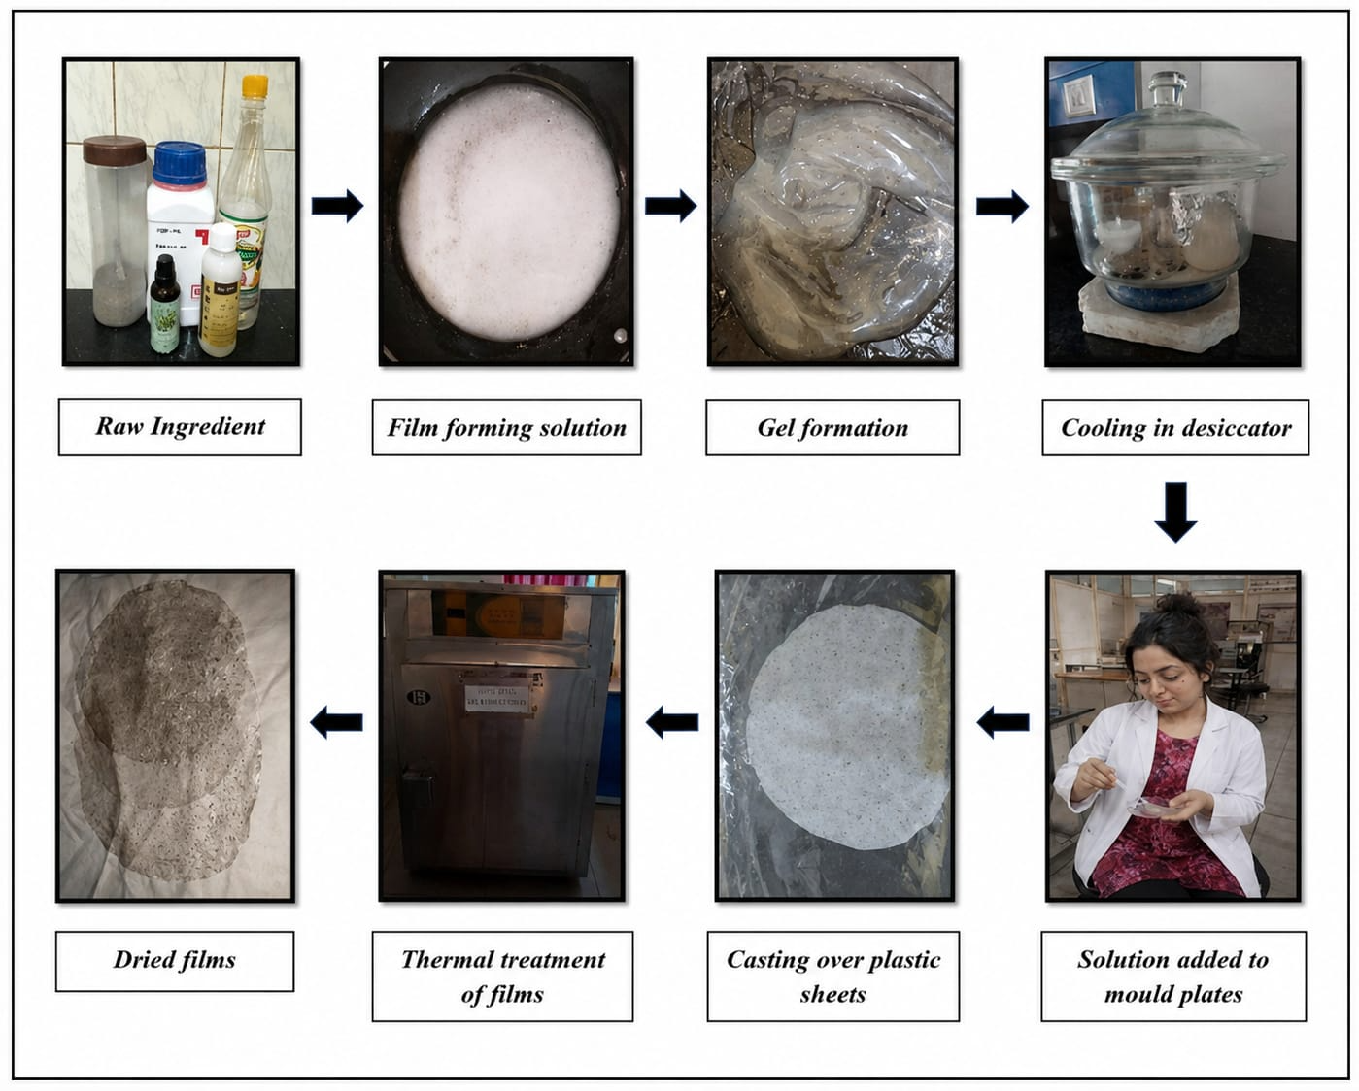
Figure 1. Process of making the optimised bio-composite film
Table 1. Composition of the OBF
Ingredient | Quantity
Corn starch | 5.0 g
Sunflower seed hull powder | 0.50 g
Glycerol | 2.5 mL
White vinegar | 3.0 mL
Thyme essential oil | 0.25 mL
Distilled water | 50 mL

2.3 Production Cost Estimation
The production cost of the optimized bio-composite film (OBF) was estimated under laboratory-scale conditions by considering all expenditures associated with film preparation. The analysis included raw material cost, energy consumption, labour cost, and equipment depreciation. Market prices of the ingredients were obtained from commercial suppliers, whereas operational costs were estimated based on laboratory processing conditions. The total production cost was calculated using Equation (1).
TPC = RMC + EC + LC + EqC
where:
TPC = Total production cost (₹)
RMC = Raw material cost (₹)
EC = Energy cost (₹)
LC = Labour cost (₹)
EqC = Equipment cost (₹)
2.4 Raw Material Cost Analysis
The raw material cost was estimated by calculating the cost of each ingredient according to the quantity used in the optimized formulation. The costs of corn starch, glycerol, white vinegar, thyme essential oil, and sunflower seed hull powder were determined from their respective market prices. The total raw material cost was obtained by summing the individual cost contribution of each component.
2.5 Energy, Labour and Equipment Cost Analysis
The energy cost was estimated based on the electricity consumed during heating and drying operations involved in film preparation. Labour cost included manual activities such as weighing, mixing, casting, drying, peeling, and conditioning of the films. Equipment cost was estimated using the depreciation method considering the laboratory instruments utilized during film production, including the magnetic stirrer, hot air oven, and other accessories.
2.6 Total Production Cost and Cost per Unit Area
The total production cost was obtained by summing the raw material, energy, labour, and equipment costs. The production cost was subsequently normalized based on the surface area of the prepared film and expressed as cost per square metre (₹/m²) to facilitate comparison with commercially available packaging materials.
2.7 Comparative Cost Analysis with Conventional Packaging Materials
The production cost of the optimized bio-composite film (OBF) was compared with commercially available packaging materials. The comparison considered production cost per unit area, biodegradability, source of raw materials, packaging functionality, and environmental sustainability.
2.8 Commercial Feasibility Assessment
The commercial feasibility of the optimized bio-composite film was qualitatively evaluated by considering raw material availability, utilization of sunflower seed hull as an agro-industrial by-product, production cost, manufacturing requirements, scalability, market potential, and environmental benefits. The feasibility assessment was carried out by comparing the developed biodegradable film with conventional petroleum-based packaging materials.
2.9 Packaging Performance Evaluation
The practical applicability of the optimized bio-composite film (OBF) was evaluated as a secondary packaging material using commercially available Mango Bite candies. The commercially packaged candies were wrapped with the developed bio-composite film and stored under ambient laboratory conditions for 15 days. Packaging performance was evaluated through visual observations on days 0, 5, 10, and 15. Parameters including wrapper integrity, flexibility, ease of handling, dimensional stability, surface appearance, moisture condensation on the outer surface, and overall packaging performance were recorded. Commercial cling film was used as the reference secondary packaging material.
3. Result and Discussion
3.1 Selection of the Optimized Bio-composite Film Formulation
The present study focused on the techno-economic assessment and packaging application of a single optimized corn starch-based bio-composite film (OBF). Rather than evaluating multiple formulations, one representative formulation was selected to estimate the production cost and assess its potential commercial feasibility under laboratory-scale conditions. The optimized formulation served as a model system for determining raw material expenditure, energy requirement, labour cost, equipment cost, and overall production cost. Furthermore, the selected formulation was used to demonstrate the practical applicability of the developed film as a sustainable secondary packaging material for confectionery products.
This approach provided a realistic estimation of the economic viability of the developed bio-composite film and facilitated comparison with a conventional plastic packaging material under identical dimensional conditions.
3.2 Optimized Bio-composite Film Formulation
The optimized bio-composite film (OBF) exhibited a translucent appearance with a uniform and continuous structure. The film was flexible enough to be folded and wrapped around the confectionery product without visible cracking or tearing during handling. The incorporation of sunflower seed hull powder imparted a characteristic light brown speckled appearance due to the dispersed plant particles, giving the film a natural bio-composite appearance. Furthermore, the film possessed sufficient integrity to maintain its shape during handling and packaging, indicating its suitability for laboratory-scale packaging applications. These characteristics enabled convenient handling and demonstrated the practical feasibility of the developed film as a sustainable secondary packaging material for confectionery products.
3.3 Production Cost Estimation of the Optimized Bio-composite Film
The production cost of the optimized corn starch-based bio-composite film (OBF) was estimated under laboratory-scale conditions to evaluate its economic feasibility as a sustainable alternative to conventional food packaging materials. The developed film measured 20.7 × 15.5 cm, corresponding to a total surface area of 320.85 cm², which served as the basis for subsequent cost normalization and comparison with conventional packaging materials. The production cost estimation included all major cost components associated with film fabrication, namely raw materials, energy consumption, labour, and equipment utilization. Evaluating the production cost of biodegradable packaging materials is essential for determining their economic feasibility and commercial viability, as manufacturing cost remains one of the major factors influencing industrial adoption and market competitiveness (Moshood et al., 2022; Tassinari et al., 2023). Furthermore, laboratory-scale cost estimation provides valuable information regarding the contribution of individual production components and helps identify opportunities for cost reduction through process optimization, automation, bulk procurement of raw materials, and large-scale manufacturing (Tassinari et al., 2023; Mohammed et al., 2023). Therefore, production cost analysis represents a fundamental step in assessing the commercialization potential of newly developed biodegradable packaging systems and facilitating their transition from laboratory research to industrial application (Moshood et al., 2022; Mohammed et al., 2023).
3.4 Raw Material Cost Analysis
The raw material cost of the optimized bio-composite film (OBF) was estimated based on the market price and quantity of each ingredient used in the formulation. As presented in Table 2, the total raw material cost required for producing one batch of the optimized film was ₹10.01. Corn starch accounted for the highest proportion of the raw material cost because it served as the primary film-forming polymer and was incorporated in the largest quantity. Glycerol represented the second highest cost component owing to its role as a plasticizer, whereas white vinegar and thyme essential oil contributed comparatively lower amounts to the total material cost. Sunflower seed hull powder contributed minimally to the overall production cost because it was derived from an abundant agricultural by-product that is readily available and economically accessible. The findings indicate that the selection of raw materials plays a crucial role in determining the overall production cost and commercial feasibility of biodegradable packaging materials (Weligama Thuppahige and Karim, 2022; George and George, 2023). The incorporation of sunflower seed hull powder not only provides a value-added application for an underutilized agro-industrial residue but also represents an economical alternative to commercially available reinforcing materials, thereby supporting resource efficiency and waste valorization (Birania et al., 2022; Kossalbayev et al., 2025). Furthermore, the use of agricultural waste-derived reinforcing materials enhances both the economic and environmental sustainability of biodegradable packaging systems by reducing dependence on virgin raw materials and promoting circular bioeconomy principles (Cristofoli et al., 2023; Selvam et al., 2025).
Table 2. Estimated Raw Material Cost of OBF
Raw Material | Estimated Cost (₹)
Corn starch | 8.35
Glycerol | 4.00
Vinegar | 0.16
Thyme essential oil | 0.50
SSH powder | Nil
Effective raw material contribution | 10.01

3.5 Energy, Labour and Equipment Cost Analysis
The energy, labour, and equipment costs associated with the production of the optimized bio-composite film (OBF) were estimated to obtain a comprehensive assessment of the manufacturing expenditure. As presented in Table 3, the estimated energy cost for producing one batch of the film was ₹0.80, primarily attributed to the electricity consumed during heating and drying operations. The labour cost was estimated to be ₹1.20, which included weighing of ingredients, mixing, film casting, drying, peeling, and conditioning. Equipment utilization contributed approximately ₹0.99 to the total production cost, based on the depreciation cost of laboratory instruments used during film preparation. Although these cost components represented a relatively smaller proportion of the overall production cost compared to raw materials, they remain important contributors to the total manufacturing expenditure (Yang et al., 2025; Muñoz et al., 2026). Efficient utilization of energy, optimization of labour requirements, and appropriate equipment management can substantially improve the economic feasibility of biodegradable packaging production, particularly during large-scale industrial manufacturing (Yang et al., 2025; Yudanto and Opaprakasit, 2023). Furthermore, technological advancements, process automation, and continuous production systems are expected to reduce operational costs and enhance the commercial competitiveness of biodegradable packaging materials (Muñoz et al., 2026; Yang et al., 2025).
Table3. Estimated Energy, Labour, and Equipment of OBF
Cost Parameter | Component/Activity | Estimated Cost (₹)
Energy Cost | Hot plate magnetic stirrer | 0.50
 | Drying oven | 0.30
 | Total Energy Cost | 0.80
Labour Cost | Raw material preparation | 0.30
 | Mixing and casting | 0.40
 | Drying and peeling | 0.30
 | Packaging and conditioning | 0.20
 | Total Labour Cost | 1.20
Equipment Cost | Magnetic stirrer | 0.40
 | Drying oven | 0.30
 | Measuring instruments | 0.29
 | Total Equipment Cost | 0.99

3.6 Total Production Cost and Cost per Unit Area
The total production cost of the optimized bio-composite film (OBF) was determined by combining the costs of raw materials, energy consumption, labour, and equipment utilization. As shown in Table 4, the total production cost for producing one batch of the optimized film was estimated to be ₹13.00. Based on the measured film dimensions, the production cost was normalized to a unit surface area and calculated to be ₹406.25 m⁻². Cost normalization based on surface area provides a practical approach for evaluating biodegradable packaging materials because commercial packaging products are commonly marketed and compared on an area basis rather than per individual film (Weligama Thuppahige and Karim, 2022; Hussain et al., 2024). The results indicate that the developed bio-composite film possesses a higher production cost under laboratory-scale conditions; however, such costs are expected to decrease with large-scale manufacturing, improved process efficiency, and bulk procurement of raw materials (Tassinari et al., 2023; Drago et al., 2024). Therefore, cost per unit area serves as a useful economic indicator for comparing biodegradable films with conventional packaging materials and assessing their commercial feasibility (Tassinari et al., 2023; Nirvana et al., 2025).
Table 4.Total Production Cost of OBF
Cost Component | Estimated Cost (₹)
Raw material cost | 10.01
Energy cost | 0.80
Labour cost | 1.20
Equipment cost | 0.99
Total Production Cost | 13.00

3.7 Comparative Cost Analysis with Conventional Packaging Materials
The production cost of the optimized bio-composite film (OBF) was compared with commercially available conventional packaging materials to evaluate its economic competitiveness. As presented in Table 5, the developed bio-composite film exhibited a higher production cost than conventional petroleum-based plastic packaging under laboratory-scale conditions. This difference can primarily be attributed to the use of food-grade biopolymers, natural bioactive additives, manual processing, and small-scale batch production (Schick et al., 2024; de Jong et al., 2025).
In contrast, conventional plastic packaging benefits from highly optimized industrial manufacturing processes, continuous production systems, and economies of scale, resulting in considerably lower production costs (Patel et al., 2005; Schick et al., 2024). Despite its relatively higher production cost, the developed bio-composite film offers several advantages over conventional packaging materials, including biodegradability, utilization of renewable resources, incorporation of agricultural waste, and reduced environmental impact (Jha et al., 2024; Bie et al., 2025). Furthermore, the presence of thyme essential oil provides additional functional benefits through its active packaging potential, which cannot be achieved using conventional plastic films without additional chemical modifications. Therefore, although the present laboratory-scale production cost remains higher than that of conventional plastics, further optimization of raw material sourcing, process efficiency, and industrial-scale manufacturing could significantly improve the economic competitiveness of the developed bio-composite film (Possidónio et al., 2025; Schick et al., 2024).
Table 5. Comparison of Developed OBF and Conventional Plastic Film
Parameter | Developed OBF | Conventional Plastic Film
Length | 20.7 cm | 20.7 cm
Width | 15.5 cm | 15.5 cm
Thickness | 0.029 cm | 0.029 cm
Surface area | 320.85 cm² | 320.85 cm²
Volume | 9.30 cm³ | 9.30 cm³
Density | Variable (biopolymer density) | Approximately 0.92 g/cm³
Estimated weight | 8.56 g | —
Production cost | ₹13.00 | ₹1.20 (industrial scale)
Production scale | Laboratory scale | Industrial scale
Biodegradability | Completely biodegradable | Non-biodegradable
Environmental impact | Eco-friendly | Environmentally hazardous
Waste utilization | Sunflower seed hull powder (agricultural waste) utilized | No waste utilization
Antimicrobial activity | Present due to thyme essential oil | Generally absent
Renewable resource utilization | Yes | No
Plastic pollution potential | Negligible | High
Sustainability potential | High | Low

3.8 Commercial Feasibility Assessment
The commercial feasibility of the optimized bio-composite film (OBF) was evaluated by considering raw material availability, production cost, manufacturing requirements, scalability, and potential industrial applications. Corn starch is an inexpensive and widely available renewable biopolymer, while sunflower seed hull powder represents an abundant agricultural by-product that can be effectively utilized as a reinforcing material, thereby promoting waste valorization and resource efficiency (Onyeaka et al., 2022; Varghese et al., 2023). The incorporation of sunflower seed hull powder not only reduces dependence on synthetic reinforcing agents but also contributes to the development of environmentally sustainable packaging materials (Gupta et al., 2022; Selvam et al., 2025). Although the laboratory-scale production cost of the developed film was higher than that of conventional plastic packaging, large-scale manufacturing is expected to substantially reduce production costs through bulk procurement of raw materials, automation of production processes, and improved manufacturing efficiency (Schick et al., 2024; Possidónio et al., 2025). Furthermore, the growing consumer demand for environmentally friendly packaging materials and increasingly stringent environmental regulations are expected to accelerate the commercialization of biodegradable packaging technologies (Boz et al., 2020; Branca et al., 2024). Therefore, the optimized bio-composite film (OBF) demonstrates promising commercial potential as a sustainable alternative to conventional petroleum-based food packaging materials.
3.9 Packaging Application
The optimized bio-composite film (OBF) was successfully applied as a secondary packaging material for commercially packaged Mango Bite candies. Throughout the 15-day storage period, the film exhibited satisfactory flexibility and could be wrapped around the packaged candies without visible tearing or structural damage. The film maintained its structural integrity during storage, with no noticeable cracking, deformation, excessive moisture condensation, or loss of wrapping performance. The developed film also demonstrated satisfactory handling characteristics during packaging and storage. Compared with conventional cling film, the optimized bio-composite film provided comparable secondary packaging performance while offering the additional advantages of biodegradability and the utilization of renewable raw materials (Gupta et al., 2022; Mangaraj et al., 2019). These findings indicate that the developed OBF has promising potential as a sustainable secondary packaging material for confectionery products (Din et al., 2020; Gupta et al., 2022). Therefore, this study shows the ability of the optimized corn-starch film to replace the conventional packaging material used in markets.
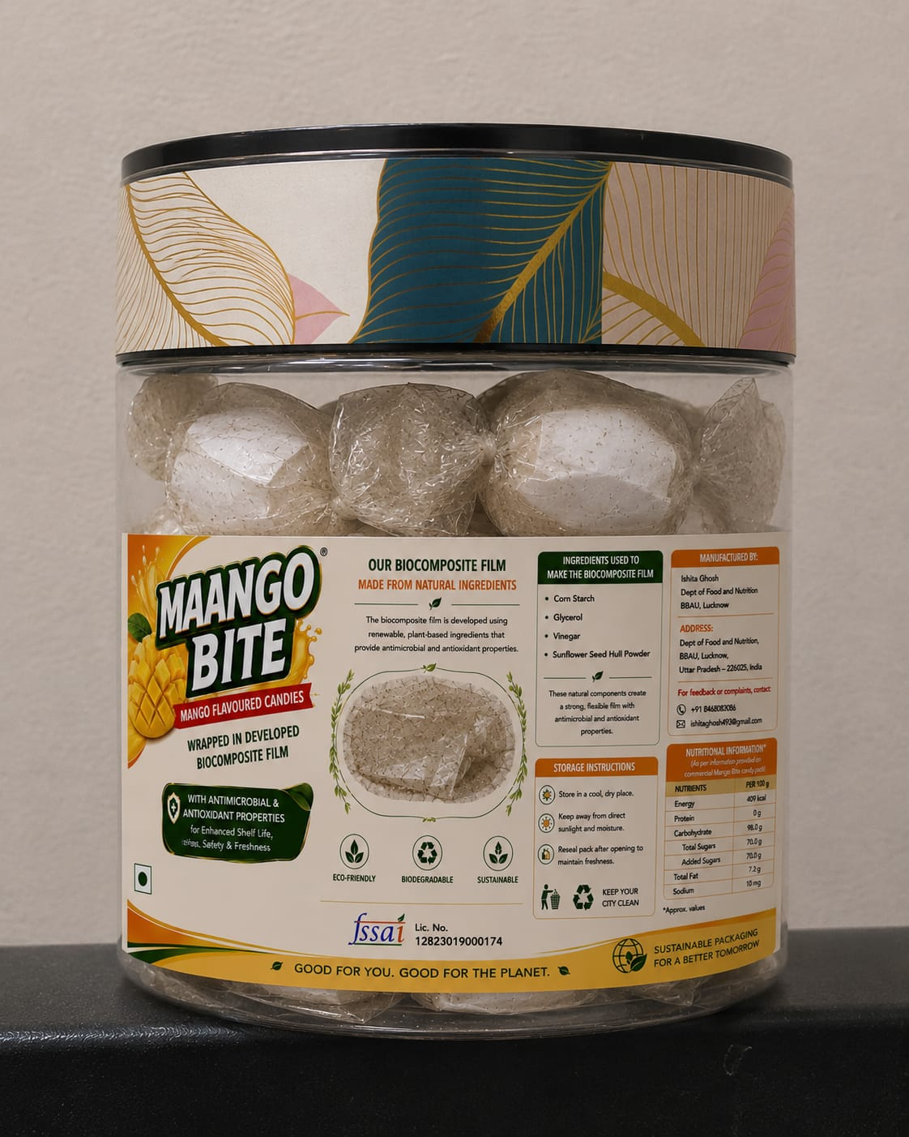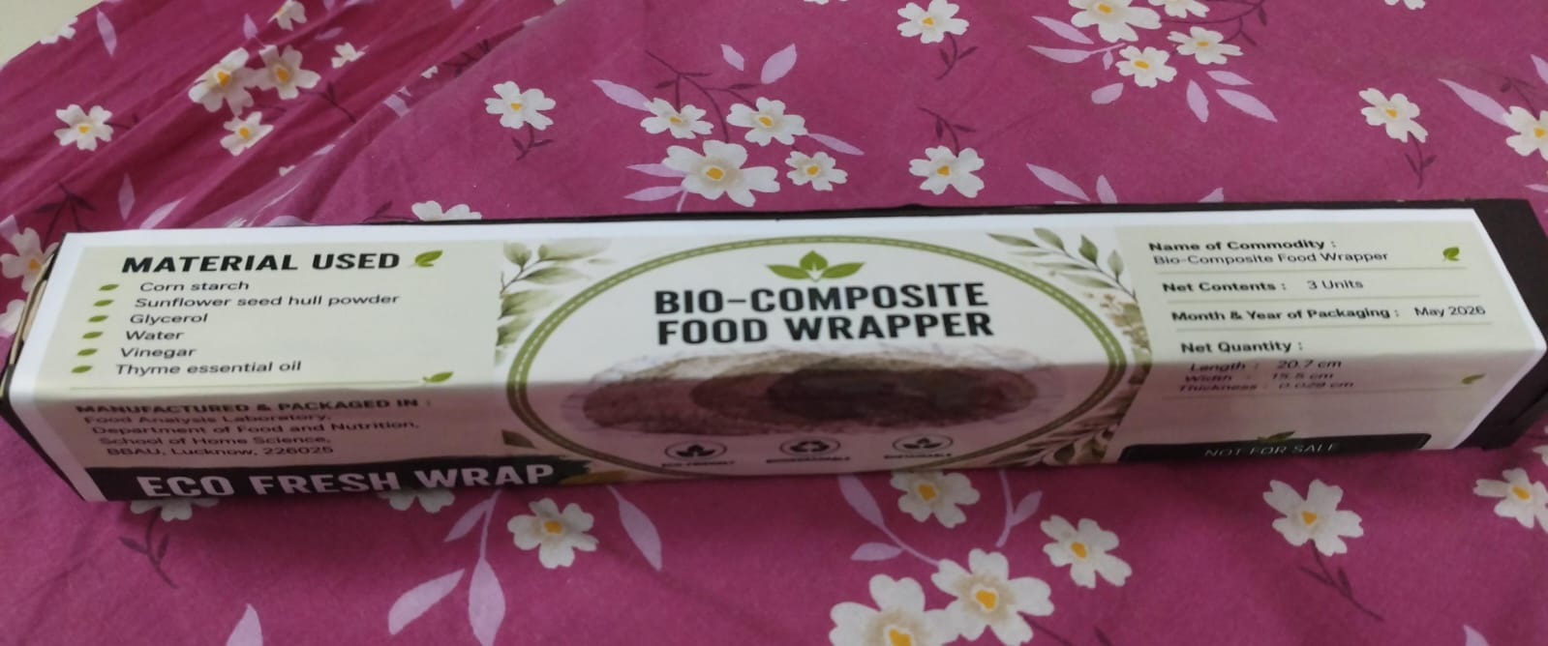
Figure 2. Demonstration of Mango Bite candy packaging and labelled food wrapper developed using the prepared OBF.
4. Conclusion
The present study evaluated the production cost, commercial feasibility, and food packaging application of an optimized corn starch-based bio-composite film reinforced with sunflower seed hull powder and thyme essential oil. The total production cost of the optimized film was estimated under laboratory-scale conditions, revealing that raw materials constituted the major proportion of the manufacturing cost, while energy, labour, and equipment contributed comparatively smaller amounts. Although the developed biocomposite film exhibited a higher production cost than conventional petroleum-based packaging materials, its biodegradable nature, utilization of renewable resources, and incorporation of an agricultural by-product highlight its potential as an environmentally sustainable packaging alternative.
The commercial feasibility assessment indicated that the availability of corn starch and sunflower seed hull powder, together with the possibility of reducing production costs through process optimization and industrial-scale manufacturing, supports the future commercialization of the developed film. Furthermore, the packaging application demonstrated that the optimized film (OBF) possessed satisfactory flexibility, handling characteristics, and structural integrity for packaging Mango Bite candies under ambient storage conditions, indicating its suitability for confectionery packaging applications. Overall, the developed bio-composite film represents a promising sustainable alternative to conventional plastic packaging. Future research should focus on pilot-scale production, comprehensive shelf-life studies with different food products, and techno-economic optimization to facilitate its industrial implementation.
Study Limitations
This study has certain limitations that should be considered while interpreting the findings. The techno-economic analysis was performed under laboratory-scale production conditions; therefore, the estimated production cost may differ from industrial-scale manufacturing where bulk procurement, process automation, and continuous production systems can substantially reduce costs. The packaging application was evaluated only as a secondary packaging material for commercially packaged Mango Bite candies under ambient storage conditions for 15 days, and no quantitative shelf-life, microbiological, or sensory analyses were performed. Furthermore, the commercial feasibility assessment was qualitative and did not include detailed market demand analysis, life cycle assessment, consumer acceptance studies, or industrial-scale economic modelling. Future research should focus on pilot-scale production, long-term storage studies with different food products, comprehensive economic modelling, and life cycle assessment to further validate the commercial applicability of the developed bio-composite film.
Conflict of Interest
The authors declared no potential conflict of interest with respect to the authorship and publication.

Ethics approval
Not applicable. No ethical approvals were required for this study as it did not involve human or animal subjects.

Consent to participate
Not applicable. This research did not involve human participants.

Consent for publication
All authors provide their consent for publication of this manuscript.

Permission to Reproduce Material from Other Sources
Permission to reproduce any material from other sources, including figures, tables, or text, has been obtained from the respective copyright holders and is duly acknowledged in this work.

Availability of data and material
The datasets generated and analyzed during the current study are available from the corresponding author on reasonable request.

Code availability
Not applicable. No software applications or custom codes were used in this research.

Declaration of AI Use

This manuscript was prepared through the combined contributions of all author(s), including contributions to the study design, data, content development, results, interpretation, and related scholarly work. The author(s) acknowledge the use of Grammarly and ChatGPT to assist with grammar checking, language refinement, reference formatting. These AI-assisted tools were not used as authors and did not replace the intellectual contributions or scholarly judgment of the author(s). All AI-assisted outputs, including content, references, and interpretations, were carefully reviewed, revised, verified, and approved by the author(s). The author(s) accept full responsibility for the accuracy, integrity, and final content of the manuscript.

COMPETING INTERESTS DISCLAIMER:
Authors have declared that they have no known competing financial interests OR non-financial interests OR personal relationships that could have appeared to influence the work reported in this paper.

References
- Gupta, V., Biswas, D. and Roy, S., 2022. A comprehensive review of biodegradable polymer-based films and coatings and their food packaging applications. Materials, 15(17), p.5899.
- Dirpan, A., Ainani, A.F. and Djalal, M., 2023. A review on biopolymer-based biodegradable film for food packaging: trends over the last decade and future research. Polymers, 15(13), p.2781.
- Muñoz, F.L., Gaiardo, R.B., Bahú, J.O., Ribeiro, V.S., Carvalho, R.M., Sato, A.Y., Almeida, M.G., Cozzolino, G.F., Carvalho, L.F., Yoshida, C.M. and Souto, E.B., 2026. Biodegradable food packaging: Carbon footprint reduction, technical and market challenges. Sustainable Futures, 11, p.101748.
- Bócoli, P.F.J., Gomes, V.E.D.S., Maia, A.A.D. and Marangoni Júnior, L., 2025. Perspectives on Eco-Friendly food packaging: challenges, solutions, and trends. Foods, 14(17), p.3062.
- Moshood, T.D., Nawanir, G. and Mahmud, F., 2022. Sustainability of biodegradable plastics: a review on social, economic, and environmental factors. Critical Reviews in Biotechnology, 42(6), pp.892-912.
- Sabet, M., 2025. Exploring biodegradable polymer composites for sustainable packaging: a review on properties, manufacturing techniques, and environmental impacts. Iranian Polymer Journal, 34(1), pp.123-142.
- Tassinari, G., Bassani, A., Spigno, G., Soregaroli, C. and Drabik, D., 2023. Do biodegradable food packaging films from agro-food waste pay off? A cost-benefit analysis in the context of Europe. Science of the Total Environment, 856, p.159101.
- Drago, E., Campardelli, R. and Perego, P., 2024. Sustainable development of biodegradable antimicrobial electrospun membranes for active food packaging and economic analysis. Advanced Sustainable Systems, 8(12), p.2400360.
- Mangaraj, S., Yadav, A., Bal, L.M., Dash, S.K. and Mahanti, N.K., 2019. Application of biodegradable polymers in food packaging industry: A comprehensive review. Journal of Packaging Technology and Research, 3(1), pp.77-96.
- Westlake, M.F., Hillman, S., Kerr-Davis, A., Viziteu, A., Silver, M. and Dykiert, D., 2023. A systematic review and meta-analysis of the type and prevalence of mental health disorders and symptoms among children living in residential care. Developmental Child Welfare, 5(4), pp.223-246.
- Mohammed, A., Ward, K., Lee, K.Y. and Dupont, V., 2023. The environmental impact and economic feasibility assessment of composite calcium alginate bioplastics derived from Sargassum. Green Chemistry, 25(14), pp.5501-5516.
- Weligama Thuppahige, V.T. and Karim, M.A., 2022. A comprehensive review on the properties and functionalities of biodegradable and semibiodegradable food packaging materials. Comprehensive Reviews in Food Science and Food Safety, 21(1), pp.689-718.
- George, A.S. and George, A.H., 2023. Biodegradable ecofriendly sustainable tableware and packaging: A comprehensive review of materials, manufacturing, and applications. Partners Universal International Research Journal, 2(2), pp.202-228.
- Birania, S., Kumar, S., Kumar, N., Attkan, A.K., Panghal, A., Rohilla, P. and Kumar, R., 2022. Advances in development of biodegradable food packaging material from agricultural and agro‐industry waste. Journal of Food Process Engineering, 45(1), p.e13930.
- Kossalbayev, B.D., Belkozhayev, A.M., Abaildayev, A., Kadirshe, D.K., Tastambek, K.T., Kurmanbek, A. and Toleutay, G., 2025. Biodegradable packaging from agricultural wastes: a comprehensive review of processing techniques, material properties, and future prospects. Polymers, 17(16), p.2224.
- Cristofoli, N.L., Lima, A.R., Tchonkouang, R.D., Quintino, A.C. and Vieira, M.C., 2023. Advances in the food packaging production from agri-food waste and by-products: market trends for a sustainable development. Sustainability, 15(7), p.6153.
- Selvam, T., Rahman, N.M.M.A., Olivito, F., Ilham, Z., Ahmad, R. and Wan-Mohtar, W.A.A.Q.I., 2025. Agricultural waste-derived biopolymers for sustainable food packaging: challenges and future prospects. Polymers, 17(14), p.1897.
- Yang, Y., Seo, K., Kim, J. and Won, W., 2025. Biodegradable plastic production: economic and environmental perspective. ACS Sustainable Chemistry & Engineering, 13(2), pp.923-935.
- Yudanto, Y.A. and Opaprakasit, P., 2023. Optimization of the supercritical carbon dioxide foaming process for biodegradable polylactide using response surface methodology (No. 311596). Thammasat University.
- Hussain, M.A., Mishra, S., Agrawal, Y., Rathore, D. and Chokshi, N.P., 2024. A comparative review of biodegradable and conventional plastic packaging. Interactions, 245(1), p.126.
- Nirvana, J.R.K., Amrullah, S. and Abiyyuddin, M.F., 2025. Preliminary Techno-Economic Feasibility of Biodegradable Food Packaging from Luffa Acutangula Peel in Indonesia. Buletin Penelitian Sosial Ekonomi Pertanian Fakultas Pertanian Universitas Haluoleo, 27(2), pp.199-212.
- de Jong, E., Goumans, I., Visser, R., Puente, Á. and Gruter, G.J., 2025. The Opportunities and Challenges of Biobased Packaging Solutions. Polymers, 17(16), p.2217.
- Schick, S., Heindel, J., Groten, R. and Seide, G.H., 2024. Overcoming challenges in the commercialization of biopolymers: from research to applications—a review. Polymers, 16(24), p.3498.
- Possidónio, C., Farias, A.R., Domingos, S., Cruz, B., Luís, S. and Loureiro, A., 2025. Exploring supply-side barriers for commercialization of new biopolymer production technologies: a systematic review. Sustainability, 17(3), p.820.
- Bie, M., Zhao, W., Dong, H., Gu, Y., Yuan, S. and Song, K., 2025. From Agricultural Waste to Recyclable Biodegradable Packaging: A Systematic and Bibliometric Review. Sustainability, 17(23), p.10742.
- Patel, M., Marscheider-Weidemann, F., Schleich, J., Hüsing, B., Angerer, G., Wolf, O., Crank, M. and Patel, M., 2005. Techno-economic feasibility of large-scale production of bio-based polymers in Europe. Techncial Report EUR, 22103.
- Jha, S., Akula, B., Enyioma, H., Novak, M., Amin, V. and Liang, H., 2024. Biodegradable biobased polymers: a review of the state of the art, challenges, and future directions. Polymers, 16(16), p.2262.
- Onyeaka, H., Obileke, K., Makaka, G. and Nwokolo, N., 2022. Current research and applications of starch-based biodegradable films for food packaging. Polymers, 14(6), p.1126.
- Gupta, P., Toksha, B. and Rahaman, M., 2022. A review on biodegradable packaging films from vegetative and food waste. The Chemical Record, 22(7), p.e202100326.
- Varghese, S.A., Pulikkalparambil, H., Promhuad, K., Srisa, A., Laorenza, Y., Jarupan, L., Nampitch, T., Chonhenchob, V. and Harnkarnsujarit, N., 2023. Renovation of agro-waste for sustainable food packaging: a review. Polymers, 15(3), p.648.
- Boz, Z., Korhonen, V. and Koelsch Sand, C., 2020. Consumer considerations for the implementation of sustainable packaging: A review. Sustainability, 12(6), p.2192.
- Branca, G., Resciniti, R. and Babin, B.J., 2024. Sustainable packaging design and the consumer perspective: a systematic literature review. Italian Journal of Marketing, 2024(1), pp.77-111.
- Din, M.I., Ghaffar, T., Najeeb, J., Hussain, Z., Khalid, R. and Zahid, H., 2020. Potential perspectives of biodegradable plastics for food packaging application-review of properties and recent developments. Food Additives & Contaminants: Part A, 37(4), pp.665-680.
- Gupta, V., Biswas, D. and Roy, S., 2022. A comprehensive review of biodegradable polymer-based films and coatings and their food packaging applications. Materials, 15(17), p.5899.
- Mangaraj, S., Yadav, A., Bal, L.M., Dash, S.K. and Mahanti, N.K., 2019. Application of biodegradable polymers in food packaging industry: A comprehensive review. Journal of Packaging Technology and Research, 3(1), pp.77-96.

