Characterization of Starch and Assessment of Plant Extracts for Antioxidant-Based Edible Film Production.

ABSTRACT
This study was conducted on comprehensive characterization of starches from locally abundant botanical sources—plantain (Musa paradisiaca) and yam (Dioscorea rotundata), with commercial corn starch (Zea mays) as a control—to evaluate their suitability as biopolymer matrices for edible films. Concurrently, the antioxidant potential of extracts from avocado (Persea americana), ginger (Zingiber officinale), and garlic (Allium sativum) was assessed to identify effective natural additives for developing active packaging systems. Starches were isolated using a standardized aqueous sedimentation method, while bioactive extracts were obtained via solvent-assisted maceration and hexane extraction. The materials were subjected to a suite of analyses, including physicochemical characterization (pH, moisture content, swelling power, solubility), structural analysis (Fourier Transform Infrared Spectroscopy, FTIR), morphological visualization (Scanning Electron Microscopy, SEM), and a battery of antioxidant assays (DPPH, ABTS, and FRAP). The results revealed statistically significant (p < 0.05) differences in the functional properties of the starches. Notably, plantain starch exhibited the lowest swelling power (1.05 mL/g) and a favorable moderate solubility (10.87%), indicating a high degree of granular rigidity and optimal potential for forming a water-resistant, cohesive film. This superior functional balance was strongly supported by structural analysis; SEM micrographs revealed that plantain starch granules were uniquely oval, smooth, and structurally intact, in stark contrast to the irregular, porous granules of yam and the smaller, polygonal granules of corn. FTIR analysis further indicated a well-ordered molecular structure in plantain starch, confirming its high potential for forming a cohesive and stable film matrix. Antioxidant assays confirmed that all three plant extracts were potent, with ginger extract demonstrating the most versatile and powerful radical scavenging activity, excelling in both the DPPH and FRAP assays. Collectively, this study concludes that plantain starch is the most promising biopolymer candidate for edible film production due to its uniquely balanced physicochemical properties and superior granular morphology. The incorporation of a potent antioxidant, such as ginger extract, into this optimized plantain starch matrix presents a scientifically sound and sustainable pathway for developing eco-friendly, active packaging materials. These findings provide a crucial foundation for the valorization of local agricultural resources, offering a viable alternative to synthetic plastics that can enhance food preservation and contribute to a circular bioeconomy.
Keywords: Starch characterization, plant extracts, antioxidant activity, plantain starch, edible film, biodegradable packaging.

Introduction
The 21st century is marked by unparalleled technical progress, but it also faces a widespread environmental problem: plastic waste. Petroleum-based synthetic plastics, such polyethylene and polypropylene, have been a major component of the worldwide food industry's packaging for decades. These materials have gained popularity due to their affordability, adaptability, and remarkable durability, which effectively safeguard food products (Sanyang et al., 2016). However, a significant and long-lasting environmental crisis stems from the very durability that makes them commercially appealing. Synthetic polymers can endure in the environment for hundreds to thousands of years since they are naturally resistant to deterioration.
Due to its lifetime, plastic debris has accumulated excessively in both terrestrial and aquatic ecosystems, creating enormous garbage patches in the ocean and contaminating landscapes on a large scale (Hassan et al., 2019). By penetrating soil, water systems, and the global food chain, these items break down into smaller pieces known as microplastics, which worsen the issue and pose subtle threats to human health and biodiversity (Sharma et al., 2021).
Plastic pollution is a particularly serious issue in developing countries like Nigeria. Plastic garbage, particularly from single-use packaging, is overwhelming municipal systems due to rapid urbanization and insufficient waste disposal infrastructure (Adeleke et al., 2020).
One of the main causes of environmental deterioration is plastic packaging, which makes up a significant amount of the country's plastic usage. Urban drainage systems are clogged by discarded plastic bags, bottles, and food wrappers, which exacerbates the effects of seasonal flooding and provides breeding grounds for disease vectors. This plastic garbage eventually finds its way into marine habitats in coastal and riverine communities, endangering aquatic life and the livelihoods of people who depend on it (Ayinde et al., 2022). A global change in scientific and industrial attention toward the development of sustainable, eco-friendly alternatives generated from renewable resources has been sparked by the pressing need to address these complex environmental, social, and public health repercussions.
Biodegradable and edible films made from natural biopolymers have become one of the most promising answers to this worldwide need (Falguera et al., 2011). These substances, which come from biological sources including lipids, proteins, and polysaccharides, are made to break down organically and reintegrate into the environment without leaving behind any hazardous residue. Starch has attracted a lot of interest among the many biopolymers as a perfect option for developing environmentally friendly packaging materials (Mali et al., 2018). As one of the most prevalent organic substances on Earth, starch is an inexpensive and easily accessible raw resource. The circular economy's tenets are ideally aligned with its renewable nature and innate biodegradability. Appropriate for use in packaging (Rhim, 2021). Furthermore, the unique molecular structure of starch grants it excellent film-forming capabilities, allowing it to be processed into thin, transparent, and flexible layers suitable for packaging applications (Rhim, 2021).
Nigeria's staple crops, which are essential to the country's food security, provide a huge and mainly unexplored pool of starch. All throughout the nation, crops like corn, yams, and plantains are widely grown (Falade and Oyeyinka, 2015). However, a large amount of this agricultural produce is not consumed due to severe post-harvest losses. The strategic opportunity to develop new value chains, cut waste, and boost rural economies is provided by the value-adding of these crops for non-food uses (Adebowale et al., 2019). The unique ratio of its constituent macromolecules—linear amylose and highly branched amylopectin—determines the mechanical characteristics, water resistance, and overall stability of starch-based film, making its botanical origin crucial to its functional performance (Wang et al., 2015).
Although natural starch films can act as a physical barrier, "active" packaging methods can be made by greatly improving their performance. In order to actively enhance the quality and prolong the shelf life of the packed food, active packaging goes beyond passive confinement (Otoni et al., 2017). This is accomplished by adding bioactive substances to the film matrix, especially antioxidants. One of the main causes of food spoiling is oxidative deterioration, which results in the production of off-flavors (rancidity), the breakdown of vital nutrients, and a decline in product quality. By neutralizing free radicals and preventing oxidative chain reactions, antioxidants stop this process (Jongjareonrak et al., 2018).
Growing consumer desire for "clean-label" and less processed foods has led to a preference for natural antioxidants derived from plant extracts over synthetic alternatives. Strong antioxidant chemicals can be found in abundance in locally accessible sources including avocado (Persea americana), ginger (Zingiber officinale), and garlic (Allium sativum). Garlic is well-known for its high concentration of organosulfur compounds like allicin; avocado oil is rich in carotenoids and tocopherols (vitamin E); and ginger includes potent phenolic compounds like gingerols (Abrahão et al., 2019; Irondi et al., 2017). When these extracts are incorporated into a starch-based film, it can be transformed from a basic biodegradable wrapper into an advanced delivery system that actively preserves food.
Therefore, this work starts a basic investigation to evaluate the antioxidant capacity of extracts from avocado, ginger, and garlic as well as to systematically describe starches from plantain, yam, and corn. The main objective is to produce the basic scientific information needed to assess these locally available raw materials' feasibility for the production of high-performance, antioxidant-based edible films in the future.
An essential step toward environmental sustainability is the switch from synthetic plastics to biodegradable films based on starch. However, there are major functional and technical obstacles to this change. Despite being environmentally beneficial, native starch films frequently have intrinsic drawbacks that hinder their extensive industrial use.
When used to package high-moisture goods, their hydrophilic nature renders them extremely susceptible to moisture, resulting in a loss of mechanical integrity and barrier function. Additionally, they often have poor mechanical qualities including low tensile strength and brittleness, which make them less durable when handled, transported, and stored (Jiménez et al., 2012). These shortcomings require adjustments to bring their performance up to line with that of their synthetic counterparts.
Both basic biopolymer films and traditional plastic packaging are functionally passive outside of these structural constraints. They just serve as physical barriers, ignoring the chemical and biological processes that are the main causes of food deterioration, such as oxidation and microbial growth.
The majority of packaging materials lack this active preservation potential, despite the fact that preventing oxidative deterioration is essential for preserving food products' nutritional value, sensory appeal, and shelf life. A workable way to provide this essential functionality is to incorporate natural antioxidant extracts into the film matrix.
The systematic and comparative characterization of starches from important Nigerian agricultural staples—plantain, yam, and corn—for this particular application is still lacking, despite the obvious potential. It is challenging to choose the best biopolymer basis for a particular application since the distinct physicochemical and structural characteristics of starches from these sources are not well-documented in a comparative perspective.
Furthermore, little information is available regarding the compatibility and potential for synergy between these particular starches and locally relevant antioxidant extracts, such as those from avocado, ginger, and garlic. It is essential to comprehend how the intrinsic characteristics of the starch matrix affect the stability and effectiveness of integrated antioxidants. By offering a methodical assessment of these raw minerals, this study seeks to close this crucial gap. In order to successfully formulate functional, bioactive edible films that properly utilize local resources, such an investigation is a crucial precondition. This study's primary goals are to assess the antioxidant capability of extracts from avocado, ginger, and garlic for their appropriateness in the creation of antioxidant-based edible films and to define the physicochemical and structural characteristics of starches derived from plantains, yams, and corn.
The characterization and assessment of raw materials meant for the creation of edible films based on antioxidants was the main focus of this investigation. The study specifically looked at plant extracts from avocado (Persea americana), ginger (Zingiber officinale), and garlic (Allium sativum), as well as starches taken from plantains (Musa paradisiaca), yams (Dioscorea rotundata), and corn (Zea mays).
Materials and Methods

Materials
Fresh unripe plantain fingers (Musa paradisiaca), white yam tubers (Dioscorea rotundata), and dry corn grains (Zea mays) were procured from Eziobodo Market, a major local market in Owerri, Imo State, Nigeria. Upon procurement, all samples were rigorously sorted and selected based on criteria of uniform physiological maturity, freshness, and the complete absence of physical damage or microbial decay. Fresh garlic bulbs (Allium sativum), ginger rhizomes (Zingiber officinale), and ripe avocado fruits (Persea americana) were purchased from Onitsha Main Market, Anambra State, Nigeria. These were similarly selected for their high quality and freshness to serve as the sources for the natural bioactive extracts.
All chemicals and reagents used in this study were of analytical grade to ensure the accuracy of the experimental results. Food-grade ethanol (95%) and n-hexane (99%) were obtained from the central repository of the Food Science and Technology Laboratory, Federal University of Technology, Owerri (FUTO). Reagents for the antioxidant assays, including 2,2-diphenyl-1-picrylhydrazyl (DPPH), 2,2'-azino-bis(3-ethylbenzothiazoline-6-sulfonic acid) (ABTS), and components of the Ferric Reducing Antioxidant Power (FRAP) reagent, were procured from certified chemical suppliers. Distilled water was used as the solvent and dispersing medium for all aqueous preparations. All glassware was meticulously cleaned, rinsed with distilled water, and oven-dried at 105 °C prior to use to prevent any potential contamination. The methodologies for sourcing and preparing raw materials were consistent with established protocols reported in similar studies (Bello-Pérez et al., 2020; Oyeyinka et al., 2018).
A combination of common and specialized laboratory equipment was used to carry out the experiment. A magnetic stirrer with an integrated hot plate (VELP Scientifica, Italy) for controlled heating and mixing, a high-speed blender (Binatone, Nigeria) for homogenizing plant tissues, a hot-air oven (Memmert UN55, Germany) for drying samples, and a precision analytical balance (Mettler Toledo, Switzerland) for all gravimetric measurements were among the basic equipment.
Specialized analytical instruments were employed for structural and functional characterization. Molecular functional group analysis was performed using a Fourier Transform Infrared (FTIR) Spectrophotometer (PerkinElmer Spectrum 100, USA). The surface morphology of the starch granules was visualized using a Scanning Electron Microscope (SEM) (Zeiss EVO MA10, Germany). The determination of antioxidant activity was carried out using a UV–Visible Spectrophotometer (Shimadzu UV-1800, Japan).
All FTIR and SEM analyses were conducted at the state-of-the-art facilities of the African Centre of Excellence in Future Energies and Electrochemical Systems (ACE-FUELS), FUTO, Nigeria. The antioxidant assays were performed at the Biochemistry and Food Chemistry Research Laboratory, Michael Okpara University of Agriculture, Umudike (MOUAU), Nigeria.

Preparation and Extraction of Starches
Native starches were extracted from plantain and yam using a modified aqueous sedimentation method designed to maximize purity while preserving the native granular structure. The protocol, adapted from Oyeyinka et al. (2018) and Olu-Owolabi et al. (2014), was as follows:
Preparation: To get rid of soil and surface impurities, freshly purchased unripe plantain fingers and yam tubers were properly cleaned under running tap water. To enhance the surface area for effective mixing, they were then peeled and cut into tiny cubes or pieces (about 2–3 mm thick).
Homogenization: To produce a fine, uniform slurry, the sliced material was homogenized with distilled water at a 1:2 (w/v) ratio in a high-speed blender for five minutes. In order to release the intracellular starch granules and break through the plant cell walls, this step was essential.
Filtration: To separate the starch-rich aqueous solution (filtrate) from the coarse fibrous pulp (residue), the resulting slurry was filtered through two layers of muslin fabric.
Sedimentation and Purification: The filtrate was gathered in big beakers and left at room temperature for six hours without being disturbed. Gravity caused the denser starch granules to sink to the bottom during this time. After being carefully decanted, the supernatant—which contained proteins, soluble carbohydrates, and other contaminants—was thrown away. To improve the starch sediment's purity, this washing and decantation procedure was carried out three times using brand-new distilled water.
Drying and Pulverization: After the final purified starch sediment was spread thinly on stainless steel trays, it was dried for 24 hours at a regulated temperature of 50 °C in a hot-air oven.
This comparatively low temperature was selected to avoid the starch's early gelatinization and thermal deterioration. Using a clean ceramic mortar and pestle, the dried starch cake was then ground into a fine powder and sieved through a 250 µm mesh sieve to guarantee a consistent particle size. Until it was needed for analysis, the finished starch powder was kept at room temperature in airtight, labeled plastic containers.

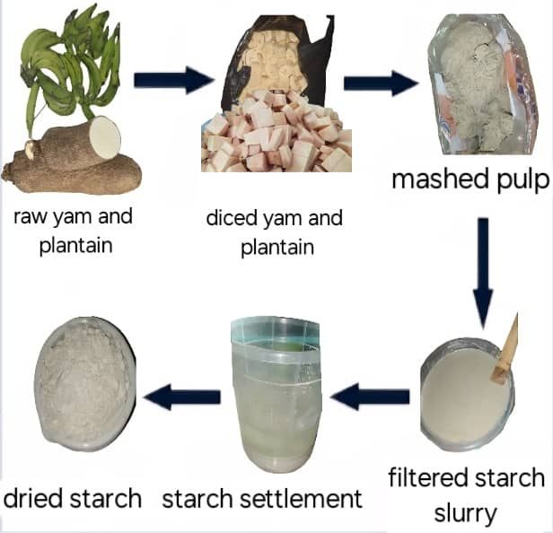

Figure.1: Starch Preparation and Extraction
A commercially available, food-grade maize starch (Zea mays) served as the control sample for this comparison investigation. It was employed straight away, without any additional extraction or alteration, after being bought from a reliable supplier. Since corn starch is the most extensively researched and industrially used starch in the world, it was chosen as the control so that the characteristics of the unconventional plantain and yam starches could be accurately compared and assessed.
Extraction of Plant-Based Bioactive Extracts
In order to efficiently isolate target antioxidant molecules while reducing their degradation, bioactive compounds were recovered from avocado, garlic, and ginger utilizing solvent-assisted maceration and hexane extraction techniques. An ethanolic maceration method, modified from Prasad et al. (2015) and Qiu et al. (2009), was used to extract polar and semi-polar bioactive chemicals from ginger and garlic. Garlic cloves and fresh ginger rhizomes were cleaned, peeled, and ground into a fine paste. A 1:5 (w/v) ratio of 95% food-grade ethanol was used to soak a weighed piece of each paste (1250 g for ginger and 1000 g for garlic). To improve solvent penetration and promote mass transfer of bioactive chemicals, the solutions were kept in sealed containers at room temperature for 72 hours while being periodically stirred.
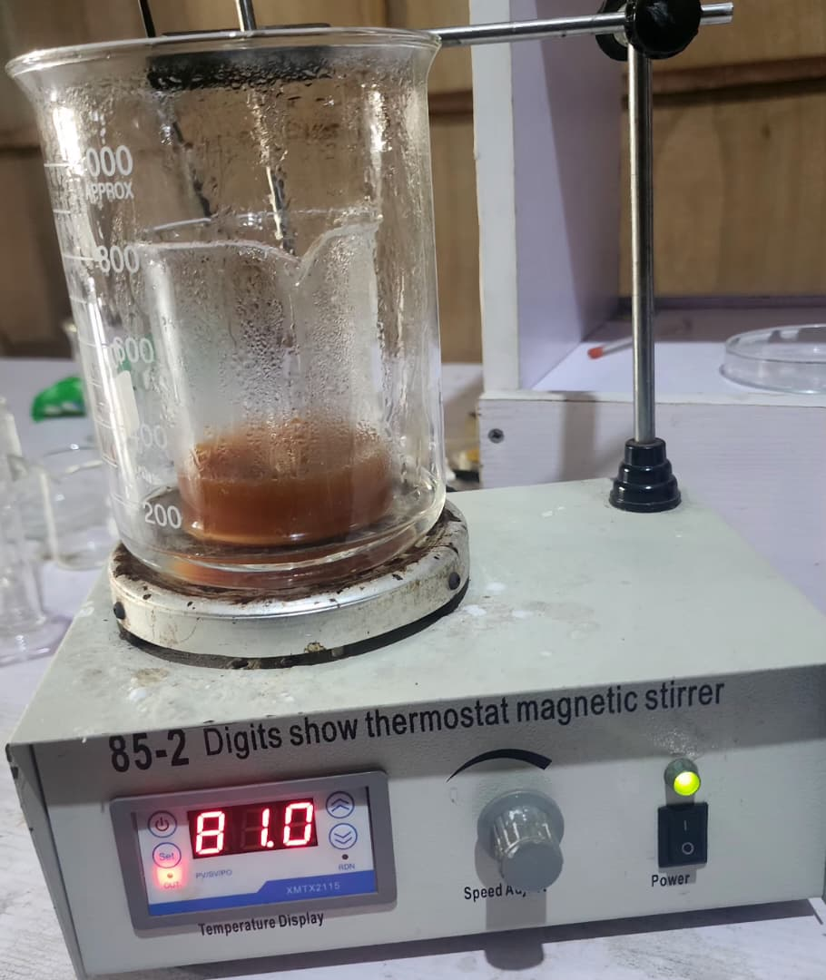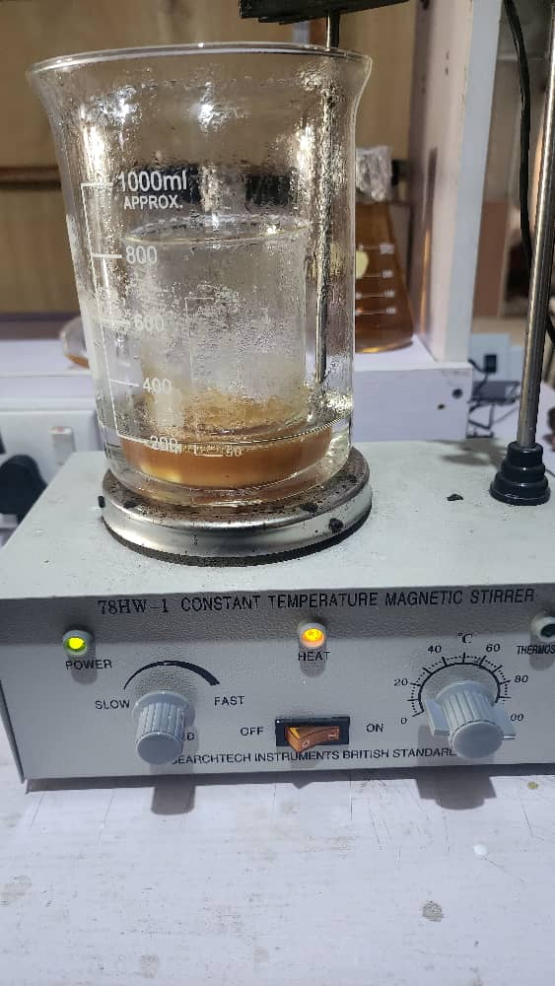
Figure 2. Ginger extract Figure 3: Garlic extract
The mixtures were filtered to remove the solid plant residue from the ethanol extract after the maceration phase. A rotary evaporator operating at 40 °C was used to concentrate the resultant filtrate at low pressure. By gently heating the water bath to 60 °C, the last traces of solvent were eliminated. Until they were needed for antioxidant analysis, the viscous, concentrated extracts were moved to sealed amber glass bottles and kept at 4 °C to prevent photodegradation and heat breakdown of labile bioactive chemicals.
Using hexane, a non-polar solvent, the lipid-soluble fraction—mainly oil—was extracted from ripe avocado fruit using a technique modified from Matanjun et al. (2019). In order to reduce surface moisture, the pulp from ripe avocados was scooped out and thinly spread out on a tray to air dry for a brief amount of time.
After that, a known weight of pulp was soaked for 48 hours in analytical-grade n-hexane at a 1:2 (w/v) ratio. Crude avocado oil was recovered by filtering the mixture and using a rotary evaporator to remove the solvent from the filtrate. The oil was kept in storage with the same safeguards as the other extracts.
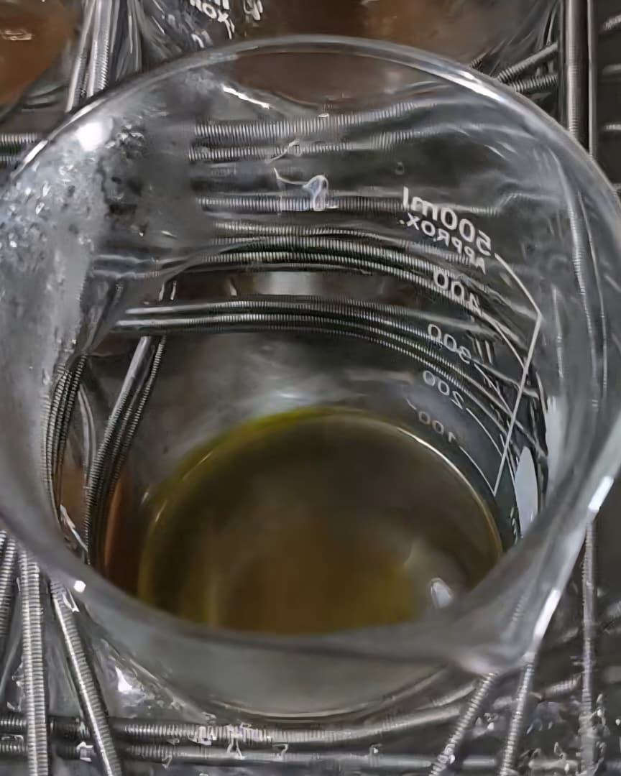

Figure 4: Avocado extract

Physicochemical Characterization of Starch Samples
The AOAC (2016) Official Method was followed in determining the pH of the starch samples. Ten grams of each starch sample were dispersed in one hundred milliliters of distilled water to create a 10% (w/v) starch slurry. After 30 minutes of constant stirring, the suspension was left to equilibrate at room temperature for an hour. A calibrated digital pH meter (Hanna Instruments, HI 2211) was used to determine the supernatant's pH.
The conventional oven-drying gravimetric method was used to calculate the moisture content of the starch granules (AOAC, 2016). A pre-dried, tared crucible was filled with precisely 2 g of each starch sample. After that, the samples were dried in a hot-air oven at 105 °C for around 24 hours to reach a consistent weight.
The crucibles were cooled to room temperature in a desiccator before final weighing. The moisture content was calculated as the percentage loss in weight.
The swelling power and solubility of the starch samples were determined simultaneously using the method described by Leach et al. (1959) with slight modifications. A 1% (w/v) aqueous suspension of starch (1 g in 100 mL of distilled water) was prepared in a centrifuge tube. For thirty minutes, the suspension was heated to 85 °C in a thermostatically controlled water bath while being gently stirred continuously. After cooling to ambient temperature, the tubes were centrifuged for 15 minutes at 3000 rpm. The weight of the enlarged sediment was noted after the supernatant was gently decanted onto an evaporating dish that had been previously weighed. The weight of the swollen sediment divided by the initial dry weight of the starch was used to compute swelling power (g/g). After that, the decanted supernatant was dried off in an oven set at 105 °C. The solubilized starch was represented by the weight of the dried residue. The percentage of this residue in relation to the original dry weight of the starch was used to compute solubility (%).
Structural and Morphological Analysis
A PerkinElmer Spectrum 100 FTIR spectrophotometer was used to examine the molecular functional groups and chemical structure of the native starch samples. For examination, 200 mg of spectroscopic-grade potassium bromide (KBr) and a tiny quantity of dry starch powder (about 2 mg) were well combined. A hydraulic press was then used to compress the mixture into a thin, clear pellet. Each sample's FTIR spectra was captured at a resolution of 4 cm⁻¹ in the mid-infrared range of 4000 cm⁻¹ to 400 cm⁻¹. The distinctive absorption bands that corresponded to the functional groups found in starch were found by analyzing the resulting spectra.
A Zeiss EVO MA10 Scanning Electron Microscope was used to analyze the native starch granules' surface morphology, size, and shape. Double-sided adhesive carbon tape was used to attach dry starch powder to an aluminum stub. After that, a tiny layer of gold was sputter-coated onto the samples under vacuum to make them electrically conductive and stop them from charging under the electron beam. The coated samples were examined under a 15 kV accelerating voltage in the SEM. To visualize the granular architecture in detail, high-resolution digital micrographs were taken at different magnifications (from × 500 to ×2000).

Determination of Antioxidant Activity
The antioxidant capacity of the ginger, garlic, and avocado extracts was fully evaluated using three complementary spectrophotometric assays: DPPH, ABTS, and FRAP.
The extracts' ability to scavenge the stable 2,2-diphenyl-1-picrylhydrazyl (DPPH) free radical was evaluated using the method described by Brand-Williams et al. (1995). To put it briefly, 1 mL of each extract that had been appropriately diluted was mixed with 1 mL of a 0.1 mM methanolic solution of DPPH. The mixture was vortexed and then allowed to sit in the dark at room temperature for 30 minutes. The reduction of the DPPH radical was measured by comparing the absorbance at 517 nm to a methanol blank. The scavenging activity was determined using the percentage inhibition of the DPPH radical.
The ABTS assay was carried out using the Re et al. (1999) method. By mixing an aqueous solution of ABTS with potassium persulfate and letting the mixture stand in the dark for 12 to 16 hours, the ABTS radical cation (ABTS•⁺) was produced. After diluting the resulting blue-green ABTS•⁺ solution with methanol, the absorbance at 734 nm was 0.70 ± 0.02. The absorbance was measured after 6 minutes of reaction between 1 mL of each extract and 1 mL of the diluted ABTS•⁺ solution. The percentage inhibition of the scavenging action was computed.
Benzie and Strain's (1996) FRAP assay was used to measure the extracts' reducing power. Acetate buffer (300 mM, pH 3.6), a solution of 10 mM TPTZ in 40 mM HCl, and 20 mM FeCl₃•6H₂O were combined in a 10:1:1 ratio to create the FRAP reagent. The freshly made reagent was preheated to 37 °C. 0.1 mL of each extract and 3.0 mL of the FRAP reagent were combined for the test. Following a 4-minute incubation time, the reaction mixture's absorbance was measured at 593 nm. The findings were presented as molar equivalents of a common antioxidant, such as Trolox or FeSO₄.

Statistical Analysis
Each experiment was conducted in triplicate (n = 3), and the results were presented using the mean ± standard deviation (SD). The data was statistically analyzed using the IBM SPSS Statistics software package (Version 25). A one-way Analysis of Variance (ANOVA) was used to determine whether the means of the different sample groups varied statistically substantially. When significant differences were found, post-hoc pairwise comparisons of the means were conducted using Tukey's Honestly Significant Difference (HSD) test. A p-value of less than 0.05 (p < 0.05) was considered statistically significant.

Results and Discussion
This section presents the experimental findings from the characterization of starches extracted from plantain (Musa paradisiaca), yam (Dioscorea rotundata), and corn (Zea mays), as well as the evaluation of the antioxidant properties of extracts from avocado (Persea americana), ginger (Zingiber officinale), and garlic (Allium sativum). The results are systematically presented, interpreted, and discussed in the context of their implications for the development of antioxidant-based edible films. All analyses were performed in triplicate, and the data were subjected to a one-way Analysis of Variance (ANOVA) to determine statistical significance (p < 0.05).

Physicochemical Properties of Starch Samples
pH and Moisture Content
The pH of a starch slurry and the moisture content of the dry powder are fundamental indicators of purity, stability, and processing suitability. The mean values for these two critical physicochemical parameters for the plantain (SPS), yam (SYS), and corn (SCS) starch samples are presented in Table 1.

Table 1: Physicochemical Properties of Starch Samples
Starch samples | pH | Moisture (%)
Plantain Starch | 6.68ª ± 0.04 | 15.50ª ± 0.71
Yam starch | 7.38ª ± 0.04 | 12.50^{b} ± 0.71
Control | 6.88ª ± 0.04 | 15.50ª ± 0.71
LSD | 1.05 | 1.66
Mean values in the same column followed by different superscript letters (a, b, c) are significantly different (p < 0.05).
The results indicate statistically significant differences among the samples for both parameters. For pH, yam starch (SYS) was slightly alkaline (7.38), while corn (SCS) and plantain (SPS) starches were near-neutral to slightly acidic (6.88 and 6.68, respectively). For moisture content, plantain and corn starches had a significantly higher moisture level (15.50%) compared to yam starch (12.50%).
A one-way Analysis of Variance (ANOVA) was used to confirm the statistical significance of these observations; the results are compiled in table B-3 in the appendix. Statistically significant differences between the group means are shown by P-values less than 0.05. The ANOVA results indicate that the starch source had a discernible impact on both pH (F(2,3) = 208.000, p = 0.001) and moisture content (F(2,3) = 49.333, p = 0.005) among the starch samples.
All samples had a near-neutral to slightly alkaline pH profile, which is a reliable sign of excellent purity and suggests that acidic contaminants were successfully removed throughout the extraction and washing processes (Adebayo-Oyetoro et al., 2017).
For the creation of edible films, a pH range around neutral is ideal because it guarantees the chemical stability of the starch's glycosidic linkages and inhibits acid-catalyzed hydrolytic breakdown during the heat-intensive gelatinization stage (Bello-Pérez et al., 2020).
The starches' botanical origins are responsible for the statistically significant differences. According to findings on some tuber starches, which may include tiny amounts of mineral ions that affect pH, yam starch has a modest alkalinity (Odeku et al., 2008). Fruit-derived starches are often rather acidic, just like plantain starch. Functionally, plantain and maize starch's slightly acidic to neutral pH makes it ideal for adding pH-sensitive bioactive substances like gingerols, which are more stable in these circumstances.
The stability of these phenolic compounds may be significantly hampered by the slightly alkaline nature of yam starch (Li et al., 2020). Consequently, plantain and maize starch exhibit more advantageous chemical characteristics from a pH standpoint for the creation of stable, antioxidant-rich edible films.
In order to reduce the possibility of microbial infection and consequent starch breakdown during storage, a moisture content of less than 15% is typically advised (Lawal, 2019). The plantain and corn starches (15.50%) are at the maximum limit, whereas the yam starch (12.50%) comfortably falls within this range, indicating great storage stability. This suggests that, in contrast to yam starch, plantain and maize starch powders would need stricter ambient humidity control for long-term preservation to avoid spoiling.
Functionally, the increased intrinsic moisture content of corn and plantain starches has a big impact on the characteristics of films. In starch, water functions as a potent natural plasticizer. The glass transition temperature (Tg) of the final film matrix can be lowered by a higher initial moisture content, indicating that films made from corn and plantain starch may have higher elongation at break and more inherent flexibility (Zeleznak and Hoseney, 1987). But this enhanced molecular mobility frequently results in a less dense polymer network, which can lead to worse barrier qualities, especially a greater Water Vapor Transmission Rate (WVTR), which is not ideal for many applications involving food packaging (Zhu, 2015). Yam starch's reduced moisture content implies that it could produce a denser, more rigid film with improved barrier qualities.

Physicochemical Properties: Swelling Power and Solubility
Swelling Power and Solubility
Functionally, the increased intrinsic moisture content of corn and plantain starches has important effects on the characteristics of films. In starch, water is a potent natural plasticizer. The glass transition temperature (Tg) of the finished film matrix can be lowered by a higher starting moisture content, indicating that films made from corn and plantain starch may have higher elongation at break and more inherent flexibility (Zeleznak and Hoseney, 1987). Nevertheless, this enhanced molecular mobility frequently results in a less dense polymer network, which can contribute to worse barrier qualities, especially a greater Water Vapor Transmission Rate (WVTR), which is undesirable for many applications involving food packaging (Zhu, 2015). Yam starch's reduced moisture content implies that it might produce a denser, more rigid film with improved barrier qualities.

Table 2: Physicochemical Properties (Swelling Power and Solubility) of Starch Samples
Sample Code | Starch Source | Mean Swelling Power (mL/g) | Mean Solubility (%)
SYS | Yam Starch | 1.40ᵃ ± 0.14 | 9.63ᶜ ± 0.05
SCS | Corn Starch (Control) | 1.15ᵇ ± 0.07 | 12.45ᵃ ± 0.03
SPS | Plantain Starch | 1.05ᶜ ± 0.07 | 10.87ᵇ ± 0.04
Mean values in the same column followed by different superscript letters (a, b, c) are significantly different (p < 0.05).
For both qualities, the results demonstrate a distinct hierarchy. Plantain starch (SPS) had the lowest swelling power (1.05 mL/g), whereas yam starch (SYS) had the greatest value (1.40 mL/g). The non-conventional starches showed the opposite trend in terms of solubility, with yam starch being the least soluble (9.63%) and maize starch (SCS) being the most soluble (12.45%). A one-way Analysis of Variance (ANOVA) was used to assess the statistical significance of these observations; Table B-4 in the appendix summarizes the findings. The ANOVA verifies that the starch sources' solubility varied significantly (p < 0.001). Although the p-value (0.081) for swelling power was slightly higher than the traditional 0.05 threshold, post-hoc testing supported the unique categories (See Table.3).
The interaction of starch's granular architecture, amylose concentration, and crystalline structure controls its swelling and solubility characteristics (Hoover, 2001). The study's findings give a clear picture of how the three starches differ functionally. In contrast to maize starch's dense A-type structure, yam starch's B-type crystallinity, which has a more open, hydrated structure that permits greater water penetration, gives it the highest swelling potential (Zavareze and Dias, 2011). Its lowest solubility, however, points to a robust internal granule network that successfully prevents the leaching of its amylose chains even though it can swell. On the other hand, the most functionally significant conclusion is that plantain starch has the lowest swelling power (1.05 mL/g).
Among the three samples, this shows the highest level of granular stiffness and resistance to thermal disruption. Strong internal molecular connection, a feature of starches with a high amylose content and a well-organized B/C-type crystalline structure, is probably responsible for this extraordinary integrity (Falade and Oyeyinka, 2017). Low swelling power is a reliable indicator of better film forming performance. It means that the granules will retain enough structure to create a dense, strongly linked polymer network after drying rather than totally disintegrating into a weak paste. In order to achieve high mechanical strength and low water vapor permeability (i.e., excellent barrier characteristics), this density reduces the free volume in the finished film.
Plantain starch's mild swelling power is nicely complemented by its moderate solubility (10.87%). A certain amount of amylose must leak out to form the continuous polymer network that gives the film its structure, even if low solubility is preferred for water resistance. Plantain starch's intermediate solubility indicates that it finds the ideal balance between releasing enough amylose to create a cohesive and robust film matrix and avoiding being unduly water-sensitive, which is a common problem with more highly soluble starches (Mali et al., 2005).
In synthesis, plantain starch is the most promising option for creating high-performance edible films with better mechanical and barrier qualities than both yam and maize starch due to its special combination of the lowest swelling power and mild solubility.

Structural and Morphological Analysis
Fourier Transform Infrared (FTIR) Spectroscopy Analysis
With noticeable bands for O-H, C-H, and C-O-C glycosidic bonds, the FTIR spectra of all three starch samples verified their usual polysaccharide structure. The ratio of absorbance at 1047 cm⁻¹, which represents ordered crystalline structure, to 1022 cm⁻¹, which represents amorphous structure, is a crucial analytical tool developed from FTIR that functions as a measure of short-range molecular order.
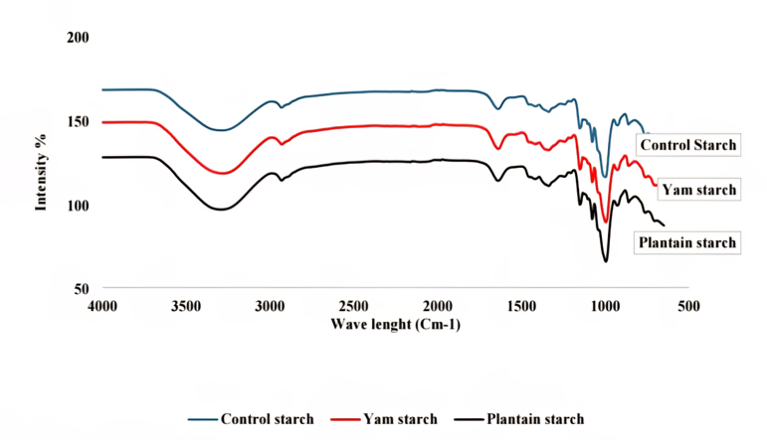

Figure 5: FTIR Analysis of Corn Starch, Yam Starch and Plantain Starch
The Control starch (corn) has the highest intensity ratio, followed by Yam starch and Plantain starch, according to a qualitative trend shown by visual inspection of the spectra (Figure 5). According to its dense crystalline arrangement, corn starch (A-type) appears to have the highest degree of short-range order. Plantain and yam starches of the B/C type have reduced initial molecular order. This lower order suggests that their gelatinization process requires less energy. However, because the more mobile polymer chains can re-associate more forcefully, it is also linked to a stronger and quicker retrogradation propensity upon cooling (Zhong et al., 2022).
When it comes to film creation, it is anticipated that this intense retrogradation in plantain and yam starches will produce films that are stronger, more rigid, and have greater barrier qualities than those made from maize starch.
Scanning Electron Microscopy (SEM) Analysis
The significant morphological variations between the botanical sources were visually confirmed by the SEM examination. The granules in corn starch were uniformly tiny and clearly polygonal. Large, oval, and frequently clustered granules were a characteristic of yam starch. Figures 6(a)–(c) show the SEM micrographs of corn, plantain, and yam starch; Table 3 summarizes their morphological features.
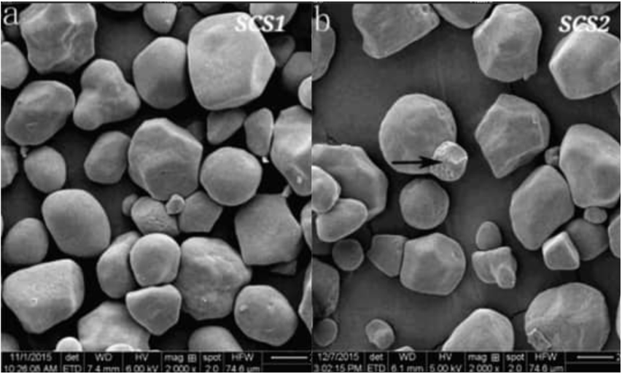

Figure 6a: SEM Micrographs for Corn

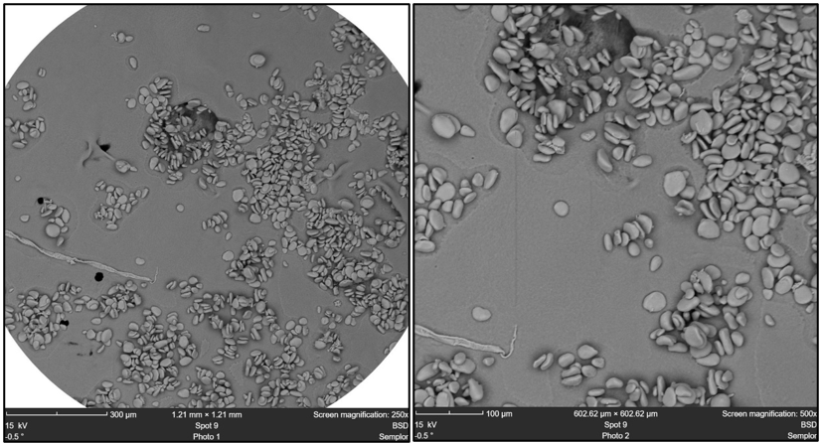

Figure 6b: SEM Micrographs for Plantain

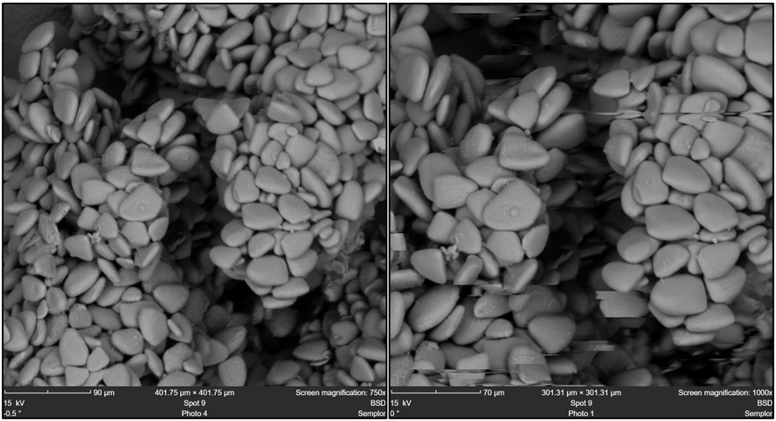
Figure 6c: SEM Micrographs for Yam

Table 3: Summary of SEM Observations of Starch Granules
Sample | Source | Morphology Description
SPS | Plantain Starch | Predominantly small, irregular, oval, or kidney-shaped granules.
SYS | Yam Starch | Large, oval, or kidney-shaped granules, often appearing clustered.
SCS | Corn Starch (Control) | Small, polygonal (mostly angular) granules.

Most significantly, the granules of plantain starch were tiny, irregular, and frequently oval or kidney-shaped. For the development of films, this morphology is quite beneficial. Smaller and more irregularly shaped grains can pack together much more effectively during film drying, reducing interstitial gaps. After gelatinization and retrogradation, this results in the creation of a more cohesive, uniform, and continuous film matrix. Because it lessens the possibility of structural discontinuities that could jeopardize the film, this improved packing efficiency is a strong predictor of higher mechanical integrity and barrier performance (Zavareze and Dias, 2011). The conclusion that plantain starch is the best material for creating a dense, high-performance film is strongly supported by the combination of this excellent packing morphology and its high inherent granular stiffness (as shown by its low swelling power).

Antioxidant Properties of Plant-Based Extracts
The antioxidant capacities of the avocado (AQA), ginger (GOA), and garlic (GRA) extracts were evaluated using three complementary assays: DPPH, ABTS, and FRAP. The results, expressed as mg/mL (with lower values indicating higher activity for DPPH and ABTS, and higher values for FRAP), are summarized in Table 4.

Table 4: Antioxidant Properties of Plant-Based Extracts
Assay | Avocado (AOA) | Ginger (GOA) | Garlic (GRA)
DPPH (IC₅₀ mg/mL) | 71.47 ± 0.40ᵇ | 46.79 ± 0.69ᵃ | 78.75 ± 0.04ᶜ
ABTS (IC₅₀ mg/mL) | 48.59 ± 0.06ᵃ | 50.60 ± 0.21ᵇ | 50.56 ± 0.05ᵇ
FRAP (IC₅₀ mg/mL) | 22.72 ± 0.61ᶜ | 16.39 ± 0.26ᵃ | 21.09 ± 0.21ᵇ
For all assays, lower IC₅₀ values indicate higher antioxidant efficacy. Mean values in the same row followed by different superscript letters are significantly different (p < 0.05) according to post-hoc analysis.
Key: DPPH - 2-Diphenyl-1-picrylhydrazyl Radical Scavenging Activity
ABTS - 2,2’-Azino-bis(3-ethylbenzothiazoline-6-sulphonic acid) Radical Cation
FRAPS - Ferric Reducing Antioxidant Power
AQA- Oil extracted from Avocado fruit
GOA- Oil extracted from Ginger
GRA- Oil extracted from Garlic
The results demonstrate that the Ginger extract (GOA) exhibited the strongest antioxidant activity across all assays, showing the lowest IC₅₀ values in DPPH (46.79 ± 0.69 mg/mL), ABTS (50.60 ± 0.21 mg/mL), and FRAP (16.39 ± 0.26 mg/mL) assays. Avocado (AOA) and Garlic (GRA) showed comparatively higher IC₅₀ values, indicating lower antioxidant potency. The statistical differences (p < 0.05) confirm significant variation in antioxidant efficacy among the extracts.
The antioxidant analysis reveals that ginger extract (GOA) possesses the most potent and versatile multi-mechanistic antioxidant activity. It significantly outperformed the other extracts in the two assays that represent fundamental chemical mechanisms: the DPPH assay, which measures hydrogen atom transfer (HAT), and the FRAP assay, which measures electron transfer (ET) (Prior et al., 2005). The phenolic nature of its primary bioactive chemicals, gingerols and shogaols, which have many hydroxyl groups and are highly effective in donating hydrogen atoms and electrons, is responsible for its dominant performance.
In the ABTS test, avocado oil demonstrated exceptional value, demonstrating its potent ability to prevent oxidation in systems with both lipid and aqueous phases. Its distinct profile of fat-soluble antioxidants, especially α-tocopherol, is responsible for this. Garlic oil's protective mechanism may rely more on indirect antioxidant or antibacterial actions, as seen by its poorest performance in direct radical scavenging.
Overall, the findings show that ginger extract is the most potent and widely applicable antioxidant of the three, which makes it the best option for producing an active film with high efficacy.

Conclusions
Plantain, yam and corn starches exhibited distinct physicochemical and morphological properties. Plantain starch recorded the lowest swelling power and intermediate solubility, while yam starch showed the highest swelling power and lowest solubility. FTIR analysis confirmed the characteristic polysaccharide functional groups in all samples, and SEM examination demonstrated differences in granule shape and organization. Among the plant extracts, ginger showed the strongest response in the DPPH and FRAP assays, whereas avocado showed the strongest ABTS response. The results provide preliminary information for selecting starch and antioxidant sources for subsequent edible-film formulation. However, the present data do not establish the mechanical strength, barrier performance, stability or food-preservation effectiveness of any film. These properties must be evaluated using formulated films before a preferred starch–extract combination can be identified.

Recommendations
The findings of this foundational characterization study provide a strong impetus for continued research and development in this field. Based on the results and conclusions, the following recommendations are proposed to guide future work; Prioritization of Plantain Starch for Film Formulation, Formulation and Comprehensive Characterization of Composite Films (Mechanical Properties, Barrier Properties, and Optical and Physical Properties), Optimization of Film Formulation (Plasticizer Concentration, Antioxidant Extract, Concentration), Application in Real Food Systems and Shelf-Life Studies, Investigation into Advanced Characterization and Enhancement Strategies, etc.

Limitations
The study evaluated starches and plant extracts separately and did not formulate or test edible films. Mechanical, barrier, optical, thermal, sensory and shelf-life properties were therefore not determined. Amylose content, crystalline structure, total phenolic content and extract yield were also not measured. The extracts were obtained using different solvents, which limits direct comparison of their antioxidant values. In addition, residual solvent, migration and food-contact safety were not assessed. The findings should consequently be regarded as preliminary raw-material characterization rather than confirmation of edible-film performance.

Declaration of AI Use

This manuscript was prepared through the combined contributions of all author(s), including contributions to the study design, data, content development, results, interpretation, and related scholarly work. The author(s) acknowledge the use of Grammarly and ChatGPT to assist with grammar checking, language refinement, reference formatting. These AI-assisted tools were not used as authors and did not replace the intellectual contributions or scholarly judgment of the author(s). All AI-assisted outputs, including content, references, and interpretations, were carefully reviewed, revised, verified, and approved by the author(s). The author(s) accept full responsibility for the accuracy, integrity, and final content of the manuscript.

References
- Abrahão, F.R., de Souza, M.C. and de Oliveira, V.M. (2019) ‘Bioactive compounds and antioxidant activity of garlic (Allium sativum L.)’, Journal of Food Composition and Analysis, 76, pp. 50–56.
- Adebowale, K.O., Olu-Owolabi, B.I., Olayinka, O.O. and Lawal, O.S. (2019) ‘Functional properties of native and modified starches from underutilized Nigerian yam cultivars’, Journal of Food Processing and Preservation, 43(3), p. e13881.
- Adebayo-Oyetoro, A.O., Ogundipe, O.O., Adeyeye, S.A.O. and Akintayo, O.A. (2017) ‘Chemical, functional, and pasting properties of starches from new varieties of cassava’, Journal of Food Processing and Preservation, 41(6), p. e13253.
- Adeleke, O.A., Orbih, M. and Otaraku, I.J. (2020) ‘Municipal solid waste management in Nigeria: A review’, Waste Management & Research, 38(10), pp. 1109–1123.
- Ayinde, I.A., Otekunrin, O.A. and Akinbode, S.O. (2022) ‘Impact of plastic pollution on the Nigerian environment’, Journal of Environmental Management, 317, p. 115383.
- Basiak, E., Lenart, A. and Debeaufort, F. (2018) ‘Effect of glycerol and water content on starch-based films’, Polymers, 10(4), p. 412.
- Bello-Pérez, L.A., Agama-Acevedo, E., Zamudio-Flores, P.B. and Tovar, J. (2020) ‘Starch-based edible films and coatings’, in Polysaccharide-based films and coatings for food packaging. Elsevier, pp. 1–28.
- Benzie, I.F.F. and Strain, J.J. (1996) ‘The ferric reducing ability of plasma (FRAP) as a measure of antioxidant power’, Analytical Biochemistry, 239(1), pp. 70–76.
- Brand-Williams, W., Cuvelier, M.E. and Berset, C. (1995) ‘Use of a free radical method to evaluate antioxidant activity’, LWT – Food Science and Technology, 28(1), pp. 25–30.
- Falade, K.O. and Oyeyinka, S.A. (2015) ‘Starch from Nigerian foods: A review’, Food Science and Technology Research, 21(5), pp. 623–633.
- Falade, K.O. and Oyeyinka, S.A. (2017) ‘Physicochemical properties of plantain starch’, Food Reviews International, 33(2), pp. 195–217.
- Falguera, V., Quintero, J.P., Jiménez, A., Muñoz, A. and Ibarz, A. (2011) ‘Edible films and coatings: Structures and applications’, Trends in Food Science & Technology, 22(6), pp. 292–303.
- Gómez-Aldapa, C.A., Castro-Rosas, J., Rangel-Vargas, E. and Rodríguez-Marín, M.L. (2020) ‘Physicochemical properties of plantain starch’, Starch/Stärke, 72(9–10), p. 1900227.
- Hassan, M., Zhao, C. and Su, C.H. (2019) ‘Environmental impact of plastic waste: An overview’, Journal of Hazardous Materials, 380, p. 120822.
- Hoover, R. (2001) ‘Composition and physicochemical properties of starches’, Carbohydrate Polymers, 45(3), pp. 253–267.
- Irondi, A.E., Oboh, G. and Akindahunsi, A.A. (2017) ‘Antioxidant properties of ginger’, Journal of Food Biochemistry, 41(2), p. e12290.
- Jiménez, A., Fabra, M.J., Talens, P. and Chiralt, A. (2012) ‘Edible and biodegradable starch films: A review’, Food and Bioprocess Technology, 5(6), pp. 2058–2076.
- Jongjareonrak, A., Benjakul, S., Visessanguan, W. and Tanaka, M. (2018) ‘Antioxidant and antimicrobial edible films’, Journal of Food Science, 73(2), pp. M117–M123.
- Lawal, O.S. (2019) ‘Starch: Properties and applications’, Journal of Food Science and Technology, 56(6), pp. 2824–2841.
- Leach, H.W., McCowen, L.D. and Schoch, T.J. (1959) ‘Structure of the starch granule: Swelling and solubility patterns’, Cereal Chemistry, 36, pp. 534–544.
- Li, J., Zhang, J. and Wang, X. (2020) ‘Interactions between starch and phenolic compounds’, Trends in Food Science & Technology, 106, pp. 15–26.
- Li, X., Wang, X., Wang, Y., Zhang, W., Chen, R. and Wu, X. (2018) ‘Antioxidant activity and mechanism of ginger compounds’, Journal of Functional Foods, 46, pp. 168–174.
- Mali, S., Grossmann, M.V.E., García, M.A., Martino, M.N. and Zaritzky, N.E. (2005) ‘Barrier, mechanical and optical properties of starch films’, Carbohydrate Polymers, 60(2), pp. 283–289.
- Mali, S., Sakanaka, L.S., Yamashita, F. and Grossmann, M.V.E. (2018) ‘Starch-based edible films’, in Edible films and coatings for food applications. Springer, pp. 119–146.
- Matanjun, P., Mohamed, S., Mustapha, N.M. and Muhammad, K. (2019) ‘Antioxidant properties of avocado’, Journal of Food Biochemistry, 43(11), p. e13031.
- Odeku, O.A., Awe, O. and Popoola, B. (2008) ‘Properties of yam starch’, Pharmaceutical Development and Technology, 13(6), pp. 515–523.
- Otoni, C.G., Avena-Bustillos, R.J., Azeredo, H.M.C. et al. (2017) ‘Recent advances in edible films’, Comprehensive Reviews in Food Science and Food Safety, 16(5), pp. 1151–1169.
- Oyeyinka, S.A., Olayinka, O.O., Karim, O.R. and Oyeyinka, A.T. (2018) ‘Plantain starch applications’, African Journal of Food Science, 12(6), pp. 133–138.
- Prasad, S., Gupta, S.C. and Aggarwal, B.B. (2015) ‘Garlic’, in The molecular targets and therapeutic uses of spices. World Scientific, pp. 161–193.
- Prior, R.L., Wu, X. and Schaich, K. (2005) ‘Standardized methods for determination of antioxidant capacity’, Journal of Agricultural and Food Chemistry, 53(10), pp. 4290–4302.
- Qiu, Y., Li, Q. and Wang, T. (2009) ‘Extraction of gingerols from ginger’, Journal of the Science of Food and Agriculture, 89(10), pp. 1642–1647.
- Re, R., Pellegrini, N., and Proteggente, A. (1999) ‘Antioxidant activity using ABTS’, Free Radical Biology and Medicine, 26(9–10), pp. 1231–1237.
- Rhim, J.W. (2021) ‘Starch-based edible films’, in Edible films and coatings. CRC Press, pp. 1–28.
- Sanyang, M.L., Sapuan, S.M., and Jawaid, M. (2016) ‘Biocomposites for packaging applications’, Renewable and Sustainable Energy Reviews, 54, pp. 533–549.
- Sharma, S., Chatterjee, S., Sharma, A. and Jha, A.K. (2021) ‘Microplastics in the environment’, Environmental Science and Pollution Research, 28, pp. 19544–19560.

