Synthesis, Spectroscopic Characterization, and DFT Calculations of 1-(2,4-dinitrophenyl)-3,5-dimethylpyrazole.

Abstract
The attempted synthesis of a Schiff-base–type compound unexpectedly led to the formation of an organic product corresponding to an asymmetric dimer, resulting from a condensation reaction between 2,4-dinitrophenylhydrazine (C₆H₂N₄O₄) and acetylacetone (C₅H₈O₂) in methanol, in a 1:1 stoichiometric ratio. The compound crystallizes in the monoclinic crystal system with space group P2₁/c and contains four independent units per unit cell (Z = 4). The unit cell parameters are: a = 20.4248(12), b = 7.7094(4), c = 16.7101(5), α = γ = 90°, and β = 113.745(7)°. In order to confirm the proposed structure, an experimental study was performed using infrared (IR), nuclear magnetic resonance (NMR), and UV–Visible spectroscopies, complemented by single-crystal X-ray diffraction. In addition, a theoretical investigation based on Density Functional Theory (DFT) was carried out to analyze Mulliken charges, vibrational assignments, and global reactivity descriptors of the compound. Calculations were performed using the B3LYP method with the B3LYP/6-311++G(d,p) and B3LYP/6-311G(d,p) basis sets. The calculated vibrational frequencies were employed to simulate the infrared spectra for both basis sets. Finally, the frontier molecular orbital energies (HOMO and LUMO), the energy gap, and the global reactivity parameters were determined in order to predict the chemical reactivity of the compound. Overall, the results highlight a strong correlation between experimental and theoretical data, emphasizing the significance of electronic and structural interactions in the stability of the compound.
Keywords: Pyrazole, Crystal structure, DFT, optimized geometry, Mulliken charges

1. Introduction
Pyrazole and its derivatives constitute a major class of heterocyclic compounds of great interest in medicinal chemistry due to the wide range of pharmacological activities attributed to them. The presence of multiple electron-donating sites, combined with high structural tunability, endows these compounds with distinctive electronic and spectroscopic properties, which are exploited both in the design of new ligands and in the development of bioactive molecules. Among these derivatives, the introduction of strongly electron-withdrawing nitro groups on an adjacent aromatic ring profoundly modifies the electronic distribution of the system, thereby influencing the reactivity, stability, and photophysical behavior of the molecule [1–3]. In this context, numerous hydrazone- and pyrazole-type organic compounds have been synthesized, characterized, and extensively reported in the literature [4–7], generating increasing interest across various physico-chemical fields [8–9]. However, some structural and electronic features of pyrazole derivatives cannot be determined solely by experimental methods, making theoretical approaches essential to complement and refine laboratory findings. Consequently, several studies have focused on investigating the electronic structure, frontier molecular orbitals, and global reactivity descriptors of pyrazole compounds [10–13]. Nevertheless, an in-depth review of the literature reveals that, to date, no Density Functional Theory (DFT) calculations using the B3LYP functional have been reported for 1-(2,4-dinitrophenyl)-3,5-dimethylpyrazole. Furthermore, to the best of our knowledge, no study combining spectroscopic, crystallographic, and theoretical analyses has yet been devoted to this compound.
In the present work, we report the synthesis of a pyrazole derivative, namely 1-(2,4-dinitrophenyl)-3,5-dimethyl-1H-pyrazole, obtained from a condensation reaction between 2,4-dinitrophenylhydrazine and acetylacetone followed by intramolecular cyclization. The synthesized compound was characterized by infrared (IR), UV–Visible, and nuclear magnetic resonance (NMR) spectroscopies. To elucidate the structure and understand the factors responsible for this unexpected cyclization, quantum chemical calculations were performed within the framework of Density Functional Theory (DFT). Geometrical parameters (experimental and theoretical), optimized structure, and vibrational frequencies were examined using the 6-311++G(d,p) and 6-311G(d,p) basis sets. This approach provides reliable prediction of molecular geometry and vibrational spectra while maintaining a satisfactory compromise between accuracy and computational cost. Finally, the dipole moment and the frontier orbitals (HOMO and LUMO) were also calculated and discussed.

2. Expérimental

2.1. Instrumentation and Experimental Measurements
¹H NMR spectra were recorded on a Bruker Avance 200 MHz spectrometer using DMSO-d₆ as solvent. UV–Vis spectra were obtained using a PerkinElmer Lambda 25 spectrophotometer equipped with two matched 10 mm quartz cuvettes. Infrared (IR) spectra of the compound were recorded at room temperature on a Fourier-transform infrared (FT-IR) spectrometer in the range 4000–400 cm⁻¹ at Cheikh Anta Diop University (Dakar).
For single-crystal X-ray diffraction, suitable crystals were selected and mounted on a « SuperNova, Dual, Cu at home/near, AtlasS2 » diffractometer equipped with a detector using Cu Kα radiation (λ = 1.54184 Å). Data collection was carried out at 296 K. The crystal structure was solved using Olex2 [14] with the Intrinsic Phasing method implemented in SHELXT [15] and subsequently refined using SHELXL [16].

Synthesis of compound
In a 250 mL round-bottom flask, 2.38 g (12 mmol) of 2,4-dinitrophenylhydrazine dissolved in 10 mL of methanol and containing two drops of concentrated sulfuric acid was introduced. The mixture was stirred for 10 min until a clear solution was obtained. Then, 1.20 g (12 mmol) of acetylacetone, previously dissolved in 10 mL of methanol containing two drops of glacial acetic acid, was added. The reaction mixture was heated at reflux at 60 °C for 2 h. The resulting solution was allowed to evaporate slowly at room temperature, affording brown crystals after several days (2.19 g, 65% yield). The synthetic reaction pathway is shown in Figure 1.
Figure 1 : Scheme for the synthesis of the ligand 1-(2,4-dinitrophenyl)-3,5-dimethyl-1H-pyrazole.
Computational Details
The theoretical study of the molecule was carried out using density functional theory (DFT), as implemented in the Gaussian 16 software package [17]. Geometry optimizations were performed in solution (methanol as solvent) using the B3LYP method combined with the 6-311++G(d,p) and 6-311G(d,p) basis sets.This choice is justified by the reliability of these basis sets for accurately describing the geometries and energies of pyrazole and its derivatives [18-21]. The calculations were conducted under standard conditions of temperature (298.15 K) and pressure (1 atm). Frequency analysis revealed no imaginary frequencies, confirming that all optimized structures correspond to energy minima on the potential energy surface [22]. Subsequently, the structural parameters as well as the highest occupied (HOMO) and lowest unoccupied (LUMO) molecular orbitals were determined. Furthermore, the energy gap (E_gap), chemical hardness (η), electronegativity (χ), chemical potential (μ), and electrophilicity index (ω) were calculated using equations (1) to (5) [23-24].
E_{gap} = E_{LUMO} - E_{HOMO} (1)
$η= E_{LUMO} -\frac{E_{HOMO}}{2}$ (2)
$χ= {-E}_{HOMO}-\frac{E_{LUMO}}{2}$ (3)
$μ= - χ$ (4)
$ω= \frac{μ^{2}}{2 η}$ (5)

Results et discussion

3.1. Structural Analysis by X-ray Diffraction
X-ray diffraction confirmed the structure of the ligand bis[1-(2,4-dinitrophenyl)-3,5-dimethylpyrazole]. A crystal with dimensions of 0.16 × 0.16 × 0.02 mm³ was analyzed. The compound crystallizes in the monoclinic system, belonging to the P2₁/c space group. The unit cell parameters are: a = 20.4248 Å, b = 7.094 Å, c = 16.7101 Å, α = 90°, β = 113.745°, γ = 90° [25]. The asymmetric unit of the studied compound consists of independent molecules forming a dimer [26]. Each molecule exhibits a similar geometry and adopts an essentially planar conformation. The aromatic ring and the pyrazole ring are nearly coplanar. The oxygen atoms of the nitro substituents are oriented on either side of the molecular plane, which reduces steric hindrance while maintaining their electron-withdrawing mesomeric effect.
The molecular structure is characterized by the presence of the C=N bond, which is typical of hydrazone-type organic compounds, also referred to as the azomethine bond [27]. This bond results from a nucleophilic attack followed by a condensation reaction with water elimination. Furthermore, the formation of the C–N bond is attributed to an intramolecular cyclization involving the carbonyl group of the ketone (pentane-2,4-dione) and the nitrogen atom of the hydrazine function, leading to a highly stable pyrazole ring. A similar mechanism was previously reported in our laboratory during the synthesis of the ligand N,N-bis(acetylacetonate)ethylenediamine [28]. The simultaneous formation of these two bonds induces an electron rearrangement that promotes mesomeric effects within the five-membered ring, thereby contributing to the stabilization of the final structure. Moreover, the phenyl groups in the molecules are conjugated with the pyrazoline rings, generating an extended conjugated π-system [29]. This stability is supported by Figure 2, which shows an arrangement in infinite bands, without the involvement of hydrogen bonding.
The incorporation of various heteroatoms into organic compounds induces subtle modifications in their electronic properties. Thus, understanding the structure–property relationship, which represents one of the main axes of fundamental research on organic semiconductors, plays an essential role in the field of optoelectronics [30].

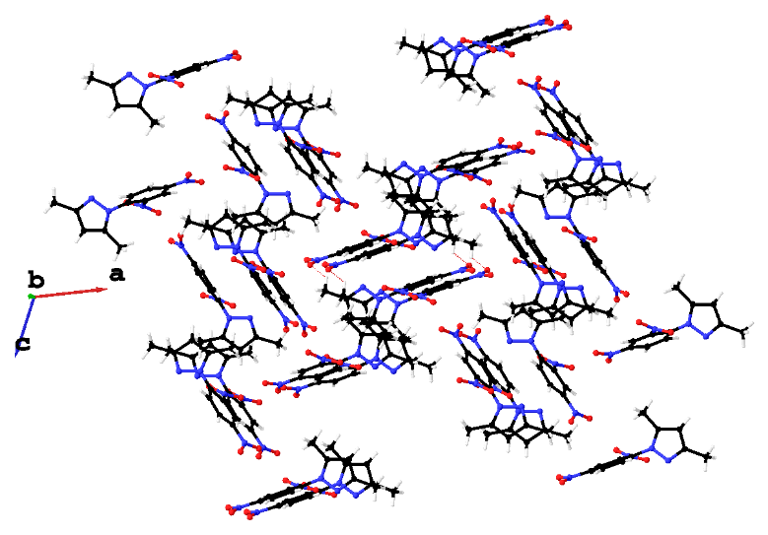
Figure 2 : ORTEP representation of the layered structure of the compound along the (010) plane, with 50% probability ellipsoids for the atoms [color code: H (white), C (black), N (blue), O (red)].
Geometrical Structure
Density Functional Theory (DFT) is a particularly powerful tool for the structural study of pyrazole derivatives [18-19]. It is also highly effective for elucidating structural, electronic, spectroscopic, and electrostatic properties, which may be relevant for applications in various fields [31]. Consequently, numerous studies, both experimental and theoretical, have been devoted to investigating these compounds [20, 32]. In this work, the geometric parameters (bond lengths and bond angles) of the compound 1-(2,4-dinitrophenyl)-3,5-dimethylpyrazole were examined. Structural optimization was performed using the B3LYP method with the 6-311++G(d,p) and 6-311G(d,p) basis sets. The optimized structure of the molecule, obtained with B3LYP/6-311++G(d,p), is shown in Figure 3. This structure confirms the formation of the C=N bond as well as intramolecular cyclization, both of which were experimentally observed. Tables 1 and 2 compile the theoretical and experimental bond lengths and angles, along with their corresponding deviations. The largest differences, observed with the 6-311G(d,p) basis set, concern the C1–C2 and C20–N8 bonds, with deviations of 0.089 Å and 0.077 Å, respectively. These relatively small values indicate good agreement between theoretical and experimental data. For the N1–C2 and N2–C4 bonds, the deviations are even smaller, reaching 0.007 Å and 0.018 Å respectively, which confirms the reliability of the theoretical results. Regarding bond angles, the deviations between experimental and calculated values also remain very small. For example, the experimental angles of the nitro groups O7–N5–O6, O1–N3–O2, O4–N4–O3, and O7–N8–O8 are 124.3°, 124.0°, 123.1°, and 122.0°, respectively. Calculations performed using B3LYP/6-311G(d,p) give 124.9°, 124.8°, 124.5°, and 124.5°, while B3LYP/6-311++G(d,p) yields 124.6°, 124.6°, 124.3°, and 124.3°. The slight differences observed are likely due to the fact that calculations are carried out for molecules in solution, whereas the experimental data are obtained from solid-state measurements [22]. Overall, the theoretical results obtained—particularly the geometric parameters—for the molecule 1-(2,4-dinitrophenyl)-3,5-dimethylpyrazole show excellent agreement with the experimental data.
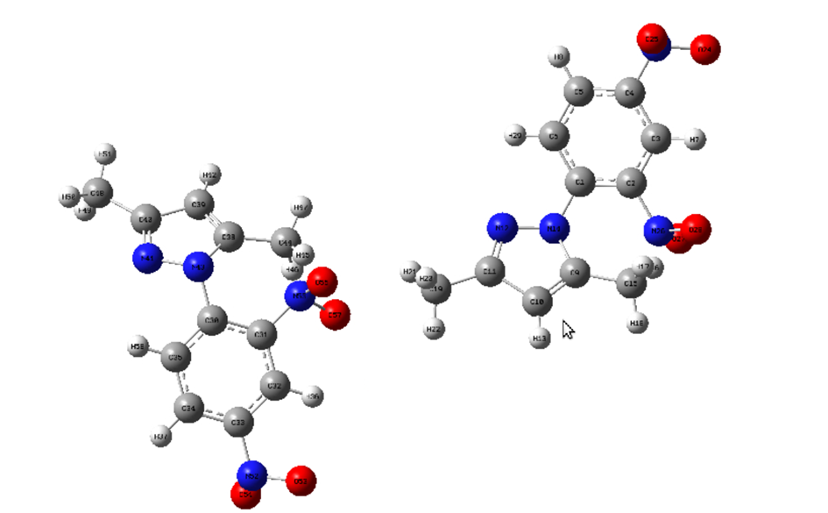

Figure 3: Optimized structure of the compound 1-(2,4-dinitrophenyl)-3,5-dimethylpyrazole obtained by theoretical (DFT) calculation.

Table 1 : Interatomic length in (Å) of compound
Chemical bonds | Length (exp) | B3LYP/6-311++G(d,p) | Ecart type |ΔL| | B3LYP/6-  311G(d,p) | Ecart type |ΔL| | Chemical bonds | Length (exp) | B3LYP/6-  311++G(d,p) | Ecart type |ΔL| | B3LYP/6-  311G(d,p) | Ecart type |ΔL|
O5-N7 | 1.213(4) | 1.223 | 0.010 | 1.222 | 0.009 | C21-C20 | 1.379(5) | 1.385 | 0.006 | 1.384 | 0.005
O6-N7 | 1.221(4) | 1.225 | 0.004 | 1.222 | 0.001 | C17-C22 | 1.389(5) | 1.407 | 0.018 | 1.407 | 0.018
N7-C22 | 1.471(4) | 1.477 | 0.006 | 1.477 | 0.006 | C17-C18 | 1.389(5) | 1.400 | 0.011 | 1.401 | 0.012
N6-N5 | 1.372(4) | 1.374 | 0.002 | 1.373 | 0.001 | O7-N8 | 1.208(6) | 1.226 | 0.018 | 1.224 | 0.016
N6-C17 | 1.422(4) | 1.406 | 0.016 | 1.405 | 0.017 | C7-C8 | 1.377(5) | 1.385 | 0.008 | 1.384 | 0.007
N6-C15 | 1.356(4) | 1.379 | 0.023 | 1.381 | 0.025 | C11-C10 | 1.380(5) | 1.388 | 0.008 | 1.388 | 0.008
N2-N1 | 1.375(4) | 1.374 | 0.001 | 1.374 | 0.001 | C4-C3 | 1.363(6) | 1.375 | 0.012 | 1.378 | 0.015
N2-C6 | 1.413(4) | 1.406 | 0.007 | 1.405 | 0.006 | C4-C5 | 1.488(5) | 1.494 | 0.006 | 1.494 | 0.006
N2-C4 | 1.361(5) | 1.379 | 0.018 | 1.382 | 0.021 | C9-C10 | 1.379(5) | 1.385 | 0.106 | 1.384 | 0.105
N1-C2 | 1.318(5) | 1.325 | 0.007 | 1.323 | 0.009 | C9-C8 | 1.379(5) | 1.393 | 0.014 | 1.392 | 0.013
O1-N3 | 1.216(4) | 1.223 | 0.007 | 1.222 | 0.006 | C20-N8 | 1.469(5) | 1.471 | 0.002 | 1.392 | 0.077
N5-C13 | 1.326(5) | 1.326 | 0.000 | 1.323 | 0.003 | C20-C19 | 1.375(6) | 1.393 | 0.018 | 1.392 | 0.017
N3-O2 | 1.224(4) | 1.225 | 0.001 | 1.223 | 0.002 | C2-C3 | 1.403(6) | 1.420 | 0.017 | 1.421 | 0.018
N3-C11 | 1.471(4) | 1.477 | 0.006 | 1.476 | 0.005 | C2-C1 | 1.496(5) | 1.495 | 0.001 | 1.407 | 0.089
N4-C9 | 1.466(5) | 1.471 | 0.005 | 1.472 | 0.005 | C15-C14 | 1.371(5) | 1.375 | 0.004 | 1.374 | 0.003
N4-O4 | 1.187(6) | 1.226 | 0.039 | 1.224 | 0.041 | C15-C16 | 1.489(5) | 1.093 | 0.396 | 1.494 | 0.005
N4-O3 | 1.216(6) | 1.226 | 0.010 | 1.224 | 0.030 | N8-O8 | 1.192(6) | 1.226 | 0.034 | 1.224 | 0.032
C6-C7 | 1.390(5) | 1.400 | 0.001 | 1.402 | 0.003 | C13-C14 | 1.400(6) | 1.420 | 0.020 | 1.420 | 0.020
C6-C11 | 1.388(5) | 1.407 | 0.019 | 1.407 | 0.019 | C13-C12 | 1.501(5) | 1.496 | 0.005 | 1.496 | 0.005
C21-C22 | 1.382(5) | 1.388 | 0.006 | 1.388 | 0.006 | C19-C18 | 1.376(5) | 1.385 | 0.009 | 1.384 | 0.008

Table 2 : Angle interatomique in (°C) of compound
Angle |  |  | Exp |  |  |  |  | Angle |  |  | Exp
 |  |  | Exp | B3LYP/6-311++G(d,p) | Ecart type |ΔL| | B3LYP/6-311G(d,p) | Ecart type |ΔL| |  |  |  | Exp | B3LYP/6-311++G(d,p) | Ecart type |ΔL| | B3LYP/6-311G(d,p) | Ecart type |ΔL|
O5 | N7 | O6 | 124.3(3) | 124,6 | 0,3 | 124,9 | 0,6 | C10 | C11 | N3 | 116.0(3) | 115.7 | 0.3 | 115.7 | 0.3
O5 | N7 | C22 | 118.6(3) | 117,9 | 0,7 | 117,8 | 0,8 | C10 | C11 | C6 | 121.8(3) | 121.7 | 0.1 | 121.6 | 0.2
O6 | N7 | C22 | 117.1(3) | 117,4 | 0,3 | 117,3 | 0,2 | N2 | C4 | C3 | 105.1(3) | 105.5 | 0.4 | 105.5 | 0.4
N5 | N6 | C17 | 118.9(3) | 118.1 | 0.8 | 117.7 | 1,2 | N2 | C4 | C5 | 123.3(3) | 124.5 | 1.2 | 124.9 | 1.6
C15 | N6 | N5 | 112.7(3) | 112.0 | 0.7 | 112.0 | 0.7 | C3 | C4 | C5 | 131.5(4) | 129.9 | 1.6 | 129.5 | 2.0
C15 | N6 | C17 | 128.4(3) | 129.6 | 1.2 | 129.9 | 1.5 | C10 | C9 | N4 | 117.8(3) | 118.7 | 0.9 | 118.7 | 0.9
N1 | N2 | C6 | 119.3(3) | 118.1 | 1.2 | 117.7 | 1.6 | C8 | C9 | N4 | 119.3(4) | 119.5 | 0.2 | 119.5 | 0.2
C4 | N2 | N1 | 112.7(3) | 112.0 | 0.7 | 111.9 | 0.8 | C8 | C9 | C10 | 122.9(3) | 121.8 | 1.1 | 121.7 | 1.2
C4 | N2 | C6 | 127.9(3) | 129.6 | 1.7 | 130.0 | 2.1 | C21 | C20 | N8 | 117.2(4) | 118.7 | 1.5 | 118.7 | 1.5
C2 | N1 | N2 | 104.1(3) | 105.2 | 1.1 | 105.2 | 1.1 | C19 | C20 | C21 | 122.9(3) | 121.8 | 1.1 | 121.7 | 1.2
C13 | N5 | N6 | 104.0(3) | 105.2 | 1.2 | 105.2 | 1.2 | C19 | C20 | N8 | 119.9(4) | 119.5 | 0.4 | 119.5 | 0.4
O1 | N3 | O2 | 124.0(3) | 124.6 | 0.6 | 124.8 | 0.8 | C9 | C10 | C11 | 117.4(3) | 118.4 | 1.0 | 118.5 | 1.1
O1 | N3 | C11 | 118.5(3) | 118.0 | 0.5 | 117.8 | 0.7 | N1 | C2 | C3 | 111.3(3) | 110.9 | 0.4 | 111.0 | 0.3
O2 | N3 | C11 | 117.5(3) | 117.4 | 0.1 | 117.3 | 0.2 | N1 | C2 | C1 | 120.8(4) | 121.0 | 0.2 | 120.9 | 0.1
O4 | N4 | C9 | 118.8(4) | 117.7 | 1.1 | 117.6 | 1.2 | C3 | C2 | C1 | 127.9(4) | 128.1 | 0.2 | 128.1 | 1.8
O4 | N4 | O3 | 123.1(4) | 124.3 | 1.2 | 124.5 | 1.4 | N6 | C15 | C14 | 105.6(3) | 105.5 | 0.4 | 105.5 | 0.1
O3 | N4 | C9 | 118.2(4) | 118.0 | 0.2 | 117.9 | 0.3 | N6 | C15 | C16 | 122.8(3) | 124.6 | 1.8 | 124.8 | 2.0
C7 | C6 | N2 | 119.0(3) | 118.2 | 0.8 | 118.0 | 1.0 | C14 | C15 | C16 | 131.4(3) | 129.9 | 1.5 | 129.6 | 1.8
C11 | C6 | N2 | 122.5(3) | 123.9 | 1.4 | 124.1 | 1.6 | O7 | N8 | C20 | 119.5(4) | 118.0 | 1.5 | 117.8 | 1.7
C11 | C6 | C7 | 118.5(3) | 117.9 | 0.6 | 117.8 | 0.7 | O8 | N8 | O7 | 122.0(4) | 124.3 | 2.3 | 124.5 | 2.5
C20 | C21 | C22 | 117.2(3) | 121.7 | 4.5 | 118.4 | 1.2 | O8 | N8 | C20 | 118.4(4) | 117.7 | 0.7 | 117.5 | 0.9
C22 | C17 | N6 | 122.4(3) | 123.8 | 1.4 | 124.1 | 1.7 | C7 | C8 | C9 | 118.2(3) | 118.9 | 0.7 | 118.9 | 0.7
C18 | C17 | N6 | 118.9(3) | 118.3 | 0.6 | 118.1 | 0.8 | N5 | C13 | C14 | 111.6(3) | 110.9 | 0.7 | 111.0 | 0.6
C18 | C17 | C22 | 118.7(3) | 117.9 | 0.8 | 117.8 | 0.9 | N5 | C13 | C12 | 120.5(4) | 121.0 | 0.5 | 120.8 | 0.3
C8 | C7 | C6 | 121.1(3) | 121.3 | 0.2 | 121.3 | 0.2 | C14 | C13 | C12 | 127.9(4) | 128.1 | 0.2 | 128.2 | 0.3
C21 | C22 | N7 | 115.8(3) | 115.7 | 0.1 | 115.7 | 0.1 | C20 | C19 | C18 | 118.6(3) | 118.9 | 0.3 | 118.9 | 0.3
C21 | C22 | C17 | 121.7(3) | 121.7 | 0.0 | 122.5 | 0.8 | C19 | C18 | C17 | 120.8(3) | 121.3 | 0.5 | 121.3 | 0.5
C17 | C22 | N7 | 122.4(3) | 122.4 | 0.0 | 117.8 | 4.6 | C15 | C14 | C13 | 106.1(3) | 106.4 | 0.3 | 106.3 | 0.2
C6 | C11 | N3 | 122.2(3) | 122.4 | 0.2 | 122.5 | 0.3 | C4 | C3 | C2 | 106.8(3) | 106.4 | 0.4 | 106.4 | 0.4

Analysis of Molecular Vibrations by FT-IR, NMR and UV-Visible Spectroscopy
- FT-IR Analysis of the Compound
FT-IR spectroscopy provides a non-destructive means of identifying the main chemical vibrational modes present within the dimer (Table 3), in particular the ʋ(C–N) vibrations of the nitro groups (C–NO₂), the ʋ(C=N), ʋ(N–N), and ʋ(C=C) modes characteristic of aromatic rings.
The medium-intensity band observed at 1608 cm⁻¹ (Figure 4) is attributed to the ʋ(C=N) stretching vibration. The simultaneous absence of the characteristic aldehyde carbonyl band ν(C=O) at around 1720 cm⁻¹ and the two primary amine bands ν(NH₂) generally located between 3100–3200 cm⁻¹ confirms the condensation reaction leading to ligand formation [33]. Moreover, the presence of the ʋ(C=N) vibration indicates that the amide function does not undergo iminolation in the solid state [34]. For ligands of similar structure, the ʋ(C=N) vibration is typically observed between 1603 and 1680 cm⁻¹, depending on the nature of the substituents attached to the carbon and nitrogen atoms [35].
DFT calculations performed at the B3LYP/6-311++G(d,p) and B3LYP/6-311G(d,p) levels predict this band at 1633 and 1636 cm⁻¹, respectively, corresponding to a deviation of 25–28 cm⁻¹ from the experimental value, which is consistent with typical discrepancies reported in the literature for this theoretical level [36–38]. In addition, an intramolecular cyclization is observed in which the nitrogen atom of 2,4-dinitrophenylhydrazine attacks the carbon of the second carbonyl group, leading to ring closure through a mechanism comparable to those reported for other hydrazone systems, and possibly involving a keto–enol tautomerization sequence [39–40].
The strong band recorded at 1529 cm⁻¹ is assigned to υas(C–NO₂) and shifts to 1573 cm⁻¹ and 1555 cm⁻¹ in the B3LYP/6-311++G(d) and B3LYP/6-311G(d,p) calculations, respectively. In addition, an intense band observed at 1338 cm⁻¹ is attributed to υs(C–NO₂) [41–42], along with an in-plane deformation at lower frequencies near 835 cm⁻¹. The N–N stretching vibration of the pyrazole core appears at 1028 cm⁻¹ [43], showing a slight decrease in the calculated spectra, appearing at 1030 and 1031 cm⁻¹ for the B3LYP/6-311++G(d,p) and B3LYP/6-311G(d,p) basis sets, respectively.
The in-plane aromatic ν(C=C) stretching vibrations appear as relatively intense and sharp bands between 1499 and 1480 cm⁻¹ [44]. This range exhibits a downward shift in the calculated spectra, likely due to differences in vibrational phase coupling. Furthermore, a weak and broad band at 3361 cm⁻¹, absent from both calculated spectra, is assigned to ν(O–H) of residual synthesis solvent. Finally, substitution on the aromatic ring is confirmed by the presence of two bands at 1031 cm⁻¹ and 777 cm⁻¹ [45]. These results indicate that the phenyl group in the molecule is conjugated with the pyrazoline ring, leading to the formation of a highly conjugated π-system, which is a key factor in the electronic stability of the compound [46].
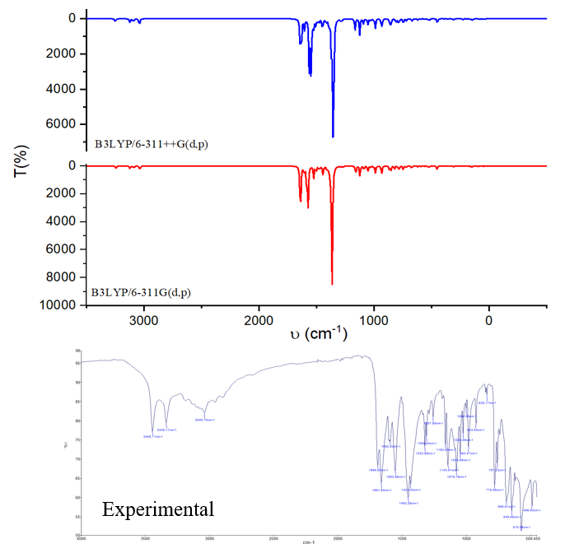
Figure 4 : Theoretical and experimental FTIR spectra of the 1-(2,4-dinitrophenyl)-3,5-dimethylpyrazole ligand
Table 3: Experimental and calculated frequencies (in cm⁻¹)
Assignements | B3LYP/6-311++G(d) | B3LYP/6-311G(d,p) | Exp
C=N | 1633 | 1636 | 1608
C=C | 1356-1547 | 1364-1524 | 1480-1499
C-H | 3029 | 3037 | 3082
C- NO₂ | 1555 | 1573 | 1529

- ¹H, ¹³C, and DEPT-135 NMR Analysis of the Compound
The ¹H NMR spectrum of the compound shows three signals appearing as a doublet (d), a doublet of doublets (dd), and a doublet (d) at 8.05 ppm, 8.62 ppm, and 8.86 ppm, respectively. Each of these signals corresponds to a single proton of the aromatic ring, which is strongly conjugated due to the presence of nitro substituents. Furthermore, the proton NMR spectrum confirms the stability of these groups. Two singlets, each integrating for three protons and appearing at 2.13 ppm and 2.31 ppm, are assigned to the two methyl (CH₃) groups of the pyrazole ring.
The ¹³C NMR spectrum reveals the presence of eleven carbon atoms, which corresponds exactly to the number of carbons in the molecule. Signals between 10 and 20 ppm are attributed to the two carbons of the methyl groups. The signals at 124, 128, 129, 136, 145, and 146 ppm are assigned to C2, C5, C4, C6, C1, and C3, representing the six carbons of the aromatic ring. The signal at 151 ppm is attributed to C9, the only carbon bearing an imine function in the molecule. Additionally, signals at 109 and 141 ppm are assigned to C10 and C9, respectively.
For this ligand, the DEPT-135 spectrum (Figure 10) shows the absence of tertiary carbons and displays six signals: three corresponding to the aromatic ring and three to the pyrazole ring.

- UV-Visible Analysis of the Compound
The UV-Visible spectrum of the compound was recorded in dimethyl sulfoxide (DMSO) as solvent and exhibits a broad absorption range between 310 and 430 nm, reflecting the extensive conjugation of the ligand. The peaks observed between 326 and 418 nm are attributed to π → π* and n → π* electronic transitions within the conjugated systems of the dimer, particularly involving the aromatic rings and pyrazole moieties.
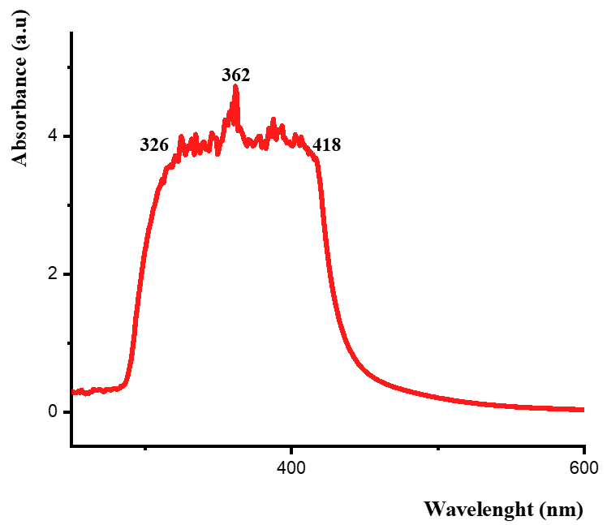
Figure 5 : UV-visible spectrum of the compound

Mulliken atomique charges
Mulliken atomic charges are an essential tool for visualizing the distribution of electronic density within a compound. They help to better understand the nature of possible interactions between different atoms by highlighting electron-rich and electron-poor regions. Several studies have shown that, despite its limitations, Mulliken analysis remains widely used to explore electronic distribution in organic and inorganic systems [47-50]. Table 4 therefore presents the Mulliken atomic charges obtained using density functional theory (DFT) with different basis sets: 6-311++G(d,p) and 6-311G(d,p). It can be observed that nitrogen atoms N12 and N14, slightly more electronegative than the surrounding carbon atoms, exhibit negative charges. This distribution reflects a local accumulation of electronic density, which gives these atoms a pronounced nucleophilic character. These sites are thus more likely to interact with electrophilic species, promoting the formation of new chemical bonds. Conversely, the carbon atoms, generally less electronegative, adopt positive charges that render them electrophilic. They therefore behave as preferred sites for nucleophilic attack. The complementarity of these two behaviors, nucleophilic and electrophilic, further justifies the formation of new bonds, particularly N12–C11 and N14–C9.

Table 4 : Mulliken atomic charge
Atoms | Theoretical
Atoms | B3LYP/6-311++G(d,p) | B3LYP/6-311G(d,p)
H18 | 0.193687 | 0.146692
H20 | 0.176056 | 0.118181
N12 | -0.182830 | -0.257647
N14 | 0.532168 | -0.370569
N26 | -0.166754 | 0.159214
N23 | -0.141684 | 0.182287
N41 | -0.198460 | -0.256429
N43 | 0.601606 | -0.371054
N52 | -0.104769 | 0.182706
N55 | -0.127568 | 0.162318
O25 | -0.008411 | -0.283034
O57 | -0.043354 | -0.252807
C1 | -0.350389 | 0.239992
C2 | 0.053327 | 0.116093
C38 | 0.048378 | 0.242453
C44 | -0.655242 | -0.282418

Chemical Reactivity of the Dimer
The reactivity of the dimer was investigated based on the frontier molecular orbital energies, the energy gap, global descriptors, and the dipole moment, using the B3LYP method with the 6-311++G(d,p) and 6-311G(d,p) basis sets. All of these results are presented in Table 5. The energy diagrams of the highest occupied (HOMO) and lowest unoccupied (LUMO) molecular orbitals of the compound are shown in Figure 6, as well as in Table 5 (rows 3 and 4). Figure 6 illustrates that the HOMO is mainly localized on a single monomer, whereas the LUMO extends over the entire dimer. The energy gap between the HOMO and the LUMO is an essential indicator of a molecule’s stability and reactivity: the larger the gap, the « harder » and more stable the molecule is, and thus the less reactive it becomes [23, 50]. The table shows that the HOMO–LUMO energy gap is 3.625 and 3.661 eV for the 6-311++G(d,p) and 6-311G(d,p) basis sets, respectively. These results indicate good stability of the dimer for both basis sets, with slightly higher stability in the case of 6-311G(d,p).
The electronic chemical potential (μ), which measures the tendency of electrons to leave the system at equilibrium, also provides an indication of molecular stability: the higher μ is, the more reactive and therefore the less stable the molecule becomes [51]. According to Table 5, the maximum chemical potential is obtained with the 6-311G(d,p) basis set, confirming that the dimer is more stable in this case. Moreover, the hardness (η) is also higher with the 6-311G(d,p) basis set (η = 0.187), reinforcing this conclusion. Regarding electronegativity, the values obtained are 8.788 eV and 8.592 eV for the 6-311++G(d,p) and 6-311G(d,p) basis sets, respectively. Finally, the dipole moments (Table 5, row 4) confirm the stability of the compound for both basis sets used.

Table 5 : Global chemical reactivity indices of the compound
Parameters | B3LYP/6-311++G(d,p) | B3LYP/6-311G(d,p)
E (au) | -1889.860 | -1889.848
E_{HOMO} (eV) | -7.067 | -6.948
E_{LUMO} (eV) | -3.442 | -3.287
Dipole moment (Debye) | 9.306 | 9.577
Energy gap ( ΔE ) (eV) | 3.625 | 3.661
µ(eV) | -8.788 | -8.592
Ƞ (eV) | 0.091 | 0.187
χ (eV) | 8.788 | 8.592

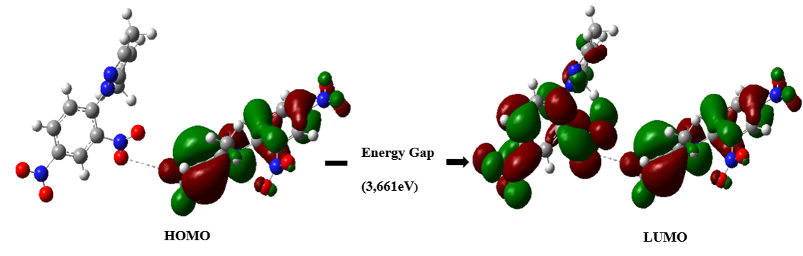

Figure 6 : The frontier molecular orbital (FMO) of HOMO–LUMO.

Conclusion
In this study, 1-(2,4-dinitrophenyl)-3,5-dimethylpyrazole was successfully synthesized via an aromatic nucleophilic substitution reaction and subsequently characterized using various spectroscopic techniques (¹H NMR, ¹³C NMR, IR, and UV–Vis). The experimental data obtained confirm the proposed structure and highlight the influence of the nitro substituents on the electronic environment of the pyrazole ring.
In parallel, DFT calculations performed at the B3LYP/6-311++G(d,p) and B3LYP/6-311G(d,p) levels allowed for geometry optimization, assignment of vibrational frequencies, and analysis of frontier molecular orbitals. The results are in good agreement with the experimental data. Frontier molecular orbital (FMO) analysis revealed a joint contribution from the pyrazole ring and the dinitrophenyl fragment, indicating extensive conjugation and a small energy gap.
Overall, these findings demonstrate that the synergy between experimental data and quantum chemical calculations provides a powerful approach to understanding the structural and electronic properties of such compounds. These results pave the way for further investigations on hydrazone derivatives for potential applications in medicinal chemistry and chemical catalysis.

Declaration of AI Use

This manuscript was prepared through the intellectual contributions of the author(s) to the study design, data analysis, interpretation of results, and scholarly content. Grammarly and ChatGPT were used solely to assist with grammatical refinement and reference formatting during manuscript revision. The author(s) accept full responsibility for the accuracy, integrity, and final content of the manuscript.

Références
[1] Karrouchi K., Radi, S., Ramli, Y., Taoufik, J., Mabkhot, Y. N., Al-Aizari, F. A., & Ansar, M. H. Synthesis and pharmacological activities of pyrazole derivatives: A review. Molecules. 2018, 23(1), 134. https://doi.org/10.3390/molecules23010134
[2] Ansari A, Ali A, Asif M & Shamsuzzaman. Biologically Active Pyrazole Derivatives. New Journal of Chemistry. 2017, 41, 16–41. https://doi.org/10.1039/C6NJ03181A
[3] Derek J, Amann B. T, Gatto G. J & Berg J. M. The Design of Functional DNA-Binding Proteins Based on Zinc Finger, Department of Biophysics and Biophysical Chemistry, Johns Hopkins University School of Medicine, 725 North Wolfe Street. ACS Publication. 2003, 789-799. https://doi.org/10.1021/cr020603o
[4] Selamoglu Z, Sevindik M, Bal C, Ozaltun B, ŞEN İ & Pasdaran A. Antioxidant, antimicrobial and DNA protection activities of phenolic content of Tricholoma virgatum (Fr.) P. Kumm. Biointerface Research in Applied Chemistry. 2020, 10(3). https://doi.org/10.33263/BRIAC103.500506
[5] Egorova K. S, Gordeev E. G & Ananikov V. P. Biological activity of ionic liquids and their application in pharmaceutics and medicine. Chemical reviews. 2017, 117(10), 7132-7189. https://doi.org/10.1021/acs.chemrev.6b00562
[6] Diop A, Diop T, Seye D, Ndoye D, Tinnemans P & Diop A.K. Synthesis, Spectroscopic Studies, Thermal Stability and Crystal Structure of New Bidentate Schiff Base and Its Cadmium Complex. Science Journal of Chemistry. 2024, 13(6), 136.
https://doi.org/10.11648/j.sjc.20241206.13
[7] Oussama M, Nadia A, Elhachmia E, Ashwag S A, El Houssine M, Hefnawy M, Moussaoui A,E, Hanane T, Azeddin B, Taleb M. Environmentally Friendly Synthesis of New Mono- and Bis-Pyrazole Derivatives; In Vitro Antimicrobial, Antifungal, and Antioxidant Activity; and In Silico Studies: DFT, ADMETox, and Molecular Docking, Pharmaceuticals. 2025, 18(2), 167; https://doi.org/10.3390/ph18020167
[8] Elhag M, Ahmad M, El-Atawy M. A, Alharbi H. Y, Aljohani M. S, Alrashdi S, Omar A. Z & El-Rahman M. A. Synthesis, spectroscopic characterization of pyridine-Pyrazole derivatives as antioxidant agents: DFT, molecular docking studies and MD simulation on iNOS inhibitors. Journal of Molecular Liquids. 2025, 437, 128477. https://doi.org/10.1016/j.molliq.2025.128477
[9] Tighadouini S, Yamari I, Roby O, Alzahrani A, Oussama A, Imane I, Rafik S, Marilena F & Samir C. Synthesis, X-Ray Structure, Characterization, Antifungal Activity, DFT, and Molecular Simulation of a Novel Pyrazole Carboxylic Acid, Current Topics in Medicinal Chemistry. 2025, 25(14). 1748 – 1764.
https://doi.org/10.2174/0115680266348692241211111312
[10] Karrouchi K, Yousfi E.B, Sebbar N, Ramli Y, Taoufik J, Ouzidan Y, Ansar M, Yahia N. M, Hazem A. G & Radi S. New Pyrazole-Hydrazone Derivatives: X-ray Analysis, Molecular Structure Investigation via Density Functional Theory (DFT) and Their High In-Situ Catecholase Activity, International Journal of Molecular Sciences. 2017, 18, 2215, https://doi.org/10.3390/ijms18112215
[11] Ben Jomaa M, Chebbi H, Fakhar Bourguiba N, & Zid M. F. Structure cristalline, caractérisation spectroscopique, calcul DFT et analyse de surface Hirshfeld du perchlorate de p-toluidinium. Structure Reports. 2018, 74(2), 91-97.
https://doi.org/10.1107/S2056989017018096
[12] Bie H, Moore S. D, Piercey D. G, Tkachuk A. V, Zelinska O. Y & Mar A. Ternary rare-earth titanium antimonides: phase equilibria in the RE–Ti–Sb (RE= La, Er) systems and crystal structures of RE2Ti7Sb12 (RE= La, Ce, Pr, Nd) and RETi3 (SnxSb1–x) 4 (RE= Nd, Sm). Journal of Solid State Chemistry. 2007, 180(8), 2216-2224.
https://doi.org/10.1016/j.jssc.2007.05.030
[13] Kalinowska D, Klepka M. T, Wolska A, Hejchman E & Młynarczuk-Biały I. Non-Crystalline Schiff Base Derivative Complexes with Cu (II) Ions: Molecular Structure Determination with Spectroscopic Techniques. Acta Physica Polonica: A. 2021, 139(1).
http://doi.org/10.12693/APhysPolA.139.3
[14] Dolomanov O.V, Bourhis L.J, Gildea R.J, Howard J.A.K. & Puschmann H. Journal of Applied Crystallography. 2009, 42, 339-341. https://doi.org/10.1107/S0021889808042726
[15] Sheldrick, G. M. SHELXT: Integrated space-group and crystal structure determination. Acta Crystallographica Section A: Foundations and Advances. 2015, 71(1), 3–8. https://doi.org/10.1107/S2053273314026370
[16] Sheldrick, G. M. Crystal structure refinement with SHELXL. Acta Crystallographica Section C: Structural Chemistry. 2015, 71(1), 3–8.
https://doi.org/10.1107/S2053229614024218
[17] Frisch, M. J.; Trucks, G. W.; Schlegel, H. B.; Scuseria, G. E.; Robb, M. A.; Cheeseman, J. R.; Scalmani, G.; Barone, V.; Petersson, G. A.; Nakatsuji, H.; Li, X.; Caricato, M.; Marenich, A. V.; Bloino, J.; Janesko, B. G.; Gomperts, R.; Mennucci, B.; Hratchian, H. P.; Ortiz, J. V.; Izmaylov, A. F.; Sonnenberg, J. L.; Williams-Young, D.; Ding, F.; Lipparini, F.; Egidi, F.; Goings, J.; Peng, B.; Petrone, A.; Henderson, T.; Ranasinghe, D.; Zakrzewski, V. G.; Gao, J.; Rega, N.; Zheng, G.; Liang, W.; Hada, M.; Ehara, M.; Toyota, K.; Fukuda, R.; Hasegawa, J.; Ishida, M.; Nakajima, T.; Honda, Y.; Kitao, O.; Nakai, H.; Vreven, T.; Throssell, K.; Montgomery, J. A., Jr.; Peralta, J. E.; Ogliaro, F.; Bearpark, M. J.; Heyd, J. J.; Brothers, E. N.; Kudin, K. N.; Staroverov, V. N.; Keith, T. A.; Kobayashi, R.; Normand, J.; Raghavachari, K.; Rendell, A. P.; Burant, J. C.; Iyengar, S. S.; Tomasi, J.; Cossi, M.; Millam, J. M.; Klene, M.; Adamo, C.; Cammi, R.; Ochterski, J. W.; Martin, R. L.; Morokuma, K.; Farkas, O.; Foresman, J. B.; Fox, D. J. Gaussian 16, Revision C.01. Gaussian, Inc., Wallingford CT, 2016.
[18] Ortiz P. D, Castillo-Rodriguez J, Tapia J, Zarate X, Vallejos G. A, Roa V, Molins E, Bustos C & Schott E. A novel series of pyrazole derivatives toward biological applications: experimental and conceptual DFT characterization. Molecular diversity. 2022, 26(5), 2443-2457. https://doi.org/10.1007/s11030-021-10342-z.
[19] Mohamed R. A. E. H, Al‐Hoshani N, Drar A. M, Khodairy A, Abdou A, El‐Hady O. M, Bakry M. M. S & Gad A.M. Functionalized Pyrazole: Synthesis, DFT Calculation, Molecular Docking Studies, and Insecticidal Evaluation of Some New Pyrazole Derivatives Against the Cotton Leafworm, Spodoptera littoralis (Boisd.). Chemistry & Biodiversity. 2025, 22(9) e202403450. https://doi.org/10.1002/cbdv.202403450
[20] Madalambika, Lohith T. N, Neetha S, Kameshwar V. H, Kumar K. S. S, Ali M. S, Al-Lohedan H. A, Vinay Kumar D. C. & Verma S. K. Structural analysis and computational studies of pyrazole derivative: Investigation of interactions by X-ray crystallography, DFT, molecular docking, and molecular dynamics simulation. Journal of Molecular Structure. 2025, 1348(2), 143497. https://doi.org/10.1016/j.molstruc.2025.143497
[21] Selvakumar S, Prabakaran A, Manikandan P & Nikpassand.M. Anticancer potential of pyrazole-triazole derivatives: A multidisciplinary approach combining quantum chemistry, spectroscopy, and molecular docking, Biochemical and Biophysical Research Communications. 2025, 770.151989, https://doi.org/10.1016/j.bbrc.2025.151989
[22] Lo M, Dieng M, Seye D, Faye D, DIOP C. A. B, Ngom A, Diaw M, Chehimi M.M, Brinck T & Fall M. Electropolymerization by self-doping of 4-amino-3-hydroxynaphthalene sulfonic acid: spectroscopy characterization and DFT for growth mechanism. Journal of Molecular Structure. 2025, 143136.
https://doi.org/10.1016/j.molstruc.2025.143136
[23] Dieng M, Diop C. A. B, Seye D, Diaw M, Faye D, Ngom A, Diedhiou I, Yaffa L, Lo M & Diop C. A. K. Harnessing Weak and Hydrogen Bonding Interactions for Tailored Crystal Formation: A Case Study of Diisopropylammonium Phenylsulfonate. International Research Journal of Pure and Applied Chemistry. 2025, 26(4), 160-173.
https://doi.org/10.9734/irjpac/2025/v26i4938
[24] Dieng M, Faye D, Diop, C. A. B, Diaw M, Ngom A, Diédhiou I, Toure A, Seye D, Lo M & Diop C. A. K. Crystallographic and Computational Insights into Hydrogen Bonding in Diisopropylammonium Hydrogenophthalate. Chemical Science International Journal. 2025, 34(5), 18-30. https://doi.org/10.9734/CSJI/2025/v34i5987
[25] Ndiolene A, Diop T, Boye M. S & Diasse-Sarr A. Tetrachloro-(acetylacetonato)stannate(IV) and Tri-iodocadmate(II) Stabilized by a Heptacyclic Cation: Synthesis, Characterization, and Crystal Structure. Eur. J. Chem. 2024, 15, 338-344.
https://doi.org/10.5155/eurjchem.15.4.338-344.2593
[26] Mani Naidu S, Krishnaiah M, Sivakumar K, & Sharma R. P. 1-(2, 4-Dinitrophenyl)-3, 5-dimethylpyrazole. 1996, Crystal Structure Communications, 52(4), 1056-1058.
https://doi.org/10.1107/S0108270195013862
[27] Biçer A, Cin G, & Yakalı G. (2022). Prediction of the Charge Transport and Electronic Properties of Two Pyrazole Derivatives in terms of Their Solid Molecular Arrangements and Reorganization Energy: The Effects of Nitro Groups on Structure-Property Relationship. Authorea Preprints. 2022, 6-7.
https://doi.org/10.22541/au.166425484.40387842/v1
[28] Zhang J, Ma Z, Zhang Q, Virk T. S, Geng H, Wang D, Xu W, Shuai Z, Kamaljit Singh K, Hu W & Zhu, D. Substitution effects on the electrical tranporting properties of tetrathia [22] annulene [2, 1, 2, 1]: experimental and theoretical investigations. Journal of Materials Chemistry C. 2013, 1(36), 5765-5771. https://doi.org/10.1039/C3TC30776J
[29] Halim S. A, Hamad H, & Ali T. E. Deeper insights into the density functional theory of structural, optical, and photoelectrical properties using 5-[(4-oxo-4H-chromen-3-yl) methylidene]-4-oxo (thioxo)-6-thioxo-2-sulfido-1, 3, 2-diazaphosphinanes. Optical and Quantum Electronics. 2023, 55(5), 458. https://doi.org/10.1007/s11082-023-04661-8
[30] Zhang N. X, Ren A. M, Ji L. F, Zhang S. F & Guo J. F. Theoretical investigations on molecular packing motifs and charge transport properties of a family of trialkylsilylethynyl-modified pentacenes/anthradithiophenes. The Journal of Physical Chemistry C. 2018, 122(33), 18880-18894. https://doi.org/10.1021/acs.jpcc.8b06527
[31] Mücahit Y. Comprehensive DFT study of 3-(2-furyl)-1 H-pyrazole-5-carboxylicacid: structural, spectroscopic, and electronic properties with optoelectronic implications. Scientific Reports. 2025, 15(21983). https://doi.org/10.1038/s41598-025-05803-6
[32] Reham O. El-Zawawy, Alaa Z. Omar, Mohamed A. El-Atawy, Hussam Y. Alharbi, Majed S. Aljohani, Ahmad Mohammad, Mohammed Elhag, Pyrazole-pyridine-carbohydrazone hybrids as promising antioxidants: synthesis, characterization, DFT, ADME, and molecular docking studies on cyclooxygenase-2. Journal of Molecular Structure. 2025, 1337(15) 142201, https://doi.org/10.1016/j.molstruc.2025.142201
[33] Davies S. C, Durrant M. C, Hughes, D. L, Richards R.L, & Sanders J. R. Iron, cobalt and vanadium complexes of the N (CH 2 CH 2 S) 3 3− ligand with chloride, azide, cyanide and carbonyl co-ligands. Journal of the Chemical Society, Dalton Transactions. 2000, (24), 4694-4701. https://doi.org/10.1039/B006591I
[34] Alizadeh F, Huseynzada A, Israyilova A, Yolchuyeva U, Hasanova U & Gasimov e. Development of amide-based molecules for enhanced antimicrobial properties. Azerbaijan chemical journal. 2025, 4. https://doi.org/10.32737/0005-2531-2025-4-61-69
[35] Salmerón-Valverde A & Bernès S. Caractérisation structurale et étude spectroscopique du transfert de charge pour deux phases polymorphes du complexe (TTF) 3 (TNF) 2, avec TTF= tétrathiofulvalène et TNF= 2, 4, 7-trinitro-9-fluorénone. Comptes rendus. Chimie. 2005, 8(6-7), 1017-1023. https://doi.org/10.1016/j.crci.2004.11.025
[36] Attar K, Camara H, Benchidmi M, Essassi, E. M., & Garrigues, B. Synthèse de nouveaux dérivés du 1-hydroxyindole et du pyrazole. Comptes rendus. Chimie. 2002, 5(6-7), 551-557.
https://doi.org/10.1016/S1631-0748(02)01409-1
[37] Grazul M, Besic-Gyenge E, Maake C, Ciolkowski M, Czyz M, Sigel R. K, & Budzisz E. Synthesis, physico-chemical properties and biological analysis of newly obtained copper (II) complexes with pyrazole derivatives. Journal of inorganic biochemistry. 2014, 135, 68-76.
https://doi.org/10.1016/j.jinorgbio.2014.02.014
[38] Reiffer U, Schumann M, Wannowius K. J & Elias H. Equilibrium studies on Schiff base complexes of copper (II) and nickel (II): Ligand substitution and formation of mixed ligand complexes. Transition Metal Chemistry. 1980, 5(1), 272-277,
https://doi.org/10.1007/BF01396936
[39] Davies S. C, Durrant M.C, Hughes D. L, Richards R. L & Sanders J. R. Iron, cobalt and vanadium complexes of the N (CH 2 CH 2 S) 3 3− ligand with chloride, azide, cyanide and carbonyl co-ligands. Journal of the Chemical Society, 2000. Dalton Transactions, (24), 4694-4701. https://doi.org/10.1039/B006591I
[40] Khoo T. J, Bin Break Khaled. M, Crouse K. A, M. Tahir M. I, Ali A.M, Cowley A.R, Watkin D.J & Tarafder M.T.H. Synthesis, characterization and biological activity of two Schiff base ligands and their nickel (II), copper (II), zinc (II) and cadmium (II) complexes derived from S-4-picolyldithiocarbazate and X-ray crystal structure of cadmium (II) complex derived from pyridine-2-carboxaldehyde. Inorganica Chimica Acta. 2014, 413, 68-76. https://doi.org/10.1016/j.ica.2014.01.001
[41] Guibedj D, Bougherara H, Kadri M, Akkari H, Berredjem M, & Khaled A. Methoxyphenyl N-sulfamoyloxazolidinone Cu (II) and Co (II) complexes: Synthesis, DFT/B3LYP (B2PLYP) study and molecular docking. Journal of Molecular Structure. 2020, 1202, 127190. https://doi.org/10.1016/j.molstruc.2019.127190
[42] Matine A, Es-Sounni B, Bakhouch M, Bahkali A. H, El Alaoui El Abdallaoui H, Wang S, & Zeroual A. Design, synthesis, and evaluation of a pyrazole-based corrosion inhibitor: a computational and experimental study. Scientific reports. 2024,14(1), 25238.
https://doi.org/10.1038/s41598-024-76300-5
[43] Turomsha I. S, Gvozdev M. Y, Loginova N. V, Ksendzova G. A, & Osipovich N. P. Synthesis, characterization and biological activity of Hydrazones and their copper (II) complexes. Chemistry Proceedings. 2022, 12(1), 73. https://doi.org/10.3390/ecsoc-26-13576
[44] Madani A, Bouchama A, & Hellal A. Synthesis, X‐Ray Structure, Hirschfield surfaces Analysis and DFT Computations of new Schiff bases. Algerian Journal of Sciences. 2024, 42-55. j’ai pas le doi
[45] Cerquera-Montealegre L, Gallego D & Baquero E. A. Recent advances in the catalytic applications of NHC-early abundant metals (Mn, Co, Fe) complexes. Advances in Organometallic Chemistry, 2024, 81, 181-270. https://doi.org/10.1016/bs.adomc.2024.04.001
[46] Reddy G. M, Garcia J. R, Zyryanov G. V, Sravya G & Reddy N. B. Pyranopyrazoles as efficient antimicrobial agents: Green, one pot and multicomponent approach. Bioorganic chemistry, 2019. 82, 324-331. https://doi.org/10.1016/j.bioorg.2018.09.035
[47] Kang J, Lu S, Zhu J, Shi L & Liu B. Absorption performance and mechanism of volatile organic compounds by phosphonium ionic liquids with different anions, Journal of Chemical Technology and Biotechnology. 2024, 99(7), 1541-1552. https://doi.org/10.1002/jctb.7648
[48] Selvaraj S. A. & Ram Kumar. A new organic compound (C₉H₁₂N₂O₂): Crystal structure, characterization, Hirshfeld surface analysis, electronic properties, NLO properties, DFT calculation and molecular docking. Solid State Sciences. 2024, 154, 107-587. https://doi.org/10.1016/j.solidstatesciences.2024.107587
[49] Platonenko A, Sambrano J, Doll K & Dovesi R. He charge and spin density of five LaBO₃ perovskites (B=Sc, Ti, V, Cr and Co). A Mulliken analysis. Chemical Physics, 2025, 591, 112594. https://doi.org/10.1016/j.chemphys.2024.112594
[50] Ai H, Li Q, Xu Q, Li X, Li D & Wu Q. Halogen substitution for fine-tuning the energy gap and intermolecular interactions of dinuclear iron (III) half schiff base complexes: experimental and theoretical investigation. Journal of Molecular Structure. 2025, 1348, 143508. https://doi.org/10.1016/j.molstruc.2025.143508
[51] Salihović M, Pazalja M, Halilović S. Š, Veljović E, Mahmutović-Dizdarević I, Roca S & Trifunović S. Synthesis, characterization, antimicrobial activity and DFT study of some novel Schiff bases. Journal of molecular structure. 2021, 1241, 130670.
https://doi.org/10.1016/j.molstruc.2021.130670

Supplementary
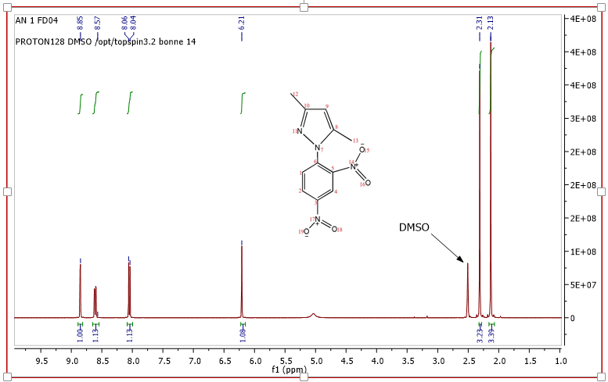
Figure 7 : Spectre RMN¹H du 1-(2,4-dinitrophenyl)-3,5-dimethylpyrazole
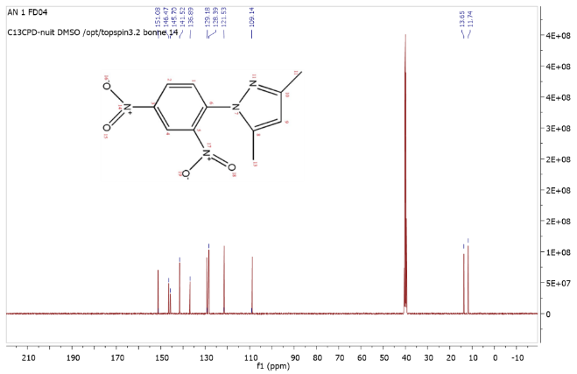
Figure 8 : Spectre RMN¹³C du 1-(2,4-dinitrophenyl)-3,5-dimethylpyrazole

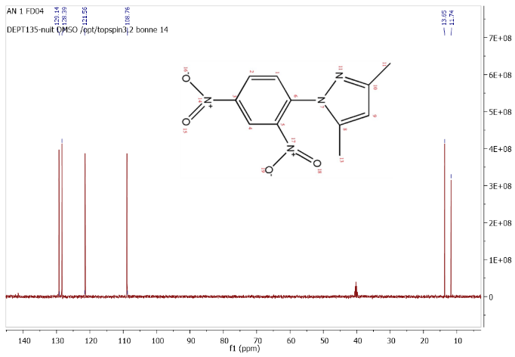
Figure 9: Spectre DEPT 135°C du 1-(2,4-dinitrophenyl)-3,5-dimethylpyrazole

