Original Research Article
ROS-Induced Lipid Peroxidation and Upregulated Antioxidant activity in Lemna minor under Heavy Metal and Herbicide Stress

.
ABSTRACT
Increase in the concentration of contaminants such as heavy metals and herbicides in aquatic systems through runoff disturb the aquatic ecosystem. The present in vitro study investigates oxidative stress and antioxidant responses in Lemna minor after 96 h exposure to graded concentrations of cadmium (Cd) (0, 0.1, 0.5, 1, 1.5 and 2 mg/L) and paraquat dichloride (0, 0.5, 1, 1.5, 2 and 2.5 mg/L). Lipid peroxidation, expressed as malondialdehyde (MDA) equivalents, was increased for both stressors in a dose-dependent manner (cadmium: +42% to +121%; paraquat: +28% to +200%), indicating increased production of reactive oxygen species (ROS). Activities of major antioxidant enzymes such as superoxide dismutase (SOD), peroxidase (POD), ascorbate peroxidase (APX) and glutathione reductase (GR) generally increased with pollutant concentration indicating induced enzymatic defense. SOD levels were significantly elevated in both cadmium and paraquat while, APX and GR gradually activated during treatment. The CAT activity showed an increase at low to moderate cadmium concentrations and a decrease at the highest cadmium concentration (2 mg/L) which may indicate the inhibition of the enzyme or the overloading of the scavenging capacity under severe metal stress. Paraquat caused a constant CAT increase. Results overall show that L. minor initiates a coordinated antioxidant response to diminish ROS generated by cadmium and paraquat exposure but very high metal stress may impair some specific defenses. These results suggest the potential of L. minor as a bioindicator of oxidative stress induced by pollutants. Furthermore, the antioxidant responses against Cd and paraquat dichloride may guide its use in phytoremediation studies.

Keywords: Lemna minor, Cadmium, Paraquat dichloride, Oxidative stress, Antioxidant enzymes, Bioindicator.

1. INTRODUCTION
Water is crucial for agriculture, industry and human wellbeing. But over the last few decades industrialization, urbanization, discharge of waste water and unchecked agriculture have all led to an over exploitation of natural resources leading to serious water pollution. Heavy metals and pesticides are continuously added by human activities in amounts harmful to human health (Zhang et al. 2009; Ishaq and Khan 2013; Arora et al. 2018). Point source contaminants are generated by industrial activity, such as metal smelting and mining, and nonpoint source pollutants are derived from agricultural runoff, including fertilizers and pesticides (Kumar et al. 2018a). Each pollutant is harmful to plants and animals in its own way, but the problem of heavy metals and pesticides entering water ecosystems is increasing. Flora and fauna assimilate highly toxic heavy metals as lead (Pb), mercury (Hg), arsenic (As), copper (Cu), zinc (Zn) and cadmium (Cd). Heavy metals in soil, aquatic system, and biota are naturally derived via rock degradation, volcanic activity, wildfire, biological processes, and marine salts from the oceans (Shahzad et al., 2024; Zaynab et al., 2022). However, anthropogenic activities such as mining, industrial processes, agriculture, waste disposal, biosolid addition, pesticide application, coal burning residues and petrochemical compounds have increased the levels of these metals causing great worldwide concern (Wuana and Okieimen, 2011). The amount of heavy metals in volcanic rocks or ash varies. Copper, lead and zinc are generally found at quantities of 1.2–47.8 μg g⁻¹, 8.4–36 mg kg⁻¹ and 15–73 mg kg⁻¹, respectively. Cadmium concentrations in volcanic rocks are in the range of 0.1-0.5 ppm in oceanic waters (Novoselov et al., 2022; Toress et al., 2023) spanning from <5 to 110 ng L⁻¹. Anthropogenic sources release higher concentrations of heavy metals since they emit large volumes of these pollutants in more dangerous and mobile forms. This is especially true in aquatic ecosystems where heavy metals can remain for long periods in the form of suspended matter, sediment layers, aquatic vegetation and fish (Kolarova and Napiórkowski, 2021). Most of the metals introduced into an aquatic system are adsorbed on suspended particles and are precipitated as sediments. Cadmium is the seventh most dangerous material on the ATSDR and EPA list given its well-documented toxicity and high potential for human exposure (ASTDR and EPA, 2024). Bioremediation is a new and eco-friendly decontamination method using microorganisms (Andreazza et al. 2011) or mainly plants (called phytoremediation) (Afonso et al. 2019; Xin et al. 2020) or using a combination of both methods (Islam et al. 2014) to remove metals from soil and water. Aquatic plants such as Lemna minor (Jayasri and Suthindhiran, 2017) and Hydrocotyle ranunculoides (Demarco et al., 2023) are suitable plant species for phytoremediation. These plants have proved their ability to remove many heavy metals from liquids. Pesticides including endosulfan, dichlorodiphenyltrichloroethane (DDT), mevinphos, ethion and copper sulfate are very harmful when ingested by flora and fauna (Kumar et al. 2016, 2018b). Duckweeds can help to solve a big modern environmental problem, namely the contamination of the hydrosphere with harmful substances (Ziegler et al. 2016). Duckweeds are macrophytes, which can uptake heavy metals from water. They are used for the removal of heavy metals from aquatic environment (Rai 2009). Cadmium (Cd) pollution is a major global environmental problem due to the rapid industrial development and the extensive use of chemical fertilizers, pesticides and herbicides in agriculture (Folgar et al. 2009). The contaminants indicated above could biomagnify in food and could be harmful to human health (Miretzky et al. 2004). Metals such as lead (Pb), mercury (Hg) and cadmium (Cd) are not required and are highly toxic even in little amounts (Nagajyoti et al 2010; Prasad 2011; Chibuike and Obiora 2014; Rezania et al 2016). Cadmium toxicity leads to oxidative stress, which harms cell membranes and electron transport, disrupts enzyme activity, and interferes with nucleic acids and photosynthesis, ultimately causing reduced development (Sarkar et al. 1998; Lu et al. 2010). Oxidative stress is usually related to the excessive accumulation of reactive oxygen species such as superoxide ion (O₂⁻), hydrogen peroxide (H₂O₂), and hydroxyl radical (OH⁻) which facilitate the conversion of fatty acids into harmful lipid peroxides and endanger the biological membranes (Weckx et al. 1996; Martín-Closas et al. 2017; Marron, 2015; Rai et al. 2016). On the other hand, non-radical reactive oxygen species (ROS) such as hypochlorous acid (HOCl), hydrogen peroxide (H₂O₂), singlet oxygen ⁽¹O₂) and peroxynitrite (ONOO⁻) are generally stable and have a long half-life. The most reactive type of oxygen species is the superoxide anion (O₂⁻). Hydrogen peroxide (H₂O₂) is produced by the rapid one-electron reduction of molecular oxygen, either spontaneously or through the dismutation of superoxide anion catalysed by superoxide dismutase (SOD) (Balakhnina et al. 2005; Zhang et al. 2009). Herbicides also cause an increase in the levels of ROS. Methyl viologen, also known as 1,1′-dimethyl-4,4′-bipyridinium dichloride, is an organic herbicide with broad spectrum activity that is generally referred to as paraquat (PQ) and is used in the management of weeds and grasses. It is effective and quick in flora but very dangerous to man and animals (Peacock 1978). PQ is harmful to the cells health as it disrupts the redox cycle by accepting and donating electrons (Homer et al. 1960). The chloroplasts accumulate reactive oxygen species (ROS) which damage proteins, enzymes and lipid membranes. PQ also limits the availability of NADPH, an essential ingredient for the Calvin Cycle in flora (Perales-Vela et al. 2021). PQ blocks photosynthesis, creates a severe oxidative stress in the cells, alters the enzymatic framework, causes cell death and finally the plant death. In the present study, we investigated the changes in the activity of antioxidant enzymes and oxidative stress generated by cadmium and paraquat dichloride in the duckweed species Lemna minor, a plant used in the phytoremediation of polluted surface waters.
2. material and methods
2.1. Plant material
Samples of Lemna minor were collected from the surface water of a pond of Roxburgh Botanical Garden, Department of Botany, University of Allahabad, Prayagraj, Uttar Pradesh India (25° 27’ 42.2352” N ,81°5’ 7.278” E). Plant samples were identified from Botanical Survey of India Central Regional Centre, Prayagraj, Uttar Pradesh, India.
The plants were transferred to 250 ml flasks with half-strength Hutner's medium with 10 g sucrose after several washes to make sure that roots and fronds have been completely washed. Cultures were kept in a growth chamber at 25°C at constant cold fluorescent light (6,800 lux; ASTME.1415-91, 1999) for 24–48 h. We prepared a stock solution of 1000 ppm cadmium as CdCl₂ (MW = 183.32 g mol⁻¹; purity = 99%; Sigma Aldrich). Paraquat dichloride (24% SL) was purchased under the brand name All Clear (chemical fertilizer) from HPM Chemicals & Fertilizers Ltd, Pitampura, New Delhi. From this stock solution, aliquots of different concentrations of cadmium (0.1, 0.5, 1.0, 1.5 and 2.0 mg/L) and paraquat dichloride (0.5, 1.0, 1.5, 2.0 and 2.5mg/L) were filled in flasks. Then the flasks with the plants were kept in a plant growth chamber for 4 days.

2.2. Oxidative stress
2.2.1. Lipid peroxidation assay
Lipid peroxidation was evaluated as malondialdehyde (MDA) equivalents according to the method of Heath and Packer (1968). One hundred milligrams of plant material were ground into fine powder and extracted in 1 mL of 0.1% trichloroacetic acid (TCA). The extract was centrifuged in an Eppendorf centrifuge 5920 R for 15 min at 10,000 × g at 4 °C. The supernatant was then mixed with 0.5% TBA and 20% TCA. The mixture was heated at 95°C for 30 min and then quickly cooled on ice. Absorbance at 532 and 600nm was measured using UV-VIS spectrophotometer (Schimadzu, Japan). Concentration of MDA equivalents was calculated using an extinction coefficient of 155 mM⁻¹ cm⁻¹ and expressed as nmol g⁻¹ FW.
2.3. Antioxidant enzyme activity
Superoxide dismutase activity (SOD; EC 1.15.1.1) was estimated by measuring the inhibition in the reduction of nitro blue tetrazoliumchloride (NBT) by the method described by Giannopolitis and Ries (1977). Catalase (CAT; EC 1.11.1.6) activity was measured by the method of Aebi (1984). The catalase activity of the samples was measured by homogenizing 100 mg of plant material with 1 mL of 50 mM PPB (Potassium Phosphate Buffer) and 1 mM EDTA. Peroxidase (POD; EC 1.11.1.7) activity was measured according to the method of Zhang (1992) with the extinction coefficient 25.5 Mm⁻¹ cm⁻¹. One unit of POD activity is defined as the amount of enzyme oxidizing 1 nmol of guaiacol min⁻¹. The activity of ascorbate peroxidase (APX) was calculated using the extinction coefficient (ε=2.8 mM ⁻¹ cm ⁻¹). One unit of APX activity is defined as the amount of enzyme oxidizing 1 nmol of ascorbate min ⁻¹ (Nakano and Asada, 1981). The activity of glutathione reductase (GR; EC 1.6.4.2) was determined as described by Schaedle and Bassham (1977). The GR activity was calculated using an extinction coefficient of 6.2 mM⁻¹cm⁻¹. 1 unit of activity is the amount of enzyme catalyzing the oxidation of 1 nmol NADPH min⁻¹.

3. results and discussion

3. Result
3.1. Oxidative stress
3.1.1. Lipid peroxidation
We measured the malondialdehyde (MDA) equivalents in the duckweed species Lemna minor to determine the amount of ROS induced lipid peroxidation. Duckweed was exposed to various concentrations of cadmium for 96 h (Figure (1A)). After 96 h treatment, the MDA equivalent content in Lemna minor increased with the increasing cadmium amount. Content of MDA equivalents of Lemna minor increased by 42%, 67%, 79.17%, 100% and 121% in the presence of cadmium levels of 0.1, 0.5, 1.0, 1.5 and 2 mg/L respectively. Figure(1B) showed a rise in MDA equivalent content in Lemna minor after 96 hours exposure to the herbicide Paraquat dichloride (0 mg/L to 2.5 mg/L). The content of MDA equivalents in Lemna minor increased by 28%, 96%, 175%, 196% and 200% at the concentrations of paraquat dichloride 0.5mg/L, 1mg/L, 1.5mg/L, 2 mg/l and 2.5 mg/l, respectively.
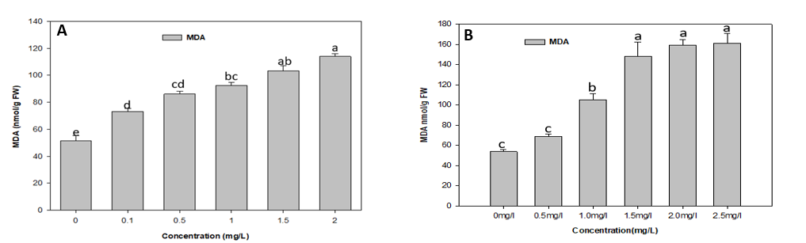
Figure. 1 Malondialdehyde (MDA) Activity in Lemna minor under heavy metal cadmium stress (A) and herbicide paraquat dichloride (B) stress. MDA Activity is measured in nmol/gm FW (Fresh weight) after 4th day of treatment.

3.2. Antioxidant activity

3.2.1. Superoxide dismutase (SOD) activity
Figure (2A) shows the results of the SOD activity test on the duckweed species Lemna minor after 96 hours of exposure to different levels of cadmium. SOD activity in Lemna minor rose by 43.08%, 51.28%, 59.45%, 66.37%, and 78.20% at cadmium (Cd) levels of 0.1, 0.5, 1, 1.5, and 2 mg/L, respectively, within the 0 to 2 mg/L range. After 96 hours of treatment with different amounts of the herbicide Paraquat dichloride, Lemna minor shows higher SOD activity, as shown in Figure (2B). At Paraquat dichloride concentrations of 0.5, 1, 1.5, 2, and 2.5 mg/L, SOD activity in Lemna minor went up by 6.25%, 9.37%, 34.37%, 31.25%, and 47%, respectively.

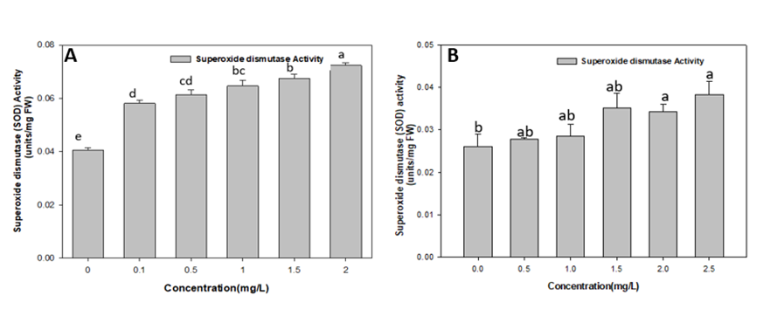
Figure. 2 Superoxide dismutase (SOD) Activity in Lemna minor under heavy metal cadmium stress (A) and herbicide paraquat dichloride (B) stress. SOD Activity is measured in units/mg FW (fresh weight after 4th day of treatment.

3.2.2. Peroxidase (POD) activity
Figure (3A) shows the data on POD activity. It shows that different levels of cadmium in the duckweed species Lemna minor after 96 hours of treatment led to a big rise in POD activity. Lemna minor has shown an increase in cadmium concentration (0 mg/L to 2 mg/L), with growth rates of 0.21%, 57.46%, 75%, 92.28%, and 97.54% at concentrations of 0.1, 0.5, 1, 1.5, and 2 mg/L, respectively. Figure (3B) shows that different amounts of the herbicide paraquat dichloride in the duckweed species Lemna minor after 96 hours of treatment led to higher POD activity. At higher concentrations i.e., 2 and 2.5 mg/L, POD activity rose significantly in Lemna minor.POD activity in Lemna minor increased by 3%,4.01%, 8.40%, 27% and 41.44% at the concentration of paraquat dichloride was 0.5mg/L,1mg/L, 1.5mg/L 2 mg/L and 2.5 mg/L, respectively.
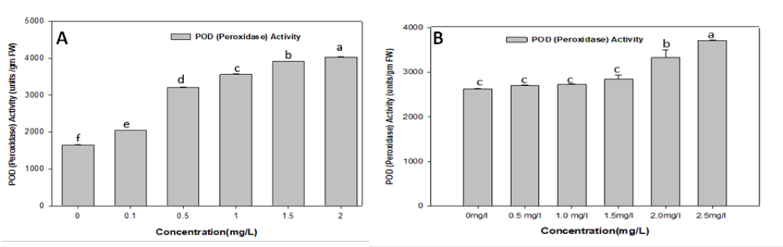
Figure. 3 POD (Peroxidase) Activity in Lemna minor under heavy metal cadmium stress (A) and herbicide paraquat dichloride (B) stress. POD Activity is measured in units/gm FW (fresh weight) after 4th day.
3.2.3. Catalase (CAT) activity
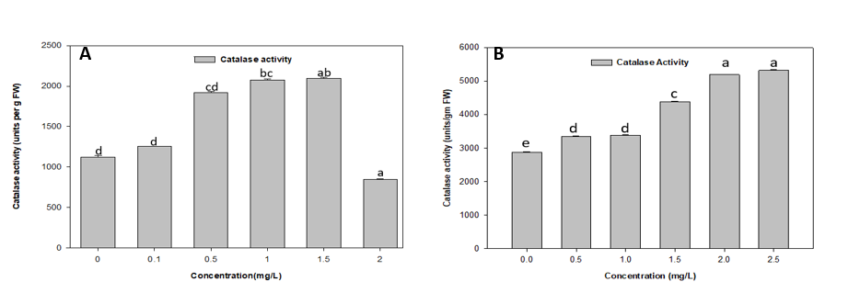
Figure (4A) shows the results of the CAT activity in the duckweed species Lemna minor after 96 hours of treatment with different amounts of cadmium. The results indicated that cadmium concentrations of 0.1, 0.5, 1, 1.5, and 2 mg/L in Lemna minor exhibited increased activity; however, a concentration of 2 mg/L resulted in a decline in activity. At cadmium concentrations of 0.1, 0.5, 1, 1.5, and 2 mg/L in Lemna minor, activity increased by 12%, 71%, 85%, and 86.45%, but then dropped by 25%. Figure (4B) shows that the duckweed species Lemna minor had higher CAT activity after being exposed to different amounts of the herbicide Paraquat dichloride for 96 hours. The findings demonstrate that at Paraquat dichloride concentrations of 0.5 mg/L, 1 mg/L, 1.5 mg/L, 2 mg/L, and 2.5 mg/L in Lemna minor, the activity escalated by 16.39%, 18%, 52.05%, 80.44% and 85%, respectively.
Figure. 4 Catalase (CAT) Activity in Lemna minor under heavy metal cadmium stress (A) and herbicide paraquat dichloride stress (B). CAT Activity is measured in units/gm FW (fresh weight) after 4th day of treatment
3.2.4. Ascorbate peroxidase (APX) activity
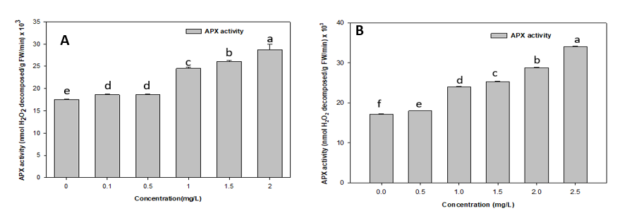
Figure (5A) shows the results of the APX activity in duckweed species. Changes in the amount of cadmium have a big effect on Lemna minor. The concentration of cadmium in Lemna minor, which ranges from 0 mg/L to 2 mg/L, shows that the plant becomes more active as the cadmium levels rise. After 96 hours of treatment, there was a significant increase of 6.26%, 7%, 40.29%, 49.27%, and 64.16% at concentrations of 0.1, 0.5, 1, 1.5, and 2 mg/L, respectively. A similar upward trend was observed in Lemna minor when exposed to Paraquat dichloride concentrations between 0 mg/L and 2.5 mg/L, suggesting that activity increased with higher Paraquat dichloride concentrations shown in Figure (5B). After 96 hours of treatment, there was a significant increase of 5.09%, 40%, 46%, 68%, and 99% at concentrations of 0.5, 1, 1.5, 2, and 2.5 mg/L, respectively.
Figure 5 – Ascorbate peroxidase (APX) Activity in Lemna minor under heavy metal cadmium stress (A) and herbicide paraquat dichloride stress (B). APX Activity is measured in nmol H₂O₂ decomposed/gm (fresh weight) FW/min *10³ after 4th day of treatment

3.2.5. Glutathione reductase (GR) Activity
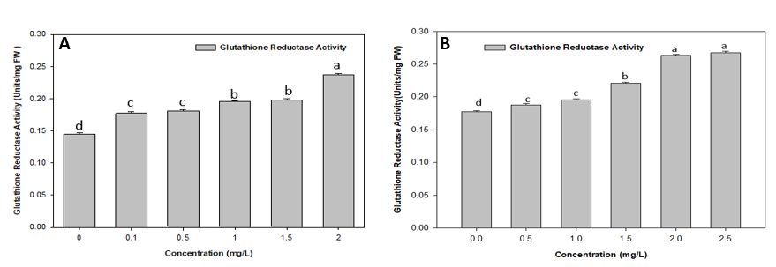
Figure (6A) shows the results of the GR activity in the duckweed species Lemna minor. Different amounts of cadmium have a big effect on Lemna minor. The concentration of cadmium in Lemna minor, which ranges from 0 mg/L to 2 mg/L, shows that the plant becomes more active as the levels of cadmium rise. After 96 hours of treatment, there was a significant increase of 23%, 25.02%, 35.38%, 38%, and 64% at concentrations of 0.1, 0.5, 1, 1.5, and 2 mg/L, respectively. Lemna minor exhibited a comparable upward trend when subjected to herbicide exposure shown in Figure(6B). The concentration of paraquat dichloride (0 mg/L to 2.5 mg/L) in Lemna minor indicates heightened activity with increasing paraquat dichloride levels. After 96 hours of treatment, there was a significant increase of 6.11%,10.29%, 25%, 49% and 51.12% at concentrations of 0.5mg/L, 1mg/L, 1.5mg/L, 2mg/Land 2.5 mg/L, respectively.
Figure 6 - Glutathione Reductase (GR) Activity in Lemna minor under cadmium stress (A) and herbicide paraquat dichloride stress (B). GR Activity is measured in units/mg FW (fresh weight) after 4th day of treatment.

Table 1. Cadmium stress on Lemna minor antioxidant activity and oxidative stress

Concentration  (mg/L) | Superoxide dismutase (SOD) Activity (units/mg FW) | Peroxidase (POD)Activity (units/g FW) | Catalase (CAT) Activity (units/g FW) | Ascorbate peroxidase (APX) Activity (nmol H₂O₂/g FW/min ×10³) | Glutathione Reductase (GR) Activity (Units/mg FW) | Malondialdehyde MDA (nmol/g FW)
0 | 0.040  ±0.01 | 2037.47  ±5.30 | 1124.0  ±18.84 | 17.492  ±0.10 | 0.144  ±0.01 | 51.6  ±3.73
0.1 | 0.058  ±0.01 | 2041  ±7.98 | 1255.4  ±3.38 | 18.111  ±0.27 | 0.177  ±0.02 | 73.1  ±2.15
0.5 | 0.061  ±0.01 | 3208.71  ±4.61 | 1918.7  ±15.50 | 18.650  ±0.14 | 0.181  ±0.02 | 86.00  ±2.15
1.0 | 0.064  ±0.02 | 3557.298  ±11.42 | 2074.4  ±16.14 | 24.539  ±0.29 | 0.196  ±0.01 | 92.45  ±2.15
1.5 | 0.067  ±0.01 | 3918.08  ±2.30 | 2094.7  ±11.84 | 26.111  ±0.29 | 0.197  ±0.02 | 103.2  ±3.72
2.0 | 0.072  ±0.01 | 4025.27  ±7.13 | 846.02  ±6.77 | 28.714  ±0.25 | 0.237  ±0.01 | 113.95  ±2.15

Table2 Paraquat dichloride stress on Lemna minor antioxidant activity and oxidative stress

Concentration  (mg/L) | Superoxide dismutase (SOD) Activity (units/mg FW) | Peroxidase (POD)Activity (units/g FW) | Catalase (CAT) Activity (units/g FW) | Ascorbate peroxidase (APX) Activity (nmol H₂O₂/g FW/min ×10³) | Glutathione Reductase (GR) Activity (Units/mg FW) | Malondialdehyde (MDA)  (nmol/g FW)
0 | 0.026  ±0.002 | 2626.58  ±4.611 | 2879.865  ±16.141 | 17.142  ±0.164 | 0.177  ±0.001 | 53.75  ±2.15
0.5 | 0.027  ±0.000 | 2698.039  ±10.884 | 3351.95  ±11.844 | 18.015  ±0.057 | 0.187  ±0.001 | 69.000  ±2.15
1.0 | 0.028  ±0.002 | 2732.026  ±12.354 | 3390.86  ±8.792 | 23.984  ±0.183 | 0.195  ±0.001 | 105.35  ±5.688
1.5 | 0.035  ±0.003 | 2847.059  ±90.448 | 4379.02  ±22.383 | 25.333  ±0.072 | 0.220  ±0.001 | 148.35  ±14.098
2.0 | 0.034  ±0.001 | 3323.747  ±174.345 | 5196.277  ±4.476 | 28.777  ±0.082 | 0.263  ±0.001 | 159.1  ±5.688
2.5 | 0.038  ±0.003 | 3715.033  ±5.442 | 5323.181  ±19.948 | 34.063  ±0.082 | 0.267  ±0.002 | 161.25  ±9.852

Discussion
The present study demonstrates that both cadmium (Cd) and paraquat dichloride (PQ) induce dose-dependent enzymatic response in Lemna minor. Heavy metals cause large amounts of lipid peroxidation that can be initiated by reactive oxygen species (O•⁻², OH• and ¹O₂) or lipoxygenase (Singh et al. 2006). The highest MDA content was observed in Lemna plants treated with Cd on 4th day of experiment. This indicates that the metal caused oxidate damage. Cd toxicity leads to oxidative stress, as has been previously reported (Singh et al. 2006; Gratão et al. 2008; Tkalec et al, 2008). The marked increase in MDA equivalents observed here after exposure to paraquat suggests the possibility of oxidative modes of phytotoxicity for these herbicides (2008). Increased MDA levels are an indicator of membrane damage, which can lead to functional impairment of the cell, arrest of growth and potentially plant death should antioxidant defenses be overwhelmed (HaroGirón et al., 2023). Monitoring of MDA level may help in assessment of risk of environment and effect of agrochemicals on aquatic ecosystems through oxidative stress. The plant response towards ROS were govern by various pathways via various antioxidant enzymes. Superoxide dismutases (SODs) catalyze the dismutation of superoxide (O₂•−) to molecular oxygen and hydrogen peroxide, protecting cells against superoxide toxicity (Cakmak, 2005). In Lemna minor, short-term Cd exposure strongly inhibits CAT relative to other antioxidant enzymes, and total antioxidative potential collapses at higher Cd levels, consistent with a transition from compensated to decompensated oxidative stress. Microalgae and other aquatic plants show comparable trends: initial upregulation of CAT followed by suppression as Cd accumulates and cellular damage progresses (Farias et al.2024; Razinger et al.2008). Catalases (CAT) and peroxidases (APX and GPX) decompose H₂O₂ to H₂O and O₂. GR activity was significantly increased at high Cd concentrations, in agreement with recent data in duckweed and other aquatic plants, where GR activity is strongly enhanced as part of a general antioxidative response. The ability of the plant to cope with acute oxidative stress caused by metals is associated with increased GR activity (Li et al. 2018; Yang et al. 2023; Moravčíková & Žiarovská 2023). The dose-dependent increase in the activities of antioxidant enzymes indicates that Lemna minor is efficient in scavenging reactive oxygen species (ROS). The high elevation of SOD in Lemna minor confirms its role as a sensitive biomarker of herbicide toxicity (Manna et al., 2020). Paraquat induces oxidative stress through redox cycling and reactive oxygen species (ROS) generation (Donaher and Van den, 2023). The process was observed for an increase in SOD activity from 6.25% to 47%. This is compatible with the sensitivity of aquatic plants (EC50 = 28–280 μg/L). High SOD response at low concentrations of paraquat (0.5-2.5 mg/L) is an indicator of high toxicity of this chemical (Donaher and Van den, 2023). At higher concentrations of paraquat (2 and 2.5 mg/L) significant increases in POD activity of Lemna minor were observed indicating an active antioxidant response to reduce the cellular damage caused by reactive oxygen species (ROS). The increase in the activity of POD is probably an attempt to protect the body from the oxidative damage caused by paraquat. As the concentration of paraquat dichloride increased, the CAT activity of Lemna minor increased significantly (16.39%-85%). According to Tagun (2014), the increase in CAT activity is a common self-protection method of plants. It catalyzes the breakdown of hydrogen peroxide, a by-product of reactive oxygen species (ROS), to protect cells from oxidative damage. Lemna minor has been found to be very sensitive to paraquat and its growth is quickly inhibited with the occurrence of physiological changes (Tagun, 2014). Increasing the concentration of paraquat dichloride exposure to Lemna minor increased the ascorbate peroxidase (APX) activity. APX expression is differentially regulated during normal plant growth and development and in response to environmental stresses (Pandey et al., 2017). Stress in a cell causes a rapid disturbance of the redox balance and accumulation of reactive oxygen species (Halliwell, 2006). The level of APX expression (Tang et al. 2006) is directly related to the time and intensity of stress and different types of stress. GR plays a very important role in the cellular scavenging system to eliminate the reactive oxygen species (ROS) in plants. It uses NADPH as an electron donor to reduce oxidized glutathione or glutathione disulfide (GSSG) to reduced glutathione (GSH). This process is required to maintain the cellular redox levels by keeping the GSH/GSSG ratio low in cells under normal or oxidative stress (Anjuma et al. 2012). The present study suggests an increase in GR activity which is in line with the findings of other studies.

4. Conclusion

Present study demonstrates that exposure to cadmium and paraquat markedly induces oxidative stress in Lemna minor, as evidenced by elevated lipid peroxidation and alterations in antioxidant enzyme activity. The elevated malondialdehyde (MDA) levels noted in response to cadmium and paraquat treatments signify considerable membrane impairment resulting from the accumulation of reactive oxygen species (ROS). A significant increase in the levels of antioxidant enzymes like SOD, CAT, APX, POD, and GR exhibits that Lemna minor is trying to mitigate oxidative problems under contaminant induced stress. SOD is necessary for the dismutation of superoxide radicals, while CAT and peroxidases (APX, GPX, and POD) help break down hydrogen peroxide, which keeps redox homeostasis. The high level of GR activity helps keep the pools of reduced glutathione intact, which are important for protecting cells. Lemna minor exhibits a coordinated antioxidative mechanism in response to heavy metal and herbicide stress, validating its sensitivity and potential as a bioindicator for evaluating oxidative damage and environmental toxicity in aquatic ecosystems.

Competing interests
The authors have no relevant financial or non-financial interests to disclose.

Consent
Not applicable.

Ethical approval
Not required

Declaration of AI Use

This manuscript was prepared through the combined contributions of all author(s), including contributions to the study design, data, content development, results, interpretation, and related scholarly work. The author(s) acknowledge the use of Grammarly and ChatGPT to assist with grammar checking, language refinement, reference formatting. These AI-assisted tools were not used as authors and did not replace the intellectual contributions or scholarly judgment of the author(s). All AI-assisted outputs, including content, references, and interpretations, were carefully reviewed, revised, verified, and approved by the author(s). The author(s) accept full responsibility for the accuracy, integrity, and final content of the manuscript.

References
Aebi H (1984) Catalase in vitro. Methods Enzymol 105: 121—126.
Afonso, T. F., Demarco, C. F., Pieniz, S., Camargo, F. A., Quadro, M. S., & Andreazza, R. (2019). Potential of Solanum viarum Dunal in use for phytoremediation of heavy metals to mining areas, southern Brazil. Environmental Science and Pollution Research, 26(23), 24132-24142.
Andreazza, R., Okeke, B. C., Pieniz, S., Brandelli, A., Lambais, M. R., & Camargo, F. A. (2011). Bioreduction of Cu (II) by cell-free copper reductase from a copper resistant Pseudomonas sp. NA. Biological trace element research, 143(2), 1182-1192.
Anjum, N. A., Ahmad, I., Mohmood, I., Pacheco, M., Duarte, A. C., Pereira, E., ... & Prasad, M. N. V. (2012). Modulation of glutathione and its related enzymes in plants’ responses to toxic metals and metalloids—a review. Environmental and Experimental Botany, 75, 307-324.
Arora, N. K., Fatima, T., Mishra, I., Verma, M., Mishra, J., & Mishra, V. (2018). Environmental sustainability: challenges and viable solutions. Environmental Sustainability, 1(4), 309-340.
Astm, E. (1999). 1415-91 Standard Guide for Conducting Static Toxicity Tests with Lemna gibba G3. American Society for Testing and Materials, West Conshohocken, PA, USA.
Balakhnina, T. I., Kosobryukhov, A. A., Ivanov, A. A., & Kreslavskii, V. D. (2005). The effect of cadmium on CO2 exchange, variable fluorescence of chlorophyll, and the level of antioxidant enzymes in pea leaves. Russian Journal of Plant Physiology, 52(1), 15-20.
Bianconi, D., Pietrini, F., Massacci, A., & Iannelli, M. A. (2013). Uptake of Cadmium by Lemna minor, a (hyper?-) accumulator plant involved in phytoremediation applications. In E3S Web of conferences (Vol. 1, p. 13002). EDP Sciences.
Blanco-Ayala, T., Andérica-Romero, A. C., & Pedraza-Chaverri, J. (2014). New insights into antioxidant strategies against paraquat toxicity. Free radical research, 48(6), 623-640.
Bus, J. S., & Gibson, J. E. (1984). Paraquat: model for oxidant-initiated toxicity. Environmental health perspectives, 55, 37.
Changfang, Z., Guorong, W., Guoxin, S., Changmei, L., Gongping, G., Xueming, Z., & Jincheng, W. (2001). The role of antioxidant systems in Cu~(2+) stress resistance in Alternanthera philoxeroides. Acta botanica sinica, 43(4), 389-394.
Chibuike, G. U., & Obiora, S. C. (2014). Heavy metal polluted soils: effect on plants and bioremediation methods. Applied and environmental soil science, 2014(1), 752708.
Demarco, C. F., Bonemann, D. H., Ribeiro, A. S., Cadaval Jr, T. R. S. A., Gelesky, M. A., Godinho, M., ... & Andreazza, R. (2023). Resistance mechanisms of Hydrocotyle ranunculoides to Cr (VI): A biolfilter plant. Journal of Cleaner Production, 405, 136721.
Donaher, S. E., & Van den Hurk, P. (2023). Ecotoxicology of the herbicide paraquat: effects on wildlife and knowledge gaps. Ecotoxicology, 32(9), 1187-1199.
Farias, J. P., Okeke, B. C., Demarco, C. F., Carlos, F. S., da Silva, R. F., da Silva, M. A., ... & Andreazza, R. (2024). Cadmium contamination in aquatic environments: detoxification mechanisms and phytoremediation approach. Sustainability, 16(22), 10072.
Folgar, S., Torres, E., Pérez-Rama, M., Cid, A., Herrero, C., & Abalde, J. (2009). Dunaliella salina as marine microalga highly tolerant to but a poor remover of cadmium. Journal of Hazardous Materials, 165(1-3), 486-493.
Giannopolitis, C. N., & Ries, S. K. (1977). Superoxide dismutases: I. Occurrence in higher plants. Plant physiology, 59(2), 309-314.
Gratão, P. L., Monteiro, C. C., Antunes, A. M., Peres, L. E. P., & Azevedo, R. A. (2008). Acquired tolerance of tomato (Lycopersicon esculentum cv. Micro‐Tom) plants to cadmium‐induced stress. Annals of applied biology, 153(3), 321-333.
Halliwell, B. (2006). Oxidative stress and neurodegeneration: where are we now?. Journal of neurochemistry, 97(6), 1634-1658.
Haro Girón, S., Monserrat Sanz, J., Ortega, M. A., Garcia-Montero, C., Fraile-Martínez, O., Gómez-Lahoz, A. M., ... & Álvarez-Mon, M. (2023). Prognostic value of malondialdehyde (MDA) in the temporal progression of chronic spinal cord injury. Journal of Personalized Medicine, 13(4), 626.
Heath, R. L., & Packer, L. (1968). Photoperoxidation in isolated chloroplasts: I. Kinetics and stoichiometry of fatty acid peroxidation. Archives of biochemistry and biophysics, 125(1), 189-198.
Homer, R. F., Mees, G. C., & Tomlinson, T. E. (1960). Mode of action of dipyridyl quaternary salts as herbicides. Journal of the Science of Food and Agriculture, 11(6), 309-315.
Cakmak, I. (2000). Tansley Review No. 111 Possible roles of zinc in protecting plant cells from damage by reactive oxygen species. The New Phytologist, 146(2), 185-205.
Fouzia Ishaq, F. I., & Amir Khan, A. K. (2013). Heavy metal analysis of River Yamuna and their relation with some physicochemical parameters.
Islam, F., Yasmeen, T., Ali, Q., Ali, S., Arif, M. S., Hussain, S., & Rizvi, H. (2014). Influence of Pseudomonas aeruginosa as PGPR on oxidative stress tolerance in wheat under Zn stress. Ecotoxicology and Environmental Safety, 104, 285-293.
Jayasri, M. A., & Suthindhiran, K. (2017). Effect of zinc and lead on the physiological and biochemical properties of aquatic plant Lemna minor: its potential role in phytoremediation. Applied Water Science, 7(3), 1247-1253.
Kolarova, N., & Napiórkowski, P. (2021). Trace elements in aquatic environment. Origin, distribution, assessment and toxicity effect for the aquatic biota. Ecohydrology & Hydrobiology, 21(4), 655-668.
Kumar, D., Bharti, S. K., Anand, S., & Kumar, N. (2018). Bioaccumulation and biochemical responses of Vetiveria zizanioides grown under cadmium and copper stresses. Environmental Sustainability, 1(2), 133-139.
Kumar, D., Singh, D. P., Barman, S. C., & Kumar, N. (2016). Heavy metal and their regulation in plant system: an overview. Plant responses to xenobiotics, 19-38.
Kumar, N., Kulsoom, M., Shukla, V., Kumar, D., Priyanka, Kumar, S., ... & Dwivedi, N. (2018). Profiling of heavy metal and pesticide residues in medicinal plants. Environmental Science and Pollution Research, 25(29), 29505-29510.
Li, B., Gu, B., Yang, Z., & Zhang, T. (2018). The role of submerged macrophytes in phytoremediation of arsenic from contaminated water: A case study on Vallisneria natans (Lour.) Hara. Ecotoxicology and environmental safety, 165, 224-231.
Lu, Y., Li, X., He, M., Zhao, X., Liu, Y., Cui, Y., ... & Tan, H. (2010). Seedlings growth and antioxidative enzymes activities in leaves under heavy metal stress differ between two desert plants: a perennial (Peganum harmala) and an annual (Halogeton glomeratus) grass. Acta Physiologiae Plantarum, 32(3), 583-590.
Manna, B., Dutta, S. M., Dalapati, S., & Maiti, S. (2020). Oxidative stress-induced toxicity and DNA stability in some Agri-field based livestock/insect by widely used pesticides. Combinatorial Chemistry & High Throughput Screening, 23(9), 972-980.
Marron, N. (2015). Agronomic and environmental effects of land application of residues in short-rotation tree plantations: A literature review. Biomass and bioenergy, 81, 378-400.
Martín-Closas, L., Costa, J., & Pelacho, A. M. (2017). Agronomic effects of biodegradable films on crop and field environment. In Soil degradable bioplastics for a sustainable modern agriculture (pp. 67-104). Berlin, Heidelberg: Springer Berlin Heidelberg.
Miretzky, P., Saralegui, A., & Cirelli, A. F. (2004). Aquatic macrophytes potential for the simultaneous removal of heavy metals (Buenos Aires, Argentina). Chemosphere, 57(8), 997-1005.
Moravčíková, D., & Žiarovská, J. (2023). The effect of cadmium on plants in terms of the response of gene expression level and activity. Plants, 12(9), 1848.
Nagajyoti, P. C., Lee, K. D., & Sreekanth, T. V. M. (2010). Heavy metals, occurrence and toxicity for plants: a review. Environmental chemistry letters, 8(3), 199-216.
Nakano, Y., & Asada, K. (1981). Hydrogen peroxide is scavenged by ascorbate-specific peroxidase in spinach chloroplasts. Plant and cell physiology, 22(5), 867-880.
Novoselov, A. A., Hodson, M. E., Tapia-Gatica, J., Dovletyarova, E. A., Yáñez, C., & Neaman, A. (2022). The effect of rock lithology on the background concentrations of trace elements in alluvial soils: Implications for environmental regulation. Applied Geochemistry, 146, 105440.
Peacock, F. C. (Ed.). (1978). Jealott's Hill. Fifty years of agricultural research 1928-1978 (pp. 160-pp).
Perales-Vela, H. V., Salcedo-Álvarez, M. O., Parra-Marcelo, R., Gaviria-González, L. C., & de Jesús Martínez-Roldán, A. (2021). Growth and metabolic responses to methyl viologen (1, 1′-dimethyl-4, 4′-bipyridinium dichloride) on Chlorella vulgaris. Chemosphere, 281, 130750.
Prasad R (2011) Aerobic rice systems. Adv Agron 111:207–247
Rai, P. K. (2009). Heavy metal phytoremediation from aquatic ecosystems with special reference to macrophytes. Critical Reviews in Environmental Science and Technology, 39(9), 697-753.
Rai, R., Agrawal, M., & Agrawal, S. B. (2016). Impact of heavy metals on physiological processes of plants: with special reference to photosynthetic system. In Plant responses to xenobiotics (pp. 127-140). Singapore: Springer Singapore.
Razinger, J., Dermastia, M., Koce, J. D., & Zrimec, A. (2008). Oxidative stress in duckweed (Lemna minor L.) caused by short-term cadmium exposure. Environmental pollution, 153(3), 687-694.
Rezania, S., Ponraj, M., Fadhil Md Din, M., Chelliapan, S., & Md Sairan, F. (2016). Effectiveness of Eichhornia crassipes in nutrient removal from domestic wastewater based on its optimal growth rate. Desalination and water treatment, 57(1), 360-365.
Sarkar, S., Yadav, P., & Bhatnagar, D. (1998). Lipid peroxidative damage on cadmium exposure and alterations in antioxidantsystem in rat erythrocytes: A study with relation to time. Biometals, 11(2), 153-157.
Pandey, S., Fartyal, D., Agarwal, A., Shukla, T., James, D., Kaul, T., ... & Reddy, M. K. (2017). Abiotic stress tolerance in plants: myriad roles of ascorbate peroxidase. Frontiers in plant science, 8, 581.
Schadle M, Bassham JA (1977) Chloroplast glutathione reductase. Plant Physiol 59: 1011—1012.
Shahzad, A., Zahra, A., Li, H. Y., Qin, M., Wu, H., Wen, M. Q., ... & Zafar, S. (2024). Modern perspectives of heavy metals alleviation from oil contaminated soil: A review. Ecotoxicology and Environmental Safety, 282, 116698.
Singh, S., Eapen, S., & D’souza, S. F. (2006). Cadmium accumulation and its influence on lipid peroxidation and antioxidative system in an aquatic plant, Bacopa monnieri L. Chemosphere, 62(2), 233-246.
Substance Priority List|ATSDR. Available online: https://www.atsdr.cdc.gov/programs/substance-priority-list.html (accessed on 3 September 2024)
Tagun, R. (2014). The Effects of mixtures of pesticides, in use in Thailand, on the aquatic macrophyte Lemna minor (Doctoral dissertation, University of York).
Tang, L., Kwon, S. Y., Kim, S. H., Kim, J. S., Choi, J. S., Cho, K. Y., ... & Lee, H. S. (2006). Enhanced tolerance of transgenic potato plants expressing both superoxide dismutase and ascorbate peroxidase in chloroplasts against oxidative stress and high temperature. Plant Cell Reports, 25(12), 1380-1386.
Tkalec, M., Prebeg, T., Roje, V., Pevalek-Kozlina, B., & Ljubešić, N. (2008). Cadmium-induced responses in duckweed Lemna minor L. Acta Physiologiae Plantarum, 30(6), 881-890.
Torres, P., Llopis, A. L., Melo, C. S., & Rodrigues, A. (2023). Environmental impact of cadmium in a volcanic archipelago: research challenges related to a natural pollution source. Journal of Marine Science and Engineering, 11(1), 100.
Weckx, J. E., & Clijsters, H. M. (1996). Oxidative damage and defense mechanisms in primary leaves of Phaseolus vulgaris as a result of root assimilation of toxic amounts of copper. Physiologia Plantarum, 96(3), 506-512.
Wuana, R. A., & Okieimen, F. E. (2011). Heavy metals in contaminated soils: a review of sources, chemistry, risks and best available strategies for remediation. International Scholarly Research Notices, 2011(1), 402647.
Xin, J., Ma, S., Li, Y., Zhao, C., & Tian, R. (2020). Pontederia cordata, an ornamental aquatic macrophyte with great potential in phytoremediation of heavy-metal-contaminated wetlands. Ecotoxicology and Environmental Safety, 203, 111024.
Yang, G. L., Huang, L., Yang, X., Li, Z., Liao, H. M., Mao, K., ... & Tan, A. J. (2023). Transcriptomic and functional analyses of two cadmium hyper-enriched duckweed strains reveal putative cadmium tolerance mechanisms. International Journal of Molecular Sciences, 24(15), 12157.
Zaynab, M., Al-Yahyai, R., Ameen, A., Sharif, Y., Ali, L., Fatima, M., ... & Li, S. (2022). Health and environmental effects of heavy metals. Journal of King Saud University-Science, 34(1), 101653.
Zhang, X., Zhao, F. J., Huang, Q., Williams, P. N., Sun, G. X., & Zhu, Y. G. (2009). Arsenic uptake and speciation in the rootless duckweed Wolffia globosa. New Phytologist, 182(2), 421-428.
Zhang, X. Z. (1992). The measurement and mechanism of lipid peroxidation and SOD, POD and CAT activities in biological system. Research methodology of crop physiology, 208-211.

