Original Research Article
Histopathological and Morphometric Evidence of Cadmium-Induced Testicular Damage in Syrian Golden Hamsters (Mesocricetus auratus)

Abstract
Cadmium is a well-known environmental pollutant which affects male reproductive system after bioaccumulation. The present study investigated the histopathological and morphometric effects of acute cadmium exposure in the testes of adult Syrian golden hamsters (Mesocricetus auratus). Animals were divided into four groups (n = 5): a control group and three treatment groups receiving injections (i.p.) of cadmium chloride at doses of 0.5, 1.0, and 2.0 mg/kg body weight for 10 consecutive days. Hemotaxylin stained slide of testis of each group was prepared and ImageJ software was used for morphometric assessments. Histological analysis showed dose-dependent seminiferous tubule degeneration with pyknotic nuclei, germ cell exfoliation, cellular debris in the lumen, spermatogenic cell depletion, interstitial space widening, epithelial thinning, tubular distortion, and a significant decrease in luminal visible spermatozoa density. gaps, tubular deformation, thinning of the epithelium, and decreased luminal spermatozoa. Morphometric analysis cross-verified the histological findings by confirming decreases in area and diameter of the seminiferous tubule, epithelial height, and spermatogonia count, with the most severe alterations observed in the 2.0 mg/kg group. These structural abnormalities indicate dose-dependent progressive disruption of normal testicular architecture and thus, as a result, impairment of spermatogenesis. The findings demonstrate that acute cadmium exposure causes severe gonadotoxic effects in male Syrian golden hamsters and validate this species as a suitable experimental model for investigating heavy metal-induced reproductive toxicity.
Keywords: Cadmium, Testis, Histopathology, Syrian golden hamster, Spermatogenesis, Seminiferous tubules, Gonadotoxicity.
Introduction
Heavy metals represent a major class of environmental pollutants characterized by their persistence, non-biodegradability, and capacity for bioaccumulation within biological systems without any positive biological function (Ali et al, 2019). Of these, cadmium (Cd) is particularly important due to its widespread industrial use in batteries, paint, pigments, coatings, electronic equipment. Mining activities and tobacco smoking are also important source of exposure in man (Genchi et al, 2020). Now, cadmium is being leached to the groundwater too (Jebril et al, 2020).
Cadmium becomes more dangerous due to its long biological half-life of 10-35 years (in human) (WHO, 2011) because of prolonged retention in body due to repeated reuptake by metallothioneins (MT). Human and animal exposure to cadmium occurs primarily through contaminated food, water and air, leading to its gradual bioaccumulation in vital organs, including the heart, liver, kidneys, and reproductive tissues (Babaknejad et al., 2017; Xiong et al., 2021). The level of toxicity depends on routes and period of cadmium exposure to the animal. The nasal route of exposure is most dangerous. Toxicity of chronic and acute exposures depends upon cadmium concentrations. Surprisingly, even a low exposure can cause reproductive harm (Laskey et al, 1984).
Cadmium, although affects most of the biological systems, is now being widely recognised as a strong reproductive toxicant (Xiong et al, 2021; Kumar & Sharma, 2019). In males of different species, cadmium is associated with decreased sperm quality & androgen production, structural damage & histopathology of testis, thus affecting overall fertility of the animal (Bhardwaj et al., 2021; Massányi et al., 2020). It has been established that the mammalian testis is very sensitive to cadmium toxicity leading to alteration in its structure and function (Zhu et al, 2020).
Several researchers have reported that cadmium exposure (Acute/Chronic) induces may histological alternations in testis viz. degeneration and disorganization of seminiferous tubules, depletion of germ cells, interstitial oedema, vascular congestion, and necrosis of spermatogenic cells (Shojaeepour et al., 2021; Iqbal et al., 2021). The integrity of blood-testis barrier (BTB), which separates the microenvironment of testis from rest of the body, is also compromised by the cadmium (Ali et al., 2022; Jiang et al., 2024).
The mechanism of cadmium-induced testicular toxicity is multifactorial. A central mechanism involves the generation of reactive oxygen species (ROS), leading to oxidative stress, lipid peroxidation, protein oxidation, and DNA damage within testicular cells (Antar et al., 2023; Xiong et al., 2021). Cadmium also interferes with the cellular antioxidant defence system (Štajn et al, 1997). It also alters the expression of different genes involved in apoptosis and cell survival including upregulation of pro-apoptotic genes (Bax, p53) and downregulation of anti-apoptotic genes (Bcl-2), resulting in germ cell death and impaired spermatogenesis (Eleawa et al., 2014; Antar et al., 2023; Venditti et al., 2021; Zhu et al., 2020). In Leydig cells, Cd interferes with steroidogenesis by downregulating genes such as StAR, CYP11A1, and 3β-HSD, 17β‐HSD, leading to decreased testosterone synthesis (Ji et al., 2024). Additionally, Cd activates innate immune pathways, including the TLR4/MAPK/NF-κB axis and AIM2 inflammasome, further promoting inflammation, pyroptosis, and testicular injury (Zhou et al., 2022; Li et al., 2022). Furthermore, cadmium-induced vascular damage (Angeli et al, 2013) and ischemia within the testis leads to necrosis (Mason et al, 1964) and degeneration of testicular tissue (Wang et al, 2017). These combined effects result in both structural and functional impairment of the testes.
The heavy toxicity is studied mostly in fishes, birds, rodents, rabbit and humans (Chandel and Jain, 2014). Of these, rodents are most common animal model, but most of the research is restricted to rat and mice only (Gad, 2019). Use of hamsters in toxicological research is very limited. However, it has been established that hamsters are very much sensitive to chemical pollutions, including heavy metals (Wlodarczy et al.,1995).
Due to limited research data of heavy metal toxicity in hamsters, we have decided to investigate cadmium toxicity in Syrian Golden Hamster (Mesocricetus auretus). This study aims to establish a proper understanding of histopathological changes in testis of cadmium exposed hamsters through histological preparations and its qualitative analysis. Being the primary reproductive organ, detailed histological examinations of testis contribute to a better understanding of impact of cadmium on male reproductive health. Reproductive organs may be a perfect "barometer" for the harmful impacts of environmental pollution on human and animal health since their reaction to hazardous compounds is different from that of other target organs (Massányi et al., 2020).
Material and method
The experiment was done in accordance with the guidelines of the Committee for Control and Supervision of Experiments on Animals (CCSEA), Government of India.
Experimental Animal and its maintenance
Adult male Syrian golden hamsters (Mesocricetus auratus) were used as experimental subjects. Animals (90–100 days old; 100–130 g) were housed in polypropylene cages under controlled environmental conditions (25 ± 2 °C) with a 12.5 h light/11.5 h dark cycle. They were maintained on standard commercial rodent pellets and provided drinking water ad libitum.
Chemicals
Analytical grade Cadmium Chloride (98% pure CdCl₂.H₂O) powder (CAS Number: 35658-65-2) was purchased from Cynor Laboratories, Surat, Gujrat, India. Regular table salt was purchased from market for preparation of normal saline.
Experimental Design
Adult male golden hamsters were randomly divided into four groups (n = 5 per group). Group I served as control (vehicle-treated), while Groups II, III, and IV received cadmium chloride (CdCl₂) at doses of 0.5, 1.0, and 2.0 mg/kg body weight, respectively. All doses (in 100 µl) were administered once daily via intraperitoneal injection. The control group received 100 µl normal saline. Treatments were done for 10 days.
Histological preparations
After 10 consecutive days of treatment, hamsters were anesthetized and
testes from all experimental groups were excised, fixed in Bouin’s fixative for 24 hours. Fixed tissues were dehydrated through graded alcohol series, cleared in xylene, and embedded in paraffin wax. Sections (4–5 µm thick) were cut using a microtome. Finally, sections were stained with hematoxylin and eosin (H&E) as per procedures laid down by Cardiff et al, 2014.
Use of ImageJ for morphometric analysis
For measurements of 4 parameters (area and diameter of tubules, height of epithelium and no. of spermatogonia in seminiferous tubules) from histological images, ImageJ software (Version: 1.52a) was used (Schneider et al, 2012). The 5 replicates of measurements (for all parameters) were done from images of 400x magnification.
Statistical Analysis
Statistical analysis of the data and preparation of histograms were performed using Microsoft excel software.
Result

Photographs of histological sides of control and various Cd-treated groups are presented in tile form in figure 1 with 200x and 400x magnification. The morphometric data is presented with bar diagram from Chart 1 to 5.
Histological examination of control testes revealed normal seminiferous tubules compactly arranged with narrow interstitial spaces and height of germinal epithelium, and visible density of spermatogonia is good. Spermatogonia cells are perfectly round with prominent nucleus. Also, the lumen is filled with abundant spermatozoa of various developing stages. Leydig cells were readily observed within the interstitial tissue of control testes which are mostly in triangular clusters. Sertoli cells are also abundant and clearly identifiable.
Cadmium-treated groups exhibited dose-dependent pathological alterations. The 0.5 mg/kg group showed mild germ cell degeneration characterized by the appearance of pyknotic nuclei and occasional exfoliation of germ cells into the tubular lumen. Dead cell debris can easily be seen in the lumen. The area and diameter of seminiferous tubule as well as lumen diameter of the tubules show marked reduction, if compared to control. Visible density of spermatozoa and counted number of spermatogonia also decreased.
In the 1 mg/kg group, seminiferous tubules displayed reduction in height of the germinal epithelial as well as number of spermatogonia. Spermatogonia are more sparsely located. The visible sperm density is also less. The interstitial space widens and seminiferous tubules shapes show irregularity with increased area and diameter. The tubules show lot of debris (very lightly stained) of disintegrating cells (due to pyknosis) which have no nucleus. Overall, the effect of cadmium is more prominent in 1 mg/kg group than previous one.
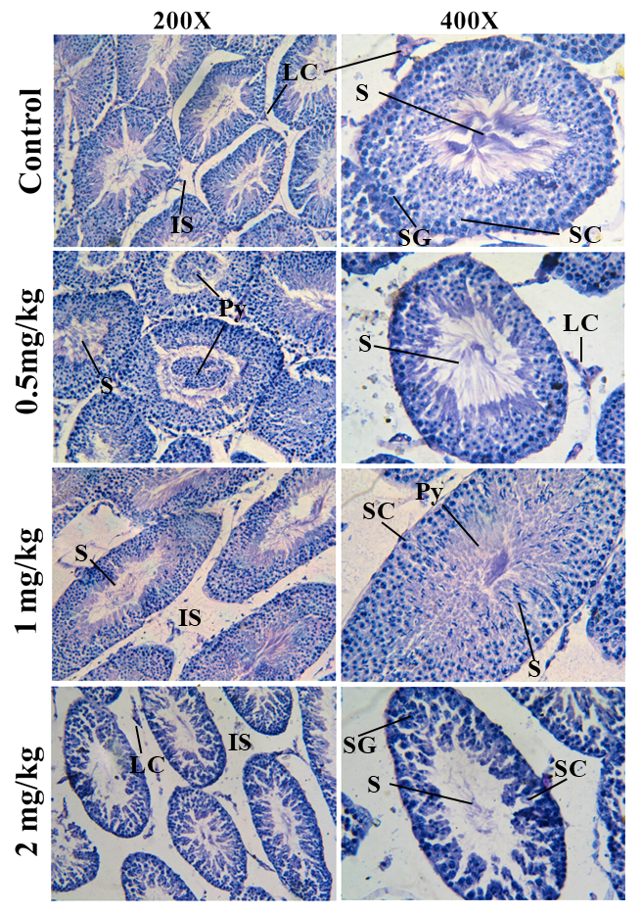
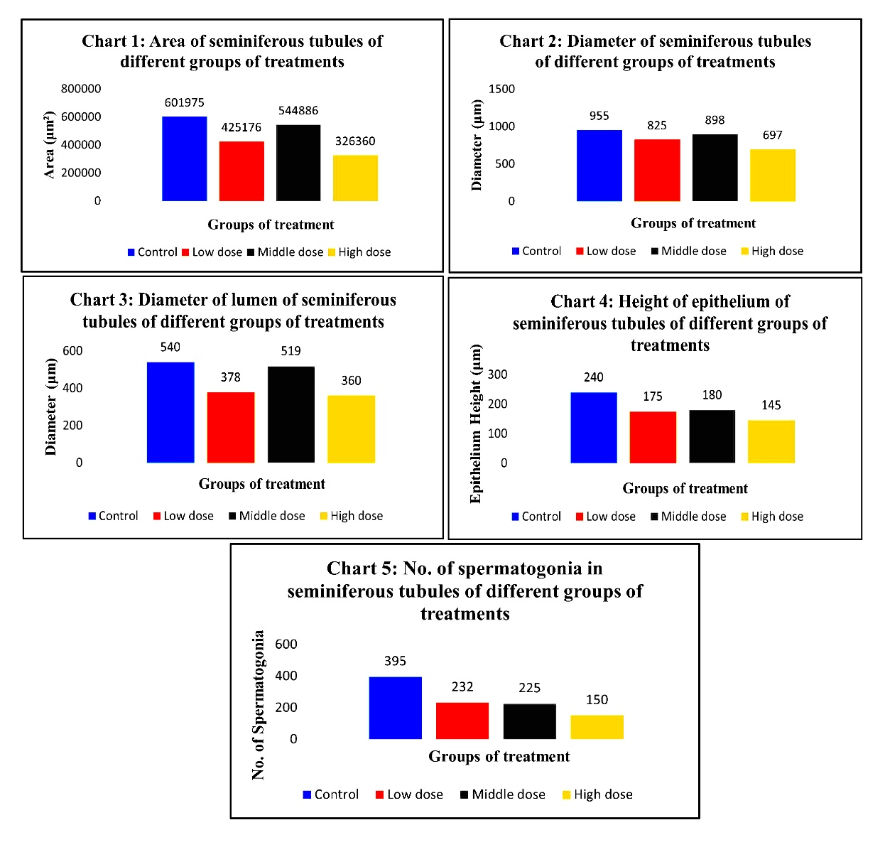
The 2 mg/kg group shows most severe histopathological damage compared to previous groups. The extensive germ cell depletion, thinning of the seminiferous epithelium, tubular distortion, and spermatozoa are rarely visible in lumen. The tubules looked much apart due to loss of interstitial tissue and widened interstitial spaces. The physical quality of spermatogonia seems highly compromised as whole cell is darkly stained and nucleus is hardly identified. Also, there is vacuolization in spermatogonia epithelial layer. These microscopic findings were consistent with morphometric data showing significant reductions in seminiferous tubule area, diameter, and epithelial height. One can’t identify Sertoli cells among spermatogonia. These factors indicate decreased spermatogenic and steroidogenic activity following cadmium exposure beyond the limit of repair.
Figure 1: Histological slides of control and cadmium-treated Syrian golden hamsters (Mesocricetus auratus) at 200× and 400× magnification, showing dose-dependent alterations in seminiferous tubule architecture and spermatogenic organization and visible sperm density. Abbreviations: S=spermatozoa; SG= spermatogonia; SC=Sertoli cells; LC=Leydig cells; IS= interstitial space; Py= pyknotic cells.
Discussion
Chart 1-5: Morphometric analysis of seminiferous tubules in control and cadmium-treated Syrian golden hamsters (Mesocricetus auratus), showing changes in seminiferous tubule area, tubular diameter, luminal diameter, germinal epithelial height, and number of spermatogonia following exposure to 0.5, 1.0, and 2.0 mg/kg body weight CdCl₂. Values represent mean measurements obtained from H&E-stained testicular sections using ImageJ.

Various researchers have established in various animals that Cadmium has negative effects on testis (Maurya et al, 2026; Marettova et al, 2015). In the current work, the acute exposer of Syrian golden hamster to the cadmium resulted into significant morphometric and histological changes in the testes which indicates progressive degradation of testicular architecture and spermatogenesis. Hamsters treated with cadmium showed signs of seminiferous tubule degeneration, decreased epithelial height, germ cell depletion, increased pyknosis/cell death, expansion of interstitial gaps, significant reductions in seminiferous tubule diameters, and reduction in sperm density. This suggests a serious disturbance in normal spermatogenic activity.
Cadmium is acknowledged as one of the most powerful environmental testicular toxicants thanks to its capacity to accumulate in reproductive organs and produce an excessive amount of reactive oxygen species (ROS) (Jahan et al. 2014). Many researchers founded that the ROS creates massive amount of oxidative stress inside the cell which promotes lipid peroxidation of plasma membrane, protein oxidation, DNA damage, and mitochondrial malfunction etc, which singles apoptosis, necrosis and autophagy and eventually damages germ cells irreversibly (Ali et al, 2022; Rinaldi et al, 2017; Zhu et al, 2020). One of the first morphological signs of irreversible cell death is nuclear condensation (pyknosis) (Morsi et al, 2020; Hirako et al, 2017), which was commonly seen in this study.
The presence of detached or exfoliated germ cells and cellular debris in the seminiferous tubule lumen was one of the study's most notable discoveries. Under normal physiological circumstances, the developing/immature germ cells stay adhered to Sertoli cells while mature spermatozoa are collected into the lumen of seminiferous tubules (Alves et al, 2013). In our experiment, spermatogonia cells prematurely exfoliate into the lumen, probably due to disruption of the blood-testis barrier and impairment of Sertoli cell junctional complexes (Zhu et al, 2020; Hew et al, 1993; Bekheet et al, 2020). Therefore, loss of Sertoli cell support and lack of normal spermatogenic organization are reflected in the buildup of detached germ cells seen in our study.
The current study's findings of progressive thinning of the germinal epithelium, decrease in the number of spermatogonia which are cross verified by shrinking of tubular area and diameter and enlargement of tubular lumen. These all symptoms point to suppression of germ cell proliferation. All treated groups stayed below control values, with the highest dose causing the most structural degradation of tubule, even though the 1 mg/kg group showed somewhat larger morphometric values than the low-dose group.
The marked reduction in sperm density within the seminiferous tubule lumen further conforms impairment of spermatogenesis which, as suggested by other researchers, is likely a consequence of both reduced germ cell proliferation and increased degeneration of differentiating spermatogenic cells (Adamkovicova et al, 2014). This affects the semen quality of the adult animal. The impairment in sperm production and quality ultimately reduces male fertility.
Vascular damage, interstitial oedema, and seminiferous tubule degeneration and shrinkage—all well-known effects of cadmium toxicity—likely contributed to the expansion of the interstitial gaps seen in this study (Obianime et al, 2009; Adamkovicova et al, 2014). The testis's blood supply is compromised by cadmium-induced vascular injury, resulting in hypoxia that exacerbates germ cell deterioration.
Various researchers have reported that cadmium negatively affects testosterone concentration in both blood serum and testis (Bhardwaj, 2021; Ji et al, 2010). This finding is in line of our investigations as structural integrity of Leydig cells are being compromised. Hence, it is now obvious that cadmium adversely affects both spermatogenic and endocrine functions of the testis which as a result, induce sub-fertility or infertility (Zhu et al, 2020; Ali et al, 2022).
Last but not least, use of hamsters as animal model in study of reproductive toxicity is not as common as rat and mice. This study produced good evidence that hamsters can be used in toxicological studies.

Conclusion
Repeated intraperitoneal exposure to cadmium chloride for 10 days produced marked histological and morphometric alterations in the testes of Syrian golden hamsters. The principal findings included germ-cell degeneration and exfoliation, pyknotic nuclei, accumulation of cellular debris, thinning and disorganization of the germinal epithelium, widening of interstitial spaces and reduced visibility of luminal spermatozoa. The high-dose group showed the greatest disruption of seminiferous-tubule organization and the lowest values for several morphometric variables. Within the limitations of the experimental design, these findings demonstrate that short-term cadmium exposure adversely affects testicular structure and spermatogenic organization in this species. Additional studies incorporating biochemical, hormonal and functional reproductive endpoints are required.

Limitations
This study included five animals per group and evaluated testicular injury after a single exposure period. The assessment was primarily based on routine histology and selected morphometric variables. Oxidative-stress markers, circulating testosterone, sperm concentration, sperm motility, fertility outcomes and molecular indicators of apoptosis or inflammation were not measured. The study also did not include a post-exposure recovery group; therefore, the reversibility of the observed lesions could not be determined. Future studies should use larger adequately powered groups, blinded histological assessment, animal-level statistical analysis and complementary biochemical and reproductive-function measurements.
Declaration of AI Use

This manuscript was prepared through the combined contributions of all author(s), including contributions to the study design, data, content development, results, interpretation, and related scholarly work. The author(s) acknowledge the use of Grammarly and ChatGPT to assist with grammar checking, language refinement, reference formatting. These AI-assisted tools were not used as authors and did not replace the intellectual contributions or scholarly judgment of the author(s). All AI-assisted outputs, including content, references, and interpretations, were carefully reviewed, revised, verified, and approved by the author(s). The author(s) accept full responsibility for the accuracy, integrity, and final content of the manuscript.

Competing Interests
Authors have declared that no competing interests exist.
References
- Adamkovicova, M., Toman, R., Cabaj, M., Massanyi, P., Martiniakova, M., Omelka, R., ... & Duranova, H. (2014). Effects of subchronic exposure to cadmium and diazinon on testis and epididymis in rats. The Scientific World Journal, 2014(1), 632581.
- Ali, H., Khan, E., & Ilahi, I. (2019). Environmental chemistry and ecotoxicology of hazardous heavy metals: environmental persistence, toxicity, and bioaccumulation. Journal of chemistry, 2019(1), 6730305.
- Ali, W., Ma, Y., Zhu, J., Zou, H., & Liu, Z. (2022). Mechanisms of Cadmium-Induced Testicular Injury: A Risk to Male Fertility. Cells, 11(22), 3601. https://doi.org/10.3390/cells11223601
- Alves, M. G., Rato, L., Carvalho, R. A., Moreira, P. I., Socorro, S., & Oliveira, P. F. (2013). Hormonal control of Sertoli cell metabolism regulates spermatogenesis. Cellular and molecular life sciences, 70(5), 777-793.
- Angeli, J. K., Pereira, C. A. C., de Oliveira Faria, T., Stefanon, I., Padilha, A. S., & Vassallo, D. V. (2013). Cadmium exposure induces vascular injury due to endothelial oxidative stress: the role of local angiotensin II and COX-2. Free radical biology and medicine, 65, 838-848.
- Antar, S. A., Halouani, A., Gad, C., & Al-Karmalawy, A. A. (2023). An overview of the mechanisms of cadmium-induced toxicity in the male reproductive system. Pharmaceutical Sciences, 30(1), 36-53.
- Babaknejad, N., Bahrami, S., Moshtaghie, A. A., Nayeri, H., Rajabi, P., & Iranpour, F. G. (2017). Cadmium testicular toxicity in male Wistar rats: protective roles of zinc and magnesium. Biological trace element research, 185(1), 106-115.
- Bekheet, S. H. (2010). Cadmium chloride rapidly alters both BTB tight junction proteins and germ cells in young rat testes. Egyptian Academic Journal of Biological Sciences, B. Zoology, 2(1), 59-64.
- Bhardwaj, J. K., Panchal, H., & Saraf, P. (2021). Cadmium as a testicular toxicant: A Review. Journal of Applied Toxicology, 41(1), 105-117.
- Cardiff, R. D., Miller, C. H., & Munn, R. J. (2014). Manual hematoxylin and eosin staining of mouse tissue sections. Cold Spring Harbor Protocols, 2014(6), pdb-prot073411.
- Chandel, M., & Jain, G. C. (2014). Toxic effects of transition metals on male reproductive system: A review. J. Env. Occup. Sci, 3, 205.
- Eleawa, S. M., Alkhateeb, M. A., Alhashem, F. H., Bin-Jaliah, I., Sakr, H. F., Elrefaey, H. M., ... & Khalil, M. A. (2014). Resveratrol reverses cadmium chloride-induced testicular damage and subfertility by downregulating p53 and Bax and upregulating gonadotropins and Bcl-2 gene expression. Journal of reproduction and development, 60(2), 115-127.
- Gad, S. C. (2019). Rodent models for toxicity testing and biomarkers. In Biomarkers in toxicology (pp. 7-73). Academic Press.
- Genchi, G., Sinicropi, M. S., Lauria, G., Carocci, A., & Catalano, A. (2020). The Effects of Cadmium Toxicity. International Journal of Environmental Research and Public Health, 17(11), 3782. https://doi.org/10.3390/ijerph17113782
- Hew, K. W., Heath, G., Jiwa, A. H., & Welsh, M. J. (1993). Cadmium in vivo causes disruption of tight junction-associated microfilaments in rat Sertoli cells. Biology of reproduction, 49, 840-840.
- Hirako, A., Takeoka, Y., Furukawa, S., & Sugiyama, A. (2017). Effects of cadmium exposure on medaka (Oryzias latipes) testes. Journal of toxicologic pathology, 30(3), 255-260.
- Iqbal, T., Cao, M., Zhao, Z., Zhao, Y., Chen, L., Chen, T., Li, C., & Zhou, X. (2021). Damage to the Testicular Structure of Rats by Acute Oral Exposure of Cadmium. International Journal of Environmental Research and Public Health, 18(11), 6038. https://doi.org/10.3390/ijerph18116038
- Jahan, S., Zahra, A., Irum, U., Iftikhar, N., & Ullah, H. (2014). Protective effects of different antioxidants against cadmium induced oxidative damage in rat testis and prostate tissues. Systems Biology in Reproductive Medicine, 60(4), 199–205. https://doi.org/10.3109/19396368.2014.912363
- Jebril, N. M. T., Boden, R., & Braungardt, C. (2022). The groundwater contaminated with cadmium: a systematic review. Sciences, 20(2), 483-494.
- Ji, H., Fan, W., Kakar, M., Alajmi, R. A., Bashir, M. A., & Shakir, Y. (2024). Effect of cadmium on the regulatory mechanism of steroidogenic pathway of Leydig cells during spermatogenesis. Journal of Experimental Zoology Part A: Ecological and Integrative Physiology, 341(1), 31-40.
- Ji, Y. L., Wang, H., Liu, P., Wang, Q., Zhao, X. F., Meng, X. H., ... & Xu, D. X. (2010). Pubertal cadmium exposure impairs testicular development and spermatogenesis via disrupting testicular testosterone synthesis in adult mice. Reproductive Toxicology, 29(2), 176-183.
- Jiang, L., Yang, F., Liao, H., Chen, W., Dai, X., Peng, C., ... & Cao, H. (2024). Molybdenum and cadmium cause blood–testis barrier dysfunction through ROS-mediated NLRP3 inflammasome activation in sheep. Science of The Total Environment, 906, 167267.
- Kumar, S. & Sharma, A. (2019). Cadmium toxicity: effects on human reproduction and fertility. Reviews on Environmental Health, 34(4), 327-338. https://doi.org/10.1515/reveh-2019-0016
- Laskey, J. W., Rehnberg, G. L., Laws, S. C., & Hein, J. F. (1984). Reproductive effects of low acute doses of cadmium chloride in adult male rats. Toxicology and applied pharmacology, 73(2), 250-255.
- Li, Y., Zhang, Y., Feng, R., Zheng, P., & Huang, H. (2022). Cadmium induces testosterone synthesis disorder via TLR4/MAPK/NF-κB signaling. Ecotoxicology and Environmental Safety. https://www.sciencedirect.com/science/article/pii/S0147651322001853
- Marettová, E., Maretta, M., & Legáth, J. (2015). Toxic effects of cadmium on testis of birds and mammals: a review. Animal reproduction science, 155, 1-10.
- Mason, K. E., Brown, J. A., Young, J. O., & Nesbit, R. R. (1964). Cadmium‐induced injury of the rat testis. The Anatomical Record, 149(1), 135-147.
- Massányi, P., Massányi, M., Madeddu, R., Stawarz, R., & Lukáč, N. (2020). Effects of Cadmium, Lead, and Mercury on the Structure and Function of Reproductive Organs. Toxics, 8(4), 94. https://doi.org/10.3390/toxics8040094
- Maurya, Ravikash & Kumar, Jitendra & Kushwaha, Swatantra & Verma, Satyendra. (2026). Acute Effect of Cadmium on Testicular and Seminal Structures: A Morphometric and Index-Based Study in Hamster. 3. 610-625. 10.5281/zenodo.18219059.
- Morsi, A. A., Shawky, L. M., & El Bana, E. A. (2020). The potential gonadoprotective effects of grape seed extract against the histopathological alterations elicited in an animal model of cadmium-induced testicular toxicity. Folia Morphologica, 79(4), 767-776.
- Obianime, A. W., & Roberts, I. I. (2009). Antioxidants, cadmium-induced toxicity, serum biochemical and the histological abnormalities of the kidney and testes of the male Wistar rats. http://www.bioline.org.br/np.
- Rinaldi, M., Micali, A., Marini, H., Adamo, E. B., Puzzolo, D., Pisani, A., ... & Minutoli, L. (2017). Cadmium, organ toxicity and therapeutic approaches: a review on brain, kidney and testis damage. Current medicinal chemistry, 24(35), 3879-3893.
- Schneider CA, Rasband WS, Eliceiri KW. NIH Image to ImageJ: 25 years of
image analysis. Nat Methods. 2012 Jul;9(7):671–5.
- Shojaeepour S, Dabiri S, Dabiri B, Imani M, Fekri Soofi Abadi M, Hashemi F. Histopathological Findings of Testicular Tissue Following Cadmium Toxicity in Rats. Iran J Pathol. 2021 Fall;16(4):348-353. doi: 10.30699/IJP.20201.130581.2443. Epub 2021 Jul 6. PMID: 34567182; PMCID: PMC8463756.
- Štajn, A., Žikić, R. V., Ognjanović, B., Saičić, Z. S., Pavlović, S. Z., Kostić, M. M., & Petrović, V. M. (1997). Effect of cadmium and selenium on the antioxidant defense system in rat kidneys. Comparative Biochemistry and Physiology Part C: Pharmacology, Toxicology and Endocrinology, 117(2), 167-172.
- Venditti, M., Ben Rhouma, M., Romano, M. Z., Messaoudi, I., Reiter, R. J., & Minucci, S. (2021). Altered Expression of DAAM1 and PREP Induced by Cadmium Toxicity Is Counteracted by Melatonin in the Rat Testis. Genes, 12(7), 1016. https://doi.org/10.3390/genes12071016
- Wang, Y. J., Yan, J., Yin, F., Li, L., Qin, Y. G., Meng, C. Y., ... & Guo, L. (2017). Role of autophagy in cadmium-induced testicular injury. Human & experimental toxicology, 36(10), 1039-1048.
- World Health Organization (2011), Cadmium in Drinking-water: Background document for development of WHO Guidelines for Drinking-water Quality, WHO Press. https://cdn.who.int/media/docs/default-source/wash-documents/wash-chemicals/cadmium.pdf?sfvrsn=4dd545bd_4#:~:text=The%20biological%20half%2Dlife%20in%20humans,be%20excreted%20in%20the%20urine.
- Xiong, L., Zhou, B., Liu, H., Cai, L. (2021). Comprehensive Review of Cadmium Toxicity Mechanisms in Male Reproduction and Therapeutic Strategies. In: de Voogt, P. (eds) Reviews of Environmental Contamination and Toxicology Volume 258. Reviews of Environmental Contamination and Toxicology, vol 258. Springer, Cham. https://doi.org/10.1007/398_2021_75
- Zhou, J., Zeng, L., Zhang, Y., Wang, M., Li, Y., & Jia, Y. (2022). Cadmium exposure induces pyroptosis via AIM2 inflammasome. Science of the Total Environment.
https://www.sciencedirect.com/science/article/pii/S0048969722045983
- Zhu Q, Li X and Ge R-S (2020) Toxicological Effects of Cadmium on Mammalian Testis. Front. Genet. 11:527. doi: 10.3389/fgene.2020.00527
- Wlodarczyk, B., Biernacki, B., Minta, M., Kozaczynski, W., & Juszkiewicz, T. (1995). Male golden hamster in male reproductive toxicology testing: assessment of protective activity of selenium in acute cadmium intoxication. Bulletin of environmental contamination and toxicology, 54(6), 907-912.

