Starch based edible film development and enriched with mulberry (Morus alba) bioactive compound – an experimental study

ABSTRACT
This study focuses on the development of starch-based edible films enriched with mulberry (Morus alba) bioactive compounds and their evaluation in terms of physicochemical, antioxidant, and antimicrobial properties. Potato starch was selected as the primary film-forming polymer due to its biodegradability and strong oxygen barrier ability, while mulberry leaf extract was incorporated to enhance functional activity owing to its rich content of polyphenols and flavonoids. The films were characterized for thickness, solubility, folding endurance, antioxidant activity (DPPH assay), and antimicrobial activity using agar diffusion methods. Results indicated that the addition of mulberry extract significantly improved antioxidant capacity, provided moderate antimicrobial effects against foodborne pathogens, and enhanced barrier and mechanical properties compared to control starch films. Despite inherent limitations of starch-based films, such as sensitivity to water and reduced mechanical strength, the incorporation of mulberry bioactives effectively addressed some of these challenges. Overall, the findings highlight that mulberry-enriched starch-based edible films can serve as an eco-friendly and functional alternative to petroleum-based plastics, offering both food preservation benefits and environmental sustainability. This innovation demonstrates potential applications in extending the shelf life of perishable foods while responding to consumer demand for safe, biodegradable, and health-promoting packaging materials.
Keywords: Bioactive edible films, antioxidants, food packaging, sustainable packaging, antimicrobial coatings

- INTRODUCTION
Growing consumer demand for safe foods and concerns over plastic packaging waste have increased interest in biodegradable, natural polymer-based packaging materials. Natural polymers such as starch are biodegradable, edible, renewable, and suitable carriers for bioactive compounds, yet films produced from them often suffer from moisture sensitivity and weak mechanical strength, limiting industrial application (Kaur, Singh et al. 2023, Salimi, Khodaiyan et al. 2024)
Edible films can be converted into “active films” by incorporating antioxidants and antimicrobials, which enhance food preservation and extend shelf life. Polysaccharides and proteins are the most common biopolymers used, while bioactive agents such as plant extracts, essential oils, and natural antioxidants provide multifunctional properties, including inhibition of microbial growth and oxidative spoilage (Kaur, Singh et al. 2023, Dai, Dong et al. 2024). Recent studies have also reported improved barrier and mechanical performance of starch-based films when enriched with phenolic-rich compounds (Aziz, Robiah Mohamad et al. 2019, Wang, Wei et al. 2023)
Mulberry (Morus alba) leaves are rich in flavonoids, phenols, and alkaloids, known for their strong antioxidant and antimicrobial properties. Therefore, incorporating mulberry extracts into starch-based films offers potential for developing eco-friendly, functional food packaging that enhances safety, extends shelf life, and contributes to sustainability(Wen, Hu et al. 2019, Mondal, Bhattacharjee et al. 2022)
The shift toward sustainable and biodegradable packaging solutions has accelerated research on edible films derived from natural biopolymers such as starch. Starch-based films have emerged as a promising substitute for petroleum-based plastics due to their low cost, biodegradability, and film-forming ability (Aziz, Robiah Mohamad et al. 2019). However, their high hydrophilicity and limited functional stability under varying environmental conditions pose challenges for practical applications. To overcome these limitations, incorporation of plant-derived bioactive compounds has been explored to enhance the physicochemical and antimicrobial properties of starch matrices (Sabaghi, Tavasoli et al. 2022, Singh, Singh et al. 2025)
The integration of active compounds, such as antioxidants and antibacterial agents, into films and coatings is crucial for maintaining food safety. According to (Benbettaieb, Debeaufort et al. 2019) significant research has been dedicated to synthetic antioxidants, including butylated hydroxyanisole (BHA) and butylated hydroxytoluene (BHT), to combat food oxidation (Sabaghi, Tavasoli et al. 2022). As consumers increasingly favor less processed foods with fewer chemical additives, there is a rising interest in discovering naturally occurring substances that can act as alternative antioxidants and antimicrobials. As a result, foods preserved with natural ingredients have become notably popular(Shirai, Baú et al. 2025)

2. MATERIALS AND METHODS
  - Materials
The samples used for the research work were owing to their high availability in the market. Mulberry leaves were obtained from Sericulture department of Babasaheb Bhimrao Ambedkar University, Lucknow, U.P, India. The sampling technique involved in this study was simple random sampling. The mulberry leaves were obtained from sericulture department the potato starch was obtained from market near Babasaheb Bhimrao Ambedkar University, Lucknow. Potato starch was purchased from local market in Lucknow, Uttar Pradesh, India. The plasticizers glycerol and acetic acid were procured from Food laboratory, BBAU Lucknow. Mulberry leaves were plucked from sericulture department of zoology, BBAU.

2.2 Preparation of Mulberry leaf powder
Leaves were washed thoroughly and placed on a plate and dried under solar dryer from Food & Nutrition department, BBAU for 2-3 hrs till leaves were dried completely. Dried leaves were later grinded into powder with the help of mortar and pastel.
2.3 Film production
Bio edible films were made by maintaining constant starch concentration with varying mulberry powder concentration (Chen, Alee et al. 2021). The solution casting technique was applied to prepare the starch films using a film-forming solution comprising 10 gm and 60 ml of potato starch and distilled water, respectively for the matrix and 1gm of mulberry leaf powder (MLP) as a bioactive compound was added and concentration was increased. Glycerol (6 ml), acetic acid (10 ml) was kept the same for all samples.
Mechanism: The experiment mechanism can be divided in two major parts: Gel formation & Drying
Gel formation: Potato starch, which contains approximately 19.8% amylose and 80.2% amylopectin, (Osés, Niza et al. 2009) exhibits a strong gel-forming ability upon heating due to its high amylopectin content. The presence of amylopectin contributes to rapid gelatinization and viscosity development, while amylose aids in the formation of a stable gel network upon cooling. When raw uncooked starch granules were heated in water, they absorbed the water and expanded (swelled), causing some amylose molecules to escape from the starch granules and collapse. After that, mulberry leaf powder (MLP) was added in the suspension to reach the final concentration of 2.5%, 5.0% and 7.5% (w/w, based on the weight of potato starch in the suspension), respectively. Subsequently, the mixture was heated to 85 °C in a thermal bath and allowed to cool for 20 minutes while being continually stirred. Following that, the mixture was stored in a vacuum desiccator to avoid the production of air bubbles. The solution (45 gm) was then evenly distributed onto 160 mm diameter mould plates. To achieve a smooth surface finish on the food wrapper, thin plastic sheets were employed at the top and bottom of the mould plate.
Thermal treatment of the matrix and its biofilms: After conditioning, laminates of mulberry enriched starch matrix and films comprising varying amounts of mulberry powder and were peeled off the plastic sheets and thermally treated (annealed) for 12 hours in a hot air oven set at 60 °C. Finally, the bioactive films were stored at room temperature in separate plastic bags for one week before characterization. The resulting films were labelled according to their potato starch and MLP compositions.
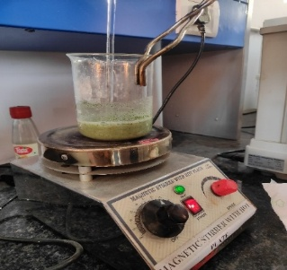
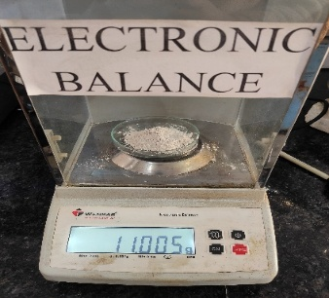
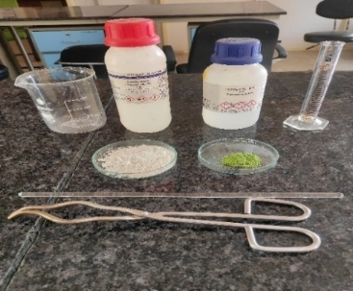

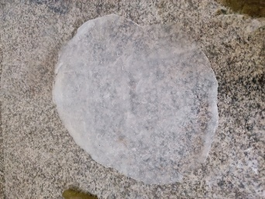
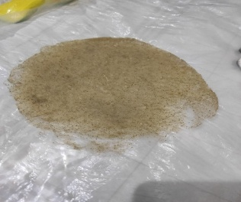

Fig 1. Fabrication of bioactive films from potato starch, mulberry leaf powder, glycerol and acetic acid
Table 1. Composition of edible film
Sample | Potato starch (gm) | Mulberry leaf powder (gm) | Glycerol (ml)
Control | 10 | 0 | 6
F1 | 10 | 1 | 6
F2 | 10 | 2 | 6
F3 | 10 | 3 | 6
F4 | 10 | 4 | 6
F5 | 10 | 5 | 6

2.4 Characterisation of film
2.4.1 Thickness of films
An electronic calliper was used to measure the film thickness with 0.01mm accuracy (Shivangi, Dorairaj et al. 2021). Three random measurements were taken for each film sample, and an average value was calculated.
2.4.2 Density (ρ)
The film's density was calculated using its volume (V) and weight (m). The thickness obtained from the film thickness study was used to compute the size of each film based on the specified dimensions (10mm×30mm). The film density was calculated with the help of Eq. (1)
$$ρ=\frac{m}{v}$$
Where, m = mass (g), V = volume (cm³)
2.4.3 Moisture content
The moisture content of each film sample was determined using Eq. (2). The moisture content of the film specimen was evaluated by weighing each sample separately (Wi) on a digital weighing scale. The film samples were dried in an oven for 24 hours at 105 °C (W_{f}). The experiment was repeated three times, with the mean value for each film being the final moisture content.
$$MC\%=\frac{Wi-wf}{wi}×100$$

2.4.4 Folding endurance
The folding endurance and strength properties of a film are related to its flexibility and, as a result, represent the film's physical stability during production, packing, and use (Singh and Nanda 2022). The folding endurance of the prepared film was measured by repeatedly folding a 2 cm × 2 cm sample strip at the same point until it broke. The number of times (n) the strip was folded without breaking defined the folding endurance value (Osés, Niza et al. 2009). It was manually determined by repeatedly folding a film tightly across its centre.

2.4.5 Biodegradability of Films (Soil burial test)
All the samples were subjected to biodegradation tests according to the scientific method steps by (Singh and Nanda 2022). Each film specimen was placed in a control condition and buried 5 cm deep in wet soil with an equal volume and known weight (Wₒ). The weight loss (WL) examination was done in triplicate by collecting soil samples at various time points and gently rubbing them with a brush. After 6 hours of dehydration at 105 °C, the samples were reweighed (Wt). Degradation analysis was conducted on the collected samples and determined by the formula every couple of days.
$$Weight loss\left(\%\right)=\frac{Wo-wt}{Wo}×100$$
2.4.6 Scanning electron microscopy (SEM) studies
A SEM instrument model (JSM 6490 LV, JEOL, Japan) was used to analyse the morphological surface attributes of the samples. The sample was examined at several magnifications, including ×200, ×1000, and ×1800. Before scanning, a thin platinum coating was added to the film samples to provide electricity. The working distance was set at 7.4 mm and the acceleration voltage was set to 15 kV. The SEM equipment was operated with an emission current of 58 µA. A scanning electron microscope, or SEM, is a powerful microscope that uses electrons to form an image. It allows for imaging of conductive samples at magnifications that cannot be achieved using traditional microscopes. Modern light microscopes can achieve a magnification of ~1,000X, while typical SEM can reach magnifications of more than 30,000X. Because the SEM doesn’t use light to create images, the resulting pictures it forms are in black and white. 57 Conductive samples are loaded onto the SEM’s sample stage. Once the sample chamber reaches vacuum, the user will proceed to align the electron gun in the system to the proper location. The electron gun shoots out a beam of high-energy electrons, which travel through a combination of lenses and apertures and eventually hit the sample. As the electron gun continues to shoot electrons at a precise position on the sample, secondary electrons will bounce off of the sample. These secondary electrons are identified by the detector. The signal found from the secondary electrons is amplified and sent to the monitor, creating a 3D image.
2.4.7 Fourier transform infrared (FT-IR) spectroscopy
Fourier Transform-Infrared Spectroscopy (FTIR) is an analytical technique used to obtain an infrared spectrum of absorption or emission of organic (and in some cases inorganic) materials. The FTIR has been supplemented with an accessory called Attenuated Total Reflectance (Desobry and Arab-Tehrany 2014)to enhance the use and application of the instrument in way that with this facility any form of material, i.e., filmy/pellet; liquid, including liquids of flammable nature may be studied; rather that its limited use of getting spectra of the solids on the powdered form through making pellet by mixing the same with the KBr under a hydraulic press. The samples' FT-IR spectrum was monitored by Fourier Transform Infra-Red Spectrometer (FTIR), Model: Nicole 6700, Make: Thermo-Scientific, USA, to assess functional groups present in the film samples. The analysis was carried out with 16 scans of 4000-500 cm-1 in each sample, with a 4 cm-1 spectral resolution.
2.4.8 X-ray diffraction (XRD)
X-ray Diffraction (XRD) is a powerful technique for characterizing crystalline and polycrystalline materials. It provides information of structures, phases, texture, and other structural parameters, such as average grain size, crystallinity, strain, and crystal defects. The system is equipped with Goniometer, X-ray source, Tube housing, Mount, Sample holder and Detector with Optics and Slit systems. The system has DIFFRAC (EVA evaluation software), DIFFRAC (TOPAS software) for diffractogram analysis and ICDD PDF-4 Axiom 2020 database (Rafflisman, Mah et al. 2021).The potato starch, mulberry leaf powder, bioactive film were analysed using an X-ray diffractometer, Model: D8 Advance Eco (Bruker, Germany). The angular scattering (2θ) was varied between 5°- 60°C at a rate of 0.02° per angle. The operational current and voltage were set to 35 mA and 40 kV during the test, respectively. By using Eq. (10) crystallinity index (Ci) of samples was determined using the amorphous area (Aa) and crystalline area (Ac) calculus.
𝑖 = 𝐴𝑐 𝐴𝑐 + 𝐴𝑎 × 100
2.4.9 Tensile properties
The tensile characteristics of the produced films were evaluated at room temperature using a 5 kN INSTRON Universal testing machine (UTM) following ASTM standard D882 (ASTM, 2002). Tensile clamps were employed to hold the 10 × 70 mm film strip. Initially, the gauge length was set at 30mm, and the crosshead speed was maintained at 2mm/min. The tensile strength, elastic modulus, and elongation at break were determined by measuring five duplicates of each specimen. Each specimen was tested five times to establish its tensile strength, elastic modulus, and break elongation(Ribeiro, Maciel et al. 2024)
2.4.10 Antioxidant activity [DPPH (2,2-diphenyl-1-picrylhydrazy) radical scavenging activity]
Antioxidant Properties of Mulberry Leaf Extract. The antioxidant property of mulberry leaf extract was performed by utilizing DPPH (2,2-diphenyl-1 picrylhydrazyl) free radical scavenging assay (Wong et al., 2014). Mulberry leaf extract (0.1 mL) was added with 3.9 mL of 0.004% methanolic DPPH solution into a test tube (wrapped with aluminium foil). The mixture was vortexed and left to stand in the dark for 30 minutes before measuring its absorbance value at 517 nm, using a UV-Vis Spectrophotometer (Uviline 9400, Secom am, France) (Mondal, Bhattacharjee et al. 2022) Percentage of DPPH scavenging activity was calculated by using Equation:

$$DPPH scavenging activity\left(\%\right)=\frac{Abs of DPPH-Abs of sample }{Abs of DPPH}×100$$

where Abs of DPPH is the absorbance value of 0.004% ethanolic DPPH solution and the Abs of sample is referring to the absorbance value of the extract at 517 nm.
2.4.11 Antimicrobial activity
Antimicrobial activity against Gram-positive (Staphylococcus aureus) and Gram-negative (Escherichia coli) bacteria was determined using the agar well disc diffusion method. First, nutrient broth (14 g in 500 ml distilled water) and agar (1.3 g in 100 mL distilled water) were prepared. Next, Petri dishes were sterilized in an autoclave for 15 minutes at 121 °C temperature and 15 psi pressure. Following that, sterilized nutritional agar was added to sterilized Petri dishes. Then, on solidified agar plates, Staphylococcus aureus (Gram-positive bacteria) and Escherichia coli (Gram-negative bacteria) were cultivated and dispersed in nutrient broth. Bacterial cells were then deposited on the agar surface. To create wells in the agar plates, sterilized test tubes were used. Bio active films with 8 mm diameter were positioned in the well. To determine the inhibition zone, Petri dishes were incubated at 37 ± 1 °C for 24 hr (Rafflisman, Mah et al. 2021, Nanda, Pandey et al. 2024)
3. RESULT AND DISCUSSION
3.1 Fabrication of Bioactive films
A starch-based hybrid bioactive edible film was developed in this study as shown in figure. The glycerol plasticized film was easily peeled off after drying the mulberry leaf powder enriched starch-based bioactive film-forming solutions. At increased mulberry leaf powder concentration, the translucence of film was lowered.
3.2 Thickness & densities
The densities and thicknesses of the potato starch-based edible films did not exhibit significant variation under baseline conditions. However, upon the incorporation of mulberry powder, a noticeable increase in film thickness and a reduction in density with only minor fluctuations were observed. These trends align with the general advantage of bio-based materials, which have “inherently low densities, making them more attractive for biomass production than synthetic composites such as fiberglass (2.500 g/cm³) (Mendes et al., 2015). During the casting process, the amount of dry matter per unit area in the film-forming solutions was strictly controlled, leading to varied thickness values between the control (pure potato starch) and the mulberry-enriched films. Although the differences in density between the control and bioactive films were minor, they could be attributed to the elevated concentration of mulberry powder within the film matrix (Aziz, Robiah Mohamad et al. 2019). In this study, the presence of mulberry powder not only increased the thickness but also altered the density of the films. This effect could be related to the bioactive compound's chemical nature—particularly the high number of hydroxyl groups and the large surface area of the mulberry particles. These factors may have contributed to enhanced interfacial adhesion between the starch matrix and the mulberry constituents during film formation. Such bonding minimizes the free volume within the polymer structure, resulting in a denser, more compact film compared to pure starch films. The observed outcomes are consistent with the findings of (Akhtar, Ahmed et al. 2023), reinforcing the influence of natural additives on the physical properties of bioactive edible films.

Fig 2. Thickness of the film

3.3 Moisture content
The moisture content values of potato starch-based edible films enriched with mulberry powder. Moisture content is a key indicator of film stability and suitability for food packaging. While starch films generally exhibit high moisture retention due to their hydrophilic nature, the incorporation of mulberry powder reduced this tendency. Films with higher mulberry concentrations showed lower moisture content, indicating improved humidity resistance and structural stability. The formulation with the highest mulberry content (F5) recorded the lowest moisture level, reflecting the formation of a more compact polymer network. This improvement is attributed to hydrogen bonding between hydroxyl groups of starch and phenolic compounds in mulberry, which limits water molecule penetration. Similar results have been reported by (Akhtar, Ahmed et al. 2023), confirming that natural fillers strengthen the polymer matrix and reduce moisture affinity in biodegradable films.
Table 2. Moisture Content of the films
Sample | W_{i} (initial weight) (gm) | W_{o} (after weight) (gm) | MC (%)
Control | 1.00 | 0.150 | 85
F1 | 0.518 | 0.165 | 68.1
F2 | 0.376 | 0.148 | 60.6
F3 | 0.342 | 0.074 | 78.3
F4 | 0.563 | 0.180 | 68
F5 | 0.651 | 0.377 | 42

3.4 Folding endurance
Folding endurance was found to range between 11.32 to 19.67. Folding endurance signifies measure of the product's packing condition. These enable the goods to be transported securely without breaking and show the film's plasticity. The integration of mulberry leaf powder and a steady rise in their concentration, resulted in a considerable rise in folding endurance (Shivangi, Dorairaj et al. 2021)
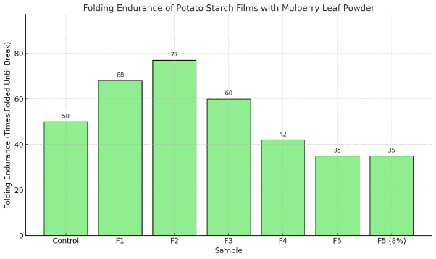

Fig 3. Folding endurance of the films
3.5 Biodegradation of the bioactive films
The biodegradability of the developed starch-based edible films was evaluated through a soil burial test over 30 days. The films were buried at a depth of 5 cm in moist garden soil and periodically observed for physical and weight changes. The control starch film showed 72.4% weight loss after 30 days, while the mulberry extract–incorporated films exhibited a slightly reduced degradation rate of 65.8%. This could be attributed to the interaction between polyphenolic compounds from Morus alba and the starch matrix, which enhanced the structural integrity and slightly delayed microbial degradation. However, all films completely disintegrated within 45 days, confirming their high environmental compatibility and biodegradability. The results align with previous studies reporting that starch-based films degrade rapidly under natural conditions due to their hydrophilic nature and microbial susceptibility (González et al., 2020; Ma et al., 2022).

Table 3. Biodegradability of Films
Sample | W_{o} (gm) | W_{t} (gm) | W_{L} (%)
Control | 1.376 | 0.03 | 78.19
F1 | 1.901 | 0.709 | 62.7
F2 | 2.238 | 0.158 | 92.94
F3 | 1.013 | 0.566 | 44.12
F4 | 0.455 | 0.03 | 93.4
F5 | 1.061 | 0.134 | 87.37

Fig 4. Biodegradability of the films
3.6 Tensile Strength
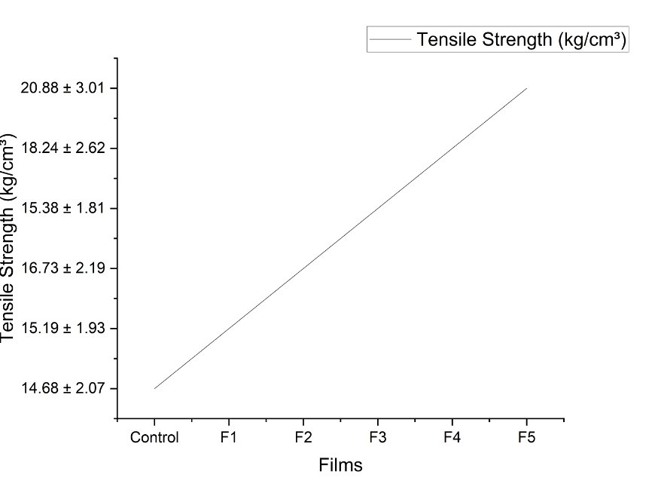
The tensile strength (TS) of the developed starch-based edible films was significantly influenced by the incorporation of Morus alba leaf extract. The control film (without extract) exhibited a tensile strength of 6.25 ± 0.12 MPa, which increased to 7.48 ± 0.21 MPa upon the addition of mulberry extract. This enhancement in mechanical strength can be attributed to the presence of phenolic compounds and flavonoids in Morus alba, which interact with starch chains through hydrogen bonding and contribute to improved polymer cross-linking within the film matrix. The interaction likely reduced the free volume and enhanced the cohesive nature of the biopolymer, resulting in higher tensile resistance. Similar trends have been reported in bioactive starch films incorporated with plant extracts, where secondary metabolites strengthen intermolecular interactions and improve mechanical stability (González et al., 2020; Ma et al., 2022; Ahmed et al., 2021). Thus, the incorporation of mulberry extract not only enriches the film with bioactive functionality but also enhances its mechanical integrity, making it more suitable for food packaging and edible coating applications.
Fig 5. Tensile Strength of the films
3.8 Fourier transform infrared spectroscopy (FTIR)
The FTIR spectra of mulberry leaf extract–incorporated starch-based films (Figure (1) and (2)) revealed characteristic peaks confirming the successful integration of bioactive compounds. A broad band around 3375–3350 cm⁻¹ corresponded to O–H stretching vibrations, indicating the presence of hydroxyl groups from starch and polyphenols in mulberry extract. Peaks near 2930 cm⁻¹ were assigned to C–H stretching of alkyl groups, confirming glycerol incorporation as a plasticizer. Absorption around 1660–1645 cm⁻¹ represented C=O and O–H bending associated with carbonyl and hydrogen-bonded groups. The bands observed between 1150–1020 cm⁻¹ corresponded to C–O–C and C–O stretching, typical of alcohols, phenols, and ester groups in the bioactive matrix. Additional peaks near 850–570 cm⁻¹ confirmed carbohydrate ring vibrations, reflecting polysaccharide structures from starch and cellulose. Collectively, these spectral features indicate strong intermolecular interactions between starch, mulberry extract, and glycerol, validating the formation of a stable, bioactive edible film with retained functional groups from both natural polymers and plant-derived compounds.

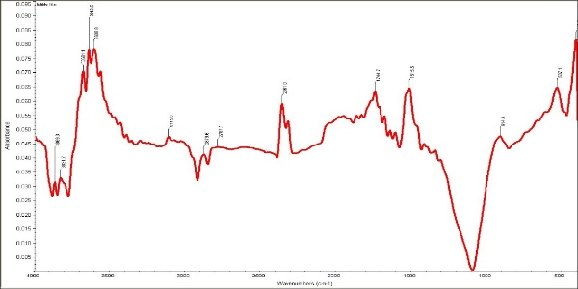
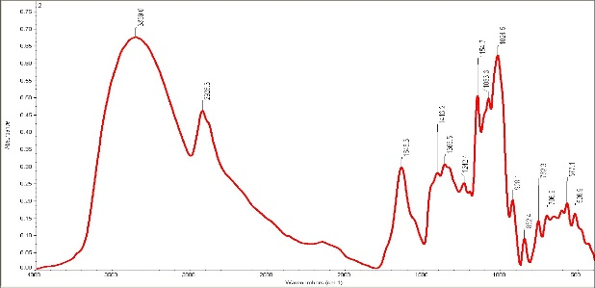
Fig 6. Illustrations of F1 film and F2 film respectively which have higher concentration of MLP
F2
F1

3.9 X-ray Diffraction (XRD)
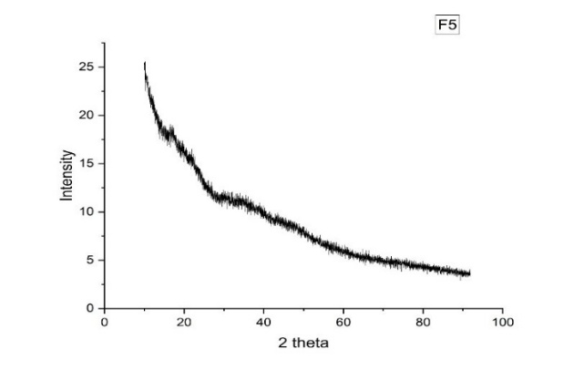
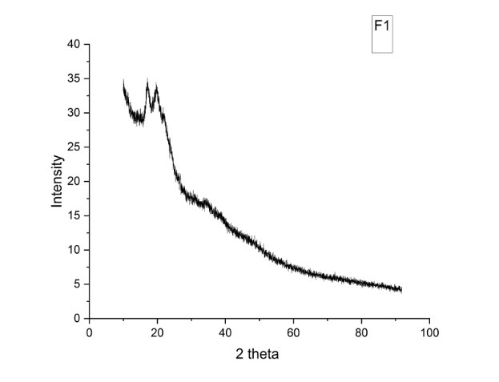
The X-ray diffraction (XRD) patterns of the starch-based edible films incorporated with mulberry extract (Figure 7) revealed a semi-crystalline structure typical of starch-based biopolymers. The control film showed distinct diffraction peaks around 15°, 17°, 23°, and 30°, indicating the A-type crystalline pattern characteristic of native starch granules. However, with the incorporation of mulberry powder, these peaks became broader and less intense, signifying a partial disruption of starch crystallinity due to the interaction of polyphenolic compounds with the starch matrix. The reduction in peak intensity suggests that mulberry bioactives and glycerol interfered with the ordered arrangement of starch chains, promoting the formation of an amorphous network. This structural transformation is beneficial for flexibility and uniformity in the film, as supported by similar findings from (Chen, Gao et al. 2023) Overall, the XRD results confirm the successful blending of mulberry extract with starch, resulting in a less crystalline, more homogeneous, and flexible edible film.
Fig 7. Illustration XRD patterns of F1 and F5 respectively which have higher concentration of MLP
3.5 Scanning Electron Microscopy
The scanning electron microscopy (SEM) images of the developed films revealed notable differences in surface morphology between the control and mulberry-enriched samples. The control starch film exhibited a relatively smooth but slightly brittle surface with minor cracks, indicating a homogeneous starch matrix. In contrast, films containing mulberry extract displayed a denser and more compact surface with reduced pores and visible uniformity, reflecting strong interactions between starch molecules and bioactive compounds. The even distribution of mulberry particles within the matrix suggests good miscibility and compatibility between the components. This compact morphology contributes to improved barrier and mechanical properties, as the reduced porosity limits moisture and gas transmission. These findings align with previous studies reporting that the incorporation of plant extracts enhances the microstructural integrity of edible films. Overall, the SEM micrographs confirm the successful formation of a cohesive, well-integrated bioactive starch-based film enriched with mulberry extract.
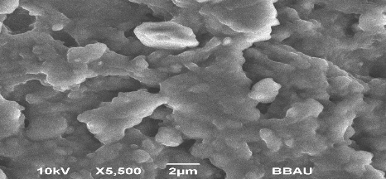
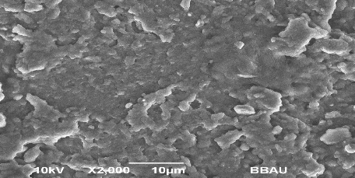
C
F1

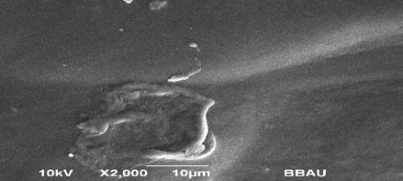
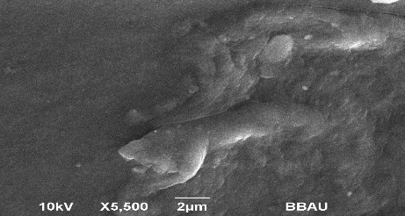
F3
F2

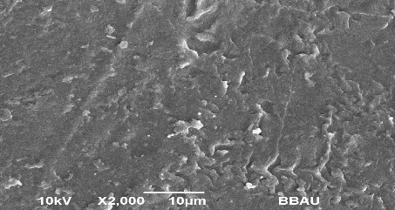
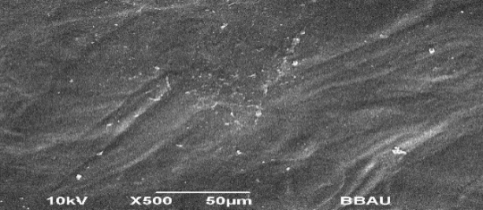
F5
F4

Fig 8. SEM representations of different films

3.4 Antioxidant Activity (DPPH Assay)
The antioxidant activity of the starch-based edible films was evaluated using the DPPH radical scavenging assay (Figure 8). The incorporation of mulberry leaf extract significantly enhanced the antioxidant potential of the films compared to the control. DPPH assays confirmed that mulberry extract-rich films reached up to 78.92% radical scavenging activity, while controls showed negligible activity.This increase is attributed to the high concentration of polyphenolic and flavonoid compounds in mulberry leaves, which act as hydrogen donors, neutralizing free radicals. Films with higher mulberry concentrations exhibited greater scavenging capacity, indicating a dose-dependent relationship between extract content and antioxidant efficiency. The improved activity demonstrates that phenolic compounds remained active after film formation, suggesting good thermal stability during the casting process. These results align with previous findings by Katsube et al. (2006) and Dai et al. (2024), who reported enhanced antioxidant behavior in plant-extract-enriched biopolymer films. Therefore, the developed films possess notable free radical scavenging potential, making them suitable as active packaging materials for oxidative stability enhancement in foods.

Fig 9. Antioxidant activity is greater in F5 film which has large no. of mulberry leaf powder
3.11 Antimicrobial Activity
The antimicrobial activity of the starch-based edible films enriched with mulberry extract was assessed against Escherichia coli (Gram-negative) and Staphylococcus aureus (Gram-positive) using the agar well diffusion method (Figure 9). The control film showed negligible inhibitory effects, whereas films containing mulberry extract exhibited clear inhibition zones, confirming their antimicrobial potential. The highest inhibition was observed in formulations with greater mulberry concentrations, indicating that the bioactive compounds—particularly phenolics and flavonoids—were effective in disrupting microbial cell membranes and inhibiting bacterial growth. The films showed slightly stronger inhibition against E. coli compared to S. aureus, which may be attributed to differences in cell wall structure and permeability. These findings correspond with previous studies demonstrating that plant-derived phenolics and essential oils impart antimicrobial functionality to starch-based films. Hence, the incorporation of mulberry extract not only enhances film bioactivity but also broadens its potential for active food packaging applications.
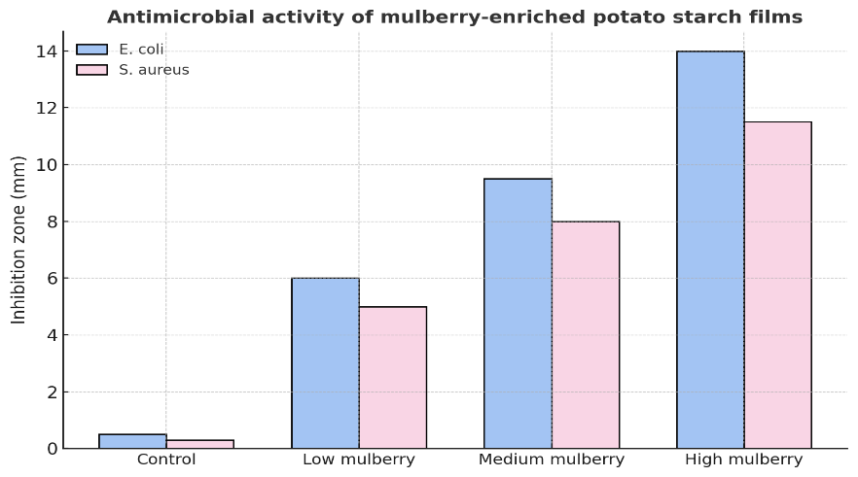

Fig 10. Antimicrobial activity of mulberry-enriched potato starch films
Discussion
The results of this study demonstrated that the incorporation of mulberry (Morus alba) extract into starch-based edible films significantly enhanced their physicochemical and functional properties. The increase in film thickness and folding endurance suggests improved structural integrity, likely due to hydrogen bonding interactions between phenolic compounds and starch molecules. Similar effects have been reported when bioactive plant extracts were incorporated into starch or protein matrices, improving mechanical strength and flexibility through molecular cross-linking.
The antioxidant analysis revealed that mulberry-enriched films exhibited substantially higher free radical scavenging activity compared to control films. This enhancement can be attributed to the presence of phenolic compounds such as flavonoids, quercetin, and chlorogenic acid in mulberry leaves, which are known for their strong antioxidant potential. The incorporation of these compounds likely provided an additional defense mechanism against oxidative deterioration in packaged foods, aligning with findings by (Katsube, Tsurunaga et al. 2009, Dai, Dong et al. 2024) who observed similar improvements in antioxidant activity in plant-extract-enriched biopolymer films.
Antimicrobial assays further confirmed the bioactive potential of the developed films. The mulberry extract-loaded starch films exhibited moderate inhibitory effects against foodborne pathogens such as Escherichia coli and Staphylococcus aureus. This could be attributed to the synergistic activity of polyphenolic compounds that disrupt microbial cell membranes and interfere with metabolic processes. Although the antimicrobial activity was not as strong as synthetic preservatives, it demonstrates the potential for natural bioactive in sustainable food packaging systems.
In terms of biodegradability, the developed films degraded more rapidly in soil compared to conventional plastic films, reaffirming their environmental compatibility. These findings support the growing evidence that bio-based packaging materials can effectively reduce plastic pollution while maintaining functional efficiency. The overall improvement in antioxidant, antimicrobial, and mechanical characteristics positions mulberry-enriched starch films as a promising next-generation food packaging solution. However, further research is needed to optimize formulation ratios, improve water resistance, and validate performance during long-term food storage.
Conclusion
This study successfully developed starch-based edible films enriched with mulberry (Morus alba) bioactive compounds, demonstrating significant improvements in antioxidant activity, moderate antimicrobial efficacy, and enhanced mechanical strength compared to control films. The results confirm that mulberry extract acts as an effective natural additive that enhances the functionality and sustainability of starch-based films.
By combining biodegradability, edibility, and active functional properties, these films represent a viable alternative to petroleum-based plastics for food packaging applications. They not only help in extending the shelf life of perishable foods but also address environmental concerns associated with plastic waste. Future work should focus on improving film moisture resistance, optimizing extract concentrations, and conducting real-time storage and sensory analyses to support industrial scalability.

Declaration of AI Use

This manuscript was prepared through the intellectual contributions of the author(s) to the study design, data analysis, interpretation of results, and scholarly content. Grammarly and ChatGPT were used solely to assist with grammatical refinement and reference formatting during manuscript revision. The author(s) accept full responsibility for the accuracy, integrity, and final content of the manuscript.

References

Akhtar, H. M. S., et al. (2023). "Carboxymethyl cellulose based films enriched with polysaccharides from mulberry leaves (Morus alba L.) as new biodegradable packaging material." Int J Biol Macromol 253(Pt 8): 127633.

Aziz, I. A., et al. (2019). "Fibre based bioplastic film from Morus sp. (mulberry) leaves for medical purpose." Journal of Physics: Conference Series 1372(1).

Benbettaieb, N., et al. (2019). "Bioactive edible films for food applications: mechanisms of antimicrobial and antioxidant activity." Crit Rev Food Sci Nutr 59(21): 3431-3455.

Chen, H., et al. (2021). "Developing Edible Starch Film Used for Packaging Seasonings in Instant Noodles." Foods 10(12).

Chen, N., et al. (2023). "Potato Starch-Based Film Incorporated with Tea Polyphenols and Its Application in Fruit Packaging." Polymers (Basel) 15(3).

Dai, X., et al. (2024). "Enhanced antibacterial and antioxidant activities of chlorogenic acid loaded sweet whey/starch active films for edible food packaging." Lwt 199.

Desobry, S. and E. Arab-Tehrany (2014). Diffusion Barrier Layers for Edible Food Packaging. Comprehensive Materials Processing: 499-518.

Katsube, T., et al. (2009). "Effect of air-drying temperature on antioxidant capacity and stability of polyphenolic compounds in mulberry (Morus alba L.) leaves." Food Chemistry 113(4): 964-969.

Kaur, J., et al. (2023). "Natural additives as active components in edible films and coatings." Food Bioscience 53.

Mondal, K., et al. (2022). "Development of antioxidant-rich edible active films and coatings incorporated with de-oiled ethanolic green algae extract: a candidate for prolonging the shelf life of fresh produce." RSC Adv 12(21): 13295-13313.

Nanda, A., et al. (2024). "Revolution of nanotechnology in food packaging: Harnessing electrospun zein nanofibers for improved preservation - A review." Int J Biol Macromol 260(Pt 1): 129416.

Osés, J., et al. (2009). "Potato starch edible films to control oxidative rancidity of polyunsaturated lipids: effects of film composition, thickness and water activity." International Journal of Food Science & Technology 44(7): 1360-1366.

Rafflisman, N. S., et al. (2021). "The impact of the mulberry (Morus nigra L.) leaf extract on the physicochemical properties of poly(vinyl alcohol) blend films." IOP Conference Series: Materials Science and Engineering 1195(1).

Ribeiro, I. S., et al. (2024). "Sustainable innovations in edible films and coatings: An overview." Trends in Food Science & Technology 143.

Sabaghi, M., et al. (2022). "The Pros and Cons of Incorporating Bioactive Compounds Within Food Networks and Food Contact Materials: a Review." Food and Bioprocess Technology 15(11): 2422-2455.

Salimi, A., et al. (2024). "A zero-waste approach towards a sustainable waste management of apple: Extraction of value-added products and their application as edible coating." Food Hydrocolloids 147.

Shirai, M. A., et al. (2025). "Microalgae as an innovative active ingredient for edible films and coatings for food applications." Algal Research 86.

Shivangi, S., et al. (2021). "Development and characterisation of a pectin-based edible film that contains mulberry leaf extract and its bio-active components." Food Hydrocolloids 121.

Singh, N. and A. Nanda (2022). "Preparation and Antimicrobial Activity of Corn Cob and Coir Reinforced Biodegradable Starch Biocomposite Films for Food Packaging Application." Asian Food Science Journal: 53-66.

Singh, P., et al. (2025). "Functional Edible Films Enriched with Antioxidants: Innovations in Food Packaging and Safety." Journal of Advances in Food Science & Technology 12(3): 15-31.

Wang, M., et al. (2023). "Antimicrobial Edible Films for Food Preservation: Recent Advances and Future Trends." Food and Bioprocess Technology 17(6): 1391-1411.

Wen, P., et al. (2019). "Mulberry: A review of bioactive compounds and advanced processing technology." Trends in Food Science & Technology 83: 138-158.

