Incidence of Alternaria blight disease in Indian Mustard (Brassica juncea L.) in Eastern region of Bihar.

Abstract
Indian mustard (Brassica juncea L.) is an important oilseed crop grown in India. Being the 9th Indian state, Bihar also contribute a major part in mustard production. Under field conditions, crops are infested by a variety of diseases, of which Alternaria blight is caused by infection by Alternaria brassicae and Alternaria brassicicicola. The symptom of the disease appears as black spots on the underside of the leaves, which gradually enlarge to form concentric rings on the surface of the leaves. At a later stage, symptoms also appear on the stems and siliquae of the plant, which cause discoloration of seeds and early ripening of the pods, resulting in immature and infected seeds yield. The disease reduces the photosynthetic potential of the crops due to the loss of chlorophyll. The severe infection caused early defoliation of the crops. In view of the seriousness of the following disease, a survey on the incidence of Alternaria blight in Indian mustard was carried out to check the availability of the pathogen. For the study, disease samples were collected and incubated at room temperature to check the presence of Alternaria brassicicola. The percentage disease index was also calculated to demonstrate the disease incidence on the crop under field conditions. The ratio of presence of Alteranria brassicicola and Curvularia lunata during the years 2023-24 and 2024-25 was 05:01 and 06:01, respectively. The observation indicated that Alternaria brassicicola dominated over Curvularia lunata.

Keywords: Alternaria brassicae, Alternaria brassicicola, concentric rings, leaf blight,
percentage disease index

Introduction
Indian mustard (Brassica juncea), a Rabi crop, commonly known as Sarson or Rai, is a well-known oilseed crop grown in India. Indian mustard is responsible for yielding about 27.8% of India’s total cooking oil production. (Prasad et al., 2006). India stands at third position in mustard production after Canada and China, with the contribution of about 13% to the world’s total output from 2020-21 to 2024-25. In 2024-25, India’s average production of mustard was 1461 kg/ha, which is around 60.7% of the global average (2070 kg/ha). It is a significant crop grown across 24 states of India, out of which Rajasthan (45.03%) is at the top, followed by Madhya Pradesh (13.47%) and Uttar Pradesh (12.54%). Bihar ranked 9th with the production of 1.01% in the year 2020-21 and 0.82% in 2024-25. During the year 2022-23 to 2024-25, yield was reported to be about 1197 Kg/ha. It is the most important crop among oilseeds in terms of both area of cultivation (0.88 Lakh/ha) and the quantity of production (1.05 Lakh/Tones) (Kumar et al., 2025). Rapeseed mustard gets infected with several types of foliar diseases like powdery mildew (Erysiphe cruciferarum), downy mildew (Peronospora parasitica), white rust (Albugo candida), Sclerotinia stem rot (Sclerotinia sclerotiorum), bacterial black rot (Xanthomonas campestris) and Alternaria blight (Alternaria spp.). Alternaria blight is caused mainly by Alternaria brassicae (Berk.) Sacc., Alternaria raphani and Alternaria brassicicola (Schw.) Among these diseases, Alternaria blight caused by the fungus Alternaria brassisicola (Schw.) is one of the most devastating black spot diseases of Indian mustard. (Pandya et al., 2022). The Alternaria infection causes dark brown lesions on the surface of leaves, stems and siliquae, which further reduces the photosynthetic ability, expedite senescence, which lastly result in crop loss (Nowicki et al., 2012). The yield loss is due to early defoliation, flower-bud abortion, pre-maturing, ripening, siliquae dehiscence and seed shrivelling that may lead to severe yield loss. (Macioszek et al., 2020). Apart from yield loss, it also affects the quality of seeds, resulting in a reduction in size and discoloration of the seed (Sharma et al., 2023).
Keeping the importance of the problems in view, the present study aims to explore the incidence of Alternaria blight disease in Indian Mustard (Brassica juncea L.) in Eastern region of Bihar.

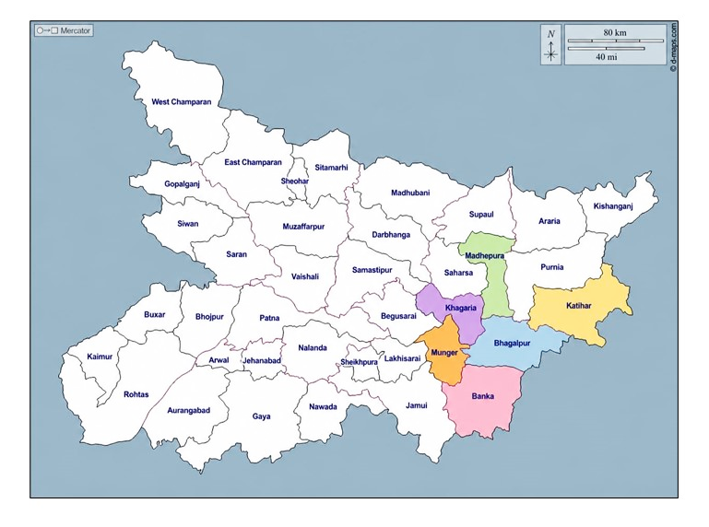
Figure 1: Map highlights the district of Eastern Bihar
taken for survey (Adapted from d-maps)

Material and Methods
The survey of Alternaria blight disease on Indian mustard caused by Alternaria brassicicola was conducted in six different districts of the Eastern region of Bihar. viz. Banka, Bhagalpur, Katihar, Khagaria, Madhepura and Munger. The survey was done during the Rabi season of 2023-2024 and 2024-2025. The data was collected from the last week of February to early March, when the crops were at the maturing stage. Five spots of each region were selected to find out the percentage disease index. During the survey, none of the spots was found free from the pathogen. Based on symptomatology, 30 spots were studied, and diseased samples were randomly collected.
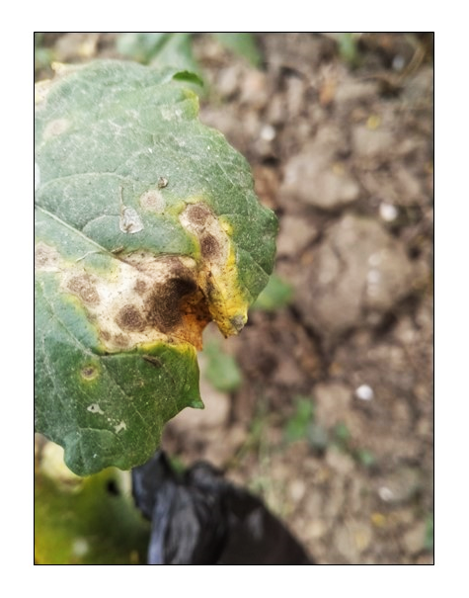
Figure 2: Leaf showing concentric blight
The diseased parts were cut, treated with ethyl alcohol (70%) for 30 seconds and then washed thrice with sterile water. The treated parts were dipped in 1% - 2% Sodium hypochlorite solution for 2-10 minutes and then cleaned with sterile water (Sahu et al., 2022). After drying, blight parts were then inoculated onto Potato Dextrose Agar medium, and the inoculated Petri plates were incubated at room temperature for 7 to 9 days. The growing fungi were examined under the compound microscope to check the occurrence of Alternaria brassicicola on the samples. The intensity of Alternaria leaf blight was calculated by observing the percentage of infected plants spread across the field. The intensity of the disease was calculated by following a 0-5 scale (Conn et al., 1990) on randomly selected plants in the same field as follows
List 1 : Percentage disease index

0 | No symptoms
1 | 1-10% leaf or pod area infected
2 | 11-25% leaf or pod area infected
3 | 26-50% leaf or pod area infected
4 | 51-75%leaf or pod area infected
5 | 75% above leaf or pod area infected

The percentage disease index was also calculated to demonstrate the disease incidence in the crop field, for which infected plants and the total number of plants were taken under consideration (Shrivastava et al., 2023; Pandey et al., 2024). This was performed by selecting any five spots on the crop field randomly. The total numbers of plants were counted from the selected area, and the diseased plants were monitored and noted for further calculations. (Manjhi et al., 2018). The formula to calculate the Percentage Disease Index (PDI) is given below:

$$PDI=\frac{No.of infected plants}{Total no.of plants}×100$$

Result and Discussion
The survey conducted in two consecutive seasons of mustard growing during the years 2023-2024 and 2024-2025, the incidence of Alternaria brassicicola was found to be maximum. The pathogen forms a dark olive brown to black colony on potato dextrose agar medium in Petri plates.
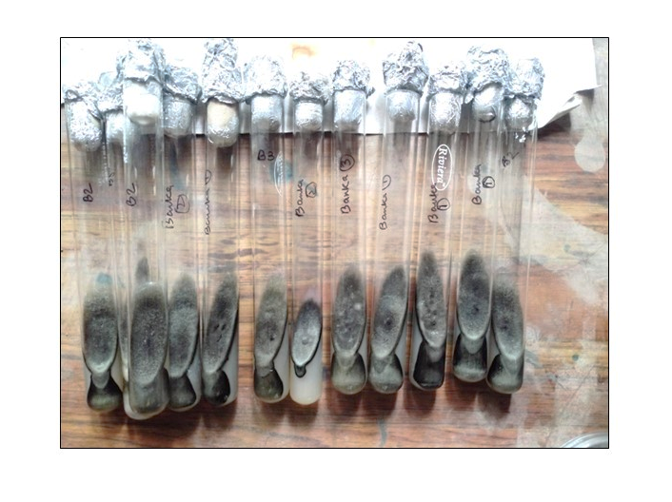
Fig 3: Pure culture of Alternaria brassicicola on
PDA medium in culture tubes

After the pathogen’s rapid growth, the media surface appears velvety due to massive spore formation. The mycelium is septate, branched and dark brown in colour, which clearly indicates that the pathogen is dematiaceous (pigmented fungi). Conidiophores arise singly or in small groups of about 2 to 12 or more through leaf stomata. Conidia are dark brown, smooth-walled, cylindrical to oblong-shaped and muriform and are produced in chains of up to 20 or more arising through small pores in the conidiophore wall. Conidia are slightly tapering towards the apex and are pseudorostrate (beakless) (Pandya et al., 2022). Conidia under a compound microscope appear septate and are pale-olivaceous brown in colour. It appears smooth and becomes slightly warty with age, with about 18 to 130 mm in length and 8 to 30 mm in thickness. (Commonwealth Mycological Institute, 1968). A similar survey was conducted on Indian mustard in 04 districts of the Gird region of Madhya Pradesh, which indicated the occurrence of Alternaria brassicae and Alternaria brassicicola in the ratio of 04:01 and 03:01 in the first and second seasons, respectively. (Shrivastava et al., 2023). Out of 30 different spots, Alternaria brassicicola was found at 25 spots, and Alteranria brassicicola along with Curvularia lunata were found at 05 spots in the first season of collection, and 24 spots of Alternaria brassicicola and 06 spots of Alternaria brassicicola along with Curvularia were found in 2nd season of collection. (Table 3) The appearance of two different fungi in ratios 05:01 and 06:01 in the first and second seasons, respectively. Results on the survey conducted for two consecutive seasons showed maximum appearance of Alternaria brassicicola as compared to Curvularia, with the percentage of 83.34% for Alternaria brassicicola and were 16.66% for Curvularia in the first year, and the percentage of 86.66% for Alternaria brassicicola and were 13.34% for Curvularia in the second year (Table 1). The result clearly indicated by (Ahmad et al., 2024) that Alternaria brassicicola was more dominant in the Eastern region of Bihar. Disease indexing of Indian Mustard against Alternaria blight when conducted on seven prominent districts of Central and Eastern Uttar Pradesh for the Year 2021-22 and 2022-23, the disease incidence was almost similar in each 05 selected districts and in the present paper when the survey conducted on 06 districts of Eastern Bihar in year 2023-24 and 2024-25 the percentage disease index calculated showed the disease incidence was severe in the region of Khagaria, Madhepura and Munger. Banka and Bhagalpur had moderate disease incidence, and Katihar showed the least among all (Table 02).
Cultural and microscopic characterization
The dark olive-brown to black, velvety colonies observed on potato dextrose agar, together with pigmented septate mycelia and chained muriform conidia, are compatible with the diagnostic morphology of Alternaria brassicicola. Nevertheless, conidial morphology within Alternaria can overlap among closely related taxa, and modern taxonomic studies recommend combining cultural and microscopic observations with molecular markers for species-level confirmation (Lawrence et al., 2013; Nowakowska et al., 2019; Woudenberg et al., 2013). Accordingly, the present identification should be regarded as morphology-based, while sequence-supported confirmation would strengthen future surveys.
Relative recovery of fungal isolates
Across the 30 survey spots, Alternaria brassicicola was recovered throughout both seasons, whereas Curvularia lunata was detected only in a smaller subset of samples. This consistent recovery supports the widespread occurrence of A. brassicicola in the surveyed mustard fields; however, isolation frequency represents relative cultural recovery and should not be equated directly with aggressiveness or exclusive causation. Multi-location studies of rapeseed-mustard diseases and controlled bioassays show that disease expression varies with the pathogen isolate, host genotype, inoculum level, and environmental conditions (Meena et al., 2024; Mishra et al., 2024; Nowakowska et al., 2019). The occasional co-isolation of C. lunata therefore warrants separate molecular identification and pathogenicity testing before its epidemiological importance is inferred.
District-wise disease incidence
Based on Table 02, mean PDI across the five surveyed spots was 63.81% in Munger, 61.39% in Madhepura, 56.90% in Khagaria, 42.22% in Bhagalpur, 41.11% in Banka, and 20.30% in Katihar, with an overall mean of 47.62%. Thus, the data indicate a pronounced spatial gradient, with Munger, Madhepura, and Khagaria experiencing substantially greater disease incidence than Katihar. Comparable studies have shown that Alternaria blight development varies across locations and crop stages and is influenced by host age, sowing date, temperature, humidity, and inoculum availability (Dhaliwal & Singh, 2020; Humpherson-Jones & Phelps, 1989; Meena et al., 2011). Long-term Indian surveillance likewise demonstrates that geographical and prevailing weather conditions contribute to variation in disease initiation and severity (Meena et al., 2024).
Biological interpretation and study limitations
The high incidence recorded in the three most affected districts indicates substantial disease pressure at crop maturity, but the observed PDI should be interpreted as a field-incidence measure based on infected plants rather than as a direct estimate of lesion area, yield reduction, or pathogen aggressiveness. Experimental studies in Brassica juncea have shown that A. brassicicola infection is associated with necrotic cell death, altered jasmonate-related responses, oxidative stress, and reduced photosynthetic performance, although the magnitude of these effects depends on leaf age and host genotype (Meur et al., 2015; Mishra et al., 2024; Nowakowska et al., 2019). Because the present survey used terminal-season observations and morphology-based isolation, repeated assessments across crop development, paired meteorological data, molecular confirmation, and pathogenicity assays would provide a stronger basis for explaining district-level differences and the significance of mixed fungal recovery.

Table 01- List of different regions of Eastern Bihar’s District taken under survey:

S. No. | District | Region | Location Coordinate | Pathogen Isolated
01. | Banka | Amarpur Road, Banka | 24.896 °N, 86.913 °E | Alternaria brassicicol
01. | Banka | Kakwara Tola, Chiutia | 24.851 °N, 86.899 °E | Alternaria brassicicol
01. | Banka | Kakwara Tola, Chiutia | 24.851 °N, 86.902 °E | Alternaria brassicicola , Curvularia
01. | Banka | Kanka | 24.917 °N, 86.898 °E | Alternaria brassicicola , Curvularia
01. | Banka | Samukhiya | 24.934 °N, 86.898 °E | Alternaria brassicicola
02. | Bhagalpur | Bhagalpur | 25.184 °N, 86.801 °E | Alternaria brassicicola
02. | Bhagalpur | Champanala | 25.239 °N, 86.926 °E | Alternaria brassicicola
02. | Bhagalpur | Hardeo Chak, Pirpainti Road | 25.230 °N, 87.389 °E | Alternaria brassicicola
02. | Bhagalpur | Itahari Pirpainti | 25.228 °N, 87.394 °E | Alternaria brassicicola
02. | Bhagalpur | Purani Sarai | 25.231 °N, 86.914 °E | Alternaria brassicicola
03. | Katihar | Bhangaha | 25.579 °N, 87.278 °E | Alternaria brassicicola
03. | Katihar | Katihar | 25.506 °N, 87.245 °E | Alternaria brassicicola
03. | Katihar | Kursela, Forbeshganj Road, Chandpur Milik | 25.507 °N, 87.246 °E | Alternaria brassicicola & Curvularia
03. | Katihar | Pothia, Malhoria | 25.535 °N, 87.261 °E | Alternaria brassicicola
03. | Katihar | Shabda | 25.542 °N, 87.261 °E | Alternaria brassicicola
04. | Khagaria | Alauli, Khagaria Road, Bachhouta | 25.538 °N, 86.455 °E | Alternaria brassicicola
04. | Khagaria | Alauli, Khagaria Road, Bachhouta | 25.532 °N, 86.455 °E | Alternaria brassicicola
04. | Khagaria | Bachhouta | 25.546 °N, 86.448 °E | Alternaria brassicicola
04. | Khagaria | Bhadas Uttar | 25.528 °N, 86.458 °E | Alternaria brassicicola & Curvularia
04. | Khagaria | Mathurapur | 25.516 °N, 86.458 °E | Alternaria brassicicola
05. | Madhepura | Dighi | 25.712 °N, 86.986 °E | Alternaria brassicicola
05. | Madhepura | Durgapur | 25.611 °N, 86.982 °E | Alternaria brassicicola
05. | Madhepura | Gamail Mohanpur, Bihariganj Road | 25.712 °N, 86.966 °E | Alternaria brassicicola
05. | Madhepura | Kathautia | 25.812 °N, 86.993 °E | Alternaria brassicicola
05. | Madhepura | Madhepura Durga Mandir Road | 25.601 °N, 86.989B °E | Alternaria brassicicola
06. | Munger | Herudiyara | 25.340 °N, 86.463 °E | Alternaria brassicicola
06. | Munger | Janki Nagar | 25.349 °N, 86.520 °E | Alternaria brassicicola
06. | Munger | Keshopur | 25.345 °N, 86.521 °E | Alternaria brassicicola
06. | Munger | Munger | 25.349 °N, 86.510 °E | Alternaria brassicicola & Curvularia
06. | Munger | Nauagarhi | 25.348 °N, 86.521 °E | Alternaria brassicicola

Table 02- Percentage disease Index of areas selected for survey:

S.No. | District | Spot | Total No. of Plants | Infected Plants | PDI
1. | Banka | 1 | 78 | 40 | 51.29%
1. | Banka | 2 | 80 | 34 | 42.5%
1. | Banka | 3 | 75 | 32 | 42.67%
1. | Banka | 4 | 82 | 25 | 30.49%
1. | Banka | 5 | 70 | 27 | 38.58%
2. | Bhagalpur | 1 | 82 | 31 | 37.81%
2. | Bhagalpur | 2 | 80 | 28 | 35%
2. | Bhagalpur | 3 | 70 | 41 | 58.58%
2. | Bhagalpur | 4 | 75 | 28 | 37.34%
2. | Bhagalpur | 5 | 85 | 36 | 42.36%
3. | Katihar | 1 | 80 | 11 | 13.75%
3. | Katihar | 2 | 70 | 18 | 25.72%
3. | Katihar | 3 | 80 | 21 | 26.25%
3. | Katihar | 4 | 88 | 8 | 9.10%
3. | Katihar | 5 | 75 | 20 | 26.67%
4. | Khagaria | 1 | 100 | 55 | 55%
4. | Khagaria | 2 | 88 | 40 | 45.46%
4. | Khagaria | 3 | 74 | 39 | 52.71%
4. | Khagaria | 4 | 84 | 55 | 65.48%
4. | Khagaria | 5 | 120 | 79 | 65.84%
5. | Madhepura | 1 | 87 | 62 | 71.27%
5. | Madhepura | 2 | 92 | 50 | 54.35%
5. | Madhepura | 3 | 96 | 59 | 61.46%
5. | Madhepura | 4 | 98 | 54 | 55.11%
5. | Madhepura | 5 | 88 | 57 | 64.78%
6. | Munger | 1 | 84 | 51 | 60.72%
6. | Munger | 2 | 104 | 78 | 75%
6. | Munger | 3 | 89 | 44 | 49.44%
6. | Munger | 4 | 90 | 57 | 63.34%
6. | Munger | 5 | 95 | 67 | 70.53%
*PDI – Per cent Disease Index

Table 03- List of pathogens isolated from different spots:

S.no. | District | Spot | Occurrence of Pathogen
S.no. | District | Spot | 2023-2024 |  | 2024-2025
S.no. | District | Spot | Alternaria brassicicola | Curvularia lunata | Alternaria brassicicola | Curvularia lunata
01. | Banka | Spot 1 | + | - | + | -
01. | Banka | Spot 2 | + | - | + | -
01. | Banka | Spot 3 | + | + | + | +
01. | Banka | Spot 4 | + | + | + | -
01. | Banka | Spot 5 | + | - | + | -
02. | Bhagalpur | Spot 1 | + | - | + | -
02. | Bhagalpur | Spot 2 | + | - | + | -
02. | Bhagalpur | Spot 3 | + | - | + | -
02. | Bhagalpur | Spot 4 | + | - | + | +
02. | Bhagalpur | Spot 5 | + | - | + | -
03. | Katihar | Spot 1 | + | - | + | +
03. | Katihar | Spot 2 | + | - | + | -
03. | Katihar | Spot 3 | + | + | + | +
03. | Katihar | Spot 4 | + | - | + | -
03. | Katihar | Spot 5 | + | - | + | -
04. | Khagaria | Spot 1 | + | - | + | -
04. | Khagaria | Spot 2 | + | - | + | -
04. | Khagaria | Spot 3 | + | + | + | -
04. | Khagaria | Spot 4 | + | - | + | -
04. | Khagaria | Spot 5 | + | - | + | -
05. | Madhepura | Spot 1 | + | - | + | -
05. | Madhepura | Spot 2 | + | - | + | -
05. | Madhepura | Spot 3 | + | - | + | -
05. | Madhepura | Spot 4 | + | - | + | +
05. | Madhepura | Spot 5 | + | - | + | -
06. | Munger | Spot 1 | + | - | + | -
06. | Munger | Spot 2 | + | - | + | -
06. | Munger | Spot 3 | + | - | + | +
06. | Munger | Spot 4 | + | + | + | -
06. | Munger | Spot 5 | + | - | + | -
(+) indicates the availability of Alternaria brassicicola and (+) shows the presence of Curvularia and (–) shows absence of Curvularia.

Conclusion
Alternaria blight symptoms were recorded at all 30 mustard-field locations surveyed across six districts of eastern Bihar. Mean field incidence ranged from 20.30% in Katihar to 63.81% in Munger, with an overall district mean of 47.62%. Morphology-consistent A. brassicicola was recovered from every surveyed spot in both seasons, while C. lunata occurred less frequently as a co-isolate. The results demonstrate widespread fungal recovery and marked spatial variation in disease incidence during the crop-maturity period. However, cultural isolation frequency should not be interpreted as a direct measure of pathogen aggressiveness or yield loss. Molecular confirmation, pathogenicity assays and repeated disease assessments are needed before firm conclusions are drawn regarding pathogen identity, epidemiological importance and district-level risk.

Limitations
The survey assessed five spots per district near crop maturity and may not represent disease development throughout the growing season. Mustard cultivars, sowing dates, management practices and meteorological conditions were not analysed. Fungal identification was based on cultural and microscopic characteristics without DNA sequencing or species-specific PCR. Pathogenicity tests were not performed, and the causal role of co-isolated C. lunata remains uncertain. The study also did not report season-specific incidence values, yield loss or statistical comparisons among districts. These limitations restrict interpretation of pathogen prevalence and the causes of geographical variation.

Declaration of AI Use

This manuscript was prepared through the combined contributions of all author(s), including contributions to the study design, data, content development, results, interpretation, and related scholarly work. The author(s) acknowledge the use of Grammarly and ChatGPT to assist with grammar checking, language refinement, reference formatting. These AI-assisted tools were not used as authors and did not replace the intellectual contributions or scholarly judgment of the author(s). All AI-assisted outputs, including content, references, and interpretations, were carefully reviewed, revised, verified, and approved by the author(s). The author(s) accept full responsibility for the accuracy, integrity, and final content of the manuscript.

Reference
- Ahmad, M. M., Siddiqui, S., Kumar, A., Singh, S. K., & Rai, D. (2024). Survey on the disease incidence of Alternaria blight of mustard in eastern and central parts of Uttar Pradesh. International Journal of Plant and Environment, 10(1), 69–75. DOI: 10.18811/ijpen.v10i01.09
- Commonwealth Mycological Institute. (1968). Alternaria brassicicola (Descriptions of Pathogenic Fungi and Bacteria, No. 163). Kew, Surrey, England: CMI.
- Conn, K. L., Tewari, J. P., & Awasthi, R. P. (1990). A disease assessment key for Alternaria black spot in rapeseed and mustard. Canadian Plant Disease Survey, 70(1), 19-22.
- Babli, Pandya, R. K., Kour, A., & Tiwari, S. (2022). Occurrence of Alternaria brassicae and A. brassicicola of mustard in Gird region of Madhya Pradesh. The Pharma Innovation Journal, 11(12), 926–928.
- Kumar, V., Sharma, A. K., Yogi, R. K., & Singh, V. V. (2025). [Title information not provided]. Journal of Oilseed Brassica, 16(2), 149–157.
- Macioszek, V. K., Wielanek, M., Morkunas, I., Ciereszko, I., & Kononowicz, A. K. (2020). Leaf position-dependent effect of Alternaria brassicicola development on host cell death, photosynthesis and secondary metabolites in Brassica juncea. Physiologia Plantarum, 168(3), 601-616. doi.org
- Nowicki, M., Nowakowska, M., Niezgoda, A., & Kozik, E. U. (n.d.). Research Institute of Horticulture Konstytucji.
- Pandey, M. K., Ahmad, M. M., Siddiqui, S., Kumar, A., Singh, S. K., & Rai, D. (2024). Survey on the disease incidence of alternaria blight of mustard in eastern and central parts of Uttar Pradesh. International Journal of Plant and Environment, 10(1), 69–75. https://doi.org/10.18811/ijpen.v10i01.09
- Prasad, R., & Lallu, P. (2006). Management of Alternaria blight of mustard with combination of chemicals and botanicals. Annual Review of Plant Protection Science, 14, 400-403
- Manjhi, P., Tomar, D. S., Srivastav, A. K., & Nayak, M. K. (2018). Alternaria blight of mustard and its association with weather parameters. Annals of Plant and Soil Research, 20(3), 250–253.
- Sahu, P. K., Tilgam, J., Mishra, S., Hamid, S., Gupta, A., Jayalakshmi, K., Verma, S. K., & Kharwar, R. N. (2022). Surface sterilization for isolation of endophytes: Ensuring what (not) to grow. Journal of Basic Microbiology, 62(6), 647–668. https://doi.org/10.1002/jobm.202100462
- Sharma, S. K., & Kumar, A. (2023). Effect of date of sowing on growth, seed yield and economics of Indian mustard (Brassica juncea) varieties under rainfed conditions. Indian Journal of Agricultural Research, 57(1), 56-59. doi.org
- Shrivastava, A., Tripathi, M. K., Singh, P., Tiwari, S., Tripathi, N., Tiwari, P. N., Parihar, P., Singh, J., & Chauhan, S. (2023). Disease indexing of Indian mustard genotypes against alternaria blight disease. The Pharma Journal, 12(4), 8–13. https://www.thepharmajournal.com/archives/?year=2023&vol=12&issue=4&ArticleId=19794
- Dhaliwal, R. S., & Singh, B. (2020). Effect of weather parameters and date of sowing on intensity of Alternaria blight of rapeseed mustard. Indian Phytopathology, 73, 89–95. https://doi.org/10.1007/s42360-020-00193-3
- Humpherson-Jones, F. M., & Phelps, K. (1989). Climatic factors influencing spore production in Alternaria brassicae and Alternaria brassicicola. Annals of Applied Biology, 114(3), 449–458. https://doi.org/10.1111/j.1744-7348.1989.tb03360.x
- Lawrence, D. P., Gannibal, P. B., Peever, T. L., & Pryor, B. M. (2013). The sections of Alternaria: Formalizing species-group concepts. Mycologia, 105(3), 530–546. https://doi.org/10.3852/12-249
- Meena, P. D., Chattopadhyay, C., Meena, S. S., & Kumar, A. (2011). Area under disease progress curve and apparent infection rate of Alternaria blight disease of Indian mustard (Brassica juncea) at different plant age. Archives of Phytopathology and Plant Protection, 44(7), 684–693. https://doi.org/10.1080/03235400903345281
- Meena, P. D., Rai, P. K., & Saharan, G. S. (2024). Distribution maps depicting geographical prevalence of rapeseed-mustard diseases in India. Indian Phytopathology, 77, 627–644. https://doi.org/10.1007/s42360-024-00765-7
- Meur, G., Shukla, P., Dutta-Gupta, A., & Kirti, P. B. (2015). Characterization of Brassica juncea–Alternaria brassicicola interaction and jasmonic acid carboxyl methyl transferase expression. Plant Gene, 3, 1–10. https://doi.org/10.1016/j.plgene.2015.06.001
- Mishra, A., Khan, N. A., Jha, R. K., Murugesh, T., & Singh, A. (2024). Study of resistance mechanism of Alternaria blight (Alternaria brassicicola) by biochemical markers in Indian mustard (Brassica juncea L. Czern. & Coss.). Frontiers in Plant Science, 15, 1420197. https://doi.org/10.3389/fpls.2024.1420197
- Nowakowska, M., Wrzesińska, M., Kamiński, P., Szczechura, W., Lichocka, M., Tartanus, M., Kozik, E. U., & Nowicki, M. (2019). Alternaria brassicicola–Brassicaceae pathosystem: Insights into the infection process and resistance mechanisms under optimized artificial bio-assay. European Journal of Plant Pathology, 153, 131–151. https://doi.org/10.1007/s10658-018-1548-y
- Woudenberg, J. H. C., Groenewald, J. Z., Binder, M., & Crous, P. W. (2013). Alternaria redefined. Studies in Mycology, 75, 171–212. https://doi.org/10.3114/sim0015

