Correlation and Path Coefficient Analysis of Yield and Yield-Contributing Traits in Bread Wheat (Triticum aestivum L.) Genotypes

ABSTRACT
Improving grain yield in bread wheat (Triticum aestivum L.) requires a clear understanding of the relationships between yield and its component traits because grain yield is governed by the combined action of several quantitative characters. The present study was undertaken to identify key yield-contributing traits through phenotypic correlation and path coefficient analyses using a diverse set of bread wheat genotypes. The experiment was conducted during the Rabi season of 2025–2026 at the Experimental Farm of Deen Dayal Upadhyaya Gorakhpur University, Gorakhpur, Uttar Pradesh, India. A total of 47 bread wheat genotypes, including four standard check varieties, were evaluated in an Augmented Block Design. Data were recorded for thirteen agronomic and yield-related traits, and phenotypic correlation coefficients and path coefficient analysis were used to assess the relationships among these characters and their contributions to grain yield. The analysis revealed that biological yield per plant exhibited the highest positive correlation with grain yield per plant (r = 0.998), followed by the number of effective tillers per plant (r = 0.521) and flag leaf area (r = 0.388). Path analysis indicated that biological yield had the highest positive direct effect (0.9860). Among all the characters studied, biological yield per plant exerted the highest positive direct effect on grain yield, followed by spike length and the number of effective tillers per plant, indicating their important roles in determining productivity. In contrast, plant height and peduncle length showed negative relationships with grain yield, suggesting that excessive vegetative growth was not advantageous under the experimental conditions. The findings suggest that biological yield per plant, productive tillering ability, flag leaf area, spike length, and harvest index are useful traits for indirect selection aimed at improving grain yield. Simultaneous consideration of these characters in breeding programmes may enhance selection efficiency and facilitate the development of high-yielding bread wheat cultivars under agro-climatic conditions similar to those of the present study. Further validation across multiple environments is required before broader recommendations can be made.
Keywords: Triticum aestivum L.; bread wheat; grain yield; correlation analysis; path coefficient analysis; biological yield; effective tillers; harvest index.

1. INTRODUCTION
Bread wheat (Triticum aestivum L.) is among the most important cereal crops cultivated worldwide and serves as a primary source of food for billions of people. Owing to its high nutritional value, adaptability to diverse agro-climatic conditions, and extensive utilisation in food products, wheat contributes significantly to global food and nutritional security. According to recent agricultural estimates, wheat supplies nearly one-fifth of the calories and protein consumed by the world's population. As global population growth, climate variability, and decreasing availability of arable land continue to challenge agricultural production, increasing wheat productivity has become a major objective of crop improvement programmes (Falconer & Mackay, 1996).
India occupies a prominent position among wheat-producing countries and is one of the largest contributors to global wheat production. The crop is cultivated extensively during the Rabi season under a wide range of environmental conditions, particularly across the Indo-Gangetic Plains. Although considerable progress has been achieved through conventional breeding and the introduction of semi-dwarf cultivars, future improvements in productivity require continuous development of superior genotypes with high yield potential and broad adaptation (Thapa et al., 2019; Patil et al., 2024).
The success of such breeding programmes depends largely on the identification of traits that consistently contribute to grain yield under field conditions. Grain yield is a polygenic character resulting from the combined influence of several morphological, physiological, and phenological traits. Characters such as effective tillers per plant, spike length, flag leaf area, biological yield, harvest index, and grain number per spike interact to determine final yield performance. Because these traits are genetically associated and are also influenced by environmental conditions, direct selection for grain yield alone is often less effective than selection based on its component traits (Johnson et al., 1955; Robinson et al., 1949). Therefore, identifying reliable secondary traits with strong relationships to grain yield is an important strategy for increasing the efficiency of wheat breeding (Burton & DeVane, 1953).
Correlation analysis is one of the most widely used statistical tools for studying the relationships among quantitative traits. It provides valuable information regarding the strength and direction of association between yield and its contributing characters, enabling plant breeders to identify traits that may be improved simultaneously through indirect selection (Searle, 1961). However, correlation coefficients alone cannot distinguish whether an observed relationship is the result of a direct effect or an indirect influence through other variables. Consequently, interpretation based solely on correlation analysis may not accurately reflect the actual contribution of individual traits towards grain yield. To overcome this limitation, path coefficient analysis has become an important approach in plant breeding research (Wright, 1921; Dewey & Lu, 1959). This method partitions correlation coefficients into direct and indirect effects, thereby providing a clearer understanding of the causal relationships among traits. By quantifying the individual contribution of each character, path analysis enables breeders to identify the most effective selection criteria for improving grain yield. The combined application of correlation and path coefficient analyses therefore provides a comprehensive framework for evaluating complex yield relationships in breeding populations (Dewey & Lu, 1959).
Recent investigations in diverse bread wheat populations have similarly shown that biological yield, harvest index, fertile tiller number, spike attributes, and related component traits may exert direct or indirect effects on grain yield, although their relative importance varies with genetic background and growing conditions (Alemu et al., 2025; Saini et al., 2024a; Sewore & Abe, 2024).
Several investigations have reported that biological yield, productive tillers, flag leaf area, spike length, harvest index, and grain number are among the major determinants of grain yield in bread wheat (Bayisa et al., 2020; Sharma et al., 2018; Kumar et al., 2021; Saini et al., 2024b). Nevertheless, the magnitude of these relationships often differs among genetic materials and production environments because of variation in genotype, climate, and management practices. Consequently, newly developed breeding materials should be evaluated under local conditions to identify stable and reliable selection criteria for future crop improvement. Despite considerable research on yield-related traits in wheat, information on recently developed breeding lines adapted to the eastern Indo-Gangetic Plains remains comparatively limited (Patil et al., 2024; Thapa et al., 2019).
Multi-environment evaluation and genetic mapping studies further indicate that yield performance and the expression of agronomic traits can vary across locations and stress conditions, reinforcing the need for region-specific evaluation followed by validation across environments (Duga et al., 2024; Manjunath et al., 2024).
Evaluation of these genotypes is essential for identifying characters that consistently contribute to higher productivity under regional growing conditions. Such information not only facilitates the selection of superior breeding materials but also assists in the identification of suitable parents for hybridisation programmes. Therefore, the present investigation was undertaken to evaluate the relationships among grain yield and its component traits using correlation and path coefficient analyses in a diverse set of bread wheat (Triticum aestivum L.) genotypes. The specific objective was to identify the most important yield-contributing characters that can serve as reliable selection criteria for the development of high-yielding wheat cultivars suitable for agro-climatic conditions similar to those of the present study.

2. MATERIALS AND METHODS

2.1 Study Site
The field experiment was conducted during the Rabi season of 2025–2026 at the Experimental Farm of the Department of Genetics and Plant Breeding, Institute of Agriculture and Natural Sciences, Deen Dayal Upadhyaya Gorakhpur University, Gorakhpur, Uttar Pradesh, India. The experimental location lies in the Eastern Gangetic Plains (approximately 26.75° N latitude and 83.39° E longitude) at an altitude of about 75 m above mean sea level. The region experiences a humid subtropical climate with cool winters and warm summers, while most of the annual rainfall occurs during the southwest monsoon. These climatic conditions are favourable for wheat cultivation during the Rabi season.

2.2 Plant Material
A set of 47 bread wheat (Triticum aestivum L.) genotypes was used in the present investigation. The experimental material included 43 test genotypes and four widely cultivated check varieties representing diverse genetic backgrounds. The inclusion of check cultivars enabled comparison of the performance of experimental entries with established commercial varieties.

2.3 Experimental Design and Crop Establishment
The field experiment was conducted using an Augmented Block Design (ABD) comprising three experimental blocks. Four check varieties were replicated across the blocks, whereas the test genotypes were unreplicated. The design was adopted to facilitate the efficient evaluation of a large number of wheat breeding lines with limited seed availability while maintaining experimental precision through repeated check varieties. Each experimental block consisted of 15 unique test genotypes together with the same four check varieties, resulting in 19 plot entries per block. Thus, the experiment comprised a total of 57 plot entries (19 × 3), although only 47 unique genotypes (43 test genotypes + 4 check varieties) were evaluated because the check varieties were repeated across all three blocks according to the augmented block design, and each genotype was planted in three rows of 2.5 m length with a row-to-row spacing of 25 cm. A 0.75 m wide drainage channel was maintained between adjacent blocks to facilitate irrigation and field operations.
Consequently, each experimental block occupied an area of 14.25 m × 2.50 m (35.63 m²), while the total experimental area for the three experimental blocks measured 14.25 m × 9.00 m (128.25 m²). A recommended fertiliser dose of 120 kg N, 60 kg P₂O₅ and 40 kg K₂O ha⁻¹ was applied uniformly to the experimental field. The full doses of phosphorus and potassium together with half of the nitrogen were applied as a basal dose at sowing, while the remaining nitrogen was top-dressed in two equal splits at the Crown Root Initiation (CRI) and first node (late tillering) stages. To ensure optimum crop growth and development, five irrigations were applied at the CRI, tillering, jointing/booting, flowering, and grain-filling (milking) stages.
All recommended agronomic practices for wheat cultivation in eastern Uttar Pradesh, including weed management, plant protection measures, and other intercultural operations, were followed uniformly throughout the experiment to minimise environmental variation among the experimental plots.

2.4 Trait Measurement
Data were recorded for thirteen quantitative characters associated with crop growth, development, and grain yield. For each genotype, observations were taken from five healthy and competitive plants selected at random from the central rows of each plot, excluding border plants to avoid edge effects. Mean values were calculated and used for statistical analyses.
The traits evaluated were:
- Days to 50% flowering
- Plant height (cm)
- Number of effective tillers per plant
- Flag leaf area (cm²)
- Days to maturity
- Spike length (cm)
- Peduncle length (cm)
- Number of spikelets per spike
- Number of grains per spike
- Test weight (1000-grain weight, g)
- Biological yield per plant (g)
- Harvest index (%)
- Grain yield per plant (g)
Measurements were recorded according to standard wheat evaluation procedures to ensure consistency and accuracy.

Table 1. List of the 47 bread wheat (Triticum aestivum L.) genotypes used in the study.
S. No. | Genotypes | 24. | KUDRATH-8
1. | AGG 4006 | 25. | C-306
2. | AGG 4010 | 26. | BANGRNI
3. | AGG 3056 | 27. | DBA 173
4. | AGG 7041 | 28. | HI 1500
5. | 3HZWYT 2023-24 | 29. | PBW 341
6. | AGG 6046 | 30. | DBW 303
7. | SAWYT 2023-24 | 31. | WL 711
8. | AGG 8044 | 32. | DBW 327
9. | AGG 7032 | 33. | HI 8498
10. | 31SAWYT 2023-24 | 34. | HI 8759
11. | AGG 2024 | 35. | PBW 502
12. | 14 HZWYT/ 2023-24 | 36. | GW 322
13. | AGG/ 2010 | 37. | DBW 47
14. | AGG 7009 | 38. | DBW 359
15. | 44 ESWYT 2023-24 | 39. | HD 3406
16. | AGG 1042 | 40. | DBW 316
17. | AGG 8047 | 41. | MD 1203
18. | 22 HTWYT 2023-24 | 42. | Agra Local
19. | AGG 6055 | 43. | DBW 252
20. | AGG 7014 | 44. | SRI RAM SUPER 303 (CH.)
21. | HI 8737 | 45. | DBW 187 (CH.)
22. | GW 273 | 46. | HD 2851 (CH.)
23. | MP 3288 | 47. | HD 2967(CH.)

CH.-Check.

2.5 Statistical Analysis
The experimental data were compiled and analysed to investigate the relationships among grain yield and its component characters. Statistical analyses were performed following standard biometrical procedures for agricultural experiments (Panse & Sukhatme, 1985).
Correlation Analysis
Phenotypic correlation coefficients were estimated to determine the degree of association among the studied traits following the procedure described by Searle (1961). The significance of the correlation coefficients was tested at the 5% and 1% probability levels to identify meaningful relationships among the characters.
Path Coefficient Analysis
Path coefficient analysis was carried out according to the method proposed by Dewey and Lu (1959), based on the path analysis concept originally developed by Wright (1921). Grain yield per plant was considered the dependent variable, whereas the remaining quantitative traits were treated as independent variables. The analysis partitioned the correlation coefficients into direct and indirect effects to determine the relative contribution of each trait to grain yield.
Data Analysis Software
All statistical analyses were performed using R statistical software (R version 4.5.1; R Core Team, 2025, Vienna, Austria), while Microsoft Excel was used for data organisation, preliminary calculations, and preparation of tables and figures. Correlation matrices and graphical outputs were generated using appropriate R packages.

2.6 Research Objective
The present study was undertaken to identify agronomic traits that influence grain yield in bread wheat by combining correlation and path coefficient analyses. The information generated is expected to assist in selecting superior genotypes and establishing efficient selection criteria for future wheat breeding programmes.

3. RESULTS

3.1 Correlation Analysis
The relationships between grain yield per plant and twelve associated agronomic characters were assessed through phenotypic correlation analysis. The estimated correlation coefficients are presented in Table 2(a), while their graphical representation is shown in Figure 1.
Grain yield per plant showed the strongest positive association with biological yield per plant (r = 0.998), followed by the number of effective tillers per plant (r = 0.521) and flag leaf area (r = 0.388). Because grain yield constitutes a component of biological yield, the exceptionally strong association between these two traits should be interpreted cautiously and should not be considered entirely independent from a biological perspective.
Moderately positive relationships were observed between grain yield and spike length (r = 0.213) as well as harvest index (r = 0.200), suggesting that improvements in spike architecture and assimilate partitioning may also enhance productivity. Conversely, plant height (r = –0.285), peduncle length (r = –0.314), and test weight (r = –0.124) exhibited negative associations with grain yield. Likewise, days to 50% flowering and days to maturity showed weak negative relationships, indicating a relatively smaller contribution of these phenological traits to yield variation under the present experimental conditions.
Among the interrelationships of yield components, days to 50% flowering was strongly and positively correlated with days to maturity (r = 0.854), reflecting the close association between flowering and maturity duration. A very high positive correlation was also observed between plant height and peduncle length (r = 0.955), demonstrating their coordinated morphological development.
Spike length was positively associated with the number of grains per spike (r = 0.452) and the number of spikelets per spike (r = 0.281). Furthermore, the number of spikelets per spike exhibited a strong positive relationship with the number of grains per spike (r = 0.788), indicating that increases in spikelet number generally resulted in greater grain production per spike. The number of effective tillers per plant was also positively correlated with biological yield (r = 0.515), confirming its contribution to total plant productivity.
Overall, the correlation analysis identified biological yield per plant, number of effective tillers per plant, flag leaf area, spike length, and harvest index as the traits most closely associated with grain yield, whereas plant height, peduncle length, and phenological traits displayed comparatively weak or negative relationships.
However, the exceptionally high positive correlation between biological yield and grain yield should be interpreted with caution, as grain yield constitutes a component of biological yield and, therefore, the association is partly mathematical in nature.

Fig. 1. Phenotypic correlation matrix among thirteen agronomic traits in bread

wheat genotypes.
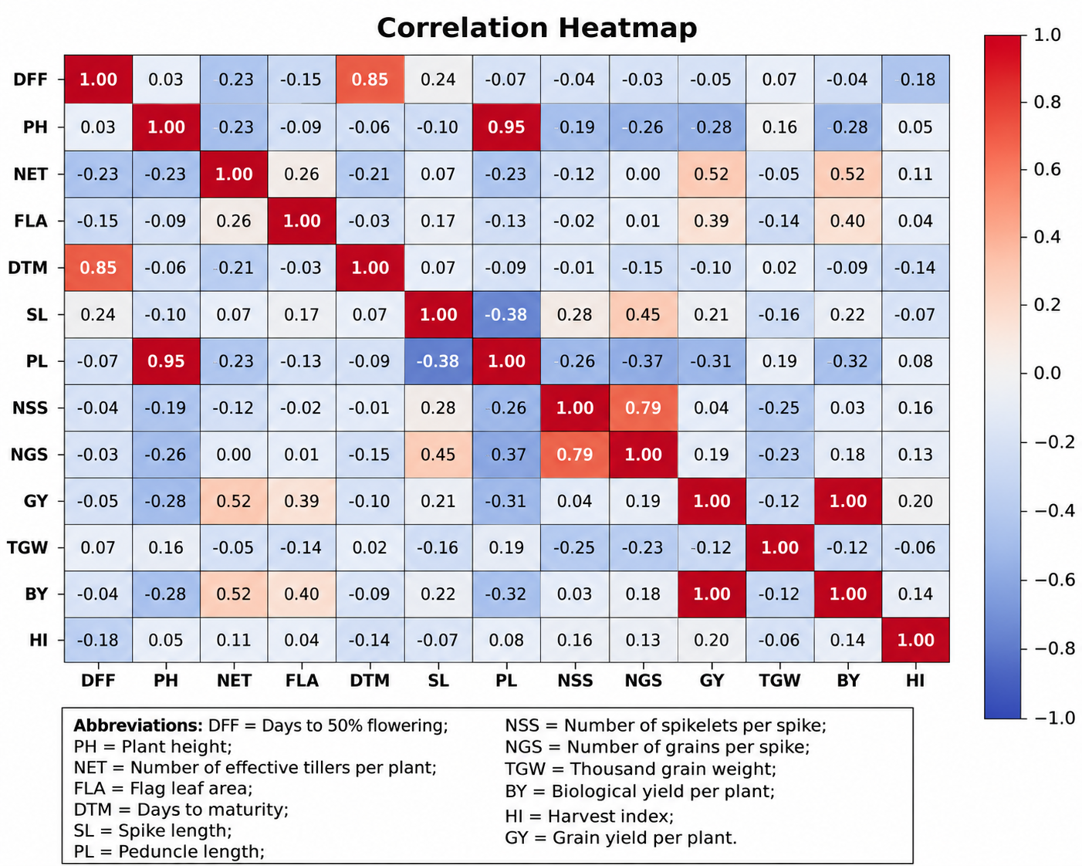

Variables | DFF | PH | NET | FLA | DM | SL | PL | NSS | NGS | GY | TGW | BY | HI
DFF | 1.0** | 0.03 | -0.226 | - 0.149 | 0.854** | 0.241 | -0.067 | -0.045 | -0.031 | -0.052 | 0.065 | -0.039 | -0.177
PH |  | 1.0** | -0.232 | -  0.087 | -0.057 | -0.105 | 0.955** | -0.186 | -0.256 | -0.285 | 0.16 | -0.282 | 0.049
NET |  |  | 1.0** | 0.263 | -0.209 | 0.066 | -0.228 | -0.123 | 0.003 | 0.521** | -0.046 | 0.515** | 0.108
FLA |  |  |  | 1.0** | -0.028 | 0.167 | -0.127 | -0.022 | 0.008 | 0.388* | -0.137 | 0.396** | 0.036
DM |  |  |  |  | 1.0** | 0.066 | -0.092 | -0.011 | -0.154 | -0.097 | 0.024 | -0.088 | -0.142
SL |  |  |  |  |  | 1.0** | -0.381* | 0.281 | 0.452** | 0.213 | -0.156 | 0.224 | -0.072
PL |  |  |  |  |  |  | 1.0** | -0.255 | -0.37* | -0.314* | 0.189 | -0.316* | 0.08
NSS |  |  |  |  |  |  |  | 1.0** | 0.788** | 0.043 | -0.252 | 0.034 | 0.16
NGS |  |  |  |  |  |  |  |  | 1.0** | 0.187 | -0.231 | 0.182 | 0.133
GY |  |  |  |  |  |  |  |  |  | 1.0** | -0.124 | 0.998** | 0.2
TGW |  |  |  |  |  |  |  |  |  |  | 1.0** | -0.125 | -0.057
BY |  |  |  |  |  |  |  |  |  |  |  | 1.0** | 0.142

Table 2(a) Correlation values for different traits in wheat genotypes.

(*Significant at 5 % level, **Significant at 1 % level)

Abbreviations: DFF = Days to 50% flowering; PH = Plant height; NET = Number of effective tillers per plant; FLA = Flag leaf area; DTM = Days to maturity; SL = Spike length; PL = Peduncle length; NSS = Number of spikelets per spike; NGS = Number of grains per spike; TGW = Thousand grain weight; BY = Biological yield per plant; HI = Harvest index; GY = Grain yield per plant.

3.2 Path Coefficient Analysis
To determine the relative importance of individual traits, correlation coefficients were partitioned into direct and indirect effects using path coefficient analysis. The estimated path coefficients are presented in Table 2(b) while their graphical representation is shown in Figure 2.
Among the thirteen characters studied, biological yield per plant recorded the highest positive direct effect (0.9860) on grain yield per plant. This trait also exhibited the strongest positive correlation with grain yield (r = 0.9978), indicating that biomass production was the principal determinant of productivity in the evaluated genotypes. Since grain yield constitutes a component of biological yield, the exceptionally high direct effect observed for biological yield may partly reflect mathematical dependency. Therefore, breeding decisions should also consider other independent yield-contributing traits.
The number of effective tillers per plant showed a positive direct effect (0.0066) and also exerted a considerable indirect influence through biological yield, resulting in a favourable overall association with grain yield. Likewise, spike length exhibited a positive direct effect (0.0390) and contributed indirectly through biological yield, demonstrating its importance in improving grain productivity.
Although flag leaf area displayed only a small direct effect, its positive indirect contribution through biological yield strengthened its association with grain yield. Similarly, harvest index exerted a favourable direct influence, indicating that efficient partitioning of assimilates towards grain formation contributed positively to overall productivity.
In contrast, plant height and peduncle length exhibited negative direct effects, suggesting that increased vegetative growth did not necessarily improve grain yield under the present experimental conditions. Days to 50% flowering, days to maturity, and test weight showed comparatively small direct effects and contributed only marginally to variation in grain yield.
The residual effect obtained from the path coefficient analysis indicated that the set of characters included in the model explained most of the variation observed in grain yield, confirming the adequacy of the analysis.
However, because biological yield includes grain yield as one of its components, interpretation of its direct effect should be made cautiously to avoid overestimating its biological importance in selection programmes.
Overall, the path coefficient analysis demonstrated that biological yield per plant, number of effective tillers per plant, spike length, flag leaf area, and harvest index were the most influential traits affecting grain yield and therefore constitute useful selection criteria for the genetic improvement of bread wheat.
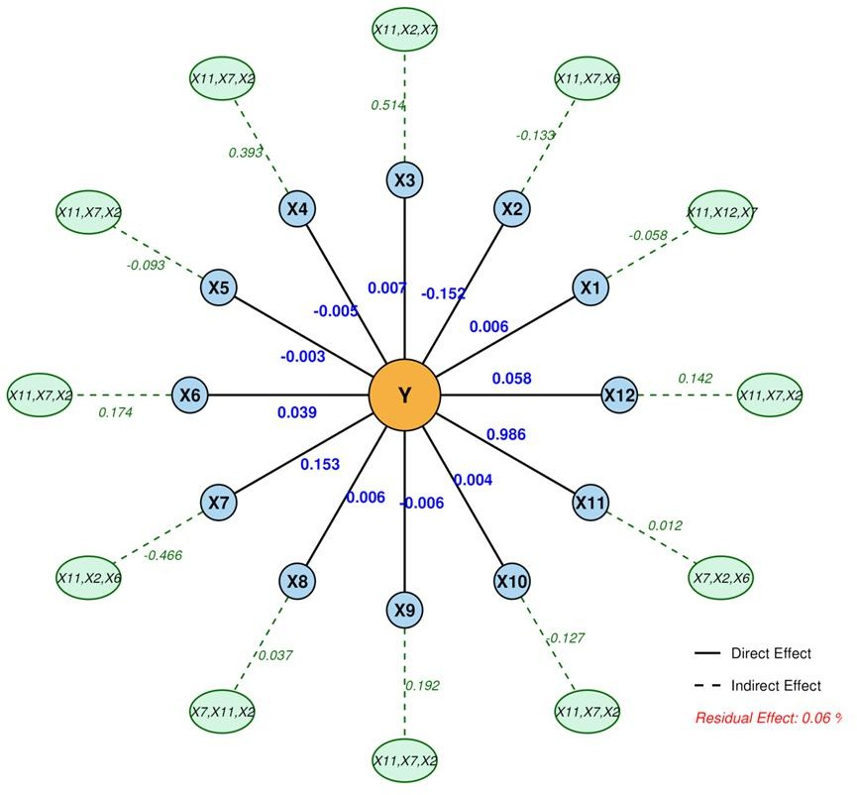
Fig. 2. Direct and indirect effects of agronomic traits on grain yield estimated through path coefficient analysis.

Symbol* | Abbreviation | X7 | Peduncle length
X1 | Days to 50% flowering | X8 | Number of spikelets / spike
X2 | Plant height | X9 | Number of grains / spike
X3 | Number of effective tillers | X10 | Test weight
X4 | Flag leaf area | X11 | Biological yield / plant
X5 | Days to maturity | X12 | Harvest index
X6 | Spike length | Y | Grain yield / plant
*Symbol used for Path analysis.

Table 2(b) Path analysis table for different traits in wheat genotypes.

Traits | DFF | PH | NET | FLA | DTM | SL | PL | NSS | NGS | TGW | BY | HI | GY
DFF | 0.0059 | - 0.0046 | -0.0015 | 0.0007 | -0.0029 | 0.0093 | -0.0102 | -0.0002 | 0.0001 | 0.0002 | -0.0384 | -0.0102 | -0.0517
PH | 0.0001 | - 0.1516 | -0.0015 | 0.0004 | 0.0002 | - 0.0040 | 0.1457 | -0.0011 | 0.0014 | 0.0005 | -0.2780 | 0.0028 | -0.2851
NET | -0.0013 | 0.0352 | 0.0066 | -0.0013 | 0.0007 | 0.0025 | -0.0347 | -0.0007 | -0.0002 | -0.0001 | 0.5076 | 0.0062 | 0.5207
FLA | -0.0008 | 0.0132 | 0.0017 | -0.0051 | 0.0001 | 0.0065 | -0.0193 | -0.0001 | -0.0005 | -0.0005 | 0.3901 | 0.0020 | 0.3878
DTM | 0.0051 | 0.0086 | -0.0013 | 0.0001 | -0.0034 | 0.0025 | -0.0139 | -0.0007 | 0.0008 | 0.0009 | -0.0868 | -0.0082 | -0.0966
SL | 0.0014 | 0.0158 | 0.0004 | -0.0008 | -0.0002 | 0.0389 | -0.0581 | 0.0018 | -0.0025 | -0.0005 | 0.2205 | -0.0041 | 0.2126
PL | -0.0004 | - 0.1448 | -0.0015 | 0.0006 | 0.0003 | - 0.0148 | 0.1525 | -0.0016 | 0.0020 | 0.0007 | -0.3113 | 0.0046 | -0.3137
NSS | -0.0002 | 0.0282 | -0.0008 | 0.0001 | 0.0004 | 0.0109 | -0.0388 | 0.0063 | -0.0043 | -0.0009 | 0.0334 | 0.0092 | 0.0432
NGS | -0.0001 | 0.0388 | 0.0002 | -0.0004 | 0.0005 | 0.0176 | -0.0564 | 0.0050 | -0.0055 | -0.0008 | 0.1798 | 0.0077 | 0.1866
TGW | 0.0003 | - 0.0242 | -0.0003 | 0.0007 | -0.0008 | - 0.0060 | 0.0288 | -0.0016 | 0.0012 | 0.0036 | -0.1229 | -0.0032 | -0.1236
BY | -0.0002 | 0.0427 | 0.0034 | -0.00203 | 0.0003 | 0.0087 | -0.0481 | 0.0002 | -0.0010 | -0.0004 | 0.9860 | 0.0082 | 0.9978
HI | -0.0010 | - 0.0075 | 0.0007 | -0.00018 | 0.0004 | - 0.0028 | 0.0121 | 0.0010 | -0.0007 | -0.0002 | 0.1398 | 0.0579 | 0.1997

Abbreviations: DFF = Days to 50% flowering; PH = Plant height; NET = Number of effective tillers per plant; FLA = Flag leaf area; DTM = Days to maturity; SL = Spike length; PL = Peduncle length; NSS = Number of spikelets per spike; NGS = Number of grains per spike; TGW = Thousand grain weight; BY = Biological yield per plant; HI = Harvest index; GY = Grain yield per plant.

4. DISCUSSION
The improvement of grain yield remains the primary objective of wheat breeding programmes; however, yield is a complex trait controlled by the interaction of numerous component characters and environmental factors. Consequently, evaluating the relationships among these traits is essential for identifying reliable selection criteria. The present investigation employed correlation and path coefficient analyses to determine the relative contribution of important agronomic traits to grain yield in bread wheat genotypes, an approach widely recommended in wheat improvement studies (Wright, 1921; Dewey & Lu, 1959).
The present findings should be interpreted within the limitations of a single-season and single-location evaluation. Therefore, broader recommendations regarding cultivar adaptation require validation across multiple environments and years.
The correlation analysis demonstrated that grain yield was positively associated with biological yield per plant, number of effective tillers per plant, flag leaf area, spike length, and harvest index. These relationships indicate that increased biomass production, productive tillering, efficient photosynthesis, and better assimilate partitioning collectively contribute to higher grain productivity. Similar observations have been reported by Bayisa et al. (2020), Sharma et al. (2018), Thapa et al. (2019), Kumar et al. (2021), and Saini et al. (2024b), who also identified these characters as major contributors to grain yield in bread wheat.
Among all the traits evaluated, biological yield per plant exhibited the strongest positive association with grain yield and the highest positive direct effect in the path coefficient analysis. This finding highlights the importance of total biomass production in determining final grain yield. Nevertheless, because grain yield forms a component of biological yield, the exceptionally high correlation observed between these two traits should be interpreted cautiously. Similar findings have been reported by Kumar et al. (2021) and Sharma et al. (2018). Physiologically, higher biological yield reflects greater dry matter accumulation resulting from enhanced photosynthetic efficiency, improved canopy development, and more effective utilisation of available resources throughout the crop growth period. Increased biomass production provides a larger source of assimilates for translocation to developing grains, thereby contributing to higher grain yield, provided that assimilate partitioning remains efficient. Therefore, biological yield should be considered together with other independent yield-contributing traits when selecting superior genotypes.
The number of effective tillers per plant emerged as another important determinant of grain yield. Genotypes producing a greater number of fertile tillers generally developed more productive spikes, resulting in enhanced grain production. The positive direct effect observed for this trait confirms its value as a practical selection criterion in wheat improvement programmes. Similar observations have been reported by Bayisa et al. (2020), Patil et al. (2024), and Saini et al. (2024b), who emphasised productive tillering as a key component influencing grain yield.
Flag leaf area also showed a favourable relationship with grain yield, primarily through indirect effects. The flag leaf contributes substantially to carbohydrate production during the grain-filling period, and larger photosynthetic surface area enhances assimilate availability for developing grains. Consequently, maintenance of healthy flag leaves during reproductive growth can improve grain filling and overall yield. These results agree with those of Thapa et al. (2019) and Kumar et al. (2021).
Spike length exhibited a positive correlation and a positive direct effect on grain yield. Longer spikes generally accommodate more spikelets and support a greater number of grains per spike, thereby increasing sink capacity. Likewise, the positive relationship observed between spikelets per spike and grains per spike indicates that improved spike architecture contributes positively to grain production. Although these traits showed comparatively smaller direct effects than biological yield, their indirect influence suggests that they remain useful secondary selection criteria. Comparable findings were reported by Sharma et al. (2018), Patil et al. (2024), and Saini et al. (2024b).
Harvest index contributed positively to grain yield by reflecting the efficiency with which total plant biomass was converted into economic yield. Genotypes with higher harvest index are generally more efficient in allocating assimilates to grain development rather than vegetative growth. Therefore, simultaneous improvement of biological yield and harvest index may provide greater genetic gain than selection based on either trait alone. Similar conclusions were drawn by Bayisa et al. (2020) and Kumar et al. (2021).
Negative associations of plant height and peduncle length with grain yield indicate that excessive vegetative growth was not advantageous under the conditions of the present study. Moderate plant stature is generally associated with improved lodging resistance and more efficient utilisation of assimilates for grain formation. Similarly, flowering and maturity traits showed relatively weak relationships with grain yield, suggesting that phenological variation contributed less to yield differences among the evaluated genotypes than morphological and physiological traits. Similar observations have been reported by Thapa et al. (2019) and Patil et al. (2024).
The path coefficient analysis provided additional insight into the causal relationships among the studied characters. While several traits exhibited moderate correlations with grain yield, only a few maintained substantial positive direct effects. This observation demonstrates the advantage of path coefficient analysis over simple correlation analysis because it distinguishes traits with genuine direct influence from those affecting yield indirectly through other characters. These findings support the principles originally proposed by Wright (1921) and further developed for plant breeding by Dewey and Lu (1959).
Overall, the present study indicates that biological yield per plant, number of effective tillers per plant, flag leaf area, spike length, and harvest index are the most dependable traits for improving grain yield in bread wheat. Simultaneous selection based on these characters may enhance breeding efficiency and facilitate the identification of promising selection criteria under conditions similar to those of the present study. The present findings are consistent with those reported by Bayisa et al. (2020), Sharma et al. (2018), Thapa et al. (2019), Patil et al. (2024), Kumar et al. (2021), and Saini et al. (2024b).
The present findings are based on evaluation of the genotypes during a single growing season at one experimental location. Therefore, the observed relationships among traits should be validated across multiple environments and years before being used as definitive selection criteria in wheat breeding programmes. Multi-location and multi-year evaluation would provide a more comprehensive assessment of the stability and reliability of these yield-contributing traits.

Conclusion
The study identified biological yield per plant, number of effective tillers per plant, spike length, flag leaf area, and harvest index as important traits associated with grain yield in the evaluated bread wheat genotypes. Correlation analysis showed that these characters were positively related to grain yield per plant, while path coefficient analysis indicated that biological yield per plant had the highest positive direct effect. However, the strong relationship between biological yield and grain yield should be interpreted with caution because grain yield contributes to biological yield. Productive tillering, spike length, flag leaf area, and harvest index may provide practical support for indirect selection in wheat improvement programmes. In contrast, plant height and peduncle length showed negative associations with grain yield under the present experimental conditions. The present findings provide preliminary evidence regarding important yield-contributing traits in bread wheat under the agro-climatic conditions of eastern Uttar Pradesh. However, these relationships should be validated through multi-location and multi-year evaluations before being considered definitive selection criteria for wheat improvement programmes.

Limitations
The study was conducted during one Rabi season at a single location, limiting inference across environments and years. Test genotypes were unreplicated within the augmented block design, restricting direct estimation of genotype-level experimental error. The near-perfect association between biological yield and grain yield is partly mathematical because grain yield forms part of biological yield. Genotype-wise adjusted means were not presented. Consequently, the identified trait associations should be regarded as preliminary until confirmed in replicated, multi-season and multi-location evaluations.

Conflict of Interest
The authors declare that there are no known financial, commercial, institutional, or personal relationships that could have appeared to influence the work reported in this manuscript. The research was conducted independently, and all results are presented objectively without any conflict of interest. All authors have read and approved the final version of the manuscript and agree to its submission for publication.

Declaration of AI Use

This manuscript was prepared through the combined contributions of all author(s), including contributions to the study design, data, content development, results, interpretation, and related scholarly work. The author(s) acknowledge the use of Grammarly and ChatGPT to assist with grammar checking, language refinement, reference formatting. These AI-assisted tools were not used as authors and did not replace the intellectual contributions or scholarly judgment of the author(s). All AI-assisted outputs, including content, references, and interpretations, were carefully reviewed, revised, verified, and approved by the author(s). The author(s) accept full responsibility for the accuracy, integrity, and final content of the manuscript.

REFERENCES
- Alemu, Y. A., Tassew, M. A., & Asfaw, A. A. (2025). Correlation and path coefficient analysis for yield and yield-related traits and quality traits in bread wheat (Triticum aestivum L.) genotypes in North Gondar, Ethiopia. Journal of Crop Science and Biotechnology, 28, 781–799. https://doi.org/10.1007/s12892-025-00305-3
- Bayisa, T., Tefera, H., & Letta, T. (2020). Genetic variability, heritability and genetic advance among bread wheat genotypes at southeastern Ethiopia. Agriculture, Forestry and Fisheries, 9(4), 128–134. https://doi.org/10.11648/j.aff.20200904.15
- Burton, G. W., & DeVane, E. H. (1953). Estimating heritability in tall fescue (Festuca arundinacea) from replicated clonal material. Agronomy Journal, 45(10), 478–481. https://doi.org/10.2134/agronj1953.00021962004500100005x
- Dewey, D. R., & Lu, K. H. (1959). A correlation and path-coefficient analysis of components of crested wheatgrass seed production. Agronomy Journal, 51(9), 515–518. https://doi.org/10.2134/agronj1959.00021962005100090002x
- Duga, R., Solomon, T., Sime, B., Zewedu, D., Geleta, N., Alemu, G., Dabi, A., Delesa, A., Zegeye, H., Asefa, B., Negash, T., Kasa, D., Asnake, D., Getamesay, A., Bayisa, M., Muche, G., Ayele, A., & Degefa, N. (2024). Evaluation of bread wheat (Triticum aestivum L.) germplasm for wheat rust diseases resistance and yield performance. Journal of Global Agriculture and Ecology, 16(4), 50–62. https://doi.org/10.56557/jogae/2024/v16i48923
- Falconer, D. S., & Mackay, T. F. C. (1996). Introduction to quantitative genetics (4th ed.). Longman. https://search-library.ucsd.edu/discovery/fulldisplay/alma991015366599706535/01UCS_SDI%3AUCSD
- Johnson, H. W., Robinson, H. F., & Comstock, R. E. (1955). Estimates of genetic and environmental variability in soybeans. Agronomy Journal, 47(7), 314–318. https://doi.org/10.2134/agronj1955.00021962004700070009x
- Patil, P., Shrivastav, S. P., Patil, K., Landge, R., & Gurjar, D. (2024). Genetic variability, heritability, genetic advance and divergence analysis in wheat (Triticum aestivum L.). Indian Journal of Agricultural Research, 58(2), 209–214. https://doi.org/10.18805/IJARe.A-6036
- Manjunath, K. K., Krishna, H., Devate, N. B., Sunilkumar, V. P., Patil, S. P., Chauhan, D., Singh, S., Kumar, S., Jain, N., Singh, G. P., & Singh, P. K. (2024). QTL mapping: Insights into genomic regions governing component traits of yield under combined heat and drought stress in wheat. Frontiers in Genetics, 14, Article 1282240. https://doi.org/10.3389/fgene.2023.1282240
- Panse, V. G., & Sukhatme, P. V. (1985). Statistical methods for agricultural workers (4th ed.). Indian Council of Agricultural Research.
- Robinson, H. F., Comstock, R. E., & Harvey, P. H. (1949). Estimates of heritability and the degree of dominance in corn. Agronomy Journal, 41(8), 353–359. https://doi.org/10.2134/agronj1949.00021962004100080005x
- R Core Team. (2025). R: A language and environment for statistical computing. R Foundation for Statistical Computing. https://www.R-project.org/
- Saini, P. K., Singh, S. V., Yadav, R. K., Singh, L., Shweta, Singh, S. K., Tripathi, H., Dwivedi, S., & Tiwari, U. (2024a). Correlation and path coefficient analyses for grain yield and its contributing traits in bread wheat (Triticum aestivum L. em. Thell). Journal of Advances in Biology & Biotechnology, 27(3), 208–218. https://doi.org/10.9734/jabb/2024/v27i3735
- Searle, S. R. (1961). Phenotypic, genetic and environmental correlations. Biometrics, 17(3), 474–480. https://doi.org/10.2307/2527838
- Sewore, B. M., & Abe, A. (2024). Genetic variability and trait associations in bread wheat (Triticum aestivum L.) genotypes under drought-stressed and well-watered conditions. CABI Agriculture and Bioscience, 5, Article 64. https://doi.org/10.1186/s43170-024-00259-6
- Sharma, P., Kamboj, M. C., Singh, N., Chand, M., & Yadava, R. K. (2018). Path coefficient and correlation studies of yield and yield-associated traits in advanced homozygous lines of bread wheat germplasm. International Journal of Current Microbiology and Applied Sciences, 7(2), 51–63. https://doi.org/10.20546/ijcmas.2018.702.008
- Thapa, R. S., Sharma, P. K., Kumar, A., Singh, T., & Pratap, D. (2019). Assessment of genetic variability, heritability and genetics advance in wheat (Triticum aestivum L.) genotypes under normal and heat stress condition. Indian Journal of Agricultural Research, 53(1), 51–56. https://doi.org/10.18805/IJARe.A-5095
- Kumar, A., Chand, P., Thapa, R. S., & Singh, T. (2021). Assessment of genetic diversity and character associations for yield and its traits in bread wheat (Triticum aestivum L.). Indian Journal of Agricultural Research, 55(6), 695–701. https://doi.org/10.18805/IJARe.A-5686
- Wright, S. (1921). Correlation and causation. Journal of Agricultural Research, 20(7), 557–585. https://search.nal.usda.gov/discovery/fulldisplay/alma9916341892807426/01NAL_INST%3AMAIN
- Saini, P. K., Singh, S. V., Yadav, R. K., Singh, L., Shweta, Singh, S. K., Tripathi, H., Dwivedi, S., & Tiwari, U. (2024b). Genetic variability and selection parameters for yield and its contributing traits in bread wheat (Triticum aestivum L. em. Thell). International Journal of Plant & Soil Science, 36(5), 240–252. https://doi.org/10.9734/ijpss/2024/v36i54522

