Original Research Article
Assessment of Ophidian Diversity In and Around Chitradurga Town, Karnataka

Abstract
Herpetofauna comprise amphibians and reptiles that are highly sensitive to habitat alteration, climate change, and pollution, making them valuable indicators of ecosystem integrity. Snakes are among the most fascinating yet misunderstood animals, although they play a crucial role in ecological communities. Semi-arid towns such as Chitradurga provide numerous microhabitats for both generalist and habitat-specialist snakes. The present study was conducted in Chitradurga town over one year, from June 2024 to June 2025, using opportunistic sightings and secondary data collection. The objectives were to document snake diversity, estimate sighting frequency and abundance, collect primary and secondary data from snake rescuers, and raise public awareness. The study recorded 19 snake species belonging to six families, with Colubridae accounting for 63% of the total species recorded. Non-venomous snakes comprised a greater proportion than venomous and mildly venomous species. Most species were classified as Least Concern, whereas the Red Sand Boa and Indian Rock Python were classified as Near Threatened. Seasonal variation showed that snake rescues were highest during the monsoon and post-monsoon months and lowest during the hot summer months. The Shannon diversity index indicated a moderately diverse snake community in the study area (H′ = 2.28). The community comprised common, moderately common, and rare species, indicating a relatively balanced distribution of individuals among species. The findings emphasise the importance of conserving snake diversity while addressing public safety. Regular monitoring, targeted awareness campaigns, and improved healthcare preparedness may facilitate human–snake coexistence.

Keywords: Ophidians, diversity, seasonal variation, conservation.

1. INTRODUCTION
India supports a great diversity of flora and fauna (Roth-Monzón et al., 2018), with more than 45,500 plant species and over 91,000 animal species, together accounting for only 7–8% of the world's recorded species (Ministry of Environment and Forests [MoEF], 2008; Stephen et al., 2015). India also encompasses a wide range of habitats that support high biodiversity, including forests, grasslands, deserts, wetlands, mountains, and coastal ecosystems, and contains four global biodiversity hotspots (Gadgil & Guha, 1993; Myers et al., 2000). India is one of the world's megadiverse countries and supports remarkable herpetofaunal diversity because of its broad range of climatic zones, habitats, and geographical regions. The country is home to more than 600 amphibian species and over 650 reptile species, many of which are endemic to biodiversity hotspots such as the Western Ghats, Eastern Himalayas, and Indo-Burma region. This rich diversity plays a crucial role in ecosystem functioning, including pest control, nutrient cycling, and the maintenance of ecological balance (Das, 2002; Dinesh et al., 2023). Herpetofauna, comprising amphibians and reptiles, represent an important component of terrestrial and aquatic ecosystems because of their roles as predators, prey, and bioindicators of environmental health. They are highly sensitive to habitat alteration, climate change, and pollution, making them valuable indicators for monitoring ecosystem integrity. India harbours a rich diversity of herpetofauna owing to its varied climatic and geographical conditions, with many endemic species occurring in biodiversity hotspots such as the Western Ghats and Eastern Himalayas (Vitt & Caldwell, 2014; Dinesh et al., 2009). India is home to approximately 270 snake species, representing about 9% of the world's known snake diversity. This remarkable diversity is attributed to the country's varied climatic conditions, habitat heterogeneity, and unique biogeographical regions, particularly the Western Ghats, Eastern Himalayas, and Indo-Burma biodiversity hotspots (Uetz et al., 2020; Kalki et al., 2021). Snakes constitute one of the oldest and most diverse clades of vertebrates (Mohapatra et al., 2011). Among all animals, snakes are among the most fascinating yet misunderstood. Owing to myths, superstitions, and misinformation, people have feared snakes for centuries, although only a small proportion of snake species possess venom that is harmful to humans. Snakes play a crucial role in ecological communities by controlling rodent populations, protecting crops, and serving as important components of food webs (Mullin & Seigel, 2009). Karnataka is one of India's biologically diverse states and contains a variety of ecosystems (Myers et al., 2000). It is rich in floral and faunal diversity, with over 4,700 species of flowering plants (Bhat, 2014), over 500 bird species, approximately 200 mammal species, approximately 200 reptile species, and more than 150 amphibian species, many of which are endemic and threatened, particularly in the Western Ghats (Forest Survey of India [FSI], 2021). Mohapatra et al. (2024) estimated that Karnataka supports 142–143 reptile species, including snakes, lizards, turtles, and crocodilians (Ganesh et al., 2013; Mohapatra et al., 2024). Karnataka encompasses habitats ranging from the moist Western Ghats to dry, rocky landscapes, which support a high diversity of snakes (Jadhav et al., 2018; Whitaker & Captain, 2004). Snakes play a crucial role in terrestrial ecosystems as both predators and prey. They also act as indicators of ecosystem health by controlling pest populations that adversely affect agriculture (Vitt & Caldwell, 2014; Whitaker & Captain, 2004). Semi-arid towns such as Chitradurga provide numerous microhabitats for generalist and habitat-specialist snakes (Jadhav et al., 2018). Temporal sampling across seasons is essential for preparing preliminary species lists in these landscapes because seasonal climatic patterns, particularly the southwest monsoon, influence snake activity. Beyond biodiversity documentation, the presence of particular snake species is a direct public health concern. Clinical preparedness requirements vary depending on the presence of Russell's Viper, the Spectacled Cobra, the Common Krait, and the Saw-scaled Viper (Mohapatra et al., 2011; World Health Organization [WHO], 2019). In Karnataka and other parts of the country, limited knowledge of snake species, widespread myths, and fear often lead to the indiscriminate killing of snakes and unsafe first-aid practices following snakebite (Mukherjee & Mackessy, 2021). Chitradurga District contains various habitats, including rocky hills, scrub forests, agricultural fields, and dry deciduous forests, which support a rich diversity of snakes. These snakes play an important role in controlling rodent populations and maintaining ecological balance. Studying snake diversity in the region helps to clarify species distribution, habitat use, and conservation needs, which is essential for protecting the district's biodiversity (Khan et al., 2022; Whitaker & Captain, 2004).

Recent Indian evidence indicates that local inventories in human-dominated landscapes can provide useful baselines for describing snake assemblages and supporting habitat-management decisions (Ojha et al., 2025). Recent Indian work on snake diversity, ecology, and conservation has likewise highlighted the continuing need for consolidated species information and long-term monitoring (Dupare et al., 2026). Rescue records can complement direct observations by revealing temporal patterns of human–snake encounters; however, their interpretation should account for variation in reporting effort, human presence, species detectability, and identification accuracy (Kuttalam et al., 2025; Pyne et al., 2024).
Despite the available district-level and regional accounts, year-round information on snake diversity, relative abundance, seasonal rescue patterns, and local community perceptions remains limited for Chitradurga town. An integrated assessment combining field observations with verified rescue records is therefore needed to establish a local baseline for biodiversity documentation, public awareness, and snakebite preparedness.
The objectives of this study were to document snake diversity in the semi-arid city of Chitradurga; estimate the frequency of sightings and abundance; collect primary and secondary data from snake rescuers; understand perceptions within the local community; and raise awareness.

2. MATERIALS AND METHODS
2.1 Study Area
The town of Chitradurga is situated in central Karnataka. Its geographical coordinates are 14.23° N latitude and 76.39° E longitude, and its average elevation is approximately 732 metres above sea level. Chitradurga is well known for its rocky hills, semi-arid environment, and scrub vegetation, which together provide a mosaic of habitats suitable for various snake species. The region has distinct dry and wet seasons and a semi-arid climate. The southwest monsoon provides most of the precipitation, with an average annual rainfall of 576 mm. Winters are generally cooler, whereas summers are hot and dry. Scrubland constitutes most of the vegetation in and around the town, interspersed with rocky terrain, agricultural fields, and urban settlements. These varied habitat types support both venomous and non-venomous snake species and influence their distribution and seasonal activity.

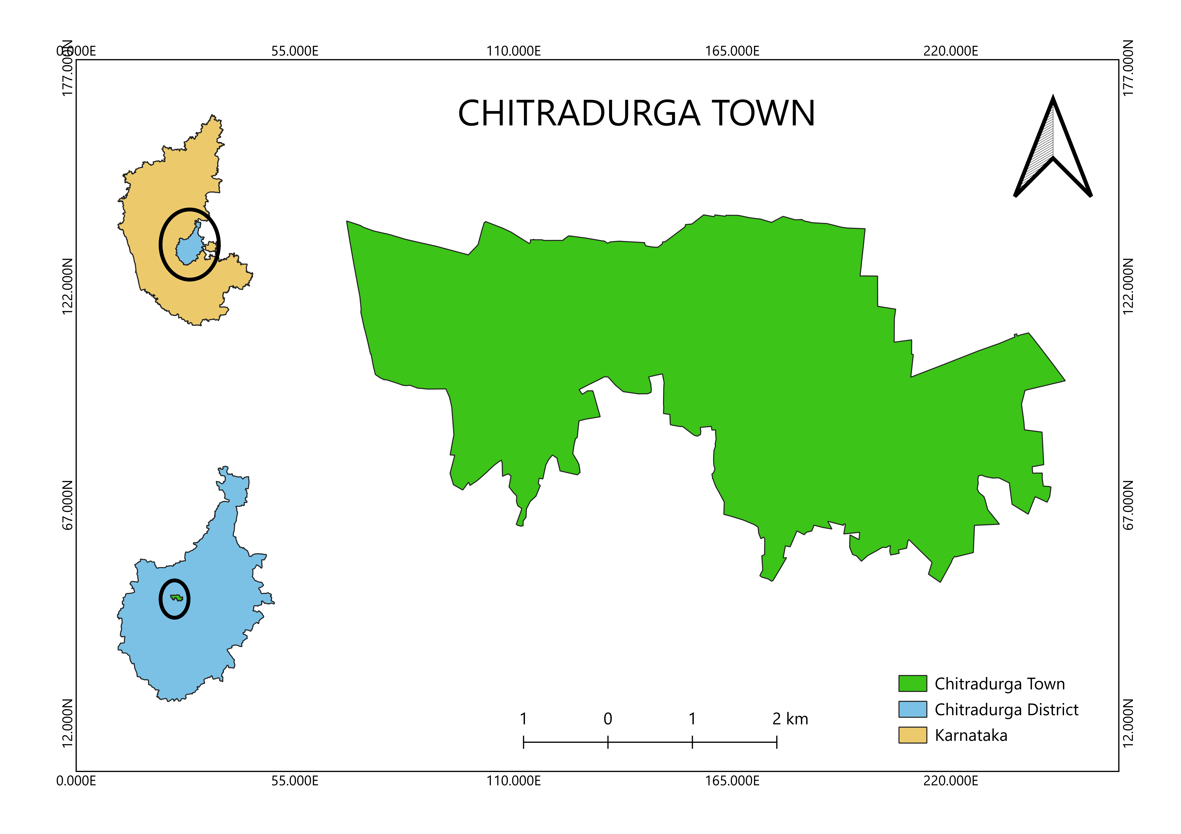

Fig 1. Showing the location of the study area

2.2 Methodology
The study was conducted over one year, from June 2024 to June 2025, using opportunistic sightings (Callaghan et al., 2020; Hutchens & DePerno, 2009) and secondary data obtained from local rescuers (Pernat et al., 2024), covering both dry and wet seasons to account for seasonal variation in snake activity. Websites such as Snakes of India and iNaturalist, along with field guides such as Snakes of India (Whitaker & Captain, 2004), were used for species identification. Photographs were taken during field surveys to support species identification and documentation. Rescue records were validated by verifying the date, location, species identity, and supporting photographs, wherever available. Duplicate records referring to the same rescue event were identified by cross-checking these details and excluded from the analysis to avoid overestimation.

2.3 Data Analysis (Quantitative Analysis)
To assess species diversity and abundance, all observations were subjected to the following quantitative analyses:
- Relative Abundance (A) = a/Nx100.
where a = the total population of a particular species and N = the total population of all species (Curtis & McIntosh, 1950).
- Frequency (F) = m/M x 100.
where m = the number of months in which the species was recorded and M = the total number of months (Misra, 1968).
- Shannon Diversity Index (H′) - Calculated to determine species diversity considering richness and evenness: H′ = – Σ (pi × ln pi)
where pi is the proportion of individuals of a species relative to the total number of individuals recorded (Shannon & Weaver, 1949; Magurran, 2004).

3. RESULTS AND DISCUSSION

3.1. Comprehensive checklist of snakes recorded during the study

During the survey in Chitradurga town, 19 snake species belonging to six families were recorded (Table 1).
Table 1 - Checklist of Snake species in the study area
SL. No. | Scientific name | Common name | Family | Venom  Category | IUCN  Status
1 | Eryx johnii | Red Sand Boa | Boidae | NV | NT
2 | Argyrogena fasciolata | Banded Racer | Colubridae | NV | LC
3 | Boiga trigonata | Common Cat Snake | Colubridae | MV | LC
4 | Dendrelaphis tristis | Common Bronzeback Tree Snake | Colubridae | NV | LC
5 | Coelognathus helena | Common Trinket Snake | Colubridae | NV | LC
6 | Fowlea piscator | Checkered Keelback | Colubridae | NV | LC
7 | Ahaetulla oxyrhyncha | Indian Vine Snake | Colubridae | MV | LC
8 | Lycodon aulicus | Common Wolf Snake | Colubridae | NV | LC
9 | Lycodon flavicollis | Yellow-collared Wolf snake | Colubridae | NV | LC
10 | Ptyas mucosa | Oriental Rat Snake | Colubridae | NV | LC
11 | Lycodon fasciatus | Russell‘s Wolf Snake | Colubridae | NV | LC
12 | Oligodon taeniolatus | Variegated/Streaked Kukri Snake | Colubridae | NV | LC
13 | Oligodon arnensis | (Banded Kukri) Arani Kukri | Colubridae | NV | LC
14 | Bungarus caeruleus | Common Krait | Elapidae | V | LC
15 | Naja naja | Indian Spectacle Cobra | Elapidae | V | LC
16 | Daboia russelii | Russell‘s Viper | Viperidae | V | LC
17 | Echis carinatus | Saw Scaled Viper | Viperidae | V | LC
18 | Python molurus | Indian rock python | Pythonidae | NV | NT
19 | Indotyphlops braminus | Brahminy blind Snake | Typhlopidae | NV | LC
Note : NT-Near threatened, LC Least Concern, NV- Non Venomous, MV-Mildly Venomous, V-Venomous.

Colubridae dominated the species composition, accounting for 63% of all recorded species. Boidae, Typhlopidae, and Pythonidae each had the lowest share, at 5%, whereas Viperidae and Elapidae each contributed 11% (Fig. 2). This dominance may be attributed to the high ecological adaptability and habitat plasticity of colubrid snakes, which enable them to occupy a wide range of environments, including rocky outcrops, scrub forests, agricultural landscapes, and peri-urban habitats (Das, 2002; Whitaker & Captain, 2004). This pattern suggests that Chitradurga's habitat structure and climate favour colubrid diversity.

Most of the 19 snake species recorded were non-venomous (Fig. 3). The high proportion of non-venomous species indicates that a substantial component of the local snake fauna contributes to ecosystem functioning by regulating rodent and other pest populations, thereby providing important ecological services without posing a significant threat to humans (Das, 2002; Whitaker & Captain, 2004). The occurrence of all four medically important venomous snakes of India, i.e., the Indian Spectacled Cobra, Russell's Viper, Common Krait, and Saw-scaled Viper, highlights the ecological significance of the area while also emphasising its public health importance because of the risk of snakebite incidents (Mohapatra et al., 2011; Whitaker & Captain, 2004).

Snakes were further categorised as rare (R) or common (C) based on their frequency of occurrence. The Red Sand Boa, Banded Racer, Banded Kukri, and Indian Rock Python were among the rarely sighted species because of their lower abundance, secretive behaviour, and specific habitat requirements (Kalki et al., 2021; Whitaker & Captain, 2004). However, the Common Wolf Snake and Checkered Keelback were fairly common, whereas the Cobra and Rat Snake were recorded most frequently during the study, as they are highly adaptable and commonly occur in agricultural fields and human-dominated landscapes (Kalki et al., 2021). According to the IUCN, only two of the 19 species, i.e., the Indian Rock Python and Red Sand Boa, were classified as Near Threatened, whereas the remaining 17 were classified as Least Concern (Table 1).
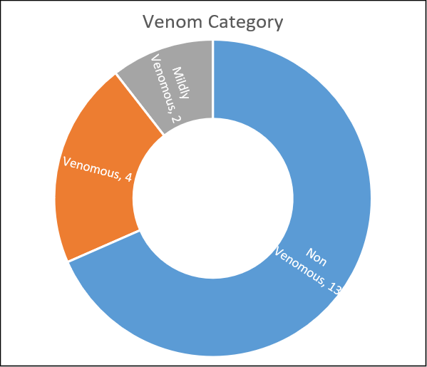
Fig 2: Percentage distribution of families Fig 3: Venom category

Monthly incidence of snake rescue

From June 2024 to June 2025, rescue teams recorded 343 snakes representing 19 species in the study area. The Indian Spectacled Cobra was the most frequently rescued species, with 98 rescues. The Oriental Rat Snake ranked second, with 66 rescues, followed by Russell's Viper and the Checkered Keelback. Several species were rare in the rescue records. The Banded Kukri, Red Sand Boa, Brahminy Blind Snake, and Yellow-collared Wolf Snake were recorded only once or twice. Species such as cobras, rat snakes, and Russell's vipers were recorded more frequently because they can occupy diverse habitats and readily find food near farms and human settlements. Species recorded in lower numbers may require specific habitat conditions, occur in smaller populations, and remain concealed for much of the time, making them more difficult to detect during surveys (MacKenzie et al., 2002; Whitaker & Captain, 2004).

Month-wise data indicated that the highest number of rescues occurred in November (n = 41), followed by August (n = 37), July (n = 36), and June (n = 30). Rescues also occurred in other months, including March (n = 12), April (n = 15), and February (n = 17) (Fig. 5). Snake rescues were highest during the monsoon and post-monsoon months, particularly in November, August, and July, and lowest during the hot summer months. This pattern may be related to increased snake activity, prey availability, and displacement caused by rainfall, resulting in more human–snake encounters during wetter periods (Barhadiya et al., 2024; Whitaker & Captain, 2004).

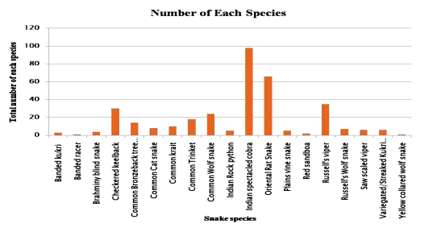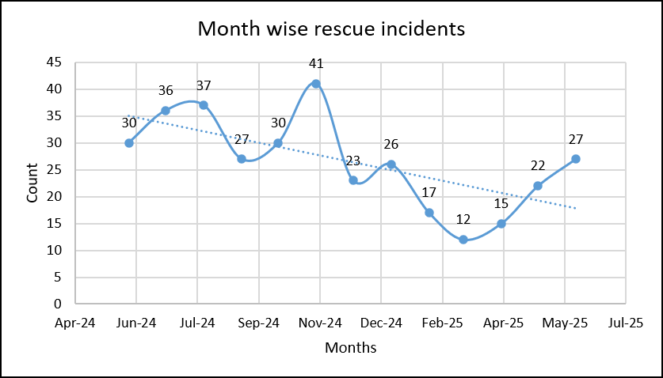

Fig 4: Total species recorded in a year Fig 5 : Monthly incidence of snake rescue

Diversity index
The Shannon diversity index was H′ = 2.28, indicating a moderately diverse snake community in the study area. This result suggests that, although species such as the Indian Spectacled Cobra and Oriental Rat Snake were more abundant, no single species overwhelmingly dominated the assemblage. The community comprised common, moderately common, and rare species, reflecting a relatively balanced distribution of individuals among species. Moderate diversity values indicate the availability of varied habitats and ecological resources capable of supporting multiple snake species with different ecological requirements (Magurran, 2004; Shannon & Weaver, 1949; Whitaker & Captain, 2004). Uneven species-abundance distributions are common in natural communities, in which a few adaptable species tend to be abundant, while others occur less frequently because of habitat specialisation, lower population densities, or limited detectability (Magurran, 2004).

- Conclusions
The study recorded 19 snake species from six families in and around Chitradurga town, indicating that the semi-arid urban and peri-urban landscape supports a moderately diverse ophidian assemblage. Colubridae was the dominant family, whereas Boidae, Pythonidae, and Typhlopidae were represented by fewer species. Non-venomous species constituted a major proportion of the recorded fauna; however, the occurrence of the Indian Spectacled Cobra, Common Krait, Russell's Viper, and Saw-scaled Viper shows that the area also has public health relevance. Rescue records were more frequent during the monsoon and post-monsoon periods, suggesting seasonal variation in snake activity and human–snake encounters. The Shannon diversity index (H′ = 2.28) indicated moderate diversity, with a mixture of common, moderately common, and rarely recorded species. These findings may support local biodiversity documentation, public awareness, and snakebite preparedness planning. Continued monitoring, improved rescue-data recording, and community education are needed to promote coexistence between people and snakes.

Limitations
This study was based mainly on opportunistic sightings and secondary rescue records, which may have been influenced by reporting bias, rescue-call frequency, human settlement patterns, and uneven search effort. The survey covered only one year; therefore, long-term temporal trends could not be established. Habitat-specific abundance, GPS-based distribution, sex and age structure, and detection probability were not assessed. Some species identifications and taxonomic names require verification, particularly where names in the table and plates differ. Snakebite data require a clearly stated source and time period. Future studies should use standardised field surveys, verified rescue databases, and multi-year monitoring.

Acknowledgement
We sincerely thank all individuals and the Department of Wildlife and Management for their support. We are especially grateful to the snake rescuers, Dr Chinmay K. Pathak and Snake Shivu, for their assistance during fieldwork and for providing photographs used in this manuscript. Their valuable contributions and cooperation are greatly appreciated.
Declaration of AI Use

This manuscript was prepared through the combined contributions of all authors, including contributions to the study design, data, content development, results, interpretation, and related scholarly work. The authors acknowledge the use of Grammarly and ChatGPT to assist with grammar checking, language refinement, and reference formatting. These AI-assisted tools were not used as authors and did not replace the authors' intellectual contributions or scholarly judgement. All AI-assisted outputs, including content, references, and interpretations, were carefully reviewed, revised, verified, and approved by the authors. The authors accept full responsibility for the accuracy, integrity, and final content of the manuscript.

- REFERENCES
Barhadiya, G., Purkayastha, J., Saha, A. K., & Ghosh, C. (2024). Spatial and temporal assessment of snake encounters in urban Delhi, India. Scientific Reports, 14, Article 5506. https://doi.org/10.1038/s41598-023-50373-0
Bhat, K. G. (2014). Flora of South Kanara: Dakshina Kannada and Udupi districts of Karnataka. Taxonomy Research Centre. https://indianmedicine.eldoc.ub.rug.nl/73789/
Callaghan, C. T., Ozeroff, I., Hitchcock, C., & Chandler, M. (2020). Capitalizing on opportunistic citizen science data to monitor urban biodiversity: A multi-taxa framework. Biological Conservation, 251, Article 108753. https://doi.org/10.1016/j.biocon.2020.108753
Curtis, J. T., & McIntosh, R. P. (1950). The interrelations of certain analytic and synthetic phytosociological characters. Ecology, 31(3), 434–455. https://doi.org/10.2307/1931497
Das, I. (2002). A photographic guide to snakes and other reptiles of India. New Holland Publishers. https://galileo-uga.primo.exlibrisgroup.com/discovery/fulldisplay/alma9928697863902959/01GALI_UGA%3AUGA
Dinesh, K. P., Radhakrishnan, C., Gururaja, K. V., & Bhatta, G. K. (2009). An annotated checklist of Amphibia of India with some insights into the patterns of species discoveries, distribution and endemism (Records of the Zoological Survey of India, Occasional Paper No. 302, pp. 1–153). Zoological Survey of India. https://zsi.gov.in/PDFVolumes/occpapers/302/index.pdf
Dinesh, K. P., Radhakrishnan, C., Deepak, P., & Kulkarni, N. U. (2023). A checklist of Indian amphibians with common names for the country and their IUCN conservation status (Version 5.0). Zoological Survey of India. https://zsi.gov.in/uploads/documents/importantLinks/hindi/10.pdf
Dupare, R., Samal, G., & Janbandhu, S. (2026). Sea snakes of India: A review on diversity, ecology and conservation. Asian Journal of Environment & Ecology, 25(6), 1–16. https://doi.org/10.9734/ajee/2026/v25i6943
Forest Survey of India. (2021). India state of forest report 2021. Ministry of Environment, Forest and Climate Change, Government of India. https://www.fsi.nic.in/forest-report-2021-details/
Gadgil, M., & Guha, R. (1993). This fissured land: An ecological history of India. University of California Press. https://www.ucpress.edu/books/this-fissured-land/paper
Ganesh, S. R., Chandramouli, S. R., Sreekar, R., & Gowri Shankar, P. (2013). Reptiles of the Central Western Ghats, India—A reappraisal and revised checklist, with emphasis on the Agumbe Plateau. Russian Journal of Herpetology, 20(3), 181–189. https://rjh.folium.ru/index.php/rjh/article/view/545
Hutchens, S. J., & DePerno, C. S. (2009). Efficacy of sampling techniques for determining species richness estimates of reptiles and amphibians. Wildlife Biology, 15(2), 113–122. https://doi.org/10.2981/08-024
Jadhav, P. L., Chavan, S. P., & Trimukhe, H. S. (2018). Snake species diversity and their distribution in and around Nanded city, Maharashtra, India. Journal of Entomology and Zoology Studies, 6(4), 1855–1860.
Kalki, Y., Gonsalves, C., Wylie, D. B., Sundaram, K. A. K., & Schramer, T. D. (2021). Annotated checklist of the snakes of Bengaluru Urban District, Karnataka, India, with notes on their natural history, distribution, and population trends over the last 150 years. Journal of Animal Diversity, 3(2), 26–41. https://doi.org/10.52547/JAD.2021.3.2.4
Khan, Y. D. I., Negi, M., Nautiyal, S., & Venkatesha, M. G. (2022). Herpetofaunal diversity in Chitradurga District, Karnataka: A semi-arid landscape in southern India. International Journal of Ecology and Environmental Sciences, 48(1), 39–50. https://doi.org/10.55863/ijees.2022.0010
Kuttalam, S. R., Owens, J. B., Santra, V., Ahmed, M. T., Das, B., Das, S., Koley, A., Koley, R., Barlow, A., & Malhotra, A. (2025). Utilising snake rescue data to understand snake–human conflict in Hooghly, West Bengal, India. Transactions of the Royal Society of Tropical Medicine and Hygiene, 119(8), 971–981. https://doi.org/10.1093/trstmh/trae124
MacKenzie, D. I., Nichols, J. D., Lachman, G. B., Droege, S., Royle, J. A., & Langtimm, C. A. (2002). Estimating site occupancy rates when detection probabilities are less than one. Ecology, 83(8), 2248–2255. https://doi.org/10.1890/0012-9658(2002)083[2248:ESORWD]2.0.CO;2
Magurran, A. E. (2004). Measuring biological diversity. Blackwell Publishing. https://www.wiley.com/en-us/shop/general-introductory-life-sciences/measuring-biological-diversity-p-9780632056330
Ministry of Environment and Forests. (2008). National biodiversity action plan. Government of India. https://moef.gov.in/biodiversity
Misra, R. (1968). Ecology workbook. Oxford & IBH Publishing. https://www.scientificpubonline.com/bookdetail/ecology-workbook/9788172338053/0
Mohapatra, B., Warrell, D. A., Suraweera, W., Bhatia, P., Dhingra, N., Jotkar, R. M., Rodriguez, P. S., Mishra, K., Whitaker, R., & Jha, P. (2011). Snakebite mortality in India: A nationally representative mortality survey. PLoS Neglected Tropical Diseases, 5(4), Article e1018. https://doi.org/10.1371/journal.pntd.0001018
Mohapatra, P. P., Ray, S., Sarkar, S., Deuti, K., Palot, M. J., Sethy, P. G. S., & Bahuguna, A. (2024). Checklist of fauna of India: Chordata: Reptilia (Version 1.0). Zoological Survey of India. https://doi.org/10.26515/Fauna/1/2023/Chordata:Reptilia
Mukherjee, A. K., & Mackessy, S. P. (2021). Prevention and improvement of clinical management of snakebite in Southern Asian countries: A proposed road map. Toxicon, 200, 140–152. https://doi.org/10.1016/j.toxicon.2021.07.008
Mullin, S. J., & Seigel, R. A. (Eds.). (2009). Snakes: Ecology and conservation. Cornell University Press. https://www.cornellpress.cornell.edu/book/9780801457852/snakes/
Myers, N., Mittermeier, R. A., Mittermeier, C. G., da Fonseca, G. A. B., & Kent, J. (2000). Biodiversity hotspots for conservation priorities. Nature, 403(6772), 853–858. https://doi.org/10.1038/35002501
Ojha, A. P., Kumar, K., Imran, & Mishra, S. (2025). Snake diversity in human landscapes: A comprehensive study of snake species in Kushinagar, Uttar Pradesh, India. Uttar Pradesh Journal of Zoology, 46(1), 177–188. https://doi.org/10.56557/upjoz/2025/v46i14753
Pernat, N., Canavan, S., Golivets, M., Hillaert, J., Itescu, Y., Jarić, I., Mann, H. M. R., Pipek, P., Preda, C., Richardson, D. M., Teixeira, H., Vaz, A. S., & Groom, Q. (2024). Overcoming biodiversity blindness: Secondary data in primary citizen science observations. Ecological Solutions and Evidence, 5(1), Article e12295. https://doi.org/10.1002/2688-8319.12295
Pyne, T., Haering, R., Sriram, A., Lorigan, S., Shine, R., & Jolly, C. J. (2024). Interactions between reptiles and people: A perspective from wildlife rehabilitation records. Royal Society Open Science, 11(10), Article 240512. https://doi.org/10.1098/rsos.240512
Roth-Monzón, A. J., Mendoza-Hernández, A. A., & Flores-Villela, O. (2018). Amphibian and reptile biodiversity in the semi-arid region of the municipality of Nopala de Villagrán, Hidalgo, Mexico. PeerJ, 6, Article e4202. https://doi.org/10.7717/peerj.4202
Shannon, C. E., & Weaver, W. (1949). The mathematical theory of communication. University of Illinois Press. https://www.press.uillinois.edu/books/?id=p725487
Stephen, A., Suresh, R., & Livingstone, C. (2015). Indian biodiversity: Past, present and future. International Journal of Environment and Natural Sciences, 7, 13–28. https://www.researchgate.net/profile/Stephen-A-2/publication/276410026_Indian_Biodiversity_Past_Present_and_Future/links/565480c808ae4988a7b03a82/Indian-Biodiversity-Past-Present-and-Future.pdf
Uetz, P., Freed, P., & Hošek, J. (Eds.). (2020). The Reptile Database. https://reptile-database.reptarium.cz/
Vitt, L. J., & Caldwell, J. P. (2014). Herpetology: An introductory biology of amphibians and reptiles (4th ed.). Academic Press. https://www.sciencedirect.com/book/monograph/9780123869197/herpetology
Whitaker, R., & Captain, A. (2004). Snakes of India: The field guide. Draco Books. https://searchworks.stanford.edu/view/6002955
World Health Organization. (2019). Snakebite envenoming: A strategy for prevention and control. https://www.who.int/publications/i/item/9789241515641

PLATE : Various types of Snakes

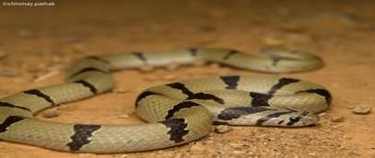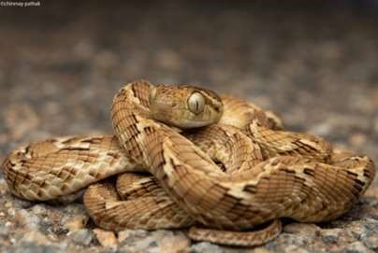

Fig 6 : Banded Kukri Fig 7 : Common Cat Snake 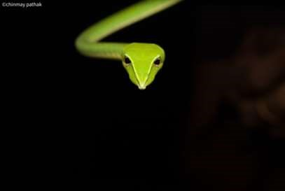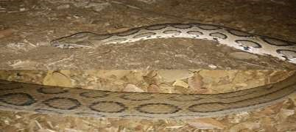

Fig 8 : Green Vine snake Fig 9 : Russell’s Viper
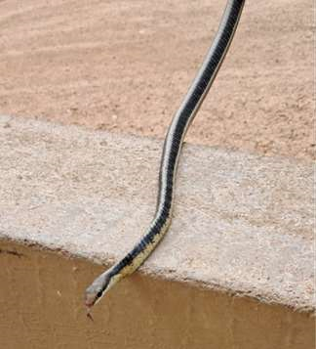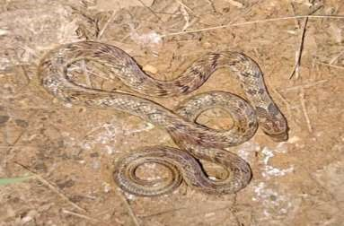

Fig 10 : Common Bronzeback Tree Snake Fig 11 : Variegated/Streaked Kukri Snake
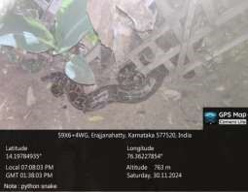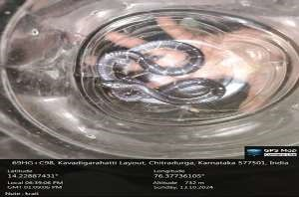
Fig 12 : Indian rock python | Fig 13 : Common Krait
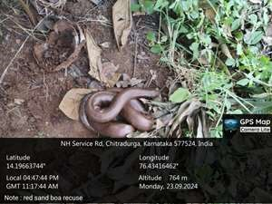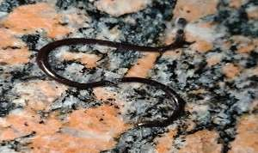
Fig 14 : Red Sand Boa | Fig 15 : Brahminy blind Snake
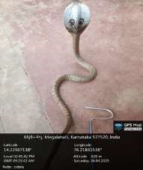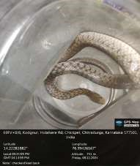
Fig 16 : Indian Spectacle Cobra | Fig 17 : Checkered Keelback
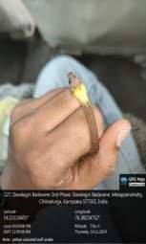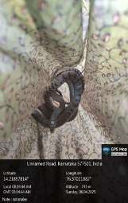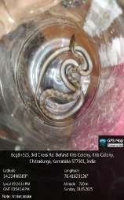

Fig 18 : Yellow Collared Wolf snake Fig 19 :Oriental Rat Snake Fig 20 :Common Trinket Snake
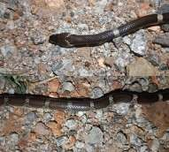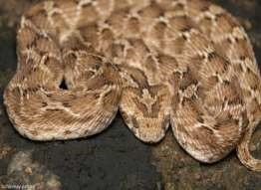

Fig 21 : Common Wolf Snake Fig 22 : Saw Scaled Viper
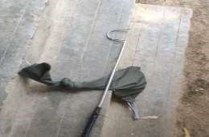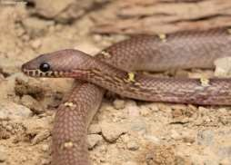

Fig 23: Russell's Wolf Snake Fig 24 : Snake hook and bag
3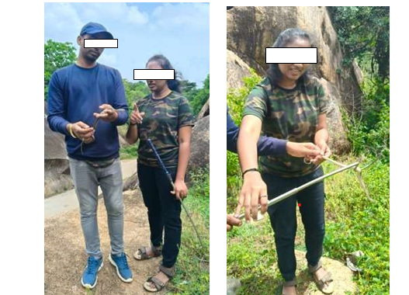
Fig 25 : Field Photos during Snake Rescue

