Diversity and Composition of Anuran Amphibian Communities in Agroecosystems in the Village of Nebo , Lôh-Djiboua Region, Southwestern Côte d’Ivoire

Abstract
The expansion of agroecosystems is one of the main causes of habitat change for amphibians in West Africa. This study assessed the diversity, structure, and distribution of anuran amphibian communities in four agroecosystem types (a rice field, an oil palm plantation, a cocoa plantation, and a rubber plantation) in the village of Nebo, Côte d’Ivoire. Surveys were conducted using visual and acoustic methods, and communities were compared using the Shannon and Simpson diversity indices, Pielou’s evenness index, and Sørensen’s similarity index. A total of 1,030 individuals belonging to 25 species, 10 genera, and 8 families were recorded. The families Phrynobatrachidae, Hyperoliidae, and Ptychadenidae were the most diverse. The rice field (21 species) and oil palm plantation (18 species) exhibited the highest species richness, diversity indices, and abundance, whereas the cocoa plantation (8 species) and rubber plantation (5 species) supported fewer species. The species Amnirana albolabris, Hyperolius concolor, and Leptopelis viridis were present in all agroecosystems, while several species were exclusive to certain habitats. The communities in the rice field and oil palm plantation were highly similar (Cs = 0.821), whereas similarity was lower among the other agroecosystem pairs. Species distribution was primarily associated with water availability, humidity, and vegetation cover. These results indicate that the rice field and oil palm plantation are important habitats for anuran amphibians in the agricultural landscapes of Nebo. Maintaining a mosaic of agroecosystems that incorporates wetlands and patches of natural vegetation appears to be important for preserving amphibian diversity in West African agroecosystems.
Keywords: Anura; amphibian diversity; agroecosystems; agricultural landscapes; community composition; habitat heterogeneity; species richness; wetland habitats; conservation.

Introduction
Global biodiversity is severely affected by habitat destruction, the intensification of human activities, pollution, and climate change (Baillie et al., 2010). Amphibians are among the most threatened vertebrate groups, with more than 40% of species declining or threatened with extinction (International Union for Conservation of Nature [IUCN], 2023). Because of their high sensitivity to environmental changes, they are considered excellent bioindicators of ecosystem health (Lamotte & Roy, 2003; Mohneke et al., 2010; Wells, 2007). West Africa is home to a rich diversity of amphibians, particularly in the Guineo-Congolese rainforests (Penner et al., 2011; Rödel, 2000). However, this biodiversity is under increasing pressure due to the conversion of natural habitats into agricultural land and deforestation (Newbold et al., 2015). A recent synthesis similarly identifies habitat destruction, climate change, disease, overexploitation, and chemical contamination as interacting pressures on amphibian populations, reinforcing the importance of habitat protection and systematic monitoring (Shelly & Singh, 2024).
In Côte d’Ivoire, the sharp decline in forest cover has led to habitat fragmentation and changes in animal communities, particularly among forest amphibians (Hillers et al., 2008). Agroecosystems now play a significant role in Ivorian landscapes, which are dominated by cocoa, coffee, rubber, and oil palm plantations (Jagoret et al., 2014). Although less favourable than natural habitats, these environments can serve as alternative habitats for certain amphibian species (Boissinot et al., 2019; Kwatrina et al., 2018). Their ability to support biodiversity depends particularly on vegetation structure, water availability, and the intensity of agricultural practices (Nowakowski et al., 2018; Tscharntke et al., 2012). Comparative research across rice fields, marshlands, and built-up habitats has also indicated that habitat heterogeneity and structural complexity can shape amphibian diversity and community composition (Adhikary & Boro, 2022). Recent evidence further indicates that agroforestry systems generally support lower amphibian diversity than native forests, although structurally complex agricultural matrices may retain important assemblages (Cervantes-López & Morante-Filho, 2024). Maintaining heterogeneous landscape mosaics and less intensive, shaded agroforestry systems may therefore support multiple dimensions of amphibian diversity in managed landscapes (Pinzón et al., 2025). Field-based research in tropical agricultural landscapes has also shown that pesticide exposure can markedly reduce amphibian occurrence, underscoring the relevance of agricultural management intensity (Wanger et al., 2023).
Despite their ecological importance, amphibians in Ivorian agricultural environments remain understudied. Research has focused primarily on protected areas and tropical forests, while the agroecosystems of the southwest, particularly those in the village of Nebo, remain insufficiently documented (Kanga et al., 2021; N’Guessan et al., 2025; Oussou et al., 2022). However, a better understanding of these communities is important for assessing the effects of human activity and guiding conservation efforts. This study aims to survey and identify the anuran amphibian species present, to estimate the species richness and relative abundance of these communities, and to characterise and compare the distribution of species across different agricultural habitats.

Methods

2.1. Study site
The study was conducted in the agroecosystems of the village of Nebo, located in the Divo Subprefecture (capital of the Lôh-Djiboua region) in southwestern Côte d’Ivoire (Figure 1). This area is one of the country’s main agricultural basins and lies between latitudes 5°30' and 6°15' N and longitudes 5°00' and 5°45' W. The region is characterised by a humid subequatorial climate marked by two rainy seasons and two dry seasons, with annual precipitation ranging from 1,200 to 1,800 mm and average temperatures varying between 25 and 28 °C. The terrain is relatively flat with gentle undulations (Brou et al., 2005).
The natural vegetation consists of dense, humid, semi-deciduous forest. However, the expansion of agricultural activities has led to a significant decline in forest cover, with natural vegetation being replaced by plantations of cacao, rubber trees, oil palms, and food crops (Jagoret et al., 2014).
The department is also crisscrossed by several watercourses and wetlands that provide suitable habitats for amphibians (Houlahan & Findlay, 2003; Knutson et al., 1999). The village of Nebo was selected as the study site due to the significance of its agricultural activities, the diversity of its agroecosystems, and the lack of scientific data on the amphibian communities associated with these anthropogenically altered environments (Kouamé et al., 2007; Rödel, 2000).

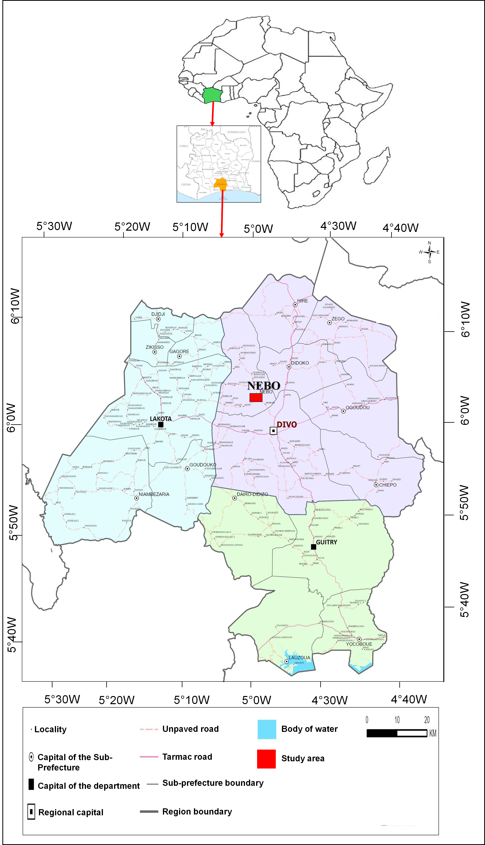

Figure 1 . Location of the village of Nebo in the Lôh-Djiboua region, in southwestern Côte d'Ivoire. (Source: ANSTAT, 2024).

2.2. Data collection
Surveys were conducted in four dominant agroecosystems in Nebo village: a cocoa plantation, a rubber plantation, an oil palm plantation, and a rice field, whose characteristics are presented in Table 1. Rectangular transects 200 m long by 100 m wide were delineated within each agroecosystem. Sampling campaigns were carried out during the rainy season, from April to September 2025, a period particularly favourable to amphibian activity.
Each habitat was visited twice (totalling 32 days) with a constant sampling intensity of 9 hours per visit (5 hours and 30 minutes during the day, from 6:30 AM to 11:00 AM, and 3 hours and 30 minutes at night, from 6:30 PM to 9:00 PM GMT). The agroecosystems were always surveyed by three people (equivalent to 27 person-hours per day), representing a total search effort of 864 person-hours of sampling (Figure 2).
Anurans were located using visual and acoustic searches across all habitats (Heyer et al., 1994; Rödel & Ernst, 2004). The visual survey consisted of active and systematic searches within various microhabitats likely to shelter amphibians. Observed individuals were captured by hand or with a dip net. During nocturnal surveys, flashlights were used to locate specimens. Directing light towards the heads of individuals caused temporary disorientation, thereby facilitating their capture.
Captured specimens were photographed and then identified using the guides and identification keys of Rödel and Spieler (2000), Frost (2024), and Madalozzo et al. (2017). After identification using the keys of Rödel and Spieler (2000) and Channing and Rödel (2019), the tip of one toe was clipped from each individual to prevent capture-recapture bias, and the specimen was subsequently released at its capture site.
Concurrently, the acoustic technique allowed for the detection of species that are difficult to observe visually, particularly males engaged in reproductive activities. In anuran amphibians, vocalisations exhibit species-specific characteristics while remaining relatively constant among individuals of the same species (Köhler et al., 2017; Rödel, 2000). Advertisement calls were recorded using a voice recorder. At the end of the data collection, all recordings were compared with those obtained by Rödel (2000) regarding West African savanna amphibians to identify the species.
Table 1. Characteristics of the Various Agroecosystems in the Village of Nebo
Agroecosystems | Vegetation Structure | Watercourse | Relief | Age
Oil Palm Plantation | - Herbaceous understory consisting of grasses, Cyperaceae, and ruderal plants;  - Thick litter between the rows. | Seasonal River | Plain (lowland) | 15 years
Rubber Plantation | - A herbaceous layer consisting of grasses, ferns, and weeds ;  - A more or less abundant layer of rubber tree leaves. | Seasonal Stream | Plateau | 15 years
Cocoa plantation | - Upper tree layer: existing or planted shade trees;  - Herbaceous layer: grasses, ferns and creeping plants;  - Abundant litter: dead leaves, pods and plant debris. | Seasonal Stream | Plateau | 15 years
Rice fields | - Aquatic and semi-aquatic plants  - Vegetation on embankments and along the banks: herbaceous plants, grasses and small shrubs. | Permanent river | Plain (lowland) | 6 months

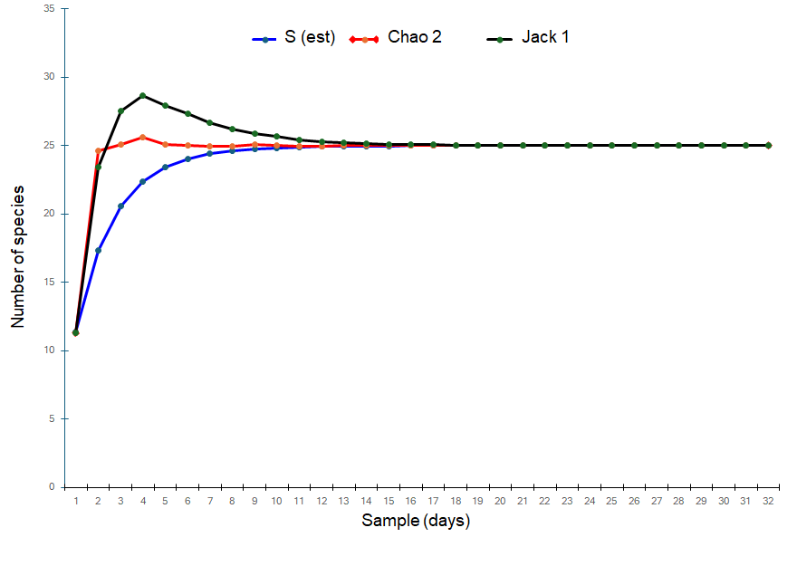
Figure 2. Species accumulation and estimated amphibian species richness (Chao 2, and Jack-knife 1) of the village of Nebo

2.3. Measurement of Habitat and Environmental Variables Influencing Anuran Communities
The environmental variables were selected because of their recognised role in shaping amphibian communities. The parameters measured included relative air humidity (%), air temperature (°C), vegetation cover (%), litter depth (cm) and the number of available breeding sites, all of which influence the distribution, abundance and reproductive success of anurans (Dodd, 2010; Wells, 2007). Relative humidity and temperature were measured in situ using a digital thermo-hygrometer positioned approximately 1 m above the ground. Vegetation cover was estimated using a forest densitometer, litter depth was determined from several random measurements per transect, and potential breeding sites (pools, temporary puddles, ditches and streams) were recorded in each transect.
These variables were selected because they determine the microclimatic conditions and the availability of habitats necessary for the survival and reproduction of amphibians. They are widely used to analyse the relationships between amphibian communities and their habitat characteristics (Dodd, 2010; Ernst & Rödel, 2005; Wells, 2007).

2.4. Data analysis methods
- Observed species richness
Two complementary techniques, visual sampling with capture and acoustic sampling, were used to estimate the abundance and species richness of amphibians in different habitats (Assemian et al., 2006). Species richness, a key indicator of biodiversity, corresponds to the number of species recorded and depends on the sampling effort.
- Sørensen’s Index
This index measures the similarity in species between two habitats. It is calculated using the following formula: Cs = (2C) / (A + B); C represents the number of species common to both habitats. A represents the number of species in habitat 1. B represents the number of species in habitat 2. The index ranges from 0, when there are no species in common between the two habitats, to 1, when all species found in habitat 1 are also present in habitat 2.
- Frequency of occurrence
This method is used to determine the habitat preferences of a given species. It involves counting the number of times species i appears in the samples (Dajoz, 2000). This number is expressed as a percentage of the total number of surveys and provides information on the species frequently encountered in a habitat. It is calculated as follows (3): F = (Fi × 100) / Ft: Fi = number of surveys containing species i; Ft = total number of surveys carried out. Depending on the value of F, three (3) groups of species are distinguished: constant species (F > 50%); accessory species (25% < F < 50%); and accidental species (F < 25%).

- Shannon index
According to Amanieu and Lasserre (1982), this index measures the degree of organisation of the stand. The Shannon and Weaver (1963) species diversity index is used to highlight the overall diversity of the stand. High values of the Shannon index correspond to a high level of diversity in the stand under study (Chao & Shen, 2003). The formula is as follows:
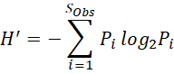 S_(obs) = total number of species observed across all samples; pi = ni / ∑ ni = relative frequency of species i in the stand ; N = ∑ ni = total number of individuals.
- Equitability
Pielou’s (1969) evenness index enables the evenness of species distribution to be studied and the diversity of two stands with different species richness (SR) to be compared (Dajoz, 2000). The calculation of the species diversity index must always be accompanied by that of the evenness index, as two stands with different physiognomies may have the same diversity. Evenness is obtained by relating the observed diversity to the stand’s maximum theoretical diversity:
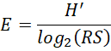 H’ = Shannon diversity index; log2 (SR) = Hmax (diversity achieved when all species have the same abundance); SR = species richness. Equitability varies between 0 and 1 and reflects the degree of homogeneity in the distribution of abundances amongst species.

2.5. Statistical analysis
PAST software (version 4.13) was used to analyse the data on diversity (H’) and evenness (E) indices across the different agroecosystems. The estimated species richness, and thus the sampling efficiency, were calculated with the Jackknife 1 and Chao 2 estimators using EstimateS software (Version 9.1.0; Colwell, 2013). The Kruskal-Wallis test is a non-parametric alternative to analysis of variance (ANOVA). It was used to compare the mean abundances across the agroecosystems. This test was carried out using STATISTICA 7.1 software (StatSoft, 2005).

3. Results

3.1. Species composition of the anuran amphibian community
During this study, 25 species of anuran amphibians were collected from the four (4) agroecosystems in the village of Nebo. These species were classified into ten (10) genera and eight (8) families (Table 2). Of the eight (8) families, the Phrynobatrachidae (6 species), Hyperoliidae (5 species) and Ptychadenidae (5 species) were the most diverse. These were followed by the Arthroleptidae (3 species) and the Bufonidae (2 species). In contrast, the monospecific families were the Ranidae, Dicroglossidae, Pipidae and Hemisotidae. Figure 3 shows photographs of one example of a species from each family.
Table 2. Diversity of the anuran amphibian community in the village of Nebo

Families | Genera | Species | Species richness
Arthroleptidae | Arthroleptis | Arthroleptis poecilonotus | 3
Arthroleptidae | Leptopelis | Leptopelis spiritusnoctis | 3
Arthroleptidae | Leptopelis | Leptopelis viridis | 3
Bufonidae | Sclerophrys | Sclerophrys maculata | 2
Bufonidae | Sclerophrys | Sclerophrys regularis | 2
Dicroglossidae | Hoplobatrachus | Hoplobatrachus occipitalis | 1
Hemisotidae | Hemisus | Hemisus marmoratus | 1
Hyperoliidae | Afrixalus | Afrixalus dorsalis | 5
Hyperoliidae | Hyperolius | Hyperolius concolor | 5
Hyperoliidae | Hyperolius | Hyperolius guttulatus | 5
Hyperoliidae | Hyperolius | Hyperolius picturatus | 5
Hyperoliidae | Hyperolius | Hyperolius fusciventris lamtoensis | 5
Phrynobatrachidae | Phrynobatrachus | Phrynobatrachus alleni | 6
Phrynobatrachidae | Phrynobatrachus | Phrynobatrachus calcaratus | 6
Phrynobatrachidae | Phrynobatrachus | Phrynobatrachus francisci | 6
Phrynobatrachidae | Phrynobatrachus | Phrynobatrachus gutturosus | 6
Phrynobatrachidae | Phrynobatrachus | Phrynobatrachus latifrons | 6
Phrynobatrachidae | Phrynobatrachus | Phrynobatrachus plicatus | 6
Pipidae | Xenopus | Xenopus tropicalis | 1
Ptychadenidae | Ptychadena | Ptychadena aequiplicata | 5
Ptychadenidae | Ptychadena | Ptychadena bibroni | 5
Ptychadenidae | Ptychadena | Ptychadena mascareniensis | 5
Ptychadenidae | Ptychadena | Ptychadena oxyrhynchus | 5
Ptychadenidae | Ptychadena | Ptychadena tellenii | 5
Ranidae | Amnirana | Amnirana albolabris | 1

Figure 3. Photos of a few species from each family of anuran amphibians in the village of Nebo ; Hemisus marmoratus (A) ; Hyperolius fusciventris lamtoensis (B) ; Hoplobatrachus occipitalis (C) ; Phrynobatrachus plicatus (D) ; Ptychadena tellenii (E) ; Amnirana albolabris (F) ; Leptopelis spiritusnoctis (G) ; Sclerophrys regularis (H) ; Afrixalus dorsalis (I) ; Arthroleptis poecilonotus (J).

3.2. Species richness by agroecosystem type
Table 3 presents amphibian species richness and distribution across the agroecosystems of Nebo. The rice field had the highest species richness (21 species), followed by the oil palm plantation (18 species). The cocoa and rubber plantations supported 8 and 5 species, respectively.
Amnirana albolabris, Hyperolius concolor and Leptopelis viridis occurred in all four habitat types. Three species (Hyperolius fusciventris lamtoensis, Phrynobatrachus plicatus and Xenopus tropicalis) were observed exclusively in rice fields, whilst Phrynobatrachus alleni and Ptychadena aequiplicata were observed only in the cocoa plantation. By contrast, no species restricted to either the oil palm or rubber plantation were observed.

Table 3. Specific richness and distribution of anuran amphibians in the agroecosystems of the village of Nebo
Species | Rice fields | oil palm  plantation | Cocoa plantation | Rubber plantation
Afrixalus dorsalis | x | x
Amnirana albolabris | x | x | x | x
Arthroleptis poecilonotus |  |  | x | x
Hemisus marmoratus | x | x
Hoplobatrachus occipitalis | x | x
Hyperolius concolor | x | x | x | x
Hyperolius guttulatus | x | x
Hyperolius picturatus | x | x
Hyperolius f. lamtoensis | x
Leptopelis spiritusnoctis |  |  | x | x
Leptopelis viridis | x | x | x | x
Phrynobatrachus alleni |  |  | x
Phrynobatrachus calcaratus | x | x
Phrynobatrachus francisci | x | x
Phrynobatrachus gutturosus | x | x
Phrynobatrachus latifrons | x | x
Phrynobatrachus plicatus | x
Ptychadena aequiplicata |  |  | x
Ptychadena bibroni | x | x
Ptychadena mascareniensis | x | x | x
Ptychadena oxyrhynchus | x | x
Ptychadena tellenii | x | x
Xenopus tropicalis | x
Sclerophrys maculata | x | x
Sclerophrys regularis | x | x
Total | 21 | 18 | 8 | 5

3.3. Diversity and Equitability Indices for Anuran Amphibian Communities
Figure 4 presents the variation in anuran amphibian diversity indices across the four agroecosystems. Anuran amphibian diversity varied according to land-use type. The highest Shannon index values (Figure 4A) were observed in the rice field (H' = 2.91) and in the oil palm plantation (H' = 2.79). In contrast, the cocoa plantation (H' = 1.94) and the rubber plantation (H' = 1.44) had the lowest Shannon indices.
A similar trend was observed with the Simpson index (Figure 4B), with the rice field and oil palm plantation showing the highest values, at 1-D = 0.94 and 1-D = 0.93, respectively. The lowest values were recorded in the cocoa plantation (0.84) and the rubber plantation (0.73).
Pielou’s evenness (Figure 4C) remained high across all agroecosystems (E = 0.89–0.97). The highest value was obtained in the oil palm plantation (E = 0.97), whilst the lowest equitability (E = 0.89) was observed in the rubber plantation.

Figure 4. Variation in species diversity indices; A = Shannon, B = Simpson, B = Equitability) for anuran amphibians across the four agroecosystems.

3.4. Structure of the anuran amphibian populations in the village of Nebo
A total of 1,030 anuran amphibians were sampled in the agroecosystems of the village of Nebo. The assemblage was dominated by Leptopelis viridis (14.66 per cent; N = 151) and Hoplobatrachus occipitalis (12.14 per cent; N = 125) (Figure 5A). These species were followed by other relatively abundant species, namely Hyperolius concolor (7.28%; N = 75) and Ptychadena mascareniensis (6.6%; N = 68). In contrast, Phrynobatrachus plicatus (0.78%; N = 8) was the least abundant species.
Furthermore, Figure 5B shows the variation in relative abundance across agroecosystems. The rice field and oil palm plantation had the highest relative abundances, at 48.44% (N = 499) and 31.26% (N = 322), respectively. These agroecosystems were followed by the cocoa plantation (14.37%; N = 148). In contrast, the rubber plantation had the lowest relative abundance (5.93%; N = 61). However, average abundances varied significantly between agroecosystems. They were highest in rice fields (19.96 ± 17.32), followed by oil palm plantations (13.44 ± 12.89), cocoa plantations (5.36 ± 10.27) and rubber plantations (2.44 ± 6.20). The non-parametric Kruskal-Wallis test revealed a highly significant difference between the four agroecosystems (H = 32.783; df = 3; P < 0.001), indicating that species abundance differed among agroecosystem types.

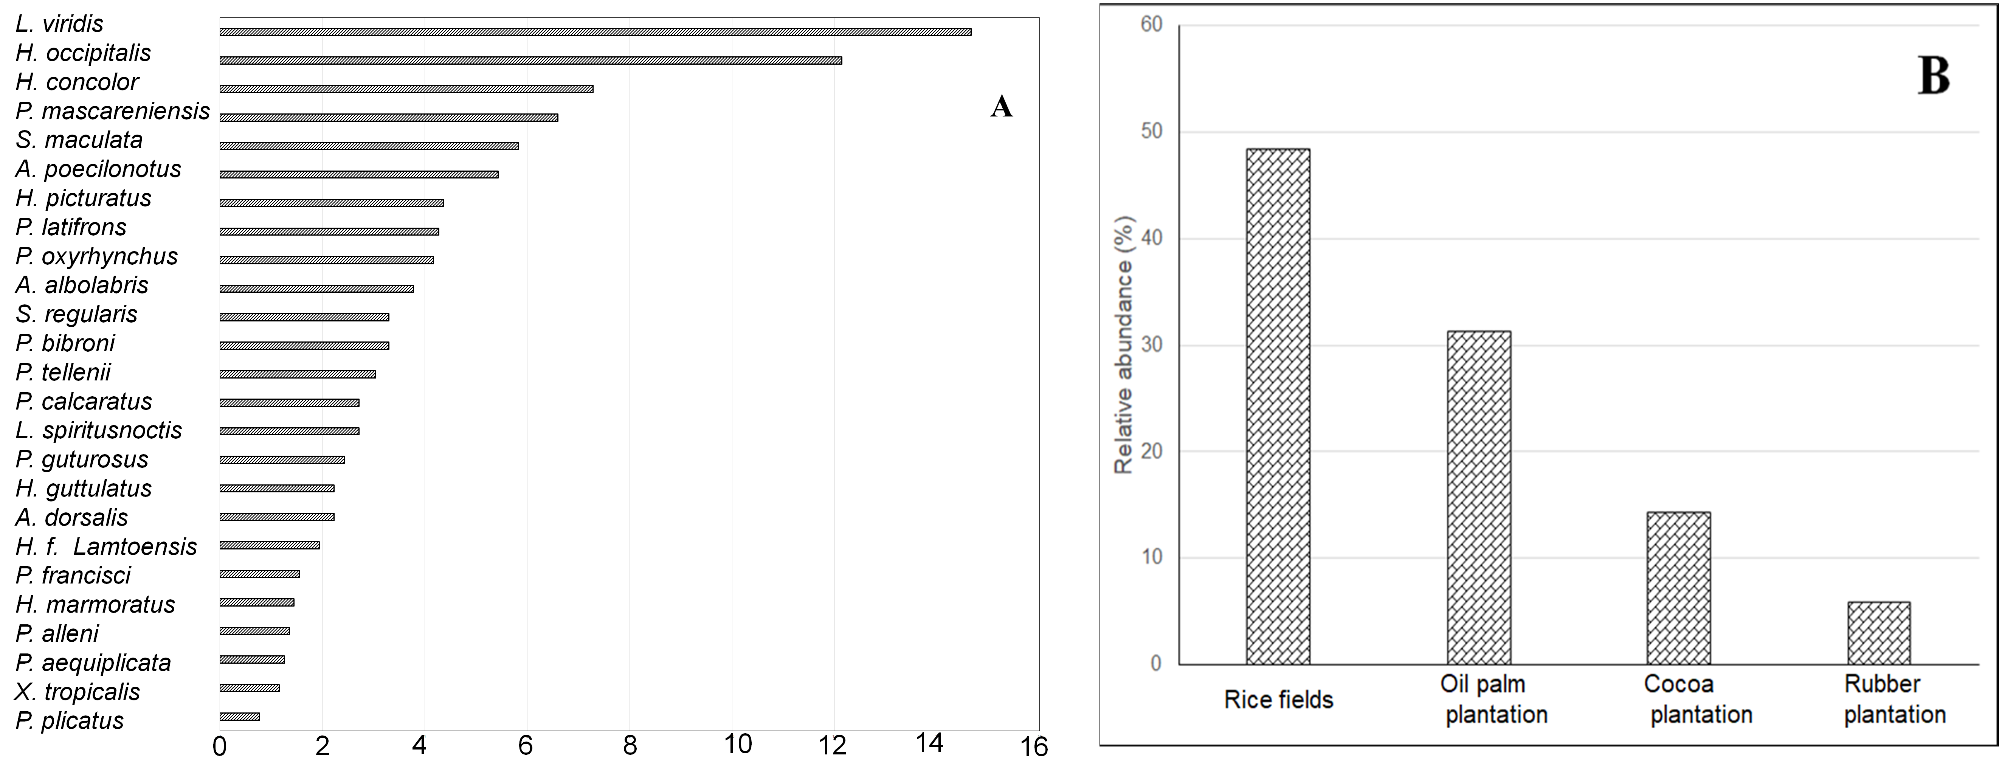
Figure 5. Variations in the relative abundances of anuran amphibian species (A) and agroecosystems (B)

3.5. Community similarity across agroecosystems
Table 4 presents the similarities among the anuran communities in the different agroecosystems. The Sørensen similarity index revealed a high degree of similarity between the anuran communities in the rice field and oil palm plantation (Cs = 0.821). A relatively high similarity was also observed between the cocoa and rubber plantations (Cs = 0.615). In contrast, the other comparisons showed low similarity values (Cs ranging from 0.154 to 0.231).
Table 4. Sørensen similarity index between communities of anuran amphibians in the agroecosystems of the village of Nebo
Agroécosystèmes | Rice fields | Oil palm plantation | Cocoa plantation | Rubber plantation
Rice fields | 1 | 0.821 | 0.207 | 0.154
Oil palm plantation |  | 1 | 0.231 | 0.174
Cocoa plantation |  |  | 1 | 0.615
Rubber plantation |  |  |  | 1

3.6. Influence of environmental characteristics on the distribution of anurans
The distribution of anurans was mainly associated with water availability, humidity and vegetation cover (Table 5). The rice field and oil palm plantation, characterised by high water availability and numerous breeding sites, favour aquatic and generalist species (Afrixalus dorsalis,
Amnirana albolabris, Hemisus marmoratus, Hoplobatrachus occipitalis, Hyperolius concolor,
Hyperolius guttulatus, Hyperolius picturatus, Leptopelis viridis, Phrynobatrachus calcaratus, Phrynobatrachus francisci, Phrynobatrachus gutturosus, Phrynobatrachus latifrons, Phrynobatrachus plicatus, Ptychadena bibroni, Ptychadena mascareniensis, Ptychadena oxyrhynchus, Ptychadena tellenii, Xenopus tropicalis, Sclerophrys maculata and Sclerophrys regularis). In contrast, the cocoa and rubber plantations, with their dense vegetation cover and more stable microclimate, supported a greater number of forest species (Amnirana albolabris, Arthroleptis poecilonotus, Hyperolius concolor, Leptopelis spiritusnoctis, Leptopelis viridis, Phrynobatrachus alleni, Ptychadena aequiplicata, Ptychadena mascareniensis).

Table 5. The influence of environmental characteristics on the distribution of anurans in different agroecosystems
Characteristics | Rice  fields | Oil palm plantation | Cocoa plantation | Rubber  plantation
Water availability | +++++ | ++++ | +++ | ++
Vegetation cover | ++ | +++ | +++++ | ++++
Relative humidity | +++++ | ++++ | +++++ | +++
Air temperature | ++++ | +++ | ++ | ++
Leaf litter depth | ++ | ++++ | +++++ | +++++
Breeding sites | +++++ | ++++ | ++ | +
Preferred species group | Aquatic and generalist | Generalist | Forestry | Tolerant forestry
+ = very low; ++ = low; +++ = moderate; ++++ = high; +++++ = very high.

4. Discussion
This study highlights a relatively high diversity of anuran amphibians in the agroecosystems of the village of Nebo, with 25 species belonging to eight families. This species richness suggests that tropical agricultural landscapes can contribute to the maintenance of amphibian communities when wet habitats and a certain degree of landscape heterogeneity are preserved. The predominance of the families Hyperoliidae, Phrynobatrachidae and Ptychadenidae is consistent with recent surveys carried out in West Africa, which have highlighted their high ecological plasticity and their ability to colonise anthropogenically modified habitats (Bell et al., 2025; Ernst et al., 2006; Ernst & Rödel, 2005; Luedtke et al., 2023).
The differences observed between agroecosystems reflect the effect of land-use patterns on community structure. The rice field exhibited the highest values for species richness, diversity and abundance, suggesting its role as an alternative habitat for many anuran species due to the availability of water, high biological productivity and an abundance of breeding sites. Similar results have been reported in several tropical agroecosystems (Kanga et al., 2021; Mohneke et al., 2010; Oussou et al., 2022). The oil palm plantation also maintained relatively high diversity where ditches, temporary pools and semi-natural features persisted, although this habitat remained less favourable to specialist forest species (Kwatrina et al., 2018). Conversely, the cocoa plantation and, particularly, the rubber plantation exhibited lower species richness, probably due to the scarcity of aquatic habitats necessary for the reproduction of anurans, as well as the intensification of agricultural practices. Several recent studies have shown that habitat simplification, drainage and the use of agricultural inputs reduce amphibian diversity in cultivated landscapes (Bell et al., 2025; Newbold et al., 2015; Nowakowski et al., 2017).
The Shannon and Simpson indices and Pielou’s evenness index indicate that differences between agroecosystems are primarily linked to species richness rather than to the dominance of a small number of taxa. These results are consistent with the findings of Newbold et al. (2015), who reported that diversity patterns in moderately disturbed assemblages were influenced by species richness.
The occurrence of Amnirana albolabris, Hyperolius concolor and Leptopelis viridis in all four agroecosystems suggests broad ecological tolerance, whilst species found exclusively in the rice field or cocoa plantation may have more specific ecological requirements. This complementarity between habitats suggests that the heterogeneity of agricultural landscapes promotes the maintenance of regional diversity (Tscharntke et al., 2012). Similarly, the high abundance of Hoplobatrachus occipitalis and Leptopelis viridis may reflect their capacity to use wet agricultural environments, a trend also reported in recent assessments of their ecology and conservation status (IUCN, 2023; Luedtke et al., 2023).
Furthermore, the strong similarity between the communities found in the rice field and oil palm plantation, as well as the relationships observed between species and environmental variables, suggests that water availability, humidity and vegetation cover are important factors shaping anuran assemblages. These results support the concept of an environmental filter and highlight the importance of conserving a mosaic of agricultural landscapes incorporating wetlands, vegetated corridors and semi-natural habitats to preserve amphibian diversity in West African agroecosystems (Bell et al., 2025).

Conclusion
This study documented 1,030 anuran individuals representing 25 species, 10 genera and eight families across four agroecosystems in Nebo. Community composition, richness and abundance differed among land-use types. The rice field and oil palm plantation supported the highest species richness and abundance, whereas the cocoa and rubber plantations contained fewer species. The occurrence of Amnirana albolabris, Hyperolius concolor and Leptopelis viridis in every agroecosystem indicates that these species can use a broad range of agricultural habitats, while habitat-restricted records suggest that other species have narrower ecological requirements. Water availability, relative humidity and vegetation cover were associated with the observed distribution patterns, and the close similarity between rice-field and oil-palm communities further reflects the importance of accessible breeding habitats. Overall, the findings show that agricultural landscapes are not ecologically uniform and that their value for anurans depends on local habitat characteristics. Conserving wetlands, maintaining vegetated corridors and retaining patches of natural vegetation within the agricultural mosaic may support amphibian diversity while recognising the more limited assemblages recorded in intensively modified habitats.
Limitation
The study was confined to four agroecosystem types in one village and was conducted only during the rainy season from April to September 2025. Consequently, seasonal variation and conditions in other agricultural landscapes were not assessed. The absence of a natural-forest reference habitat limits direct comparison between agroecosystems and less-disturbed environments. In addition, several environmental characteristics were expressed using qualitative scores, which restricts quantitative assessment of their relationships with species distribution. These factors should be considered when interpreting and generalising the findings.

Ethical Approval
This study was approved by the Institutional Committee in charge of animal ethics at Peleforo Gon Coulibaly University, in Côte d’Ivoire.

Declaration of AI Use
This manuscript was prepared through the combined contributions of all author(s), including contributions to the study design, data, content development, results, interpretation, and related scholarly work. The author(s) acknowledge the use of Grammarly and ChatGPT to assist with grammar checking, language refinement, reference formatting. These AI-assisted tools were not used as authors and did not replace the intellectual contributions or scholarly judgment of the author(s). All AI-assisted outputs, including content, references, and interpretations, were carefully reviewed, revised, verified, and approved by the author(s). The author(s) accept full responsibility for the accuracy, integrity, and final content of the manuscript.

References

Adhikary, A., & Boro, A. R. (2022). An account of amphibian diversity and composition in three different habitat types in Baksa District, Assam, India. Uttar Pradesh Journal of Zoology, 43(3), 24–31. https://doi.org/10.56557/upjoz/2022/v43i32913
Amanieu, M., & Lasserre, G. (1982). Organisation et évolution des peuplements lagunaires. Oceanologica Acta, Special Issue, 201–213. https://archimer.ifremer.fr/doc/00246/35752/
ANSTAT. (2024). Administrative map of the Lôh-Djiboua Region [Map]. Cartographic Innovation Center, National Institute of Statistics, Republic of Côte d’Ivoire.
Assemian, N. E., Kouamé, N. G., Tohé, B., Gourène, G., & Rödel, M.-O. (2006). The anurans of the Banco National Park, Côte d’Ivoire, a threatened West African rainforest. Salamandra, 42(1), 41–51.
Baillie, J. E. M., Griffiths, J., Turvey, S. T., Loh, J., & Collen, B. (2010). Evolution lost: Status and trends of the world’s vertebrates. Zoological Society of London. https://portals.iucn.org/library/node/8523
Bell, R. C., Irian, C., McLaughlin, P. J., Thomas, K. N., Loew, E. R., & Zamudio, K. R. (2025). Camouflage, conspicuousness, and inducible color change in a polymorphic, sexually dichromatic frog. Integrative Organismal Biology, 7(1), obaf028. https://doi.org/10.1093/iob/obaf028
Boissinot, A., Besnard, A., & Lourdais, O. (2019). Amphibian diversity in farmlands: Combined influences of breeding-site and landscape attributes in western France. Agriculture, Ecosystems & Environment, 269, 51–61. https://doi.org/10.1016/j.agee.2018.09.016
Brou, Y. T., Akindès, F., & Bigot, S. (2005). La variabilité climatique en Côte d’Ivoire: Entre perceptions sociales et réponses agricoles. Cahiers Agricultures, 14(6), 533–540. https://revues.cirad.fr/index.php/cahiers-agricultures/article/view/30548
Cervantes-López, M. de J., & Morante-Filho, J. C. (2024). A global meta-analysis on patterns of amphibian and reptile diversity in agroforestry systems. Global Ecology and Conservation, 51, e02914. https://doi.org/10.1016/j.gecco.2024.e02914
Channing, A., & Rödel, M.-O. (2019). Field guide to the frogs & other amphibians of Africa. Struik Nature. https://struiknature.co.za/product/fg-frogs-other-amphibians-of-africa/
Chao, A., & Shen, T.-J. (2003). Nonparametric estimation of Shannon’s index of diversity when there are unseen species in a sample. Environmental and Ecological Statistics, 10(4), 429–443. https://doi.org/10.1023/A:1026096204727
Colwell, R. K. (2013). EstimateS: Statistical estimation of species richness and shared species from samples (Version 9.1.0) [Computer software]. University of Connecticut. https://www.robertkcolwell.org/pages/estimates
Dajoz, R. (2000). Précis d’écologie (7th ed.). Dunod.
Dodd, C. K., Jr. (Ed.). (2010). Amphibian ecology and conservation: A handbook of techniques. Oxford University Press. https://doi.org/10.1093/oso/9780199541188.001.0001
Ernst, R., Linsenmair, K. E., & Rödel, M.-O. (2006). Diversity erosion beyond the species level: Dramatic loss of functional diversity after selective logging in two tropical amphibian communities. Biological Conservation, 133(2), 143–155. https://doi.org/10.1016/j.biocon.2006.05.028
Ernst, R., & Rödel, M.-O. (2005). Anthropogenically induced changes of predictability in tropical anuran assemblages. Ecology, 86(11), 3111–3118. https://doi.org/10.1890/04-0800
Frost, D. R. (2024). Amphibian species of the world: An online reference (Version 6.2). American Museum of Natural History. https://doi.org/10.5531/db.vz.0001
Heyer, W. R., Donnelly, M. A., McDiarmid, R. W., Hayek, L.-A. C., & Foster, M. S. (Eds.). (1994). Measuring and monitoring biological diversity: Standard methods for amphibians. Smithsonian Institution Press. https://pubs.usgs.gov/publication/5200175
Hillers, A., Loua, N.-S., & Rödel, M.-O. (2008). Assessment of the distribution and conservation status of the viviparous toad Nimbaphrynoides occidentalis on Monts Nimba, Guinea. Endangered Species Research, 5(1), 13–19. https://doi.org/10.3354/esr00099
Houlahan, J. E., & Findlay, C. S. (2003). The effects of adjacent land use on wetland amphibian species richness and community composition. Canadian Journal of Fisheries and Aquatic Sciences, 60(9), 1078–1094. https://doi.org/10.1139/f03-095
International Union for Conservation of Nature. (2023). The IUCN Red List of Threatened Species (Version 2023-1). https://www.iucnredlist.org
Jagoret, P., Kwesseu, J., Messie, C., Michel-Dounias, I., & Malézieux, E. (2014). Farmers’ assessment of the use value of agrobiodiversity in complex cocoa agroforestry systems in central Cameroon. Agroforestry Systems, 88(6), 983–1000. https://doi.org/10.1007/s10457-014-9698-1
Kanga, K. P., Kouamé, N. G., Zogbassé, P., Gongomin, B. A. I., Agoh, K. L., Kouamé, A. M., Konan, J. C. B. Y. N., Adepo-Gourène, A. B., Gourène, G., & Rödel, M.-O. (2021). Amphibian diversity of a West African biodiversity hotspot: An assessment and commented checklist of the batrachofauna of the Ivorian part of the Nimba Mountains. Amphibian & Reptile Conservation, 15(1), 71–107 (e275). https://www.biodiversitylibrary.org/part/383270
Knutson, M. G., Sauer, J. R., Olsen, D. A., Mossman, M. J., Hemesath, L. M., & Lannoo, M. J. (1999). Effects of landscape composition and wetland fragmentation on frog and toad abundance and species richness in Iowa and Wisconsin, USA. Conservation Biology, 13(6), 1437–1446. https://doi.org/10.1046/j.1523-1739.1999.98445.x
Köhler, J., Jansen, M., Rodríguez, A., Kok, P. J. R., Toledo, L. F., Emmrich, M., Glaw, F., Haddad, C. F. B., Rödel, M.-O., & Vences, M. (2017). The use of bioacoustics in anuran taxonomy: Theory, terminology, methods and recommendations for best practice. Zootaxa, 4251(1), 1–124. https://doi.org/10.11646/zootaxa.4251.1.1
Kouamé, N. G., Tohé, B., Assemian, N. E., Gourène, G., & Rödel, M.-O. (2007). Prey composition of Huia tropicalis (Amphibia: Anura: Ranidae) in fragmented forests of western Ivory Coast. Salamandra, 43(4), 223–231.
Kwatrina, R. T., Santosa, Y., Bismark, M., & Santoso, N. (2018). The impacts of oil palm plantation establishment on the habitat type, species diversity, and feeding guild of mammals and herpetofauna. Biodiversitas, 19(4), 1213–1219. https://doi.org/10.13057/biodiv/d190405
Lamotte, M., & Roy, R. (Eds.). (2003). Le peuplement animal du mont Nimba (Guinée, Côte d’Ivoire, Liberia) (Mémoires du Muséum national d’Histoire naturelle, Vol. 190). Muséum national d’Histoire naturelle.
Luedtke, J. A., Chanson, J., Neam, K., Hobin, L., Maciel, A. O., Catenazzi, A., Borzée, A., Hamidy, A., Aowphol, A., Jean, A., Sosa-Bartuano, Á., Fong G., A., de Silva, A., Fouquet, A., Angulo, A., Kidov, A. A., Muñoz Saravia, A., Diesmos, A. C., Tominaga, A., … Stuart, S. N. (2023). Ongoing declines for the world’s amphibians in the face of emerging threats. Nature, 622(7982), 308–314. https://doi.org/10.1038/s41586-023-06578-4
Madalozzo, B., Santos, T. G., Santos, M. B., Both, C., & Cechin, S. (2017). Biodiversity assessment: Selecting sampling techniques to access anuran diversity in grassland ecosystems. Wildlife Research, 44(1), 78–91. https://doi.org/10.1071/WR16086
Mohneke, M., Onadeko, A. B., Hirschfeld, M., & Rödel, M.-O. (2010). Dried or fried: Amphibians in local and regional food markets in West Africa. TRAFFIC Bulletin, 22(3), 117–128. https://www.traffic.org/site/assets/files/2988/traffic_pub_bulletin_22_3.pdf
Newbold, T., Hudson, L. N., Hill, S. L. L., Contu, S., Lysenko, I., Senior, R. A., Börger, L., Bennett, D. J., Choimes, A., Collen, B., Day, J., De Palma, A., Díaz, S., Echeverría-Londoño, S., Edgar, M. J., Feldman, A., Garon, M., Harrison, M. L. K., Ingram, D. J., … Purvis, A. (2015). Global effects of land use on local terrestrial biodiversity. Nature, 520(7545), 45–50. https://doi.org/10.1038/nature14324
N’Guessan, O., Zingbé, G. U., Kanga, K. P., Rödel, M.-O., & Kouamé, N. G. (2025). The reproductive biology of two sympatric West African savanna reed frogs (genus Hyperolius) in Marahoué National Park, Ivory Coast. African Journal of Herpetology, 74(2), 342–348. https://doi.org/10.1080/21564574.2025.2498330
Nowakowski, A. J., Frishkoff, L. O., Thompson, M. E., Smith, T. M., & Todd, B. D. (2018). Phylogenetic homogenization of amphibian assemblages in human-altered habitats across the globe. Proceedings of the National Academy of Sciences of the United States of America, 115(15), E3454–E3462. https://doi.org/10.1073/pnas.1714891115
Nowakowski, A. J., Thompson, M. E., Donnelly, M. A., & Todd, B. D. (2017). Amphibian sensitivity to habitat modification is associated with population trends and species traits. Global Ecology and Biogeography, 26(6), 700–712. https://doi.org/10.1111/geb.12571
Oussou, K. H., Assemian, N. E., Kouadio, A. L., Tiédoué, M. R., & Rödel, M.-O. (2022). The anuran fauna in a protected West African rainforest and surrounding agricultural systems. Amphibian & Reptile Conservation, 16(1), 1–13 (e298). https://amphibian-reptile-conservation.org/pdfs/Volume/Vol_16_no_1/ARC_16_1_%5BGeneral_Section%5D_1-13_e298.pdf
Penner, J., Wegmann, M., Hillers, A., Schmidt, M., & Rödel, M.-O. (2011). A hotspot revisited—A biogeographical analysis of West African amphibians. Diversity and Distributions, 17(6), 1077–1088. https://doi.org/10.1111/j.1472-4642.2011.00801.x
Pielou, E. C. (1969). An introduction to mathematical ecology. Wiley-Interscience. https://catalog.library.vanderbilt.edu/discovery/fulldisplay/alma991016865139703276/01VAN_INST%3A01VAN_INST
Pinzón, J., Aceros, L., Reu, B., Ramírez-Pinilla, M. P., & Ernst, R. (2025). Matrix-protection rather than protected area conservation can safeguard multilevel amphibian diversity in Colombian agroforestry systems. Agriculture, Ecosystems & Environment, 386, 109559. https://doi.org/10.1016/j.agee.2025.109559
Rödel, M.-O. (2000). Herpetofauna of West Africa: Vol. 1. Amphibians of the West African savanna. Edition Chimaira. https://amphibiansoftheworld.amnh.org/Bibliography/R/Roedel-2000-Herpetofauna-W.-Afr.-1
Rödel, M.-O., & Ernst, R. (2004). Measuring and monitoring amphibian diversity in tropical forests: I. An evaluation of methods with recommendations for standardisation. Ecotropica, 10(1), 1–14.
Rödel, M.-O., & Spieler, M. (2000). Trilingual keys to the savannah-anurans of the Comoé National Park, Ivory Coast. Stuttgarter Beiträge zur Naturkunde, Serie A (Biologie), 620, 1–31. https://www.zobodat.at/publikation_articles.php?id=237433
Shannon, C. E., & Weaver, W. (1963). The mathematical theory of communication. University of Illinois Press. https://www.press.uillinois.edu/books/?id=p725487
Shelly, & Singh, R. (2024). Global amphibian decline: Diversity, threats and management strategies. Journal of Scientific Research and Reports, 30(7), 543–562. https://doi.org/10.9734/jsrr/2024/v30i72168
StatSoft, Inc. (2005). STATISTICA (Version 7.1) [Computer software].
Tscharntke, T., Tylianakis, J. M., Rand, T. A., Didham, R. K., Fahrig, L., Batáry, P., Bengtsson, J., Clough, Y., Crist, T. O., Dormann, C. F., Ewers, R. M., Fründ, J., Holt, R. D., Holzschuh, A., Klein, A. M., Kleijn, D., Kremen, C., Landis, D. A., Laurance, W. F., … Westphal, C. (2012). Landscape moderation of biodiversity patterns and processes—Eight hypotheses. Biological Reviews, 87(3), 661–685. https://doi.org/10.1111/j.1469-185X.2011.00216.x
Wanger, T. C., Brook, B. W., Evans, T., & Tscharntke, T. (2023). Pesticides reduce tropical amphibian and reptile diversity in agricultural landscapes in Indonesia. PeerJ, 11, e15046. https://doi.org/10.7717/peerj.15046
Wells, K. D. (2007). The ecology and behavior of amphibians. University of Chicago Press. https://press.uchicago.edu/ucp/books/book/chicago/E/bo5298950.html

