Land Cover Dynamics and Multitemporal Erosion-Sedimentation Modelling of the Rejoso Watershed for Sustainable Management

Fernanda Azmi Hariyadi ^{a*}, Bambang Hermiyanto ^{b}
Subhan Arif Budiman ^{b}, Idah Andriyani ^{c} and Luh Putu Suciati ^{d}

ª Department of Water Resources Management, Magister Program, University of Jember, Indonesia.
^{b} Department of Soil Sciences, Faculty of Agricultural, University of Jember, Indonesia.
^{c} Department of Agricultural Engineering, Faculty of Agricultural Technology, University of Jember, Indonesia.
^{d} Department of Agribusiness, Faculty of Agricultural, University of Jember, Indonesia.

Authors’ contributions

This work was carried out in collaboration among all authors. All authors read and approved the final manuscript.

Article Information

DOI: 10.56557/JOGEE/2026/XXXX

Open Peer Review History:
This journal follows the Advanced Open Peer Review policy. Identity of the Reviewers, Editor(s) and additional Reviewers, peer review comments, different versions of the manuscript, comments of the editors, etc are available here:

Received: DD/MM/20YY
Original Research Article
Published: DD/MM/20YY

Abstract

The Rejoso Watershed in Pasuruan Regency, East Java, has experienced land-cover degradation associated with forest loss, expansion of built-up areas and increasing pressure on watershed functions. This study assessed land use/cover change from 2017 to 2024 and linked the observed dynamics with erosion and sedimentation patterns to support sustainable watershed management. Sentinel-2 land-cover data for 2017, 2020 and 2024 were analysed using multitemporal LUCC assessment, supported by non-parametric statistical verification through the Friedman test, Kendall’s W and Wilcoxon signed-rank tests. Potential erosion and sediment yield were estimated using USLE, MUSLE and the Sediment Delivery Ratio at the land mapping unit level. The results showed that forest cover declined by 2,721.64 ha during the study period, with the sharpest decrease occurring between 2020 and 2024. Built-up land expanded consistently, indicating continued conversion pressure. The statistical tests confirmed significant forest decline and built-up land expansion across the watershed. Erosion modelling identified SPL 20 in Tosari as the main potential erosion hotspot, whereas SPL 11 in Nguling produced the highest sediment yield across all periods. Although total sediment yield declined from 276,026 tonnes/year in 2017 to 189,256 tonnes/year in 2024, the reduction was mainly associated with lower rainfall erosivity rather than improved land cover conditions. These findings provide a spatial basis for prioritising conservation and watershed rehabilitation.

Keywords: Rejoso Watershed; land cover change; Sentinel-2; USLE; MUSLE; sediment yield; rainfall erosivity; erosion hotspot; Sediment Delivery Ratio; sustainable watershed management.

1. Introduction

Watershed degradation driven by land cover change is one of the most pressing environmental challenges in tropical regions, where rapid population growth and agricultural expansion continuously exert pressure on natural ecosystems. The Rejoso Watershed (DAS Rejoso), located in Pasuruan Regency, East Java, Indonesia, exemplifies this challenge. Encompassing a total area of approximately 40,131 ha, the watershed spans from the volcanic slopes of Mount Bromo-Tengger in the upstream zone to the lowland coastal areas of Nguling in the downstream zone, traversing twelve administrative sub-districts.

Recent watershed studies further demonstrate that remote-sensing and GIS-based basin assessments can support the prioritisation of erosion-prone sub-watersheds for sustainable land and water management (Dube et al., 2025; Reza et al., 2026).

Over the past decade, the watershed has experienced a marked shift in land cover composition, characterised by the conversion of natural forest to agricultural land, settlements, and open areas. This conversion has intensified surface runoff, reduced infiltration capacity, and increased sediment transport, ultimately contributing to recurrent flooding in downstream areas. The most severe manifestation of this process occurred in 2025, when a major flood inundated residential settlements in Kecamatan Rejoso to depths reaching approximately one metre, causing significant socioeconomic losses and highlighting the urgent need for evidence-based watershed management (Meilisa, 2025).

Forest-cover assessments and erosion-risk mapping studies also indicate that land-cover conversion, settlement expansion and deforestation can weaken watershed protection and increase the need for spatially targeted conservation planning (Gondore & Hunduma, 2023; Hajisheko et al., 2025).

Despite the recognised importance of the Rejoso Watershed as a water resource for both agriculture and domestic supply, comprehensive quantitative assessments integrating multitemporal land cover dynamics with spatially explicit erosion-sedimentation modelling remain limited. Previous studies have addressed individual components, including land cover classification (Amalia et al., 2024), agroforestry dynamics (Wariunsora et al., 2024), and RTRW land use projections (Mujibadi et al., 2020), but none have simultaneously quantified LUCC trends with statistical significance testing and linked these to spatial erosion-sedimentation patterns across multiple time periods.

This study addresses that gap by integrating three analytical frameworks: (1) multitemporal LUCC analysis using Sentinel-2 satellite imagery for 2017, 2020, and 2024, with non-parametric statistical verification; (2) spatiotemporal erosion-sedimentation modelling using USLE and MUSLE coupled with the Sediment Delivery Ratio (SDR); and (3) identification of erosion and sedimentation hotspots at the land mapping unit level. The study aims to provide a biophysical evidence base for prioritising sustainable management interventions in the Rejoso Watershed.

2. Materials and Methods

2.1 Study Area

The Rejoso Watershed is located in Pasuruan Regency, East Java Province, Indonesia (7°35’–8°05’ S; 112°45’–113°10’ E). The watershed covers an area of approximately 40,131 ha, spanning twelve sub-districts from the highland volcanic zone of Tosari (upstream) to the coastal lowlands of Nguling (downstream). Elevation ranges from approximately 2,500 m above sea level in the upstream area to near sea level at the watershed outlet. The watershed encompasses diverse land cover types, including montane forest, agroforestry systems, dryland agriculture, paddy fields, and urban settlements.

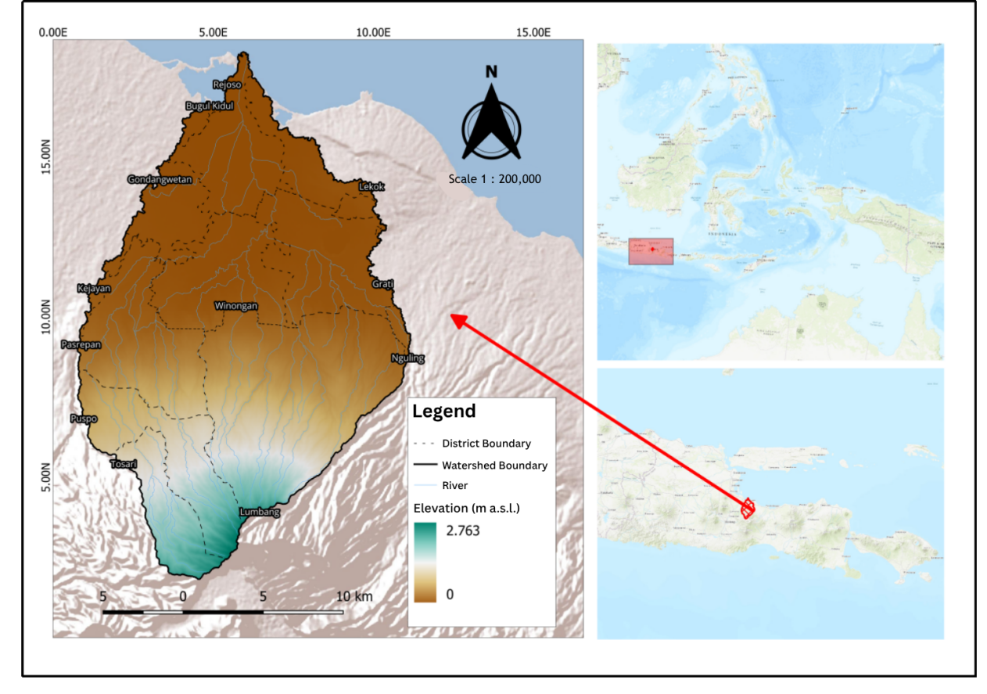
Fig. 1. Study area map of the Rejoso Watershed, Pasuruan Regency, East Java, Indonesia

2.2 Land Use/Cover Change (LUCC) Analysis

Land cover data were derived from the Sentinel-2 10m Annual Land Use/Land Cover Time Series, a global product developed by Impact Observatory in partnership with Esri and Microsoft using a deep learning segmentation model (Karra et al., 2021), accessed via ArcGIS Living Atlas Land Cover Explorer for three reference years: 2017, 2020, and 2024. Seven land cover classes were present at the Rejoso Watershed location: water body, forest/vegetation, swamp, agricultural land, built-up land, bare land, and dryland (tegalan). A small number of cloud-affected pixels in the 2020 imagery, located in the forested upstream zone, were manually assigned to the forest/vegetation class based on surrounding land cover context. As this dataset is delivered as a pre-generated annual composite accessed directly through the Land Cover Explorer platform, no single image acquisition date is applicable or reported by the data provider for each reference year.

To quantify land cover distribution per sub-district, spatial intersection analysis was conducted between the classified land cover maps and sub-district administrative boundaries (n = 12) using QGIS version 3.40.5. This produced a dataset of land cover area per class per sub-district for each of the three reference years, which served as the input for subsequent statistical analysis.

Statistical significance of land cover changes across the three periods was verified using non-parametric repeated-measures tests, as Mauchly’s test confirmed that the sphericity assumption was not met (p < .05), precluding the use of parametric repeated-measures ANOVA (Field et al., 2025). The Friedman test was applied as a non-parametric alternative to detect significant differences across at least one pair of observation periods:

χ²F = [12 / nk(k+1)] ΣRj² - 3n(k+1)

where n is the number of spatial units (sub-districts; n = 12), k is the number of observation periods (k = 3), and Rj is the sum of ranks for period j. The strength of inter-unit consistency was assessed using Kendall’s W coefficient of concordance, with values approaching 1.0 indicating high consistency across sub-districts (Kendall & Babington Smith, 1939).

When the Friedman test yielded a significant result (p < .05), the Wilcoxon Signed-Rank test was applied as a post-hoc procedure to identify specific periods with significant pairwise differences (Wilcoxon, 1945):

W = Σ [sgn(x2i - x1i) · Ri]

where W is the test statistic, x1i and x2i are the land cover area values for the two periods being compared for sub-district i, Ri is the rank of the absolute difference |x2i - x1i|, and sgn(·) is the sign function (+1 for positive differences, -1 for negative, 0 for no difference). All statistical analyses were conducted using JASP version 0.18 at a significance level of α = 0.05.

2.3 Erosion Modelling: USLE

Potential soil erosion was estimated using the Universal Soil Loss Equation (USLE; Wischmeier & Smith, 1978):

A = R · K · LS · C · P

where A is the annual soil loss (tonnes ha⁻¹ year⁻¹), R is the rainfall erosivity factor (MJ mm ha⁻¹ h⁻¹ year⁻¹), K is the soil erodibility factor (t ha h ha⁻¹ MJ⁻¹ mm⁻¹), LS is the slope length-steepness factor (dimensionless), C is the cover-management factor (dimensionless), and P is the support practice factor (dimensionless). The R factor was computed from daily rainfall data using the Modified Fournier Index. The K factor was derived from soil texture and organic matter content based on the Wischmeier and Smith nomograph. The LS factor was calculated from a Digital Elevation Model (DEM) at 30-m resolution. The C factor was assigned based on land cover class derived from the LUCC analysis. The P factor was determined based on field conditions and land management practices.

2.4 Sediment Yield Modelling: MUSLE and SDR

Sediment yield at the land mapping unit (SPL) level was estimated using the Modified Universal Soil Loss Equation (MUSLE; Williams, 1975):

Qs = 11.8 · (Vq · qp)°0.56 · K · LS · C · P

where Qs is the sediment yield per rainfall event (tonnes), Vq is the runoff volume (m³), and qp is the peak discharge (m³ s⁻¹), each computed using the SCS-CN method (USDA, 1972) under antecedent moisture condition II for three rainfall-intensity categories (light, moderate and heavy). Event-based Qs values were aggregated across these three categories to obtain annual sediment yield for each SPL. The MUSLE replaces the rainfall erosivity factor (R) in the USLE with a runoff energy term, enabling event-based estimation of sediment yield.

The R factor was computed at 15 CHIRPS rainfall grid points distributed across the watershed following Bols (1978), based on monthly rainfall totals, number of rainy days, and maximum daily rainfall. Point-based R values were interpolated using Thiessen polygons and area-weighted to the 25 SPL boundaries, yielding watershed means of 1,577.0 (range: 1,134.4–2,608.3), 1,494.1 (range: 1,148.2–2,367.2) and 1,169.5 (range: 823.3–1,908.0) MJ·mm·ha⁻¹·h⁻¹·year⁻¹ for 2017, 2020 and 2024, respectively. Because R varies spatially across SPLs, inter-SPL variability in potential erosion (A) reflects the combined influence of R, K, LS, C and P. Across the 25 SPLs, K ranged from approximately 0.09 (Andisols, dominant in 12 SPLs) to 0.36 (Vertisols, SPL 1, 2, 17 and 25); LS ranged from 0.4 on flat-to-gentle slopes (0–8%, 9 SPLs) to 6.8 on steep slopes (25–45%, SPL 8, 16 and 20); weighted C values were most dynamic in SPL 7, 8, 14, 15 and 23, reflecting land cover change between 2017 and 2024; and P ranged from 0.04 in well-conserved units (SPL 1, 2, 6, 7, 11, 12, 13, 17, 18, 22, 24 and 25) to 0.90 in poorly conserved units (SPL 16 and 20).

The Sediment Delivery Ratio (SDR) was applied to estimate the proportion of eroded material reaching the watershed outlet, following Vanoni (1975):
SDR = Ys / Ā

where Ys is the watershed-level actual sediment yield (tonnes ha⁻¹ year⁻¹) obtained from the aggregated MUSLE output, and Ā is the area-weighted mean potential soil loss for the watershed (tonnes ha⁻¹ year⁻¹) obtained from the USLE output.

Spatial analysis was performed on 25 Land Mapping Units (SPL) derived through overlay of soil type, slope class, and land cover maps within the watershed boundary using QGIS. Each SPL was used as the unit of calculation for erosion and sedimentation estimation, enabling spatial identification of erosion and sedimentation hotspots.

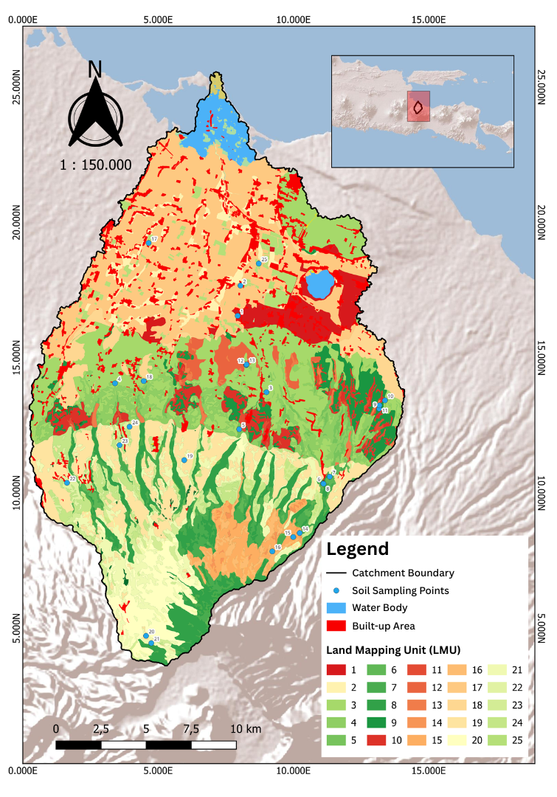

Fig. 2. Distribution of 25 Land Mapping Units (SPL) in the Rejoso Watershed derived from overlay of soil type, slope class, and land cover

3. Results and Discussion

3.1 Land Use/Cover Change 2017–2024

The multitemporal classification of Sentinel-2 imagery revealed significant land cover changes across the Rejoso Watershed between 2017 and 2024 (Table 1). Two dominant trends were identified: a decline in natural vegetation cover, particularly forest, and an expansion of built-up land and agricultural areas.

Table 1. Land cover change in the Rejoso Watershed, 2017–2024.

Land Cover Class | 2017 (ha) | 2020 (ha) | 2024 (ha) | Δ 2017–2020 (ha) | Δ 2017–2020 (%) | Δ 2020–2024 (ha) | Δ 2020–2024 (%)
Water Body | 956.09 | 985.21 | 1,066.01 | +29.12 | +3.05 | +80.80 | +8.20
Forest | 16,962.79 | 17,921.93 | 14,241.15 | +959.14 | +5.65 | -3,680.78 | -20.54
Swamp | 93.09 | 69.02 | 91.15 | -24.07 | -25.86 | +22.13 | +32.06
Agricultural Land | 11,884.21 | 11,961.10 | 12,799.64 | +76.89 | +0.65 | +838.54 | +7.01
Built-up Land | 5,234.34 | 5,665.16 | 6,853.31 | +430.82 | +8.23 | +1,188.15 | +20.97
Bare Land | 4.35 | 0.25 | 1.10 | -4.10 | -94.25 | +0.85 | +340.00
Dryland (Tegalan) | 4,996.53 | 3,523.80 | 5,074.50 | -1,472.73 | -29.48 | +1,550.70 | +44.01
Total | 40,131.40 | 40,126.47 | 40,126.86 | -4.93 | -0.01 | +0.39 | +0.00
Source: Analysis results, 2026. Total classified area is consistent across the three reference years (40,131.40 ha in 2017, 40,126.47 ha in 2020, and 40,126.86 ha in 2024), with a maximum deviation of 4.93 ha (0.01%) from the watershed area of 40,131 ha reported in the study area description, confirming internal consistency of the land cover classification.

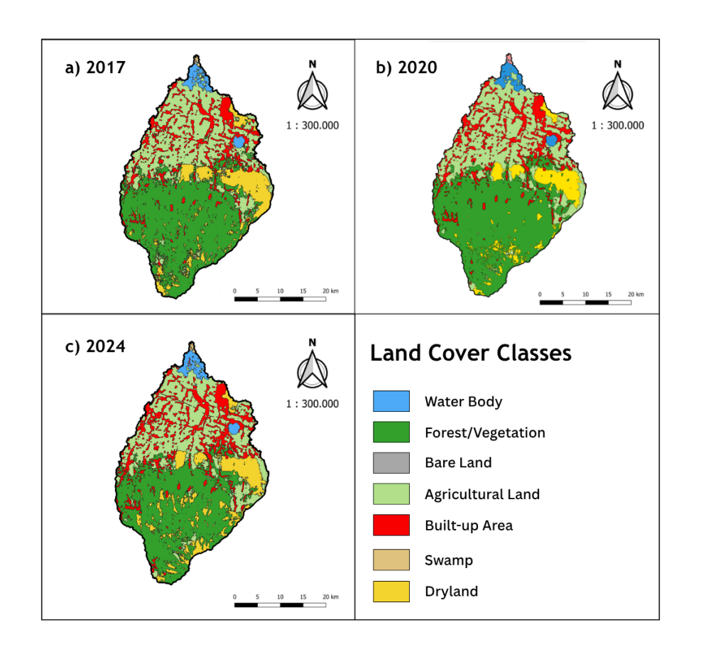

Fig. 3. Multitemporal land cover maps of the Rejoso Watershed derived from Sentinel-2 classification: (a) 2017, (b) 2020, (c) 2024

Forest cover declined by a total of 2,721.64 ha over the seven-year study period, but the trajectory was non-monotonic. Forest area actually increased between 2017 and 2020 (+959.14 ha; +5.65%), before declining sharply between 2020 and 2024 (-3,680.78 ha; -20.54%) — a loss more than three times larger than the net change over the full period. This pattern is consistent with the Wilcoxon results (Table 2), which found no significant change in 2017–2020 (p = .689) but a highly significant decline in 2020–2024 (p = .011), confirming that forest loss was concentrated almost entirely in the second half of the study period. Built-up land expanded consistently across both periods, recording gains of +430.82 ha (+8.23%) between 2017 and 2020 and +1,188.15 ha (+20.97%) between 2020 and 2024, representing a total expansion of 30.93% over the study period. These patterns are consistent with reported urbanisation pressures in the Pasuruan area, where the Land Cover Quality Index (IKTL) of Kota Pasuruan declined sharply from 45.12 in 2018 to 26 in 2023 (Pemerintah Kota Pasuruan, 2024).

These changes also align with broader evidence that Sentinel-2 imagery is suitable for monitoring forest, agricultural and urban land-cover transitions, particularly when machine-learning classifiers are combined with appropriate pre-processing. In watershed contexts, conversion of forest or perennial vegetation to cropland and settlement generally increases runoff generation, reduces surface protection, and can elevate sediment production, although the magnitude varies with rainfall regime, slope, soil erodibility, and conservation practices (Phiri et al., 2020; Nampak et al., 2018; Sadhwani et al., 2022). Therefore, the observed forest decline and built-up expansion should be interpreted not only as land-cover transition, but also as a potential shift in hydrological response and sediment connectivity.

3.2 Statistical Significance of Land Cover Change

The Friedman test confirmed that statistically significant changes occurred in three of the seven land cover classes over the study period (Table 2). Forest cover showed a significant overall trend (χ²F = 11.45; p = .003; Kendall’s W = 0.477), with post-hoc Wilcoxon analysis revealing that the significant change was concentrated in the 2020–2024 period (W = 62.00; p = .011) and cumulatively across 2017–2024 (W = 59.00; p = .023); the 2017–2020 comparison was not significant (p = .689), consistent with forest area having increased slightly rather than declined during that period. Built-up land exhibited the strongest and most consistent trend of all classes (χ²F = 24.00; p < .001; Kendall’s W = 1.000), with significant expansion confirmed across all three pairwise periods. Dryland (tegalan) showed a significant change primarily in the 2017–2020 period (W = 36.00; p = .014), with the subsequent rebound in 2020–2024 not reaching statistical significance (p = .076), indicating spatially heterogeneous and inconsistent dynamics.

The statistical confirmation is important because LUCC maps derived from remote sensing may contain class-level uncertainty and spatial noise; therefore, testing changes across repeated spatial units provides a more conservative basis for interpreting temporal trends. The use of the Friedman test, Kendall’s W and Wilcoxon signed-rank procedures is appropriate for repeated comparisons where normality or sphericity assumptions are not satisfied, because these methods evaluate ranked differences rather than relying on distributional assumptions (Friedman, 1937; Kendall & Babington Smith, 1939; Wilcoxon, 1945). This strengthens the interpretation that forest decline and built-up expansion were not merely descriptive fluctuations, but statistically supported watershed-scale changes.

Table 2. Results of Friedman test and Wilcoxon Signed-Rank test for land cover change, 2017–2024

Land Cover Class | χ²F | p | Kendall's W | W (2017–2020) | p | W (2020–2024) | p
Water Body | 0.059 | .971 | 0.002 | 11.00 | .363 | 19.00 | .944
Forest* | 11.45 | .003 | 0.477 | 28.00 | .689 | 62.00 | .011
Swamp | 3.000 | .223 | 0.125 | 3.000 | .371 | 0.000 | .371
Agricultural Land | 0.167 | .920 | 0.007 | 33.00 | .677 | 38.00 | .970
Built-up Land* | 24.00 | <.001 | 1.000 | 0.000 | <.001 | 0.000 | <.001
Bare Land | 1.368 | .504 | 0.057 | 9.000 | .201 | 3.000 | .584
Dryland* | 7.600 | .022 | 0.317 | 36.00 | .014 | 7.000 | .076
*Statistically significant (p < .05); Friedman test applied due to violation of sphericity assumption (Mauchly's test, p < .05). Source: Statistical analysis results, 2026.

3.3 Erosion-Sedimentation Dynamics

Potential erosion rates estimated using USLE across the 25 SPLs showed considerable spatial variability. SPL 20, located in the upstream sub-district of Tosari, consistently recorded the highest potential erosion rates across all three study periods, attributable to the combination of steep slopes, high rainfall erosivity, and increasing conversion of forest cover to dryland agriculture. Notably, SPL 20 reached the Heavy erosion hazard class in 2017, coinciding with the highest rainfall erosivity year of the study period, before declining to Moderate in 2020 and 2024 — indicating that this location is particularly sensitive to interannual rainfall variability and warrants priority monitoring during high-rainfall years. The spatial pattern of potential erosion is presented in Fig. 4.

The identification of SPL 20 as an erosion hotspot is consistent with studies showing that high slope gradients, reduced canopy cover and exposed agricultural surfaces strongly increase modelled erosion risk in GIS-based USLE/RUSLE assessments (Pham et al., 2018; Park et al., 2011; Sadhwani et al., 2022). In practical terms, this suggests that conservation measures in upstream Tosari should prioritise slope stabilisation, vegetative cover restoration, contour-based farming and runoff interception rather than relying only on downstream flood-control structures.

Table 3. SPLs with the highest potential erosion (A) and sediment yield (Ys), 2017–2024

SPL | Area (ha) | A 2017 (t/ha/yr) | A 2020 (t/ha/yr) | A 2024 (t/ha/yr) | TBE Class | Ys range (t/ha/yr) | Role
20 | 1,603.93 | 191.68 | 111.03 | 112.14 | Heavy→Moderate | 4.72–21.67 | Erosion hotspot
11 | 214.26 | 58.51 | 53.47 | 43.05 | Light | 132.56–244.23 | Sediment yield hotspot
16 | 470.29 | 53.18 | 59.89 | 66.90 | Light→Moderate | 1.37–12.21 | Rising erosion risk
10 | 982.55 | 19.85 | 18.99 | 14.31 | Light→Very Light | 38.23–71.95 | Secondary Ys contributor
TBE = Tingkat Bahaya Erosi (erosion hazard class, Arsyad, 2010). Full results for all 25 SPLs are available from the authors upon request. Source: Analysis results, 2026.
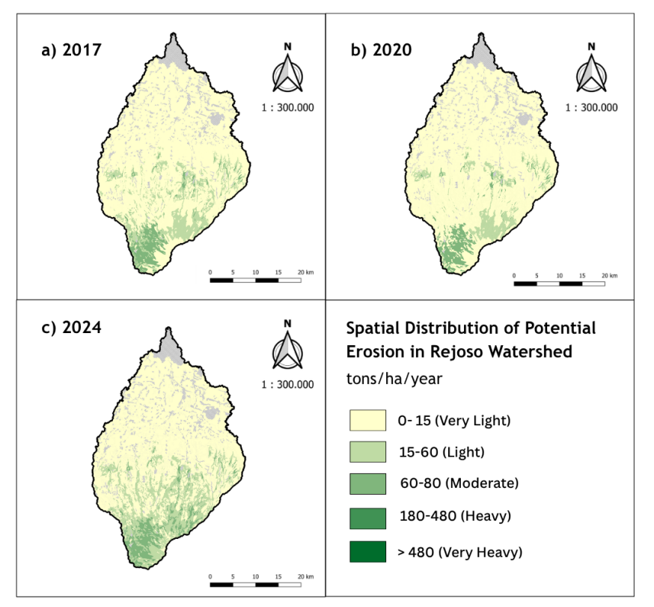

Fig. 4. Spatial distribution of potential erosion estimated by USLE across 25 Land Mapping Units (SPL) of the Rejoso Watershed: 2017, 2020, 2024

Sediment yield estimated using MUSLE revealed that SPL 11, located in the downstream sub-district of Nguling, recorded the highest sediment yield values consistently across all three periods. This result reflects the compound effect of accumulated runoff from upstream areas, high land cover disturbance, and proximity to the watershed outlet, which reduces the distance available for sediment deposition before reaching the river network.

Total sediment yield at the watershed level showed a declining trend across the study period, from approximately 276,026 tonnes/year (7.67 t ha⁻¹ yr⁻¹) in 2017 to 189,256 tonnes/year (5.26 t ha⁻¹ yr⁻¹) in 2024, with an intermediate value of 269,074 tonnes/year (7.48 t ha⁻¹ yr⁻¹) in 2020. However, this apparent improvement warrants careful interpretation. A simulation combining the 2017 rainfall-runoff regime with 2024 land cover produced a sediment yield of 280,380 tonnes/year (7.79 t ha⁻¹ yr⁻¹) — slightly higher than the actual 2017 value despite using identical rainfall inputs — confirming that land cover degradation between 2017 and 2024 increased the watershed's underlying erosion potential rather than reducing it. Area-weighted rainfall data across the 25 SPLs show that the mean number of heavy-rainfall days (>45 mm/day) fell from 3.4 to 1.8 per year between 2017 and 2024, while mean peak daily intensity in this category fell from 83.8 to 58.0 mm. This decline in rainfall erosivity, rather than any improvement in land cover or conservation practice, was the dominant driver of the observed reduction in modelled sediment yield. This pattern is consistent with evidence from other tropical watersheds that sediment yield is highly sensitive to short-term rainfall-runoff variability even where land-cover trends are unfavourable (Sadhwani et al., 2022). The corresponding SDR values of 0.461 (2017), 0.656 (2020) and 0.397 (2024) further show that the proportion of eroded material reaching the outlet did not decline monotonically; the 2020 peak reflects a sharp fall in mean potential erosion (Ā, from 16.65 to 11.39 t ha⁻¹ yr⁻¹) that outpaced the decline in Ys, rather than an improvement in sediment retention. Given that forest cover continued to decline substantially during the same period, and that potential erosion (USLE) at several steep-slope SPLs (8, 19, 21, 23) increased between 2020 and 2024 despite falling rainfall, the underlying vulnerability of the watershed to erosion and sedimentation has increased rather than decreased. A return to higher-erosivity years such as 2017 would be expected to produce substantially elevated sediment yields on top of the already-degraded land cover baseline.

The contrast between high potential erosion upstream and high sediment yield downstream is also plausible because delivered sediment depends on hillslope-channel connectivity, runoff energy, deposition opportunities and the location of each SPL relative to the drainage network. Similar studies have shown that sediment yield may respond strongly to land-cover disturbance and rainfall-runoff variability, so lower modelled yield during a low-erosivity period should not be interpreted as durable recovery unless supported by improvements in vegetation cover and conservation practices (Ouyang et al., 2010; Ranzi et al., 2012; Pal et al., 2021).

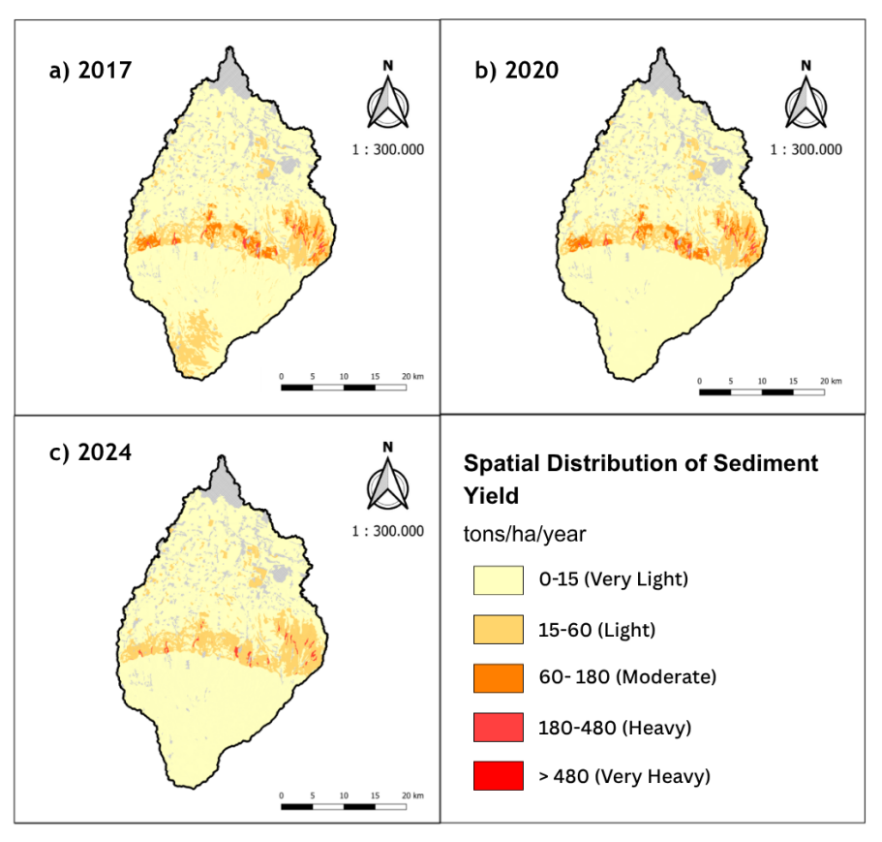

Fig. 5. Spatial distribution of sediment yield estimated by MUSLE across 25 Land Mapping Units (SPL) of the Rejoso Watershed: 2017, 2020, 2024

4. Conclusion

The study confirms that the Rejoso Watershed underwent measurable land-cover change between 2017 and 2024, with forest loss and built-up land expansion representing the most important transitions. Forest cover declined most strongly during 2020–2024, while built-up land increased throughout the observation period, indicating continued pressure on watershed function. The erosion and sedimentation analysis showed spatially differentiated risk, with SPL 20 in Tosari identified as the principal potential erosion hotspot and SPL 11 in Nguling as the main sediment-yield hotspot. The decline in estimated total sediment yield from 276,026 tonnes/year in 2017 to 189,256 tonnes/year in 2024 should be interpreted cautiously, as it was mainly linked to reduced rainfall erosivity rather than recovery of land cover. The results suggest that management should prioritise upstream erosion control, protection of remaining forest, rehabilitation of degraded dryland areas and regulation of expanding built-up zones. The integrated LUCC, USLE, MUSLE and SDR approach provides a practical basis for spatially targeted watershed management.

5. Limitations

This study was limited by the availability and resolution of remote-sensing, rainfall, soil and hydrological data. In particular, land cover data were obtained from the Esri/Impact Observatory Sentinel-2 10m global land cover product rather than an independently trained and locally validated classifier; consequently, algorithm-specific parameters, training/validation sample sizes, and a study-specific confusion matrix or kappa coefficient could not be reported. Global accuracy assessments for this product are documented by its developers (Karra et al., 2021), but these reflect performance at global scale and may not fully represent classification reliability under the complex topography and mixed land uses of the Rejoso Watershed. In addition, a small number of cloud-affected pixels in the 2020 data were manually assigned to the forest class based on spatial context rather than pixel-level verification, which may introduce minor uncertainty in the 2020 forest baseline. USLE and MUSLE modelling relied on a single rainfall station to represent the entire watershed, so the R factor is spatially uniform and does not capture potential orographic rainfall gradients between the upstream and downstream zones. The study did not include field-based erosion or sediment discharge measurements for model calibration, although qualitative ground verification was conducted at the two identified hotspots (SPL 20 and SPL 11). Future research should include a formal accuracy assessment of the land cover classification, distributed rainfall monitoring, and observed sediment discharge data at the watershed outlet for model validation.

Acknowledgements

The authors gratefully acknowledge the support of the Faculty of Agriculture, Universitas Jember, and all stakeholders of the Rejoso Watershed who contributed data and insights to this research.

Declaration of AI Use

This manuscript was prepared through the combined contributions of all author(s), including contributions to the study design, data, content development, results, interpretation, and related scholarly work. The author(s) acknowledge the use of Grammarly and ChatGPT to assist with grammar checking, language refinement, and reference formatting. These AI-assisted tools were not used as authors and did not replace the intellectual contributions or scholarly judgment of the author(s). All AI-assisted outputs, including content, references, and interpretations, were carefully reviewed, revised, verified, and approved by the author(s). The author(s) accept full responsibility for the accuracy, integrity, and final content of the manuscript.

Competing Interests

Authors have declared that no competing interests exist.

References

Amalia, N. N., Suhartanto, E., & Andawayanti, U. (2024). Analysis of land cover change trends at Rejoso Watershed, Pasuruan Regency, East Java Province. Jurnal Teknik Pengairan, 15(2), 124–132. https://doi.org/10.21776/ub.pengairan.2024.015.02.3
Arsyad, S. (2010). Konservasi tanah & air. IPB Press. http://repository.ipb.ac.id/handle/123456789/42667
Bols, P. L. (1978). The iso-erodent map of Java and Madura. Belgian Technical Assistance Project ATA 105, Soil Research Institute.
Dube, S. K., Rana, N. K., & Sharma, L. (2025). Morphometric analysis of the West Rapti River Basin: Geospatial assessment and hydrological implications. Asian Journal of Environment & Ecology, 24(8), 12–33. https://doi.org/10.9734/ajee/2025/v24i8769
Field, A., van Doorn, J., & Wagenmakers, E.-J. (2025). Discovering statistics using JASP. SAGE Publications. https://uk.sagepub.com/en-gb/eur/discovering-statistics-using-jasp/book288224
Friedman, M. (1937). The use of ranks to avoid the assumption of normality implicit in the analysis of variance. Journal of the American Statistical Association, 32(200), 675–701. https://doi.org/10.1080/01621459.1937.10503522
Gondore, T. U., & Hunduma, T. (2023). Assessment of forest covers change in the Central Highlands of Ethiopia: The case of Walmara District: Centeral Oromia (1985–2017). Journal of Global Agriculture and Ecology, 15(1), 1–11. https://doi.org/10.56557/jogae/2023/v15i18010
Hajisheko, K. K., Suryabhagavan, K. V., & Soumya, K. (2025). WebGIS-based decision support system for soil erosion risk assessment for Guder River catchment, Ethiopia. Geosystems and Geoenvironment, 4(2), Article 100387. https://doi.org/10.1016/j.geogeo.2025.100387
Karra, K., Kontgis, C., Statman-Weil, Z., Mazzariello, J. C., Mathis, M., & Brumby, S. P. (2021). Global land use/land cover with Sentinel-2 and deep learning. In 2021 IEEE International Geoscience and Remote Sensing Symposium IGARSS (pp. 4704–4707). IEEE. https://doi.org/10.1109/IGARSS47720.2021.9553499
Kendall, M. G., & Smith, B. B. (1939). The problem of m rankings. The Annals of Mathematical Statistics, 10(3), 275–287. https://doi.org/10.1214/aoms/1177732186
Meilisa, R. (2025, January 30). Banjir di Rejoso Pasuruan masih 1 meter, sebagian warga mengungsi. Detik.com. https://www.detik.com/jatim/berita/d-7756432/banjir-di-rejoso-pasuruan-masih-1-meter-sebagian-warga-mengungsi
Mujibadi, J. K. (2020). Prediksi hidrograf aliran Sungai Rejoso Kabupaten Pasuruan akibat perubahan tata guna lahan dan curah hujan [Master’s thesis, Institut Teknologi Sepuluh Nopember]. ITS Repository. http://repository.its.ac.id/id/eprint/80754
Nampak, H., Pradhan, B., Mojaddadi Rizeei, H., & Park, H. J. (2018). Assessment of land cover and land use change impact on soil loss in a tropical catchment by using multi-temporal SPOT-5 satellite images and revised universal soil loss equation model. Land Degradation & Development, 29(10), 3440–3455. https://doi.org/10.1002/ldr.3112
Ouyang, W., Hao, F., Skidmore, A. K., & Toxopeus, A. G. (2010). Soil erosion and sediment yield and their relationships with vegetation cover in upper stream of the Yellow River. Science of the Total Environment, 409(2), 396–403. https://doi.org/10.1016/j.scitotenv.2010.10.020
Pal, S. C., Chakrabortty, R., Roy, P., Chowdhuri, I., Das, B., Saha, A., & Shit, M. (2021). Changing climate and land use of 21st century influences soil erosion in India. Gondwana Research, 94, 164–185. https://doi.org/10.1016/j.gr.2021.02.021
Park, S., Oh, C., Jeon, S., Jung, H., & Choi, C. (2011). Soil erosion risk in Korean watersheds, assessed using the revised universal soil loss equation. Journal of Hydrology, 399(3–4), 263–273. https://doi.org/10.1016/j.jhydrol.2011.01.004
Pemerintah Kota Pasuruan. (2024). Lampiran Peraturan Daerah Kota Pasuruan Nomor 6 Tahun 2024 tentang Rencana Perlindungan dan Pengelolaan Lingkungan Hidup. Jaringan Dokumentasi dan Informasi Hukum Kota Pasuruan. https://jdih.pasuruankota.go.id/_upload/produk_hukum/Peraturan%20Daerah/lampiran/2024/lampiran-2024perda3534006-lampiran_compressed.pdf
Pham, T. G., Degener, J., & Kappas, M. (2018). Integrated universal soil loss equation (USLE) and Geographical Information System (GIS) for soil erosion estimation in A Sap basin: Central Vietnam. International Soil and Water Conservation Research, 6(2), 99–110. https://doi.org/10.1016/j.iswcr.2018.01.001
Phiri, D., Simwanda, M., Salekin, S., Nyirenda, V. R., Murayama, Y., & Ranagalage, M. (2020). Sentinel-2 data for land cover/use mapping: A review. Remote Sensing, 12(14), Article 2291. https://doi.org/10.3390/rs12142291
Ranzi, R., Le, T. H., & Rulli, M. C. (2012). A RUSLE approach to model suspended sediment load in the Lo River (Vietnam): Effects of reservoirs and land use changes. Journal of Hydrology, 422–423, 17–29. https://doi.org/10.1016/j.jhydrol.2011.12.009
Reza, S. K., Chakraborty, J., Saha, K., Khan, S. K., Dash, B., & Rahman, F. H. (2026). Assessment of land use and land cover change over the last 20 years and its relation to land capability classes for sustainable watershed planning using remote sensing and GIS techniques. Journal of the Indian Society of Remote Sensing, 54, 2095–2113. https://doi.org/10.1007/s12524-025-02416-4
Sadhwani, K., Eldho, T. I., Jha, M. K., & Karmakar, S. (2022). Effects of dynamic land use/land cover change on flow and sediment yield in a monsoon-dominated tropical watershed. Water, 14(22), Article 3666. https://doi.org/10.3390/w14223666
Sadhwani, K., Eldho, T. I., Jha, M. K., & Karmakar, S. (2022). Effects of dynamic land use/land cover change on flow and sediment yield in a monsoon-dominated tropical watershed. Water, 14(22), Article 3666. https://doi.org/10.3390/w14223666
USDA. (1972). National Engineering Handbook, Section 4: Hydrology. Soil Conservation Service, United States Department of Agriculture. https://directives.nrcs.usda.gov/sites/default/files2/1712930634/Part%20630%20-%20Hydrology.pdf
Vanoni, V. A. (Ed.). (1975). Sedimentation engineering (ASCE Manuals and Reports on Engineering Practice No. 54). American Society of Civil Engineers. https://cedb.asce.org/CEDBsearch/record.jsp?dockey=0139314
Wariunsora, S., Kusuma, Z., & Suprayogo, D. (2024). Analisis hubungan tutupan lahan dan indikator kesehatan hidrologi DAS Rejoso, Jawa Timur. Jurnal Tanah dan Sumberdaya Lahan, 11(1), 289–300. https://doi.org/10.21776/ub.jtsl.2024.011.1.31
Wilcoxon, F. (1945). Individual comparisons by ranking methods. Biometrics Bulletin, 1(6), 80–83. https://doi.org/10.2307/3001968
Williams, J. R. (1975). Sediment-yield prediction with universal equation using runoff energy factor. In Present and prospective technology for predicting sediment yield and sources (USDA ARS-S-40, pp. 244–252). United States Department of Agriculture. https://www.hec.usace.army.mil/confluence/hmsdocs/hmsag/surface-erosion-and-sediment-routing-studies/references-for-surface-erosion-and-sediment-routing-studies
Wischmeier, W. H., & Smith, D. D. (1978). Predicting rainfall erosion losses: A guide to conservation planning (Agriculture Handbook No. 537). United States Department of Agriculture. https://naldc.nal.usda.gov/catalog/CAT79706928

Disclaimer/Publisher’s Note: The statements, opinions and data contained in all publications are solely those of the individual author(s) and contributor(s) and not of the publisher and/or the editor(s). This publisher and/or the editor(s) disclaim responsibility for any injury to people or property resulting from any ideas, methods, instructions or products referred to in the content.
__________________________________________________________________________________________
© Copyright (2026): Author(s). The licensee is the journal publisher. This is an Open Access article distributed under the terms of the Creative Commons Attribution License (http://creativecommons.org/licenses/by/4.0), which permits unrestricted use, distribution, and reproduction in any medium, provided the original work is properly cited.

