Review Article
From Waste Streams to Superbugs: How Pharmaceutical and Hospital Effluents Drive Antimicrobial Resistance in Urban Ecosystems
Abstract
Background: Antimicrobial resistance (AMR) is a major global public health challenge, and environmental pathways are increasingly recognised as important drivers of resistance emergence and dissemination. Pharmaceutical manufacturing activities and hospital wastewater systems release antibiotic residues, resistant microorganisms, and antimicrobial resistance genes into urban aquatic environments, creating conditions that favour resistance selection and persistence.
Objective: This narrative review synthesises current evidence on the contribution of pharmaceutical and hospital effluents to antimicrobial resistance in urban ecosystems, identifies major environmental pathways, and examines existing mitigation and regulatory strategies.
Methods: Relevant literature published between January 2000 and August 2025 was identified through searches of PubMed, Scopus, and Web of Science, supplemented by reports from international organisations. Evidence relating to pharmaceutical pollution, hospital wastewater, environmental reservoirs, wastewater treatment technologies, and policy responses was synthesised using a thematic narrative approach.
Key Findings: Studies across diverse geographical settings indicate that pharmaceutical and hospital effluents frequently contain antibiotic concentrations capable of promoting resistance selection and introducing multidrug-resistant organisms and mobile resistance genes into municipal wastewater systems. Conventional treatment processes do not consistently remove these contaminants, enabling their persistence and dissemination within urban environments. Regulatory oversight remains uneven, with limited implementation of enforceable effluent standards and targeted pretreatment requirements.
Conclusions: Reducing environmentally mediated AMR requires strengthened environmental surveillance, improved wastewater treatment infrastructure, responsible pharmaceutical waste management, and integrated One Health governance frameworks. Coordinated action across healthcare, industry, and environmental sectors is essential to mitigate resistance amplification in urban ecosystems.
Keywords: Antimicrobial resistance; pharmaceutical effluents; hospital wastewater; urban ecosystems; environmental surveillance; One Health
- Introduction
Antimicrobial resistance (AMR) has become one of the most serious public health challenges of the 21st century. It reduces the effectiveness of antibiotics, which have long been central to modern treatment. The World Health Organization (WHO) recognises AMR as a global problem that could reverse decades of medical progress by increasing the risk of infections that are difficult to treat, prolonged illness and mortality. Although the clinical misuse and overuse of antibiotics are well recognised as major causes, an increasingly important dimension of this problem occurs beyond hospitals, through environmental pathways that disseminate and amplify resistance [1].
One important but often overlooked environmental factor is waste generated from pharmaceutical production and healthcare facilities. During the manufacture, formulation and cleaning of medicinal products, pharmaceutical production waste may contain substantial levels of active pharmaceutical ingredients (APIs), particularly antibiotics. These residues can exert selective pressure on ambient microbiota, even at low concentrations, thereby supporting the establishment and persistence of resistant bacteria. Hospital effluents are also complex mixtures of antimicrobial agents, disinfectants, metabolites and resistant bacteria shed by patients. Hospital discharges often contain higher levels of residual antibiotics and multidrug-resistant organisms than ordinary household wastewater [2], and they are generally released into municipal sewer systems without adequate pretreatment. Recent wastewater-focused studies continue to support this pathway by showing that hospital-related waste streams can carry clinically relevant resistance determinants and multidrug-resistant bacteria, strengthening the rationale for treating healthcare-origin effluents as high-priority sources within environmental AMR surveillance [42,45].
Urban ecosystems provide a distinctive and favourable setting for the dissemination of antimicrobial resistance through multiple waste streams. High population density is associated with increased antibiotic use, while complex and interconnected wastewater systems enable different microbial species and pharmaceutical pollutants to mix. Wastewater treatment plants (WWTPs), which are the primary route for urban sewage management, are not designed to completely remove pharmaceuticals or resistance genes; consequently, these contaminants may enter surface waters, sediments and soils. In many rapidly developing areas, untreated or partially treated effluents are discharged directly into natural water bodies, further intensifying the problem [3].
These combined factors make urban aquatic and terrestrial ecosystems important sites for horizontal gene transfer, allowing resistant bacteria to spread far beyond their original clinical or industrial sources. This environmental reservoir of resistance presents a dual threat: it jeopardises ecological integrity and facilitates the reintroduction of resistant infections into human populations through water, food and direct contact. Recent evidence from industrial wastewater and wastewater-associated surface waters also indicates that resistant Gram-negative bacteria may persist across discharge-impacted environments, reinforcing the need to evaluate pharmaceutical, hospital and municipal wastewater routes together rather than as isolated sources [41,43,44].
Research gap: Available evidence is distributed across pharmaceutical pollution, hospital wastewater, municipal wastewater treatment, environmental reservoirs and One Health surveillance. However, a concise synthesis that links these pathways within urban ecosystems remains necessary to guide mitigation-oriented discussion.
Objective of the review: This review aims to synthesise evidence on the role of pharmaceutical and hospital effluents in environmental AMR, describe the major urban transmission pathways and ecological implications, and discuss mitigation and regulatory responses.
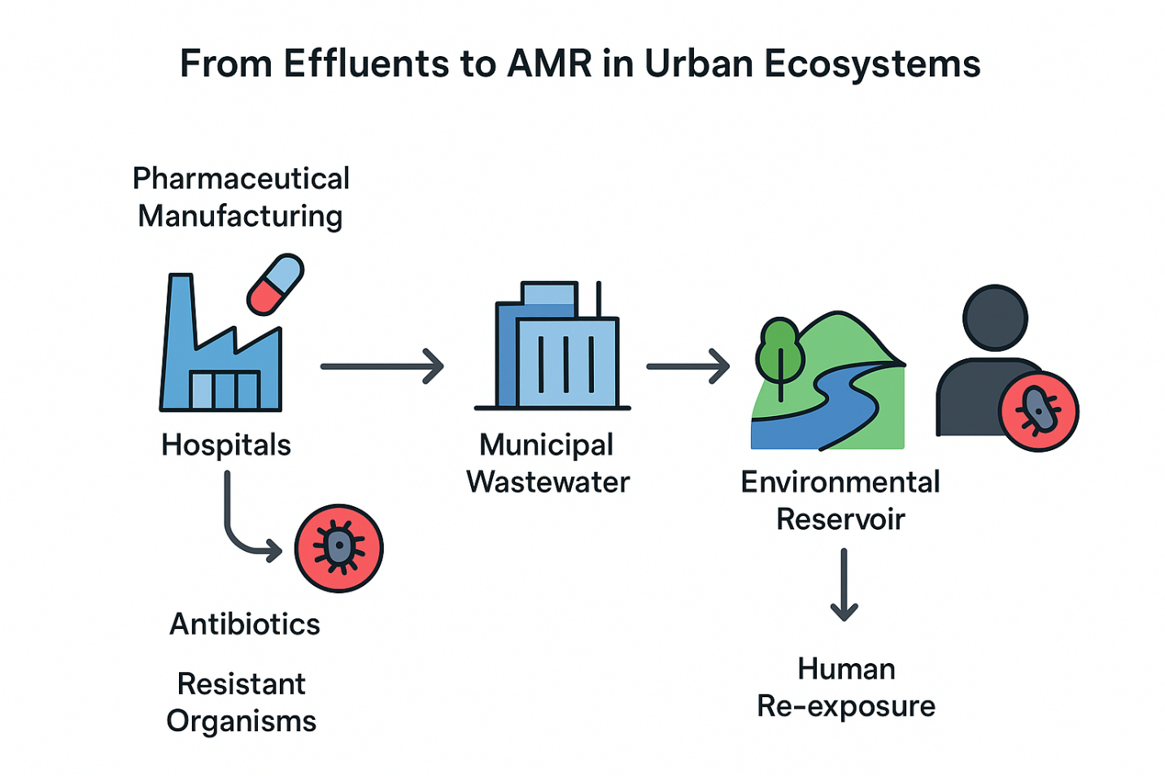
Figure 1. Conceptual pathways linking pharmaceutical manufacturing and hospital effluents to the emergence and dissemination of antimicrobial resistance in urban ecosystems.
The figure illustrates how antibiotic residues, resistant microorganisms, and antimicrobial resistance genes originating from pharmaceutical facilities and healthcare institutions enter municipal wastewater systems, accumulate within environmental reservoirs, and contribute to human re-exposure through interconnected One Health pathways.

2. Literature Search Strategy
This review adopted a narrative literature review approach to synthesise current evidence regarding the contribution of pharmaceutical and hospital effluents to antimicrobial resistance (AMR) within urban ecosystems. Relevant literature was identified through a comprehensive search of PubMed, Scopus, and Web of Science databases. Additional publications were located through manual searches of reference lists and reports published by international organisations, including the World Health Organization (WHO), the United Nations Environment Programme (UNEP), and other agencies involved in environmental health and antimicrobial resistance monitoring.
2.1 Database Search
The literature search covered studies published between January 2000 and June 2025. Search terms included combinations of the keywords "antimicrobial resistance", "antibiotic resistance", "pharmaceutical effluents", "hospital wastewater", "urban ecosystems", "wastewater treatment", "antibiotic residues", "environmental contamination", "antimicrobial resistance genes" and "One Health". Boolean operators were used to refine searches and improve the retrieval of relevant studies. The search strategy was designed to capture research addressing environmental pathways of resistance emergence, dissemination and mitigation within urban settings.
2.2 Eligibility Criteria
Studies were included if they investigated pharmaceutical manufacturing effluents, hospital wastewater, municipal wastewater systems, antibiotic residues, antimicrobial resistance genes, resistant microorganisms, environmental transmission pathways, ecological impacts, wastewater treatment technologies or policy responses related to environmental antimicrobial resistance. Eligible sources included peer-reviewed journal articles and authoritative reports published in English. Studies focused exclusively on clinical antimicrobial resistance without environmental relevance, conference abstracts, editorials, opinion papers and publications lacking sufficient methodological detail were excluded from the review.
2.3 Study Selection
The literature search yielded a broad body of evidence from diverse geographical regions. Studies were selected based on their relevance to pharmaceutical pollution, hospital wastewater, environmental reservoirs of resistance, wastewater treatment technologies and regulatory responses. The final synthesis prioritised studies that provided substantial empirical or policy insights into environmental AMR dynamics.
2.4 Data Extraction
Information was systematically extracted from eligible studies to facilitate comparison and synthesis. Extracted data included study location, characteristics of wastewater sources, concentrations of antibiotic residues, prevalence of resistant microorganisms, occurrence of antimicrobial resistance genes, treatment technologies evaluated, environmental impacts observed, and regulatory or policy recommendations. Particular attention was given to studies examining mechanisms of resistance selection, environmental dissemination and human re-exposure pathways.
2.5 Narrative Synthesis
A thematic narrative synthesis approach was employed to integrate findings across the included studies. Evidence was organised into four major thematic areas: pharmaceutical effluents as sources of environmental contamination, hospital wastewater as a reservoir of antimicrobial resistance determinants, ecological interactions driving resistance amplification within urban ecosystems, and mitigation strategies and regulatory responses. This approach enabled the identification of recurring patterns, emerging challenges, knowledge gaps and future research priorities while providing a comprehensive overview of the environmental dimensions of antimicrobial resistance from a One Health perspective.
- Background: AMR Mechanisms & Effluent Pathways
The environmental dimension of antimicrobial resistance (AMR) is influenced by the continuous influx of antibiotic residues and resistant bacteria into natural and human-made water systems. Most of these inputs originate from human activities, particularly pharmaceutical production, healthcare delivery and community antibiotic use. Unused or metabolised antibiotics are excreted through urine and faeces from humans and animals, or are released into water as part of industrial waste. Resistant bacteria, including clinically relevant strains, disseminate through similar pathways: excreted by patients, transported within biofilms or growing in waste-holding systems. Together, chemical pollutants and living microorganisms create conditions that support the selection, persistence and dissemination of resistance traits [4,5].
In environmental settings, bacterial resistance emerges through both mutation-driven selection and horizontal gene transfer. Genetic mutations may alter antimicrobial targets or metabolic pathways, enabling bacterial survival under selective pressure, whereas transformation, transduction and conjugation facilitate the movement of resistance determinants across species [6]. Mobile genetic elements, including plasmids, integrons and transposons, accelerate the dissemination of multidrug resistance within environmental microbial communities [7].

These processes are strengthened by environmental factors, including nutrient availability, microbial diversity and biofilm formation. Biofilms, in particular, serve as microenvironments characterised by elevated cell density and gene exchange rates, protecting bacteria from environmental stresses and facilitating the maintenance of resistance genes [8].

Drug residues and antibiotic-resistant bacteria can enter larger water bodies through several pathways:
1. Direct discharge from pharmaceutical and healthcare institutions - Industrial wastewater that is not treated properly may contain antibiotic levels far higher than therapeutic concentrations, placing substantial selective pressure on bacteria. Untreated hospital wastewater often contains residual drugs and many multidrug-resistant organisms (MDROs), including Escherichia coli, Klebsiella pneumoniae and Pseudomonas aeruginosa [9].
2. Combined sewer overflows (CSOs) occur when stormwater and sewage share the same pipes in many cities. During heavy rainfall, treatment plants may bypass excess flow, releasing untreated or partially treated wastewater containing antibiotics and resistant bacteria directly into receiving waterways. This episodic but substantial discharge introduces concentrated microbiological and chemical burdens into the environment [10].

Wastewater treatment plants (WWTPs) - Although WWTPs are essential for pathogen reduction, conventional treatment procedures are not specifically designed to remove pharmaceutical residues or resistance genes. Research indicates that WWTP effluents can retain quantifiable concentrations of antibiotics and identifiable levels of resistance determinants, such as extended-spectrum β-lactamase (ESBL) genes. Sludge from these facilities, which is often used as fertiliser for crops, can further disseminate resistance into soils and crop-associated microbiomes [11].

Antibiotics and resistance genes can persist in the environment after their introduction and interact with existing microbial communities in rivers, lakes, wetlands and sediments. Aquatic habitats, characterised by substantial microbial diversity and fluctuating physical conditions, function as centres for the amplification and redistribution of resistance genes. From these habitats, resistant bacteria and genetic material can move downstream, enter groundwater or be absorbed into agricultural irrigation systems, creating multiple routes for re-entry into human and animal populations [11,12].
Understanding these mechanisms and transmission pathways is essential for developing effective interventions that address both the environmental reservoirs and dissemination routes of antimicrobial resistance.
- Pharmaceutical Effluents in Urban Environments
Pharmaceutical manufacturing and the improper disposal of unused medicines are important but often under-recognised contributors to environmental antibiotic loading. Manufacturing plants, particularly in settings with limited regulatory oversight, may release effluents with high levels of active pharmaceutical ingredients (APIs). For example, in the Patancheru region of central India, antibiotic concentrations in wastewater were reported to be orders of magnitude higher than therapeutic levels. The reported daily release of ciprofloxacin was sufficient to treat 44,000 people, illustrating the severity of localised pollution [13]. Globally, manufacturing wastewater containing anti-infective residues has been reported to range from approximately 4,900 ng/L to 920,000,000 ng/L, equivalent to 0.0049-920 mg/L, with a median value of about 300,000 ng/L [14].

In China's Pearl River Delta, monitoring across 15 pharmaceutical facilities revealed maximum influent antibiotic levels such as lincomycin reaching approximately 56,258 ng/L (56 µg/L), with a notably high detection frequency of norfloxacin [15]. These findings show how urban industrial clusters can act as potent point sources of resistance-selective contamination.
In addition to industrial sources, the improper disposal of leftover prescriptions by flushing or informal dumping is a major route through which pharmaceuticals enter metropolitan water systems. For example, surface water monitoring in Lagos State, Nigeria, identified multiple pharmaceutical compounds, with maximum concentrations ranging from 75 to 129 µg/L and mean concentrations for 13 analytes remaining within the µg/L range. These concentrations are among the higher values reported in comparable studies, although direct comparisons remain challenging because of differences in sampling methods, analytical techniques and environmental conditions [13,16].

Municipal solid waste also introduces pharmaceutical residues into urban environments. Research conducted in Ghana's Ejisu-Juaben municipality detected various medicines, including antibiotics such as amoxicillin, doxycycline and metronidazole, in leachate (0.01-74.5 µg/L) and soil (0.06-305 µg/kg, with amoxicillin being the most prevalent), indicating pollution originating from dumpsites [17].

Pharmaceutical residues have been detected in rivers worldwide. In the Kabul River and its tributaries in Pakistan, ciprofloxacin (410-1,810 ng/L), amoxicillin (180-850 ng/L) and cefixime (120-600 ng/L) have been reported. Ecotoxicological and antimicrobial-resistance risk evaluations revealed elevated risk quotients for ciprofloxacin, with the potential resistance development risk (RQ_ARD) reaching approximately 28 for ciprofloxacin alone [18]. In China, raw river water samples from key basins, including the Yellow and Yangtze Rivers, also contained penicillins, cephalosporins and sulfonamides at average levels of tens to hundreds of ng/L, such as penicillin at approximately 26-116 ng/L and sulfonamides up to 505 ng/L in some basins [19]. A broader global comparison found that rivers such as the Ganges exhibited median sulfamethoxazole (SMX) and trimethoprim (TMP) concentrations of 10.9 and 431 ng/L, respectively, markedly exceeding levels reported in the Yangtze or Rhine [20].
Collectively, these data show how pharmaceutical manufacturing, improper disposal, dumpsite leachate, and untreated or inadequately treated urban wastewater converge to introduce diverse antibiotics at concentrations ranging from ng/L to mg/L, and in some settings even g/L, into urban water systems and soils. These elevated levels impose selection pressure that supports the spread of resistant microbes, facilitates horizontal gene transfer and creates environmental reservoirs of resistance [21].

Overall, evidence from diverse geographical settings demonstrates that pharmaceutical pollution is a significant environmental driver of antimicrobial resistance in urban ecosystems. Industrial discharges, inappropriate disposal practices and inadequately treated wastewater create interconnected pathways through which antibiotic residues and resistance determinants accumulate, persist and recirculate between environmental and human populations [22].
- Hospital Effluents: Pathways & Risks
Hospital wastewater (HWW) is a distinctive and important factor in urban antimicrobial resistance dynamics because it combines three risk factors: high levels of diverse antimicrobial compounds, substantial microbial loads from humans, including pathogens and commensals resistant to antimicrobials, and wastewater infrastructure that mixes clinical loads with sewage from the wider city [23,24]. Hospital discharges typically contain elevated frequencies and concentrations of antibiotics, disinfectants and metabolites, together with a more diverse profile of multidrug-resistant organisms (MDROs), including extended-spectrum β-lactamase (ESBL)-producing Escherichia coli and Klebsiella pneumoniae, carbapenemase producers and other clinically significant taxa, compared with household sewage. The combination of chemical and biological materials in HWW creates a selective environment for resistance development and a concentrated source of antibiotic-resistance genes (ARGs) that enter municipal systems [25,26].
Chemical characterisation of hospital effluents across diverse geographies reveals measurable antibiotic concentrations, frequently in the ng/L to low µg/L range, with occasional hotspots far exceeding typical environmental levels. Comparative studies have reported substantially higher antibiotic levels in HWW than in influent municipal sewage, with peak values in some surveys reaching tens of µg/L, such as maximum reported residential and hospital effluent values up to approximately 35,500 ng/L in compiled datasets. These concentrations are important because predicted no-effect concentrations for selection (PNECs) for some antibiotics, such as ciprofloxacin at approximately 0.064 µg/L, are within or below reported environmental ranges, indicating that even low-level residues in HWW can impose selection for resistance [27,28].
Microbial investigations have consistently shown a higher prevalence and variety of ARGs and culturable MDROs in hospital discharges. Metagenomic and culture-based surveys reveal numerous class 1 integrons, plasmid-encoded β-lactamase genes, such as bla_CTX-M and bla_NDM, sulfonamide/trimethoprim resistance loci and mobile colistin resistance determinants in hospital wastewater. These surveys occasionally identify novel carbapenemases not yet prevalent in clinical isolates, indicating that hospital sewers may serve as sites for emergent genotypes [29]. Culture-dependent monitoring has also detected elevated levels of ESBL- and carbapenemase-producing Enterobacterales in untreated HWW and subsequent receiving waters, with reductions achieved but not complete eradication by standard wastewater treatment methods [28].

Empirical case studies demonstrate both prevalence and contextual variation. A metagenomic analysis of hospital sewage in Mumbai revealed a complex resistome characterised by the presence of carbapenemase genes and a significant abundance of clinically relevant taxa, highlighting the risk of hospital wastewater contaminating urban waterways with high-risk antibiotic resistance genes (ARGs) [30]. In Europe, routine wastewater surveillance in Switzerland has demonstrated that culturable ESBL-producing E. coli are consistently present in sewage, functioning as a sentinel for population-level carriage patterns. In West Africa, studies of hospital wastewater from Korle Bu Teaching Hospital in Accra, Ghana, found several multidrug-resistant isolates and showed that on-site treatment was not consistently effective, which could contribute to the spread of these organisms in urban tropical areas [31]. Comparative studies indicate that low- and middle-income countries (LMICs) and regions with limited on-site treatment capacity frequently exhibit elevated levels of antibiotic residues and ARG abundance in HWW. However, high-income settings are not exempt; episodic releases, combined sewer overflows and inadequate removal at wastewater treatment plants (WWTPs) facilitate the dissemination of ARGs into the broader environment [26].

From an operational standpoint, traditional hospital sewer connections to municipal wastewater treatment plants (WWTPs) present a dual challenge: WWTPs handle concentrated clinical loads that can isolate and amplify antibiotic-resistant genes (ARGs) in treatment bioreactors, while treated effluents and biosolids may still harbour ARGs and residual antimicrobials that re-enter receiving environments. Studies indicate incomplete removal of antibiotics and ARGs throughout treatment trains, with effectiveness differing by compound, treatment technique and operational conditions; notably, the application of sludge to land can expand the spatial distribution of clinical ARGs [16,32].

The chemical and microbiological evidence indicates that hospital effluents are high-risk point sources for urban AMR because they concentrate selection pressure, contain clinically important ARGs, including mobile elements, and connect directly to public wastewater infrastructure. This combination calls for focused measures, including source control, antimicrobial stewardship, on-site pretreatment and advanced treatment upgrades, to reduce the specific threats that HWW poses to urban ecosystems [26,33].
- Interactions & Ecological Impacts
The merging of pharmaceutical and hospital waste in urban wastewater systems creates complex ecological interfaces where chemical and microbiological pollutants interact in ways that may intensify antimicrobial resistance (AMR) selection and dissemination. Environmental selection pressure is central to this process and involves long-term, sub-lethal exposure of microbial communities to antimicrobial drugs. Antibiotics can inhibit susceptible bacteria even at levels far below therapeutic concentrations, allowing resistant subpopulations to expand. These sub-inhibitory levels are particularly important because they can trigger stress responses, increase mutation rates and promote the movement of resistance genes through horizontal gene transfer (HGT) [33].
In mixed-wastewater settings, the selection landscape is further influenced by co-contaminants such as heavy metals, disinfectants and biocides, many of which exert co-selective pressure. For example, metals such as copper and zinc can help select for resistance genes located on the same mobile genomic elements as antibiotic resistance determinants. This co-selection supports the persistence and spread of resistance genes even when antibiotic concentrations are relatively low.
The effects on ecosystems extend beyond the wastewater matrix itself. When resistant bacteria and resistance genes are released into rivers, lakes, wetlands or soils, they come into contact with diverse environmental microbial communities. Transformation, transduction and conjugation are horizontal gene transfer pathways that facilitate ARG spread. Aquatic sediments and biofilms function as hotspots for HGT because of their high microbial densities, stable microenvironments and frequent physical interactions among cells. Genes conferring resistance to β-lactams, fluoroquinolones, sulfonamides and even last-resort drugs such as colistin have been detected in environmental isolates far from clinical settings, demonstrating the potential reach of ecological gene exchange [34].
The environmental resistome, composed of ARGs found in non-pathogenic bacteria, can serve as a source from which resistance may re-emerge in human infections. Commensal or opportunistic bacteria in the environment can act as genetic intermediates, facilitating the transfer of ARGs to pathogenic strains under selective conditions. Wastewater treatment plants (WWTPs) can also be important sites for gene exchange because they bring together heterogeneous microbial communities from different sources and expose them to selective pressures from residual antimicrobials [35].
- Drinking water - Inadequate treatment or contamination of source water used for municipal supply can introduce ARGs and resistant bacteria directly into domestic systems.
- Recreational contact - Swimming, fishing or other activities in contaminated waters can lead to direct exposure.
- Food chain - Irrigation with contaminated water can transfer ARGs to crop-associated microbiomes; seafood harvested from impacted waters may carry resistant bacteria.
- Occupational exposure - Workers in wastewater treatment, sanitation and aquaculture may be repeatedly exposed to high levels of resistant microbes [36].
The public health burden extends beyond the immediate risk of infection. Environmental ARG dissemination can complicate infection treatment by continually reintroducing resistance traits into clinical settings, potentially reducing the effectiveness of stewardship efforts. Furthermore, the mobility of ARGs implies that even short-term environmental contamination incidents, such as combined sewer overflows or illicit industrial discharges, can have lasting effects on microbial communities and resistance dynamics [4].
In conclusion, the interactions among effluents, environmental microbiomes and ecological processes form a feedback loop: human-generated pollution favours resistance, environmental systems spread and diversify ARGs, and these ARGs may return to human and animal populations. This interaction highlights the need for a unified One Health approach that recognises the interconnectedness of human, animal and environmental health in addressing AMR. Figure 2 illustrates the cyclical movement of resistant pathogens and antimicrobial resistance genes between environmental reservoirs, human populations and clinical settings within urban ecosystems [37].
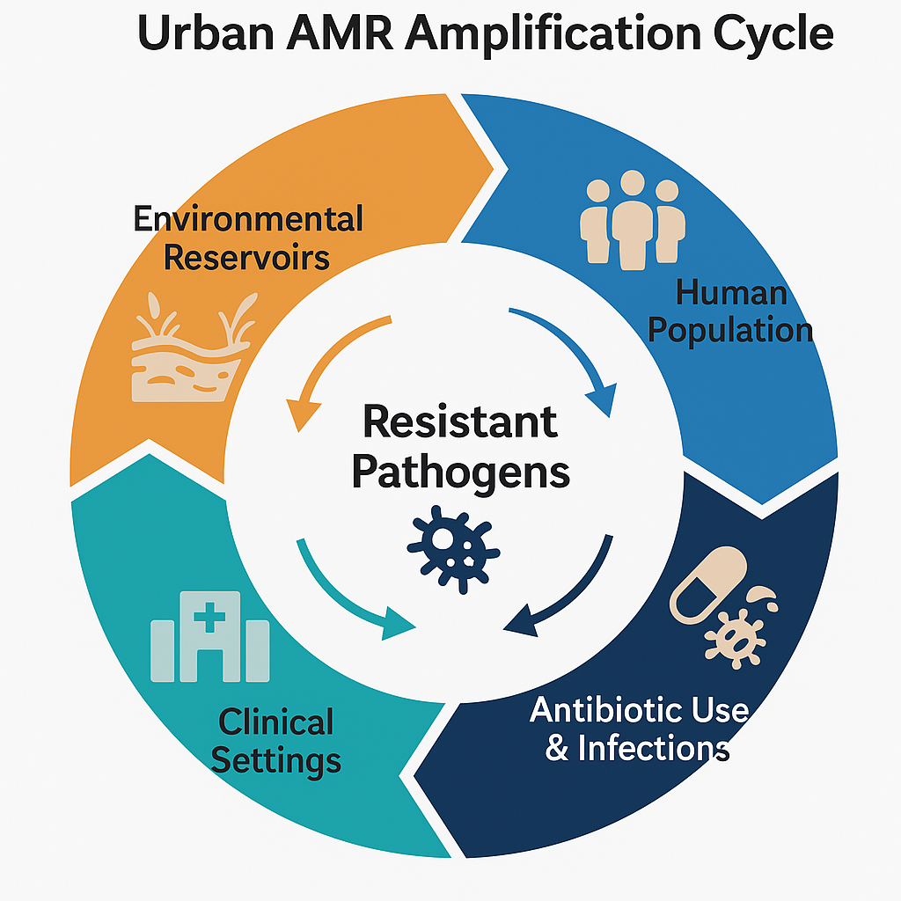
Figure 2. Urban AMR Amplification Cycle.
Infographic illustrating the cyclical reinforcement of antimicrobial resistance (AMR) between environmental reservoirs, human populations, antibiotic use and infections, and clinical settings. Arrows indicate continuous feedback loops through which resistant pathogens and resistance genes circulate, amplifying AMR across urban ecosystems.

Table 1. Evidence-Based Sources and Environmental Pathways of Effluent-Driven Antimicrobial Resistance in Urban Ecosystems
Source | Major Contaminants | Environmental Impact | AMR Risk | Representative Studies
Pharmaceutical manufacturing effluents | Active pharmaceutical ingredients, particularly antibiotics, chemical intermediates, and antimicrobial residues | Elevated antibiotic concentrations in receiving waters, sediments, and soils create strong selection pressure on environmental microbiota | High | [13,15,21,22]
Hospital wastewater | Antibiotic residues, disinfectants, multidrug-resistant organisms, and antimicrobial resistance genes | Introduction of clinically important resistance determinants into municipal wastewater systems | High | [24,25,26,27,29]
Municipal wastewater treatment plant effluents | Residual antibiotics, resistant bacteria, resistance genes, and treated biosolids | Dissemination of resistance determinants into aquatic and terrestrial environments due to incomplete removal | High | [11,16,31]
Combined sewer overflows | Untreated sewage containing antibiotics and resistant microorganisms | Episodic release of concentrated contaminants into urban waterways during storm events | Moderate to High | [10,32]
Pharmaceutical disposal from households | Unused and expired medications are discharged into sewage systems | Continuous low-level contamination of urban water systems | Moderate | [2,13]
Landfill and dumpsite leachate | Pharmaceutical residues, antibiotics, and resistant bacteria | Contamination of surrounding soils, groundwater, and surface waters | Moderate | [17,22]
Agricultural reuse of wastewater and biosolids | Residual antimicrobials, resistant microorganisms, and resistance genes | Transfer of resistance determinants into agricultural soils and crop-associated microbiomes | High | [11,31,36]
Environmental reservoirs (rivers, sediments, wetlands, and biofilms) | Accumulated antibiotic residues and antimicrobial resistance genes | Amplification of resistance through microbial interactions and horizontal gene transfer | Very High | [12,33,35,37]
- Mitigation Strategies & Regulatory Responses
Mitigating effluent-driven antimicrobial resistance requires integrated legislative, technological and operational interventions across healthcare, industrial and environmental sectors. Several countries have established or proposed guidelines for the discharge of antibiotics and resistant microorganisms into the environment, but these rules differ considerably in scope and enforcement. The Water Framework Directive of the European Union requires the monitoring of specific priority compounds. Recent AMR action plans have also called for the monitoring of antibiotic residues and resistance genes in the environment [4]. In India, draft guidelines have proposed limits for important antibiotics, including ciprofloxacin and azithromycin, in wastewater from pharmaceutical manufacturing. Sweden has taken a more precautionary approach by incorporating environmental risk assessments into procurement procedures to encourage greener production. However, in most regions, legally binding limits on effluent antibiotics remain limited, and hospital wastewater pretreatment standards are still the exception rather than the rule [6].

On the technological front, several advanced treatment options have demonstrated potential to reduce antibiotic loads and resistance gene abundance in effluents:
- Advanced oxidation processes (AOPs), including ozonation, photocatalysis and Fenton-based methods, can degrade a broad spectrum of antibiotics and disrupt genetic material.
- Advanced filtration technologies, such as nanofiltration, reverse osmosis and membrane bioreactors (MBRs), offer high removal efficiencies for both chemical residues and microbial contaminants.
- Constructed wetlands and hybrid ecological systems combine physical, chemical and biological removal mechanisms, providing low-energy, adaptable solutions for decentralised hospital or pharmaceutical wastewater treatment [38].
Despite encouraging pilot and full-scale applications, widespread implementation remains uneven because of high capital costs, operational demands, limited technical capacity and the absence of enforceable performance standards. Furthermore, treatment effectiveness is often evaluated primarily through chemical removal efficiency rather than reductions in antimicrobial resistance genes and their downstream dissemination [39]. Regulatory enforcement challenges further constrain mitigation efforts, particularly in low- and middle-income countries where monitoring capacity and environmental oversight may be limited. Inadequate pharmaceutical disposal systems, untreated combined sewer overflows and fragmented global supply chains collectively undermine accountability and environmental stewardship [40].
Addressing these challenges requires integrated policy frameworks that incorporate environmental surveillance, mandatory pretreatment requirements for high-risk effluents, incentives for cleaner manufacturing technologies and strengthened public education on pharmaceutical disposal within a One Health governance model.

8. Conclusions

Pharmaceutical manufacturing effluents and hospital wastewater constitute important environmental pathways through which antimicrobial residues, resistant microorganisms and antimicrobial resistance genes enter urban ecosystems. Inadequate treatment processes and uncontrolled discharges may promote resistance selection, persistence and dissemination across wastewater systems, surface waters, sediments, soils and other environmental compartments. These processes contribute to the establishment of environmental reservoirs that facilitate the circulation of resistance determinants between ecological and human systems.
Addressing effluent-driven antimicrobial resistance requires strengthened environmental surveillance, improved wastewater treatment infrastructure, responsible pharmaceutical waste management and enforceable discharge regulations. Greater integration of environmental considerations into antimicrobial stewardship efforts is also essential to reduce resistance amplification beyond clinical settings. A One Health framework that connects public health, environmental protection, healthcare systems and pharmaceutical production provides an effective foundation for coordinated action against this multifaceted challenge.
By advancing evidence-based policies, investing in sustainable treatment technologies and strengthening cross-sector collaboration, urban ecosystems can shift from reservoirs of resistance emergence towards critical components of global antimicrobial resistance prevention and control strategies.
Limitations
This review is limited by its narrative design and reliance on previously published studies and reports. It does not include a reproducible systematic search record, formal quality appraisal, risk-of-bias assessment or quantitative meta-analysis. The included evidence varies across geography, sampling design, analytical methods, wastewater sources and treatment conditions, which limits direct comparison. Some regions with weak environmental monitoring may be underrepresented.

Future Directions

Future research should expand the application of wastewater-based epidemiology as a tool for monitoring population-level resistance trends and identifying environmental hotspots of resistance emergence. Advances in artificial intelligence, machine learning and digital environmental monitoring systems offer promising opportunities to improve predictive risk assessment, optimise surveillance efforts and support real-time decision-making. In addition, greater investment is needed in affordable and scalable wastewater treatment technologies designed specifically for low- and middle-income countries, where infrastructure limitations often increase environmental exposure risks.
From a governance perspective, stronger One Health frameworks are required to integrate environmental regulators, public health authorities, water utilities, healthcare institutions and the pharmaceutical industry into coordinated antimicrobial resistance management strategies. Future policy development should prioritise enforceable discharge standards, environmental accountability across pharmaceutical supply chains and international collaboration aimed at reducing the environmental burden of antimicrobial resistance.
By combining scientific innovation, technological advancement, environmental stewardship and coordinated governance, urban ecosystems can be transformed from reservoirs of resistance amplification into critical components of global antimicrobial resistance prevention and control efforts.

Competing Interests
The authors declare that they have no competing interests.

Declaration of AI Use
This manuscript was prepared through the combined contributions of all author(s), including contributions to the study design, data, content development, results, interpretation, and related scholarly work. The author(s) acknowledge the use of Grammarly and ChatGPT to assist with grammar checking, language refinement, reference formatting. These AI-assisted tools were not used as authors and did not replace the intellectual contributions or scholarly judgment of the author(s). All AI-assisted outputs, including content, references, and interpretations, were carefully reviewed, revised, verified, and approved by the author(s). The author(s) accept full responsibility for the accuracy, integrity, and final content of the manuscript.

REFERENCES

• World Health Organization. (2023, November 21). Antimicrobial resistance. https://www.who.int/news-room/fact-sheets/detail/antimicrobial-resistance
• Hiew, S. Y., & Low, B. Y. (2025). A systematic review of the knowledge, attitude and practice of healthcare professionals and healthcare professional students towards household pharmaceutical waste disposal. Exploratory Research in Clinical and Social Pharmacy, 17, 100556. https://doi.org/10.1016/j.rcsop.2024.100556
• Liu, N., Zhang, L., Xue, H., Yang, Z., & Meng, F. (2025). Sources, dissemination, and risk assessment of antibiotic resistance in surface waters: A review. Emerging Contaminants, 11(1), 100455. https://doi.org/10.1016/j.emcon.2024.100455
• Salam, M. A., Al-Amin, M. Y., Salam, M. T., Pawar, J. S., Akhter, N., Rabaan, A. A., & Alqumber, M. A. A. (2023). Antimicrobial resistance: A growing serious threat for global public health. Healthcare, 11(13), 1946. https://doi.org/10.3390/healthcare11131946
• Tang, K. W. K., Millar, B. C., & Moore, J. E. (2023). Antimicrobial resistance (AMR). British Journal of Biomedical Science, 80, 11387. https://doi.org/10.3389/bjbs.2023.11387
• Muteeb, G., Rehman, M. T., Shahwan, M., & Aatif, M. (2023). Origin of antibiotics and antibiotic resistance, and their impacts on drug development: A narrative review. Pharmaceuticals, 16(11), 1615. https://doi.org/10.3390/ph16111615
• Emamalipour, M., Seidi, K., Zununi Vahed, S., Jahanban-Esfahlan, A., Jaymand, M., Majdi, H., Amoozgar, Z., Chitkushev, L. T., Javaheri, T., Jahanban-Esfahlan, R., & Zare, P. (2020). Horizontal gene transfer: From evolutionary flexibility to disease progression. Frontiers in Cell and Developmental Biology, 8, 229. https://doi.org/10.3389/fcell.2020.00229
• Sharma, S., Mohler, J., Mahajan, S. D., Schwartz, S. A., Bruggemann, L., & Aalinkeel, R. (2023). Microbial biofilm: A review on formation, infection, antibiotic resistance, control measures, and innovative treatment. Microorganisms, 11(6), 1614. https://doi.org/10.3390/microorganisms11061614
• Mehanni, M. M., Gadow, S. I., Alshammari, F. A., Modafer, Y., Ghanem, K. Z., El-Tahtawi, N. F., El-Homosy, R. F., & Hesham, A. E.-L. (2023). Antibiotic-resistant bacteria in hospital wastewater treatment plant effluent and the possible consequences of its reuse in agricultural irrigation. Frontiers in Microbiology, 14, 1141383. https://doi.org/10.3389/fmicb.2023.1141383
• Jung, Y. E., Jeong, M. M., Jun, H., & Smith, T. (2023). Contemplation of improvement efforts to manage combined sewer overflows. Infrastructures, 8(10), 150. https://doi.org/10.3390/infrastructures8100150
• Mutuku, C., Gazdag, Z., & Melegh, S. (2022). Occurrence of antibiotics and bacterial resistance genes in wastewater: Resistance mechanisms and antimicrobial resistance control approaches. World Journal of Microbiology and Biotechnology, 38(9), 152. https://doi.org/10.1007/s11274-022-03334-0
• Ripanda, A., Rwiza, M. J., Nyanza, E. C., Hossein, M., Alfred, M. S., El Din Mahmoud, A., Ananda Murthy, H. C., Bakari, R., Vuai, S. A. H., & Machunda, R. L. (2025). Ecological consequences of antibiotics pollution in sub-Saharan Africa: Understanding sources, pathways, and potential implications. Emerging Contaminants, 11(2), 100475. https://doi.org/10.1016/j.emcon.2025.100475
• Ugoeze, K., Alalor, C., Ibezim, C., Chinko, B., Owonaro, P., Anie, C., Okoronkwo, N., Mgbahurike, A., Ofomata, C., Alfred-Ugbenbo, D., & Ndukwu, G. (2024). Environmental and human health impact of antibiotics waste mismanagement: A review. Advances in Environmental and Engineering Research, 5(1), 005. https://doi.org/10.21926/aeer.2401005
• Gevao, B., Uddin, S., Krishnan, D., Rajagopalan, S., & Habibi, N. (2022). Antibiotics in wastewater: Baseline of the influent and effluent streams in Kuwait. Toxics, 10(4), 174. https://doi.org/10.3390/toxics10040174
• Liu, Y., Shi, X., Chen, X., Ding, P., Zhang, L., Yang, J., Pan, J., Yu, Y., Wu, J., & Hu, G. (2023). Spatial distribution and risk assessment of antibiotics in 15 pharmaceutical plants in the Pearl River Delta. Toxics, 11(4), 382. https://doi.org/10.3390/toxics11040382
• Gomes, M. P. (2024). The convergence of antibiotic contamination, resistance, and climate dynamics in freshwater ecosystems. Water, 16(18), 2606. https://doi.org/10.3390/w16182606
• Otoo, B. A., Amoabeng, I. A., Darko, G., & Borquaye, L. S. (2022). Antibiotic and analgesic residues in the environment: Occurrence and ecological risk study from the Sunyani municipality, Ghana. Toxicology Reports, 9, 1491–1500. https://doi.org/10.1016/j.toxrep.2022.07.003
• Shams, D. F., Izaz, M., Khan, W., Nayab, S., Tawab, A., & Baig, S. A. (2024). Occurrence of selected antibiotics in urban rivers in northwest Pakistan and assessment of ecotoxicological and antimicrobial resistance risks. Chemosphere, 352, 141357. https://doi.org/10.1016/j.chemosphere.2024.141357
• Wang, J., Yan, Z., Qiao, Y., Liu, D., Feng, C., & Bai, Y. (2023). Distribution and characterization of typical antibiotics in water bodies of the Yellow River Estuary and their ecological risks. Toxics, 11(5), 400. https://doi.org/10.3390/toxics11050400
• Pesce, S., Kergoat, L., Paris, L., Billet, L., Besse-Hoggan, P., & Bonnineau, C. (2021). Contrasting effects of environmental concentrations of sulfonamides on microbial heterotrophic activities in freshwater sediments. Frontiers in Microbiology, 12, 753647. https://doi.org/10.3389/fmicb.2021.753647
• Wu, J., Han, Z., Ma, X., Su, M., Hamidian, A. H., Zhang, Y., & Yang, M. (2025). A database on antibiotics and antibiotic resistance in wastewater and solid waste from pharmaceutical industry based on a systematic review. China CDC Weekly, 7(3), 92–100. https://doi.org/10.46234/ccdcw2025.015
• Ortúzar, M., Esterhuizen, M., Olicón-Hernández, D. R., González-López, J., & Aranda, E. (2022). Pharmaceutical pollution in aquatic environments: A concise review of environmental impacts and bioremediation systems. Frontiers in Microbiology, 13, 869332. https://doi.org/10.3389/fmicb.2022.869332
• Lawal, O., Orenolu, I. O., Ajobiewe, M. A., Mensah Forson, K. A. A., Agu, U. F., Fidelix, M. E., Madugba, F. C., & Obi, L. I. (2025). Hospital-acquired infections in the age of antimicrobial resistance and smart surveillance. Australian Journal of Biomedical Research, 1(1), aubm002. https://doi.org/10.63946/aubiomed/16759
• Endalamaw, K., Tadesse, S., Asmare, Z., Kebede, D., Erkihun, M., & Abera, B. (2024a). Antimicrobial resistance profile of bacteria from hospital wastewater at two specialized hospitals in Bahir Dar city, Ethiopia. BMC Microbiology, 24, 525. https://doi.org/10.1186/s12866-024-03693-8
• Endalamaw, K., Tadesse, S., Asmare, Z., Kebede, D., Erkihun, M., & Abera, B. (2024). Antimicrobial resistance profile of bacteria from hospital wastewater at two specialized hospitals in Bahir Dar city, Ethiopia. BMC Microbiology, 24, 525. https://doi.org/10.1186/s12866-024-03693-8
• Hounmanou, Y. M. G., Houefonde, A., I-CRECT Consortium, Nguyen, T. T., & Dalsgaard, A. (2025). Mitigating antimicrobial resistance through effective hospital wastewater management in low- and middle-income countries. Frontiers in Public Health, 12, 1525873. https://doi.org/10.3389/fpubh.2024.1525873
• Deedat, F. Z., Faya, A. M., Gumbi, B. P., Johnston, D. M. G., Karpoormath, R., & Essack, S. Y. (2025). The association between antibiotic use in hospitals and residual antibiotic concentrations in hospital effluents: A pilot study. JAC-Antimicrobial Resistance, 7(3), dlaf070. https://doi.org/10.1093/jacamr/dlaf070
• Vestel, J., Caldwell, D. J., Tell, J., Constantine, L., Häner, A., Hellstern, J., Journel, R., Ryan, J. J., Swenson, T., & Xei, W. (2022). Default predicted no-effect target concentrations for antibiotics in the absence of data for the protection against antibiotic resistance and environmental toxicity. Integrated Environmental Assessment and Management, 18(4), 863–867. https://doi.org/10.1002/ieam.4560
• Lawal, O. P., Babatunde, J. O., Owusu-Ansah, S., Ani, C. P., Adegbesan, A. C., Hashim, H., Okeke, J. C., Okei, N. C., Igunma, A. A., Ubebe, D. O., Ugoagwu, K. U., Agbo, O. S., & Ani, C. F. (2025). Antibiogram and molecular characterization of extended-spectrum β-lactamase-producing Klebsiella pneumoniae in a Nigerian teaching hospital. Microbes, Infection and Chemotherapy, 5, e2305. https://doi.org/10.54034/mic.e2305
• Marathe, N. P., Berglund, F., Razavi, M., Pal, C., Dröge, J., Samant, S., Kristiansson, E., & Larsson, D. G. J. (2019). Sewage effluent from an Indian hospital harbors novel carbapenemases and integron-borne antibiotic resistance genes. Microbiome, 7, 97. https://doi.org/10.1186/s40168-019-0710-x
• Conforti, S., Holschneider, A., Sylvestre, É., & Julian, T. R. (2024). Monitoring ESBL-Escherichia coli in Swiss wastewater between November 2021 and November 2022: Insights into population carriage. mSphere, 9(5), e00760-23. https://doi.org/10.1128/msphere.00760-23
• Punch, R., Azani, R., Ellison, C., Majury, A., Hynds, P. D., Payne, S. J., & Brown, R. S. (2025). The surveillance of antimicrobial resistance in wastewater from a One Health perspective: A global scoping and temporal review (2014–2024). One Health, 21, 101139. https://doi.org/10.1016/j.onehlt.2025.101139
• Endale, H., Mathewos, M., & Abdeta, D. (2023). Potential causes of spread of antimicrobial resistance and preventive measures in One Health perspective—A review. Infection and Drug Resistance, 16, 7515–7545. https://doi.org/10.2147/IDR.S428837
• Elbaiomy, R. G., El-Sappah, A. H., Guo, R., Luo, X., Deng, S., Du, M., Jian, X., Bakeer, M., Li, Z., & Zhang, Z. (2025). Antibiotic resistance: A genetic and physiological perspective. MedComm, 6(11), e70447. https://doi.org/10.1002/mco2.70447
• Galgano, M., Pellegrini, F., Catalano, E., Capozzi, L., Del Sambro, L., Sposato, A., Lucente, M. S., Vasinioti, V. I., Catella, C., Odigie, A. E., Tempesta, M., Pratelli, A., & Capozza, P. (2025). Acquired bacterial resistance to antibiotics and resistance genes: From past to future. Antibiotics, 14(3), 222. https://doi.org/10.3390/antibiotics14030222
• Kusi, J., Ojewole, C. O., Ojewole, A. E., & Nwi-Mozu, I. (2022). Antimicrobial resistance development pathways in surface waters and public health implications. Antibiotics, 11(6), 821. https://doi.org/10.3390/antibiotics11060821
• Ma, L. C., Zhao, H. Q., Wu, L. B., Cheng, Z. L., & Liu, C. (2023). Impact of the microbiome on human, animal, and environmental health from a One Health perspective. Science in One Health, 2, 100037. https://doi.org/10.1016/j.soh.2023.100037
• Kaur, A., Arora, S., Kumar, A., Karnwal, A., & Singh, R. (2026). Nature-based wastewater treatment technologies: A comprehensive review of constructed wetlands and vermifiltration. Cleaner Water, 5, 100204. https://doi.org/10.1016/j.clwat.2026.100204
• Raju, N. P., Dhanorkar, M., & Singh, P. (2025). The interplay between antimicrobial resistance genes and emerging contaminants in wastewater treatment plants: Key players in One Health. Annals of Microbiology, 75, 28. https://doi.org/10.1186/s13213-025-01814-w
• Nyarko, K., Whale, J., & Urmee, T. (2023). Drivers and challenges of off-grid renewable energy-based projects in West Africa: A review. Heliyon, 9(6), e16710. https://doi.org/10.1016/j.heliyon.2023.e16710
• Muthoni, E., Mbogo, K., Mutoro, C., Kagendo, D., & Marangu, V. M. (2025). Surveillance of antibiotic resistance in Gram-negative bacteria from industrial wastewater in Nairobi. Chemical Science International Journal, 34(3), 38–46. https://doi.org/10.9734/CSJI/2025/v34i3966
• Nwajiobi, F. O., Chukwujekwu, A. G., Nwozor, N. C., Ogu, C. T., Ikegwuonu, A. E., & Anene, C. C. (2026). Molecular detection of carbapenemase and fluoroquinolone resistance genes in Pseudomonas aeruginosa isolated from hospital waste. Asian Journal of Microbiology and Biotechnology, 11(1), 30–37. https://doi.org/10.56557/ajmab/2026/v11i110098
• Satyaprakash, K., Pesingi, P. K., Das, A., Vineeth, M. R., Malik, S. V. S., Barbuddhe, S. B., & Rawool, D. B. (2024). Occurrence of multidrug-resistant (MDR) extended-spectrum beta-lactamase (ESBL)-producing Escherichia coli in wastewater and natural water sources from the eastern part of Uttar Pradesh, India. Water, Air, & Soil Pollution, 235, 125. https://doi.org/10.1007/s11270-024-06914-y
• Khatun, M. S., Afrin, N., Wahra, M. A. A., Rashid, I., & Hossain, M. S. (2025). Prevalence of multi-drug-resistant bacteria in wastewater of Gazipur district, Bangladesh. The Microbe, 8, 100447. https://doi.org/10.1016/j.microb.2025.100447
• Sayem, M., Rafi, M. A., Mishu, I. D., & Mahmud, Z. (2025). Comprehensive genomic analysis reveals virulence and antibiotic resistance genes in a multidrug-resistant Bacillus cereus isolated from hospital wastewater in Bangladesh. Scientific Reports, 15, 22915. https://doi.org/10.1038/s41598-025-06655-w

