Evaluation of Cytoplasmic and Stromal Components of Diseased Skin Tissue with Annatto Seed-Pigment Crude Extract

ABSTRACT
Background: Interest in natural dyes has increased because of their biodegradability, low toxicity, and widespread availability. Some components of natural dyes, such as the polyphenols present in Bixa orellana (annatto), exhibit a high affinity for denatured and inflammatory proteins, a characteristic that may enhance their binding to diseased tissues.
Aim: This study aimed to evaluate the staining of cytoplasmic and stromal components in diseased skin tissues using crude annatto seed-pigment extracts.
Study Design: This was an experimental study. Crude extracts prepared using 95% ethanol and acetone as solvents were compared with the conventional eosin counterstain. They were applied to skin tissue sections with three established histopathological diagnoses: chronic granulomatous inflammation, lichen planus, and chronic spongiotic dermatitis.
Methodology: Pigment from Bixa orellana was extracted with 95% ethanol and acetone using the maceration method. One hundred grams of seeds were soaked in 200 mL of 95% ethanol, and another 100 g were soaked in 200 mL of acetone at 25 °C for 72 h. A total of 90 archived skin-tissue blocks were used: 30 with chronic granulomatous inflammation, 30 with lichen planus, and 30 with chronic spongiotic dermatitis. Phytochemicals of interest were determined using a UV-visible spectrophotometer, and the stability of the extracts was evaluated. The extracts were used to stain the tissues and were compared with the standard eosin counterstain.
Results: Quantitative screening identified polyphenols and carotenoids as the two major components, at mean concentrations of 67 mg/mL and 27 mg/mL, respectively. Both the 95% ethanol and acetone extracts remained stable for at least eight weeks. The staining assessment showed that the 95% ethanol extract performed better as a counterstain than the acetone extract, although both were inferior to standard eosin. Nevertheless, both extracts demonstrated all evaluated parameters. The Kruskal-Wallis comparisons of haematoxylin and eosin (H&E), haematoxylin with 95% ethanol extract, and haematoxylin with acetone extract in chronic granulomatous inflammation, lichen planus, and chronic spongiotic dermatitis showed that H&E generally had the highest mean rank (10.5), followed by haematoxylin with 95% ethanol extract (up to 6.5) and haematoxylin with acetone extract (up to 3.5), with p < 0.05.
Conclusion: A staining approach termed the Haematoxylin and Annatto Seed Pigment Extract (ASPE) technique was established for use in skin-disease sections. It requires only minor modification. Its plant origin may provide an environmentally friendly option and reduce dependence on imported synthetic dyes.
Keywords: Annatto; Bixa orellana; cytoplasmic staining; stromal staining; histopathology; natural dye; eosin alternative; diseased skin tissue

- INTRODUCTION
The skin is the largest organ of the integumentary system in humans (Gaikwad et al., 2016) and has a surface area of 1.5–2 m², covering the surface of the human body. It is in direct contact with the external environment and protects the body from environmental factors (Chambers & Vukmanovic-Stejic, 2020).

Although skin diseases are among the most frequently occurring human illnesses, the specialised layers and histochemical components of the skin act together to support immune resilience and facilitate an appropriate response to health challenges within a short time frame. Consequently, the histomorphology of the skin covering any region contributes substantially to protection against disease development, as has been reported for the cervix (Ndubuka et al., 2019a). Microscopic demonstration of skin-tissue constituents through staining with biological dyes establishes, confirms, and provides supportive evidence for disease identification, development, differentiation, and possible prognosis, thereby informing treatment and management (Ndubuka et al., 2019b).

Skin and subcutaneous disorders were the fourth leading cause of non-fatal disease burden worldwide in 2010 (Hay et al., 2014), and chronic skin diseases have a substantial effect on daily life (Evers et al., 2008). Furthermore, studies have shown that a high proportion of skin lesions remain undiagnosed or incorrectly classified even after clinical and histological evaluation, reflecting significant clinicopathological discordance in dermatology (Skuhala et al., 2022; Patterson, 2016).
Histological stains are substances or biological dyes that colour tissues to aid the optical differentiation of tissue components (Avwioro, 2010). Dyes are coloured substances that impart colour to materials such as textiles, cosmetics, food, drugs, rubber, plastics, hair, fur, and tissues. Dyes may be natural or synthetic (Bhuyan & Saikia, 2005). Stains are prepared from dyes manufactured to rigid specifications or subjected to strict quality-assurance procedures to ensure their suitability for this specialised purpose.
Bixa orellana (annatto) is popularly known as achiote or the lipstick tree. In south-eastern Nigeria, the Igbo reportedly used it for cosmetic purposes during the Nigeria–Biafra War, and it is now grown as an ornamental shrub in the region. Central and South American populations have also used the seeds to colour their bodies and lips.
Carotenoids are major natural pigments responsible for yellow-to-red colouration and are synthesised mainly by plants, algae, and certain photosynthetic bacteria (Saikia & Das, 2023). Organic-solvent extraction has also been used to recover constituents from Bixa orellana seeds, including ethanolic seed extracts (Abayomi et al., 2014). Annatto is a source of bixin, an apocarotenoid whose biosynthesis in Bixa orellana is influenced by the developmental stage of the plant (Machado et al., 2024).
Conventional haematoxylin and eosin (H&E) staining remains the standard technique for the histopathological evaluation of skin tissues; however, eosin is synthetic, relatively costly, and potentially environmentally hazardous (Suvarna et al., 2019). There is therefore an increasing need to explore safe, cost-effective, environmentally friendly, and locally available alternatives that can provide useful cytoplasmic contrast for dermatopathological assessment (Aiswarya et al., 2025).
Recent evaluations of plant-derived pigments indicate that selected natural dyes can demonstrate cytoplasmic, muscular, and collagenous components, although staining quality depends on pigment chemistry, pH, and preparation conditions (Alshamar et al., 2022). A recent comparison involving Bixa orellana as a counterstain similarly reported useful tissue differentiation, while conventional H&E retained superior overall staining quality (Aiswarya et al., 2025).
Despite growing interest in plant-derived histological dyes, evidence remains limited regarding the comparative staining performance and short-term stability of ethanol- and acetone-derived annatto seed pigments in diseased human skin tissues. Their ability to distinguish cytoplasmic and stromal components across chronic granulomatous inflammation, lichen planus, and chronic spongiotic dermatitis has not been adequately established.
Study Objective
This study aimed to evaluate the staining performance of crude Bixa orellana seed-pigment extracts prepared with 95% ethanol and acetone for demonstrating cytoplasmic and stromal components in selected diseased skin tissues, using conventional eosin as the comparator.
- MATERIALS AND METHODS

2.1 Study Area
The study was conducted in the Anatomic Pathology Laboratory of the University of Port Harcourt Teaching Hospital (UPTH), located in Alakahia, Rivers State, Nigeria.
Rivers State is bounded by the Atlantic Ocean to the south, Imo and Abia States to the north, Akwa Ibom State to the east, and Bayelsa and Delta States to the west.
The state lies at coordinates 4°45′N and 6°50′E. It covers a land area of 11,077 square kilometres and has a population density of 635 people per square kilometre.
UPTH is a tertiary healthcare facility that performs multiple functions in education, diagnosis, clinical treatment, research, and the referral of medical and health-related cases. Its host communities include Aluu, Alakahia, and Choba, situated within the Ikwerre and Obio/Akpor Local Government Areas of Rivers State, whose administrative headquarters are Isiokpo and Rumuodomaya, respectively.

The teaching hospital is a 1,000-bed multispecialist centre dedicated to treatment, teaching, research, and healthcare management. The hospital operates under its parent institution, the University of Port Harcourt.

2.2 Study Design
This was an experimental study designed to evaluate the staining performance of annatto (Bixa orellana) seed extracts prepared using 95% ethanol and acetone as solvents, in comparison with the conventional eosin counterstain. The study focused on skin-tissue sections with established histopathological diagnoses of chronic granulomatous inflammation, lichen planus, and chronic spongiotic dermatitis at the University of Port Harcourt Teaching Hospital.
Grouping of Slides
For each disease, the following groups were used:
- Positive control group: The slides were stained with Mayer’s haematoxylin and eosin, with eosin serving as the standard counterstain.
- Experimental groups: Groups A, B, and C.
Group A represented chronic granulomatous inflammation. One slide was stained with Mayer’s haematoxylin and 95% ethanol annatto seed crude extract, with the latter serving as the counterstain, and another slide was stained with Mayer’s haematoxylin and acetone annatto seed crude extract, with the latter serving as the counterstain.
Group B represented lichen planus. One slide was stained with Mayer’s haematoxylin and 95% ethanol annatto seed crude extract, with the latter serving as the counterstain, and another slide was stained with Mayer’s haematoxylin and acetone annatto seed crude extract, with the latter serving as the counterstain.
Group C represented chronic spongiotic dermatitis. One slide was stained with Mayer’s haematoxylin and 95% ethanol annatto seed crude extract, with the latter serving as the counterstain, and another slide was stained with Mayer’s haematoxylin and acetone annatto seed crude extract, with the latter serving as the counterstain.

Sample Size
Ninety skin-tissue blocks were used to prepare slides comprising three skin diseases, three staining techniques, and two duplicates of each.
2.3 Eligibility Criteria
Inclusion Criteria
The study included formalin-fixed, paraffin-embedded skin-biopsy specimens with confirmed histopathological diagnoses of skin disease. Only tissue blocks with well-preserved epidermal and dermal components were included, and all specimens had been routinely processed using standard histopathological techniques before selection for the study.

Exclusion Criteria
Poorly fixed or autolysed skin-tissue samples, tissue sections exhibiting extensive processing artefacts, specimens with incomplete epidermal or dermal layers, and tissue blocks with insufficient material for repeat sectioning and staining were excluded from the study.

2.4 Plant Identification
The seeds were obtained from a garden in Ubima, Rivers State. Taxonomic identification of the plant and assignment of the specimen voucher number were carried out in the Department of Plant Science and Biotechnology, Rivers State University, Port Harcourt. The voucher specimen number RSUPBH0196 was assigned by Dr M. G. Ajuru.

2.5 Pigment Extraction and Phytochemical analysis procedure
The annatto seeds were cleaned to remove dirt and then weighed. One hundred grams of annatto seeds were soaked in 200 mL of 95% ethanol, and another 100 g were soaked in 200 mL of acetone. Pigment was extracted from annatto seeds (Bixa orellana) in 95% ethanol and acetone by maceration for three days at room temperature, with occasional agitation (Rodriguez-Amaya, 2016). The extracts were filtered once through Whatman filter paper and stored in brown bottles until use. The pH values of the 95% ethanol and acetone extracts were adjusted to 5.8 and 4.5, respectively. One hundred grams of seeds were used for extraction for phytochemical analysis. The sample was then prepared in accordance with ISO 17025. Phytochemicals of interest were determined using a UV-visible spectrophotometer (UV-Visible 752pro), which operates on the principle of spectrophotometry through scan analysis over a wavelength range of 200–1,100 nm. At each wavelength, the absorbance was compared with the UV-developed reference standard for the phytochemicals. This enabled determination of the phytochemicals present. Quantification was performed using the dilution factor and the Beer–Lambert law, and the resulting concentrations were expressed in mg/mL.

2.6 Stability Period Evaluation
The stability of the acetone and 95% ethanol crude annatto seed extracts was evaluated over eight weeks at room temperature by monitoring absorbance with a UV-visible spectrophotometer, measuring pH with a pH meter, assessing sedimentation or separation by visual observation, and evaluating odour by sensory perception (Scotter, 1995; Lawless & Heymann, 2010; McGuire, 1992). Absorbance measurements were performed in triplicate, and the mean values were calculated. The percentage retention of pigment was calculated to assess stability.

2.7 Staining Procedure:
Positive Control: Hematoxylin and Eosin Staining
Paraffin-embedded tissue sections were first deparaffinised in xylene and rehydrated through a descending ethanol series, followed by rinsing in distilled water. The slides were then immersed in Mayer’s haematoxylin solution for 15 minutes to stain the nuclei, differentiated in 1% acid alcohol, and blued with ammonia water. Counterstaining was performed with eosin for 1 minute to highlight cytoplasmic and stromal elements. The sections were dehydrated through ascending concentrations of alcohol, cleared in xylene, and mounted in DPX. See Table 1.

Table 1: Hematoxylin and Eosin Staining Technique
Step | Procedure | Reagent | Time
1. | Deparaffinization | Xylene | 5 minutes
2. | Deparaffinization | Xylene | 5 minutes
3. | Rehydration | 100% Ethanol | 3 minutes
4. | Rehydration | 90% Ethanol | 3 minutes
5. | Rehydration | 70% Ethanol | 3 minutes
6. | Rehydration | 50% Ethanol | 3 minutes
7. | Rehydration | Distilled water | 3 minutes
8. | Nuclear staining | Mayers hematoxylin | 15 minutes
9. | Washing | Running tap water | 3 minutes
10. | Differentiation | 1% acid alcohol | 3 seconds
11. | Washing | Running tap water | 3 minutes
12. | Counterstaining | Eosin | 1 minute
13. | Dehydration | 70% Ethanol | 2 minutes
14. | Dehydration | 90% Ethanol | 2 minutes
15. | Dehydration | 100% Ethanol | 2 minutes
16. | Dehydration | 100% Ethanol | 2 minutes
17. | Clearing | Xylene | 3 minutes
18 | Clearing | Xylene | 3 minutes
Experimental Group: Acetone Extract
Sections were dewaxed in xylene and brought to distilled water through descending concentrations of ethyl alcohol (100%, 90%, 70%, and 50%). They were stained with Mayer’s haematoxylin for 15 minutes and rinsed in running tap water. The sections were differentiated with 1% acid alcohol until only the nuclei remained stained, rinsed in running tap water, and blued in ammoniacal water for 1 minute. They were then counterstained with the acetone extract for 15 minutes, dehydrated through ascending alcohol concentrations, cleared in xylene, and mounted in DPX. See Table 2.

Table .2: Hematoxylin and Acetone Extract Staining Technique
Step | Procedure | Reagent | Time
1. | Deparaffinization | Xylene | 5 minutes
2. | Deparaffinization | Xylene | 5 minutes
3. | Rehydration | 100% Ethanol | 3 minutes
4. | Rehydration | 90% Ethanol | 3 minutes
5. | Rehydration | 70% Ethanol | 3 minutes
6. | Rehydration | 50% Ethanol | 3 minutes
7. | Rehydration | Distilled water | 3 minutes
8. | Nuclear staining | Mayers hematoxylin | 15 minutes
9. | Washing | Running tap water | 3 minutes
10. | Differentiation | 1% acid alcohol | 3 seconds
11. | Washing | Running tap water | 3 minutes
12. | Counterstaining | Acetone extract | 15 minutes
13. | Dehydration | 70% Ethanol | 2 minutes
14. | Dehydration | 90% Ethanol | 2 minutes
15. | Dehydration | 100% Ethanol | 2 minutes
16. | Dehydration | 100% Ethanol | 2 minutes
17. | Clearing | Xylene | 3 minutes
18 | Clearing | Xylene | 3 minutes

95% Ethanol Extract:
Sections were dewaxed in xylene and brought to distilled water through descending concentrations of ethyl alcohol (100%, 90%, 70%, and 50%). They were stained with Mayer’s haematoxylin for 15 minutes and rinsed in running tap water. The sections were differentiated with 1% acid alcohol until only the nuclei remained stained, rinsed in running tap water, and blued in ammoniacal water for 1 minute. They were then counterstained with the 95% ethanol extract for 15 minutes, dehydrated through ascending alcohol concentrations, cleared in xylene, and mounted in DPX. See Table 3.

Table 3: Hematoxylin and 95% Ethanol Extract Staining Technique
Step | Procedure | Reagent | Time
1. | Deparaffinization | Xylene | 5 minutes
2. | Deparaffinization | Xylene | 5 minutes
3. | Rehydration | 100% Ethanol | 3 minutes
4. | Rehydration | 90% Ethanol | 3 minutes
5. | Rehydration | 70% Ethanol | 3 minutes
6. | Rehydration | 50% Ethanol | 3 minutes
7. | Rehydration | Distilled water | 3 minutes
8. | Nuclear staining | Mayers hematoxylin | 15 minutes
9. | Washing | Running tap water | 3 minutes
10. | Differentiation | 1% acid alcohol | 3 seconds
11. | Washing | Running tap water | 3 minutes
12. | Counterstaining | 95% Ethanol extract | 15 minutes
13. | Dehydration | 70% Ethanol | 2 minutes
14. | Dehydration | 90% Ethanol | 2 minutes
15. | Dehydration | 100% Ethanol | 2 minutes
16. | Dehydration | 100% Ethanol | 2 minutes
17. | Clearing | Xylene | 3 minutes
18 | Clearing | Xylene | 3 minutes

2.8 Statistical analysis
Data generated from the study were expressed as mean rank ± standard deviation (SD). The scores were analysed using SPSS version 24 (IBM, Armonk, NY, USA). Statistical significance was set at p < 0.05, and the results were presented in tabular form.

RESULTS
4.1 Quantitative Screening for Phytochemical Components in the Annatto Seed
Phytochemical analysis of the annatto seed constituents revealed two major components: polyphenols and carotenoids, with mean concentrations of 67 mg/mL and 27 mg/mL, respectively. The polyphenol group included phenolic acids, lignans, stilbenes, and phenols, while the carotenoid group included alpha-carotene, beta-carotene, and lycopene. Isorotenoids were not detected, as shown in Table 4.

Table 4. Quantitative Screening for Phytochemical Components in the Annatto Seed
S/N. | Components | Qualitative | Quantitative (mg/ml)
1 | Polyphenol |  | 67.00
A | Phenolic Acid | +
B | Lignans | +
C | Stibenes | +
D | Phenol | +
2 | Carotenoids |  | 27.00
A | Alpha Carotene | +
B | Beta Carotene | +
C | Lycopene | +
D | Iso-rotenoids | -

Key for qualitative result:
+ Detected, - Not detected.

4.2 Evaluation of Stability Period of 95% Ethanol Extract
The findings on the stability of the 95% ethanol extract, presented in Table 5, showed that the extract remained stable over an eight-week observation period at a storage temperature of 25 °C. There was no measurable change in absorbance at 400 nm, no observable change in colour intensity, no development of a foul or rancid odour, minimal sedimentation, and no variation in pH, which remained constant at 5.8. The stability assessment showed 100% pigment retention during storage, with no measurable change in pigment concentration.
Absorbance measurement @ 400nm (week 1): 0.8157
Absorbance measurement @ 400nm (week 8): 0.8157
Δ Absorbance approximately 0.0000.

Table 5 Evaluation of Stability Period of 95% Ethanol Extract
Date | (Weeks)  Time Point | Storage Temperature (ºC) | Absorbance@400nm (mean) | Pigment Retention  (%) | pH | Sedimentation | Colour/Appearance | Odour
01-03-2025 | T₀ | 25 | 0.8157 | 100 | 5.8 | None | Brown-Orange | No rancid
08-03-2025 | T₁ | 25 | 0.8157 | 100 | 5.8 | Minimal | Same | No rancid
15-03-2025 | T₂ | 25 | 0.8157 | 100 | 5.8 | Minimal | Same | No rancid
22-03-2025 | T₃ | 25 | 0.8157 | 100 | 5.8 | Minimal | Same | No rancid
29-03-2025 | T₄ | 25 | 0.8157 | 100 | 5.8 | Minimal | Same | No rancid
05-04-2025 | T₅ | 25 | 0.8157 | 100 | 5.8 | Minimal | Same | No rancid
12-04-2025 | T₆ | 25 | 0.8157 | 100 | 5.8 | Minimal | Same | No rancid
19-04-2025 | T₇ | 25 | 0.8157 | 100 | 5.8 | Minimal | Same | No rancid
26-04-2025 | T₈ | 25 | 0.8157 | 100 | 5.8 | Minimal | Same | No rancid

Time
T0 = Immediately after extraction
T1 = 1 week
T2 = 2 weeks
T3 = 3 weeks
T4 = 4 weeks
T5 = 5 weeks
T6 = 6 weeks
T7 = 7 weeks
T8 = 8 weeks

Evaluation of Stability Period of Acetone Extract
The findings on the stability of the acetone extract, presented in Table 6, showed that the extract remained stable over an eight-week observation period at a storage temperature of 25 °C. There was minimal variation in absorbance at 400 nm, no observable change in colour intensity, no development of a foul or rancid odour, minimal sedimentation, and no variation in pH, which remained constant at 4.5. The stability assessment showed 99.97% pigment retention during storage, corresponding to an observed pigment decrease of 0.03%.
Absorbance measurement @400nm (week 1): 0.9990
Absorbance measurement @400nm (week 8): 0.9987
Δ Absorbance: 0.0003.
0.03% observed decrease

Table 6 Evaluation of Stability Period of Acetone Extract

Date | (Weeks)  Time Point | Storage Temperature (ºC) | Absorbance@400nm (mean) | Pigment Retention  (%) | pH | Sedimentation | Colour/Appearance | Odour
01-03-2025 | T₀ | 25 | 0.9990 | 100 | 4.5 | None | Dark brown-orange | No rancid
08-03-2025 | T₁ | 25 | 0.9990 | 100 | 4.5 | Minimal | Same | No rancid
15-03-2025 | T₂ | 25 | 0.9990 | 100 | 4.5 | Minimal | Same | No rancid
22-03-2025 | T₃ | 25 | 0.9990 | 100 | 4.5 | Minimal | Same | No rancid
29-03-2025 | T₄ | 25 | 0.9990 | 100 | 4.5 | Minimal | Same | No rancid
05-04-2025 | T₅ | 25 | 0.9990 | 100 | 4.5 | Minimal | Same | No rancid
12-04-2025 | T₆ | 25 | 0.9990 | 100 | 4.5 | Minimal | Same | No rancid
19-04-2025 | T₇ | 25 | 0.9990 | 100 | 4.5 | Minimal | Same | No rancid
26-04-2025 | T₈ | 25 | 0.9987 | 99.97 | 4.5 | Minimal | Same | No rancid

Time
T0 = Immediately after extraction
T1 = 1 week
T2 = 2 weeks
T3 = 3 weeks
T4 = 4 weeks
T5 = 5 week
T6 = 6 weeks
T7 = 7 weeks
T8=8weeks
Comparative Analysis of The Three Staining Techniques on Chronic Granulomatous Inflammation Using Kruskal Wallis Test
Table 7 presents the comparative staining ability of Haematoxylin and Eosin (H&E), Haematoxylin with 95% Ethanol, and Haematoxylin with Acetone in chronic granulomatous inflammation using the Kruskal-Wallis test. The results are expressed as mean rank ± standard deviation, alongside chi-square (χ²) values and corresponding p values. For nuclear clarity, H&E demonstrated the highest mean rank (10.5 ± 0.2), followed by haematoxylin & 95% ethanol (6.5 ± 0.12), while haematoxylin & acetone showed the lowest (2.5 ± 0.01). The Kruskal-Wallis test revealed a statistically significant difference among the groups (χ² = 12.0, p = 0.004), indicating superior nuclear definition with H&E staining. Similarly, in cytoplasmic staining, H&E recorded the highest mean rank (10.5 ± 0.2), compared to haematoxylin & 95% ethanol (6.5 ± 0.3) and haematoxylin & acetone (2.5 ± 0.2), with a significant difference observed (χ² = 12.0, p = 0.005). In terms of stromal staining, H&E again exhibited the highest mean rank (10.5 ± 0.01), followed by haematoxylin & 95% ethanol (6.5 ± 0.00) and haematoxylin & acetone (2.5 ± 0.004), with a statistically significant variation (χ² = 12.0, p = 0.004). For nuclear-cytoplasmic contrast, H&E maintained the highest ranking (10.5 ± 0.02), while haematoxylin & 95% ethanol and haematoxylin & acetone had mean ranks of 5.5 ± 0.00 and 3.5 ± 0.05, respectively, with a significant difference (χ² = 8.0, p = 0.009). Likewise, tissue morphology preservation showed H&E with the highest mean rank (10.5 ± 0.023), followed by haematoxylin & 95% ethanol (5.5 ± 0.009) and haematoxylin & acetone (3.5 ± 0.05), with significant differences (χ² = 12.0, p = 0.009). For staining uniformity, H&E recorded the highest mean rank (10.5 ± 0.1), compared to haematoxylin & 95% ethanol (5.5 ± 0.087) and haematoxylin & acetone (3.5 ± 0.04), with the Kruskal-Wallis test indicating statistical significance (χ² = 8.0, p = 0.009). In assessing pathological features, H&E also ranked highest (10.5 ± 0.08), followed by haematoxylin & 95% ethanol (6.5 ± 0.012) and haematoxylin & acetone (2.5 ± 0.032), with a significant difference (χ² = 12.0, p = 0.004). Finally, for background clarity, H&E showed superior performance (10.5 ± 0.032), compared to haematoxylin & 95% ethanol (5.5 ± 0.015) and haematoxylin & acetone (3.5 ± 0.059), with a statistically significant difference (χ² = 12.0, p = 0.009).

Table 7 Comparative Analysis of the Three Staining Techniques on Chronic Granulomatous Inflammation Using Kruskal Wallis Test

Parameter | Staining Technique | Mean Rank | Standard Deviation | Chi-Square value | P value of Kruskal Wallis Test
Nuclear clarity | Hematoxylin & Eosin | 10.5 | 0.2
 | Hematoxylin & 95% Ethanol | 6.5 | 0.12 | 12.0 | 0.004
 | Hematoxylin & Acetone | 2.5 | 0.01
Cytoplasmic staining | Hematoxylin & Eosin | 10.5 | 0.2
 | Hematoxylin & 95% Ethanol | 6.5 | 0.3 | 12.0 | 0.005
 | Hematoxylin & Acetone | 2.5 | 0.2
Stromal staining | Hematoxylin & Eosin | 10.5 | 0.01
 | Hematoxylin & 95% Ethanol | 6.5 | 0.00 | 12.0 | 0.004
 | Hematoxylin & Acetone | 2.5 | 0.004
Nuclear cytoplasmic contrast | Hematoxylin & Eosin | 10.5 | 0.02
 | Hematoxylin & 95% Ethanol | 5.5 | 0.00 | 8.0 | 0.009
 | Hematoxylin & Acetone | 3.5 | 0.05
Tissue morphology preservation | Hematoxylin & Eosin | 10.5 | 0.023
 | Hematoxylin & 95% Ethanol | 5.5 | 0.009 | 12.0 | 0.009
 | Hematoxylin & Acetone | 3.5 | 0.05
Staining uniformity | Hematoxylin & Eosin | 10.5 | 0.1
 | Hematoxylin & 95% Ethanol | 5.5 | 0.087 | 8.0 | 0.009
 | Hematoxylin & Acetone | 3.5 | 0.04
Pathologic features | Hematoxylin & Eosin | 10.5 | 0.08
 | Hematoxylin & 95% Ethanol | 6.5 | 0.012 | 12.0 | 0.004
 | Hematoxylin & Acetone | 2.5 | 0.032
Background clarity | Hematoxylin & Eosin | 10.5 | 0.032
 | Hematoxylin & 95% Ethanol | 5.5 | 0.015 | 12.0 | 0.009
 | Hematoxylin & Acetone | 3.5 | 0.059

NOTE: Values are statistically significant at P˂0.05, the higher the mean rank the higher the staining ability

Comparative Analysis of the Three Staining Techniques on Lichen Planus Using Kruskal Wallis Test
Table 8 presents the comparative staining performance of Haematoxylin and Eosin (H&E), Haematoxylin with 95% Ethanol, and Haematoxylin with Acetone in lichen planus using the Kruskal-Wallis test, with results expressed as mean rank ± standard deviation, alongside chi-square (χ²) values and corresponding p values. For nuclear clarity, H&E exhibited the highest mean rank (10.5 ± 0.05), followed by haematoxylin & 95% ethanol (6.0 ± 0.01), while haematoxylin & acetone recorded the lowest (3.0 ± 0.01). The observed difference was statistically significant (χ² = 8.0, p = 0.009), indicating superior nuclear visualisation with H&E. Similarly, in cytoplasmic staining, H&E showed the highest mean rank (10.5 ± 0.5), compared to Haematoxylin & 95% ethanol (6.5 ± 0.7) and haematoxylin & acetone (2.5 ± 0.3), with a significant difference among groups (χ² = 8.0, p = 0.005). In stromal staining, H&E maintained the highest mean rank (10.5 ± 0.21), followed by haematoxylin & 95% ethanol (6.0 ± 0.010) and Haematoxylin & acetone (3.0 ± 0.014), with statistical significance observed (χ² = 8.0, p = 0.009). For nuclear–cytoplasmic contrast, H&E again ranked highest (10.5 ± 0.01), while haematoxylin & 95% ethanol and Haematoxylin & acetone had mean ranks of 5.5 ± 0.02 and 3.5 ± 0.05, respectively, with a significant difference (χ² = 12.0, p = 0.009). Similarly, tissue morphology preservation showed H&E with the highest mean rank (10.5 ± 0.03), followed by haematoxylin & 95% ethanol (6.5 ± 0.010) and haematoxylin & acetone (2.5 ± 0.05), with statistically significant variation (χ² = 12.0, p = 0.004). For staining uniformity, H&E recorded the highest mean rank (10.5 ± 0.12), compared to haematoxylin & 95% ethanol (5.5 ± 0.087) and haematoxylin & acetone (3.5 ± 0.04), with a significant difference among groups (χ² = 12.0, p = 0.010). In evaluating pathological features, H&E again demonstrated superior performance (10.5 ± 0.08), followed by haematoxylin & 95% ethanol (6.5 ± 0.012) and haematoxylin & acetone (2.5 ± 0.032), with statistical significance (χ² = 12.0, p = 0.004). Lastly, for background clarity, H&E showed the highest mean rank (10.5 ± 0.032), while haematoxylin & 95% ethanol (6.5 ± 0.015) and haematoxylin & acetone (2.5 ± 0.059) recorded lower values, with a significant difference (χ² = 12.0, p = 0.004).

Table 8 Comparative Analysis of The Three Staining Techniques on Lichen Planus Using Kruskal Wallis Test
Parameter | Staining Technique | Mean Rank | Standard Deviation | Chi-Square value | P value of Kruskal Wallis Test
Nuclear clarity | Hematoxylin & Eosin | 10.5 | 0.05
 | Hematoxylin & 95% Ethanol | 6.0 | 0.01 | 8.0 | 0.009
 | Hematoxylin & Acetone | 3.0 | 0.01
Cytoplasmic staining | Hematoxylin & Eosin | 10.5 | 0.5
 | Hematoxylin & 95% Ethanol | 6.5 | 0.7 | 8.0 | 0.005
 | Hematoxylin & Acetone | 2.5 | 0.3
Stromal staining | Hematoxylin & Eosin | 10.5 | 0.21
 | Hematoxylin & 95% Ethanol | 6.0 | 0.010 | 8.0 | 0.009
 | Hematoxylin & Acetone | 3.0 | 0.014
Nuclear cytoplasmic contrast | Hematoxylin & Eosin | 10.5 | 0.01
 | Hematoxylin & 95% Ethanol | 5.5 | 0.02 | 12.0 | 0.009
 | Hematoxylin & Acetone | 3.5 | 0.05
Tissue morphology preservation | Hematoxylin & Eosin | 10.5 | 0.03
 | Hematoxylin & 95% Ethanol | 6.5 | 0.010 | 12.0 | 0.004
 | Hematoxylin & Acetone | 2.5 | 0.05
Staining uniformity | Hematoxylin & Eosin | 10.5 | 0.12
 | Hematoxylin & 95% Ethanol | 5.5 | 0.087 | 12.0 | 0.010
 | Hematoxylin & Acetone | 3.5 | 0.04
Pathologic features | Hematoxylin & Eosin | 10.5 | 0.08
 | Hematoxylin & 95% Ethanol | 6.5 | 0.012 | 12.0 | 0.004
 | Hematoxylin & Acetone | 2.5 | 0.032
Background clarity | Hematoxylin & Eosin | 10.5 | 0.032
 | Hematoxylin & 95% Ethanol | 6.5 | 0.015 | 12.0 | 0.004
 | Hematoxylin & Acetone | 2.5 | 0.059

NOTE: Values are statistically significant at P˂0.05, the higher the mean rank the higher the staining ability
Comparative Analysis of The Three Staining Techniques on Chronic Spongiotic Dermatitis Using Kruskal Wallis Test
Table 9 presents the comparative staining ability of Haematoxylin and Eosin (H&E), Haematoxylin with 95% Ethanol, and Haematoxylin with Acetone in chronic spongiotic dermatitis using the Kruskal-Wallis test. The results are expressed as mean rank ± standard deviation, with corresponding chi-square (χ²) values and p values. For nuclear clarity, H&E recorded the highest mean rank (10.5 ± 0.2), followed by haematoxylin & 95% ethanol (6.5 ± 0.12), while haematoxylin & acetone showed the lowest (2.5 ± 0.01). This difference was statistically significant (χ² = 12.0, p = 0.004), indicating superior nuclear staining with H&E. Similarly, in cytoplasmic staining, H&E demonstrated the highest mean rank (10.5 ± 0.2), compared to haematoxylin & 95% ethanol (6.5 ± 0.3) and haematoxylin & acetone (2.5 ± 0.2), with a significant difference among groups (χ² = 12.0, p = 0.004). In stromal staining, H&E again showed the highest mean rank (10.5 ± 0.01), followed by haematoxylin & 95% ethanol (6.5 ± 0.00) and haematoxylin & acetone (2.5 ± 0.004), with a statistically significant difference (χ² = 12.0, p = 0.005). For nuclear-cytoplasmic contrast, H&E maintained the highest ranking (10.5 ± 0.02), while haematoxylin & 95% ethanol and haematoxylin & acetone recorded mean ranks of 5.5 ± 0.00 and 3.5 ± 0.05, respectively, with a significant difference (χ² = 12.0, p = 0.009). Likewise, tissue morphology preservation showed H&E with the highest mean rank (10.5 ± 0.023), followed by haematoxylin & 95% ethanol (6.5 ± 0.009) and haematoxylin & acetone (2.5 ± 0.05), with statistical significance observed (χ² = 12.0, p = 0.004). For staining uniformity, H&E recorded the highest mean rank (10.5 ± 0.1), compared to haematoxylin & 95% ethanol (6.5 ± 0.087) and haematoxylin & acetone (2.5 ± 0.04), with a significant difference among groups (χ² = 8.0, p = 0.005). In assessing pathological features, H&E again ranked highest (10.5 ± 0.08), followed by haematoxylin & 95% ethanol (6.5 ± 0.012) and haematoxylin & acetone (2.5 ± 0.032), with statistical significance (χ² = 12.0, p = 0.004). Finally, for background clarity, H&E demonstrated the highest mean rank (10.5 ± 0.032), compared to haematoxylin & 95% ethanol (6.0 ± 0.015) and haematoxylin & acetone (3.0 ± 0.059), with a significant difference (χ² = 8.0, p = 0.009).

Table 9 Comparative Analysis of The Three Staining Technique on Chronic Spongiotic Dermatitis Using Kruskal Wallis Test
Parameter | Staining Technique | Mean Rank | Standard Deviation | Chi-Square value | P value of Kruskal Wallis Test
Nuclear clarity | Hematoxylin & Eosin | 10.5 | 0.2
 | Hematoxylin & 95% Ethanol | 6.5 | 0.12 | 12.0 | 0.004
 | Hematoxylin & Acetone | 2.5 | 0.01
Cytoplasmic staining | Hematoxylin & Eosin | 10.5 | 0.2
 | Hematoxylin & 95% Ethanol | 6.5 | 0.3 | 12.0 | 0.004
 | Hematoxylin & Acetone | 2.5 | 0.2
Stromal staining | Hematoxylin & Eosin | 10.5 | 0.01
 | Hematoxylin & 95% Ethanol | 6.5 | 0.00 | 12.0 | 0.005
 | Hematoxylin & Acetone | 2.5 | 0.004
Nuclear-cytoplasmic contrast | Hematoxylin & Eosin | 10.5 | 0.02
 | Hematoxylin & 95% Ethanol | 5.5 | 0.00 | 12.0 | 0.009
 | Hematoxylin & Acetone | 3.5 | 0.05
Tissue morphology preservation | Hematoxylin & Eosin | 10.5 | 0.023
 | Hematoxylin & 95% Ethanol | 6.5 | 0.009 | 12.0 | 0.004
 | Hematoxylin & Acetone | 2.5 | 0.05
Staining uniformity | Hematoxylin & Eosin | 10.5 | 0.1
 | Hematoxylin & 95% Ethanol | 6.5 | 0.087 | 8.0 | 0.005
 | Hematoxylin & Acetone | 2.5 | 0.04
Pathologic features | Hematoxylin & Eosin | 10.5 | 0.08
 | Hematoxylin & 95% Ethanol | 6.5 | 0.012 | 12.0 | 0.004
 | Hematoxylin & Acetone | 2.5 | 0.032
Background clarity | Hematoxylin & Eosin | 10.5 | 0.032 | 8.0
 | Hematoxylin & 95% Ethanol | 6.0 | 0.015 |  | 0.009
 | Hematoxylin & Acetone | 3.0 | 0.059
NOTE: Values are statistically significant at P˂0.05, the higher the mean rank the higher the staining ability
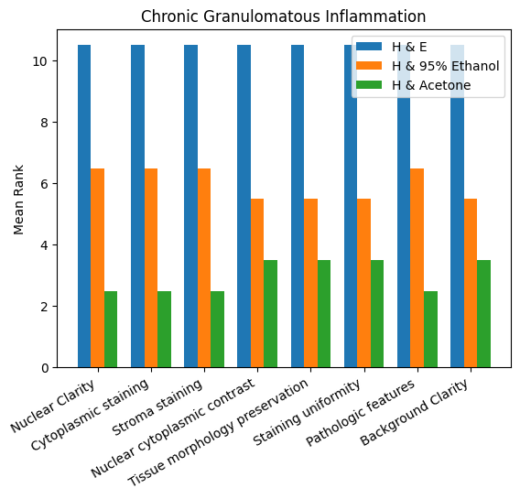
Figure 1 Bar Chart of the Three Staining Techniques on Chronic Granulomatous Inflammation

The chart compares the staining performance of haematoxylin and eosin (H&E), haematoxylin with 95% ethanol extract, and haematoxylin with acetone extract across the evaluated histological parameters in chronic granulomatous inflammation. H&E consistently had the highest mean rank for nuclear clarity, cytoplasmic staining, stromal staining, nuclear–cytoplasmic contrast, tissue-morphology preservation, staining uniformity, pathological features, and background clarity. Haematoxylin with 95% ethanol extract showed moderate performance, whereas haematoxylin with acetone extract consistently had the lowest mean ranks. Overall, H&E showed the strongest staining performance, followed by the ethanol-extract method and then the acetone-extract method.

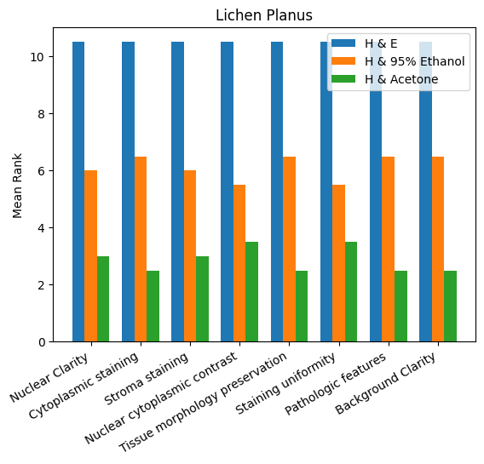
Figure 2 Bar Chart of the Three Staining Techniques on Lichen Planus

The chart compares the staining performance of haematoxylin and eosin (H&E), haematoxylin with 95% ethanol extract, and haematoxylin with acetone extract across the evaluated histological parameters in lichen planus. H&E consistently had the highest mean rank for nuclear clarity, cytoplasmic staining, stromal staining, nuclear–cytoplasmic contrast, tissue-morphology preservation, staining uniformity, pathological features, and background clarity. Haematoxylin with 95% ethanol extract showed moderate performance, whereas haematoxylin with acetone extract consistently had the lowest mean ranks. Overall, H&E showed the strongest staining performance, followed by the ethanol-extract method and then the acetone-extract method.

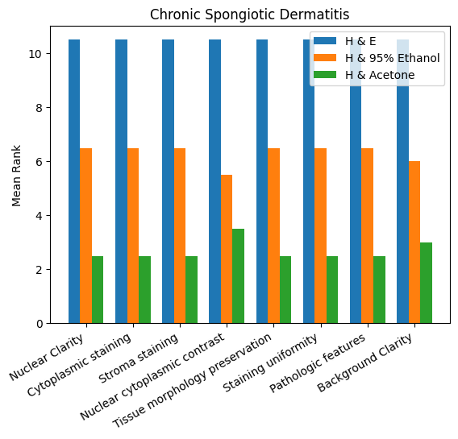
Figure.3 Bar Chart of the Three Staining Techniques on Chronic Spongiotic Dermatitis

The chart compares the staining performance of haematoxylin and eosin (H&E), haematoxylin with 95% ethanol extract, and haematoxylin with acetone extract across the evaluated histological parameters in chronic spongiotic dermatitis. H&E consistently had the highest mean rank for nuclear clarity, cytoplasmic staining, stromal staining, nuclear–cytoplasmic contrast, tissue-morphology preservation, staining uniformity, pathological features, and background clarity. Haematoxylin with 95% ethanol extract showed moderate performance, whereas haematoxylin with acetone extract consistently had the lowest mean ranks. Overall, H&E showed the strongest staining performance, followed by the ethanol-extract method and then the acetone-extract method.

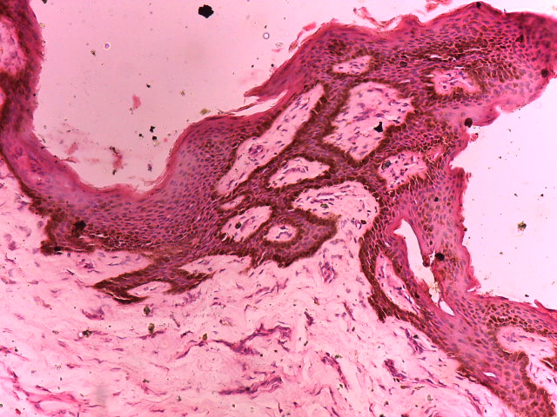
Figure.4 Photomicrograph of a Skin section diagnosed as Chronic Granulomatous Inflammation and stained with Hematoxylin and Eosin showed acanthosis and epidermolysis in a typical papillary fashion with clear nucleo-cytoplasmic differentiation in epidermis (red arrows) and dermis (black arrows). (H&E x100).

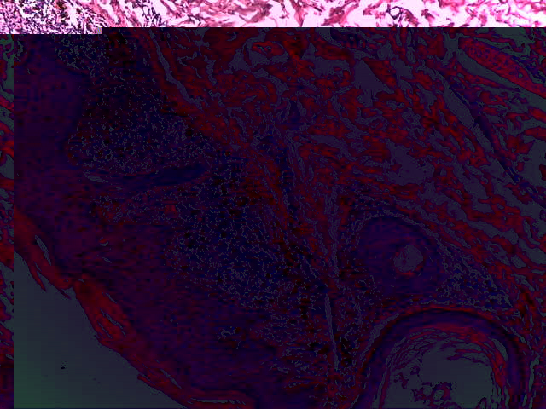
Figure.5 Photomicrograph Section of skin tissue with Lichen Planus with papilloma, nevus, cyst formation and mononuclear cell infiltration. The section showed clear stained tissue with well differentiated nucleus and cytoplasm cellularly and well delineated epidermis (blue arrows) and dermal structures (red arrows), (H&Ex400).

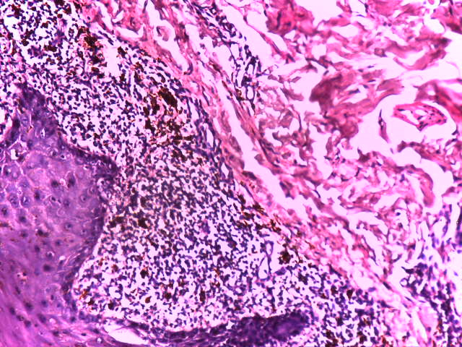
A
A
B
c
c
Figure.6. Photomicrograph section of skin tissue with chronic spongiotic dermatitis. The hematoxylin stain demonstrated clear nuclear cytoplasmic differentiation with refractive intensity between the nucleus and cytoplasm cellularly with melanocytic infiltration (blue arrows) and between the epidermis and dermis structurally showing spongiosis and hyperkeratosis. (H&E x400).

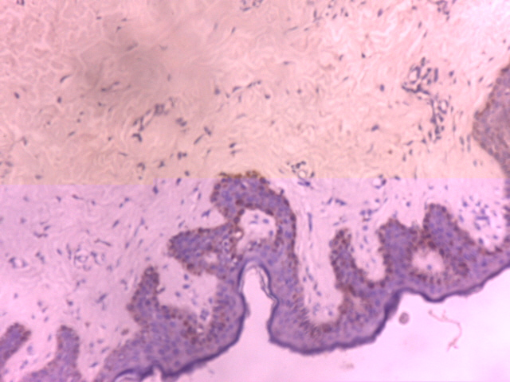
F

Figure 7 Photomicrograph of a skin section showing Chronic Granulomatous Inflammation stained with Hematoxylin and counterstained with 95% Ethanol crude Extract of Annatto seed. Section showed epidermal acanthosis (black arrows) at the epidermis but poor dermal structures expression (red arrows). (H & 95% Ethanol Extract x100).

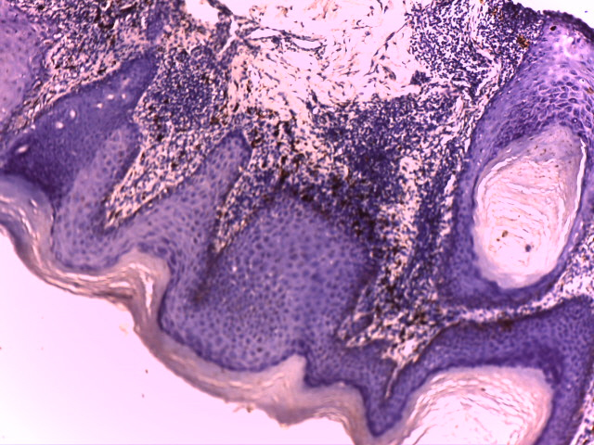
Figure.8. Photomicrograph of a section of Skin tissue from a patient with Lichen Planus. Section showed the epidermis with well demonstrated hyper keratinization (blue arrows) and pigmentation in the stratified epithelial tissue with infiltration of melanocytes (red arrows) and myxoid dermis (green arrows) with focal thinning and thickened granular layer (yellow arrow) with irregular epidermal hyperplasia. (H & 95% Ethanol Extract x400).

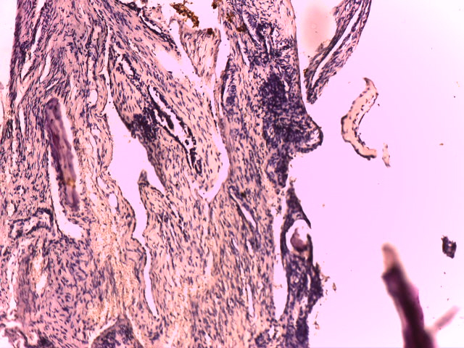
Figure.9 Photomicrograph of a section of Skin tissue from a patient with Chronic Spongiotic Dermatitis. Section showed dermal elements with fluid collection (blue arrows). (H & 95% Ethanol x100)
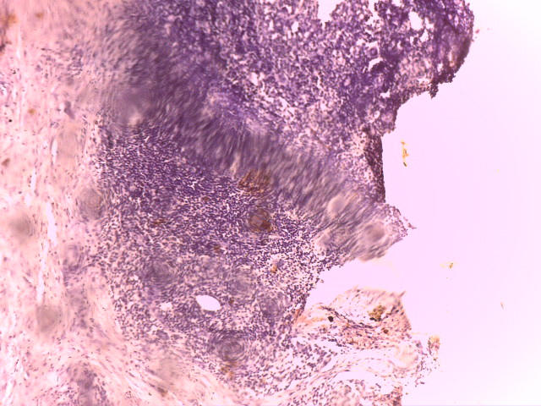
Figure 10 Photomicrograph of a section of skin tissue from a patient with Chronic Granulomatous Inflammation. Section showed granuloma dermal reaction (blue arrows). (H & Acetone Extract x100)

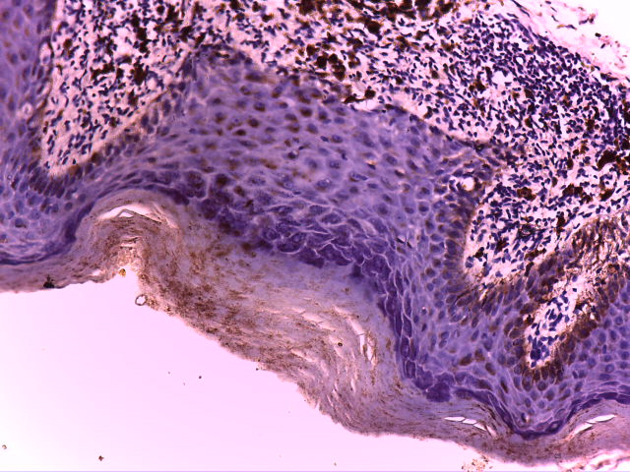
Figure.11 Photomicrograph of a section of skin tissue taken from a patient with Lichen planus. Section showed thickened epidermal layer with hyperkeratosis (black arrow) and infiltration of melanin pigments in keratinocytes. There is also infiltration of melanocytes at the hypodermis and epithelial tissue hyper-keratinization (red arrows), (H &Acetone x400)

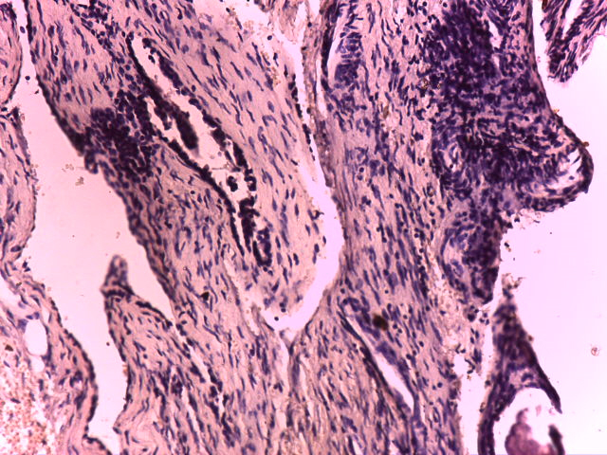
Figure.12 Photomicrograph of a section of skin tissue taken from a patient with Chronic Spongiotic Dermatitis. Section showed dermal elements with inflammatory cells (blue arrows) (H & Acetone Extract x400)

5. DISCUSSION
Phytochemical screening of the annatto (Bixa orellana) seed pigment used in this study revealed two major pigment-related groups: polyphenols and carotenoids. The identified polyphenolic compounds included phenolic acids, lignans, stilbenes, and phenols, while the carotenoid fraction comprised alpha-carotene, beta-carotene, and lycopene. Polyphenols contain several hydroxyl (-OH) groups, enabling them to form hydrogen bonds and electrostatic interactions with tissue proteins, particularly denatured and inflammatory proteins (Shahid et al., 2013). Carotenoids are highly conjugated, lipophilic pigments responsible for yellow-to-orange colouration and have an affinity for lipid-rich and proteinaceous cellular components (Rodriguez-Amaya, 2016). The predominance of polyphenols in the extract may therefore have contributed substantially to the dye–tissue interactions observed in this study.
The observed differences in staining performance between the two annatto extracts may be largely explained by their pH values. Annatto pigments behave as weak acidic dyes, and their binding to tissue components depends on the degree of ionisation, which is influenced by pH (Rodriguez-Amaya, 2016; Culling et al., 2014).
At a moderately acidic pH, such as 5.8, annatto pigments are sufficiently ionised to bind effectively to the basic amino groups of cytoplasmic and stromal proteins. This may explain the improved cytoplasmic staining, clearer stromal definition, and better contrast with haematoxylin-stained nuclei observed with the ethanol extract. Conversely, at a lower pH of 4.5, excessive protonation of tissue-binding sites may reduce dye–protein interactions, resulting in weaker overall staining intensity, as observed with the acetone extract (Suvarna et al., 2019).
The acetone and 95% ethanol extracts maintained physical and chemical stability at 25 °C during eight weeks of storage. Their pH values and colour intensity remained stable, no foul odour developed, sedimentation was minimal, and little or no change in absorbance was observed. These findings indicate that the solvents maintained the integrity of the extracts during the observation period. The observed stability is consistent with reports that pigment recovery and performance are influenced by solvent properties and extraction conditions (Jayakumar et al., 2023; Scotter, 1995).
The haematoxylin and eosin (H&E)-stained section of chronic granulomatous inflammation provided the baseline for evaluating the performance of the experimental annatto seed extracts. In the H&E slide, the epidermis was clearly stratified, with a discernible keratin layer that appeared partly separated. The granular layer was focally thinned, and acanthosis was evident, accompanied by mononuclear inflammatory infiltration. Within the dermis, multiple clusters of inflammatory cells, including mononucleated giant-cell forms, were distributed within a thin fibrous stroma. Stromal staining and tissue-morphology preservation each had a mean rank of 10.5. These features, particularly the presence of giant cells and chronic inflammatory infiltrates, are characteristic of chronic granulomatous inflammation (Kumar et al., 2020; Rosai, 2011), and the pathological-features parameter had a mean rank of 10.5. H&E provided strong contrast, with sharply defined haematoxylin-stained nuclei and vividly eosinophilic cytoplasm and stroma, facilitating recognition of pathological structures (Suvarna et al., 2019); the mean rank for nuclear–cytoplasmic contrast was 10.5. In comparison, the section stained with the 95% ethanol annatto extract in Figure 7 showed moderate cytoplasmic and stromal colouration, with the extract imparting a light-orange hue. Nuclear outlines remained identifiable, although they were less crisp than with eosin, resulting in a mean rank of 6.5 for nuclear clarity. Stromal staining had a mean rank of 6.5, while nuclear–cytoplasmic contrast had a mean rank of 5.5. Despite the limited contrast, inflammatory cell clusters, fibrous tissue, and giant-cell formations remained identifiable, and the pathological-features parameter had a mean rank of 6.5. The orange tone is consistent with carotenoid-based dyes such as bixin and norbixin derived from Bixa orellana (Rodriguez-Amaya, 2016). Its staining intensity was lower than that of eosin, as also reported in comparisons of organic counterstains (Aiswarya et al., 2025). Nevertheless, the extract demonstrated tissue architecture and cellular distribution (Prentø, 2009).
The acetone extract produced a lighter orange staining reaction than the ethanol extract, with a mean rank of 2.5 for both cytoplasmic intensity and stromal uptake, as shown in Figure 10. The reduced binding of the lipophenolic components to acidic cellular constituents may have favoured the prominence of nuclear colour over the cytoplasm. Nuclear features remained visible, with a mean rank of 2.5, but the contrast was lower than that observed with both the ethanol extract and standard eosin. The lighter staining produced by the acetone extract may be attributable to differences in pigment solubility and extraction efficiency, which affect the concentration of dye components available for binding to tissue proteins (Jayakumar et al., 2023). Major tissue structures, including the epidermal layers, inflammatory infiltrates, fibrous stroma, and giant cells, remained demonstrable; tissue-morphology preservation and demonstration of pathological features each had a mean rank of 3.5. However, these structures required more careful assessment because of the reduced optical contrast, consistent with reports of weaker plant-dye uptake under less favourable preparation conditions (Aiswarya et al., 2025).
The H&E-stained section of lichen planus served as the diagnostic benchmark for evaluating the staining performance of the annatto extracts. In the H&E preparation, the epidermis demonstrated prominent acanthosis, focal thinning, and a thickened granular layer, which are typical features of lichen planus, in which hypergranulosis and irregular epidermal hyperplasia are characteristic findings (Kumar et al., 2020). The whorl-like separation of keratin strands due to oedema reflected surface orthokeratosis, another feature reported in chronic lichenoid dermatitis. The presence of colloid bodies (Civatte bodies) was particularly important because these apoptotic keratinocytes are characteristic indicators of interface dermatitis and lichen planus (Suvarna et al., 2019; Patterson, 2016). Although the dermis was scanty in this section, the dense inflammatory infiltrate that limited stromal visibility was consistent with the band-like lichenoid infiltrate composed predominantly of lymphocytes, which is diagnostic of lichen planus (Kumar et al., 2020). Accordingly, all evaluated parameters had a mean rank of 10.5.
In the slide counterstained with the 95% ethanol annatto extract at pH 5.8, shown in Figure 8, the epidermal and dermal features remained clearly distinguishable despite the light-orange colour imparted by the carotenoid-based pigments. Acanthosis, thickening of the granular layer, keratin separation, and Civatte bodies were visualised, indicating preservation of the architecture required to recognise lichenoid interface dermatitis. Tissue-morphology preservation and demonstration of pathological features each had a mean rank of 6.5. The moderately acidic pH of 5.8 may have favoured ionisation of the annatto seed pigments and enhanced their interaction with basic cytoplasmic and stromal proteins (Kiernan, 2015; Suvarna et al., 2019). The darker orange staining of Civatte bodies suggested greater dye affinity for apoptotic keratinocytes. This uptake may reflect protein denaturation within Civatte bodies, which exposes binding sites for acidic, protein-reactive dyes (Prentø, 2009).
The acetone extract at pH 4.5, shown in Figure 11, also allowed identification of the key diagnostic features of lichen planus, including acanthosis, thickening of the granular layer, keratin separation, and Civatte bodies, but produced a substantially lighter staining reaction than the ethanol extract. Its mean rank was 2.5. The lower pH may have resulted in excessive protonation of tissue-binding sites, reducing electrostatic interactions between dye molecules and cytoplasmic proteins and thereby diminishing staining intensity (Kiernan, 2015; Culling et al., 2014). Differences in solvent extraction efficiency may also have reduced the availability of carotenoids and polyphenols for binding to tissue components (Jayakumar et al., 2023; Rodriguez-Amaya, 2016).
The basal-cell cytoplasm was particularly faint with the acetone extract, with a mean rank of 2.5, possibly because basal keratinocytes are rich in nucleoproteins and require an adequate concentration of acidic dye for optimal visualisation (Culling et al., 2014; Suvarna et al., 2019).
The H&E-stained section of chronic spongiotic dermatitis revealed epidermal vesiculation, disruption of the granular layer, variable acanthosis, and a conspicuous inflammatory reaction in the dermis. The intraepidermal vesicles, which elevated and thinned the epidermis, reflected epidermal spongiosis or microvesiculation, a feature of inflammatory and interface dermatoses (Kumar et al., 2020; Elder et al., 2018). The pathological-features parameter and the other evaluated parameters had a mean rank of 10.5.
In the section counterstained with the 95% ethanol annatto extract at pH 5.8, shown in Figure 9, the histological features, including vesiculation, disruption of the granular layer, acanthosis, and dermal inflammatory infiltration, were preserved and clearly recognisable. Tissue-morphology preservation and demonstration of pathological features each had a mean rank of 6.5. The moderately acidic pH of 5.8 may have favoured effective ionisation of the annatto pigments and enhanced electrostatic interactions with basic cytoplasmic and stromal proteins involved in inflammatory reactions (Kiernan, 2015; Suvarna et al., 2019). The orange cytoplasmic staining provided sufficient contrast, with a mean rank of 6.5, to delineate the epidermal layers and stromal changes, which also had a mean rank of 6.5, although the staining was lighter than that produced by eosin.
The acetone extract at pH 4.5, shown in Figure 12, also allowed identification of essential pathological features, including vesicles, acanthosis, disruption of the granular layer, and dermal inflammation, with a mean rank of 2.5. However, the staining intensity was noticeably weaker than that produced by the ethanol extract.

Conclusions
The study showed that annatto seed-pigment extract could demonstrate cytoplasmic and stromal components in selected diseased skin tissues when used with Mayer’s haematoxylin. Phytochemical analysis identified polyphenols and carotenoids as the major pigment-related constituents, and both the 95% ethanol and acetone extracts remained stable during the eight-week observation period at 25 °C. Among the experimental extracts, the 95% ethanol annatto extract provided better staining performance than the acetone extract, particularly for cytoplasmic and stromal visualisation. However, conventional haematoxylin and eosin staining consistently produced superior nuclear clarity, cytoplasmic contrast, stromal definition, tissue-morphology preservation, staining uniformity, and background clarity. Therefore, annatto seed-pigment extract should not yet be considered a complete substitute for eosin in routine diagnostic histopathology. With further optimisation of the extraction conditions, pH, staining time, and concentration, together with validation by blinded observers, annatto extract may serve as a plant-derived counterstain in histological teaching, research, or selected laboratory settings.

Limitations
This study was limited to three skin-disease categories and archived tissue blocks from a single setting. The staining-assessment method, number of observers, scoring scale, and blinding procedure require clearer description. Interobserver agreement was not reported. The extracts were evaluated for only eight weeks, and long-term stability was not assessed. Advanced chemical characterisation of the pigment fractions was not performed. Further validation using larger tissue sets, optimised protocols, and blinded comparison with routine eosin staining is required.
Declaration of AI Use

This manuscript was prepared through the combined contributions of all author(s), including contributions to the study design, data, content development, results, interpretation, and related scholarly work. The author(s) acknowledge the use of Grammarly and ChatGPT to assist with grammar checking, language refinement, reference formatting. These AI-assisted tools were not used as authors and did not replace the intellectual contributions or scholarly judgment of the author(s). All AI-assisted outputs, including content, references, and interpretations, were carefully reviewed, revised, verified, and approved by the author(s). The author(s) accept full responsibility for the accuracy, integrity, and final content of the manuscript.

Ethical Permit
All authors hereby declare that all experiments have been examined and approved by the appropriate ethics research committee.
Conflict of interest
All authors declare there is no conflict of interest.

REFERENCES
Abayomi, M., Adebayo, A. S., Bennett, D., Porter, R., Campbell, J. S., & Dawkin, G. (2014). Phytochemical testing and in vitro antibacterial activity of Bixa orellana (annatto) seed extract. Journal of Pharmaceutical Research International, 4(11), 1387–1399. https://doi.org/10.9734/BJPR/2014/10925
Aiswarya, A. M., Patel, B., Tiwari, H., Doria, G., Mehta, R., & Asnani, P. (2025). Alternatives to eosin in histopathological assessments: A comparison of organic stains. Journal of Oral and Maxillofacial Pathology, 29(4), 563–570. https://doi.org/10.4103/jomfp.jomfp_128_25
Alshamar, H. A., Hatem, N. A., & Dapson, R. W. (2022). Betacyanins are plant-based dyes with potential as histological stains. Biotechnic & Histochemistry, 97(7), 480–489. https://doi.org/10.1080/10520295.2022.2113142
Avwioro, O. G. (2010). Histochemistry and tissue pathology: Principles and techniques (3rd ed.). Claverianum Press. https://delsu.edu.ng/viewstaff.aspx?id=156%2F002
Bhuyan, R., & Saikia, C. N. (2005). Isolation of colour components from native dye-bearing plants in north-eastern India. Bioresource Technology, 96(4), 363–372. https://doi.org/10.1016/j.biortech.2004.02.032
Chambers, E. S., & Vukmanovic-Stejic, M. (2020). Skin barrier immunity and ageing. Immunology, 160(2), 116–125. https://doi.org/10.1111/imm.13152
Culling, C. F. A., Allison, R. T., & Barr, W. T. (2014). Cellular pathology technique (4th ed.). Elsevier. https://www.sciencedirect.com/book/monograph/9780407729032/cellular-pathology-technique
Elder, D. E., Massi, D., Scolyer, R. A., & Willemze, R. (Eds.). (2018). WHO classification of skin tumours (4th ed., Vol. 11). International Agency for Research on Cancer. https://publications.iarc.fr/Book-And-Report-Series/Who-Classification-Of-Tumours/WHO-Classification-Of-Skin-Tumours-2018
Evers, A. W. M., Duller, P., van de Kerkhof, P. C. M., van der Valk, P. G. M., de Jong, E. M. G. J., Gerritsen, M. J. P., Otero, E., Verhoeven, E. W. M., Verhaak, C. M., & Kraaimaat, F. W. (2008). The Impact of Chronic Skin Disease on Daily Life (ISDL): A generic and dermatology-specific health instrument. British Journal of Dermatology, 158(1), 101–108. https://doi.org/10.1111/j.1365-2133.2007.08296.x
Gaikwad, S. L., Kumawat, U. D., Sakhare, N. A., & D’Costa, G. F. (2016). Histopathological spectrum of skin lesions: Experience at a rural-based hospital. International Journal of Current Research, 8(8), 36223–36227. https://www.journalcra.com/article/histopathological-spectrum-skin-lesions-experience-rural-based-hospita
Hay, R. J., Johns, N. E., Williams, H. C., Bolliger, I. W., Dellavalle, R. P., Margolis, D. J., Marks, R., Naldi, L., Weinstock, M. A., Wulf, S. K., Michaud, C., Murray, C. J. L., & Naghavi, M. (2014). The global burden of skin disease in 2010: An analysis of the prevalence and impact of skin conditions. Journal of Investigative Dermatology, 134(6), 1527–1534. https://doi.org/10.1038/jid.2013.446
Jayakumar, J., Sudha, P., Rajkumar, P., Pandiselvam, R., Gurusamy, K., Kumaran, K., & Subramanian, P. (2023). Comparative study on the effect of solvents on extraction of bixin from annatto seed (Bixa orellana L.) and optimisation of process parameters using Box–Behnken design. Biomass Conversion and Biorefinery. https://doi.org/10.1007/s13399-023-04071-6
Kiernan, J. A. (2015). Histological and histochemical methods: Theory and practice (5th ed.). Scion Publishing. https://www.scionpublishing.com/shop/histological-and-histochemical-methods-fifth-edition/
Kumar, V., Abbas, A. K., & Aster, J. C. (2020). Robbins and Cotran pathologic basis of disease (10th ed.). Elsevier. https://www.elsevier.com/books/robbins-and-cotran-pathologic-basis-of-disease/kumar/9780323531139
Lawless, H. T., & Heymann, H. (2010). Sensory evaluation of food: Principles and practices (2nd ed.). Springer. https://doi.org/10.1007/978-1-4419-6488-5
Machado, K. L. de G., Faria, D. V., Duarte, M. B. S., Silva, L. A. S., Oliveira, T. dos R. de, Falcão, T. C. A., Batista, D. S., Costa, M. G. C., Santa-Catarina, C., Silveira, V., Romanel, E. A. da C., Otoni, W. C., & Nogueira, F. T. S. (2024). Plant age-dependent dynamics of annatto pigment (bixin) biosynthesis in Bixa orellana. Journal of Experimental Botany, 75(5), 1390–1406. https://doi.org/10.1093/jxb/erad458
McGuire, R. G. (1992). Reporting of objective colour measurements. HortScience, 27(12), 1254–1255. https://doi.org/10.21273/HORTSCI.27.12.1254
Ndubuka, G. I. N., Ngwogu, K. O., Ejeta, K. O., Okafor, C. W., Ajugo, E., Nwosu, I. O., & Nwosu, I. L. (2019a). The occurrence and pattern of uterine cervix lesions in the tropics: The Igbo women of eastern Nigeria experience. International Journal of Forensic Science & Pathology, 6(1), 400–406. https://doi.org/10.19070/2332-287X-1900084
Ndubuka, G. I. N., Ngwogu, K. O., Ajugo, E., Okafor, C. W., Ekezie, J., Ejeta, K. O., Nwosu, I. O., & Nwosu, I. L. (2019b). The incidence pattern, causes, and histomorphologic characters of cervical cancer in the tropics: Residents of south-eastern Nigeria experience. International Journal of Recent Scientific Research, 10(9), 35098–35105. https://doi.org/10.24327/ijrsr.2019.1009.4031
Patterson, J. W. (2016). Diagnostic clues. In J. W. Patterson (Ed.), Weedon’s skin pathology (4th ed., pp. 19–33). Elsevier. https://www.elsevier.com/books/weedons-skin-pathology/patterson/9780702051838
Prentø, P. (2009). Staining of macromolecules: Possible mechanisms and examples. Biotechnic & Histochemistry, 84(4), 139–158. https://doi.org/10.1080/10520290902908810
Rodriguez-Amaya, D. B. (2016). Natural food pigments and colorants. Current Opinion in Food Science, 7, 20–26. https://doi.org/10.1016/j.cofs.2015.08.004
Rosai, J. (2011). Rosai and Ackerman’s surgical pathology (10th ed.). Elsevier. https://www.elsevier.com/books/rosai-and-ackermans-surgical-pathology/rosai/9780323069694
Saikia, S., & Das, J. N. (2023). Carotenoids as a dietary supplement for enhancing pigmentation and colouration in ornamental fishes: A review. Uttar Pradesh Journal of Zoology, 44(13), 1–16. https://doi.org/10.56557/upjoz/2023/v44i133541
Scotter, M. J. (1995). The chemistry and analysis of annatto in food and cosmetics. Food Chemistry, 53(2), 177–185. https://doi.org/10.1016/0308-8146(95)90785-7
Shahid, M., Shahid-ul-Islam, & Mohammad, F. (2013). Recent advancements in natural dye applications: A review. Journal of Cleaner Production, 53, 310–331. https://doi.org/10.1016/j.jclepro.2013.03.031
Skuhala, T., Trkulja, V., Rimac, M., Divic, A., & Despot, B. (2022). Analysis of types of skin lesions and diseases in everyday infectious disease practice: How experienced are we? Life, 12(7), 978. https://doi.org/10.3390/life12070978
Suvarna, S. K., Layton, C., & Bancroft, J. D. (Eds.). (2019). Bancroft’s theory and practice of histological techniques (8th ed.). Elsevier. https://www.us.elsevierhealth.com/bancrofts-theory-and-practice-of-histological-techniques-9780702068645.html

