Research Article
Molecular Docking Study of Selected Phytoconstituents Against Human Diabetic Target Proteins
Abstract
Diabetes mellitus is a chronic metabolic disorder characterised by persistent hyperglycaemia resulting from defects in insulin secretion, insulin action, or both. Medicinal plants are widely explored as potential sources of antidiabetic agents because of their diverse phytochemical constituents and comparatively fewer side effects. The present study aimed to evaluate the antidiabetic potential of selected phytoconstituents through molecular docking against diabetes-related target proteins. Phytoconstituents from Momordica charantia, Trigonella foenum-graecum, Syzygium cumini, and Gymnema sylvestre were selected based on their reported medicinal importance. Molecular docking studies were performed using PyRx and AutoDock Vina against alpha-glucosidase, PPAR-γ, and PPAR-δ receptors. Binding affinity, docking score, and ligand–protein interactions were analysed using BIOVIA Discovery Studio. Among the studied compounds, Momordicoside 1 demonstrated the highest binding affinity against alpha-glucosidase, with a docking score of −9.8 kcal/mol. Flavonoids such as Quercetin, Kaempferol, Catechin, Apigenin, and Genistein also exhibited strong and consistent interactions with all target proteins. ADMET analysis showed favourable pharmacokinetic properties for most flavonoids, indicating their suitability as potential drug candidates. The study suggests that these phytoconstituents have promising antidiabetic potential and may serve as lead compounds for future antidiabetic drug development. Further in vitro and in vivo studies are required to validate their therapeutic efficacy and safety.
Keywords: Diabetes mellitus; molecular docking; phytoconstituents; alpha-glucosidase; PPAR-γ; PPAR-δ; ADMET analysis; ligand–protein interaction; antidiabetic activity; AutoDock Vina.
1. Introduction
Diabetes mellitus is one of the most common metabolic disorders worldwide and is characterised by elevated blood glucose levels caused by defects in insulin secretion, insulin action, or both. Persistent hyperglycaemia can lead to severe complications affecting the eyes, kidneys, nerves, and cardiovascular system. Type 2 diabetes mellitus is the most prevalent form and is mainly associated with insulin resistance and impaired glucose metabolism (Kumar et al., 2011).
Currently available antidiabetic drugs are effective in controlling blood glucose levels but are often associated with side effects, high cost, and limited long-term efficacy. Therefore, interest in medicinal plants and plant-derived compounds as alternative therapeutic agents has increased. Many medicinal plants contain bioactive phytoconstituents with antihyperglycaemic, antioxidant, and insulin-sensitising properties (Rahman et al., 2022).
Molecular docking is a computer-aided drug discovery technique widely used to predict ligand–protein interactions and binding affinity. It helps identify potential drug candidates by estimating the stability of ligand–receptor complexes. Docking studies reduce the experimental workload, save time, and support the identification of promising compounds for further biological evaluation. Recent studies on plant-derived antidiabetic candidates have used in vivo, in vitro, and in silico approaches, including molecular docking, ADMET evaluation, and enzyme-inhibition assays, to support the prioritisation of bioactive compounds before further validation (Dela Rosa et al., 2025; Kesavan & Gnanasekaran, 2024; McMillan et al., 2025; Nwakulite et al., 2021; Vijh & Gupta, 2024).
PPAR-γ, PPAR-δ, and α-glucosidase were selected as molecular targets because they regulate distinct but complementary pathways involved in glucose and lipid metabolism. PPAR-γ activation enhances insulin sensitivity, PPAR-δ promotes fatty acid oxidation and glucose utilisation, and α-glucosidase inhibition delays intestinal carbohydrate digestion, thereby reducing postprandial hyperglycaemia. Simultaneous evaluation against these targets enables a comprehensive assessment of the antidiabetic potential of the test compounds and supports the identification of multi-target therapeutic candidates for the management of Type 2 diabetes mellitus. However, comparative multi-target docking information on the selected phytoconstituents from Momordica charantia, Trigonella foenum-graecum, Syzygium cumini, and Gymnema sylvestre against α-glucosidase, PPAR-γ, and PPAR-δ remains insufficiently defined.
Objective
The present study investigates the interactions of selected phytoconstituents from Momordica charantia, Trigonella foenum-graecum, Syzygium cumini, and Gymnema sylvestre against diabetes-related target proteins using molecular docking techniques.
2. Materials and Methods
2.1 Selection of Phytoconstituents
Selected phytoconstituents were obtained from PubChem based on their reported antidiabetic activity and medicinal importance (Lionta et al., 2014; Sliwoski et al., 2014). The selected compounds included Quercetin, Kaempferol, Catechin, Apigenin, Genistein, Momordicoside 1, Cucurbitacin B, Vicine, Trigonelline, and other phytochemicals listed in Table 1.
Table 1: Formula and Structure of Phytoconstituents
SR NO | PHYTOCONSTITUENTS | FORMULA | STRUCTURE
1 | 5-hydroxytryptamine | C₁₀H₁₂N₂O | 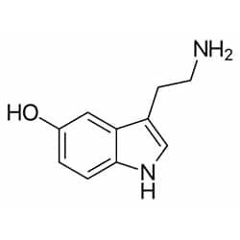
2 | Quercetin | C₁₅H₁₀O₇ | 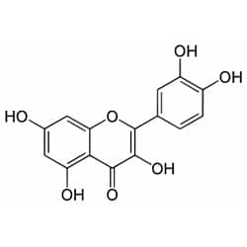
3 | Kaempferol | C₁₅H₁₀O₆ | 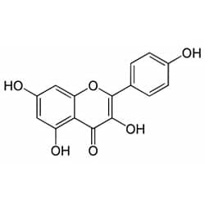
4 | Cucurbitacin-b | C₃₂H₄₆O₈ | 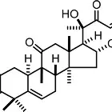
5 | Ascorbic acid | C₆H₈O₆ | 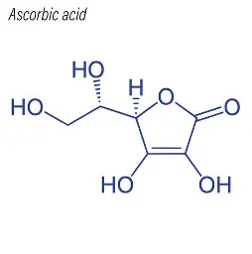
6 | Arginine | C₆H₁₄N₄O₂ | 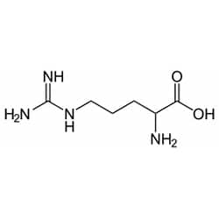
7 | Catechin | C₁₅H₁₄O₆ | 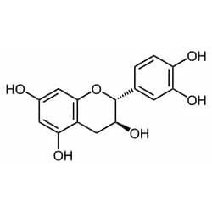
8 | Momordicoside-1 | C₄₂H₆₂O₁₆ | 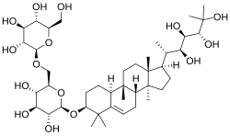
9 | Momordicin-2 | C₃₆H₅₈O₉ | 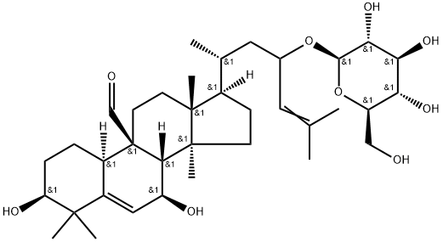
10 | Conduritol-A | C₆H₁₀O₄ | 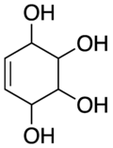
11 | 3-methyl pent 1 ene | C₆H₁₂ | 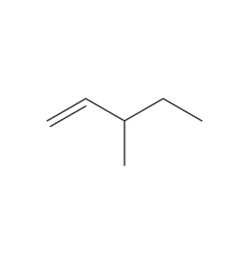
12 | Vicine | C₁₀H₁₆N₄O₇ | 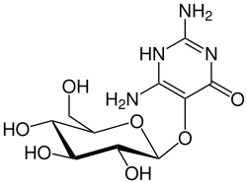
13 | Gallic acid | C₇H₆O₅ | 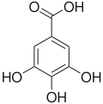
14 | Vitexin | C₂₁H₂₀O₁₀ | 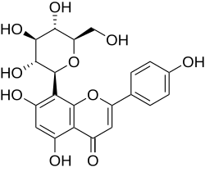
15 | Apigenin | C₁₅H₁₀O₅ | 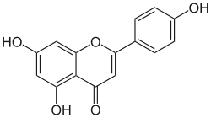
16 | Genistein | C₁₅H₁₀O₅ | 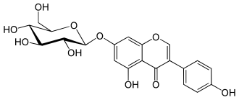
17 | Trigonelline | C₇H₇NO₂ | 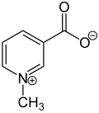
18 | Azardiradione | C₂₈H₃₄O₆ | 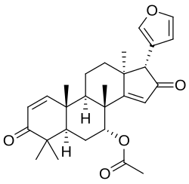
19 | Gymnemagenin | C₃₀H₅₀O₄ | 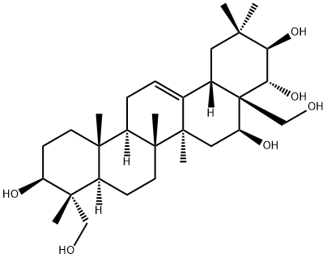
20 | Nimbin | C₃₀H₃₆O₉ | 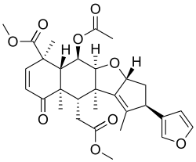
21 | Nimbolide | C₂₇H₃₀O₇ | 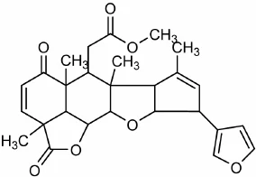
22 | Salannin | C₃₄H₄₄O₉ | 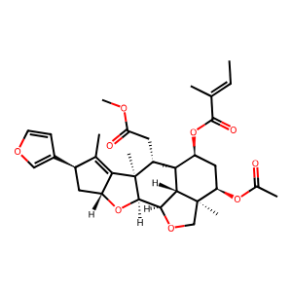

2.2 Preparation of Receptors
The target proteins associated with diabetes were obtained from the Protein Data Bank (Dej-Adisai et al., 2021; Tanazi et al., 2024). The receptor structures were prepared by removing water molecules and other unwanted components to make them suitable for docking analysis. The schematic diagram of the receptors is shown in Figure 1.
Sr No. | Name of Receptors | Structure
1 | Alpha glucosidase  PDB ID: 3WY1 | 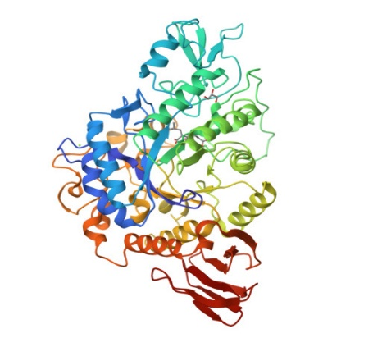
2 | PPAR-GAMMA  PDB ID: 3KMG | 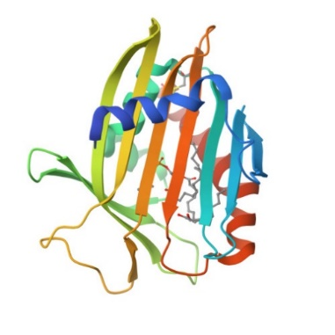
3 | PPAR DELTA  PDB ID: 2ZNQ | 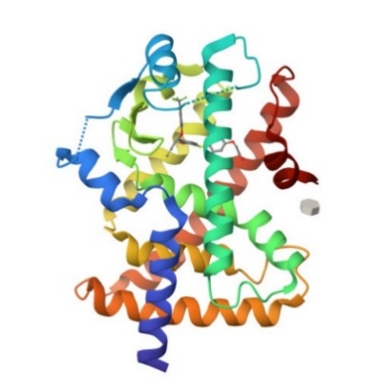

Fig 1: Structure of Receptors
2.3 Preparation of Ligands
The molecular structures of the selected phytoconstituents were downloaded from PubChem in suitable file formats. Ligands were energy-minimised and converted into PDBQT format using PyRx and Open Babel software.
2.4 Preparation of Receptors
Target proteins associated with diabetes mellitus, including alpha-glucosidase, PPAR-γ, and PPAR-δ, were obtained from the Protein Data Bank (PDB). Protein preparation involved the removal of water molecules, heteroatoms, and co-crystallised ligands, followed by the addition of hydrogen atoms and charge stabilisation.
2.5 Molecular Docking Study
Molecular docking simulations were performed using AutoDock Vina integrated into the PyRx platform (Bhosale et al., 2024; Üst et al., 2024). A grid box was generated around the active site of the receptors with a spacing of 1 Å. During docking, the receptors were treated as rigid molecules, whereas the ligands remained flexible.
Binding affinity scores were expressed in kcal/mol. Lower binding energy values indicated stronger and more stable ligand–protein interactions. (Grid box size: (X, Y, Z: 21.2734 -0.7528 18.6321)).
2.6 Result Analysis and Visualisation
Docking interactions, hydrogen bonding, and amino acid interactions were analysed using BIOVIA Discovery Studio (Ahmed et al., 2022; Dirir et al., 2022; Hossain et al., 2024; Okoh et al., 2023; Ononamadu & Ibrahim, 2021). ADMET and physicochemical parameters, such as molecular weight, hydrogen bond donors and acceptors, lipophilicity, TPSA, and synthetic accessibility, were evaluated.
3. Results and Discussion
3.1 Docking Analysis
The molecular docking study demonstrated that several phytoconstituents exhibited strong binding affinity against diabetes-related target proteins.
Among the screened compounds, several phytoconstituents demonstrated strong binding affinity toward the target proteins, as shown in Table 2.
Momordicoside 1 showed the highest binding affinity, with a docking score of -9.8 kcal/mol against alpha-glucosidase, suggesting strong inhibitory potential.
Kaempferol and Quercetin exhibited consistently high binding energies across all targets, with values reaching up to -9.0 kcal/mol and -8.8 kcal/mol, respectively.
Catechin also demonstrated strong interactions, with docking scores of approximately -8.4 to -8.5 kcal/mol. The docking scores of the phytoconstituents are presented in Table 2. These compounds may serve as promising candidates for enzyme inhibition because of their stable ligand–protein interactions.
3.1.1 Alpha-Glucosidase
Among all compounds, Momordicoside 1 showed the highest binding affinity against alpha-glucosidase, with a docking score of −9.8 kcal/mol. Flavonoids such as Quercetin, Kaempferol, Apigenin, Genistein, and Catechin also demonstrated strong binding affinity, ranging from −8.3 to −8.5 kcal/mol.
3.1.2 PPAR-γ
Vitexin and Apigenin showed strong interactions with PPAR-γ receptors. Catechin, Quercetin, and Genistein also demonstrated favourable docking scores, indicating stable ligand–receptor interactions.
3.1.3 PPAR-δ
Kaempferol and 3-methylpent-1-ene exhibited the best docking scores against PPAR-δ receptors. Quercetin, Catechin, Apigenin, and Genistein also maintained strong interactions.
3.2 Comparative Analysis
Flavonoids (Quercetin, Kaempferol, Catechin, Apigenin, and Genistein) consistently demonstrated strong binding across all targets, suggesting broad-spectrum inhibitory potential. The presence of phenolic hydroxyl groups enhances hydrogen bonding and π–π stacking interactions, thereby improving binding stability.
Momordicoside 1 showed exceptional binding toward alpha-glucosidase but weaker interactions with other proteins, indicating target specificity.
3.2.5 Interpretation of Binding Affinity
Binding energies below -7.0 kcal/mol are generally considered significant. In this study, several compounds exceeded this threshold, indicating strong ligand–protein interactions. The presence of hydroxyl groups and aromatic rings in flavonoids likely contributed to hydrogen bonding and π–π interactions within the active site.
The docking results suggest that Quercetin, Kaempferol, Catechin, and Genistein are the most promising multi-target inhibitors, while Momordicoside 1 is a potent and selective inhibitor of alpha-glucosidase. These phytocompounds may contribute to antidiabetic activity through enzyme inhibition and warrant further in vitro and in vivo validation.
3.3 ADMET and Physicochemical Analysis
ADMET analysis indicated that flavonoids possessed favourable pharmacokinetic properties (Kotadiya, 2024; Kotadiya & Ajudia, 2024; Kotadiya et al., 2024).
Quercetin and Kaempferol showed acceptable molecular weight and lipophilicity. Catechin exhibited good solubility and hydrogen bonding properties. Compounds with high TPSA values, such as Vicine, may exhibit limited membrane permeability.
Complex molecules, such as Momordicoside 1 and Momordicin-2, may face bioavailability challenges due to poor solubility and higher molecular complexity. Protein interactions with phytoconstituents are shown in Figure 2.
The overall analysis suggested that flavonoids represent promising multi-target antidiabetic candidates with balanced docking performance and drug-like properties.
3.3.1 Comparative Analysis
The pharmacokinetic properties of the selected compounds were analysed using parameters such as LogS (solubility), molecular weight, hydrogen bonding capacity, lipophilicity (LogP), TPSA, and synthetic accessibility, as presented in Table 3.
3.3.2 Solubility and Lipophilicity
Compounds such as Arginine and Gallic acid showed high solubility, indicating good absorption potential (Kotadiya et al., 2026; Tran et al., 2020). Optimal LogP values (~1–3) were observed for Kaempferol, Quercetin, and Genistein, suggesting a good balance between solubility and permeability.
3.3.3 Molecular Weight and Drug-Likeness
Most active flavonoids (e.g., Quercetin, 302.24 g/mol; Kaempferol, 286.24 g/mol) fall within Lipinski's rule (<500 g/mol). Larger molecules, such as Cucurbitacin B and Momordicin (>500 g/mol), may face permeability limitations.
3.3.4 Hydrogen Bonding and TPSA
Compounds such as Quercetin and Catechin possess multiple hydrogen bond donors/acceptors, enhancing binding interactions. However, high TPSA (>140 Å²), as observed for Vicine, may reduce membrane permeability.
3.3.5 Synthetic Accessibility
Most flavonoids showed moderate synthetic accessibility (2–4), indicating feasibility for drug development. Complex molecules, such as Momordicoside, showed higher values (>6), suggesting synthesis challenges.
3.3.6 Overall Interpretation:
Flavonoid-rich compounds are the most promising due to their strong binding affinity and favourable pharmacokinetic profile. Structure–activity relationship (SAR) analysis suggests that hydroxyl groups and aromatic rings enhance protein binding. Compounds with poor ADMET properties may still be useful after structural modification or nanoformulation approaches.
Quercetin, Kaempferol, Catechin, and Genistein emerged as the most promising multi-target inhibitors. Momordicoside 1 showed exceptional potency against alpha-glucosidase. The integration of docking and ADMET analysis highlights potential candidates for further in vitro and in vivo studies in antidiabetic drug development.
Conclusion:
The present molecular docking study demonstrated that selected phytoconstituents from medicinal plants possess significant antidiabetic potential against important diabetes-related target proteins. Among all studied compounds, Momordicoside 1 exhibited the strongest binding affinity against alpha-glucosidase. Flavonoids such as Quercetin, Kaempferol, Catechin, Apigenin, and Genistein also showed strong and consistent interactions with multiple receptors. ADMET evaluation further supported the suitability of flavonoids as potential drug candidates due to their favourable pharmacokinetic properties. The results suggest that these phytoconstituents may serve as promising lead compounds for the development of novel antidiabetic agents. However, further experimental validation through in vitro and in vivo studies is necessary to confirm their therapeutic efficacy and safety.

Limitation
This study was limited to molecular docking and ADMET-based computational analysis. The findings indicate possible ligand–protein interactions but do not confirm biological activity, clinical efficacy or safety. The docking results should therefore be validated through in vitro enzyme inhibition assays, cellular studies, in vivo experiments and pharmacokinetic evaluation before the selected phytoconstituents can be considered for therapeutic development.

Declaration of AI Use
This manuscript was prepared through the combined contributions of all author(s), including contributions to the study design, data, content development, results, interpretation, and related scholarly work. The author(s) acknowledge the use of Grammarly and ChatGPT to assist with grammar checking, language refinement, and reference formatting. These AI-assisted tools were not used as authors and did not replace the intellectual contributions or scholarly judgement of the author(s). All AI-assisted outputs, including content, references, and interpretations, were carefully reviewed, revised, verified, and approved by the author(s). The author(s) accept full responsibility for the accuracy, integrity, and final content of the manuscript.

PPAR DELTA
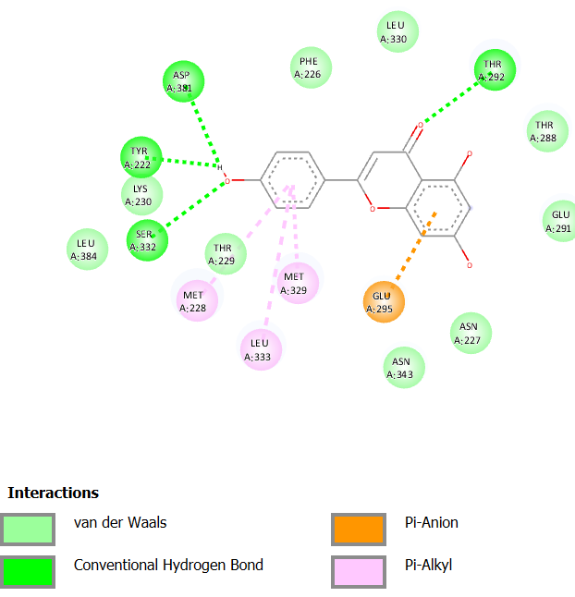
[a] Apigenin
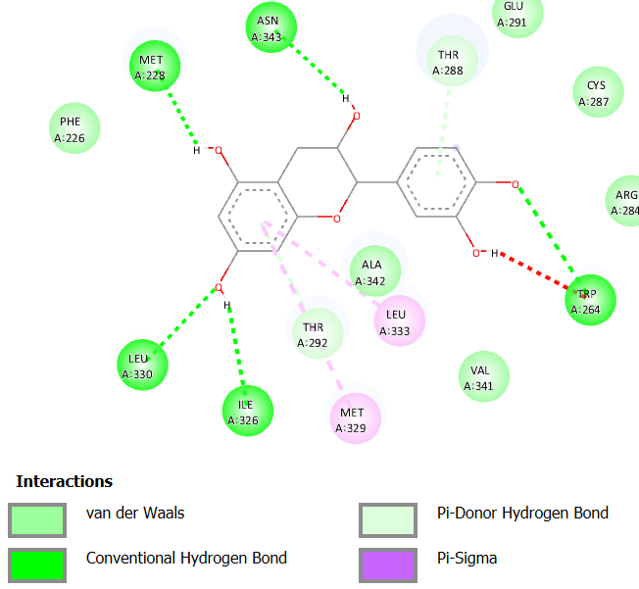
[b] Catechin
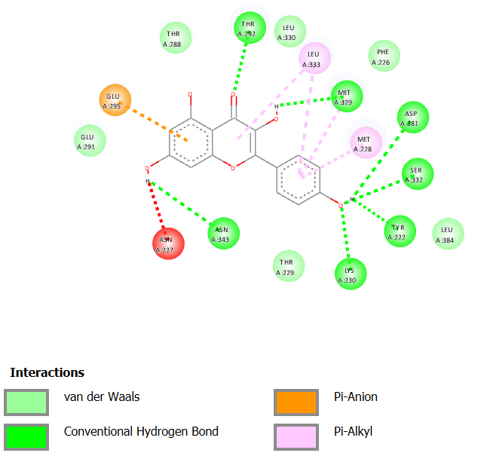
[c] Kaempferol
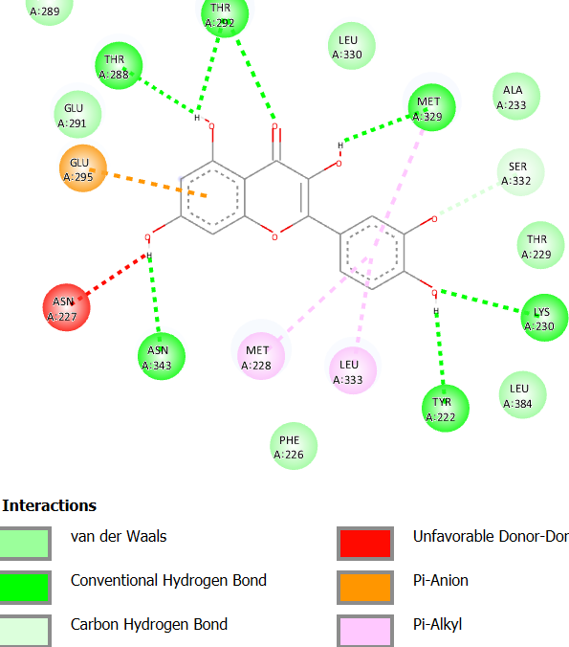
[d] Quercetin
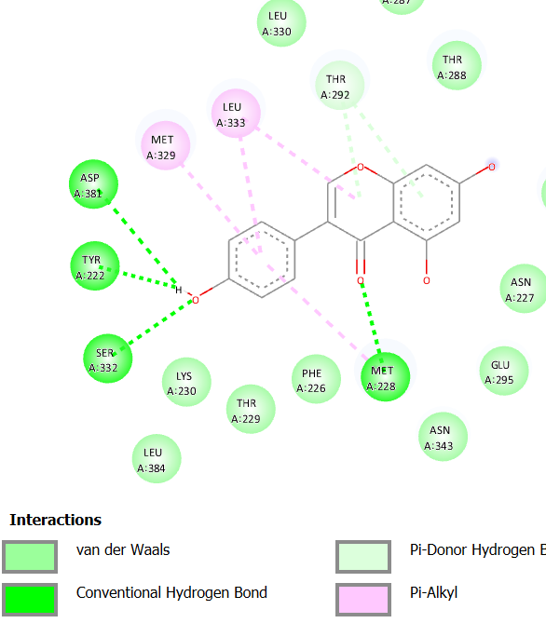
[e] Genistein

2.PPAR GAMMA
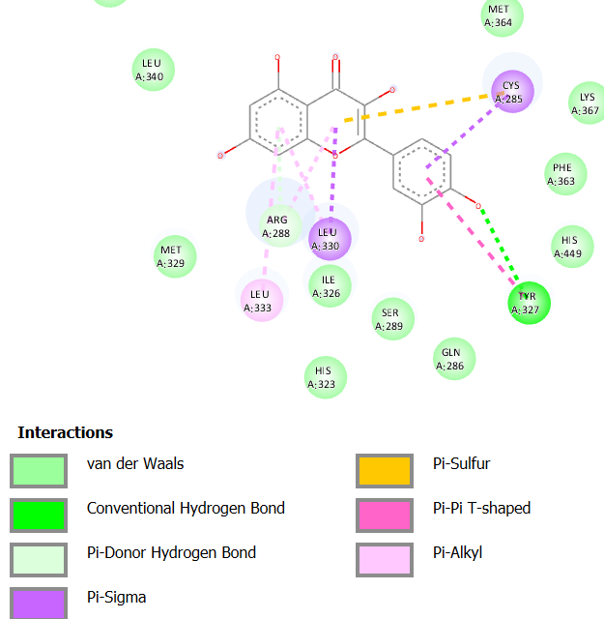
[a] Quercetin

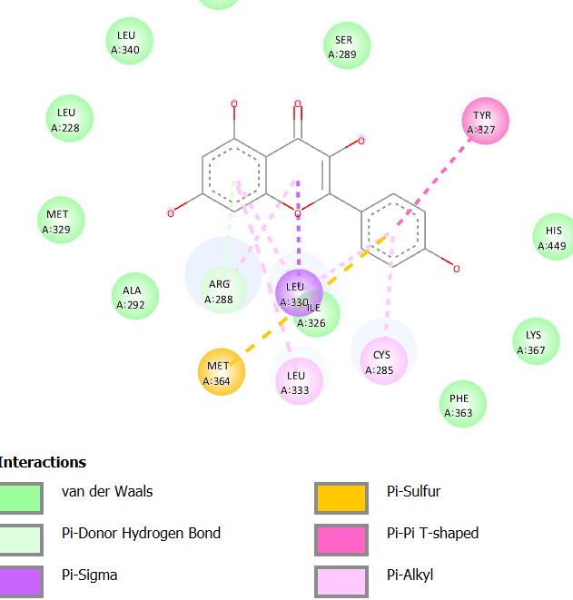
[b]Kaempferol
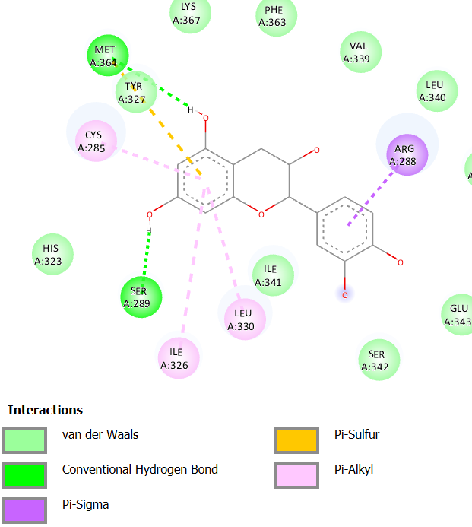
[c] Catechin
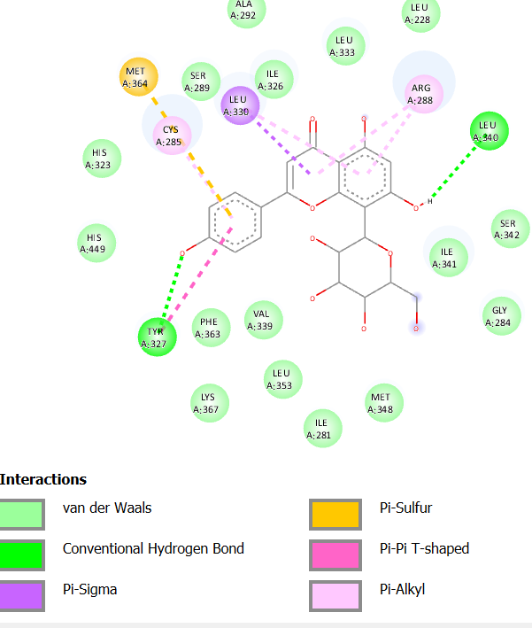
[d] Apigenin
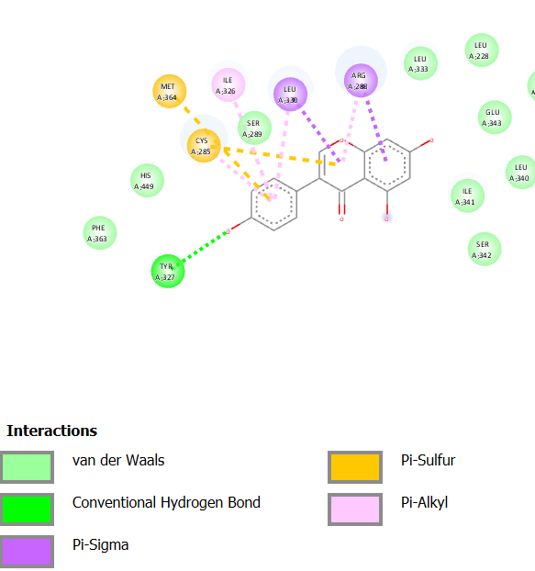
[e] Genistein
Figure 2: Interactions of Various Phytoconstituents with Receptors (PPAR DELTA and PPAR GAMMA).

Table 2: Docking score of Phytoconstituents
Sr. no | Phytocompounds | Binding energy (kcal/mol)
Sr. no | Phytocompounds | Alpha-glucosidase | PPAR  GAMMA | PPAR  DELTA
1 | 5-hydroxytryptamine | -6.8 | -5.8 | -6.4
2 | Quercetin | -8.3 | -7.3 | -8.8
3 | Kaempferol | -8.3 | -7.2 | -9
4 | Cucurbitacin B | -7.8 | -3.6 | -4.1
5 | Ascorbic acid | -6 | -5.8 | -5.8
6 | Arginine | -6 | -5 | -6.2
7 | catechin | -8.4 | -7.6 | -8.5
8 | Momordicoside 1 | -9.8 | -2.3 | -7.1
9 | Momordicin-2 | -8.5 | -3 | -4.4
10 | Conduritol A | -4.9 | -5.3 | -5.5
11 | 3-methylpent-1-ene | -6.4 | -7.7 | -8.9
12 | Vicine | -8.4 | -6.6 | -7.5
13 | Gallic acid | -6.1 | -5.5 | -6.3
14 | Vitexin | -6.3 | -8.6 | -5.8
15 | Apigenin | -8.3 | -8.6 | -8.8
16 | Genistein | -8.3 | -8.2 | -8.5
17 | Trigonelline | -4.8 | 6.3 | -5.7
18 | Azardiradione | -6.8 | -0.9 | -0.3
19 | Gymnemagenin | -3 | -2.2 | 2
20 | Nimbin | -4.3 | -0.8 | -2
21 | Nimbolide | -5.8 | -5.8 | -3.7
22 | Salannin | 0.2 | -3.8 | -1.3

Sr  no | Constituent  Name | Log s | Solubility | Mol  Weight | HBA | HBD | Log p | TPSA | Synthetic Accessibility
1 | 5-hydroxytryptamine | -2.25 | 9.87 | 176.22 | 2 | 3 | 1.18 | 62.24 | 1.42
2 | Quercetin | -3.16 | 2.11 | 302.24 | 7 | 5 | 1.63 | 131.36 | 3.23
3 | Kaempferol | -3.31 | 1.40 | 286.24 | 6 | 4 | 1.70 | 111.13 | 3.14
4 | Cucurbitacin B | -4.57 | 1.50 | 558.70 | 8 | 3 | 3.77 | 138.20 | 6.79
5 | Ascorbic Acid | 0.23 | 3.01 | 176.12 | 6 | 4 | -0.3 | 107.22 | 3.47
6 | Arginine | 2.05 | 1.95 | 174.20 | 4 | 4 | 0.27 | 127.72 | 2.47
7 | Catechin | -2.22 | 1.74 | 290.27 | 6 | 5 | 1.33 | 110.38 | 3.50
8 | Momordicoside | -6.06 | 3.88 | 441.67 | 3 | 2 | 00 | 49.69 | 7.29
9 | Momordicin-2 | -5.55 | 1.77 | 634.84 | 9 | 6 | 3.59 | 156.91 | 8.06
10 | Conduritol A | 0.56 | 5.36 | 146.14 | 4 | 4 | 1.04 | 80.92 | 3.90
11 | 3-methylpent-1-ene | -1.96 | 9.31 | 84.16 | 00 | 0 | 2.23 | 0 | 1.76
12 | Vicine | 0.16 | 1.22 | 304.26 | 8 | 7 | -0.3 | 197.17 | 4.59
13 | Gallic acid | 1.64 | 3.90 | 170.12 | 5 | 4 | 0.21 | 97.99 | 1.22
14 | Vitexin | -2.84 | 6.29 | 432.38 | 10 | 7 | 1.63 | 181.05 | 5.12
15 | Apigenin | -3.94 | 3.07 | 270.24 | 5 | 3 | 1.89 | 90.90 | 2.96
16 | Genistein | -3.72 | 5.11 | 270.24 | 5 | 3 | 1.91 | 90.90 | 2.87
17 | Trigonelline | -1.39 | 5.59 | 137.14 | 2 | 0 | -3.1 | 44.01 | 1.04
18 | Azardiradione | -5.58 | 1.17 | 450.57 | 5 | 0 | 3.17 | 73.58 | 5.89
19 | Gymnemagenin | -5.35 | 2.26 | 506.71 | 6 | 6 | 3.32 | 121.38 | 6.82
20 | Nimbin | -4.20 | 3.45 | 540.60 | 9 | 0 | 3.68 | 118.34 | 6.54
21 | Nimbolide | -3.94 | 5.30 | 466.52 | 7 | 0 | 3.18 | 92.04 | 6.07
22 | Salannin | -5.51 | 185 | 596.71 | 9 | 0 | 3.61 | 110.5 | 7.04
Table 3: Physical chemical properties of phytoconstituents in ADME

References
- Ahmed, S., Ali, M. C., Ruma, R. A., Mahmud, S., Paul, G. K., Saleh, M. A., Alshahrani, M. M., Obaidullah, A. J., Biswas, S. K., Rahman, M. M., Rahman, M. M., & Islam, M. R. (2022). Molecular docking and dynamics simulation of natural compounds from betel leaves (Piper betle L.) for investigating the potential inhibition of alpha-amylase and alpha-glucosidase of type 2 diabetes. Molecules, 27(14), 4526. https://doi.org/10.3390/molecules27144526
- Bhosale, H. J., Mamdapure, S. V., Panchal, R. B., & Dhuldhaj, U. P. (2024). Alpha-amylase, alpha-glucosidase and aldose reductase inhibitory and molecular docking studies on Tinospora cordifolia (Guduchi) leaf extract. Future Journal of Pharmaceutical Sciences, 10, Article 107. https://doi.org/10.1186/s43094-024-00671-9
- Dej-Adisai, S., Rais, I. R., Wattanapiromsakul, C., & Pitakbut, T. (2021). Alpha-glucosidase inhibitory assay-screened isolation and molecular docking model from Bauhinia pulla active compounds. Molecules, 26(19), 5970. https://doi.org/10.3390/molecules26195970
- Dela Rosa, D., Elya, B., Hanafi, M., Khatib, A., Budiarto, E., Nur, S., & Surya, M. I. (2025). Investigation of alpha-glucosidase inhibition activity of Artabotrys sumatranus leaf extract using metabolomics, machine learning and molecular docking analysis. PLOS ONE, 20(1), e0313592. https://doi.org/10.1371/journal.pone.0313592
- Dirir, A. M., Daou, M., Yousef, A. F., & Yousef, L. F. (2022). A review of alpha-glucosidase inhibitors from plants as potential candidates for the treatment of type-2 diabetes. Phytochemistry Reviews, 21, 1049-1079. https://doi.org/10.1007/s11101-021-09773-1
- Hossain, A., Rahman, M. E., Faruqe, M. O., Saif, A., Suhi, S., Zaman, R., Hirad, A. H., Matin, M. N., Rabbee, M. F., & Baek, K.-H. (2024). Characterization of plant-derived natural inhibitors of dipeptidyl peptidase-4 as potential antidiabetic agents: A computational study. Pharmaceutics, 16(4), 483. https://doi.org/10.3390/pharmaceutics16040483
- Kesavan, K., & Gnanasekaran, J. (2024). Assessment of the antidiabetic and antihyperlipidemic effects of aqueous extract from Zanthoxylum armatum DC. in high-fat diet and streptozotocin-induced type 2 diabetic rats. Uttar Pradesh Journal of Zoology, 45(16), 318-325. https://doi.org/10.56557/upjoz/2024/v45i164312
- Kotadiya, M. (2024). An in-silico method to identify and analyze phytocompounds from medicinal plants as HIV-1 protease inhibitors. International Journal of Biology, Pharmacy and Allied Sciences, 13(7), 3246-3255. https://doi.org/10.31032/IJBPAS/2024/13.7.8141
- Kotadiya, M., & Ajudia, R. (2024). In-silico docking and ADME studies of natural phytoconstituents from different medicinal plants as potential HIV reverse transcriptase inhibitors. International Journal of Pharmaceutical Quality Assurance, 15(1), 1-4. https://doi.org/10.25258/ijpqa.15.1.00
- Kotadiya, M., Lakhani, R., Trivedi, D., Prajapati, R., Patel, R., Vyas, N., Chavda, H., & Patel, M. S. (2026). Mechanistic in silico and in vitro evaluation of phytochemicals targeting HIV-1 reverse transcriptase and protease. International Journal of Drug Delivery Technology, 16(15s), 658-673. https://doi.org/10.25258/ijddt.16.15s.76
- Kotadiya, M., Shah, B., Patel, R. R., Zala, K. S., Soni, M., Patel, M., Joshi, H., & Ajudia, R. (2024). Exploring plant metabolites as potential inhibitors of HIV-1 Nef protein: A computational approach. African Journal of Biological Sciences, 6(5), 336-349. https://doi.org/10.33472/AFJBS.6.5.2024.336-349
- Kumar, S., Narwal, S., Kumar, V., & Prakash, O. (2011). Alpha-glucosidase inhibitors from plants: A natural approach to treat diabetes. Pharmacognosy Reviews, 5(9), 19-29. https://doi.org/10.4103/0973-7847.79096
- Lionta, E., Spyrou, G., Vassilatis, D. K., & Cournia, Z. (2014). Structure-based virtual screening for drug discovery: Principles, applications and recent advances. Current Topics in Medicinal Chemistry, 14(16), 1923-1938. https://doi.org/10.2174/1568026614666140929124445
- McMillan, J., Bester, M. J., & Apostolides, Z. (2025). In silico docking and ADMET studies on clinical targets for type 2 diabetes correlated to in vitro inhibition of pancreatic alpha-amylase and alpha-glucosidase by rutin, caffeic acid, p-coumaric acid, and vanillin. In Silico Pharmacology, 13, Article 42. https://doi.org/10.1007/s40203-025-00324-6
- Nwakulite, A., Obeagu, E. I., Nwanjo, H. U., Nwosu, D. C., Nnatuanya, I. N., Eze, R., Obeagu, G. U., Vincent, C. C. N., Amaechi, C. O., Okafor, C. J., Ezeoru, V., Chukwuani, U., & Adu, M. E. (2021). Studies on molecular docking of Moringa oleifera leaf phytochemical constituents on alpha-glucosidase, alpha-amylase and dipeptidyl peptidase. Journal of Pharmaceutical Research International, 33(28A), 239-245. https://doi.org/10.9734/jpri/2021/v33i28A31527
- Okoh, O. S., Yakubu, A., Adegboyega, A. E., Uti, D. E., Obeten, U. N., Agada, S. A., Oluwaloni, F., Johnson, G. I., Mela, L. P., Asomadu, R. O., Iwaloye, O., Johnson, T. O., & Orji, O. U. (2023). Identification of some bioactive compounds from Trignonella foenumgraecum as possible inhibitors of PPAR gamma for diabetes treatment through molecular docking studies, pharmacophore modelling and ADMET profiling: An in-silico study. PLOS ONE, 18(5), e0284210. https://doi.org/10.1371/journal.pone.0284210
- Ononamadu, C. J., & Ibrahim, A. (2021). Molecular docking and prediction of ADME/drug-likeness properties of potentially active antidiabetic compounds isolated from aqueous-methanol extracts of Gymnema sylvestre and Combretum micranthum. BioTechnologia, 102(1), 85-99. https://doi.org/10.5114/bta.2021.103765
- Rahman, M. M., Dhar, P. S., Sumaia, Anika, F., Ahmed, L., Islam, M. R., Sultana, N. A., Cavalu, S., Pop, O., & Rauf, A. (2022). Exploring the plant-derived bioactive substances as antidiabetic agent: An extensive review. Biomedicine & Pharmacotherapy, 152, 113217. https://doi.org/10.1016/j.biopha.2022.113217
- Sliwoski, G., Kothiwale, S., Meiler, J., & Lowe, E. W., Jr. (2014). Computational methods in drug discovery. Pharmacological Reviews, 66(1), 334-395. https://doi.org/10.1124/pr.112.007336
- Tanazi, N. N. H., Aziz, A. N., Azmi, M. N., Abu Bakar, M. H., Hassim, M. F. N., Abdul Wahab, N. H., Rasol, N. E., Ab Ghani, N., Maulidiani, M., & Awang, K. (2024). Phytoconstituents of Endiandra kingiana; antidiabetic effects and molecular docking studies on alpha-amylase and alpha-glucosidase. Natural Product Research, 38(24), 4375-4382. https://doi.org/10.1080/14786419.2023.2283759
- Tran, N., Pham, B., & Le, L. (2020). Bioactive compounds in anti-diabetic plants: From herbal medicine to modern drug discovery. Biology, 9(9), 252. https://doi.org/10.3390/biology9090252
- Üst, Ö., Yalçın, E., Çavuşoğlu, K., Acar, A., Ütük, A. E., & Özkan, B. (2024). LC-MS/MS, GC-MS and molecular docking analysis for phytochemical fingerprint and bioactivity of Beta vulgaris L. Scientific Reports, 14, Article 7491. https://doi.org/10.1038/s41598-024-58338-7
- Vijh, D., & Gupta, P. (2024). GC-MS analysis, molecular docking, and pharmacokinetic studies on Dalbergia sissoo barks extracts for compounds with anti-diabetic potential. Scientific Reports, 14, Article 24936. https://doi.org/10.1038/s41598-024-75570-3

