Histomorphological Demonstration of Stromal Components in Palpable Female Breast Tumors, Counterstained with Annatto Seed crude Extract

Abstract
Background: Annatto seed, obtained from Bixa orellana, contains natural yellow-orange pigments that may be useful as biological staining agents.
Aims: This study evaluated the histomorphological demonstration of stromal components in palpable female breast tumours using crude annatto seed extracts as counterstains to haematoxylin.
Methods: A total of 100 female breast tissue blocks were examined, comprising fibroadenoma (40 blocks), fibrocystic change (30 blocks), and invasive ductal carcinoma (30 blocks). Dried annatto seeds were used for crude dye extraction. One hundred grams of seed material was extracted in 200 ml of each solvent, including 95% ethanol, 70% ethanol, distilled water, and acetone. Phytochemical assessment of the extract was performed. Tissue sections were stained using routine haematoxylin and eosin as the control method, while the annatto seed extracts were used as counterstains to Harris haematoxylin. Stained sections were evaluated photomicrographically for staining intensity, visibility of stromal components, and preservation of tissue architecture.
Results: The extracts produced varying colour intensity and staining performance. Acetone produced the highest colour yield and volume, followed by 95% ethanol, 70% ethanol, and distilled water. However, sections stained with acetone showed a yellowish background that reduced cellular clarity. Sections counterstained with 95% ethanolic extract showed clearer stromal visualisation and better preservation of tissue morphology across fibroadenoma, fibrocystic change, and invasive ductal carcinoma when compared with the other crude extracts. The appearance was closer to that observed in routine haematoxylin and eosin-stained control sections.
Conclusion: Crude annatto seed extract, particularly the 95% ethanolic preparation, demonstrated potential as a counterstain for stromal components in selected palpable female breast tumours. Further optimisation and quantitative validation are required before routine diagnostic use can be recommended.
Keywords: Annatto seed extract; Bixa orellana; breast tumours; stromal components; counterstaining; haematoxylin and eosin; fibroadenoma; fibrocystic change; invasive ductal carcinoma; histomorphology.

INTRODUCTION
Palpable breast abnormalities represent one of the most frequent clinical presentations encountered in breast practice. Although the majority of these lesions are benign, they also constitute one of the principal presenting features of breast cancer. Moreover, breast malignancies identified following the onset of symptoms are generally associated with less favourable prognostic outcomes than those detected through routine screening programmes (Dodelzon & Katzen, 2019). Breast disorders affect more than one-quarter of women during their lifetime, with the development of a new breast lump being among the most common reasons for clinical consultation. While most newly detected breast masses are non-malignant, approximately 10% are ultimately diagnosed as breast cancer (Malherbe et al., 2022). The presence of a palpable breast lump frequently generates considerable patient anxiety and may necessitate repeated clinical examinations, radiological investigations, tissue biopsy, and, in some cases, surgical intervention. A palpable breast lesion is regarded as a dominant mass when it is three-dimensional, clearly distinguishable from the surrounding breast parenchyma, asymmetrical in comparison with the contralateral breast, and remains detectable throughout the menstrual cycle. Dominant masses that are smooth, well-circumscribed, and freely mobile are generally indicative of benign pathology. Contemporary breast imaging guidelines continue to recognise palpable breast masses as a common indication for diagnostic evaluation, recommending ultrasound as the primary imaging modality for women younger than 30 years, whereas diagnostic mammography or digital breast tomosynthesis is generally preferred for older women according to the clinical presentation (Klein et al., 2023).
Annatto (E-160B) is a naturally occurring yellow–orange pigment derived from the seeds of Bixa orellana and is widely regarded as a safer alternative to many synthetic colourants because of its relatively low toxicity, superior biodegradability, and favourable environmental profile (Shahid-ul-Islam et al., 2016). The colourant is obtained from the resinous outer coating of the seeds of the tropical plant Bixa orellana L., where the principal pigment, cis-bixin, is concentrated. Conventional processing involves mechanical abrasion of the seed coating in an appropriate suspending medium to release native bixin (Raju et al., 2022). Alternatively, alkaline hydrolysis in an aqueous medium may be employed to convert bixin into norbixin during extraction. Water and vegetable oil have traditionally served as suspending agents; however, solvent extraction techniques are increasingly utilised to obtain annatto extracts of higher purity. In response to industrial demand for more concentrated products, microcrystalline bixin preparations with purities ranging from 80% to 97% have been developed. Bixin and norbixin remain the principal colouring constituents isolated from the external seed layer (Taham et al., 2015). More recent investigations have further characterised bixin as a commercially important apocarotenoid that accumulates predominantly within the seed aril of Bixa orellana, reinforcing the significance of annatto seeds as an economically valuable natural source of pigment (Moreira et al., 2023).
An investigation employing ethanol-based extraction successfully isolated and characterised both bixin and norbixin from Bixa orellana seed dye, emphasising the importance of extraction solvent selection in determining the chemical composition and properties of annatto-derived pigments (Aluko, 2024). More broadly, plant-derived carotenoids have been recognised as naturally occurring pigments responsible for yellow-to-red colouration, thereby providing an important biochemical basis for the chromogenic characteristics exhibited by annatto seed extracts (Saikia & Das, 2023). Plant-derived dyes have also attracted attention as potential low-toxicity alternatives to conventional histological stains for microscopic applications, although their effectiveness is influenced by factors including the target tissue, extraction methodology, and staining protocol employed (Adeyemo et al., 2018). Phytochemical investigations of crude aqueous extracts of Bixa orellana have demonstrated the presence of flavonoids, tannins, anthraquinones, saponins, and terpenoids. Furthermore, solvent-dependent variations in phytochemical composition have been reported, with acetone extracts containing terpenoids and glycosides, methanol extracts containing tannins and glycosides, ethanol extracts containing tannins, flavonoids, saponins, steroids, and terpenoids, and hexane extracts predominantly containing glycosides (Alcazar-Alay et al., 2017).
The histomorphological assessment of breast lesions depends substantially on the accurate visualisation of stromal architecture, given the integral role of stromal components and the extracellular matrix in regulating the tumour microenvironment (Zhao et al., 2023). Recent advances in spatial transcriptomics and single-cell analytical approaches have further demonstrated that dynamic interactions between tumour stroma and cancer-associated fibroblasts evolve during tumour invasion and progression. These findings highlight the importance of histological staining techniques capable of preserving stromal integrity and providing clear morphological detail to facilitate accurate pathological interpretation (Risom et al., 2022; Mayer et al., 2023).
Research Gap
Although the chemical and biological basis of annatto pigments has been described, limited evidence is available on the performance of crude annatto seed extracts as counterstains for stromal components in human breast tumour sections. Existing work on natural staining has largely addressed microorganisms, animal tissues, or general pigment characterisation rather than comparative stromal demonstration in fibroadenoma, fibrocystic change, and invasive ductal carcinoma.
Objective of the Study
This study aimed to evaluate the histomorphological demonstration of stromal components in palpable female breast tumour sections counterstained with crude annatto seed extract and to compare the staining performance of different solvent extracts with routine haematoxylin and eosin staining.

Materials and Methods
Study Area
This study was carried out on female patients who visited the Rivers State University Teaching Hospital, 6-8 Harley Street, Old GRA, Port Harcourt. Written informed consent was obtained from all study subjects before inclusion in the study. A total of 100 patients presenting with palpable breast masses were included based on the inclusion and exclusion criteria. Only female patients aged 15-60 years with a clinical diagnosis of breast lump were included. Female patients with a history of previous breast trauma, recurrent malignancy, or chemotherapy or radiotherapy were excluded.

Plant Identification
The plant was identified by the Herbarium of the Department of Plant Science and Biotechnology, Faculty of Science, Rivers State University, Nkpolu-Oroworukwo, and was assigned the identification number RSUPbH0196 by Dr M. G. Ajuru in August 2024.
Phytochemical Analysis of the Extract
Phytochemicals in the extract were determined quantitatively and qualitatively using classical methods and spectrophotometric methods, respectively (Spectro UV-Vis UV-2500, LaboMed Inc., USA). This analysis was carried out in the Department of Biochemistry, Faculty of Science, Rivers State University, in accordance with ISO 17025.
Dye Extraction/Preparation
The seeds were commercially obtained from Ubima, a village in Ikwerre Local Government Area, Rivers State, Nigeria, and were sun-dried.
Staining Protocol
95% ethanolic seed extract
Materials and reagents
Paraffin-embedded tissue sections (4-5 µm thick)
Xylene
Absolute ethanol (100%)
95% ethanol
70% ethanol
Distilled water
Haematoxylin solution
10% acid alcohol
Ammonia water (0.1% ammonium hydroxide)
Mounting medium (DPX)
Glass slides and coverslips
Slide rack and staining dishes
Timer
Incubator
Procedure
Dewaxing and rehydration
1. Dewaxed in two changes of xylene for 20 minutes each.
2. Transferred the slides to absolute ethanol for 1 minute in two changes.
The slides were sequentially rehydrated by placing them in 95% ethanol for 1 minute, 70% ethanol for 1 minute, and then rinsing them in distilled water for 1 minute.
Haematoxylin staining: The slides were submerged in haematoxylin solution for 15 minutes, rinsed in tap water for 1 minute, differentiated in 10% acid alcohol for 3 minutes, rinsed quickly in tap water, blued by dipping in ammonia water for 10 seconds, and rinsed in tap water for 1 minute to remove excess bluing agent.
Counterstaining
The slides were submerged in 95% ethanolic annatto seed extract for 10 minutes.
Dehydration and Clearing
The slides were dehydrated by sequential immersion in 70% ethanol, 80% ethanol, 95% ethanol, and absolute ethanol for 30 seconds each. The slides were allowed to drain and were then cleared in xylene for 1 minute.

Mounting
Slides were mounted using DPX mountant and covered with clean coverslips.
Staining Protocol for acetone extract
Paraffin-embedded tissue sections (4-5 µm thick)
Xylene
Absolute ethanol (100%)
95% ethanol
70% ethanol
Distilled water
Haematoxylin solution
10% acid alcohol
Ammonia water (0.1% ammonium hydroxide)
Acetone
Mounting medium (DPX)
Glass slides and coverslips
Slide rack and staining dishes
Timer
Incubator
Procedure
Dewaxing and rehydration
Dewaxed in two changes of xylene for 20 minutes each.
The slides were transferred to absolute ethanol for 1 minute in two changes.
The slides were sequentially rehydrated by placing them in 95% ethanol for 1 minute and 80% ethanol for 1 minute.
The slides were then placed in 70% ethanol for 1 minute and rinsed in distilled water for 1 minute.
Haematoxylin staining
The slides were submerged in haematoxylin solution for 15 minutes.
The slides were rinsed in tap water for 1 minute.
The slides were differentiated in 10% acid alcohol for 3 minutes.
The slides were rinsed quickly in tap water.
The slides were blued by dipping them in ammonia water for 10 seconds.
The slides were rinsed in tap water for 1 minute to remove excess bluing agent.
Counterstaining
The slides were submerged in acetone annatto seed extract for 10 minutes.
Dehydration and Clearing
The slides were dehydrated by sequential immersion in 70% ethanol, 80% ethanol, 95% ethanol, and absolute ethanol for 30 seconds each.
The slides were allowed to drain and were then cleared in acetone for 2 minutes before transfer to xylene for 1 minute.

Mounting
Slides were mounted using DPX mountant and covered with clean coverslips.
Data Analysis
The results obtained from the staining reaction of B. orellana seed extract were presented photomicrographically and analysed after photomicrographs of sections from all staining interventions were taken and compared with haematoxylin and eosin staining techniques.

RESULTS
4.1 Crude Extract of Annatto Seed
Varying degrees of colour intensity were observed from the solvents used to extract dye from the dried annatto seeds. The extract volumes also differed. Acetone gave the highest extract volume and deepest colour. The 95% ethanolic extract gave a lower volume than acetone, followed by the 70% ethanolic extract, while distilled water produced the least colour and volume.
Histological Analysis
Fibrocystic Change
The photomicrographs obtained from breast tissue stained with haematoxylin and eosin showed proliferative ducts and stroma. The ducts were lined by a double layer of benign cells.
Photomicrographs obtained from sections stained with acetone appeared poorly stained and were not well differentiated, with an obvious yellowish background.
Sections stained with 70% extract also appeared poorly stained and were not well differentiated, with an obvious yellowish background.
In contrast, photomicrographs obtained from the 95% extract showed clearer staining with visible stromal components and no obvious yellowish background.

Fibroadenoma
The photomicrographs obtained from breast tissue stained with haematoxylin and eosin showed an encapsulated benign biphasic neoplasm composed of glands lined by both luminal and myoepithelial cells.
Photomicrographs obtained from sections stained with acetone appeared poorly stained and were not well differentiated, with an obvious yellowish background, although the tissue architecture was retained.
Sections stained with 70% extract also appeared poorly stained and were not well differentiated, with an obvious yellowish background.
In contrast, photomicrographs obtained from the 95% extract showed clearer staining with visible stromal components, no obvious yellowish background, and clearer tissue architecture and morphology.
Invasive ductal carcinoma
The photomicrographs obtained from breast tissue stained with haematoxylin and eosin showed desmoplastic stroma with an intense infiltrate of lymphocytes and plasma cells and a moderate mitotic rate.
Photomicrographs obtained from sections stained with acetone appeared poorly stained and were not well differentiated, with an obvious yellowish background, although the tissue architecture was retained.
Sections stained with 70% extract also appeared poorly stained and were not well differentiated, with an obvious yellowish background.
In contrast, photomicrographs obtained from the 95% extract showed clearer staining with visible stromal components, no obvious yellowish background, and clearer tissue architecture and morphology.

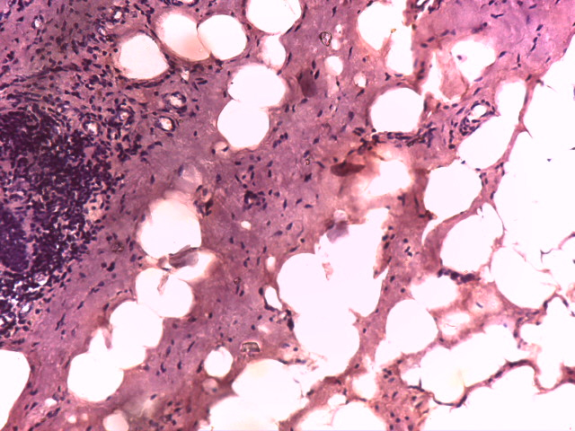
Figure 1: Breast Tissues showing Collagenous Fibrous Band Staining Light Yellow and Inflammatory Cells (95% Ethanolic Extract, x 40) (Fibroadenoma)

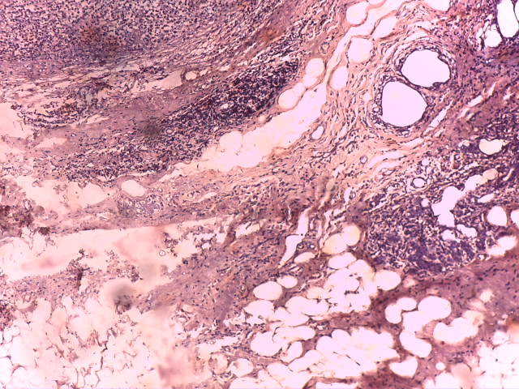
Figure 2. Breast Tissues showing Collagenous Fibrous Band Staining Light Yellow and Inflammatory Cells (Acetone Extract, x 40) (Fibroadenoma)

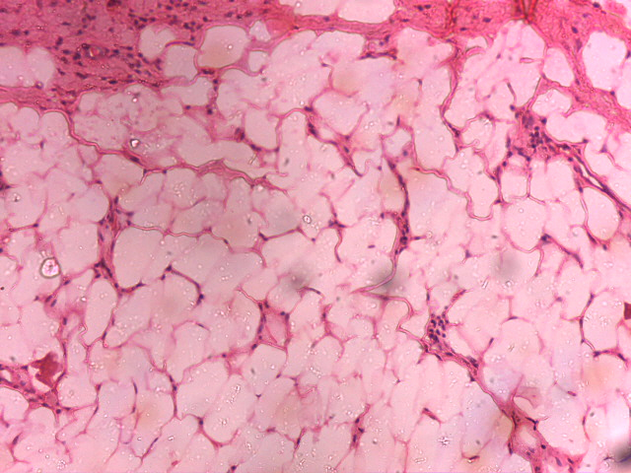
Figure 3: Breast Tissues showing Collagenous Fibrous Band Staining Light Yellow and Inflammatory Cells (H&E x 40) (Fibroadenoma)

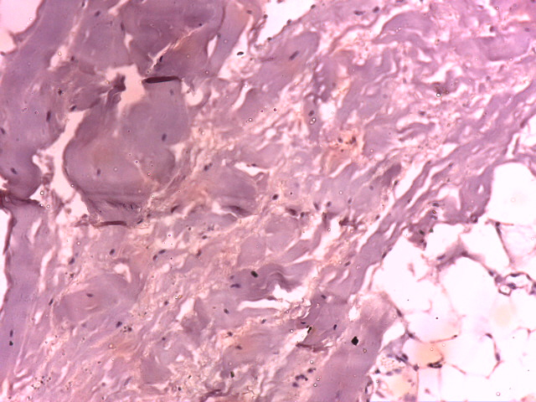
Figure 4: Breast Tissues showing Bands of Cancer Cells invading the Stroma (95% Ethanolic Extract, x 40) (Invasive Ductal Carcinoma IDC)

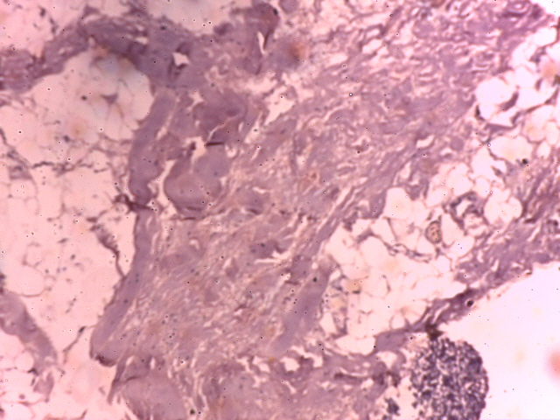
Figure 5: Breast Tissues showing Bands of Cancer Cells invading the Stroma (Acetone Extract, x 40) (Invasive Ductal Carcinoma IDC)

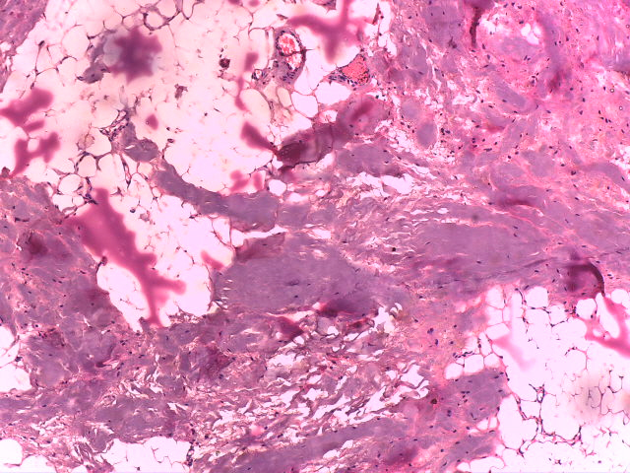
Figure 6: Breast Tissues showing Bands of Cancer Cells invading the Stroma (H&E x 40) (Invasive Ductal Carcinoma IDC)

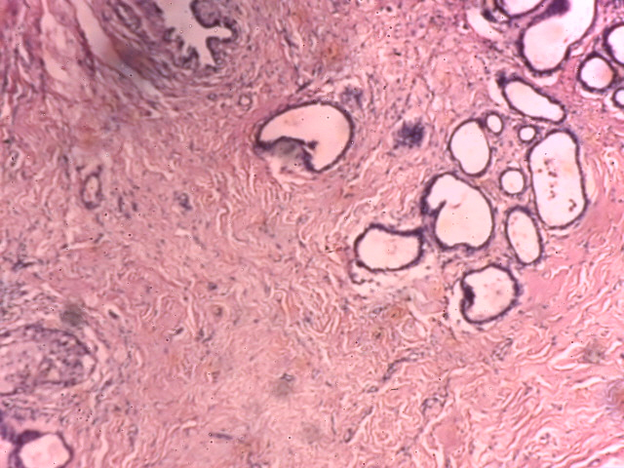
Figure 7: Breast Tissues showing Collagenous Fibrous Band Staining Light Yellow embedded in cyst of various sizes and shapes (95% Ethanolic Extract x 40) (Fibrocystic change)
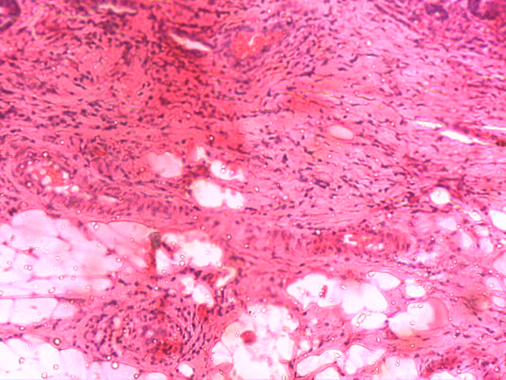

Figure 8: Breast Tissues showing Collagenous Fibrous Band Staining Light Yellow embedded in cyst of various sizes and shapes H&E x 40) (Fibrocystic change)

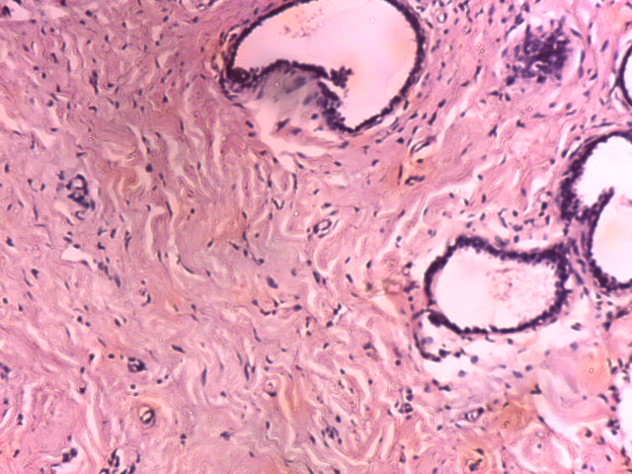
Figure 9: Breast Tissues showing Collagenous Fibrous Band Staining Light Yellow embedded in cyst of various sizes and shapes (Acetone Extract x 40) (Fibrocystic change)

Discussion

This study centred on the histomorphological demonstration of stromal components in palpable tumours of the female breast counterstained with crude annatto seed extract. Phytochemical analysis of the plant extract indicated the presence of carotenoids and polyphenols.
Extracts obtained from the different solvents showed brown to orange-coloured liquids. Acetone gave a very dark brown-orange colour, 95% alcohol gave a clear brown colour, 70% alcohol gave a light and clear brown colour, and distilled water gave a lighter brown colour than the other solvents. The varying colour intensity shows that B. orellana seed has appreciable extractive value in different solvents, which agrees with the results of Okorie et al. (2019).
The staining reactions of B. orellana extracts from different solvents showed varying degrees of staining, with the 95% alcoholic extract staining most clearly, followed by the 70% alcoholic extract, while acetone showed the least clear staining.
These staining reactions were observed at a pH range of 5.5-6.5. This agrees with the chemical theory of staining described by Avwioro (2010), which indicates that staining reactions in tissue depend on pH in relation to the isoelectric points of dye molecules.
Bixa orellana may be considered a compound dye or neutral dye because it stains both the nucleus and cytoplasm of the cell.
Staining Effect on Palpable Tumours of the Breast

Inflammatory Changes (fibrocystic change)
The H&E stain, as seen in Figure 8, served as the control baseline. The section revealed preserved lobular architecture and cystically dilated ducts, some of which were lined by columnar cells with apocrine metaplasia. Areas of mild periductal lymphocytic infiltrate were also present, and the stroma appeared densely desmoplastic, indicating increased fibrous stromal tissue surrounding the ducts and lobules, which may contribute to the tumour-like feeling (Apeksha et al., 2022).
The section stained with 95% ethanol extract showed a well-stained slide with preserved tissue architecture and visible diagnostic features. The cytoplasmic and nuclear components were well differentiated, with little to negligible yellow colouration. Therefore, the staining result was diagnostically useful. Sections stained with acetone also showed preservation of tissue architecture and visible diagnostic details similar to those seen in the H&E-stained slide; however, yellow colouration tended to obscure proper visibility of cellular details, making the slide appear blurry and translucent.
Benign breast tumour (fibroadenoma)
Sections from the H&E-stained slide revealed an encapsulated biphasic neoplasm with proliferating acini lined by luminal and myoepithelial cells. In the slides stained with 95% ethanolic extract, the histological diagnostic features seen in the standard slide were well visualised and identified, with no distortion of tissue architecture. Stromal components were also observed, with the extract imparting a yellow-coloured background that contrasted with haematoxylin.
Malignant breast tumour (invasive breast carcinoma)
The haematoxylin and eosin-stained slide, which served as the standard for this lesion, showed well-differentiated staining with clear stromal components. The slide showed a wide area of haemorrhagic necrosis, no lymphovascular invasion, stroma marked by desmoplasia, and moderate lymphoplasmacytic infiltrate. The slide also showed a moderate mitotic rate, with about 20-30% glandular differentiation. These findings are features of invasive breast carcinoma of no special type.
The slides stained with 95% ethanol extract revealed diagnostic stromal features similar to those seen in haematoxylin and eosin-stained slides. Proper cellular and cytoplasmic differentiation and visualisation were observed, with no interfering colour. In contrast, the acetone-stained slide showed cellular differentiation and identification of diagnostic features, although interfering colouration was observed.

Conclusion
This study evaluated crude annatto seed extracts as counterstains for demonstrating stromal components in palpable female breast tumour sections. The examined tissue blocks included fibroadenoma, fibrocystic change, and invasive ductal carcinoma. Among the solvents used for extraction, acetone produced a strong colour yield, but its staining performance was limited by a yellowish background that reduced cellular clarity. The 95% ethanolic extract showed comparatively better staining quality, with clearer visualisation of stromal components and better preservation of tissue architecture across the examined breast lesions. Its staining pattern was closer to the routine haematoxylin and eosin control than the other crude extracts assessed in the study.
The findings suggest that 95% ethanolic annatto seed extract may have potential as a natural counterstain in the histological demonstration of breast stromal components. However, the observations remain primarily descriptive. Further work is required to standardise extraction conditions, staining duration, pH, concentration, and storage stability. Quantitative scoring, statistical analysis, interobserver assessment, and comparison with established counterstains are also necessary to confirm reproducibility and diagnostic usefulness.
Limitations
This study has some limitations. Staining outcomes were mainly assessed descriptively, without quantitative scoring or statistical comparison of staining intensity, stromal visibility, or tissue architecture preservation. The extraction and staining procedures were not fully detailed for extraction duration, filtration, concentration, staining time, and pH adjustment. The number of sections prepared from each block and the slide evaluation method were not clearly stated. Observer blinding, interobserver agreement, and long-term extract stability were not reported. The study also focused only on selected breast lesions.
Ethical Approval
Ethical approval for the study was obtained from the ethical committee of the Rivers State University Teaching Hospital.

Consent
As per international standards or university standards, patient(s) written consent has been collected and preserved by the author(s).
Declaration of AI Use

This manuscript was prepared through the combined contributions of all author(s), including contributions to the study design, data, content development, results, interpretation, and related scholarly work. The author(s) acknowledge the use of Grammarly and ChatGPT to assist with grammar checking, language refinement, reference formatting. These AI-assisted tools were not used as authors and did not replace the intellectual contributions or scholarly judgment of the author(s). All AI-assisted outputs, including content, references, and interpretations, were carefully reviewed, revised, verified, and approved by the author(s). The author(s) accept full responsibility for the accuracy, integrity, and final content of the manuscript.

REFERENCEs
- Adeyemo, S. M., Akinloye, A. J., & Adekanmi, G. B. (2018). The use of plant dyes for microbial staining and identification: An eco-friendly and non-toxic alternative method. Journal of Advances in Biology & Biotechnology, 16(4), 1–10. https://doi.org/10.9734/JABB/2017/35014
- Alcázar-Alay, S. C., Osorio-Tobón, J. F., Forster-Carneiro, T., Steel, C. J., & Meireles, M. A. A. (2017). Polymer modification from semi-defatted annatto seeds using hot pressurized water and supercritical CO2. The Journal of Supercritical Fluids, 129, 48–55. https://doi.org/10.1016/j.supflu.2016.12.011
- Aluko, E. (2024). Ethanol-based extraction of annatto (Bixa orellana L.) and characterization of the bixin and norbixin. ACS Omega, 9(16), 18273–18277. https://doi.org/10.1021/acsomega.3c10120
- Apeksha, N., Agarwal, D. D., & Mais, A. D. (2022). Fibrocystic changes: Nonproliferative fibrocystic changes. https://www.pathologyoutlines.com/topic/breastfcc.html
- Avwioro, O. G. (2010). Histochemistry and tissue pathology: Principles and techniques (2nd ed.). Claverianum Press.
- Dodelzon, K., & Katzen, J. T. (2019). Evaluation of palpable breast abnormalities. Journal of Breast Imaging, 1(3), 253–263. https://doi.org/10.1093/jbi/wbz040
- Klein, K. A., Kocher, M., Lourenco, A. P., Niell, B. L., Bennett, D. L., Chetlen, A., Freer, P. E., Ivansco, L. K., Jochelson, M. S., Kremer, M. E., Malak, S. F., McCrary, M., Mehta, T. S., Neal, C. H., Porpiglia, A., Ulaner, G. A., & Moy, L. (2023). ACR Appropriateness Criteria palpable breast masses: 2022 update. Journal of the American College of Radiology, 20(5 Suppl.), S146–S163. https://doi.org/10.1016/j.jacr.2023.02.013
- Malherbe, F., Nel, D., Molabe, H., Cairncross, L., & Roodt, L. (2022). Palpable breast lumps: An age-based approach to evaluation and diagnosis. South African Family Practice, 64(1), a5571. https://doi.org/10.4102/safp.v64i1.5571
- Mayer, S., Milo, T., Isaacson, A., Halperin, C., Miyara, S., Stein, Y., Lior, C., Pevsner-Fischer, M., Tzahor, E., Mayo, A., Alon, U., & Scherz-Shouval, R. (2023). The tumor microenvironment shows a hierarchy of cell-cell interactions dominated by fibroblasts. Nature Communications, 14, 5810. https://doi.org/10.1038/s41467-023-41518-w
- Moreira, V. S., de Souza, V. C., Soares, V. L. F., Sousa, A. O., de Souza de Nascimento, K. T., de Santana, M. R., Rebouças, T. N. H., Leitão, C. A. E., Goliatt, P. V. Z. C., Faria, D. V., Otoni, W. C., & Costa, M. G. C. (2023). Dynamics of annatto pigment synthesis and accumulation in seeds of Bixa orellana L. revealed by integrated chemical, anatomical, and RNA-Seq analyses. Protoplasma, 260, 1207–1219. https://doi.org/10.1007/s00709-023-01842-w
- Okorie, N., Avwioro, O. G., Fasogbon, S. A., Abubakar, U., Adeluwoye, A. O., Agada, U. N., & Okoro, G. O. (2019). Staining interactions of Bixa orellana (annatto) seed extracts with tissues of Wistar rats. Annals of Advanced Biomedical Sciences, 2(2), 1–14. https://doi.org/10.23880/aabsc-16000144
- Raju, S. K., Chandrasekar, S., Vengadhajalapathy, P., Sundaram, R., Periyasamy, S., Chinnaraj, T., Sekar, P., & Kumar, S. (2022). Review on phytochemical composition and pharmacological activities of Bixa orellana L. Journal of Pharmaceutical and Biological Sciences, 10(2), 57–67. https://doi.org/10.18231/j.jpbs.2022.012
- Risom, T., Glass, D. R., Averbukh, I., Liu, C. C., Baranski, A., Kagel, A., McCaffrey, E. F., Greenwald, N. F., Rivero-Gutiérrez, B., Strand, S. H., Varma, S., Kong, A., Keren, L., Srivastava, S., Zhu, C., Khair, Z., Veis, D. J., Deschryver, K., Vennam, S., ... Angelo, M. (2022). Transition to invasive breast cancer is associated with progressive changes in the structure and composition of tumor stroma. Cell, 185(2), 299–310.e18. https://doi.org/10.1016/j.cell.2021.12.023
- Saikia, S., & Das, J. N. (2023). Carotenoids as a dietary supplement for enhancing pigmentation and colouration in ornamental fishes: A review. Uttar Pradesh Journal of Zoology, 44(13), 1–16. https://doi.org/10.56557/upjoz/2023/v44i133541
- Shahid-ul-Islam, Rather, L. J., & Mohammad, F. (2016). Phytochemistry, biological activities and potential of annatto in natural colorant production for industrial applications: A review. Journal of Advanced Research, 7(3), 499–514. https://doi.org/10.1016/j.jare.2015.11.002
- Taham, T., Cabral, F. A., & Barrozo, M. A. S. (2015). Extraction of bixin from annatto seeds using combined technologies. The Journal of Supercritical Fluids, 100, 175–183. https://doi.org/10.1016/j.supflu.2015.02.006
- Zhao, Y., Shen, M., Wu, L., Yang, H., Yao, Y., Yang, Q., Du, J., Liu, L., Li, Y., & Bai, Y. (2023). Stromal cells in the tumor microenvironment: Accomplices of tumor progression? Cell Death & Disease, 14, 587. https://doi.org/10.1038/s41419-023-06110-6

