Scalpel or Steroid? A Descriptive Comparison of Two Cases of Oral Mucocele Managed with Surgical Excision and Intralesional Triamcinolone Acetonide

ABSTRACT

Aim: The present study describes two cases of lower-lip oral mucocele managed by conventional surgical excision and intralesional triamcinolone acetonide and to compare their clinical courses descriptively.
Case presentation: A 35-year-old male presented with a 1.8 × 1.2 cm bluish, fluctuant lesion of two months’ duration. The lesion and adjacent minor salivary glands were excised under local anaesthesia, and histopathological examination confirmed a mucus extravasation phenomenon. A 23-year-old male presented with a 1.0 × 0.8 cm recurrently rupturing and refilling lesion of four months’ duration. In accordance with the patient’s preference for minimally invasive treatment, 0.3 mL of triamcinolone acetonide (10 mg/mL) was injected intralesionally.
Results: The surgical site healed uneventfully after suture removal, while the injected lesion regressed progressively and showed complete clinical resolution at four weeks. Neither lesion recurred during six months of follow-up, and no treatment-related complication was observed in the corticosteroid-treated patient.
Discussion: Surgical excision provided tissue for definitive histopathological confirmation but required suturing, analgesics, and postoperative wound care. Intralesional triamcinolone acetonide avoided surgery and was well tolerated, but histopathological confirmation was unavailable.
Conclusion: Both approaches were followed by complete clinical resolution in these individual cases. Because only one patient received each intervention and spontaneous regression cannot be excluded, the findings do not establish comparative effectiveness. Treatment should be individualised according to lesion characteristics, diagnostic certainty, patient preference, and follow-up requirements.

Keywords: Oral mucocele; Minor salivary gland; Surgical excision; Intralesional triamcinolone acetonide; Corticosteroid injection; Case report.

1. INTRODUCTION

Oral mucoceles are among the most common benign lesions of the minor salivary glands and result from mucus accumulation following rupture or obstruction of a salivary duct (More et al., 2014; Nallasivam & Sudha, 2015). The term mucocele is derived from the Latin words mucus (mucus) and coele (cavity), referring to a mucus-filled cavity. These lesions are frequently encountered in children, adolescents, and young adults, with no marked sex predilection. The lower labial mucosa is the most commonly affected site because of its susceptibility to repeated mechanical trauma, such as lip biting. Less commonly, mucoceles occur on the buccal mucosa, ventral surface of the tongue, floor of the mouth (ranula), palate, and retromolar region (More et al., 2014; Shinde et al., 2024).
Histopathologically, oral mucoceles are classified into two types: the mucus extravasation phenomenon and the mucus retention cyst. The mucus extravasation phenomenon accounts for approximately 80–90% of cases and results from traumatic rupture of a salivary duct, with mucin escaping into the surrounding connective tissue. Because these lesions lack an epithelial lining, they are regarded as pseudocysts. By contrast, mucus retention cysts are true, epithelium-lined cysts that develop secondary to ductal obstruction caused by mucus plugs, sialoliths, fibrosis, or inflammation (More et al., 2014; Nallasivam & Sudha, 2015).
Clinically, mucoceles present as painless, soft, fluctuant, dome-shaped swellings with a translucent or bluish appearance, depending on lesion depth and vascular congestion. Their size may fluctuate because of repeated rupture and refilling with saliva. Diagnosis is based primarily on the clinical history and examination and may be confirmed by histopathological evaluation after surgical excision (Mukundan & Ramesh, 2024; Nallasivam & Sudha, 2015).
Conventional surgical excision remains a commonly used treatment because it permits removal of the lesion together with adjacent minor salivary glands and provides tissue for histopathological confirmation. However, surgery may be associated with postoperative pain, bleeding, scarring, and recurrence if adjacent glandular tissue is not adequately removed. Several less invasive modalities, including laser excision, cryosurgery, micromarsupialisation, marsupialisation, and intralesional corticosteroid injection, have therefore been investigated as alternatives (Mukundan & Ramesh, 2024; Scribante et al., 2023). Recent case-based literature has also described favourable short-term outcomes after conventional surgical management, although such evidence cannot establish comparative effectiveness (Deivanayagi et al., 2025).
Although recent case reports have described favourable clinical outcomes following intralesional corticosteroid injection, direct comparative evidence between conventional surgical excision and intralesional triamcinolone acetonide remains limited (Kar et al., 2025; Yermalkar et al., 2024). Furthermore, evidence does not clearly establish the superiority of one surgical technique for preventing recurrence, and the potential for spontaneous fluctuation or resolution of lower-lip mucoceles may complicate attribution of outcomes after conservative treatment (Hashemi et al., 2023; Liu et al., 2024). This evidential gap supports cautious, descriptive comparison rather than inference of comparative effectiveness.
Therefore, the objective of the present report is to descriptively compare two cases of oral mucocele managed by surgical excision and intralesional triamcinolone acetonide, with emphasis on lesion resolution, healing, postoperative discomfort, patient acceptance, histopathological confirmation, and recurrence during follow-up.

2. Case Presentation

Case 1: Surgical Excision

A 35-year-old male presented to the Department of Oral Medicine and Radiology with a painless swelling on the right lower labial mucosa that had been present for two months. The patient reported that the swelling had gradually increased in size and occasionally interfered with speech and mastication. A history of repeated lip biting or trauma was elicited. The patient's medical, dental, and family histories were non-contributory.
Intraoral examination revealed a solitary, well-defined, dome-shaped swelling measuring up to 1.8 × 1.2 cm on the right lower labial mucosa. The lesion was translucent and bluish, with a smooth surface and a soft, fluctuant consistency. It was non-tender, non-compressible, and non-pulsatile. Based on the history and clinical findings, a provisional diagnosis of oral mucocele was made. The differential diagnoses included traumatic fibroma, lipoma, haemangioma, and a benign minor salivary gland neoplasm.
After written informed consent had been obtained, the lesion was surgically excised under local anaesthesia using aseptic precautions. The lesion and adjacent minor salivary glands were completely removed to minimise the risk of recurrence. Haemostasis was achieved, and the surgical wound was closed with interrupted 3-0 silk sutures. Postoperatively, the patient was prescribed aceclofenac 100 mg with paracetamol 325 mg orally twice daily for three days and received routine postoperative instructions.
The excised specimen was submitted for histopathological examination. Microscopic evaluation revealed a mucin-filled cavity surrounded by granulation tissue containing numerous muciphages (foamy macrophages), chronic inflammatory cells, and proliferating capillaries. The absence of an epithelial lining confirmed a mucus extravasation phenomenon (oral mucocele).
The postoperative course was uneventful. The sutures were removed after seven days, and complete healing was observed. No recurrence was noted during six months of follow-up.
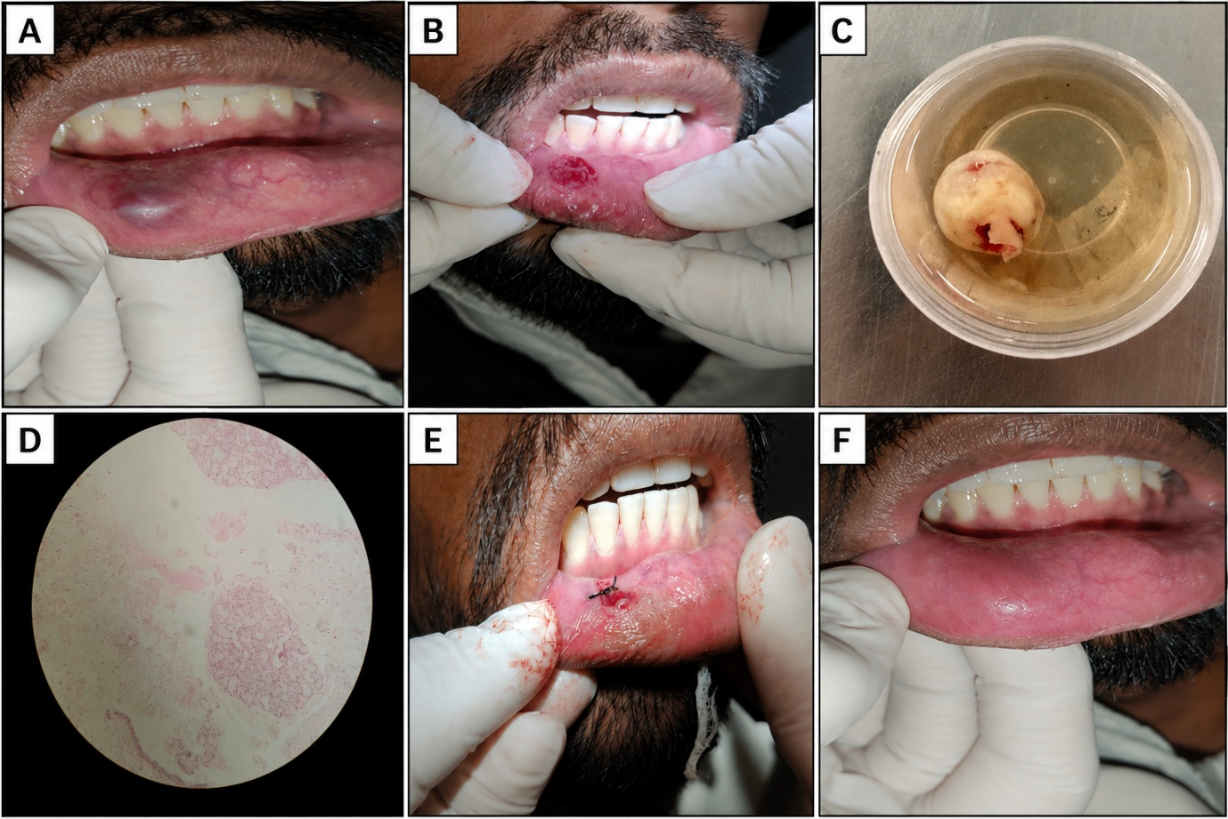
Figure 1. Clinical presentation, surgical excision, histopathological features, and postoperative healing of the lower lip mucocele.

(A) Preoperative clinical photograph showing a bluish, fluctuant swelling on the lower labial mucosa.
(B) Intraoperative view following complete excision of the lesion.
(C) Excised specimen.
(D) Photomicrograph showing a cystic cavity with mucin pooling surrounded by granulation tissue containing numerous mucinophages (Hematoxylin and Eosin stain)
(E) Immediate postoperative view after wound closure with interrupted sutures.
(F) Follow-up after 7days demonstrating satisfactory healing of the surgical site.

Case 2: Intralesional Triamcinolone Acetonide Injection

A 23-year-old male presented to the Department of Oral Medicine and Radiology with a painless swelling on the right lower labial mucosa that had been present for four months. The patient reported that the swelling had gradually increased in size and occasionally interfered with mastication. The lesion showed intermittent changes in size, with episodes of spontaneous rupture and refilling. A history of repeated lip biting or trauma was present. The patient's medical, dental, and family histories were non-contributory.
Intraoral examination revealed a solitary, well-circumscribed, dome-shaped swelling measuring approximately 1.0 × 0.8 cm on the right lower labial mucosa, opposite the mandibular canine–premolar region. The lesion appeared pinkish-white to translucent and had a smooth, shiny surface with well-defined margins. On palpation, it was soft, fluctuant, non-tender, non-compressible, and non-pulsatile, with no ulceration, bleeding, or discharge. Based on the clinical findings, a provisional diagnosis of oral mucocele was made.
The differential diagnosis included traumatic fibroma, irritation fibroma, lipoma, haemangioma, lymphangioma, and a benign minor salivary gland lesion.

Considering the patient's preference for minimally invasive treatment, intralesional triamcinolone acetonide (10 mg/mL) was selected. After written informed consent had been obtained and aseptic precautions maintained, 0.3 mL of triamcinolone acetonide was injected directly into the lesion using a 1 mL insulin syringe with a 31-gauge needle. The patient was advised to avoid lip biting and local trauma and was scheduled for weekly follow-up to assess the clinical response. The lesion progressively decreased in size, and complete clinical regression was observed at the four-week follow-up. No recurrence was observed during the subsequent six months. The patient was also assessed clinically for local and systemic adverse effects. No mucosal atrophy, infection, pigmentary change, steroid deposition, allergic reaction, or other treatment-related complication was observed.
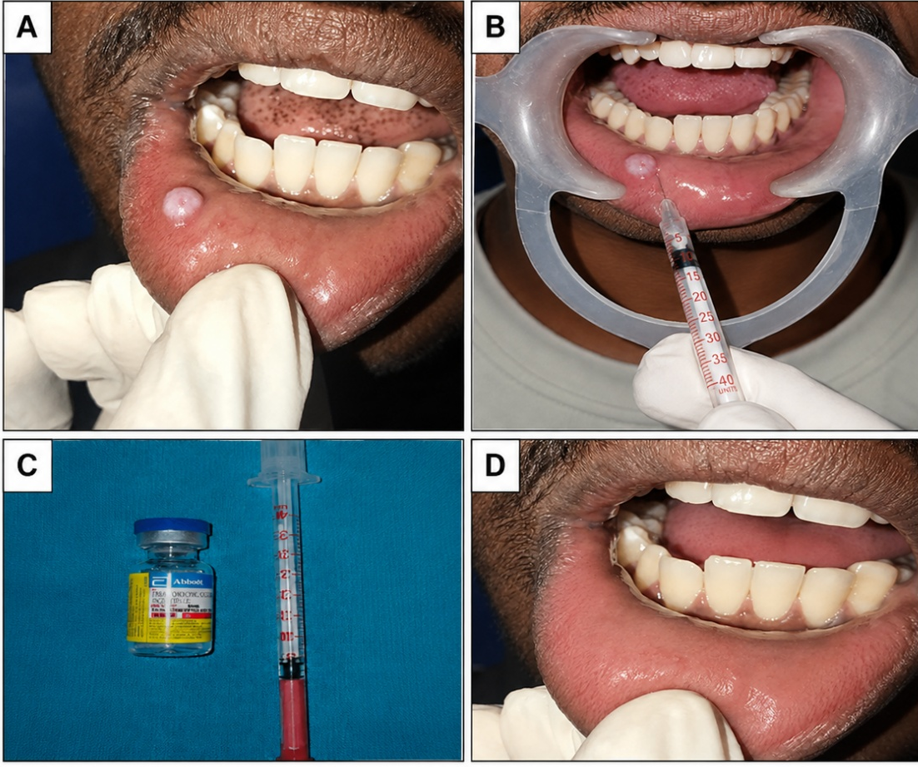

Figure 2. Intralesional corticosteroid therapy for mucocele

(A) Preoperative clinical photograph showing a dome shaped translucent swelling on the lower labial mucosa consistent with a mucocele.
(B) Injection of intralesional corticosteroid at the base of the mucocele.
(C) A vial of triamcinolone acetonide and an insulin syringe used for intralesional administration.
(D) Post-treatment for follow-up after 4 weeks showing complete resolution of the lesion with satisfactory healing and no evidence of recurrence.

Table 1. Clinical Timeline of the Two Cases

Clinical Event | Case 1: Surgical Excision | Case 2: Intralesional Triamcinolone Acetonide
Duration before presentation | Painless swelling for 2 months | Painless swelling for 4 months
Day 0 | Clinical examination, provisional diagnosis, surgical excision under local anesthesia, specimen sent for histopathological examination | Clinical examination, provisional diagnosis, single intralesional injection of 0.3 mL triamcinolone acetonide (10 mg/mL) administered
Week 1 | Postoperative review; satisfactory healing | First follow-up; reduction in lesion size noted
Week 2 | Healing progressed satisfactorily | Second follow-up; further reduction in lesion size
Week 3 | Continued uneventful healing | Third follow-up; marked reduction in lesion size
Week 4 | Complete healing of the surgical site | Complete clinical regression of the lesion
6 months | No recurrence observed | No recurrence observed

Table 2. Comparison of Surgical Excision and Intralesional Triamcinolone Acetonide Injection in the Management of Oral Mucocele

Parameters | Surgical Excision | Intralesional Triamcinolone Acetonide Injection
History | Painless swelling of the lower lip for 2 months | Painless swelling of the lower lip for 4 months
Clinical presentation | Bluish-translucent, dome-shaped, fluctuant swelling | Pinkish-translucent, dome-shaped, fluctuant swelling
Clinical diagnosis | Oral mucocele | Oral mucocele
Treatment | Complete surgical excision under local anesthesia | Intralesional triamcinolone acetonide (0.3 mL of 10 mg/mL)
Bleeding assessment | Minimal bleeding, controlled during surgery | No bleeding
Sutures | 3-0 black silk sutures placed | No sutures required
Postoperative discomfort | Mild postoperative discomfort | Minimal discomfort
Analgesics | Prescribed for 3 days* | Not required*
Histopathological examination | Confirmed mucus extravasation phenomenon | Not performed
Post-treatment healing | Uneventful healing with satisfactory tissue repair | Complete clinical resolution without scarring
Follow-up | No recurrence after 6 months of follow-up. | No recurrence after 6 months of follow-up.

3. Discussion

Oral mucoceles are common benign lesions of the minor salivary glands and are usually caused by trauma-induced rupture of a salivary duct, resulting in mucin extravasation into the surrounding connective tissue. The lower labial mucosa is the most frequently affected site because of its susceptibility to chronic mechanical trauma, particularly lip biting. Histopathologically, mucoceles are classified as mucus extravasation phenomena or mucus retention cysts, with the former accounting for approximately 80–90% of reported cases (More et al., 2014; Nallasivam & Sudha, 2015).
Clinically, oral mucoceles present as painless, soft, fluctuant, dome-shaped swellings that may appear translucent or bluish depending on their depth and vascularity. Because these lesions may resemble traumatic fibroma, lipoma, haemangioma, lymphangioma, or a benign minor salivary gland tumour, careful clinical examination is essential. Histopathological examination provides definitive diagnostic confirmation when tissue is obtained through surgical excision (More et al., 2014; Nallasivam & Sudha, 2015).
Conventional surgical excision is commonly used for oral mucoceles because it permits removal of the lesion together with the associated minor salivary glands and provides tissue for histopathological confirmation (Kannan et al., 2024; More et al., 2014). Kannan et al. (2024) similarly described successful management of a lower-lip mucocele by complete surgical excision and emphasised the importance of removing adjacent feeder glands to reduce recurrence. Nevertheless, surgery may involve postoperative pain, bleeding, oedema, scar formation, suturing, and patient anxiety, particularly in young or apprehensive individuals.
In the present report, the surgically treated lesion healed uneventfully and did not recur during follow-up. Histopathological examination confirmed a mucus extravasation phenomenon, demonstrating the diagnostic and therapeutic functions of excision in this case. Comparable case-based outcomes have been reported by More et al. (2014) and Kannan et al. (2024); however, individual case reports do not determine comparative effectiveness or long-term recurrence risk.
Interest has increased in less invasive modalities intended to reduce patient discomfort while maintaining acceptable clinical outcomes. These approaches include laser excision, cryosurgery, marsupialisation, micromarsupialisation, and intralesional corticosteroid therapy (Mukundan & Ramesh, 2024; Scribante et al., 2023). Intralesional triamcinolone acetonide has been used because corticosteroids can suppress inflammatory cell infiltration, reduce capillary permeability, inhibit fibroblast proliferation, and facilitate resorption of extravasated mucin (Yermalkar et al., 2024).
In the second case, a single intralesional injection of triamcinolone acetonide (0.3 mL, 10 mg/mL) was followed by progressive lesion reduction, complete clinical resolution at four weeks, and no recurrence during the subsequent six months. Nevertheless, spontaneous fluctuation or regression cannot be excluded, particularly because lower-lip mucoceles may resolve without intervention (Liu et al., 2024). The outcome should therefore be interpreted as an individual clinical observation rather than evidence of treatment efficacy. The procedure was minimally invasive, well tolerated, and did not require suturing or postoperative wound care. Yermalkar et al. (2024) also described resolution after intralesional triamcinolone injections, whereas Kar et al. (2025) reported resolution after serial intralesional dexamethasone injections.
Intralesional corticosteroid therapy avoids surgical trauma, bleeding, and scar formation and may therefore be considered for carefully selected patients who prefer a conservative approach or are reluctant to undergo surgery. However, unlike surgical excision, this treatment does not provide tissue for histopathological confirmation. It should consequently be considered only when the clinical presentation is characteristic and other possible pathologies have been appropriately evaluated.
Local adverse effects are uncommon, but mucosal steroid deposition has been reported after intralesional triamcinolone administration, underscoring the importance of appropriate dosage and injection technique (Kang et al., 2025).
The available literature supports considering intralesional corticosteroid therapy as a conservative option for selected oral mucoceles, but the evidence remains largely case-based and does not establish superiority over surgical treatment. A systematic review and meta-analysis likewise found no clear difference in recurrence among several surgical techniques, although the underlying evidence was limited (Hashemi et al., 2023). In the present report, surgical excision provided healing and histopathological confirmation, whereas intralesional triamcinolone acetonide was followed by clinical resolution with minimal postoperative discomfort. These observations support individualised treatment planning based on lesion characteristics, diagnostic certainty, patient preference, the need for histopathological examination, and follow-up requirements.

4. Conclusion

In the two cases described, surgical excision and intralesional triamcinolone acetonide were each followed by complete clinical resolution of a lower-lip oral mucocele, with no recurrence during six months of follow-up. Surgical excision enabled removal of the lesion and adjacent minor salivary glands and provided tissue for histopathological confirmation. However, it required local anaesthesia, suturing, analgesic medication, and postoperative wound care. Intralesional triamcinolone acetonide was minimally invasive and was followed by progressive regression after a single injection without bleeding, scarring, or an observed treatment-related complication, but it did not permit histopathological examination. These outcomes represent individual clinical observations and should not be interpreted as evidence that either modality is superior. Treatment selection should be based on the clinical characteristics of the lesion, diagnostic certainty, the need for tissue confirmation, patient preference, and the ability to provide follow-up. Prospective studies with larger samples, standardised treatment protocols, objective outcome measures, and longer observation periods are required to clarify effectiveness, safety, recurrence, and appropriate patient selection.

Limitations
This descriptive report includes only two patients, with one patient receiving each treatment; therefore, comparative efficacy cannot be assessed. The patients differed in age, lesion size, symptom duration, and diagnostic confirmation, and treatment allocation was partly influenced by patient preference. The corticosteroid-treated lesion was diagnosed clinically without histopathological confirmation. Six months of follow-up may not identify late recurrence. Spontaneous regression and differences in lesion biology cannot be excluded, limiting the generalisability of the observations.

Declaration of AI Use

This manuscript was prepared through the combined contributions of all author(s), including contributions to the study design, data, content development, results, interpretation, and related scholarly work. The author(s) acknowledge the use of Grammarly and ChatGPT to assist with grammar checking, language refinement, and reference formatting. These AI-assisted tools were not used as authors and did not replace the intellectual contributions or scholarly judgement of the author(s). All AI-assisted outputs, including content, references, and interpretations, were carefully reviewed, revised, verified, and approved by the author(s). The author(s) accept full responsibility for the accuracy, integrity, and final content of the manuscript.

Ethical Approval:
As per international standards or university standards written ethical approval has been collected and preserved by the author(s).

Consent

Written informed consent was obtained from both patients for publication of this case series and accompanying images.

COMPETING INTERESTS:
Authors have declared that they have no known competing financial interests OR non-financial interests OR personal relationships that could have appeared to influence the work reported in this paper.

References

Deivanayagi, M., Elamparithi, B., Narmadha, C., Sindhuja, T., & Abinaya, P. (2025). Management of mucocele: A case report. Asian Journal of Dental Sciences, 8(1), 338–343. https://doi.org/10.9734/ajds/2025/v8i1252
Hashemi, M., Zohdi, M., Zakeri, E., Abdollahzadeh-Baghaei, T., & Katebi, K. (2023). Comparison of the recurrence rate of different surgical techniques for oral mucocele: A systematic review and meta-analysis. Medicina Oral, Patología Oral y Cirugía Bucal, 28(6), e614–e621. https://doi.org/10.4317/medoral.26015
Kang, K. H., Byun, J. S., Jung, J. K., & Kim, J. R. (2025). Mucosal deposit after triamcinolone injection: A case report. BMC Oral Health, 25(1), Article 561. https://doi.org/10.1186/s12903-025-05919-1
Kannan, N., Ramalingam, K., Ramani, P., & Krishnan, M. (2024). Mucocele of the lower lip and its surgical management. Cureus, 16(10), e70874. https://doi.org/10.7759/cureus.70874
Kar, S. R., Sangamesh, N. C., Nahar, N., Sharan, J., & Basnyat, S. K. C. (2025). Needle and nodule: A case of intra-lesional success in oral mucocele treatment. Clinical Case Reports, 13(12), e71668. https://doi.org/10.1002/ccr3.71668
Liu, J.-L., Liu, Y.-N., Wang, L., & Wang, D.-C. (2024). Waiting for self-healing as a primary management strategy for lower lip mucoceles. Clinical Oral Investigations, 28(7), Article 363. https://doi.org/10.1007/s00784-024-05766-4
More, C. B., Bhavsar, K., Varma, S., & Tailor, M. (2014). Oral mucocele: A clinical and histopathological study. Journal of Oral and Maxillofacial Pathology, 18(Suppl. 1), S72–S77. https://doi.org/10.4103/0973-029X.141370
Mukundan, D., & Ramesh, R. (2024). Pediatric oral mucocele management: A case series investigating different treatment approaches. Cureus, 16(6), e63342. https://doi.org/10.7759/cureus.63342
Nallasivam, K. U., & Sudha, B. R. (2015). Oral mucocele: Review of literature and a case report. Journal of Pharmacy & Bioallied Sciences, 7(Suppl. 2), S731–S733. https://doi.org/10.4103/0975-7406.163516
Scribante, A., Pellegrini, M., Pulicari, F., De Martino, F., Li Vigni, G., Ghizzoni, M., & Spadari, F. (2023). Oral cavity mucocele and different surgical treatment strategies: Is laser excision effective? A scoping review. Applied Sciences, 13(22), Article 12327. https://doi.org/10.3390/app132212327
Shinde, S., Lohe, V., Shirbhate, U., Mohod, S., & Solanki, D. (2024). Laser-assisted surgical management of oral mucocele: A case report. Cureus, 16(1), e53020. https://doi.org/10.7759/cureus.53020
Yermalkar, G. S., Shashikiran, N. D., Gaonkar, N., Gugawad, S., Hadakar, S. G., & Waghmode, S. (2024). Nonsurgical treatment of oral mucocele with intralesional corticosteroid injections: A case report. Cureus, 16(8), e67363. https://doi.org/10.7759/cureus.67363

