Giant High-Risk Cutaneous Squamous Cell Carcinoma of the Lower Abdominal Wall with Lymphovascular Invasion Managed by Wide Excision and Modified Abdominoplasty-like Reconstruction: A Case Report

Abstract
Cutaneous squamous cell carcinoma (cSCC) is a common non-melanoma skin cancer that usually develops in chronically sun-exposed areas. Giant cSCC of the lower abdominal wall is rare and presents distinct oncological and reconstructive challenges, particularly when high-risk pathological features are present. This case report describes a 67-year-old man with a progressively enlarging ulcerated suprapubic mass measuring approximately 6.5 × 6 cm. Preoperative contrast-enhanced abdominopelvic computed tomography and inguinal ultrasonography showed no muscular or fascial invasion, regional lymph node involvement, or distant metastasis. The patient underwent wide local excision with oncological margins, resulting in a 14 × 9 cm soft tissue defect with preservation of the abdominal fascia. Reconstruction was performed using a modified abdominoplasty-like advancement and translation plasty, allowing primary closure without mesh reinforcement. Histopathological examination confirmed a moderately differentiated non-keratinising invasive cSCC with multiple vascular tumour emboli, consistent with lymphovascular invasion, and negative lateral and deep surgical margins. Adjuvant volumetric modulated arc therapy was delivered to the tumour bed at a total dose of 60 Gy in 30 fractions. At 18 months of follow-up, there was no evidence of local recurrence, regional nodal disease, distant metastasis, abdominal wall weakness, or incisional hernia, and the cosmetic outcome was satisfactory. This case supports careful multidisciplinary management of selected giant high-risk abdominal wall cSCC.

Keywords: Cutaneous squamous cell carcinoma; Giant cSCC; Lower abdominal wall; Lymphovascular invasion; Wide local excision; Modified abdominoplasty-like reconstruction; Adjuvant radiotherapy; Volumetric modulated arc therapy; High-risk skin cancer; Abdominal wall reconstruction

Introduction
Cutaneous squamous cell carcinoma (cSCC) is the second most common skin cancer and predominantly arises on chronically sun-exposed skin. However, it may develop in non-sun-exposed areas, where factors other than ultraviolet radiation, including chronic inflammation, scars, trauma, immunosuppression, or other unidentified pathogenic mechanisms, may contribute to tumour development (Morelló-Vicente et al., 2023).
Recent reviews describe cSCC as a biologically heterogeneous epithelial malignancy in which ultraviolet-related damage, genetic alterations and local immune interactions influence disease behaviour (Winge et al., 2023). Experimental UV-B skin models have also reported oxidative imbalance and autophagy-related changes in skin tissue, supporting the broader role of ultraviolet exposure in cutaneous carcinogenesis (Subasri et al., 2026).
Most cSCCs occur on the head, neck, and upper extremities, whereas involvement of the lower abdominal wall is exceptionally uncommon and may pose diagnostic, oncological, and reconstructive challenges (Fania et al., 2021).
Recent case-based evidence further supports that cSCC may present across variable clinical contexts and may mimic benign or inflammatory lesions, reinforcing the need for early biopsy and histopathological confirmation in atypical cases (Patil et al., 2025). Risk stratification is also important because accumulating tumour risk factors have been associated with higher risks of recurrence, metastasis, and disease-related death in cSCC (Ran et al., 2025). Recent data on cSCC arising in chronically damaged or minimally sun-exposed skin further support the need for careful individualised assessment when non-solar mechanisms are suspected (Miodovnik et al., 2025). Despite these observations, published descriptions of giant high-risk cSCC of the lower abdominal wall with lymphovascular invasion and reconstruction without mesh remain limited, leaving a practical gap in reporting site-specific oncological and reconstructive decision-making.
We report a rare case of giant high-risk cSCC of the lower abdominal wall with lymphovascular invasion, successfully managed by wide local excision, modified abdominoplasty-like reconstruction, and adjuvant VMAT radiotherapy.

Case Presentation
A 67-year-old man presented with a progressively enlarging ulcerated suprapubic mass. Clinical examination revealed a fungating lesion measuring approximately 6.5 × 6 cm (Fig. 1). Computed tomography demonstrated a localised abdominal wall process without invasion of the muscular or fascial layers. Preoperative staging included contrast-enhanced abdominopelvic computed tomography and inguinal ultrasonography, both of which demonstrated no evidence of regional lymph node involvement or distant metastasis.
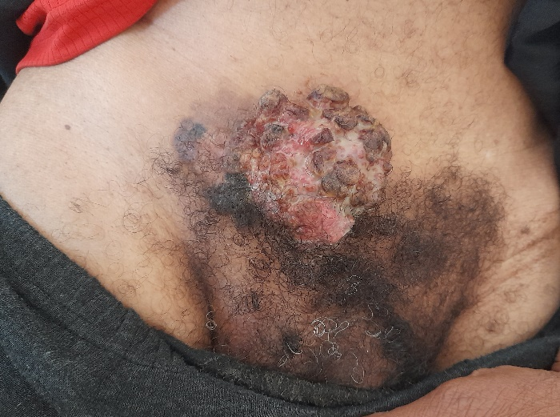
Fig 1: Preoperative view showing a 6.5 × 6 cm ulcerated exophytic tumor of the lower abdominal wall.
The patient underwent wide local excision with oncological margins. The resulting defect measured approximately 14 × 9 cm (Fig. 2). The surgical specimen was oriented and submitted for histopathological examination (Fig. 3).
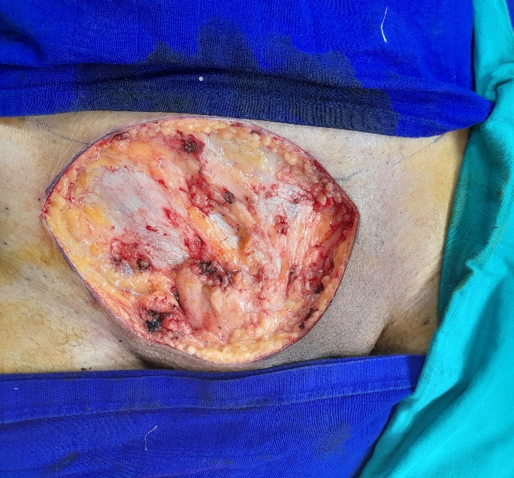
Fig 2: Intraoperative appearance after wide local excision demonstrating a 14 × 9 cm soft tissue defect with preservation of the abdominal fascia.
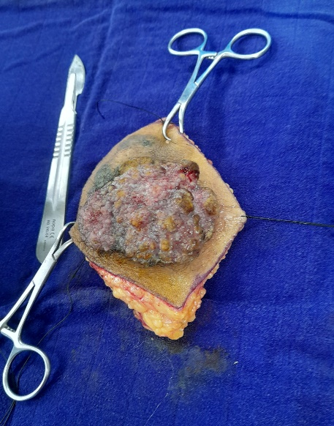
Fig 3: Oriented surgical specimen submitted for histopathological examination.
Reconstruction was achieved using a modified abdominoplasty-like advancement and translation plasty, allowing primary closure without mesh reinforcement.
Histopathological examination demonstrated a moderately differentiated non-keratinising invasive squamous cell carcinoma with multiple vascular tumour emboli, consistent with lymphovascular invasion (Fig. 4). Surgical margins were negative laterally (0.8–2.8 cm) and deeply (1 cm).
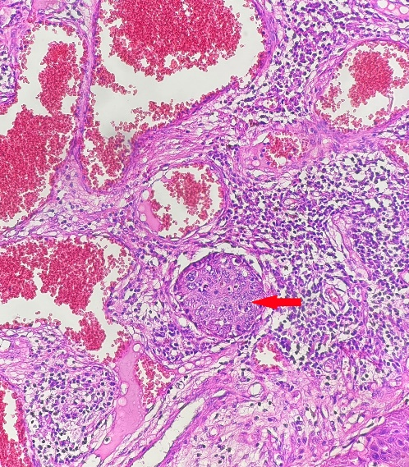
Fig 4: Histopathological examination showing a moderately differentiated non-keratinizing cutaneous squamous cell carcinoma with vascular tumor emboli (the red arrow), confirming lymphovascular invasion (hematoxylin and eosin stain, ×100).
The postoperative course was uneventful. The patient received adjuvant radiotherapy to the tumour bed using volumetric modulated arc therapy (VMAT) at a total dose of 60 Gy in 30 fractions to achieve conformal dose distribution and reduce toxicity to adjacent structures.
At 18 months of follow-up, no local recurrence, regional lymph node involvement, distant metastasis, abdominal wall weakness, or incisional hernia were observed. The aesthetic outcome was satisfactory (Fig. 5).
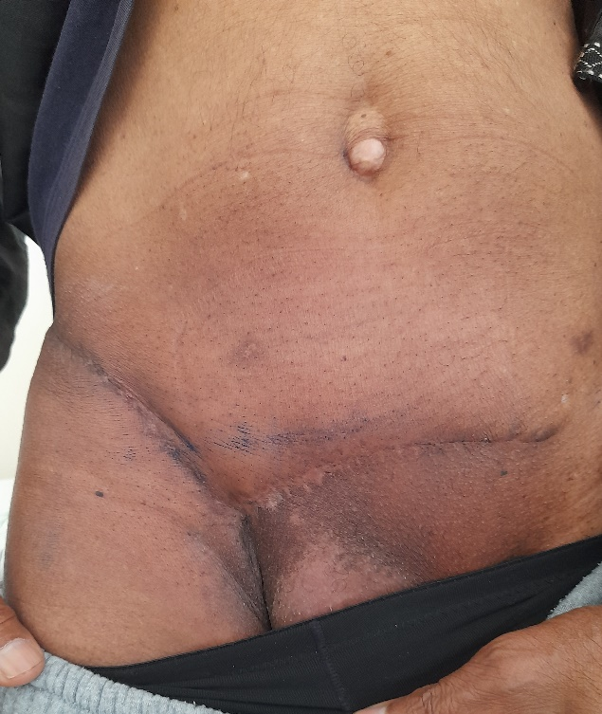
Fig 5: Eighteen-month postoperative follow-up showing satisfactory healing without local recurrence or abdominal wall deformity.
Discussion
Lower abdominal wall involvement by cutaneous squamous cell carcinoma is exceptionally uncommon (Makiguchi et al., 2015), making the present case noteworthy because of both its unusual location and its large size. Although no universally accepted definition exists, lesions measuring more than 5 cm are generally considered giant cSCC. The present tumour measured 6.5 × 6 cm, fulfilling the commonly accepted criteria for a giant lesion. Unlike the majority of cSCC, which arise on chronically sun-exposed skin, our patient's tumour developed in a non-sun-exposed area, emphasising the heterogeneous clinical presentation of this malignancy. In such cases, alternative pathogenic mechanisms, including chronic inflammation, scars, trauma, immunosuppression, or other unidentified factors, should be considered (Fania et al., 2021; Schmults et al., 2021).
Preoperative imaging plays an important role in the assessment of large abdominal wall tumours (Porrello et al., 2023). In the present case, computed tomography demonstrated preservation of the muscular and fascial planes, which facilitated complete resection while avoiding the need for complex abdominal wall reconstruction. Likewise, inguinal ultrasonography revealed no regional lymphadenopathy, supporting a localised disease stage.
Current international guidelines recommend complete surgical excision as the gold standard treatment for localised cSCC (Schmults et al., 2021). Surgical margins should be adapted according to tumour size, histological differentiation, and high-risk features. The primary objective is complete tumour removal with histologically negative margins while preserving function and minimising morbidity (Stratigos et al., 2026).
Several pathological features identified in our case classified the tumour as high-risk. These included a tumour diameter exceeding 6 cm, moderate differentiation, ulceration, infiltrative growth pattern, and, most importantly, the presence of lymphovascular invasion (Yildizdal et al., 2026). Among the high-risk histopathological features, lymphovascular invasion is considered one of the strongest predictors of nodal metastasis and disease-specific mortality. Its presence therefore justifies close postoperative surveillance even after complete tumour excision (Brancaccio et al., 2021). For this reason, careful long-term surveillance was considered mandatory despite complete excision.
Large defects of the abdominal wall following oncological resection often require reconstructive procedures ranging from skin grafting and local flaps to component separation techniques and prosthetic mesh reinforcement (Makiguchi et al., 2015). The choice depends on the size and depth of the defect as well as on involvement of the musculoaponeurotic layer.
In our patient, the absence of fascial involvement allowed reconstruction using a modified abdominoplasty-like advancement and translation plasty. The reconstructive challenge was amplified by the large postoperative defect measuring 14 × 9 cm. Despite its size, preservation of the musculoaponeurotic layer enabled tension-controlled closure using local tissue advancement without prosthetic reinforcement. Compared with mesh-based reconstruction or more complex flap procedures, this technique provided durable soft tissue coverage while preserving abdominal wall integrity without prosthetic reinforcement (Hew et al., 2024; Hope et al., 2023). Furthermore, no postoperative hernia or abdominal wall weakness was observed during follow-up.
Several studies have emphasised the importance of achieving histologically clear margins in high-risk cSCC (Zhang et al., 2015). Complete excision remains the most significant predictor of local disease control (Halim et al., 2023). In the present case, pathological examination confirmed tumour-free margins ranging from 0.8 to 2.8 cm laterally and 1 cm in depth, supporting the oncological adequacy of the procedure.
Although the tumour exhibited a non-keratinising morphology and immunohistochemical analysis was not performed, the diagnosis of primary cutaneous squamous cell carcinoma was supported by the concordance of the clinical presentation, imaging findings, anatomical location, and conventional histopathological features. Nevertheless, immunohistochemical markers such as p40, p63, and CK5/6 may be useful in diagnostically challenging cases, particularly when metastatic squamous cell carcinoma from a mucosal primary is considered in the differential diagnosis (Bălășescu et al., 2022).
Although the AJCC (8th edition) TNM staging system is validated for cutaneous squamous cell carcinoma of the head and neck, tumours arising on the trunk are generally stratified according to recognised high-risk clinicopathological features rather than formal AJCC staging (Jiang et al., 2024). In the present case, the lesion exhibited several high-risk characteristics, including a diameter exceeding 6 cm and lymphovascular invasion.
Adjuvant radiotherapy is generally reserved for giant cutaneous squamous cell carcinomas with high-risk features such as positive margins, deep invasion, nodal involvement, or recurrent disease. Modern techniques such as VMAT allow precise target coverage while limiting radiation exposure to adjacent organs (Muto et al., 2021). In our case, complete surgical excision with negative margins, the absence of nodal or distant metastases, and adjuvant VMAT radiotherapy may have contributed to favourable disease control during follow-up. Recent advances have expanded the therapeutic options for high-risk cSCC. The phase III C-POST trial demonstrated a significant improvement in disease-free survival with adjuvant cemiplimab following complete surgical resection in patients with high-risk disease. Although our patient was managed with adjuvant VMAT radiotherapy because of lymphovascular invasion, despite negative surgical margins, adjuvant anti-PD-1 therapy may represent an additional option in selected patients according to evolving evidence (Rischin et al., 2025). Based on these results, adjuvant cemiplimab received FDA approval in October 2025 for patients with high-risk resected cSCC.
At 18 months of follow-up, our patient remained free of local recurrence, regional nodal disease, and distant metastasis. Although this outcome is encouraging, the presence of lymphovascular invasion justifies prolonged surveillance because late recurrence remains possible. Longer follow-up is warranted to confirm durable oncological control (Ruiz et al., 2019).

Limitation
This report is limited by its single-case design and 18-month follow-up period. Immunohistochemical analysis was not performed, and nodal assessment relied on clinical examination and inguinal ultrasonography rather than more comprehensive cross-sectional staging. Longer follow-up is required to confirm durable oncological control and abdominal wall integrity.

Conclusion

Giant cutaneous squamous cell carcinoma of the lower abdominal wall is an uncommon presentation that requires careful evaluation of both oncological risk and reconstructive feasibility. In this case, preoperative imaging confirmed preservation of the fascial and muscular planes, permitting complete wide local excision and reconstruction with a modified abdominoplasty-like advancement and translation plasty without mesh reinforcement. Histopathological confirmation of negative margins supported the adequacy of surgical clearance; however, lymphovascular invasion and the large tumour size indicated high-risk disease and justified adjuvant treatment and close follow-up. The absence of recurrence, metastasis, abdominal wall weakness, or incisional hernia at 18 months suggests that this approach may provide satisfactory disease control and functional reconstruction in carefully selected patients. The case also highlights the value of coordinated surgical, pathological, radiological and radiation oncology assessment when managing unusual high-risk cSCC sites. Nevertheless, this is a single case, and durable outcomes cannot be assumed. Long-term surveillance remains essential because high-risk cSCC may recur or metastasise after apparently complete treatment.

Ethical Approval:

As per international standards or university standards written ethical approval has been collected and preserved by the author(s).

Consent
As per international standards or university standards, patient written consent has been collected and preserved by the author.
Declaration of AI Use
This manuscript was prepared through the combined contributions of all author(s), including contributions to the study design, data, content development, results, interpretation, and related scholarly work. The author(s) acknowledge the use of Grammarly and ChatGPT to assist with grammar checking, language refinement, and reference formatting. These AI-assisted tools were not used as authors and did not replace the intellectual contributions or scholarly judgement of the author(s). All AI-assisted outputs, including content, references, and interpretations, were carefully reviewed, revised, verified, and approved by the author(s). The author(s) accept full responsibility for the accuracy, integrity, and final content of the manuscript.

Competing Interests
Author have declared that no competing interests exist

References
Morelló-Vicente, A., Espejo-Marín, M., Oteiza-Rius, I., Antoñanzas, J., Vélez, A., & Salido-Vallejo, R. (2023). Increased risk of local recurrence in cutaneous squamous cell carcinoma arising in sun-exposed skin: A retrospective cohort study. Cancers, 15(20), 5037. https://doi.org/10.3390/cancers15205037
Fania, L., Didona, D., Di Pietro, F. R., Verkhovskaia, S., Morese, R., Paolino, G., Donati, M., Ricci, F., Coco, V., Ricci, F., Candi, E., Abeni, D., & Dellambra, E. (2021). Cutaneous squamous cell carcinoma: From pathophysiology to novel therapeutic approaches. Biomedicines, 9(2), 171. https://doi.org/10.3390/biomedicines9020171
Makiguchi, T., Yokoo, S., Takaku, Y., Morita, H., & Yasuda, M. (2015). Squamous cell carcinoma arising from abdominal wall defect lesion complicated with cloacal exstrophy. Plastic and Reconstructive Surgery Global Open, 3(3), e315. https://doi.org/10.1097/GOX.0000000000000286
Schmults, C. D., Blitzblau, R., Aasi, S. Z., Alam, M., Andersen, J. S., Baumann, B. C., Bordeaux, J., Chen, P. L., Chin, R., Contreras, C. M., DiMaio, D., Donigan, J. M., Farma, J. M., Ghosh, K., Grekin, R. C., Harms, K., Ho, A. L., Holder, A., Lukens, J. N., ... Nguyen, M. Q. (2021). NCCN Guidelines® Insights: Squamous cell skin cancer, Version 1.2022. Journal of the National Comprehensive Cancer Network, 19(12), 1382–1394. https://doi.org/10.6004/jnccn.2021.0059
Porrello, G., Cannella, R., Alvarez-Hornia Pérez, E., Brancatelli, G., & Vernuccio, F. (2023). The neoplastic side of the abdominal wall: A comprehensive pictorial essay of benign and malignant neoplasms. Diagnostics, 13(2), 315. https://doi.org/10.3390/diagnostics13020315
Stratigos, A. J., Dessinioti, C., Garbe, C., Lebbe, C., Amaral, T., Bataille, V., Dreno, B., Dummer, R., Fargnoli, M. C., Forsea, A. M., Gebhardt, C., Harwood, C. A., Hauschild, A., Hoeller, C., Kandolf-Sekulovic, L., Kaufmann, R., Kelleners-Smeets, N. W., Koelblinger, P., Lallas, A., ... Malvehy, J. (2026). European consensus-based interdisciplinary guideline for invasive cutaneous squamous cell carcinoma: Part 2. Treatment—update 2026. European Journal of Cancer, 243, 116764. https://doi.org/10.1016/j.ejca.2026.116764
Yildizdal, S., Cavusoglu, G., Kucukguven, A., Calis, M., & Vargel, I. (2026). Prognostic factors for recurrence in cutaneous squamous cell carcinoma: A retrospective analysis of 347 patients. Turkish Journal of Plastic Surgery, 34(1), 15–20. https://doi.org/10.4103/tjps.tjps_56_25
Brancaccio, G., Briatico, G., Pellegrini, C., Rocco, T., Moscarella, E., & Fargnoli, M. C. (2021). Risk factors and diagnosis of advanced cutaneous squamous cell carcinoma. Dermatology Practical & Conceptual, 11(Suppl 2), e2021166S. https://doi.org/10.5826/dpc.11S2a166S
Hew, C. Y., Rais, T., Antoniou, S. A., Deerenberg, E. B., & Antoniou, G. A. (2024). Prophylactic mesh reinforcement versus primary suture for abdominal wall closure after elective abdominal aortic aneurysm repair with midline laparotomy incision: Updated systematic review including time-to-event meta-analysis and trial sequential analysis of randomized controlled trials. Annals of Vascular Surgery, 109, 149–161. https://doi.org/10.1016/j.avsg.2024.06.026
Hope, W. W., Abdul, W., & Winters, R. (2023). Abdominal wall reconstruction. In StatPearls. StatPearls Publishing. https://www.ncbi.nlm.nih.gov/books/NBK431108/
Zhang, Y., Chen, B., Zhu, J., & Chen, L. (2015). Squamous cell carcinoma of unknown primary site presenting with an abdominal wall lesion as the primary symptom: A case report and review of the literature. Oncology Letters, 10(4), 2161–2165. https://doi.org/10.3892/ol.2015.3520
Halim, A. S., & Ramasenderan, N. (2023). High-risk cutaneous squamous cell carcinoma (CSCC): Challenges and emerging therapies. Asian Journal of Surgery, 46(1), 47–51. https://doi.org/10.1016/j.asjsur.2022.04.079
Bălășescu, E., Gheorghe, A. C., Moroianu, A., Turcu, G., Brînzea, A., Antohe, M., Hodorogea, A., Manea, L., Balaban, M., Andrei, R., Hulea, I., Popp, C. G., Nichita, L., Cioplea, M. D., Zurac, S. A., Ion, D. A., & Nedelcu, R. I. (2022). Role of immunohistochemistry in the diagnosis and staging of cutaneous squamous-cell carcinomas (Review). Experimental and Therapeutic Medicine, 23(6), 383. https://doi.org/10.3892/etm.2022.11308
Jiang, R., Fritz, M., & Que, S. K. T. (2024). Cutaneous squamous cell carcinoma: An updated review. Cancers, 16(10), 1800. https://doi.org/10.3390/cancers16101800
Muto, P., & Pastore, F. (2021). Radiotherapy in the adjuvant and advanced setting of CSCC. Dermatology Practical & Conceptual, 11(Suppl 2), e2021168S. https://doi.org/10.5826/dpc.11S2a168S
Rischin, D., Porceddu, S., Day, F., et al. (2025). Adjuvant cemiplimab or placebo in high-risk cutaneous squamous-cell carcinoma. The New England Journal of Medicine, 393(8), 774–785. https://doi.org/10.1056/NEJMoa2502449
Ruiz, E. S., Karia, P. S., Besaw, R., & Schmults, C. D. (2019). Performance of the American Joint Committee on Cancer Staging Manual, 8th edition vs the Brigham and Women’s Hospital Tumor Classification System for cutaneous squamous cell carcinoma. JAMA Dermatology, 155(7), 819–825. https://doi.org/10.1001/jamadermatol.2019.0032
Patil, S., Chaudhary, F., Sehgal, S., Patil, A., & Rathod, A. (2025). Spectrum of cutaneous squamous cell carcinoma: A case study emphasizing diagnostic vigilance. Asian Oncology Research Journal, 8(1), 210–219. https://doi.org/10.9734/aorj/2025/v8i1117
Subasri, P., Surya, R., Thenmozhi, A. J., & Manivasagam, T. (2026). Hypericin confers photoprotection in UV-B-exposed mouse skin by attenuating oxidative stress and modulating autophagy. Uttar Pradesh Journal of Zoology, 47(1), 269–278. https://doi.org/10.56557/upjoz/2026/v47i15454
Winge, M. C. G., Kellman, L. N., Guo, K., Tang, J. Y., Swetter, S. M., Aasi, S. Z., Sarin, K. Y., Chang, A. L. S., & Khavari, P. A. (2023). Advances in cutaneous squamous cell carcinoma. Nature Reviews Cancer, 23, 430–449. https://doi.org/10.1038/s41568-023-00583-5
Ran, N. A., Granger, E. E., Brodland, D. G., Cañueto, J., Carr, D. R., Carter, J. B., Carucci, J. A., Hirotsu, K. E., Koyfman, S. A., Mangold, A. R., Girardi, F. M., Shahwan, K. T., Srivastava, D., Vidimos, A. T., Willenbrink, T. J., Wysong, A., & Ruiz, E. S. (2025). Risk factor number and recurrence, metastasis, and disease-related death in cutaneous squamous cell carcinoma. JAMA Dermatology, 161(6), 597–604. https://doi.org/10.1001/jamadermatol.2025.0128
Miodovnik, M., Dolev, Y., Buchen, R., Brezis, M. R., Nikolaevski-Berlin, A., Finkel, I., Wolf, I., Ospovat, I., Gutfeld, O., & Leshem, Y. (2025). Squamous cell carcinoma arising in chronically damaged skin (Marjolin’s ulcer): Still an unmet need in the era of immunotherapy. The Oncologist, 30(8), oyae326. https://doi.org/10.1093/oncolo/oyae326

