Diversity, Threats, and Conservation of Catfishes (Siluriformes) at the Wainganga–Chulbandh River Confluence, Soni-Chapral, Maharashtra, India

Abstract
Freshwater catfishes are ecologically and economically important components of riverine ecosystems, and their diversity reflects habitat quality and environmental conditions. River confluences support heterogeneous habitats and rich fish assemblages, but increasing anthropogenic pressures may threaten their biodiversity and long-term persistence. The present study assessed the diversity, relative abundance, conservation status, and major threats affecting freshwater catfishes at the Wainganga–Chulbandh River confluence near Soni-Chapral, Bhandara District, Maharashtra, India. Field surveys were conducted twice weekly from December 2024 to November 2025 along a 3-km stretch extending upstream and downstream of the confluence. Fish were collected with the assistance of local fishermen using cast nets, gill nets, drag nets, and hook-and-line methods and were identified from external morphological and meristic characteristics. Thirteen species representing seven families were recorded. Bagridae was the dominant family, comprising six species (46.15%), followed by Siluridae with two species (15.38%); each remaining family was represented by one species (7.69%). Based on field occurrence, nine species (69.23%) were common, three (23.08%) were rare, and one (7.69%) was occasional. The IUCN categories assigned to the recorded fauna comprised ten Least Concern species, two Vulnerable species, and one Near Threatened species. The confluence supported a comparatively rich catfish assemblage, but destructive fishing practices, harvesting of juvenile fish, agricultural runoff, habitat degradation, and river regulation were identified as potential pressures. The findings provide site-specific baseline information for biodiversity monitoring and indicate the need for habitat protection, sustainable fishing practices, pollution reduction, community awareness, and periodic assessment of catfish populations in the Wainganga–Chulbandh River system.
Keywords: Catfish; Siluriformes; freshwater biodiversity; fish assemblage; river confluence; relative abundance; conservation status; anthropogenic threats; Wainganga River; Maharashtra

Introduction
Freshwater ecosystems are among the most productive and biologically diverse habitats, supporting a wide variety of fish species that contribute significantly to ecosystem functioning, food security, and rural livelihoods. Among freshwater fishes, catfishes (Order: Siluriformes) constitute one of the most diverse groups and are of considerable ecological, economic, and conservation importance. Owing to their wide distribution, habitat preferences, and sensitivity to environmental changes, catfishes are considered valuable indicators of riverine ecosystem health (Dudgeon et al., 2006; Kottelat & Whitten, 1996; Sarkar et al., 2012). Recent river-scale evidence shows that freshwater fish diversity is increasingly influenced by anthropogenic pressures and habitat alteration, including land-use change, non-native species introductions, and degradation of riparian conditions (Danet et al., 2024; Stefani et al., 2024).
The Wainganga River is one of the major tributaries of the Godavari River and serves as an important freshwater resource in eastern Maharashtra. Originating in the Satpura Hills of Madhya Pradesh, the river traverses Maharashtra before joining the Pranhita River. The Chulbandh River, a major tributary of the Wainganga River, originates near the Chulbandh Dam in Gondia District and joins the Wainganga River at Soni-Chapral, Taluka Lakhandur, Bhandara District, forming a biologically significant river confluence. River confluences are recognised as biodiversity hotspots because they provide diverse microhabitats, stable hydrological conditions, and abundant food resources that support rich fish assemblages. Recent river-network evidence further indicates that confluences and tributary junctions can support distinct and comparatively diverse fish assemblages because hydrological connectivity and habitat heterogeneity influence community structure across seasons (Liu et al., 2025).
Approximately 930 of the nearly 2,500 fish species reported from India are freshwater species (Jayaram, 1999). Fish diversity is widely regarded as an important indicator of freshwater ecosystem integrity and environmental quality (Nikam et al., 2014). Previous studies have documented 51 fish species belonging to 8 orders and 15 families from the Wainganga River in Bhandara District (Gadekar, 2015), while the Wainganga River around Desaiganj has been reported to support 28 species belonging to 10 orders, 15 families, and 22 genera. Comparable ichthyofaunal diversity has also been documented in the Dhansiri River (Acharjee et al., 2012). In these investigations, Siluriformes represented the second most dominant order after Cypriniformes. Similarly, 15 catfish species have been recorded from the Pranhita River at Sironcha (Sayyad & Dhamani, 2018), whereas 13 catfish species have been reported from the Wainganga sub-basin of Armori Taluka (Talmale et al., 2025).
Recent Indian assessments have likewise integrated ichthyofaunal inventories with water-quality evaluation and conservation-status appraisal to establish locally relevant ecological baselines for freshwater management (Ali, 2026; Wahlang et al., 2026). Despite these studies, no comprehensive assessment has been conducted on the diversity, abundance, threats, and conservation status of catfishes inhabiting the Wainganga–Chulbandh River confluence at Soni-Chapral. Considering the ecological significance of river confluences and the increasing anthropogenic pressures on freshwater ecosystems, baseline information on catfish diversity is essential for effective conservation planning. The available literature does not provide a site-specific account of catfish assemblage composition, relative abundance, principal threats, and conservation status at this confluence. Therefore, the present study was undertaken to document the diversity of catfishes (Order: Siluriformes), assess their relative abundance and conservation status based on the IUCN Red List, identify major threats affecting their populations, and provide scientific information to support the conservation and sustainable management of freshwater fish biodiversity in the Wainganga–Chulbandh River confluence.

Materials and Methods

Study Area
The present investigation was carried out at the Wainganga–Chulbandh River confluence located near Soni-Chapral village, Taluka Lakhandur, Bhandara District, Maharashtra, India. The study area comprised a 3-km stretch extending upstream and downstream from the confluence. The confluence is characterised by moderate water flow, variable depth, sandy and muddy substrata, and riparian vegetation, providing favourable habitats for diverse freshwater fish species.

Sampling and Collection
Field surveys were conducted for one year, from December 2024 to November 2025. Fish sampling was performed twice weekly with the assistance of local fishermen using traditional fishing gear, including cast nets, gill nets, drag nets, and hook-and-line methods. Specimens collected from the sampling sites were examined immediately, and representative individuals of each species were photographed using a Canon EOS 3000D DSLR camera before identification.

Species Identification
Collected specimens were identified using external morphological characters such as body shape, fin configuration, barbel arrangement, colour pattern, and meristic characteristics. Identification followed the standard taxonomic keys and descriptions provided by Beavan (1877), Day (1878, 1967), Jayaram (1981, 1999, 2002), Talwar and Jhingran (1991), together with relevant recent taxonomic literature.

Data Analysis
All recorded species were classified according to their family and genus. Species richness, family-wise composition, and relative abundance were calculated to evaluate catfish diversity within the study area. Based on field observations, each species was categorised as Common, Occasional, or Rare according to its frequency of occurrence during the sampling period. The global conservation status of each species was determined using the latest International Union for Conservation of Nature (IUCN) Red List of Threatened Species. Major threats to catfish diversity, including habitat degradation, overexploitation, pollution, destructive fishing practices, and other anthropogenic disturbances, were documented through direct field observations and discussions with local fishermen.

Table-1. Fin formula of recorded catfish species from the Wainganga–Chulbandh River confluence.
Sr. No. | Name of Fish | Fin Formula
1. | Mystus vittatus | D. 1/6-7; P. 1/8-9; V. i 5; A. 12-13; C. 17
2. | Mystus Cavasius | D. 1/7; P. 1/8; V. 6; A. 11; C. 19
3. | Mystus tengra | D. I/7; P. I/8; V. i 5; A. ii-iii/9-13; C. 14-19
4. | Rita gogra | D. I/6; P. I/10: V. i 5; A. iii-iv/8-9; C.19
5. | Rita kuturnee | D. I/6; P. I/10; V. 6; A. III/ii 8-9; C. 18
6. | Sperata seenghala | D. I/7; P. I/9; V. 8; A. 11-12; C. 19-21
7. | Ompak bimaculatus | D. 4; P. I/13; V. I/8; A. II-III/58-72; C. 17-18
8. | Wallago attu | D 5; P/13-15; V 8-10; A 77-93; C 18
9. | Clarias batrachus | D. 62-76; P. I/8-11; V. 6; A. 45-58; C. 15-17
10. | Bagarius bagarius | D. I/7; P. I/12; V. 6; A. iii 10-12; C. 17-20
11. | Pangasius pangasius | D. I/6-7; P. I/12-13; V. i 5; A. iv-v/26-29; C. 19
12. | Heteropneustes fossilis | D. 6-7; P. I/6-7; V. 6; A. 60-79; C. 17-19
13. | Clupisoma garua | D. I/7; P. I/9-11; V. I/6; A. iii-iv/27-47; C. 17-20

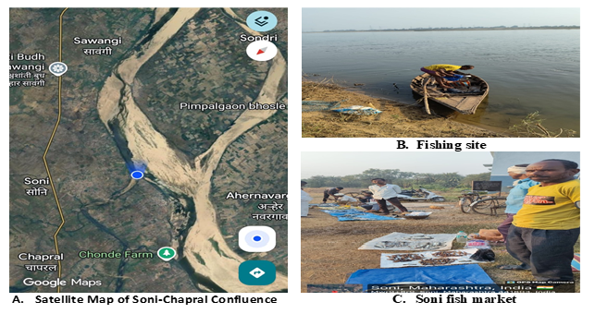
Fig 1. Study area showing: A. Satellite map of Soni-Chapral confluence (Satellite map@https://maps.google.com); B. Fishing site; C. Soni fish market.
Table 2. Taxonomic details, common names, vernacular names, abundance, and IUCN status of catfish species recorded from the study area.
Sr. No. | Name of order | Name of family | Scientific name | Common Name | Vernacular Name | Abundance | IUCN status
1. | Siluriformes | Bagridae | Mystus vittatus | Striped dwarf catfish | Katwa | Common | LC
2. | Siluriformes | Bagridae | Mystus cavasius | Gangetic mystus | Jala katwa | Common | LC
3. | Siluriformes | Bagridae | Mystus tengara | Tengara | Rignya Katwa | Common | LC
4. | Siluriformes | Bagridae | Rita gogra | Velvet catfish | Ghogar | Common | LC
5. | Siluriformes | Bagridae | Sperata seenghala | Giant river catfish | Singta/Koir | Common | LC
6. | Siluriformes | Bagridae | Rita kuturnee | Deccain rita | Kurud katwa/kuddo | Common | LC
7. | Siluriformes | Sisoridae | Bagarius bagarius | Goonch | Bodh | Rare | VU
8. | Siluriformes | Pangasiidae | Pangasius pangasius | Punga | Jarang | Rare | LC
9. | Siluriformes | Clariidae | Clarias batrachus | Walking catfish | Gavthi wagur | Rare | LC
10. | Siluriformes | Schilbeidae | Clupisoma garua | Ghaura | Wayali | Common | LC
11. | Siluriformes | Siluridae | Wallago attu | Helicopter catfish | Shiwada / Sawada | Common | VU
12. | Siluriformes | Siluridae | Ompak bimaculatus | Butter catfish | Waranja | Common | NT
13. | Siluriformes | Heteropneustidae | Heteropneustes fossilis | Stinging catfish | Singur/Ingur | Occassional | LC

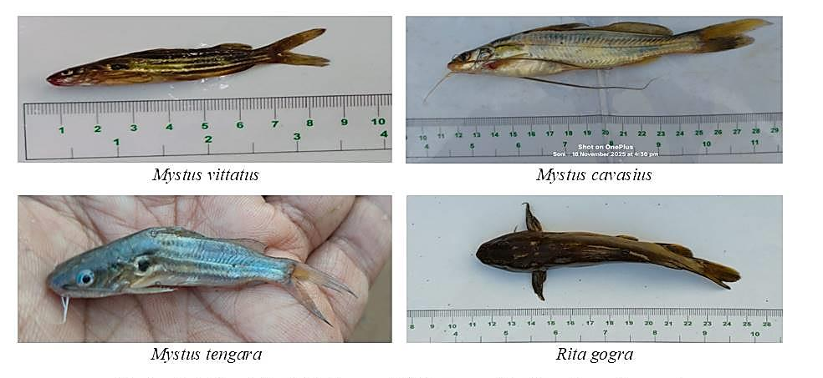
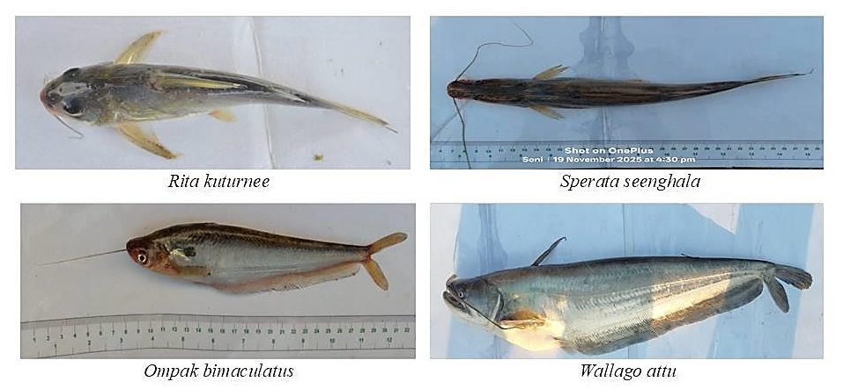
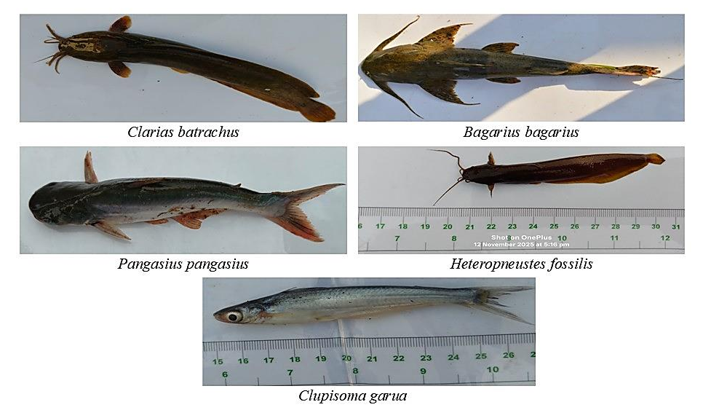
FIG 2. Photoplate showing catfish fauna of the Wainganga–Chulbandh confluence.

Fig3. Comparative study of species showing IUCN status, local abundance status, and species reported.

Fig 4. Family-wise distribution of catfish fauna showing number of genera and species in each family.

Results and Discussion
A total of 13 catfish species belonging to 9 genera and 7 families under the order Siluriformes were recorded from the Wainganga–Chulbandh River confluence during the study period (December 2024–November 2025). Among the recorded families, Bagridae was dominant, contributing six species (46.15%), followed by Siluridae with two species (15.38%). The remaining families, namely Clariidae, Pangasiidae, Schilbeidae, Sisoridae, and Heteropneustidae, were each represented by one species (7.69%).
Based on field observations, nine species (69.23%) were classified as common, one species (7.69%) as occasional, and three species (23.08%) as rare. Wallago attu was recorded throughout the year, indicating its broad habitat tolerance and stable population in the study area, whereas Bagarius bagarius was observed mainly during the winter season, suggesting seasonal variation in its occurrence.
The dominance of the family Bagridae is consistent with previous reports from the Wainganga River and other Indian river systems (Patra, 2011; Sarkar, 2023; Sarkar et al., 2012; Talmale et al., 2025). Similar studies have shown that catfish diversity is strongly influenced by river morphology, habitat heterogeneity, water quality, flow characteristics, and food availability. The relatively high species richness observed at the Wainganga–Chulbandh confluence may therefore be attributed to the diverse microhabitats and favourable environmental conditions created by the confluence of two rivers. Such habitats provide suitable spawning and feeding grounds and shelter, thereby supporting a rich catfish assemblage (Yuan et al., 2023).
Assessment of the conservation status using the IUCN Red List revealed that ten species were categorised as Least Concern (LC), two species as Vulnerable (VU), and one species as Near Threatened (NT). The occurrence of threatened species, particularly Wallago attu, Bagarius bagarius, and Ompok bimaculatus, emphasises the ecological significance of the study area and highlights the need for immediate conservation measures.
Field observations also identified several anthropogenic threats affecting catfish diversity. Destructive fishing methods, indiscriminate harvesting of juvenile fishes, increasing dependence of local communities on river resources, and habitat degradation were common in the study area. Agricultural runoff carrying fertilisers and pesticides from surrounding paddy fields may further deteriorate water quality, adversely affecting fish survival and reproduction. Similar impacts of pollution and other anthropogenic pressures on freshwater fish communities have been reported by Dudgeon et al. (2006) and Sarkar et al. (2012).
The influence of the Gosikhurd Dam on the Wainganga River may also have altered the natural flow regime, habitat connectivity, and sediment transport. During the present investigation, some fish species reported in earlier studies, including Mystus spp. and the locally known fish "Kuddu", were not recorded. Although the absence of these species during a one-year survey cannot be considered evidence of local extinction, it may indicate declining populations or habitat alteration. Previous studies have demonstrated that river regulation and dam construction can significantly affect fish diversity, migration, and community structure (Dudgeon et al., 2006; Cooper et al., 2017; Chen et al., 2023).
The present study provides the first comprehensive documentation of catfish diversity, abundance, threats, and conservation status from the Wainganga–Chulbandh River confluence. The findings establish valuable baseline information for future biodiversity assessments and emphasise the importance of conserving this ecologically significant riverine habitat.

Conclusion

The study documented 13 freshwater catfish species belonging to seven families at the Wainganga–Chulbandh River confluence. Bagridae was the dominant family, accounting for six species, whereas Siluridae contained two species and each remaining family contained one. Nine species were classified as common, three as rare, and one as occasional. The recorded assemblage included ten species listed as Least Concern, two as Vulnerable, and one as Near Threatened. These findings demonstrate the importance of the confluence as a habitat for freshwater catfish diversity and provide baseline information for future monitoring. Nevertheless, destructive fishing methods, indiscriminate capture of juvenile fish, agricultural runoff, habitat degradation, and possible effects of river regulation may adversely affect the persistence of these populations. Conservation efforts should therefore prioritise regulation of harmful fishing practices, protection of important habitats, reduction of agricultural and domestic pollution, engagement of local communities, and repeated biodiversity assessments. Long-term, standardised monitoring is also required to evaluate changes in species occurrence and abundance and to support evidence-based management of the Wainganga–Chulbandh River system.

Limitation
This study was limited to a single 3-km stretch of the Wainganga–Chulbandh River confluence surveyed over one year. Species abundance was classified as common, occasional, or rare without standardised catch-per-unit-effort estimates. Water quality, habitat variables, fishing intensity, and pollution loads were not measured systematically, while the effects of dam regulation and agricultural runoff were assessed descriptively. Species identification relied solely on morphological characteristics without molecular confirmation. Consequently, the findings provide a site-specific baseline but do not establish long-term population trends or causal relationships between environmental pressures and catfish diversity.

Declaration of AI Use

This manuscript was prepared through the combined contributions of all author(s), including contributions to the study design, data, content development, results, interpretation, and related scholarly work. The author(s) acknowledge the use of Grammarly and ChatGPT to assist with grammar checking, language refinement, reference formatting. These AI-assisted tools were not used as authors and did not replace the intellectual contributions or scholarly judgment of the author(s). All AI-assisted outputs, including content, references, and interpretations, were carefully reviewed, revised, verified, and approved by the author(s). The author(s) accept full responsibility for the accuracy, integrity, and final content of the manuscript.
Disclaimer (AI)
Author(s) hereby declares that NO generative AI technologies such as Large Language Models (ChatGPT, COPILOT, etc.) and text-to-image generators have been used during writing or editing of this manuscript.
Competing Interests:
Authors have declared that they have no known competing financial interests OR non-financial interests OR personal relationships that could have appeared to influence the work reported in this paper.
References:
Acharjee, B. K., Das, M., Borah, P., & Purkayastha, J. (2012). Ichthyofaunal diversity of Dhansiri River, Dimapur, Nagaland, India. Check List, 8(6), 1163–1165. https://doi.org/10.15560/8.6.1163
Ali, H. (2026). Diversity and conservation status of ichthyofauna in the River Rapti, Uttar Pradesh, India. Uttar Pradesh Journal of Zoology, 47(7), 28–40. https://doi.org/10.56557/upjoz/2026/v47i75584
Beavan, R. (1877). Handbook of the freshwater fishes of India: Giving the characteristic peculiarities of all the species at present known, and intended as a guide to students and district officers. L. Reeve & Co. https://doi.org/10.5962/bhl.title.5073
Chen, Q., Li, Q., Lin, Y., Zhang, J., Xia, J., Ni, J., Cooke, S. J., Best, J., He, S., Feng, T., Chen, Y., Tonina, D., Benjankar, R., Birk, S., Fleischmann, A. S., Yan, H., & Tang, L. (2023). River damming impacts on fish habitat and associated conservation measures. Reviews of Geophysics, 61(4), e2023RG000819. https://doi.org/10.1029/2023RG000819
Cooper, A. R., Infante, D. M., Daniel, W. M., Wehrly, K. E., Wang, L., & Brenden, T. O. (2017). Assessment of dam effects on streams and fish assemblages of the conterminous USA. Science of the Total Environment, 586, 879–889. https://doi.org/10.1016/j.scitotenv.2017.02.067
Danet, A., Giam, X., Olden, J. D., & Comte, L. (2024). Past and recent anthropogenic pressures drive rapid changes in riverine fish communities. Nature Ecology & Evolution, 8(3), 442–453. https://doi.org/10.1038/s41559-023-02271-x
Day, F. (1878). The fishes of India: Being a natural history of the fishes known to inhabit the seas and fresh waters of India, Burma, and Ceylon. B. Quaritch. https://doi.org/10.5962/bhl.title.62705
Day, F. (1967). The fishes of India: Being a natural history of the fishes known to inhabit the seas and fresh waters of India, Burma, and Ceylon (Vols. 1–2). Today & Tomorrow's Book Agency. https://catalog.hathitrust.org/Record/001500894
Dudgeon, D., Arthington, A. H., Gessner, M. O., Kawabata, Z.-I., Knowler, D. J., Lévêque, C., Naiman, R. J., Prieur-Richard, A.-H., Soto, D., Stiassny, M. L. J., & Sullivan, C. A. (2006). Freshwater biodiversity: Importance, threats, status and conservation challenges. Biological Reviews, 81(2), 163–182. https://doi.org/10.1017/S1464793105006950
Gadekar, G. P. (2015). Ichthyofaunal diversity of Wainganga River, Dist. Bhandara, Maharashtra, India. European Journal of Zoological Research, 4(1), 19–22. https://www.scholarsresearchlibrary.com/abstract/ichthyofaunal-diversity-of-wainganga-river-dist-bhandara-maharashtra-india-2442.html
Jayaram, K. C. (1981). The freshwater fishes of India, Pakistan, Bangladesh, Burma, and Sri Lanka: A handbook. Zoological Survey of India. https://catalog.hathitrust.org/Record/002959160
Jayaram, K. C. (1999). The freshwater fishes of the Indian region. Narendra Publishing House. https://libnet.vidyasagar.ac.in/cgi-bin/koha/opac-detail.pl?biblionumber=17388
Jayaram, K. C. (2002). Fundamentals of fish taxonomy. Narendra Publishing House. https://library.manipuruniv.ac.in/cgi-bin/koha/opac-detail.pl?biblionumber=49598&shelfbrowse_itemnumber=80729
Kottelat, M., & Whitten, T. (1996). Freshwater biodiversity in Asia: With special reference to fish (World Bank Technical Paper No. 343). World Bank. https://documents.worldbank.org/en/publication/documents-reports/documentdetail/406791468770639011
Liu, Z., Wu, Y., You, W., Li, S., Shi, G., & Zhang, C. (2025). Revealing the structure and biodiversity patterns of fish communities in river networks based on environmental DNA. Fishes, 10(4), 175. https://doi.org/10.3390/fishes10040175
Nikam, D. S., Shaikh, A. L., Salunkhe, P. S., Kamble, A. B., & Rao, K. R. (2014). Ichthyofaunal diversity of Ashti Lake, Tal. Mohol, Dist. Solapur (M.S.). Global Journal for Research Analysis, 3(12), 4–5. https://www.globaljournalforresearchanalysis.com/articles.php?b1=5&k=2&val=MTEzOTk%3D
Patra, A. K. (2011). Catfish (Teleostei: Siluriformes) diversity in Karala River of Jalpaiguri District, West Bengal, India. Journal of Threatened Taxa, 3(3), 1610–1614. https://doi.org/10.11609/JoTT.o2474.1610-4
Sarkar, U. K., Pathak, A. K., Sinha, R. K., Sivakumar, K., Pandian, A. K., Pandey, A., Dubey, V. K., & Lakra, W. S. (2012). Freshwater fish biodiversity in the River Ganga (India): Changing pattern, threats and conservation perspectives. Reviews in Fish Biology and Fisheries, 22(1), 251–272. https://doi.org/10.1007/s11160-011-9218-6
Sarkar, T. (2023). Catfish diversity and conservation status in the River Teesta, West Bengal, India. International Journal of Ecology and Environmental Sciences, 49(3), 282–287. https://doi.org/10.55863/ijees.2023.2634
Sayyad, N., & Dhamani, A. (2018). Catfish fauna (Order: Siluriformes) diversity of Pranhita River sub-basin at Sironcha, Gadchiroli District, Maharashtra, India. International Journal of Life Sciences, Special Issue A12, 235–239.
Stefani, F., Fasola, E., Marziali, L., Tirozzi, P., Schiavon, A., Bocchi, S., & Gomarasca, S. (2024). Response of functional diversity of fish communities to habitat alterations in small lowland rivers. Biodiversity and Conservation, 33, 1439–1458. https://doi.org/10.1007/s10531-024-02809-w
Talwar, P. K., & Jhingran, A. G. (1991). Inland fishes of India and adjacent countries (Vols. 1–2). Oxford & IBH Publishing Co. https://agris.fao.org/search/en/providers/122535/records/65ddd36cb766d82b18fa0e90
Talmale, A. D., Bansod, D. S., Chaudhari, S. S., & Wadpalliwar, G. G. (2025). Diversity, threats and conservation of catfish (Order Siluriformes) from sub-basin of Wainganga River near Armori, District Gadchiroli, Maharashtra, India. The Bioscan, 20(Special Issue 2), 182–188. https://doi.org/10.63001/tbs.2025.v20.i02.S.I(2).pp182-188
Wahlang, E. C., Yadav, M. K., & Saxena, S. (2026). Ichthyofaunal diversity and physicochemical water quality of Dahod Reservoir, Raisen, Madhya Pradesh, India. International Journal of Environment and Climate Change, 16(7), 36–44. https://doi.org/10.9734/ijecc/2026/v16i75521
Yuan, S., Qiu, J., Tang, H., Xu, L., Xiao, Y., Liu, M., Rennie, C., & Gualtieri, C. (2023). Fish community traits near a large confluence: Implications for its nodal effects in the river ecosystem. Journal of Hydrology, 626, 130335. https://doi.org/10.1016/j.jhydrol.2023.130335

