Efficacy of Plant-Derived Biopesticides Against Aphids: A Comparative Evaluation of Custard Apple Seed Oil, Neem Oil, Castor Oil, and Tobacco Leaf Extract

Abstract
The present study evaluated the efficacy of selected plant-derived biopesticides against aphids associated with brinjal, common bean and mungbean under laboratory and pot conditions. Treatments consisted of tobacco leaf extract, custard apple seed oil, castor oil and neem oil, each applied at 2% and 5% concentrations, along with an untreated control. The experiments were arranged in a completely randomised design with nine treatments and three replications. Mortality of brinjal aphid and bean aphid was recorded at 12, 18 and 24 hours after spraying under laboratory conditions, whereas mungbean aphid mortality was assessed at 12-hour intervals for 72 hours in the pot experiment. Among the tested botanicals, 5% neem oil consistently produced the highest aphid mortality. In brinjal aphid, 5% neem oil caused 94.44% mortality at 24 hours, followed by 5% tobacco leaf extract with 83.33% mortality. In bean aphid, 5% neem oil and 5% tobacco leaf extract resulted in 77.77% mortality at 24 hours. In the mungbean pot experiment, 5% neem oil achieved 100% mortality at 72 hours, followed by 5% tobacco leaf extract with 95.87% mortality and 2% neem oil with 89.96% mortality. The untreated control recorded no mortality in all experiments. However, tobacco leaf extract caused visible brown burning spots in the pot experiment, indicating possible phytotoxicity. The findings indicate that neem oil, particularly at 5%, showed comparatively higher efficacy against aphids in this study.

Keywords: aphid; neem oil; tobacco leaf extract; custard apple seed oil; castor oil; botanical insecticide; mungbean; brinjal; common bean; phytotoxicity.

INTRODUCTION
Aphids are small, soft-bodied, pear-shaped insects measuring approximately 1–10 mm in length that belong to the family Aphididae within the order Hemiptera. They are phloem-feeding insects of considerable agricultural significance owing to their pronounced polymorphism, host alternation, viviparous mode of reproduction, and exceptional capacity to transmit numerous plant viral pathogens. Globally, more than 250 aphid species are recognised as economically important pests affecting a wide range of agricultural and horticultural crops. In Bangladesh, however, the aphid fauna remains inadequately documented. To date, only approximately 30 aphid species representing 20 genera have been reported, infesting 58 host plant species, including annual and perennial crops, vegetables, trees, shrubs, and roses. In India, 10-90% yield losses to crops caused by aphids have been reported depending on infestation and crop stage (Razaq et al., 2011). Aphids attack a wide range of plants, including brinjal or eggplant (Solanum melongena L.), common bean (Lablab purpureus L.) and mungbean (Vigna radiata L.), which are important vegetable and pulse crops in Bangladesh. Brinjal or eggplant (Solanum melongena L.) is one of the most common, popular and principal vegetables in Bangladesh and other parts of the world. Brinjal is the second most important vegetable crop in relation to total production (Department of Agricultural Extension, 2016). This useful crop is grown throughout the year in Bangladesh and covers 46,558 ha, about 25.4% of the total vegetable area of the country, with a production of 341,000 tons. Brinjal is grown in all areas and seasons of Bangladesh. However, it is grown intensively during the winter season in Jessore, Mymensingh, Narsingdi, Comilla, Savar, Bogra, Jamalpur, Dinajpur, Rajshahi and the southern districts of Bangladesh. Hyacinth bean, known as common bean (Lablab purpureus L.), is also one of the most important winter vegetables in Bangladesh. It is highly nutritious, as the green pods contain a good amount of protein in addition to fibre, vitamins and minerals (Gopalan et al., 1989).
Mungbean (Vigna radiata L.) is an important grain legume cultivated extensively throughout South and Southeast Asia, predominantly by smallholder farming households. This short-duration, low-input crop is highly valued for its protein-rich seeds, which are readily digestible and widely consumed as a nutritious food source. It serves as a major source of dietary protein, particularly across the Indian subcontinent, where the intake of animal-derived protein remains relatively low. Recent evaluations of mungbean agroecosystems have further highlighted the importance of considering both insect pest populations and the activity of natural enemies when developing effective pest management strategies for this crop (Kishor et al., 2025).
However, aphid infestation is one of the most limiting factors for increasing the yield potential of these crops. Among various aphid species in Bangladesh, especially in the southern part of the country, brinjal is infested by Aphis gossypii, while common bean and mungbean are infested by Aphis craccivora. Aphids generally attack plants and suck sap from stems, buds, leaves, flowers, fruits and pods. They then digest plant sap and excrete sticky, sugary honeydew, which may attract other insects such as ants. Honeydew causes economic loss through physical contamination and by providing a nutrient source for fungi that contaminate produce and reduce photosynthesis by blocking sunlight. These aphids are also considered important vectors of plant viruses. Nymphs and adults are capable of virus transmission (Namba & Sylvester, 1981). In lablab, neem- and pyrethrum-based botanical insecticides have been evaluated against bean aphids alongside the conservation of natural enemies, indicating the relevance of assessing botanical treatments within crop-specific aphid-management systems (Ochieng et al., 2022).
Different strategies are practised to control these insect pests. Chemical control is commonly used as an effective method, and farmers continue to rely on chemicals to control a variety of insect pests (Naranjo, 2001). However, the excessive use of insecticides may lead to serious problems, such as pesticidal pollution, pest resurgence, mortality of natural enemies and pollinators, high production costs, reduction in nitrogen fixation and loss of biodiversity (Desneux et al., 2007).
Considering the above-mentioned problems, the proposed research work was planned to evaluate the performance of low-cost and environmentally friendly botanicals against aphids in Bangladesh. This information may help farmers to adopt appropriate management strategies and improve the sustainability of quality production.
Botanicals can play an important role in agriculture as naturally occurring plant-derived compounds with pesticidal activity. There are several advantages to using botanicals rather than synthetic insecticides. Plant-derived insecticides break down quickly in the environment, resulting in little risk of residues on food crops and less risk to beneficial insects. Some materials can be used shortly before harvest. Most botanicals are fast acting, and many are of low to moderate toxicity to mammals. Recent reviews have noted that botanical pesticides derived from plant secondary metabolites can act through multiple mechanisms, including repellency, antifeedant activity and insecticidal effects, while also requiring careful formulation and context-specific evaluation (Isman, 2020; Saikumar et al., 2025).
Neem-based biopesticides, including neem oil and neem seed-kernel extract, have also been reviewed for aphid suppression in crop-production contexts (Prasad et al., 2025). Although botanicals are recognised as possible alternatives to conventional insecticides, comparative information on tobacco leaf extract, custard apple seed oil, castor oil and neem oil at 2% and 5% against aphids on brinjal, common bean and mungbean under laboratory and pot conditions remains limited in the present study context.
The aim of this research work was to propose an alternative approach for aphid control in brinjal and country bean and to reduce reliance on large amounts of pesticides. Botanicals may offer a safer and effective alternative to conventional insecticides for controlling aphids within an integrated pest-management programme. The proposed study highlights the practical application of botanical insecticides for controlling aphids of brinjal and country bean. The proposed research work was carried out to determine the efficacy of botanical extracts for controlling aphids and to identify appropriate doses of botanical extracts against aphids.

MATERIALS AND METHODS

The experiments were carried out in the Insect Pest Management (IPM) Laboratory of the Department of Entomology and in the vegetable farm of Patuakhali Science and Technology University in Bangladesh.
Target Crop
Brinjal (Solanum melongena L.) and common bean (Lablab purpureus L.) were used because these are among the most popular vegetables cultivated by farmers in Bangladesh. Mungbean (Vigna radiata L.) was used for the pot experiment.
Planting of Seedlings
Healthy 28-day-old seedlings of uniform height were transplanted into pots of 1 ft x 1 ft height and diameter. The seedlings were watered immediately after transplanting.
Insect Rearing in the Laboratory
Several adult brinjal aphids and bean aphids were collected separately from their respective host plants at Patuakhali, Bangladesh, and brought to the IPM laboratory of the Department of Entomology, Patuakhali Science and Technology University, with their host plants for starting colonies in separate rearing chambers. These colonies were reared in separate insect-rearing chambers at 25 ± 2°C, 60 ± 5% relative humidity and a 16 h light/8 h dark (16L:8D) photoperiodic cycle.
Collection and Processing of Plant Materials
Fresh seeds of custard apple (Annona reticulata), neem (Azadirachta indica) and castor (Ricinus communis) were collected from the surroundings of Patuakhali Science and Technology University and dried, whereas tobacco leaves (Nicotiana tabacum) were purchased from the market. After being brought to the laboratory, the plant materials were washed under running water. They were then kept in the shade for air-drying and preserved in a refrigerator for seven days at 4°C.

Seed Oil Extraction
Extraction was carried out by drying seeds in a microwave oven at 65°C for about 24 hours. Seed powder was then prepared by grinding the dried seeds with an electric grinding machine. About 1 g of powdered seed material was soaked in 50 mL of acetone (50%) with frequent shaking before heating. The mixture was then heated at about 53°C for 10 minutes. After cooling, it was centrifuged at 7,000 rpm for 15 minutes, after which the extracts were filtered using Whatman No. 1 filter paper (Whatman International Ltd., England) and allowed to evaporate.

Experimental Design
In the laboratory experiment, brinjal leaf (one leaf per unit) and bean twig (7-10 cm long and one twig per unit) were used as plant materials. There were nine treatments with three replications for each. The treatments were T0: control (none); T1: 2% tobacco leaf extract (Nicotiana tabacum); T2: 5% tobacco leaf extract (Nicotiana tabacum); T3: 2% custard apple seed oil (Annona reticulata); T4: 5% custard apple seed oil (Annona reticulata); T5: 2% castor oil (Ricinus communis); T6: 5% castor oil (Ricinus communis); T7: 2% neem oil (Azadirachta indica); and T8: 5% neem oil (Azadirachta indica).
The effects of the above-listed treatments on percent mortality were observed in brinjal aphid (Aphis gossypii) and bean aphid (Aphis craccivora). The experiment was designed following a completely randomised design (CRD).
Pot Experiment
In the pot experiment, mungbean (Vigna radiata L.) was used as the plant material. Seedlings were transplanted into pots, with three plants per pot. The same treatments and replications described above were used.

Cultural Practices
The normal agronomic practices recommended for growing vegetables in an experimental farm, such as watering, weeding, mulching, fertilisation, staking and pruning, were followed.

Spraying Method
At first, six adult aphids were released per unit. Botanicals were sprayed 6 hours after aphid release. Botanicals at 2% and 5% concentrations were sprayed once on experimental units for brinjal and bean. Both the upper and lower surfaces of plant leaves and twigs were sprayed with botanicals. In the pot experiment, three sprays of botanicals were applied at 24-hour intervals.

Data Collection
Brinjal aphid and black bean aphid (six aphids per twig) were released from their mother stock plants onto the selected experimental units 6 hours before spraying to allow settlement. For brinjal and bean aphids, the number of dead insects was counted and recorded 12, 18 and 24 hours after one spray. For mungbean, dead insects were counted and recorded at 12-hour intervals for 3 days. Finally, mortality percentages (%) of these insects were calculated.

Statistical Analysis
Data were expressed from three individual replicates, and mean values ± standard error were plotted using SigmaPlot 8.0 (Systat Software, Inc., Point Richmond, CA, USA). Analysis of variance (ANOVA) was carried out to analyse the means using PROC General Linear Model (GLM) in Statistical Analysis System (SAS) version 9.1. Significant differences among mean values were determined using Duncan's Multiple Range Test (DMRT) at the 1% and 5% levels of significance.

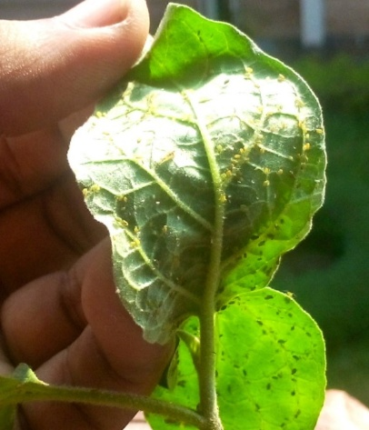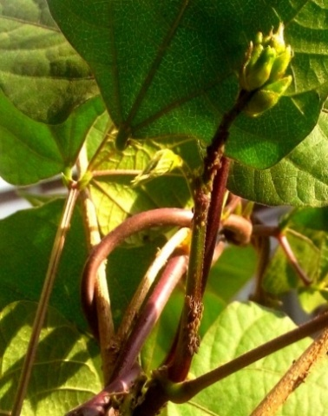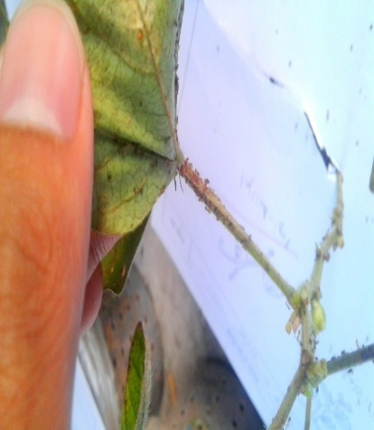

Figure 1: Rearing of brinjal aphid, bean aphid and mungbean aphid

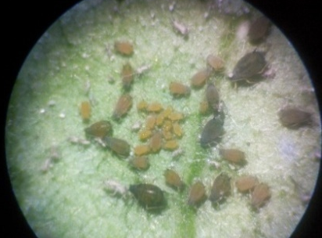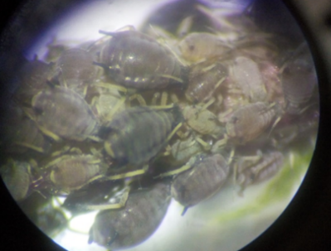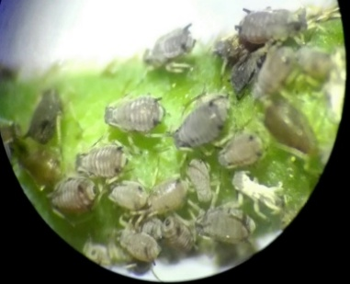

Figure 2: Colony of reared brinjal aphid, bean aphid and mungbean aphid under microscope

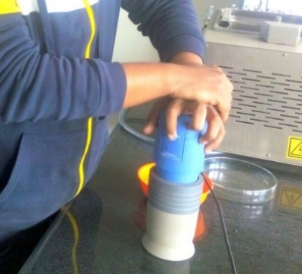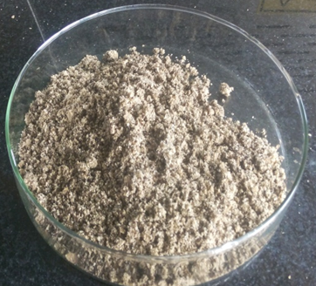

Figure 3: Drying and grinding of seed

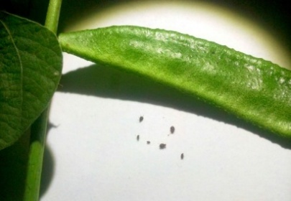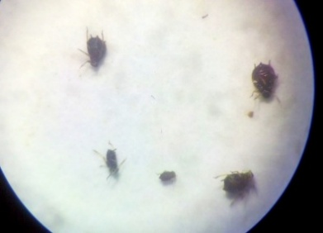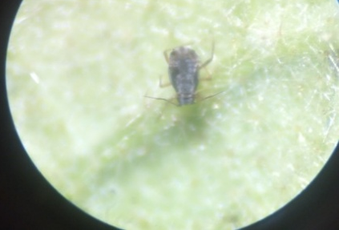
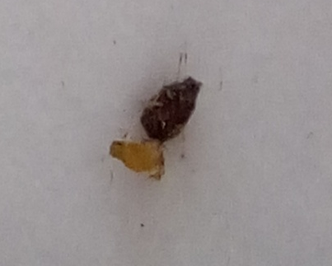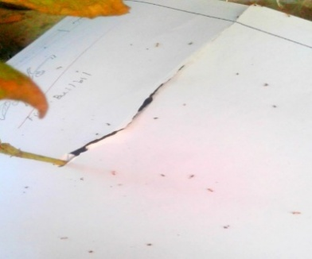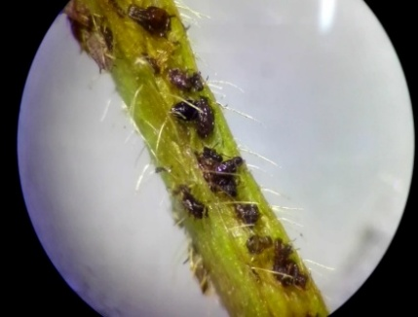

Figure 4: Dead insects under microscope

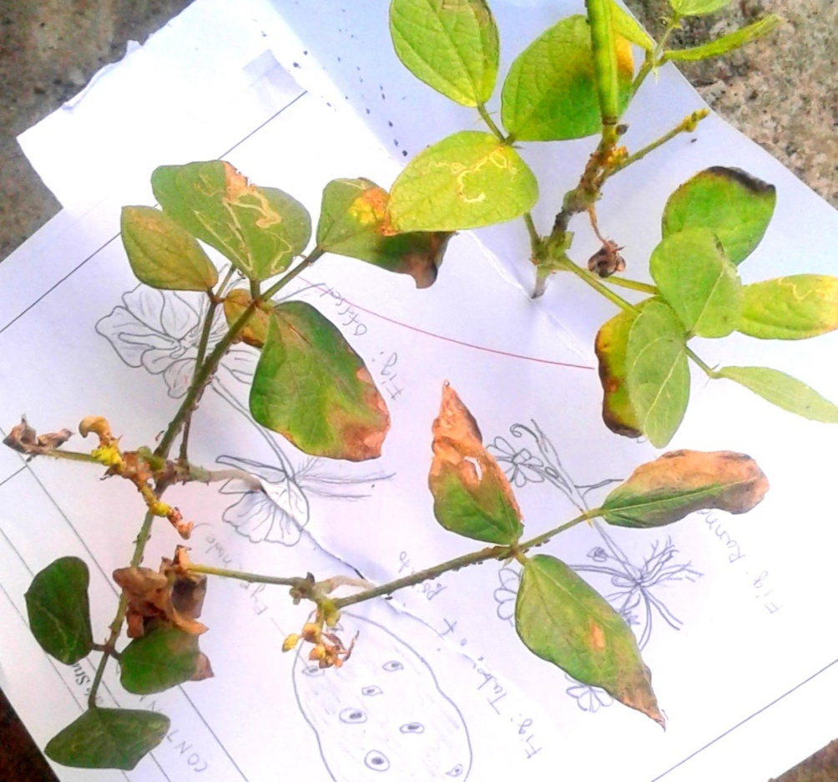
Brown burning spots

Figure 5: Phyotoxicity in case of tobacco leaf extract
in the pot experiment.

RESULTS

Performance of Botanicals on Aphid of Brinjal
Aphids were released from the colony of the IPM laboratory of Patuakhali Science and Technology University onto brinjal leaves in Petri dishes with wet cotton 6 hours before spraying to allow settlement. After spraying once with the botanicals (2% tobacco leaf extract, 5% tobacco leaf extract, 2% custard apple seed oil, 5% custard apple seed oil, 2% castor oil, 5% castor oil, 2% neem oil and 5% neem oil), the number of dead aphids was counted under a microscope and recorded at 12, 18 and 24 hours. After spraying, final aphid mortality was calculated.

Figure 6: Performance of botanicals against aphid of brinjal

At 12 hours after spraying, the highest mortality percentage was recorded with 5% neem oil (72.22%), followed by 5% tobacco leaf extract (44.44%), 5% castor oil (44.44%), 5% custard apple seed oil and 2% neem oil (38.88%). The lowest mortality was recorded for 2% custard apple seed oil (22.22%), 2% castor oil (22.77%) and 2% tobacco leaf extract (27.27%). No mortality was recorded in the control. At 18 hours after botanical spray, 5% neem oil showed the highest mortality (77.77%), followed by 5% tobacco leaf extract (61.11%), 5% custard apple seed oil (50%), 5% and 2% castor oil (44.44%), 2% neem oil (38.88%), 2% custard apple seed oil (33.33%), 2% tobacco leaf extract (27.27%) and control (0%) (Figure 6).

Figure 7: Performance of botanicals against brinjal aphid

The bar graph (Figure 7) shows that, at the first 12 hours, 5% neem oil had the highest performance, followed by 5% tobacco leaf extract, 5% castor oil, 5% custard apple seed oil and 2% neem oil, 2% tobacco leaf extract, 2% castor oil, 2% custard apple seed oil and control. After 18 hours, the effect of 5% neem oil was highest, followed by 5% tobacco leaf extract, 5% custard apple seed oil, 5% and 2% castor oil, 2% neem oil, 2% custard apple seed oil and 2% tobacco leaf extract. No mortality was recorded in the control. Furthermore, after 24 hours, 5% neem oil showed the highest mortality, followed by 5% tobacco leaf extract, 5% custard apple seed oil and 5% castor oil. The lowest mortality was recorded for 2% castor oil and 2% tobacco leaf extract, followed by 2% custard apple seed oil and 2% neem oil. No mortality was recorded in the control.

The efficacy of botanicals at different concentrations on brinjal leaf under laboratory conditions was in the following order: 5% neem oil > 5% tobacco leaf extract > 5% custard apple seed oil > 5% castor oil > 2% neem oil > 2% custard apple seed oil > 2% tobacco leaf extract and 2% castor oil > control.

Performance of Botanicals on Aphid of Bean
Aphids were released from the colony of the IPM laboratory of Patuakhali Science and Technology University onto bean twigs in Petri dishes with wet cotton 6 hours before spraying to allow settlement. After spraying once with the botanicals (2% tobacco leaf extract, 5% tobacco leaf extract, 2% custard apple seed oil, 5% custard apple seed oil, 2% castor oil, 5% castor oil, 2% neem oil and 5% neem oil), the number of dead aphids was counted under a microscope and recorded at 12, 18 and 24 hours. After spraying, final aphid mortality was calculated. At 12 hours, mortality was highest for 5% neem oil (55.55%), followed by 5% tobacco leaf extract (44.44%), 5% castor oil (38.88%) and 5% custard apple seed oil (38.88%), 2% tobacco leaf extract (22.22%), and 2% custard apple seed oil, 2% castor oil and 2% neem oil (16.66%). No mortality was recorded in the control. After 18 hours, the effect of 5% neem oil was highest (61.11%), followed by 5% tobacco leaf extract (55.55%), 5% custard apple seed oil (50%), 5% castor oil (44.44%), 2% neem oil (38.88%), 2% tobacco leaf extract and 2% custard apple seed oil (27.77%), and 2% castor oil (22.77%). No mortality was recorded in the control. After 24 hours, 5% neem oil and 5% tobacco leaf extract showed the highest mortality (77.77%), followed by 5% custard apple seed oil and 5% castor oil (61.11%). The lowest mortality was recorded for 2% custard apple seed oil and 2% tobacco leaf extract (44.44%). Mortality with 2% neem oil was 50%. No mortality was recorded in the control.

Figure 8: Performance of botanicals against aphid on bean

After the first 12 hours, mortality with 5% neem oil was the highest, followed by 5% tobacco leaf extract, 5% castor oil and 5% custard apple seed oil, 2% tobacco leaf extract, 2% custard apple seed oil, 2% castor oil and 2% neem oil, and control (Figure 8). After 18 hours, the effect of 5% neem oil was highest, followed by 5% tobacco leaf extract, 5% custard apple seed oil, 5% castor oil, 2% neem oil, 2% tobacco leaf extract and 2% custard apple seed oil, and 2% castor oil. No mortality was recorded in the control. After 24 hours, 5% neem oil showed the highest mortality, followed by 5% tobacco leaf extract, 5% custard apple seed oil, 5% castor oil, 2% neem oil, 2% custard apple seed oil and 2% tobacco leaf extract. No mortality was recorded in the control.
The efficacy of botanicals at different concentrations on common bean twig under laboratory conditions is given below:
5% neem oil > 5% tobacco leaf extract > 5% custard apple seed oil > 5% castor oil > 2% castor oil > 2% neem oil > 2% custard apple seed oil and 2% tobacco leaf extract > control.

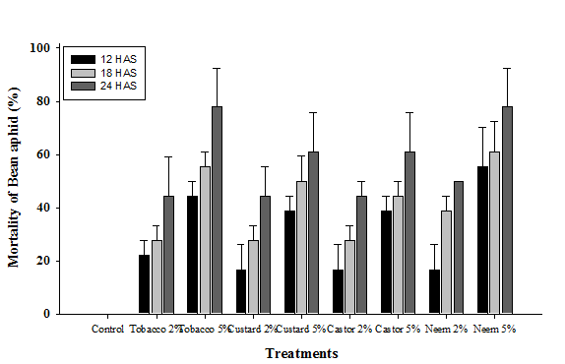

Figure 9: Performance of botanicals against aphid of bean

Performance of Botanicals against Aphid of Mungbean in the Pot Experiment
Aphids were reared under natural conditions on plants in pots at the farm of PSTU. Three sprays of botanicals (2% tobacco leaf extract, 5% tobacco leaf extract, 2% custard apple seed oil, 5% custard apple seed oil, 2% castor oil, 5% castor oil, 2% neem oil and 5% neem oil) were applied. After spraying, the number of dead aphids was counted under a microscope and recorded at 12-hour intervals. After spraying, final aphid mortality was calculated. After 12 hours, mortality percentages for 5% neem oil and 5% custard apple seed oil were the highest (6.86%), followed by 5% castor oil (6.15%), 5% tobacco leaf extract and 2% tobacco leaf extract, 2% neem oil (2.86%), 2% castor oil (0.89%) and 2% custard apple seed oil (0.25%). No mortality was recorded in the control. After 24 hours, the mortality percentage was highest in 5% neem oil (13.08%), followed by 5% tobacco extract (12.72%), 2% neem oil (10.21%), 5% custard apple seed oil (6.96%), 2% tobacco extract (5.85%), 5% castor oil (5.73%), 2% custard apple seed oil (5.37%), 2% castor oil (5.04%) and control (0%).

Fig 10: Performance of botanicals for aphid of mung bean in the pot experiment

At 36 hours, 12 hours after the second spray, the highest mortality was observed with 5% tobacco leaf extract (29.39%), followed by 2% tobacco leaf extract (22.04%), 5% neem oil (20.43%), 5% custard apple seed oil (19.89%), 2% neem oil (17.56%), 2% custard apple seed oil (15.41%), 5% castor oil (12.54%), 2% castor oil (11.11%) and control (0%). After 48 hours, 5% tobacco leaf extract showed the highest mortality (48.92%), followed by 2% tobacco leaf extract (37.09%), 5% neem oil (34.945%), 2% neem oil (33.51%) and 5% custard apple seed oil (32.43%). The lowest mortality was recorded with 2% castor oil (22.22%). Mortality with 5% castor oil was 24.91%, and mortality with 2% custard apple seed oil was 26.52%. No mortality was recorded in the control. After 60 hours following the third spray, mortality was highest in 5% tobacco leaf extract (74.01%), followed by 5% neem oil (62.54%), 2% neem oil (57.52%), 5% custard apple seed oil (53.76%), 5% castor oil (53.33%), 2% castor oil (50.46%), 2% tobacco leaf extract (47.49%), 2% custard apple seed oil (41.03%) and control (0%). Finally, after 72 hours, the highest mortality was recorded with 5% neem oil (100%), followed by 5% tobacco leaf extract (95.87%), 2% neem oil (89.96%) and 5% custard apple seed oil (77.41%). The lowest mortality was recorded with 2% castor oil (46.23%). Mortality with 5% castor oil was 57.52%, and mortality with 2% custard apple seed oil was 65.77%. No mortality was recorded in the control.
The efficacy of different treatments on mungbean in the pot experiment is given below:
5% neem oil > 5% tobacco leaf extract > 2% neem oil > 5% custard apple seed oil > 2% custard apple seed oil > 5% castor oil > 2% castor oil > control.

DISCUSSION
Since ancient times, several neem products, such as neem seed kernel, dry fruit extracts, neem oil, and leaf and bark extracts, have been used to control insects. Several neem and tobacco leaf extract products at different concentrations and formulations have shown positive and variable results against aphids and other insects on different plants (Ali et al., 2016; Azad et al., 2012; Bahar et al., 2007; Dimetry & Schmidt, 1992).

Ali et al. (2016) carried out a field study to examine the effect of biopesticides against sucking insect pests of brinjal under field conditions. Mortality with neem extract was the highest (82.60%), followed by tobacco extract (75.95%). Similarly, in the current experiment, neem oil gave a superior result to tobacco leaf extract.

Dimetry and Schmidt (1992) evaluated the effect of Neem-Azal S application. It produced an effective result in the suppression of bean aphid. This literature strongly supports the current research work.

Bahar et al. (2007) reported that tobacco extract gave better results, recording about 74-90% aphid suppression, followed by neem extract (53-64%) on yard-long bean aphid. These findings differ from the present research because, in the present research work, neem oil showed the better result, followed by tobacco extract.

Azad et al. (2012) evaluated the effect of eight botanical extracts on pest control in a brinjal field. Water extracts of dried leaves of khuksha (Ficus hispida), chotra (Lantana sp.), chirata (Swertia chirata), neem (Azadirachta indica), bael (Aegle marmelos), holde-hurhuri (Cleome viscosa) and marigold (Tagetes erecta), and seeds of mahogany (Swietenia mahagoni), were prepared and sprayed in an experimental brinjal field at Rajshahi University. Among these botanicals, khuksha leaf extract showed the best performance against pest attack compared with the other extracts. However, the present research shows that neem oil gave better results than the other botanicals.

Performance of Botanicals on Brinjal Aphid
The present study was accomplished through a laboratory experiment conducted in the IPM laboratory of the Department of Entomology at PSTU, Patuakhali, Bangladesh. The performance of different botanicals in reducing aphids was evaluated on brinjal leaf. Nine treatments were tested on aphids and compared with each other: T0, control (100% water); T1, 2% tobacco leaf extract; T2, 5% tobacco leaf extract; T3, 2% custard apple seed oil; T4, 5% custard apple seed oil; T5, 2% castor oil; T6, 5% castor oil; T7, 2% neem oil; and T8, 5% neem oil. For brinjal, the following trend of aphid mortality percentage was observed after the application of different treatments: T8, 5% neem oil > T2, 5% tobacco leaf extract > T4, 5% custard apple seed oil > T6, 5% castor oil > T7, 2% neem oil > T3, 2% custard apple seed oil > T1, 2% tobacco leaf extract and T5, 2% castor oil. T8 was significant at both the 1% and 5% levels.

The most effective results were obtained with T8 (5% neem oil) and T2 (5% tobacco leaf extract). The review of literature on the performance of the same botanicals on different plants supports the current research work.

Performance of Botanicals on Bean Aphid
The present study was carried out in the laboratory. The experiment was conducted in the entomology laboratory at PSTU, Patuakhali, Bangladesh. The performance of different botanicals in reducing aphids was evaluated on bean twig. Nine treatments were tested on aphids and compared with each other: T0, control (100% water); T1, 2% tobacco leaf extract; T2, 5% tobacco leaf extract; T3, 2% custard apple seed oil; T4, 5% custard apple seed oil; T5, 2% castor oil; T6, 5% castor oil; T7, 2% neem oil; and T8, 5% neem oil. The trend in aphid mortality percentage was as follows: T8, 5% neem oil > T2, 5% tobacco leaf extract > T4, 5% custard apple seed oil > T6, 5% castor oil > T7, 2% neem oil > T3, 2% custard apple seed oil > T1, 2% tobacco leaf extract and T5, 2% castor oil. T8 was significant at both the 1% and 5% levels.

The most effective results were obtained with T8 (5% neem oil) and T2 (5% tobacco leaf extract). The review of literature on the performance of the same botanicals on different plants supports the current research work.

Performance of Botanicals on Mungbean Aphid in the Pot Condition
The present study was accomplished through a pot experiment conducted at the farm of PSTU, Patuakhali, Bangladesh. The performance of different botanicals in reducing aphids was evaluated on mungbean. Nine treatments were tested on aphids and compared with each other: T0, control (100% water); T1, 2% tobacco leaf extract; T2, 5% tobacco leaf extract; T3, 2% custard apple seed oil; T4, 5% custard apple seed oil; T5, 2% castor oil; T6, 5% castor oil; T7, 2% neem oil; and T8, 5% neem oil.

The trend in aphid mortality percentage was as follows: T8, 5% neem oil > T2, 5% tobacco leaf extract > T7, 2% neem oil > T4, 5% custard apple seed oil > T1, 2% tobacco leaf extract > T3, 2% custard apple seed oil > T6, 5% castor oil > T5, 2% castor oil > T0, control. T8 was significant at both the 1% and 5% levels.

The most effective results were obtained with T8 (5% neem oil) and T2 (5% tobacco leaf extract). The review of literature on the performance of the same botanicals on different plants supports the current research work. However, in the pot experiment, some brown spots were observed in the tobacco leaf extract treatment.
Conclusion
The present study compared the aphicidal effects of tobacco leaf extract, custard apple seed oil, castor oil and neem oil at 2% and 5% concentrations against aphids of brinjal, common bean and mungbean. The results showed that the effectiveness of the tested botanicals varied with plant species, treatment concentration and exposure period. Among all treatments, 5% neem oil resulted in the highest mortality in brinjal aphid, bean aphid and mungbean aphid. At 24 hours after spraying, 5% neem oil resulted in 94.44% mortality of brinjal aphid and 77.77% mortality of bean aphid. In the mungbean pot experiment, 5% neem oil caused 100% mortality at 72 hours. Tobacco leaf extract at 5% also showed considerable aphicidal activity, particularly in bean and mungbean aphids, but visible brown burning spots were observed in the pot experiment, suggesting possible phytotoxic effects. Custard apple seed oil and castor oil showed comparatively lower or moderate efficacy depending on crop and concentration. Based on these observations, 5% neem oil may be considered a promising botanical treatment for aphid management under the conditions of the present experiment. Further field-level evaluation is required before wider recommendation.
Limitations
This study was limited to laboratory and pot conditions, so the findings may not fully represent aphid control under open-field environments. The experiment used six aphids per unit and three replications, with short observation periods. Longer-term aphid recovery, crop growth, yield response, natural-enemy effects and detailed phytotoxicity were not assessed. The chemical composition of extracts and oils was not analysed, and no standard insecticide comparison or corrected mortality analysis was included.
Declaration of AI Use
This manuscript was prepared through the combined contributions of all author(s), including contributions to the study design, data, content development, results, interpretation, and related scholarly work. The author(s) acknowledge the use of Grammarly and ChatGPT to assist with grammar checking, language refinement, reference formatting. These AI-assisted tools were not used as authors and did not replace the intellectual contributions or scholarly judgment of the author(s). All AI-assisted outputs, including content, references, and interpretations, were carefully reviewed, revised, verified, and approved by the author(s). The author(s) accept full responsibility for the accuracy, integrity, and final content of the manuscript.

REFERENCES

• Ali, S. S., Ahmad, S., Ahmed, S. S., Rizwana, H., Siddiqui, S., Ali, S. S., Rattar, I. A., & Shah, M. A. (2016). Effect of biopesticides against sucking insect pests of brinjal crop under field conditions. Journal of Basic & Applied Sciences, 12, 41–49. https://doi.org/10.6000/1927-5129.2016.12.06
• Azad, M. A. K., Yesmin, M. N., & Islam, M. S. (2012). Effect of botanical extract on pest control in brinjal field. Journal of Environmental Science and Natural Resources, 5(2), 173–176. https://doi.org/10.3329/jesnr.v5i2.14809
• Bahar, M. H., Islam, M. A., Mannan, M. A., & Uddin, M. J. (2007). Effectiveness of some botanical extracts on bean aphids attacking yard-long beans. Journal of Entomology, 4(2), 136–142. https://doi.org/10.3923/je.2007.136.142
• Department of Agricultural Extension. (2016). Pest risk analysis (PRA) of brinjal in Bangladesh. Ministry of Agriculture, Government of the People’s Republic of Bangladesh. https://objectstorage.ap-dcc-gazipur-1.oraclecloud15.com/n/axvjbnqprylg/b/V2Ministry/o/office-dae/2024/12/d502f5b304b749b7af80dc2137855bee.pdf
• Desneux, N., Decourtye, A., & Delpuech, J.-M. (2007). The sublethal effects of pesticides on beneficial arthropods. Annual Review of Entomology, 52(1), 81–106. https://doi.org/10.1146/annurev.ento.52.110405.091440
• Dimetry, N. Z., & Schmidt, G. H. (1992). Efficacy of Neem-Azal S and Margosan-0 against the bean aphid, Aphis fabae Scop. Anzeiger für Schädlingskunde, Pflanzenschutz, Umweltschutz, 65, 75–79. https://doi.org/10.1007/BF01906393
• Gopalan, C., Rama Sastri, B. V., & Balasubramanian, S. C. (1989). Nutritive value of Indian foods (B. S. Narasinga Rao, Y. G. Deosthale, & K. C. Pant, Rev. & updated). National Institute of Nutrition, Indian Council of Medical Research. https://www.icmr.gov.in/post/nutritive-value-of-indian-foods-nvif-by-c-gopalan-b-v-rama-sastri-s-c-balasubramanian-revised-updated-1989-by-b-s-narasinga-rao-y-g-deosthala-k-c-pant-reprinted-2007-2011
• Isman, M. B. (2020). Botanical insecticides in the twenty-first century: Fulfilling their promise? Annual Review of Entomology, 65(1), 233–249. https://doi.org/10.1146/annurev-ento-011019-025010
• Kishor, R., Singh, R. S., Biswas, S. K., Maurya, C. L., Kumar, S., & Singh, H. C. (2025). Biodiversity of insect pest and their natural enemy efficiency in mung bean (Vigna radiata L.) agro-ecosystem in Central Uttar Pradesh. Uttar Pradesh Journal of Zoology, 46(20), 61–69. https://doi.org/10.56557/upjoz/2025/v46i205300
• Namba, R., & Sylvester, E. S. (1981). Transmission of cauliflower mosaic virus by the green peach, turnip, cabbage, and pea aphids. Journal of Economic Entomology, 74(5), 546–551. https://doi.org/10.1093/jee/74.5.546
• Naranjo, S. E. (2001). Conservation and evaluation of natural enemies in IPM systems for Bemisia tabaci. Crop Protection, 20(9), 835–852. https://doi.org/10.1016/S0261-2194(01)00115-6
• Ochieng, L. O., Ogendo, J. O., Bett, P. K., Nyaanga, J. G., Cheruiyot, E. K., Mulwa, R. M. S., Arnold, S. E. J., Belmain, S. R., & Stevenson, P. C. (2022). Field margins and botanical insecticides enhance Lablab purpureus yield by reducing aphid pests and supporting natural enemies. Journal of Applied Entomology, 146(7), 838–849. https://doi.org/10.1111/jen.13023
• Prasad, S., Raypuriya, N., Naan, T., Vanlalhmuliana, H., Kashyap, P., Nagaraju, D., & Panigrahi, C. K. (2025). Evaluation of neem-based biopesticides in controlling aphid population in Brassica juncea: A review. Journal of Experimental Agriculture International, 47(8), 481–497. https://doi.org/10.9734/jeai/2025/v47i83690
• Razaq, M., Mehmood, A., Aslam, M., Ismail, M., Afzal, M., & Shad, S. A. (2011). Losses in yield and yield components caused by aphids to late sown Brassica napus L., Brassica juncea L. and Brassica carrinata A. Braun at Multan, Punjab (Pakistan). Pakistan Journal of Botany, 43(1), 319–324. https://www.pakbs.org/pjbot/paper_details.php?id=2655
• Saikumar, T., Manideep, S., Paschapur, A. U., & Thrilekha, D. (2025). Botanical pesticides: Exploring successes, challenges, and future directions in sustainable pest management. Journal of Plant Diseases and Protection, 132, Article 175. https://doi.org/10.1007/s41348-025-01177-z

