Original Research Article

Association of the NRF2 rs6721961 Polymorphism with Serum Vitamin E Levels in Idiopathic Male Infertility: A Case-Control Study among Iraqi Men.

ABSTRACT
Background: Oxidative stress plays an important role in the pathogenesis of idiopathic male infertility. The transcription factor NRF2 regulates antioxidant defence genes, and polymorphisms in its promoter region may affect antioxidant capacity. Vitamin E (α-tocopherol) is a major lipid-soluble, chain-breaking antioxidant that protects sperm membranes from peroxidative damage.
Objective: This study aims to evaluate the frequency of the rs6721961 (−617 C>A) polymorphism in the NRF2 gene and its association with serum vitamin E levels in Iraqi men with idiopathic infertility.
Methods: This case-control study included 160 men (80 infertile patients and 80 fertile controls). The rs6721961 polymorphism was genotyped using tetra-primer ARMS-PCR, and serum vitamin E levels were measured using a validated colourimetric assay. Statistical analyses included chi-squared tests for genotype distributions, Mann-Whitney U tests, Kruskal-Wallis H tests, and Spearman's rank correlation.
Results: The rs6721961 A allele was significantly more frequent among infertile patients than among controls (46.9% vs. 16.9%; OR = 4.35, 95% CI: 2.59–7.29; p < 0.001). The AA genotype was detected only in the infertile group (21.3% vs. 0.0%). Overall serum vitamin E levels were significantly lower in infertile patients than in controls (p < 0.001). Within the patient group, serum vitamin E concentrations decreased across the CC, CA, and AA genotypes, although the between-genotype comparison was not statistically significant (p = 0.080). Spearman's analysis nevertheless showed a significant inverse correlation between the number of A alleles and serum vitamin E levels (ρ = −0.373, p < 0.001).
Conclusion: The rs6721961 A allele and AA genotype were associated with idiopathic male infertility and lower serum vitamin E levels in this Iraqi population. The inverse association between A-allele dosage and serum vitamin E may indicate a relationship between NRF2 variation and antioxidant status; however, larger studies and functional validation are required before clinical implications can be established.

Keywords: NRF2; NFE2L2; rs6721961; vitamin E; idiopathic male infertility; oxidative stress; antioxidant status; genetic polymorphism;

1. INTRODUCTION
Approximately one in six people experience infertility. Both male and female factors contribute, with male factors accounting for nearly half of all cases. Despite extensive clinical evaluation, many men remain classified as having idiopathic infertility, and the underlying molecular mechanisms remain unclear (Minhas et al., 2021; P et al., 2025; Sengupta et al., 2026; World Health Organization, 2023). Oxidative stress is an important contributor to male infertility because excessive reactive oxygen species can impair sperm function (Agarwal et al., 2018; Dutta et al., 2022; Jignoua et al., 2024).
Nuclear factor erythroid 2-related factor 2 (NRF2) is a crucial regulator of cellular antioxidant defence and modulates the transcription of several antioxidant enzymes required for redox homeostasis. The rs6721961 A allele (−617 C>A) is associated with reduced NRF2 transcriptional activity, thereby potentially compromising antioxidant defence. Previous studies and a recent meta-analysis have reported associations between this allele, male infertility, and sperm quality (Aydos et al., 2021; Kaur et al., 2025; Marzec et al., 2007; Rehman et al., 2022).
Vitamin E (α-tocopherol), the principal lipid-soluble antioxidant, protects sperm membranes from lipid peroxidation. Because its regeneration depends on glutathione- and NRF2-regulated pathways, reduced NRF2 activity may contribute to lower vitamin E status and increased oxidative damage (Dinkova-Kostova & Abramov, 2015). Systematic reviews of antioxidant therapy, preconception diet, and nutritional interventions suggest that selected approaches may influence semen parameters; however, heterogeneous study designs and limited reporting of pregnancy or live-birth outcomes preclude firm clinical recommendations (Saleh et al., 2025; Tully et al., 2024; Zafar et al., 2023).
However, the association between the NRF2 rs6721961 polymorphism and serum vitamin E levels has not been examined in Iraqi men. Accordingly, this case-control study investigated whether rs6721961 is associated with idiopathic male infertility and lower serum vitamin E concentrations. We hypothesised that the A allele would be more frequent among infertile men and that increasing A-allele dosage would be inversely associated with serum vitamin E concentrations, consistent with reduced NRF2-associated antioxidant defence.
Objective: The present study aimed to determine the frequency of the NRF2 rs6721961 polymorphism in Iraqi men with idiopathic infertility and to evaluate its association with serum vitamin E concentrations.

2. MATERIAL AND METHODS
2.1. Study Design and Population
This case-control study was conducted over four months, from November 2025 to February 2026, at the Fertility and Infertility Prevention Center, Al-Sadr Medical City, Najaf, Iraq.
A total of 160 Iraqi men were recruited in a 1:1 ratio (80 patients with idiopathic male infertility and 80 fertile controls). Idiopathic infertility was diagnosed in the patient cohort according to the sixth edition of the WHO laboratory manual (World Health Organization, 2021) and was defined as failure to establish a pregnancy after 12 months of regular, unprotected intercourse when physical examination, endocrine profiles, and standard semen analyses failed to reveal a definitive aetiological cause. The same WHO criteria (World Health Organization, 2021) were used to define oligozoospermia, asthenozoospermia, and teratozoospermia. The control group comprised 80 healthy, fertile men who had fathered a child within the previous 1–2 years.
The same exclusion criteria were applied to both groups. Participants were excluded for any of the following: azoospermia or obstructive infertility; clinical varicocele or genital tract infection; a history of hormonal therapy, chemotherapy, or radiotherapy; known genetic or endocrine disorders; major systemic diseases (e.g., diabetes mellitus, cardiovascular disease, or chronic renal failure); use of antioxidant supplements or specific medications within the previous 3–6 months; smoking (cigarettes, e-cigarettes, or waterpipes), alcohol consumption, or occupational toxin exposure; or previous urogenital surgery or radiation exposure. Blood samples were collected from all participants while fasting; all participants were non-smokers.

2.2. Sample Size Determination
Because population-specific genetic data from Iraqi cohorts were unavailable, an internal pilot design was adopted using the first 30 participants in each group. The primary genetic endpoint, the minor allele frequency of rs6721961, was used for the sample-size calculation. Based on the observed allele frequencies (16.9% in controls and 46.9% in patients; odds ratio ≈ 4.7), a chi-squared test for two independent proportions (α = 0.05, power = 0.80) yielded a required sample size of 34 participants per group using G*Power software (Faul et al., 2007). To accommodate secondary biochemical endpoints and potential PCR failures, the final sample size was set at 80 participants per group (total n = 160).

2.3. Blood Collection and Serum Preparation
Semen analysis and blood collection were performed on the same day. Approximately 5 mL of blood was collected from the antecubital vein into plain serum gel tubes. The blood was allowed to clot for 30 minutes at room temperature and was then centrifuged at 3000×g for 10 minutes. Serum was separated, aliquoted into sterile microcentrifuge tubes, and stored at −80 °C until biochemical analysis. All assays were performed in duplicate to ensure analytical precision.
2.4. Measurement of Serum Vitamin E
Serum vitamin E (α-tocopherol) levels were determined using a colourimetric assay kit (Elabscience® Vitamin E Assay Kit, Cat. No. E-BC-K033-S). The assay is based on the reduction of ferric ions (Fe³⁺) to ferrous ions (Fe²⁺) by vitamin E, followed by chromogenic complexation with phenanthroline; the absorbance of the pink-coloured product was measured at 532 nm (Elabscience, n.d.). The assay detection range was 0.09–40 μg/mL, and the intra-assay and inter-assay coefficients of variation were <5.2%, indicating acceptable analytical precision. Procedures were performed according to the manufacturer's instructions, and final concentrations were calculated as described in the kit manual.

2.5. Genomic DNA Extraction and rs6721961 Genotyping
Total genomic DNA was isolated from EDTA-treated whole-blood specimens using the gSYNC™ DNA Extraction Kit (Geneaid Biotech, Taiwan), according to the manufacturer's spin-column protocol for mammalian whole blood.
The purity and concentration of the eluted DNA were assessed spectrophotometrically using a NanoDrop™ 2000; only samples with an A₂₆₀/A₂₈₀ absorbance ratio of 1.8–2.0 were accepted. Purified DNA templates were stored at −20 °C until genotyping.
The single-nucleotide polymorphism rs6721961 (−617 C>A) within the NRF2 promoter region was genotyped using the tetra-primer amplification refractory mutation system-polymerase chain reaction (ARMS-PCR) technique (Ye et al., 2001). Primer sequences were adopted from a previously validated study conducted in a geographically proximate Middle Eastern population and are summarised in Table 1 (Maqsood et al., 2022).
Table 1: Primer Sequences and Expected Amplicon Sizes for NRF2 rs6721961 Genotyping
Primer Name | Primer Sequence (5′→3′) | Allele Specificity | Product Size (bp)
Outer Forward (OF) | CTCCGTTTGCCTTTGACGAC | Outer control | 282
Outer Reverse (OR) | GGGGAGATGTGGACAGCG | Outer control | 282
Inner Forward (IF) | CCCTGATTTGGAGTTGCAGAACC | C allele (wild‑type) | 113
Inner Reverse (IR) | GCGAACACGAGCTGCCGGA | A allele (mutant) | 205
Each PCR reaction had a total volume of 25 µL and contained 12.5 µL of a 2.5× master mix (Syntol, Russia), 2 µL of genomic DNA template (50–100 ng), 1 µL (10 pmol) of each outer primer, 1.5 µL (15 pmol) of each inner primer, and 0.5 µL of supplemental 25 mM MgCl₂. Amplification was performed in a Techne TC-5000 thermal cycler under the following conditions: initial denaturation at 94 °C for 5 minutes; 35 cycles of denaturation at 94 °C for 30 seconds, annealing at 60 °C for 30 seconds, and extension at 72 °C for 30 seconds; and a final extension at 72 °C for 5 minutes. The amplified products were resolved by electrophoresis on a 2% agarose gel pre-stained with RedSafe™ nucleic acid dye at 100 V for 60 minutes in 1× TBE buffer. Banding patterns were visualised under UV transillumination and compared with a 100 bp DNA ladder to assign the CC, CA, or AA genotypes (Marzec et al., 2007).
2.6. Statistical Analysis
All statistical analyses were performed using SPSS version 26.0 (IBM Corp., Armonk, NY, USA). The normality of continuous variables, specifically serum vitamin E levels, was assessed using the Shapiro-Wilk test. Because the data deviated significantly from a normal distribution, non-parametric tests were used for all between-group and across-group comparisons of vitamin E levels. The Mann-Whitney U test was used to compare vitamin E concentrations between two independent groups, specifically patients and controls overall and patients and controls within the CC and CA genotype categories. The Kruskal-Wallis H test was used to compare vitamin E levels across the three genotype categories (CC, CA, and AA) within the patient group. Genotype and allele frequency distributions between infertile patients and fertile controls were compared under codominant, dominant, recessive, and overdominant genetic models using Pearson's chi-squared (χ²) test. For each genetic model, a 2×2 contingency table was used to estimate the odds ratio (OR) and 95% confidence interval (95% CI) for infertility status. When the AA genotype was absent from the control group, the OR was mathematically undefined and was therefore reported as 'not estimable'. Pearson's chi-squared test remained applicable because the minimum expected cell count in the corresponding 2×2 tables exceeded 5. Fisher's exact test was also applied to all 2×2 comparisons involving the AA genotype to assess the robustness of the p-values. Spearman's rank correlation coefficient was calculated between the ordinal genotypic score (CC = 0, CA = 1, AA = 2) and serum vitamin E concentrations within the patient group to evaluate the relationship between A-allele dosage and vitamin E levels.
3. RESULTS
3.1 Genotype and Allele Distribution of rs6721961 in the NRF2 Gene
A cohort of 80 infertile men and 80 fertile controls was genotyped for the rs6721961 SNP in the NRF2 gene (Figure 1). The genotype distribution in the control group did not deviate significantly from Hardy-Weinberg equilibrium (χ² = 3.30, df = 1, p = 0.069). Genotype and allele frequencies differed significantly between the two groups under each inheritance model examined (Table 2, Figure 2).
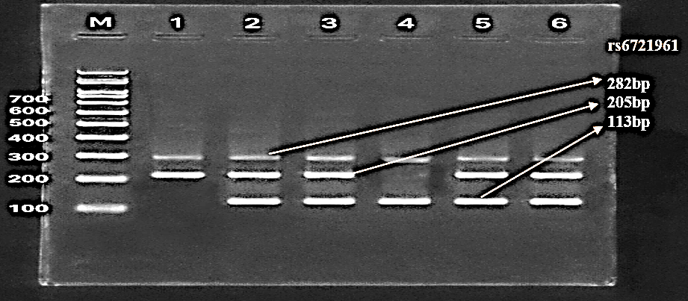

Figure 1: Typical agarose gel electrophoresis of genotyping of the NRF2 rs6721961 (−617 C>A) polymorphism (using tetra-primer ARMS-PCR). Lane M: 100 bp DNA ladder. An outer control primer produced a 282 bp fragment and allele-specific inner primers generated products of 113 bp (C allele) and 205 bp (A allele).

Amplification was successful in all cases, as indicated by the presence of the 282 bp control band in every lane. In the codominant model, the CA genotype was observed in 51.3% of patients and 33.8% of controls (OR = 3.66; 95% CI: 1.83–7.33; p < 0.001). The AA genotype was observed in 17 of 80 patients (21.3%) and in none of the 80 controls, precluding standard OR estimation; the corresponding chi-squared value was 28.34 (p < 0.001). The CC genotype was detected in 27.5% of patients and 66.3% of controls, indicating that it was more frequent among fertile controls. Under the dominant model, the combined CA and AA carrier rate was 72.5% among patients and 33.8% among controls (OR = 5.18; 95% CI: 2.64–10.17; χ² = 24.12, p < 0.001). The recessive model yielded χ² = 19.02 (p < 0.001), with an undefined OR because no control participant had the AA genotype. The overdominant comparison of CA versus CC+AA also showed a statistically significant difference between groups.
At the allele level, the A-allele frequency was 46.9% in patients and 16.9% in controls (OR = 4.35; 95% CI: 2.59–7.29; χ² = 33.15, p < 0.001). The C allele was more frequent in controls than in patients (83.1% vs. 53.1%). Across all models, the results consistently indicated an association between the A allele and male infertility in this study population.

Table 2: Genetic Model Analysis of rs6721961 Polymorphism in NRF2 Gene with Male Infertility
Genetic Model | Genotype Comparison | Patient (n=80)  n (%) | Control (n=80)  n (%) | OR (95% CI) | χ² (p-value)
Codominant | CA vs CC | CA: 41 (51.3%) CC: 22 (27.5%) | CA: 27 (33.8%) CC: 53 (66.3%) | 3.66 (1.83–7.33) | 13.87 (p < 0.001)
 | AA vs CC | AA: 17 (21.3%) CC: 22 (27.5%) | AA: 0 (0.0%) CC: 53 (66.3%) | *Not estimable | 28.34 (p < 0.001)
Dominant | (CA+AA) vs CC | (CA+AA): 58 (72.5%) CC: 22 (27.5%) | (CA+AA): 27 (33.8%) CC: 53 (66.3%) | 5.18(2.64–10.17) | 24.12 (p < 0.001)
Recessive | AA vs (CC+CA) | AA: 17 (21.3%) (CC+CA): 63 (78.8%) | AA: 0 (0.0%) (CC+CA): 80 (100.0%) | *Not estimable | 19.02 (p < 0.001)
Overdominant | CA vs (CC+AA) | CA: 41 (51.3%) (CC+AA): 39 (48.7%) | CA: 27 (33.8%) (CC+AA): 53 (66.3%) | 2.06 (1.09–3.90) | 5.01 (p = 0.025)
Allele | A vs C | A: 75 (46.9%) C: 85 (53.1%) | A: 27 (16.9%) C: 133 (83.1%) | 4.35 (2.59–7.29) | 33.15 (p < 0.001)

* OR was not calculable due to zero AA count in controls. χ² derived from the 2×2 table without continuity correction.

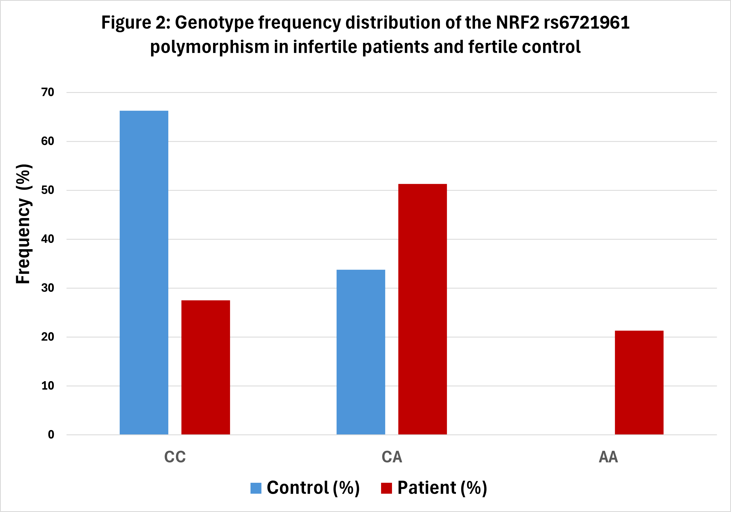

Figure 2: Genotype frequency distribution of the NRF2 rs6721961 polymorphism in infertile patients and fertile controls. Bars represent the percentage of individuals carrying the CC, CA, and AA genotypes. Significant differences were observed between groups (χ² = 32.696, df = 2, p < 0.001).

3.2 Serum Vitamin E Levels by Genotype
Serum vitamin E was measured in all participants and compared by genotype and group (Table 3, Figure 3). In the control group, mean vitamin E levels were 12.65 ± 1.19 µg/mL among CC carriers and 12.17 ± 1.22 µg/mL among CA carriers. No control participant carried the AA genotype; therefore, comparison of that subgroup was not possible.
Among patients, mean vitamin E levels showed a downward pattern across genotypes: CC = 11.71 ± 0.80 µg/mL, CA = 11.25 ± 1.08 µg/mL, and AA = 11.12 ± 0.72 µg/mL. This difference was not statistically significant within the patient group (p = 0.080), possibly because the AA subgroup was small (n = 17). When the Kruskal-Wallis test was applied to the entire study population (n = 160), a significant difference was observed across the three genotype categories (H = 22.231, df = 2, p < 0.001). However, this overall comparison reflects both genotype and patient-control group differences and should therefore be interpreted cautiously.
Between-group comparisons were more informative. Compared with controls carrying the same genotype, patients had lower mean vitamin E levels for both CC carriers (11.71 vs. 12.65 µg/mL; p = 0.002) and CA carriers (11.25 vs. 12.17 µg/mL; p = 0.006). Overall, vitamin E levels were significantly lower in the patient cohort than in the control cohort (p < 0.001), irrespective of genotype. Within the patient group, Spearman's correlation analysis showed a moderate inverse correlation between the number of A alleles and vitamin E levels (ρ = −0.373, p < 0.001).

Table 3: Serum Vitamin E Levels (Mean± SD) by NRF2 rs6721961 Genotype
Parameter | Group | CC | CA | AA | p-value
Vitamin E (µg/mL) | Control | 12.65 ± 1.19 (n=53) | 12.17 ± 1.22 (n=27) | – (n=0) | N/A
 | Patient | 11.71 ± 0.80 (n=22) | 11.25 ± 1.08 (n=41) | 11.12 ± 0.72 (n=17) | 0.080†
 | p-value (Control vs Patient) | 0.002‡ | 0.006‡ | N/A* | < 0.001§
* No control subject carried the AA genotype (n = 0); inter group comparison was therefore not applicable for this category.
† p‑value from Kruskal‑Wallis test comparing vitamin E levels across the three genotype groups (CC, CA, AA) within the patient group only.
‡ p‑value from Mann‑Whitney U test comparing patients versus controls within each genotype category (CC and CA).
§ p‑value from Mann‑Whitney U test comparing overall patient versus control cohorts.

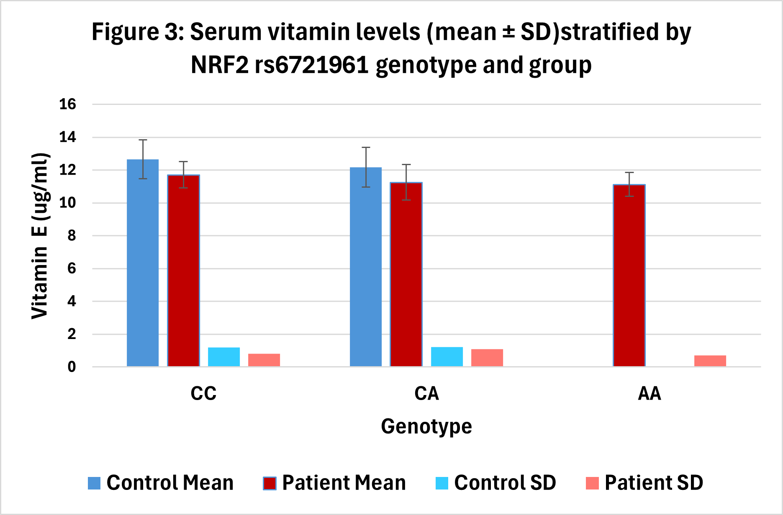
Figure 3: Serum vitamin E levels (mean ± SD) stratified by NRF2 rs6721961 genotype and group. Data are shown for control (blue bars) and patient (red bars) groups. Significant differences were observed between patients and controls within CC (p = 0.002) and CA (p = 0.006) genotypes. The AA genotype was absent in the control group (n = 0).

4. DISCUSSION

This study provides population-specific data on the association between the NRF2 rs6721961 polymorphism and serum vitamin E levels in Iraqi men with idiopathic infertility. The observed inverse relationship between A-allele dosage and vitamin E levels may help explain a link between genetic variation and antioxidant status in this population. These findings add to the evidence on the role of oxidative stress in male infertility but require confirmation before genotype-guided clinical strategies can be considered.

4.1 The rs6721961 Polymorphism Association with Male Infertility
NRF2, encoded by the NFE2L2 gene, regulates cellular responses to oxidative stress by binding to antioxidant response elements (AREs) in antioxidant and cytoprotective genes (Itoh et al., 1997; Kensler et al., 2007). Because spermatozoa have limited antioxidant defences, a variant that reduces this regulatory function could increase their vulnerability to oxidative injury. The rs6721961 SNP is located 617 bp upstream of the NRF2 transcription start site within an ARE-like sequence and is therefore a biologically plausible candidate variant affecting NRF2 expression.
In the present study, the A allele was nearly three times more frequent among infertile men (46.9%) than among fertile controls (16.9%), corresponding to an OR of 4.35 (95% CI: 2.59–7.29). Under the dominant model, carriage of at least one A allele was associated with approximately fivefold higher odds of infertility (OR = 5.18). The overdominant model also showed an association for the CA genotype compared with CC+AA (OR = 2.06, p = 0.025), suggesting that heterozygous carriage may also be relevant to infertility risk.
The AA genotype was present in 21.3% of patients and absent from controls. This difference was statistically significant under both the codominant (χ² = 28.34) and recessive (χ² = 19.02) models. One possible explanation is that reduced NRF2 promoter activity in AA carriers lowers antioxidant capacity towards a threshold relevant to testosterone-dependent spermatogenesis; however, this mechanism was not directly tested. Whether the association reflects direct effects on spermatogenesis or secondary effects of chronic oxidative stress in the testis remains to be determined.
4.2 Vitamin E, Oxidative Stress, and the Infertile Male
Vitamin E is a major lipid-soluble antioxidant in sperm membranes. Spermatozoa are particularly susceptible to oxidative damage because their membranes contain high concentrations of polyunsaturated fatty acids, especially DHA, and their sparse cytoplasm provides limited space for protective enzymes (Agarwal et al., 2014; Aitken & Clarkson, 1987). Depletion of vitamin E may promote lipid peroxidation of the plasma membrane and impair sperm motility, morphology, and fertilising capacity.
Among CA carriers, mean serum vitamin E was 11.25 µg/mL in patients and 12.17 µg/mL in controls (p = 0.006), while the overall difference between the two cohorts was also significant (p < 0.001). Although the absolute differences were modest, they may reflect differences in antioxidant status. Because oxidative stress markers were not measured, the lower vitamin E levels cannot be attributed solely to ongoing oxidative stress or distinguished from dietary and metabolic influences.
Although CA controls were fertile, their mean vitamin E level was lower than that of CC controls (12.17 vs. 12.65 µg/mL). This small difference was not statistically significant within the control group but may suggest that the A allele has a detectable association with antioxidant status before clinical manifestations become apparent. Further studies are needed to determine whether this difference becomes more pronounced under additional oxidative challenges, such as infection, poor diet, or environmental exposure.
4.3 Potential Molecular Basis Linking the Polymorphism to Reduced Vitamin E Levels
NRF2 induces the expression of the glutathione biosynthetic enzyme γ-GCS, together with HO-1 and NQO1, which contribute to cellular redox control (Hayes et al., 2010). The glutathione system also contributes to the regeneration of oxidised vitamin E to its functional tocopherol form (Dinkova-Kostova & Abramov, 2015; Packer et al., 1979). If the rs6721961 A allele reduces NRF2 promoter activity, lower glutathione availability could slow vitamin E recycling and contribute to the lower tocopherol concentrations observed in patients. The gradient in patient vitamin E levels (11.71 > 11.25 > 11.12 µg/mL across CC, CA, and AA, respectively) is consistent with this model but does not establish the underlying mechanism. Although the Kruskal-Wallis comparison across the three patient genotypes was not statistically significant (p = 0.080), possibly because the AA subgroup was small (n = 17), Spearman's rank correlation showed a significant moderate inverse association between the number of A alleles and serum vitamin E levels (ρ = −0.373, p < 0.001). Spearman's test evaluates an ordered monotonic association, whereas the Kruskal-Wallis test evaluates any distributional differences among groups; this distinction may explain the differing results.
The magnitude of the association between genotype and infertility (OR = 4.35; AA genotype present in 21.3% of patients and 0% of controls) exceeded the observed differences in serum vitamin E levels, which were approximately 1 µg/mL between the extreme patient genotypes. This disparity suggests that pathways other than vitamin E depletion may contribute to the association. These pathways may include oxidative damage to sperm DNA, because the AA genotype has been associated with higher sperm DNA fragmentation (Aydos et al., 2021). NRF2 also regulates several antioxidant enzymes relevant to spermatogenesis, including glutathione peroxidase, catalase, and superoxide dismutases; reduced NRF2 activity may therefore compromise testicular redox homeostasis through pathways independent of circulating vitamin E (Hayes et al., 2010). In humans, the rs6721961 A allele has been associated with reduced sperm concentration and motility in infertile men (Rehman et al., 2022), and a recent meta-analysis identified NRF2 rs6721961 among variants associated with an increased risk of male infertility (Kaur et al., 2025). The absence of the AA genotype among fertile controls raises the possibility of broader reproductive effects, but this observation requires confirmation. Future studies incorporating sperm functional assays, DNA fragmentation analysis, and testicular NRF2 expression are needed to clarify these pathways.
4.4 Comparison with Published Evidence
The present findings are broadly consistent with previous studies. Aydos et al. (2021) reported that the AA genotype was associated with increased odds of oligoasthenozoospermia (OR = 5.75, p = 0.037) and greater sperm DNA damage in a Turkish population. Rehman et al. (2022) reported similar associations, while Yu and Huang (2015) reviewed evidence linking antioxidant-gene variation with male infertility. Related evidence indicates that disruption of NRF2/Keap1 regulation is associated with impaired antioxidant defence (Goven et al., 2008), whereas the rs6721961 A allele has reduced NRF2 promoter activity (Marzec et al., 2007). Lower serum vitamin E levels have also been reported among infertile men, and antioxidant supplementation has been associated with improved sperm motility in some studies (Keskes-Ammar et al., 2003; Scott et al., 1998). The absence of the AA genotype in the control group of the present study was more pronounced than in previous reports and may reflect population differences or the comparatively small control sample.
4.5 Clinical Implications
If the rs6721961 A allele is confirmed as a reliable marker of impaired antioxidant status in infertile men, genotyping could potentially complement the assessment of otherwise unexplained male infertility. Individuals with CA or AA genotypes and low serum vitamin E may be appropriate candidates for future genotype-stratified intervention trials rather than routine supplementation based on the present findings alone. In controlled studies, vitamin E and selenium co-supplementation has been associated with improvements in sperm motility, morphology, and DNA integrity (Greco et al., 2005; Moslemi & Tavanbakhsh, 2011). Compounds such as sulforaphane and dimethyl fumarate have also been investigated as pharmacological activators of NRF2 in other diseases. Whether this strategy could compensate for reduced rs6721961-associated NRF2 promoter activity in infertile men remains unknown and warrants further investigation.

5. Conclusions

This study identified an association between the NRF2 rs6721961 polymorphism and idiopathic male infertility among Iraqi men. The A allele was substantially more frequent among infertile patients, whereas the AA genotype was observed only in the patient group. Infertile participants also had lower serum vitamin E concentrations than fertile controls. Within the patient group, vitamin E levels decreased across the CC, CA, and AA genotypes, and increasing A-allele dosage was inversely correlated with serum vitamin E. These findings suggest that NRF2 genetic variation may be related to antioxidant status in idiopathic male infertility. Nevertheless, the case-control design does not establish causality, and the comparatively small AA subgroup limits the precision of genotype-specific interpretation. The findings should therefore be viewed as population-specific and hypothesis-generating. Confirmation in larger, multicentre cohorts is required, together with assessment of diet, lipid status, semen oxidative-stress markers, sperm DNA integrity, and functional NRF2 expression. Such studies would clarify whether the observed genetic and biochemical associations have reproducible biological or clinical relevance.

Limitations
This single-centre case-control study included a moderate sample, with a particularly small AA-genotype subgroup and no AA carriers among controls. The design precludes causal inference and prevented odds-ratio estimation for some genetic models. Serum vitamin E may have been affected by diet, lipid status, body mass index, lifestyle, and other nutritional factors that were not fully assessed. Oxidative-stress biomarkers, sperm DNA fragmentation, and functional NRF2 expression were not measured. The findings should therefore be considered preliminary and population-specific. Larger multicentre studies with functional assays and improved control of confounding variables are required before clinical application can be considered.
Ethical approval and Consent
The study protocol was formally approved by the Institutional Ethics Committee of AL-Qasim Green University (Approval No. Qgec/21/2025) and conducted following the principles of the Declaration of Helsinki. All subjects provided written, informed consent before enrollment.

Declaration of AI Use

This manuscript was prepared through the combined contributions of all author(s), including contributions to the study design, data, content development, results, interpretation, and related scholarly work. The author(s) acknowledge the use of Grammarly and ChatGPT to assist with grammar checking, language refinement, and reference formatting. These AI-assisted tools were not used as authors and did not replace the intellectual contributions or scholarly judgement of the author(s). All AI-assisted outputs, including content, references, and interpretations, were carefully reviewed, revised, verified, and approved by the author(s). The author(s) accept full responsibility for the accuracy, integrity, and final content of the manuscript.
7. Conflicts of Interest
The authors declare no conflicts of interest. The funders had no role in the design of the study; in the collection, analyses, or interpretation of data; in the writing of the manuscript; or in the decision to publish the results.

Abbreviations
NRF2: Nuclear factor erythroid 2‑related factor 2
ROS: Reactive oxygen species
ARE: Antioxidant response element
ARMS‑PCR: Amplification refractory mutation system‑polymerase chain reaction
OR: Odds ratio
CI: Confidence interval
HWE: Hardy‑Weinberg equilibrium

REFERENCES
Agarwal, A., Rana, M., Qiu, E., AlBunni, H., Bui, A. D., & Henkel, R. (2018). Role of oxidative stress, infection and inflammation in male infertility. Andrologia, 50(11), Article e13126. https://doi.org/10.1111/and.13126
Agarwal, A., Virk, G., Ong, C., & du Plessis, S. S. (2014). Effect of oxidative stress on male reproduction. The World Journal of Men’s Health, 32(1), 1–17. https://doi.org/10.5534/wjmh.2014.32.1.1
Aitken, R. J., & Clarkson, J. S. (1987). Cellular basis of defective sperm function and its association with the genesis of reactive oxygen species by human spermatozoa. Journal of Reproduction and Fertility, 81(2), 459–469. https://doi.org/10.1530/jrf.0.0810459
Aydos, O. S., Yükselten, Y., Aydos, D., Sunguroğlu, A., & Aydos, K. (2021). Relationship between functional Nrf2 gene promoter polymorphism and sperm DNA damage in male infertility. Systems Biology in Reproductive Medicine, 67(6), 399–412. https://doi.org/10.1080/19396368.2021.1972359
Dinkova-Kostova, A. T., & Abramov, A. Y. (2015). The emerging role of Nrf2 in mitochondrial function. Free Radical Biology and Medicine, 88, 179–188. https://doi.org/10.1016/j.freeradbiomed.2015.04.036
Dutta, S., Sengupta, P., Roychoudhury, S., Chakravarthi, S., Wang, C.-W., & Slama, P. (2022). Antioxidant paradox in male infertility: “A blind eye” on inflammation. Antioxidants, 11(1), Article 167. https://doi.org/10.3390/antiox11010167
Elabscience. (n.d.). Vitamin E (VE) colorimetric assay kit (Cat. No. E-BC-K033-S) [Product manual]. https://www.elabscience.com/p/vitamin-e-ve-colorimetric-assay-kit--e-bc-k033-s
Faul, F., Erdfelder, E., Lang, A.-G., & Buchner, A. (2007). G*Power 3: A flexible statistical power analysis program for the social, behavioral, and biomedical sciences. Behavior Research Methods, 39(2), 175–191. https://doi.org/10.3758/BF03193146
Goven, D., Boutten, A., Leçon-Malas, V., Marchal-Sommé, J., Amara, N., Crestani, B., Fournier, M., Lesèche, G., Soler, P., Boczkowski, J., & Bonay, M. (2008). Altered Nrf2/Keap1-Bach1 equilibrium in pulmonary emphysema. Thorax, 63(10), 916–924. https://doi.org/10.1136/thx.2007.091181
Greco, E., Iacobelli, M., Rienzi, L., Ubaldi, F., Ferrero, S., & Tesarik, J. (2005). Reduction of the incidence of sperm DNA fragmentation by oral antioxidant treatment. Journal of Andrology, 26(3), 349–353. https://doi.org/10.2164/jandrol.04146
Hayes, J. D., McMahon, M., Chowdhry, S., & Dinkova-Kostova, A. T. (2010). Cancer chemoprevention mechanisms mediated through the Keap1-Nrf2 pathway. Antioxidants & Redox Signaling, 13(11), 1713–1748. https://doi.org/10.1089/ars.2010.3221
Itoh, K., Chiba, T., Takahashi, S., Ishii, T., Igarashi, K., Katoh, Y., Oyake, T., Hayashi, N., Satoh, K., Hatayama, I., Yamamoto, M., & Nabeshima, Y.-I. (1997). An Nrf2/small Maf heterodimer mediates the induction of phase II detoxifying enzyme genes through antioxidant response elements. Biochemical and Biophysical Research Communications, 236(2), 313–322. https://doi.org/10.1006/bbrc.1997.6943
Jignoua, Y. S., Beboy, S. N. E., Pechangou, S. N., Tchana, A. N., & Moundipa, P. F. (2024). Protective effects of Terminalia superba Engl. & Diels (Combretaceae) on aluminium chloride-induced reproductive toxicity and oxidative stress in male Wistar rats. Journal of Complementary and Alternative Medical Research, 25(7), 95–107. https://doi.org/10.9734/jocamr/2024/v25i7551
Kaur, M., Shahil Rahman, T. K., Dolma, S., Kaur, R., Kapoor, H. S., Goyal, L. D., & Khetarpal, P. (2025). Xenobiotic metabolizing gene variants and the risk of male infertility: A systematic review, meta-analysis and in silico analysis. Toxicology Reports, 14, Article 102019. https://doi.org/10.1016/j.toxrep.2025.102019
Kensler, T. W., Wakabayashi, N., & Biswal, S. (2007). Cell survival responses to environmental stresses via the Keap1-Nrf2-ARE pathway. Annual Review of Pharmacology and Toxicology, 47, 89–116. https://doi.org/10.1146/annurev.pharmtox.46.120604.141046
Keskes-Ammar, L., Feki-Chakroun, N., Rebai, T., Sahnoun, Z., Ghozzi, H., Hammami, S., Zghal, K., Fki, H., Damak, J., & Bahloul, A. (2003). Sperm oxidative stress and the effect of an oral vitamin E and selenium supplement on semen quality in infertile men. Archives of Andrology, 49(2), 83–94. https://doi.org/10.1080/01485010390129269
Maqsood, J., Rahim, A., Afzal, M., Bajwa, M. I., Karim, B., & Hashmi, T. S. (2022). Association of Nrf2 gene polymorphism with polycystic ovary syndrome: A case-control study. Pakistan Journal of Physiology, 18(3), 15–18. https://doi.org/10.69656/pjp.v18i3.1467
Marzec, J. M., Christie, J. D., Reddy, S. P., Jedlicka, A. E., Vuong, H., Lanken, P. N., Aplenc, R., Yamamoto, T., Yamamoto, M., Cho, H.-Y., & Kleeberger, S. R. (2007). Functional polymorphisms in the transcription factor NRF2 in humans increase the risk of acute lung injury. The FASEB Journal, 21(9), 2237–2246. https://doi.org/10.1096/fj.06-7759com
Minhas, S., Bettocchi, C., Boeri, L., Capogrosso, P., Carvalho, J., Cilesiz, N. C., Cocci, A., Corona, G., Dimitropoulos, K., Gül, M., Hatzichristodoulou, G., Jones, T. H., Kadioglu, A., Martínez Salamanca, J. I., Milenkovic, U., Modgil, V., Russo, G. I., Serefoglu, E. C., Tharakan, T., … Salonia, A. (2021). European Association of Urology guidelines on male sexual and reproductive health: 2021 update on male infertility. European Urology, 80(5), 603–620. https://doi.org/10.1016/j.eururo.2021.08.014
Moslemi, M. K., & Tavanbakhsh, S. (2011). Selenium–vitamin E supplementation in infertile men: Effects on semen parameters and pregnancy rate. International Journal of General Medicine, 4, 99–104. https://doi.org/10.2147/IJGM.S16275
P, G. I., Nwadike, C. N., Nwanjo, H. U., Nwachukwu, U. C., Mgbeosuru, B., Oko, O. M., Mbarah, I. E., Arinzechi, E. G., Ogbuokiri, A. C., & Egwurugu, J. N. (2025). Association of testosterone with markers of inflammation in men with infertiity in Imo State, Nigeria. Journal of Disease and Global Health, 18(2), 260–271. https://doi.org/10.56557/jodagh/2025/v18i29886
Packer, J. E., Slater, T. F., & Willson, R. L. (1979). Direct observation of a free radical interaction between vitamin E and vitamin C. Nature, 278(5706), 737–738. https://doi.org/10.1038/278737a0
Rehman, B., Rahim, A., Afzal, M., Tazarrat, A., Kashif, H., & Qayyum, S. (2022). Association of Nrf2 gene polymorphism (rs6721961) with semen parameters in primary male infertility cases in Pakistani population. Pakistan Armed Forces Medical Journal, 72(2), 398–402. https://doi.org/10.51253/pafmj.v72i2.7565
Saleh, R., Sallam, H., Elsuity, M. A. E., Dutta, S., Sengupta, P., & Nasr, A. (2025). Antioxidant therapy for infertile couples: A comprehensive review of the current status and consideration of future prospects. Frontiers in Endocrinology, 15, Article 1503905. https://doi.org/10.3389/fendo.2024.1503905
Scott, R., MacPherson, A., Yates, R. W., Hussain, B., & Dixon, J. (1998). The effect of oral selenium supplementation on human sperm motility. British Journal of Urology, 82(1), 76–80. https://doi.org/10.1046/j.1464-410x.1998.00683.x
Sengupta, P., Dutta, S., Henkel, R., Maldonado Rosas, I., & Roychoudhury, S. (2026). Idiopathic male infertility revisited: Can redox endophenotypes reframe the “idiopathic” label? Frontiers in Endocrinology, 17, Article 1747453. https://doi.org/10.3389/fendo.2026.1747453
Tully, C. A., Alesi, S., McPherson, N. O., Sharkey, D. J., Teong, X. T., Tay, C. T., Silva, T. R., Puglisi, C., Barsby, J. P., Moran, L. J., Grieger, J. A., & Mousa, A. (2024). Assessing the influence of preconception diet on male fertility: A systematic scoping review. Human Reproduction Update, 30(3), 243–261. https://doi.org/10.1093/humupd/dmad035
World Health Organization. (2021). WHO laboratory manual for the examination and processing of human semen (6th ed.). https://www.who.int/publications/i/item/9789240030787
World Health Organization. (2023). Infertility prevalence estimates, 1990–2021. https://www.who.int/publications/i/item/978920068315
Ye, S., Dhillon, S., Ke, X., Collins, A. R., & Day, I. N. M. (2001). An efficient procedure for genotyping single nucleotide polymorphisms. Nucleic Acids Research, 29(17), Article e88. https://doi.org/10.1093/nar/29.17.e88
Yu, B., & Huang, Z. (2015). Variations in antioxidant genes and male infertility. BioMed Research International, 2015, Article 513196. https://doi.org/10.1155/2015/513196
Zafar, M. I., Mills, K. E., Baird, C. D., Jiang, H., & Li, H. (2023). Effectiveness of nutritional therapies in male factor infertility treatment: A systematic review and network meta-analysis. Drugs, 83(6), 531–546. https://doi.org/10.1007/s40265-023-01853-0

