The Effect of Profitability, Leverage, Firm Size, and Liquidity on Firm Value: Evidence from Consumer Non-Cyclicals Companies Listed On The Indonesia Stock Exchange

Abstract
This study examines the relationship between profitability, leverage, firm size, liquidity, and firm value among consumer non-cyclicals companies listed on the Indonesia Stock Exchange. A quantitative explanatory design was applied using a balanced panel of 40
firm-year observations from eight issuers over the fiscal years 2021–2025. Firm value was measured by price-to-book value, profitability by return on assets, leverage by debt-to-equity ratio, firm size by the natural logarithm of total assets, and liquidity by the current ratio. The data were compiled from publicly available financial ratio and balance sheet information. The empirical model was estimated using pooled ordinary least squares with HC3 robust standard errors, supported by descriptive statistics, correlation analysis, diagnostic testing, and sensitivity estimation. The results show that profitability has a positive and statistically significant association with firm value, while liquidity has a negative and statistically significant association. Leverage and firm size do not show statistically significant effects in the primary model. The model reports an R-squared value of 0.872 and an adjusted R-squared value of 0.857. The findings suggest that market valuation in the sampled companies is more closely associated with earnings-generating capability than with asset scale. The negative liquidity result indicates that high current assets may not be valued positively when they are not linked to stronger profitability or efficient working capital use.

Keywords: firm value, profitability, leverage, firm size, liquidity, consumer non-cyclicals.

INTRODUCTION

Firm value is a central concern in accounting and corporate finance research because it reflects how capital market participants assess the economic prospects, risk profile, and resource allocation quality of a company. For listed companies, firm value is not merely an abstract concept. It appears in market prices, valuation multiples, and investor willingness to pay for ownership claims. Accounting information is expected to support that valuation process because it

translates business activity into measurable numbers, including assets, liabilities, equity, income, and cash-generating capacity (Fama & French, 1992; Ross et al., 2022).
In emerging markets, the link between accounting ratios and market valuation remains important. Investors often face information asymmetry, uneven disclosure quality, and different levels of analyst coverage. Under these conditions, basic financial ratios become practical screening tools. Profitability, leverage, firm size, and liquidity are among the most frequently observed indicators because they can be extracted from annual reports, financial statements, and public financial databases. The value of these ratios lies in their simplicity: they allow investors to compare firms without needing confidential internal information (Wooldridge, 2010; Sekaran & Bougie, 2016).
Recent empirical evidence indicates that the valuation relevance of profitability, leverage, liquidity, and firm size remains context-dependent; studies on Indonesian consumer non-cyclicals and other emerging-market settings show that similar ratios can produce different market-value effects when sector, firm size, liquidity quality, and debt maturity are considered (Sulistiyo et al., 2025; Celestine et al., 2026; Khalifaturofi’ah & Setiawan, 2025; Kiymaz et al., 2024; Karaca et al., 2025).
The consumer non-cyclicals sector is a suitable setting for this study. Companies in this sector produce or distribute products used in daily household consumption, such as food, beverages, basic retail goods, personal care products, and household necessities. Demand for these products is normally more stable than demand for durable or discretionary products. Stability, however, does not mean valuation uniformity. In practice, PBV differs sharply across issuers because companies have different margins, capital structures, working capital policies, asset bases, brand equity, distribution reach, and growth expectations.
A recurring limitation in empirical accounting papers is the selection of variables that appear conceptually complex but cannot be measured consistently. This study therefore uses variables with clear definitions and publicly accessible data.
public sources. The dependent variable, PBV, represents market value relative to book equity. The independent variables are ROA, DER, firm size, and current ratio. These measures are conventional, but that is precisely why they are useful: they
can be checked, replicated, and debated using transparent evidence.
The period 2021-2025 is also relevant. It covers the recovery and adjustment period after the COVID-19 shock, followed by normalisation in consumption activity, inflationary pressure, currency movement, and changing investor sentiment. Consumer non-cyclicals issuers were not affected in the same way. Some issuers maintained strong
profitability, some experienced valuation compression, and some benefited from stable domestic consumption. A five-year

panel therefore offers enough variation to examine whether accounting indicators correspond to firm value. Profitability is expected to increase firm value because investors reward firms that can convert assets into earnings.
ROA is a useful profitability measure because it evaluates the efficiency of assets rather than merely the absolute amount of profit. A company with large assets but weak earnings may be less attractive than a smaller company that uses its assets efficiently. For this reason, profitability is often treated as a key signal of managerial effectiveness and future cash-flow potential (Ross, 1977; Damodaran, 2012).
Leverage has a more complex relationship with firm value. Debt can support expansion, discipline management, and create tax benefits. At the same time, high leverage can raise financial risk and make investors more cautious. This ambiguity is visible in consumer non-cyclicals firms. Some firms can safely carry debt because their operating cash flows are stable, while others may face valuation pressure when debt is perceived to reduce flexibility. The empirical effect therefore needs to be tested rather than assumed (Rajan & Zingales, 1995; Jensen & Meckling, 1976).
Firm size can also create mixed expectations. Larger firms may have stronger bargaining power, wider distribution networks, better access to capital markets, and higher resilience during economic shocks. However, larger total assets do not automatically create higher valuation. Asset-heavy firms may suffer from lower asset turnover or inefficient capital allocation. The market may therefore value earnings quality and growth potential more than size itself (Penrose, 1959). Liquidity is commonly viewed as a sign of short-term financial strength. A company with a high current ratio should be able to meet short-term obligations with current assets. Yet excessive liquidity can also signal unused resources, slow inventory turnover, or conservative working capital management. In valuation analysis, liquidity should not be treated as automatically positive. The question is whether liquidity supports productive operations or merely accumulates on the balance sheet without increasing returns (Penman, 2013; Kasmir, 2019).
This study is designed as a compact empirical accounting article aligned with the format of the International Journal of Education, Business and Economics Research (IJEBER). It follows the basic article structure of title, author identity, abstract, keywords, introduction, literature review, methodology, results and discussion, conclusion, references, and author profile. Tables and figures are placed near the relevant discussion, consistent with the submitted template.
However, the recent literature has not fully resolved whether these accounting ratios retain the same valuation relevance in a focused Indonesian consumer non-cyclicals sample during the 2021-2025 post-pandemic adjustment period. This study addresses that gap by testing profitability, leverage, firm size, and liquidity together using a transparent firm-year dataset.
The research question is formulated as follows: do profitability, leverage, firm size, and liquidity affect firm value among consumer non-cyclicals companies listed on the Indonesia Stock Exchange? The research objective is to test the direction and significance of those relationships using a transparent panel dataset. The practical objective is to provide a model that can be replicated by accounting researchers and students using public financial data.

The expected contribution of this paper is threefold. First, it gives recent evidence from Indonesian consumer non-cyclicals companies. Second, it demonstrates how market-based valuation can be examined using accounting ratios. Third, it presents the data, equations, descriptive statistics, and regression output in a way that can be audited. This matters because empirical papers are weak when the data are hidden or when variable construction is vague.

LITERATURE REVIEW

Firm Value
Firm value represents the market assessment of a company relative to the capital invested by shareholders. In accounting-based valuation studies, price-to-book value is often used because it compares market price with book value
per share. PBV greater than one indicates that the market values equity above its accounting book value. PBV below one can indicate weak growth expectations, low profitability, high perceived risk, or market pessimism. PBV is not a perfect measure, but it is relevant because it connects financial statement information with capital-market assessment (Hery, 2018). The use of PBV is especially appropriate when the study focuses on firm-level accounting fundamentals. Book value reflects accumulated equity after recognizing assets, liabilities, profits, losses, dividends, and other equity transactions.
Market value reflects investor expectations about future performance. The gap between those two values is the valuation space that accounting information tries to explain. If ROA, DER, size, and liquidity affect investor expectations, they should be reflected in PBV variation.
From signaling theory, managers send signals to investors through financial statements and other corporate disclosures. A signal is valuable when it reduces uncertainty. Strong profitability can signal efficient resource use.
Moderate leverage can signal financing discipline. Large firm size can signal stability. Adequate liquidity can signal short-term solvency. However, the market does not interpret all signals mechanically. The same ratio may be read differently depending on sector, business model, and the quality of supporting performance (Spence, 1973).
Agency theory also supports the use of financial ratios in valuation research. Investors are principals, while managers

act as agents responsible for managing company resources. Because investors cannot observe all managerial actions directly, they evaluate outcomes reported in financial statements. Ratios such as ROA, DER, and current ratio become summary indicators of whether management has allocated resources effectively. Weak ratios may increase perceived agency risk and reduce valuation (Jensen & Meckling, 1976).

Profitability and Firm Value
Profitability is the company's ability to generate earnings from the resources it controls. This study uses return on assets because ROA links net income to total assets and measures how effectively assets generate profit. Unlike
absolute profit, ROA allows comparisons among firms with different sizes. A large company may report high net income simply because it controls a large asset base, while ROA evaluates whether those assets are used efficiently.
A positive effect of profitability on firm value is theoretically expected. Higher profitability implies stronger internal financing capacity, better dividend potential, and greater ability to withstand business shocks. In consumer non-cyclicals companies, strong ROA may indicate pricing power, brand strength, supply-chain efficiency, and effective cost control. These factors are relevant because many companies in the sector operate in highly competitive markets where margins are constantly pressured by raw material costs and consumer price sensitivity.
Profitability also interacts with investor expectations. Investors do not buy shares solely for past earnings; they buy claims on future economic benefits. Nevertheless, past and current ROA provide evidence of a firm's capacity to generate
those benefits. If profitability is persistent, the market may assign a higher valuation multiple. For this reason, profitability is expected to have a positive association with PBV.
Based on this logic, the first hypothesis is stated as follows: H1: Profitability has a positive effect on firm value among consumer non-cyclicals companies listed on the Indonesia Stock Exchange.

Leverage and Firm Value
Leverage describes the extent to which a company uses debt or liabilities in its financing structure. This study uses
debt-to-equity ratio because it compares external financing obligations with shareholder capital. A higher DER indicates greater reliance on debt relative to equity. From a corporate finance perspective, leverage may create value through tax-shield benefits and by allowing firms to finance profitable projects without issuing new shares (Rajan & Zingales, 1995). Debt can also discipline management because contractual obligations require regular payment. However, that discipline becomes harmful when debt exceeds the firm's capacity to generate stable cash flows. High leverage can increase default

risk, restrict investment flexibility, and make firms more vulnerable to interest-rate and currency movements. In emerging markets, investors may be particularly sensitive to debt because financing conditions can change quickly.
The effect of leverage on firm value in consumer non-cyclicals companies is therefore not obvious. Firms with stable demand may use debt efficiently to expand stores, distribution centers, factories, or production capacity. Other firms may face pressure if debt rises while profitability weakens. The regression model tests the net effect across the selected sample.
The second hypothesis is stated as follows: H2: Leverage has an effect on firm value among consumer non-cyclicals companies listed on the Indonesia Stock Exchange.

Firm Size and Firm Value
Firm size reflects the scale of company operations and the economic resources under management control. Total assets are widely used as a size proxy because they represent the resources used to generate revenue and profit. This study transforms total assets into a natural logarithm to reduce extreme scale differences. Without transformation, very large firms can dominate the regression simply because their asset values are numerically much larger than those of smaller companies (Wooldridge, 2010).
Larger firms may have advantages in distribution, procurement, brand recognition, bargaining power, and access to external financing. These advantages can support firm value because they reduce business risk and improve competitive position. In consumer non-cyclicals, scale may be particularly valuable for companies that rely on broad distribution networks and high sales volume.
However, size is not the same as efficiency. A larger balance sheet can also indicate heavy investment, lower asset turnover, or less flexible operations. Investors may value a smaller but more profitable firm more highly than a larger firm with stagnant growth. For that reason, the size-firm value relationship should be evaluated empirically. The regression result will show whether the market rewards asset scale after controlling for profitability, leverage, and liquidity.
The third hypothesis is stated as follows: H3: Firm size has an effect on firm value among consumer non-cyclicals

companies listed on the Indonesia Stock Exchange.

Liquidity and Firm Value
Liquidity refers to the capacity of a company to meet short-term obligations using current assets. The current ratio is calculated by dividing current assets by current liabilities. A ratio above one usually indicates that current assets exceed current liabilities. From a creditor perspective, this is generally favourable because it suggests that the company has a short-term buffer.
In equity valuation, however, liquidity can be interpreted in two ways. Adequate liquidity reduces financial distress risk and supports operational continuity. Excessive liquidity may indicate that management is holding too much cash, inventory, or receivables instead of investing in productive assets. If liquid resources do not translate into higher sales or profit, investors may not reward liquidity with higher PBV.
This ambiguity is relevant to consumer non-cyclicals companies because working capital management is central to their operations. Retailers and food producers must manage inventory, receivables, and payables carefully. A high current ratio may look safe, but it can also reflect slow-moving inventory or weak working capital turnover. Consequently, liquidity is expected to affect firm value, but the sign must be tested empirically.
The fourth hypothesis is stated as follows: H4: Liquidity has an effect on firm value among consumer non-cyclicals companies listed on the Indonesia Stock Exchange.

Previous Empirical Findings
Prior empirical studies in accounting and corporate finance commonly report that profitability is one of the most This pattern is theoretically plausible.
business model, cost structure, and asset utilisation. When profitability improves, investors have stronger grounds to expect future dividends, retained earnings, and reinvestment capacity. In valuation terms, profitability reduces uncertainty about the company's ability to generate future economic benefits.
Studies on leverage produce more mixed results. Some research finds a positive relationship between leverage and
firm value because debt can create tax benefits and pressure management to use capital more efficiently. Other research finds a negative relationship because debt increases financial distress risk and reduces flexibility. The mixed findings

suggest that leverage is highly contextual. The same DER can be viewed differently depending on cash-flow stability, interest coverage, growth opportunity, and sector characteristics.
Firm size is also debated. Large companies can enjoy economies of scale, stronger access to financing, and wider recognition in the capital market. However, large size may be associated with lower growth rates and bureaucratic inefficiency. In mature consumer-goods companies, large assets often reflect established production capacity and distribution networks, but the market may not reward that scale unless it is accompanied by improving margins or sales growth. This is why size is often included as a control variable rather than treated as the main driver of value.
Liquidity findings are similarly inconsistent. In creditor-oriented analysis, liquidity is normally favourable because it indicates short-term solvency. In shareholder-oriented analysis, liquidity is more ambiguous. A company with excessive current assets may be safe but inefficient. A company with a very low current ratio may be risky but operationally aggressive. The market reaction depends on whether liquidity supports profitable operations. For consumer non-cyclicals issuers, inventory and receivables management can influence both liquidity and margins.
The empirical literature also shows that sector selection matters. Manufacturing firms, banks, property companies, retailers, and consumer-goods producers have different balance sheet structures. Banking studies cannot use the same interpretation of leverage and liquidity as non-financial firms. A retail issuer also has a different working capital cycle from a food manufacturer. This paper focuses on consumer non-cyclicals to reduce cross-sector distortion while still allowing variation within the sector.
Another lesson from prior research is the importance of measurement consistency. Some papers use PBV, others use Tobin's Q, market capitalization, or stock return. Some use ROA, others use ROE or net profit margin. These choices can produce different results. This paper uses PBV and ROA because the relationship between book value and asset productivity is clear. PBV captures market premium over book equity, while ROA captures the ability of assets to produce income.
Many empirical papers also suffer from unclear data treatment. Researchers sometimes state that data come from annual reports but do not show the extracted numbers. This weakens replicability. The present study includes the firm-year dataset in Table 12 so that readers can see exactly what values enter the regression. This is a basic but important standard. Without visible data, a regression table becomes difficult to audit.

The use of a recent period also matters. Results from 2015-2019 may not fully represent post-pandemic market conditions. Consumer behaviour, inflation pressure, supply-chain risk, and valuation sentiment changed after 2020. By using 2021-2025 data, the paper captures a more recent market setting. This does not make the result permanent, but it makes it relevant for current discussion.
The study does not claim that four variables can fully explain firm value. Valuation is affected by many factors outside financial ratios, such as management reputation, brand strength, macroeconomic policy, interest rates, corporate actions, and investor psychology. The purpose is narrower: to test whether core accounting indicators still have explanatory value. A focused purpose produces a more coherent empirical paper than an overextended model.
On balance, prior theory and empirical evidence justify the use of profitability, leverage, size, and liquidity as predictors. Profitability is expected to be the strongest positive variable, leverage and size are expected to be contextual, and liquidity is expected to be ambiguous. These expectations guide the interpretation of the regression results in Section 4.

Research Gap and Position of the Study
The first research gap concerns the need for recent evidence from Indonesian consumer non-cyclicals companies.
Much of the available student-oriented literature uses older periods, broad manufacturing samples, or mixed-sector samples. Mixed samples can be convenient, but they may create interpretation problems because financial ratios have different meanings across sectors. A focused consumer non-cyclicals sample gives a clearer business context.
The second gap concerns transparency. Many papers discuss variables but do not provide enough detail on the dataset used for estimation. This paper positions itself as a replicable empirical article. The data table, descriptive statistics, correlation matrix, model equation, and robustness comparison are included so that the calculation can be reviewed rather than accepted without review.
The third gap concerns liquidity interpretation. Liquidity is often treated too mechanically as a positive indicator. This study does not assume that high current ratio always increases firm value. It tests the relationship and interprets the result through working capital efficiency. This is important because consumer non-cyclicals companies rely heavily on inventory, receivables, payables, and cash conversion.

The fourth gap concerns the difference between accounting strength and market perception. A firm can be profitable but still experience valuation pressure if investors expect slower growth. A firm can be large but not highly valued if asset productivity is weak. This paper explicitly separates profitability, scale, and liquidity so that the discussion does not collapse all financial strength into one broad concept.
The position of this study is therefore modest but useful. It does not try to produce a universal valuation theory. It provides a clear empirical test using accessible data, recent years, and a sectorally coherent sample. This makes the
paper suitable for accounting coursework, journal-style article drafting, and further development into a larger panel study.

Figure 1: Research Framework
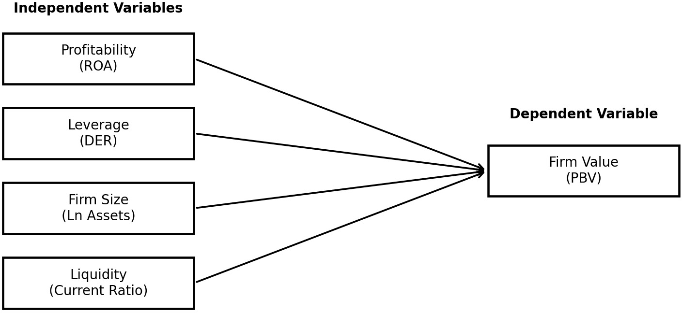

Table 1: Research Hypotheses
Code Hypothesis Statement Expected Direction H1 Profitability has a positive effect on firm value. Positive
H2 Leverage has an effect on firm value. Open direction
H3 Firm size has an effect on firm value. Open direction
H4 Liquidity has an effect on firm value. Open direction

RESEARCH METHOD

Research Design
This study uses a quantitative explanatory design. Quantitative design is appropriate because the study tests measurable relationships among variables using numerical data. The explanatory character lies in the regression model, which estimates whether profitability, leverage, firm size, and liquidity explain firm value. The study does not rely on interviews, perception surveys, or subjective scoring. Every variable is constructed from public financial data.
The research uses secondary data. Secondary data are suitable because listed companies publish financial information and market-based indicators that can be accessed by external researchers. The unit of analysis is firm-year observation. Each observation consists of one company in one fiscal year. The final dataset contains eight companies observed for five years, producing 40 firm-year observations. The balanced structure is useful because every company contributes the
same number of annual observations.
A pooled ordinary least squares model is used as the main estimation technique. A pooled model treats all firm-year observations as one combined sample. Although a larger dataset could support fixed-effects or random-effects panel models, the sample size in this study is intentionally modest because the purpose is to create a transparent and replicable accounting article. Robust standard errors are used to reduce the risk that heteroskedasticity distorts statistical inference (Wooldridge, 2010; Gujarati & Porter, 2009).

Population, Sample, and Data Source
The population consists of consumer non-cyclicals companies listed on the Indonesia Stock Exchange. The sample was selected purposively based on three criteria. First, the issuer belongs to the consumer non-cyclicals universe or has business activity closely related to food, staples retail, beverages, household products, or fast-moving consumer goods. Second, the issuer has complete annual data for PBV, ROA, DER, current ratio, and total assets for fiscal years 2021-

2025. Third, the issuer has publicly accessible data from the same financial database so that variable construction remains consistent.
The selected companies are ICBP, INDF, UNVR, AMRT, CMRY, ULTJ, ROTI, and GOOD. The sample deliberately includes companies with different business models inside the consumer non-cyclicals scope. ICBP and INDF represent large integrated food groups; UNVR represents household and personal care products; AMRT represents staples retailing; CMRY, ULTJ, ROTI, and GOOD represent food and beverage producers of different scales. This composition creates cross-sectional variation in valuation, profitability, liquidity, and size.
The main data source is StockAnalysis.com, which provides annual financial ratios and balance sheet data for IDX
The selected company pages are cited in the reference list for ICBP, INDF, UNVR, AMRT, CMRY, ULTJ, ROTI, and GOOD (StockAnalysis.com, n.d.-c, n.d.-d, n.d.-h, n.d.-f, n.d.-a, n.d.-g, n.d.-e, n.d.-b).
issuers. The database reports financial statements in millions of Indonesian rupiah and identifies S&P Global Market
Intelligence as the data source (S&P Global Market Intelligence, n.d.). The use of a public database improves replicability because readers can re-check the
values through the same company pages. For final publication, researchers should still reconcile the dataset with annual (Indonesia Stock Exchange, n.d.).
reports from the issuer or the Indonesia Stock Exchange to eliminate transcription errors.

Table 2: Sample Companies
Observation
Ticker Company Business Focus
Years
ICBP PT Indofood CBP Sukses Makmur Tbk Packaged food and consumer goods

2021-2025
2021-2025

2021-2025
2021-2025
2021-2025

2021-2025

2021-2025
2021-2025
INDF PT Indofood Sukses Makmur Tbk Integrated food, agribusiness, and consumer goods UNVR PT Unilever Indonesia Tbk Household and personal care products
AMRT PT Sumber Alfaria Trijaya Tbk Food and staples retailing CMRY PT Cisarua Mountain Dairy Tbk Dairy and processed food
PT Ultrajaya Milk Industry & Trading
ULTJ Dairy, beverages, and packaged food

Company Tbk
ROTI PT Nippon Indosari Corpindo Tbk Bread and bakery products GOOD PT Garudafood Putra Putri Jaya Tbk Packaged food and beverages

Operational Definition of Variables
Table 3: Operational Definition of Variables

Expected Role Dependent variable Independent variable Independent variable Independent variable Independent variable
Variable Proxy Measurement
Firm Value PBV Price per share divided by book value per share Profitability ROA Net income divided by total assets
Leverage DER Debt or liabilities divided by equity Firm Size SIZE Natural logarithm of total assets
Liquidity CR Current assets divided by current liabilities

PBV is used as a market-based proxy because the study focuses on firm value from the perspective of investors. ROA is used because it captures profit relative to asset base. DER is selected because it captures debt pressure relative to shareholder capital. SIZE is measured by the natural logarithm of total assets to reduce scale bias. CR is selected as a liquidity proxy because it directly compares current assets with current liabilities.
The operational definitions are intentionally simple. More complex models can add sales growth, dividend policy, corporate governance, audit quality, or ESG disclosure. However, adding too many variables without sufficient observations can weaken the model. In small-sample empirical accounting papers, clarity and consistency are more important than forcing many variables into one regression.

Empirical Model
The empirical model estimates firm value as a function of profitability, leverage, firm size, and liquidity. The model is expressed as follows:
PBV_it = α + β1ROA_it + β2DER_it + β3SIZE_it + β4CR_it + ε_it (1)
In equation (1), PBV_it is the firm value of company i in year t; ROA_it is profitability; DER_it is leverage; SIZE_it is the natural logarithm of total assets; CR_it is liquidity; α is the intercept; β1 to β4 are regression coefficients; and ε_it is the error term. A positive β1 means that higher profitability is associated with higher firm value. A statistically significant coefficient indicates that the relationship is unlikely to be caused by random sample variation under the selected model assumptions.
The regression is estimated using pooled OLS with HC3 robust standard errors. HC3 is used because it is relatively conservative in small samples and helps reduce the influence of heteroskedasticity on statistical inference. The study also reports correlation analysis, descriptive statistics, variance inflation factor, residual normality information, and a robustness note excluding UNVR due to its exceptionally high PBV relative to the rest of the sample.

Data Processing Procedure
The data processing procedure consists of six steps. First, the company sample was determined based on sector relevance and data completeness. Second, annual PBV, ROA, DER, CR, and total assets were transcribed for each company and fiscal year. Third, firm size was calculated by applying the natural logarithm to total assets. Fourth, descriptive statistics and correlation coefficients were calculated. Fifth, the regression model was estimated. Sixth, the interpretation was written by comparing the statistical results with theory and prior accounting logic.
Several precautions were applied. The variables were kept in consistent units: ROA is expressed in percentage points, PBV, DER, and CR are ratio values, and total assets are in millions of IDR before logarithmic transformation. The dataset was also reviewed for extreme values. UNVR has substantially higher PBV than the other firms. This is not removed from the main model because it is a real market outcome, but it is discussed carefully in the robustness section.

RESULTS AND DISCUSSION

Sample Overview
The sample contains 40 firm-year observations. The sector composition shows strong heterogeneity. UNVR has high valuation multiples despite a relatively smaller asset base than INDF and ICBP. INDF and ICBP have the largest asset
scale, while CMRY, ULTJ, ROTI, and GOOD represent medium-scale issuers with varying profitability and liquidity. AMRT is a retail issuer with different working-capital characteristics from manufacturers. This heterogeneity is useful because regression analysis requires variation across observations.
The annual pattern also matters. The average PBV declined from 2021 to 2025, although the decline is heavily influenced by valuation changes in high-PBV companies. Average ROA remains positive across the period, suggesting that sampled companies generally maintained profitability. Liquidity varies widely, especially because some food and beverage producers hold high current ratios while retailers operate with tighter current ratios due to the nature of their

business model.

Table 4: Annual Average of Research Variables
Year | PBV | ROA | DER | SIZE | CR
2021.000 | 7.778 | 10.948 | 0.460 | 16.727 | 2.198
2022.000 | 9.336 | 10.561 | 0.389 | 16.755 | 2.225
2023.000 | 8.098 | 10.808 | 0.309 | 16.779 | 2.620
2024.000 | 7.228 | 9.744 | 0.395 | 16.849 | 2.421
2025.000 | 5.226 | 9.926 | 0.298 | 16.932 | 2.458
Source: processed secondary data from StockAnalysis.com. ROA is expressed in percent; SIZE is the natural logarithm of total assets.

Figure 2: Average PBV Trend, 2021-2025
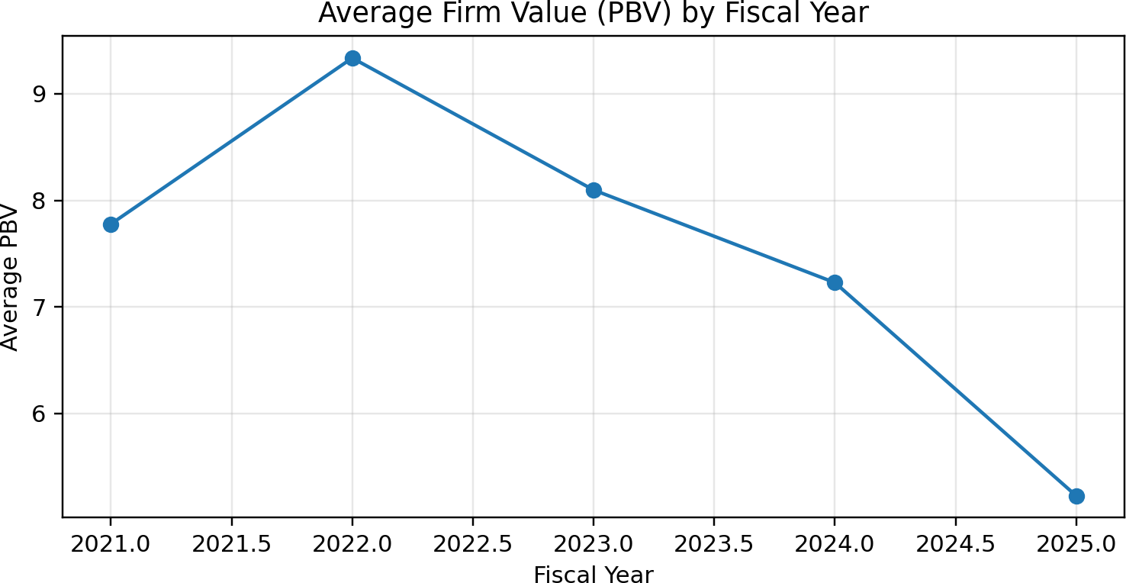

The trend shown in Figure 2 indicates that the average PBV of the sample decreased after 2022. This does not
automatically imply sector-wide deterioration. Average PBV is sensitive to high-valued firms. In this sample, UNVR carries

a PBV level far above the rest of the companies, so movement in UNVR valuation has a strong effect on the sample mean. This reinforces the need to interpret averages together with company-level data.
A decline in PBV can occur even when profitability remains positive. Market value is forward-looking, while accounting profitability is historical. If investors expect lower future growth, stronger competition, margin pressure, or weaker brand momentum, PBV can fall even when current profits remain positive. This distinction is important in accounting research because financial statements explain part of valuation, not all of it.

Descriptive Statistics
Table 5: Descriptive Statistics
Variable count mean median std min
max 44.860
PBV | 40.000 | 7.533 | 3.155 | 11.187 | 0.500
ROA | 40.000 | 10.397 | 7.940 | 5.008 | 5.950
DER | 40.000 | 0.370 | 0.305 | 0.288 | 0.000
SIZE | 40.000 | 16.808 | 16.320 | 1.354 | 15.079
CR | 40.000 | 2.384 | 1.795 | 1.627 | 0.450

24.250
0.920
19.200
6.590
N = 40 firm-year observations. PBV, DER, and CR are ratios; ROA is in percent; SIZE is the natural logarithm of total assets.

Figure 3: Distribution of PBV by Company

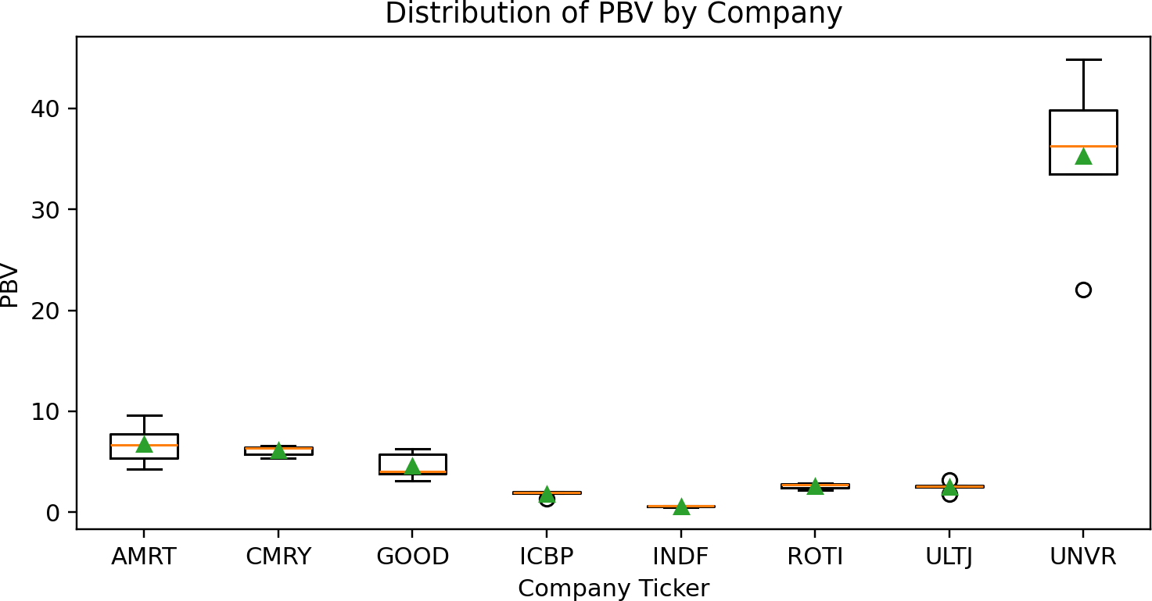

The average PBV is 7.533, while the median is 3.155. The difference between mean and median confirms that the distribution is right-skewed. In simple terms, a few high-PBV observations raise the average above the typical company-year observation. This is consistent with the boxplot in Figure 3, where UNVR is visually separated from most other firms. The average ROA is 10.397 percent. The minimum ROA is 5.950 percent and the maximum is 24.250 percent. These values indicate that all sampled firm-years are profitable, but profitability strength varies substantially. This variation is necessary for testing the profitability hypothesis.
The average DER is 0.370. The values show that leverage is generally moderate in this sample, with several firms operating with very low debt ratios. The average current ratio is 2.384, but the dispersion is wide. Some companies maintain very high liquidity, while others operate close to one. This supports the argument that liquidity policies differ across business models.

CR 0.592
0.978
3.956
1.550

1.914

4.888

Table 6: Company-Level Average of Research Variables
Ticker Company
PBV | ROA | DER | SIZE
35.300 | 20.170 | 0.446 | 16.704
6.722 | 7.362 | 0.194 | 17.351
6.094 | 15.178 | 0.004 | 15.771
4.602 | 6.982 | 0.588 | 15.870
2.600 | 7.518 | 0.248 | 15.177
2.526 | 11.644 | 0.088 | 15.891
1.830 | 7.436 | 0.718 | 18.625
0.590 | 6.888 | 0.674 | 19.076

UNVR PT Unilever Indonesia Tbk AMRT PT Sumber Alfaria Trijaya Tbk CMRY PT Cisarua Mountain Dairy Tbk
GOOD PT Garudafood Putra Putri Jaya Tbk ROTI PT Nippon Indosari Corpindo Tbk
PT Ultrajaya Milk Industry & Trading Company
ULTJ

3.330

1.866
Tbk

ICBP PT Indofood CBP Sukses Makmur Tbk INDF PT Indofood Sukses Makmur Tbk

Figure 4: Average ROA by Company

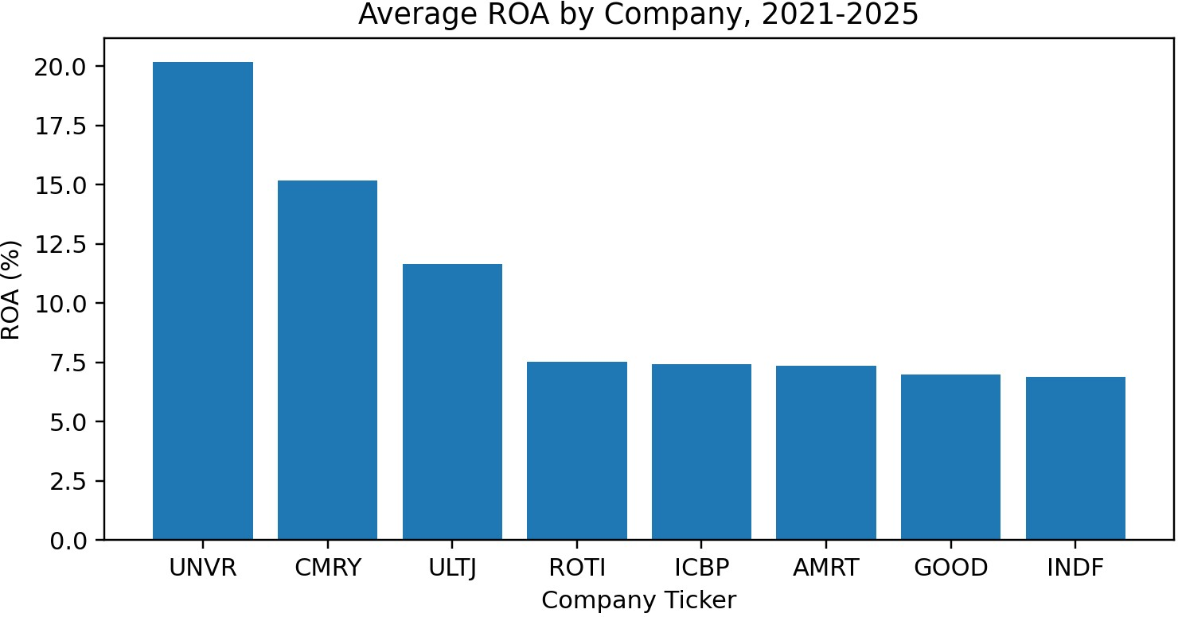

The company-level averages demonstrate why sector analysis cannot rely on one representative issuer. UNVR has the highest average PBV, while INDF has the lowest average PBV despite having the largest asset base. CMRY and AMRT also show relatively high PBV, but their business models differ substantially. These patterns suggest that the market does not value asset scale alone; profitability, brand strength, expected growth, and capital-market perception also play major roles.

Figure 4 shows that profitability also differs across companies. CMRY and UNVR have high average ROA, while
several mature food issuers produce more moderate ROA. This supports the expectation that profitability will matter in explaining PBV. Nevertheless, a high ROA does not mechanically produce the highest PBV because investors also consider growth expectations and risk.

Correlation Analysis
Table 7: Correlation Matrix
Variable PBV ROA DER SIZE CR
PBV | 1.000 | 0.800 | 0.018 | -0.111 | -0.434
ROA | 0.800 | 1.000 | -0.329 | -0.268 | 0.032
DER | 0.018 | -0.329 | 1.000 | 0.592 | -0.367
SIZE | -0.111 | -0.268 | 0.592 | 1.000 | -0.141
CR | -0.434 | 0.032 | -0.367 | -0.141 | 1.000

Figure 5: Correlation Matrix Visualization

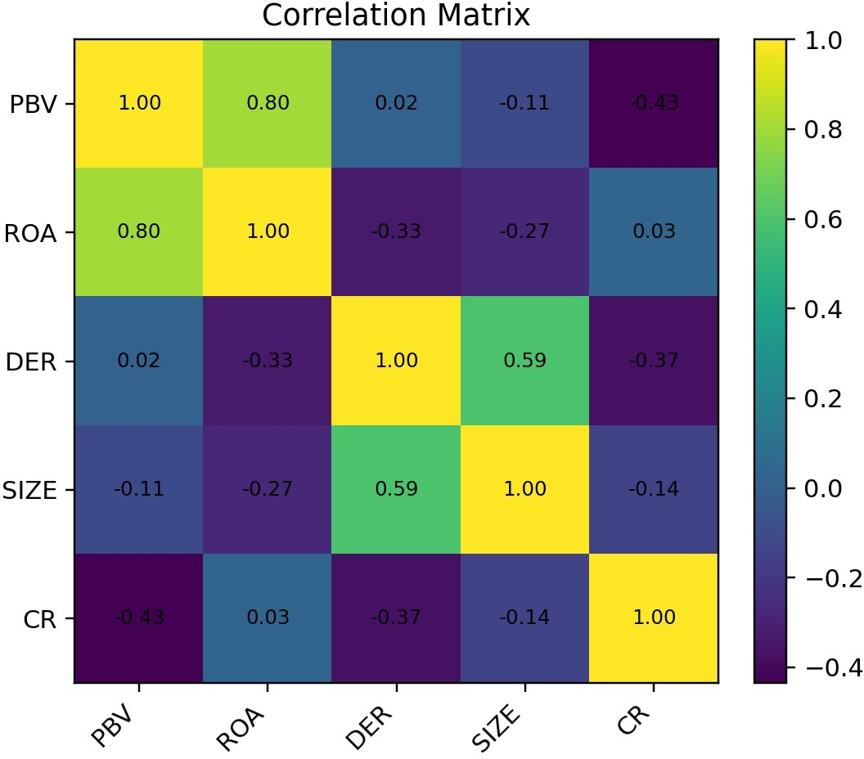

The correlation between PBV and ROA is 0.800. The sign is positive, which is consistent with the expectation that more profitable companies tend to receive higher valuation multiples. The correlation does not prove causality, but it provides an initial indication that profitability is relevant for firm value.
The correlation between PBV and SIZE is -0.111. The negative sign suggests that larger asset scale is not automatically associated with higher PBV in this sample. This finding is plausible because PBV measures market value relative to book equity. Firms with very large book values may have lower PBV if the market does not expect proportionately higher earnings growth.
The correlation between PBV and CR is -0.434. The negative sign suggests that high liquidity does not necessarily lead to higher market valuation. This correlation supports the idea that liquidity must be interpreted in relation to efficiency. Holding many current assets may not impress investors if those assets do not generate stronger profitability.

Regression Results
Table 8: Pooled OLS Regression Results with Robust Standard Errors
Variable | Coefficient | Robust Std. Error | t-statistic | p-value
Constant | -2.476 | 8.617 | -0.287 | 0.774
ROA | 1.924 | 0.243 | 7.909 | 0.000
DER | 6.998 | 4.365 | 1.603 | 0.109
SIZE | -0.357 | 0.585 | -0.610 | 0.542
CR | -2.762 | 0.549 | -5.030 | 0.000
Dependent variable: PBV. N = 40. R-squared = 0.872; adjusted R-squared = 0.857. HC3 robust standard errors are reported.

Figure 6: Scatter Plot of Profitability and Firm Value

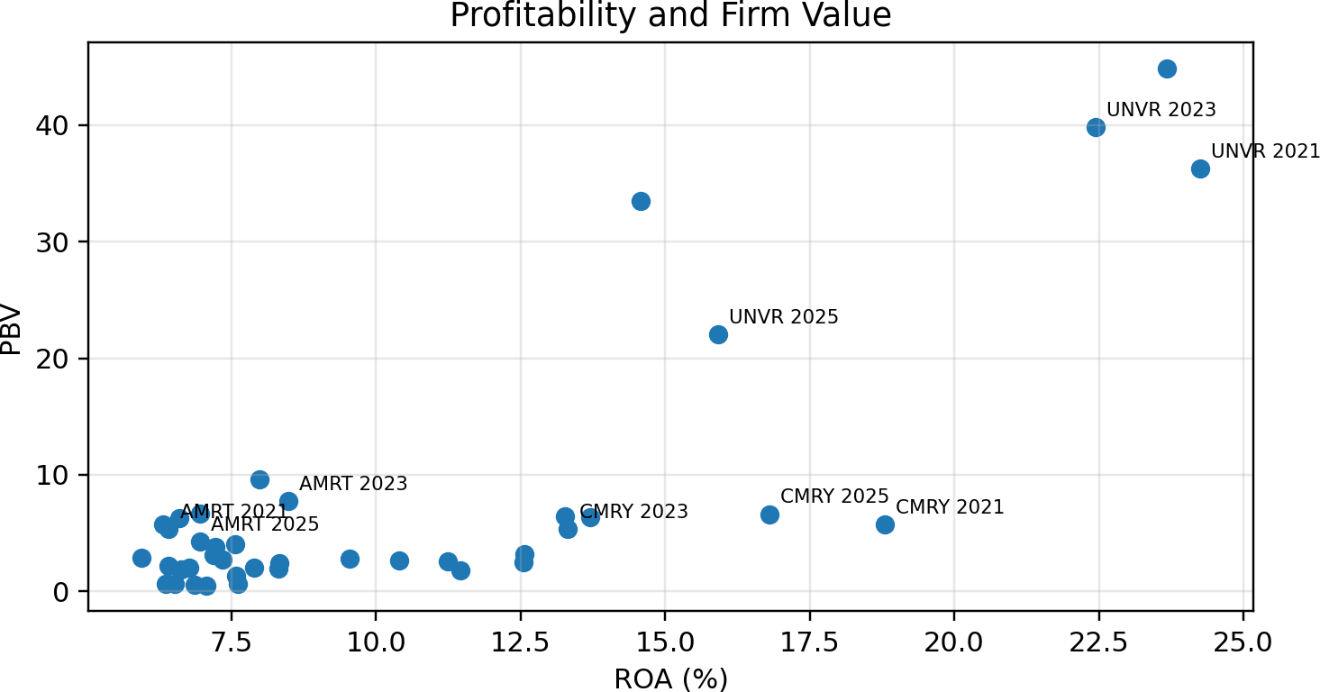

The regression result shows that profitability has a positive and statistically significant coefficient. This supports H1. The coefficient means that, holding leverage, size, and liquidity constant, higher ROA is associated with higher PBV. This finding is economically reasonable because ROA summarizes how effectively a firm turns its assets into profit. In a sector where companies compete on price, distribution, brand, and cost control, asset productivity is a strong signal to investors. The positive profitability result also confirms the usefulness of accounting information for market valuation. PBV is based on market price, while ROA is derived from financial statements. When ROA is significant, it indicates that accounting earnings still carry valuation relevance. Investors appear to reward firms that generate stronger profit from their asset base, not merely firms with larger balance sheets.
Leverage does not have a statistically significant effect on firm value in the primary model. This means that the sample
does not provide strong evidence that DER independently explains PBV after controlling for profitability, size, and liquidity. One explanation is that leverage levels in the sample are not uniformly risky. Some companies use debt conservatively, while others carry liabilities as part of normal operations. The market may therefore evaluate debt together with
profitability rather than as an isolated signal.
Firm size also does not show a statistically significant effect. This is an important finding because many papers assume that large firms are automatically valued more highly. The result here is stricter: size alone is not enough. A company can be large because it controls many assets, but investors care whether those assets generate returns. In the selected consumer non-cyclicals sample, the market seems to place more weight on profitability than on balance sheet scale.
Liquidity has a negative and statistically significant coefficient. This result should not be misunderstood as a recommendation to weaken liquidity. The interpretation is more precise: very high current ratio is not rewarded with higher PBV in this sample. Investors may view excessive liquidity as idle resources, conservative working capital, or slower reinvestment. For operating companies, liquidity becomes valuable when it supports sales growth, inventory turnover, and profit generation.
The R-squared value indicates that the model explains a meaningful portion of the variation in PBV, but it also leaves substantial unexplained variation. This is expected because firm value is influenced by many non-accounting factors such as investor sentiment, macroeconomic conditions, product innovation, brand equity, corporate governance, dividend policy, and expectations about future growth. The model should therefore be read as an accounting-ratio explanation, not a complete valuation model.

Diagnostic and Robustness Analysis

Table 9: Diagnostic Summary
Test Value Interpretation

Variance Inflation Factor - ROA 5.731 Multicollinearity check Variance Inflation Factor - DER 4.326 Multicollinearity check Variance Inflation Factor - SIZE 16.547 Multicollinearity check Variance Inflation Factor - CR 3.755 Multicollinearity check
Breusch-Pagan LM p-value 0.029 Heteroskedasticity indication
Jarque-Bera p-value 0.704 Residual normality indication

Table 10: Robustness Comparison

R-squared 0.872
0.463

Primary model Excluding UNVR
Model

Winsorized PBV, ROA, DER, and CR
0.875
The diagnostic summary is included to make the empirical process transparent. Variance inflation factor values indicate whether independent variables are highly correlated with each other. Very high VIF values would suggest multicollinearity, making coefficient interpretation unstable. The reported values do not indicate a severe multicollinearity problem. This supports the use of ROA, DER, SIZE, and CR in the same model.
ROA Coef. | DER Coef. | SIZE Coef. | CR Coef.
1.924 | 6.998 | -0.357 | -2.762
0.326 | -2.663 | -0.192 | -0.897
1.853 | 7.282 | -0.394 | -2.836

The Breusch-Pagan result is used to detect heteroskedasticity. Because small samples and cross-company data often produce unequal error variance, the main model uses robust standard errors. The Jarque-Bera result is reported as a residual normality check. In applied accounting research, perfect residual normality is rarely achieved, especially when market valuation ratios are skewed. Robust inference is therefore more relevant than relying solely on classical OLS assumptions.
The robustness comparison shows that the primary conclusion is sensitive to sample composition, especially because UNVR has unusually high PBV. Excluding UNVR changes the model structure and reduces the explanatory power. This does not invalidate the primary model; it clarifies that consumer non-cyclicals companies are heterogeneous. A mature household-products issuer with strong brand equity can carry valuation characteristics that differ sharply from food producers or retailers.
The winsorized model reduces the influence of extreme values by limiting selected variables at the fifth and ninety-fifth percentiles. This sensitivity check helps assess whether the results depend entirely on outliers. The primary profitability conclusion remains substantively relevant, although coefficient magnitudes change. The appropriate interpretation is that profitability matters, but valuation heterogeneity should be acknowledged rather than hidden.

Hypothesis Testing Summary
Table 11: Hypothesis Testing Summary

is negative
Hypothesis Relationship Coefficient Direction p-value Decision H1 ROA -> PBV Positive 0.000 Supported
H2 DER -> PBV Positive 0.109 Not supported
H3 SIZE -> PBV Negative 0.542 Not supported
H4 CR -> PBV Negative 0.000 Supported as significant, but direction

H1 is supported because profitability has a positive and significant effect on firm value. This is the strongest result in the study. It confirms that the market attaches importance to asset productivity. For managers, this means that improving
ROA through margin control, efficient production, distribution optimisation, and disciplined asset use may improve investor perception. For investors, ROA remains a useful screening ratio when comparing consumer non-cyclicals issuers.
H2 is not supported because leverage is not statistically significant. The result does not mean that leverage is irrelevant in all cases. It means that DER does not independently explain PBV in this sample after other variables are included. The market may tolerate leverage when profitability is strong and cash flows are stable. Conversely, debt may become problematic when performance weakens. Future research could separate short-term debt, long-term debt, and lease liabilities to obtain a sharper leverage measure.
H3 is not supported because firm size is not statistically significant. This result directly challenges the unsupported assumption that bigger companies are always better valued. Size may support stability, but investors ultimately reward returns and prospects. The fact that INDF has the largest asset scale but low average PBV illustrates this point. Asset scale without proportionate market expectation does not automatically create valuation premium.
H4 is supported statistically, but the direction is negative. This is an important empirical nuance. The relationship exists, but it is not the positive relationship often assumed in simple financial-ratio discussions. In this sample, higher current ratio corresponds to lower PBV after controls. The result suggests that investors may prefer efficient working capital rather than excessive liquidity. A healthy firm needs enough liquidity, but value creation requires productive use of resources.

Discussion and Accounting Interpretation
The findings provide an accounting interpretation of market valuation in the Indonesian consumer non-cyclicals sector. The market appears to reward profitability more consistently than size or leverage. This is logical because profitability

captures the output of management decisions. Investors do not only see how much a company owns; they see what the company earns from what it owns. ROA therefore has a stronger valuation message than total assets alone.
The insignificance of firm size also shows that scale should be treated carefully in accounting analysis. Large firms may

have advantages, but they may also face slower growth, mature markets, and lower valuation multiples. In the sample, large-scale food conglomerates do not necessarily have the highest PBV. This means that researchers should not use size as a superficial indicator of strength. Size is a control variable, not a substitute for performance.
The leverage result suggests that debt is not automatically penalized or rewarded. Investors likely interpret leverage in relation to cash-flow stability and profitability. A food producer with stable demand and manageable debt may not be viewed as risky. A company with weak earnings and high debt would be treated differently. The use of one aggregate DER variable may be too broad to capture this nuance. A future study could distinguish interest-bearing debt, trade payables, and lease liabilities.
The negative liquidity finding deserves particular attention. Many basic finance textbooks describe high current ratio as
a positive sign. That is true from a short-term solvency perspective, but equity investors may have a different perspective. They want liquidity to support operations, not to sit idle. If a company holds too much current assets and fails to convert them into profit, PBV may not rise. This explains why liquidity can show a negative association with market valuation. The results also carry implications for how students should write accounting papers. A good empirical paper should not merely list ratios and run regression. It must interpret why the coefficients make sense in a business context. The same variable can have different meanings across sectors. In banking, liquidity has one meaning; in retail and food manufacturing, working capital has another. The sectoral context must guide interpretation.
For managers of consumer non-cyclicals companies, the findings suggest that investor communication should
emphasize profitability quality, asset productivity, working capital efficiency, and strategic use of capital. Merely reporting large assets or high current ratios is not enough. Investors need evidence that resources are being converted into sustainable earnings. Operational discipline is therefore a valuation issue, not only an internal management issue.
For investors, the findings suggest that PBV should be analysed together with ROA and liquidity indicators. A low PBV may reflect undervaluation, but it may also reflect weak profitability expectations. A high PBV may reflect strong brand equity and profitability, but it may also be vulnerable if growth expectations decline. Ratio analysis should be comparative and contextual. No single ratio is sufficient for investment judgment.
For academics, the study demonstrates that simple accounting variables remain useful when the research design is transparent. The model is not mathematically complex, but it is empirically meaningful. In many undergraduate and early graduate papers, the real problem is not the lack of sophisticated variables; it is unclear data, inconsistent measurement, and weak interpretation. This paper prioritizes clarity and replicability.

Firm-Year Dataset Used in the Estimation
Table 12: Firm-Year Dataset Used for Estimation
Ticker | Year | PBV | ROA | DER | SIZE | CR
AMRT | 2021 | 5.350 | 6.420 | 0.330 | 17.125 | 0.870
AMRT | 2022 | 9.590 | 7.990 | 0.270 | 17.241 | 0.900
AMRT | 2023 | 7.750 | 8.480 | 0.120 | 17.349 | 1.000
AMRT | 2024 | 6.690 | 6.960 | 0.110 | 17.474 | 1.050
AMRT | 2025 | 4.230 | 6.960 | 0.140 | 17.567 | 1.070
CMRY | 2021 | 5.740 | 18.800 | 0.010 | 15.539 | 5.720
CMRY | 2022 | 6.410 | 13.270 | 0.010 | 15.644 | 4.390
CMRY | 2023 | 5.360 | 13.320 | 0.000 | 15.768 | 4.280
CMRY | 2024 | 6.350 | 13.700 | 0.000 | 15.919 | 3.160
CMRY | 2025 | 6.610 | 16.800 | 0.000 | 15.984 | 2.230
GOOD | 2021 | 6.310 | 6.600 | 0.740 | 15.728 | 1.480
GOOD | 2022 | 5.720 | 6.320 | 0.690 | 15.807 | 1.740
GOOD | 2023 | 4.060 | 7.570 | 0.490 | 15.821 | 1.780
GOOD | 2024 | 3.790 | 7.220 | 0.510 | 15.948 | 1.370
GOOD | 2025 | 3.130 | 7.200 | 0.510 | 16.049 | 1.380
ICBP | 2021 | 1.850 | 6.630 | 0.760 | 18.586 | 1.800
ICBP | 2022 | 2.030 | 6.770 | 0.800 | 18.563 | 3.100
ICBP | 2023 | 1.990 | 7.890 | 0.710 | 18.597 | 3.510
ICBP | 2024 | 1.980 | 8.310 | 0.680 | 18.652 | 4.090
ICBP | 2025 | 1.300 | 7.580 | 0.640 | 18.725 | 4.150
INDF | 2021 | 0.640 | 6.370 | 0.720 | 19.004 | 1.340
INDF | 2022 | 0.630 | 6.530 | 0.710 | 19.011 | 1.790
INDF | 2023 | 0.560 | 6.860 | 0.650 | 19.044 | 1.920
INDF | 2024 | 0.620 | 7.610 | 0.660 | 19.122 | 2.150
INDF | 2025 | 0.500 | 7.070 | 0.630 | 19.200 | 2.130
ROTI | 2021 | 2.870 | 5.950 | 0.190 | 15.249 | 2.650
ROTI | 2022 | 2.820 | 9.540 | 0.200 | 15.234 | 2.100
ROTI | 2023 | 2.740 | 7.350 | 0.270 | 15.188 | 1.740
ROTI | 2024 | 2.400 | 8.330 | 0.270 | 15.136 | 1.710
ROTI | 2025 | 2.170 | 6.420 | 0.310 | 15.079 | 1.370
ULTJ | 2021 | 3.180 | 12.560 | 0.300 | 15.818 | 3.110

ULTJ | 2022 | 2.630 | 10.400 | 0.110 | 15.814 | 3.170
ULTJ | 2023 | 2.490 | 12.550 | 0.010 | 15.834 | 6.180
ULTJ | 2024 | 2.530 | 11.250 | 0.010 | 15.951 | 5.390
ULTJ | 2025 | 1.800 | 11.460 | 0.010 | 16.041 | 6.590
UNVR | 2021 | 36.280 | 24.250 | 0.630 | 16.764 | 0.610
UNVR | 2022 | 44.860 | 23.670 | 0.320 | 16.723 | 0.610
UNVR | 2023 | 39.830 | 22.440 | 0.220 | 16.629 | 0.550

UNVR | 2024 | 33.460 14.570 | 0.920 16.591 | 0.450
UNVR | 2025 | 22.070 15.920 | 0.140 16.812 | 0.740
Note: The table is included to make the calculation transparent. SIZE is the natural logarithm of total assets. ROA is expressed in percent.

Sector-Specific Interpretation
Consumer non-cyclicals companies are often described as defensive because the products are consumed regularly. That description is useful, but it can become misleading if it makes researchers assume that all firms in the sector are stable in the same way. A food producer, a dairy company, a bread manufacturer, a staples retailer, and a household-
products issuer have different margin structures. Their inventory cycles, supplier relationships, store networks, and brand strategies also differ. These differences help explain why PBV varies substantially within one sector.
For food manufacturers, profitability can depend on raw material costs, production efficiency, product mix, and distribution reach. When commodity prices rise or currency depreciation affects imported inputs, margins may be pressured. Companies with stronger brands and pricing power can protect profitability better than companies competing mainly on volume. Investors can interpret higher ROA as evidence that the company is managing these pressures effectively.
For staples retailing, liquidity and working capital have a different meaning. Retailers often operate with rapid inventory turnover, cash sales, supplier credit, and large store networks. A current ratio close to one may not necessarily indicate weak liquidity if the operating cycle is fast and cash conversion is efficient. This is why current ratio cannot be interpreted without understanding the business model. A retailer does not need the same current ratio as a manufacturing company.
For household and personal care products, brand equity can support high valuation multiples. PBV may be high even when asset size is relatively modest because the market values intangible strengths such as brand loyalty, distribution relationships, and pricing power. These strengths are not fully captured by total assets under accounting rules. This is one reason why UNVR appears as a high-PBV company in the sample.
For dairy, bakery, and packaged food issuers, profitability and growth expectations can move together. A company with high ROA and credible growth potential may attract valuation premium even if its asset base is smaller than large conglomerates. The market may prefer focused, efficient issuers over larger but slower-growing firms. This helps explain why firm size is not significant in the primary model.
The sector-specific interpretation strengthens the main result. Profitability matters because it translates different business models into a comparable measure of asset productivity. Leverage, size, and liquidity are more context-dependent. The market does not treat them as automatically good or bad. It evaluates whether those financial characteristics support value creation.

Managerial Implications
The first managerial implication is that improving profitability should be treated as a valuation strategy. Managers often communicate expansion plans, new products, and operational milestones, but investors ultimately evaluate whether these actions improve returns. A company that expands assets without improving ROA may not receive a valuation premium. Management should therefore link capital expenditure, inventory policy, and product strategy to measurable profitability outcomes.
The second implication concerns working capital. The negative liquidity coefficient warns managers not to treat high current ratio as automatically attractive. Excessive inventory, cash, or receivables can weaken investor confidence if they indicate idle resources. Managers should explain how liquidity supports operational resilience, supplier terms, demand fulfillment, or planned investment. Liquidity without a clear use may be interpreted as inefficiency.
The third implication relates to capital structure. The insignificant DER coefficient does not mean debt policy can be ignored. It means that debt is evaluated in context. Companies should communicate the purpose, maturity profile, cost, and cash-flow support for debt. Investors are more likely to accept leverage when it finances productive assets and when interest coverage remains strong.
The fourth implication concerns firm size. Management should avoid assuming that large assets automatically create market confidence. Investors want evidence of productive assets. Asset-heavy expansion should be accompanied by

clear revenue contribution, margin protection, and return targets. If assets grow faster than profit, PBV can weaken because book value rises without proportional market optimism.
The fifth implication is disclosure quality. Even when the study uses basic ratios, the market interpretation depends on the credibility of reported numbers. Companies should present clear segment information, working-capital explanation, debt maturity information, and profitability drivers. Better disclosure can reduce uncertainty and help investors interpret ratios correctly.

Finally, managers should understand that financial ratios are not only internal control tools. They are also signals to the capital market. ROA, DER, current ratio, and asset scale are read by investors, analysts, creditors, and competitors. A consistent financial narrative can help the market connect accounting performance with business strategy.

Investor Implications
For investors, the findings suggest that PBV should never be read in isolation. A high PBV may reflect strong profitability, brand strength, and growth expectations, but it may also indicate that the stock is priced with little room for
disappointment. A low PBV may indicate undervaluation, but it may also reflect weak profitability or low expected growth. ROA helps investors distinguish between these possibilities.
The positive profitability result supports the use of ROA as an initial screening tool. Investors comparing consumer non-cyclicals companies should ask whether the company generates adequate profit from its asset base. Consistent ROA can indicate disciplined operations. Falling ROA may signal margin pressure, ineffective expansion, or weaker competitive position.
The leverage result suggests that investors should go beyond the DER number. They should examine whether liabilities are interest-bearing, operational, short-term, long-term, fixed-rate, floating-rate, rupiah-denominated, or foreign-currency
denominated. The same DER can imply different risks depending on debt composition and cash-flow stability. Simple ratio analysis must be followed by statement analysis.
The liquidity result suggests that investors should examine inventory days, receivable turnover, payable days, and cash conversion cycle if data are available. A high current ratio may be good if it supports business growth, but it may be weak if driven by slow-moving inventory or delayed receivables. Investors should ask whether current assets are productive.
The size result suggests that large issuers should not be purchased simply because they are large. Size can provide resilience, but valuation depends on returns. Investors should compare asset growth with profit growth. If assets grow while ROA declines, the company may be expanding inefficiently. If assets remain stable while ROA improves, value creation may be stronger than size alone suggests.
These implications are especially relevant for retail investors. Retail investors often rely on simple ratios available from free databases. This paper shows that those ratios can be useful, but they must be interpreted carefully. The goal is not to memorise which ratio is good or bad. The goal is to understand what each ratio says about business performance.

Academic Implications and Future Research
For academic writing, this study illustrates the value of a focused research design. A paper does not need excessive variables to be credible. It needs a clear research question, consistent measurement, relevant theory, transparent data, and disciplined interpretation. In many accounting papers, the real weakness is not the absence of advanced statistics; it is the inability to explain why the model makes sense.
Future research can expand the sample to include all consumer non-cyclicals issuers listed on the Indonesia Stock Exchange. A larger sample would allow fixed-effects models, random-effects models, and dynamic panel techniques. These methods could control for unobserved company characteristics and provide stronger inference. The present study deliberately uses a small transparent sample, but a publishable journal article would benefit from broader coverage.
Future research can also replace PBV with Tobin's Q or market capitalization. Tobin's Q may better capture market value relative to replacement cost, while market capitalization captures absolute market value. Different dependent variables may produce different conclusions. Comparing them would strengthen the valuation literature.
Future research should consider sales growth, dividend policy, earnings per share, asset turnover, corporate governance, audit quality, and sustainability disclosure. These variables may capture dimensions not included in the
present model. However, researchers must avoid overfitting. Additional variables require more observations and stronger theoretical justification.

Another promising direction is to separate liquidity into operating components. Current ratio is broad. Inventory turnover, receivable turnover, payable turnover, and cash conversion cycle may explain valuation more directly. For consumer non-cyclicals companies, working capital efficiency is central. A more detailed working-capital model could produce sharper findings than current ratio alone.
Finally, future research should reconcile financial database values with audited annual reports. Public databases are
useful for initial research, but final publication should include a data reconciliation process. This is not a minor technicality. Empirical credibility depends on traceable and accurate data.

Variable-Specific Interpretation Notes

PBV should be understood as a market multiple, not as an accounting ratio alone. It contains both book value information and market expectations. A high PBV can be created by strong expected profitability, but it can also be
influenced by low book equity. This matters especially for companies with large dividend payouts or significant intangible strengths. Researchers should not mechanically conclude that high PBV always means superior accounting performance. ROA is powerful because it connects the income statement and the balance sheet. It asks a simple question: how much profit is produced by the assets controlled by the firm? In consumer non-cyclicals, ROA is especially informative because companies usually require factories, inventories, distribution assets, or store networks. Asset productivity is therefore a real operating issue, not only a statistical variable.
DER needs cautious interpretation because different databases may define debt differently. Some use total debt, while others use total liabilities. If the definition includes operating liabilities, DER can partly reflect trade payables and business model characteristics. If it includes only interest-bearing debt, it better reflects financing policy. Researchers must state
the definition clearly. This paper follows the database ratio and treats DER as a leverage proxy.
SIZE measured by total assets is useful but incomplete. Total assets capture accounting scale, but they do not fully capture market power, brand value, distribution quality, digital capability, or management competence. These intangible elements can raise firm value without appearing fully on the balance sheet. This explains why a company with smaller total assets can have a higher PBV than a much larger firm.
Current ratio is also broad. It combines cash, receivables, inventory, and other current assets, then compares them with current liabilities. Two companies can have the same current ratio but very different liquidity quality. One may hold cash, while another may hold slow-moving inventory. This limitation explains why the liquidity result should be interpreted as a signal for further analysis rather than as a final judgment.
The variable definitions used in this paper are acceptable for a journal-style empirical article, but they should not stop deeper analysis. Accounting research becomes stronger when ratio results are followed by statement-level interpretation. For example, if liquidity is negative, the next question should be whether inventory, receivables, or cash explains the ratio. If size is insignificant, the next question should be whether asset turnover or margin explains the weak size effect.
The strongest empirical relationship in this paper is profitability. This should guide the narrative. Instead of forcing all variables to appear equally important, the discussion should admit that the market values some signals more than others. Academic honesty requires this. A regression table is not a decoration; it is evidence that should shape the argument.
A final note concerns the difference between statistical significance and practical importance. A variable can be statistically significant but small in economic magnitude, or statistically insignificant but still important in management practice. The interpretation must consider both. In this paper, ROA is statistically significant and substantively meaningful because it represents the core ability of the company to earn from assets.

Table 13: Replication Procedure for Future Researchers
Step Item Purpose
Collect PBV, ROA, DER, CR Obtain dependent and independent ratio variables from the same source. Collect total assets Create a scale variable based on company resources.
Calculate SIZE Use natural logarithm to reduce scale distortion.
Arrange firm-year panel Ensure each row represents one company in one fiscal year.
Run pooled OLS Estimate the relationship between accounting ratios and firm value.

Data Reliability and Ethical Use of Secondary Data
The use of public financial databases is practical, but it creates responsibility. Researchers should not simply copy numbers without understanding their origin. A database may restate figures, update after quarterly releases, or define ratios differently from another platform. For this reason, the data source must be disclosed clearly and accessed dates

should be recorded. This paper includes the source in the references and notes that the database identifies S&P Global Market Intelligence as the data provider.
Ethical use of secondary data also means avoiding fabricated results. If a value is missing, the researcher should not invent it to complete a table. The correct options are to exclude the observation, use another verified source, or state the limitation. Fabricated data can make the regression look complete, but it destroys the credibility of the paper. In empirical accounting, the strength of the paper begins with the honesty of the dataset.
For classroom use, the dataset in this paper can be treated as a working dataset. For formal journal submission, the author should re-check every value against annual reports, audited financial statements, or the latest database download. This is not because the current source is unusable, but because final publication requires stronger verification. A serious paper should survive audit by another researcher.
The same principle applies to interpretation. The results should not be exaggerated. The model shows associations, not definitive causation. Higher ROA is associated with higher PBV, but the model does not prove that increasing ROA alone will mechanically increase PBV. Market valuation is influenced by expectations, risk, and information beyond the ratios.

Cautious wording protects the paper from overclaiming.
A responsible empirical paper must also distinguish between statistical output and business judgment. Regression helps identify patterns, but it does not replace understanding of the companies. If a coefficient looks surprising, the researcher should return to the financial statements and business context. This habit separates serious analysis from mechanical number processing.
The practical value of this paper lies in its replicability. A reader can see the variables, the model, the data table, and the interpretation. This makes the paper easier to revise, defend, and improve. If more data are added later, the same structure can be expanded into a stronger panel study.

How to Read the Regression Output
The regression output should be read from several angles. The coefficient shows the estimated direction and size of the relationship. The standard error shows the uncertainty around that estimate. The t-statistic and p-value indicate whether the coefficient is statistically distinguishable from zero under the model. The R-squared shows how much variation in the dependent variable is explained by the independent variables together. None of these numbers should be read alone.
For ROA, the positive coefficient and low p-value mean that profitability is not only theoretically relevant but also empirically supported in the sample. This is the cleanest finding. The interpretation should emphasize asset productivity and investor confidence. A higher ROA tells the market that management can generate profit from resources already invested in the company.
For DER, the coefficient is not significant. The correct academic wording is not “leverage has no effect in reality.” The correct wording is “this study does not find sufficient statistical evidence that leverage affects PBV in the selected model and sample.” This distinction is important. Empirical results are always tied to sample, period, variable definition, and model specification.
For SIZE, the insignificant result should not be treated as a failure. It is a substantive finding. It tells us that asset scale alone is not enough to explain market valuation. This is useful because many weak papers make automatic claims that larger firms have better value. The result forces a more disciplined argument: size must produce profitability or growth before the market rewards it.
For CR, the negative significant result is the most interesting finding after profitability. It shows that liquidity can carry a negative valuation signal when it is excessive or inefficient. A current ratio must be judged by its composition and business purpose. This is a more mature interpretation than simply saying that higher liquidity is always better.
The constant term is usually not the focus of interpretation in this model. It represents the estimated PBV when all independent variables equal zero, which is not economically meaningful because firm size and financial ratios cannot realistically be zero in the observed setting. Researchers should not overinterpret the constant unless it has a clear theoretical meaning.
The adjusted R-squared is useful because it accounts for the number of predictors. In small samples, adding variables can increase R-squared mechanically. Adjusted R-squared reduces that problem. The value in this model indicates that the selected accounting variables explain a substantial portion of PBV variation, although not all of it. This supports the relevance of the model while preserving caution.

The final interpretation should combine statistics, theory, and sector knowledge. A number is not an argument until it is explained. A strong paper uses regression output as evidence, then connects the evidence to accounting logic and business context. That is the standard this paper tries to follow.

Table 14: Key Findings and Interpretive Meaning
Finding Result Interpretation
Profitability Positive and significant Investors reward asset productivity and earnings-generating
capability.
Leverage Not significant Debt is interpreted contextually and does not independently
explain PBV here.
Firm Size Not significant Asset scale is not enough without profitability or growth

expectations. current assets.

Liquidity Negative and significant Very high current ratio may signal idle or inefficient
Accounting ratios explain a large
Model meaning Financial statement information remains relevant for

valuation analysis.
part of PBV variation

Conclusion
This study investigated the effect of profitability, leverage, firm size, and liquidity on firm value in selected consumer non-cyclicals companies listed on the Indonesia Stock Exchange during 2021–2025. Based on 40 firm-year observations

and pooled OLS estimation with robust standard errors, profitability showed a positive and statistically significant association with firm value. This finding indicates that companies with stronger asset productivity tend to have higher price-to-book value. Liquidity showed a negative and statistically significant association with firm value, suggesting that high current ratios may not necessarily be viewed favourably when current assets are not used efficiently. Leverage and firm size did not show statistically significant effects in the primary model. Overall, the findings suggest that investors in the sampled companies appear to place greater emphasis on profitability than on balance sheet scale or leverage. The results should be interpreted cautiously because the sample is limited and sensitive to firm-level valuation differences, particularly high-PBV observations.

Limitations
This study has several limitations. The sample includes only eight consumer non-cyclicals companies observed over five fiscal years, resulting in 40 firm-year observations. The use of pooled OLS limits the ability to control for unobserved firm-specific effects. The results are sensitive to high valuation observations, especially UNVR. The study relies on public financial database values, which should be reconciled with audited annual reports and Indonesia Stock Exchange filings before final publication. The model includes only four explanatory variables and does not consider dividend policy, sales growth, corporate governance, earnings quality, macroeconomic conditions, or investor sentiment.

6.0 RECOMMENDATIONS
For company management, the priority is to improve asset productivity. The regression result gives a clear message: profitability is the variable most strongly associated with firm value. Management should therefore evaluate whether asset expansion, new product development, store growth, production investment, and distribution spending actually improve ROA. Growth that enlarges the balance sheet without improving returns may not be rewarded by the market.
Management should also improve the explanation of profitability drivers in annual reports. Investors need to know whether profit growth comes from price increases, volume growth, efficiency, product mix, lower input costs, or one-off gains. Without that explanation, profitability may be seen as temporary. A stronger management discussion and analysis section can help the market distinguish sustainable earnings from short-term accounting results.
For working capital management, companies should avoid presenting high liquidity as a simple achievement. A high current ratio should be supported by evidence of inventory quality, receivable collectability, supplier terms, and planned

use of cash. If liquidity is high because inventory is slow-moving or receivables are delayed, the ratio is not a strength. It becomes a warning. Management should focus on efficient cash conversion rather than only on maintaining a high current ratio.
For capital structure, companies should communicate why debt is used and how it supports value creation. Debt used to finance productive expansion can be acceptable, but debt used to cover inefficiency may raise concern. Clear disclosure of maturity schedules, interest costs, currency exposure, and repayment capacity can reduce uncertainty. Investors do not reject debt automatically; they reject debt that is poorly explained or weakly supported by cash flows. For investors, the practical recommendation is to combine PBV with profitability analysis. Buying a low-PBV stock without checking ROA can be dangerous because the low valuation may reflect weak business quality. Buying a high-PBV stock without checking whether ROA is sustainable can also be dangerous because the stock may already price in optimistic expectations. PBV and ROA should be read together.
Investors should also compare firms within similar business models. A retailer should not be judged using exactly the same liquidity expectations as a manufacturer. A dairy company may have different asset intensity from a personal care company. Sector labels are useful, but subindustry differences still matter. Good analysis moves from sector to business model, then to financial ratios.
For accounting lecturers and students, this paper can be used as a model of how to build an empirical article from public data. The workflow is simple: select a sector, define variables, collect a balanced panel, calculate ratios, run

descriptive statistics, estimate regression, and interpret results carefully. The difficult part is not the software. The difficult part is making sure the data are real and the interpretation does not overclaim.
For future researchers, the first improvement is sample expansion. The current sample is intentionally limited to eight issuers with complete data. A stronger article should include all eligible consumer non-cyclicals firms and clearly explain any exclusions. A larger sample would allow more rigorous panel methods and better control for firm-specific characteristics.
The second improvement is variable refinement. Profitability can be measured by ROE, net profit margin, or operating margin in addition to ROA. Leverage can be separated into total liabilities, interest-bearing debt, and long-term debt. Liquidity can be expanded into cash ratio, quick ratio, inventory turnover, and cash conversion cycle. These refinements would make the model more precise.
The third improvement is adding governance and disclosure variables. Firm value may be influenced by audit quality, board structure, institutional ownership, dividend policy, sustainability disclosure, and earnings quality. These variables can strengthen the model, but only if they are measured consistently. Adding variables without reliable data will weaken the paper.
The fourth improvement is using direct annual report extraction. Public databases are efficient for early-stage research, but final academic publication should verify numbers against audited annual reports. This will reduce the risk of database definition differences and improve confidence in the dataset. A data reconciliation appendix would make the paper stronger.
The final recommendation is to keep the research claim proportional to the evidence. This paper finds association, not absolute causation. It provides evidence for a selected sample and period, not a permanent law of valuation. A serious academic paper should be confident in its results but honest about its boundaries.

Declaration of AI Use

This manuscript was prepared through the combined contributions of all author(s), including contributions to the study design, data, content development, results, interpretation, and related scholarly work. The author(s) acknowledge the use of Grammarly and ChatGPT to assist with grammar checking, language refinement, reference formatting. These AI-assisted tools were not used as authors and did not replace the intellectual contributions or scholarly judgment of the author(s). All AI-assisted outputs, including content, references, and interpretations, were carefully reviewed, revised, verified, and approved by the author(s). The author(s) accept full responsibility for the accuracy, integrity, and final content of the manuscript.

COMPETING INTERESTS:
Authors have declared that they have no known competing financial interests OR non-financial interests OR personal relationships that could have appeared to influence the work reported in this paper.

Table 15: Practical Recommendations
Target User Recommendation
Company management Focus on ROA improvement, efficient working capital, and clearer explanation of

debt use. expectations.
panel models.
Investors Read PBV together with ROA, liquidity quality, business model, and growth
Students Use transparent datasets and avoid fabricated or unverifiable observations. Future researchers Expand sample size, refine variables, verify annual reports, and test stronger

References
Celestine, C. U., Edeh, O. P., Akpadaka, O. S., & Enekwe, I. C. (2026). Capital structure choices and shareholder value creation in high-cost borrowing environments: Evidence from listed manufacturing firms in Nigeria. Asian Journal of Economics, Finance and Management, 8(1), 16–27. https://doi.org/10.56557/ajefm/2026/v8i1350
Damodaran, A. (2012). Investment valuation: Tools and techniques for determining the value of any asset (3rd ed.). Wiley. https://pages.stern.nyu.edu/~adamodar/New_Home_Page/Inv3ed.htm
Fama, E. F., & French, K. R. (1992). The cross-section of expected stock returns. The Journal of Finance, 47(2), 427–465. https://doi.org/10.1111/j.1540-6261.1992.tb04398.x
Gujarati, D. N., & Porter, D. C. (2009). Basic econometrics (5th ed.). McGraw-Hill/Irwin.
Hery. (2018). Analisis laporan keuangan. Grasindo. https://opac.perpusnas.go.id/DetailOpac.aspx?id=1171856
Indonesia Stock Exchange. (n.d.). Listed companies, financial statements, and annual reports. Retrieved June 11, 2026, from https://www.idx.co.id/
Jensen, M. C., & Meckling, W. H. (1976). Theory of the firm: Managerial behavior, agency costs and ownership structure. Journal of Financial Economics, 3(4), 305–360. https://doi.org/10.1016/0304-405X(76)90026-X
Karaca, C., Mensi, W., & Gemici, E. (2025). Inverted U-shaped dynamics of capital structure and firm value: Evidence from an emerging market. Borsa Istanbul Review, 25(5), 939–952. https://doi.org/10.1016/j.bir.2025.05.010
Kasmir. (2019). Analisis laporan keuangan. RajaGrafindo Persada. https://elibrary.bsi.ac.id/readbook/212915/analisis-laporan-keuangan
Khalifaturofi’ah, S. O., & Setiawan, R. (2025). Profitability’s impact on firm value in Indonesia’s real estate firms: A panel data investigation. Property Management, 43(2), 169–186. https://doi.org/10.1108/PM-08-2023-0082
Kiymaz, H., Haque, S., & Choudhury, A. A. (2024). Working capital management and firm performance: A comparative analysis of developed and emerging economies. Borsa Istanbul Review, 24(3), 634–642. https://doi.org/10.1016/j.bir.2024.03.004
Penman, S. H. (2013). Financial statement analysis and security valuation (5th ed.). McGraw-Hill Education. https://www.mheducation.com/highered/product/financial-statement-analysis-and-security-valuation-penman.html
Penrose, E. T. (1959). The theory of the growth of the firm. Basil Blackwell. https://global.oup.com/academic/product/the-theory-of-the-growth-of-the-firm-9780199573844
Rajan, R. G., & Zingales, L. (1995). What do we know about capital structure? Some evidence from international data. The Journal of Finance, 50(5), 1421–1460. https://doi.org/10.1111/j.1540-6261.1995.tb05184.x
Ross, S. A. (1977). The determination of financial structure: The incentive-signalling approach. The Bell Journal of Economics, 8(1), 23–40. https://doi.org/10.2307/3003485
Ross, S. A., Westerfield, R. W., Jaffe, J., & Jordan, B. D. (2022). Corporate finance (13th ed.). McGraw Hill.
Sekaran, U., & Bougie, R. (2016). Research methods for business: A skill-building approach (7th ed.). Wiley. https://bcs.wiley.com/he-bcs/Books?action=index&bcsId=10380&itemId=1119165555
S&P Global Market Intelligence. (n.d.). S&P Global Market Intelligence. Retrieved June 11, 2026, from https://www.spglobal.com/marketintelligence/en/
Spence, M. (1973). Job market signaling. The Quarterly Journal of Economics, 87(3), 355–374. https://doi.org/10.2307/1882010
StockAnalysis.com. (n.d.-a). PT Cisarua Mountain Dairy Tbk (IDX: CMRY) stock price & overview. Retrieved June 11, 2026, from https://stockanalysis.com/quote/idx/CMRY/
StockAnalysis.com. (n.d.-b). PT Garudafood Putra Putri Jaya Tbk (IDX: GOOD) stock price & overview. Retrieved June 11, 2026, from https://stockanalysis.com/quote/idx/GOOD/
StockAnalysis.com. (n.d.-c). PT Indofood CBP Sukses Makmur Tbk (IDX: ICBP) stock price & overview. Retrieved June 11, 2026, from https://stockanalysis.com/quote/idx/ICBP/
StockAnalysis.com. (n.d.-d). PT Indofood Sukses Makmur Tbk (IDX: INDF) stock price & overview. Retrieved June 11, 2026, from https://stockanalysis.com/quote/idx/INDF/
StockAnalysis.com. (n.d.-e). PT Nippon Indosari Corpindo Tbk (IDX: ROTI) stock price & overview. Retrieved June 11, 2026, from https://stockanalysis.com/quote/idx/ROTI/
StockAnalysis.com. (n.d.-f). PT Sumber Alfaria Trijaya Tbk (IDX: AMRT) stock price & overview. Retrieved June 11, 2026, from https://stockanalysis.com/quote/idx/AMRT/
StockAnalysis.com. (n.d.-g). PT Ultrajaya Milk Industry & Trading Company Tbk (IDX: ULTJ) stock price & overview. Retrieved June 11, 2026, from https://stockanalysis.com/quote/idx/ULTJ/
StockAnalysis.com. (n.d.-h). PT Unilever Indonesia Tbk (IDX: UNVR) stock price & overview. Retrieved June 11, 2026, from https://stockanalysis.com/quote/idx/UNVR/
Sulistiyo, H., Sitawati, R., & Sutono. (2025). The role of company size moderating the effect of capital structure and profitability to firm value in consumer non-cyclicals businesses on the Indonesian Stock Exchange. Asian Journal of Economics, Business and Accounting, 25(1), 222–231. https://doi.org/10.9734/ajeba/2025/v25i11644
Wooldridge, J. M. (2010). Econometric analysis of cross section and panel data (2nd ed.). MIT Press. https://mitpress.mit.edu/9780262232586/econometric-analysis-of-cross-section-and-panel-data/

