Analysing Social Media’s Role in Developing Emotional Attachment and Driving Cross Buying behaviour: A Bibliometric Study

.
ABSTRACT

This bibliometric study maps the development of scholarly literature on the relationship between social media marketing, emotional attachment and cross-buying behaviour. Bibliographic data were collected over a two-week period from Crossref through Publish or Perish using three search keywords: Social Media Marketing, Emotional Attachment and Cross-Buying. Each search produced 1,000 publication records, giving an initial dataset of 3,000 documents. The records were analysed in VOSviewer using keyword co-occurrence network analysis, overlay visualisation and density visualisation. The findings show that the literature is organised around connected keyword clusters. Social media marketing appears with concepts such as social media, advertising, brand, brand awareness, purchase intention and loyalty, while attachment appears with concepts such as emotion, individual, age and attachment style. Linking terms, including factor, mediating role and review, indicate conceptual connections between marketing activity, consumer emotion and behavioural outcomes. The overlay visualisation suggests temporal variation in the emergence of research topics, whereas the density visualisation indicates that attachment and social media marketing are the most prominent keywords in the dataset. The study provides a structured overview of the knowledge base and identifies dominant themes and potential areas for further inquiry on social media marketing, emotional attachment and cross-buying behaviour in digital marketing scholarship.
Keywords: Social media marketing; Emotional attachment; Cross-buying; Consumer behaviour; Bibliometric analysis; VOSviewer; co-occurrence; Digital marketing; Brand engagement; Purchase intention.

1. INTRODUCTION
The development of digital technology has transformed the way companies interact with consumers, particularly through the use of social media as an increasingly dominant marketing communication channel. Social media enables brands to shift from one-way communication patterns to ongoing interactive dialogue with consumers, creating more dynamic and personalised relationships in the digital environment. This transformation makes social media a strategic platform for building long-term relationships between brands and consumers through interaction, participation, and relevant content. Various studies have shown that marketing activities through social media can influence consumer engagement with brands, brand awareness, brand image, and various consumer purchasing behaviour outcomes (Drossos et al., 2024; Santos et al., 2023; Zeqiri et al., 2025). Furthermore, consumer engagement generated through social media activities has also been shown to influence loyalty, willingness to pay premium prices, and electronic word-of-mouth in the digital environment (Changani et al., 2022; Fondevila-Gascón et al., 2020; V. Kumar et al., 2022; Zeqiri et al., 2025; Zha et al., 2023). In this context, social media functions not only as a marketing communication tool but also as an ecosystem that facilitates social interaction, the formation of perceptions, and emotional connections between consumers and brands. Therefore, understanding how social media shapes emotional connections with consumers is becoming increasingly important in modern marketing research.
Recent evidence also indicates that social media marketing activities can influence purchase intention through customer experience and trust, which supports the need to examine relational mechanisms rather than direct promotional effects alone (Kumar & Mishra, 2024; Singh et al., 2025).
The social media marketing literature indicates that consumer brand engagement is a key mechanism bridging social media marketing activities and various consumer behavioural outcomes. Consumer engagement is understood as a multidimensional process encompassing cognitive, affective, and behavioural dimensions in brand-related activities on social media (Changani et al., 2022; Cheung et al., 2020; Reyvina & Tjokrosaputro, 2024; Zeqiri et al., 2025). Across various industry contexts, high consumer engagement through social media has been shown to foster stronger relationships between consumers and brands and generate more positive behavioural responses. Research also highlights that several key elements in social media marketing, such as interactivity, electronic word-of-mouth, and digital content trends, play a significant role in increasing consumer engagement with brands (Cheung et al., 2020; Santos et al., 2023). Furthermore, influencers, user-generated content, and parasocial interactions with public figures or content creators are also important factors that strengthen consumer relationships with brands on social media (Fan et al., 2023; Ferreira et al., 2022; Zha et al., 2023). Authentic content and user participation in creating brand experiences have also been shown to increase brand trust and retention, ultimately influencing consumer purchasing decisions (B. Kumar, 2024; Moisescu et al., 2025). Thus, social media serves not only as a marketing communication tool but also as a means of creating more emotional and meaningful brand experiences for consumers. The development of digital technology has transformed the way companies interact with consumers, particularly through the use of social media as an increasingly dominant marketing communication channel. Social media enables brands to shift from one-way communication patterns to ongoing interactive dialogue with consumers, creating more dynamic and personalised relationships in the digital environment. This transformation makes social media a strategic platform for building long-term relationships between brands and consumers through interaction, participation, and relevant content. Various studies have shown that marketing activities through social media can influence consumer engagement with brands, brand awareness, brand image, and various consumer purchasing behaviour outcomes (Drossos et al., 2024; Santos et al., 2023; Zeqiri et al., 2025). Furthermore, consumer engagement generated through social media activities has also been shown to influence loyalty, willingness to pay premium prices, and electronic word-of-mouth in the digital environment (Changani et al., 2022; Fondevila-Gascón et al., 2020; Zeqiri et al., 2025; Zha et al., 2023). In this context, social media functions not only as a marketing communication tool but also as an ecosystem that facilitates social interaction, the formation of perceptions, and emotional connections between consumers and brands. Therefore, understanding how social media shapes emotional connections with consumers is becoming increasingly important in modern marketing research.
One important aspect of the relationship between consumers and brands is the formation of emotional attachment to the brand. Emotional attachment is an emotional bond that reflects the depth of the relationship between consumers and brands and its connection to the consumer's identity and self-concept (Ahuvia et al., 2022; Hemsley‐Brown, 2023; Sriwidadi et al., 2022). The literature shows that emotional attachment to brands often arises through psychological processes involving psychological ownership, namely the feeling that a brand or product is part of the consumer's self (Chen et al., 2022; Jiang et al., 2022; Kou & Powpaka, 2021). This feeling of psychological ownership then develops into a deeper emotional connection with the brand, which further drives loyalty and repeat purchase intentions (Fu et al., 2023; Hemsley‐Brown, 2023; Sriwidadi et al., 2022). Furthermore, emotional attachment can also be strengthened through meaningful brand experiences, engagement in brand communities, and value congruence between brands and consumers (Ahuvia et al., 2022; Ma & Chelliah, 2024; Jiang et al., 2022). In a digital context, brand experiences formed through interactions on social media can trigger feelings of psychological ownership and emotional attachment to brands (Chen et al., 2022). This suggests that social media has significant potential to build emotional connections between consumers and brands, ultimately influencing consumer behaviour.
Recent research further shows that perceived social media marketing activities may be associated with brand attachment, loyalty, and consumer engagement with brand social media, reinforcing the relevance of emotional bonds in digitally mediated consumer-brand relationships (Laradi et al., 2026).
Emotional attachment to brands not only influences consumer loyalty but can also encourage a wider range of purchasing behaviours, including cross-buying. Cross-buying refers to consumers' tendency to purchase additional products or services from the same company or within the same ecosystem (Latusi et al., 2023; Singh et al., 2023; Zhang & Yu, 2020). This behaviour is increasingly relevant in digital and e-commerce environments that offer multiple product categories and integrated services within a single platform. Research shows that various factors, such as perceived value, consumer trust, perceived risk, and digital platform design, can influence consumers' propensity to cross-buy (Dong et al., 2025; Özdemir & Bayraklı, 2022; Singireddy, 2023). Furthermore, the diversity of information, online reviews, and the influence of influencers also play a role in encouraging consumers to purchase additional products within the digital ecosystem (Julianti et al., 2025; Nartea & Barrera, 2023; Amalia & Nurlinda, 2022). Thus, in the context of modern digital marketing, social media and various digital marketing stimuli have the potential to expand consumer purchasing behaviour through complex psychological and social mechanisms.
Recent omnichannel retail evidence also treats cross-buying as a consumer behaviour shaped by service experience and perceived authenticity, which supports positioning cross-buying as a relational purchasing outcome in digital and integrated retail contexts (Wang et al., 2025).
Recent evidence from an emerging-economy digital consumption context also suggests that digital marketing exposure and internet use are associated with online purchasing behaviour, underscoring the relevance of digitally mediated stimuli in studies of consumer purchase outcomes (Goplani et al., 2026).

Although numerous studies have addressed the relationship between social media marketing, consumer engagement, emotional attachment, and consumer purchasing behaviour, studies that systematically map the development of research on this topic remain relatively limited. Most previous studies have used empirical approaches such as surveys and structural equation modelling to examine the relationships between variables in specific contexts (Changani et al., 2022; Cheung et al., 2020; Drossos et al., 2024; V. Kumar et al., 2022; Santos et al., 2023). These approaches provide an in-depth understanding of cause-and-effect relationships in specific contexts, but they do not fully reflect the overall development of knowledge in the academic literature. Therefore, a bibliometric approach is needed to map the knowledge structure, research trends, and relationships between concepts in the literature discussing the role of social media, emotional attachment, and cross-buying. Bibliometric analysis allows researchers to systematically identify key research themes, scientific collaboration networks, and the development of research topics over time. Thus, this approach can provide a comprehensive overview of the direction of research development and research gaps that still need to be explored. Based on this background, this study aims to analyse and map the development of scientific literature discussing the role of social media in forming emotional attachments and their impact on cross-buying behaviour using a bibliometric analysis approach. This study also seeks to identify key research themes, publication development trends, and conceptual relationships between key variables in the digital marketing and consumer behaviour literature. By mapping the knowledge structure in this field, this study is expected to provide theoretical contributions to understanding the relationship between social media, emotional attachment, and cross-buying in the context of digital marketing. Furthermore, this research may also provide practical implications for marketers in designing more effective social media marketing strategies that build emotional connections with consumers and encourage broader purchasing behaviour in the digital ecosystem.
Despite these contributions, the manuscript identifies a need for consolidated bibliometric mapping that jointly considers social media marketing, emotional attachment, and cross-buying, because the existing discussion remains distributed across engagement, attachment, and purchasing-behaviour streams.
Research Questions (for Bibliometric Analysis)
a. What scientific publications address the role of social media in forming emotional attachments and its impact on cross-buying in the marketing literature?
b. What are the main research themes, dominant keywords, and conceptual relationships that emerge in research on social media, emotional attachment, and cross-buying?
c. What contributions have authors, institutions, and journals made to the development of the literature on social media, emotional engagement, and cross-buying?
d. What are the research trends in social media, emotional engagement, and cross-purchasing based on bibliometric analysis?

Research Objective
The objective of this study is to map the development of scholarly literature on the role of social media in forming emotional attachment and its relationship with cross-buying behaviour through bibliometric analysis.
2. METHODOLOGY
This study uses a bibliometric analysis approach to map the development of scientific literature related to the role of social media in forming emotional attachment and its implications for cross-buying. The bibliometric approach was chosen because it can provide a systematic overview of the knowledge structure, research trends, and relationships between concepts within a research field. In the context of social media marketing, studies on consumer engagement, emotional relationships with brands, and various purchasing behaviour outcomes have grown rapidly in various sectors such as retail, fashion, hospitality, and electronics (Fondevila-Gascón et al., 2020; V. Kumar et al., 2022; Reyvina & Tjokrosaputro, 2024; Silva et al., 2024; Zeqiri et al., 2025). Furthermore, previous research has also shown that emotional attachment and consumer engagement are important mechanisms in explaining the relationship between social media marketing activities and various consumer behaviour outcomes (Changani et al., 2022; Cheung et al., 2020; Drossos et al., 2024; Santos et al., 2023). In the consumer-brand relationship literature, emotional attachment is seen as an emotional bond formed through psychological processes such as psychological ownership, consumer involvement, and value congruence between the brand and the consumer (Ahuvia et al., 2022; Chen et al., 2022; Fu et al., 2023; Hemsley‐Brown, 2023; Sriwidadi et al., 2022). Meanwhile, research on cross-buying shows that cross-product or service purchasing behaviour is influenced by various factors such as perceived value, trust, perceived risk, and various digital marketing stimuli in the online platform ecosystem (Dong et al., 2025; Julianti et al., 2025; Latusi et al., 2023; Nartea & Barrera, 2023; Özdemir & Bayraklı, 2022; Amalia & Nurlinda, 2022; Singh et al., 2023; Singireddy, 2023; Zhang & Yu, 2020). Therefore, a bibliometric approach is used in this study to identify patterns of literature development, main research themes, and conceptual relationships among the three topics more comprehensively.

The data collection process was conducted using Publish or Perish software, with the Crossref database used as a source of scientific publication data. Data searches were conducted using three main keywords: Social Media Marketing, Emotional Attachment, and Cross-Buying. Each keyword was used as a separate search query to obtain relevant scientific publication data. In each search, the maximum number of publication records retrieved was 1,000 documents, resulting in a total of 3,000 initial publications. The extracted data included bibliographic information such as article title, author name, year of publication, journal source, abstract, and keywords used by the author. The data obtained from Publish or Perish were then exported in RIS or CSV format to facilitate bibliometric analysis using VOSviewer software.
Data analysis in this study was conducted using VOSviewer, focusing on keyword-based analysis. Three main types of analysis were conducted in this study: network analysis, trend analysis (overlay visualisation), and density visualisation. Network analysis was used to identify relationships between keywords that frequently appear together in the research literature, thereby depicting the conceptual structure of research related to social media, emotional attachment, and cross-buying. Trend analysis was used to observe the development of research topics over time based on the colour of the visualisation, which indicates the publication period of certain keywords. Meanwhile, density analysis was used to identify the most dominant research topics in the literature based on the intensity of keyword appearance in the dataset. Using this approach, the study was able to map key research clusters and identify research areas that have been extensively examined, as well as those that still offer opportunities for further development. This approach allows researchers to obtain a comprehensive overview of the structure and development of the literature related to the relationship between social media marketing, emotional attachment, and cross-buying behaviour in the context of digital marketing.

3. RESULTS
3.1. Keyword Network Analysis Results (Network Visualisation)

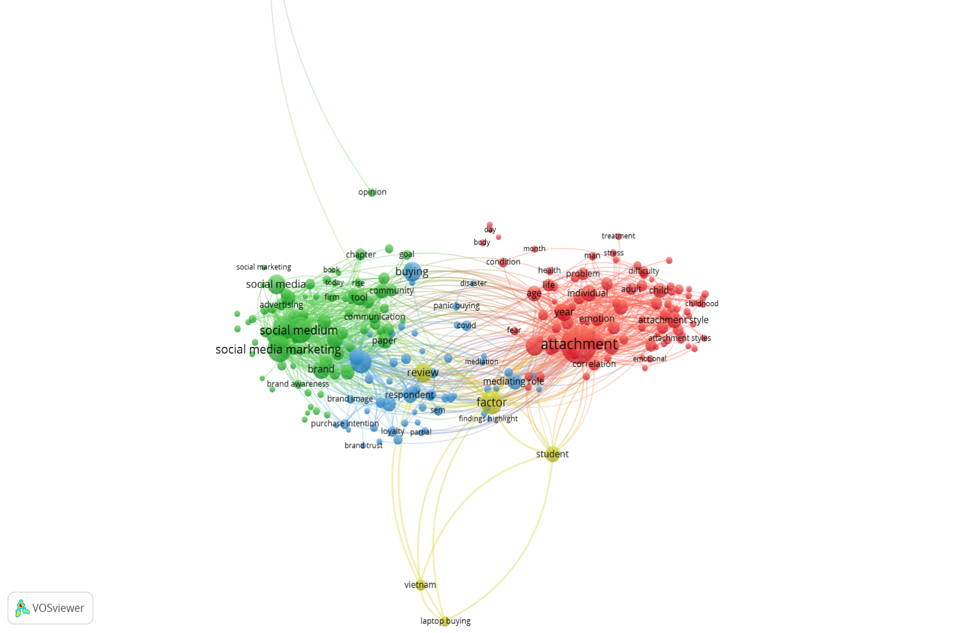

Source: VOSviewer

Figure 1. Network Visualization

Network analysis was conducted using VOSviewer with a keyword-based co-occurrence analysis approach, based on 3,000 publication records downloaded from the Crossref database using Publish or Perish software. The network visualisation results show that keywords appearing in the dataset form several research clusters connected by keyword co-occurrence relationships. Each cluster is represented by a different colour, indicating a group of research topics that frequently appear together in the literature.

The network mapping results show that the keyword "attachment" appears as one of the largest nodes in the network, indicating its high frequency of occurrence in the dataset. This keyword is connected to various other keywords, such as emotion, individual, age, correlation, and attachment style. Furthermore, this keyword also has network relationships with other keywords related to marketing and consumer behaviour, such as factor, mediating role, and review.

On the other side of the network, the keyword "social media marketing" appears as a key node in a different cluster. This keyword is related to other keywords, such as social media, advertising, brand, brand awareness, brand image, purchase intention, and loyalty. This relationship demonstrates the interconnection between social media marketing topics and various concepts related to consumer behaviour and marketing outcomes.

In addition to these two main clusters, the network visualisation also displays several linking keywords that connect the social media marketing cluster with the emotional attachment cluster. Keywords such as factor, mediating role, and review appear in the central area of the network, connecting the two topic groups. The presence of these connecting keywords indicates a co-occurrence relationship between research on social media marketing and research on emotional attachment in the analysed publication dataset.
The network visualisation also shows several additional keywords that appear in the research network, such as buying, community, communication, panic buying, COVID, and respondent. These keywords appear with smaller node sizes than the main keywords, indicating a lower frequency of occurrence in the analysed publication dataset. Overall, the network analysis results indicate that the analysed literature structure consists of several research topic clusters interconnected through keyword co-occurrence relationships.

3.2. Keyword Cluster Distribution
Based on the network analysis results, the keywords in the research dataset can be grouped into several main clusters, as follows:

Table 1. Cluster Distribution

Cluster | Visualization Color | Main Keywords
Cluster 1 | Red | attachment, emotion, individual, age, correlation, attachment style
Cluster 2 | Green | social media marketing, social media, advertising, brand, brand awareness
Cluster 3 | Blue | purchase intention, brand image, brand trust, loyalty, respondent
Cluster 4 | Yellow | factor, mediating role, review, findings highlight
Cluster 5 | Other | buying, community, communication, panic buying, covid

Table 1 shows the grouping of keywords based on the closeness of co-occurrence relationships in the analysed research network.

3.3. Research Trend Analysis Results (Overlay Visualisation)
Research trend analysis was performed using the overlay visualisation feature in VOSviewer software. This visualisation displays temporal changes in keyword appearance within the analysed publication dataset. The colours in the visualisation indicate the relative time period of keyword appearance, with blue indicating earlier publications and yellow indicating more recent publications.

The visualisation results show that the keywords social media marketing, social media, and advertising appear in colours that tend to fall within the blue to green spectrum. This indicates that these keywords appeared earlier in the analysed publication period. Other keywords appearing in a similar colour range include brand, communication, and community.
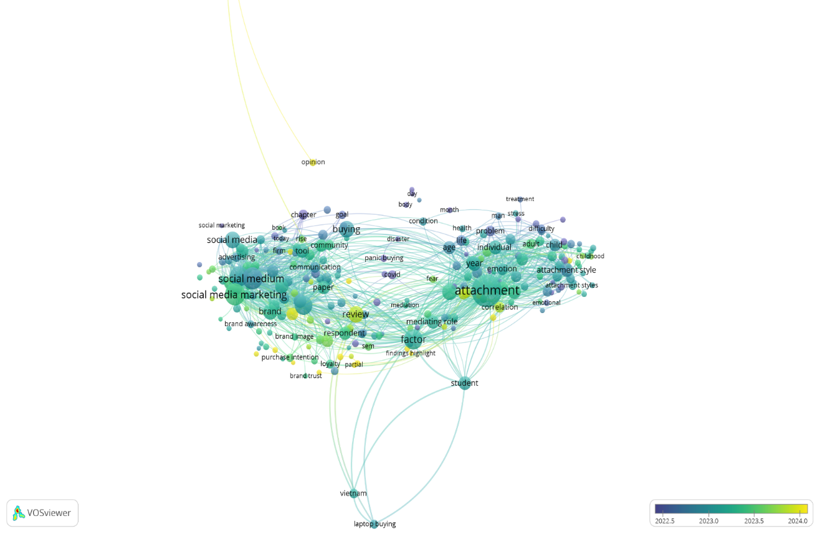

Source: VOSviewer

Figure 2. Overlay Visualization

Meanwhile, several other keywords, such as attachment, emotion, individual, and attachment style, appear in colours that tend towards green to yellow. This indicates that these keywords appeared in a more recent publication period in the research dataset. Furthermore, keywords such as factor, review, and mediating role also appear in relatively lighter colours in the trend visualisation.
The trend visualisation also shows that several keywords related to purchasing behaviour, such as buying and purchase intention, appear in the green spectrum. This indicates that these keywords appeared in the middle publication period in the analysed dataset. Thus, the overlay visualisation provides an overview of the temporal distribution of keyword occurrences in the analysed literature.

3.4. Keyword Density Analysis Results (Density Visualisation)
Density analysis was performed using density visualisation in VOSviewer software. This visualisation shows the intensity of keyword occurrences in the analysed publication dataset. Lighter colours indicate areas with higher keyword density, while darker colours indicate lower density.
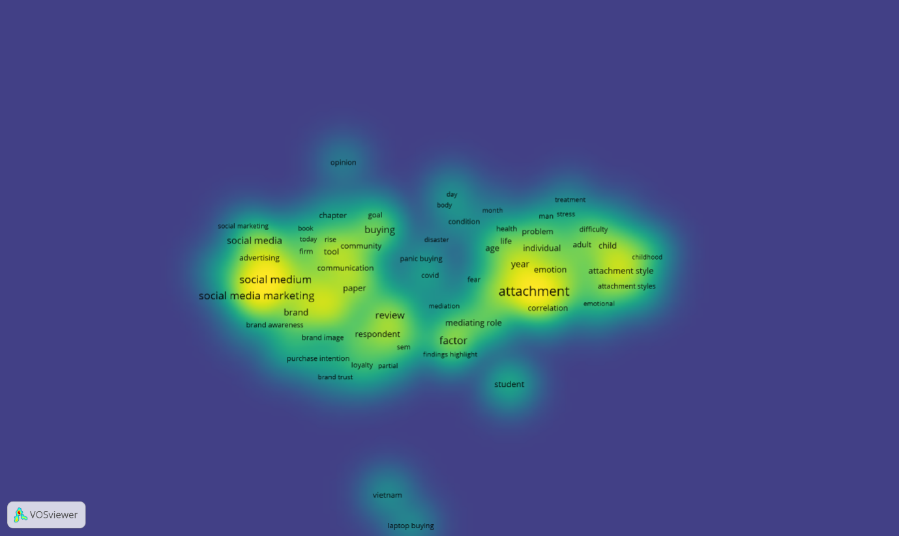

Source: VOSviewer

Figure 3. Density Visualization

The visualisation results show that the areas with the highest density are the keywords "attachment" and "social media marketing". These two keywords appear in bright yellow on the density map, indicating a high frequency of occurrence in the analysed publication dataset.

In addition to these two primary keywords, several other keywords also appear in relatively high-density areas, such as "social medium", "brand", "emotion", and "factor". These keywords appear in green to yellow areas in the density visualisation.

Meanwhile, several other keywords, such as "student", "Vietnam", and "laptop buying", appear in lower-density areas. These keywords are displayed in green to blue, indicating a lower frequency of occurrence than the primary keywords.

The density visualisation also shows that keywords related to social media marketing tend to be clustered on the left side of the map, while keywords related to emotional attachment tend to be located on the right side. The centre area of the map shows the presence of several keywords that serve as a bridge between the two topic groups.

3.5. Summary of Key Findings
Based on the network, trend, and keyword density analysis using VOSviewer, several key findings from the analysed publication dataset are as follows:
a. The keywords "attachment" and "social media marketing" have the largest node sizes in the research network.
b. The research network forms several keyword clusters, indicating distinct research topic groups.
c. The social media marketing cluster includes keywords such as "social media", "advertising", "brand", and "brand awareness".
d. The emotional attachment cluster includes keywords such as "attachment", "emotion", "individual", and "attachment style".
e. Several keywords, such as "factor", "mediating role", and "review", appear as links between different research clusters.
f. Trend visualisations demonstrate temporal variations in keyword occurrences in the publication dataset.
g. Density visualisations demonstrate that some keywords appear more frequently than others.
h. The distribution of keywords in the visualisation map demonstrates the relationship between social media marketing and emotional attachment topics in the analysed literature.

4. DISCUSSION
4.1. Development of Research Publications on Social Media Marketing, Emotional Attachment, and Cross-Buying
The first research question in this study concerns the development of scientific publications regarding the role of social media in forming emotional attachment and its impact on cross-buying behaviour. The results of the bibliometric analysis indicate that the analysed literature forms two large research topic groups: research focused on social media marketing and research focused on attachment or emotional attachment. This finding is consistent with the literature showing that social media has evolved into a primary marketing channel capable of forming more interactive relationships between companies and consumers in the digital environment (Drossos et al., 2024; Santos et al., 2023; Zeqiri et al., 2025). This development occurs in line with the transformation of marketing from one-way communication to two-way communication, which allows consumers to actively participate in the interaction process with brands.

In the digital marketing literature, social media marketing activities have been shown to have a strong relationship with consumer brand engagement, which in turn influences various consumer behavioural outcomes such as loyalty, willingness to pay a premium, and purchase intention (Changani et al., 2022; Fondevila-Gascón et al., 2020; V. Kumar et al., 2022; Zha et al., 2023). The results of keyword network mapping in this study indicate that concepts such as brand, brand awareness, purchase intention, and loyalty appear in the same cluster as social media marketing. This suggests that research on social media marketing often focuses on its impact on various marketing performance indicators and consumer behaviour.

On the other hand, the research cluster focusing on attachment shows links to concepts such as emotion, individual, age, and attachment style. These findings align with the literature explaining that emotional attachment is an emotional connection formed between consumers and brands and is related to self-identity, emotional experiences, and deeper psychological processes within the consumer-brand relationship (Ahuvia et al., 2022; Hemsley‐Brown, 2023; Sriwidadi et al., 2022). In this literature, emotional attachment often emerges as a consequence of consumer engagement with brands, which occurs through various interactions within the brand ecosystem, including interactions facilitated by social media.

Furthermore, the literature also shows that emotional attachment to brands can develop through psychological mechanisms such as psychological ownership, which is the feeling that a brand is part of the consumer's self (Chen et al., 2022; Jiang et al., 2022; Kou & Powpaka, 2021). This feeling of psychological ownership then develops into a stronger emotional attachment that can influence various consumer behaviours, such as loyalty and repeat purchases (Fu et al., 2023; Hemsley‐Brown, 2023; Sriwidadi et al., 2022). Thus, the network mapping results in this study indicate that the analysed literature reflects two main research streams in digital marketing: research on social media marketing activities and research on emotional attachment in consumer-brand relationships.

4.2. Main Research Themes and Conceptual Relationships in the Literature
The second research question in this study is to identify the main research themes and conceptual relationships between social media marketing, emotional attachment, and cross-buying. The results of the network analysis indicate that several keywords, such as factor, review, and mediating role, emerged as links between different research clusters. The presence of these keywords indicates that many studies in the literature focus on examining the relationships between variables in the context of digital marketing and consumer behaviour.

Previous literature indicates that consumer engagement with brands often acts as a mediating variable between social media marketing activities and various consumer behavioural outcomes (Changani et al., 2022; Cheung et al., 2020; Zeqiri et al., 2025). Consumer engagement is understood as a multidimensional process encompassing cognitive, affective, and behavioural aspects in consumer interactions with brands on social media. In this context, social media marketing activities such as interactivity, electronic word-of-mouth, and digital content trends can increase consumer engagement with brands, which then influences consumer attitudes and behaviours towards the brand (Cheung et al., 2020; Santos et al., 2023).

Furthermore, the literature also shows that various social mechanisms within social media, such as user-generated content and interactions with influencers, can strengthen emotional connections between consumers and brands (Fan et al., 2023; Ferreira et al., 2022; B. Kumar, 2024; Moisescu et al., 2025). Consumers often perceive user-generated content as more authentic, and it can increase trust and engagement with a brand. In this context, brand experiences formed through digital interactions can trigger emotional attachment to the brand, which then influences consumer behaviour.

In the literature on consumer purchasing behaviour, emotional attachment to a brand is often associated with various behavioural outcomes, such as loyalty, brand advocacy, and repeat purchases (Hemsley‐Brown, 2023; Ma & Chelliah, 2024; Sriwidadi et al., 2022). Furthermore, emotional attachment can influence consumers' propensity to purchase additional products from the same brand or within the same ecosystem. This phenomenon is known as cross-buying, which is the tendency of consumers to purchase multiple additional products or services within a single brand ecosystem or digital platform (Latusi et al., 2023; Singh et al., 2023; Zhang & Yu, 2020).

The literature shows that cross-buying behaviour is influenced by various factors such as perceived value, perceived risk, consumer trust, and various digital marketing stimuli within the online platform ecosystem (Dong et al., 2025; Özdemir & Bayraklı, 2022; Singireddy, 2023). Furthermore, the diversity of information, online reviews, and the influence of influencers can also influence consumers' decisions to purchase across products or services (Julianti et al., 2025; Nartea & Barrera, 2023; Amalia & Nurlinda, 2022). Thus, the results of the bibliometric analysis in this study indicate that the literature on social media marketing and emotional attachment is conceptually related to the literature on consumer purchasing behaviour, including cross-buying behaviour.

4.3. Research Network Structure and Significance of Findings
The third research question in this study is the structure of the research network in the literature discussing social media marketing, emotional attachment, and cross-buying. The results of the bibliometric analysis indicate that the analysed research network forms several clusters interconnected through keyword co-occurrence relationships. This network structure indicates that research in the field of digital marketing and consumer behaviour is multidisciplinary and involves various interrelated concepts.

The significance of this finding is that research on social media marketing cannot be separated from research on the emotional relationship between consumers and brands and various consumer behavioural outcomes. Social media serves as a platform that enables more intense interactions between brands and consumers, which ultimately can form stronger emotional relationships between consumers and brands. These emotional relationships can then influence various consumer behaviours, including loyalty, brand advocacy, and cross-product purchasing.

By using a bibliometric approach, this study provides a more comprehensive overview of the structure of the literature discussing the relationship between social media marketing, emotional attachment, and consumer purchasing behaviour. This approach allows researchers to systematically identify key research themes, relationships between concepts, and research developments in this field.

4.4. Research Implications
This research has several important implications for the development of marketing and consumer behaviour. Theoretically, this research contributes to mapping the knowledge structure in the literature that addresses the relationship between social media marketing, emotional engagement, and consumer purchasing behaviour. By identifying key research clusters and the relationships between concepts in the literature, this research helps clarify how various concepts in digital marketing interrelate in explaining consumer behaviour.

Furthermore, this research also makes a methodological contribution by demonstrating how a bibliometric analysis approach can be used to map the development of literature in the field of digital marketing. This approach allows researchers to identify research trends, key research themes, and research gaps that need to be explored in future research.

Practically, the results of this research provide implications for marketing practitioners in designing more effective social media marketing strategies. By understanding how interactions on social media can shape emotional engagement between consumers and brands, companies can design more effective content and communication strategies to build long-term relationships with consumers.

4.5. Research Limitations

Although this study provides a comprehensive overview of the structure of the analysed literature, several limitations warrant consideration. First, the publication data used in this study came solely from the Crossref database, downloaded through Publish or Perish software. Using a single database source may limit the scope of the literature analysed in this study.

Second, the bibliometric analysis in this study used only keywords as the unit of analysis in mapping the research network. This approach allows for mapping conceptual relationships within the literature, but does not analyse the content or context of each publication in depth.
Third, this study focused on mapping the structure of the literature and did not empirically test the relationship between social media marketing, emotional attachment, and cross-buying. Therefore, future research could develop an empirical model to examine the relationship among these three concepts in the context of digital marketing.

5. CONCLUSION
This study concludes that the literature on social media marketing, emotional attachment, and cross-buying behaviour forms a connected body of research within digital marketing and consumer behaviour. Based on the bibliometric analysis of 3,000 documents obtained from the Crossref database through Publish or Perish, the keyword network shows two dominant thematic areas. The first relates to social media marketing and includes concepts such as brand, brand awareness, advertising, purchase intention, and loyalty. The second relates to attachment and includes concepts such as emotion, individual, age, and attachment style. The appearance of linking keywords such as factor, review, and mediating role indicates that these themes are not isolated but are connected through studies examining relationships among marketing activities, consumer emotions, and behavioural outcomes. The overlay and density visualisations further show differences in topic development and keyword concentration across the dataset. These results provide a useful overview of how scholarly attention has developed around the role of social media in shaping emotional relationships with consumers and supporting purchasing behaviour across products or services. The study also demonstrates the usefulness of bibliometric analysis for identifying research clusters, dominant keywords, and conceptual connections in digital marketing literature for future scholarly inquiry.

Declaration of AI Use
This manuscript was prepared through the combined contributions of all author(s), including contributions to the study design, data, content development, results, interpretation, and related scholarly work. The author(s) acknowledge the use of Grammarly and ChatGPT to assist with grammar checking, language refinement, and reference formatting. These AI-assisted tools were not used by the author (s) and did not replace the intellectual contributions or scholarly judgment of the author(s). All AI-assisted outputs, including content, references, and interpretations, were carefully reviewed, revised, verified, and approved by the author(s). The author(s) accept full responsibility for the accuracy, integrity, and final content of the manuscript.

Competing Interests
Authors have declared that no competing interests exist.

REFERENCES

Ahuvia, A., Izberk-Bilgin, E., & Lee, K. (2022). Towards a theory of brand love in services: The power of identity and social relationships. Journal of Service Management, 33(3), 453–464. https://doi.org/10.1108/JOSM-06-2021-0221
Changani, S., Kumar, R., & Tripathi, S. (2022). Does social media marketing stimulate customer engagement in virtual brand communities? Examining the related outcomes. In Proceedings of the 2nd Indian International Conference on Industrial Engineering and Operations Management. https://doi.org/10.46254/IN02.20220308
Chen, C., Zhang, J., Bu, X., & Gao, J. (2022). Fueling the passion: The role online brand experiences play in developing harmonious or obsessive brand passion. Human Systems Management, 41(5), 629–642. https://doi.org/10.3233/HSM-211566
Cheung, M. L., Pires, G. D., & Rosenberger, P. J. (2020). The influence of perceived social media marketing elements on consumer–brand engagement and brand knowledge. Asia Pacific Journal of Marketing and Logistics, 32(3), 695–720. https://doi.org/10.1108/APJML-04-2019-0262
Dong, X., Li, B., Xie, K., Zhao, X., & Xiao, R. (2025). The effect of the product categories diversity recommended on cross-buying in electronic commerce platforms: The moderating role of user navigation heterogeneity. Journal of Consumer Behaviour, 24(1), 304–331. https://doi.org/10.1002/cb.2393
Drossos, D., Coursaris, C. K., & Kagiouli, E. (2024). Social media marketing content strategy: A comprehensive framework and empirically supported guidelines for brand posts on Facebook pages. Journal of Consumer Behaviour, 23(3), 1175–1192. https://doi.org/10.1002/cb.2269
Fan, F., Chan, K., Wang, Y., Li, Y., & Prieler, M. (2023). How influencers’ social media posts have an influence on audience engagement among young consumers. Young Consumers, 24(4), 427–444. https://doi.org/10.1108/YC-08-2022-1588
Ferreira, A. G., Crespo, C. F., & Mendes, C. (2022). Effects of athletic performance and marketable lifestyle on consumers’ engagement with sport celebrity’s social media and their endorsements. International Journal of Sports Marketing and Sponsorship, 23(2), 259–277. https://doi.org/10.1108/IJSMS-12-2020-0211
Fondevila-Gascón, J.-F., Polo-López, M., Rom-Rodríguez, J., & Mir-Bernal, P. (2020). Social media influence on consumer behavior: The case of mobile telephony manufacturers. Sustainability, 12(4), Article 1506. https://doi.org/10.3390/su12041506
Fu, M., Yan, L., Xiong, W., & Guo, S. (2023). The influence path of customer gratitude on repeat purchase intention based on SEM: An analysis of chain mediation effect. Advances in Economics and Management Research, 4(1), 218. https://doi.org/10.56028/aemr.4.1.218.2023
Goplani, M., Jagannarayan, N., & Uma, R. (2026). Digital marketing and sustainable consumer behavior in India. Asian Basic and Applied Research Journal, 8(1), 14–23. https://doi.org/10.56557/ABAARJ/2026/v8i1206
Hemsley-Brown, J. (2023). Antecedents and consequences of brand attachment: A literature review and research agenda. International Journal of Consumer Studies, 47(2), 611–628. https://doi.org/10.1111/ijcs.12853
Ma, H., & Chelliah, S. (2024). Accessing the influence of perceived brand authenticity and value co-creation on brand loyalty of China’s insurgent brands: The mediating role of psychological ownership. Humanities and Social Sciences Letters, 12(2), 289–307. https://doi.org/10.18488/73.v12i2.3708
Jiang, Y., Liao, J., Chen, J., Hu, Y., & Du, P. (2022). Motivation for users’ knowledge-sharing behavior in virtual brand communities: A psychological ownership perspective. Asia Pacific Journal of Marketing and Logistics, 34(10), 2165–2183. https://doi.org/10.1108/APJML-06-2021-0436
Julianti, N., Tahu, G. P., & Mitariani, N. W. E. (2025). The effect of influencer credibility and trust on impulse buying behavior with purchase intention as mediation Somethinc skincare products. Journal of Economics, Finance and Management Studies, 8(7). https://doi.org/10.47191/jefms/v8-i7-36
Kou, Y., & Powpaka, S. (2021). Pseudo-ownership advertising appeal creates brand psychological ownership: The role of self-construal and customer type. Journal of Product & Brand Management, 30(2), 215–230. https://doi.org/10.1108/JPBM-08-2019-2527
Kumar, K., & Mishra, P. (2024). The dynamic role of customer experience in shaping the social media marketing-purchase intention relationship: An S-O-R perspective. Asian Journal of Economics, Business and Accounting, 24(12), 252–265. https://doi.org/10.9734/ajeba/2024/v24i121606
Kumar, B. (2024). The impact of user-generated content on brand perception: A case study of social media platforms. International Journal of Scientific Research in Engineering and Management, 8(4), 1–5. https://doi.org/10.55041/IJSREM32702
Kumar, V., Khan, I., Fatma, M., & Singh, A. (2022). Engaging luxury brand consumers on social media. Journal of Consumer Marketing, 39(1), 121–132. https://doi.org/10.1108/JCM-10-2020-4175
Laradi, S., Younes, O., Alsharif, A. H., & Hossain, M. B. (2026). Unveiling the power of communication through social media marketing in brand attachment formation: Bridging brand and platform outcomes. Journal of Theoretical and Applied Electronic Commerce Research, 21(5), Article 131. https://doi.org/10.3390/jtaer21050131
Latusi, S., Sarti, E., Martinelli, E., & Luceri, B. (2023). Predictors of cross-buying in grocery retailing: The role of non-traditional product/service categories. Sinergie Italian Journal of Management, 41(1), 107–126. https://doi.org/10.7433/s120.2023.06
Moisescu, O. I., Gică, O. A., Herle, F. A., Dan, I., & Sarstedt, M. (2025). Does one size fit all? The role of extraversion in generating electronic word-of-mouth through social media brand page engagement. Psychology & Marketing, 42(7), 1827–1847. https://doi.org/10.1002/mar.22205
Nartea, M. A., & Barrera, R. T. (2023). Impact of digital marketing in purchase decision and buying behaviour of Gen Z. Jurnal The Messenger, 15(1), 1–18. https://doi.org/10.26623/themessenger.v15i1.2547
Özdemir, Y. E., & Bayraklı, S. (2022). A case study on building a cross-selling model through machine learning in the insurance industry. European Journal of Science and Technology, 35, 364–372. https://doi.org/10.31590/ejosat.895069
Amalia, K., & Nurlinda, R. A. (2022). Pengaruh influencer marketing dan online customer review terhadap purchase intention melalui perceived value produk serum Somethinc. Sibatik Journal: Jurnal Ilmiah Bidang Sosial, Ekonomi, Budaya, Teknologi, Dan Pendidikan, 1(11), 2383–2398. https://doi.org/10.54443/sibatik.v1i11.353
Reyvina, R., & Tjokrosaputro, M. (2024). The effect of social media marketing on awareness and brand image of local fashion through consumer brand engagement. International Journal of Application on Economics and Business, 2(2), 3417–3429. https://doi.org/10.24912/ijaeb.v2i2.3417-3429
Santos, S., Gonçalves, H. M., & Teles, M. (2023). Social media engagement and real-time marketing: Using net-effects and set-theoretic approaches to understand audience and content-related effects. Psychology & Marketing, 40(3), 497–515. https://doi.org/10.1002/mar.21756
Silva, C., Silva, S., & Rodrigues, A. C. (2024). Instagram as a digital marketing tool of a hotel brand. International Conference on Tourism Research, 7(1), 390–400. https://doi.org/10.34190/ictr.7.1.2103
Singh, I., Dutt, A., Chauhan, P., & Mehra, P. (2025). Impact of social media marketing practices on purchase intentions in the F&B industry and the mediating effect of trust. International Journal of Information Technology, 17, 2465–2476. https://doi.org/10.1007/s41870-024-02391-y
Singh, A., Raghuwanshi, S., Sharma, S., Khare, V., Singhal, A., Tripathi, M., & Banerjee, S. (2023). Modeling the nexus between perceived value, risk, negative marketing, and consumer trust with consumers’ social cross-platform buying behaviour in India using Smart-PLS. Journal of Law and Sustainable Development, 11(4), Article e488. https://doi.org/10.55908/sdgs.v11i4.488
Singireddy, S. (2023). Multi-policy synergies: A data-driven analysis of consumer behavior and cross-selling strategies in auto, home, life, and umbrella insurance. Journal for ReAttach Therapy and Developmental Diversities, 6(10s[2]). https://doi.org/10.53555/jrtdd.v6i10s(2).3600
Sriwidadi, T., Prabowo, H., Sari, R. K., Wong, F., & Alfarizi, M. (2022). Effect of brand psychological ownership and value congruity to brand attachment and behavioral brand loyalty through customer brand engagement. In Proceedings of the 5th European International Conference on Industrial Engineering and Operations Management. IEOM Society International. https://doi.org/10.46254/EU05.20220195
Wang, X., Aw, E. C.-X., & Ki, C.-W. (2025). Understanding cross-buying in omnichannel retail: An experiential learning theory perspective. International Journal of Retail & Distribution Management, 53(10/11), 1057–1074. https://doi.org/10.1108/IJRDM-02-2025-0112
Zeqiri, J., Koku, P. S., Dobre, C., Milovan, A.-M., Hasani, V. V., & Paientko, T. (2025). The impact of social media marketing on brand awareness, brand engagement and purchase intention in emerging economies. Marketing Intelligence & Planning, 43(1), 28–49. https://doi.org/10.1108/MIP-06-2023-0248
Zha, T., Aw, E. C.-X., Dastane, O., & Fernando, A. G. (2023). Social media marketing for luxury brands: Parasocial interactions and empowerment for enhanced loyalty and willingness to pay a premium. Marketing Intelligence & Planning, 41(8), 1138–1161. https://doi.org/10.1108/MIP-05-2023-0192
Zhang, X., & Yu, X. (2020). The impact of perceived risk on consumers’ cross-platform buying behavior. Frontiers in Psychology, 11, Article 592246. https://doi.org/10.3389/fpsyg.2020.592246

