Eco-Friendly Bio-Carbon Doped ZnO Thin Films: Structural, Optical, and Humidity Sensing Properties
Abstract
Bio-carbon-doped ZnO thin films were prepared using bio-carbon extracted from pomegranate peels and deposited on glass substrates by spray pyrolysis. The study examined the influence of bio-carbon doping, ranging from 0 to 7.5 wt.%, on the structural, morphological, optical and humidity-sensing properties of the films. X-ray diffraction analysis indicated that all films retained the hexagonal wurtzite structure of ZnO without secondary phases. Increasing bio-carbon content reduced the crystallite size from 29.5 to 25.4 nm and increased microstrain and dislocation density, indicating the introduction of structural defects and lattice distortion. FESEM and AFM analyses showed compact granular surfaces, reduced grain size and increased surface roughness, with roughness increasing from 5.20 to 9.80 nm. FTIR spectra confirmed the presence of Zn-O bonds and carbon-related functional groups, suggesting interaction between bio-carbon components and the ZnO surface. Optical measurements showed enhanced absorbance and a gradual reduction in the optical band gap from 3.28 to 3.09 eV. Humidity-sensing measurements demonstrated improved performance with increasing bio-carbon concentration. The film doped with 7.5 wt.% bio-carbon showed the highest sensitivity of 82% and response/recovery times of 14 s and 18 s over 20–90% relative humidity. The findings indicate that pomegranate-peel-derived bio-carbon can enhance ZnO thin-film properties for low-cost humidity-sensing applications.
Keywords: ZnO thin films; bio-carbon doping; pomegranate peel; spray pyrolysis; wurtzite structure; optical band gap; surface roughness; FTIR analysis; relative humidity; humidity sensor.

1. Introduction
Semiconductor thin films are important materials in many modern technological applications, such as solar cells, optical sensors, chemical sensors and environmental sensors, owing to the ability to control their structural, electrical and optical properties through the selection of the substrate material and appropriate preparation techniques. Among these materials, zinc oxide (ZnO) has garnered significant attention due to its wide energy gap (3.37 eV), high excitonic binding energy (60 meV), chemical stability, high transparency, low cost and non-toxicity, making it a promising material for numerous electronic, optical and sensing applications [1, 2]. Recent reviews also emphasise that solution-based ZnO thin-film deposition methods, including spray pyrolysis, remain relevant because they can produce films with tunable structural, optical and sensing characteristics [24].
The efficiency of ZnO films depends largely on their structural and morphological properties, which can be enhanced through various doping processes. Carbon doping is an effective method for modifying the electronic structure of zinc oxide (ZnO) and improving its optical and surface responses. It introduces additional energy levels into the forbidden gap and increases the number of active adsorption sites on the surface, which positively affects the material's performance in sensing applications. Although numerous studies have addressed carbon doping of ZnO using conventional chemical sources, current research trends focus on using sustainable and environmentally friendly carbon sources within the framework of green chemistry and reducing the environmental impact of industrial materials [3, 4]. Recent biosynthesis studies have similarly reported plant-derived routes for preparing and characterising ZnO nanomaterials, supporting greener material-preparation strategies [22, 23].
Agricultural waste is a rich source of bio-carbon. It has garnered increasing attention in recent years due to its abundance, low cost and potential for conversion into value-added functional materials. Among these wastes, pomegranate peels stand out for their high content of carbon compounds and organic elements that can be converted into bio-carbon with a high surface area and active functional groups that can directly influence the surface and optical properties of nanomaterials [5, 6].
At the same time, the demand for low-cost, fast-response and high-accuracy humidity sensors is increasing due to their importance in environmental, industrial, medical and agricultural monitoring systems. ZnO-based nanomaterials are among the most widely used materials in this field because of their high sensitivity to water molecules and the ease with which their surface properties can be modified. Therefore, incorporating bio-carbon with ZnO represents a promising strategy for improving the performance of humidity sensors by increasing the effective surface area and enhancing adsorption and charge-transfer processes on the film surface.
Recent reports on ZnO-based and carbon/ZnO humidity-sensing platforms further indicate that surface area, defect modulation and conductive carbonaceous pathways can affect water-molecule adsorption, charge transfer and response/recovery behaviour [25, 26].
However, the specific use of pomegranate-peel-derived bio-carbon to tune spray-pyrolysed ZnO thin films for combined structural, optical and humidity-sensing performance remains insufficiently addressed.
Objective of the Study
Accordingly, this work aims to prepare zinc oxide thin films doped with bio-carbon extracted from pomegranate peels and deposited on glass substrates using spray pyrolysis. It also investigates the effect of the bio-carbon doping ratio on the structural, morphological and optical properties of these films, as well as evaluating their potential use as high-performance and environmentally friendly humidity sensors.
2. Experimental Work
2.1 Materials
Zinc acetate dihydrate [Zn(CH3COO)2·2H2O] was used as the zinc precursor for the preparation of ZnO thin films. Absolute ethanol served as the solvent, while monoethanolamine (MEA) was employed as a stabilising agent. Bio-carbon powder extracted from pomegranate peel was used as the carbon dopant. Distilled water was used throughout the experimental procedures. Microscope glass slides were selected as substrates for thin-film deposition.
2.2 Preparation of Bio-Carbon from Pomegranate Peel
Fresh pomegranate peels were thoroughly washed with distilled water to remove dust and impurities. The cleaned peels were dried in an electric oven at 80 °C for 24 h until complete moisture removal. The dried material was then ground into a fine powder using a laboratory grinder. The obtained powder was subjected to thermal carbonisation in a muffle furnace at 500 °C for 2 h under limited oxygen conditions. After cooling to room temperature, the resulting black carbonaceous material was collected, finely ground and sieved using a 75 μm mesh to obtain homogeneous bio-carbon powder suitable for use as a dopant in ZnO thin films.

2.3 Preparation of Carbon Doped ZnO Thin Films
A 0.1 M precursor solution was prepared by dissolving zinc acetate dihydrate in 250 mL ethanol. The mass of zinc acetate was calculated as follows:
$$m\left(Zn acetate\right)=C×V×Mw……………(1)$$
where m is the required mass in g, C is the molar concentration in mol/L, V is the solution volume in L and Mw is the molecular weight of zinc acetate dihydrate, equal to 219.5 g/mol.
$$m(Zn-acetate) = 0.1 × 0.25 × 219.5 = 5.49 g$$
Therefore, 5.49 g of zinc acetate dihydrate was dissolved in 250 mL ethanol.
MEA was added as a stabiliser at a zinc acetate:MEA molar ratio of 1:1.
$n = C × V$…………………..….(2)
where n is the number of moles in mol.
$n = 0.1 × 0.25 = 0.025 mol$
$m(MEA) = n × Mw(MEA)$……..(3)
where Mw(MEA) = 61.08 g/mol.
m(MEA) = 0.025 × 61.08 = 1.527 g
$V(MEA) = m(MEA) / ρ(MEA)$….(4)
where ρ(MEA) = 1.01 g/mL.
V(MEA) = 1.527 / 1.01 = 1.51 mL
Thus, 1.51 mL of MEA was added dropwise. The solution was stirred at 60 °C for 2 h and aged for 24 h. The solution was divided into five equal portions of 50 mL. Since each portion contained 1.098 g of zinc acetate, bio-carbon was added at 0, 1.5, 3.5, 5.5 and 7.5 wt.% according to:
$m(C) = [wt.\% × m(Zn-acetate in 50 mL)] / 100$….(5)
mC: required bio-carbon mass (g), mZnAc: zinc acetate mass in each 50 mL portion (1.098 g).
The corresponding bio-carbon masses were:
Table 1. Weight percentage and calculated bio carbon mass added to the ZnO precursor solution for the preparation of ZnO:C thin films.
Sample | Wt% | Mass (gm)
CZ0 | 0 | 0
CZ1 | 1.5 | 0.016
CZ2 | 3.5 | 0.038
CZ3 | 5.5 | 0.060
CZ4 | 7.5 | 0.082

Each solution was stirred for 1 h and ultrasonicated for 30 min.
Glass substrates were ultrasonically cleaned in distilled water and ethanol for 15 min each, dried with hot air and heated at 100 °C for 10 min. The films were deposited by spray pyrolysis at 450 °C. The nozzle-to-substrate distance was 30 cm. The deposition process included 25 spray cycles; each cycle consisted of 10 s of spraying followed by a 60 s pause. Approximately 40 mL of solution was consumed for each sample. The films were then annealed in air at 500 °C for 1 h.

3. Characterisation Techniques
XRD was used to study the crystal structure using CuKα radiation with a wavelength of λ = 1.5406 Å over the range 20°-80°. Crystallite size was calculated using: D = Kλ / (β cosθ), where D is the crystallite size, K is Scherrer's constant equal to 0.9, λ is the X-ray wavelength, β is the full width at half maximum in radians and θ is the Bragg angle. Microstrain was calculated using: ε = β cosθ / 4, where ε is the microstrain, β is the FWHM in radians and θ is the Bragg angle. Dislocation density was calculated using: δ = 1 / D2, where δ is the dislocation density and D is the crystallite size. FESEM was used to study surface morphology, EDX was used to determine elemental composition and AFM was used to analyse surface roughness and grain distribution. FTIR spectra were recorded in the range 400-4000 cm-1 to identify chemical bonds and confirm carbon-related functional groups. UV-Vis spectroscopy was used to record absorbance and transmittance spectra in the range 300-1100 nm. The absorption coefficient was calculated using: α = 2.303 A / t, where α is the absorption coefficient, A is absorbance and t is film thickness. The optical band gap was calculated using the Tauc relation: (αhν)2 = B(hν - Eg), where α is the absorption coefficient, hν is the photon energy, B is a constant and Eg is the optical band gap. A schematic flowchart summarising the preparation of bio-carbon, synthesis of carbon-doped ZnO thin films, deposition conditions, annealing process and characterisation techniques is presented in Figure 1.
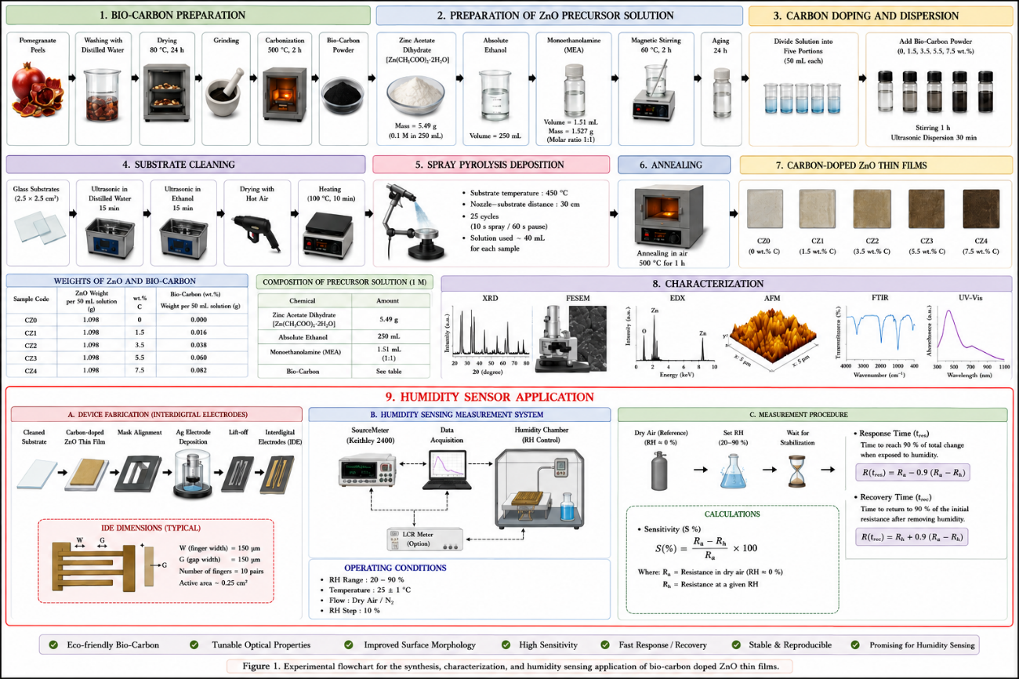
Figure 1. Experimental flowchart for the fabrication and characterization of bio-carbon doped ZnO thin films.

3. Results
3.1 X-ray Diffraction Analysis
Figure 2 shows the XRD patterns of ZnO and ZnO:C nanocomposites with various C contents. All ZnO:C samples exhibited the hexagonal wurtzite crystal structure, with no other phases formed during growth. All characteristic XRD peaks were in good agreement with the standard data for ZnO powder (space group P63mc, JCPDS no. 36-1451) [7], and no preferential orientation was observed. The ZnO:C nanocomposites tended to become more amorphous as the C content increased. The XRD signal showed a decrease in intensity with an increase in carbon content to 7.5 wt.%, indicating that the nanocomposite contained disordered material in the form of amorphous carbon. The (100) and (002) peaks showed that the full width at half maximum (FWHM) increased as the carbon concentration increased. Using Debye-Scherrer's formula and the FWHM of the (100) peak, as shown in Figure 3, the crystallite size decreased from 29.5 to 25.4 nm as the C content increased from 0 to 7.5 wt.%. A shift in the peak positions towards lower angles was noted after C was introduced, indicating its effective incorporation into the ZnO crystal. Microstrain and dislocation density increased with increasing carbon content and decreasing crystal size, with microstrain increasing from 1.178 x 10-3 to 1.368 x 10-3 and dislocation density increasing from 11.58 x 1014 to 15.604 x 1014 m-2. This is attributed to the fact that carbon addition inhibits the uniform growth of crystals and introduces localised distortions within the crystal lattice. As the carbon concentration increases, the number of crystal defects and grain boundaries also increases, leading to internal stresses and distortions in the crystal lattice, which are reflected as an increase in the width of the X-ray diffraction peaks (FWHM). Consequently, the microscopic stress values increase. A decrease in crystal size indicates an increase in the number of crystal grains per unit volume and a higher proportion of atoms at grain boundaries, resulting in increased defect density and crystal dislocations. These results indicate that doping ZnO with bio-carbon introduces additional structural defects and lattice distortions that affect the crystal structure and limit crystal growth [8].

Figure 2: X-ray diffraction analysis of bio-carbon doped
ZnO thin films.

Figure 3: Crystal size, micro-stress, and dislocation density of
bio-carbon doped ZnO thin films.
3.2 FESEM Analysis
Figure 4 shows FESEM images of pure ZnO films doped with different concentrations of bio-carbon extracted from pomegranate peels. All samples exhibited a homogeneous surface composed of closely packed spherical grains distributed evenly across the entire film surface, without any observed cracks or large voids. This indicates successful deposition and the production of films with good surface quality. For the pure film (CZ0), the surface structure consisted of closely packed spherical nanoparticles with an average size of approximately 33 nm, exhibiting good crystallinity and granular compactness. Upon the addition of bio-carbon to the ZnO system, a gradual decrease in grain size was observed, reaching approximately 30 nm for sample CZ1 and 29 nm for sample CZ2, followed by 26 nm and 23 nm for samples CZ3 and CZ4, respectively. This gradual decrease in grain size is attributed to the effect of bio-carbon in inhibiting crystal growth during annealing. Carbon increases the number of crystallisation centres and reduces the grain growth rate, resulting in the formation of a greater number of smaller crystals. Furthermore, the presence of carbon at grain boundaries limits the fusion of adjacent crystals and hinders complete crystal growth [9]. This is consistent with the X-ray diffraction results, which showed a decrease in crystal size and an increase in both microscopic stress and dislocation density with increasing doping.

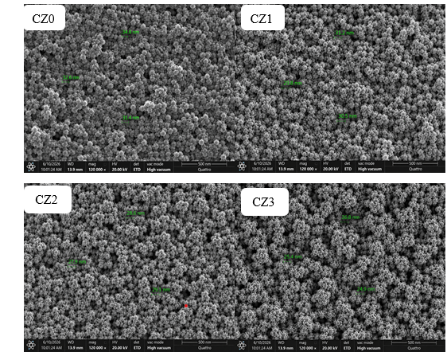

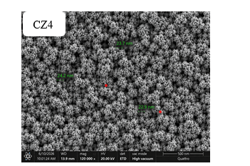
Figure 4: FESEM Analysis of bio-carbon doped ZnO thin films.

3.3 AFM Analysis
The surface topography of pure ZnO films and those doped with bio-carbon was examined using atomic force microscopy (AFM), as shown in Figure 5. The two-dimensional and three-dimensional images reveal a clear change in surface characteristics as the carbon doping ratio increases from CZ0 to CZ4. The pure ZnO film exhibited a relatively homogeneous surface composed of distinct nanograins, with an average grain size of approximately 78.4 nm and roughness values of Ra = 5.20 nm and Rq = 6.50 nm, respectively. With the addition of bio-carbon, the average grain size gradually decreased to 73.6, 69.2, 63.8 and 58.7 nm for samples CZ1, CZ2, CZ3 and CZ4, respectively. This decrease is attributed to the role of carbon in inhibiting grain growth and limiting grain fusion during annealing. Surface roughness also increased gradually with increasing carbon content, with Ra rising from 5.20 nm for sample CZ0 to 9.80 nm for sample CZ4 and Rq increasing from 6.50 to 12.30 nm. This behaviour indicates that the introduction of bio-carbon led to increased surface irregularity and the formation of a greater number of ridges and grain boundaries, thereby increasing the effective surface area.
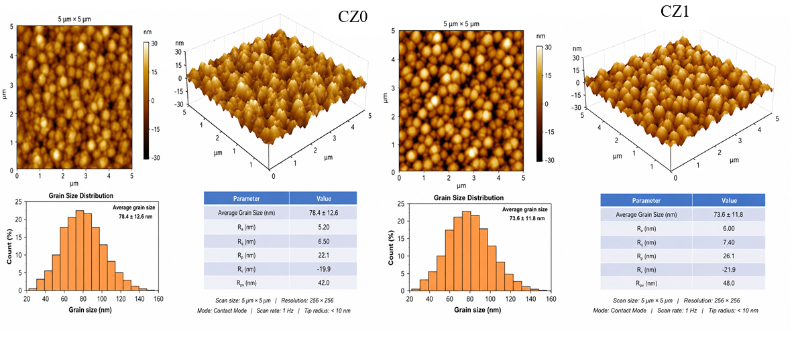

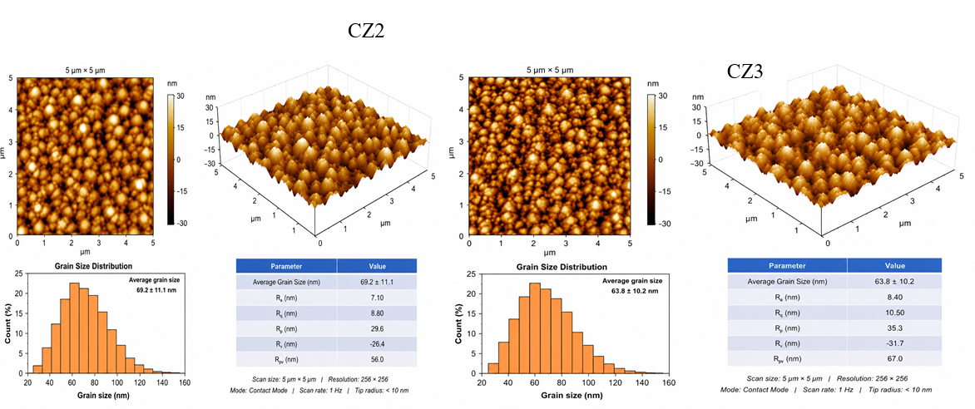
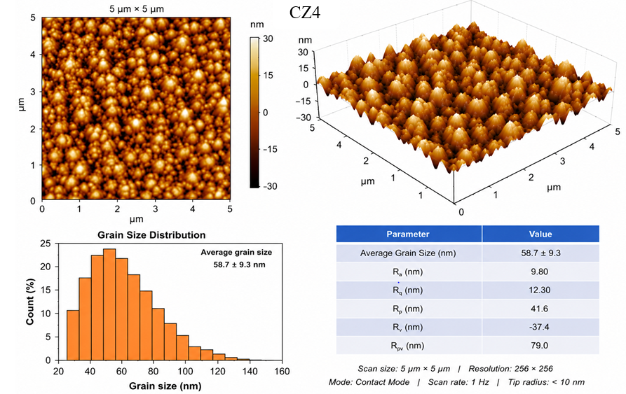
Figure 5: AFM Analysis of bio-carbon doped ZnO thin films.
3.4 FTIR Analysis
Fourier transform infrared spectroscopy (FTIR) was used to study the effect of ZnO doping with bio-carbon extracted from pomegranate peels and to investigate the presence of chemical interactions or surface bonds between ZnO and the bio-carbon functional groups. Figure 6 shows the FTIR spectra of pure and doped films with different concentrations of bio-carbon. The spectrum of pure ZnO (CZO) showed a broad absorption band at approximately 3400 cm-1, attributed to O-H hydroxyl group vibrations resulting from adsorbed water molecules and hydroxyl groups attached to the ZnO surface [10]. A peak was also observed at approximately 2920 cm-1, attributed to the stretching vibrations of C-H groups, while the peak at 1630 cm-1 was attributed to the bending vibrations of adsorbed water molecules on the film surface [11]. Peaks were also observed in the 1000-1450 cm-1 range, attributed to vibrations of oxygen-carbon bonds such as C-O and C-C, which are associated with organic residues from the bio-carbon synthesis process [12]. The peak near 470 cm-1 was attributed to Zn-O bond vibrations characteristic of the zinc oxide crystal structure, confirming the successful formation of ZnO films [13]. As the bio-carbon ratio increased from CZ1 to CZ4, a gradual increase in the intensity of the absorption bands associated with the carbon groups was observed, particularly at 3400, 2920, 1384, 1250 and 1020 cm-1, with slight changes in the positions of some peaks and a decrease in transmittance at these locations. These changes indicate an interaction between the ZnO surface and the bio-carbon functional groups, demonstrating the successful incorporation of carbon into the surface structure of the films. The Zn-O peak remained clear in all samples, with no additional peaks of secondary phases, indicating that carbon doping did not lead to the formation of new compounds or a change in the crystalline phase of zinc oxide; rather, its effect was limited to modifying the chemical and surface environment of the grains.

Figure 6: FTIR Analysis of bio-carbon doped
ZnO thin films.

3.5 Absorption and Optical Gap Analysis
To investigate the effect of bio-carbon addition on the optical properties of zinc oxide films, the absorption spectra of pure and bio-carbon-doped films were recorded, as shown in Figure 7 (a). All samples exhibited high absorption in the ultraviolet region, which gradually decreased with increasing wavelength towards the visible and near-infrared regions. This is a characteristic feature of zinc oxide as a wide-bandwidth semiconductor [14]. The figure shows that the absorbance intensity gradually increased with increasing bio-carbon content from sample CZ0 to sample CZ4, with sample CZ4 exhibiting the highest absorbance values. This behaviour is attributed to the introduction of new local energy levels resulting from the presence of bio-carbon within the ZnO crystal structure. This increases the probability of electron transfer and enhances the interaction of the material with incident photons. Furthermore, the gradual decrease in crystal size confirmed by X-ray diffraction and scanning electron microscopy results led to an increase in the number of grain boundaries and crystal defects, which further contributed to enhanced light absorption [15].
To determine the optical band gap, the Tauc relation for allowed direct transitions was used by plotting (αhν)2 as a function of photon energy (hν), as shown in Figure 7 (b). Extrapolating the linear portion of the curves towards the photon energy axis yielded optical band gap values of 3.28, 3.24, 3.19, 3.14 and 3.09 eV for samples CZ0, CZ1, CZ2, CZ3 and CZ4, respectively. The gradual decrease in the band gap with increasing bio-carbon content indicates a modification in the electronic structure of the zinc oxide films resulting from the interaction between the ZnO matrix and the bio-carbon components. This is attributed to the formation of intermediate energy levels within the forbidden band gap due to crystal defects and surface states associated with the carbon atoms, which reduces the energy required for electrons to transition from the valence band to the conduction band. The increase in microstress and dislocation density associated with the decrease in crystal size contributes to the emergence of additional energy levels within the forbidden gap, which explains the gradual shift of the absorption edge towards larger wavelengths.
Figure 7: (a) absorption spectra, (b) optical band gap of pure
and bio-carbon-doped films.
3.6 Humidity Sensing Characteristics
The performance of pure and bio-carbon-doped ZnO films as relative humidity sensors was evaluated by studying the changes in electrical resistance, sensitivity, response time and recovery time at different relative humidity (RH) levels, as shown in Figures 8 (a, b, c and d).
Figure 8 (a) shows the relationship between electrical resistance and relative humidity of the prepared films. It was observed that the resistance of all samples gradually decreased with increasing relative humidity from 20% to 90% RH, which is the expected behaviour for zinc oxide-based humidity sensors. This is attributed to the increasing number of water molecules adsorbed onto the film surface with increasing humidity. Initially, a chemically adsorbed layer of hydroxyl groups forms, followed by multiple physical layers of water at higher humidity levels. These layers facilitate proton transport via the Grotthuss proton-hopping mechanism, which increases electrical conductivity and leads to a decrease in resistance [16]. It was also observed that resistance values decreased further with increasing bio-carbon content. Sample CZ4 exhibited the lowest resistance across all humidity levels, indicating improved charge-transport pathways and an increase in active sites for water-molecule adsorption.
Figure 8 (b) shows the change in sensor sensitivity with increasing bio-carbon content. The sensitivity gradually increased from approximately 38% for sample CZ0 to over 80% for sample CZ4. This improvement is attributed to the combined effect of bio-carbon and the nanostructure of the ZnO films. The reduced particle size increased surface roughness and specific surface area, providing a greater number of active sites for water-molecule adsorption. Furthermore, the presence of bio-carbon contributed to an increased density of surface defects and improved charge transport between the particles, enhancing the sensor's response to changes in ambient humidity.
Figure 8 (c) also shows that the sensitivity increased almost linearly with increasing relative humidity for all samples. The slope of the curves increased gradually from CZ0 to CZ4, demonstrating that the effect of humidity became more pronounced with increasing bio-carbon content. This behaviour indicates improved surface adsorption efficiency and increased interaction between water molecules and the film surface, leading to a greater change in the sensor's electrical properties when exposed to moisture. Regarding the dynamic properties, Figure 8 (d) shows that the response and recovery times gradually decreased with increasing bio-carbon content. The response time decreased from approximately 42 seconds for sample CZ0 to about 14 seconds for sample CZ4, while the recovery time decreased from approximately 51 seconds to about 18 seconds. This improvement is attributed to the porous nature of the bio-carbon-doped films and the increased surface roughness, which facilitates the diffusion, adsorption and removal of water molecules within the film layers more rapidly. Furthermore, the reduction in the optical band gap and the increased density of surface states resulting from the addition of bio-carbon contribute to accelerating charge-transfer processes, thereby improving the sensor's response speed and recovery to its original state.

Figure 8: Humidity sensing characteristics of pristine and bio carbon doped ZnO thin films, (a) electrical resistance as a function of relative humidity, (b) effect of bio-carbon concentration on sensitivity, (c) sensitivity versus relative humidity, and (d) response and recovery times.
Table 2. Comparison of the humidity sensing performance of the present bio-carbon doped ZnO thin films with previously reported semiconductor-based humidity sensors.
Materials | Performance | Synthesis method | Ref.
ZnO/SnO₂ | Lower hysteresis between 11-95% RH | Solvothermal | [17]
Al-doped ZnO-coated/Al-doped ZnO nanorod | 7.38 sensitivity ratio at 40-90% RH | Spin coating | [18]
AFZO nanostructure | 247 sensitivity ratio at 40-90% RH for AFZO-010 | Sol-gel | [19]
Ag/ZnO nanoparticles | 151,800% sensitivity at 11-95% RH, smaller lag error (3%), fast response/recovery time (36/6 s) | Hydrothermal | [20]
SnZO nanorod/SnO₂ nanowire | 67.8 sensitivity ratio at 50-90% RH | Two-step immersion | [21]
Bio carbon doped ZnO thin films | 82% sensitivity at 20-90% RH, response/recovery time of 14/18 s | Spray pyrolysis | Present work

4. Conclusions

Bio-carbon-doped ZnO thin films were successfully prepared using pomegranate-peel-derived bio-carbon and deposited by spray pyrolysis. The results showed that increasing the bio-carbon content influenced the structural, morphological, optical and humidity-sensing behaviour of the ZnO films. XRD analysis confirmed the retention of the hexagonal wurtzite phase, while the decrease in crystallite size and the increase in microstrain and dislocation density indicated defect formation and lattice distortion. FESEM and AFM results showed that bio-carbon addition reduced grain size and increased surface roughness, which contributed to a larger effective surface area. FTIR analysis confirmed Zn-O bonding and carbon-related functional groups on the film surface. The optical band gap decreased from 3.28 to 3.09 eV as the doping concentration increased. Humidity-sensing performance improved progressively, with the 7.5 wt.% bio-carbon-doped film showing the highest sensitivity of 82% and response/recovery times of 14 s and 18 s. These findings support the potential use of bio-carbon-doped ZnO thin films in low-cost humidity sensor applications.

Limitation
This study was limited to bio-carbon concentrations between 0 and 7.5 wt.% and humidity sensing within the 20–90% relative humidity range. Long-term stability, repeatability, hysteresis, selectivity against interfering gases and performance under varying temperature conditions were not extensively evaluated. Further work is needed to assess device durability, reproducibility and practical integration before wider sensor application.

Declaration of AI Use
This manuscript was prepared through the combined contributions of all author(s), including contributions to the study design, data, content development, results, interpretation, and related scholarly work. The author(s) acknowledge the use of Grammarly and ChatGPT to assist with grammar checking, language refinement, reference formatting. These AI-assisted tools were not used as authors and did not replace the intellectual contributions or scholarly judgment of the author(s). All AI-assisted outputs, including content, references, and interpretations, were carefully reviewed, revised, verified, and approved by the author(s). The author(s) accept full responsibility for the accuracy, integrity, and final content of the manuscript.

References
[1] Hussain, A. A., & Abdullah, Q. N. (2023). Studying the structural, optical and electrical properties of ZnO:SnO2 thin films as an application of a gas sensor using vacuum thermal evaporation technique. Tikrit Journal of Pure Science, 28(6), 66–75. https://doaj.org/article/1a45c74c7edb44048081161362706843
[2] Li, F., Li, P., & Zhang, H. (2022). Preparation and research of a high-performance ZnO/SnO2 humidity sensor. Sensors, 22(1), Article 293. https://doi.org/10.3390/s22010293
[3] Sreenan, B., Kafil, V., Hunt, T., Shin, S. H. R., Brennan, A. A., Thallapally, P. K., Tal-Gan, Y., & Zhu, X. (2025). Luminescent ZnO-carbon hybrid nanomaterials: Synthesis, characterization, emission mechanism, and applications. ACS Applied Optical Materials, 3(3), 698–711. https://doi.org/10.1021/acsaom.4c00509
[4] Dagareh, M. I., Hafeez, H. Y., Mohammed, J., Kafadi, A. D. G., Suleiman, A. B., & Ndikilar, C. E. (2024). Current trends and future perspectives on ZnO-based materials for robust and stable solar fuel (H2) generation. Chemical Physics Impact, 9, Article 100774. https://doi.org/10.1016/j.chphi.2024.100774
[5] Kaliappan, S., Manikanta, C., Natrayan, L., Balamurugan, K., Ramya, M., Kannan, S., Mohanavel, V., & Soudagar, M. E. M. (2025). Sustainable EMI shielding in flexible PVA matrix using Cymbopogon citratus-derived ZnO nanoparticles and natural fiber hybridization. Journal of Materials Science: Materials in Electronics, 36, Article 1524. https://doi.org/10.1007/s10854-025-15536-x
[6] Zhang, C., Jia, Y., Chen, X., Liu, Y., Zhang, L. D., & Zhang, Y. (2026). From agricultural waste to device: Corncob-derived biocarbon for coupled solar evaporation and photocatalysis. Journal of Environmental Management, 401, Article 129013. https://doi.org/10.1016/j.jenvman.2026.129013
[7] Gaidi, M., Salem, M., Akir, S., Massoudi, I., Ghrib, T., Litaiem, Y., & Khirouni, K. (2018). ZnO and carbon nanocomposites for enhanced photoelectrochemical sensing activity: Influence of the carbon content. Journal of Solid State Electrochemistry, 22(11), 3631–3637. https://doi.org/10.1007/s10008-018-4062-4
[8] Li, Y., Sun, J., Li, P., Li, X., Tan, J., Zhang, H., Li, T., Liang, J., Zhou, Y., Hai, Z., & Zhang, J. (2023). High-performance piezoelectric nanogenerators based on hierarchical ZnO@CF/PVDF composite film for self-powered meteorological sensor. Journal of Materials Chemistry A, 11(25), 13708–13719. https://doi.org/10.1039/D3TA01886E
[9] Thirukumaran, P., Atchudan, R., Shakila Parveen, A., Kalaiarasan, K., Lee, Y. R., & Kim, S. C. (2019). Fabrication of ZnO nanoparticles adorned nitrogen-doped carbon balls and their application in photodegradation of organic dyes. Scientific Reports, 9, Article 19509. https://doi.org/10.1038/s41598-019-56109-3
[10] Bozetine, H., Meziane, S., Aziri, S., Berkane, N., Allam, D., Boudinar, S., & Hadjersi, T. (2021). Facile and green synthesis of a ZnO/CQDs/AgNPs ternary heterostructure photocatalyst: Study of the methylene blue dye photodegradation. Bulletin of Materials Science, 44, Article 64. https://doi.org/10.1007/s12034-021-02353-1
[11] Ramesh, M., Anbuvannan, M., & Viruthagiri, G. (2015). Green synthesis of ZnO nanoparticles using Solanum nigrum leaf extract and their antibacterial activity. Spectrochimica Acta Part A: Molecular and Biomolecular Spectroscopy, 136, 864–870. https://doi.org/10.1016/j.saa.2014.09.105
[12] Ahmad, M., Ahmed, E., Hong, Z. L., Xu, J. F., Khalid, N. R., Elhissi, A., & Ahmed, W. (2013). A facile one-step approach to synthesizing ZnO/graphene composites for enhanced degradation of methylene blue under visible light. Applied Surface Science, 274, 273–281. https://doi.org/10.1016/j.apsusc.2013.03.035
[13] Akir, S., Hamdi, A., Addad, A., Coffinier, Y., Boukherroub, R., & Omrani, A. D. (2017). Facile synthesis of carbon-ZnO nanocomposite with enhanced visible light photocatalytic performance. Applied Surface Science, 400, 461–470. https://doi.org/10.1016/j.apsusc.2016.12.212
[14] Akir, S., Hamdi, A., Addad, A., Coffinier, Y., Boukherroub, R., & Omrani, A. D. (2017). Facile synthesis of carbon-ZnO nanocomposite with enhanced visible light photocatalytic performance. Applied Surface Science, 400, 461–470. https://doi.org/10.1016/j.apsusc.2016.12.212
[15] Sreenan, B., Kafil, V., Hunt, T., Shin, S. H. R., Brennan, A. A., Thallapally, P. K., Tal-Gan, Y., & Zhu, X. (2025). Luminescent ZnO-carbon hybrid nanomaterials: Synthesis, characterization, emission mechanism, and applications. ACS Applied Optical Materials, 3(3), 698–711. https://doi.org/10.1021/acsaom.4c00509
[16] Ahmad Kamal, S., Md Sin, N. D., Mamat, M. H., Hussin, M. Z., Asli, N. A., & Malek, M. F. (2023). A review of zinc oxide (ZnO) nanostructure based humidity sensor. International Journal of Nanoscience and Nanotechnology, 19(2), 85–95. https://doi.org/10.22034/ijnn.2023.1986188.2317
[17] Ismail, A. S., Mamat, M. H., Malek, M. F., Mohd Yusoff, M., Mohamed, R., Md Sin, N. D., Abu Bakar, S., & Mahmood, M. R. (2018). Heterogeneous SnO2/ZnO nanoparticulate film: Facile synthesis and humidity sensing capability. Materials Science in Semiconductor Processing, 81, 127–138. https://doi.org/10.1016/j.mssp.2018.03.022
[18] Subki, A. S. R. A., Mamat, M. H., Zahidi, M. M., Abdullah, M. H., Banu, I. B. S., Vasimalai, N., Ahmad, M. K., Nayan, N., Abu Bakar, S., Mohamed, A., Birowosuto, M. D., & Mahmood, M. R. (2022). Optimization of aluminum dopant amalgamation immersion time on structural, electrical, and humidity-sensing attributes of pristine ZnO for flexible humidity sensor application. Chemosensors, 10(11), Article 489. https://doi.org/10.3390/chemosensors10110489
[19] Gu, Y., Ye, Z., Sun, N., Kuang, X., Liu, W., Song, X., Zhang, L., Bai, W., & Tang, X. (2019). Preparation and properties of humidity sensor based on K-doped ZnO nanostructure. Journal of Materials Science: Materials in Electronics, 30(20), 18767–18779. https://doi.org/10.1007/s10854-019-02230-y
[20] Niu, L., Hong, S., & Wang, M. (2021). Properties of ZnO with oxygen vacancies and its application in humidity sensor. Journal of Electronic Materials, 50(8), 4480–4487. https://doi.org/10.1007/s11664-021-08966-w
[21] Dubey, C., & Kumar, B. (2018). Organic humidity sensors with different materials and its application in environment monitoring. In 2018 5th IEEE Uttar Pradesh Section International Conference on Electrical, Electronics and Computer Engineering (UPCON) (pp. 1–6). IEEE. https://doi.org/10.1109/UPCON.2018.8597009
[22] Atiyah, H. M., & Al-Rumaidh, Y. S. (2026). Physicochemical characterization and evaluation of antibiofilm activity against nosocomial pathogens. Archives of Current Research International, 26(5), 116–130. https://doi.org/10.9734/acri/2026/v26i51876
[23] Catherine Sheeja, V., Arul, A. A. A., Besant, S. A., Blessy, R., & Alexander, H. J. (2024). Green synthesis and characterization of zinc oxide nanoparticles from Mukia maderaspatana (L.) Roem. leaf extract and their antibacterial activity. Uttar Pradesh Journal of Zoology, 45(16), 345–352. https://doi.org/10.56557/upjoz/2024/v45i164315
[24] Toma, F. T. Z., Rahman, M. S., & Maria, K. H. (2025). A review of recent advances in ZnO nanostructured thin films by various deposition techniques. Discover Materials, 5, Article 60. https://doi.org/10.1007/s43939-025-00201-1
[25] Ullah, Z., Mustafa, G. M., Raza, A., Khalil, A., Bahajjaj, A. A. A., Batool, R., Sonil, N. I., Ali, I., & Nazar, M. F. (2024). Facile assembly of flexible humidity sensors based on nanostructured graphite/zinc oxide-coated cellulose fibrous frameworks for human healthcare. RSC Advances, 14, 37570–37579. https://doi.org/10.1039/D4RA05761A
[26] Amrute, V., Bhunia, K., Koroth, S. K., Vasundhara, M., Chakraborty, A. K., & Chanda, A. (2026). Large enhancement in humidity sensing performance and photocatalytic efficiency of Ag-doped ZnO/GO nanocomposites. Scientific Reports, 16, Article 18432. https://doi.org/10.1038/s41598-026-49542-8

