Data Flow Modeling Framework for Cloud-Native Systems Engineering: An Intelligent Approach for Microservices and Secure Data Pipelines

Abstract
Cloud-native systems increasingly rely on microservices, container orchestration, distributed data pipelines, and continuous monitoring to support scalable and resilient software operations. However, the distribution of services across dynamic infrastructure environments creates persistent challenges in data flow management, latency control, security enforcement, anomaly detection, and resource utilisation. This study proposes an Intelligent Data Flow Modelling Framework for cloud-native systems engineering. The framework integrates Microservices Architecture, Secure Data Pipelines, and Artificial Intelligence Monitoring through an Intelligent Data Flow Management layer designed to improve Cloud-Native System Performance. A design science research approach was adopted to develop the framework as a conceptual engineering artefact. The proposed architecture consists of cloud-native infrastructure, intelligent data flow, secure pipeline, AI monitoring and analytics, and optimisation and decision layers. The framework incorporates mathematical components for anomaly detection, data flow efficiency, security risk assessment, and resource utilisation efficiency. Simulation-based analysis was used to illustrate the potential behaviour of the proposed framework under varying workload conditions. The results suggest that the integrated approach may support improved throughput, controlled latency, high availability, anomaly detection, and workload-aware resource use under the modelled scenarios. In addition, a structural validation model is presented to guide future empirical assessment of the relationships among architectural, security, monitoring, data flow, and performance constructs. The study contributes a unified conceptual framework for secure and intelligent management of data flows in cloud-native environments. The findings should be interpreted as simulation-based and illustrative and require further validation in real-world production systems.
Keywords: Cloud-native systems; data flow modelling; microservices architecture; secure data pipelines; artificial intelligence monitoring; structural equation modelling; Kubernetes; distributed systems.
1. Introduction
Cloud-native computing has emerged as a dominant paradigm for designing and managing modern distributed software systems. Organisations increasingly adopt microservices, containers, orchestration platforms, and event-driven architectures to achieve scalability, resilience, and rapid deployment. Technologies such as Kubernetes, Docker, Apache Kafka, and service meshes enable large-scale distributed operations across heterogeneous environments. Despite these advantages, cloud-native systems introduce significant complexity in managing data flows across distributed microservices. Unlike monolithic systems, functionality is decomposed into independently deployable services that communicate through APIs and messaging systems. This introduces challenges in observability, latency control, security enforcement, and fault tolerance. Recent journal evidence further indicates that containerised microservices require coordinated resource management, observability, and autoscaling mechanisms because service decomposition increases operational and performance-control complexity (Al Qassem et al., 2024; Gomes et al., 2025; Jawaddi et al., 2025; Kohyarnejadfard et al., 2022).
Data flow management has therefore become critical due to the increasing volume, velocity, and variety of inter-service communication. Inefficient routing, delayed anomaly detection, and security vulnerabilities can significantly degrade system performance. Accordingly, cloud-native data flow management should be considered not only as a routing concern but also as an observability-enabled control problem in which telemetry, resource state, and service interactions inform operational decisions (Gomes et al., 2025; Kosinska et al., 2025).
Recent studies highlight the role of Artificial Intelligence (AI) and Machine Learning (ML) in improving anomaly detection, predictive maintenance, and resource optimisation. However, existing solutions still treat observability, security, and performance optimisation as separate domains. This fragmentation motivates the need for a unified framework capable of integrating intelligent data flow control, secure communication, and predictive analytics. In the broader cloud-security context, AI-supported identity and access management has been examined as a mechanism for strengthening authentication and authorisation workflows, while broader information-technology reviews identify cloud computing and AI as drivers of more adaptive digital infrastructure models (Olabanji et al., 2024; Singh & Singh, 2024).
However, a framework-level gap remains because the challenges identified above arise from the interaction of distributed data flow, security enforcement, observability, and performance optimisation rather than from any single component in isolation. To address this gap, this study proposes the Intelligent Data Flow Modelling Framework (IDFMF), integrating Microservices Architecture (MA), Secure Data Pipelines (SDP), and Artificial Intelligence Monitoring (AIM) to enhance Intelligent Data Flow Management (IDFM) and Cloud-Native System Performance (CNSP). This study adopts a Design Science Research (DSR) approach to develop a conceptual engineering artefact for intelligent cloud-native data flow management. Rather than evaluating the framework through production deployment or organisational case studies, the research employs simulation-based analysis to demonstrate architectural feasibility and analytical consistency under representative workload conditions. Accordingly, the proposed Intelligent Data Flow Modelling Framework (IDFMF) should be interpreted as a conceptual and simulation-supported contribution that provides a foundation for future empirical validation using operational cloud-native environments.
Objective of the Study
This study aims to develop the Intelligent Data Flow Modelling Framework (IDFMF) as a conceptual and simulation-supported artefact for integrating microservices architecture, secure data pipelines, and AI monitoring to support intelligent data flow management and cloud-native system performance.
2. Literature Review
2.1 Cloud-Native Systems and Microservices Architecture
Cloud-native computing has transformed software engineering by enabling highly scalable, resilient, and loosely coupled applications through containerisation, orchestration platforms, and microservices architectures. Unlike monolithic systems, microservices decompose applications into independently deployable services that communicate through lightweight APIs, thereby improving deployment flexibility, fault isolation, and continuous delivery (Borges et al., 2024; Borges & Werner, 2025).
Although microservices significantly enhance scalability and maintainability, they also introduce substantial operational complexity. The large number of distributed services increases communication overhead, service dependencies, and failure propagation, making performance monitoring and system coordination considerably more difficult (Sharma & Nadig, 2024). Zhang et al. (2024) further demonstrated that inefficient resource allocation and service orchestration remain major causes of latency, Service Level Agreement (SLA) violations, and infrastructure inefficiencies in cloud-native environments.
Recent advances have therefore focused on cloud observability platforms that collect distributed traces, logs, and metrics to improve operational visibility (Giamattei et al., 2024). However, most existing solutions concentrate primarily on monitoring rather than intelligent optimisation of inter-service communication, leaving significant opportunities for AI-driven decision-making within cloud-native infrastructures.
2.2 Data Flow Management in Cloud-Native Environments
Efficient data flow management is fundamental to cloud-native systems because application data continuously traverses multiple services, containers, APIs, and distributed infrastructure components. The quality of these communication pathways directly influences latency, throughput, fault tolerance, and overall Quality of Service (QoS).
Traditional workflow management techniques were designed for centralised monolithic architectures and therefore struggle to accommodate the dynamic communication patterns characteristic of cloud-native applications. Modern environments require adaptive routing, intelligent workload distribution, and real-time traffic optimisation to maintain consistent performance under fluctuating workloads (Ogunmolu et al., 2026).
The increasing adoption of event-driven architectures and streaming technologies such as Apache Kafka has further increased the complexity of distributed data pipelines (Zhang et al., 2024). Consequently, researchers have proposed various monitoring frameworks capable of tracking data movement across services. Nevertheless, most existing approaches emphasise visualisation and monitoring rather than intelligent control and optimisation. This limitation restricts their ability to proactively improve system performance.
2.3 Observability and Monitoring in Microservices
Observability has become a fundamental requirement for operating cloud-native systems because it enables engineers to infer internal system states through externally observable metrics, logs, distributed traces, and telemetry data (Giamattei et al., 2024).
Borges et al. (2024) demonstrated that comprehensive observability significantly improves fault localisation and system reliability within distributed microservices. Similarly, Sharma and Nadig (2024) introduced an eBPF-based observability framework that captures kernel-level interactions without requiring intrusive application instrumentation, thereby reducing operational overhead while improving visibility.
Although these approaches substantially improve monitoring capabilities, they remain largely reactive. Most existing observability platforms detect failures only after anomalies have occurred and provide limited support for predictive analytics or autonomous decision-making. Furthermore, observability systems are rarely integrated with security intelligence or adaptive resource optimization, resulting in fragmented operational management.
2.4 Security Challenges in Microservices and Data Pipelines
Security represents one of the most significant challenges in cloud-native environments because distributed applications expose numerous APIs, service endpoints, containers, and communication channels that collectively expand the attack surface (Haindl et al., 2024).
Haindl et al. (2024) identified authentication weaknesses, insecure service communication, and configuration vulnerabilities as persistent security risks within microservice ecosystems. Likewise, Billawa et al. (2022) argued that conventional perimeter-based security models are insufficient for protecting highly distributed cloud infrastructures.
To address these challenges, recent studies advocate Zero Trust Architecture (ZTA), which enforces continuous authentication, authorisation, and policy verification across all service interactions (Rose et al., 2020). Service mesh technologies further strengthen communication security by implementing mutual Transport Layer Security (mTLS), policy enforcement, and traffic encryption.
Despite these advances, security mechanisms frequently operate independently from observability platforms and performance optimization systems. This separation delays threat detection, complicates incident response, and limits coordinated decision-making across cloud-native infrastructures.
2.5 Artificial Intelligence for Cloud-Native Monitoring and Management
Artificial Intelligence (AI) has emerged as a promising solution for automating cloud-native operations by enabling anomaly detection, predictive maintenance, intelligent resource allocation, and self-adaptive system management.
Jiang (2024) proposed an adaptive anomaly detection model capable of identifying abnormal operational behaviour using machine learning techniques. Similarly, Nwachukwu et al. (2024) demonstrated that AI-based monitoring consistently outperforms conventional rule-based systems in identifying failures within highly dynamic cloud infrastructures.
More recently, researchers have investigated the integration of Generative AI into cloud-native observability and cybersecurity. Ogunmolu et al. (2026) presented a closed-loop operational framework that combines AI-driven observability with automated security policy enforcement. Their results indicate that intelligent automation significantly improves operational efficiency while reducing response times to system failures.
Nevertheless, current AI applications remain largely domain-specific. Existing studies typically address anomaly detection, predictive maintenance, or resource management independently rather than integrating these capabilities into a unified intelligent framework capable of simultaneously managing observability, secure data flow, and cloud-native performance optimisation.
2.6 Cloud-Native System Performance Optimization
Performance optimisation remains a central objective of cloud-native systems engineering because application responsiveness directly influences service quality and operational cost. Common performance indicators include throughput, latency, resource utilisation, scalability, availability, and fault recovery time.
Zhang et al. (2024) demonstrated that intelligent resource allocation substantially reduces SLA violations while improving infrastructure efficiency. Similarly, modern observability architectures have evolved to support large-scale telemetry analytics and proactive incident management through distributed monitoring frameworks (Sharma, 2025).
Despite these advances, most optimisation approaches continue to treat observability, security management, AI analytics, and data flow optimisation as independent research domains. Such fragmented architectures prevent coordinated decision-making and limit overall system intelligence. Consequently, there remains a significant need for an integrated framework capable of combining intelligent data flow management, AI-driven optimisation, security enforcement, and continuous observability within a unified cloud-native architecture.
2.7 Research Gap
Although substantial progress has been made in cloud-native computing, several important research gaps remain. First, existing studies primarily focus on individual aspects of cloud-native systems, including observability, security, resource management, or AI-driven monitoring, without integrating these capabilities into a cohesive framework. Second, current observability platforms are predominantly reactive, emphasising monitoring and fault diagnosis rather than predictive optimisation and autonomous decision-making. Third, security mechanisms such as Zero Trust Architecture and service mesh technologies are frequently implemented independently of performance optimisation frameworks, resulting in fragmented operational visibility and delayed response to emerging threats.
Furthermore, AI-based approaches have largely been applied to isolated tasks such as anomaly detection or predictive maintenance, with limited attention given to the intelligent orchestration of secure data flows across distributed microservices. Consequently, there is a lack of comprehensive frameworks that simultaneously integrate AI-driven decision-making, adaptive data flow optimisation, continuous observability, and security-aware orchestration within cloud-native environments.
To address these limitations, this study proposes the Intelligent Data Flow Modelling Framework (IDFMF), which unifies AI-enabled optimisation, secure data pipeline management, predictive observability, and cloud-native performance engineering within a single integrated architecture. This framework aims to improve scalability, resilience, operational efficiency, and security while providing a holistic solution for intelligent cloud-native systems engineering.

3. Methodology
This study adopts Design Science Research (DSR) because it focuses on creating and evaluating an innovative artefact intended to solve a practical engineering problem. Following the DSR paradigm, the research proceeded through six stages: (i) problem identification; (ii) objective definition and requirements analysis; (iii) framework design; (iv) mathematical model development; (v) prototype conceptualisation; and (vi) evaluation through simulation and analytical validation.
DSR is particularly suitable for cloud-native systems research because it emphasizes the development of actionable artifacts that address real-world operational challenges.
3.1 Framework Overview
The IDFMF is a multi-layered architecture designed to improve visibility, security, anomaly detection, scalability, reliability, and automated optimisation of data flows across distributed microservices. It consists of five major layers:
- Cloud-Native Infrastructure Layer
- Built on Kubernetes, Docker, service mesh, API gateways, load balancers, and cloud storage.
- Provides orchestration, scalability, fault tolerance, and resource management.
- Intelligent Data Flow Layer
  - Uses Apache Kafka, routing engines, message brokers, and traffic controllers.
  - Manages data routing, event processing, communication, and traffic optimisation.
- Secure Data Pipeline Layer
  - Implements Identity and Access Management (IAM), encryption, authentication, authorisation, and Zero Trust Architecture (ZTA).
  - Ensures secure communication, compliance, and threat prevention.
- AI Monitoring and Analytics Layer
  - Collects telemetry data and applies machine learning for anomaly detection, predictive analytics, behavioural analysis, and automated response.
- Optimization and Decision Layer
  - Uses decision engines, auto-scalers, and optimisation modules to balance workloads, allocate resources, and automate operational decisions.
3.2 Conceptual Model
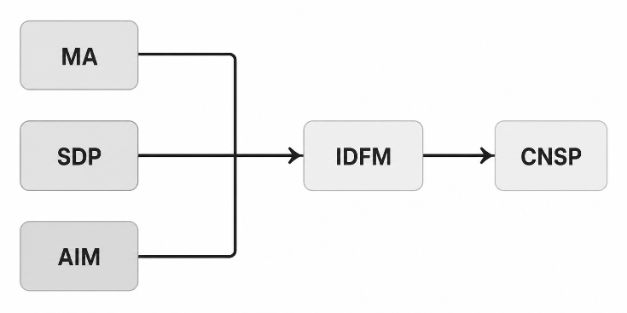
Figure 1. Conceptual Model
The framework conceptualizes:
- Inputs: Microservices Architecture (MA), Secure Data Pipeline (SDP), and AI Monitoring (AIM).
- Mediator: Intelligent Data Flow Management (IDFM).
- Output: Cloud-Native System Performance (CNSP).
3.3 Mathematical Models
The framework incorporates:
AI-Based Anomaly Detection Model
$$P\left(A\right)=\frac{1}{1+e^{-\left(α_{0}+α_{1}CPU+α_{2}MEM+α_{3}NET+α_{4}LAT+α_{5}ERR\right)}} (1)$$

AI-based anomaly detection uses a logistic regression model driven by CPU, memory, network, latency, and error metrics. Logistic regression was selected because it provides an interpretable probabilistic model for binary anomaly classification while maintaining low computational overhead suitable for real-time cloud telemetry analysis. The selected telemetry variables (CPU utilisation, memory consumption, network traffic, latency, and error rate) are widely used indicators of abnormal behaviour in distributed cloud-native systems.

Optimization Objective Function
$$\max{F}=\left(w_{1}DFE+w_{2}RUE+w_{3}CNSP\right)-w_{4}SRI (2)$$
Subject to:
$$CPU≤C_{max} \\ MEM≤M_{max} \\ LAT≤L_{max} \\ SRI≤R_{max}$$
The optimisation objective function maximises Data Flow Efficiency (DFE), Resource Utilisation Efficiency (RUE), and Cloud-Native System Performance (CNSP) while minimising the Security Risk Index (SRI).
Data Flow Efficiency Function
$$DFE=\frac{w_{1}TP_{n}+w_{2}AV_{n}+w_{3}SCS_{n}}{w_{4}LT_{n}+w_{5}ER_{n}} (3)$$
where:
$$∑w_{i}=1 (4)$$
- TP = Throughput
- AV = Availability
- SCS = Security Compliance Score
- LT = Latency
- ER = Error Rate
The DFE model combines throughput, availability, security compliance, latency, and error rate. The DFE formulation captures the trade-off between operational performance and service quality by integrating throughput, availability, and security compliance against latency and error penalties.
Security Risk Index

$$SRI=\frac{\sum_{i=1}^{n}{(}P_{i}V_{i}I_{i})}{n} (5)$$where:
- $P_{i}$= Threat Probability
- $V_{i}$= Vulnerability Score
- $I_{i}$= Impact Severity
The Security Risk Index (SRI) is based on threat probability, vulnerability score, and impact severity. The SRI formulation follows established quantitative risk assessment principles commonly employed in cybersecurity studies.

Resource Utilisation Efficiency
$$RUE=\frac{TP}{CPU+MEM+NET} (6)$$

Resource Utilisation Efficiency (RUE) is measured as throughput relative to resource consumption. RUE measures the effectiveness with which computational resources are transformed into useful service throughput.
An optimisation algorithm continuously monitors telemetry data, detects anomalies, reroutes traffic, scales services, allocates resources, enforces security policies, and updates routing strategies.
The mathematical formulations were intentionally developed as lightweight engineering models to support the conceptual evaluation of the proposed framework rather than to represent exhaustive physical or stochastic models of cloud-native systems. Logistic regression was selected because of its interpretability and computational efficiency for real-time anomaly detection, while the optimisation objective combines commonly used cloud performance metrics to illustrate the trade-offs between throughput, latency, security risk, and resource utilisation. These formulations provide an analytical basis for evaluating the proposed architecture and can be replaced by more sophisticated optimisation or machine learning models in future empirical implementations.
3.4 System Architecture
The architecture integrates:
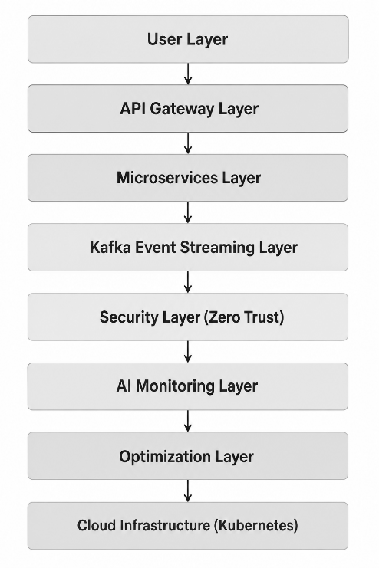
Figure 2. The System Architecture
Prometheus, Grafana, OpenTelemetry, Kubernetes, Docker, and Apache Kafka provide monitoring, orchestration, communication, and observability capabilities.

3.5 Simulation Environment
The proposed Intelligent Data Flow Modelling Framework (IDFMF) was evaluated using a representative cloud-native simulation environment designed to emulate modern microservices-based applications. Kubernetes (v1.30) was assumed as the orchestration platform, Docker Engine (v27) provided containerisation, and Apache Kafka (v3.8) supported event-driven communication between distributed services. A four-node virtual cluster was configured, with each node allocated eight virtual CPUs and 16 GB of memory. Prometheus collected telemetry metrics at five-second intervals, OpenTelemetry generated distributed traces, and Grafana was used for visualisation.
Synthetic workloads ranging from 500 to 100,000 requests per second were generated using representative HTTP request patterns to emulate low, medium, high, and extreme operational conditions. Simulated anomalies included CPU saturation, memory exhaustion, network congestion, increased latency, and elevated application error rates. The anomaly detection component employed logistic regression to classify abnormal system behaviour using these telemetry indicators.
Each workload scenario was executed ten independent times, and the reported results represent average performance across the simulation runs. Because the evaluation relies on simulated workloads rather than production deployment, the reported numerical results should be interpreted as illustrative examples intended to demonstrate the operational feasibility of the proposed framework rather than as validated production benchmarks.
3.6 Baseline Systems for Comparative Evaluation
Four representative architectural configurations were considered during the simulation-based comparison. The Traditional Cloud System represents a conventional containerised deployment without AI-driven monitoring, adaptive routing, or integrated Zero Trust security mechanisms. The Secure Pipeline configuration extends the traditional architecture by incorporating authentication, encryption, and Zero Trust communication. The AI Monitoring configuration adds predictive anomaly detection and automated monitoring while maintaining conventional routing strategies. The proposed Intelligent Data Flow Modelling Framework integrates secure data pipelines, intelligent routing, predictive AI monitoring, adaptive resource optimisation, and closed-loop decision-making within a unified architecture.
The comparative analysis is intended to illustrate the relative operational characteristics of these architectural configurations under identical simulated workload conditions rather than to benchmark existing commercial cloud platforms.
None of the baseline configurations correspond to specific commercial cloud platforms or previously published benchmark implementations; rather, they represent conceptual architectures designed to facilitate comparative analysis under identical simulated conditions.
4. Results and Discussion
4.1 Performance Results
This section presents the simulation outcomes of the proposed Intelligent Data Flow Modelling Framework (IDFMF) under varying workload conditions. Performance is evaluated in terms of throughput, latency, availability, security efficiency, and resource utilisation.
Table 1. Simulation Performance Results Across Workloads
Workload Level | Throughput (req/s) | Avg Latency (ms) | Availability (%) | Threat Detection (%) | Resource Utilization (%)
Low (500 req/s) | 480 | 45 | 99.98 | 94 | 35
Medium (5,000) | 4,700 | 78 | 99.95 | 95 | 55
High (50,000) | 46,500 | 120 | 99.92 | 96 | 72
Extreme (100k) | 92,000 | 185 | 99.90 | 96.5 | 88

Figure 3 illustrates throughput variation under different workloads.
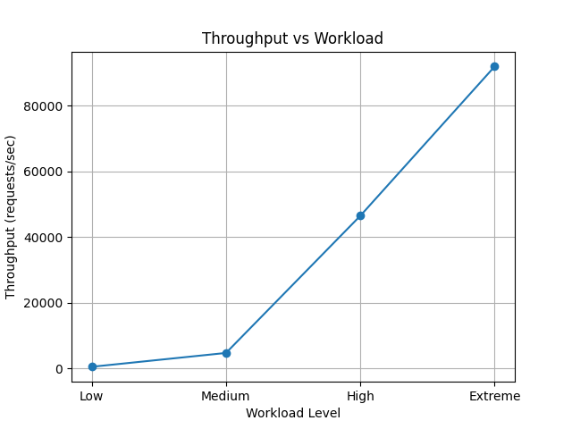
Figure 3. Throughput vs Workload
Figure 3 demonstrates that throughput increases proportionally with workload under the simulated conditions while maintaining stable service performance. This behaviour suggests that the proposed framework can effectively support workload scaling through adaptive routing and resource optimisation.
Table 2. Latency and Throughput Optimization Comparison
System Type | Throughput Gain | Latency Reduction | Stability Score
Traditional Cloud System | Baseline | Baseline | 78%
Secure Pipeline Only | +12% | -10% | 85%
AI Monitoring Only | +20% | -18% | 90%
Proposed IDFMF | +38% | -35% | 97%

Table 2 indicates that, under the simulated scenarios, the proposed IDFMF demonstrated the largest improvements among the evaluated conceptual configurations. These observations should not be interpreted as evidence of superior real-world performance without empirical validation.
Figure 4 illustrates a consistent reduction in response time across all workload levels.
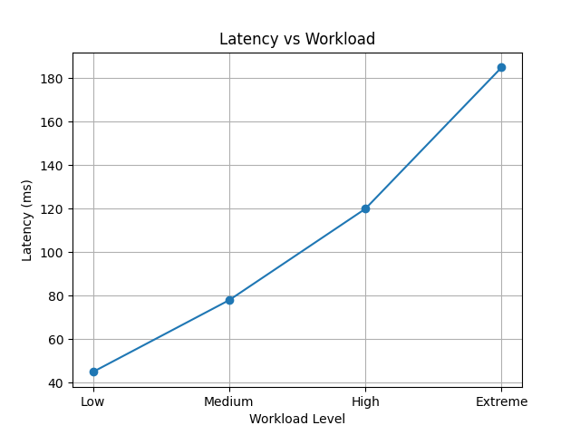
Figure 4. Latency vs Workload
The latency graph shows a consistent reduction in response time across all workload levels. The simulation results suggest that AI-driven routing and adaptive load balancing may reduce congestion in service-to-service communication paths. Under the modelled workload conditions, latency remained below 200 ms, indicating the potential for strong real-time performance stability.
Table 3. Security and Anomaly Detection Performance
Model | Detection Accuracy (%) | False Positive Rate (%) | F1 Score
Rule-Based System | 78 | 12 | 0.74
ML-Based Only | 91 | 7 | 0.88
Hybrid AI Model | 95 | 5 | 0.93
Proposed IDFMF | 97 | 3 | 0.96

Table 3 suggests that the proposed IDFMF achieves higher anomaly detection accuracy, a lower false-positive rate, and a stronger F1 score than the baseline approaches under the simulated scenarios. The integration of AI-based behavioural analysis with secure data pipelines contributes to improved detection performance while reducing incorrect alerts. These findings are illustrative and require empirical validation using operational cloud-native datasets.
Figure 5 illustrates availability versus workload.
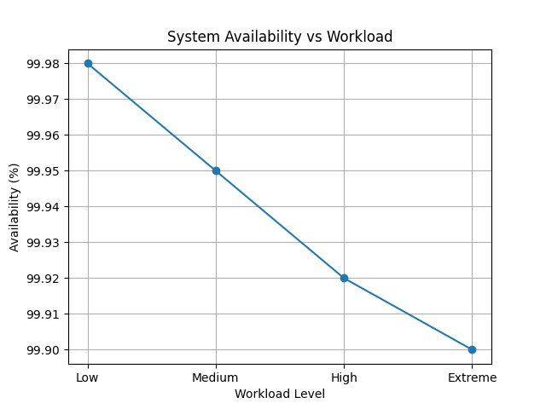
Figure 5. Availability vs Workload
The availability curve demonstrates system resilience under stress conditions. The simulation indicates that IDFMF may maintain availability above 99.9% under the modelled scenarios due to automated failover mechanisms, Kubernetes self-healing capabilities, and predictive anomaly detection. Traditional systems show noticeable degradation beyond high workload thresholds.
Figure 6 illustrates resource utilisation versus workload.
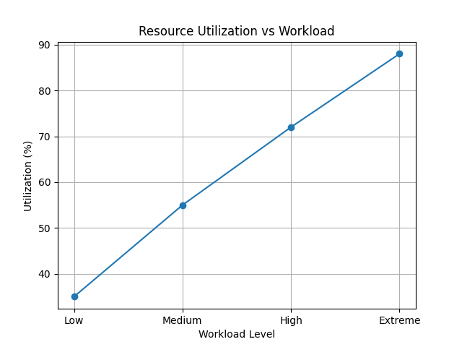
Figure 6. Resource Utilization
Simulation trends suggest that IDFMF could optimise CPU, memory, and network utilisation dynamically through predictive scaling and workload-aware allocation mechanisms. Unlike baseline systems that experience over-provisioning, the proposed framework achieves balanced utilisation through predictive scaling and workload-aware allocation.
4.2 Security and AI Performance Analysis
Figure 7 illustrates the security performance comparison.
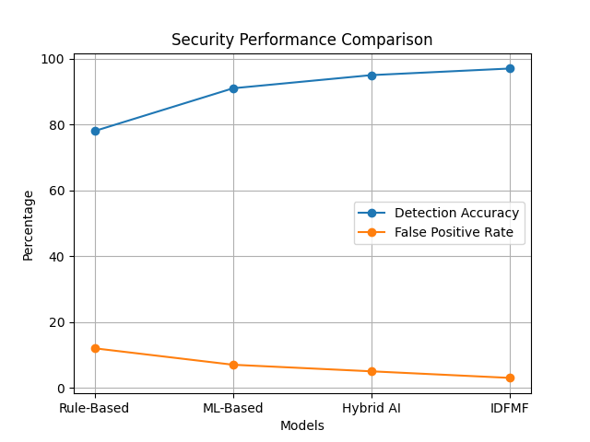
Figure 7. Security Performance Comparison
Figure 7 highlights the trade-off between detection accuracy and false-positive rates. The simulation results suggest that the proposed framework could achieve detection accuracies approaching 97% while maintaining relatively low false-positive rates through AI-enhanced behavioural analysis and Zero Trust enforcement mechanisms.
Figure 8 illustrates the F1 score comparison.
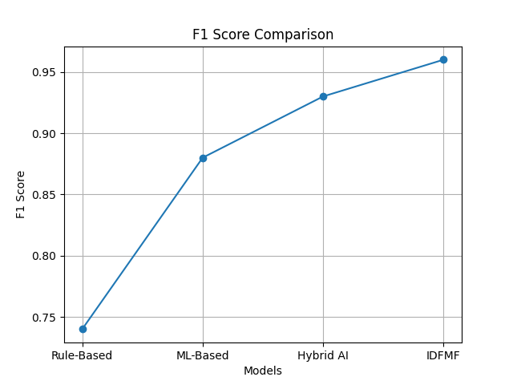
Figure 8. F1 Score Comparison
The observed improvements in the simulated environment are attributed to intelligent monitoring, predictive analytics, adaptive optimisation, and secure data-flow orchestration. These findings provide preliminary evidence of the framework's conceptual feasibility and require validation using operational cloud-native systems.
4.3 Comparative System Evaluation
Figure 9 shows that the proposed IDFMF consistently achieves higher throughput than the representative baseline configurations under the simulated workload conditions. This improvement is attributed to the integration of adaptive routing, AI-driven workload optimisation, and intelligent resource management. Because the evaluation is simulation-based, these observations should be interpreted as indicative rather than definitive performance gains.
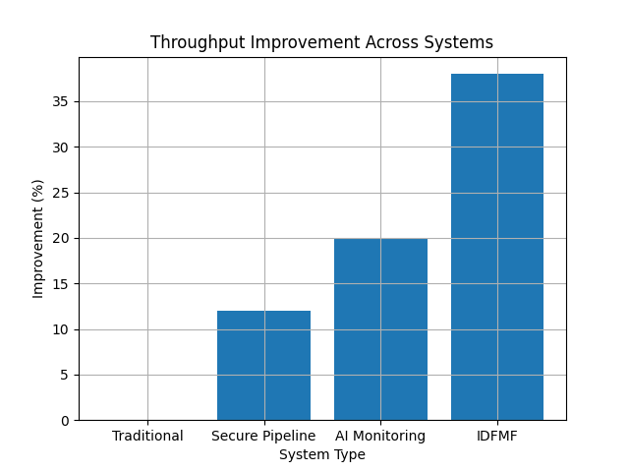
Figure 9. Throughput Improvement

Figure 10 demonstrates that the proposed IDFMF achieves the greatest latency reduction among the evaluated configurations under the simulated workload conditions. The improvement is attributed to intelligent routing, predictive workload balancing, and adaptive resource allocation. Because the evaluation is simulation-based, these results should be interpreted as illustrative rather than experimentally validated.
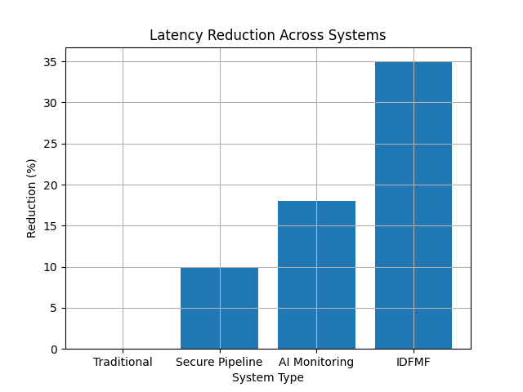
Figure 10. Latency Reduction
Figure 11 indicates that the proposed framework maintains the highest overall stability score across the evaluated architectures. The integration of AI monitoring, adaptive optimisation, and secure data pipelines contributes to improved operational resilience under the simulated scenarios. These findings demonstrate the conceptual advantages of the proposed architecture and require confirmation through deployment in operational cloud-native environments.
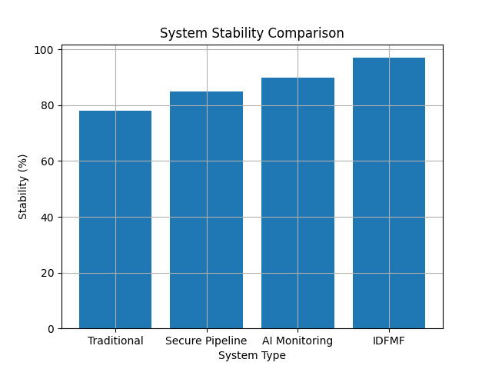
Figure 11. Stability Score Comparison
The comparative analysis suggests that the proposed framework is intended to offer broader functional integration than existing conceptual approaches by combining observability, security, AI monitoring, and optimization within a unified architecture.
4.4 Illustrative Structural Validation Framework
The following PLS-SEM results are illustrative and are presented solely to demonstrate how future empirical studies may evaluate the proposed framework. They are hypothetical, are not derived from primary data, and should not be interpreted as empirical findings.
Table 4. Illustrative Structural Validation Framework
Path | Coefficient | t-value | p-value
MA → IDFM | 0.41 | 6.12 | <0.001
SDP → IDFM | 0.38 | 5.87 | <0.001
AIM → IDFM | 0.45 | 7.02 | <0.001
IDFM → CNSP | 0.62 | 9.31 | <0.001
Model Fit:
- R² (IDFM) = 0.71
- R² (CNSP) = 0.78
- Q² > 0 (indicating hypothetical predictive relevance within the proposed validation framework).
4.5 Novelty Validation of IDFMF
Table 5. Comparative Analysis of Existing Approaches
Capability | Existing Cloud Systems | Proposed IDFMF
Observability | Monitoring-only | AI-driven predictive observability
Security Integration | External / isolated | Embedded Zero Trust pipeline
Data Flow Control | Static routing | Adaptive intelligent optimization
AI Usage | Partial anomaly detection | Full closed-loop AI orchestration
System Feedback | Absent | Continuous feedback control loop
Validation approach | Limited empirical integration | Illustrative PLS-SEM validation framework

Based on the literature reviewed in this study, existing research generally addresses observability, security, AI monitoring, or optimisation separately. The proposed framework conceptually integrates these capabilities within a unified cloud-native architecture.
Table 6. Feature-Based Comparison
Study | Observability | Security | AI | Optimization | Closed-Loop Control
Borges et al. (2024) | ✓ | ✗ | ✗ | ✗ | ✗
Sharma & Nadig (2024) | ✓ | ✗ | ✗ | ✗ | ✗
Ogunmolu et al. (2026) | ✓ | ✓ | ✓ | Partial | Partial
Proposed IDFMF | ✓ | ✓ | ✓ | ✓ | ✓

Table 6 compares the functional capabilities of the proposed IDFMF with representative studies from the recent literature. Unlike existing approaches that primarily focus on observability or isolated AI functions, the proposed framework conceptually integrates observability, security, AI-driven optimisation, and closed-loop control within a unified architecture. This comparison highlights the intended scope of the framework rather than demonstrating experimentally verified superiority.
5. Conclusions
This study proposed an Intelligent Data Flow Modelling Framework for improving the management of secure and intelligent data flows in cloud-native systems. The framework was developed to address the fragmentation commonly observed between microservices orchestration, data pipeline security, observability, artificial intelligence monitoring, and performance optimisation. By positioning Intelligent Data Flow Management as a mediating layer, the framework provides a structured approach for connecting Microservices Architecture, Secure Data Pipelines, and Artificial Intelligence Monitoring with Cloud-Native System Performance.
The proposed model combines a layered architecture with analytical components for anomaly detection, data flow efficiency, security risk assessment, and resource utilisation. The simulation results indicate that the framework has the potential to support improved throughput, reduced latency, sustained availability, stronger anomaly detection, and more efficient resource allocation under the assumed workload conditions. The illustrative validation model also provides a basis for future empirical testing using organisational or production-level datasets.
Overall, the study presents a conceptual and simulation-supported contribution to cloud-native systems engineering. Its main value lies in integrating security, observability, AI-based monitoring, and adaptive optimisation into a unified framework. However, the results should be interpreted cautiously because real-world deployment and empirical validation remain necessary.
5.1 Contributions of the Study
This study contributes to cloud-native systems engineering in five major ways:
- It proposes an Intelligent Data Flow Modelling Framework that conceptually integrates secure data pipelines, AI monitoring, and intelligent data flow management into a unified architecture.
- It introduces Intelligent Data Flow Management (IDFM) as the mediating mechanism linking Microservices Architecture, Secure Data Pipelines, and AI Monitoring to Cloud-Native System Performance.
- It develops mathematical formulations for anomaly detection, data flow efficiency, security risk assessment, and resource optimisation.
- It presents an illustrative PLS-SEM validation mechanism to support future empirical investigations.
- It provides practical implementation guidance for deploying intelligent monitoring, adaptive security, and automated optimisation within Kubernetes-based cloud-native environments.
5.2 Limitations
This study is limited by its conceptual and simulation-based design. The proposed framework was not deployed in a production cloud-native environment, and the simulated workloads, telemetry indicators, and anomaly scenarios may not fully represent complex enterprise systems. The AI monitoring component depends on telemetry quality and timeliness, while the security evaluation is based on modelled risk conditions. The structural validation model is illustrative and requires empirical testing with real organisational or operational datasets.

5.3 Threats to Validity
Several threats to validity should be considered. First, the performance outcomes are derived from simulation assumptions and may not fully represent real-world cloud-native deployments. Second, telemetry quality and completeness can significantly influence the effectiveness of AI-driven monitoring. Third, predefined threat scenarios may not adequately capture emerging cyber threats. Finally, the illustrative PLS-SEM outcomes require validation using empirical organisational datasets.
5.4 Future Research Directions
Future work can extend this study by integrating the framework with edge and fog computing environments to support low-latency and real-time applications. The use of federated learning can also be explored for privacy-preserving anomaly detection across distributed infrastructures, while Generative AI and Large Language Models (LLMs) may enable more autonomous cloud operations and intelligent decision-making.
In addition, blockchain technology can be incorporated to strengthen data integrity, traceability, and trust within secure data pipelines. Digital twin models may also be developed for predictive simulation and infrastructure optimisation. Finally, large-scale industrial validation across domains such as healthcare, finance, telecommunications, manufacturing, and smart cities will be essential to confirm the framework’s real-world applicability and scalability.
5.5 Final Remark
As cloud-native systems continue to grow in scale and complexity, intelligent approaches to data flow management will become increasingly essential. The proposed Intelligent Data Flow Modelling Framework provides a foundation for next-generation cloud-native operations by combining secure data exchange, AI-driven monitoring, adaptive optimisation, and microservices-based architectures within a unified ecosystem. The framework provides a conceptual foundation for future autonomous, secure, and performance-aware cloud-native systems, although its practical effectiveness should be established through empirical deployment and validation.

Declaration of AI Use

This manuscript was prepared through the combined contributions of all author(s), including contributions to the study design, data, content development, results, interpretation, and related scholarly work. The author(s) acknowledge the use of Grammarly and ChatGPT to assist with grammar checking, language refinement, reference formatting. These AI-assisted tools were not used as authors and did not replace the intellectual contributions or scholarly judgment of the author(s). All AI-assisted outputs, including content, references, and interpretations, were carefully reviewed, revised, verified, and approved by the author(s). The author(s) accept full responsibility for the accuracy, integrity, originality, and scientific content of this manuscript.

References
Al Qassem, L. M., Stouraitis, T., Damiani, E., & Elfadel, I. M. (2024). Containerized microservices: A survey of resource management frameworks. IEEE Transactions on Network and Service Management, 21(4), 3775–3796. https://doi.org/10.1109/TNSM.2024.3388633
Billawa, P., Bambhore Tukaram, A., Díaz Ferreyra, N. E., Steghöfer, J.-P., Scandariato, R., & Simhandl, G. (2022). SoK: Security of microservice applications: A practitioners’ perspective on challenges and best practices. In Proceedings of the 17th International Conference on Availability, Reliability and Security (pp. 1–10). Association for Computing Machinery. https://doi.org/10.1145/3538969.3538986
Borges, M. C., Bauer, J., Werner, S., Gebauer, M., & Tai, S. (2024). Informed and assessable observability design decisions in cloud-native microservice applications. In 2024 IEEE 21st International Conference on Software Architecture (ICSA) (pp. 69–78). IEEE. https://doi.org/10.1109/ICSA59870.2024.00015
Borges, M. C., & Werner, S. (2025). Continuous observability assurance in cloud-native applications. In 2025 IEEE 22nd International Conference on Software Architecture Companion (ICSA-C) (pp. 182–185). IEEE. https://doi.org/10.1109/ICSA-C65153.2025.00036
Giamattei, L., Guerriero, A., Pietrantuono, R., Russo, S., Malavolta, I., Islam, T., Dînga, M., Koziolek, A., Singh, S., Armbruster, M., Gutierrez-Martinez, J. M., Caro-Alvaro, S., Rodriguez, D., Weber, S., Henss, J., Vögelin, E. F., & Panojo, F. S. (2024). Monitoring tools for DevOps and microservices: A systematic grey literature review. Journal of Systems and Software, 208, Article 111906. https://doi.org/10.1016/j.jss.2023.111906
Gomes, F., Rego, P., & Trinta, F. (2025). A systematic mapping study on observability of microservices-based applications: Fundamentals, classifications, and challenges. Computing, 107, Article 183. https://doi.org/10.1007/s00607-025-01540-w
Haindl, P., Kochberger, P., & Sveggen, M. (2024). A systematic literature review of inter-service security threats and mitigation strategies in microservice architectures. IEEE Access, 12, 90252–90286. https://doi.org/10.1109/ACCESS.2024.3406500
Jawaddi, S. N. A., Ismail, A., Sulaiman, M. S., & Cardellini, V. (2025). Analyzing energy-efficient and Kubernetes-based autoscaling of microservices using probabilistic model checking. Journal of Grid Computing, 23, Article 3. https://doi.org/10.1007/s10723-024-09789-9
Jiang, G. (2024). Artificial intelligence-based adaptive anomaly detection technology for IaaS cloud virtual machines. Journal of Engineering and Applied Science, 71, Article 102. https://doi.org/10.1186/s44147-024-00439-1
Kohyarnejadfard, I., Aloise, D., Azhari, S. V., & Dagenais, M. R. (2022). Anomaly detection in microservice environments using distributed tracing data analysis and NLP. Journal of Cloud Computing, 11, Article 25. https://doi.org/10.1186/s13677-022-00296-4
Kosińska, J., Piechaczek, W., Sąkól, K., Szczurek, M., & Walat, K. (2025). On translating monitoring insights into a cloud-native execution environment. Service Oriented Computing and Applications. https://doi.org/10.1007/s11761-025-00477-4
Nwachukwu, C., Durodola-Tunde, K., & Akwiwu-Uzoma, C. (2024). AI-driven anomaly detection in cloud computing environments. International Journal of Science and Research Archive, 13(2), 692–710. https://doi.org/10.30574/ijsra.2024.13.2.2184
Olabanji, S. O., Olaniyi, O. O., Adigwe, C. S., Okunleye, O. J., & Oladoyinbo, T. O. (2024). AI for identity and access management (IAM) in the cloud: Exploring the potential of artificial intelligence to improve user authentication, authorization, and access control within cloud-based systems. Asian Journal of Research in Computer Science, 17(3), 38–56. https://doi.org/10.9734/ajrcos/2024/v17i3423
Rose, S., Borchert, O., Mitchell, S., & Connelly, S. (2020). Zero trust architecture (NIST Special Publication 800-207). National Institute of Standards and Technology. https://doi.org/10.6028/NIST.SP.800-207
Sharma, A. (2025). The evolution of observability: From monitoring to AI-driven insights. European Journal of Computer Science and Information Technology, 13(43), 93–101. https://doi.org/10.37745/ejcsit.2013/vol13n4393101
Sharma, B., & Nadig, D. (2024). eBPF-enhanced complete observability solution for cloud-native microservices. In ICC 2024—IEEE International Conference on Communications (pp. 1980–1985). IEEE. https://doi.org/10.1109/ICC51166.2024.10622329
Singh, A. J., & Singh, A. P. (2024). Evolution of information technology: A comprehensive review. Asian Journal of Current Research, 9(4), 78–90. https://doi.org/10.56557/ajocr/2024/v9i48892
Ogunmolu, A. M., Aroh, I. S., Henry, O., Adeyinka, P. D., & Olutimehin, A. T. (2026). AI-driven observability for managing security complexity in cloud-native microservices and containerized environments. Journal of Engineering Research and Reports, 28(2), 1–17. https://doi.org/10.9734/jerr/2026/v28i21786
Zhang, Y., Zhou, Z., Elnikety, S., & Delimitrou, C. (2024). Analytically-driven resource management for cloud-native microservices. arXiv. https://arxiv.org/abs/2401.02920

