Optimization of Solvent Extracted Okra Seed Oil - A Response Surface Approach

Abstract
Okra (Abelmoschus esculentus) oil has a significant unsaturated fatty acid content and notable nutritional and industrial potential in food and allied industries. However, efficient extraction of the oil remains a challenge, limiting its utilisation. Therefore, this study aimed to investigate the effects of extraction parameters on the oil yield and quality attributes of oil from okra seeds. The effects of extraction temperature, extraction time, and solid-to-solvent ratio on the yield and quality attributes (acid value, free fatty acid, peroxide value, iodine value, saponification value, refractive index, and pH) of oil extracted from okra seeds were studied using RSM. Extraction temperatures, times, and solid-to-solvent ratios were 35, 45, and 55 °C; 60, 120, and 180 min; and 1:20, 1:30, and 1:40 g/mL, respectively. Data were analysed by ANOVA and regression analysis. Oil yield ranged from 10.50 to 13.00%, free fatty acid from 1.70 to 2.98 mgKOH/g, acid value from 8.03 to 12.00 mg KOH/g, peroxide value from 8.70 to 13.00 meq O₂/kg, saponification value from 182.00 to 200.80 mg KOH/g, refractive index from 1.45 to 1.47, iodine value from 15.86 to 42.82 g I₂/100 g, and pH from 2.00 to 6.60. The treatments had significant effects on all response variables at p < 0.05. The coefficients of determination (R²) for the oil yield, acid value, free fatty acid, peroxide value, iodine value, saponification value, refractive index, and pH models were 0.9273, 0.8345, 0.8331, 0.9421, 0.8457, 0.9459, 0.9374, and 0.9931, respectively. The optimum extraction temperature, time, and solid-to-solvent ratio were 36.96 °C, 100.49 min, and 21.62 g/mL, respectively. This combination gave an oil yield of 12.43%, free fatty acid of 21.48 mg KOH/g, acid value of 10.20 mg KOH/g, peroxide value of 8.70 meq O₂/kg, saponification value of 190.00 mg KOH/g, refractive index of 1.47, iodine value of 18.77 g I₂/100 g, and pH of 3.24. The extraction of okra seed oil was successfully optimised using RSM. The regression models obtained provide a basis for selecting optimum process variables for oil recovery using solvent extraction.
Keywords: Abelmoschus esculentus; okra seed oil; solvent extraction; n-hexane; response surface methodology; Box–Behnken design; oil yield; physicochemical properties; process optimisation; desirability function
1. INTRODUCTION

Oilseeds are vital agricultural commodities that serve dual roles as sources of nutritious food and industrial raw materials. Global demand for vegetable oils continues to rise, driven by population growth, urbanisation, and increasing consumer preference for oils rich in unsaturated fatty acids (Micha et al., 2014; Gunstone, 2011). In Nigeria, the deficit between local production capacity and domestic consumption is particularly pronounced: the country relies on imports to bridge a substantial vegetable oil supply gap, underscoring the urgent need for locally sourced alternatives that do not compete with staple food crops (U.S. Department of Agriculture, Foreign Agricultural Service, 2024).

Okra (Abelmoschus esculentus L.) is widely cultivated across tropical regions and is primarily valued for its edible pods. The seeds, which are routinely discarded as processing waste, contain between 11 and 28% oil, with a favourable fatty acid profile dominated by linoleic and oleic acids and appreciable levels of natural antioxidants, such as tocopherols and polyphenols, rendering the seeds a promising but chronically underutilised edible oil source (Anwar et al., 2011; Guo et al., 2024). Recent compositional evidence also indicates that okra seed oil contains unsaturated fatty acids together with tocopherols and sterols, supporting its continued evaluation as an alternative oil source (Nia et al., 2025).
Traditional oil extraction methods, including mechanical pressing and simple solvent soaking, typically yield low and inconsistent oil recovery because process conditions such as extraction temperature, time, and solid-to-solvent ratio are not scientifically optimised; local practice continues to rely predominantly on trial-and-error approaches (Akinoso et al., 2023; Nde & Foncha, 2020). Broader reviews of seed-oil processing similarly indicate that the extraction method and operating conditions influence product yield, safety, and quality, highlighting the need for systematic process control (Musa et al., 2023).

Response surface methodology (RSM) provides a rigorous statistical framework for the simultaneous modelling and optimisation of processes governed by multiple interacting variables. Unlike conventional one-factor-at-a-time experimentation, RSM evaluates both the individual and interactive effects of parameters within a reduced number of experimental runs, generating predictive polynomial models and interpretable response surface visualisations (Montgomery, 2005; Yolmeh & Jafari, 2017). Previous investigations have successfully applied RSM to optimise oil extraction from cottonseed (Kalkan & Maskan, 2025), rice bran (Akinoso & Adeyanju, 2012), coconut oil (Adeyanju et al., 2016), and okra seed oil (Akinoso et al., 2023), demonstrating its efficiency in identifying optimum process conditions. However, comprehensive RSM-based optimisation of okra seed oil extraction that simultaneously addresses both oil yield and selected physicochemical properties remains scarce in the published literature.
Recent RSM studies on other underutilised oilseeds have further shown that solvent selection, extraction time, material loading, and related operating variables can be jointly optimised while oil yield and physicochemical attributes are evaluated (Betiku et al., 2024; Eddaoudi et al., 2025). RSM has also been used to evaluate the effects of roasting temperature and duration on walnut oil yield and quality indices (Raji & Akinoso, 2020). Nevertheless, evidence remains limited regarding the combined influence of extraction temperature, extraction time, and solid-to-solvent ratio on both okra seed oil recovery and the selected physicochemical properties assessed in this study. Therefore, this study investigates the effects of extraction temperature, extraction time, and solid-to-solvent ratio on oil yield and selected physicochemical properties of okra seed oil using RSM.

2. MATERIALS and Methods

2.1 Raw Material Collection and Preparation
Overmature okra (Abelmoschus esculentus) pods were obtained from a local farm in Ogbomoso, Nigeria. The pods were manually broken to release the seeds, which were dried to 7% moisture content following the procedure of Adelakun et al. (2009). The dried seeds were milled to a uniform particle size of 1.0 mm using a laboratory hammer mill; particle size reduction has been shown to enhance extraction efficiency by increasing the surface area available for solvent contact (Nde & Foncha, 2020). The prepared seed flour was stored in sealed, airtight containers at ambient temperature until use.
2.2 Experimental Design
A Box-Behnken design (BBD) was employed within RSM using Design-Expert software (Version 13.0.1, Stat-Ease Inc., Minneapolis, MN, USA) to study the effects of three independent variables on oil yield and the physicochemical properties of the oil. As shown in Table 1, the independent variables and their coded levels were extraction temperature (A: 35, 45, and 55 °C), extraction time (B: 60, 120, and 180 min), and solid-to-solvent ratio (C: 1:20, 1:30, and 1:40 g/mL). BBD was selected over a full central composite design because it requires fewer experimental runs while providing sufficient resolution to estimate linear, quadratic, and two-factor interaction effects (Montgomery, 2005; Yolmeh & Jafari, 2017).

The response variables measured were oil yield (%), acid value (mg KOH/g), free fatty acid (%), peroxide value (meq O₂/kg), iodine value (g I₂/100 g), saponification value (mg KOH/g), refractive index, and pH. A general second-order polynomial model was fitted to each response:

Y = β₀ + Σβᵢxᵢ + Σβᵢᵢxᵢ² + Σβᵢⱼxᵢxⱼ + ε (1)
where Y is the predicted response; β₀, βᵢ, βᵢᵢ, and βᵢⱼ are the regression coefficients for the intercept, linear, quadratic, and interaction terms, respectively; xᵢ and xⱼ are the coded independent variables; and ε is the residual error.

Table 1: Design of Experiments
Process Variable | Unit | Level (-1) | Level (0) | Level (+1)
Temperature | °C | 35 | 45 | 55
Time | min | 60 | 120 | 180
Solid to liquid ratio | g/mL | 1:20 | 1:30 | 1:40

2.3 Oil Extraction Procedure
Solvent extraction was conducted using analytical-grade n-hexane. For each experimental run, 100 g of okra seed flour was combined with n-hexane at solid-to-solvent ratios of 1:20, 1:30, and 1:40 g/mL, corresponding to 2000, 3000, and 4000 mL of solvent, respectively, in sealed Erlenmeyer flasks. The mixtures were maintained at the designated extraction temperature in a Thermo Scientific Precision general-purpose water bath for the prescribed extraction time. The solutions were filtered through Whatman No. 1 filter paper, and the solvent was recovered by rotary evaporation at 70 °C under reduced pressure.

Oil yield (%) =$\frac{{\text{w}}_{\text{1}}}{{\text{w}}_{\text{2}}}\text{×100}$ (2)
Where ${\text{w}}_{\text{1}}$= mass of extracted oil and ${\text{w}}_{\text{2}}$= mass of seed flour

2.4 Determination of Physicochemical Properties of Okra Oil
Physicochemical properties of the extracted oil were determined using official methods of the American Oil Chemists' Society (AOCS, 2004). Acid value and free fatty acid content were quantified by titration with standardised KOH solution. Peroxide value was determined by iodometric titration (AOCS Cd 8-53). Iodine value was determined by the Wijs method (AOCS Cd 1-25). Saponification value was measured by refluxing oil samples with excess alcoholic KOH, followed by back-titration with hydrochloric acid. Refractive index was measured at 40 °C using an Abbe refractometer, and pH was determined with a calibrated digital pH meter.

2.5 Statistical Analysis and Optimization
Data were analysed using Design-Expert software. Analysis of variance (ANOVA) was performed to evaluate the statistical significance of model terms at p < 0.05. Model adequacy was assessed using R², adjusted R², predicted R², and the lack-of-fit test. Three-dimensional response surface plots were generated to visualise the interactive effects of the independent variables on each response. Overall process optimisation was performed using the numerical desirability function approach, which simultaneously maximises oil yield and minimises undesirable quality parameters (Kalkan & Maskan, 2025; Akinoso & Adeyanju, 2012).

The optimal conditions were obtained using a commercial statistical package (Design-Expert, Stat-Ease Inc., Minneapolis, USA). The optimisation process was designed to identify the levels of extraction temperature, time, and solid-to-liquid ratio that could maximise oil yield and minimise free fatty acid, acid value, and peroxide value, while maintaining iodine value, saponification value, and refractive index within their respective ranges.

3. RESULTS and Discussion
3.1 Quality Attributes of Okra Oil
3.1.1 Oil Yield (OY)
Oil yield ranged from 10.50 to 13.00% (Table 2). These values fall within the 11–28% range previously reported for okra seed oil, with variability attributable to differences in cultivar, seed maturity, and particle size (Anwar et al., 2011; Guo et al., 2024). The yield was somewhat lower than that recorded for soybeans (Ndangui et al., 2010), reflecting the inherently different oil content and structural composition of the okra seed matrix. ANOVA results confirmed that the quadratic RSM model for oil yield was highly significant (F = 9.93, p = 0.0031), with an R² of 0.9273, indicating that the model accounted for 92.7% of the total variability in yield. The lack-of-fit test was non-significant (p = 0.4486), confirming model adequacy. Among the linear terms, extraction time (B) was significant (p = 0.0282), as were the interaction terms AB and AC (p = 0.0168 and p = 0.0015, respectively) and the quadratic terms A² and B² (p = 0.0011 and p = 0.0240, respectively). The second-order polynomial equation for oil yield was:

OY = 12.43 + 0.32A + 0.28B + 0.41C − 0.15A² − 0.12C² + 0.09AB (3)

where OY is the predicted oil yield (%), A is extraction temperature, B is extraction time, and C is solid-to-solvent ratio.

The three-dimensional response surface plot (Fig. 1) illustrated that oil yield increased with moderate temperature (approximately 40–45 °C) and extended extraction time but declined at temperatures exceeding 50 °C, consistent with thermal degradation of oil constituents and reduced solvent efficiency at elevated temperatures. Increasing the solid-to-solvent ratio enhanced yield up to an optimum, beyond which solvent saturation limited further mass transfer. These observations are consistent with studies on cottonseed oil (Kalkan & Maskan, 2025) and rice bran oil (Akinoso & Adeyanju, 2012), in which temperature and solvent ratio were identified as primary determinants of extraction yield.
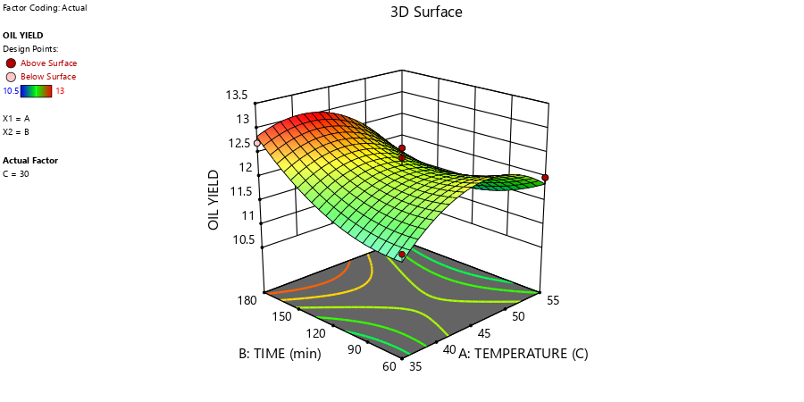

Fig. 1: Response surface plot showing the interactive effect of extraction temperature and extraction time on oil yield

3.1.2 Free Fatty Acid (FFA)
FFA values varied between 1.70 and 2.98 mgKOH/g across the experimental runs (Table 2). ANOVA for the quadratic FFA model confirmed that extraction time was the primary significant factor (B: p = 0.0051). Higher temperatures and prolonged extraction periods promoted hydrolytic cleavage of triglycerides, increasing free acid formation, a phenomenon well documented in vegetable oil extraction (Tsai et al., 2023). The response surface plot (Fig. 2) illustrated that shorter extraction times and moderate temperatures effectively limited FFA accumulation. The values obtained are comparable to those reported for okra oil (Guo et al., 2024) and fall within the limits for food-grade edible oils (Akinoso et al., 2023). The empirical second-order model for FFA is given in Equation (4):
FFA = 2.56 + 0.0288A + 0.37B − 0.0388C + 0.2275AB − 0.295AC − 0.0725BC − 0.2945A² − 0.2470B² + 0.1005C² (4)
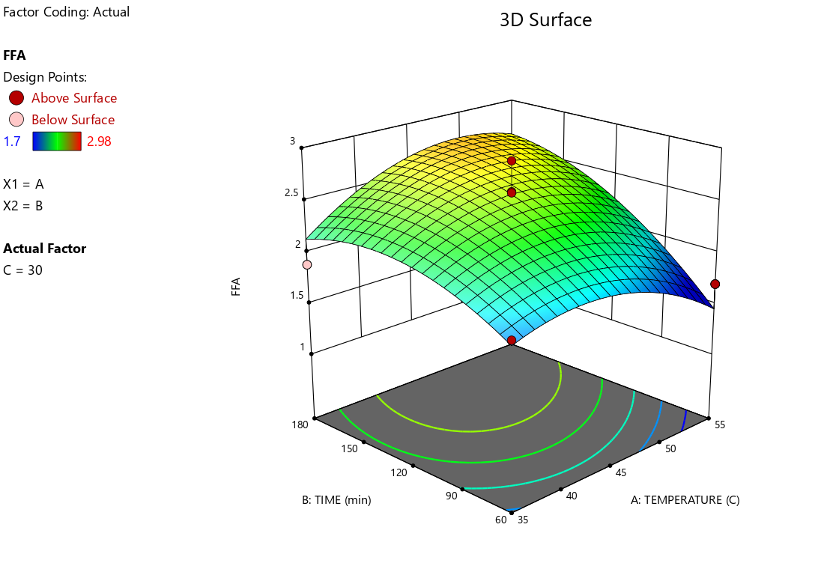
Fig. 2: Response surface plot showing the interactive effect of extraction temperature and extraction time on free fatty acid content
3.1.3 Acid Value (AV)
AV values ranged from 8.03 to 12.00 mgKOH/g across the experimental runs (Table 2). ANOVA for the quadratic AV model revealed that the solid-to-solvent ratio (C: p = 0.0038), the AC interaction (p = 0.0035), and the BC interaction (p = 0.0001) were the most significant contributors to AV variability. Specifically, higher solid-to-solvent ratios in combination with elevated temperatures accelerated the hydrolytic breakdown of triglycerides, increasing free fatty acid concentration and, consequently, the acid value (Tsai et al., 2023). The quadratic term A² was also significant (p = 0.0112). These findings reinforce the recommendation for moderate extraction conditions (temperature < 45 °C; solid-to-solvent ratio < 25 g/mL) to preserve oil quality. The AV values obtained were within the acceptable range for crude vegetable oils prior to refining (Akinoso et al., 2023). The response surface plot (Fig. 3) demonstrated that moderate extraction conditions (temperature < 45 °C; time < 120 min) minimised acid development. The regression equation is given in Equation (5).

Run | Extraction temp °C | Extraction time (min) | Solid to liquid ratio (g/mL) | Oil yield (%) | FFA  (mg KOH/g) | Acid Value  (mg KOH/g) | Peroxide Value  (meqO₂ /kg) | Saponification Value (mgKOH/g) | Refractive Index | Iodine  Value | pH
1 | 45 | 180 | 20 | 13.00 | 2.98 | 10.20 | 8.70 | 190.00 | 1.465 | 18.77 | 3.70
2 | 45 | 120 | 30 | 12.40 | 2.28 | 10.00 | 11.70 | 198.00 | 1.454 | 16.21 | 3.51
3 | 55 | 60 | 30 | 11.99 | 1.70 | 9.89 | 12.70 | 192.17 | 1.465 | 27.07 | 3.54
4 | 35 | 180 | 30 | 12.70 | 1.89 | 9.80 | 9.00 | 200.80 | 1.465 | 32.80 | 2.80
5 | 55 | 120 | 40 | 11.77 | 1.90 | 8.50 | 11.89 | 190.77 | 1.465 | 32.22 | 5.50
6 | 35 | 60 | 30 | 11.54 | 1.90 | 9.80 | 9.70 | 197.90 | 1.458 | 42.82 | 2.00
7 | 45 | 60 | 20 | 12.55 | 1.80 | 12.00 | 13.00 | 193.00 | 1.464 | 15.86 | 6.60
8 | 45 | 120 | 30 | 12.60 | 2.59 | 10.60 | 10.50 | 194.00 | 1.458 | 18.21 | 3.40
9 | 45 | 120 | 30 | 11.87 | 2.88 | 10.10 | 10.50 | 194.38 | 1.458 | 18.21 | 3.30
10 | 55 | 120 | 20 | 10.50 | 2.70 | 10.85 | 10.00 | 182.00 | 1.465 | 29.45 | 6.80
11 | 45 | 60 | 40 | 11.57 | 2.00 | 8.03 | 9.80 | 194.81 | 1.466 | 23.20 | 4.40
12 | 45 | 120 | 30 | 12.11 | 2.49 | 10.40 | 10.60 | 194.38 | 1.458 | 18.21 | 3.10
13 | 45 | 120 | 30 | 12.23 | 2.58 | 10.60 | 10.30 | 194.38 | 1.458 | 18.21 | 2.20
14 | 35 | 120 | 40 | 10.76 | 2.63 | 10.24 | 10.24 | 190.25 | 1.464 | 38.20 | 3.40
15 | 35 | 120 | 20 | 12.34 | 2.25 | 9.58 | 10.40 | 191.88 | 1.466 | 34.71 | 2.50
16 | 45 | 180 | 40 | 12.78 | 2.89 | 11.68 | 10.93 | 199.40 | 1.466 | 24.80 | 4.50
17 | 55 | 180 | 30 | 11.38 | 2.60 | 9.98 | 9.70 | 192.60 | 1.456 | 38.35 | 4.50

Table 2: Effect of extraction process parameters on oil yield and quality attributes of okra seeds

$AV=10.34-0.025A+0.2425B-0.5225C+0.0225AB-0.7525AC+1.36BC-0.5787A^{2}+0.1063B^{2}+0.0312C^{2}$ (5)

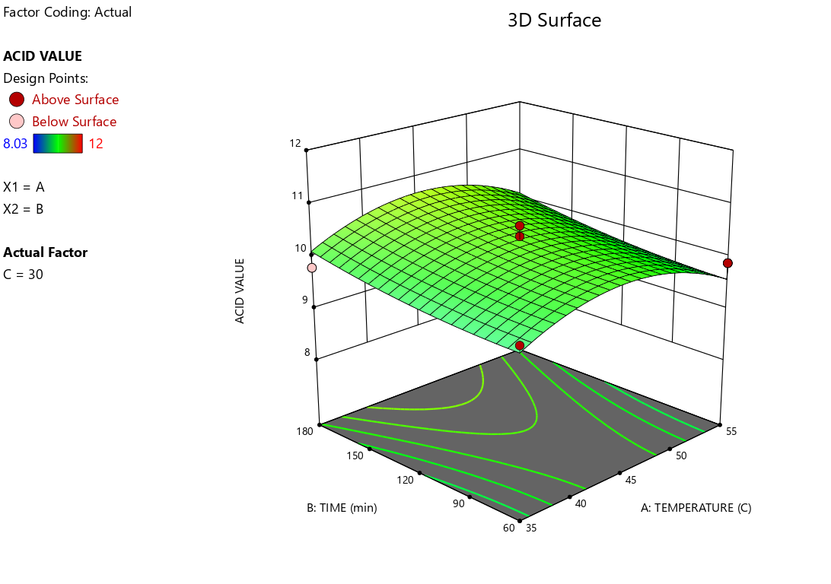
Fig. 3: Response surface plot showing the interactive effect of extraction temperature and extraction time on acid value
3.1.4 Peroxide Value (PV)
Peroxide values ranged from 8.70 to 13.00 meqO₂/kg (Table 2). The recorded PV values are consistent with those reported for cottonseed oil (Kalkan & Maskan, 2025) and fall below the threshold of 15 meqO₂/kg stipulated for freshly extracted edible oils (AOCS, 2004). ANOVA confirmed that extraction time (B: p = 0.0020) and temperature (A: p = 0.0136) had significant linear effects, and that the BC interaction was significant (p = 0.0009). The response surface (Fig. 4) indicated that prolonged extraction at elevated temperatures accelerated lipid oxidation and peroxide accumulation, consistent with free-radical chain reactions initiated by thermal stress. The regression equation for peroxide value is presented in Equation (6).

$PV=10.57+0.6188A-0.8588B+0.0950C-0.5750AB+0.5125AC+1.36BC (6)$
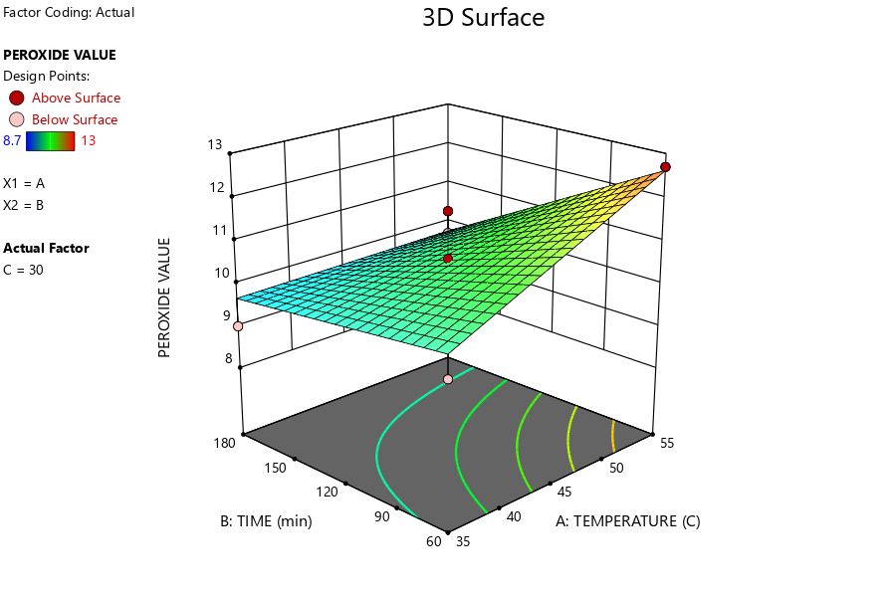
Fig. 4: Response surface plot showing the interactive effect of extraction temperature and extraction time on peroxide value

3.1.5 Saponification Value (SV)
Saponification values ranged from 182.00 to 200.80 mgKOH/g (Table 2). ANOVA confirmed significant quadratic effects of temperature (A²: p = 0.0152), extraction time (B²: p = 0.0035), and solid-to-solvent ratio (C²: p = 0.0011), along with significant interaction effects of AC (p = 0.0112) and BC (p = 0.0414). The response surface (Fig. 5) demonstrated that moderate temperatures facilitated more complete extraction of shorter-chain fatty acid glycerides, yielding higher saponification values. The recorded SV range is consistent with values reported for semi-drying oils, such as soybean oil and palm kernel oil (Gunstone, 2011), confirming the utility of okra seed oil as a feedstock in soapmaking and cosmetic industries. The regression equation is presented in Equation (8).

$SV=195.03-2.91A+0.6150B+2.29C-0.6175AB+2.60AC+1.90BC-2.37A^{2}+3.21B^{2}-3.93C^{2}$(7)

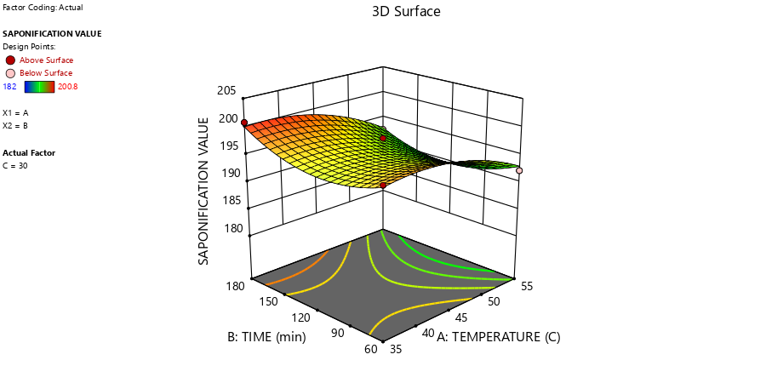
Fig. 5: Response surface plot showing the interactive effect of extraction temperature and extraction time on saponification value
3.1.6 Refractive Index
The refractive index ranged from 1.45 to 1.47 across the experimental runs (Table 2). ANOVA for the quadratic RI model indicated that the AB interaction (p = 0.0015) and the quadratic terms B² (p = 0.0342) and C² (p = 0.0001) were significant. The response surface plot (Fig. 6) showed that RI increased marginally with extraction temperature, consistent with the temperature-dependent variation in fatty acid composition and oil density. These values fall within the acceptable ranges reported for crude edible oils (Anwar et al., 2011). The regression equation is presented in Equation (8).
$RI=1.46-0.0002A-0.0001B+0.0001C-0.0040AB+0.0005AC-0.0003BC+0.0018A2+0.0020B2+0.0060C2$ (8)
3.1.7 Iodine Value (IV)
Iodine value varied considerably from 15.86 to 42.82 g I₂/100 g (Table 2), reflecting substantial differences in the degree of fatty acid unsaturation under different extraction conditions. ANOVA revealed that both temperature (A: p = 0.0005) and solid-to-solvent ratio (C: p = 0.0009) had significant linear effects on IV, with a significant AB interaction (p < 0.0001) and a dominant quadratic effect of temperature (A²: p < 0.0001). The response surface (Fig. 7) exhibited a characteristic U-shaped relationship between temperature and IV, suggesting preferential extraction of polyunsaturated fractions at both low and high temperatures, possibly linked to temperature-dependent differences in fatty acid solubility in n-hexane (Knothe & Steidley, 2007; Gunstone, 2011). The values recorded confirmed the classification of okra seed oil as a semi-drying oil, consistent with Ndangui et al. (2010). The regression equation is given in Equation (9).
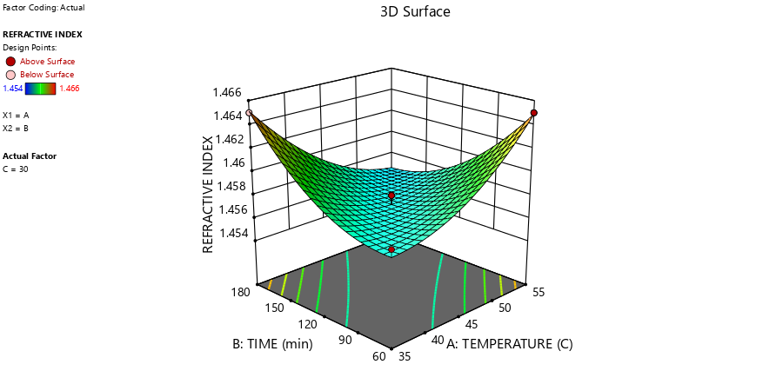
Fig. 6: Response surface plot showing the interactive effect of extraction temperature and extraction time on refractive index

$Iodine Value=17.81-2.68A+0.7212B+2.45C+5.32AB-0.18AC-0.3275BC+15.22A^{2}+2.23B^{2}+0.6162C^{2}$ (9)

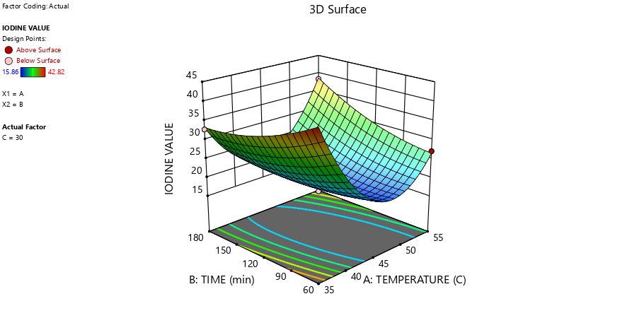
Fig. 7: Response surface plot showing the interactive effect of extraction temperature and extraction time on iodine value

3.1.8 pH
pH varied from 2.00 to 6.60 (Table 2). ANOVA for the quadratic pH model confirmed significant effects of extraction temperature (A: p = 0.0052) and the quadratic term C² (p = 0.0081). The response surface plot (Fig. 8) revealed that pH declined under prolonged extraction at elevated temperatures, reflecting progressive hydrolysis and increasing acidity of the oil. These findings align with previous reports that associate increased processing severity with the formation of acidic degradation products in oils (Tsai et al., 2023). Thus, these observations agree with the AV and FFA trends and further support the recommendation for controlled extraction conditions to preserve oil quality. The regression equation is presented in Equation (10).

$pH=3.10+1.21A-0.31B-0.225C+0.04AB-0.55AC+0.75BC-0.071A^{2}+0.179B^{2}+1.52C^{2}$ (10)

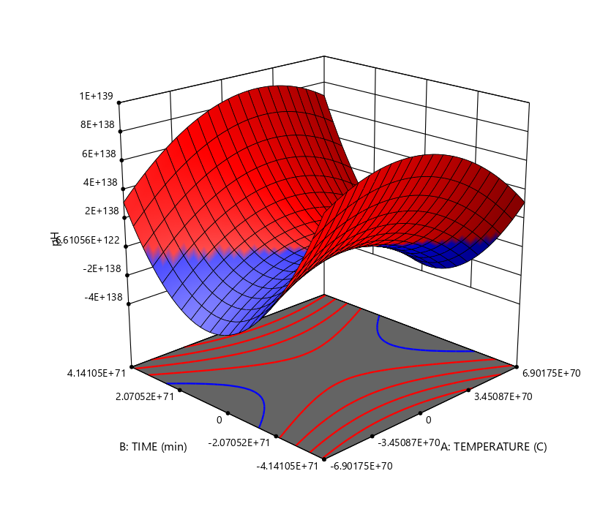
Fig. 8: Response surface plot showing the interactive effect of extraction temperature and extraction time on pH

3.2 Optimization
Seven applicable solutions were identified through the optimisation process using the software package. Thus, temperature, time, and solid-to-liquid ratio could be varied to maximise oil yield and minimise acid value, free fatty acid, and peroxide value, while saponification value, pH, iodine value, and refractive index were maintained within their specified ranges. The desirability of the selected solution was 0.67. The process conditions with the highest desirability for extracting a high yield of acceptable-quality okra oil were an extraction temperature of 36.96 °C, an extraction time of 100.49 min, and a solid-to-liquid ratio of 21.62 g/mL. These conditions gave an oil yield of 12.43%, free fatty acid of 21.48 mgKOH/g, acid value of 10.20 mgKOH/g, peroxide value of 8.70 meqO₂/kg, saponification value of 190.00 mgKOH/g, refractive index of 1.47, iodine value of 18.77 gI₂/100g, and pH of 3.24.

4. Conclusion

Extraction temperature, extraction time, and solid-to-solvent ratio influenced both the recovery and physicochemical properties of solvent-extracted okra seed oil. The response surface models adequately described the experimental responses, with coefficients of determination ranging from 0.8331 to 0.9931. Within the investigated factor ranges, numerical optimisation identified 36.96 °C, 100.49 min, and a solid-to-solvent ratio of 21.62 g/mL as the preferred extraction conditions. The predicted oil yield under these conditions was 12.43%, while the corresponding peroxide value, saponification value, refractive index, iodine value, and pH were 8.70 meq O₂/kg, 190.00 mg KOH/g, 1.47, 18.77 g I₂/100 g, and 3.24, respectively. The findings demonstrate that simultaneous consideration of yield and quality responses can support the selection of practical extraction conditions. Accordingly, response surface methodology provides a useful statistical basis for optimising okra seed oil extraction within the experimental domain examined. Further verification of the predicted optimum would strengthen its application beyond the laboratory conditions used in this study.

Limitation
The findings are limited to okra seeds obtained from one local source and to the specific moisture content, particle size, n-hexane solvent, factor ranges, and laboratory-scale conditions examined. The study did not compare alternative solvents or extraction methods, and it did not assess detailed fatty acid composition, sensory quality, storage stability, or scale-up performance. The predicted optimum should therefore be interpreted within the experimental domain and independently validated before broader application.

Declaration of AI Use
This manuscript was prepared through the combined contributions of all author(s), including contributions to the study design, data, content development, results, interpretation, and related scholarly work. The author(s) acknowledge the use of Grammarly and ChatGPT to assist with grammar checking, language refinement, reference formatting. These AI-assisted tools were not used as authors and did not replace the intellectual contributions or scholarly judgment of the author(s). All AI-assisted outputs, including content, references, and interpretations, were carefully reviewed, revised, verified, and approved by the author(s). The author(s) accept full responsibility for the accuracy, integrity, and final content of the manuscript.

COMPETING INTERESTS
Authors have declared that no competing interests exist.

REFERENCES
Adelakun, O. E., Oyelade, O. J., Ade-Omowaye, B. I. O., Adeyemi, I. A., Van de Venter, M., & Koekemoer, T. C. (2009). Influence of pre-treatment on yield, chemical and antioxidant properties of a Nigerian okra seed (Abelmoschus esculentus Moench) flour. Food and Chemical Toxicology, 47(3), 657-661. https://doi.org/10.1016/j.fct.2008.12.023
Adeyanju, J. A., Ogunlakin, G. O., Adekunle, A. A., Alawode, G. E., & Majekolagbe, O. S. (2016). Optimization of oil extraction from coconut using response surface methodology. Journal of Chemical and Pharmaceutical Research, 8(1), 374-381. https://www.jocpr.com/articles/optimization-of-oil-extraction-from-coconut-using-response-surface-methodology-6411.html
Akinoso, R., Adegoroye, E. O., & Sanusi, M. S. (2023). Effects of roasting on physicochemical properties and fatty acids composition of okra seed oil. Measurement: Food, 9, Article 100076. https://doi.org/10.1016/j.meafoo.2023.100076
Akinoso, R., & Adeyanju, J. A. (2012). Optimization of edible oil extraction from Ofada rice bran using response surface methodology. Food and Bioprocess Technology, 5, 1372-1378. https://doi.org/10.1007/s11947-010-0456-8
American Oil Chemists' Society. (2004). Official methods and recommended practices of the AOCS (5th ed.). AOCS Press. https://www.aocs.org/technical-products/
Anwar, F., Rashid, U., Mahmood, Z., Iqbal, T., & Sherazi, T. H. (2011). Inter-varietal variation in the composition of okra (Hibiscus esculentus L.) seed oil. Pakistan Journal of Botany, 43(1), 271-280. https://www.pakbs.org/pjbot/paper_details.php?id=2650
Betiku, E., Olatundun, E. A., Taiwo, D. A., Omotunde, O. F., Omofaye, V. I., Babalola, B. A., Agboola, A. A., & Latinwo, L. M. (2024). Investigation of factors affecting extraction of Calophyllum inophyllum seed oil via response surface methodology. Journal of Oleo Science, 73(9), 1149-1158. https://doi.org/10.5650/jos.ess24022
Eddaoudi, F. E., El Guezzane, C., El Moudden, H., Badi, A., El Idrissi, Y., Harhar, H., Santanatoglia, A., Maggi, F., Caprioli, G., Bouyahya, A., & Tabyaoui, M. (2025). Optimization of seed oil extraction from Asphodelus tenuifolius Cav. using response surface methodology. Plants, 14(15), Article 2298. https://doi.org/10.3390/plants14152298
Guo, G., Xu, W., Zhang, H., Hu, X., Chen, Y., He, X., Huang, K., Ma, S., & Fu, J. (2024). Characteristics and antioxidant activities of seed oil from okra (Abelmoschus esculentus L.). Food Science & Nutrition, 12(4), 2393-2407. https://doi.org/10.1002/fsn3.3924
Gunstone, F. D. (Ed.). (2011). Vegetable oils in food technology: Composition, properties and uses (2nd ed.). Wiley-Blackwell. https://doi.org/10.1002/9781444339925
Kalkan, E., & Maskan, M. (2025). Ultrasound- and homogenization-assisted extraction of cottonseed oil using ethyl acetate: Optimization and evaluation of oil quality and energy aspect. Food and Bioprocess Technology, 18, 2033-2049. https://doi.org/10.1007/s11947-024-03582-y
Knothe, G., & Steidley, K. R. (2007). Kinematic viscosity of biodiesel components (fatty acid alkyl esters) and related compounds at low temperatures. Fuel, 86(16), 2560-2567. https://doi.org/10.1016/j.fuel.2007.02.006
Micha, R., Khatibzadeh, S., Shi, P., Fahimi, S., Lim, S., Andrews, K. G., Engell, R. E., Powles, J., Ezzati, M., & Mozaffarian, D. (2014). Global, regional, and national consumption levels of dietary fats and oils in 1990 and 2010: A systematic analysis including 266 country-specific nutrition surveys. BMJ, 348, Article g2272. https://doi.org/10.1136/bmj.g2272
Montgomery, D. C. (2005). Design and analysis of experiments (6th ed.). Wiley. https://bcs.wiley.com/he-bcs/Books?action=index&bcsId=2172&itemId=047148735X
Musa, S. H., Alhassan, A. S., Ahmed, U. A., Magami, S. M., & Ahmad, Y. M. (2023). Recent advances in seed oil extraction science: A review. Journal of Applied Chemical Science International, 14(2), 28-34. https://doi.org/10.56557/jacsi/2023/v14i28498
Nde, D. B., & Foncha, A. C. (2020). Optimization methods for the extraction of vegetable oils: A review. Processes, 8(2), Article 209. https://doi.org/10.3390/pr8020209
Ndangui, C. B., Kimbonguila, A., Nzikou, J. M., Matos, L., Pambou-Tobi, N. P. G., Abena, A. A., Silou, T., Scher, J., & Desobry, S. (2010). Nutritive composition and physico-chemical properties of gumbo (Abelmoschus esculentus L.) seed and its extracted oil. Research Journal of Environmental and Earth Sciences, 2(1), 49-54. https://maxwellsci.com/print/rjees/v2-49-54.pdf
Nia, S., Benguechoua, M., Hadj Mahammed, T., Reggagui, K., & Yousfi, M. (2025). Investigating the composition of fatty acid, tocopherol, and sterol contents and antioxidant capacity of oils from the seeds of Abelmoschus esculentus L. growing in Algeria. Turkish Journal of Biology, 49(1), 85-91. https://doi.org/10.55730/1300-0152.2726
Raji, F. A., & Akinoso, R. (2020). Effect of roasting temperature and duration on the quality of oil from walnut (Plukenetia conophorum) using response surface methodology. Asian Food Science Journal, 13(4), 1-12. https://doi.org/10.9734/afsj/2019/v13i430116
Tsai, Y.-H., Chiang, D., Li, Y.-T., Perng, T.-P., & Lee, S. (2023). Thermal degradation of vegetable oils. Foods, 12(9), Article 1839. https://doi.org/10.3390/foods12091839
U.S. Department of Agriculture, Foreign Agricultural Service. (2024). Nigeria: Oilseeds and products annual (GAIN Report No. NI2024-0006). https://apps.fas.usda.gov/newgainapi/api/Report/DownloadReportByFileName?fileName=Oilseeds+and+Products+Annual_Lagos_Nigeria_NI2024-0006.pdf
Yolmeh, M., & Jafari, S. M. (2017). Applications of response surface methodology in the food industry processes. Food and Bioprocess Technology, 10(3), 413-433. https://doi.org/10.1007/s11947-016-1855-2

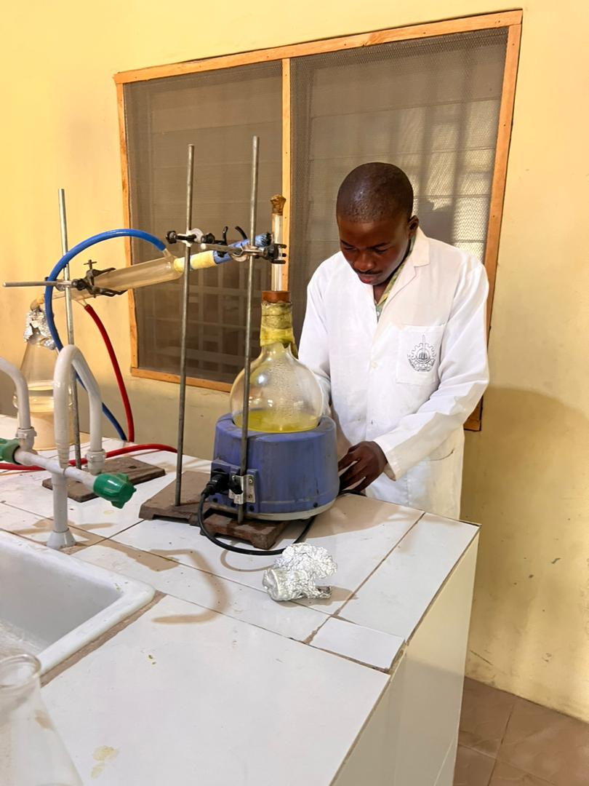

A
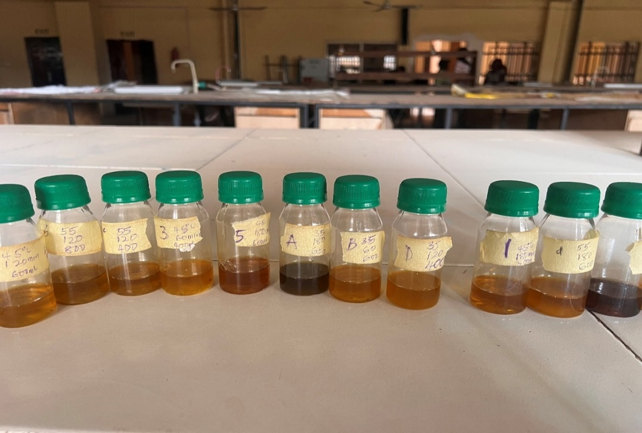 B Appendix I(A-B): Relevant pictures for the extraction of oil from okra seeds

