Original Research Article

Production and Quality Evaluation of Jam from Black Plum (Vitex Doniana) Fruit

Abstract
Black plum (Vitex doniana) is an underutilised indigenous fruit with potential for value-added processing, particularly in regions where post-harvest losses are common. Its natural pectin content and nutritional properties make it a suitable raw material for jam production. This study evaluated the suitability of black plum (Vitex doniana) fruit for jam production using different proportions of ripe and unripe fruits. Three jam formulations were prepared: 100% ripe fruit jam (RHJ), 60% ripe and 40% unripe fruit jam (RSJ), and 40% ripe and 60% unripe fruit jam (RFJ). The jam samples were subjected to proximate, physicochemical and sensory analyses using standard procedures. The results showed that fruit maturity influenced the quality characteristics of the jam samples. Increasing the proportion of unripe fruit increased titratable acidity, pectin content and viscosity, while reducing sugar content and total soluble solids decreased. RFJ recorded the highest pectin content (8.91%) and viscosity (87.47 dynes/cm²), whereas RHJ had the highest reducing sugar content (54.41%) and total soluble solids (68.85 °Brix). Sensory evaluation showed that black plum jam compared favourably with commercial black currant-strawberry jam in taste and mouthfeel and had a higher aroma score. However, its overall acceptability was slightly lower because of its darker colour. The findings indicate that black plum fruit has useful natural pectin and acceptable sensory attributes for jam production. Processing black plum into jam may support value addition and improve the utilisation of this underexploited indigenous fruit.
Keywords: Vitex doniana; jam formulation; fruit maturity; pectin content; titratable acidity; viscosity; proximate composition; sensory acceptability; value addition.

Introduction
Black plum (Vitex doniana) is a perishable indigenous fruit that may deteriorate through microbial contamination if it is not processed promptly. It can be consumed whole or processed into juice, jam and concentrate (Ajenifujah-Solebo & Aina, 2011). Fruit processing and preservation support value addition by reducing quality loss and extending product availability (Amit et al., 2017; Baker et al., 2005; Codex Alimentarius Commission, 2009). Juices are economically important fruit products; however, plum juices remain uncommon, and wild-growing indigenous fruits such as black plum continue to contribute to the diets and livelihoods of some African populations, particularly in sub-Saharan regions (Ajenifujah-Solebo & Aina, 2011). Wild fruits are also traded informally and may provide income for rural communities. Their importance is greater in dry regions where drought and weather-related challenges affect food availability. However, the loss of forest resources through urbanisation and industrialisation can reduce access to these fruits. Limited documentation on cultivation and slow progress in improving indigenous plant species for food use further justify the need for improved utilisation of perishable resources (Kader, 2005; Dadjo, 2014).
Black plum (Vitex doniana) is an indigenous deciduous fruit tree associated with rural livelihoods. The plant commonly grows in the wild, on the fringes of virgin forests, on farms and around dwellings in secondary bushes (Dadjo, 2014; Orwa et al., 2009). It is a tropical forest tree that also occurs in open woodland and savanna environments.
Black plum has more than twelve reported varieties. Related species include Vitex barbata, Vitex campartem, Vitex cordata and Vitex madiensis. Vitex doniana Sweet is among the common Vitex species in West Africa (Dadjo, 2014). The fruit occurs in northern, eastern and western Nigeria. It is green when immature and turns dark brown when fully ripe, with pulp surrounding a hard stone that contains one to four seeds (Dadjo, 2014). In parts of Delta State and Anambra State, black plum is referred to as "Mbembe". In Enugu State, it is called "Erigheri" or "Mgbamgba". In Abia State, it is called "Uchakiri" or "Uchakoro", while in Imo State it is referred to as "Achakiri" or "Urobia". The Hausa people in northern Nigeria call it "Dinya", the Fulani call it "Galbihi", and the Yoruba people in western Nigeria call it "Ori-nla" (Dadjo, 2014). The fruit is also referred to as African black plum or African olive (Ajenifujah-Solebo & Aina, 2011).

Black plum is a nutritious fruit. It contains approximately 77.03% moisture, 1.65% ash, 2.9% fat, 2.75% fibre, 8.10% protein and 7.57% carbohydrate. It also contains vitamin A (0.27), vitamins B1 (18.33), B2 (4.80), B6 (20.45m) and vitamin C (35.58) mg/100 g DW, respectively (Adejumo et al., 2013; Ajenifujah-Solebo & Aina, 2011; Agbede & Ibitoye, 2007). The minerals reported in mg/100 g DW include potassium (16.5), sodium (10.40), calcium (30.27), iron (5.20), copper (2.70), magnesium (20.10) and phosphorus (16.50) (Vunchi et al., 2011). Physicochemical and sensory results indicate that the fruit has soluble solids of 18.83 °Brix, pH 3.85, ascorbic acid of 33.35 mg, and Na, K and Ca contents of 0.1, 1.33 and 0.765 mg/100 g, respectively (Ajenifujah-Solebo & Aina, 2011). Black plum syrup can substitute for other syrups as a nutritive sweetener (Abu & Arogba, 2001; Burkill, 2000; Oumorou et al., 2010). The pulp may be promoted as a carbohydrate and lipid supplement for cereal-based diets in rural communities and as a relatively inexpensive raw material for juice production (Okigbo, 2001). Its moderate calcium value has also been associated with potential dietary use (Vunchi et al., 2011).
In some West African countries, including the Republic of Benin, the bark and leaves are used traditionally, while the young leaves are consumed as vegetables (Dadjo et al., 2012). The fruit pulp is consumed fresh, cooked or toasted and is locally marketed. It can be used to produce jam and wine, while the leaves are used traditionally for eye-related problems. The pounded leaves may also be added to warm filtered grain beer, and the bark yields a dye that can be used as a colourant (Dadjo et al., 2012). Studies have also investigated the phytochemical, antibacterial and flavour-related properties of Vitex doniana fruit and plant parts (Ali et al., 2017; Chinyere et al., 2021). Black plum can be processed into juice and jam. Like some other fruits, it contains higher pectin when unripe. Pectin is a complex plant-derived polysaccharide and a soluble fibre found in fruits and vegetables. It is a gelling agent that thickens fruit preserves, including jams and jellies. Pectin forms a gel during heating and may serve as a commercial thickener or gelling agent in jams and jellies. It may also be added to yoghurts and fruit juices as a stabiliser and used as an emulsifier in ice cream.
Pectin is particularly relevant to jam systems because controlled pectin addition can affect gel formation, spreadability and sensory response in fruit-based preserves (Chan et al., 2017; Chauhan et al., 2001; Veliu et al., 2025).
Recent fruit-product and jam studies indicate that formulation quality is commonly assessed through pH, total soluble solids, titratable acidity, pectin-related textural behaviour and sensory acceptability, while the balance of sugar, acid, pectin and processing conditions influences product performance (Arora & Avinash, 2025; Awolu et al., 2018; Bartholomew et al., 2003; Begum et al., 2018; Brandão et al., 2018; Chalchisa et al., 2022; Machalela et al., 2023; Zhang et al., 2025).
In Nigeria, especially in the eastern region, black plum has not received adequate attention because of limited awareness of its nutritional composition, preservation methods and conversion into value-added products (Dadjo, 2014; Okigbo, 2001). Its usefulness has not been fully harnessed. Apart from a few trees retained as shade plants on agricultural land, new plants are rarely established, and fully mature fruits are often left at the base of the tree for wild animals. Information on the nutritional value of black plum and its use in juice, jam and concentrate production remains limited. The fruit is underutilised in Nigeria, particularly in the eastern region. It is not readily accessible, and ripe fruits are often collected from the ground rather than harvested directly. This underutilisation is partly associated with limited knowledge of its benefits and potential food-industry applications. Limited domestication may also contribute to its gradual decline, although seed-related studies suggest that propagation factors can influence its establishment (Adelani et al., 2019; Dadjo, 2014). Despite the reported nutritional and processing potential of black plum, information remains limited on how different proportions of ripe and unripe fruits influence the proximate composition, physicochemical properties and sensory acceptability of black plum jam.
Therefore, this study aimed to produce and evaluate the quality of jam made from black plum (Vitex doniana) fruit using different ripe and unripe fruit formulations.

MATERIALS AND METHODS

Material Procument
Black plum (Vitex doniana) fruits were collected from Urobia farmland in Umuchima Community, Ideato South Local Government Area, Imo State, Nigeria. The fruits are shown in Plate 1 and Plate 2. The chemicals, reagents and equipment used were obtained from the Department of Food Science and Technology, Federal University of Technology Owerri (FUTO), Nigeria, and were of analytical grade. Other ingredients for fruit preserves, including white granulated sugar, lime (citric acid) and containers, were purchased from Ochanja Market, Onitsha, Anambra State, Nigeria.

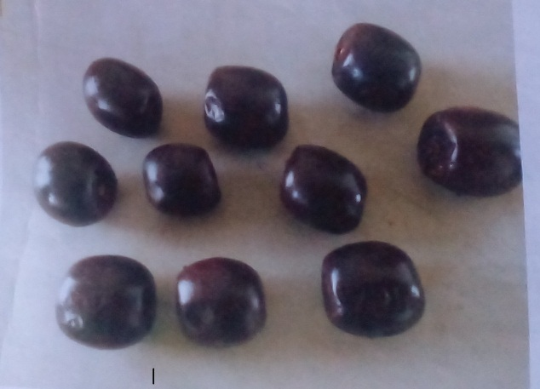

Plate1: Ripened Black plum Fruit Source: Urobia farmland Umuchima.
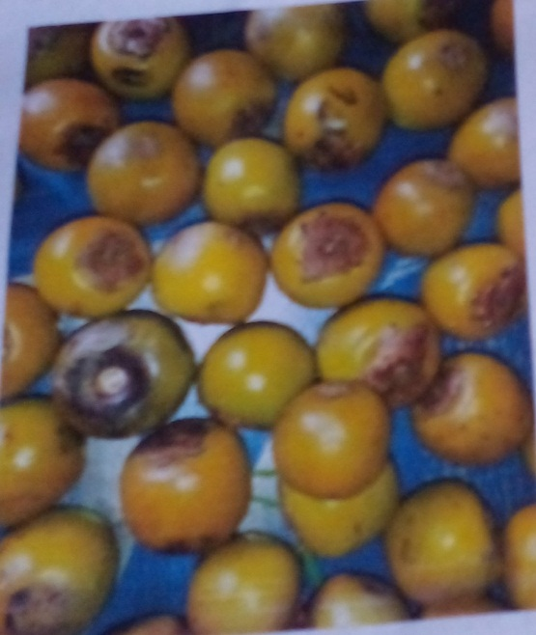
Plate 2: Unripe Black Plum Fruit
METHODS

Sample Preparation

Production of Jam Samples
The black plum jam samples were produced using the methods outlined by Ajenifujah-Solebo and Aina (2011) and Ofoedum et al. (2025a, 2025b). Freshly harvested ripe and mature unripe black plum fruits were obtained from the bush farm. They were sorted and washed with water. The kernels were removed and discarded, leaving only the pulp and skin. Three formulations were prepared from the pulp and skin obtained. One container contained 100% ripe black plum pulp, the second contained 60% ripe and 40% mature unripe black plum pulp by mass, and the third contained 40% ripe and 60% unripe black plum pulp by mass. The pulp in each container was blended, and 49% by weight of the puree (blended pulp and skin) was combined with 50% by weight of sugar and 1% citric acid. The mixtures were boiled in a pot and allowed to simmer at 165 °C for 15 min, after which each sample was bottled. The jams were filled hot into sterilised glass jars, leaving headspace, and then sealed. The jams produced from 100%, 60% and 40% ripe black plums were labelled RHJ, RSJ and RFJ, respectively. The flow chart is shown in Figure 1.
The labelled jam samples were then stored in a refrigerator at 4 °C until further analysis.

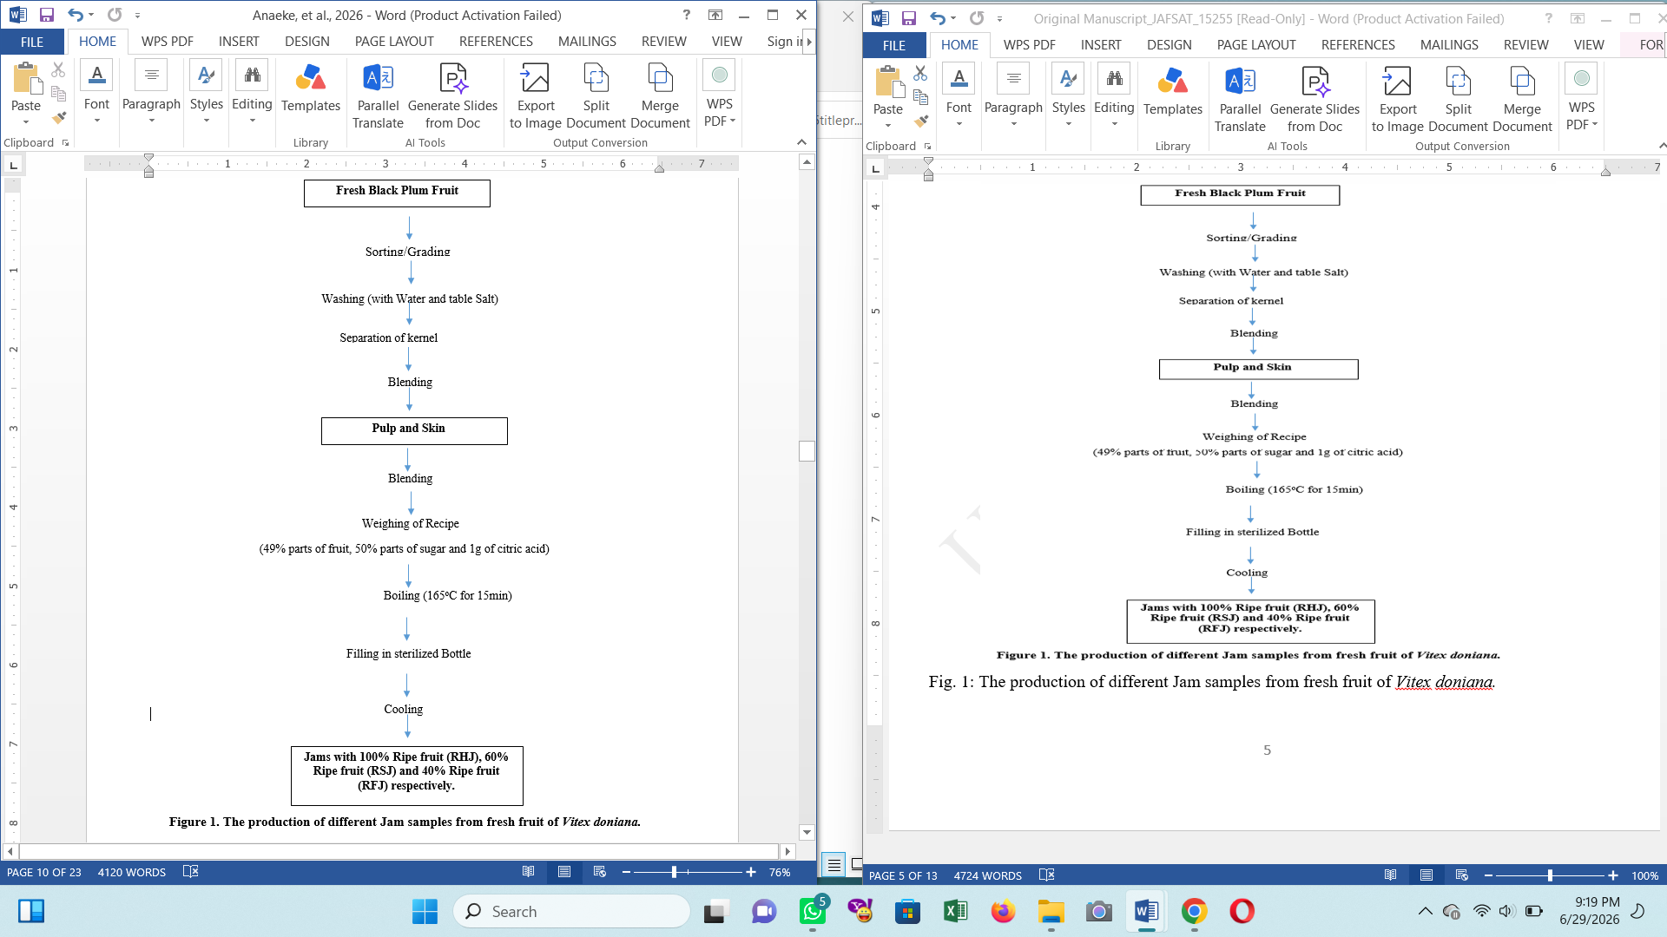

Proximate Analysis
The methods of AOAC (2016) were used to determine the proximate composition of the black plum samples. The measured parameters included ash content, moisture, crude fat, protein and carbohydrate. Standard analytical procedures were used for estimation, and the readings obtained were calculated and recorded.

Determination of the Physicochemical Properties of Jams samples made from Black plum
The AOAC (2016) method was used to determine the physicochemical properties of the samples.
Determination of Total Phenols
A 0.2 g portion of the sample was mixed with 10 mL of methanol. The intensity of the resulting blue colouration was measured as absorbance in a colorimeter at a wavelength of 540 nm (AOAC, 2016). The percentage phenol content was calculated as follows:
%Phenol = × 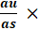 C × × D (3.21)
Where;
W = weight of the sample
a_{u} = Absorbance of the test sample
a_{s} = Absorbance of standard phenol solution
C = Concentration of standard phenol solution
Vt = Total volume of extract
Va = Volume of analytes,
D: Dilution factor

Viscosity
This procedure was described by Onwuka (2005). A 15 g portion of the sample was made into a slurry in 300 mL of water in a beaker. The beaker containing the mixture was fixed below the impeller blade of a Brookfield viscometer, model LVT (Brookfield Engineering Laboratories Inc., Middleboro, MA 02346, USA), for rheological measurements.

Determination of pH
After the pH meter electrode was properly cleaned with distilled water, the reading was set to zero. The meter was then standardised at 25 °C using buffer solutions of pH 4, 7 and 9. After 25 mL of each sample had been pipetted into separate beakers, the pH electrode was dipped into the samples, and the readings were allowed to stabilise before being recorded.

Determination of soluble solids (ºBrix)
A portable refractometer, VBR32T Brix/ATC-32%, was used to measure the °Brix of the jam samples. The glass prism of the digital refractometer was cleaned with distilled water and wiped with a clean wiper. Using a micropipette, a few drops of the test sample were applied to the optical area of the refractometer. The reading was then observed on the visual display and recorded.

Total titratable acidity
The method of Ajenifujah-Solebo and Aina (2011) was adopted for this determination. To ensure complete mixing of the sample and indicator, 5 mL of the sample and 0.5 mL (3 drops) of 5% phenolphthalein indicator were added to a conical flask and gently shaken. The contents of the flask were titrated against 0.1N sodium hydroxide on a white background. Titration continued until a persistent pink colouration was observed. The endpoint was determined by recording the burette reading. Total acidity was calculated as follows:
Total titratable acidity is equal to (V × N × 75)/(1000 × v) × 100.
V is the milliliter of sodium hydroxide solution used in the titration.
N is the sodium hydroxide solution's normality, and v is the sample volume (ml).

Sensory Evaluation
Twenty (20) untrained panellists from the Federal University of Technology, Owerri, Imo State, evaluated the jam samples for acceptability and preference using the methodology outlined by Chukwu (2017). Using a nine-point hedonic scale, each participant scored the jam samples for appearance, taste, flavour, texture and overall acceptability, with 9 representing "extremely liked" and 1 representing "extremely disliked".

Statistical Analysis
The experimental results from triplicate determinations were expressed as mean ± standard deviation (SD). One-way analysis of variance (ANOVA) was used to analyse the data obtained, following the method adopted from Chukwu (2017). Fisher's least significant difference test at the 95% confidence level (P ≤ 0.05) was used to separate the means after statistical analysis using Statistical Package for Service Solutions (SPSS) version 15.0. The data were displayed in tabular and graphical formats.

RESULTS AND DISCUSSION
Table 1. The Proximate composition of the Jam samples (%)

Sample | Moisture | Ash | Dietary Fibre | Fat | Protein | Carbohydrates
RHJ | 26.46ª±1.68 | 1.17ª±0.02 | 0.44^{c}±0.04 | 0.43ª±0.03 | 0.83^{b}±0.11 | 70.67^{c}±1.69
RSJ | 23.16^{b}±0.92 | 1.15ª±0.02 | 0.96^{b}±0.09 | 0.48ª±0.05 | 1.04ª±0.03 | 73.21^{b}±0.94
RFJ | 18.09^{c}±0.91 | 1.03^{b}±0.09 | 1.02^{b}±0.04 | 0.49ª±0.04 | 1.16ª±0.08 | 78.21ª±0.85
SBJ | 24.31^{b}±0.80 | 0.41^{c}±0.03 | 1.29ª±0.08 | 0.09^{b}±0.01 | 0.31^{c}±0.06 | 73.59^{b}±0.82
LSD_{(0.05)} | 2.13 | 0.09 | 0.13 | 0.07 | 0.14 | 2.12
The mean values with same superscripts are not significantly different, while the mean scores with different superscripts are significantly different
Keys:
RHJ =Jam formulated with 100% ripened black plum fruit
RSJ = Jam formulated with 60% ripened and 40% unripe black plum fruit
RFJ = Jam formulated with 40% ripened and 60% unripe black plum fruit
SBJ = Commercial Jam
Table 2: The Physicochemical composition of the Jam samples
Samples | TTA (%) | pH | Viscosity (shear stress dynes/cm²) | Pectin content (%) | Reducing Sugar (%) | Brix (ºB)
RHJ | 0.41^{b}±0.06 | 3.40^{b}±0.10 | 74.62^{d}±2.08 | 5.64^{c}±0.79 | 54.41^{b}±1.11 | 68.85ª±2.28
RSJ | 0.59ª±0.07 | 3.10^{c}±0.10 | 80.13^{c}±1.68 | 7.55^{bc}±0.47 | 43.09^{c}±1.75 | 60.41^{b}±3.34
RFJ | 0.64ª±0.02 | 3.10^{c}±0.10 | 87.47^{b}±1.47 | 8.91^{b}±1.99 | 37.35^{d}±3.76 | 54.39^{c}±2.54
SBJ | 0.55ª±0.03 | 4.90ª±0.20 | 94.12ª±3.88 | 14.08ª±1.30 | 62.18ª±2.32 | 71.33ª±2.12
LSD_{(0.05)} | 0.1 | 0.25 | 4.65 | 2.41 | 4.6 | 4.92
The mean values with same superscripts in the same are not significantly different, while those with different subscripts are significantly different
RHJ =Jam formulated with 100% ripened black plum fruit
RSJ = Jam formulated with 60% ripened and 40% unripe black plum fruit
RFJ = Jam formulated with 40% ripened and 60% unripe black plum fruit
SBJ = Commercial Jam

Table 3: The Sensory evaluation of the Jam samples
Samples | Taste | Aroma | Appearance | Mouthfeel | Texture | Overall Acceptability
SBJ | 7.35ª±0.93 | 7.15^{b}±1.31 | 6.70ª±1.30 | 7.85ª±1.37 | 7.20ª±1.01 | 7.80ª±0.55
BPJ | 7.25ª±0.85 | 8.05ª±1.05 | 6.30^{b}±1.17 | 7.10ª±1.17 | 6.15^{b}±1.19 | 7.05^{b}±0.51
LSD_{(0.05)} | 0.55 | 0.74 | 0.27 | 0.79 | 0.58 | 0.33

Each value is the mean of 20th panelists. The mean values with different superscripts down a row are significantly different.
SBJ= Store bought jam (black currant-strawberry Jam), BPJ= Black plum jam.

Proximate composition of the Jams
The results of the proximate composition of the three jam samples produced and the commercially produced black currant jam are shown in Table 1. The jam samples were produced from the same quantities of black plum pulp and skin (45 parts) and sugar (55 parts). Sample RHJ was produced from 100% ripe black plum fruit, RSJ from 60% ripe and 40% unripe fruit, and RFJ from 40% ripe and 60% unripe black plum fruit. Sample SBJ was the commercially purchased black currant jam. The moisture content of the jam samples ranged from 18.09% (RFJ) to 26.46% (RHJ). The moisture content of RHJ was significantly higher, followed by that of the commercially produced jam (SBJ, 24.31%). There was no significant difference (P ≥ 0.05) in the moisture content of the commercially produced jam (SBJ) and jam sample RSJ. The moisture content of sample RFJ was lower than that of the other samples. Sample RHJ, which contained 100% ripe fruit, had a higher moisture content than the other samples. This suggests that the pectin in the 40% ripe fruit jam (RFJ) did not retain as much moisture as the other samples. Some moisture may also have evaporated during boiling.
The three jam samples produced from black plum fruit had higher ash contents than the commercially produced jam. The higher ash content of the produced jam samples suggests that fruit-derived components contributed to the mineral residue, whereas the commercial pectin used in the commercial black currant-strawberry jam may have contributed less ash. There was no significant difference (P ≥ 0.05) in ash content between the jam produced with 60% ripe fruit (RSJ) and that produced with 40% ripe fruit (RFJ). The results obtained in this study are related to those reported by Amah and Okogeri (2019) and Kader (2005).

Physico-chemical composition of Jam samples
The results of the physicochemical composition are shown in Table 2. The titratable acidity of the jam samples ranged from 0.41% to 0.64%, with the jam made from 40% ripe and 60% unripe black plum fruit (RFJ) having the highest value and the jam from 100% ripe black plum fruit (RHJ) having the lowest value. This implies that a higher percentage of unripe fruit in the jam formulation increased titratable acidity and that ripening reduced acid values. There was no significant difference in titratable acidity among the jam containing 60% ripe fruit, the jam containing 40% ripe fruit and the store-bought jam. The pH level increased with ripening; therefore, as the fruit ripened, acidity decreased. However, the store-bought jam (SBJ) had a significantly higher pH than the jam produced from 100% ripe fruit (RHJ).
The pH measures the amount of hydrogen ions and hydroxyl ions in a solution (Ofoedum et al., 2024). The viscosity of the jam samples ranged from 74.62 dynes/cm² in RHJ to 87.47 dynes/cm² in RFJ. The viscosity of RSJ was significantly higher than that of RHJ but lower than that of RFJ. This implies that a higher unripe fruit component in the jam increased pectin content and viscosity. Fruit tends to lose pectin content as it ripens. The store-bought jam (SBJ) had the highest viscosity among the jam samples. The high viscosity and pectin content of SBJ may be due to the commercial pectin added during production. The pectin from black plum improved the viscosity and acceptability of the jam. Similarly, °Brix and reducing sugar content increased with a higher percentage of ripe fruit. The store-bought jam (SBJ) recorded the highest °Brix and reducing sugar content, possibly because of the type of fruit and sugar used in its formulation. This may explain why the organoleptic analysis of syrup produced by concentrating black plum juice compared favourably with sucrose in sensory properties in model foods (Abu & Arogba, 2001; Jat et al., 2018).

Sensory evaluation of Jam samples

The results of the sensory evaluation between the store-bought jam (SBJ) and the jam produced from fully ripe black plum fruit (BPJ) are shown in Table 3. There was no statistical difference in taste between the two jams. However, there was a significant difference (P ≤ 0.05) in aroma, with black plum jam (BPJ) receiving a higher score (8.05) than black currant-strawberry jam (SBJ; 7.15). For appearance, the store-bought jam had a higher score (6.70), while the 100% ripe black plum jam had a lower score (6.30). There was also no significant difference in taste and mouthfeel between the black plum jam produced with 100% ripe fruit and the store-bought jam. However, the store-bought jam was more acceptable than the black plum jam because of the dark colour of the black plum jam. This implies that the taste of the two jam samples was statistically similar, but the black plum jam was rated lower in appearance, possibly because of its very dark black-brown colour, which may have resulted from high heat treatment, caramelisation and the Maillard reaction. When subjected to high temperatures, sugars in the presence of ascorbic acid can turn brown and may also caramelise. The mouthfeel evaluation of the jam samples was statistically similar, and the flavour of the black plum jam was rated higher than that of the store-bought jam. In terms of texture, consistency and spreadability, the store-bought jam differed significantly from the black plum jam. For overall acceptability, the store-bought jam had a higher score (7.80) than the black plum jam (7.05), although the black plum jam was still accepted. The dark appearance of the black plum jam may have reduced its acceptability, even though it had acceptable taste. The use of mixed fruit in this formulation to improve colour acceptance is recommended. Yellow fruits such as mango or pawpaw could be blended with black plum to produce a lighter colour that may be more acceptable to consumers. Agbede and Ibitoye (2007), Ofoedum et al. (2025a) and Ofoedum et al. (2025b) reported comparable findings in sensory evaluation studies.

Conclusions
This study showed that black plum fruit can be used to produce acceptable jam. Fruit maturity affected the proximate and physicochemical properties of the jam samples. The inclusion of unripe fruit increased pectin content, viscosity and titratable acidity, indicating its contribution to gel formation and product consistency. Jam produced from fully ripe fruit had higher reducing sugar content and total soluble solids, while formulations containing higher proportions of unripe fruit showed improved pectin-related characteristics. Sensory evaluation indicated that black plum jam was generally accepted by the panellists and compared favourably with commercial jam in taste, aroma and mouthfeel. However, the darker colour of the product reduced its appearance score and slightly lowered overall acceptability. These findings suggest that black plum fruit is a useful raw material for jam production and may support value addition to this underutilised indigenous fruit. Further work should improve colour, formulation balance, storage stability and shelf-life evaluation.

Limitations
This study was limited to three jam formulations prepared from ripe and unripe black plum fruit. Storage stability, shelf life, microbial quality, antioxidant activity and colour parameters were not fully reported. The sensory evaluation used a limited panel size and compared only one black plum jam sample with a commercial product. Processing conditions, pectin determination and formulation basis require clearer reporting. Further studies should include standardised processing, larger sensory panels and detailed shelf-life evaluation.
Declaration of AI Use

This manuscript was prepared through the combined contributions of all author(s), including contributions to the study design, data, content development, results, interpretation, and related scholarly work. The author(s) acknowledge the use of Grammarly and ChatGPT to assist with grammar checking, language refinement, reference formatting. These AI-assisted tools were not used as authors and did not replace the intellectual contributions or scholarly judgment of the author(s). All AI-assisted outputs, including content, references, and interpretations, were carefully reviewed, revised, verified, and approved by the author(s). The author(s) accept full responsibility for the accuracy, integrity, and final content of the manuscript.

REFERENCES

• Abu, J. D., & Arogba, S. S. (2001). High temperature drying characteristics and moisture adsorption isotherms of black plum (Vitex doniana) syrup and syrup-starch. International Journal of Food Properties, 4(2), 285–295. https://doi.org/10.1081/JFP-100105194
• Adejumo, A. A., Alaye, S. A., Ajagbe, R. O., Abi, E. A., & Adedokun, F. T. (2013). Nutritional and anti-nutritional composition of black plum (Vitex doniana). Journal of Natural Sciences Research, 3(12), 144–148. https://www.iiste.org/Journals/index.php/JNSR/article/view/8520
• Adelani, D. O., Suleiman, R., & Apene, E. (2019). Effect of periods of hydro-priming and seed weights on the germination of Vitex doniana Sweet seeds. Journal of Research in Forestry, Wildlife and Environment, 11(3), 185–194. https://www.ajol.info/index.php/jrfwe/article/view/190292
• Agbede, J. O., & Ibitoye, A. A. (2007). Chemical composition of black plum (Vitex doniana): An underutilized fruit. Journal of Food, Agriculture and Environment, 5(2), 95–96.
• Ajenifujah-Solebo, S. O., & Aina, J. O. (2011). Physico-chemical properties and sensory evaluation of jam made from black-plum fruit (Vitex doniana). African Journal of Food, Agriculture, Nutrition and Development, 11(3), 4772–4784. https://doi.org/10.4314/ajfand.v11i3.66629
• Ali, M., Aminu, F., & Ibrahim, I. S. (2017). In vitro assessment of antibacterial activity and phytochemical screening of Vitex doniana on clinical isolates of Salmonella typhi. International Journal of Advanced Academic Research, 3(1), 9–16. https://www.ijaar.org/articles/Volume3-Number1/Sciences-Technology-Engineering/ijaar-ste-v3n1-jan17-p13.pdf
• Amah, U. J., & Okogeri, O. (2019). Nutritional and phytochemical properties of wild black plum (Vitex doniana) seed from Ebonyi State. International Journal of Horticulture, Agriculture and Food Science, 3(1), 32–36. https://doi.org/10.22161/ijhaf.3.1.5
• Amit, S. K., Uddin, M. M., Rahman, R., Islam, S. M. R., & Khan, M. S. (2017). A review on mechanisms and commercial aspects of food preservation and processing. Agriculture & Food Security, 6, Article 51. https://doi.org/10.1186/s40066-017-0130-8
• Kader, A. A. (2005). Increasing food availability by reducing postharvest losses of fresh produce. Acta Horticulturae, 682, 2169–2176. https://doi.org/10.17660/ActaHortic.2005.682.296
• AOAC International. (2016). Official methods of analysis of AOAC International (20th ed.). AOAC International. https://www.aoac.org/scientific-solutions/standards-and-official-methods/
• Arora, P., & Avinash, P. (2025). Development of micronutrient-rich ready-to-eat food products using millet flours: Nutritional and sensory evaluation. Asian Journal of Current Research, 10(4), 416–428. https://doi.org/10.56557/ajocr/2025/v10i410083
• Awolu, O. O., Okedele, G. O., Ojewumi, M. E., & Oseyemi, F. G. (2018). Functional jam production from blends of banana, pineapple and watermelon pulp. International Journal of Food Science and Biotechnology, 3(1), 7–14. https://doi.org/10.11648/j.ijfsb.20180301.12
• Baker, R. A., Berry, N., Hui, Y. H., & Barrett, D. M. (2005). Fruit preserves and jams. In D. M. Barrett, L. Somogyi, & H. Ramaswamy (Eds.), Processing fruits: Science and technology (2nd ed., pp. 113–132). CRC Press. https://doi.org/10.1201/9781420040074
• Bartholomew, D. P., Paull, R. E., & Rohrbach, K. G. (Eds.). (2003). The pineapple: Botany, production and uses. CABI Publishing. https://doi.org/10.1079/9780851995038.0000
• Begum, S., Das, P. C., & Karmoker, P. (2018). Processing of mixed fruit juice from mango, orange and pineapple. Fundamental and Applied Agriculture, 3(2), 440–445. https://doi.org/10.5455/faa.289995
• Brandão, T. M., do Carmo, E. L., Elias, H. E. S., de Carvalho, E. E. N., Borges, S. V., & Martins, G. A. S. (2018). Physicochemical and microbiological quality of dietetic functional mixed cerrado fruit jam during storage. The Scientific World Journal, 2018, Article 2878215. https://doi.org/10.1155/2018/2878215
• Burkill, H. M. (2000). The useful plants of West Tropical Africa: Volume 5, Families S–Z. Royal Botanic Gardens, Kew. https://press.uchicago.edu/ucp/books/book/distributed/U/bo9857025.html
• Chalchisa, T., Zegeye, A., Dereje, B., & Tolesa, Y. (2022). Effect of sugar, pectin, and processing temperature on the qualities of pineapple jam. International Journal of Fruit Science, 22(1), 711–724. https://doi.org/10.1080/15538362.2022.2113598
• Chan, S. Y., Choo, W. S., Young, D. J., & Loh, X. J. (2017). Pectin as a rheology modifier: Origin, structure, commercial production and rheology. Carbohydrate Polymers, 161, 118–139. https://doi.org/10.1016/j.carbpol.2016.12.033
• Chauhan, S. K., Tyagi, S. M., & Singh, D. (2001). Pectinolytic liquefaction of apricot, plum and mango pulps for juice extraction. International Journal of Food Properties, 4(1), 103–109. https://doi.org/10.1081/JFP-100002190
• Chinyere, I., Julius, I. U., & Samuel, O. E. (2021). Determination of the flavoring components in Vitex doniana fruit following hydrodistillation extraction. American Journal of Food and Nutrition, 9(2), 69–75. https://doi.org/10.12691/ajfn-9-2-2
• Chukwu, M. (2017). Production and organoleptic attributes of ogiri-ahuekere produced from groundnut (Arachis hypogaea Linn.) seeds. Research Journal of Food Science and Quality Control, 3(2), 39–45. https://iiardjournals.org/get/RJFSQC/VOL.%203%20NO.%202%202017/PRODUCTION%20AND%20ORGANOLEPTIC.pdf
• Codex Alimentarius Commission. (2009). Standard for jams, jellies and marmalades (CXS 296-2009). Food and Agriculture Organization/World Health Organization. https://www.fao.org/input/download/standards/11254/CXS_296e.pdf
• Dadjo, C. (2014). Assessment of nutritional variation and establishment of an efficient tissue culture propagation protocol for Vitex doniana Sweet (Lamiaceae) from Benin (Western Africa) [Master’s thesis, Jomo Kenyatta University of Agriculture and Technology]. https://ir.jkuat.ac.ke/bitstream/handle/123456789/3897/Colombe%20DADJO%20MSc%20Thesis.pdf
• Dadjo, C., Assogbadjo, A. E., Fandohan, B., Kakaï, R. G., Chakeredza, S., Houehanou, T. D., van Damme, P., & Sinsin, B. (2012). Uses and management of black plum (Vitex doniana Sweet) in southern Benin. Fruits, 67(4), 239–248. https://doi.org/10.1051/fruits/2012017
• Jat, R., Mahawer, L. N., Bairwa, H. L., Meena, R. H., Pilania, S., & Singh, M. (2018). Sensory evaluation and microbial analysis of rose petal jam. Journal of Pharmacognosy and Phytochemistry, 7(5), 617–620. https://www.phytojournal.com/archives/2018.v7.i5.5611/sensory-evaluation-and-microbial-analysis-of-rose-petal-jam
• Machalela, A. A., Massingue Júnior, A. A., Vatiro, A., & Nanelo, R. F. (2023). Production and characterization of tomato (Lycopersicon esculentum) jam. Asian Food Science Journal, 22(10), 120–131. https://doi.org/10.9734/afsj/2023/v22i10679
• Ofoedum, A. F., Chikelu, E. C., Nwuka, M. U., Olawuni, I. A., Uzoukwu, A. E., Alagbaoso, S. O., Eluchie, C. N., Okezie, F. P., Anaeke, E. J., & Odeyemi, T. A. (2024). Antioxidant activities and sensory evaluation of functional beverages produced by incorporation of crude extracts from tropical spices. Journal of Food Legumes, 37(4), 462–471. https://doi.org/10.59797/jfl.v37.i4.234
• Ofoedum, A. F., Owuamanam, C. I., Iwouno, J. O., Olawuni, I. A., Abbah, E. C., Uyanwa, N. C., Anaeke, E. J., & Ofoedum, S. L. (2025a). Functional and storage stabilities of functional beverages developed from crude extracts from tropical spices (Zingiber officinale, Monodora myristica and Tetrapluera tetraptera). Journal of Food Legumes, 38(4), 624–632. https://doi.org/10.53550/jfl.v38.i4.313
• Ofoedum, A. F., Owuamanam, C. I., Iwouno, J. O., Ofoedu, C. E., Chikelu, E. C., Odimegwu, E. N., Alagbaoso, S. O., Njoku, N. E., & Anaeke, E. J. (2025b). Physicochemical and shelf life studies of functional beverages developed from crude extracts from tropical spices (Zingiber officinale, Monodora myristica and Tetrapluera tetraptera). Asian Journal of Dairy and Food Research, 44(5), 799–806. https://doi.org/10.18805/ajdfr.DRF-478
• Okigbo, R. N. (2001). Mycoflora within black plum (Vitex doniana Sweet) fruits. Fruits, 56(2), 85–92. https://www.cambridge.org/core/journals/fruits/article/mycoflora-within-black-plum-vitex-doniana-sweet-fruits/5E008C74F5A27E5429BB97030E22CEC0
• Onwuka, G. I. (2005). Food analysis and instrumentation: Theory and practice (2nd ed.). Naphtali Prints. https://futapac.futa.edu.ng/cgi-bin/koha/opac-detail.pl?biblionumber=25980
• Orwa, C., Mutua, A., Kindt, R., Jamnadass, R., & Simons, A. (2009). Agroforestree Database: A tree reference and selection guide version 4.0. World Agroforestry Centre. https://apps.worldagroforestry.org/treedb/
• Oumorou, M., Sinadouwirou, T., Kiki, M., Glele Kakaï, R., Mensah, G. A., & Sinsin, B. (2010). Disturbance and population structure of Vitex doniana Sw. in northern Benin, West Africa. International Journal of Biological and Chemical Sciences, 4(3). https://doi.org/10.4314/ijbcs.v4i3.60467
• Veliu, A., Abdullahi, X., Sulejmani, E., Celik, O. F., Olcer, M. A., & Ozturk, B. (2025). Effect of pectin on the quality attributes and phenolic composition of blackberry jam from wild and cultivated fruits at different altitudes. Foods, 14(19), Article 3420. https://doi.org/10.3390/foods14193420
• Vunchi, M. A., Umar, A. N., King, M. A., Liman, A. A., Jeremiah, G., & Aigbe, C. O. (2011). Proximate, vitamins and mineral composition of Vitex doniana (black plum) fruit pulp. Nigerian Journal of Basic and Applied Sciences, 19(1), 97–101. https://doi.org/10.4314/njbas.v19i1.69352
• Zhang, M., Li, B., Pan, S., Xu, H., Qian, G., Yan, M., Pan, A., Xin, D., & Xin, G. (2025). Selection of Actinidia arguta germplasm resources suitable for processing into high-quality jam. Journal of Future Foods. Advance online publication. https://doi.org/10.1016/j.jfutfo.2025.03.009

