Original Research Article

Production and Quality Evaluation of Jam from Black Plum (Vitex Doniana) Fruit

Abstract
This study elaborated the suitability of black plum (Vitex doniana) fruit for jam production using different proportions of ripe and unripe fruits. Three jam formulations were prepared: 100% ripe fruit jam (RHJ), 60% ripe and 40% unripe fruit jam (RSJ), and 40% ripe and 60% unripe fruit jam (RFJ). The jams were produced using 45% fruit puree, 55% sugar, and 4% citric acid, followed by physicochemical, proximate, and sensory analyses using standard methods. Results showed that increasing the proportion of unripe fruit significantly increased titratable acidity, pectin content, and viscosity, while reducing sugar content and total soluble solids decreased. RFJ exhibited the highest pectin content (8.91%) and viscosity (87.47 dynes/cm²), whereas RHJ recorded the highest reducing sugar (54.41%) and total soluble solids (68.85 °Brix). Sensory evaluation revealed that black plum jam compared favourably with commercial black currant–strawberry jam in taste and mouthfeel, while achieving superior aroma scores. However, overall acceptability was slightly lower due to the darker colour of the black plum jam. The findings demonstrate that black plum possesses adequate natural pectin and desirable sensory characteristics for jam production and represents a promising strategy for reducing post-harvest losses as well as promoting the utilization of this underexploited indigenous fruit.
Keywords: Vitex doniana, black plum, jam, pectin, physicochemical properties, sensory evaluation.

Introduction
Black plum (Vitex doniana) is among the perishable fruits that, when not processed, would get contaminated by microorganisms and can be taken whole, raw, and processed into juices, jam and concentrate (Ajenifuja-Solebo and Aina, 2011). Juices are economically very important fruit products, but Plum juices are rare and the contributions of the wild-growing indigenous fruit such as black plum to the diets of a good percentage of the African population is increasing, especially in the sub-Saharan (Ajenifuja-Solebo and Aina, 2011). These supplement the nutrients provided by cereals, legumes and root crops (Ajenifuja-Solebo and Aina, 2011). The wild fruits like black plum are articles of informal trade and hence sources of income for the economy of the rural population. Wild fruits gain increased importance in the Sahel regions, where drought and other weather-related calamities threaten. However, these wild fruits are disappearing due to urbanization and industrialization, sweeping through African, leading to the clearing of forests, and this may have dire consequences for the rural populace who eat them fresh (Ajenifuja-Solebo and Aina, 2011). There is little or no documentation on the cultivation of these indigenous trees and low progress in improving and utilising indigenous plant species for food and other uses (Dadjo, 2018). Hence, the advocacy for the improvement of existing methods or the adoption of new methods for the greater utilization of perishable food resources, without which nutrient depletion, quality loss and damage of physiological structures before consumption or conversion into secondary products occur (Aniche, 2003; McDonald and McDonald, 2006).
The Black Plum (Vitex doniana), is an indigenous deciduous fruit tree found in the livelihood of the rural population. The plant is commonly found growing in the wild, in the fringes of virgin forest, though it also grows naturally on farms and around dwellings in secondary bushes (Orwa et al., 2009; Dadjo, 2018). A forest tree of the tropics grows in the open woodland and savanna region.
Black plum has over twelve varieties. The species include Vitex barbata, Vitex campartem, Vitex cordata and Vitex madiensis. The Black plum has many names in Eastern Nigeria, depending on the locality. Vitex doniana sweet is the commonest of the Vitex species in West Africa (Dadjo, 2018). The fruit is a savanna species that grows in northern, eastern, and western Nigeria. It is green when grown and turns dark brown when completely ripe, with pulp around a hard stone that contains one to four seeds (Dadjo, 2018). In portions of Delta State and Anambra, Black Plum is referred to as "Mbembe." The state of Enugu refers to it as "Erigheri or Mgbamgba." Abia State residents refer to it as "Uchakiri" or "Uchakoro," whilst Imo State residents refer to it as "Achakiri or Urobia." The Hausas in Northern Nigeria refer to it as "Dinya," the Fulani as "Galbihi," and the Yorubas in Western Nigeria refer to it as "Ori-nIa" (Dadjo, 2018). T
he fruit is also referred to as the African Black plum or African Olive (Ajenifujah-Solebo and Aina, 2011).
Black plum is an important nutritious fruit. It contains moisture of about 77.03%, Ash Content 1.65%; Fat 2.9%; Fibre 2.75%; Protein 8.10% and Carbohydrate 7.57% and it also contains vitamin A (0.27), vitamins B₁ (18.33), B₂ (4.80), B₆ (20.45m) and vitamin C(35.58) (mg/100g DW), respectively (Ajenifuja-Solebo and Aina, 2011).. Mineral (mg/100g DW) were: potassium (16.5), sodium (10.40), calcium (30.27), iron (5.20), copper (2.70), magnesium (20.10) and phosphorous (16.50) (Vunchi et al., 2011). The physico-chemical and sensory results indicate that the fruit has soluble solids of 18.83 ºBrix, pH3.85, ascorbic acid 33.35mg, Na, K, and Ca content of 0.1mg/100g,1.33 and 0.765mg/100g, respectively (Ajenifujah- Solebo and Aina, 2011). Black plum syrup can substitute for other syrups as a nutritive sweetener (Burkill, 2000; Abu, 2002; Oumorou et al., 2010). The Black plum pulp could be promoted as a carbohydrate and lipid supplement for cereal-based diets in rural communities, another cheaper source for juice production (Okigbo, 2001). It can be fortified into a feed of ruminants, while its moderate calcium value could be used to manage Osteomalacia (Vunchi et al., 2011).
In some West African countries like the Benin Republic, the bark and the leaves are used as stimulants for impulse control. The young leaves of black plums are used as vegetables. The fruit pulp is consumable when fresh, cooked or toasted and is locally marketed. It can make jam, while the leaves can be used as herbs to treat eye problems. The fruits are used to make wine. The pounded leaves can also be added to warm filtered grain beer to make it stronger, and the bark yields a dye that can be used as a colourant (Dadjoet al., 2012).Black plum can be processed into juice and jam. Just like other fruits, it has high pectin when unripe. Pectin is a complex starch derived from plants. It is a soluble fibre found in fruits and vegetables. It is a strong gelling agent that thickens fruit preserves- jam, jellies, and gummy candy. This pectin can be made into a gel by heating. It can serve as a commercial thickener/gelling agent in jams, and jellies, can be added to yoghurts and fruit juices as a stabilizer. Pectin can also be used as an emulsifier in ice cream.
In Nigeria, especially the Eastern region, the Black plum has not been accorded the importance they deserve due to their ignorance of the nutritive composition and may lack knowledge of its preservation methods or the conversion to value-added products (Dadjo, 2018). The usefulness of the Black plum has not been harnessed (Okigbo, 2001). With the exception of a few that are retained as shelter on the agricultural area, no new or fresh plants are developed since the full and matured fruits are dispersed at the base of the tree for wild animals. Information about the nutritional value of black plums and their usage in making juice, jam, and concentrate is either nonexistent or extremely limited. The black plum fruit is underutilized in Nigeria, particularly in the Eastern area. It's not easily accessible. Instead of being picked, the ripe fruit is gathered from the ground. The underutilization of this fruit was caused in part by a lack of knowledge regarding its benefits and its uses in the food industry and diet. The lack of utilization has contributed to its lack of domestication, hence its gradual extinct (Dadjo, 2018). Producing and qualitatively assessing jam made from black plum (Vitex doniana) fruit using various treatments is the aim of this study.

MATERIALS AND METHODS

Material Procument
Black Plum (Vitex doniana) fruits were collected from Urobia farm land in Umuchima Community, Ideato South Local Government Area of Imo State, Nigeria. The fruits were shown in Plate 1 and Plate 2. The chemicals, reagents, and the equipment used were obtained from the Departments of Food Science and Technology, of the Federal University of Technology Owerri (FUTO), Nigeria and all were of analytical grades. Other ingredients for fruit preserves, like white granulated sugar, lime (citric acid) and containers were purchased at Ochanja Market Onitsha, Anambra state, Nigeria.

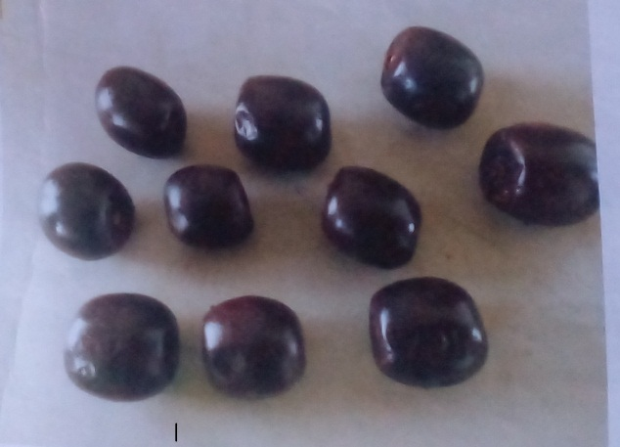

Plate1: Ripened Black plum Fruit Source: Urobia farmland Umuchima.
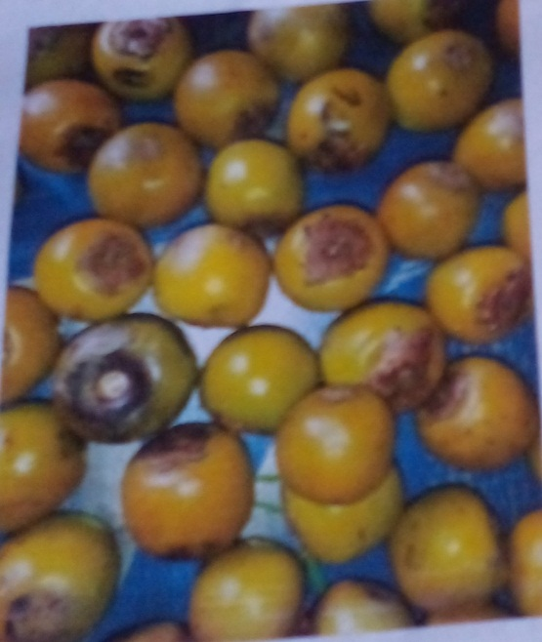
Plate 2: Unripe Black Plum Fruit
METHODS

Sample Preparation

Production of Jam Samples
The black plum jam samples were produced using the methods outlined by Ajenifujah-Solebo and Aina (2011) and Ofoedum et al (2025). Freshly harvested black plum fruits, ripe and matured unripe fruits were obtained from the bush farm. They were sorted and washed with water. The kernels were removed and discarded, leaving only the pulps and the skin. Three formulations were made from the pulp and skin obtained. Three different containers were used to put 100% ripe black plum, 60% and 40% by mass of ripe and mature unripe black plum pulps were placed in the second container, while the third container had 40% and 60% by mass of ripe and unripe black plum pulps respectively. The pulps in each container were then blended, and 49% by weight of the puree (blended pulp and skin) was combined with 50% by weight of sugar, and 1% of citric acid was added to it. The mixtures were boiled, in a pot and allowed to simmer at 165ºC for 15 min, after which each was bottled. The jams were filled hot into sterilized glass jars, leaving head space, sealed. The jams produced from 100%, 60% and 40% ripe black plums were labelled RHJ, RSJ and RFJ, respectively. The flow chart is shown in Figure 1.
The labelled jam samples were then stored in the refrigerator at 4ºC until further analysis.

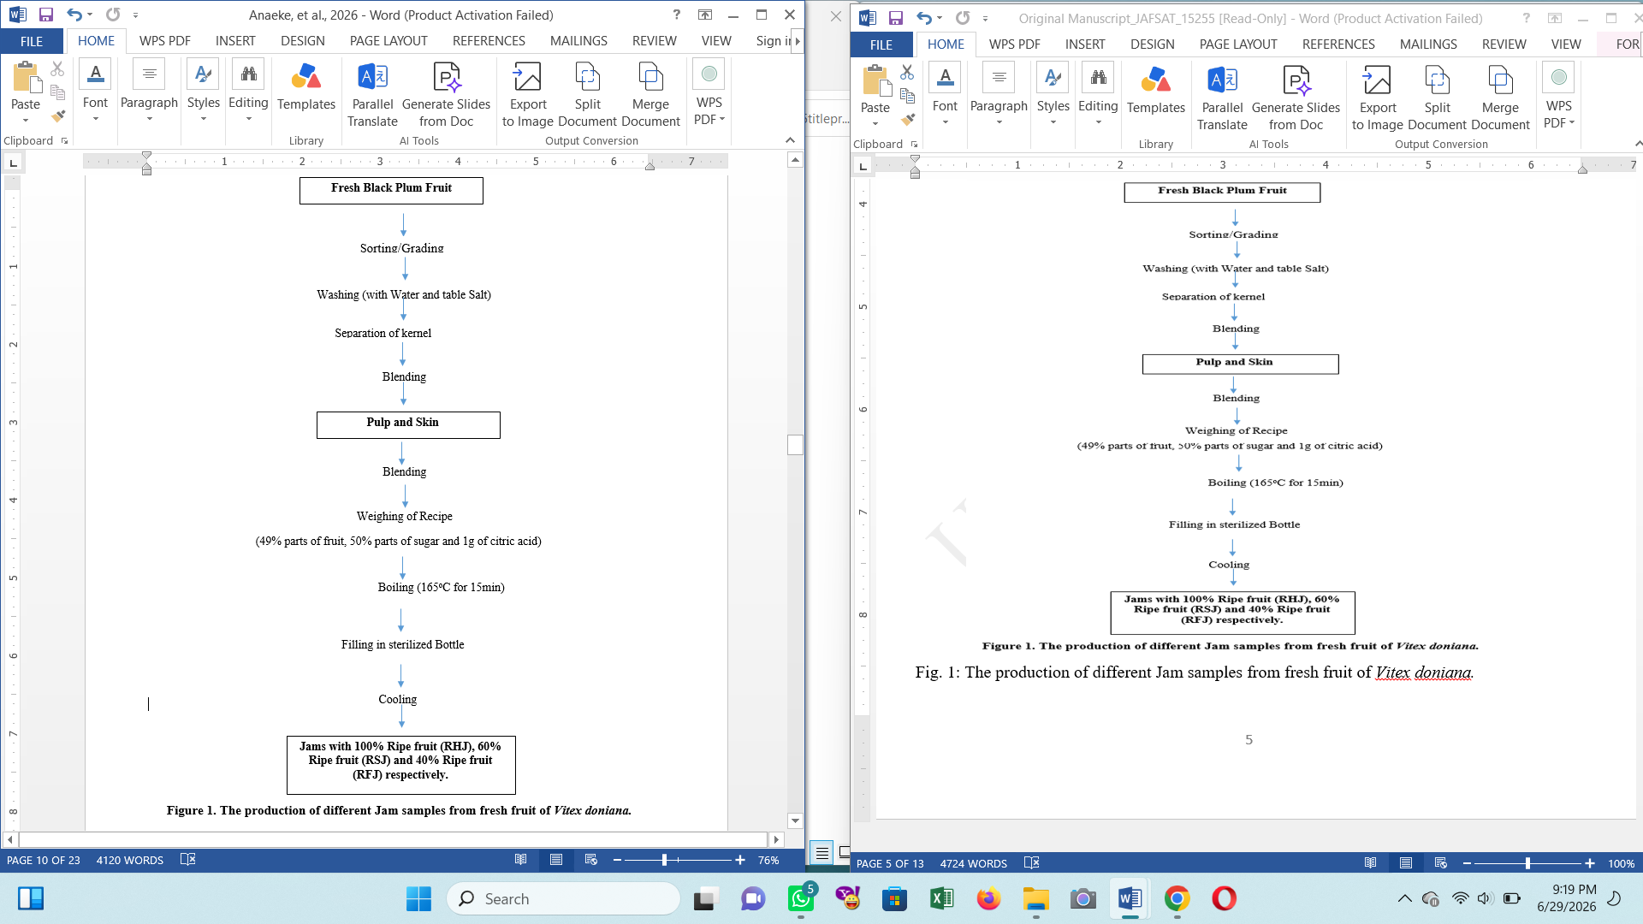

Proximate Analysis
The methods of AOAC (2015) were used for the determinations of proximate compositions of the black plum samples. The measurable parameters include, the ash contents, moisture, crude fats, Protein contents, and Carbohydrates. Standard analytical procedures were used for their estimation and the readings obtained were calculated and recorded.

Determination of the Physicochemical Properties of Jams samples made from Black plum
AOAC (2015) method was used to determine the physicochemical properties of the samples.
Determination of Total Phenols
A 0.2g portion of the sample was mixed with 10ml of concentrated methanol. The intensities of the resulting blue colouration was measured (absorbance) in a colorimeter at 540nm wavelength (AOAC 2015). The percentage phenol content was calculated as follows;
%Phenol = $\frac{100}{w}$ × $\frac{au}{as} ×$ C ×$\frac{Vt}{Va}$ × D (3.21)
Where;
W = weight of the sample
a_{u} = Absorbance of the test sample
a_{s} = Absorbance of standard phenol solution
C = Concentration of standard phenol solution
Vt = Total volume of extract
Va = Volume of analytes,
D: Dilution factor

Viscosity
This procedure is described by Onwuka (2005). In a beaker, 15g of the sample was made into a slurry in 300 ml water. The mixture in a beaker was fixed below the impeller blade of the brook field viscometer, model-LVT (Brook field engineering Laboratories Inc. Middle boro, M.A.0234 USA) for rheological measurements.

Determination of pH
After properly cleaning the pH meter electrode with distilled water, the reading was set to zero. After that, the meter was standardized at 25°C using buffer 4, 7, and 9 solutions. After pipetting 25 milliliters of each sample into three separate beakers, the pH electrode (probe) was dipped into the samples, and the readings from each sample were allowed to stabilize before being recorded.

Determination of soluble solids (ºBrix)
A portable refractometer VBR32T Brix/ATC -32% was used to measure the brix of the various jam samples. The digital refractometer's glass prism was wiped with a clean wiper after being cleaned with distilled water. Using a micropipette, a few drops of the test sample were applied to the optical (sensitive) area of the refractometer. The reading was then observed from the visual display and recorded.

Total titratable acidity
The method of Ajenifujah-Solebo, (2011) was adopted for this determination. To ensure complete mixing of the sample and the indicator, 5 milliliters of the sample and 0.5 milliliters (3 drops) of 5% phenolphthalein indicator were added to the same conical flask and gently shaken. 0.1N sodium hydroxide was used to titrate the conical flask's contents on a white backdrop. The titration was continued until the burette read off and a persistent pink coloration was seen. The endpoint was determined by taking the burette reading. This is how the total acidity was determined:
Total titratable acidity is equal to (V × N × 75)/(1000 × v) × 100.
V is the milliliter of sodium hydroxide solution used in the titration.
N is the sodium hydroxide solution's normality, and v is the sample volume (ml).

Sensory Evaluation
Twenty (20) untrained panelists from the Federal University of Technology in Owerri, Imo State, evaluated the jam samples for acceptability and preference using the methodology outlined by Chukwu (2017). Using a nine-point hedonic scale, each participant was asked to score the juice and jam samples according to appearance, taste, flavor, texture, and overall acceptability with 9 as extremely liked and 1 as extremely disliked.

Statistical Analysis
The mean ±standard deviation (SD) was used to express the experimental results in triplicate. One-way Analysis of Variance (ANOVA) was used to analyze the data obtained which was a method adopted from, Chukwu (2017). Fisher's Least Significant Difference at 95% confidence level (P≤0.05) was used to separate the means after the findings were statistically analyzed using Statistical Package for Service Solution (SPSS) version 15.0. Both tabular and graphical formats were used to display the data.

RESULTS AND DISCUSSION
Table 1. The Proximate composition of the Jam samples (%)

Sample | Moisture | Ash | Dietary Fibre | Fat | Protein | Carbohydrates
RHJ | 26.46ª±1.68 | 1.17ª±0.02 | 0.44^{c}±0.04 | 0.43ª±0.03 | 0.83^{b}±0.11 | 70.67^{c}±1.69
RSJ | 23.16^{b}±0.92 | 1.15ª±0.02 | 0.96^{b}±0.09 | 0.48ª±0.05 | 1.04ª±0.03 | 73.21^{b}±0.94
RFJ | 18.09^{c}±0.91 | 1.03^{b}±0.09 | 1.02^{b}±0.04 | 0.49ª±0.04 | 1.16ª±0.08 | 78.21ª±0.85
SBJ | 24.31^{b}±0.80 | 0.41^{c}±0.03 | 1.29ª±0.08 | 0.09^{b}±0.01 | 0.31^{c}±0.06 | 73.59^{b}±0.82
LSD_{(0.05)} | 2.13 | 0.09 | 0.13 | 0.07 | 0.14 | 2.12
The mean values with same superscripts are not significantly different, while the mean scores with different superscripts are significantly different
Keys:
RHJ =Jam formulated with 100% ripened black plum fruit
RSJ = Jam formulated with 60% ripened and 40% unripe black plum fruit
RFJ = Jam formulated with 40% ripened and 60% unripe black plum fruit
SBJ = Commercial Jam
Table 2: The Physicochemical composition of the Jam samples
Samples | TTA (%) | pH | Viscosity (shear stress dynes/cm²) | Pectin content (%) | Reducing Sugar (%) | Brix (ºB)
RHJ | 0.41^{b}±0.06 | 3.40^{b}±0.10 | 74.62^{d}±2.08 | 5.64^{c}±0.79 | 54.41^{b}±1.11 | 68.85ª±2.28
RSJ | 0.59ª±0.07 | 3.10^{c}±0.10 | 80.13^{c}±1.68 | 7.55^{bc}±0.47 | 43.09^{c}±1.75 | 60.41^{b}±3.34
RFJ | 0.64ª±0.02 | 3.10^{c}±0.10 | 87.47^{b}±1.47 | 8.91^{b}±1.99 | 37.35^{d}±3.76 | 54.39^{c}±2.54
SBJ | 0.55ª±0.03 | 4.90ª±0.20 | 94.12ª±3.88 | 14.08ª±1.30 | 62.18ª±2.32 | 71.33ª±2.12
LSD_{(0.05)} | 0.1 | 0.25 | 4.65 | 2.41 | 4.6 | 4.92
The mean values with same superscripts in the same are not significantly different, while those with different subscripts are significantly different
RHJ =Jam formulated with 100% ripened black plum fruit
RSJ = Jam formulated with 60% ripened and 40% unripe black plum fruit
RFJ = Jam formulated with 40% ripened and 60% unripe black plum fruit
SBJ = Commercial Jam

Table 3: The Sensory evaluation of the Jam samples
Samples | Taste | Aroma | Appearance | Mouthfeel | Texture | Overall Acceptability
SBJ | 7.35ª±0.93 | 7.15^{b}±1.31 | 6.70ª±1.30 | 7.85ª±1.37 | 7.20ª±1.01 | 7.80ª±0.55
BPJ | 7.25ª±0.85 | 8.05ª±1.05 | 6.30^{b}±1.17 | 7.10ª±1.17 | 6.15^{b}±1.19 | 7.05^{b}±0.51
LSD_{(0.05)} | 0.55 | 0.74 | 0.27 | 0.79 | 0.58 | 0.33

Each value is the mean of 20th panelists. The mean values with different superscripts down a row are significantly different.
SBJ= Store bought jam (black currant-strawberry Jam), BPJ= Black plum jam.

Proximate composition of the Jams
The results of the proximate composition of the three jam samples produced and the commercially produced black currant jam are shown in Table 1. The jam samples were produced from the same quantity of black plum pulp and skin (45parts) and sugar (55parts). Sample RHJ was produced from 100% ripe black plum fruit, RSJ from 60% ripe and 40% unripe fruit, and RFJ from 40% ripe and 60% unripe black plum fruit, respectively. The sample, SBJ, is the commercially bought black currant Jam. From the result, the moisture content of the jam samples ranges from 18.09 (RFJ) to 26.46 (RHJ). The moisture content of RHJ is significantly higher, followed by that of the commercially produced jam (SBJ, 24.30). There was no significant difference (P ≥0.05) in the moisture content of the commercially produced jam (SBJ) and the jam RSJ and RFJ. The moisture content of the sample RFJ is much lower. Sample RHJ that has 100% ripe fruit had more moisture content than others. This suggested that the pectin in the 40% ripe fruit jam RFJ did not hold as much moisture as in other samples. The moisture may have evaporated during the boiling process.
The three produced jam samples from black plum fruit had higher ash content than the commercially produced jam. The higher ash content in the produced jam samples suggests that pectin from fruits contributes to the higher ash content, whereas, the commercial pectin used in the Commercial juice (Black currant-strawberry) has less ash content. There is no significant difference (P ≥0.05) in the ash content of the jam produce with 60% ripe fruit (RSJ) and 40% ripe fruit (RFJ). The results obtained in this work is related to the results obtained by Amah and Okogeri (2019); Aniche, et al (2003)

Physico-chemical composition of Jam samples
The results of the physicochemical compositions are shown in Table 2. The titratable acidity of the jam samples ranges from 0.4 to 0.64, with the jam made with 40% ripened and 60% unripe black plum fruit(RFJ), giving the highest value and the jam from 100%ripened black plum having the lowest value. This implies that the more the percentage of the unripe fruit in the jam formulation, the more the titratable acidity and that ripening reduced the acid values. There is no significant difference in the titratable acidity content of the jam that contained 60% and 40% ripened juice and the store-bought jam. The pH level increases with ripening. Thus as the fruit ripens, the acidity lowers. However, there is also a significant increase in the pH of the store-bought jam (SBJ) than the jam from 100% ripened fruit (RHJ).
Thus, pH measures the amount of hydrogen ion and hydroxyl ions in a solution (Ofoedum et al 2024}The viscosity of the jam samples ranges from 74.62(Shear stress/dryness/cm²) in (RHJ) to 87.47(Shear stress/dryness/cm²) in (RFJ). The viscosity of the RSJ jam is significantly higher than RHJ jam but lower than RFJ. This implies that the higher the unripe fruit component in the jam, the higher the pectin content and the higher the viscosity. Fruit tends to lose the pectin content to sugar as the fruit ripens. The store-bought jam (SBJ) had the highest viscosity of other jam samples. The high viscosity and pectin content of SBJ may be due to the commercial pectin added during production. The pectin content of the fruit reduces as it ripens. The pectin from black plum improved the viscosity and acceptability of the jam. Similarly, the brix and reducing sugar content increased with the higher percentage of ripened fruit. The store-bought jam (SBJ) recorded the highest brix and reducing sugar content, possibly due to the type of fruit used for the jam and the type of sugar contained. This suggest why the organoleptic analysis of the syrup produced by the concentration of Black plum juice compares favourably with sucrose in sensory properties in model foods (Abu, 2002; Jatet al., 2018).

Sensory evaluation of Jam samples

The result of the sensory evaluation between a store-bought jam (SBJ) and a jam produced with full ripe black plum fruit (BPJ) were shown in Table 3. There is no statistical difference in the taste of both jams. However, there is a significant difference (P≤ 0.05) in their aroma, with black plum jam (BPJ) rating higher (8.05), while Black currant- strawberry jam (SBJ) is (7.15). In appearance, the store-bought jam rated higher (6.70), and the 100% ripe black plum jam rated lower (6.30). Also, there is no significant difference in the taste and mouth feel of the black plum jam produced with 100% ripe fruit BPJ and the store-bought jam SBJ. However, the store-bought jam was more accepted than the black plum jam due to the dark colour of the black plum jam. This implies that the taste of the two jam samples was statistically the same, but the black plum jam was rated lower in appearance, maybe due to its very dark colour (black-brown), which may result from the high heat treatment, caramelization and Maillard reaction. When subjected to high temperatures, sugars in the presence of ascorbic acid turn brown. It also caramelizes in a high-heat treatment. The mouth-feel evaluation of the jam samples is statistically the same due to the taste and flavour being rated high though the flavour of the black plum jam was rated higher than store-bought jam. In terms of texture, consistency and spreadability, the store-bought jam significantly differed from the black plum jam. In overall acceptability, the store-bought jam rated higher (7.80) than the black plum jam (7.05), accepted but not as much as the store-bought jam. The reason is that the black plum jam is very dark, and the appearance may have repelled some of the panelists, even when it tastes good. The use of mixed fruit in this formulation to augment colour acceptance is highly advocated. Mango or pawpaw fruits which are yellow, can blend with the black plum to give a lighter colour to be cherished by many. Agbede and Ibitoye (2007); Ofoedum et al 2025 also reported similar results in sensory evaluation of jam from sycamore fruits.

Conclusions
The study showed that black plum fruit can be used for the production of acceptable jam. Fruit maturity influenced the proximate and physicochemical properties of the jam samples. The inclusion of unripe fruit increased pectin content, viscosity, and titratable acidity, indicating its contribution to gel formation and product consistency. Jam produced from fully ripe fruit had higher reducing sugar and total soluble solids, while formulations containing higher proportions of unripe fruit showed improved pectin-related characteristics. Sensory evaluation indicated that black plum jam was generally accepted by panelists and compared favourably with commercial jam in taste, aroma, and mouthfeel. However, the darker colour of the product reduced appearance score and slightly lowered overall acceptability. The findings suggest that black plum fruit is a promising raw material for jam production and may support value addition to this underutilized indigenous fruit. Further improvement in colour, formulation balance, storage stability, and shelf-life assessment is recommended.

Limitations
This study was limited to three jam formulations prepared from ripe and unripe black plum fruit. Storage stability, shelf life, microbial quality, antioxidant activity, and colour parameters were not fully reported. The sensory evaluation used a limited panel size and compared only one black plum jam sample with a commercial product. Processing conditions, pectin determination, and formulation basis require clearer reporting. Further studies should include standardized processing, larger sensory panels, and detailed shelf-life evaluation.
Declaration of AI Use

This manuscript was prepared through the combined contributions of all author(s), including contributions to the study design, data, content development, results, interpretation, and related scholarly work. The author(s) acknowledge the use of Grammarly and ChatGPT to assist with grammar checking, language refinement, reference formatting. These AI-assisted tools were not used as authors and did not replace the intellectual contributions or scholarly judgment of the author(s). All AI-assisted outputs, including content, references, and interpretations, were carefully reviewed, revised, verified, and approved by the author(s). The author(s) accept full responsibility for the accuracy, integrity, and final content of the manuscript.

REFERENCES
Abu, J.D. and Arogba, S.S. (2001) ‘High temperature drying characteristics and moisture adsorption isotherms of black plum (Vitex doniana) syrup and syrup-starch’, International Journal of Food Properties, 4(2), pp. 285–295.
Adejumo, A.A., Alaye, S.A., Ajagbe, R.O., Abi, E.A. and Adedokun, F.T. (2013) ‘Nutritional and anti-nutritional composition of black plum (Vitex doniana)’, Journal of Natural Sciences Research, 3(12), pp. 144–148.
Adelani, D.O., Suleiman, R. and Apene, E. (2019) ‘Effect of periods of hydro-priming and seed weights on the germination of Vitex doniana Sweet seeds’, Journal of Research in Forestry, Wildlife and Environment, 11(3), pp. 185–194.
Agbede, J.O. and Ibitoye, A.A. (2007) ‘Chemical composition of black plum (Vitex doniana): an underutilized fruit’, Journal of Food, Agriculture and Environment, 5(2), pp. 95–96.
Ajenifujah-Solebo, S. O., and Aina, J. O. (2011). Physico-chemical properties and sensory evaluation of jam made from black-plum fruit (Vitex doniana). African Journal of Food, Agriculture, Nutrition and Development, 11(3).
Ajenifujah-Solebo, S.O. and Aina, J.O. (2011) ‘Physico-chemical properties and sensory evaluation of jam made from black plum fruit (Vitex doniana)’, African Journal of Food, Agriculture, Nutrition and Development, 11(3), pp. 4772–4784.
Ali, M., Aminu, F. and Ibrahim, I.S. (2017) ‘In vitro assessment of antibacterial activity and phytochemical screening of Vitex doniana on clinical isolates of Salmonella typhi’, International Journal of Advanced Academic Research, 3(1), pp. 9–16.
Amah, U.J. and Okogeri, O. (2019) ‘Nutritional and phytochemical properties of wild black plum (Vitex doniana) seed from Ebonyi State’, International Journal of Horticulture, 3(1), pp. 32–36.
Amit, S.K., Uddin, M.M. and Rahman, R. (2017) ‘A review on mechanisms and commercial aspects of food preservation and processing’, Agriculture and Food Security, 6, p. 51.
Aniche, O. K. (2003). The Need for Post-harvest Physiology Application in Food Security Approach in Nigeria. Owerri, Nigeria: Food Science and Technology, Federal University of Technology.
Aniche, O.K. (2003) The need for post-harvest physiology application in food security approach in Nigeria. Owerri: Department of Food Science and Technology, Federal University of Technology.
AOAC (2015) Official methods of analysis of AOAC International. 20th edn. Gaithersburg, MD: AOAC International.
Awolu, O.O., Okedele, G.O., Ojewumi, M.E. and Oseyemi, F.G. (2018) ‘Functional jam production from blends of banana, pineapple and watermelon pulp’, International Journal of Food Science and Biotechnology, 3(1), pp. 7–14.
Baker, R.A., Berry, N., Hui, Y.H. and Barrett, D.M. (2005) ‘Fruit preserves and jams’, in Barrett, D.M., Somogyi, L. and Ramaswamy, H. (eds.) Processing fruits: science and technology. 2nd edn. Boca Raton, FL: CRC Press, pp. 113–132.
Bartholomew, D.P., Paull, R.E. and Rohrbach, K.G. (2003) The pineapple: botany, production and uses. Wallingford: CABI Publishing.
Begum, S., Das, P.C. and Karmoker, P. (2018) ‘Processing of mixed fruit juice from mango, orange and pineapple’, Fundamental and Applied Agriculture, 3(2), pp. 440–445.
Brandão, T.M., do Carmo, E.L., Elias, H.E.S., de Carvalho, E.E.N., Borges, S.V. and Martins, G.A.S. (2018) ‘Physicochemical and microbiological quality of dietetic functional mixed cerrado fruit jam during storage’, The Scientific World Journal, 2018, Article ID 2878215.
Burkill, H.M. (2000). The useful plants of West Tropical Africa. Volume 5: Families S–Z. Richmond: Royal Botanic Gardens, Kew.
Chan, S.Y., Choo, W.S., Young, D.J. and Loh, X.J. (2017) ‘Pectin as a rheology modifier: origin, structure, commercial production and rheology’, Carbohydrate Polymers, 161, pp. 118–139.
Chauhan, S.K., Tyagi, S.M. and Singh, D. (2001) ‘Pectinolytic liquefaction of apricot, plum and mango pulps for juice extraction’, International Journal of Food Properties, 4(1), pp. 103–109.
Chinyere, I., Julius, I.U. and Samuel, O.E. (2021) ‘Determination of the flavoring components in Vitex doniana fruit following hydrodistillation extraction’, American Journal of Food Science and Nutrition, 9(2), pp. 69–75.
Chukwu, M. (2017) ‘Production and organoleptic attributes of ogiri-ahuekere produced from groundnut (Arachis hypogaea Linn.) seeds’, Research Journal of Food Science and Quality Control, 3(2), pp. 39-45
Codex Alimentarius Commission (1997) Codex standard for jams, jellies and marmalades. Rome: Food and Agriculture Organization/World Health Organization.
Dadjo, C. (2018) Assessment of nutritional variation and establishment of an efficient tissue culture propagation protocol for Vitex doniana Sweet (Lamiaceae) from Benin (West Africa). PhD thesis. Jomo Kenyatta University of Agriculture and Technology.
Dadjo, C., Assogbadjo, A.E., Fandohan, B., Kakaï, R.G., Chakeredza, S., Houehanou, T.D., van Damme, P. and Sinsin, B. (2012) ‘Uses and management of black plum (Vitex doniana Sweet) in southern Benin’, Fruits, 67(4), pp. 239–248.
Jat, R., Mahawer, L.N, Bairwa,H.L., Meena, R. H., Philania,S. and Singh, M. (2018). Sensory evaluation and Microbial analysis of rose petal Jam. J. of Pharmacognosy and phytochemistry 7(5): 617-620.
Ofoedum, A.F., Owuamanam, C.I., Iwouno, J.O., Olawuni, I.A., Abbah, E.C., Uyanwa, N.C., Anaeke, E.J. and Ofoedum, S.L. (2025). Functional and storage stabilities of functional beverages developed from crude extracts from tropical spices (Zingiber officinale, Monodora myristica and Tetrapluera tetraptera). Journal of Food Legumes. 38(4): 624-632.
Ofoedum, A.F., Chikelu, E.C., Nwuka, M.U., Olawuni, I.A., Uzoukwu, A.E., Alagbaoso, S.O., Eluchie, C.N., Okezie, F.P., Anaeke, E.J. and Odeyemi, T.A. (2024). Antioxidant activities and sensory evaluation of functional beverages produced by incorporation of crude extracts from tropical spices. Journal of Food Legumes. 37(4): 462-471.
Ofoedum, A.F., Owuamanam, C.I., Iwouno, J.O., Ofoedu, C.E., Chikelu, E.C., Odimegwu, E.N., Alagbaoso, S.O., Njoku, N.E. and Anaeke, E.J. (2025). Physicochemical and shelf life studies of functional beverages developed from crude extracts from tropical spices (Zingiber officinale, Monodora myristica and Tetrapluera tetraptera). Asian Journal of Dairy and Food Research. 44(5): 799-806. doi: 10.18805/ajdfr.DRF-478.

Okigbo, R. N. (2001). Mycoflora within black plum (Vitex doniana sweet) fruits. Fruits, 56(2), 85-92.
Onwuka, G. I. (2005). Analysis of fat In Food Analysis and Instrumentation, Theory and Practice. 2nd Edi. Naphtali prints Pp187-188.
Orwa, J. A., Ngeny, L., Mwikwabe, N. M., Ondicho, J., & Jondiko, I. J. O. (2013). Antimalarial and safety evaluation of extracts from Toddalia asiatica (L) Lam.(Rutaceae). Journal of ethnopharmacology, 145(2), 587-590.
Oumorou, M., Sinadouwirou, T., Kiki, M., Kakaï, R. G., Mensah, G. A., & Sinsin, B. (2010). Disturbance and population structure of Vitex doniana Sw. in northern Benin, West Africa. International Journal of Biological and Chemical Sciences, 4(3).
Vunchi, M. A., Umar, A. N., King, M. A., Liman, A. A., Jeremiah, G., & Aigbe, C. O. (2011). Proximate, vitamins and mineral composition of Vitex doniana (black plum) fruit pulp.

