PRELIMINARY PILOT STUDY ON FUNGAL CONTAMINATION IN TREATED DRINKING WATER COLLECTED FROM SAIDAPET, CHENNAI, INDIA

ABSTRACT

Safe drinking water is essential for human health, yet fungal contamination receives less attention than bacterial contamination. This preliminary pilot study assessed the possible occurrence of fungi in treated drinking water collected from Raghava Colony, Saidapet, Chennai, India. A single 100 mL sample was collected aseptically and analysed using the Indian Standard method IS 5403:1999 with Yeast Extract Dextrose Chloramphenicol agar. Following incubation at 25 ± 1°C for 3–5 days, colonies were evaluated by macroscopic morphology and microscopic examination using Lactophenol Cotton Blue staining. The isolates were presumptively identified as Aspergillus flavus and Aspergillus niger. Characteristic colonies of Candida albicans and Saccharomyces cerevisiae were not detected. These observations indicate that fungal propagules may be present in treated drinking water despite filtration and chlorination; however, they do not establish the extent, frequency, or public health significance of contamination. Interpretation is limited by the analysis of one sample, the absence of replicate sampling, quantitative colony enumeration, statistical analysis, and molecular confirmation. The findings therefore provide only preliminary baseline evidence for the selected location. Further investigations using multiple samples, seasonal sampling, quantitative fungal counts, and molecular identification are required to characterise fungal occurrence more reliably within the drinking water distribution system at this location.
Keywords: Treated drinking water; fungal contamination; Aspergillus flavus; Aspergillus niger; water quality; preliminary pilot study; YDC agar; IS 5403:1999; municipal water supply; fungal surveillance

INTRODUCTION

Fungi are ubiquitous microorganisms found in freshwater, oceans and drinking water distribution systems, where they survive through spore formation and adaptation to diverse environmental conditions (Gostinčar et al., 2011; De Bruin et al., 2008; Wurzbacher et al., 2011). Unlike bacterial contamination, fungal contamination in drinking water has received comparatively less attention (Afonso et al., 2021; Department for Environment, Food & Rural Affairs [DEFRA], 2011; Zhao et al., 2022). Although certain fungi can survive conventional water treatment processes, form biofilms in distribution systems and produce mycotoxins that may pose potential health risks to humans (Grabińska-Łoniewska et al., 2007).
Recent investigations have shown that culturable fungal communities can occur throughout drinking-water treatment and distribution systems, with their occurrence influenced by water source, disinfection regime and distribution materials (Novak Babič et al., 2023). Complementary field evidence has identified diverse fungi, including Aspergillus species, in drinking-water samples and has indicated incomplete removal of some fungal propagules by routine treatment processes (Hussain et al., 2024). Potable-water isolates of Aspergillus and Candida have also exhibited reduced susceptibility to selected antifungal agents, further supporting the value of fungal surveillance in water systems (Novak Babič & Gunde-Cimerman, 2025).
Among these fungi, Aspergillus flavus and Aspergillus niger are commonly reported in drinking water systems and are considered important because of their ability to persist in water distribution systems and cause opportunistic infections in immunocompromised individuals (Horn et al., 2009; Krishnan et al., 2009). However, information on fungal contamination in treated drinking water remains limited, particularly in local drinking water distribution systems.
A recent microbiological assessment of household-used surface-water and groundwater sources reported measurable yeast and mould burdens, illustrating the value of including fungal parameters alongside bacterial indicators in water-quality evaluation (Constant et al., 2025).
Household water-storage and handling practices have been associated with post-collection microbial contamination, particularly when storage containers are inadequately cleaned or covered (Diala et al., 2025).
Accordingly, a local evidence gap remains regarding the possible occurrence of fungi in treated drinking water at the selected sampling location in Saidapet, Chennai.
Therefore, the present study was conducted as a preliminary pilot study to assess the possible occurrence of fungal contamination in treated drinking water. Since only one treated drinking water sample was analysed, the findings should be considered preliminary and provide baseline information for future large-scale investigations involving multiple samples, quantitative fungal analysis and molecular identification.
MATERIALS AND METHODS

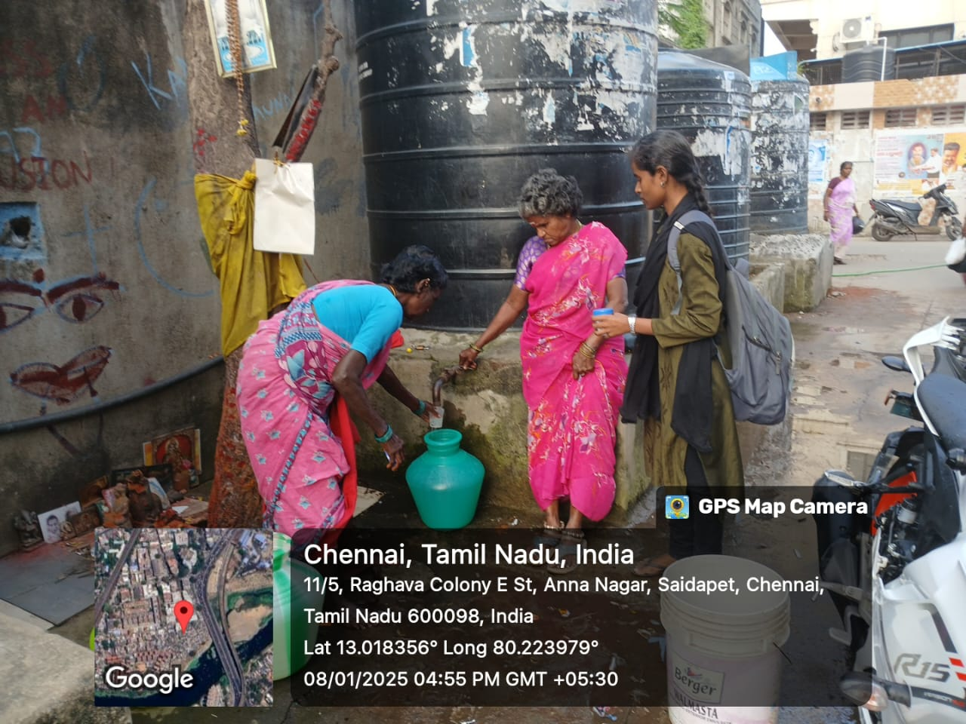
Figure.1 Water sample collection from Saidapet, Chennai
Study area
The present study was conducted in Saidapet, Chennai, Tamil Nadu, India. Treated drinking water was collected from Raghava Colony, E Street (Latitude: 13.018352° N; Longitude: 80.223963° E). The area depends mainly on the municipal water supply, and the treated water undergoes filtration and chlorination before distribution. Ageing pipelines and household storage practices may contribute to fungal contamination.

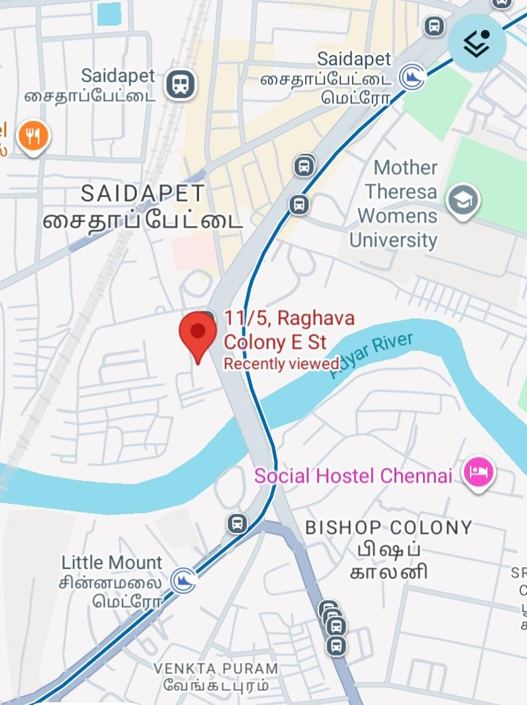
Figure.2 Location of the sampling site

Sample Collection
A total volume of 100 mL of treated drinking water was collected aseptically from household storage containers and municipal tap water using sterile sampling bottles. The sample was transported immediately to the laboratory under hygienic conditions and processed without delay to minimise external contamination.

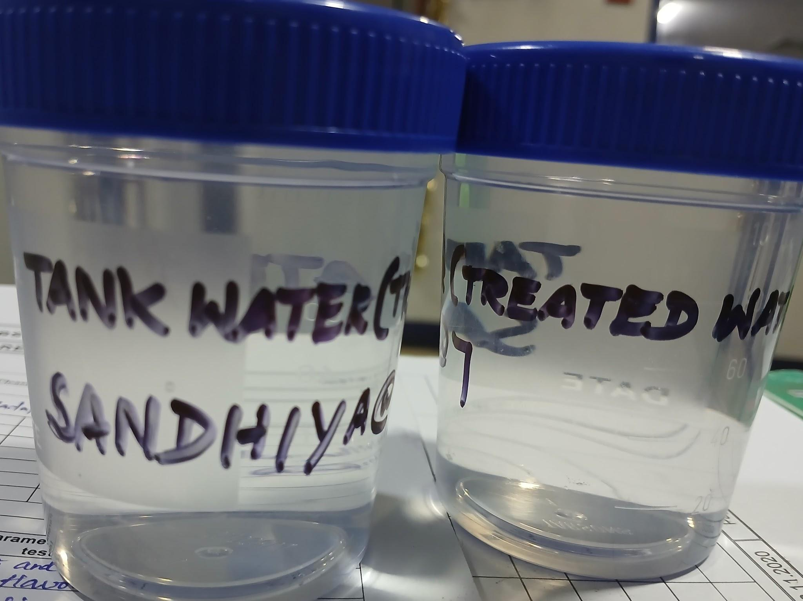
Figure.3 Treated drinking water sample (100 mL)

Culture Medium Preparation
Yeast Extract Dextrose Chloramphenicol (YDC) agar was prepared according to the Indian Standard Method (IS 5403:1999). The medium was sterilised by autoclaving at 121 ± 1°C for 15 minutes, cooled to approximately 45°C, and poured aseptically into sterile Petri dishes.

Fungal Enumeration
The enumeration of yeasts and moulds was performed according to the Indian Standard IS 5403:1999 (Bureau of Indian Standards, 1999) using the pour plate technique. One millilitre of the water sample was inoculated into sterile Petri dishes, followed by the addition of molten YDC agar. The plates were gently mixed, allowed to solidify and incubated at 25 ± 1°C for 3–5 days. After incubation, fungal colonies were examined for their cultural characteristics.

Identification of Fungal Isolates
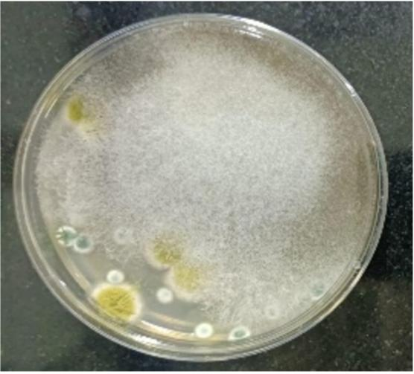
Figure : 4 fungal identification

The fungal isolates were presumptively identified based on colony morphology and microscopic characteristics using standard taxonomic descriptions (Kendrick, 2000).
Colony colour, texture, sporulation pattern and hyphal morphology were examined. Microscopic examination was carried out using Lactophenol Cotton Blue (LPCB) staining under a light microscope. Since molecular identification (ITS sequencing) was not performed, the fungal identification should be considered presumptive.

Quality Control
All glassware, culture media and sampling bottles were sterilised before use. Sterile techniques were followed throughout the experimental procedure to prevent contamination. An uninoculated control plate was maintained to verify the sterility of the culture medium.

DATA INTERPRETATION AND DISCUSSION

The presence or absence of fungal growth was recorded based on colony development on YDC agar. The fungal isolates were identified using colony morphology and microscopic observations. Because only a single sample was analysed, quantitative statistical analysis and replicate comparisons were not performed.

A single 100 mL treated drinking water sample was collected and analysed as part of this preliminary pilot study using the Indian Standard Method (IS 5403:1999). Following incubation on Yeast Extract Dextrose Chloramphenicol (YDC) agar, fungal colonies were examined based on colony morphology and microscopic characteristics. The fungal isolates were presumptively identified, as molecular confirmation was not performed.

Table 1 Presumptive Identification of Fungal Isolates from Treated Drinking Water

S.  No | PARAMETERS | TEST  METHOD | COLONY MORPHOLOGY | IDENTIFICATION  METHOD | RESULT
1 | Aspergillus flavus | IS 5403 | Yellowish-green colonies | Colony morphology and microscopy (Presumptive) | Present
2 | Aspergillus niger | IS 5403 | Black colonies | Colony morphology and microscopy (Presumptive) | Present
3 | Candida albicans | IS 5403 | No characteristic colonies observed | Not detected | Absent
4 | Saccharomyces  cerevisiae | IS 5403 | No characteristic colonies observed | Not detected | Absent

The results indicate the presumptive presence of Aspergillus flavus and Aspergillus niger in the treated drinking water sample, whereas Candida albicans and Saccharomyces cerevisiae were not detected. Since the identification was based only on colony morphology and microscopic examination, the results should be considered presumptive and require confirmation by molecular methods such as ITS sequencing.

The present preliminary pilot study investigated the possible occurrence of fungal contamination in treated drinking water. The presumptive identification of Aspergillus flavus and Aspergillus niger suggests that fungal propagules may persist in treated drinking water despite conventional treatment processes such as filtration and chlorination. Similar observations were reported by Grabińska-Łoniewska et al. (2007), who demonstrated that environmental fungi can survive within drinking water distribution systems through biofilm formation and spore persistence.
The occurrence of Aspergillus species in drinking water does not necessarily indicate an immediate public health risk.
However, their presence suggests that routine monitoring of fungal contamination may be beneficial, particularly in water distribution systems.
Previous studies have reported that Aspergillus species are widely distributed in soil, air and water environments and may act as opportunistic pathogens in immunocompromised individuals (Horn et al., 2009; Krishnan et al., 2009). Therefore, their detection should be interpreted cautiously and in conjunction with quantitative fungal analysis and molecular confirmation.
In contrast, Candida albicans and Saccharomyces cerevisiae were not detected in the analysed sample, suggesting satisfactory microbiological quality with respect to these yeasts. However, because only a single treated drinking water sample was examined, these findings cannot be generalised to the entire water distribution system.
Limitation

The present study has several limitations. The investigation was based on a single water sample without replicate sampling, quantitative fungal enumeration (CFU), statistical analysis or molecular identification (ITS sequencing). Therefore, fungal identification should be regarded as presumptive, and the findings should be considered preliminary.
Despite these limitations, the study provides baseline information on the possible occurrence of fungal contamination in treated drinking water. Future investigations should include larger sample sizes, seasonal sampling, quantitative fungal counts, molecular identification techniques and statistical analysis to better understand the occurrence and significance of fungi in drinking water distribution systems.

CONCLUSION

This preliminary pilot study examined a single 100 mL treated drinking water sample from Saidapet, Chennai, for fungal contamination. Based on colony morphology and microscopic examination, the recovered isolates were presumptively identified as Aspergillus flavus and Aspergillus niger, while Candida albicans and Saccharomyces cerevisiae were not detected. The result suggests that fungal propagules may occur in treated water after conventional filtration and chlorination. Nevertheless, the observation should be interpreted cautiously because the study did not include replicate or seasonal sampling, quantitative fungal enumeration, statistical analysis, or molecular confirmation. Accordingly, the findings cannot be generalised to the wider distribution system or used to determine the magnitude or health significance of contamination. The study provides location-specific preliminary evidence that may support the design of larger investigations. Future work should include multiple sampling points and sampling periods, quantitative colony counts, appropriate controls, and molecular identification to establish the occurrence, distribution, and identity of fungi in treated drinking water more reliably.

Declaration of AI Use
This manuscript was prepared through the combined contributions of all author(s), including contributions to the study design, data, content development, results, interpretation, and related scholarly work. The author(s) acknowledge the use of Grammarly and ChatGPT to assist with grammar checking, language refinement, and reference formatting. These AI-assisted tools were not used as authors and did not replace the intellectual contributions or scholarly judgement of the author(s). All AI-assisted outputs, including content, references, and interpretations, were carefully reviewed, revised, verified, and approved by the author(s). The author(s) accept full responsibility for the accuracy, integrity, and final content of the manuscript.

REFERENCE

Afonso, T. B., Simões, L. C., & Lima, N. (2021). Occurrence of filamentous fungi in drinking water: Their role in fungal–bacterial biofilm formation. Research in Microbiology, 172(1), 103791. https://doi.org/10.1016/j.resmic.2020.11.002
Bureau of Indian Standards. (1999). IS 5403:1999: Method for yeast and mould count of foodstuffs and animal feeds (1st rev.). https://standardsbis.bsbedge.com/BIS_SearchStandard.aspx?Standard_Number=5403&id=0
Constant, Z. A., Paul, A. Y., Haziz, S., Bethsabé, Y. A., Rose, K.-N., Nathalie, C., Ibrahim, K., & Lamine, B.-M. (2025). Physicochemical and microbiological characteristics of surface and groundwater frequently used by households in some districts of Daloa, Côte d’Ivoire. Journal of Advances in Microbiology, 25(3), 1–12. https://doi.org/10.9734/jamb/2025/v25i3903
De Bruin, A., Ibelings, B. W., Kagami, M., Mooij, W. M., & van Donk, E. (2008). Adaptation of the fungal parasite Zygorhizidium planktonicum during 200 generations of growth on homogeneous and heterogeneous populations of its host, the diatom Asterionella formosa. The Journal of Eukaryotic Microbiology, 55(2), 69–74. https://doi.org/10.1111/j.1550-7408.2008.00306.x
Department for Environment, Food & Rural Affairs. (2011). A review of fungi in drinking water and the implications for human health (DWI 70/2/255). Drinking Water Inspectorate. https://www.dwi.gov.uk/research/completed-research/risk-assessment-microbiological/a-review-of-fungi-in-drinking-water-and-the-implications-for-human-health/
Diala, C. G., Chigozie, O. F., Femi-Olatunji, T. R., Edim, P. D., Willie, I. P., Imade, O. E., Binuyo, O. A., & Ibishagba, S. M. (2025). Investigating the role of household water storage practices in shaping microbial contamination and diarrheal disease burden in South East Nigeria. Asian Journal of Microbiology and Biotechnology, 10(2), 232–241. https://doi.org/10.56557/ajmab/2025/v10i29848
Gostinčar, C., Grube, M., & Gunde-Cimerman, N. (2011). Evolution of fungal pathogens in domestic environments? Fungal Biology, 115(10), 1008–1018. https://doi.org/10.1016/j.funbio.2011.03.004
Grabińska-Łoniewska, A., Koniłłowicz-Kowalska, T., Wardzyńska, G., & Boryn, K. (2007). Occurrence of fungi in water distribution system. Polish Journal of Environmental Studies, 16(4), 539–547. https://www.pjoes.com/Occurrence-of-Fungi-in-Water-Distribution-System-r-n,88020,0,2.html
Horn, B. W., Moore, G. G., & Carbone, I. (2009). Sexual reproduction in Aspergillus flavus. Mycologia, 101(3), 423–429. https://doi.org/10.3852/09-011
Hussain, F., Salam, I.-U., Farzana, Memon, Z.-N., Abdullah, M., Abbas, G., Akbar, M., Hussain, A., Majeed, M., Ali, K., & Moda, H. M. (2024). Occurrence of fungal microbial contamination in drinking water of the megacity of Karachi, Pakistan, and its physicochemical control. Heliyon, 10(7), e28926. https://doi.org/10.1016/j.heliyon.2024.e28926
Kendrick, B. (2000). The fifth kingdom (3rd ed.). Focus Publishing.
Krishnan, S., Manavathu, E. K., & Chandrasekar, P. H. (2009). Aspergillus flavus: An emerging non-fumigatus Aspergillus species of significance. Mycoses, 52(3), 206–222. https://doi.org/10.1111/j.1439-0507.2008.01642.x
Novak Babič, M., & Gunde-Cimerman, N. (2025). Potable water as a source of intermediate and borderline-resistant Aspergillus and Candida strains. Journal of Water and Health, 23(2), 225–237. https://doi.org/10.2166/wh.2025.300
Novak Babič, M., Marolt, G., Imperl, J., Breskvar, M., Džeroski, S., & Gunde-Cimerman, N. (2023). Effect of location, disinfection, and building materials on the presence and richness of culturable mycobiota through oligotrophic drinking water systems. Journal of Fungi, 9(11), 1086. https://doi.org/10.3390/jof9111086
Wurzbacher, C., Kerr, J., & Grossart, H.-P. (2011). Aquatic fungi. In O. Grillo and G. Venora (Eds.), The dynamical processes of biodiversity: Case studies of evolution and spatial distribution (pp. 227–258). IntechOpen. https://doi.org/10.5772/23029
Zhao, H.-X., Zhang, T.-Y., Wang, H., Hu, C.-Y., Tang, Y.-L., & Xu, B. (2022). Occurrence of fungal spores in drinking water: A review of pathogenicity, odor, chlorine resistance, and control strategies. Science of the Total Environment, 853, 158626. https://doi.org/10.1016/j.scitotenv.2022.158626

