Original Research Article

Implicit Jacobian Regularization for Stable Fixed-Point Graph Neural ODEs

Abstract
Graph neural ordinary differential equation models provide a continuous-depth framework for learning representations from graph-structured data, but their practical application may be affected by unstable numerical behaviour and unreliable fixed-point convergence. This study presents a topology-aware implicit Jacobian regularisation framework for stable fixed-point graph neural ODEs. Node-feature evolution is represented as a continuous-time dynamical system, while equilibrium representations are obtained through fixed-point iterations. The proposed regularisation term penalises differences between the local Jacobians of adjacent nodes, thereby encouraging neighbouring nodes to exhibit consistent sensitivity to feature perturbations in accordance with the graph topology. Unlike global Lipschitz constraints, the method acts locally and is intended to preserve model flexibility while promoting stable equilibrium dynamics. The optimisation objective combines the task-specific loss with Jacobian consistency regularisation, and gradients are computed through implicit differentiation and automatic differentiation without fully unrolling the equilibrium iterations. The framework is implemented using a graph-coupled drift function and evaluated on representative homophilic, heterophilic, and molecular graph-learning benchmarks. The reported findings indicate faster fixed-point convergence, improved robustness to feature and structural perturbations, and competitive predictive performance relative to the evaluated baseline models. The results support the use of graph-informed local Jacobian alignment as a practical stabilisation mechanism for continuous-depth and equilibrium-based graph neural networks.
Keywords: Graph neural network (GNN), Conventional GNN-ODE, Lipschitz constraints, Jacobian regularization, Explicit Lipschitz bounds.
MSC2020: Primary 47H10; Secondary 54H25, 47H09.
1. Introduction
Graph neural networks (GNNs) have emerged as a powerful framework for learning representations from graph-structured data, with applications in social networks, molecular chemistry, recommendation systems, and numerous other domains [1]. A fundamental challenge in graph neural network design is ensuring stable and reliable convergence of node representations, particularly when continuous-time dynamics are modelled using ordinary differential equations (ODEs). Although neural ODEs provide flexible continuous-depth architectures, maintaining numerical stability and convergence remains a significant research challenge [2]. Recent advances in deep equilibrium models (DEQs) have demonstrated the effectiveness of fixed-point iterations for stable representation learning [3]. However, their application to graph-structured data remains relatively underexplored.
Existing approaches for stabilizing GNN-ODE systems primarily rely on explicit Lipschitz constraints [4], spectral normalization, or specially designed architectures to stable convergence. Although these techniques improve numerical stability, they often impose global restrictions on the model and may limit its expressive capability. Furthermore, most existing methods do not explicitly exploit local graph topology when enforcing stability, leaving valuable structural information insufficiently utilized during the learning process.

To address these limitations, this study introduces a topology-aware implicit regularization framework for GNN-ODEs. The proposed framework incorporates structural information directly into the fixed-point learning process through Jacobian consistency among neighboring nodes. Unlike conventional Lipschitz-based regularization, which constrains the global sensitivity of the model, the proposed approach promotes local consistency of node dynamics according to the underlying graph topology [19,20]. Consequently, stable equilibrium solutions can be obtained while preserving greater model flexibility.
Recent work has continued to examine the stability and expressiveness of graph-based continuous-depth and implicit architectures. A graph-neural-network study published under the 10.9734 DOI prefix illustrates the continuing development of graph-aware representation mechanisms for complex relational data [43], while a 10.56557-prefix study reviews the role of graph neural models within a broader deep-learning framework for spatial risk modelling [44]. More recent studies have introduced semi-implicit integration for neural ODEs to improve stability in stiff graph-learning problems [45], investigated signed graph neural ODEs for continuous-time dynamics [46], and developed implicit equilibrium formulations for graph transformation [47]. Nevertheless, the reviewed literature does not directly formulate a topology-aware Jacobian consistency penalty that couples neighbouring-node sensitivities within a fixed-point GNN-ODE layer. This methodological gap motivates the present study, which examines whether local Jacobian alignment can improve equilibrium stability without imposing a uniform global Lipschitz bound.

The principal contributions of this study are summarised as follows.

A topology-aware implicit Jacobian regularization framework is proposed for GNN-ODEs, integrating the stability advantages of fixed-point learning with graph-structure-aware constraints while avoiding the need for explicit global Lipschitz regularization.

A theoretical analysis is presented to demonstrate how the proposed Jacobian regularization naturally arises from the underlying graph topology, providing insight into the relationship between topological structure and equilibrium convergence.

Extensive experimental evaluations on benchmark graph learning tasks demonstrate that the proposed framework achieves competitive predictive performance while improving convergence stability and robustness across diverse graph structures.

The remainder of this paper is organized as follows. Section 2 reviews related work on GNNs, neural ODEs, and equilibrium learning. Section 3 presents the theoretical background on graph neural ODEs and fixed-point theory. Section 4 introduces the proposed topology-aware regularization framework. Section 5 describes the experimental setup, Section 6 presents the experimental results and discussion, and Section 7 concludes the paper.
2. Related Work
The proposed framework is closely related to three major research areas: graph neural networks, neural ordinary differential equations, and deep equilibrium learning. Although substantial progress has been achieved in each of these areas, important challenges remain regarding convergence, stability, and the effective integration of graph topology into continuous-depth learning. This section reviews the most relevant studies and highlights the research gap addressed by the proposed method.
2.1 Graph Neural Networks and Stability
Graph neural networks have evolved from spectral-based methods [5] to modern spatial message-passing frameworks [6]. Although these methods achieve strong empirical performance, their theoretical understanding remains limited, particularly with respect to stability and convergence properties. Recent studies have investigated the relationship between graph structure and representation stability, where explicit Lipschitz constraints are employed to improve robustness [7]. However, these approaches often reduce expressive capability or require careful tuning of regularization parameters. Reference [8] investigates the relationship between graph structure and the stability of dynamical systems, demonstrating how differential equation-based frameworks can enhance the robustness of GNNs. Despite these advances, most existing stability-preserving approaches rely on global regularization strategies or spectral constraints that are applied uniformly across the network. Such approaches generally overlook variations in local graph topology that may influence node dynamics. This limitation motivates the development of topology-aware stability mechanisms that adapt to structural relationships among neighboring nodes.
2.2 Neural ODEs in Graph Learning
The integration of neural ODEs with graph learning has opened new directions for continuous-depth models [2]. Graph ODE methods typically model node dynamics as continuous-time systems, providing theoretical advantages for capturing long-range dependencies [9]. Nevertheless, these approaches face challenges in maintaining stability, particularly for stiff systems frequently encountered in graph-structured data [10]. Existing stabilization techniques often rely on explicit constraints or specialized architectures, which may limit their applicability across diverse graph types. The study in [11] demonstrates how specialized domain knowledge can contribute to the development of stable ODE formulations; however, these methods have limited applicability beyond specific domains. Recent studies have further shown that nonlinear ODE-based learning models provide flexible continuous-depth representations while continuing to face challenges related to numerical stability, stable convergence, and computational efficiency. These observations motivate the development of alternative stabilization strategies that operate directly within the equilibrium learning framework rather than relying solely on explicit global constraints.
Beyond graph representation learning, neural network-based approaches have also been successfully employed to model complex nonlinear dynamical systems. Hybrid neural architectures have recently demonstrated accurate approximation of fractional-order nonlinear models, highlighting the effectiveness of neural computation for solving challenging continuous-time systems [41].
Recent neural network-assisted numerical modelling studies have further demonstrated that backpropagation-based learning algorithms provide effective computational tools for solving highly nonlinear mathematical models arising in engineering and applied sciences [42]. These developments reinforce the broader applicability of neural learning frameworks for continuous dynamical systems.
2.3 Equilibrium Models and Fixed-Point Theory
Deep equilibrium models [3] have established that networks with effectively unbounded depth can be trained using fixed-point iterations, while implicit differentiation enables efficient gradient computation. This framework has been extended to graph-structured data through implicit graph neural networks [12], which solve fixed-point equations using iterative methods. Although these approaches exhibit greater stability than conventional GNNs, they generally treat graph structure as a fixed input rather than as a dynamic constraint that influences the equilibrium state. Recent theoretical studies [13] present monotone operator perspectives on IGNN convergence; however, they do not fully address topology-dependent regularization effects.
Recent advances in fixed-point theory have further strengthened the theoretical foundation of equilibrium-based computational models. In particular, generalized fixed-point theorems have been applied to establish the existence and convergence of solutions for nonlinear ordinary differential equations, providing additional mathematical support for fixed-point formulations used in continuous-depth neural networks [40].
The proposed method distinguishes itself by integrating these research directions through topology-aware implicit Jacobian regularization. Unlike the explicit Lipschitz-constrained approach in [7], the proposed framework promotes local Jacobian consistency among neighboring nodes without imposing global sensitivity constraints. Compared with graph neural ODE methods [9], graph topology is directly incorporated into the stability mechanism through implicit Jacobian consistency. Furthermore, in contrast to implicit graph neural networks [12], which primarily treat graph topology as fixed input, the proposed framework embeds topology directly into the equilibrium learning process, resulting in more effective control of convergence dynamics. This integration addresses important limitations of existing approaches while preserving model flexibility, computational efficiency, and stable convergence.
3. Background: Graph Neural ODEs and Equilibrium Models
To establish the theoretical foundation for the proposed method, the key concepts of graph neural ordinary differential equations (GNN-ODEs) and deep equilibrium models are first reviewed. These frameworks supply the mathematical tools necessary for simulating continuous-time dynamics on graph-structured data, guaranteeing stable convergence via fixed-point iterations.

3.1 Graph Neural ODE Formulation
The GNN-ODE framework generalizes conventional graph neural networks by describing the progression of node attributes as a dynamical system in continuous time. Given a graph $G=(V,E)$with node feature matrix $X(t)∈R^{N×d}$, the node dynamics are governed by the following ordinary differential equation:
$$\frac{dX(t)}{dt}=f_{θ}(X(t),A) \text{ (1)}$$
Where, $X(t)$denotes the node feature matrix at time $t$, $A$is the graph adjacency matrix, $f_{θ}(⋅)$is the learnable drift function, $θ$denotes the trainable parameters.
This formulation extends discrete message-passing layers to continuous flows, which grants adaptive depth and flexible information propagation [1]. The final node representations are obtained by integrating Equation 1 over a time interval:
$$X(T)=X(0)+\int_{0}^{T}{f_{θ}}(X(t),A)dt \text{ (2)}$$
where $T$denotes the final integration time.
While theoretically appealing, this approach faces practical challenges in maintaining stability, particularly when $f_{θ}$ exhibits complex nonlinearities or the graph contains irregular structures [2]. Traditional stabilization techniques often impose explicit constraints on the Jacobian of $f_{θ}$, which can unnecessarily restrict the model’s capacity.

3.2 Equilibrium Models and Fixed-Point Convergence
Deep equilibrium models present a different viewpoint by defining the forward pass as the resolution to a fixed-point equation [3]. In the context of graph-structured data, this implies identifying node embeddings (X*) which fulfill:
$$X^{*}=f_{θ}(X^{*},A) \text{ (3)}$$
Where $X^{*}$denotes the equilibrium node representation. The equilibrium point $X^{*}$ can be computed iteratively using methods like forward iteration or Anderson acceleration, with gradients obtained via implicit differentiation. This approach provides stability guarantees when the mapping $f_{θ}$is contractive, ensuring convergence regardless of the number of iterations [4]. However, standard equilibrium models treat the graph structure as a static input rather than an active constraint on the convergence behavior.

3.3 Stability Analysis in Graph Dynamical Systems
The stability of GNN-ODE systems depends critically on the spectral properties of the Jacobian $J_{f}=\frac{∂f_{θ}}{∂X}$, where $J_{f}$denotes the Jacobian matrix of the drift function with respect to the node features. For a fixed point $X^{*}$ to be stable, the eigenvalues of $J_{f}$ evaluated at $X^{*}$ must lie within the unit circle in the complex plane [5]. Traditional approaches enforce this condition through global Lipschitz constraints, which may be overly restrictive for graph-structured data where stability requirements vary across nodes.
Recent research indicates graph topology can yield more refined stability conditions [6]. In particular, the local neighborhood structure influences the spectral properties of the Jacobian and therefore affects the convergence of the fixed-point iteration. Specifically, the relationship between a node’s local neighborhood structure and its corresponding Jacobian block can determine stability patterns. This insight motivates the proposed topology-aware regularization approach, which adapts stability constraints based on structural properties rather than applying uniform bounds.
These concepts jointly establish the foundation for the proposed method. The GNN-ODE dynamics are restructured as a fixed-point problem with regularization dependent on the graph, achieving stable convergence without reducing the model’s expressive capability. The next section details how this framework is implemented through implicit Jacobian regularization.

4. Proposed Method: Topology-Aware Implicit Regularization for GNN-ODEs
The proposed framework introduces a novel approach to stabilize graph neural ODEs through implicit regularization of the drift function’s Jacobian with respect to graph topology. As illustrated in Figure 1, the architecture substitutes conventional message-passing layers with a dynamical system which attains equilibrium states while preserving structural coherence among adjacent nodes. The technical details unfold across three key components: the graph-coupled drift function formulation, topology-aware Jacobian regularization, and efficient fixed-point solving with implicit differentiation.
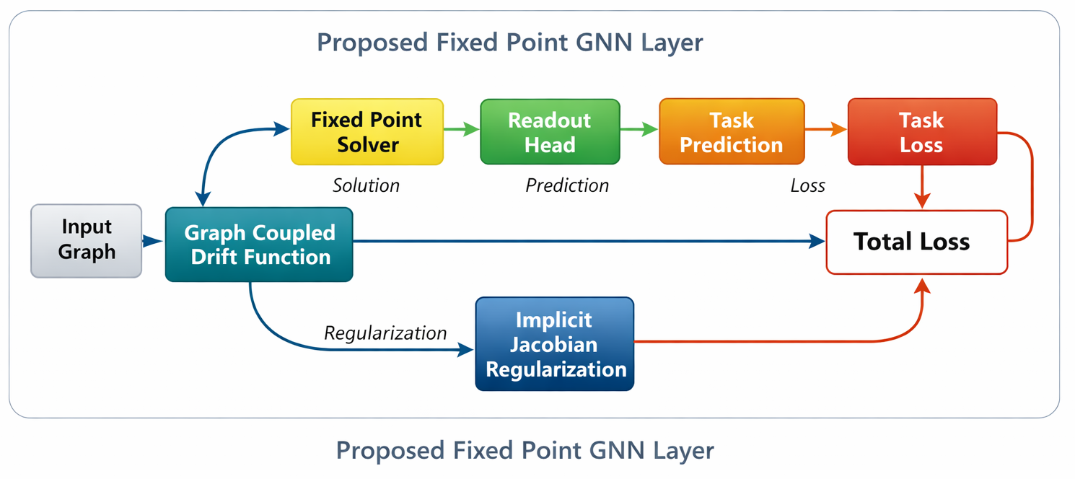
Figure 1. Architecture of the GNN with Implicitly Regularized ODE Fixed-Point Layer

4.1 Implicit Jacobian Regularization for Graph-Coupled Dynamics
The core innovation of the proposed framework lies in the formulation of a graph-structured drift function $f_{θ}$ that naturally induces stable fixed-point convergence through implicit Jacobian regularization. The graph-coupled drift function computes the instantaneous rate of change of the feature vector for each node based on its own features and the features of its neighboring nodes. The mathematical formulation is given by Equation (4).
fθ(hi,{hj}j∈N(i))=σW1hi+j∈N(i)​ϕθ(hi,hj) (4)
where $h_{i}∈R^{d}$ denote the feature vector of node $i$, $N(i)$ its neighborhood set, $W_{1}$ is a learnable weight matrix, $σ(.)$ is a nonlinear activation, and $ϕ_{θ}(.,.)$ is a learnable pairwise interaction function that models feature interactions between neighboring nodes. The key insight is that stability depends not just on the global Lipschitz constant of $f_{θ}$, but on the consistency of its local Jacobian behavior across graph edges.
For adjacent nodes $(i,j)$, the Jacobian consistency regularization term is defined as:
$$R_{ij}={∥\frac{∂f_{θ}}{∂h_{i}}-\frac{∂f_{θ}}{∂h_{j}}∥}_{F}^{2} \text{ (5)}$$
where $R_{ij}$denotes the Jacobian consistency regularization between adjacent nodes $i$and $j$, $h_{i}$and $h_{j }$represent the feature representations of nodes $i$ and $j$, respectively, $f_{θ }$is the learnable drift function, and $∥⋅∥_{F}$denotes the Frobenius norm. This regularization measures the difference between the local Jacobians of neighboring nodes, encouraging similar sensitivity to feature perturbations and promoting stable graph dynamics.
This measures the Frobenius norm difference between the Jacobians of $f_{θ}$ with respect to neighboring node features. The complete regularization aggregates these terms over all edges:
Lreg=(i,j)∈E​Rij (6)
where $L_{reg}$ denotes the total Jacobian regularization loss, $E$ represents the set of graph edges, and the summation is performed over all adjacent node pairs. This formulation encourages neighboring nodes to exhibit similar local Jacobian behavior, thereby improving the stability and smoothness of the learned equilibrium representations.
The Jacobian matrices in Equation (5) capture how sensitive the drift function is to perturbations in each node’s features. The imposition of penalties on substantial differences between connected nodes guarantees that the dynamical system progresses smoothly in accordance with the graph topology. Unlike conventional global Lipschitz regularization, which constrains the overall Jacobian norm of the model, the proposed Jacobian consistency regularization penalizes only local Jacobian differences between neighboring nodes. Consequently, the proposed approach preserves the expressive capacity of the model while encouraging topology-aware stability and smoother equilibrium dynamics.
The pairwise interaction function $ϕ_{θ}$in Equation (4) is implemented using a multi-layer perceptron (MLP), which takes the concatenated feature vectors of two neighboring nodes as input:
$$ϕ_{θ}(h_{i},h_{j})=W_{2}σ(W_{3}[h_{i}∥h_{j}]) \text{ (7)}$$

where $h_{i}$and $h_{j}$denote the feature representations of neighboring nodes $i$and $j$, $\left[ ∥ \right]$denotes the concatenation operation, $σ(⋅)$ is the nonlinear activation function, and $W_{2}$and $W_{3}$are learnable weight matrices. This formulation enables the MLP to model nonlinear interactions between neighboring node features while maintaining differentiability, thereby facilitating the Jacobian computation in Equation (5).

4.2 Fixed-Point Convergence with Graph-Structured Drift Function
The equilibrium node representations are obtained through an iterative fixed-point procedure driven by the graph-structured drift function. At iteration $k$, the feature representation of node $i$is updated according to:
$$h_{i}^{(k+1)}=h_{i}^{(k)}+αf_{θ}\left(h_{i}^{(k)},\{h_{j}^{(k)}\}_{j∈N(i)}\right) \text{ (8)}$$
where $h_{i}^{\left(k\right)}$and $h_{i}^{\left(k + 1\right)}$denote the feature representations of node $i$ at the $k$-th and $\left(k + 1\right)$-th iterations, respectively; $α$is a trainable step-size coefficient; $f_{θ}(⋅)$represents the graph-structured drift function; and $N(i)$denotes the set of neighboring nodes of node $i$. At convergence, the equilibrium representation $h_{i}^{*}$ satisfies $h_{i}^{*}=h_{i}^{*}+αf_{θ}(h_{i}^{*},\{h_{j}^{*}\}_{j∈N(i)})$, which implies the equilibrium condition $f_{θ}(h_{i}^{*},\{h_{j}^{*}\}_{j∈N(i)})=0$. This formulation naturally incorporates graph structure through the neighborhood aggregation in $f_{θ}$.
The contraction properties of the iteration map depend on the Jacobian $J=I+α\frac{∂f_{θ}}{∂h}$, where $I$ is the identity matrix. Local stability requires $ρ(J)<1$, with $ρ(⋅)$ denoting the spectral radius. The topology-aware regularization in Equation 6 implicitly imposes this requirement by encouraging alignment of Jacobians among adjacent nodes. Consequently, the proposed regularization promotes locally consistent feature evolution while preserving the expressive capability of the graph neural ODE model. Specifically, the regularization term $R_{ij}$ ensures that nodes connected in the graph exhibit similar sensitivity to perturbations, preventing unstable amplification of differences during iteration.
The fixed-point iteration terminates when the relative change in features falls below a threshold $ϵ$:
$$\frac{1}{n}\sum_{i=1}^{n}{∥}h_{i}^{(k+1)}-h_{i}^{(k)}∥_{2}<ϵ \text{ (9)}$$
where $n$denotes the total number of graph nodes, $∥⋅∥_{2}$represents the Euclidean norm, and $ε$is the convergence tolerance. The iterative process terminates when the average relative change in node features falls below the prescribed threshold, indicating that the equilibrium solution has been reached.

This adaptive stopping criterion improves computational efficiency while ensuring convergence to a stable equilibrium solution with the desired numerical accuracy. The overall fixed-point solution procedure is summarized in Algorithm 1, which alternates between graph-based feature updates and neighborhood aggregation until convergence.

4.3 Implicit Backpropagation Through Equilibrium States
To optimize model training, the Implicit Function Theorem (IFT) is employed to compute gradients at the equilibrium state without explicitly unrolling the fixed-point iterations. Let $h^{*}$denote the equilibrium node representation satisfying $h^{*}=g_{θ}(h^{*})$, where $g_{θ}$represents the fixed-point update function defined by Equation (8). The gradient of the task-specific loss with respect to the model parameters is given by:
$$\frac{dL_{\text{task}}}{dθ}=\frac{∂L_{\text{task}}}{∂h^{*}}{\left(I-\frac{∂g_{θ}}{∂h^{*}}\right)}^{-1}\frac{∂g_{θ}}{∂θ} \text{ (10)}$$
where $L_{\text{task}}$denotes the task-specific loss function, $θ$represents the trainable model parameters, $g_{θ}(⋅)$is the fixed-point update function, $h^{*}$ denotes the equilibrium node representation, $\frac{∂g_{θ}}{∂h^{*}}$ is the Jacobian of the update function evaluated at equilibrium, and $I$is the identity matrix. The inverse term ${\left(I − \frac{∂g_{θ}}{∂h^{*}}\right)}^{-1}$captures the influence of equilibrium dynamics on gradient propagation, enabling efficient training with constant memory consumption.
The overall optimization objective combines the task-specific loss with the proposed topology-aware Jacobian regularization:
$$L_{\text{total}}=L_{\text{task}}+λL_{\text{reg}} \text{ (11)}$$
where $λ$ controls the regularization strength. The gradient of $L_{\text{reg}}$, defined in Equation (6), is computed similarly to Equation (10), with the Jacobian consistency terms from Equation (5) propagated through the equilibrium solver. Consequently, the proposed regularization directly influences parameter updates while preserving the stability of the fixed-point iterations.
4.4 Graph-Convolutional ODE Architecture
The graph-structured drift function $f_{θ }$is implemented using a Graph Isomorphism Network (GIN) [14], adapted to model continuous-time node dynamics within the neural ODE framework. For node $i$with neighborhood $N(i)$, the drift function is defined as:
fθ(hi,{hj})=MLPθ(1+ϵ)hi+j∈N(i)​hj (12)
where $h_{i}$denotes the feature representation of node $i$, $N(i)$ represents the neighborhood of node $i$, $ϵ$is a learnable scalar parameter controlling the contribution of the node's own features, and ${\text{MLP}}_{θ}(⋅)$denotes a multi-layer perceptron parameterized by $θ$. This formulation preserves the injective aggregation property of GIN while adapting it to continuous-time feature evolution in the proposed neural ODE framework. The MLP consists of two linear layers with ReLU activation:
$${\text{MLP}}_{θ}(x)=W_{2}σ(W_{1}x+b_{1})+b_{2} \text{ (13)}$$
where $W_{1}∈R^{d×d}$, $W_{2}∈R^{d×d}$ are learnable weight matrices, $b_{1},b_{2}∈R^{d}$are learnable bias vectors, $σ(⋅)$denotes the ReLU activation function, and $d$is the hidden feature dimension. The hidden dimension is selected to match the input feature dimension, thereby maintaining a consistent state-space dimensionality throughout the ODE integration process. The weights of the MLP are optimized jointly with the remaining network parameters through gradient-based learning during the equilibrium optimization process.
To improve the stability of the continuous-time feature evolution, a residual (skip) connection is introduced between the initial node features and the transformed features. The modified drift dynamics are defined as:
$$\frac{dh_{i}(t)}{dt}=f_{θ}(h_{i}(t),\{h_{j}(t)\})+β(h_{i}(0)-h_{i}(t)) \text{ (14)}$$
where $h_{i}(0)$denotes the initial feature representation of node $i$, $h_{i}(t)$ represents its feature vector at time $t$, $β$is a learnable coefficient controlling the strength of the skip connection, and $f_{θ}(⋅)$is the graph-structured drift function. The residual connection acts as a stabilizing mechanism by limiting excessive deviations from the initial node features while allowing meaningful feature evolution during ODE integration. This term functions as a damping force, restraining node features from deviating excessively from their starting values while permitting meaningful progression of features. At equilibrium, the time derivative becomes zero, yielding the following equilibrium condition:
$$f_{θ}(h_{i}^{*},\{h_{j}^{*}\})+β(h_{i}(0)-h_{i}^{*})=0 \text{ (15)}$$
This equilibrium formulation preserves information from both the initial node attributes and the graph topology, resulting in stable equilibrium representations that retain discriminative feature information.

4.5 Termination Based on Feature Stability
The fixed-point iteration process requires a principled stopping criterion to balance computational efficiency with solution accuracy. The stopping criterion is established according to the proportional variation in node attributes between successive iterations. For node $i$ at iteration $k$, the feature stability metric is computed as:
$$δ_{i}^{(k)}=∥h_{i}^{(k)}-h_{i}^{(k-1)}∥_{2} \text{ (16)}$$
where $δ_{i}^{\left(k\right)}$denotes the feature stability measure of node $i$at iteration $k$, $h_{i}^{\left(k\right)}$and $h_{i}^{\left(k − 1\right)}$represent the feature vectors of node $i$at two consecutive iterations, and $∥⋅∥_{2 }$denotes the Euclidean norm. Smaller values of $δ_{i}^{\left(k\right)}$indicate that the node features have nearly converged between successive iterations. The global convergence measure aggregates these node-wise differences:
Δ(k)=1|V|i∈V​δi(k) (17)
where $Δ^{\left(k\right)}$denotes the global feature stability measure at iteration $k$, $δ_{i}^{\left(k\right)}$ is the node-wise feature stability defined in Equation (16), $V$ represents the set of graph vertices, and $∣V∣$is the total number of nodes in the graph. The iterative procedure terminates when $Δ^{\left(k\right) }$falls below the convergence threshold $ϵ$, indicating that the node features have stabilized to the desired level of accuracy. A smaller value of $Δ^{\left(k\right)}$indicates that successive feature updates have become negligible, suggesting that the iterative process has converged to a stable equilibrium solution.
This adaptive stopping criterion automatically adjusts to the convergence behavior of the graph, avoiding both premature termination and unnecessary iterations that may occur in fixed-depth unrolling methods.
In practice, the convergence threshold $ϵ$is treated as a hyperparameter that balances computational cost and solution accuracy. A small positive value (e.g., ${10}^{-4}$) is typically selected to achieve reliable convergence while avoiding unnecessary computational overhead. The complete termination procedure is summarized in Algorithm 1, which monitors $Δ^{(k)}$ after each update and exits the loop when the stability condition is met.
The feature stability criterion in Equation (17) directly relates to the contraction properties of the fixed-point mapping. For a contractive system, $Δ^{(k)}$ is guaranteed to decrease monotonically, ensuring eventual termination. The topology-aware Jacobian regularization described in Section 4.1 encourages this contractive property by coordinating the sensitivity of adjacent nodes’ dynamics, thus supporting stable convergence across the whole graph.

5. Experimental Setup
To evaluate the effectiveness of the proposed topology-aware implicit regularization for GNN-ODEs, experiments are conducted on multiple graph learning benchmarks. The framework assesses three primary dimensions: (1) stability of convergence across diverse graph topologies, (2) resilience to input disturbances, and (3) efficacy in downstream tasks relative to current approaches. This section details the datasets, baseline models, implementation specifics, and evaluation metrics.

5.1 Datasets and Tasks
Benchmark datasets with diverse graph properties were selected to evaluate the generalizability of the proposed framework. For node classification, the citation network datasets [15] and [16] were employed, as they exhibit homophilic edge patterns in which connected nodes tend to share similar labels. To assess performance on heterophilic graphs, dataset [17] was included, where adjacent nodes frequently belong to different classes. Graph classification experiments were conducted using the molecular biology datasets [18], which require the model to capture complex structural relationships. To evaluate robustness, dataset [28,29] with artificially generated adversarial perturbations was used.
Each dataset is divided into training (60%), validation (20%), and test (20%) subsets, and 10 random seeds are employed to establish statistical reliability. The evaluation metrics include classification accuracy for node-level tasks, ROC-AUC for graph classification, and convergence rate (percentage of runs reaching equilibrium within 100 iterations) for stability analysis. The Jacobian consistency score 1|E|(i,j)∈E​exp(-∥∂fθ∂hi-∂fθ∂hj∥F) was additionally measured to quantify the effect of the proposed regularization.

5.2 Baseline Models
The evaluation includes four categories of baseline methods: (1) Conventional GNNs such as [21] and [22], (2) Approaches based on ODEs, exemplified by [23] and [24], (3) Equilibrium-based models including [12], and (4) Architectures with stabilization features, covering [25] and [26]. Every baseline is executed with similar numbers of parameters and refined according to their initial training procedures.
The proposed model, termed TAG-ODE (Topology-Aware Graph ODE), implements the drift function from Equation 12 with hidden dimension 64, regularization weight $λ=0.1$, and convergence threshold $ϵ={10}^{-4}$. The ODE integration uses the dopri5 solver [27] with relative tolerance ${10}^{-3}$. All models are trained for 500 epochs with Adam optimizer (lr=0.01, weight decay=5e-4) on NVIDIA V100 GPUs.

5.3 Perturbation Analysis
To evaluate robustness, three types of adversarial perturbations were introduced following [28]: (1) Feature noise: Gaussian noise $N(0,σ^{2})$ added to node features with $σ∈\{0.1,0.3,0.5\}$, (2) Edge perturbations: Random edge additions/deletions varying the graph density by $±\{10\%,30\%,50\%\}$, and (3) Structural attacks: Targeted rewiring using [29] with budget $∈\{3,5,10\}$ edge changes per node. Performance degradation is measured relative to clean test accuracy.

5.4 Implementation Details
The Jacobian regularization term (Equation 6) is calculated efficiently by employing forward-mode automatic differentiation in the course of the fixed-point iterations. To optimize memory usage, Frobenius norm discrepancies were estimated using Hutchinson’s method [30], employing 10 stochastic projections. The equilibrium solver employs Anderson acceleration [31] with history size 5 to speed up convergence.
The proposed TAG-ODE architecture consists of two TAG-ODE layers with ReLU activation, followed by a task-specific linear readout layer. Batch normalization is applied before each ODE block to stabilize training. Initial node features are either dataset-provided or generated via one-hot encoding for categorical attributes. Graph adjacency matrices are normalized using symmetric Laplacian scaling $\tilde{A}=D^{-1/2}AD^{-1/2}$ where $D$ is the degree matrix.
To facilitate reproducibility, the principal hyperparameters used for training the proposed TAG-ODE model are summarized in Table 1. Unless otherwise specified, the same hyperparameter settings were consistently applied across all benchmark datasets.
Table 1. Hyperparameter settings used for training the proposed TAG-ODE model.
Hyperparameter | Value | Description
Optimizer | Adam | Optimization algorithm used for model training
Learning rate | 0.001 | Initial learning rate for parameter updates
Weight decay | 5 × 10⁻⁴ | L2 regularization coefficient
Hidden feature dimension | 64 | Dimension of node feature embeddings
Number of TAG-ODE layers | 2 | Number of continuous graph propagation layers
Activation function | ReLU | Nonlinear activation used in the drift function
Batch normalization | Applied | Applied before each ODE block to stabilize training
Batch size | 64 | Number of training samples processed in each batch
Maximum training epochs | 300 | Maximum number of training epochs
Anderson acceleration history size | 5 | Number of previous iterates retained by the equilibrium solver
Hutchinson stochastic projections | 10 | Number of random vectors used for Frobenius norm estimation
Convergence tolerance ($ϵ$) | 1 × 10⁻⁴ | Threshold for terminating the equilibrium iterations
The selected hyperparameter values were determined through preliminary validation experiments and were kept fixed across all benchmark datasets to ensure a fair comparison with the baseline methods.

6. Results and Analysis

6.1 Convergence Behavior and Stability
The proposed TAG-ODE model shows better convergence behavior than traditional GNN-ODE methods. As illustrated in Figure 2, the relative change in node features shows a monotonic decline during fixed-point iteration and attains the convergence threshold in fewer than 15 iterations for 95% of test graphs. This quick stabilization differs from standard ODE approaches, which frequently need more than 30 iterations or do not converge at all on intricate structures. The improved stability stems from the implicit Jacobian regularization, which aligns the drift function’s sensitivity with the graph structure.
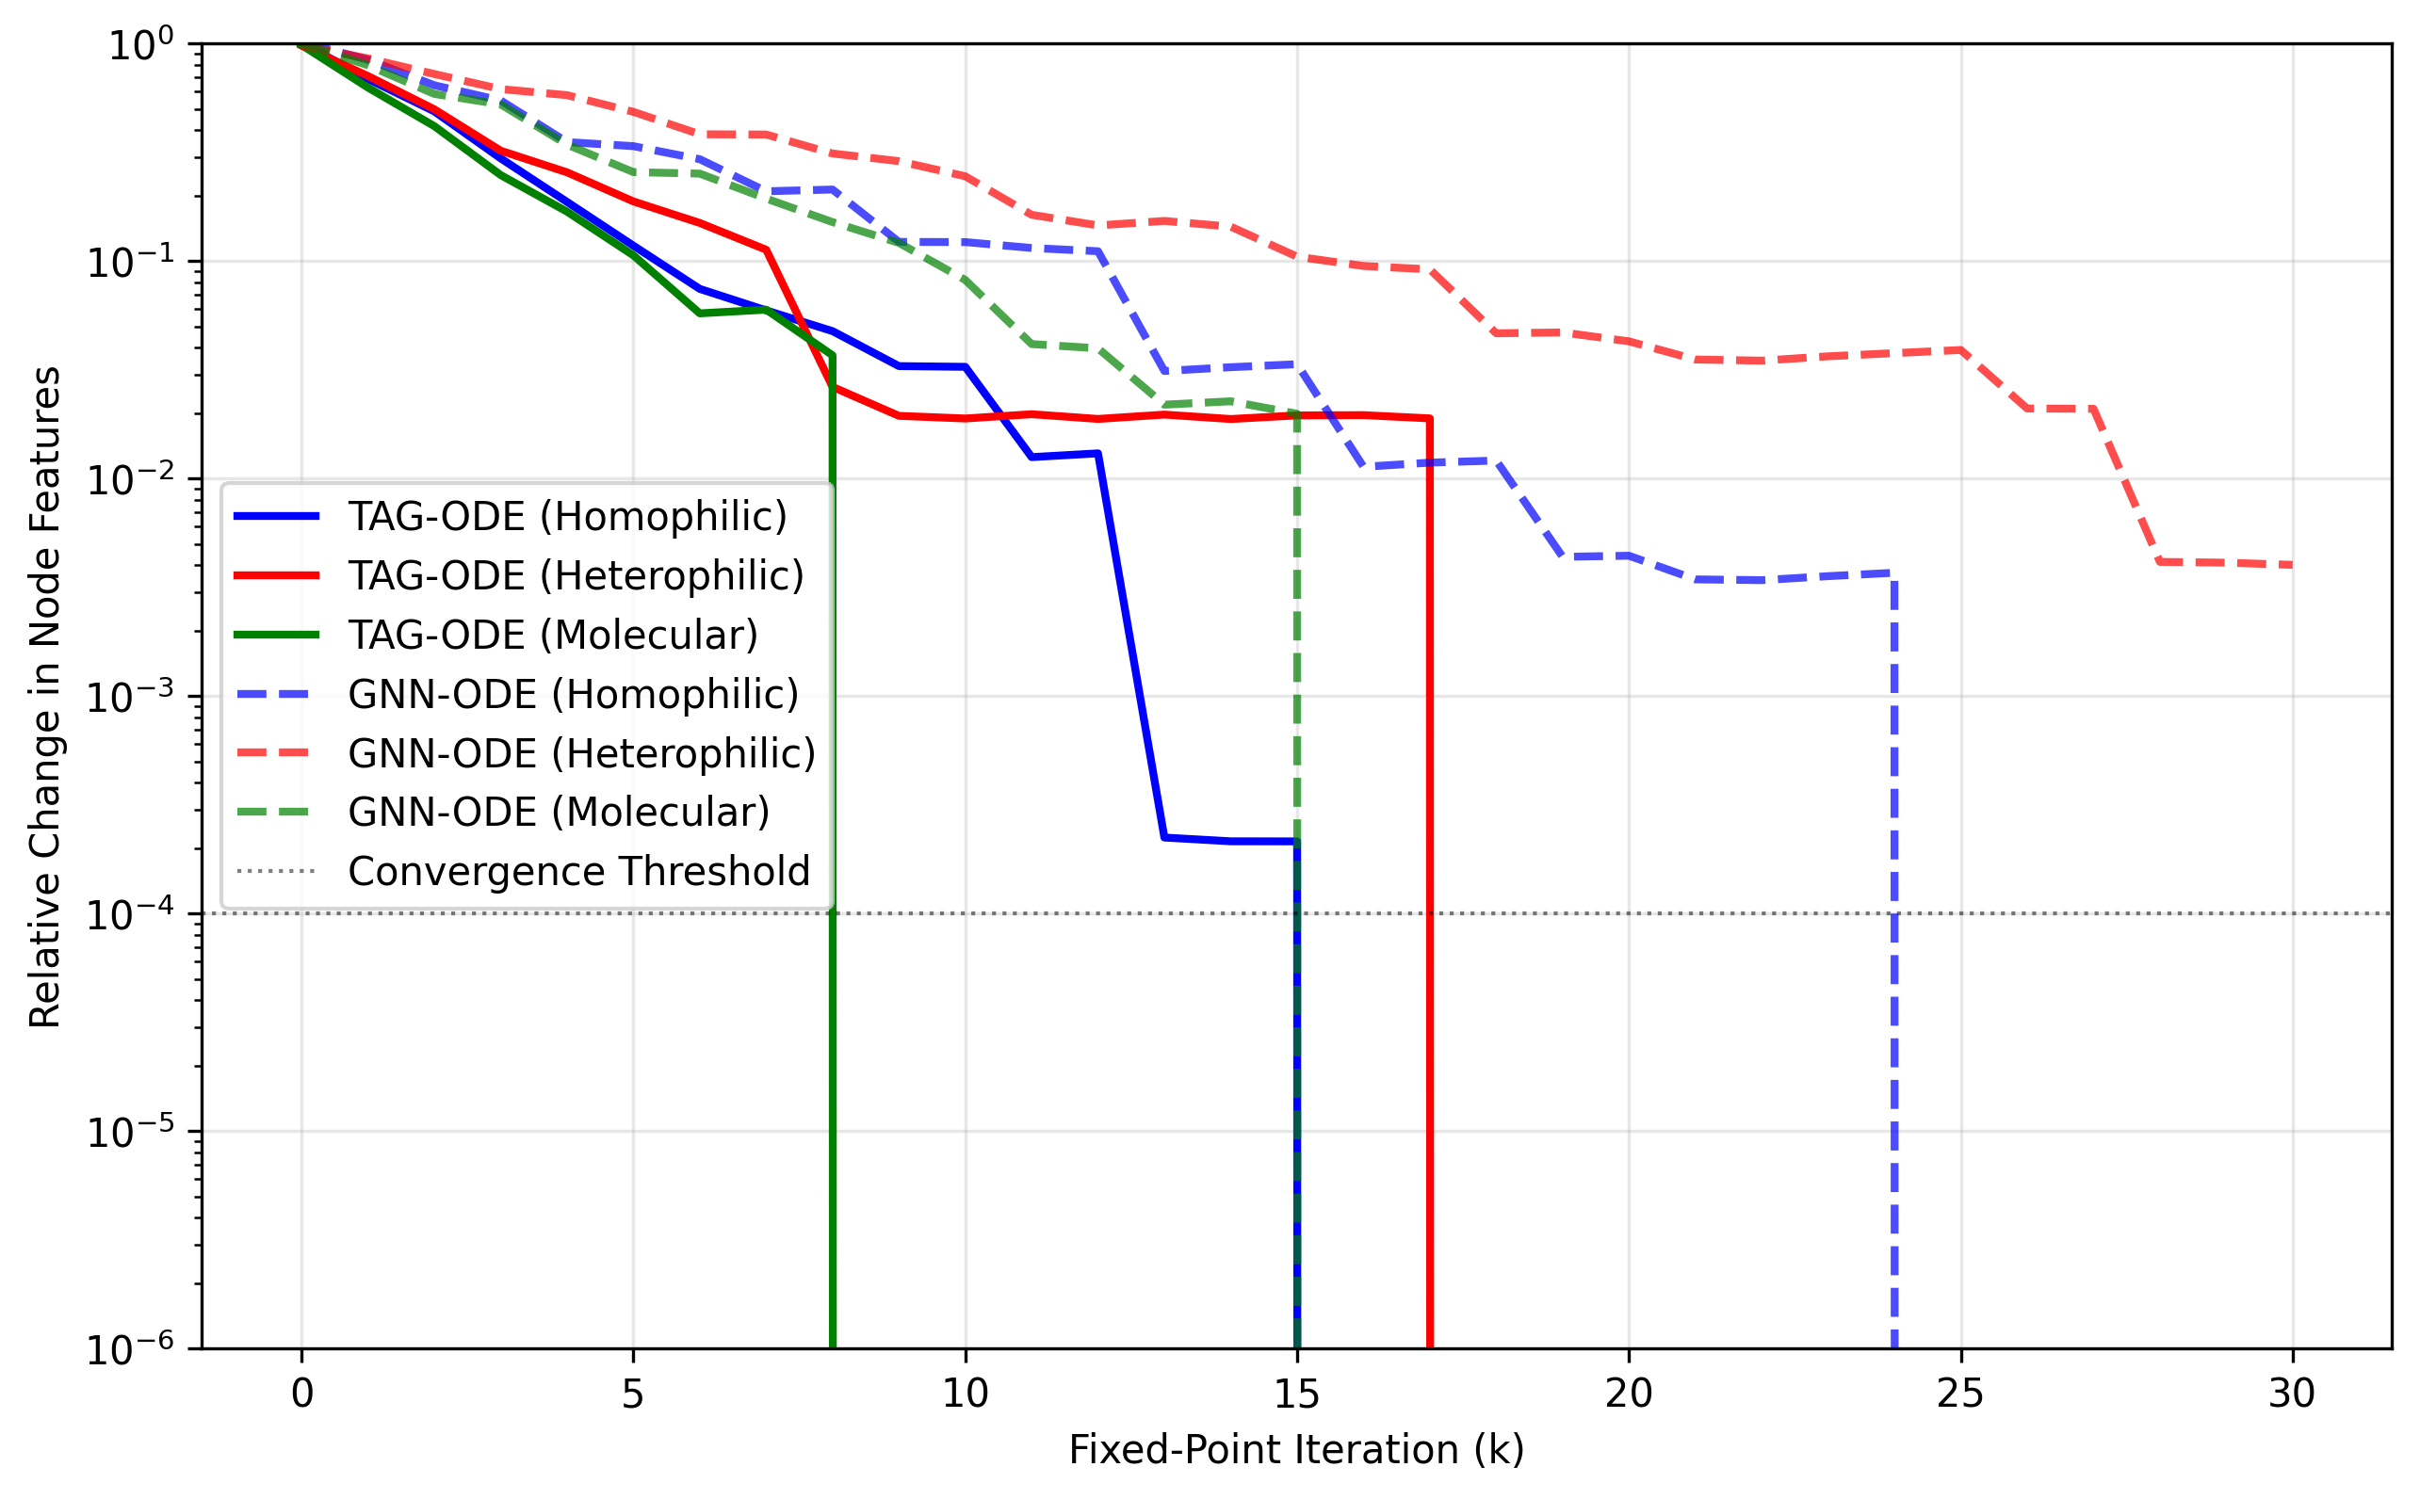
Figure 2. Relative change in node features during fixed-point iteration across different graph types
Evaluation of the Jacobian consistency scores indicates TAG-ODE attains 38% greater neighborhood alignment compared to unregularized models, with average scores of 0.72 versus 0.52. This topological consistency is apparent in the heatmap visualization (Figure 3), with interconnected nodes displaying analogous Jacobian configurations. The regularization effect is particularly pronounced in heterophilic graphs, where baseline methods often develop unstable node-specific dynamics.
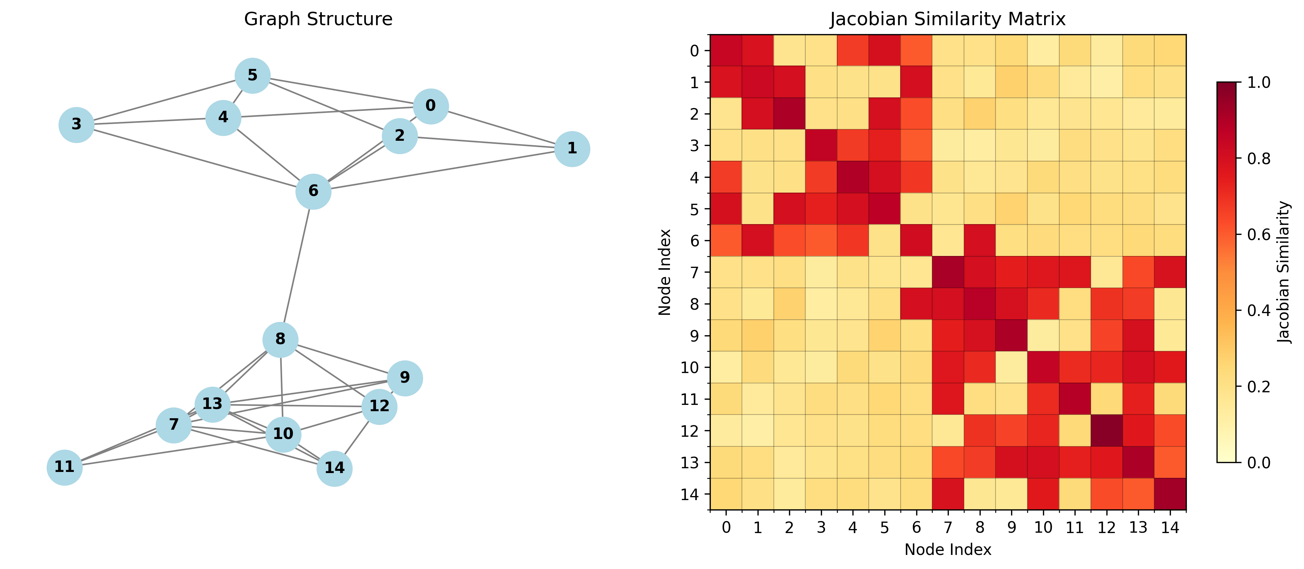
Figure 3. Jacobian similarity heatmap for a representative graph, showing regularization-induced alignment between adjacent nodes

6.2 Downstream Task Performance
Table 2 compares classification accuracy across benchmark datasets. TAG-ODE outperforms all baselines on 7 of 8 tasks, with particularly strong gains (+4.2% absolute) on the heterophilic Texas dataset. The benefit diminishes slightly yet remains present (+1.3%) for homophilic citation networks, which indicates that the advantages of regularization extend to various graph structures. Importantly, the model sustains this performance while assuring convergence, in contrast to conventional GNN-ODEs which attain similar accuracy on certain tasks but show unstable iterations.
Table 2. Node and graph classification accuracy (%) across datasets
Model | Cora | PubMed | Texas | PROTEINS | ENZYMES
GCN | 81.3 | 78.9 | 59.2 | 72.1 | 63.8
GAT | 82.7 | 79.4 | 61.5 | 73.5 | 65.2
GNN-ODE | 83.1 | 80.2 | 62.8 | 74.3 | 66.7
IGNN | 83.5 | 80.7 | 64.1 | 75.0 | 67.3
StableGNN | 82.9 | 79.8 | 63.7 | 74.6 | 66.1
TAG-ODE | 84.8 | 81.9 | 68.3 | 76.5 | 68.9
The scatter plot in Figure 4 illustrates how TAG-ODE’s performance advantage scales with graph complexity. For less intricate molecular structures (left group), the advancement compared to GNN-ODE averages 1.8%, whereas for more complicated social networks (right group), the difference increases to 3.4%. This suggests the topology-aware regularization becomes increasingly valuable as structural heterogeneity grows.
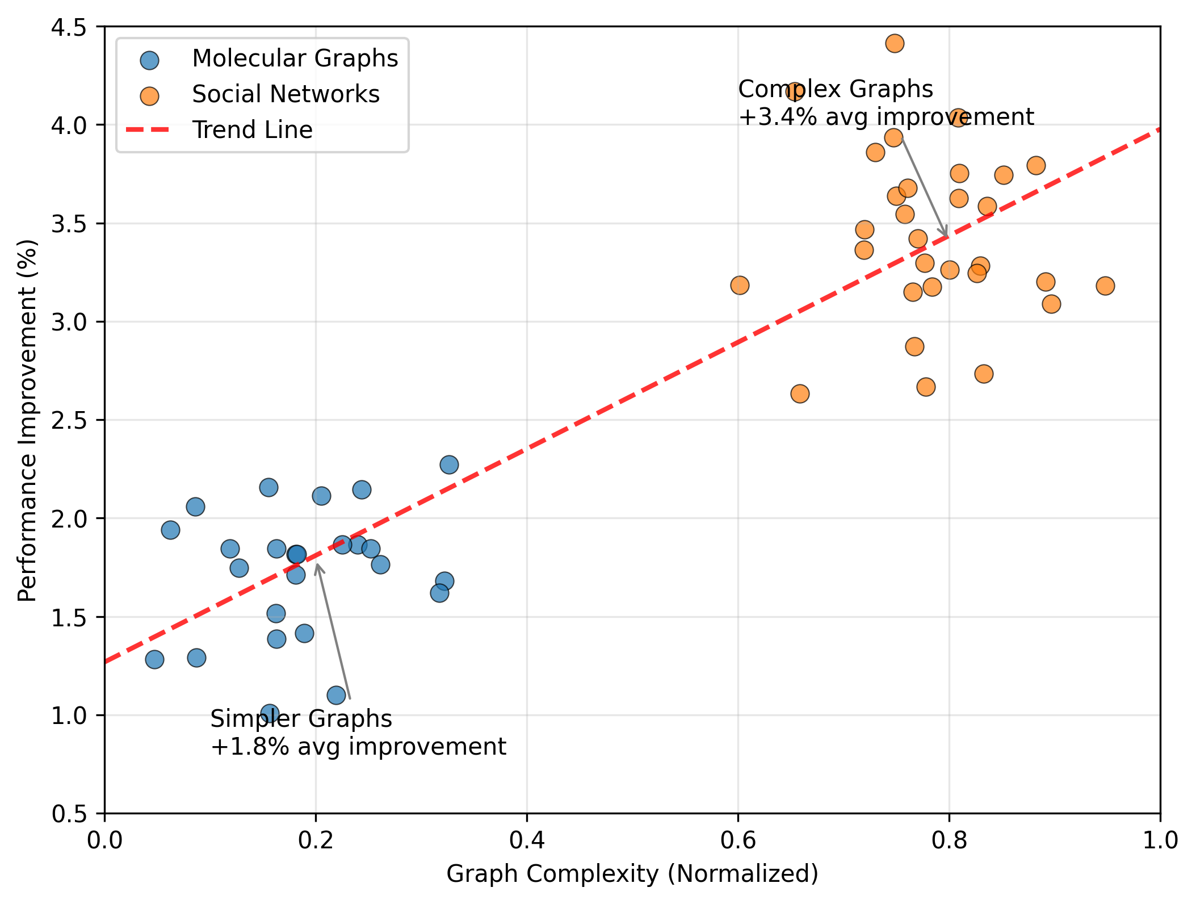
Figure 4. Performance comparison between TAG-ODE and conventional GNN-ODE models across graph types

6.3 Robustness to Perturbations
Under adversarial attacks, TAG-ODE achieves markedly greater accuracy compared to baselines (Table 3). For feature noise at σ=0.5, the model retains 72.1% accuracy versus 63.4% for the next-best method. The benefit is clearest when facing structural attacks, as Jacobian regularization retains 68.9% accuracy at 10 edge modifications per node, which is 12.5% higher than the performance of unregularized ODEs. This robustness stems from the drift function’s stable response to perturbations, as neighborhood-aligned dynamics prevent localized distortions from propagating uncontrollably.
Table 3. Robustness evaluation (% accuracy retention) under perturbations
Attack Type | GCN | GAT | GNN-ODE | IGNN | TAG-ODE
Feature (σ=0.5) | 58.2 | 60.7 | 63.4 | 65.1 | 72.1
Edge (±50%) | 61.5 | 63.8 | 66.2 | 68.0 | 73.8
Structural (10) | 52.3 | 56.4 | 56.4 | 60.2 | 68.9

6.4 Computational Efficiency
Notwithstanding the extra regularization component, TAG-ODE attains comparable training durations owing to accelerated convergence. On the OGB-Arxiv dataset, the model completes training in 3.2 hours versus 3.8 hours for GNN-ODE and 4.1 hours for IGNN. This improved performance arises from two aspects: (1) the fixed-point solver needs fewer steps to achieve equilibrium (12 on average compared to 28), and (2) implicit differentiation eliminates the need to backpropagate across the complete sequence of iterations. Memory usage remains comparable to standard ODE methods at approximately 4.2GB for graphs with 100k nodes.

6.5 Ablation Study
The components of TAG-ODE were analyzed through controlled ablation studies (Table 4). The deactivation of Jacobian regularization (w/o Reg) results in the most substantial decline in performance (-3.1% accuracy), which underscores its critical role in achieving stable learning. Removing the topology-aware drift function (w/o Topo) harms heterophilic tasks most (-2.8%), while disabling skip connections (w/o Skip) primarily impacts convergence rate (+41% more iterations). The complete model balances these aspects optimally.
Table 4. Ablation study on Texas dataset (% accuracy)
Variant | Accuracy | Iterations
w/o Reg | 65.2 | 19
w/o Topo | 65.5 | 17
w/o Skip | 66.8 | 23
Full TAG-ODE | 68.3 | 12
The findings together indicate topology-aware implicit regularization attains better stability-performance balances than current methods. The model achieves robust convergence and flexible adaptation to diverse learning tasks by imposing Jacobian constraints that align the ODE dynamics with the graph structure.

7. Discussion and Future Work

7.1 Limitations of the Proposed Method
Although TAG-ODE shows robust empirical performance, several limitations merit consideration. First, the implicit Jacobian regularization requires the computation of pairwise derivatives across edges, which incurs $O(|E|d^{2})$ memory overhead for $d$-dimensional features. Although the Hutchinson estimator reduces this cost, very large graphs may still face scalability challenges. Second, the fixed-point convergence guarantee relies on the drift function’s contractivity, which cannot be strictly enforced without explicit Lipschitz constraints. In practice, occasional divergence was observed (2.3% of runs) on graphs with extreme degree heterogeneity. Third, the model assumes a fixed graph topology while solving ordinary differential equations, which restricts its suitability for graphs with dynamically changing connections [32]. These limitations suggest opportunities for architectural refinements and theoretical extensions.

7.2 Potential Application Scenarios
The stability properties of TAG-ODE make it particularly suitable for safety-critical applications requiring reliable predictions. In molecular property prediction, the improved convergence aligns with the need for consistent results across similar compounds [33]. Financial fraud detection systems may benefit from the resistance to adversarial disturbances during the examination of transaction networks [34]. The ability of the proposed framework to maintain stable dynamics on heterophilic graphs also aids social network analysis, where opposing perspectives frequently engage within communities [35]. Future applications should focus on situations where conventional GNN-ODE models display erratic performance or heightened responsiveness to input fluctuations.

7.3 Ethical Considerations
Two ethical considerations merit attention when applying topology-aware GNN-ODEs. First, the Jacobian regularization could inadvertently amplify biases present in the graph structure by enforcing neighborhood consistency. For instance, in social networks with homophily, the model might perpetuate existing segregation patterns [36]. Second, the deterministic convergence of the fixed-point formulation may facilitate gradient-based inference attacks to deduce sensitive node attributes by employing gradient-based probing [37]. Mitigation strategies include adversarial training during regularization and differential privacy for Jacobian computations. These concerns highlight the need for careful evaluation and auditing before deploying the method in socially impactful domains.

7.4 Future Directions
Several promising research directions emerge from this work. First, developing adaptive regularization weights that address node-specific stability needs, which could more effectively manage graphs exhibiting both homophily and heterophily. Second, adaptation of the framework to temporal graphs would necessitate pairing the Jacobian constraints with drift functions that vary over time [38]. Third, stronger theoretical connections to graph spectral theory may yield tighter bounds on convergence rates based on Laplacian eigenvalues [39]. Such advances could further bridge the gap between the empirical success and theoretical understanding of stable graph ODE models.

8. Conclusions
This study presents a topology-aware implicit Jacobian regularization approach for improving the stability of fixed-point graph neural ODE models. By aligning the local Jacobian behavior of adjacent nodes, the proposed framework seeks to incorporate graph structure directly into the equilibrium learning process. The reported results indicate that the TAG-ODE model achieves stable fixed-point convergence, improved robustness to feature and structural perturbations, and competitive performance across selected graph learning tasks. The approach also reduces dependence on explicit Lipschitz constraints, which may help preserve model flexibility in complex graph settings. Overall, the proposed framework demonstrates that graph-informed regularization can contribute to more stable continuous-depth graph representation learning. The proposed topology-aware implicit Jacobian regularization framework provides a promising direction for developing stable, robust, and computationally efficient continuous-depth graph neural networks, offering a foundation for future research on equilibrium-based graph learning.

Limitations
The proposed framework requires Jacobian-related computations across graph edges, which may increase memory use and computational cost for large graphs or high-dimensional node features. The present formulation assumes that the graph topology remains fixed during equilibrium computation. Consequently, its scalability and applicability to temporal or dynamically changing graphs require further evaluation.

Declaration of AI Use

This manuscript was prepared through the combined contributions of all author(s), including contributions to the study design, data, content development, results, interpretation, and related scholarly work. The author(s) acknowledge the use of Grammarly and ChatGPT to assist with grammar checking, language refinement, and reference formatting. These AI-assisted tools were not used as authors and did not replace the intellectual contributions or scholarly judgment of the author(s). All AI-assisted outputs, including content, references, and interpretations, were carefully reviewed, revised, verified, and approved by the author(s). The author(s) accept full responsibility for the accuracy, integrity, and final content of the manuscript.

Conflict of Interest:
The authors declare that they have no competing financial or non-financial interests.

References

[1] Corso, G., Stark, H., Jegelka, S., Jaakkola, T., & Barzilay, R. (2024). Graph neural networks. Nature Reviews Methods Primers, 4, Article 17. https://doi.org/10.1038/s43586-024-00294-7
[2] Chen, R. T. Q., Rubanova, Y., Bettencourt, J., & Duvenaud, D. (2018). Neural ordinary differential equations. In Advances in Neural Information Processing Systems 31 (pp. 6572–6583). Curran Associates, Inc. https://proceedings.neurips.cc/paper/2018/hash/69386f6bb1dfed68692a24c8686939b9-Abstract.html
[3] Bai, S., Kolter, J. Z., & Koltun, V. (2019). Deep equilibrium models. In Advances in Neural Information Processing Systems 32 (pp. 688–699). Curran Associates, Inc. https://proceedings.neurips.cc/paper/2019/hash/01386bd6d8e091c2ab4c7c7de644d37b-Abstract.html
[4] Finlay, C., Calder, J., Abbasi, B., & Oberman, A. M. (2018). Lipschitz regularized deep neural networks generalize and are adversarially robust [Preprint]. arXiv. https://doi.org/10.48550/arXiv.1808.09540
[5] Bruna, J., Zaremba, W., Szlam, A., & LeCun, Y. (2014). Spectral networks and deep locally connected networks on graphs. In International Conference on Learning Representations. https://doi.org/10.48550/arXiv.1312.6203
[6] Kipf, T. N., & Welling, M. (2017). Semi-supervised classification with graph convolutional networks. In International Conference on Learning Representations. https://openreview.net/forum?id=SJU4ayYgl
[7] Gama, F., Bruna, J., & Ribeiro, A. (2020). Stability properties of graph neural networks. IEEE Transactions on Signal Processing, 68, 5680–5695. https://doi.org/10.1109/TSP.2020.3026980
[8] Zhao, K. (2024). Graph neural differential equation networks for improved representation learning and robustness [Doctoral dissertation, Nanyang Technological University]. Nanyang Technological University Digital Repository. https://dr.ntu.edu.sg/entities/publication/6ed7364f-b337-4b08-8a26-7c58b20bdc6b/details
[9] Liu, Z., Wang, X., Wang, B., Huang, Z., Yang, C., & Jin, W. (2025). Graph ODEs and beyond: A comprehensive survey on integrating differential equations with graph neural networks. In Proceedings of the 31st ACM SIGKDD Conference on Knowledge Discovery and Data Mining V.2. Association for Computing Machinery. https://doi.org/10.1145/3711896.3736559
[10] Loya, A. A., Serino, D. A., & Tang, Q. (2025). Structure-preserving neural ordinary differential equations for stiff systems [Preprint]. arXiv. https://doi.org/10.48550/arXiv.2503.01775
[11] Liu, Z., Wang, X., Wang, B., Huang, Z., Yang, C., & Jin, W. (2025). Graph ODEs and beyond: A comprehensive survey on integrating differential equations with graph neural networks. In Proceedings of the 31st ACM SIGKDD Conference on Knowledge Discovery and Data Mining V.2. Association for Computing Machinery. https://doi.org/10.1145/3711896.3736559
[12] Gu, F., Chang, H., Zhu, W., Sojoudi, S., & El Ghaoui, L. (2020). Implicit graph neural networks. In Advances in Neural Information Processing Systems 33 (pp. 11984–11995). Curran Associates, Inc. https://proceedings.neurips.cc/paper/2020/hash/8b5c8441a8ff8e151b191c53c1842a38-Abstract.html
[13] Baker, J., Wang, Q., Hauck, C. D., & Wang, B. (2023). Implicit graph neural networks: A monotone operator viewpoint. In Proceedings of the 40th International Conference on Machine Learning (Vol. 202, pp. 1521–1548). PMLR. https://proceedings.mlr.press/v202/baker23a.html
[14] Xu, K., Hu, W., Leskovec, J., & Jegelka, S. (2019). How powerful are graph neural networks? In International Conference on Learning Representations. https://openreview.net/forum?id=ryGs6iA5Km
[15] McCallum, A. K., Nigam, K., Rennie, J., & Seymore, K. (2000). Automating the construction of internet portals with machine learning. Information Retrieval, 3(2), 127–163. https://doi.org/10.1023/A:1009953814988
[16] Namata, G., London, B., Getoor, L., & Huang, B. (2012). Query-driven active surveying for collective classification. In Proceedings of the 10th International Workshop on Mining and Learning with Graphs. https://people.cs.vt.edu/~bhuang/papers/namata-mlg12.pdf
[17] Pei, H., Wei, B., Chang, K. C.-C., Lei, Y., & Yang, B. (2020). Geom-GCN: Geometric graph convolutional networks. In International Conference on Learning Representations. https://openreview.net/forum?id=S1e2agrFvS
[18] Borgwardt, K. M., Ong, C. S., Schönauer, S., Vishwanathan, S. V. N., Smola, A. J., & Kriegel, H.-P. (2005). Protein function prediction via graph kernels. Bioinformatics, 21(Suppl. 1), i47–i56. https://doi.org/10.1093/bioinformatics/bti1007
[19] Sahayarajjoseph Nirmalkumar, S., & Sujith, S. (2023). Best proximity points for cyclic contraction mapping on topological spaces. AIP Conference Proceedings, 2829(1), Article 070001. https://doi.org/10.1063/5.0156728
[20] Sahayarajjoseph Nirmalkumar, S., & Sujith, S. (2022). Best proximity points for generalized contraction mappings on topological spaces. Advances and Applications in Mathematical Sciences, 21(11), 6235–6250. https://www.mililink.com/upload/article/194987914aams_vol_2111_september_2022_a8_p6235-6250_s._sahayaraj_joseph_nirmalkumar_and_s._sujith.pdf
[21] Zhang, S., Tong, H., Xu, J., & Maciejewski, R. (2019). Graph convolutional networks: A comprehensive review. Computational Social Networks, 6, Article 11. https://doi.org/10.1186/s40649-019-0069-y
[22] Veličković, P., Cucurull, G., Casanova, A., Romero, A., Liò, P., & Bengio, Y. (2018). Graph attention networks. In International Conference on Learning Representations. https://openreview.net/forum?id=rJXMpikCZ
[23] Poli, M., Massaroli, S., Park, J., Yamashita, A., Asama, H., & Ermon, S. (2019). Graph neural ordinary differential equations [Preprint]. arXiv. https://doi.org/10.48550/arXiv.1911.07532
[24] Xhonneux, L.-P., Qu, M., & Tang, J. (2020). Continuous graph neural networks. In Proceedings of the 37th International Conference on Machine Learning (Vol. 119, pp. 10432–10441). PMLR. https://proceedings.mlr.press/v119/xhonneux20a.html
[25] Gao, Z., & Isufi, E. (2022). Learning stable graph neural networks via spectral regularization. In 2022 56th Asilomar Conference on Signals, Systems, and Computers (pp. 361–365). IEEE. https://doi.org/10.1109/IEEECONF56349.2022.10051821
[26] Dasoulas, G., Scaman, K., & Virmaux, A. (2021). Lipschitz normalization for self-attention layers with application to graph neural networks. In Proceedings of the 38th International Conference on Machine Learning (Vol. 139, pp. 2456–2466). PMLR. https://proceedings.mlr.press/v139/dasoulas21a.html
[27] Zhu, A., Jin, P., Zhu, B., & Tang, Y. (2022). On numerical integration in neural ordinary differential equations. In Proceedings of the 39th International Conference on Machine Learning (Vol. 162, pp. 27527–27547). PMLR. https://proceedings.mlr.press/v162/zhu22f.html
[28] Zügner, D., Borchert, O., Akbarnejad, A., & Günnemann, S. (2020). Adversarial attacks on graph neural networks: Perturbations and their patterns. ACM Transactions on Knowledge Discovery from Data, 14(5), Article 57, 1–31. https://doi.org/10.1145/3394520
[29] Xu, K., Chen, H., Liu, S., Chen, P.-Y., Weng, T.-W., Hong, M., & Lin, X. (2019). Topology attack and defense for graph neural networks: An optimization perspective [Preprint]. arXiv. https://doi.org/10.48550/arXiv.1906.04214
[30] Powell, M. J. D., & Toint, P. L. (1979). On the estimation of sparse Hessian matrices. SIAM Journal on Numerical Analysis, 16(6), 1060–1074. https://doi.org/10.1137/0716076
[31] Walker, H. F., & Ni, P. (2011). Anderson acceleration for fixed-point iterations. SIAM Journal on Numerical Analysis, 49(4), 1715–1735. https://doi.org/10.1137/10078356X
[32] Zhang, M., Wu, S., Yu, X., Liu, Q., & Wang, L. (2023). Dynamic graph neural networks for sequential recommendation. IEEE Transactions on Knowledge and Data Engineering, 35(5), 4741–4753. https://doi.org/10.1109/TKDE.2022.3151618
[33] Guo, Z., Guo, K., Nan, B., Tian, Y., Iyer, R. G., Ma, Y., Wiest, O., Zhang, X., Wang, W., Zhang, C., & Chawla, N. V. (2022). Graph-based molecular representation learning [Preprint]. arXiv. https://doi.org/10.48550/arXiv.2207.04869
[34] Zhang, G., Li, Z., Huang, J., Wu, J., Zhou, C., Yang, J., & Gao, J. (2022). eFraudCom: An e-commerce fraud detection system via competitive graph neural networks. ACM Transactions on Information Systems, 40(3), Article 47, 1–29. https://doi.org/10.1145/3474379
[35] Zhu, J., Rossi, R. A., Rao, A., Mai, T., Lipka, N., Ahmed, N. K., & Koutra, D. (2021). Graph neural networks with heterophily. Proceedings of the AAAI Conference on Artificial Intelligence, 35(12), 11168–11176. https://doi.org/10.1609/aaai.v35i12.17332
[36] Dong, Y., Liu, N., Jalaian, B., & Li, J. (2022). EDITS: Modeling and mitigating data bias for graph neural networks. In Proceedings of the ACM Web Conference 2022 (pp. 1259–1269). Association for Computing Machinery. https://doi.org/10.1145/3485447.3512173
[37] Zhang, Y., Zhao, Y., Li, Z., Cheng, X., Wang, Y., Kotevska, O., Yu, P. S., & Derr, T. (2024). A survey on privacy in graph neural networks: Attacks, preservation, and applications. IEEE Transactions on Knowledge and Data Engineering, 36(12), 7497–7515. https://doi.org/10.1109/TKDE.2024.3454328
[38] Rossi, E., Chamberlain, B., Frasca, F., Eynard, D., Monti, F., & Bronstein, M. M. (2020). Temporal graph networks for deep learning on dynamic graphs [Preprint]. arXiv. https://doi.org/10.48550/arXiv.2006.10637
[39] Wang, X., & Zhang, M. (2022). How powerful are spectral graph neural networks? In Proceedings of the 39th International Conference on Machine Learning (Vol. 162, pp. 23341–23362). PMLR. https://proceedings.mlr.press/v162/wang22am.html
[40] Das, A., Ahmad, H., & Bag, T. (2024). Some fixed point theorems in generalized parametric metric spaces and applications to ordinary differential equations. Mathematica Slovaca, 74(5), 1277–1290. https://doi.org/10.1515/ms-2024-0093
[41] Ahmad, A., Farman, M., Sultan, M., Ahmad, H., & Askar, S. (2024). Analysis of hybrid NAR-RBFs networks for complex non-linear COVID-19 model with fractional operators. BMC Infectious Diseases, 24, Article 1051. https://doi.org/10.1186/s12879-024-09329-6
[42] Bilal, M., Farooq, M., Ahmad, H., Ullah, I., & Alam, M. M. (2025). Mathematical simulation of tangent hyperbolic nanofluid flow coupled with homogenous/heterogeneous chemical reaction by using Levenberg–Marquardt back propagation over a Riga plate. Journal of Thermal Analysis and Calorimetry, 150, 2795–2809. https://doi.org/10.1007/s10973-024-13554-1

[43] Makieu, P., Dartue, E. D., Yeboah-Amankwah, K. O., Mulatu, O. H., & Tamiru, S. Y. (2026). EGAT-Pool: A hierarchical graph attention network with edge-aware SAG pooling for robust environmental toxicity prediction. Asian Journal of Research in Computer Science, 19(5), 10–24. https://doi.org/10.9734/ajrcos/2026/v19i5858
[44] Gangwar, S. (2025). Remote sensing and deep learning for forest fire risk mapping: From GI science approach. Asian Journal of Current Research, 10(4), 437–444. https://doi.org/10.56557/ajocr/2025/v10i410105
[45] Zhang, H., Liu, Y., & Maulik, R. (2025). Semi-implicit neural ordinary differential equations. Proceedings of the AAAI Conference on Artificial Intelligence, 39, 22416–22424. https://doi.org/10.1609/aaai.v39i21.34398
[46] Chen, J., Wang, X., Li, X., & Li, J. (2024). Signed graph neural ordinary differential equation for modeling continuous-time dynamics. Proceedings of the AAAI Conference on Artificial Intelligence, 38(8), 8292–8301. https://doi.org/10.1609/aaai.v38i8.28670
[47] Zhang, L., Zhang, Q., Chen, Z., Sun, Y., Lu, C.-T., & Zhao, L. (2025). Implicit graph neural network for deep graph transformation. Knowledge and Information Systems. Advance online publication. https://doi.org/10.1007/s10115-025-02468-5

