Case report

Acute Cholecalciferol (Vitamin D₃) Toxicosis Following Accidental Ingestion of Cholecalciferol Capsules in a Kitten: A Case Report

Abstract
Cholecalciferol (vitamin D₃) toxicosis is an uncommon but potentially life-threatening intoxication in companion animals, characterised by persistent hypercalcaemia and hyperphosphataemia that may lead to metastatic soft tissue mineralisation, acute kidney injury, and cardiovascular complications. This report describes a two-month-old domestic long-haired kitten weighing approximately 1.0 kg that presented approximately 3 days after accidental ingestion of three cholecalciferol (vitamin D₃) capsules (60,000 IU each). The kitten exhibited repeated vomiting, anorexia, reduced water intake, lethargy, and constipation. Physical examination revealed mild dehydration, pale mucous membranes, and prolonged capillary refill time. Serum biochemical analysis demonstrated marked hypercalcaemia (17.1 mg/dL) and hyperphosphataemia (10.73 mg/dL). Together with the documented history of toxin exposure, these findings strongly supported a presumptive diagnosis of acute cholecalciferol toxicosis, although serum vitamin D metabolite concentrations were not measured. The kitten was managed with intravenous isotonic crystalloid fluid therapy, furosemide, prednisolone, antiemetic therapy, gastroprotective medication, and supportive care, resulting in progressive clinical improvement during hospitalisation. This case highlights the importance of obtaining a thorough exposure history, recognising the characteristic biochemical abnormalities, and initiating prompt treatment to reduce the risk of irreversible soft tissue mineralisation and other systemic complications. It also emphasises the need for serial biochemical monitoring to assess therapeutic response and detect delayed complications associated with vitamin D intoxication.
Keywords: Cholecalciferol; vitamin D₃ toxicosis; kitten; hypercalcaemia; hyperphosphataemia; accidental ingestion; soft tissue mineralisation; feline toxicology; presumptive diagnosis; supportive therapy.

Introduction
Vitamin D is a fat-soluble prohormone essential for maintaining calcium and phosphorus homeostasis, skeletal mineralisation, and normal neuromuscular function (Ettinger et al., 2024). Cholecalciferol (vitamin D₃), the major naturally occurring form of vitamin D used in nutritional supplements, pharmaceutical preparations, and rodenticides, is a precursor of the biologically active hormone rather than the active form itself. Following absorption, cholecalciferol undergoes sequential hydroxylation in the liver to form 25-hydroxyvitamin D (calcidiol) and subsequently in the kidneys to form 1,25-dihydroxyvitamin D (calcitriol), the biologically active metabolite that regulates intestinal calcium absorption, bone remodelling, and renal calcium homeostasis (Rumbeiha, 2013; Peterson & Talcott, 2021; Plumb, 2024).
Excessive ingestion of cholecalciferol disrupts normal calcium homeostasis, leading to sustained hypercalcaemia and hyperphosphataemia (Klainbart & Aroch, 2024). As the calcium-phosphorus product increases, mineralisation occurs in soft tissues, particularly the kidneys, myocardium, lungs, and blood vessels, predisposing affected animals to acute kidney injury, cardiac dysfunction, and multi-organ complications (Peterson & Talcott, 2021; Ettinger et al., 2024). Clinical signs generally develop within 12–72 hours after exposure and commonly include vomiting, anorexia, lethargy, dehydration, constipation, polyuria, and polydipsia (Peterson & Talcott, 2021).
Accidental ingestion of cholecalciferol-containing rodenticides, human vitamin supplements, topical vitamin D analogues, and contaminated commercial pet foods are the principal causes of vitamin D intoxication in companion animals (Wehner et al., 2013; Vecchiato et al., 2021; Mellanby et al., 2005). Although the condition is well documented in dogs, naturally occurring cases in cats remain relatively uncommon, particularly those involving accidental ingestion of pharmaceutical vitamin D preparations. In the absence of serum vitamin D metabolite measurements, the diagnosis is generally based on a compatible history of exposure together with characteristic clinical and biochemical abnormalities. Therefore, the diagnosis is considered presumptive rather than definitive (Peterson & Talcott, 2021). Early recognition based on a reliable exposure history and characteristic biochemical abnormalities is critical for successful management and favourable prognosis (Peterson & Talcott, 2021). Recent veterinary studies indicate that vitamin D metabolite concentrations may remain abnormal after clinical hypercalcaemia has resolved and that developmental age can complicate the interpretation of 25-hydroxyvitamin D concentrations in immature cats (Voss & Chow, 2023; Backus & Ueda, 2024; Ippolito et al., 2024). However, published clinical information remains limited on accidental ingestion of high-dose pharmaceutical cholecalciferol preparations in very young cats, especially when the diagnosis is based on exposure history and routine biochemical findings rather than measurement of vitamin D metabolites. The present report describes the clinical presentation, presumptive diagnosis, and successful medical management of acute cholecalciferol toxicosis following accidental ingestion of vitamin D₃ capsules in a young kitten.

Case History and Clinical Findings
A two-month-old domestic long-haired kitten weighing approximately 1.0 kg was presented to the Veterinary Clinical Complex, College of Veterinary Science, Rajendranagar, Hyderabad, with a history of accidental ingestion of three cholecalciferol (vitamin D₃) capsules (60,000 IU each) approximately three days before presentation. According to the owner, the kitten accidentally consumed the capsules while unattended. Based on a body weight of 1.0 kg, the estimated exposure was 180,000 IU (approximately 4.5 mg/kg) of cholecalciferol, which exceeds the reported toxic dose associated with severe hypercalcaemia and soft tissue mineralisation in companion animals (Peterson & Talcott, 2021; Chasnick & Levy, 2026).
During the three days following ingestion, the kitten developed repeated episodes of vomiting, followed by anorexia, reduced water intake, lethargy, and absence of defecation for two days (Figures 1 and 2). No previous history of systemic illness, medication, or exposure to other known toxic substances was reported.
On physical examination, the kitten was depressed but responsive. Rectal temperature was 102.4°F at presentation and 101.1°F on the following day. Mild dehydration, pale mucous membranes, and a capillary refill time of 2–4 seconds were observed. Cardiovascular, respiratory, and neurological examinations were unremarkable.
Based on the exposure history and compatible clinical findings, acute cholecalciferol (vitamin D₃) toxicosis was considered the primary presumptive diagnosis. Differential diagnoses included acute kidney injury, ethylene glycol intoxication, pancreatitis, and severe gastroenteritis. However, these conditions were not definitively excluded because a complete blood count, serum renal biochemical profile, urinalysis, diagnostic imaging, and specific toxicological investigations were not performed. Serum biochemical analysis demonstrated marked hypercalcaemia (17.1 mg/dL; reference interval: 10.4–13.0 mg/dL) and hyperphosphataemia (10.73 mg/dL; reference interval: 5.0–7.3 mg/dL). These reference intervals were those used by the institutional clinical biochemistry laboratory for feline serum analysis (Figure 3). The combination of marked hypercalcaemia, hyperphosphataemia, and a documented history of cholecalciferol ingestion strongly supported a presumptive diagnosis of acute cholecalciferol toxicosis. As serum 25-hydroxyvitamin D concentrations were not measured, definitive confirmation of vitamin D intoxication was not possible. Immediate treatment was therefore initiated to reduce the risk of progressive soft tissue mineralisation and renal injury.
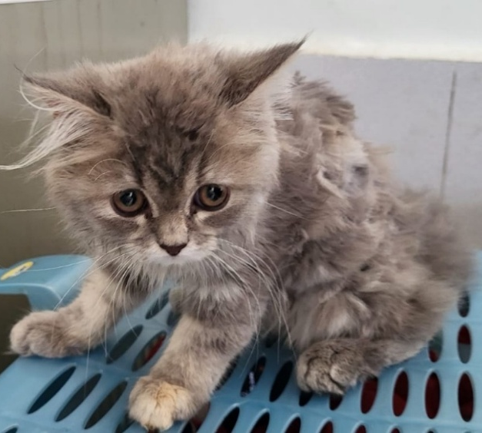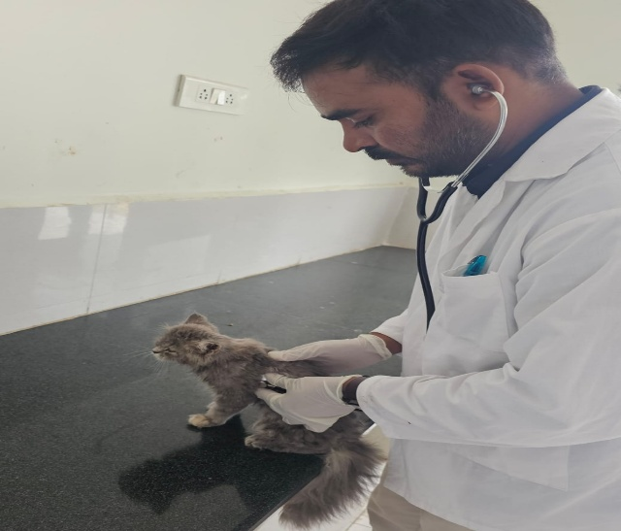
Figure 1& 2 Clinical appearance of the kitten at presentation showing depression and reduced responsiveness.
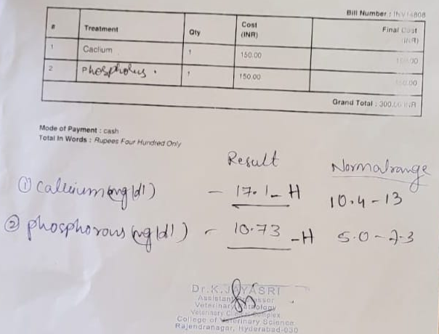
Figure 3. Serum biochemical profile demonstrating marked hypercalcaemia (17.1 mg/dL) and hyperphosphataemia (10.73 mg/dL), strongly supporting a presumptive diagnosis of acute cholecalciferol toxicosis.

Diagnostic Evaluation and Therapeutic Management
A presumptive diagnosis of acute cholecalciferol (vitamin D₃) toxicosis was established based on the documented history of accidental ingestion of cholecalciferol capsules, compatible clinical signs, and characteristic biochemical abnormalities. Serum biochemistry revealed marked hypercalcaemia (17.1 mg/dL) and hyperphosphataemia (10.73 mg/dL). The calculated calcium-phosphorus (Ca × P) product was 183.5 mg²/dL², substantially exceeding the threshold of 60–70 mg²/dL², indicating a high risk of metastatic soft tissue mineralisation (Peterson & Talcott, 2021; Ettinger et al., 2024). Although measurement of the serum 25-hydroxyvitamin D concentration could have provided additional diagnostic confirmation, this assay was not available. Therefore, the diagnosis was based on the documented exposure history together with compatible clinical signs and characteristic biochemical abnormalities.
Considering the substantial toxic exposure and marked biochemical abnormalities, treatment was initiated immediately. Intravenous isotonic crystalloid fluid therapy was administered to correct dehydration, restore renal perfusion, and promote urinary calcium excretion. Following adequate rehydration, furosemide (1 mg/kg, IV) was administered to enhance calciuresis. Prednisolone injection (0.5 mg/kg, IV) was administered to reduce intestinal calcium absorption and osteoclastic bone resorption. Supportive therapy included ondansetron (0.1 mg/kg, IV) to control vomiting and pantoprazole (0.5 mg/kg, IV) for gastric protection. Inj. N-acetylcysteine (50 mg/kg, IV) was administered as an adjunctive antioxidant therapy during systemic intoxication. The kitten was monitored closely throughout hospitalisation for hydration status, appetite, activity, urine output, and overall clinical response.
The kitten showed gradual clinical improvement during hospitalisation, with resolution of vomiting, improvement in appetite and activity, and correction of dehydration. Following discharge, the kitten has remained under regular clinical follow-up because the toxic effects of cholecalciferol may persist and delayed complications, particularly renal injury and soft tissue mineralisation, can develop. Periodic monitoring of serum calcium, phosphorus, renal function, and overall clinical status is ongoing to assess long-term recovery. At the time of writing, the kitten remains clinically stable and continues to improve; however, long-term follow-up is still in progress. Therefore, complete resolution of biochemical abnormalities and the absence of delayed complications cannot yet be definitively confirmed.

Discussion
The estimated ingestion of 180,000 IU (approximately 4.5 mg/kg) of cholecalciferol represented a substantial toxic exposure for a 1.0 kg kitten and was consistent with the development of marked hypercalcaemia, hyperphosphataemia, and acute gastrointestinal signs observed in the present case. Similar clinical manifestations have been described in previous reports of feline cholecalciferol intoxication, in which vomiting, anorexia, lethargy, dehydration, and biochemical evidence of disturbed calcium-phosphorus homeostasis were the predominant findings (Wehner et al., 2013; Vecchiato et al., 2021; Chasnick & Levy, 2026).
Although cholecalciferol intoxication is well recognised in dogs, naturally occurring cases in cats remain comparatively uncommon, particularly those associated with accidental ingestion of pharmaceutical vitamin D preparations. Most published feline cases have been linked to contaminated commercial diets or cholecalciferol-containing rodenticides (Wehner et al., 2013; Vecchiato et al., 2021). The present case therefore contributes additional clinical information regarding accidental ingestion of pharmaceutical cholecalciferol capsules in a young kitten.
In the present case, the diagnosis was presumptively established from the history of toxin exposure together with compatible clinical signs and characteristic biochemical abnormalities. Although determination of serum vitamin D metabolites would have strengthened the diagnosis, these assays were not available. Similar diagnostic approaches have been described in previous reports in which the diagnosis relied primarily on exposure history and clinicopathological findings (Peterson & Talcott, 2021).
Early recognition of the exposure history and prompt initiation of intravenous fluid therapy, furosemide, prednisolone, antiemetic therapy, and supportive care were considered important factors contributing to the favourable short-term clinical response. Nevertheless, because serial biochemical monitoring and advanced diagnostic investigations were not available, complete resolution of hypercalcaemia, renal injury, or soft tissue mineralisation could not be objectively confirmed. The kitten remains under regular clinical follow-up, and periodic evaluation of serum calcium, phosphorus, renal function, and overall clinical status continues to monitor long-term recovery and identify any delayed complications associated with cholecalciferol toxicosis.
Although the present case demonstrated a favourable short-term clinical response to medical management, continued follow-up and serial biochemical monitoring are necessary to evaluate long-term recovery and detect any delayed complications associated with cholecalciferol intoxication. Documentation of additional feline cases with long-term follow-up will further improve the understanding of the clinical course, prognosis, and optimal management of this uncommon intoxication in cats.
The favourable short-term clinical response observed in this kitten was likely associated with recognition of the toxic exposure, timely biochemical evaluation, and prompt initiation of appropriate therapy. However, because long-term follow-up is still ongoing, complete resolution of biochemical abnormalities and the absence of delayed renal or soft tissue complications cannot yet be confirmed. This case highlights the importance of obtaining a thorough exposure history in suspected poisoning cases and emphasises that early diagnosis and timely therapeutic intervention may improve the clinical outcome, particularly in young animals with acute cholecalciferol toxicosis.

Conclusion

Acute cholecalciferol (vitamin D₃) toxicosis should be considered in cats presenting with acute gastrointestinal signs after possible exposure to vitamin D-containing supplements or other cholecalciferol products. In this kitten, the reported ingestion of three 60,000 IU capsules, together with marked hypercalcaemia and hyperphosphataemia, supported a presumptive diagnosis. Prompt management with intravenous isotonic crystalloid fluids, furosemide, prednisolone, antiemetic treatment, gastroprotective medication, N-acetylcysteine, and supportive care was associated with favourable short-term clinical improvement. Vomiting resolved, hydration improved, and appetite and activity gradually returned during hospitalisation. However, serum vitamin D metabolites were not measured, serial biochemical data were incomplete, and long-term follow-up remains ongoing. Consequently, complete biochemical recovery and the absence of delayed renal injury or soft tissue mineralisation cannot yet be confirmed. Continued monitoring of serum calcium, phosphorus, renal function, urine output, and overall clinical status is therefore warranted. The case demonstrates the clinical value of a detailed exposure history, early biochemical evaluation, and timely intervention in the management of suspected feline cholecalciferol intoxication.

Limitations
This report is limited by the absence of serum 25-hydroxyvitamin D measurement, ionised calcium assessment, complete renal and hepatic biochemical profiles, urinalysis, blood pressure measurement, electrocardiography, and diagnostic imaging. Serial biochemical results, the precise duration of hospitalisation, and complete follow-up laboratory data were unavailable. As long-term follow-up remains ongoing, complete biochemical recovery and the absence of delayed renal or soft tissue complications cannot yet be established.
Declaration of AI Use
This manuscript was prepared through the combined contributions of all author(s), including contributions to the study design, data, content development, results, interpretation, and related scholarly work. The author(s) acknowledge the use of Grammarly and ChatGPT to assist with grammar checking, language refinement, reference formatting. These AI-assisted tools were not used as authors and did not replace the intellectual contributions or scholarly judgment of the author(s). All AI-assisted outputs, including content, references, and interpretations, were carefully reviewed, revised, verified and approved by the author(s). The author(s) accept full responsibility for the accuracy, integrity, and final content of the manuscript.

Ethical Approval
Animal Ethic committee approval has been collected and preserved by the author(s)

Conflict of Interest
The authors declare that there is no conflict of interest regarding the publication of this manuscript.

References
Backus, R. C., & Ueda, D. C. (2024). Age-dependent changes in plasma concentrations of 25-hydroxyvitamin D may complicate vitamin D status assessment of immature cats. Frontiers in Veterinary Science, 11, Article 1365204. https://doi.org/10.3389/fvets.2024.1365204
Chasnick, I. R., & Levy, N. A. (2026). Acute vitamin D toxicosis in an adult cat. Journal of Feline Medicine and Surgery Open Reports, 12(1), Article 20551169261448248. https://doi.org/10.1177/20551169261448248
Ettinger, S. J., Feldman, E. C., & Côté, E. (Eds.). (2024). Ettinger’s textbook of veterinary internal medicine: Diseases of the dog and the cat (9th ed.). Elsevier. https://www.us.elsevierhealth.com/ettingers-textbook-of-veterinary-internal-medicine-9780323775728.html
Ippolito, E., Merkhassine, M., Forbes, J. M., & Loftus, J. P. (2024). Elevated 24,25-dihydroxyvitamin D serum concentrations in two dogs with cholecalciferol toxicosis. Pets, 1(3), 420–426. https://doi.org/10.3390/pets1030029
Klainbart, S., & Aroch, I. (2024). Hypercalcemia. In S. J. Ettinger, E. C. Feldman, and E. Côté (Eds.), Ettinger’s textbook of veterinary internal medicine: Diseases of the dog and the cat (9th ed.). Elsevier. https://www.us.elsevierhealth.com/ettingers-textbook-of-veterinary-internal-medicine-9780323775728.html
Mellanby, R. J., Mee, A. P., Berry, J. L., & Herrtage, M. E. (2005). Hypercalcaemia in two dogs caused by excessive dietary supplementation of vitamin D. Journal of Small Animal Practice, 46(7), 334–338. https://doi.org/10.1111/j.1748-5827.2005.tb00329.x
Peterson, M. E., & Talcott, P. A. (Eds.). (2021). Small animal toxicology (4th ed.). Elsevier. https://www.us.elsevierhealth.com/small-animal-toxicology-9780323851602.html
Plumb, D. C. (2024). Plumb’s veterinary drug handbook (10th ed.). Wiley-Blackwell. https://www.wiley.com/en-us/Plumb%27s+Veterinary+Drug+Handbook%2C+10th+Edition-p-9781119834458
Rumbeiha, W. K. (2013). Cholecalciferol. In M. E. Peterson & P. A. Talcott (Eds.), Small animal toxicology (3rd ed., pp. 489–498). Elsevier. https://doi.org/10.1016/B978-1-4557-0717-1.00038-7
Vecchiato, C. G., Delsante, C., Galiazzo, G., Perfetti, S., Pinna, C., Sabetti, M. C., Zagnoli, L., Biagi, G., & Pietra, M. (2021). Case report: A case series linked to vitamin D excess in pet food: Cholecalciferol (vitamin D₃) toxicity observed in five cats. Frontiers in Veterinary Science, 8, Article 707741. https://doi.org/10.3389/fvets.2021.707741
Voss, A., & Chow, R. (2023). Intravenous lipid emulsion therapy in 2 dogs and 2 cats with vitamin D toxicosis. The Canadian Veterinary Journal, 64(12), 1119–1124. https://pmc.ncbi.nlm.nih.gov/articles/PMC10637706/
Wehner, A., Hartmann, K., & Hirschberger, J. (2013). Vitamin D intoxication caused by ingestion of commercial cat food in three cats. Journal of Feline Medicine and Surgery, 15(9), 730–736. https://doi.org/10.1177/1098612X13489298

